BIOMETRIC AUTHENTICATION SYSTEM FOR CYBERSECURITY

BY

ANJORIN OLUWAFEMI DAVID
HND/23/COM/FT/0595

SUBMITTED TO THE DEPARTMENT OF COMPUTER SCIENCE,
INSTITUTE OF INFORMATION AND COMMUNICATION TECHNOLOGY
KWARA STATE POLYTECHNIC, ILORIN.

IN PARTIAL FULFILLMENT OF THE REQUIREMENTS FOR THE AWARD OF HIGHER NATIONAL DIPLOMA (HND) IN
COMPUTER SCIENCE

JUNE, 2024.

CERTIFICATION
This is to certify that this project research was carried out by ANJORIN OLUWAFEMI DAVID with Matriculation Number: HND/23/COM/FT/0595, has been read and approved as meeting part of the requirement for the award of Higher National Diploma (HND) in computer science

…………………………………. ….………………………
MR. ABIODUN E.T. Date
Project Supervisor

…………………………………. ….………………………
MR OYEDEPO F.S Date
Head of Department

…………………………………. ….………………………
External Examiner Date

DEDICATION
I dedicate this project work to Almighty God who inspired me and directed my ways during my academic stay in the polytechnic.

ACKNOWLEDGEMENT
All praise is due to Almighty God the Lord of universe. I praise him and thank him for giving me the strength and knowledge to complete my HND programand also for our continued existence on the earth.
I appreciate the utmost effort of our supervisor, Mr. Abiodun, E.T whose patience, support and encouragement have been the driving force behind the success of this research work. He gave useful corrections, constructive criticisms, comments, recommendations, advice and always ensures that an excellent research is done. My sincere gratitude goes to Head of Department and other members of staff of the Department of Computer Science, Kwara State Polytechnic, Ilorin, for their constant cooperation, constructive criticisms and encouragements throughout the programme.
Special gratitude to my parents, who exhibited immeasurable financial, patience, support, prayers and understanding during the period in which I was busy tirelessly on mystudies, special thanks go to my lovely siblings
My sincere appreciation goes to my friends and classmates.

TABLE OF CONTENT
TITLE PAGE
CERTIFICATION PAGE
DEDICATION
ACKNOWLEDGEMENT
LIST OF FIGURES
LIST OF TABLES
ABSTRACT
TABLE OF CONTENT

CHAPTER 1 – GENERAL INTRODUCTION
1.1 BACKGROUND OF THE STUDY
1.2 STATEMENT OF THE PROBLEM
1.3 AIM AND OBJECTIVES
1.4 SIGNIFICANCE OF THE STUDY
1.5 SCOPE OF THE STUDY
1.6 ORGANIZATION OF THE REPORT

CHAPTER 2 - LITERATURE REVIEW
2.1 LITERATURE REVIEW
2.2 FINGER AUTHENTIFICATION

CHAPTER 3: RESEARCH METHODOLOGY
3.1 RESEARCH METHODOLOGY
3.2 ANALYZING OF THE EXISTING SYSTEM
3.3 PROBLEM OF THE EXISTING SYSTEM
3. 4 DESCRIPTION OF THE PROPOSED SYSTEM
3.5 ADVANTAGE OF THE PROPOSED SYSTEM
CHAPTER 4: DESIGN AND IMPLEMENTATION AND DOCUMENTATION OF THE SYSTEM
4.1 DESIGN OF THE SYSTEM
4.1.1 OUTPUT OF SYSTEM
4.1.2 INPUT SYSTEM
4.1.3 DATABASE DESIGN
4.1.4 PROCEDURE DESIGN
4.2 IMPLEMENTATION OF THE SYSTEM
4.2.1 CHOICE OF PROGRAMMING LANGUAGE
4.2.2 HARDWARE SUPPORT
4.2.3 SOFTWARE SUPPORT
4.2.4 CHANGE OVER TECHNIQUES
4.3 SYSTEM DOCUMENTATION
4.3.1 OPERATING SYSTEM
4.3.2 MAINTAINING THE SYSTEM
CHAPTHER 5: SUMMARY CONCLUSION AND RECOMMENDATION
5.1 SUMMARY
5.2 CONCLUSION
5.3 RECOMMENDATION
References
APPENDICES

ABSTRACT
Biometrics refers to metrics related to human characteristics. Biometrics authentication (or realistic authentication) used in computer science as a form of identification and access control. It is also used to identify individuals in groups that are under surveillance. Biometric identifiers are then distinctive, measurable characteristics used to label and describe individuals. Biometric identifiers are often categorized as physiological versus behavioral characteristics. Physiological characteristics are related to the shape of the body. Examples include, but are not limited to fingerprint, palm veins, face recognition, DNA, palm print, hand geometry, iris recognition, retina and odour/scent. Behavioral characteristics are related to the pattern of behavior of a person, including but not limited to typing rhythm, gait, and voice. Some researchers have coined the term behaviometrics to describe the latter class of biometrics. More traditional means of access control include token-based identification systems, such as a driver's license or passport, and knowledge-based identification systems, such as a password or personal identification number. We will talk about biometric, importance and types of biometric. Since biometric identifiers are unique to individuals, they are more reliable in verifying identity than token and knowledge-based methods; however, the collection of biometric identifiers raises privacy concerns about the ultimate use of this information.
Keywords: Dna Matching, Ear, Eyes - Iris Recognition, Eyes - Retina Recognition, Face Recognition, Fingerprint Recognition

CHAPTER ONE
GENERAL INTRODUCTION

  - BACKGROUND TO THE STUDY
Biometric authentication system offers greater security and convenience than traditional personal verification systems. Biometrics is about measuring unique personal features (Jain, Ross and Prabhakar, 2014). It has the potential to identify individuals with a high degree of assurance, thus providing a foundation for trust. Biometric signals are also harder to copy or steal, and cannot be forgotten or lost. On the other hand, cryptography concerns itself with the ensuring the authenticity of information. Unfortunately, cryptographic security is conditioned by an authentication step typically based on long pseudo random keys, which are almost impossible to remember. As a result, cryptosystems commonly rely on user generated passwords, which are easy to memorize, in order to release the pseudo random keys. Biometric cryptosystems combine cryptographic security with biometric authentication (Hao, Anderson and Daugman, 2016). The merging of biometric and cryptography has been introduced as an effective means to address the convenient and security issues of privacy enhancing technologies with respect of personal data protection. It is also introduced to solve cryptographic keys management problems, because all cryptographic algorithms fully depend on the assumption that the keys will be kept in absolute secrecy. It intends to bind a cryptographic key with the user’s biometric information in a manner to meet the distortion tolerance and discrimination requirements. Therefore, Crypto-Biometric merging can be done broadly at two different modes (Al-Tarawneh, Khor, Woo and Dlay, 2016): (1) loosely-coupled mode (biometric key release), the biometric matching is decupled from the cryptographic part. Biometric matching operates on biometric templates, if they match; cryptographic key release from it is secure location, e.g. a server or smart card. (2) tightly-coupled mode (biometric key generation), biometric and cryptography are merged together at a much deeper level, i.e. the biometric signals are monolithically bounded to the keys. The matching at this level can effectively take place within cryptographic domain. Cryptographic construct, i.e. Fuzzy Vault, is an example of biometric crypto bounded mode.
Proper biometric use is very application dependent Certain biometrics will be better than others based on the required levels of convenience and security. No single biometric will meet all the requirements of every possible application. The block diagram illustrates the two basic modes of a biometric system. First, in verification (or authentication) mode the system performs a one-to-one comparison of a captured biometric with a specific template stored in a biometric database in order to verify the individual is the person they claim to be. Three steps are involved in the verification of a person. In the first step, reference models for all the users are generated and stored in the model database. In the second step, some samples are matched with reference models to generate the genuine and impostor scores and calculate the threshold. Third step is the testing step. This process may use a smart card, username or ID number (e.g. PIN) to indicate which template should be used for comparison. Positive recognition' is a common use of the verification mode, "where the aim is to prevent multiple people from using the same identity.
Second, in identification mode the system performs a one-to-many comparison against a biometric database in an attempt to establish the identity of an unknown individual. The system will succeed in identifying the individual if the comparison of the biometric sample to a template in the database falls within a previously set threshold. Identification mode can be used either for positive recognition (so that the user does not have to provide any information about the template to be used) or for 'negative recognition' of the person "where the system establishes whether the person is who she (implicitly or explicitly) denies to be".^{[3]} The latter function can only be achieved through biometrics since other methods of personal recognition such as passwords, PINs or keys are ineffective.
The first time an individual uses a biometric system is called enrollment. During the enrollment, biometric information from an individual is captured and stored. In subsequent uses, biometric information is detected and compared with the information stored at the time of enrollment. Note that it is crucial that storage and retrieval of such systems themselves be secure if the biometric system is to be robust. The first block (sensor) is the interface between the real world and the system; it has to acquire all the necessary data. Most of the times it is an image acquisition system, but it can change according to the characteristics desired. The second block performs all the necessary pre-processing: it has to remove artifacts from the sensor, to enhance the input (e.g. removing background noise), to use some kind of normalization, etc. In the third block necessary features are extracted. This step is an important step as the correct features need to be extracted in the optimal way.
Fingerprint identification is the most mature biometric method being implemented at an early level since 1960. The recognition of a fingerprint can be done with two methods: ”one-to-one” (verification) and ”one-to-many”. The first method is applied when we have two fingerprints and we want to verify if they belong to the same person. The second one is used when we have one fingerprint and we search it in a data base. The verification is much easier and faster because we have the two fingerprints and we just need to compare them. On the other hand, the identification implies more time for extracting the fingerprint because there are needed much more details. The fingerprints are not compared with images, they use a method based on characteristic points named ”minutiae”. These points are characterized by ridge ending (the abrupt end of a ridge), ridge bifurcation (a single ridge that divides in two ridges), delta (a Y-shaped ridge meeting), core (a U-turn in ridge pattern), etc. All these features are grouped in three types of lines: line ending, line bifurcation and short line. After the minutiae points are localized, a map with all their locations on the finger is created (Samuel, 2015)
as a mathematical model of the vagueness phenomenon while probability is a mathematical model of randomness.(Cong, 2015)

1.2 STATEMENT OF THE PROBLEM
Current cryptographic algorithms (e.g., Advanced Encryption Standard (AES) (NIST, 2011), RSA (Stallings, 2013) have a very high proven security but they suffer from the key management problem. All these algorithms fully depend on the assumption that the keys will be kept in absolute secrecy. If the secret key is compromised, the security provided by them immediately falls apart. Another limitation of the these algorithms is that they require the keys to be long and random for higher security, e.g., 128 bits for AES, which makes it impossible for users to memorize the keys. As a result, the cryptographic keys are stored somewhere (e.g., in a computer or on a smart card) and released based on some alternative authentication mechanism. The most popular authentication mechanism used for this purpose is based on passwords, which are again cryptographic key-like strings but simple enough for users to remember. Hence, plain text (e.g., multimedia content, email records, financial records, and private encryption keys) protected by a cryptographic algorithm is only as secure as the passwords (weakest link) used for authentication that release the correct decrypting key(s). Simple passwords compromise security; complex passwords are difficult to remember and expensive to maintain. Also, passwords are unable to provide nonrepudiation.

1.3 AIM AND OBJECTIVES
The aim of the proposed system is to develop a biometric authentication system for enhanced cyber security using fuzzy logic. The objectives are as follows:
- To develop a system that will enable biometric authentication for security using fuzzy logic.
- To develop the system using C# programming language.

1.4 SIGNIFICANCE OF THE STUDY
The proposed system is of importance in the sense that the method not only outputs high entropy keys, but also conceals the original biometric data such that it is impossible to recover the biometric data even when the stored information in the system is open to an attacker.

1.5 SCOPE OF THE STUDY
The scope of this project focuses mainly on the development of an enhanced security for cyber environment using biometric, like: fingerprint, face recognition e.t.c and it doesn’t go beyond that.

1.6 ORGANIZATION OF THE STUDY
For ease study and proper understanding of this project write-up, It is planned and organized into five chapters. The description of what each chapter contains is explained below:
Chapter One: contains an Introduction to the whole write-up, the problem of the study, aims and objectives of the study, the significant of the study, the scope and limitation of the study, and organization of the report.
Chapter Two: contains the literature review of the study, an application in fingerprint identification.
Chapter Three: presents data collection method employed, analysis of data and existing system, advantages of the proposed system, design and implementation, programming language used with reasons, hardware and software support.
Chapter Four: contains system design implementation and documentation, design of the system, output design, input design, file system, procedural design, and documentation of the new system.
CHAPTER FIVE: contains the summary, experienced gained, recommendation and conclusion.

CHAPTER TWO
LITERATURE REVIEW
2.1 REVIEW OF RELATED WORKS
The word “biometrics” comes from the Greek language and is derived from the words bio (life) and metric (to measure). Biometric systems use a person’s physical characteristics (like fingerprints, irises or veins), or behavioral characteristics (like voice, handwriting or typing rhythm) to determine their identity or to confirm that they are who they claim to be. (Bolle et al, 2003) Biometric data are highly unique to each individual, easily obtainable non-intrusively, time invariant (no significant changes over a period of time) and distinguishable by humans without much special training.(Jain, 1999). Biometric data are highly unique to each individual, easily obtainable non-intrusive, time invariant that is no changes over period of time, distinguishable by humans without much special trainings. Biometric identifiers are categorized as physiological versus behavioral characteristics. A physiological biometric would identify ones voice, DNA, hand print, iris A behavioral biometrics is related to the behavior of a person, including typing rhythm, and signature (chang, 2005). The tradition or conventional means of access control include knowledge based methods such as password or pin and token based method such as passport, driver’s license, ID card. These methods are prone to fraud because pin numbers could be forgotten and hacked and the token could be lost, duplicated or stolen, to address the need for robust, reliable and fool proof personal identification, authentication and systems will necessarily require a biometric component. (calvin ,2007).
To overcome the integration of biometric into cryptosystem, a number of approaches were introduced in the literatures. In (Juels and Wattenberg, 2019), Juels and Wattenberg present the first binding crypto-biometric system called fuzzy commitment, in which cryptographic key is de-committed using biometric data. The committed value will be extracted when the fuzziness value close to the original enrolled value. The fuzzy commitment scheme is based on the use of error correcting codes, considers binary strings where the similarity is measured by Hamming distance. In fuzzy commitment, the de-commitment key is built from an enrolled fingerprint, as a set of minutiae positions. These yield two shortcomings. First, it does not allow key modifications, such as re-ordering, and addition/deletion of an element in the key, although such modifications are frequent in real life. Second, the security proof of this scheme holds only if enrolled fingerprint is uniformly distributed, which is not the case in reality. In order to overcome these drawbacks, Juels and Sudan propose a fuzzy vault scheme (FVS) (Juels and Sudan, 2012). This scheme designed to work with biometric features, (e.g., minutiae in fingerprints). The idea behind FVS is to encode a secret s as a polynomial p of degree d using the Reed-Solomon encoding scheme (polynomial constructer block) and evaluate the polynomial on all elements of biometric template points. The user then chooses a large number of random false points which do not lie on the polynomial p (point generator block).
The total points (real polynomial points and chaff, i.e. false points) are used to form the vault V. The chaff points conceal the real points lying on p from an attacker. The secret key can be retrieved from the vault V by providing another query template. Using polynomial reconstructer block to format a query unordered set. If the query set overlaps substantially with reference set, then user can identify many points in V that lie on p . If sufficient number of points on p can be identified, an error correction scheme can be applied to exactly reconstruct p and thereby decode the secret key. If reference points do not overlap substantially with query points, it is infeasible to reconstruct p and the authentication is unsuccessful. The scheme fuzziness come from the variability of biometric data and that does not affect on the secret key retrieval from vault. Based on fuzzy vault scheme, Clancy et al. (Clancy, Lin and Kiyavash, 2013) proposed a fingerprint vault using multiple minutiae location sets per finger (based on 5 impressions of a finger), they first find the canonical positions of minutia, and use these as the elements.
They added the maximum number of chaffA(of the set. However, their system)k ( that locks)R(points to find inherently assumes that fingerprints (the one that locks the vault and the one that tries to unlock it) are pre-aligned. This is not a realistic assumption for fingerprint-based authentication schemes. Jain, Uludag, Pankanti, Ross, and Prabhakar further developed the fuzzy vault scheme for fingerprint minutiae. The authors achieved FRR = 21% and FAR = 0 (i.e., less than one in 10000) under ideal conditions: fingerprints were manually pre-aligned and rotated, and the correspondence of the minutiae across images was manually established. Clancy et al. (Clancy, Lin and Kiyavash, 2013) simulated the error-correction step without actually implementing it. They found that 69-bit security (for False Accept Rate (FAR)) could be achieved with a False Reject Rate (FRR) of 20-30%. Note that the cited security translates to
2⁻⁶⁹≈1.7*10⁻²¹FAR. Further, FRR value suggests that≈∗−−69 21 107.12 a genuine user may need to present her finger multiple times to unlock the vault. Uludg and Jain (Uludag and Jain, 2014) used lines based fingerprint minutiae representation to design fuzzy vault system, but it was without the actual implementation. Their work suffers from complexity and alignment problems.
It differs from Clancy system in way that both location and angle of minutiae are used to extract lines for forming the templates. Nagar and Chaudhury proposed another modified fuzzy vault scheme (Nagar and Chaudhury, 2016) which is used within asymmetric cryptosystem. A zero error rate (i.e., FRR=FAR=0) is reported for a small database of fingerprints. However, these unrealistic numbers were likely obtained because all attackers had different secret random masks assigned and, naturally, their templates did not get a match with a legitimate template. All previous reviewed approaches assumed that the source of reference data, i.e. fingerprints (the one that locks the vault and the one that tries to unlock it) are pre-aligned, which is not a realistic assumption in practical fingerprint authentication systems. Chung et al. (Chung, Moon, Lee, Jung, Kim and Ahn, 2015) proposed a geometric hashing technique to perform alignment in a minutiae-based fingerprint fuzzy vault but still has the problem of limited security. That is, the maximum number of hiding points (chaff points) for hiding the real fingerprint minutiae is limited by the size of the fingerprint sensor meanwhile the size of the fingerprint images captured and the possible degradation of the verification accuracy caused by the added chaff minutiae. Lee et al proposed both the automatic alignment of fingerprint data and higher security by using a 3D geometric hash table. A number of chaff points for proposed approach were more than in previous approaches in two times, as well as a complexity of cracking the proposed system was very high. A processed extracted feature vector is used in this paper as a replaceable base for fuzzy vault scheme.
Abhishek, Karthik(2008) in their paper Multibiometric Cryptosystem based on feature level fusion, explained the multi-biometric cryptosystem using both fuzzy vault and fuzzy Commitment. Also they proposed different embedding algorithms for transforming biometric representations.
They propose a feature level fusion framework to simultaneously secure multiple templates of user using biometric cryptosystems. They proposed simple algorithms for three tasks:
1) Different biometric representations are converted into a common representation space using different embedding algorithms viz. binary strings to pointsets, point-sets to binary strings and fixed length real valued vectors to binary strings.
2) Different features are fused into a single multibiometric template that can be secured using an appropriate biometric cryptosystem such as fuzzy vault and fuzzy commitment. They also proposed efficient decoding strategies for these biometric cryptosystems.
3) A minimum matching constraint for each trait is incorporated in order to encounter the possibility of an attacker gaining illegitimate access to the secure system by simply guessing/knowing only a subset of biometric traits.
Umut and Sharath(2009) in their paper Fuzzy Vault for Fingerprints, explained the unibiometric authentication system using fingerprint minutiae as the single biometric trait. For the encoding and decoding to work they used the new cryptographic construct called Fuzzy Vault.
This paper explains how to extract the fingerprint features. These features are the abrupt changes in the regular ridge structure on the fingertip, characterized by either ending or bifurcation of the ridges. They are typically represented as (x, y, Ө) triplets, where x, y and Ө denotes the row indices, column indices and angle of the associated ridge respectively. This paper also represents the working of the unibiometric system using fuzzy vault. This system works in two stages viz. encoding stage and decoding stage. In encoding stage, features of the biometric template are extracted and then they are quantized and mapped into binary form. Then fusion of password and the extracted features takes place and is then stored into the fuzzy vault. When the fuzzy vault is created the data is secured. In the decoding stage another biometric template is accepted as the input. The accepted biometric template and the stored biometric template are matched; if they are matched the user is authenticated otherwise the user is declared as invalid.
Haiping and Karl (2012) in their paper Face Recognition with biometric encryption for privacy enhancing, explained a combination of face recognition and simple biometric encryption using helper data system. Their main objective was to address the privacy concern in a self exclusion scenario of face recognition.
Kim and Sang-Ho (2013) in their paper Authentication Protocol using Fuzzy Eigenface Vault based on MOC, proposed a fuzzy vault based on the eigenfaces. For this scheme, they use a feature vector, which is called an eigenface, from a face image. The eigenface is calculated by the principle component analysis method.
Kim and Sang-Ho proposed the authentication protocol based fuzzy eigenface vault scheme. For the calculation of fuzzy eigenface vault sets, we need the eigenface E as the feature vector, secret information or a cryptographic key S and a cyclic redundancy check value (CRC) for construction of a polynomial and checking the valid polynomial. The secret value S and the cyclic redundancy check value CRC are formed by 16-bit units which will be coefficients and used to construction of the D-degree polynomial P. In the experiment, D is 8. Using the polynomial P and the eigenface components Wpca, we calculate a genuine set, a chaff point set, and a final vault set. The s is locked in the final vault set.
Julesand Sudan (2011) in their paper A fuzzy vault scheme, proposed the concept of fuzzy vault. It is a logical constraint which is used to store the transformed data. It acts as the locking agent viz. whenever the fuzzy vault is created the data is considered to be locked.
They explained the concept by giving the example of Alice and Bob. Alice may place a secret value k in a fuzzy vault and lock it using a set A of elements from some public universe U. If Bob tries to unlock the vault using the set B of similar length , he obtains k only if B is close to A. i.e. only if A and B overlap substantially.

2.2 FINGERPRINT AUTHENTICATION
Biometric authentication technologies such as face, finger, hand, iris, and speaker recognition are commercially available today and are already in use. (Fernando L. Podio: year) A biometric system is essentially a pattern recognition system that operates by acquiring biometric data from an individual, extracting a feature set from the acquired data, and comparing this feature set against the template set in the database. Depending on the context, a biometric system may operate either in verification mode or identification mode.(Anil, Arun and Salil,2011). Verification mode: In the verification mode, the system validates a person’s identity by comparing the captured biometric data with her own biometric template(s) stored system database. In such a system, an individual who desires to be recognized claims an identity, usually via a PIN Personal Identification Number), a user name, a smart card, etc., and the system conducts a one-to-one comparison to determine whether the claim is true or not (e.g., “Does this biometric data belong to Bob?”). Identity verification is typically used for positive recognition, where the aim is to prevent multiple people from using the same identity. (O'Gorman, 2010.). Identification mode: In the identification mode, the system recognizes an individual by searching the templates of all the users in the database for a match. Therefore, the system conducts a one-to-many comparison to establish an individual’s identity (or fails if the subject is not enrolled in the system database) without the subject having to claim an identity (e.g., “Whose biometric data is this?”). Identification is a critical component in negative recognition applications where the system establishes whether the person is who she (implicitly or explicitly) denies to be. The purpose of negative recognition is to prevent a single person from using multiple identities. Identification may also be used in positive recognition for convenience (the user is not required to claim an identity). While traditional methods of personal recognition such as passwords, PINs, keys, and tokens may work for positive recognition, negative recognition can only be established through biometrics. (O'Gorman, 2015.)

CHAPTER THREE
METHODOLOGY AND ANALYSIS OF THE EXISTING SYSTEM

3.1 RESEARCH METHODOLOGY

Method of data collection refers to the practices and techniques in research used to gather, process, and manipulate information that can then be used to test ideas and theories about social life. Types of methodologies include interview, textbooks and internet research. The main type of method employed in this system is observation on the ways in which message is been sent and not known may be it delivered or not. The method is achieved through the following steps:
- An application that will enable fingerprint biometric cryptosystem using fussy logic was developed.
- To develop the system using C# programming language.
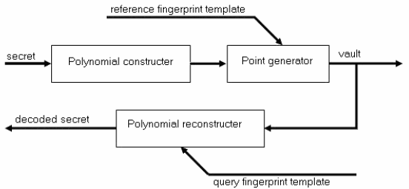
Figure 3.1: Fuzzy vault system block diagram

3.2 ANALYSIS OF THE EXISTING SYSTEM
In traditional cryptography, one or more keys are used to convert the plain text (data to be encrypted) to cipher text (encrypted data): the encrypting key(s) maps the plain text to essentially a sequence of random bits, that can be mapped back to the plain text using the decrypting key(s). Without the knowledge of the correct decrypting keys, the conversion of cipher text to the plain text is infeasible (considering time and cost limitations).
3.3 PROBLEMS OF THE EXISTING SYSTEM
The problems of the existing system are listed below:
- they suffer from the key management problem.
- If the secret key is compromised, the security provided by them immediately falls apart.
- they require the keys to be long and random for higher security, e.g., 128 bits for AES, which makes it impossible for users to memorize the keys.

3.4 DESCRIPTION OF THE PROPOSED SYSTEM
Fuzzy control provides a formal methodology for representing, manipulating and implementing human’s heuristic knowledge about how to control a system. In a fuzzy logic controller, the expert knowledge is of the form.
IF (a set o f conditions are satisfied) T HEN (a set o f consequences are in f erred) where the antecedents and the consequences of the rules are associated with fuzzy concepts (linguistic terms). The most known systems are: Mamdani, Tsukamoto, Sugeno and Larsen which work with crisp data as inputs. A Mamdani type model which works with interval inputs is presesnted.
In this paper we use a version of Fuzzy Logic Control (FLC) system from [9] in fingerprints identification. This version is characterized by:
- the linguistic terms (or values), that are represented by trapezoidal fuzzy numbers
- Lukasiewicz implication, which is used to represent the rules
- the crisp control action of a rule, computed by Middle-of-Maxima method
- the overall crisp control actions, computed by discrete Center-of-Gravity. We assume that the facts can be given by crisp data, intervals and/or linguistic terms and a rule is characterized by:
- a set of linguistic variable A, having as domain an interval IA = [aA,bA]
- nA linguistic values A₀,A₁,...,AnA for each linguistic variable A
- membership function µ₀ Ai (x) for each value Ai , where i ∈ {1, 2,...,nA} and x ∈ IA. According to the structure of a FLC, the following steps are necessary in order to work with our system.
Firing levels
We consider an interval input [a,b] with aA ≤ a < b ≤ bA. The membership function of Ai is modified ( [10]) by membership function of [a,b] as follows
∀x ∈IA,µAi (x) = min(µ  Ai (x),µ[a,b] (x))
Where
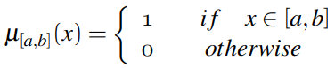
It is obvious that, any t-norm T can be used instead of min (see, for instance,).
The firing level, generated by the input interval [a,b], corresponding to the linguistic value Ai is given by:
µAi = max{µA_{i} (x)|x ∈ [a,b]}
The firing level µ_{Ai}, generated by a linguistic input value A′ _{i} is
µ_{Ai} = max{min{ µ⁰_{Ai} (x),µA ′ _{i} (x)}|x ∈ I_{A}}.
The firing level µ_{Ai} , generated by a crisp value x₀ is µ⁰_{Ai} (x₀).
Fuzzy inference
We consider a set of fuzzy control rules
Ri : if X₁ is A₁^{i} and ... and X_{r} is A^{r}_{i} then Y is C_{i}
where the variables X_{j} , j ∈ {1, 2,...,r}, and Y have the domains Uj and V, respectively. The firing levels of the rules, denoted by {α_{i}}, are computed by
α_{i} = T(α ₁ ^{i},...,α r i )
where T is a t-norm and α ^{j}_{i} is the firing level for A^{j}_{i} , j ∈ {1, 2,...,r}. The conclusion inferred from the rule R_{i}, using the Lukasiewicz implication is
C ′ _{i} (v) = I(α_{i} ,C_{i}(v)),∀_{v} ∈ V.
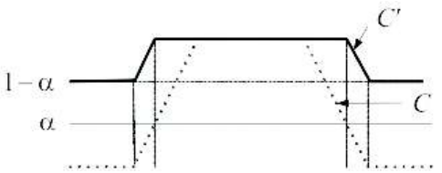
Figure 3.2: Conclusion obtained with Lukasiewicz implicationDefuzzification
The fuzzy output C′_{i} of the rule R_{i} is transformed in a crisp output z_{i} using the Middle-of-Maxima operator. The crisp value z₀ associated to a conclusion C′ inferred from a rule having the firing level α and the conclusion C represented by the fuzzy number (m_{C} ,m_{C},α_{C},β_{C}) is:
Z₀ = $\frac{mC +mC + (1-α)(βC -αC) }{2}$
The overall crisp control action is computed by the discrete Center-of-Gravity method: if the number of fired rules is N then the final control action is
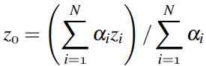
where α_{i} is the firing level and z_{i} is the crisp output of the i-th rule.

3.5 ADVANTAGES OF THE NEW SYSTEM OVER THE EXISTING SYSTEM
The advantages of the proposed system over the existing system are as follows:
- The merging of biometric and cryptography has been introduced more effective means to address the convenient and security issues of privacy enhancing technologies with respect of personal data protection.
- It is also introduced to solve cryptographic keys management problems, because all cryptographic algorithms fully depend on the assumption that the keys will be kept in absolute secrecy.

CHAPTER FOUR
DESIGN, IMPLEMENTATION AND DOCUMENTATION OF THE SYSTEM
4.1 DESIGN OF THE SYSTEM
This consists of the design which includes output design, input design, database design and procedure design. Each of the sections is explained as follows with a diagram

4.1.1 OUTPUT DESIGN
This refers to the text to speech conversion from the system. The results include conversion from text to speech The output of the proposed system are as shown below

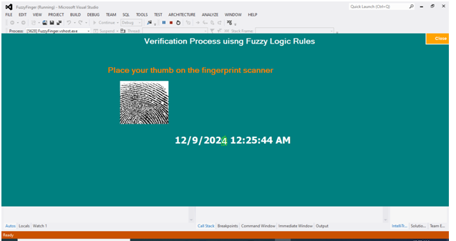
Figure 4.1: This is timming page that process the verification

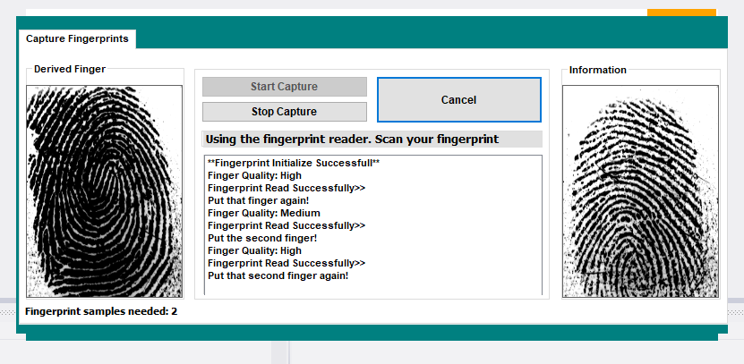
Figure 4.3: Capture: Thi is showing the fingerprint page that capture new users
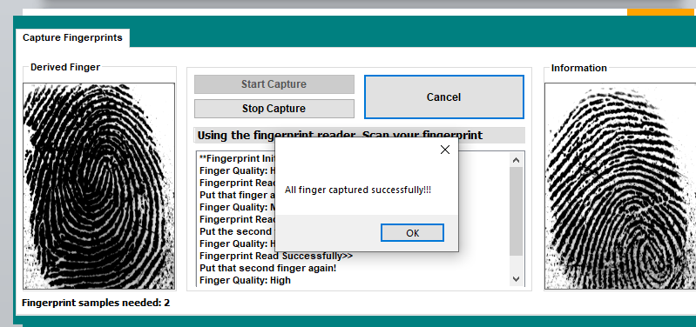
Figure 4.4 Capture status: This interface show the registration status after submission

4.1.2 INPUT DESIGN
This refers to the inputs required to make the website functioning as intended. The inputs to the system include user details for new text as well as the meaning of the text. The input to the proposed system are as shown below

Figure 4.5: This is showing the enrolment form to register new user
4.1.3 DATABASE DESIGN
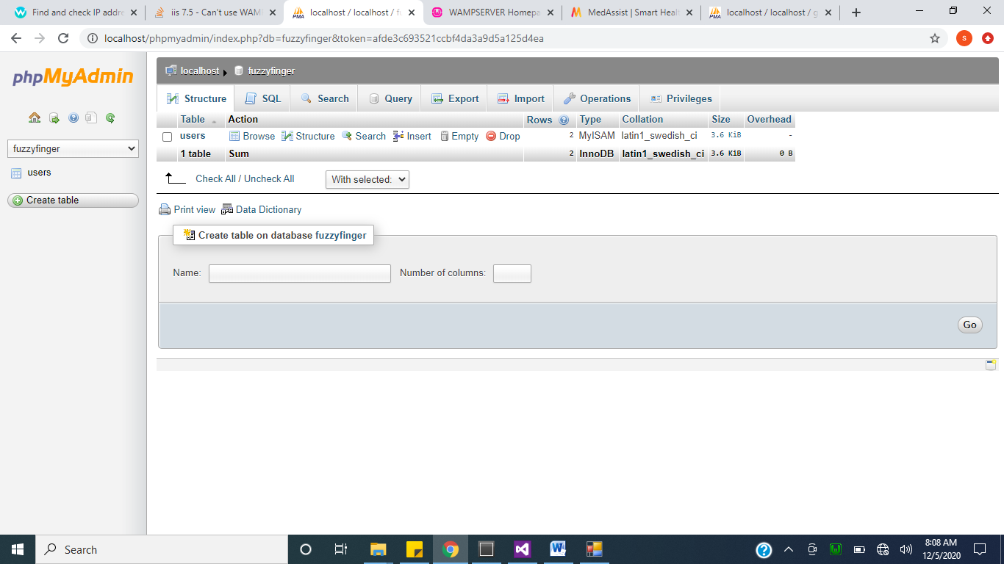
Figure 4.7: Enrolment Database: This handles all tables which includes user details.
4.1.4 PROCEDURE DESIGN
This refers to the step by step method of using the proposed system. The proposed system comprises of the timing process, biometric enrolment, fingerprint.
4.2 SYSTEM IMPLEMENTATION
The design system depends on the capabilities and power of the computer on which the application system is installed. However, selecting a choice of application support (Hardware and Software) depends much on:
- How readily the user is to interfere with the computer
- Cost and benefits
- Managements support for changes
Hence, choosing the appropriate hardware and software will enhance the performance of the system.
A most important requirement on which the running of the program basically depends on is the provision of internet facility. So any system that must run this program must be internet ready.

4.2.1 CHOICE OF PROGRAMMING LANGUAGE
The programming language used is c#. C# is a tool that allows you to develop Windows (Graphic User Interface - GUI) applications. The applications have a familiar appearance to the user.
C# is event-driven, meaning code remains idle until called upon to respond to some event (button pressing, menu selection). C# is governed by an event processor. Nothing happens until an event is detected. Once an event is detected, the code corresponding to that event (event procedure) is executed. Program control is then returned to the event processor.
Some Features of C#
- Full set of objects - you 'draw' the application
- Lots of icons and pictures for your use
- Response to mouse and keyboard actions
- Clipboard and printer access
- Full array of mathematical, string handling, and graphics functions
- Can handle fixed and dynamic variable and control arrays
- Sequential and random access file support
- Useful debugger and error-handling facilities
- Powerful database access tools
- ActiveX support
Package & Deployment Wizard makes distributing your applications simple

4.2.2 HARDWARE SUPPORT
The hardware requirements for the support of the fuzzy logic application are as follows:
- An enhanced keyboard and mouse
- Minimum of PIII computer and internet enabled
- A processor speed of 500MHz
- RAM size is 18mb
- hard disk size is 100mb
- UPS
- VGA or SVGA colored monitor to be able to achieve the effective user friendliness of the program
- A printer for hard copy record production

4.2.3 IMPLEMENTATION TECHNIQUES
Until it is decided that the new system works correctly the new and old system are used together. Every time a transaction occurs (e.g. a sale) it is entered into both systems. This is very time consuming but if there are any problems with the new system they can be easily identified by comparing the output of the two systems. It is also easy to revert back to using the old system if the new system does not work as all the data in it will be up-to-date.

4.3 SYSTEM DOCUMENTATION
It has to do with the installation and usage of the new system.
After the program has been well tested with input that the output has already been known, the next is to install the software in to the computer system for use.
The process of installing are been stated below
- Insert the CD into the system through the CD-ROM after the computer is switch on
- Locate the CD drive directory in my computer and click it to open
- After open, locate setup.exe, and then click to install the program by following the necessary step in installing the program.
- Ensure full installing of the software for effective operation of the system.
After the program has been fully install. The next thing is to locate the package install to put it into operation, to locate the package for expiration purpose the following step are to be taking
v. Click on start menu from task bar. Then select all program

4.3.1 PROGRAM DOCUMENTATION
- SPLASHSCEEN
- VERIFICATION
- TIMMING
- FINGER PRINT CAPTURING
4.3.2 OPERATING THE SYSTEM
In order for the proposed system to be used on any computer system it takes the following ways
- Boot the system
- Copy the software to your system then install it onto the system.
- After the installation then go to start->all program->fuzzy logic .
- Then follow the operating process thereafter.

4.3.3 MAINTAINING THE SYSTEM
This is the last stage in the system life cycle and can be described as the periodical evaluation and modification of the system. This is done from time to time and to ascertain whether system meets the requirement and provide the service which it is designed for. This software can be easily maintained by adding more modules or removing which are found to be less useful by the user. Also the database allows the data resilience and portability maintenance of program simply refers to the correction, by adding or deletion of parts of the program with ease which is referred to as a good structure program.

CHAPTER FIVE
SUMMARY, CONCLUSION AND RECOMMENDATION
5.1 SUMMARY
Biometric authentication system offers greater security and convenience than traditional personal verification systems. Biometrics is about measuring unique personal features. It has the potential to identify individuals with a high degree of assurance, thus providing a foundation for trust. Biometric signals are also harder to copy or steal, and cannot be forgotten or lost. On the other hand, cryptography concerns itself with the ensuring the authenticity of information. Hence, the system was developed using C# programming language.

5.2 CONCLUSION
As connectivity continues to spread across the globe, it is clear that old security methods are simply not strong enough to protect what’s most important. Thankfully, biometric technology is more accessible than ever before, ready to bring enhanced security and greater convenience to whatever needs protecting, from a door, to your car to the PIN on your phone. Waiting patiently in line to use the cash machine and then forgetting your PIN number as you finally reach the front of the queue: a frustrating but fairly universal experience. However, everyday most of us have to identify ourselves on numerous occasions be it entering a code on a keypad to enter the workplace, a password to log onto our computer or a pin number to access cash from the bank.
5.3 RECOMMENDATION
In years gone by, we may have cryptically recorded passwords or PIN numbers in the contacts section of our diary or address books. But in a world that is going paperless, more advanced method of identifying individuals and verifying who they are have had to be developed. This is particularly the case with the growing threats of global terror, cyber hacking and the sophisticated methods of organised crime. It is here that biometric security has come into its own as the most sophisticated technology for authentication, verification and identification purposes. What a few years ago may have seemed like Hollywood fantasy is increasingly becoming reality with the technology allowing shoppers to verify their online transaction using fingerprint biometrics or banks introducing voice recognition software to allow customers to access their internet account.
REFERENCES
Al-Tarawneh, M. S., Khor, L. C., W. L. Woo, and Dlay, S. S., (2016). "Crypto key generation using contour graph algorithm " in Proceedings of the 24th IASTED international conference on Signal processing, pattern recognition, and applications Innsbruck, Austria ACTA Press, pp. 95-98
Chmielewski, L. and Hoepman, J. H., (2019) Fuzzy Private Matching (Extended Abstract), ARES ’08: Proceedings of the 2008 Third International Conference on Availability, Reliability and Security, IEEE Computer Society, pp. 327–334.
Chung, Y., Moon, D., Lee, S., Jung, S., Kim, T., and Ahn, D., (2015) "Automatic Alignment of Fingerprint Features for Fuzzy Fingerprint Vault" presented at Information Security and Cryptology, Beijing, China.
Clancy, T., Lin, D., and Kiyavash, N., (2013). "Secure Smartcard-Based Fingerprint Authentication" presented at ACM SIGMM Workshop on Biometric Methods and Applications,, Berkley, USA, 2003.
Czogola, E. and Leski, J., (2011). On equivalence of approximate reasoning results using different interpretations of fuzzy if-then rules, Fuzzy Sets and Systems, vol. 117, no. 2, pp. 279–296.
Iancu I., (2014) T-norms with threshold, Fuzzy Sets and Systems. International Journal of Soft Computing and Intelligence, vol. 85, no. 1, pp. 83–92, 1997.
Iancu I., (2015) Operators with n-thresholds for uncertainty management, Journal of Applied Mathematics & Computing, Springer Berlin, vol. 19, no. 1-2, pp. 1–17.
Iancu I., (2019) Generalized Modus Ponens Using Fodor’s Implication and T-norm Product with Threshold, International Journal of Computers, Communications & Control (IJCCC), vol. 4, no. 4, pp. 330–343.
Jain, A. K., Prabhakar, S., Hong, L., and Pankanti, S., (2010). "Filterbankbased Fingerprint Matching" IEEE Transactions on Image Processing, vol. 9, pp. 846-859.
Jain, A. K., Ross, A., and Prabhakar S., (2014) "An Introduction to Biometric Recognition," IEEE Transactions on Circuits and Systems for Video Technology, Special Issue on Image- and Video-Based Biometrics, vol. 14, pp. 4-20.
Juels A. and Wattenberg M., (2019). "A fuzzy commitment scheme" in Proceedings of the 6th ACM conference on Computer and communications security: ACM Press, pp. 28-36.
Juels A. and Sudan M., (2012). "A fuzzy vault scheme" presented at Information Theory,.Proceedings.IEEE International Symposium on.
Lee, S., Moon, D., Jung, S., and Chung, Y., (2017). "Protecting Secret Keys with Fuzzy Fingerprint Vault Based on a 3D Geometric Hash Table" presented at ICANNGA 2007, Warsaw, Poland.
Nagar, A. and Chaudhury, S., (2016). "Biometrics based Asymmetric Cryptosystem Design Using Modified Fuzzy Vault Scheme" in Proceedings of the 18th International Conference on Pattern Recognition - Volume 04 IEEE Computer Society, pp. 537-540.
Prabhakar, S., (2011). "Fingerprint Classification and Matching Using a Filterbank" in Computer Science & Engineering: Michigan State University, pp. 259.
Stallings, W., (2013). Cryptography and Network Security: Principles and Practices, 3. Ed., Prentice Hall. [2] NIST, Advanced Encryption Standard (AES). http://csrc.nist.gov/publications/fips/fips197/fips197.pdf
Uludag, U. and Jain, A. K., (2014). "Fuzzy Fingerprint Vault.," presented at Workshop: Biometrics: Challenges Arising from Theory to Practice, Cambridge, UK.

APPENDIX 1: PROGRAM FLOWCHART
START
MAIN MENU
DISPLAY OPTION
ACCEPT OPTION

CREATE
ACCTOUNT
CREATE ACCT
Y

N
IS OPTION
= DEPOSIT ?
Y
DEPOSIT

N
IS OPTION
= WITHDRAWAL?
Y
WITHDRAWAL

N
IS OPTION
= FUND TRANSFER?
Y
N
FUND TRANSFER

N
Y
REPORT
IS OPTION
= REPORT?

APPENDIX 2: CREATE ACCOUNT FLOWCHART

START
OPEN DATABASE
ENTER RECORD
GENRATE ACCOUNT NUMBER
ANY MORE
REC ?
CLOSE DATABASE
EXIT
Save Details to Database
Display details saved
Y
N

APPENDIX 3: TRANSFER FLOWCHART
START

OPEN DATABASE

ENTER SENDER ACCT. NO AND RECEIVER ACCT. NO AND AMOUNT

DISPLAY ACCOUNT DO NOT EXIST
N
DO THE ACCT. NO EXIST ?

IS AMOUNT > PREVIOUS AMOUNT ?
DISPLAY ACCOUNT TOO SMALL
Y
N
Y
PREVIOUS AMT = PREVIOUS AMOUNT - AMOUNT

SAVE THE FUND TRANSFER DETAIL

DISPLAY TRANFER SUCCESSFUL

Y
ANY MORE
?

N
CLOSE

APPENDIX 3 : DEPOSIT FLOWCHART
START

OPEN DATABASE

ENTER ACCOUNT NUMBER AND AMOUNT

DO ACCT. NO EXIST ?
DISPLAY ACCOUNT NUMBER DO NOT EXIST

N

Y
UPDATE ACCOUNT RECORD

ANY MORE RECORD
?
Y

N
CLOSE DATABASE

EXIT

WITHDRAWAL FLOWCHART
START
DISPLAY AMOUNT IS GREATER THAN ACCOUNT BALANCE
DISPLAY ACCOUNT DO NOT EXIST

UPDATE ACCOUNT RECORD

Y
Y
N
N
N
Y
CLOSE DATABASE
IS AMOUNT > PREVIOUS AMOUNT ?
STOP
ANY MORE OPERATION
?
PREVIOUS AMT = PREVIOUS AMOUNT - AMOUNT
DO THE ACCT. NO EXIST ?
ENTER ACCOUNT NUMBER AND AMOUNT
OPEN DATABASE
APPENDIX 4: REPORT FLOWCHART
YES
START
OPEN DATABASE
SELECT OPTION
IS OPTION REPORT ?
DISPLAY REPORT
CLOSE DATABASE
RETURN
NO

APPENDIX 5: SOURCE CODES
HOME PAGE
<!DOCTYPE html PUBLIC "-//W3C//DTD XHTML 1.0 Transitional//EN" "http://www.w3.org/TR/xhtml1/DTD/xhtml1-transitional.dtd">
<html xmlns="http://www.w3.org/1999/xhtml">
<head>
<meta http-equiv="Content-Type" content="text/html; charset=utf-8" />
<meta http-equiv="Page-Enter" content="revealTrans(Duration=0.5,Transition=12)" />
<meta http-equiv="Page-Exit" content="revealTrans(Duration=0.5,Transition=12)" />
<title>Student Learning Archive</title>
<link href="css/style.css" rel="stylesheet" type="text/css" />
</head>

<body>

<div id="home-user-bar">
<a href="login">Log in/Register</a>
</div>

<div id="home_container">
<div id="home_sitename">
<p><span class="head">Student Learning Archive</span></p>
<p><span class="for">for</span></p>
<p><span class="other">Faculty of Communication and Information Science,<br />
University of Ilorin, Nigeria.
</span></p>
</div>
<div id="home_quick_links">
<a href="recent" class="recent1">
<div class="recent">
<p><img src="images/recent.png" alt="Recently Added" /></p>
<p> Recent Uploads</p>
</div></a>
<a href="popular" class="popular1">
<div class="popular">
<p><img src="images/hits.png" alt="Most Popular Archives" /></p>
<p>Most Popular</p>
</div></a>
</div>
<div id="home_search">
<form id="form1" name="form1" method="post" action="search">
<div class="search_div">
<label for="searchWord"></label>
<input type="text" name="searchWord" id="searchWord" placeholder="Search the archive" /><input name="button" type="submit" id="button" value=" " />
</div>
</form>
</div>
</div>
</body>
</html>
REGISTRATION PAGE
<!DOCTYPE html PUBLIC "-//W3C//DTD XHTML 1.0 Transitional//EN" "http://www.w3.org/TR/xhtml1/DTD/xhtml1-transitional.dtd">
<html xmlns="http://www.w3.org/1999/xhtml">
<head>
<meta http-equiv="Content-Type" content="text/html; charset=utf-8" />
<meta http-equiv="Page-Enter" content="revealTrans(Duration=0.5,Transition=12)" />
<meta http-equiv="Page-Exit" content="revealTrans(Duration=0.5,Transition=12)" />

<link rel="stylesheet" type="text/css" href="css/tooltip/tooltipster.css" />
<script type="text/javascript" src="js/jquery.js"></script>
<script type="text/javascript" src="js/tooltip/jquery.tooltipster.min.js"></script>

<script type="text/javascript" src="js/functions.js"></script>
<title>Register | Student Learning Archive</title>
<link href="css/style.css" rel="stylesheet" type="text/css" />

<script>
$(document).ready(function() {
$('.tooltip').tooltipster();
});
</script>
</head>

<body>
<div id="wrapper">
<div id="in-wrapper">
<div id="sitename">
Student Learning Archive<br />
<span class="other1">for
CIS Faculty,
Unilorin, Nigeria.
</span>
</div>
<div id="after-sitename">
<div id="user-bar">
<a href="login">Log in/Register</a>
</div>
<div id="search-bar">
<form id="form1" name="form1" method="post" action="search">
<div class="search_div">
<label for="searchWord"></label>
<input type="text" name="searchWord" id="searchWord" placeholder="Search the archive" value="" /><input name="button" type="submit" id="button" value=" " />
</div>
</form>
</div>
</div> <div id="container">
<div id="left-column">
<ul>
<li><a href="images/..">Home</a></li>
<li><a href="recent">Recently Uploaded</a></li>
<li><a href="popular">Most Popular Docs</a></li>
</ul> </div>
<div id="main-container">
<h1 align="center">User Registration</h1>
<p align="center">All fields marked <span class="colo-red">*</span> are compulsory</p>
<div id="reply">
</div>
<form action="" method="post" id="userReg" name="userReg"><table border="0" align="center" cellpadding="5" cellspacing="0">
<tr>
<td align="right">Name <span class="colo-red">*</span></td>
<td><label for="sname"></label>
<input type="text" name="sname" id="sname" title="<br>Surname" placeholder="Surname" onblur="validate(this.name,this.value)" class="tooltip all_a" /></td>
<td><label for="mname"></label>
<input name="mname" type="text" class="all_a" id="mname" title="Middlename" placeholder="Middlename" onblur="validate(this.name,this.value)" /></td>
<td><label for="lname"></label>
<input name="lname" type="text" class="all_a" id="lname" title="Lastname" placeholder="Lastname" /></td>
</tr>
<tr>
<td align="right">Sex<span class="colo-red"> *</span></td>
<td colspan="3"><select name="sex" class="all_a" id="sex">
<option value="male">Male</option>
<option value="female">Female</option>
</select></td>
</tr>
<tr>
<td align="right">Phone Number 1 <span class="colo-red">*</span></td>
<td colspan="3"><label for="telephone1"></label>
<input name="telephone1" type="text" class="all_a" id="telephone1" title="Phone Number 1" onblur="validate(this.name,this.value)" placeholder="Phone Number 1" />
<div id="fone1_reply">
</div>
</td>
</tr>
<tr>
<td align="right">Phone Number 2 &nbsp;&nbsp;</td>
<td colspan="3"><label for="telephone2"></label>
<input name="telephone2" type="text" class="all_a" id="telephone2" title="Phone Number 2" placeholder="Phone Number 2" onblur="validate(this.name,this.value)" />
<div id="fone2_reply"></div>
</td>
</tr>
<tr>
<td align="right">Email Address<span class="colo-red"> *</span></td>
<td colspan="3"><label for="email"></label>
<input name="email" type="text" class="all_a" id="email" title="Email Address" onblur="validate(this.name,this.value)" placeholder="you@example.com" autocomplete="off" />
<div id="email_reply">
</div></td>
</tr>
<tr>
<td align="right">Status<span class="colo-red"> *</span></td>
<td colspan="3"><label for="status"></label>
<select name="status" class="all_a" id="status" onblur="validate(this.name,this.value)">
<option value="" selected="selected">Please Select</option>
<option value="student">Student</option>
<option value="lecturer">Lecturer</option>
</select></td>
</tr>
<tr>
<td align="right">Desired Username<span class="colo-red"> *</span></td>
<td colspan="3"><label for="username"></label>
<input name="username" type="text" class="all_a" id="username" title="Username" onblur="validate(this.name,this.value)" placeholder="Username" autocomplete="off" />
<div id="user_reply"></div></td>
</tr>
<tr>
<td align="right">Password<span class="colo-red"> *</span></td>
<td colspan="3"><label for="password"></label>
<input name="password" type="password" class="all_a" id="password" title="Password" onblur="validate(this.name,this.value)" placeholder="Password" autocomplete="off" /></td>
</tr>
<tr>
<td align="right">Confirm Password<span class="colo-red"> *</span></td>
<td colspan="3"><label for="c_password"></label>
<input name="c_password" type="password" class="all_a" id="c_password" title="Confirm Password" onblur="validate(this.name,this.value)" autocomplete="off" />
<div id="pass_reply"></div></td>
</tr>
<tr>
<td align="right">&nbsp;</td>
<td colspan="3"><input type="button" name="button" id="button" value="Register" onclick="registerUser()" class="buttons" /></td>
</tr>
</table></form>
</div>
</div>
<div id="footer">
<div id="copyright">
<p>Copyright &copy; 2012
- 2013 Student Learning Archive. All rights reserved.</p>
</div> </div>
</div>
</div>
</body>
</html>
<!DOCTYPE html PUBLIC "-//W3C//DTD XHTML 1.0 Transitional//EN" "http://www.w3.org/TR/xhtml1/DTD/xhtml1-transitional.dtd">
<html xmlns="http://www.w3.org/1999/xhtml">
<head>
<meta http-equiv="Content-Type" content="text/html; charset=utf-8" />
<meta http-equiv="Page-Enter" content="revealTrans(Duration=0.5,Transition=12)" />
<meta http-equiv="Page-Exit" content="revealTrans(Duration=0.5,Transition=12)" />
<title>Recently Uploaded | Student Learning Archive</title>
<link href="css/style.css" rel="stylesheet" type="text/css" />
</head>

<body>
<div id="wrapper">
<div id="in-wrapper">
<div id="sitename">
Student Learning Archive<br />
<span class="other1">for
CIS Faculty,
Unilorin, Nigeria.
</span>
</div>
<div id="after-sitename">
<div id="user-bar">
<ul class="menu">
<li>
<a href="#">
yemi </a>
<ul>
<li><a href="profile-9">My Profile</a></li>

