DESIGN AND IMPLEMENTATION OF COMPUTERISED CAREER GUIDANCE INFORMATION SYSTEM USING MACHINE LEARNING ALGORITHM

BY
OLANIYI WARIS OPEYEMI
HND/23/COM/FT/0287

A PROJECT SUBMITTED TO:
DEPARTMENT OF COMPUTER SCIENCE,
INSTITUTE OF INFORMATION AND COMMUNICATION TECHNOLOGY (IICT),

KWARA STATE POLYTECHNIC, ILORIN.
IN PARTIAL FULFILLMENT OF THE REQUIREMENTS FOR THE AWARD OF HIGHER NATIONAL DIPLOMA (HND) IN COMPUTER SCIENCE.

JULY, 2025
CERTIFICATION
This is to certify that this project work is carried out and it has been read and approved as meeting the requirements for the award of Higher National Diploma in the Department of Compute Science, Institute of Information and Communication Technology (IICT), Kwara State Polytechnic Ilorin, Kwara State.

__________________________ __________________
MR. ABIODUN, E.T. DATE
PROJECT SUPERVISOR

__________________________ ___________________
MR. OYEDEPO F.S DATE
HEAD OF DEPARTMENT

__________________________ ___________________
EXTERNAL EXAMINER DATE

DEDICATION
This project work is sincerely dedicated to Almighty God for his mercy upon my live, divine protection, for his wisdom, knowledge and understanding given to me to put this project work together and throughout the course our study in this great polytechnics. May his name be praise forever and ever (amen).Also to my lovely, caring and darling parents for their moral and financial support. God bless you.

LIST OF FIGURES
Figure 4.1: Admin New Page 18
Figure 4.2 List Of User Page 18
Figure 4.3: Sent Page 19
Figure 4.4: Register Page 19
Figure 4.5: Admin Page 20
Figure 4.6: Compose Page 21

LIST OF TABLES
Table 4.1: Database 22
Table 4.2: Account Details 22
Table 4.3: Sent Database 23

ACKNOWLEDGEMENT
All praise and thanks to my inestimable Almighty God the most beneficial, merciful, nourished and the sustainer for his guidance over my lives throughout this research work and myprogramme in this great institution.
I also appreciate the effort of my amiable supervisor Mr Abiodun E.T for his supervision and corrections made during the project work. May almighty God bless you and your home (amen).
Special thanks to Hod of the department Mr Oyedepo F.S, MR. ISIAKA O.S, Mrs olusi R.T, Dr Agboola O.M ,Mrs Dada M.O, (Dr.Raji A.K) and other members of the staff of the Department of Computer science for their support always.
Finally, i express my profound gratitude to all lecturers in computer science department in Kwara State Polytechnics, Ilorin. God bless you all (amen). More grease to your elbow.

TABLE OF CONTENTS
TITLE PAGE I
CERTIFICATION PAGE II
DEDICATION III
ACKNOWLEDGEMENT IV
LIST OF FIGURES V
LIST OF TABLES VI
TABLE OF CONTENT VII
ABSTRACT X

CHAPTER ONE: GENERAL INTRODUCTION
  - BACKGROUND TO THE STUDY 1
  - STATEMENT OF THE PROBLEM 1
  - AIM AND OBJECTIVES 2
  - SIGNIFICANCE OF THE STUDY 2
  - SCOPE OF THE STUDY 3
  - DEFINITION OF TECHNICAL TERMS 3
  - ORGANIZATION OF REPORT 4
CHAPTER TWO: LITERATURE REVIEW
2.1 REVIEW OF PAST WORK 5
2.2 REVIEW OF GENERAL TEXT 5
2.2.1 OVERVIEW OF COUNSELLING
2.2.2 COUNSELLING TECHNIQUES USED BY COUNSELLORS
2.2.3 RELATED PROFESSIONAL ACTIVITIES
2.2.4 ACADEMIC ADVISING COUNSELLING
2.2.5 CAREER GUIDE PROFESSIONALS
2.3 HISTORICAL BACKGROUND OF THE STUDY

CHAPTER THREE: METHODOLOGY AND ANALYSIS OF THE SYSTEM
3.1 RESEARCH METHODOLOGY 11
3.2 ANALYSIS OF THE EXISTING SYSTEM 11
3.3 PROBLEM OF THE EXISTING SYSTEM 12
3.4 DESCRIPTION OF THE PROPOSED SYSTEM 12
3.5 ADVANTAGES OF THE PROPOSED SYSTEM 13
CHAPTER FOUR: DESIGN, IMPLEMENTATION AND DOCUMENTATION OF THE SYSTEM
4.1 DESIGN OF THE SYSTEM 15
4.1.1 OUTPUT DESIGN 15
4.1.2 INPUT DESIGN 17
4.1.3 DATABASE DESIGN 18
4.1.4 PROCEDURE DESIGN 19
4.2 SYSTEM IMPLEMENTATION 19
4.2.1 CHOICE OF PROGRAMMING LANGUAGE 19
4.2.2 HARDWARE SUPPORT 20
4.2.3 SOFTWARE SUPPORT 20
4.2.4 IMPLEMENTATION TECHNIQUES 20
4.3 SYSTEM DOCUMENTATION 21
4.3.1 PROGRAM DOCUMENTATION 21
4.3.2 OPERATING THE SYSTEM 21
4.3.3 MAINTAINING OF THE SYSTEM 21
CHAPTER FIVE: CONCLUSIONS AND RECOMMENDATIONS
5.1 SUMMARY 22
5.2 CONCLUSION 23
5.3 RECOMMENDATION 23
REFERENCE SECTION
REFERENCES 24
APPENDIXES
APPENDIX 1: SYSTEM FLOWCHART 32
APPENDIX 2: LOGIN FLOWCHART 33
APPENDIX 3: SIGNUP FLOWCHART 34
APPENDIX 4: ADMIN FLOWCHART 35
APPENDIX 5: PROGRAM SOURCE CODE 36

ABSTRACT
Man in search of comfort struggle to meet up with good career and for this to be achieved, it has to be started as early as possible. From the time man is born, expectations abound to know what likely he will be able to do as he grows up. This has to do with his natural behaviour and mental exercise display. This continues in family/parents and other relaxation acting as counselling unit until the child goes in to school. The aim of this project is to develop career guidance and career application and the objectives are; The implementation of the design will use WAMP Technology which has PHP and MySQL as part of the system. PHP programming Language and MySQL, which offers lots of benefits that help the application to customize operations running on a server, PHP will present the system in a real and fascinating manner for the students and more important it is robust for simple users. The programming language used in the proposed system is php. PHP meaning (PHP Hypertext Preprocessor) is a server-side programming language. It is an open source server-side scripting language that has taken web-based development to a new level of sophistication.

CHAPTER ONE

GENERAL INTRODUCTION
  - BACKGROUND TO THE STUDY
Man in search of comfort struggle to meet up with good career and for this to be achieved, it has to be started as early as possible. From the time man is born, expectations abound to know what likely he will be able to do as he grows up. This has to do with his natural behaviour and mental exercise display. This continues in family/parents and other relaxation acting as counselling unit until the child goes in to school. In school the teacher takes over the counseling, it is a continuous exercise until one finds one‟s feet, then he can continue from there and equally be in a position to guide and counsel others. The stages where much work is carried out on counselling is in secondary schools .This is a stage when a child is grown to be able to understand maturely and when the child‟s attitude is fully studied in line with academic performance . In all secondary school across the country, there exist a guidance and counsellor office where people knowledgeable in the area of psychology are employed in order to help advise the younger ones in school which way forward to their future career . There people through class visitation, Observing students during recreation and calling on them at intervals for questioning, came to know the students betters and be able to guide and counsel them in their future career probably in university or in any other area of endeavour. Mark L (2024)
The job of counseling in secondary school is not an easy job to be taking into consideration the number students involved with respect to the number of staff involved. It is always very difficult to handle all the students and to remember everything about the students. This Counseling exercise needs a sophisticated system for the operation of counseling alliterates some of the problem associated with exercise. Personal behaviour and area of interest, they keep very close marks with the students to make sure that no stone is left unturned. This aspect of one‟s life is taken very seriously in schools because that is mainly the reason people go to school for the academics tests and examination only. The battle of career choice is handed over to individual when he/she attain a stage of being able to duct for himself what he/she really wants and how best possible to get such height. The person can steer the wheels directly to his destination or deviate in the other way due to carelessness or youthful exuberance; but the end justifies the means. Sometimes, due to laxity and incapability on the side of the career guidance and counsellor in schools, most of the students are led astray. Brice Y. (2022)
Hoyfield (2021) argues that a good career in life, makes a lot of meaningful process in life. He queried „‟what is comfort and where comfort without a good career‟‟. In his own views, it takes a long and rough way to arrive and clinch a good career but when one finally gets to it, life comes to be what nature made it be. He made it clear and that life is associated with a good career and that such a career is what can give full meaning of life a priceless gift of nature. Statistics shows that people who find good career are enjoying high standard of living and the unlucky ones cry of frustration and negatives social factors that limits life.
In the past, ability tests were used in admitting students into University and professional schools, for instance the scholastic aptitude test, which measure, both aptitude and achievement, (the aptitude test measures accomplished skills & indicate what a person can do at present, while the achievements test predicts what a person can accomplished with training). But the essential requirements for any test include reliability, validity and uniform testing procedure. The test which measure general intelligence ability are often called “Career Test”. Richard R (2019)
Intelligence test are usually designed and implemented for a group of people to access the nature and course of mental development, intellectual and non-intellectual personality differences associated with age, sex & facial membership, differences that might be attributed to hereditary or to environmental factors, differences among persons at different occupational levels and among their children, intellectual and others traits of a typical group such as the mentally gifted, the mentally retorted, the neurotic and the psychotic. The topic Career Guidance information system is geared towards selecting careers for candidates who wish to further their education to Universities, Polytechnics and Colleges of Education.

  - STATEMENT OF THE PROBLEM
The number of students involved in schools counseling are very enormous and few staff in counseling cannot handle the job effectively. It is always very easy to forget information about students and to reach all the students, contributes and problems. Another major problem of the counseling is information storage. The made of storage of information observed from the students in different forms is not reliable and this makes the counseling to apply guess work in trying to direct students in their future career work.
This is a very big delay in taking decision on students concerning their future career. This is also because referencing to students information for decision making takes a very long time.
  - AIM AND OBJECTIVES
The aim of this project is to develop career guidance and career application and the objectives are;
- To design the system using the object oriented approach to system design, which has enormous benefits and to develop an evolutionary and iterative process that encompasses abstractions of the system attributes and behaviours using necessary tools
- The implementation of the design will use WAMP Technology which has PHP and MySQL as part of the system. PHP programming Language and MySQL, which offers lots of benefits that help the application to customize operations running on a server, PHP will present the system in a real and fascinating manner for the students and more important it is robust for simple users.

  - SIGNIFICANCE OF THE STUDY
This study is of numerous important to the guidance and counsellor department and the society in general in different ways: It will help the counselor to always direct the students in their best career area with happiness because it will be result oriented, it will also help to eliminate the word frustration among the people which is very common in the society, it will ease of the stress of the counselor using his/her brain trying to store information about different students in their large number and each student‟s area of interest he/she is fit for, using an automated system in this situation would be very efficient especially in information storage.

  - SCOPE OF THE STUDY
Change is the only permanent and constant thing on earth. Sometimes or most times, people resist change because they are looking at the inconveniences of switching over to new system that yields a better results. So much time, resources and energy has been expended on this research work to make sure an old fashion and cumbersome way of handling student’s information and the wrong class type suggestions as a result of lost of data is eradicated.

  - ORGANIZATION OF THE REPORT
This report is organized as stated below. Chapter one discusses the general introduction and overview of the whole project. It also discusses the statement of the problem, aim and objectives of the proposed system, significance of the study, scope and limitations of the project, organization of the report and the definition of technical terms used.
Chapter two deals with the literature review, it reviews related topic to the project, discussion of related aspect of the project topic relative to computer technology.
Chapter three deals with analysis of the system which include the data collection method employed, the description of the existing system and its problems and the description of the proposed system and possible advantages it will provide the will solve problems encountered in the existing manual system.
Chapter four deals with the design, implementation and the description of the proposed system. It covers description of the output design, input design, database design and procedure design. The implementation techniques used, the programming language used in developing the new system and system requirements for running the system. And also talks about the program documentation as well user documentation.
Lastly chapter five presents a brief summary of the work done, experience gained and problems encountered in the course of the project, conclusion and recommendation. Other appendices included after the references used are; algorithm, system flowchart, program flowchart, program source listing and generated computer output.

CHAPTER TWO

LITERATURE REVIEW
2.1 REVIEW OF PAST WORK
Hatch, P. (2019) Professional school counselors ideally implement a school counseling program that promotes and enhances student achievement. A framework for appropriate and inappropriate school counselor responsibilities and roles is outlined in the ASCA National Model. School counselors, in most USA states, usually have a master's degree in school counseling from a Counselor Education graduate program. In Canada, they must be licensed teachers with additional school counseling training and focus on academic, career, and personal/social issues. China requires at least three years of college experience. In Japan, school counselors were added, part-time, primarily focused on behavioral issues. In Taiwan, they are often teachers with recent legislation requiring school counseling licensure focused on individual and group counseling for academic, career, and personal issues. In Korea, school counselors are mandated in middle and high schools.
Rawul, H. (2022) Elementary school counselors provide academic, career, college access, and personal and social competencies and planning to all students, and individual and group counseling for some students and their families to meet the developmental needs of young children K-6. Transitions from pre-school to elementary school and from elementary school to middle school are an important focus for elementary school counselors. Increased emphasis is placed on accountability for closing achievement and opportunity gaps at the elementary level as more school counseling programs move to evidence-based work with data and specific results. School counseling programs that deliver specific competencies to all students help to close achievement and opportunity gaps. To facilitate individual and group school counseling interventions, school counselors use developmental, cognitive-behavioral, person-centered (Rogerian) listening and influencing skills, systemic, family, multicultural, narrative, and play therapy theories and techniques. released a research study showing the effectiveness of elementary school counseling programs in Washington state.
2.2 REVIEW OF GENERAL TEXT
2.2.1 OVERVIEW OF COUNSELLING
Counselling is the service offered to the individual who is undergoing a problem and needs professional help to overcome it. The problem keeps him disturbed high strung and under tension and unless solved his development is hampered or stunted. Counseling therefore is a more specialized service requiring training in personality development and handling exceptional groups of individuals. According to Willey and Andrew Counseling involves two individuals one skeeking help and other a professionally trained person helped solved problems to orient and direct him to words a goals. Which needs to his maximum development and growth?
Counseling services are therefore required for individuals having developmental problems because of the handicap they suffer in any area of emotional either because of hereditary factors or environment conditions. Generally such cases are only about five to seven percent in a population and therefore counseling is required only for such a small number. As compared to guidance which is for percent of individuals. Counseling involves a lot of time for the client to unfold the problem, gain an insight in to the complex situation. Counseling techniques involve active listening, emphatic understanding releasing the pent up feelings confronting the client and so on counseling therefore is offered to only those individuals who are under serious problem and need professional help to overcome it.

2.2.2 COUNSELING TECHNIQUES USED BY COUNSELORS

Figure 2.1: Counseling ministries
There are many different techniques that counselors can use with their clients. Let’s take a look at some of the techniques that we feel to be most effective during a counseling session:
- Spheres of Influence: This assessment tool will get the individual to look at areas of their life and see which areas may be impacting and influencing them. The person’s job is to figure out which systems in their life give them strength, and which ones give them stress. Some spheres of influence to consider are: themselves, immediate family, friends, husband or wife, extended family, job or school, community, culture or religion, and any external influences.
- Clarification: A counselor should often ask their client to clarify what they are telling them to make sure they understand the situation correctly. This will help the counselor avoid any misconceptions or avoid them having to make any assumptions that could hinder their feedback.
- Client Expectations: When a person enters therapy, they should voice their opinions about counseling and their beliefs about treatment. In the beginning, they should be able to communicate with their counselor as to what they expect to get out of counseling. This can help the counselor guide and direct their counseling accordingly.
- Confrontation: We do not mean the client confronting the therapist, or vice versa. The confrontation that should happen here is within the client. The client should be able to self-examine themselves during counseling. However, the speed at which they do this should be discussed between the counselor and the client.
- Congruence: This has to do with the counselor being genuine with their feedback and beliefs about their client’s situation and progress. The more authentic and true they are with their counseling, the more that their client and work to grow and benefit from their help.
- Core Conditions: This technique in counseling goes over some essential traits that the counselor needs to integrate for effective counseling, which are: positive regard, empathy, congruence or genuineness, and warmth.
- Encouraging: Being encouraging as a counselor for your client is an essential technique that will help facilitate confidence and respect between both parties. This technique asks that the counselor focus on the client’s strengths and assets to help them see themselves in a positive light. This will help with the client’s progression.
2.2.3 RELATED PROFESSIONAL ACTIVITIES
Career counseling or career guidance includes a wide variety of professional activities which help people deal with career-related challenges. Career counselors work with adolescents seeking to explore career options, experienced professionals contemplating a career change, parents who want to return to the world of work after taking time to raise their child, or people seeking employment. Career counselling is also offered in various settings, including in groups and individually, in person or by means of digital communication. Several approaches have been undertaken to systemize the variety of professional activities related to career guidance and counseling. In the most recent attempt, the Network for Innovation in Career Guidance and Counselling in Europe (NICE) a consortium of 45 European institutions of higher education in the field of career counseling has agreed on a system of professional roles for guidance counselors. Each of these five roles is seen as an important facet of the career guidance and counselling profession. Career counselors performing in any of these roles are expected to behave professionally, e.g. by following ethical standards in their practice. The NICE Professional Roles (NPR) are:
- The Career Educator "supports people in developing their own career management competences"
- The Career Information & Assessment Expert "supports people in assessing their personal characteristics and needs, then connecting them with the labour market and education systems"
- The Career Counsellor "supports individuals in understanding their situations, so as to work through issues towards solutions"
- The Programme & Service Manager "ensures the quality and delivery of career guidance and counselling organisations' services"
- The Social Systems Intervener & Developer "supports clients (even) in crisis and works to change systems for the better"

2.2.4 ACADEMIC ADVISING COUNSELLING
A variety of approaches exist to academic advising, each of which is informed by the goals of the advisor-student interaction. Three principle models of advising include developmental advising, prescriptive advising, and intrusive advising.

Developmental Advising
Developmental advising was first introduced by Crookson in 1972. This approach is focused on helping students explore and define academic, career and life goals and pathways, and develop problem-solving and decision-making skills through collaborative and process-oriented advising. Fostering a relationship between the advisor and student is critical to this model, which is based primarily on adult development theory and student development theory.^{[6]} Although many studies have shown that students generally prefer this approach it can require a greater commitment of time and resources compared to other advising models.

Prescriptive Advising
The prescriptive or traditional advising model is focused primarily on providing students with information directly related to their academic program and progress, such as academic policies, major/program requirements and course selection. Prescriptive advising is normally initiated by the student as the goal of this approach is to address immediate questions to facilitate the student’s progress through their academic program, rather than play a role in helping the student form long-term goals beyond their academic pursuits. This type of advising is sometimes equated to a doctor-patient relationship model.

Intrusive Advising
A model for intrusive advising (also known as high involvement or proactive advising) was first introduced by Glennon in 1975. A defining feature of this approach is that contact is initiated by the advisor rather than the student. Generally, contact with students is initiated at critical periods throughout a student’s academic career, such as during a student’s first year of study, before they must declare a major, or as they approach graduation. Additionally, particular cohorts of students may be targeted such as academically at-risk students (e.g. students on probation), or high-achieving students. In practice intrusive advising has been shown to have a positive impact on student retention and degree attainment rates, and research indicates that students prefer this approach to advising over strictly prescriptive advising. However, it is important to note that some students may find this approach invasive.

2.2.5 CAREER GUIDE PROFESSIONALS
Individuals who work as career guides usually take the approach of combining coaching, mentoring, advising and consulting in their work, without being limited to any one of these disciplines. A typical career guide will have a mixture of professional qualifications and work experiences from which to draw when guiding clients. They may also have a large network of contacts and, when appropriate will put a particular client in touch with a contact relevant to their case. A career guide may work for themselves independently or for one or more private or public careers advisory services. The term 'Career Guide' has been first used by Nav Bharat Times of the Times of India Group under Guidance of Mr. Rakesh Mathur in 1992 in Hindi. It was brand within a brand and First with a Hindi newspaper. In 1996 Dainik Bhaskar, the largest circulated Hindi Newspaper started Career Guide under the Guidance of Mr. Rakesh Mathur, who is a well known Career Guide. The term later used by career consulting firm Position Ignition, which was created in 2009 and has been using the term for their career consultants and career advisors.

CHAPTER THREE

METHODOLOGY AND ANALYSIS OF THE EXISTING SYSTEM

3.1 RESEARCH METHODOLOGY
System study is aims at establishing request for the system to be acquire, developed and installed. It involves studying and analyzing the ways of an organization currently processing the data to produce information analyzing the problem thoroughly, the vital part of the system studies in system analysis, different situation of problem are identified and information is solvated. Data gatherings essential to any analysis or request. It is necessary that this analysis familiarizes the designer with objectives, activities and the function of the organization in which the system is to be implemented. In this system a number of activities were carried out in an attempt to complete the project. Some of these are briefly described in this. Since direct observation is one of the most successful tools employed investigation technique, because it yields very high and accurate result. It entails direct contact with the subject understudy. Direct observation helps in data validation and verification. Therefore, the compilations of the data used in this write-up are gathered using observation method. Thus, some materials were also gotten using some website on the internet.

3.2 ANALYSIS OF DATA AND THE EXISTING SYSTEM
Counseling is specialty that encompasses research and applied work in several broad domains: counseling process and outcome; supervision and training; career development and counseling; and prevention and health. Some unifying themes among counseling psychologists include a focus on assets and strengths, person environment interactions, educational and career development, brief interactions, and a focus on intact personalities.
The existing system do not make room for the computerized system but only way is to visit the HOD of the department for advise

3.3 PROBLEMS OF THE EXISTING SYSTEM
The counselor and student will work together to explore personal issues to develop individualized goals that will help to empower the student to make positive changes and learn personalized strategies for coping with difficult situations and managing stress. The following are the problem associated with the existing system
- Adjustment / Transition to / from College
- Alcohol / Other Drugs
- Anger Management
- Anxiety / Stress
- Behavioral / Mood Changes (Depression)
- Relationship Conflicts
- Sexual Concerns
- Spirituality
- Suicidality

3.4 DESCRIPTION OF THE PROPOSED SYSTEM

Choosing a career is not a serious affair. Choosing the right career option keeping the market in mind is necessary. In addition to this, selecting the right education institution is equally important. Unfortunately, not many students are able to discover their potentials and interests at the stage and this is when pressure starts building. In this scenario, seeking the help of an experienced and qualified career counselor becomes necessary who can assist in discovering your potential and aptitude and accordingly suggest the right course. Career counselor usually employ through testing of three factors aptitude, interest and personality. These aspects help these counselors in deciding the right career path for a student. With an increase in the number of opportunities in the market, the importance of career counseling has also increased manifold. People have begun to realize the fact that not all can become engineers or doctors and started exploring other fields depending on their talent and interest in alternate domains.

3.5 ADVANTAGES OF THE PROPOSED SYSTEM
i. Testing to Determine Strengths and Weaknesses: When you engage in career counseling, you will most likely be working with a trained professional who can provide you with various aptitude and career assessment tests. These tests are designed to match your natural skills, strengths and abilities with key components of specific careers. You will also be able to determine what weaknesses you may have so that you can avoid working towards a career that will only lead to frustration. Having this information ahead of time can be invaluable when choosing what career path to take.
ii. Goal Setting for Greater Results: A large part of the career counselor's job is to guide you through the process of goal setting in your career endeavors. The career counselor can help you identify the steps needed to reach important goals along the way as you explore new career options or make changes in the career you already have. This can be a major benefit for you if you struggle with reaching goals or making changes, as you will be accountable not only to yourself, but to another person.
iii. Identifying Choices in Careers: Whether you are new on the job market or have been going through the process of switching careers mid-life, you may be amazed at the full range of career options available today. While this may be positive, it can also be overwhelming. A career counselor can assist you with focusing on one area of a career path that works best for you so that you save time and efforts by working on realistic career goals that are right for you.
iv. Educational Support and Guidance: As you start working with a career counselor, you may encounter many careers that require specific training or education. This process can be made more pleasant by sharing the experience with a supporting career counselor who can help you along the way with support, resources and tools to help you achieve the training you need to be successful in your new career path.
v. Helps in determining a student’s true potential: There are students who are clear as to what they want to become. On the other hand, there are others who are either confused or have no idea about their career preferences. Regular aptitude tests and counseling sessions conduct by career counselors can help students in finding out the right career options and the fields that interest them. On the basis on these counseling results, students make the right choice regarding what course they want to enroll into in order to accomplish their career goals.

CHAPTER FOUR

DESIGN AND IMPLEMENTATION OF THE SYSTEM

4.1 DESIGN OF THE SYSTEM
This is the process of designing the input, output and the processing steps to meet the user’s requirement identified in the system analysis. It starts with logical design, which produces a specification of major features of the system. These include the data, input, output, processing storage and other control requirement.

4.1.1 OUTPUT DESIGN
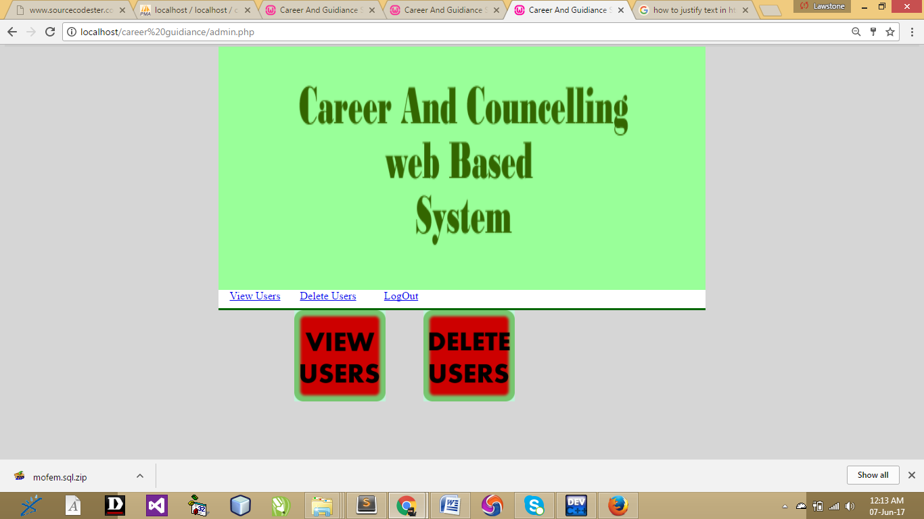
Figure 4.1: Admin menu page: This page is used to monitor the student career data.
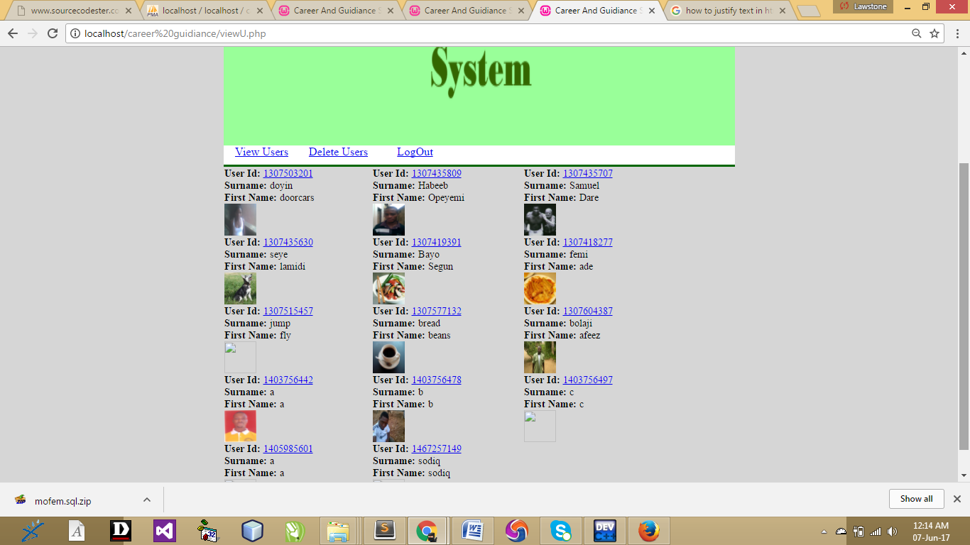
Figure 4.2: List of users page: This shows the list of all registered users
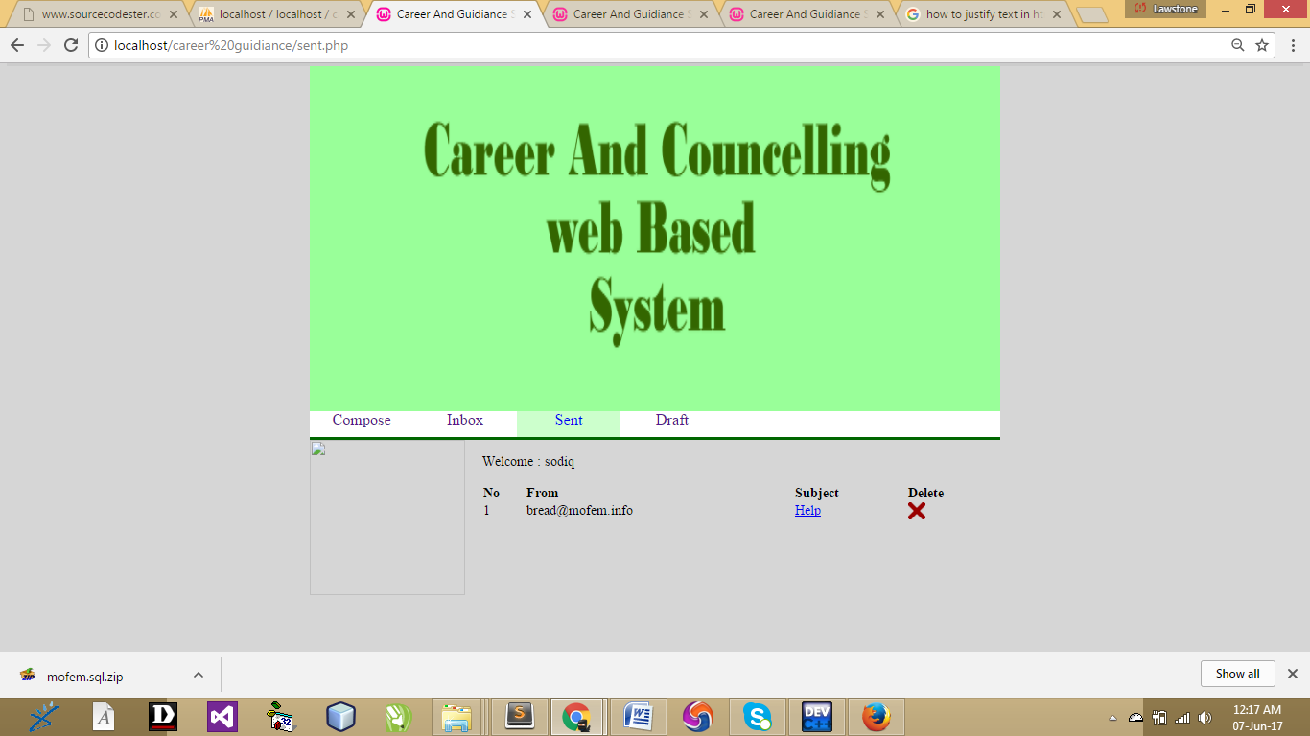
Figure 4.3: sent page: This is where to check for sent counseling
4.1.2 INPUT DESIGN
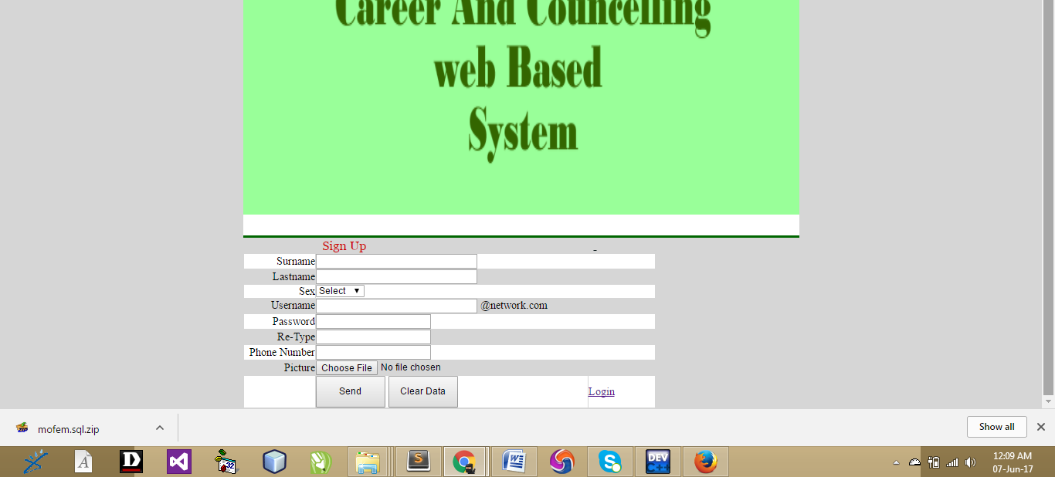
Figure 4.4 Registration page: This is the registration page, this page allows student to make their registration. New student use this page to add their information
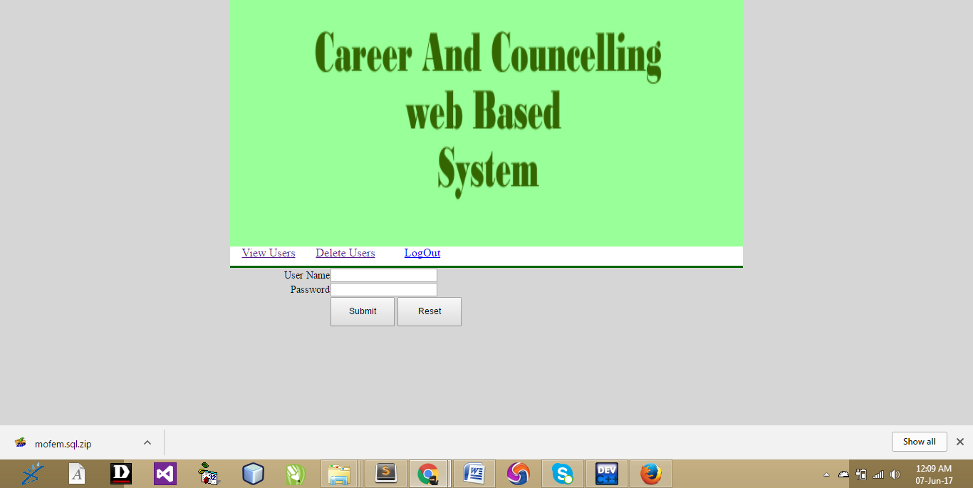
Figure 4.5: Admin page: This page is where the admin will login to get access into the admin dashboard. The admin is the master user of this web application
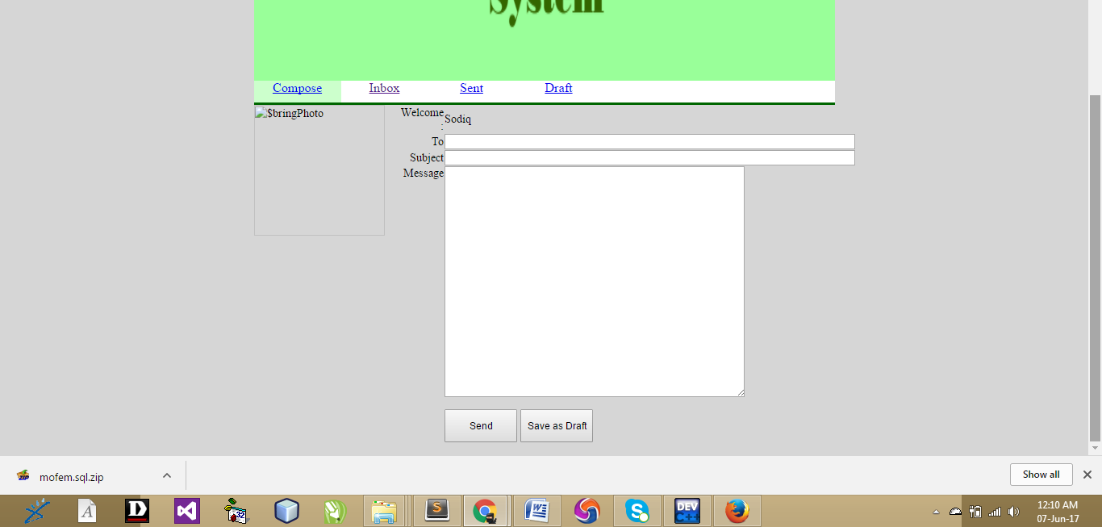
Figure 4.6: Compose page: This is where student will be composing information to the counseling mistress or master
4.1.3 DATABASE DESIGN
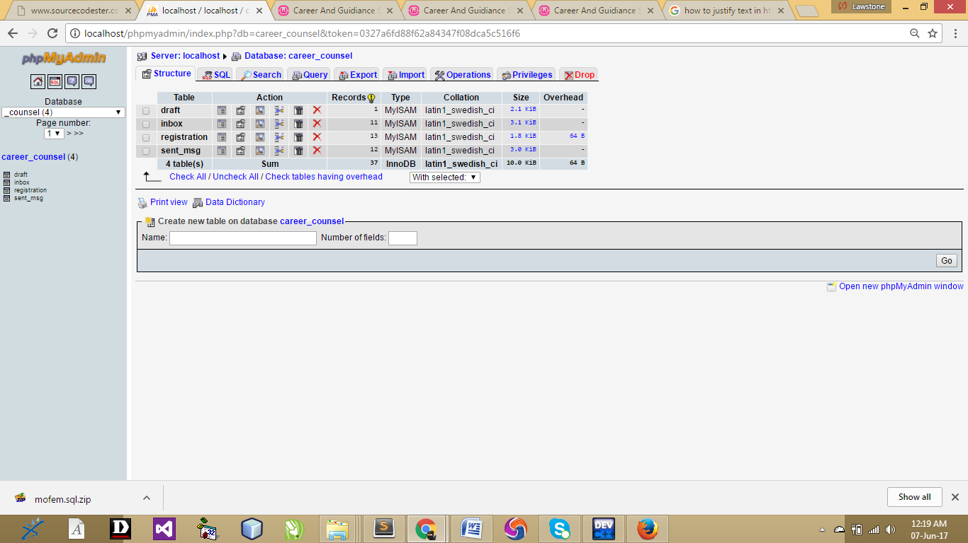
Table 4.1: Database: this is the database which handles the web based program datas
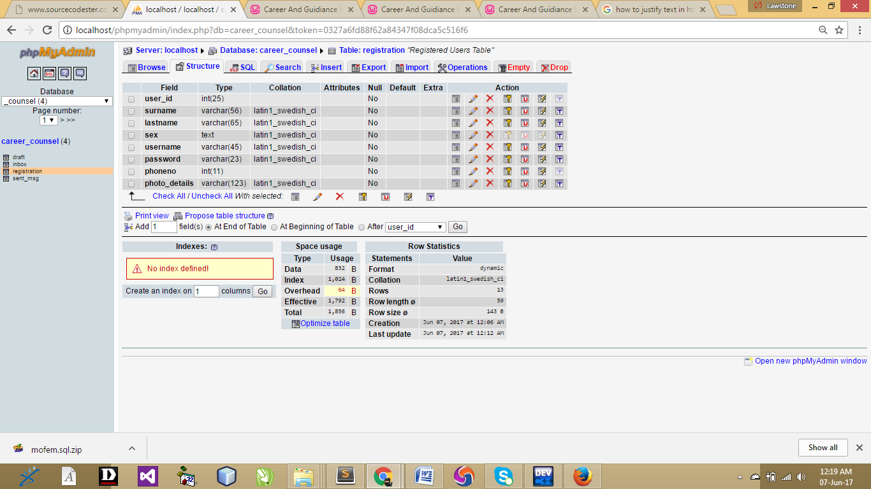
Table 4.2: Account_details: This table handles the registered students
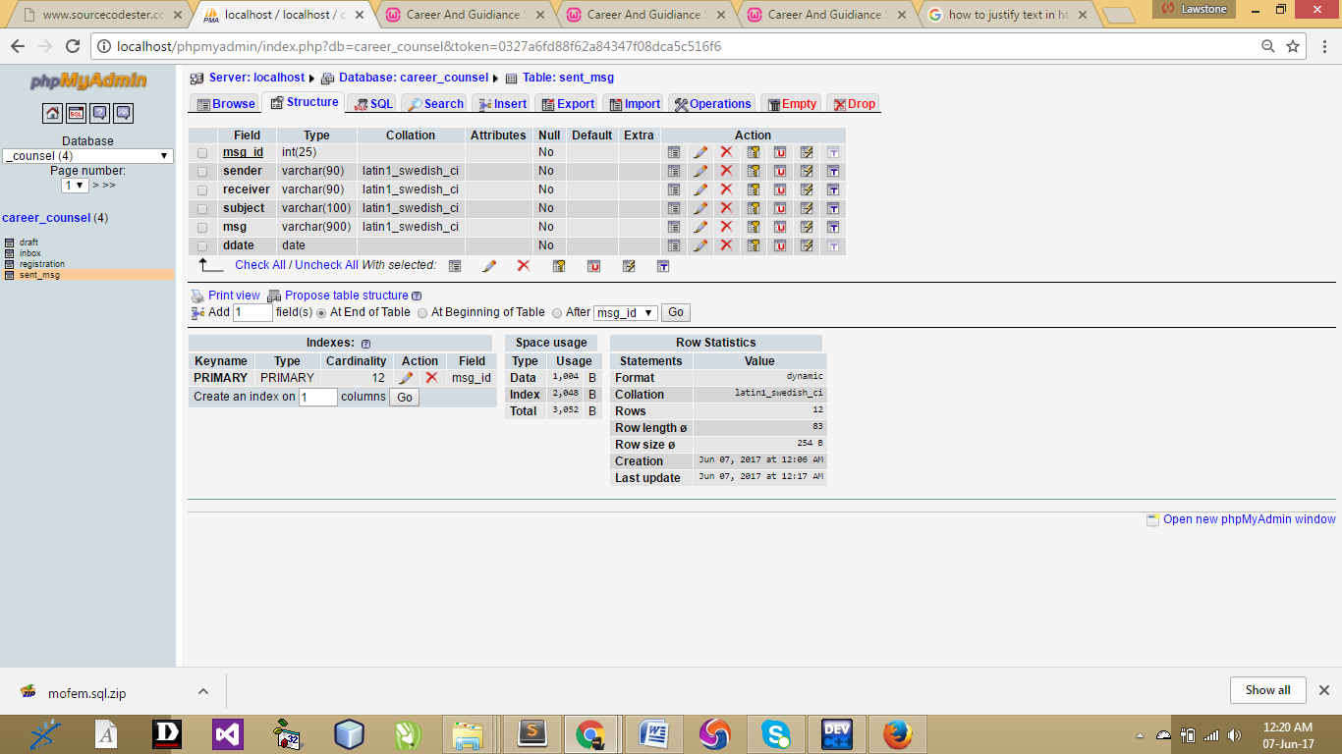
Table 4.3: sent database: This is the page where all sent counseling are shown

4.1.4 PROCEDURE DESIGN
This refers to the ways in which the proposed system will be used and the steps are as follows:
- Click start on the computer desktop
- Select all programs
- Select any browser e.gMorzilla Firefox , internet Explorer , Google Chrome e.t.c
- Type the url (Uniform Resource Locator) of the system into the address bar (localhost/career_counsel) /index.php)

4.2 SYSTEM IMPLEMENTATION
The design system depends on the capabilities and power of the computer on which the application system is installed. However, selecting a choice of application support (Hardware and Software) depends much on;
- How readily the user is to interfere with the computer
- Cost and benefits
- Managements support for changes
Hence, choosing the appropriate hardware and software will enhance the performance of the system. A most important requirement on which the running of the program basically depends on is the provision of internet facility. So any system that must run this program must be internet ready.

4.2.1 CHOICE OF PROGRAMMING LANGUAGE
The programming language used in the proposed system is php. PHP meaning (PHP Hypertext Preprocessor) is a server-side programming language. It is an open source server-side scripting language that has taken web-based development to a new level of sophistication. The PHP scripting engine is well optimized for the response times needed on web applications, it can even be part of the web server itself improving the throughput even more.
If it were only a matter of improving the speed of the scripts, then PHP will be one of many solutions. But there is more to the PHP equation than that. There is the simplicity and robustness of the language and the scripting engine. There is the connectivity to an ever increasing number of database servers, the shorter development cycles and the ease (encouraged by the syntaxes and constructs) of creating modular and reusable components.

4.2.2 HARDWARE SUPPORT
The hardware that is required in the successful completion of this project includes monitor, CPU, keyboard, mouse, printer and an uninterrupted power supply (UPS) and an internet access.
- An appropriate hard disk storage of at least 120 GB (for the dynamically expandable database)
- A minimum of 1.0 GHz processor
- Random access memory (RAM) of at least 1 GB
- An effective display unit (VGA monitor)
- A suitable printer
- Standard input devices such as keyboard, mouse, etc.
- CD-ROM drive or DVD-ROM drive (since the installation would be made through this medium)
- An uninterrupted power supply (UPS) unit (to prevent abrupt interruption due to power failure)
- A network modem (for internet connection).

4.2.3 SOFTWARE SUPPORT
The software required are basically any web browser (internet explorer, Firefox and the likes), WampServer and a network service, be it wired or wireless.
- A network operating system windows NT from Microsoft, Novell Netware.
- A DBM either PhpMyAdmin
- MySQL as the query language to query the database.
- Wambserver

4.2.4 IMPLEMENTATION TECHNIQUES
The system will be implemented using the parallel approach. This approach is considered because it ensures that the new system is tested along side with the old system to ensure the effectiveness and efficiency of the system.

4.3 SYSTEM DOCUMENTATION
It has to do with the installation and usage of the new system.
After the program has been well tested with input that the output has already been known, the next is to install the software in to the computer system for use.
The process of installing are been stated below
- Insert the CD into the system through the CD-ROM after the computer is switch on
- Locate the CD drive directory in my computer and click it to open
- After open, locate setup.exe, and then click to install the program by following the necessary step in installing the program.
- Ensure full installing of the software for effective operation of the system.
After the program has been fully install. The next thing is to locate the package install to put it into operation, to locate the package for expiration purpose the following step are to be taking
v. Click on start menu from task bar. Then select all program
From the display sub option, select by locating the software installed named temperament/ personality check to load the software.

4.3.1 PROGRAM DOCUMENTATION
- HOME
- COMPOSE
- DRAFT COUNSEL
- INBOX COUNSEL
- ADMIN
- DELETE COUNSEL
- READ COUNSEL
- REGISTER
4.3.2 OPERATING THE SYSTEM
- Click on the start button
- Click on control panel
- Click add/remove program
After the configuration, the folder called career_counsel will be created in the local disk.

4.3.3 MAINTAINING OF THE SYSTEM
This refers to the changes that have to be, made to complete systems after having been delivered. This project takes care of two types of maintenance these are:
- Adaptive maintenance and
- Perfective maintenance
Adaptive Maintenance: This refers to the type of maintenance which will be done to the system to make it adjust to any changes occurring to it. An example of adaptive maintenance is the yearly updating of the customers database to change account code in database.
Corrective Maintenance: This is a type of maintenance which takes care of some parts of the system which have been omitted in the initial design. The need for this arises as the system is being put into use over a period of time.

CHAPTER FIVE

CONCLUSION AND RECOMMENDATION
5.1 SUMMARY
Counselling is the service offered to the individual who is under going a problem and needs professional help to overcome it. The problem keeps him disturbed high strung and under tension and unless solved his development is hampered or stunted. Counseling therefore is a more specialized service requiring training in personality development and handling exceptional groups of individuals. According to Willey and Andrew Counseling involves two individuals one skeeking help and other a professionally trained person helped solved problems to orient and direct him to words a goals

5.2 CONCLUSION
The significance of career guidance in tertiary institution contexts from two perspectives, (i) the needs of students, and (ii) development of the university. For students, career planning can help them set personal goals and decide upon current and future directions. Such career guidance is helpful to them in overcoming any misunderstandings in choosing careers, in selecting their study paths, and in identifying their potential strengths to enhance their competitiveness for positions. Effective career guidance provides guidelines with a long-term vision for career planning, from which students can benefit by realizing their true potential in life. For tertiary institution, career guidance can help promote necessary reforms in teaching and can improve employment rates for their graduates, thus enhancing the reputation of a university. Solving the problem of employment is not only related to university students and their families, but also to the universities’ reputations, and even to the country's politics, construction of the economy, and maintaining a harmonious society.

5.3 RECOMMENDATION
In general terms, current research and practice in career guidance and counseling in Nigeria remains at an early stage of development, lacking a sound basis in theory, still learning from foreign experiences, and still drawing upon Western methods to a large extent. However, through day-to-day experiences in those institutions where dedicated practitioners are now designing and implementing innovative models, rapid progress is being made and is achieving some positive results. I recommend that other student should make more research on this project work and to have more research on new programming languages

REFERENCES
Abdullahi, O.E., (2013). Towards improving the Nigeria senior secondary school students performance in the joint admissions and matriculation board examinations (JAMB). J. Sociol. Educ. Africa, Vol. 8.
Adejumo, G.O., Adeusi, S.O. and Olowookere, E.I.(2013). Psychological Test Usage Among Secondary School Counsellors in Nigeria.
Adedipe, V. O.,(2012). “The adolescent problem behaviour (ii)” Saturday Tribune, October14th.
Aluede, Adomeh, & Afen-Akpaida (2014) discussed “the overreliance on textbooks from the USA and the need for school counselors in Nigeria”
Amahala, B. M. (2015). The Teacher in the Classroom. In Ukeje, B. O. (Ed) Foundations of Education. Benin-City: Ethiope Publishing. pp. 229-252.
Arinza, B.(2013). “A Contingency Model of DSS Development Methodology’’. Journal of MIS. 15: 503-522.
Blustein, D. (2016). “A Context-Rich Perspective of Career Exploration Across the Life Roles”. The Career Development Quarterly. 45:260-274.
Bonczek R.H C.W Holsapple and A.B Whinston, (2014). “The Evolving Roles in Decision Support Systems” Decision Sciences, 11
Borgen W. and Amundson, N, (2013). “Youth Unemployment and the Transition from High School”. Educational and Vocational Guidance. 24:32-43.
Council of the European Union. (2014). “Draft Resolution of the Council on the Representatives of the Governments of the Members State meeting within the Council on Strengthening Policies, Systems and Practices in their field of Guidance throughout life in Europe”. CEU: Brussels, Belgium.
DfES (2013).”Information, Advice and Guidance for Adults. Towards a National Policy Framework: Discussion Document”. DfES:Sheffeld.
Gorry, G.A. and M.S. Scott-Morton. (2013). “A Framework for Management Information Systems”. Sloan Mangement Review. 13.
Hatch, P. (2009) “Professional school counselors ideally implement a school counseling program that promotes and enhances student achievement”
Herr, E2000. (2013) Preparation for the World of Work. Paper presented at International symposium for Career development and Public Policy, Ottawa, Ca. Available online:http//www.contactpoint.ca.
Hiebert, B. and Benzanson, L. (2014). “On the Horizon: Important Future Directions for Career Development”. In: B. Hiebert (ed). Exemplary Career Development Programs & Practices: The Best from Canada. Erric/CASS: Greensboro, NC.
Mr. Rakesh Mathur in (1992) in Hindi. .” It was brand within a brand and First with a Hindi newspaper.”
Rawul, H. (2012) “Elementary school counselors provide academic, career, college access, and personal and social competencies and planning to all students,”

APPENDIX 1 : SYSTEM FLOWCHART
Start
Login
New User
Admin
Stop

APPENDIX 2: LOGIN FLOWCHART
Start
Input username & password
Select Option
Is option submit?
Display Profile
Stop

No
Yes
Yes

APPENDIX 3: SIGN UP FLOWCHART
Start
Input details
Select Option
Is option submit ?
Registration saved successfully

Stop

No
Yes

APPENDIX 4: ADMIN FLOWCHART
Start
Input username & password
Is Username & password correct?
Display admin page
Stop

No

Yes

APPENDIX 5 :PROGRAM SOURCE CODE
ADMIN
<!DOCTYPE html PUBLIC "-//W3C//DTD XHTML 1.0 Transitional//EN" "http://www.w3.org/TR/xhtml1/DTD/xhtml1-transitional.dtd">
<html xmlns="http://www.w3.org/1999/xhtml">
<head>
<meta http-equiv="Content-Type" content="text/html; charset=iso-8859-1" />
<title>Career And Guidiance System</title>
<link href="css/css.css" rel="stylesheet" type="text/css" />
<script src="Scripts/swfobject_modified.js" type="text/javascript"></script>
<script type="text/JavaScript">
<!--
function MM_preloadImages() { //v3.0
var d=document; if(d.images){ if(!d.MM_p) d.MM_p=new Array();
var i,j=d.MM_p.length,a=MM_preloadImages.arguments; for(i=0; i<a.length; i++)
if (a[i].indexOf("#")!=0){ d.MM_p[j]=new Image; d.MM_p[j++].src=a[i];}}
}
//-->
</script>
</head>

<body class="body">
<div class="container">
<div class="banner"><img src="images/social_engine_banner.png" width="800" height="400" /></div>
<div class="main_content">
<div class="menu">
<div class="menu_links"><a href="viewU.php">View Users</a></div>
<div class="menu_links"><a href="deleteP.php">Delete Users</a></div>
<div class="menu_links"><a href="index.php">LogOut</a> </div>
</div>
<div class="body_content">
<div class="main_wall">&nbsp;&nbsp;&nbsp;&nbsp;&nbsp;&nbsp;&nbsp;&nbsp;&nbsp;&nbsp;&nbsp;&nbsp;&nbsp;&nbsp;&nbsp;&nbsp;&nbsp;&nbsp;&nbsp;&nbsp;&nbsp;&nbsp;&nbsp;&nbsp;&nbsp;&nbsp;&nbsp;&nbsp;<a href="viewU.php"><img src="images/vuser.png" width="150" height="150" /></a>&nbsp;&nbsp;&nbsp;&nbsp;&nbsp;&nbsp;&nbsp;&nbsp;&nbsp;&nbsp;&nbsp;&nbsp;&nbsp;&nbsp;<a href="deleteP.php"><img src="images/duser.png" width="150" height="150" /></a>
</div>
</div>
</div>
</div>
<script type="text/javascript">
swfobject.registerObject("FlashID");
</script>
</body>
</html>
ADMIN LOGIN
<!DOCTYPE html PUBLIC "-//W3C//DTD XHTML 1.0 Transitional//EN" "http://www.w3.org/TR/xhtml1/DTD/xhtml1-transitional.dtd">
<html xmlns="http://www.w3.org/1999/xhtml">
<head>
<meta http-equiv="Content-Type" content="text/html; charset=iso-8859-1" />
<title>Career And Guidiance System</title>
<link href="css/css.css" rel="stylesheet" type="text/css" />
<script src="Scripts/swfobject_modified.js" type="text/javascript"></script>
<script type="text/JavaScript">
<!--
function MM_preloadImages() { //v3.0
var d=document; if(d.images){ if(!d.MM_p) d.MM_p=new Array();
var i,j=d.MM_p.length,a=MM_preloadImages.arguments; for(i=0; i<a.length; i++)
if (a[i].indexOf("#")!=0){ d.MM_p[j]=new Image; d.MM_p[j++].src=a[i];}}
}
//-->
</script>
</head>

<body class="body">
<div class="container">
<div class="banner"><img src="images/social_engine_banner.png" width="800" height="400" /></div>
<div class="main_content">
<div class="menu">
<div class="menu_links"><a href="login.php">View Users</a></div>
<div class="menu_links"><a href="registration.php">Delete Users</a></div>
<div class="menu_links"><a href="index.php">LogOut</a> </div>
</div>
<div class="body_content">
<div class="main_wall"><form action="adminP.php" method="post"><table width="600" border="0">
<tr>
<td style="text-align:right">User Name</td>
<td><label for="textfield2"></label>
<input type="text" name="uName" id="textfield2" /></td>
</tr>
<tr>
<td style="text-align:right">Password</td>
<td><label for="textfield"></label>
<input type="password" name="pWord" id="textfield" /></td>
</tr>
<tr>
<td>&nbsp;</td>
<td><input name="button" type="submit" class="button" id="button" value="Submit" />
<input name="button2" type="reset" class="button" id="button2" value="Reset" /></td>
</tr>
</table>
</form></div>
</div>
</div>
</div>
<script type="text/javascript">
swfobject.registerObject("FlashID");
</script>
</body>
</html>
COMPOSE
<?php session_start(); ?>
<?php if (!isset($_SESSION['username'])){
die('<a href="login.php">Please Login</a>');
}
?>
<!DOCTYPE html PUBLIC "-//W3C//DTD XHTML 1.0 Transitional//EN" "http://www.w3.org/TR/xhtml1/DTD/xhtml1-transitional.dtd">
<html xmlns="http://www.w3.org/1999/xhtml">
<head>
<meta http-equiv="Content-Type" content="text/html; charset=iso-8859-1" />
<title>Career And Guidiance System</title>
<link href="css/css.css" rel="stylesheet" type="text/css" />
<script src="Scripts/swfobject_modified.js" type="text/javascript"></script>
</head>

<body class="body">
<div class="container">
<div class="banner"><img src="images/social_engine_banner.png" width="800" height="400" /></div>
<div class="main_content">
<div class="menu">
<div style="background-color:#CCFFCC" class="menu_links"><a href="#">Compose</a></div>
<div class="menu_links"><a href="inbox.php">Inbox</a> </div>
<div class="menu_links"><a href="sent.php">Sent</a></div>
<div class="menu_links"><a href="draft.php">Draft</a></div>
</div>
<div class="body_content">
<div class="photo_wall">
<div class="photo"><?php
$bringPhoto = $_SESSION['photo_details'];
echo'<img src="upload/'.$bringPhoto.'" width="180" height="180" align="left" alt=$bringPhoto>'; ?></div>
</div>
<div class="main_wall">
<form id="compose" name="compose" method="post" action="compose_process.php">
<table width="594" border="0">
<tr>
<td align="right">Welcome :</td>
<td><?php echo ucfirst($_SESSION['surname']); ?></td>
</tr>
<tr>
<td align="right" width="104">To</td>
<td width="480"><input name="receiver" type="text" size="80" /></td>
</tr>
<tr>
<td align="right">Subject</td>
<td><input name="subject" type="text" size="80" /></td>
</tr>
<tr>
<td align="right" valign="top">Message</td>
<td><textarea name="msg" cols="50" rows="20"></textarea></td>
</tr>
<tr>
<td>&nbsp;</td>
<td align="left"><p>
<input name="Submit" type="submit" class="button" value="Send" />
<input name="Draft" type="submit" class="button" onclick="" value="Save as Draft"/>
</p>
</td>
</tr>
</table>
</form>
</div>
</div>
</div>
</div>
<script type="text/javascript">
swfobject.registerObject("FlashID");
</script>
</body>
</html>
COMPOSE_PROCESS
<?php
session_start();
require("connect.php");
//
$sender = $_SESSION['username'];
$msg_id = mktime();
$receiver =$_POST['receiver'];
$subject =$_POST['subject'];
$msg =$_POST['msg'];
//
if(isset($_POST['Submit'])){
$confirm=mysql_query("SELECT *
FROM registration
WHERE username LIKE '$receiver'") or die(mysql_error());
while($check=mysql_fetch_array($confirm)){
$receiverPerson=$check['username'];
}
if($receiverPerson==$receiver){
$sequel_inbox = "INSERT INTO inbox(`msg_id`,`sender`, `receiver`, `subject`, `msg`)VALUES ('$msg_id','$sender','$receiver','$subject','$msg')";
mysql_query($sequel_inbox) or die(mysql_error());
$sequel_sent = "INSERT INTO sent_msg(`msg_id`,`sender`, `receiver`, `subject`, `msg`)VALUES ('$msg_id','$sender','$receiver','$subject','$msg')";
mysql_query($sequel_sent) or die(mysql_error());
echo "Message Sent Successfully. "."Back to "."<a href ='compose.php'>Compose</a>"."Another Message ";
}else{
echo "The Username You Specified Is Not A Valid Address.";
}
} // end of the first if statement
// checks if the draft button is clicked and saves the content into the draft table
if(isset($_POST['Draft'])){
$draftSql="INSERT INTO draft(`msg_id`,`sender`, `receiver`, `subject`, `msg`, `date`)VALUES('$msg_id','$sender','$receiver','$subject','$msg', Now())";
mysql_query($draftSql) or die(mysql_error());
echo "Draft Saved Successfully. "."Back to "."<a href ='compose.php'>Compose</a>"." Another Message.";
}
?>

