DETERMINATION OF RELATIVE PRESSURE FROM WIND DIRECTION MEASUREMENTS IN A TROPICAL LOCATION, ILORIN, KWARA STATE, NIGERIA

BY

MUSTAPHA BARAKAT MOROMOKE
HND/23/SLT/FT/0678

SUBMITTED TO:
THE DEPARTMENT OF SCIENCE LABORATORY TECHNOLOGY, INSTITUTE OF APPLIED SCIENCES (IAS) KWARA STATE POLYTECHNIC, ILORIN

IN PARTIAL FULFILLMENT OF THE REQUIREMENTS FOR THE AWARD OF HIGHER NATIONAL DIPLOMA (HND) IN SCIENCE LABORATORY TECHNOLOGY
PHYSICS AND ELECTRONICS UNIT

JULY, 2025
CERTIFICATION
This is to certify that this project titled DETERMINATION OF RELATIVE PRESSURE FROM WIND DIRECTION MEASUREMENTS IN A TROPICAL LOCATION ILORIN, KWARA STATE, NIGERIA was carried out by MUSTAPHA BARAKAT MOROMOKE with Matriculation number HND/23/SLT/FT/0678 and submitted to Department of Science Laboratory Technology (SLT) Physics and Electronics unit, Institute of Applied Science (IAS), Kwara State Polytechnic, Ilorin has been read and approved as a partial fulfilment of the requirements for the award of Higher National Diploma in science Laboratory Technology.

______________________________ ____________________
MR. USMAN ABDULKAREEM DATE
PROJECT SUPERVISOR

____________________________________ ____________________
MR. SALAHU BASHIR DATE
(H.O.U PHYSICS AND ELECTRONICS)

______________________________ ____________________
DR. USMAN ABDULKAREEM DATE
H.O.D

______________________________ ____________________
EXTERNAL SUPERVISOR DATE

DEDICATION
This project research is dedicated to God Almighty and the giver of life for seeing me through my HIGHER NATIONAL DIPLOMA I also dedicate this project to Almighty Allah the author and the finisher of my life to and to my beloved parents, Siblings, friends and also to people who have contributed In one or the other to enable me accomplish this project work.
ACKNOWLEDGEMENT
My appreciation goes to Almighty Allah the omnipotent and omniscience all appreciation and adorable be unto him for his guidance and protection throughout my life and academic ALLIAMDULILIA My indebted gratitude to my irreplaceable loving and Demi Gold MR AND MRS MUSTAPHA none of this world have been possible without the financial advices and spiritual support through prayers.
My unalloyed appreciation goes to my supervisor DR USMAN ABDULKAREEM for his understanding contribution time and normal support for the successful completion to this project and my gratitude also goes to the HOD of the department of physics and Electronics unit DR USMAN ABDULKAREEM May God bless you and your family. A Big thanks to my life sustainer My brother to the one who motivate and whom fraternal support is incomparable in person of MUSTAPHA SODIQ OLAMILEKAN (OLAMALL) and without the experience who showed me tough love, support and so much more that has helped me succeed in life toward the program I am externally grateful to my sister and brother MUSTAPHA BALIQEES DAMILOLA and MUSTAPHA ADAM AKINKUNMI I’m forever grateful for your support And my one strenuous a big shout to My Man My Rare Gem M! Obsession whom fraternal support is incomparable in person AYODELE CHRISTOPHER GBOYEGA (MANCHY) thanks you for standing by through this journey I pray God guide you through the spheres of life thanks for being the part of the journey To my cute and dearest school daddy OLANIYAN ABDULAKEEM AYOMIDE(KYMGOLD) and to my dearest Twins sis who always support me YUSUF ANUOLUWAPO OLUWASEUN and FASASI AYISAT ABIMBOLA and to my lovely squad who always being there for me ATOKE,SIMISOLA,ADUNNI(FAIR AND SQUARE) thanks for being the part of the journey which of your favor will I deny I’m forever indebted to my uncles and other family members with their effort and encouragement through my education schemes and without the experience and support from my friends and villa mate which they all become a family friends through this journey And all my family friends, Mustapha,Saheed,Mariam,jamal,Ewatomilola Janet,Owo baba yomola, yemisi(Neigbour),Aishat,Ewaola,Adetayo,Adewale,promise,Saddam,Adefresh thanks you all To any one who ever anything positive to me or thought me something you meant something to me alot. Appreciation goes back to Allah because without God I would not be able to successful completion of this project

ABSTRACT
Relative pressure is the pressure within the atmosphere of the Earth. Relative pressure is pressure (P_{R}) relative to the respective atmospheric pressure (air pressure / ambient pressure). The direction and speed of winds play an important role in the occurrence of pollutions and dust storm as well as location placement for the establishment of industries and the expansion of cities. The measurement of the relative pressure (P_{R)} and wind direction W_{D} are highly significant for various applications of hydro and agro–climatological researches. This project work was carried out at a tropical location (Kwara state polytechnic) in Ilorin, Kwara state. The instrument used for this research are barometer and wind vane. The measurements were taken for a period of one week (25th April – 1st May, 2022). The data were recorded at every 30 minutes and were reduced to hourly measurement. For the period under consideration, the highest value of relative pressure for this research is 979 while the lowest value for this research is 972. The parametric equation obtain in this research was found to be: P_{Rp}= 0.006 (W_{D}) + 974.918.

TABLE OF CONTENTS
Page
Title Page i
Certification ii
Dedication iii
Acknowledgement iv
Abstract v
Table of Contents vi
List of Figures 24-30
CHAPTER ONE: INTRODUCTION

1.1 General Background 1

1.2 Relevance of relative pressure 1-2

1.3 Wind direction 2

1.4 Statement of the problem 2

1.5 Objectives of the research 3

1.6 Justification for the research 3

1.7 Expected Contribution to Knowledge 3

CHAPTER TWO: LITERATURE REVIEW 4-6
CHAPTER THREE: THEORETICAL BACKGROUND
3.1 Relative pressure 7-9
3.2 Wind direction 9-11
3.3 Estimation for P_{R} 11

3.3.1 Equations for relative pressure determination 11

3.4 Statistical Analysis 11-12

CHAPTER FOUR: METHODOLOGY

4.1 Pre-Field Experimental Work 13-14

4.2 Site Description 14-15

4.3 Field Measurements 15

4.4 Barometer and Wind Vane 15

4.5 Data Acquisition and Reduction 16

4.5.1 Data logging of the sample data 16

4.5.2 Pre-processing of the raw data 17

CHAPTER FIVE: RESULTS AND DISCUSSION

5.1 Characteristics of relative pressure and wind direction 18-27

5.2 Determination of relative pressure from wind direction 28-30

CHAPTER SIX: SUMMARY AND CONCLUSIONS

6.1 Summary and Conclusions 31

References 32-33

CHAPTER ONE

INTRODUCTION
  - GENERAL BACKGROUND
Pressure is defined as a normal force exerted by a fluid per unit area. We speak of pressure only when we deal with a gas or a liquid. The counterpart of pressure in solids is normal stress. Since pressure is defined as force per unit area, it has the unit of Newtons per square meter (N/m²), which is also known as a Pascal (Pa).The pressure unit Pascal is too small for pressures encountered in practice. Therefore, its multiples kilopascal (1 kPa 103 Pa) and megapascal (1 MPa = 106 Pa) are commonly used (Zhu et al., 2004).
Relative pressure is the atmospheric pressure corrected to sea-level conditions. To compare pressure conditions from one location to another, meteorologists correct the measured pressure (referred to as absolute pressure) to sea-level conditions. Because the air pressure decreases as you rise in altitude, the sea-level corrected pressure (the pressure your location would be at if located at sea-level) is higher than your measured pressure if you live above sea-level and lower than your measured pressure if you live below sea-level (NCEES, 2011).
  - RELEVANCE OF RELATIVE PRESSURE
Across various industries, measuring the pressure of a substance is an integral part of the manufacturing process. Obtaining accurate and meaningful data is vital in determining the quality and consistency of the product (Dutton, 2014). In a pragmatic way, meteorology is related only to processes that take place in-situ in the atmosphere, while other sciences can investigate processes and reactions in the laboratory. This underlines the specific character of meteorology, i.e., a science that investigates an open system with a great number of atmospheric influences operating at all times but with changing intensity (Bradt, 2004).
1.3 WIND DIRECTION
The direction and speed of winds play an important role in the occurrence of pollutions and dust storm as well as location placement for the establishment of industries and the expansion of cities (Panofsky and Brie, 1965).
Wind-rose is a typical meteorological tool which can give an estimate of prominent flow directions and ranges for wind velocity naturally available at a wind monitoring station. It is important to know the measurement height for a given wind speed because of the variation of wind speed with height. It is also desirable to know the exposure of a particular location to the prevailing winds because nearby obstacles such as trees and buildings can reduce the apparent wind speed (Panofsky and Brie, 1965).
Direction of wind is an important factor in the sitting of a wind energy conversion system (WECS). Information about the distribution of wind speeds and the frequency of the varying wind directions in a combined form can be presented in the wind roses (Petrson et al., 1997).
1.4 STATEMENT OF THE PROBLEM
Relative pressure is the pressure within the atmosphere of the Earth. It is however, necessary to obtain the relative pressure from routine measurement as it involves changes in the atmospheric condition. This study, therefore, intends to obtain relative pressure from values of wind direction measured data.

1.5 OBJECTIVES OF THE STUDY
The specific objectives of this study are to:
- Measure relative pressure and wind direction
- Observe the diurnal variation of relative pressure and wind direction
- Obtain a parametric equation of relative pressure from wind direction
- Validate the parametric equation obtained in (iii) above.
1.6 JUSTIFICATION FOR THE RESEARCH
Determinationof Relative Pressure from Wind direction,such as we have in this study, is very useful in estimating Relative Pressure without necessarily passing through the experimental ways of measuring the Relative Pressure.
1.7 EXPECTED CONTRIBUTION TO KNOWLEDGE
The results of this study will provide an empirical equation that can be used to determine the Relative Pressure from the routinely measured wind direction data. This directly affects evapotranspiration and will be useful to agro-meteorologists, climate modeling, and weather forecasting.

CHAPTER TWO
LITERATURE REVIEW
The atmosphere that surrounds Earth has weight and pushes down on anything below it. The weight of air above a given area on Earth’s surface is called atmospheric pressure. It is an important factor influencing Earth’s weather and climate. Atmospheric pressure can be measured with an instrument called a barometer and thus is also known as barometric pressure. It is usually measured in millibars (mb) or kilopascals (kPa) (IBWM, 2006).
Atmospheric pressure changes at different altitudes. Pressure is greatest at sea level and decreases with height. Air is heaviest at sea level because the air molecules are compressed by the weight of the air above them. Air becomes lighter farther away from Earth’s surface as the air molecules become separated by more space. As the weight of the air decreases, so does the air pressure. At sea level, atmospheric pressure is about 1,000 mb (100 kPa). At the top of Mt. Everest—a height of 29,032 feet (8.85 kilometers) pressure drops to about 300 mb (30 kPa). The air is so thin at an altitude of 31 miles (50 kilometers) that it exerts a pressure of only 1 mb (0.1 kPa). Even at a height of 5,000 feet (1,500 meters), the atmospheric pressure is low enough to produce mountain (altitude) sickness and other severe physical problems in some people (IBWM, 2006).
Uneven heating by the Sun causes differences in Earth’s atmospheric pressure. These pressure differences affect the motion of the atmosphere, as air moves from areas of high pressure to areas of low pressure. The result is wind, which has a great effect on weather and climate.
Meteorologists monitor changes in pressure as one indication of upcoming weather changes. Falling pressure generally indicates that stormy weather is on the way. Rising pressure usually indicates the approach or continuation of fair weather. On weather maps, points of equal pressure are connected by curved lines called isobars.
Wind direction is reported by the direction from which it originates. For example, a northerly wind blows from the north to the south (Kentley, 2005). Wind direction is usually reported in cardinal directions or in azimuth degrees. Wind direction is measured in degrees clockwise from due north. Consequently, a wind blowing from the north has a wind direction of 0° (360°); a wind blowing from the east has a wind direction of 90°; a wind blowing from the south has a wind direction of 180°; and a wind blowing from the west has a wind direction of 270°.
In general, wind directions are measured in units from 0° to 360°, but can alternatively be expressed from -180° to 180°. Winds are named for the direction from which they come, followed by the suffix -erly. For example, winds from the north are called "northerly winds" (north + -erly) (Vishwakarma, 2009).
One of the types of natural disasters that result in damage each year in many arid areas of the world is dust and sand storms and severe winds (Omidvar, 2005). Dust and sand storms contain small dust particles, sometimes going up to kilometers in the sky (Lashkari, 2006). In general, there are four types of dust storms including severe dust storms, dust storms, blowing dust, dust particles floating in the air (Wang et al., 2005). Large storms occur when a prolonged drought occurs and the soil surface is completely dry, and the wind blows at a considerable speed (Azimzade et al., 2001). Another important factor in dust generation is the absence of humidity. When there is enough humidity in the air, wind generates precipitation and thunderstorms, while in dry conditions, wind blows lead to dust storms (Alijani, 1996).
Studies of wind field characteristics have increased as wind affects heat and moisture transfer between the earth's surface and the atmosphere, this study employs wind direction analysis. The objectives are to describe and evaluate seasonal means and inter-annual variability of surface wind speed and direction. Like all other meteorological data, wind recordings have specific features that must be taken into account by the use and interpretation of them. It is well known that wind data characterize first of all the measurement site. They depend not only on the properties of the landscape but also on the particular location of the station in the landscape (Keevallik et al., 2007).

CHAPTER THREE
3.0 THEORITICAL BACKGROUND
3.1 RELATIVE PRESSURE
The difference between the pressure of a gas or vapor and a fixed reference pressure, especially atmospheric pressure. Pressure is the amount of force applied at right angles to the surface of an object per unit area. The symbol for it is "p" or P. The IUPAC recommendation for pressure is a lower-case p. However, upper-case P is widely used. The usage of P vs p depends upon the field in which one is working, on the nearby presence of other symbols for quantities such as power and momentum, and on writing style (IBWM, 2006).
Mathematically:

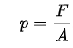
Where:
Ƥis the pressure

Fis the magnitude of the normal force
A is the area of the surface in contact.
Pressure is a scalar quantity. It relates the vector area element (a vector normal to the surface) with the normal force acting on it. The pressure is the scalar proportionality constant that relates the two normal vectors (IBWM, 2006).
Relative pressure is the atmospheric pressure corrected to sea-level conditions (IBWM, 2006).To compare pressure conditions from one location to another, meteorologists correct the measured pressure (referred to as absolute pressure) to sea-level conditions. Because the air pressure decreases as you rise in altitude, the sea-level corrected pressure (the pressure your location would be at if located at sea-level) is higher than your measured pressure if you live above sea-level and lower than your measured pressure if you live below sea-level (wikipedia.com).
Relative pressure is pressure as compared to that of the surrounding air. As air pressure depends on the height above sea level and the weather, it varies depending on ambient conditions. Most pressure measurements in the process industry refer to relative rather than absolute pressure (wikipedia.com).
Unit
The SI unit for pressure is the pascal (Pa), equal to one newton per square metre (N/m², or kg·m⁻¹·s⁻²). This name for the unit was added in 1971; before that, pressure in SI was expressed simply in newtons per square metre.
Other units of pressure, such as pounds per square inch (lbf/in²) and bar, are also in common use. The CGS unit of pressure is the barye (Ba), equal to 1 dyn·cm⁻², or 0.1 Pa. Pressure is sometimes expressed in grams-force or kilograms-force per square centimetre (g/cm² or kg/cm²) and the like without properly identifying the force units. But using the names kilogram, gram, kilogram-force, or gram-force (or their symbols) as units of force is expressly forbidden in SI. The technical atmosphere (symbol: at) is 1 kgf/cm² (98.0665 kPa, or 14.223 psi) (IBWM, 2006).
Since a system under pressure has the potential to perform work on its surroundings, pressure is a measure of potential energy stored per unit volume. It is therefore related to energy density and may be expressed in units such as joules per cubic metre (J/m³, which is equal to Pa).

Applications
- Hydraulic brakes
- Artesian well
- Blood pressure
- Hydraulic head
- Plant cell turgidity
- Pythagorean cup
3.2 WIND DIRECTION
The direction and speed of winds play an important role in the occurrence of pollutions and dust storm as well as location placement for the establishment of industries and the expansion of cities (Beaufort, 2003).
In modern power systems integration of wind energy has become one of the key issues. Wind energy is the most promising energy in the present day world. In now a day’s wind energy is fast growing among all the renewable energy sources. The chaotic behavior of wind is a great challenge to the stability and reliability of power system. Wind power forecast is helpful for unit commitment, power system operations and economic dispatch. Wind forecast depends on several factors like temperature, humidity, direction of wind among others (Beaufort, 2003).

Units
Wind direction can be expressed in two ways:
1. By direction (Sixteen point of a compass).
2. By degree (from north, measured in clockwise as N, E, S, W means 360°, 90°,
180° and 270° respectively)
Wind Rose
Wind direction is normally defined by a wind rose. Wind rose is a graphic display of the distribution of wind direction at a location during a defined period. The characteristic patterns can be presented in either tabular or graphic forms. A wind rose is a set of wind statistics that describes the frequency, direction, force, and speed. In this plot the average wind direction is shown as one of the sixteen compass points, each separated by 22.5′ measured from true north. The length of the bar for a direction indicates the percent of time the wind came from that direction. Since the direction is constantly changing, the time percentage for a compass point includes those times for wind direction at 11.25° on either side of the point. The percentage of time for a velocity is shown by the thickness of the direction bar (NIMET, 2012).
Preparation of Wind Rose
- A circle is first divided into 8, 12, or 16 sectors representing the directions of wind flow.
- The percentage of time the wind blows from each direction is determined from wind direction data.
- The data is then plotted on a circular graph as a line emanating from the center of the circle. The length of the line is scaled to the percentage obtained from the data, pointing in the given direction.
- The wind speed can be included in wind rose diagram. For this purpose, the percent of time that the wind is blowing at given speeds toward each direction needs to be determined (wikipedia.com).
3.3 DETERMINATION FOR P_{R}
In this research, the estimate is tested against the measured data set. This is subject to the same input data sets.
3.3.1 EQUATION FOR RELATIVE PRESSURE DETERMINATION
The linear regression equation, which estimates Relative Pressure from Wind Direction measurements,
P_{R}= a (W_{D}) + b
Where P_{R} is the estimated Relative Pressure, a is the slope, W_{D} is the Wind Direction, and b is the intercept.
3.4 STATISTICAL ANALYSIS
The performance of the parameterized approach was tested statistically by calculating the mean bias error (MBE) and root mean square error (RMSE). These indicators are defined respectively as:
$MBE=\frac{\sum{\left({PR}_{E}-{PR}_{M}\right)}}{n}$
$\sum{PR}$_{P} = 93701.01, $\sum{PR}$_{M} = 93715.8, n = 96
MBE = $\frac{93701.01-93715.8}{96}$
= -0.154
$RMSE=\sqrt{\frac{\sum{{\left(\left({PR}_{E}-{PR}_{M}\right)\right)}^{2}}}{n}}$
RMSE = $\sqrt{\frac{\sum{{\left(9370101-93715.8\right)}^{2}}}{96}}$
= 0.168
Where, PR_{E} and PR_{M} are the estimated and the measured mean values of Relative Pressure, respectively, and n is the total number of observations.
In general, a low RMSE and MBE are desirable, while positive MBE shows overestimation and a negative MBE indicates underestimation.

CHAPTER FOUR:

METHODOLOGY

This research work was carried out at a tropical location (Kwara state polytechnic) in Ilorin, Kwara State. The instrument used for this research are Barometer and Wind vane. The measurements were taken for a period of one week (10th– 23rdMay, 2025). The data were recorded at every 30 minutes and were reduced to hourly measurement.

The reduced data (hourly) was plotted against local standard time to show the diurnal variation of the measured data.

4.1 PRE-FIELD EXPERIMENTAL WORK

INSTALLATION OF THE BAROMETER AND WIND VANE

We installed Barometer and Wind vane, we adhere to the instructions below to test the Barometer and Wind vane function
- We inserted the battery
- We connected the Barometer and Wind vane to the appropriate connector on the junction box.
- We checked their altitude usage, to make sure it works perfectly in the location.
- We mounted it with the Barometer and Wind vane having a solar panel in it.
- We used an iron rod to mount it, the rod is of 5meter length.
- We mounted the Barometer and Wind vane which consist of solar panel at the top mounting stage.
- Then we connected the data Weather Smart Data logger to a personal computer (PC).

CHOOSING THE BEST PHOTOMETER AND THERMOMETER LOCATION

We used the following guideline to determine the best location for Barometer and Wind vane.
- We installed the Barometer and Wind vane in a location where wind flow is unobstructed by tress and nearby buildings.
- For the most accurate readings the Barometer and Wind vane should be mounted at least 4 feet (1.2m) above the roof line.
- We did this by mounting the Barometer and Wind vane on a metal rod of shout 4feet (1.2) above the roof line.
- We make sure the metal rod is properly grounded.

4.2 SITE DESCRIPTION

This research was carried out inside physics laboratory, Kwara State Polytechnic, Ilorin, Kwara State.
Kwara State Polytechnic has been in operation since 1973 with focus on technological and entrepreneurship skills. It is located in Ilorin, the capital of Kwara state. Kwara state polytechnic started with 110 pioneering students and it offer National Diploma and Higher National Diploma in courses at undergraduate levels.
Kwara state polytechnic is a Nigeria Tertiary Institution that was established in 1973 by the military Governor of Kwara state col. (David Bamigboye) after the decision of establishing a polytechnic in Kwara state was announced in 1971.
The latitude of kwara state is 8.9848⁰N while the longitude is 4.5624⁰E. The latitude and longitude can be mapped to closest address of kwara, Nigeria.
Kwara state is located in sub-locality, locality, district, kwara state of Nigeria country (Federal Republic of Nigeria Population census, 2006).

4.3 FIELD MEASUREMENTS

The Barometer and Wind vane were mounted. We used measuring tape to measured 5.2m pole above ground levelin Kwara state polytechnic, Ilorin, Kwara state.

4.4 BAROMETER AND WIND VANE
The probe or instruments used for this research for are Barometer and Wind Vane.
Measurement of Wind Direction
The instrument used for the measurement of wind is wind vane. The direction from which a wind blow is known as the windward side and towards which it bows is known as leeward side.
Wind Vane
Wind vane consists of a brass-arm, mounted on ball bearing to a vertical axis. To one side of the brass arm there is an arrowhead and on another side there are two flat vanes forming an acute angle (about 20°). The ball bearings are in bearing house where there is an oil hole. The screw below the bearing are in bearing house are tightened to a brass covering known as brass sleeve. Below the wind vane there are 4 direction arms fixed to the vertical axis by means of a brass boss. In between the direction arms there are corner indicators. The direction arms and corner indicators are tightened to the brass boss by means of knots known as check knots. The direction arms are leveled with N, S, E and W. The vertical axis is erected by means of an iron-stand (NIMET, 2012).

4.5 DATA ACQUISITION AND REDUCTION

This research work was carried out at a tropical location (Kwara state polytechnic) in Ilorin, Kwara State. The instruments used for this research are Barometer and Wind vane. The measurements were taken for a period of one week (10th– 23rdMay, 2025). The data were recorded at every 30 minutes and were reduced to hourly measurement. The reduced data (hourly) was plotted against local standard time to show the diurnal variation of the measured data.

Custom-built software for the operation, acquisition and pre-processing of the raw data was used (Weather Smart, 2017). In this software, the following parameters were configured: sampling time, average time and data storage.

4.5.1 DATA LOGGING OF THE SAMPLE DATA
In this project, the acquisition of the data was achieved by using Weather Smart data logger systems (measurement and control module). An RS232 connection to the computer for communication purposes was achieved by using a USB cable. The data logger is wirelessly connected to all the sensing elements thereby accepting their respective signals.
The transducers signals were then sampled, digitized and stored in the internal/expanded memory. The data which were collated in ASCII format were then reduced using a data reduction program, MicroCal Origin 7.1 Version. All the sensors used was sampled every 30 minutes but later reduced to hourly data. The radiation measuring instruments were sampled at 10 Hz, and subsequently averaged to produce hourly data statistics for the surface radiation fluxes.

4.5.2 PRE-PROCESSING OF THE RAW DATA

The data processing and presentation package, MicroCal Origin 7.1 Version has been used for necessary computations and data reduction. After elimination of spurious data values and the data to 30 minutes, data were then reduced to hourly data averages. The data thereafter were imported into the MicroCal origin version 7.1 new worksheet and a graphical presentation of the diurnal variability of the measured parameters was produced.

CHAPTER FIVE:
RESULTS AND DISCUSSION
This study is aimed at estimating Relative Pressure from Wind Direction. The estimations of Relative Pressure from Wind Direction at a tropical station were obtained as datasets from the field experimental measurement at Ilorin, the Kwara State capital. The field experiment was carried out from 10th– 23rdMay, 2025.

5.1 CHARACTERISTICS RELATIVE PRESSURE AND WIND DIRECTION

For day 1, the result shows constant reading of 1000N/m²of Relative Pressure from0 to 2400 hours of the day. Only the wind direction has a fluctuatingreading from 0 to 2400 hours of the day. And the highest value of wind direction for day 1 is about 300. The diurnal variation of both the Relative Pressure and wind direction on this day was depicted in Figure 5.1.

For day 2, the result shows constant reading of 1000N/m²of Relative Pressure from 0 to 2400 hours of the day. Only the wind direction has a fluctuating reading from 0 to 2400 hours of the day. And the highest value of wind direction for day 2 is about 300. The diurnal variation of both the Relative Pressure and wind direction on this day was depicted in Figure 5.2.

For day 3, the result shows constant reading of 1000N/m²of Relative Pressure from 0 to 2400 hours of the day. Only the wind direction has a fluctuating reading from 0 to 2400 hours of the day. And the highest value of wind direction for day 1 is about 300. The diurnal variation of both the Relative Pressure and wind direction on this day was depicted in Figure 5.3.
For day 4, the result shows increase in the reading of Relative Pressure (estimated)50 to 200 hours. The highest reading for relative pressure (estimated) is 978.5 N/m² for the day. While the highest value for relative pressure measured is 976.5N/m²which occurs around 1500 to 2000 hours. The diurnal variation of both the Relative Pressure (estimated) and Relative Pressure measured on this day was depicted in Figure 5.4 which some levels of agreement with the estimated and the measured value of relative pressure for the day.
For day 5, the result shows increase in the reading of Relative Pressure (estimated) 50 to 200 hours. The highest reading for relative pressure (estimated) is 979 N/m² for the day. While the highest value for relative pressure measured is 976.5N/m² which occurs around 1000 to 1500 hours. The diurnal variation of both the Relative Pressure (estimated) and Relative Pressure measured on this day was depicted in Figure 5.5 which some levels of agreement with the estimated and the measured value of relative pressure for the day.
For day 6, the result shows increase in the reading of Relative Pressure (estimated) 50 to 200 hours. The highest reading for relative pressure (estimated) is 978.7 N/m² for the day. While the highest value for relative pressure measured is 976.7N/m² which occurs around 500 to 1000 hours. The diurnal variation of both the Relative Pressure (estimated) and Relative Pressure measured on this day was depicted in Figure 5.6 which some levels of agreement with the estimated and the measured value of relative pressure for the day.
For day 7, the result shows increase in the reading of Relative Pressure (estimated) 50 to 200 hours. The highest reading for relative pressure (estimated) is 978.5 N/m² for the day. While the highest value for relative pressure measured is 976.5N/m² which occurs around 500 to 1000 hours. The diurnal variation of both the Relative Pressure (estimated) and Relative Pressure measured on this day was depicted in Figure 5.7 which some levels of agreement with the estimated and the measured value of relative pressure for the day.

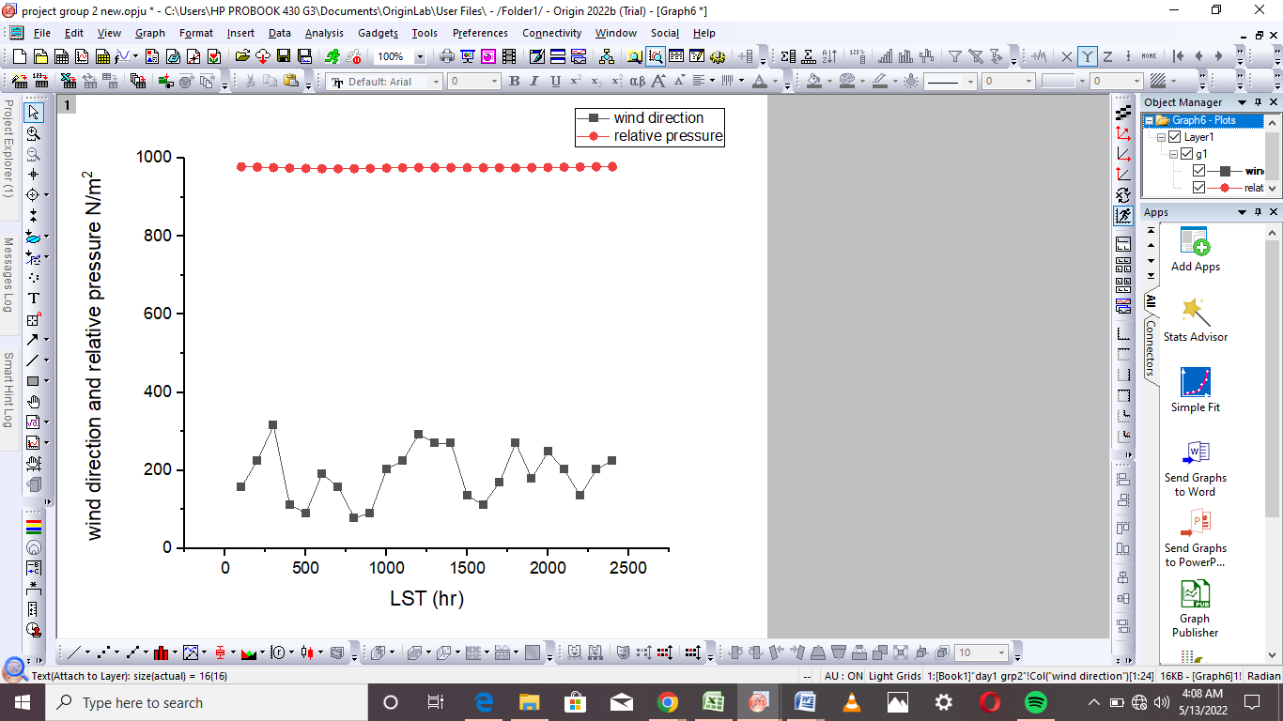
Figure 5.1: Diurnal variation of Relative Pressure and Wind Direction for (DOY 130).

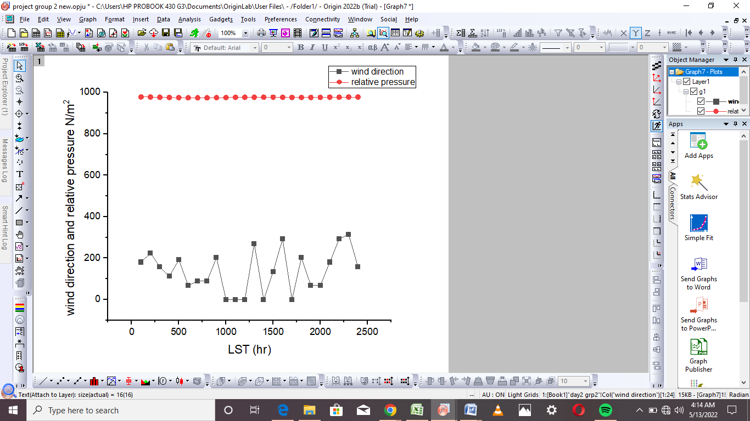
Figure 5.2: Diurnal variation of Relative Pressure and Wind Direction for (DOY 131).

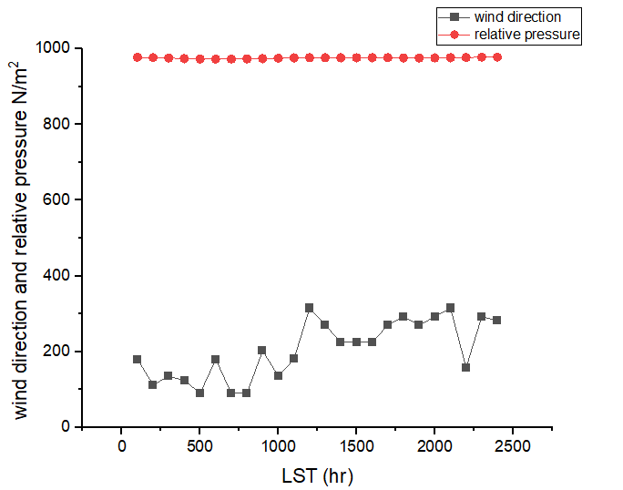
Figure 5.3: Diurnal variation of Relative Pressure and Wind Direction for (DOY 132).

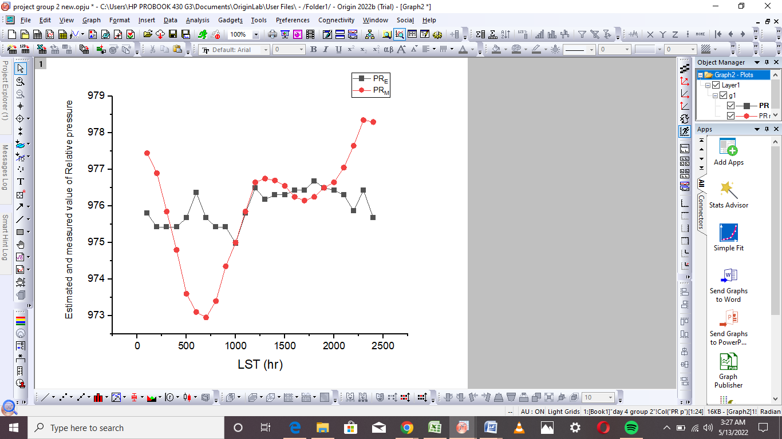
Figure 5.4: Diurnal variation of Estimated and Measured Relative Pressure for(DOY 137).

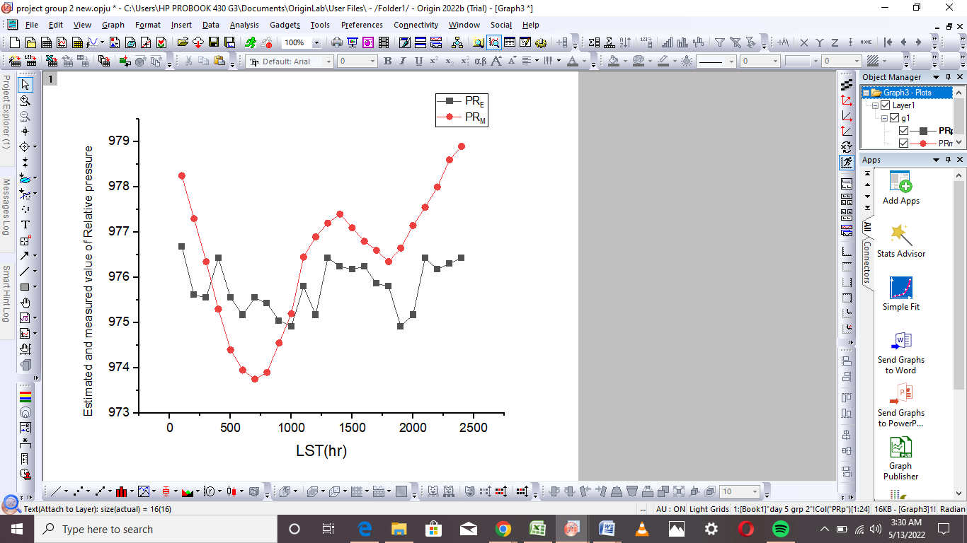
Figure 5.5:Diurnal variation of Estimated and Measured Relative Pressure for (DOY 138).

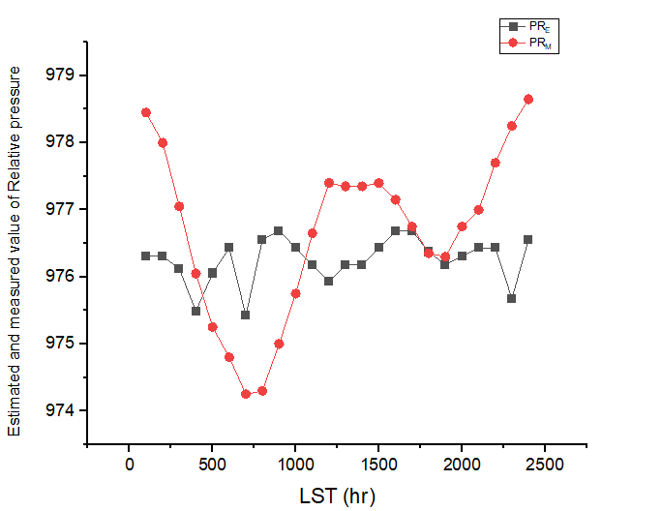
Figure 5.6: Diurnal variation of Estimated and Measured Relative Pressure for (DOY 139).

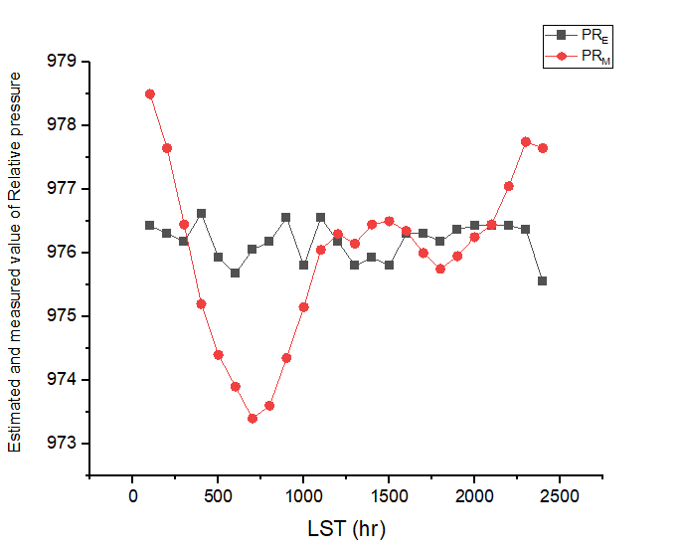
Figure 5.7: Diurnal variation of Estimated and Measured Relative Pressure for(DOY 140).

5.2 ESTIMATION OF RELATIVE PRESSURE FROM WIND DIRECTION
Data for P_{R} are often needed in micrometeorology, hence, there have been many publications on how to measureP_{R} with less sensors or how to correlate it from only few measurements.
In order to evaluate the effectiveness of the tested equation, the results were compared to the measured data set considering graphical and statistical means of evaluation.
The linear regression equation, to determine Relative Pressure and Wind Direction measurements is obtained and given
P_{R}=a (W_{D}) + b
Where, P_{R} is the estimated relative pressure, a is the slope and b is intercept. The values obtained from the calibration in Fig 5.8 are $a=0.006, b=$ 974.918$and r=$0.341respectively.
Conclusively, the parameters found from the linear regression of the calibration data set give a slope of $0.006$and $b=$974.918as the intercept for this research.

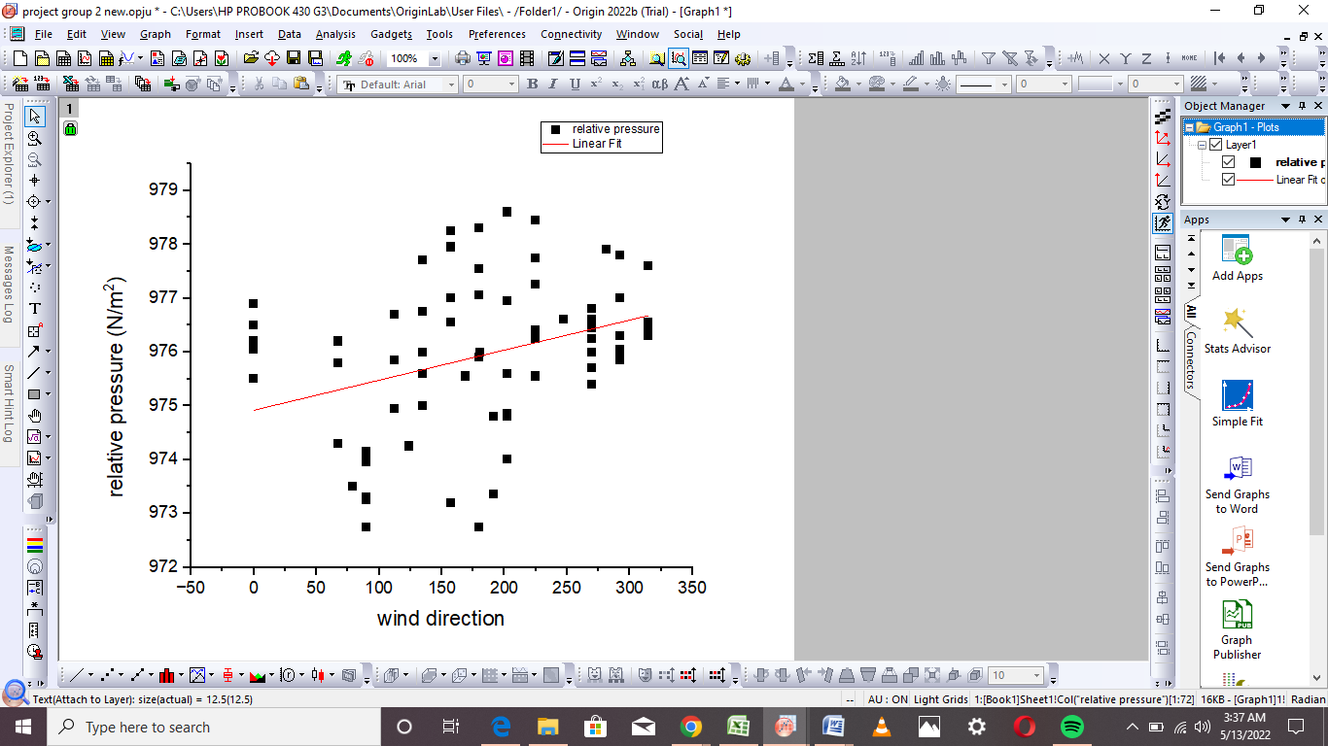
Figure 5.8: Calibration of the data sets for some selected days between (DOY 138-143).

Table 5.1: Parameters of the linear regression (slope a, intercept b and correlation coefficient r) as well as standard deviation and coefficient of determination for the tested estimated with respect to the measured values for the overall dataset.
Parameterization | a | b | r | SD | r²
Linear equation | 0.006 | 974.92 | 0.341 | 0.85 | 0.116

CHAPTER SIX:

SUMMARY AND CONCLUSIONS

Continuous measurements of Relative Pressure and Wind Direction at an experimental site (08⁰ 9’21⁰N, 04⁰30’.50⁰E) located at the Kwara State Polytechnic Ilorin, Nigeria, were carried out between 10th– 23rdMay, 2025. Using the direct measurement technique, these datasets were used to investigate the diurnal variation of the relative Pressure, Wind Direction and estimation of Relative Pressure from Wind Direction using linear regression equation.
From comparison of the simple parametric relationship used for the Relative Pressure with the measured data, assessment of the estimated value with the measured value indicated a remarkably fair agreement with the estimation of Relative Pressure from Wind direction. Thus, in the absence of direct measurements of the Relative Pressure, the parametric equation considered in this study is capable of yielding good result for Relative Pressure even with a small of measured Wind Direction data.
The investigation has sufficiently demonstrated that there is a considerable divergence from the viewpoints of many researchers regarding the wind potentials in Nigeria. The installation of a wind energy system is simply supported by the average wind speed of the several study locations.

REFERENCES
Azimzade, K.E; Neuendorf, J; Mehl, Jr. and Jackson, J. A. (2001). Glossary of
Geology. Springer-Verlag, New York. p. 779. ISBN 978-3-540-27951-8.
Alijani, I. (1996). "The Atmospheres of Uranus and Neptune". Annual Review of
Astronomy and Astrophysics. 31: 217–263
Beaufort, S. (2003). Wind speed is the speed of the weather related air movement from one place to the next). The spatial information of neighboring sites.
Bradt, G. (2004). “Make and Use an Anemometer to measure Wind
Speed” www.ciese.org. Retrieved 2018-04-18.
Dutton, J. (2014). On the forces of steam or vapour from water and various other
liquids, both in a vacuum and in air.
Federal Republic of Nigeria Population Census (2006). Description of Kwara
state Polytechnic in the map of Nigeria.
Kantly, D. (2005). “The Papaguayo Wind”. NASA Goddard Earth Sciences Data
and Information Services Centre. Retrieved 2009-06-16.
Keevallik, T. Hann, K. and Bannon, S. (2007). Wind field characteristic and wind
speed analysis
Lashkari, R. (2006). "On the mode of origin of the loess". Geological Magazine
(Decade II). 9 (7): 293–305.
NCEES, (2011). Structural Commentaries - Part 4 of Div. B, Comm. I
Nigerian Meteorological Agency (NIMET, 2012). In: Annual Climate Review
Bulletin. National Weather Forecasting and Climate Research Centre
Omidvar, P. (2015). Gliding: a Handbook on Soaring Flight. Knauffand Grove. pp. 85–86, 130–132. ISBN 978-0-9605676-4-5.
Panofsky, H. and Brie, G. (1965). Collected wind data should be analyzed to make a wind rose with wind speed at prevailing directions.
Petrson, O; Panofsky, H. and Brie, G. (1997). Collected wind data should be analyzed to make a wind rose with wind speed at prevailing directions.
Vishwarkarma, J. (2009). “Modelling sea-breeze climatologies and interactions on
coasts in the southern North Sea: implications for offshore wind energy". Quarterly Journal of the Royal Meteorological Society. 141 (690): 1821–1835. ISSN 1477-870X
www.wikipedia.com
Zhu, G; Su, Y. H; Li, X; Zhang, K. and Li, C. B. (2004). Estimating actual
evapotranspiration from an alpine grassland on Qinghai-Tibetan plateau using a two-source model and parameter uncertainty analysis by Bayesian approach. J Hydrol 476:42–51.

