DIGITAL SURFACE MODEL
OF PART OF KWARA STATE POLYTECHNIC, ILORIN

BY

GANIYU MISTURA DAMILOLA
MATRIC NO: HND/22/SGI/FT/111

SUBMITTED IN PARTIAL FULFILMENT OF THE REQUIREMENTS FOR THE
AWARD OF HIGHER NATIONAL DIPLOMA (HND) IN SURVEYING AND
GEO-INFORMATICS TO THE DEPARTMENT OF SURVEYING AND
GEOINFORMATICS, KWARA STATE POLYTECHNIC, ILORIN.

JULY, 2025

CERTIFICATE
This is to certify that all the field work and information given in this project were obtained as a result of the observations and measurements carried out by me and that the survey was carried out in accordance with survey rules and regulations as well as departmental instructions.

Name of the Student: GANIYU MISTURA DAMILOLA
Signature of the Student: ______________________
Date of Completion:

CERTIFICATION
This is to certify that this project report was prepared and submitted by GANIYU MISTURA DAMILOLA with Matric No:- HND / 22 / SGI / FT / 111 to the department of Surveying and Geo-informatics, Institute of Environmental Studies, Kwara State Polytechnic, Ilorin, as a result of field observation and measurement using appropriate instruments and equipment to carry out the task.

------------------------------------ ---------------------------
MR ISAU. A . I. DATE
Project Supervisor

------------------------------------ -------------------------
DATE
Project Coordinator

------------------------------------ -------------------------
MR ISAU A. I. DATE
Head of Department

………………………………………………. ………………………………..

(EXTERNAL EXAMINER) DATE

DEDICATION
This project is dedicated to the author of life and finisher of our faith. And also to my lovely parent MR and MRS GANIYU for their unceasing and parental cares of all through, you people are the best I can ever have in my life time.

ACKNOWLEDGEMENT
All glory and adoration goes to Almighty God for his protection over my life throughout the programe, the journey was rough and tough but he saw me through.
My gratitude goes to my supervisor in person of MR ISAU A. I. for his guidance and support during the project, and for making this project a successful one. Also my appreciation goes to the Head of Department (H O D) of Surveying and Geoinformatics, Kwara State Polytechnic, Ilorin, Mr. Isau Ibraheem Abimbola and all the staffs of the department, may God be with you and grant all your heart desires, amen.
I will also like to show my heart of gratitude to my parents Mr. & Mrs. Ganiyu for their parental care, love, encouragement and words of advice day and night, I pray that God almighty should grant you long life to harvest the fruit u labor for .Amen.
I will never seize my breath without appreciating all my lecturers for their fatherly advice, love, care, and the word of motivations and encouragement before and during my period of study, I say a big thank you for standing by me and for keeping my company day and night, may God reward you here on Earth and in Heaven, I really appreciate you both.

ABSTRACT
The project was carried out to generate a Digital Surface Model of part of Kwara State Polytechnic, Ilorin. The reconnaissance was first carried out, spatial data were acquired directly from the field using HandheldGPS, while non-spatial data were obtained through social survey by means of oral interviews and observations. The data were processed and analyzed using ArcGIS 10.1 software for database design and geospatial analysis, AutoCAD2007 for graphical representation, surfer 10 for generating the contour as well as Digital Terrain Modelling (DTM) and other relevant software. Some queries were generated to enable spatial search on the database created and transform such dataset into information system which will support decision making process, as a result of this we produced Topographic data in softcopy to be accessible for various application . Finally, a comprehensive technical report was written.

TABLE OF CONTENTS
CERTIFICATE………………………………………………………………………………………….ii
CERTIFICATION………………………………………………………………………………………iii
DEDICATION…………………………………………………………………....................................iv
ACKNOWLEDGEMENTS……………………………………………………………………………..v
ABSTRACT……………………………………………………………………………………………vi
TABLE OF CONTENTS……………………………………………………………………………....vii
LSIT OF FIGURES………………………………………………………………………………….viii
LIST OF TABLES…………………………………………………………………………………...ix
CHAPTER ONE……………………………………………………………………………………1
1.0 INTRODUCTION ……………………………………………………………………………...1
1.1 BACKGROUND TO THE PROJECT……………………………………………………………1
1.2 STATEMENT OF PROBLEM ……………………………………………………………………3
1.3 RESEARCH QUESTIONS…………………………………………………………………….4
1.4 AIM OF THE PROJECT…………………….…………………………………………………4
1.5 OBJECTIVES OF THE PROJECT…………...………………………………………………...5
1.6 SCOPE OF THE PROJECT…………………………………………………………………….6
1.5 PERSONNEL INVOLVED IN THE PROJECT………………………………………………6
1.6 PROJECT AREA………………………………………………………………………………7
CHAPTER TWO…………………………………………………………………………………..8
2.0 LITERATURE REVIEW……………….………………………………………………………8
CHAPTER THREE………………………………………………………………………………16
- METHODOLOGY……………………………………………………………………………16
3.1.1 VIEW OF REALITY……………………………………….………………………………..17
3.1.2 CONCEPTUAL DESIGN…………………………………………………………………….18
3.2 RECONNAISSACE...………………..………………………………………………………………19
3.2.1 OFFICE PLANNING………………………………………………………………………….19
3.2.1.2 FIELD RECONNAISSANCE………………………………………………………………..20
3.2.3 EQUIPMENT USED/SYSTEM SELECTION AND SOFTWARE…………………………….21
3.2.7 GEOMETRIC DATA ACQUISITION…………………………………………………………..23
3.3 DATA PROCESSING……………………………………………………………………………..23
3.4 PHYSICAL DESIGN………………………………………………………………………………25
3.5 DATABASE IMPLEMENTATION………………………………………………………………26
3.6.1 DATA SECURITY……………………………………………………………………………..26
3.6.2 DATA INTEGRITY……………………………………………………………………………27
3.6.3 DATABASE MANITENANCE………………………………………………………………..27
CHAPTER FOUR…………………………………………………………………………………..28
4.0 SPATIAL ANALYSES AND INFORMATION PRESENTATION……………………………28
4.1 TESTING OF DATABASE……………………….……………………………………………..32
CHAPTER FIVE…………………………………………………………………………………….40
5.0 PROJECT COSTING, SUMMARY, CONCLUSION AND RECOMMENDATIONS………….40
5.1 PROJECT COSTING…………………………………………………………………………… 40
5.2 SUMMARY……………………………………………………………………………………...44
5.3 CONCLUSION…………………………………………………………………………………..45
5.4RECOMMENDATION…………………………………………………………………………..46
REFERENCE………………………………………………………………………………………...47

LIST OF FIGURES
FIG 1.6 STUDY AREA………………………………………………………………………………..6
FIG 3.1 DESIGN AND CONSTRUCTION PHASE OF A SPATIAL……………………….……….21
FIG 3.3 POINT ENTITY AND ITS ATTRIBUTES………………….…….………….……………..22
FIG 3.4 LINE ENTITY AND ITS ATTRIBUTES……………………………………..……………22
FIG 3.5 POLYGON ENTITY AND ITS ATTRIBUTES……………………………….…………….22
FIG 3.7 RECCE DIAGRAM OF THE PROJECT AREA…………………………………………….26

LIST OF TABLE
TABLE 3.1: NODE ENTITY AND ITS ATTRIBUTES……………………………………………23
TABLE 3.2: ARC ENTITY AND ITS ATTRIBUTES………………………………………………24
TABLE 3.3: POLYGON ENTITY AND ITS ATTRIBUTES………………………………………24
TABLE 3.11 NODE ENTITY DATA STRUCTURE……………………………………………….36
TABLE 3.1 ARC ENTITY AND ITS ATTRIBUTES STRUCTURE………………………………36
TABLE 3.13: POLYGON DATA STRUCURE ……………………………………………………36

CHAPTER ONE

1.0 INTRODUCTION

1.1 BACKGROUND TO THE STUDY
The surface of the land is an important resource which human activities are continually modifying. Land is the earth's surface, land and water, plus natural resources in their original state, such as: mineral deposit, wildlife, fish, timber, etc. Particular areas of land can be utilized by humans in diverse ways. These can include residential, institutional, business, industrial, agricultural, forestry, park, and other relatively natural land uses. In order to create a sustainable and favourable living, it is essential to protect our property or investment, in which land surveying helps in the positioning of objects in space and time as well as the positioning and monitoring of physical features, structures and engineering works on, above or below the surface of the earth and the analysis, interpretation and integration of spatial objects and phenomena in GIS, including the visualisation and communication of such data in maps, models and mobile digital devices. (http://en.wikipedia.org/)
A Digital Elevation Model (DEM) is a digital representation of ground surface, topography or terrain. A DEM can be represented as a raster (a grid of squares) or as a triangular irregular network. DEMs are commonly built using remote sensing techniques; however, they may also be built from land surveying. DEMs are used often in geographic information systems, and are the most common basis for digitally-produced relief maps.
A Digital Surface Model (DSM) is a representation of any surface by using three dimensional (3D) coordinates, normally X, Y, Z Cartesian coordinates. The surface might be part of a small object, for example a vase, or it may be a very large object such as the surface of the Earth. When related to the Earth.s surface, these coordinates are often converted into Easting, Northing and Height (E, N and H). A Digital Elevation Model (DEM) specifically relates to elevation and therefore height, and so will be defined as a DSM of the Earth’s surface. It is used generically to define the ground surface, also called a Digital Terrain Model (DTM), and the ground surface plus the tops of features above the ground surface such as artificial structures and vegetation. The DSM is therefore the first surface that many airborne and spaceborne sensors will interact with. A DTM is normally created by stripping off all above ground surface features from the DSM to reveal a bald-earth Model.
A digital surface model (DSM) is an important geospatial infrastructure used in various fields, such as ortho image generation, 3D analysis, and city modelling. It is usually represented as grid data composed of regularly spaced cells with elevation values. For automatic generation of DSMs, light detection and ranging (LiDAR) survey and stereo image matching are mainly used. While high-quality point clouds can be extracted from LiDAR, it may be expensive and might lack texture information. On the other hand, stereo image matching has become a more attractive solution for DSM generation with the recent spread of high-resolution satellite and unmanned aerial vehicle (UAV) images. In this paper, we focus on DSM generation from stereo image matching.
Digital Elevation Model (DEM) represents a very important geospatial data type in the analysis and modelling of different hydrological and ecological phenomenon which are required in preserving our immediate environment. DEMs are typically used to represent terrain relief. DEMs are particularly relevant for many applications such as lake and water volumes estimation, soil erosion volumes calculations, flood estimate, quantification of earth materials to be moved for channels, roads, dams, embankment etc.
There are known methods by which DSMs can be constructed. Such methods include but not limited to digitising existing topographic maps or by using stereoscopic aerial photographs, with the advance of digital photogrammetry.
Maune (2001) stated that Surface modelling is essential for various applications; orthophoto productions, engineering design, floodplain mapping, telecommunication, etc. all require surface data with different level of detail and accuracy.

1.2 STATEMENT OF PROBLEM
Topographic map of part of Kwara State Polytechnic, Ilorin is not up-to-date and heights of features were not represented. The production of Digital Surface Model will solve the following problems.
- Lack of current maps for the school’s management use.
- Lack of information about the height of details within the School.

1.3 AIM AND OBJECTIVE OF THE STUDY

1.3.1 AIM
The aim of the project is to produce a digital surface model of part of Kwara State Polytechnic, Ilorin and to demonstrate my capability in executing projects of such calibre.

1.3.2 OBJECTIVES OF THE STUDY
In achieving the above stated aim, the following operations were carried out:
- Database Design for the study area
- Data Acquisition.
- Creation of Database for Spatial entities in the study area.
- Spatial Analysis.
- Information Presentation and Management.

1.4 SIGNIFICANCE OF THE STUDY
The significance of this project is to, as stated below;
- Easy planning of any meaningful development.
- Provide up-to-date Digital Elevation Model for the School.
- Provision of useful spatial analysis of information about any object for viable decision making and deformation studies.
- For map revision purposes i.e. easy retrieval and updating of the database, and
- To get student acquainted with the knowledge needed for future environmental occurrences.

1.5 SCOPE OF THE PROJECT
The scope of the project covers the following:
- Review of previous projects, literatures, journals, reports and text books.
- Project Planning.
- Database Design techniques.
- Data Acquisition with automated Survey equipment for perimeter traversing, detailing and spot heighting.
- Data processing, spatial analyses and information presentation.

1.6 PERSONNEL
The following are the personnel involved in executing the project:
NAMES | POSITION
GANIYU MISTURA DAMILOLA | AUTHOR
ILESANMI ESTHER | MEMBER
TIAMIYU ZAINAB | MEMBER
BABALOLA OLUWATOSIN | MEMBER
ADEOYE AYOBAMI | MEMBER
OGUNLADE MATTHEW | MEMBER
SOURCE: AUTHOR 2025

1.7 STUDY AREA
The site is part of Kwara State Polytechnic, Ilorin, Nigeria. It is situated along old Jebba Road and have geographic locations between latitude 04º 49’ 25”N and 4º 49’17” longitude 8º 55’ 12”E and 8º 55’ 10”E. The project area is developed with existing structures such as, road, electricity line, buildings etc
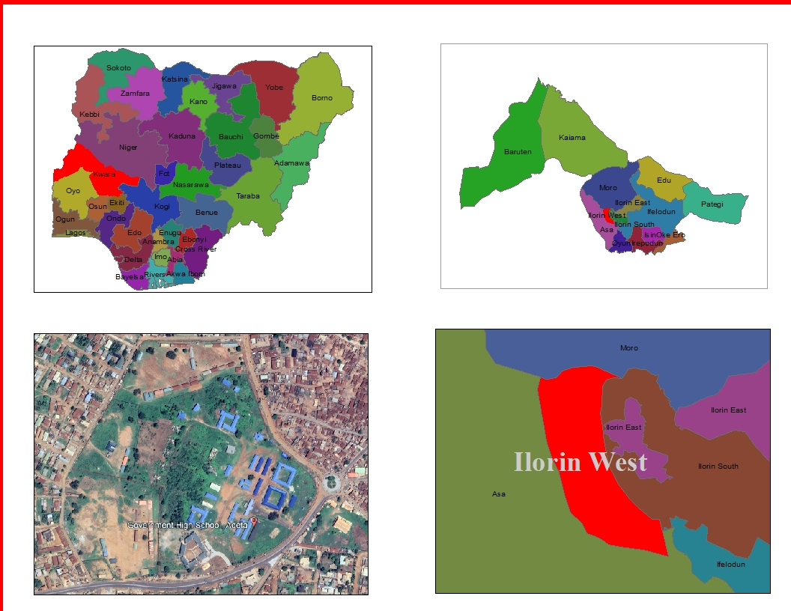

Source: Author 2025

CHAPTER TWO

2.0 LITERATURE REVIEW
Digital Surface Models, or DSMs, represent the topography of the earth’s surface, including all objects on it, such as trees, buildings, and other features. DSMs are created using aerial data capture methods, like LiDAR (Light Detection and Ranging) or photogrammetry. LiDAR uses laser beams to measure the distance between the sensor and the ground, while photogrammetry uses aerial photographs to create 3D models. There are many benefits of DSMs. For one, they accurately represent the earth’s surface, allowing users to accurately measure features and make decisions based on that information. 3D visualization of the Earth’s surface allows users to see the surface and features in a more realistic and immersive way. This is particularly useful in applications such as urban planning and design where visualizing the impact of planned developments on the existing landscape is critical. Digital surface models offer several advantages over traditional topographic mapping. Because DSMs are typically created using LiDAR or photogrammetry, they provide high-resolution data. This means that DSMs can capture much more detail than traditional topographic maps, often based on field surveys, and may not accurately capture all features. The high-res data also provides highly accurate elevation measurements. This allows for more precise calculations of slope, aspect and other terrain characteristics, essential for industries that model water flow and drainage.
Digital Terrain Models, or DTMs, represent the bare earth surface without any features such as buildings or vegetation. DTMs are created using methods similar to DSMs, such as LiDAR or photogrammetry, but require additional processing to remove objects above the ground. This process is known as “bare-earth extraction.”
A digital terrain model has three main components:
- The surface itself
- The elevation at each point on the surface
- The slope at each point on the surface
This model is similar to DSM, but it represents only the highest points on the surface of the terrain instead of every point on its surface as DSM does. DTMs can be used to create contour lines. This is useful for building roads or railroad tracks because they allow you to see if there are any obstacles such as trees or rocks in your way before you start building them.
DTMs are particularly useful for terrain analysis, such as slope and aspect calculations, hydrological modeling and geological applications. Digital Elevation Models, or DEMs, represent the elevation of the earth’s surface. DEMs can be either a DSM or DTM. The resulting model shows the elevation of the earth’s surface. The DEM is essentially a superset of the DSM and DTM. DEMs are a 3D grid of terrain elevations collected from an area with satellite imagery or LiDAR technology. DEMs are useful for visualizing landscape changes over time, creating simulations of natural phenomena like landslides and floods, and measuring land use changes over time — as well as many other applications. They can also be combined with other models to create more detailed representations of the earth’s surface.
Digital models offer numerous benefits over traditional methods of mapping and surveying. They accurately represent the earth’s surface, allowing for better decision-making and planning. They can also be created quickly and efficiently using aerial data capture methods such as LiDAR, which reduces the need for ground-based surveys and minimizes environmental impact. In addition, digital models can be easily shared and used in many applications, making them a valuable resource for many industries. They can be used in GIS software for spatial analysis, integrated into 3D modeling software, or applied in conjunction with other data sources such as satellite imagery.
However, because of the peculiar nature and importance of the built environment, planners around the world have emphasized the need to cater for physical development within the cities and other human settlement using the planning principles and concepts. The essence of this is to achieve a livable settlement described as ‘a welcoming, organized and comprehensible environment, where physical elements is unifying, accessibility within and without facilitate communication and promote interactions and flexibility, involving the design and development of buildings, circulation and service/utility system adapt to the needs of an evolving environment’ (Office of University Planning,1997). Physical development planning which is concerned with the process of ordering the use of land and siting of buildings structures and communications to secure the maximum degree of economy, functionality, convenience, and beauty (Keeble, 1969) has, therefore, come to be accepted as a major area of planning because it encompasses all other facets of human interaction with land, including building engineering, mining or other operations in, on, over or under any land.
Aerial data capture methods such as LiDAR have revolutionized how we map and analyze the earth’s surface. LiDAR is a highly accurate and efficient method of collecting data and can be used to create highly detailed digital models of the earth’s surface.
LiDAR emits laser beams from a sensor mounted on an aircraft, which bounce off the earth’s surface and return to the sensor. The time it takes for the laser beam to return to the sensor is used to calculate the distance between the sensor and the ground.
LiDAR can be used to collect data over large areas quickly and efficiently, making it ideal for creating digital models of the earth’s surface. It is particularly useful in complex topography areas where ground-based surveys would be difficult or impossible. DSM Includes all objects on the earth’s surface such as trees, buildings, and other features. In other words, it represents the topography of the earth’s surface including all objects on it. Also it is Useful in applications such as land-use planning, urban modeling, and forestry. DTM Represents the bare earth’s surface elevation with all features removed, including buildings, trees, and other objects. Therefore, additional processing is required to remove any objects above the ground. DTMs are created by removing objects from a digital surface model (DSM) to create a more accurate representation of the terrain. Particularly useful for terrain analysis, such as slope and aspect calculations, hydrological modeling, and geological applications. DEM Represents the earth’s elevation. It is Useful for applications such as urban planning, forestry and land-use planning. It provides a more complete understanding of the topography of a given area.
As technology advances, digital models will become more prevalent and valuable in many areas. By understanding the difference between these models and their benefits, we can continue to make informed decisions and utilize these powerful tools to their fullest potential so we can understand the world around us.
GIS technology has made topographical mapping and geo-visualization more accurate, appealing and a large area can be mapped within a far lesser time frame. It has the power to visualize geographic data by allowing the user to dynamically integrate multiple data sources, unconstrained by format, scale and coordinate system. Also, the capability of GIS technology to visualize and analyze spatial and non-spatial information from diverse sources makes it a powerful platform for multilevel decision making, and so greater credit should be given to its geo-visualization capabilities. They enable a large volume of geographic data to be summarized into a map which, without doubt, facilitates fast visual interpretation (Nkeki, 2013a). In this paper, GIS technology is viewed from two dimension–the spatial data gathered with sensor-based space satellite devices used for producing topographic maps such as DEM and those used for manipulating and geo-visualizing the DEM data such as GIS softwares and algorithms. Geovisualization (geographic visualization) refers to the technologies and procedures of displaying geographic data for quick visual interpretation. Presently, this method of visualizing geographic dataset is fast replacing the cumbersome paper topographical map. It is capable of visualizing multiple spatial data and presents a friendly interface between the map and the user.
DSM (digital surface model) is a topographic digital model, which describes the relief and the situation on the surface. It consists of digital terrain model and represents the earth's surface, including all objects on it. GEO Innoter provides the creation of digital surface models (DSM) based on satellite or aerial survey materials, followed using digital surface models for 3D modeling of cities and other terrain objects. A digital surface model (digitized map) is a three-dimensional representation of the heights of the Earth's surface, including natural or man-made objects located on it. The main data sources for creating digital surface models, digitized map and 3D modeling are:
- topographic map-provides a geographic reference that stores coordinate and elevation information about terrain features such as terrain, buildings and structures, roads, rivers, land-use contours, administrative boundaries, and so on.
- Remote sensing materials obtained in stereo mode are used to create digital surface models and orthophotos.
- a cloud of points obtained by laser scanning
The orthophoto and topographic map are used to obtain the contour of the buildings. Ground-based photos of each individual building from multiple points of view are necessary to build a photorealistic 3D model of the buildings.
The digital surface model is used in a variety of planning, analysis, visualization, and modeling applications, including:
- localities for various purposes (urban planning, architectural planning, tourism, virtual tours, etc.),
- navigation systems,
- intelligent transport systems,
- forecasting of urban risks;
- telecommunications-positioning of mobile phone transmitters;
- in the mapping of flood risk.
Podobnikar and Vrec ˇko proposed a methodology for extraction of terrain (bare
earth) points from point clouds captured with airborne laser scanning. It is focused on
the areas that are covered with dense vegetation – the places that create extra difﬁculties for DEM generation. They tested a number of different ﬁltering techniques accessible by freeware. The resulting methodology was fused using three ﬁlters: multiscale curvature classiﬁcation, hierarchical robust interpolation and LAStools ﬁltering. The article by Zawadzki, Nikie, and Warszawski addresses the problem of modeling virtual caves and tunnels, and presents an alternative solution in the form of a hybrid system. The innovative approach combines two independent methods well known in computer graphics: shape grammars and shape morphing for modelling three-dimensional geometry. Bühler, Marty, and Ginzler examine the quality of digital surface models derived from opto-electronic scanner data using photogrammetric image correlation techniques based on the multispectral nadir and backward looking sensor data. Tested datasets came from high alpine terrain and the results showed that the deviations are surprisingly low. The work presented by Caha, Tuc ˇek, Vondráková, and Paclíková looks at uncertainty processing. They work with fuzzy surface and utilized the Neighbourhood method to calculate slope. Georelief transﬁguration in areas affected by open-cast mining is the focus of the article of Pacina, Novák, and Popelka. They reconstructed the original georelief in different time periods together with analysis showing the process of landscape devastation. The workﬂow and analysis is based on precise elevation data obtained from aerial photographs and old maps. The use of a digital surface model in solar radiation modelling is presented by Hoﬁerka and Zlocha. They developed new open-source 3-D solar radiation tools for GRASS GIS. Their module is based on the existing solar radiation methodology with a new capability to process 3-D vector data frequently used in the 3-D city models representing complex urban environments. The calculation procedure is based on the effective volume tessallation using a voxel data structure. The shadowing algorithm uses a combined vector-voxel approach. Another application of using a digital surface model is presented by Zieher, Formanek, Bremer, Meissl, and Rutzinger. Their research was focused on estimating the extent of rockfall area, especially the sensitivity of this estimation to the resolution of an input surface model Persson, Hasan, Tang, and Pilesjo targeted permafrost landscapes and the water table depth and water depths above the frozen layer for different peat land types. They examined modeled ﬂow routing patterns with a topographical wetness index in these areas and then evaluated the correlations between the topographical wetness index and site-septic wetness.
Finally, Kubiak and Dzieszko present an unconventional use of thermo vision for topoclimatic delimitation. The method is based on the spatial distribution of land surface temperature, which indicates the amount of solar energy reaching the Earth’s surface, and depends primarily on a terrain’s shape and land cover types. Land surface temperature based on topoclimatic classiﬁcation was compared with a classical, theoretical topoclimatic classiﬁcation. New classes of topoclimates were delimited and some existing types were diversiﬁed.

CHAPTER THREE

3.0 METHODOLOGY

3.1 PROJECT PLANNING

Before beginning any survey assignment, project planning is a crucial requirement. It entails a careful investigation of the topic matter about a certain land region that is being evaluated. This crucial step in the surveying process allows the surveyor to become acquainted with the chosen location before starting work. During the reconnaissance phase, the survey's goals, requirements, and required precision levels are examined because these elements have a big impact on the choice of survey tools and techniques. In the end, this project resulted in the development of a first working diagram. Reconnaissance is divided into two phases: (i) Office Planning and (ii) Field reconnaissance.

3.1.1 FIELD RECONNAISSANCE

As part of this process, a surveyor or student must physically visit the site to gain a thorough understanding of its topography, including any vegetation, accessibility, existing frame work, as well as the social and economic 19 activities that take place there. The optimal approach and tools for improved decision-making must also be chosen. This on-site visit gives the surveyor or student a comprehensive grasp of the entire region and allows them to look at the entire area of the land. To guarantee correct orientation, the locations of all accessible horizontal and vertical controls in the region of the research area will be visited, and their outlooks will be viewed. This exercise makes it easier to create a Recce diagram, which is shown below but is not drawn to scale:

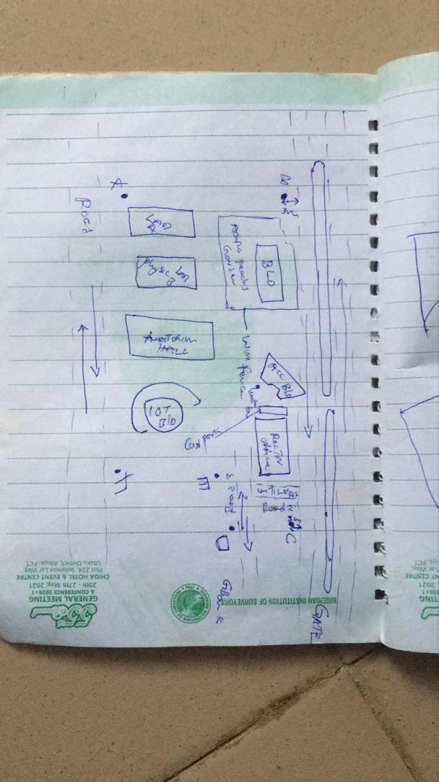

Figure 1.4: RECCI DIAGRAM

3.1.2 OFFICE PLANNING

Gathering crucial project information is the focus of this phase, which is usually done in an office setting. It is the initial phase of planning that comes before the fieldwork itself and entails gathering and analyzing a variety of project-related data. This covers a range of requirements for the project, scheduling, budgeting, and generating the coordinates for the control points under the project control prefix. It includes figuring out the best process, picking the right tools, as well as subscription for the CORS station.

3.2 EQUIPMENT USED/ SYSTEM SELECTION SOFTWARE
The following equipment was used:
- Total station and accessories
- One Tripod
- Two Prism
- One 7.5 meters short tape
- One Plumb bob
- One Cutlass
- Bottle corks and nails
- Writing materials.

3.2.1 HARDWARE USED
Model: HP 15 Note book PC
System Manufacturer: Hewlett-Packard
Rating: 1.0 Windows Experience Index.
Processor: Intel(R) Core(TM) i5-3230M CPU @ 2.60GHz, 2601 Mhz, 2 Core(s), 4 Logical Processor(s)
Installed Memory RAM: 8.00 GB
System Type: x64-based PC.
Product ID: F9F84EA#ABV

3.2.2 SOFTWARE USED
Some of the software used includes:
- AutoCAD 2007
- Notepad
- Microsoft Word 2007
- Microsoft Excel 2007
- Arc GIS 10.5

3.3 DATA ACQUISITION

This involves using different surveying methods and tools to gather data and make observations in the field. To acquire data for this project, HANDHELD GPS and Total station were both used.

3.3.1 PRIMARY DATA SOURCE: This is a type of data source in which data is direct acquired from the field such as data acquired from field survey operations.

3.3.2 SECONDARY DATA SOURCE: This data source are already made data or gotten from research work, which has been acquired for future use. This involves downloading satellite imagery used for the project area and Google map as guide.

3.4 TEST OF INSTRUMENT
Testing of instruments is very crucial when carrying out any survey operation. Having collected the required instruments from the department, the check was carried out on the accuracy and precision of both the Handheld GPS and TOTAL STATION to ensure they were in proper working condition before the actual field observation of the project.

3.4.1 TEST FOR TOTAL STATION
The horizontal collimation and vertical index inaccuracies of the instrument were confirmed. Once the device was positioned on a rather flat surface, the required temporary modifications, including focusing, centering, and setting, were made. Configuration information, such as extra parameters and fast settings, was examined and adjusted as necessary. The configuration parameters selected collimation, namely horizontal collimation. Next, to focus on a distant object, the means' option located on the left side of the device was chosen. The instrument was transited, and the right side went through the same procedure. Then, when the 'accept' button was pushed, the table that was displayed showed the old and new values for the vertical index errors and horizontal collimation. Re-press "ok" signified acceptance of the updated values, which were minimal.
Figure 3.5: INSTRUMENT TEST

The diagrammatic representation of the procedure and the readings obtained are shown below

Table 3.4.1 COLLIMATION TEST OF TOTAL STATION
STN | SIGHT | FACE | HCR | REDUCTION | VCR | REDUCTION
A | B | L | 126º 07’ 11.33” |  | 67º 22’40”
 | B | R | 306º 07’ 31.3” | 180º 00’ 20” | 292º 37’ 1” | 359 º 59’ 41”
HORIZONTAL COLLIMATION ERROR = 180°00’20’’ - 180°
=00°00’20’’
=00°00’20’’/2 =00°00’10’’
VERTICAL INDEX ERROR=360° - 359°59’41.6’’
=00°00’18.4’’
=00°00’18’’/2 =00°00’9.2’’
The instrument's satisfactory operation was validated by the acceptance of the updated readings. It appears from this result that any possible issues can be resolved or at least greatly reduced.

3.4.2 REFERENCING AND ORIENTATION OF TOTAL STATION
Tripod Setup:
- Place the tripod over the station point (known or assumed).
- Level the tripod head as much as possible by adjusting the legs.
Mount the Total Station:
- Fix the total station onto the tripod head.
- Ensure it’s securely locked in place.
Centering and Leveling:
- Use the optical plummet or laser plummet to center the instrument exactly over the survey station mark (station point).
- Level the instrument using the foot screws and circular bubble.
- Fine-tune leveling using the electronic level display.
Power On and Instrument Configuration
- Switch on the Total Station.
- Set the correct project, coordinate system, and units.
- Select the appropriate survey mode (e.g., topographic survey or station setup).
Orientation (Station Setup)
Orientation means establishing the direction of the horizontal angle reference (back sight direction).
Orientation by Known Coordinates (Resection or Free Station)
Used when both the instrument station and a back sight point have known coordinates.
- Input the coordinates of the instrument station (or let the instrument compute it later).
- Sight and measure to one or more known reference points (minimum of 2 for better accuracy).
- The Total Station calculates the instrument position and orientation using these known points.

3.3.7 PERIMETER TRAVERSING
The perimeter of the project area was traversed for the purpose of the coordinating the boundary points. HANDHELD GPS (GALAXY G1) was connected to Kwara State CORS station for referencing and orientation after which all the boundary points were traversed using HANDHELD GPS from the initial until each successive boundary is occupied.

3.3.8 DETAILING
All features such as roads, buildings, electric poles, street light, trees, etc. were captured by coordinating their edges simultaneously as the perimeter is being measured within the project area. Buildings were measured and identifiers (BD) were used to differentiate them from other features. Roads were also measured and labelled (RD) accordingly. Data captured here were basically in 3Dimension i.e. Easting, Nothings and Elevations (X, Y, and Z) coordinates.

3.3.9 REMOTE ELEVATION MEASUREMENT
All the features such as buildings, electric poles, street light, etc. captured by coordinating their edges from a subsidiary traverse stations created within the project area. Buildings heights were measured and recorded. Electric poles height were also measured and recorded accordingly. So also the same was repeated for the trees. Data captured here were basically in 3Dimension i.e. Easting, Nothings and Elevations + Heights (X, Y and Z + H) coordinates. The following procedures were followed:
- Escape key was pressed then F1 for MENU
- The REM programme was selected.
- Observation was made again and the height of reflector was displayed.
- The telescope was tilted to the top of the object and the height keeps changing until F4 is been pressed to stop.
- The value was recorded.
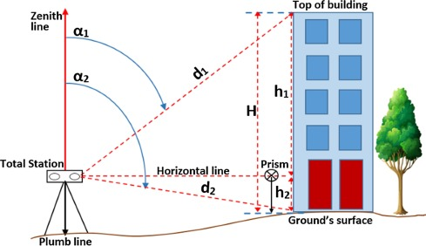
Figure 3.3.9: REM OBSERVATION STRATEGY

3.3.9 SPOT HEIGHTINGS
This was carried out by occupying randomly the subsidiary points within the project area and taking measurements (Easting, Nothings and Heights) along the terrain at approximate intervals to determine the difference in height between points and some areas within the project location. Spot heighten is very important in producing topographical information of the area with the aid of ArcGIS 10.5.

3.4 PHYSICAL DESIGN
At this stage, all geospatial (attribute) data were structured and organized to form a database in a format acceptable by the implementing software and hardware. This was done in a way that, stored information can be accessed and retrieved at any time. Also, for regular updates when the need arise and to allow for analytical functions to be carried out answering generic questions. Also, it provided integrity and security that must be obeyed before such data could be accepted into the records. These virtues are as show in the tables below. ArcGIS 10.5 was used for database creation of the project area.

Table 3.4A TREE TABLE
ATTRIBUTE | DATA TYPE | WIDTH | DECIMAL
T_ ID | String | 5 | -
T_NAME | Float | 20 | -
EASTING | Number | 10 | 3
NORTHING | Number | 10 | 3
T_USE | Float | 10 | -
T_HEGHT | Number | 7 | 3

Table 3.4B ROAD TABLE
ATTRIBUTE | DATA TYPE | WIDTH | DECIMAL
POINT_ID | String | 10 | -
NORTHING | Number | 10 | 3
EASTING | Number | 10 | 3
RD_HEIGHT | Number | 7 | 3

Table 3.4C ELECTRIC POLE TABLE
ATTRIBUTE NAME | DESCRIPTION OF ATTRIBUTE | DATA TYPE | WIDTH | DECIMAL
POINT_ID | Electric pole identifier | Number | 6 | -
NORTHING | Coordinate | Number | 15 | 3
EASTING | Coordinate | Number | 15 | 3
EP_TYPE | Type of Electric pole | Text | 15 | -
EP_HEIGHT | Height of the Electric pole | Number | 5 | 2

Table 3.4D BUILDING TABLE
ATTRIBUTE | DATA TYPE | WIDTH | DECIMAL
P_ID | String | 15 | -
NAME | Text | 15 | -
CONDITION | Text | 15 | -
USE | Text | 15 | -
HEIGHT | Number | 15 | 2
AREA_METERS | Number | 15 | 2

Table 3.4E STREETLIGHT TABLE
ATTRIBUTE NAME | DESCRIPTION OF ATTRIBUTE | DATA TYPE | WIDTH | DECIMAL
POINT_ID | Street light identifier | Number | 6 | -
NORTHING | Coordinate | Number | 15 | 3
EASTING | Coordinate | Number | 15 | 3
SL_HEIGHT | Height of the street light | Number | 5 | 2

3.5 DATABASE CREATION
Database is an organized integrated collection of data stored so as to be capable of use by relevant application with data being accessed by different logical part. This was the construction phase where database was created. After the table has being populated via the keyboard, some attributes such as area, perimeters of parcel were automatically displayed by special command in the ArcGIS 10.5 version.
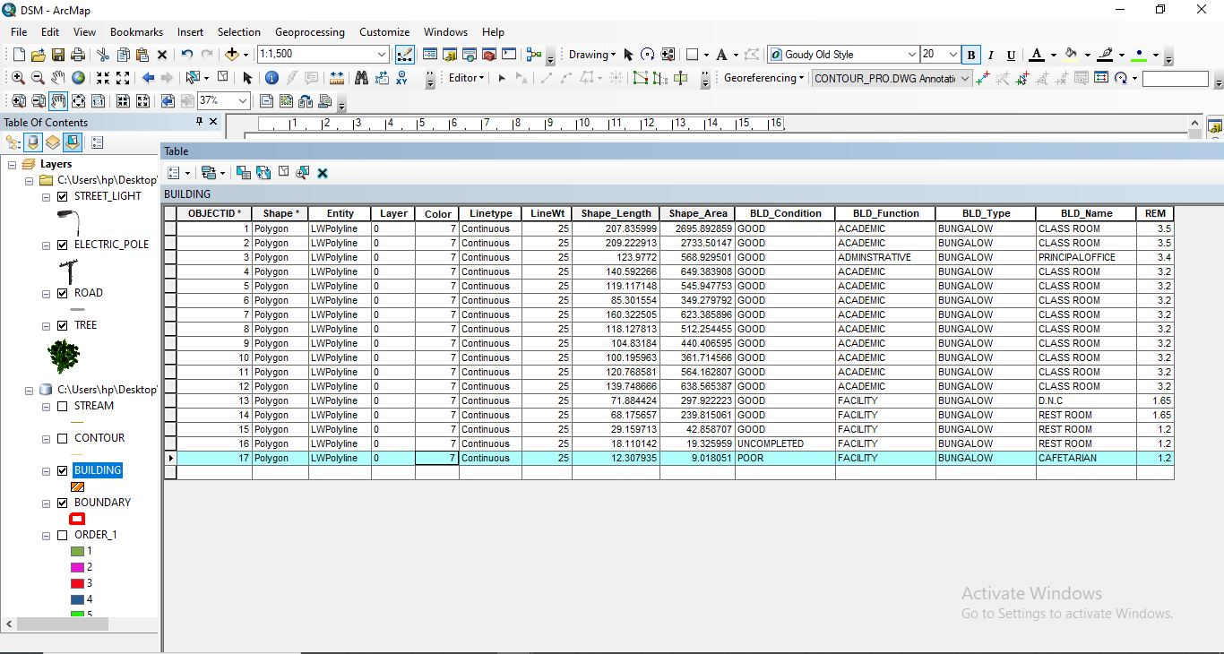
Figure 3.5: ABSTRACT OF TABLE CREATED

3.5.1 ATTRIBUTE DATA ACQUISITION
The data about the characteristics of features especially man-made features were acquired through oral interview method and online source (Google Earth). Social survey was carried out during which information such as; building name, building use and related data about features were obtained from the students and staffs within the school. All these data formed the attribute aspect of the feature necessary for the database creation.

3.6 DATA PROCESSING

3.6.1 TOTAL STATION DATA DOWNLOADING PROCEDURE
Data downloading is the process of transferring data from the instrument into the computer system connected through the connection cable or wireless such as Bluetooth with the help of software in the computer, the process is as follows as performed on Total station.
- Connection of the two devices (computer and the instrument).
- Go to project working folder created on the instrument.
- Click on export.
- Input the name of file
- Indicate the file extension for the output
- Permit the other device to receive the file.

3.6.2 DRAFTING AND PLOTTING
The script file created containing the refined coordinates was then opened in the AutoCAD environment and the boundary of the project area was plotted using AutoCAD 2007. This was followed by the details, which included buildings, roads, trees, sport facilities and electric poles.
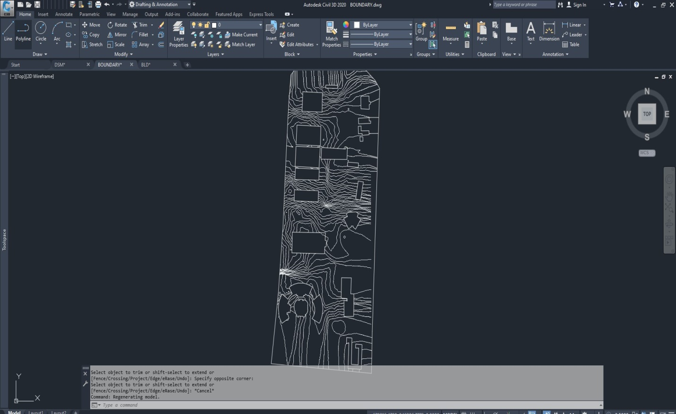
Figure 3.6.2: AUTOCAD PLOTTING.

3.7 DATABASE MANAGEMENT

3.7.1 DATA SECURITY
This is the security measure used the protection of the database security is very important since it is vital for data integrity. The strategic measure used included controlling access to database by use of password.

3.7.2 DATA INTEGRITY
This ensures that data in the database is accurate and that cases of violation of integrity can be detected automatically by the system. Here, care was taken while entering data into the system, such that, accurate data were entered and updating could be done accurately without tampering with existing data. Backups are provided to cater for any loss of data through system failure. Also a member of the project group was appointed for quality assurance and checks therefore do checks the consistency, accuracy and integrity of the input data.

3.8.3 DATABASE MAINTANANCE
Having created the database, proper maintenance practice was made to meet its stated objectives. The ability to include more data and remove irrelevant data can be possible. There is every need for the data to be updated regularly because of the physical changes that tends to occur on the landscape with time, even as a result of development.
Both security and integrity were also exercised to ensure maintenance and to meet its stated objectives.

CHAPTER FOUR

4.0 SPATIAL ANALYSIS AND INFORMATION PRESENTATION

4.1 TESTING OF DATABASE
This is the test carried out to determine whether the relationship between the spatial data of a feature and their attributes is capable of being retrieved. This is necessary to ascertain the quality of data in the database, its reliability to satisfy the demand of the user. The spatial data were arranged logically in an organized manner with respect to their attributes. This was carried out by designing a sample query and running the query to see if the desired result would be achieved. In this project, the database was queried to show different categories of information levels in the project area. Hence the database was confirmed fit for analysis. A sample of the attribute table in the database design can be found on the next page.
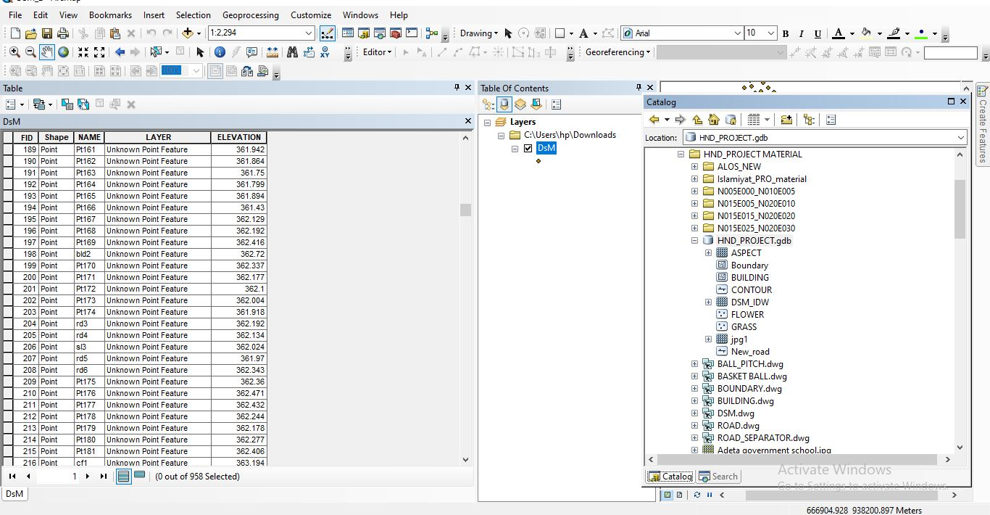
Figure 2.1: SAMPLE OF ATTRIBUTE TABLE

4.2 SPATIAL QUERY
Queries were designed for the purpose of retrieving information from the database. The queries performed in this project gave answers to certain generic questions asked from the database. This was made possible as a result of the implicit link of both the spatial and attributes data. The queries were based on the products from the analysis carried out on the database.

4.2.1 SINGLE CRITERIA QUERY
A single criterion is carried out where one condition is used to design query. This condition is used to retrieve the information from the database.

QUERY ANALYSIS 1 (selection by attribute)
ANALYSIS ONE
Analysis Name: Database extraction
Analysis Type: Single criteria analysis
Syntax: Query analyses showing buildings that are used for Administrative.

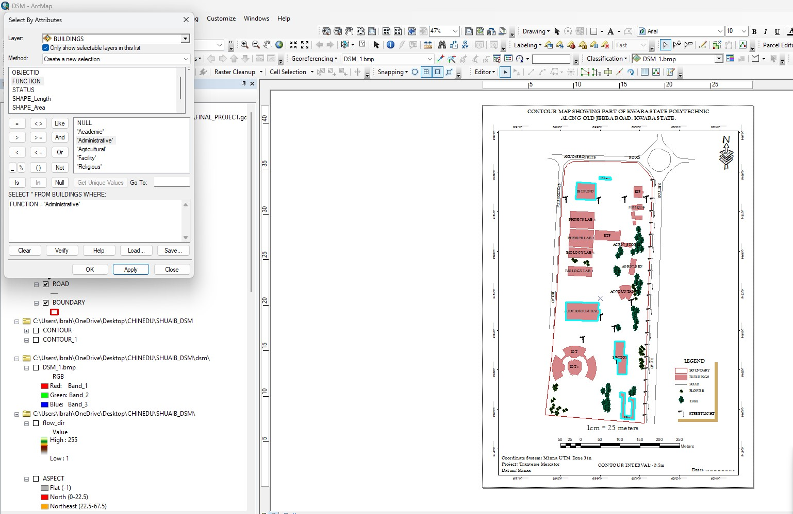
Figure 4.2.1.1 RESULT OF QUERY: (BLD_FUNCTION = “ADMINISTRATIVE”).

ANALYSIS TWO
Analysis Name: Database extraction
Analysis Type: Single criteria analysis
Syntax: “BLD_ Function” =”Agricultural”
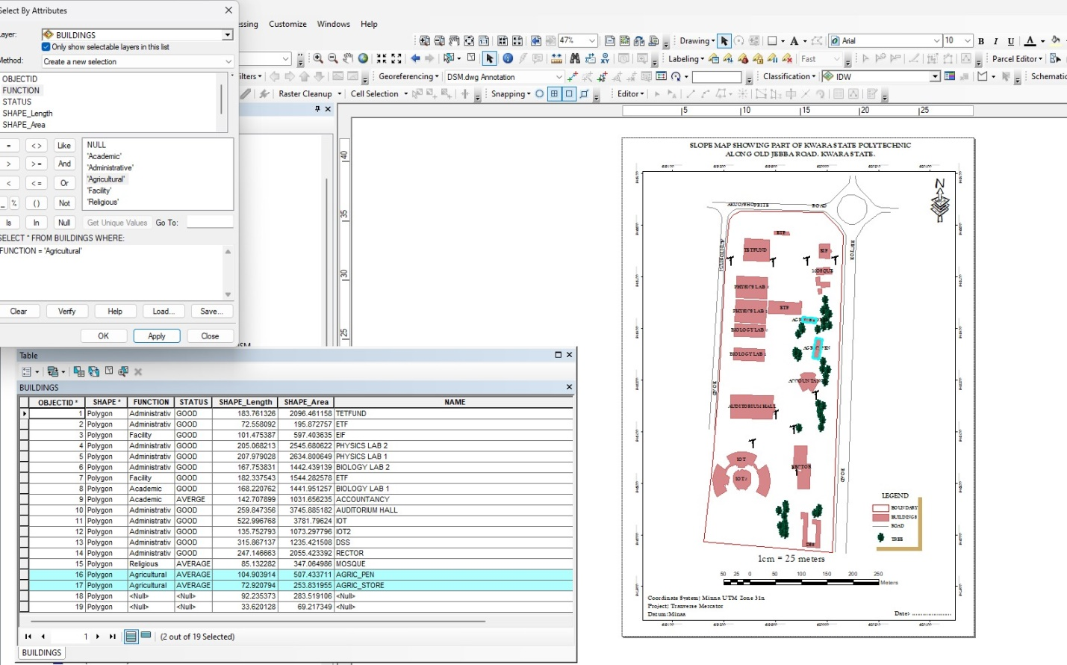
Figure 4.2.1.2: RESULT OF QUERY: (BLD_FUNCTION = “AGRICULTURAL”).
ANALYSIS THREE
Analysis Name: Database extraction
Analysis Type: Single criteria analysis
Syntax: “BLD_ CODITION” =”ACADEMIC”
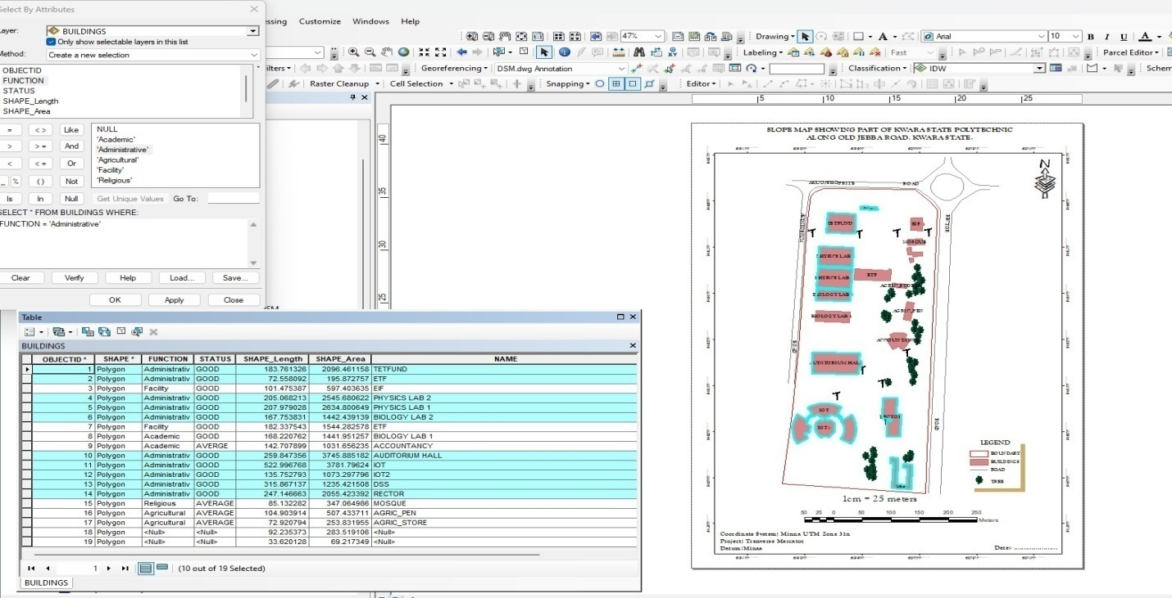
Figure 4.2.1.3: QUERY BLD_FUNCTION"ACADEMIC"
ANALYSIS FOUR
Analysis Name: Database extraction
Analysis Type: Single criteria analysis
Syntax: “TREE_FUNCTION= ORNAMENT”

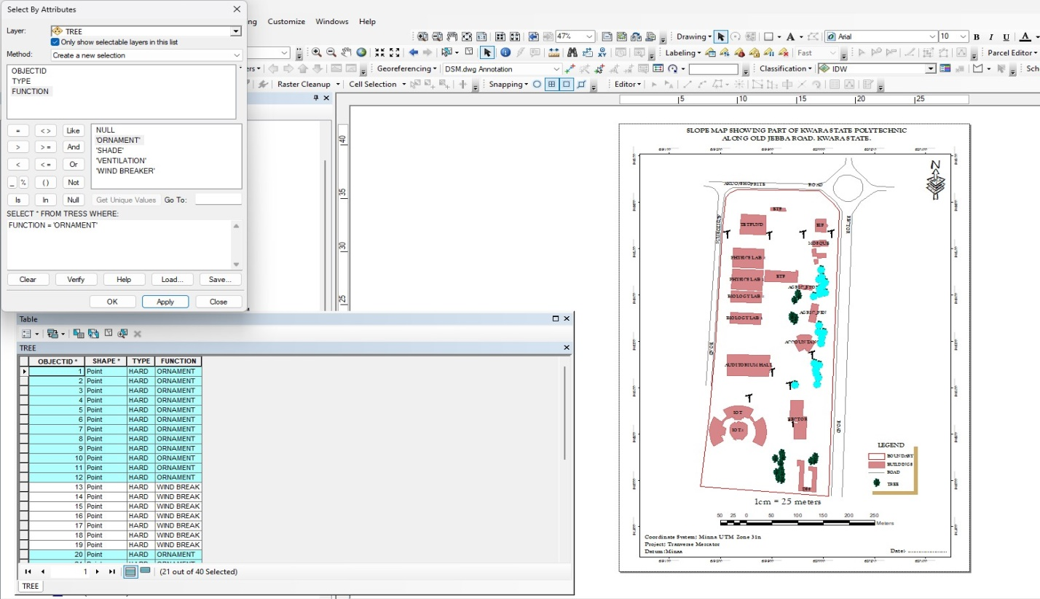
Figure 4.2.1.4: RESULT OF QUERY: (TREE_FUNCTION “ORNAMENT”).

4.2.2 MULTIPLE CRITERIA
This is a situation where two or more conditions are used to design a query. The conditions determine the information that may be requested by the user from the database.
Query for QUERY: TREE_FUNCTION “ORNAMENT” AND TREE_TYPE “HARD”

ANALYSIS FIVE
Analysis Name: Database extraction
Analysis Type: Multiple criteria analysis
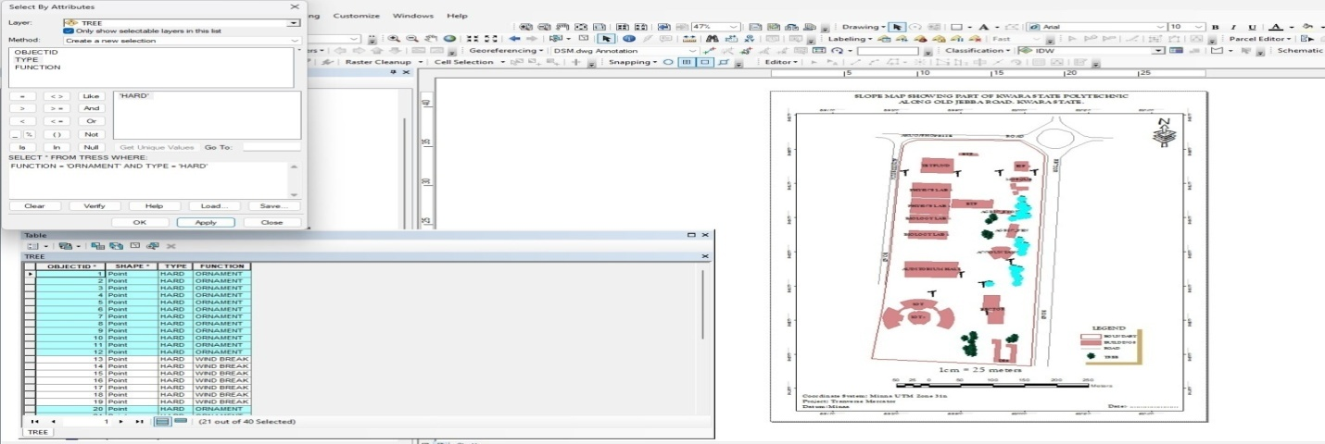
Figure 4.2.2.1 RESULT OF QUERY: TREE_FUNCTION “ORNAMENT” AND TREE_TYPE “HARD”
Query for BLD_FUNCTION =“RELIGIOUS” AND BLD_STATUS= “AVERAGE”
ANALYSIS FOUR
Analysis Name: Database extraction
Analysis Type: Multiple criteria analysis

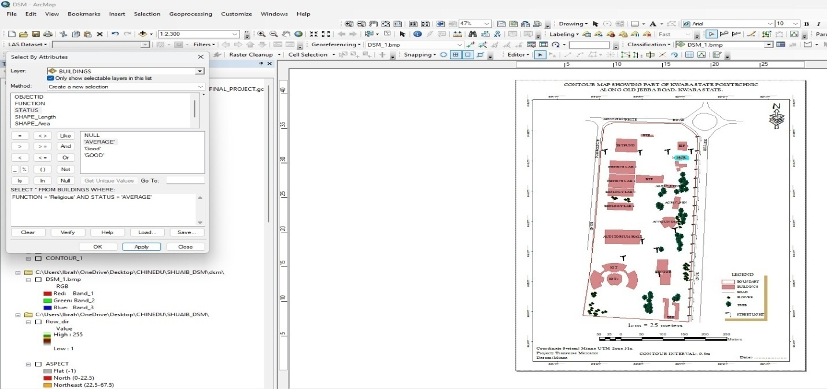
Figure 4.2.2.2 RESULT OF QUERY: BLD_FUNCTION =“RELIGIOUS” AND BLD_STATUS= “AVERAGE”

4.2 SPATIAL ANALIYSIS
This makes Geographic Information System (GIS) a unique analytical tool or technique because of its ability to combine spatial attribute data to produce information relevant for decision making. The basic GIS analysis performed in this project includes overlay and topographic operations. Maps on various themes were overlaid since they were from the same geometric origin.

4.2.1 OVERLAY OPERATION
This overlay operation is the presentation that shows different features within the project area. The outcome of overlay operation could be composite plan if it shows all the existing features, and boundary.

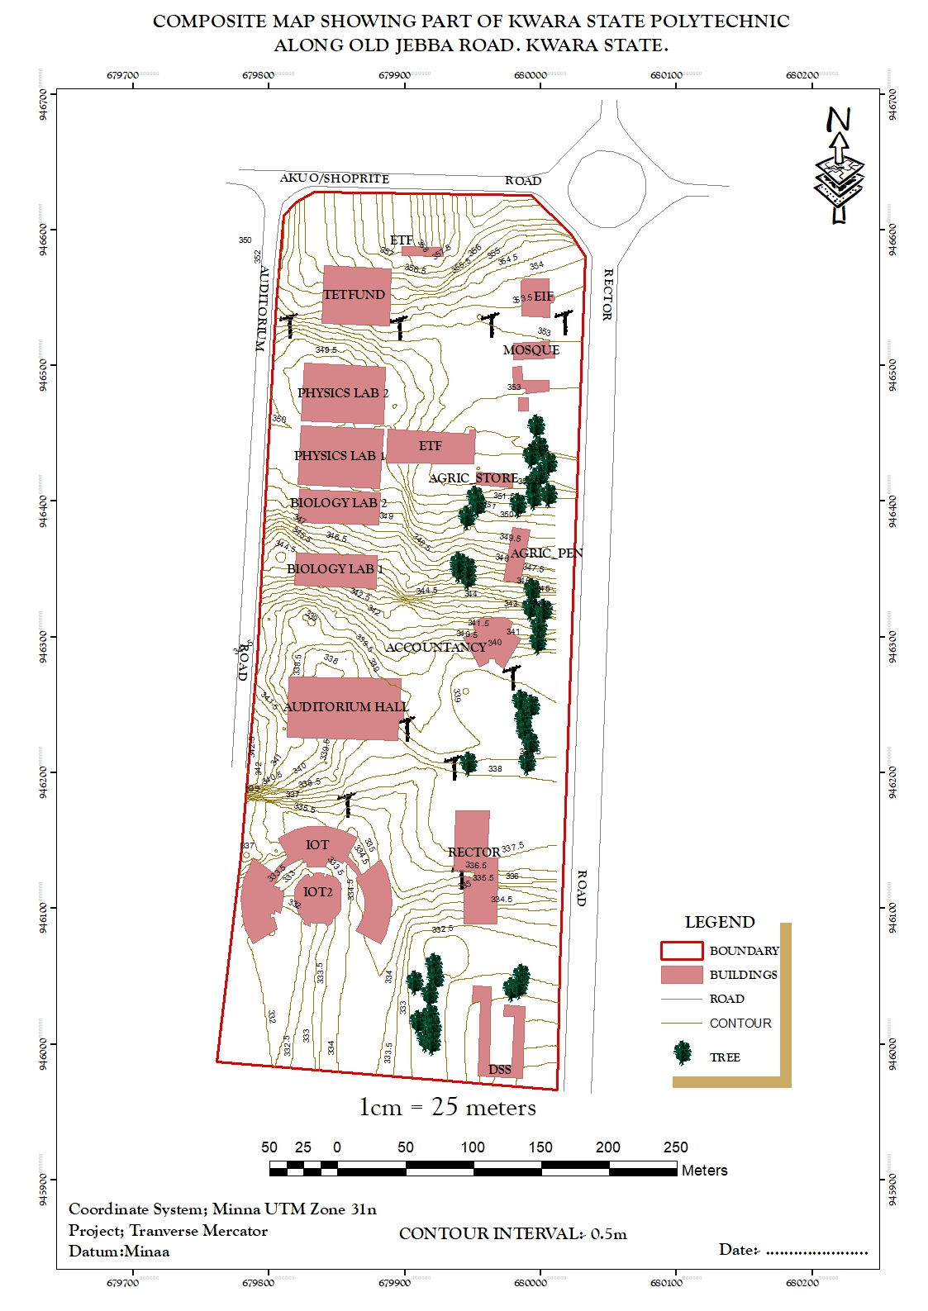
Figure 4.2.1: COMPOSITE MAP OF THE PROJECT AREA.

4.2.2 TOPOGRAPHICAL OPERATIONS
Topographic operations were carried out to determine the surface characteristic of the area which showed the relief of the project. These operations were performed on the Digital Elevation Model (DEM) generated from the use of relevant software, in this case, ArcGIS 10.5 and ArcScene 10.5 was used. The following maps were produced from the topographic operations and analysis:

- TRIANGULATION IRREGULAR NETWORK (TIN): this shows series of triangulated surface automatically generated from ArcGIS 10.5 using 3D analysis tools. This is applicable in finding suitable place for building or any engineering construction
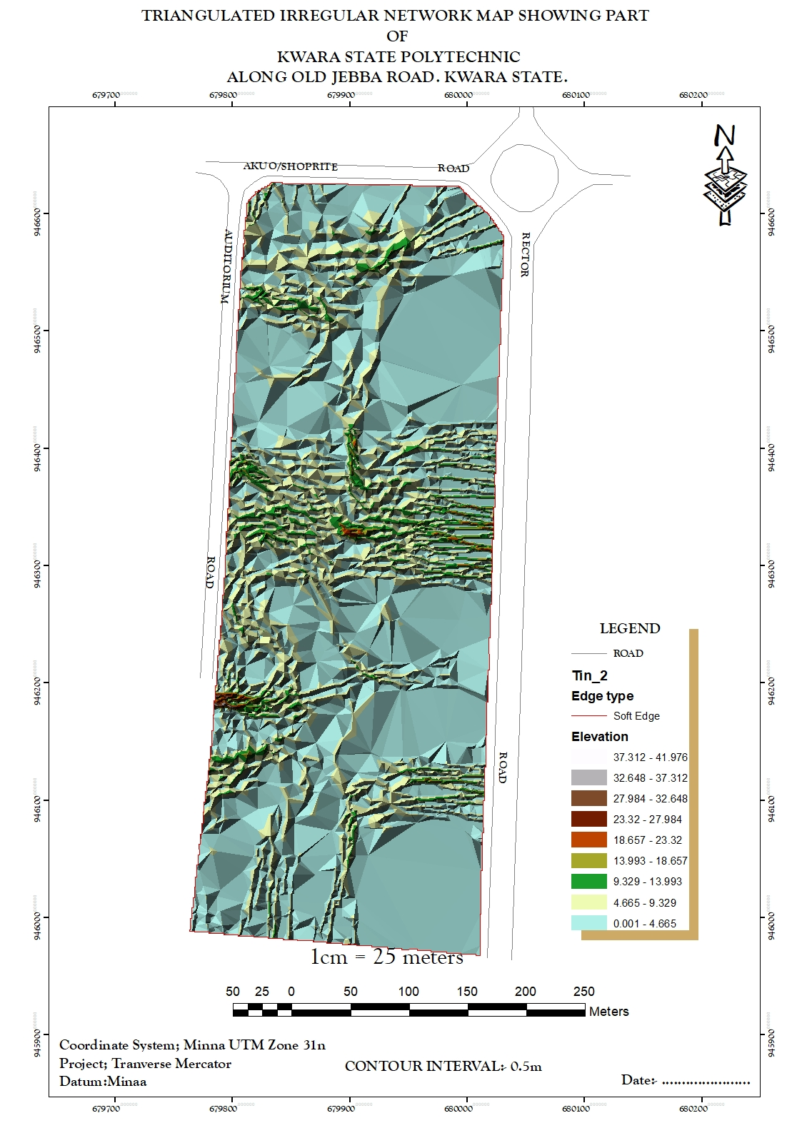
Figure 4.2.2.1: TIN AND DETAILS OVERLAY MAP OF THE PROJECT AREA

- SLOPE MAP: A slope map represents the gradient or steepness of the terrain's surface. It calculates the rate of change in elevation between neighboring pixels or points on a digital elevation model (DEM). Typically, slope is measured in degrees or percentage. Steeper slopes are represented by higher values, while flatter areas have lower values.
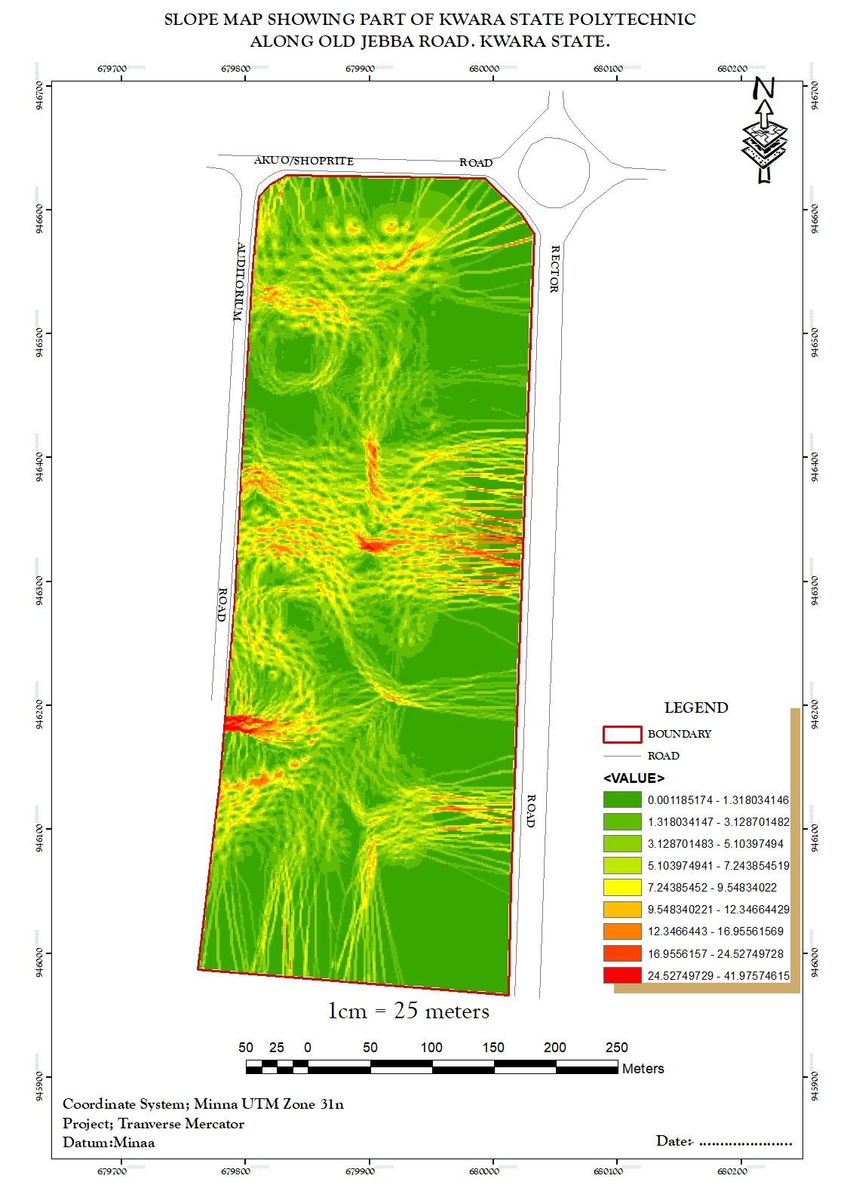
Figure 4.2.2.2: SLOPE MAP OF THE PROJECT AREA

- THE ASPECT MAP:
This shows the direction of the surface faces. It is used to determine how much sun a hill received and the information can be used to put building where they will get enough sun. Also the aspect map shows the suitable place for plane landing i.e. the flat terrain area and also solar illumination which can affect the diversity of life i.e. Vegetation and soil studies; glaciology.

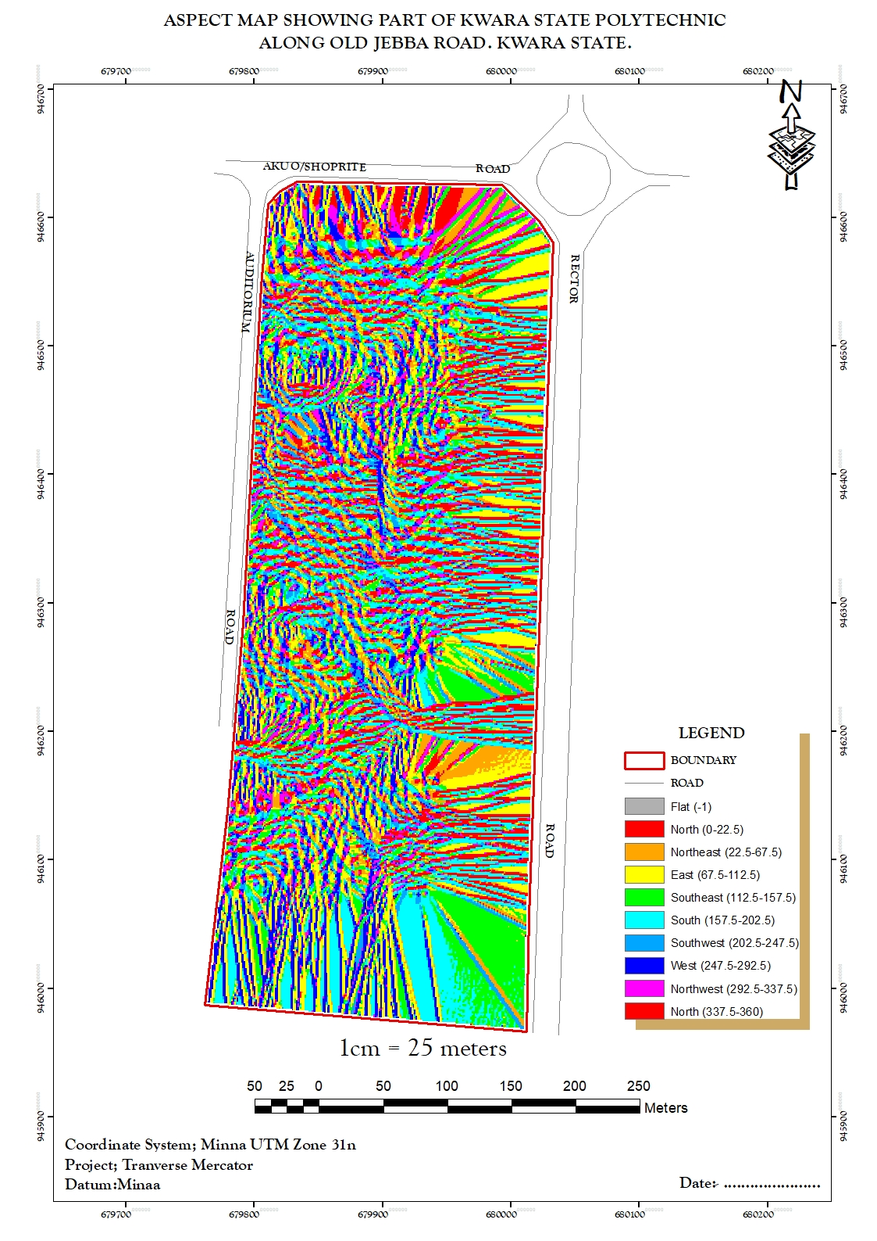
Figure 4.2.2.3: ASPECT MAP OF THE PROJECT AREA.

- THE CONTOUR MAP:
Contour maps display lines connecting points of equal elevation on the terrain surface. These lines, called contour lines, depict the shape and elevation of the land. Contour maps are widely used in topographic mapping and land surveying for visualizing elevation changes and terrain features. This provides a very intuitive view of the landscape. Contour map of the project area can aid in giving information on the highest and the lowest point on the terrain. This is important in road construction and location of other facilities like storage tanks for water distribution.
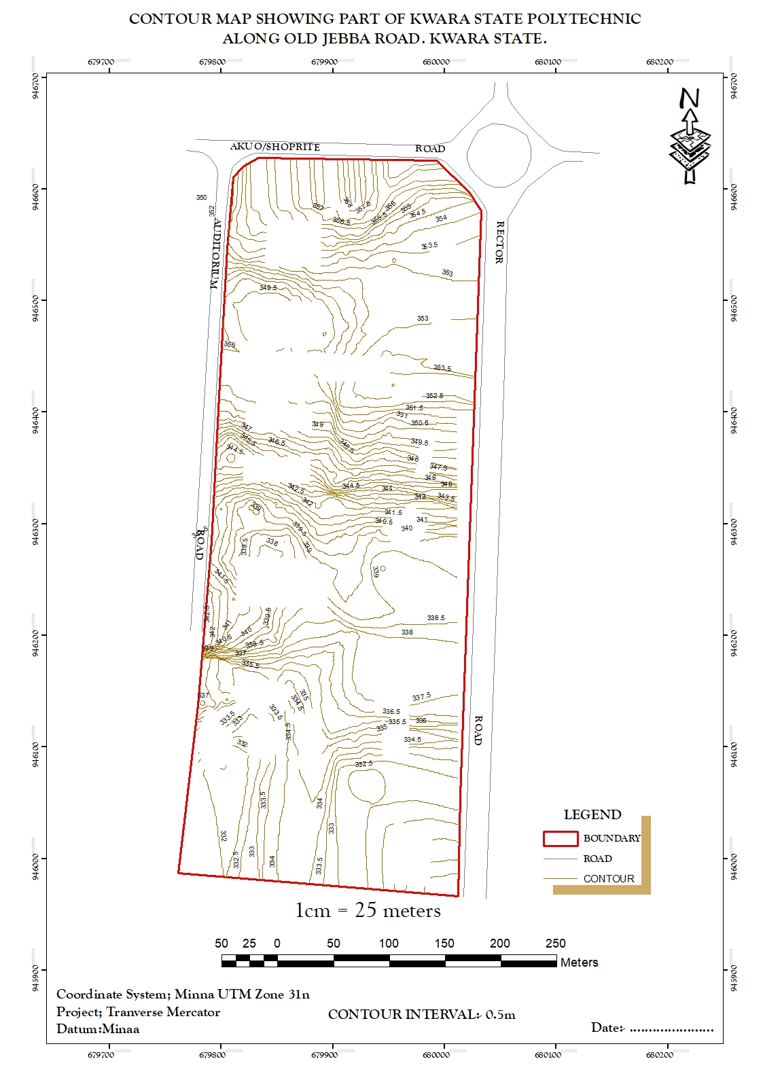
Figure 4.2.2.4: CONTOUR MAP OF THE PROJECT AREA.

- FLOW DIRECTION MAP:
This is used to determine the direction of flow of water within the project area. It also indicates the magnitude and erosive force water passing through an area.
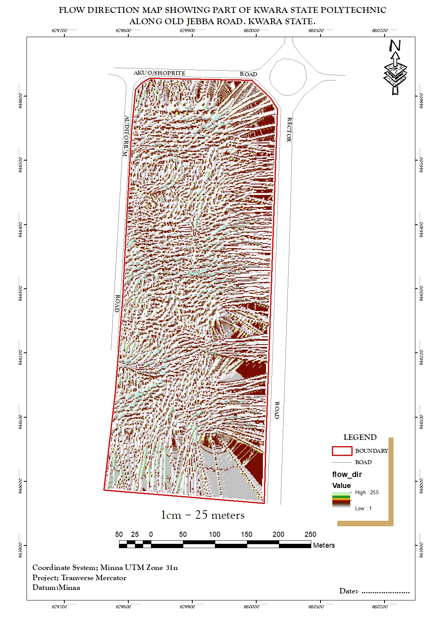
Figure 4.2.2.5 FLOW_DIRECTION MAP OF THE PROJECT AREA

- DIGITAL SURFACE MODEL MAP:
A DSM (Digital Surface Model) map, or Digital Surface Model, represents the elevation of the Earth's surface including all objects on it, such as buildings, vegetation, and other structures. Unlike a DTM (Digital Terrain Model), which only includes the bare-earth surface, a DSM incorporates both natural and man-made features. DSMs are useful for various applications, including urban planning, infrastructure design, and 3D visualization. They are often derived from aerial or satellite imagery, LiDAR data, or photogrammetry techniques. This shows the reality of the terrain of the project area.
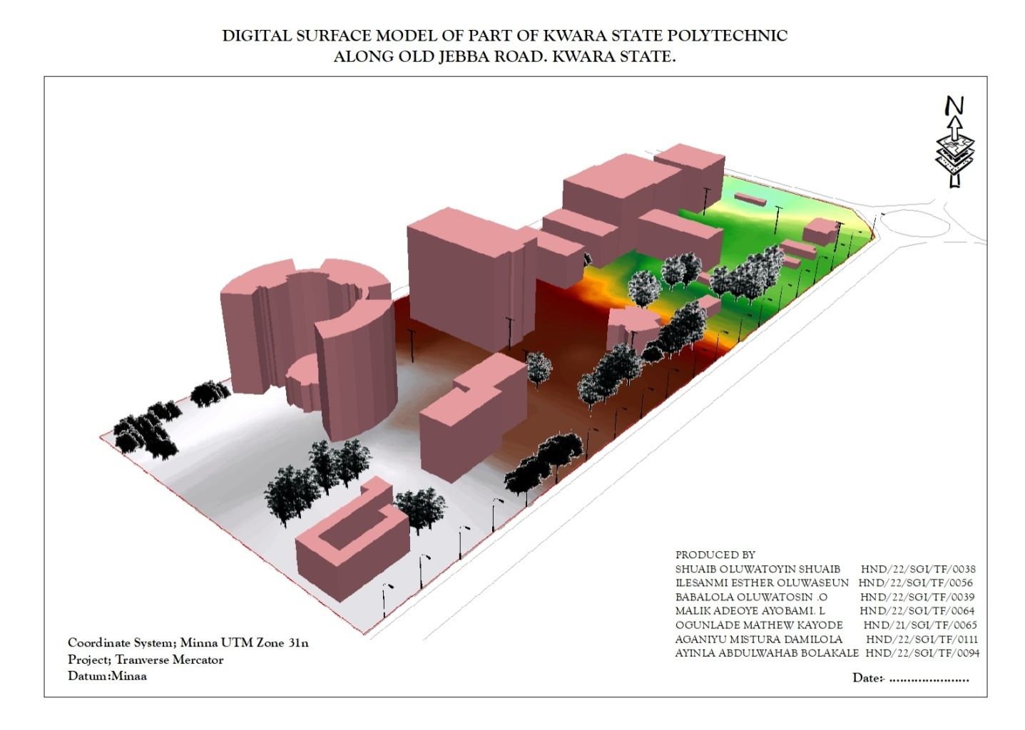
Figure 4.2.2.6: DIGITAL SURFACE MAP OF THE PROJECT AREA

4.3 RESULT ANALYSIS
From the below pie chart, it is inferred that large percentage is serving academic function. The DSM project commenced with the utilization of a Total station referenced to control station within Kwara State Polytechnic to capture 3D data of the project area. The captured data were then processed using software, employing photogrammetry techniques to generate a high-precision DSM and create a detailed 3D model. Subsequently, ArcGIS and ArcScene software was employed to visualize and analyze the DSM data, facilitating spatial analysis and information presentation both in 2D and 3D respectively.
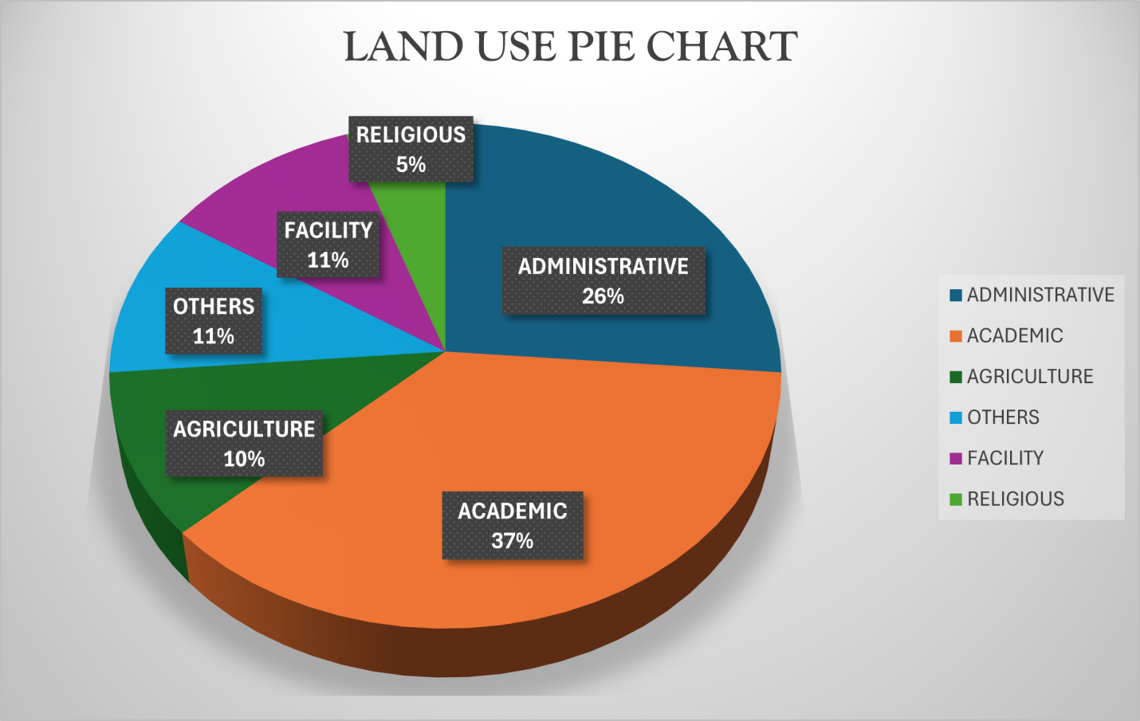
Figure 4.2.2.7: LAND USE PIE CHART

4.4 APPLICATION OF PROJECT
- Generally DSM is applicable in urban development modeling.
- It enhanced visualization and communication of such data not only in maps modeling but also in mobile digital devices for quick navigation and assessment.
- To create a sustainable and favourable living environment.
- Positioning and monitoring of physical features, structures and engineering works on, above or below the surface of the earth to protect properties or investment.
- The feasibility studies through the use of line of sight analysis provide visibility between two points. This is good for network distribution in telecommunication.
- The profile graph is good road construction which will provide the cross section of the topography from which rivers, streams and depression can be shown. Points require bridges, culverts and filling can be known from the profile graph.
- The vector map shows the direction of rivers, streams and depression which helps in road construction.
- The aspect map shows the direction of the surface faces. It is used to determine how much sun a hill received and the information can be used to put building where they will get enough sun also used to find where different crop will do best and also the Converging/diverging flow; soil water properties.
- The aspect map shows the suitable place for plane landing i.e. the flat terrain area and also solar illumination which can affect the diversity of life i.e. Vegetation and soil studies; glaciology.
- The result from the analysis can be help in managing the land resources of the project area. With the DSM, adequate information has been provided for proper decision making on the school land. Proper allocation various land use can now be done without difficulty in the decision making process.
- The slope map which is used to find low- slope for potential construction site and high slope that may be vulnerable to erosion or landslide.
- Also, the slope map shows slope length which is important topographical parameters for soil erosion analysis and traditional soil erosion studied
- Contour map of the project area can aid in giving information on the highest point on the terrain as well as the lowest. This is important in Road construction and location of other facilities like storage tank for water distribution.

CHAPTER FIVE

PROJECT COSTING, SUMMARY, CONCLUSION AND RECOMMENDATIONS.

5.1 PROJECT COSTING

Table 5.1: RECONNAISSANCE
PERSONNEL | RATE/DAY | NO OF DAYS | UNIT COST | AMOUNT
Senior surveyor | 10000 | 1 | 10000 | 10000
Technical officer | 5000 | 1 | 40000 | 40000
Skilled labour | 5000 | 1 | 5000 | 5000
Transportation | 20000 | 1 | 20000 | 20000
Basic equipment | 5000 | 1 | 5000 | 5000
Sub-total |  |  |  | 80,000

DETAILING AND SPOT HEIGHTING
PERSONNEL | RATE/DAY | NO OF DAYS | UNIT COST | AMOUNT
Senior surveyor | 10000 | 4 | 40000 | 40000
Technical officer | 5000 | 4 | 20000*8 | 160000
Transportation | 20000 | 4 | 80000 | 80000
Basic equipment | 5000 | 4 | 20000 | 20000
Sub-total |  |  |  | 300,000

DATA PROCESSING
PERSONNEL | RATE/DAY | NO OF DAYS | UNIT COST | AMOUNT
Principal surveyor | 10000 | 5 | 50000 | 50000
Surveyor | 8000 | 5 | 40000 | 40000
Assistant Technical officer | 5000 | 5 | 25000 | 25000
Computer accessories | 15000 | 5 | 75000 | 75000
Sub-total |  |  |  | 190,000

INFORMATION PRESENTATION
PERSONNEL | RATE/DAY | NO OF DAYS | UNIT COST | AMOUNT
Senior surveyor | 10000 | 1 | 10000 | 10000
Technical officer | 8000 | 1 | 8000 | 8000
Standard set | 15000 | 1 | 15000 | 15000
Sub-total |  |  |  | 33,000

TECHNICAL REPORT
PERSONNEL | RATE/DAY | NO OF DAYS | UNIT COST | AMOUNT
Chief surveyor | 30000 | 1 | 30000 | 30000
Surveyor | 20000 | 1 | 20000*2 | 40000
Sub-total |  |  |  | 70,000

COST BREAKDOWN TABLE
PERSONNEL | AMOUNT(#)
Sum of the project base cost | 673,000
Mobilization/demobilization (10% of the project) | 67,300
Contingency (5% of the project) | 33,650
VAT (7.5% of the project) | 50,475
Accommodation (1.5% of the project) | 10,095
Grand total | 838,520

5.2 SUMMARY
Digital terrain modeling is an important component of GIS. Almost all current GIS software has some kind of DTM function in its functional capability specifications. In recent years, the rapid development of elevation data acquisition techniques has been witnessed. Numerous public-accessible global and national DEM databases have become available at various spatial scales. These advancements will certainly encourage more advanced applications in a broader application domain. DTM, in a broader sense, is not only the data representing terrain surface but also the provider of geographical analytical functions that derive and extract geographical/geomorphological parameters and features from digital elevation data. In many GIS application projects, particularly those dealing with environment, natural resources, and urban lives, use of DTM data and analytical functions has been a common practice. In the foreseeable future, it is expected that DEMs will progress in the following aspects:
• MoreA rapid and cheaper acquisition of high-resolution digital elevation data;
• More advanced generalization/extraction methods and algorithms in constructing multiscale DEMs from very large elevation datasets;
• Broader adoption and integration of DTM data and techniques in applications of specific application fields
5.3 PROBLEMS ENCOUNTERED
The problem encountered in the course of carrying out this project was:

The management of the Institution's refusal to approve the initially granted letter of permission has caused delays in the project's timely execution.

The harsh weather conditions, specifically the intense sun during data acquisition, pose significant challenges.

Financial difficulties are also impacting the project's progress.

5.4 CONCLUSION
Environmental management is no doubt a sine-qua-non for a sustainable built environment. As a resource to any nation, the environment should be well planned, developed, conserved and managed (Adedokun&Adewara, 2017). For this reason there is the need for a robust system to host the voluminous amount of topographic data so that data manipulations and several spatial and non-spatial data analysis can be performed to produce relevant topographical information. Up to date digital map produced from satellite images are very vital in developmental process, infrastructure maintenance, fault detection and rectification by any utility management scheme. Digital map of the utility supply network which is product of topographic survey is also very necessary for network extension and integration. It is anticipated by this paper that TIS should be adopted to support environmental management and used as a decision making tool.

5.5 RECOMMENDATIONS
Having considered various stages undergone in this project, I hereby recommend as follows;
From the results of the study the following recommendations are made:
- The Physical Planning: Unit of the institution should adopt this result as a Decision Support System (DSS) for planning purposes.
- There is need for proper construction of drainage system within the boundary to channel the volume of flow of water during raining season especially along the steep slope.
- Government should advocate for and implement sustainable practices in data acquisition and processing to minimize environmental impact.

REFERENCE
Adriana, A. and Nicholas, Y. (2002).“Sustainable Urbanization: Bridging the Brown and GreenAgenda”. University College London pp 31-35.
(Charles D. Ghilani& Paul R. Wolf 2008): Elementary surveying An introduction to Geomatics_12th edition
Harrison, JD, Birrell, SJ, Sudduth, KA and Borgelt, SC (1992).Global positioning
system applications for site-specific farming research. Proc ofASAE, Nashville, Tennessee, Paper no. 92-3615.
Keeble, Lewis (1969). Principles and Practice of Town and Country Planning,).In Shrapnel Urban Planning http://www.shrapnel.com.au/planning.htm.
Kufoniyi, O. (1998):Database Design and Creation in C.U. Ezeigbo, Principles and Application of Geographic Information System. Pp. 46.
Li, (1994); Maume et al., (2001); Li et al., (2005) Jobin, (2010): Digital terrain modellingprinciples and methodology. Pp. 7 - 9. CRC Press. Boca Raton.
Maune, D.F., Huff, L.C., and Guenther, G.C. 2001.DEM user applications. In: Maune,
D.F. (Ed.), Digital Elevation Model Techniques and Applications: The DEM User
Manual, American Society for Photogrammetry and Remote Sensing, Bethesda, MD,
pp. 367–394.
Moore and Foster, (1990): Terrain Modelling in Surveying and Civil Engineering, Computer Aided Design, Vol. 19/4, Pp. 173.
Ndukwe, N.(2001): Digital Technology in Surveying and Mapping, principle, Application and Legislative Issues RhyceKerex Publishers, Enugu pg. 18-21.
Nkeki, F. N. (2013a). Living near high-voltage power lines: GIS-based modeling of the risk in Nigeria’s Beninregion.Applied GIS, 9(1), 1-20.

APPENDIX
E N ELEVATION
679549.147 940622.115 349.661
679571.054 940634.161 349.647
679592.961 940646.207 349.647
679614.867 940658.253 357.133
679636.911 940670.039 4330
679659.764 940680.158 349.661
679683.38 940688.339 349.661
679707.585 940674.572 349.647
679731.947 940700.18 349.661
679,756 940705.789 349.661
679780.673 940711.397 349.647
679805.036 947717.006 349.647
679829.399 940722.614 357.133
679853.761 940728.223 349.635
679878.124 940733.831 350.567
679902.468 940739.52 349.731
679926.406 940746.703 350.484
679949.664 940755.852 350.233
679972.079 940766.906 350.012
679993.497 940779.788 349.347
680013.768 940794.407 349.402
680032.752 940810.663 349.661
680050.318 940808.441 349.661
680067.208 940846.873 349.647
680084.097 940865.305 349.647
680100.986 940883.738 357.133
680177.876 940902.17 349.635
680134.765 940920.602 350.567
680151.654 940939.034 349.731
680168.544 940957.467 350.484
680185.433 940975.899 350.233
680202.323 940994.331 350.012
680219.212 941012.764 349.347
680236.101 941031.196 349.402
680252.991 941049.628 349.661
680269.88 941068.06 349.661
680286.77 941086.493 349.647
680303.996 941104.607 349.647
680322.097 941121.847 357.133
680341.038 941138.161 349.635
680360.77 941153.507 350.567
680381.244 941167.848 349.731
680402.41 941181.148 350.484
680424.213 941193.373 350.233
680446.601 941204.494 350.012
680469.485 941214.558 349.347
680492.472 941224.39 349.402
680595.455 941234.233 349.661
680538.44 941244.055 349.661
680561.426 941253.888 349.647
680584.411 941263.72 349.647
680677.396 941273.552 357.133
680630.382 941283.385 349.635
680653.367 941293.271 350.567
680676.352 941303.05 349.731
680699.337 941312.882 350.484
680722.323 941322.547 350.233
680745.308 941342.379 350.012
680768.296 941352.212 349.347
680791.279 941362.044 349.402
680814.264 941371.877 349.661
680837.249 941381.779 349.661
680869.234 941391.542 349.647
680883.22 941401.374 349.647
680906.205 941411.206 357.133
680929.19 941421.039 349.635
680952.175 941430.871 350.567
680975.161 941440.774 349.731
680998.146 941450.334 350.484
681021.216 941459.483 350.233
681044.482 941468.576 350.012
681067.77 941477.669 349.347
681091.057 941486.761 349.402
681114.345 941495.854 356.33
681160.921 941504.947 333.336
681184.209 941514.039 350.561
681207.496 941523.132 350.528
681230.784 941532.225 349.57
681254.072 941541.318 349.314
681277.36 941550.411 336.852
681300.248 941559.503 336.426
681323.935 941568.596 336.839
681347.223 941577.689 336.841
681370.511 941586.782 346.601
681393.799 941595.874 335.186
681417.087 941604.967 346.322
681440.374 941614.06 346.327
681463.662 941623.153 346.33
681486.95 961632.245 335.276
681510.238 941641.338 335.358
681533.526 941650.431 335.304
676356.26 938198.37 335.258
676368.289 938195.409 356.33
636364.319 938192.449 333.336
676368.348 938189.448 350.561
676372.377 938186.528 350.528
676376.407 938183.568 349.57
676380.436 938180.607 349.314
676384.465 938177.647 336.852
676388.495 938174.686 336.426
676392.524 938171.726 336.839
676396.553 938168.765 336.841
676400.583 938165.805 346.601
676404.612 938160.847 335.186
676408.648 938159.892 346.322
676412.698 938156.961 346.327
676416.763 938154.049 346.33
676420.842 938151.158 335.276
676424.936 938148.287 335.358
676429.044 938145.437 335.304
676433.158 938142.596 335.258
676437.272 938139.754 356.33
676441.386 938136.913 333.336
676445.5 938134.071 350.561
676449.615 938131.229 350.528
676453.729 938128.388 349.57
676457.843 938125.546 349.314
676461.957 938122.705 336.852
676466.071 938119.863 336.426
676470.185 938117.022 336.839
676474.299 938114.18 336.841
676478.415 938111.341 346.601
676482.538 938108.541 335.186
676486.49 938105.7 346.322
676490.808 938102.89 346.327
679494.943 938100.08 346.33
676499.079 938097.271 335.276
676503.215 938094.461 335.358
676507.351 938091.651 335.304
676511.487 938088.841 335.258
675515.622 938086.031 356.33
676519.758 938083.222 333.336
676523.894 938080.412 350.561
676528.03 938077.602 350.528
676532.166 938074.792 349.57
676536.302 938071.982 349.314
676540.437 938069.173 336.852
676544.573 938066.363 336.426
676548.709 938063.553 336.839
676552.845 938060.743 336.841
676556.981 938057.934 346.601
676561.117 938055.124 335.186
676565.252 938052.314 346.322
676569.388 938049.504 346.327
676573.524 938046.694 346.33
676577.66 938042.885 335.276
676581.796 938041.075 335.358
676585.932 938038.265 335.304
676590.067 938035.455 335.258
676594.205 938032.647 335.354
676598.354 938029.857 335.526
676602.517 938027.088 346.038
676606.694 938024.34 346.075
676610.884 938021.612 346.127
676615.086 938019.902 335.887
676619.289 938016.194 335.276
676623.492 938013.486 335.358
676627.695 938010.778 335.304
676631.898 938008.069 335.258
676636.101 938005.361 335.354
676640.302 938002.649 335.526
676644.48 937999.903 346.038
676648.63 937997.114 346.075
676652.759 937994.294 346.127
676656.887 937991.472 335.887
676661.014 937988.65 348.773
676665.142 937985.829 349.333
676669.269 937983.006 349.333
676673.397 937980.185 348.33
676677.525 937977.363 335.354
676681.652 937974.541 335.354
676685.78 937971.719 335.526
676689.907 937968.897 346.038
676694.035 937966.075 346.075
676698.162 937963.253 346.127
676702.29 937960.431 335.887
676706.417 937957.609 335.276
676710.545 937951.965 335.358
676714.672 937949.143 335.304
676718.8 937946.321 335.258
676722.927 937943.521 335.354
676727.069 937940.818 335.526
676731.276 937938.221 346.038
676735.548 937935.732 346.075
676739.885 937933.345 346.127
676744.278 937930.981 335.887
676748.684 937928.616 348.773
676753.089 937926.252 349.333
676757.495 937923.888 349.333
676761.901 937921.524 348.33
676766.307 937919.16 335.354
676770.713 937919.16 349.661
676775.118 937916.196 349.661
676779.524 937914.432 349.647
676783.93 937912.068 349.647
676788.336 937909.103 357.133
679950.479 946498.189 349.661
679950.491 946498.191 349.661
679950.504 946498.018 349.647
679950.518 946498.081 349.647
679934.511 946685.294 357.133
679950.555 946498.085 349.635
679767.154 946487.096 350.567
679889.863 946495.087 349.731
679908.552 946495.934 350.484
679922.324 946485.237 350.233
679938.369 946482.334 350.012
YB 679942.726 946447.667 349.347
YB 679951.616 946494.93 349.402
muu 679954.166 946493.685 356.33
zsu 680052.252 946663.441 333.336
Pl 679877.555 946362.24 350.561
kp704cp 679790.101 946612.117 350.528
Rd1 679797.106 946608.52 349.57
Rd1 679798.963 946607.102 349.314
PL1 679951.493 946504.835 336.852
PL2 679778.794 946218.243 336.426
PL3 679773.011 946212.525 336.839
Rd2 679776.97 946218.623 336.841
Rd2 679776.992 946218.657 346.601
Rd2 679874.136 946428.193 335.186
679884.297 946419.018 346.322
679874.159 946428.114 346.327
679935.313 946390.241 346.33
679761.812 946401.236 335.276
IOT 679767.23 946400.507 335.358
IOT 679766.877 946397.766 335.304
IOT 679767.39 946393.899 335.258
680034.027 946378.19 330.378
BLD 680039.434 946385.919 330.379
BLD 680029.451 946392.61 330.33
BLD 680064.95 946449.304 330.116
BLD 680072.991 946462.481 330.178
BLD 680060.274 946470.863 330.3306
BLD 680026.388 946279.188 330.553
CP1 680026388 946279.188 330.553
CP1 687969.31 946303.241 330.035
CP1 679967.787 946291.188 330.722
CP2 679915.507 945264.285 330.035
PT4 679938.317 946279.995 330.722
BLD 679960.805 946294.594 330.429
BLD 679944.446 946328.264 330.3306
BLD 679957.896 946322.486 330.859
679965.619 946311.485 330.622
679970.16 946304.965 330.05
679940.921 946298.082 330.256
679970.341 946298.082 330.731

