CHAPTER 1
- INTRODUCTION
1.1 Background to the Study
Height determination is an essential aspect of surveying that involves determining the vertical location of a point relative to a reference datum. Surveyors typically use different techniques to determine the elevation of a point, including trigonometric levelling, barometric levelling, and spirit levelling (Simbolon et al., 2017).
Levelling is a widely used method for determining the elevations of ground points relative to a reference datum. It involves measuring the vertical distance between the ground point and the reference datum to obtain what is known as the reduced level. This is an important procedure that is used in various fields such as mapping, engineering design, construction, and setting out. The reference datum used in levelling is usually the mean sea level, which is assumed to be an equipotential surface. This means that points on this surface have the same gravitational potential energy. As such, the mean sea level is adopted as the reference surface for vertical control surveys (Schofield & Breach, 2007; Uren & Price, 2010).
1.1.1 Leveling
Schofield and Breach (2007) opined that levelling is a technique used to determine the vertical location of a point on or beneath the surface of the earth relative to a reference datum, while planimetry refers to the horizontal position of a point relative to a coordinate system. The authors also noted that these two procedures are separate and distinct, as each involves different equipment, procedures, and techniques. This idea is further supported by Ghilani and Wolf (2014), who stated that levelling is primarily concerned with determining the elevations of ground points, whereas planimetry is focused on determining the position of those points in a horizontal plane. The choice of height system is critical in many applications, especially those that require accurate determination of elevation. For instance, in civil engineering projects such as road construction, it is important to know the elevation of the terrain to design the road profile, drainage, and culverts. The orthometric height system is widely used in such projects as it provides a meaningful height reference that is directly linked to the earth's gravity field.
However, other height systems, such as the ellipsoidal height system, are used in different applications. The ellipsoidal height system is based on the normal to the reference ellipsoid and is commonly used in satellite positioning systems such as GPS. The choice of height system depends on the application, and it is important to understand the differences between them to avoid errors in height determination (Torge, 2001).
Orthometric heights are determined by measuring the vertical distance between the point of interest and the geoid. This can be achieved through traditional techniques such as spirit levelling, trigonometric levelling, and GPS measurements (Odumosu et al., 2018). In spirit levelling, a series of measurements are taken with a level instrument, and the heights are computed based on the height of the instrument and the readings taken at the different locations. Trigonometric levelling involves measuring the angles and distances between two points and computing the height difference between them using trigonometric functions. GPS measurements use satellite signals to determine the height of a point above the ellipsoid and geoid is computed with high accuracy (Ghilani& Wolf, 2014).
The process of levelling involves using a levelling instrument to measure the vertical distance between the ground point and the reference datum. The levelling instrument consists of a spirit level and a graduated staff. The spirit level is used to ensure that the staff is held vertically, while the graduated staff is marked with a series of divisions that enable the observer to measure the vertical distance between the ground point and the reference datum. There are several methods for leveling observations in modern days, they include geometric leveling and trigonometric leveling methods (Lee & Rho, 2021). The choice of method to use largely depends on the accuracy desired, nature of the work to do and the availability of instrument to use.
1. 1.2 Total Station
The total station is a surveying instrument that combines the angle measuring capabilities of theodolite with an electronic distance measurement (EDM) and processing capabilities to calculate and determine horizontal angle, vertical angle and slope distance to the particular point.
The determination of the coordinates for an unknown point in relation to a known coordinate is achievable through the utilization of a total station, provided that a direct line of sight can be established between the two points (Putra et al., 2023). The process involves measuring angles and distances from the total station to the points under survey. Subsequently, trigonometry and triangulation are employed to calculate the coordinates (X, Y, and Z or northing, easting, and elevation) of surveyed points concerning the position of the total station. To get data on the distance of a point, the Total Station emits a wave, then the object will reflect the wave and be received back by the tool. Then the software inside the tool will automatically calculate the distance from where the tool stands to the measured point. To determine an absolute location, a total station requires line of sight observations and must be set up over a known point or with line of sight to two or more points with known location (Solomon, 2014).
1.2 Statement of the Problem
There is a need to evaluate the accuracy and reliability of digital leveling and total station equipment for height measurement, in order to determine which instrument is more suitable for specific applications.
1.3 Aim of the Project
The primary aim of this project is to compare the accuracy and reliability of digital leveling and total station equipment in determining height measurements.
1.4 Objectives
- To evaluate the accuracy of digital leveling and total station equipment in measuring heights.
- To assess the reliability of digital leveling and total station equipment in measuring heights.
- To compare the performance of digital leveling and total station equipment in different environmental conditions.
- To determine the suitability of digital leveling and total station equipment for various applications.
1.5 Scope of the Project
This project will focus on comparative evaluation of accuracy and reliability of digital levelling and total station equipment to determine the height measurement. The comparison will involve assessing the consistency of height readings, identifying sources of error, and determining the efficiency of each method in height determination.
1.6 Project Justification
This project is justified for the following reasons:
- Improving Accuracy and Reliability: The project aims to evaluate the accuracy and reliability of digital leveling and total station equipment, which will help to identify the most accurate and reliable instrument for height measurement for different applications.
- Reducing Errors: By identifying the most accurate and reliable instrument, the project will help to reduce errors in height measurement, which can have significant consequences in various fields.
- Increasing Efficiency: The project will help to increase efficiency in surveying, engineering, and construction by providing a comprehensive evaluation of the accuracy and reliability of digital leveling and total station equipment.
- Cost Savings: By identifying the most accurate and reliable instrument, the project will help to reduce costs associated with inaccurate height measurements and the need for rework.
- Contribution to Knowledge: The project will contribute to the existing knowledge on the accuracy and reliability of digital leveling and total station equipment, which will be useful for researchers, surveyors, engineers, and construction professionals.
1.7 Significance of the Project
Understanding the differences between height measurements obtained from a total station and leveling instrument is crucial for surveyors, engineers, and researchers involved in topographic mapping and elevation studies. By comparing the performance of these two methods, this project aims to provide valuable insights into the strengths and limitations of each technique, helping professionals make informed decisions in choosing the most suitable method for their specific surveying tasks.

1.8 Personnel
The project was assigned to and was successfully carried by the personnel listed below;
NAME | MATRIC. NO.
Ganiyu Akeem Abiodun | HND/23/SGI/FT/0076 | Writer
Abdul Kareem Ramota Olawumi | HND/23/SGI/FT/0078 | Member
Kazeem Kabirat Damilola | HND/23/SGI/FT/0079 | Member
Adeoti Qudus Adebayo | HND/23/SGI/FT/0080 | Member
Adeleye Sheriffdeen Olawale | HND/23/SGI/FT/0081 | Member
Abdul Qudus Shukurah Temitope | HND/23/SGI/FT/0083 | Member
Ogunsuyi Babatunde Sunday | HND/23/SGI/FT/0118 | Member
Jimoh Halimah Titilayo | HND/22/SGI/FT/082 | Member

1.9 Project Location
The project site is located inside Kwara state polytechnic Ilorin, Kwara state.
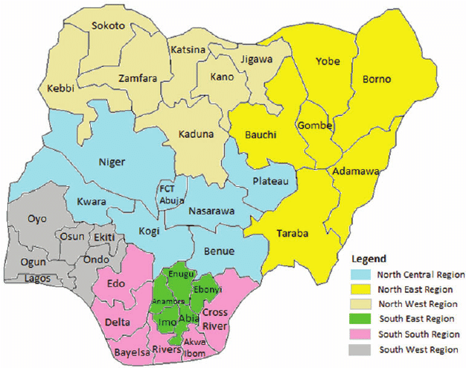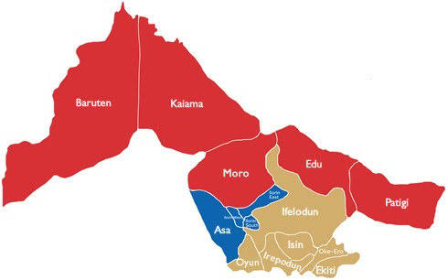
Map of Kwara State
Map of Nigeria
``

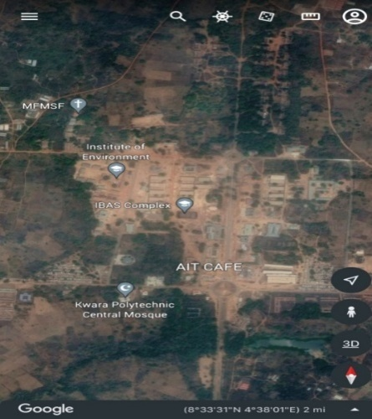
Figure 1.10: Study Area Map

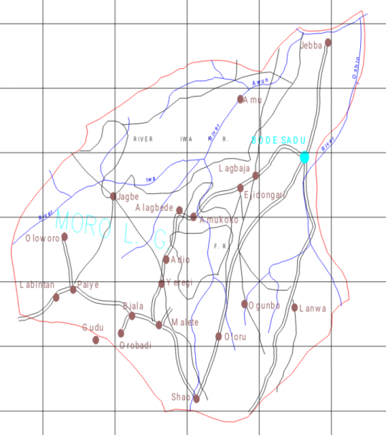

Google Imagery of the Study Area

Map of Moro L.G.A
CHAPTER 2
2.0 LITERATURE REVIEW
Height determination is an essential aspect of surveying that involves determining the vertical location of a point relative to a reference datum. Surveyors typically use different techniques to determine the elevation of a point, including trigonometric levelling, barometric levelling, and spirit levelling (Simbolon et al., 2017). Levelling is a widely used method for determining the elevations of ground points relative to a reference datum. It involves measuring the vertical distance between the ground point and the reference datum to obtain what is known as the reduced level. This is an important procedure that is used in various fields such as mapping, engineering design, construction, and setting out. The reference datum used in levelling is usually the mean sea level, which is assumed to be an equipotential surface. This means that points on this surface have the same gravitational potential energy. As such, the mean sea level is adopted as the reference surface for vertical control surveys (Schofield & Breach, 2007; Uren & Price, 2010). The total station is a surveying instrument that combines the angle measuring capabilities of theodolite with an electronic distance measurement (EDM) and processing capabilities to calculate and determine horizontal angle, vertical angle and slope distance to the particular point (Lin, 2014). The determination of the coordinates for an unknown point in relation to a known coordinate is achievable through the utilization of a total station, provided that a direct line of sight can be established between the two points (Putra et al., 2023). The process involves measuring angles and distances from the total station to the points under survey. Subsequently, trigonometry and triangulation are employed to calculate the coordinates (X, Y, and Z or northing, easting, and elevation) of surveyed points concerning the position of the total station (Reyes, 2021). To get data on the distance of a point, the Total Station emits a wave, then the object will reflect the wave and be received back by the tool. Then the software inside the tool will automatically calculate the distance from where the tool stands to the measured point. To determine an absolute location, a total station requires line of sight observations and must be set up over a known point or with line of sight to two or more points with known location (Solomon, 2014).
Leveling is the general term, which applied to any of the various processes by which elevations of points or differences in elevation are determined. It is a vital operation in producing necessary data for engineering design, mapping, and construction. Leveling results usually used to:
- Design highways, railroads, canals, sewers, water supply systems, and other facilities having grade lines that best conform to existing topography;
- Lay out construction projects according to planned elevations;
- Calculate volumes of earthwork and other materials;
- Investigate drainage characteristics of an area
- Develop maps showing general ground configurations;
- Study earth subsidence and crustal motion.
Leveling is the measurement of geodetic height using an optical leveling instrument and a level staff or rod having a numbered scale. Common levelling instruments include the spirit level, the dumpy level, the digital level, and the laser level. Total station instruments can accomplish all of the tasks that could be done with transits and theodolites and do them much more efficiently. In addition, they can also observe distances accurately and quickly. Furthermore, they can make computations with the angle and distance observations, and display the results in real time. These and many other significant advantages have made total stations the predominant instruments used in surveying practice today. These instruments are usually use for all types of surveys including topographic, hydrographic, cadastral, and construction surveys.
Previous studies have investigated the accuracy and reliability of digital leveling and total station equipment. For example, a study by (Awwad & Shaker, 2013) compared the accuracy of digital leveling and total station equipment and found that total station equipment exhibited higher accuracy. Another study by (El-Sheimy& Schwarz, 2010) evaluated the reliability of digital leveling equipment and found that it was affected by various factors, including instrument calibration and operator training.
Other studies have also investigated the factors that affect the accuracy and reliability of digital leveling and total station equipment. For example, a study by (Kang & Kim, 2015) found that the accuracy of total station equipment was affected by the quality of the instrument and the skill level of the operator. Another study by (Li & Wang, 2017) found that the reliability of digital leveling equipment was affected by the frequency of instrument calibration and the type of leveling rod used.
Furthermore, researchers have also explored the application of digital leveling and total station equipment in various fields. For example, a study by (Tao & Li, 2018) investigated the use of digital leveling equipment in monitoring the settlement of buildings. Another study by (Kim & Kang, 2019) evaluated the use of total station equipment in surveying large-scale construction projects.
Additionally, studies have also investigated the impact of environmental conditions on the accuracy and reliability of digital leveling and total station equipment. For example, a study by (Schwarz & El-Sheimy, 2011) found that temperature and humidity affected the accuracy of digital leveling equipment. Another study by (Kavanagh & Bird, 2017) found that weather conditions affected the reliability of total station equipment.
Height measurement is a critical component of various fields, including surveying, engineering, and construction. With the advancement of technology, various instruments have been developed to measure heights accurately and efficiently. Two such instruments are Digital Leveling instruments and Total stations. This chapter reviews the existing literature on the comparison of height measurement using Digital Leveling instruments and Total stations.
2.1 Digital Leveling Instruments
Leveling instruments are used to measure the difference in height between two or more points on the Earth's surface. These instruments are essential tools in surveying, engineering, and construction for determining the elevation of points, establishing reference levels, and monitoring changes in the terrain.
The earliest leveling instruments were developed in the 17th century, with the introduction of the "dumpy level" (Schwarz, 2003). This instrument used a telescope and a spirit level to measure the difference in height between two points. Over the years, leveling instruments have evolved to include digital levels, laser levels, and total stations.
Digital Leveling instruments are electronic devices that use sensors and algorithms to measure the angle of elevation and calculate the height difference between two points (El-Sheimy, 2004). They are widely used in surveying, engineering, and construction due to their high accuracy, ease of use, and compact design
2.2 Total Station Instrument
Total stations are electronic instruments that combine the functions of a theodolite and an electronic distance measurement (EDM) device (Schwarz, 2003). They are widely used in surveying, engineering, and construction due to their high accuracy, versatility, and ability to measure distances and angles.
The first Total Station was introduced in the 1970s, with the development of electronic distance measurement (EDM) technology (Schwarz, 2003). Since then, Total Station has evolved to include advanced features, such as GPS integration, robotic measurement, and 3D scanning.
2.2.1 Components of Total Station
Total Station consists of several components, including:
1. Telescope: A magnifying device used to observe the target.
2. EDM: An electronic distance measurement device used to measure distances.
3. Theodolite: A device used to measure angles.
4. Processor: A computer used to process the measurements and calculate the results.
5. Display: A screen used to display the results.
2.3 Comparison of Height Measurement Capabilities
Several studies have compared the height measurement capabilities of Digital Leveling instruments and Total stations. A study by Kang (2015) found that Total stations were more accurate than Digital Leveling instruments in measuring heights, with a mean error of 1.3 mm compared to 2.5 mm for Digital Leveling instruments.
2.3.1 Factors Affecting Height Measurement Accuracy
Several factors can affect the accuracy of height measurements using Digital Leveling instruments and Total stations. These include:
- Instrument calibration and maintenance (Schwarz, 2003)
- Environmental conditions, such as temperature and humidity (El-Sheimy, 2004)
- Operator error and training (Kang, 2015)
- Quality of the instrument and its components (Schwarz, 2003)
2.3.2 Advantages and Limitations
Digital Leveling instruments and Total stations have several advantages and limitations.
The advantages of Digital Leveling instruments include:
- High accuracy and reliability
- Ease of use and compact design
- Fast and efficient measurement
The limitations of Digital Leveling instruments include:
- Limited range and accuracy in certain environmental conditions
- Requires calibration and maintenance
The advantages of Total stations include:
- High accuracy and versatility
- Ability to measure distances and angles
- Wide range of applications
The limitations of Total stations include:
- Higher cost compared to Digital Leveling instruments
- Requires more training and expertise to operate
2.4 Literature Review on Comparison of Total Station and Levelling Instrument in Height Measurement
Digital leveling is considered one of the most precise methods for height determination. It employs an electronic level instrument and a bar-coded staff to measure vertical distances, reducing human errors common in conventional leveling (Wolf & Ghilani, 2012). The technology ensures high precision by minimizing reading errors, making it ideal for precise engineering projects such as dam construction, bridge alignment, and geodetic surveys. However, digital leveling can be time-consuming and less efficient over long distances, which limits its use in large-scale projects (Kavanagh, 2014).
Total stations integrate electronic distance measurement (EDM) and angular measurement capabilities, allowing surveyors to determine both horizontal and vertical positions efficiently. Unlike digital levels, total stations are multifunctional, supporting a range of applications from topographic mapping to construction staking (Schofield & Breach, 2007). However, the accuracy of height measurement using total stations is influenced by factors such as instrument calibration, target reflectivity, and atmospheric conditions, leading to potential errors in elevation determination (Ghilani, 2017).
Comparative studies also reveal differences in the application of these instruments in different terrains. Researchers such as Uren & Price (2010) argue that levelling instruments are best suited for flat or gently sloping terrain, where accurate benchmark elevations can be established. Total stations, on the other hand, perform better in rugged and mountainous areas, where direct levelling may be difficult or impractical.
In terms of cost analysis, various scholars have pointed out that levelling instruments are generally more affordable than total stations. Kavanagh & Bird (2009) mention that traditional levelling instruments have a lower initial cost, making them a cost-effective solution for small projects. However, the time-consuming nature of levelling surveys may offset this cost advantage in large-scale projects, where total stations provide a quicker alternative.
A study by Ghilani& Wolf (2017) compared the reliability of height measurements from both instruments and found that while levelling instruments consistently produced highly accurate results, total stations exhibited minor variations due to EDM-related errors. However, advancements in total station technology, such as improved angular encoders and compensators, have significantly enhanced their accuracy in height determination.
The effect of atmospheric conditions on measurement accuracy has been widely studied. Hofmann-Wellenhof et al. (2008) explain that total stations require careful consideration of temperature, pressure, and humidity adjustments to minimize EDM errors. Levelling instruments, being optically based, are less sensitive to these factors, making them more reliable in extreme weather conditions.
Scholars also examine the role of error correction techniques in height determination. Uren & Price (2010) highlight that both instruments require regular calibration and error checks to ensure accuracy. Total stations need periodic adjustments to their EDM units and angular measurement systems, while levelling instruments must be checked for collimation errors and bubble alignment.
2.5 Project Review
In conclusion, both Digital Leveling instruments and Total stations are capable of accurate height measurements. However, Total stations are generally more accurate and versatile than Digital Leveling instruments. The accuracy of height measurements using both instruments can be affected by various factors, including instrument calibration and maintenance, environmental conditions, operator error and training, and quality of the instrument and its components.

CHAPTER THREE
3.0 METHODOLOGY
Methodology is the systematic theoretical analysis of the methods applied to a field of study, it comprises the theoretical analysis of the body of methods and principles associated with a branch of knowledge. Typically, it encompasses concepts such as paradigm, theoretical model, phases and quantitative or qualitative techniques.
3.1 Reconnaissance
This has to do with framework of survey operation whereby all survey operations are going to base on.
Reconnaissance is also known as (Recce). Reconnaissance is examination of all part of an area accomplished insufficient detail to make generalization about the type and distribution of historical properties that may be present with a given project area. Also, is the process of having the general overview of the area to be surveyed with the view of determining the arrangement of the work such as method to employed, personnel to be involved, instrument to be used, scale at which plan/map is to be drawn. There are two stages of reconnaissance namely: Office and Field reconnaissance.
    - Field Reconnaissance
The first stage in this project was search for existing information in connection with the area in which the project was undertaken. Rough sketch diagram(recce) of the project area was drawn selecting and marking the approximate position of each point. To sum up, the reconnaissance facilitated the planning and execution of the actual survey as its takes into consideration, the possible problems that are likely to be encountered, and how such problems can be overcome or reduced to minimum.
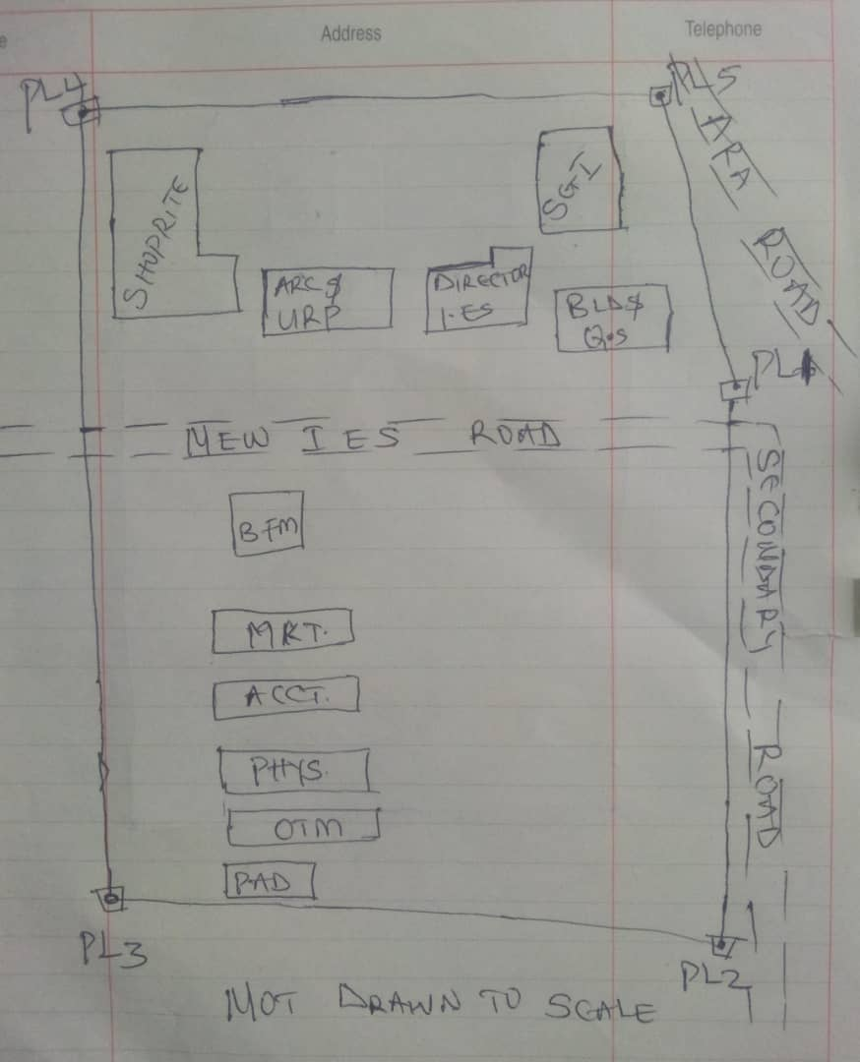

Recce diagram
3.1.2 Office Reconnaissance
Office reconnaissance/data gathering as the name implies is the exploratory survey, scouting or examination, to collect information necessary for the successful execution of the project. It can be simply define as making a preliminary survey before the actual mobilization for the project site. For the purpose of this project, the data search involved retrieving of the coordinate of three (3) existing control.
Pillar No. | Easting(m) | Northing(m) | Height | Location
KWPT 49 | 674341.289 | 937679.115 | 353.682 | Kwara Polytechnic
KWPT 50 | 674555.841 | 937618.402 | 354.903 | Kwara Polytechnic
Table 1: Show coordinates of existing and used control point.
3.1.3 Selection of Station
The boundaries as shown in the recce diagram were laid down by marking points on the ground (station).
The factors considered in selecting these stations include:
- Inter visibility between two points.
- Firmness of the ground at the selected point.
- Working convenience over the station.
- Points located where not disturbed.
3.2 Survey Rod
A survey rod is a physical marker, typically made of metal, used to mark the boundaries of a parcel of land. These markers are used to define the limits of a property and can be used as reference points for future surveys. Rods are durable and can be used in a variety of environments.
3.2.1 Survey rules guiding rod uses:
1. Placement: Rods should be placed at boundary corners or points of change in the boundary.
2. Visibility: Rods should be visible and easily identifiable
3. Durability: Rods should be durable and resistant to weathering.
4. Accuracy: Rods should be placed accurately, following the surveyed boundary.
5. Documentation: the location and description of rods or pegs should be documented in the survey records.

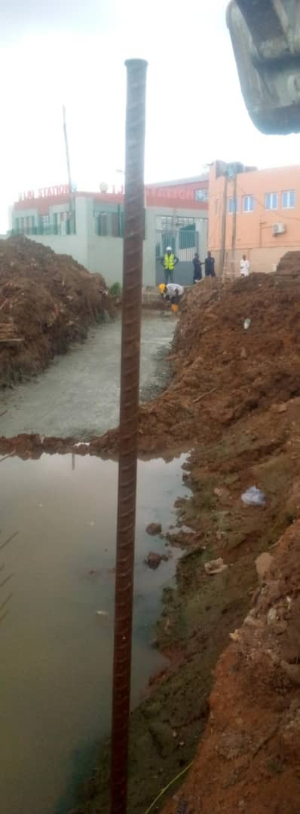

Figure 3.1: Graphical View of Cadastral Survey Rod
3.3 Instrumentation
It refers to the equipment and accessories employed for the successful execution of this project and they are as follows:
Hardware Used
- Stonex R2 Plus Total Station and its accessories
- Leica Digital Level instrument and its accessories
- Handheld GPS
- Hp Core i5 vPro 8th Gen Laptop
- Cutlasses
- Head-pan
- Nail and bottle cover
- 1 Hammer
- 1 Spade
- 1 Hand-trowel
Software Used
- AutoCAD 2007
- Golden Software Surfer 20.0
- Microsoft Office Excel 2013
- Microsoft Office Word 2013
Material Used
- Water
- Cement
Total Station:- It is an electronic or optical instrument used in modern surveying and building construction that used Electronic Distance Measurement (EDM). It is also known as electronic data collection and storage system of which all the data acquired on site is been stored and secured for office reconnaissance.
Digital Leveling:- It is considered one of the most precise methods for height determination. It employs an electronic level instrument and a bar-coded staff to measure vertical distances, reducing human errors common in conventional leveling.
Table 3.2: Equipment Description
S/N | Equipment | Uses
1 | Stonex R2 Plus Total Station | X, Y and Z coordinates of boundaries
2 | Leica Automatic Level | Determination of the reduced level
3 | Handheld GPS | X & Y coordinates of details
4 | Autodesk AutoCAD 2007 | Presentation of the boundaries
5 | Golden Software Surfer 20.0 | Contour and Generation of 3D model
6 | Microsoft Office Excel 2013 | X, Y and Y coordinates editing&program
7 | Microsoft Office Word 2013 | Report writing
3.4 Test of Instrument
For any survey job, testing of the instrument must be done before execution of the job, the instruments used for data acquisition were tested to ascertain whether they are in good working condition.
The following test were carried out,

3.4.1 Total Station
The total station instrument used (Stonex R2 Plus Total Station) underwent a two-phase check. Firstly, the vertical and horizontal angles were verified using pre-established control points within the school campus. Secondly, the electronic distance measurement (EDM) capability was tested for horizontal distances. The instrument passed all tests and was deemed suitable for use.
Below is the procedure for carryout the tests
3.4.1 Total Station
Instrument used in data acquisition was checked for integrity before moving them to site. Apart from check carried-out on Total Station, the following instruments were also checked: Tripod stand legs and their screw were confirmed okay, foot screws, focusing knob, vertical and horizontal knob for slow motion and clamp were all confirmed okay.
3.4.1.1 Horizontal Collimation Test
This error exists when the optical axis of the total station is not exactly perpendicular to the telescope axis. To test for horizontal collimation error, station A was selected and the instrument was set on it and leveled using three foot screws. Then, the telescope was rotated through 360°, but the bubble did not run out of the level tube centre which shows that the line of sight is parallel to the axis of the level tube.
Furthermore, the telescope was pointed to a target on station B in face left, then, pointed back to same target in face right; the difference in horizontal circle readings after averaging the result from both faces of the instrument was 180° except small variation is seconds which is permissible based on the allowable accuracy limit (least Count). The following results were displayed below.
Fairly Level Ground
STATION A
100m
REFLECTOR
(TARGET)
STATION B
Total Station

Fig 3.4.1.1: Horizontal Collimation and Vertical Index error test.
Table 3.4.1.1: Horizontal Collimation Data
Station | Target | Face | Hz Reading | Difference | Error
A | B | L | 38˚42’32”
 |  | R | 218˚42’35” | 180˚00’03” | 03”

3.4.1.2 Vertical Index Error Test
This test was performed to ensure that the vertical reading is exactly ninety degrees (90˚) when the line of sight is horizontal. Any deviation from this figure is known as vertical index error.
The Total Station was set over a point and necessary temporary adjustments were performed. A target set about 100m away from the Total station was sighted and bisected with the instrument on the face left and the reading was recorded. The target was also sighted and bisected on face right and the reading was also recorded. These readings are shown below
Table 3.4.1.2: Vertical Index Data
Instrument Station | Target Station | Face | Vertical | Sum | Error
A | B | L | 90˚00’00”
 |  | R | 270˚00’02” | 360˚00’02” | 02”

3.4.1.3 Analysis of Collimation and Vertical Index Data
The reading obtain during calibration were reduced to obtain new collimation and vertical errors.
Horizontal collimation = {(FR – FL) – 180}/2 = {(00˚00’03”}/2 = 1.5”
Vertical collimation = {(FL + FR) – 360} = (90˚00’00” + 270˚00’02”) - 360} = 02”
The result shows that the instrument is still in good working condition.
3.4.2 Digital Level Instrument
The level instrument employed for the research was Leica Digital level. Two pegs test was carried out on the digital level to check the collimation error of the instrument. The level instrument was set on a specific point A, with initial adjustments made for proper alignment, levelling, and focusing to eliminate parallax, it was now backsight on peg 1 and foresight on peg 2, the instrument was then now moved to another point B, and all the necessary adjustments were made, the peg 2 was bisected as backsight, and the peg 1 as foresight.

Level instrument STAFF (TARGET)

FairlyLevelGround
STATION A PEG 1
Fig3.4.1.1.:HorizontalCollimation errortest
Table3.4.2.HorizontalCollimation Data
STATION | Remarks | BS | IS | FS | Diff.
A | Peg 1 | 1.734
A | Peg 2 |  |  | 2.042
 |  |  |  |  | 0.308
B | Peg 2 | 1.578
B | Peg 1 |  |  | 1.262
 |  |  |  |  | 0.316
 | Collimation Error |  |  |  | 0.008
The difference of the two-pegs test from 2 stations (0.008), shows the instrument is in good condition and can be used for the project.
3.5 Control Check
The control points were found along the road in Kwara State Polytechnic. In order to determine their correctness and their true position, one was used as station point KWPT 49 while the point KWPT 50 was used as the backsight. The coordinates obtained were compared with the received data from Department Field Data Records, the difference falls within the allowable accuracy of 3rd order survey job as can be seen in Table 3.3 below:
Table 3.3:Analysis of control check
PILLAR | COORDINATE | EASTING(m) | NORTHING(m) | HEIGHT(m)
KWPT 49 | RECEIVED | 674341.289 | 937679.115 | 353.682
KWPT 49 | OBSERVED | 674341.289 | 937679.115 | 353.682
KWPT 49 | DIFFERENCE | 0.000 | 0.000 | 0.000
PILLAR | COORDINATE | EASTING(m) | NORTHING(m) | HEIGHT(m)
KWPT 50 | RECEIVED | 674555.841 | 937679.115 | 353.682
KWPT 50 | OBSERVED | 674555.853 | 937679.097 | 353.691
KWPT 50 | DIFFERENCE | 0.012 | 0.018 | 0.009
Allowable accuracy |  | 0.600 | 0.600 | 0.600
3.6 Data Acquisition
Data acquisition in land surveying refers to the process of collecting and recording data about the land, its features, and boundaries. This can include:
- Geometric data acquisition
- Attribute data acquisition
3.6.1 Geometric Data Acquisition
Geometric data acquisition involves collecting data that defines the spatial relationships and positions of features on the land. This can include:
- Coordinates: Collecting X, Y, and Z coordinates of points on the land using instruments like total stations, GPS, and levels.
- Distances and angles: Measuring distances and angles between points on the land using instruments like total stations and tape measures.
- Elevations: Determining the height of points on the land above a reference datum using instruments like levels and GPS.
The geometric data of this project was obtained using the total station i.e. combination of electronic theodolite and the Electronic Distance Measurement (for X, Y, Z determination), and Level instrument (for height measurement) Geometric data are positional data, (i.e. they have the X, Y, Z) coordinates which make it easy to locate their actual position of features on the earth surface.
Here is a step-by-step procedure used for Total Station for geometric data acquisition:
Preparation
1. Setup: The Total Station was set over a known control point (KWPT 49).
2. Leveling: Level the instrument to ensure accurate measurements.
3. Orientation: It was done using two know control points KWPT 49(as occupy station) and KWPT 50(as backsight)
Data Collection
1. Target sighting: Sight the target (reflector) at the point to be measured.
2. Measurement: Determination of X, Y, Z of the target.
3. Recording: Record the measured data (coordinates).
4. Repeat: Repeat the process for each point to be measured.
Here's a step-by-step procedure used for Level instrument for data acquisition:
Preparation
1. Setup: The Level instrument was set on a stable surface, ensuring it's level and secure.
2. Leveling: Level the instrument using the built-in leveling mechanism.
3. Focus: The telescope was focused on the target (staff or rod).
Data Collection
1. Backsight: Took a backsight reading on a benchmark (KWPT 49).
2. Foresight: Take foresight readings on points to be measured, ensuring the staff is held plumb.
3. Reading: Record the readings, including the staff readings and points description.
4. Repeat: Repeat the process for each point to be measured.
3.6.2 Attributes Data Acquisition
Attribute data refers to information that describes the characteristics and properties of spatial features. It provides details such as names, classifications, and functions of geographic objects. In this study, the attribute data collected Include the names of buildings (e.g., lecture room of office), as well as information on roads. Handheld GPS was used to acquire attribute data for this project.
Handheld GPS units we used to gather attribute data by:
Collecting positional data: the GPS determines the location (LATITUTDE, Longtitude, and sometimes elevation) of the point where we standing.
Attaching attribute: you can then link attribute information to that location. This could be done by entering the information manually, (e.g. using the keypad on the GPS unit) or by uploading the data to a computer.
Saving the data: the GPS saves the location data along with the attributes, creating a dataset of points with associated information.
3.7 Perimeter, Detailing and Spot Heighting
Perimeter is the total distance covered along the boundary line and an area of land, the total distance covered is 1.214km. It is very important in order to get the exact location of a property. Traversing is a subordinate to perimeter and it may be defined as the process of connecting the series of lines with known bearing and distances (or XYZ).
The Total Station was carefully set up over control point KWPT49, with a back sight taken to point KWPT 50 after performing the necessary station adjustments, including cantering, levelling, and focusing, the KWPT50 (backsight) was measured and the observed coordinates was compared with given one, the difference is not significant and allowable. Then peg1 was established and measured in other to transfer the control to the site. The same procedure was repeated to determine the coordinates of the next point (peg2), and continued progressively until the site was reached. The radiation method was used for data acquisition, where two or more points were coordinated from a single instrument station.
The following steps outline the procedure:
- After completing temporary adjustments, the instrument was powered on, and a new job titled PRJT1 was created in the internal memory under the job menu.
- In the coordinate menu, orientation was established by inputting the coordinates of the instrument station and back sight.
- The height of the instrument and the reflector height were measured and entered into the instrument.
- The reflector at the back sight was accurately bisected before confirming the orientation.
- Once oriented, the reflector was aimed at the next target (nail), and the "OBS" (observe) function was selected. The three-dimensional coordinates (Easting, Northing, and Height) were displayed and saved by pressing "REC" (record). For subsequent observations, the "ALL" option was used to streamline the process.
- It was ensured that the centre of the prism on the reflector was properly aligned and securely mounted on the tripod to minimize height determination errors.
- Once all visible details, including boundary points, spot heights and building, had been observed from the current station, the instrument was relocated to the next control nail, and the temporary adjustments were repeated.
This process was systematically carried out until all boundary points and elevation data were captured. In this project, spot heights were not recorded at regular grid intervals but were instead collected randomly after it has been pegged. For each building, three corner points were surveyed. Upon completing the data acquisition phase, all relevant features were accurately recorded and positioned accordingly on the final site plan.
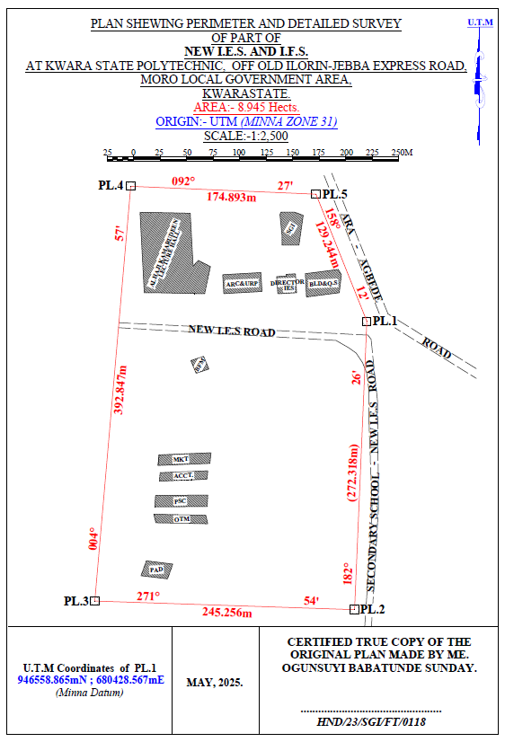
HND/23/SGI/FT/0076
GANIYU AKEEM ABIODUN
Figure 3.7: Plan shewing Perimeter and Detailed Survey.
Area Computation using Cross Multiply Coordinates
E1 N1
E2 N2
E3 N3
E4 N4
E5 N5
E1 N6
680428.567 946558.865
680417.004 946286.792
680171.885 946294.956
680205.833 946686.334
680380.567 946678.865
680428.567 946558.865

∑ - ∑
2
460,787,138,011.03 – 460,786,959,116.36
2

178,894.67
2
Area = 89,447.335 sqft
Area = 8.945 hect.

CHAPTER FOUR
4.0 DATA DOWNLOADING, PROCESSING, ANALYSIS AND DISCUSSION
This chapter provides a detailed overview of the procedures involved in data download, data processing, correction, and data analysis conducted on the acquired data from the site and data presentation.
4.1 Data Download
All the recorded data was stored in the memory of the total station. To download the data, the total station was connected to a computer using a wired cable and downloading software. The software parameters were configured to match those of the instrument. The instrument's menu was accessed, and the memory manager was selected. From there, the "send data" option was chosen, and the file named "PRJT1" was located and downloaded to the computer through the software. The data was saved with a ".txt" file extension on the desktop of the laptop for further processing.
4.2 Data Editing
The downloaded geometric data were further processed to convert them into usable formats and improve their accuracy. The resulting coordinate data were edited using Notepad and Excel software. This file was then imported into AutoCAD2007 for additional processing.

4.3 Data Processing using Autocad 2007
Before using AutoCAD, we processed the coordinate data observed in the field by first transferring it into Notepad, then copying it into AutoCAD. The following steps outline the process for handling the data in AutoCAD:
- Launch AutoCAD on the computer.
- Click "New" from the application menu to start a new drawing.
- Type UNITS in the command line and press Enter.
- Select the desired unit type (e.g., decimal, architectural, engineering).
- In the menu bar, select the "Polyline" tool.
- Copy the data from Notepad and paste it into AutoCAD.
- Type Z (for zoom) and press Enter, then type E (for extents) and press Enter to adjust the view.
4.4 Results and Discussion
Table 4.4:Total station and Digital level Spot height Readings and their differences
REMARKS | EASTING | NORTHING | HEIGHT |  | DIFF.
REMARKS | EASTING | NORTHING | T.S | LEVEL | DIFF.
SH1 | 680272.275 | 946497.781 | 355.749 | 355.715 | 0.034
SH2 | 680267.717 | 946479.907 | 356.403 | 356.362 | 0.041
SH3 | 680273.327 | 946450.469 | 354.811 | 354.772 | 0.039
SH4 | 680287.358 | 946434.349 | 354.268 | 354.208 | 0.060
HSH5 | 680317.873 | 946433.648 | 355.036 | 354.984 | 0.052
SH6 | 680304.544 | 946455.727 | 355.710 | 355.668 | 0.042
SH7 | 680337.867 | 946463.436 | 355.448 | 355.386 | 0.062
SH8 | 680342.774 | 946441.708 | 356.295 | 356.240 | 0.055
SH9 | 680342.774 | 946441.708 | 356.736 | 356.680 | 0.056
SH10 | 680348.740 | 946443.460 | 355.971 | 355.931 | 0.040
SH11 | 680377.262 | 946451.836 | 355.725 | 355.673 | 0.052
SH12 | 680382.060 | 946482.711 | 355.318 | 355.277 | 0.041
SH13 | 680381.009 | 946518.108 | 354.819 | 354.766 | 0.053
SH14 | 680350.494 | 946509.345 | 355.174 | 355.128 | 0.046
SH15 | 680356.104 | 946484.813 | 355.033 | 355.005 | 0.028
SH16 | 680332.603 | 946480.960 | 355.228 | 355.188 | 0.040
SH17 | 680308.051 | 946470.796 | 355.517 | 355.464 | 0.053
SH18 | 680298.581 | 946490.422 | 355.834 | 355.802 | 0.032
SH19 | 680318.222 | 946506.191 | 355.726 | 355.678 | 0.048
SH20 | 680308.753 | 946526.168 | 356.148 | 356.096 | 0.052
Mean |  |  | 355.8163 | 355.7726 | 0.0437
Variance |  |  | 2.5758 | 2.5881 | 0.0123
Standard Deviation |  |  | 1.6049 | 1.6088 | 0.0039
Working Formulas for Mean, Variance and Standard Deviation Calculation
The mean is calculated as:
µ = ∑xi
n
µ= mean
xi = each point height
n = number of points
The variance is calculated as:
ꭤ²=∑(xi - µ)²
n
ꭤ²= variance
xi = each point height
µ= mean
n = number of points
The Standard Deviation is calculated as:
ꭤ = √ꭤ²
ꭤ= standard deviation
ꭤ²= variance
The table above shows the station Id, eastings, northings, total station height, digital level reduced level and the difference between the total station height and the digital level reduced level.
The comparison of the two pieces of equipment revealed variations within a specific range. The differences observed between the two pieces of equipment were found to be in the range of 0.028 to 0.062 meters. These differences indicate slight disparities in the measurements obtained from each instrument. Statistical analysis was performed to evaluate the mean, variance, and standard deviations of the observed differences. The mean difference was calculated to be 0.0437, indicating an average deviation between the measurements obtained by the two equipment. The variance, which quantifies the spread of the differences, was found to be 0.0123.
This value suggests that the variations in the measurements obtained by the two pieces of equipment were relatively consistent. The standard deviation, which provides a measure of the dispersion of the data, was determined to be 0.0039. This indicates that the differences between the measurements obtained from the two pieces of equipment had a moderate level of variability.
Overall, the results of the analysis demonstrate that there were slight variations between the measurements obtained from the two pieces of equipment. The mean, variance, and standard deviations provide insights into the magnitude and consistency of these differences, offering valuable information for assessing the accuracy and reliability of the equipment in question.

Figure 1:Bar chart showing heights obtained from the total station and level instrument

Figure 2:Histogram showing the difference in the two instrument’s result
The histogram presented above illustrates the distribution of deviations between the two methods being compared. The deviations are depicted in centimeter, showcasing the level of accuracy achieved by both methods. The histogram highlights that the deviations are tightly clustered and exhibit a consistent pattern.
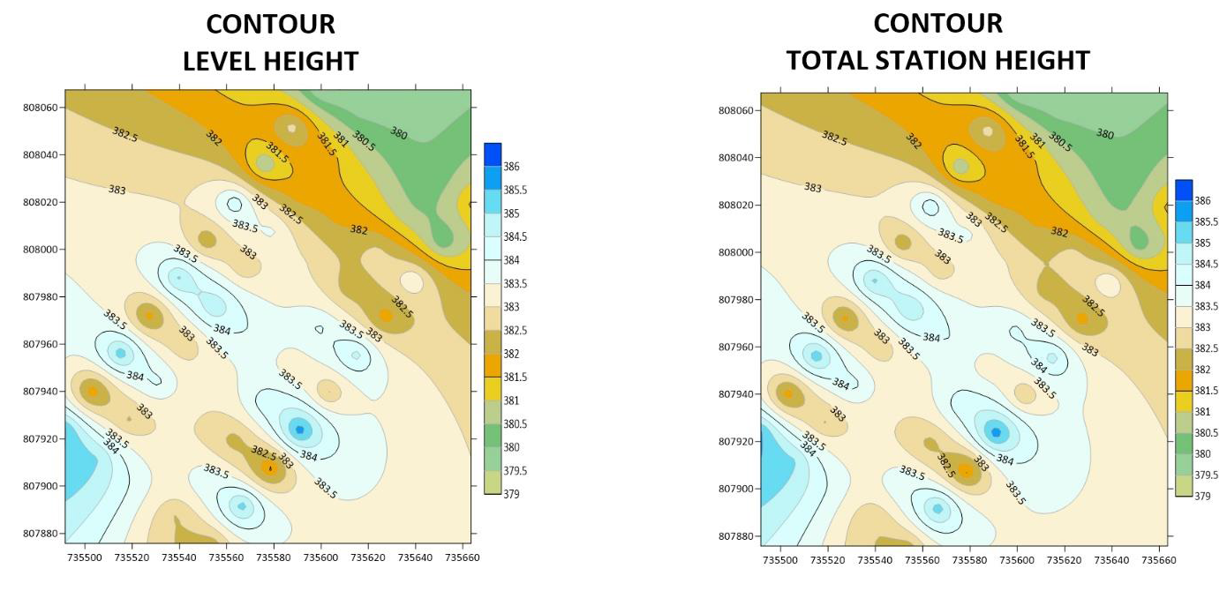Figure 3. Showing the contour map obtained from the two instruments.
3-D SURFACE MODEL USING TOTAL STATION
3-D SURFACE MODEL USING AUTO LEVEL
CONTOUR MAP USING TOTAL STATION
CONTOUR MAP USING AUTO LEVEL
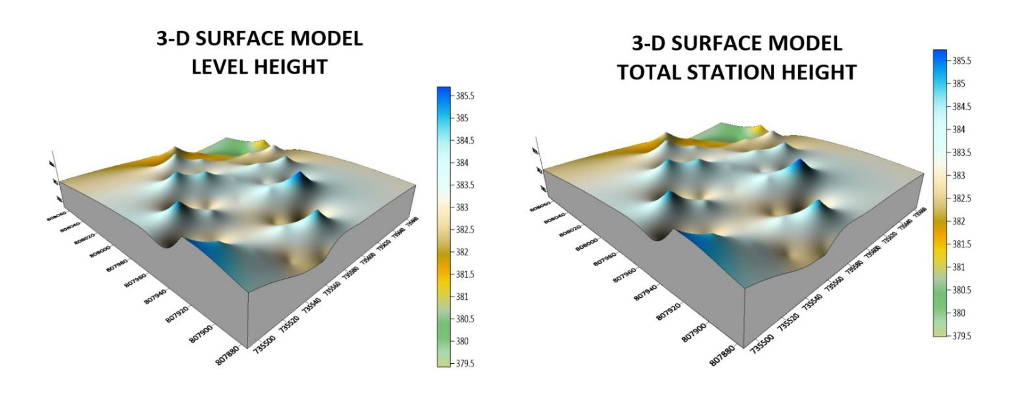Figure 4:Showing the 3D surface map obtained from the two instruments
The mean of the deviations, calculated to be 0.0437m, provides an indication of the average difference between the measurements obtained from the two methods. This value signifies a small average deviation, suggesting that the two methods generally yield similar results with minimal variation.
The histogram provides a visual representation of the data, allowing for a comprehensive understanding of the distribution of deviations. By examining the histogram, one can observe the concentration of deviations around the mean value, indicating a central tendency in the measurements obtained by the two methods.
The centimeter-level accuracy exhibited by the deviations underscores the precision of the measurement techniques employed. This level of accuracy is crucial, particularly in applications that require high precision, such as engineering, construction, or geospatial analysis. The contour maps presented above exhibit strikingly similar patterns, which serve as a testament to the high degree of precision achieved by the instruments used. The consistent and replicated patterns observed on the maps reinforce the reliability and accuracy of the measurements obtained.
The similarity in the contour patterns indicates that the instruments employed in the surveying process were able to capture the subtle variations in elevation with great precision.
This level of accuracy is crucial in applications such as topographic mapping, land surveying, and engineering, where even minor deviations can have significant implications. By displaying the contours of the surveyed area, the maps provide a visual representation of the landscape's topography and elevation changes.
The congruity in the contour lines across the maps signifies that the instruments effectively captured and recorded the elevation data, resulting in a reliable representation of the terrain
4.5 Statistical Analysis
A statistical investigation was carried out using Paired Two Samples as Means to test whether there is any significant difference in the performance of the two instruments for terrain height determination. The independent sample t-test is a member of the t-test family, which consists of tests that compare mean value(s) of continuous-level (interval or ratio data), normally distributed data (Hinton, 2004). The independent-sample t-test evaluates the difference between the means of two independent or unrelated groups. That is, we evaluate whether the means for the two independent groups are significantly different from each other.
Hypothesis
A hypothesis was set up and tested using an Independent – sample T-Test:
- Null Hypothesis: H0: There is no difference between the terrain height obtained from the total station and digital level instrument.
- Alternative Hypothesis: H1: There is a difference between terrain height obtained from total station and digital levelling instrument.
The null hypothesis is rejected if the calculated t value has a probability sig. (p) greater than the chosen significance level. An Independent sample T-Test was used in testing the hypothesis at a significance level of 0.05. Data analysis Package extension in Excel was activated and used in running the T-Test.
Table 4.5: T-Test: Two-Sample Assuming Unequal Variances
 | Digital Level | Total Station
Mean | 355.77262 | 355.81628
Variance | 2.588092118 | 2.575687471
Observations | 20 | 20
Pearson Correlation | 0.032104369 | 0.031950494
Hypothesized Mean Difference | 0.001605218 | 0.001597525
t Stat | 0.056215684 | 0.056208782
P(T<=t) one-tail | 0.145413689 | 0.144776257
P(T<=t) two-tail | 0.290982737 | 0.289552551
Sum | 7096.631 | 7095.814
Kurtosis | 2.049052417 | 2.0403051292
Skewness | 0.612867732 | 0.5907755549
Median | 354.772 | 354.811
Maximum | 356.680 | 356.736
Minimum | 354.208 | 354.268
Range | 2. 472 | 2.468
The statistical data provided supports our discussion by indicating a high degree of agreement and consistency between the digital level and total station measurements. The mean values are very close, the variances are similar, and the Pearson correlation coefficient indicates a strong linear relationship. The t-test results suggest that any observed difference between the two instruments' means is likely due to random variation rather than a significant discrepancy.
CHAPTER FIVE
5.0 COSTING, SUMMARY, RECOMMENDATION AND CONCLUSION.
5.1 Cost Estimation of the Project
The project costing was based on number of variables which includes area to be covered, instruments, personnel, transportation and so on. However, another critical factor to be considered is the time duration in which the project was executed. The table below shows the duration the project was accomplished.
Table 5.1: Scheduled and Duration of the Project Execution
Description | Duration (Days)
Reconnaissance | 1
Beaconing / Monumentation | 1
Spot height points establishment | 1
XYZ acquisition of the spot height points (using TS) | 1
Height observation of the spot height points (using level instrument) | 1
Detailing (using handheld GPS) | 1
Data Downloading / Processing | 3
Plotting and Report Writing | 7
Submission of Report and Plan | 5
Total No. of Days Spent for the Project | 21

5.1.1 Project Costing Breakdown

Costing of this project was based on Professional Scale of Fees as approved by Nigerian Institution of Surveyor (NIS) in 2017 using 1996 Federal Government Approved Scale of Fees for Consultants in the Construction Industry. The prevailing inflation rate as at February 2023 was 21.91 % and this was applied to the cost estimate.
Table 5.2: Worked out Calculation for the grand Total Cost
S/N | OPERATION | RATE/DAY | NO OF DAYS | UNIT  COST (#) | AMOUNT (#)
1 | RECONNISSANCE(1 DAY)
 | 4 Technician | 15,189.11 | 1 | 15,189.11 x 4 | 60,756.40
 | 1 Skilled Labour | 9,468.61 | 1 | 9,468.61x 1 | 9,468.61
 | Transportation (Field vehicle + Driver / Mechanic + fuel | 46,027.61 | 1 | 46,027.61 x 1 | 46,027.61
 | Basic equipment (Hand held GPS etc.) | 46,027.61 | 1 | 46,027.61 x 1 | 46,027.61
 | SUB TOTAL |  |  |  | 157,546.00
2 | - BEACONS (5)  (standard Cadastral Beacon) | 5,000 per Beacon |  | 5,000 x 5 | 25,000.00
2 | - BEACONING/  MONUMENTATION (1 day)
2 | 6 Surveyors | 15,189.11 | 1 | 6x 15,189.11x 1 | 91,134.11
2 | 3 Skilled Labour | 9,468.61 | 1 | 3x 9,468.61x 1 | 28,405.83
2 | Transportation (Field vehicle + Driver / Mechanic + fuel) | 46,027.61 | 1 | 46,027.61 x 1 | 46,027.61
2 | Basic tools (Crow bar, Trowel, Shovel etc) | 13,929.00 | 1 | 13,929.00x 1 | 13,929.00
2 | SUBTOTAL |  |  |  | 179,496.55
3 | Spot Height Establishment  ( 1 DAY)
 | 2 surveyors | 15,189.11 | 1 | 2x15,189.11 x 1 | 30,378.22
 | 3 Unskilled Labour | 9,468.61 | 1 | 3 x9,468.61x 1 | 56,811.66
 | Basic Equipment | 46,027.61 | 1 | 46,027.61x1 | 92,055.22
 | Transportation (Field vehicle + Driver / Maintenance + Fuel) | 46,027.61 | 1 | 46,027.61 x 1 | 92,055.22
 | SUBTOTAL |  |  |  | 271,300.32
4 | XYZ ACQUISITION USING (TS)  (1 DAY)
 | 1 Senior Surveyor | 22,783.67 | 1 | 1x 22,783.67 x 2 | 45,567.34
 | 2 Surveyors | 15,189.11 | 1 | 2 x15,189.11 x 2 | 60,756.44
 | 2skilled Labour | 9,468.61 | 1 | 2 x9,468.61x 2 | 37,874.44
 | Basic Equipment | 46,027.61 | 1 | 46,027.61x 2 | 92,055.22
 | Transportation (Field vehicle + Driver / Maintenance + Fuel) | 46,027.61 |  | 46,027.61 x 2 | 92,055.22
 | SUBTOTAL |  |  |  | 328,308.66
5 | HEIGHT OBSERVATIION (LEVEL INSTRUMENT)  (1DAY)
 | 1 Senior Surveyor | 22,783.67 | 1 | 1x 22,783.67 x 2 | 45,567.34
 | 2 surveyors | 15,189.11 | 1 | 2 x15,189.11 x 2 | 60,756.44
 | 2skilled Labour | 9,468.61 | 1 | 2 x9,468.61x 2 | 37,874.44
 | Basic Equipment | 46,027.61 | 1 | 46,027.61x 2 | 92,055.22
 | Transportation (Field vehicle + Driver / Maintenance + Fuel) | 46,027.61 | 1 | 46,027.61 x 2 | 92,055.22
 | SUBTOTAL |  |  |  | 328,308.32
6 | DETAILING  (1 DAY)
 | 2 Surveyors | 15,189.11 | 1 | 2x 15,189.11x 1 | 30,378.22
 | 3 Skilled Labour | 9,468.61 | 1 | 3x 9,468.61x 1 | 28,405.83
 | Transportation (Field vehicle + Driver / Mechanic + fuel) | 46,027.61 | 1 | 46,027.61 x 1 | 46,027.61
 | Basic Equipment | 46,027.61 | 1 | 46,027.61x 1 | 46,027.61
 | SUBTOTAL |  |  |  | 150,839.27
7 | DATA DOWNLOADING  / PROCESSING  (3 DAYS)
 | 1 Senior Surveyor | 22,783.67 | 3 | 22,783.67 x 3 | 68,351.01
 | 2 surveyors | 15,189.11 | 3 | 2x15,189.11 x 3 | 91,134.66
 | Computer Accessories | 49,315.28 | 3 | 49,315.28 x 3 | 147,945.84
 | SUBTOTAL |  |  |  | 307,431.51
8 | PLOTTING AND REPORT WRITTING  (7 DAYS)
 | 1 Senior Surveyor | 22,783.67 | 7 | 1x22783.67 x 7 | 159,485.69
 | 2 surveyors | 15,189.11 | 7 | 2x15,189.11 x 7 | 212,647.54
 | Standard set (computer, plotter etc) | 65,753.70 | 7 | 1x65,753.70 x 7 | 460,275.90
 | SUBTOTAL |  |  |  | 832,409.13
9 | SUBMISSION OF REPORT AND PLAN  (1 DAY)
 | 1 Chief Surveyor | 30,800.00 | 1 | 30,800.00x 1 | 30,800.00
 | 2 surveyors | 15,189.11 | 1 | 2x 15,189.11x 1 | 30,378.22
 | 1 Computer | 46,027.61 | 1 | 46,027.61 x 1 | 46,027.61
 | Consumables | 13,929.00 | 1 | 13,929.00 x 1 | 13,929.00
 | SUBTOTAL |  |  |  | 121,135.41
COST OF TH]E PROJECT = |  |  |  |  | 2,676,775.17 |  |  | 1,379,346.77
ACCOMODATION(15% of the cost of the project) |  |  |  |  | 595,177.22
MOBILIZATION/DEMOBILIZATION (10% of cost of the project) = |  |  |  |  | 396,784.81
CONTINGENCIES (5% of cost of the project) = |  |  |  |  | 198,392.41
VAT (7.5% of the Total cost of the project)= |  |  |  |  | 297,588.61
ACTUAL BILL/ GRAND TOTAL = |  |  |  |  | 4,164,718.22
Hence, the total cost of expenditure used for comparative evaluation of digital levelling and total station equipment for height measurement project was estimated to be Four Million, One Hundred and Sixty Four Thousand, Seven Hundred Eighteen Naira, Twenty Two Kobo only.
5.2 Summary
The comparative evaluation of digital levelling and total station equipment for height measurement reveals that both tools have their advantages and disadvantages. Digital levelling offers high precision and accuracy, particularly in precise levelling tasks, whereas total station equipment provides flexibility and versatility in various surveying applications. The project demonstrates that the choice between these two instruments depends on the specific requirements of the project, including the range, precision, and type of measurement. The results of this research contribute to a deeper understanding of the capabilities and limitations of digital levelling and total station equipment, ultimately enhancing the accuracy and reliability of height measurements in various fields.
5.3 Recommendation
This project recommends that surveying professionals and organizations invest in both digital levelling and total station equipment, as both tools have distinct strengths and limitations. By having access to both tools, professionals can select the most suitable equipment for specific projects, ensuring the accuracy and reliability of height measurements. Furthermore, it is recommended that professionals stay up-to-date with the latest technological advancements and best practices in surveying, to ensure that they are using the most effective and efficient methods for height measurement.
5.4 Conclusion
This comparative evaluation has provided valuable insights into the accuracy and reliability of digital levelling and total station equipment for height measurement. The project's findings demonstrate that digital leveling excels in precise leveling tasks, while total station equipment offers versatility and flexibility in various surveying applications. In conclusion, the choice between these two tools depends on the specific requirements of the project, including the range, precision, and type of measurement. By selecting the most suitable equipment, surveying professionals can ensure the accuracy and reliability of height measurements, ultimately contributing to the success of their projects. This project's results have significant implications for the development of more effective surveying methodologies and the advancement of surveying practices.

REFERENCES
Audu, H.A.P., Tijjani, M.Y. (2017). Comparative Assessment of the Accuracy of the Elevation differences obtained from different Geomatics Techniques and Instruments. Nigerian Journal of Environmental Sciences and Technology Vol 1, No. 1 pp 136 - 145
Beshr, A.A.A.; Abo Elnaga, I.M. ( 2011). Investigating the Accuracy of Digital Levels and Total Stations for Purposes of Geodetic Engineering. Alex. Eng. J. 50, 399–405 FIG Congress: Comparative Study of Digital Levelling and Total Station for Height Measurement.
International Journal of Civil Engineering: Digital Levelling and Total Station: A Comparative Study in Surveying Applications.
Journal of Spatial Science: Accuracy Assessment of Digital Levelling and Total Station in Surveying.
M. A (2018).Comparative Study of Conventional Surveying Techniques with Total Station and Digital Levelling International Journal of Civil Engineering Technology, 9, 440–446
Simbolon, A. B. S., Yuwono, B. D., &Amarrohman, F. J. (2017). Comparatory analysis of the accuracy between Total Station and Digital Levelling. UndipJournal of Geodesy, 6(4), 285-294. https://doi.org/10.14710/jgundip.2017.18153
W. Maembe, “Potential Application of Total Station Levelling as a Precise Geodetic Levelling” BSc. Thesis, Department of Geomantic Ardhi University Dare Salam Tanzania,2012.
APPENDIX
ID EASTING NORTHING TS HEIGHT LEVEL HEIGHT
PL.1 680428.567 946558.865 356.128
PL.2 680417.004 946286.792 354.746
PL.3 680171.885 946294.956 353.013
PL.4 680205.833 946686.334 357.652
PL.5 680380.567 946678.865 356.849
SH1 680272.275 946497.781 355.749 355.715
SH2 680267.717 946479.907 356.403 356.362
SH3 680273.327 946450.469 354.811 354.772
SH4 680287.358 946434.349 354.268 354.208
SH5 680317.873 946433.648 355.036 354.984
SH6 680304.544 946455.727 355.710 355.668
SH7 680337.867 946463.436 355.448 355.386
SH8 680342.774 946441.708 356.295 356.240
SH9 680342.774 946441.708 356.736 356.680
SH10 680348.740 946443.460 355.971 355.931
SH11 680377.262 946451.836 355.725 355.673
SH12 680382.060 946482.711 355.318 355.277
SH13 680381.009 946518.108 354.819 354.766
SH14 680350.494 946509.345 355.174 355.128
SH15 680356.104 946484.813 355.033 355.005
SH16 680332.603 946480.960 355.228 355.188
SH17 680298.581 946490.422 355.834 355.802
SH18 680318.222 946506.191 355.726 355.678
SH19 680308.753 946526.168 356.148 356.096
SH20 680342.774 946441.708 356.736 356.680
SHOPRITE 680275.567 946584.865 , S.G.I 680364.567 946630.865
SHOPRITE 680229.567 946585.865 , S.G.I 680368.567 946658.865
SHOPRITE 680218.567 946585.865 , S.G.I 680360.567 946661.865
SHOPRITE 680214.567 946661.865 , S.G.I 680347.567 946661.865
SHOPRITE 680262.006 946660.833 , S.G.I 680346.567 946659.865
SHOPRITE 680264.633 946610.907 , S.G.I 680348.567 946639.865
SHOPRITE 680269.493 946616.306 , S.G.I 680348.567 946630.865
SHOPRITE 680281.021 946610.551 , S.G.I 680364.567 946630.865
SHOPRITE 680281.021 946610.551
DRCT. IES 680344.567 946584.865 , BLD&QS 680371.567 946581.865
DRCT. IES 680343.551 946601.098 , BLD&QS 680370.514 946603.802
DRCT. IES 680352.430 946601.591 , BLD&QS 680401.497 946607.815
DRCT. IES 680352.329 946603.210 , BLD&QS 680404.537 946602.905
DRCT. IES 680361.208 946603.703 , BLD&QS 680402.499 946585.830
ARC&URP 680328.567 946604.865 , BFM 680262.567 946521.871
ARC&URP 680292.567 946602.865 , BFM 680267.567 946509.867
ARC&URP 680293.684 946585.013 , BFM 680279.567 946513.862
ARC&URP 680329.684 946587.013 , BFM 680274.567 946525.865
MKT. 680215.442 946426.097 , ACCT.680262.660 946428.209
MKT. 680214.930 946436.134 , ACCT.680218.483 946419.645
MKT. 680263.075 946445.466 , ACCT.680218.891 946411.655
MKT. 680263.587 946435.430 , ACCT.680263.068 946420.219
PHYS. 680266.105 946405.563 , OTM. 680266.988 946386.384
PHYS. 680267.046 946394.755 , OTM. 680218.393 946380.018
PHYS. 680218.331 946387.08 , OTM. 680221.571 946372.409
PHYS. 680217.389 946397.897 , OTM. 680270.166 946378.775
PAD. 680240.402 946321.660
PAD. 680215.235 946320.874
PAD. 680218.077 946335.465
PAD. 680243.244 946336.252

