LAND INFORMATION SYSTEM
(A CASE STUDY OF PART OF ASA-DAM COMMUNITY AREA, ILORIN WEST LOCAL GOVERNMENT, KWARA STATE.) (LAND USEAGE)
PRESENTED BY

ADAMS FATIMO OLAMIDE
MATRIC NUMBER: HND/23/SGI/FT/0013

TO

THE DEPARTMENT OF SURVEYING AND GEO INFORMATICS,
INSTITUTE OF ENVIRONMENTAL STUDIES,
KWARA STATE POLYTECHNIC, ILORIN

IN PARTIAL FULFILLMENT OF THE REQUIREMENTS FOR AWARD OF HIGHER NATIONAL DIPLOMA IN SURVEYING AND GEO INFORMATICS.

JULY, 2025.
CERTIFICATE
I Adams fatimo olamide, with the Matriculation numberHND/23/SGI/FT/0013
hereby certify that all the information given in this project work was carried out in accordance with the survey Laws, Regulations and departmental instructions. To be submit to the Department Surveying and Geo informatics, Institute of EnvironmentalStudies, Kwara State Polytechnic, Ilorin. In partial fulfillment of the requirements for award of Higher National Diploma inSurveying and Geo informatics.

Candidate’s Name: Adams Fatimo olamide
Matric No:​HND/23/SGI/FT/0013
Signature ............................................... and ​Date:…………………………...

CERTIFICATION​
This is to certify that this project was carried out by Adams Fatimo olamide with matric number HND/23/SGI/FT/0013 in accordance with survey laws and departmental instructions.
___________________________​​​____________________________​

Surv. R. O. Asonibare​​​……………………………
Supervisor ​​​Signature & Date

Surv. R. S. Awoleye​​​…………………………..
Project Coordinator​​​Signature & Date​​

Surv. I. I. Abimbola​​ ​……………………………
Head of Surveying & Geo informatics Department ​Signature & Date

​​ DEDICATION
This project work is dedicated to Almighty Allah for His infinite-mercy and protections over my life and my families.

ACKNOWLEDGEMENT
​Glory be to Almighty Allah who gave me the opportunity to complete my ND and HND.
I’m grateful to project supervisor in person of Surv. R.O Asonibare, for his gracious technical advice and encouragement and his unreserved teaching guidance and supervision.​I also acknowledge my amiable lecturers in the department who encouraged me toward my academics.​
My profound gratitude goes to my Mother and Father, Mrs. Adams and Mr. Adams , who supported me through my academic both financially, spiritually, morally and for their advice towards my academics.
A special thanks for my husband (Mr lukman Muh’ bashir ) that saw me through my ND and stood with my during my HND I am very very grateful to o u to being my supporting engine in all perspective .

My sincere appreciation goes to my friends and course mate, odeniyi idayat boluwatife , Agbalaya Margaret, who always put me through what I didn’t understand through my academic. I am so happy to have you guys.
And again my sincere thanks goes to my fellow students for the love we showed each other.
Finally I thank myself for believing in me ,I thank myself for the hard work, I thank myself for never quitting instead I keeping pushing hard and forward and for always being me and no one else.

ABSTRACT
The need to improve on a system must begin with
glare lapse(s) in the existing system yearning for redress. The
desire for a much better way of going about the business evokes
intensive search for possible available alternatives. The process
ultimately leads the relevant stakeholders to discovery or
fashioning of a pragmatic model that will not only serve the
purpose more effectively and efficiently but will also have the
approval of the majority of the stakeholders and stand the test of
time. This study provided an overview of contributions made so
far on land information management systems, with the sole
purpose of ascertaining the progress recorded and inherent
challenges to the existing system. Nigerians suffer unnecessary
delays in obtaining land title and land title information. The
scenario has caused failure and abandonment of many
developmental projects. A more robust and integrated land
information management system that will provide timely land
information for the stakeholders in Nigeria is imperative.
In the field of Geospatial science input data can be generated using hardcopy maps,
photogrammetry, remote sensing and ground survey technique. In this research both
geometrical and attribute data were used. The geometrical data were generated using
ground survey technique, while the attribute data were generated from land
register/record of yobe state ministry of land and survey and field inspection. The data
were processed using AutoCAD and ArcView software. A prototype land information
system was successfully developed, comprising essential spatial and attribute
information of land parcels in the area of study. Such as plots and other cadastral
information, information of plots ID, owner’s, street, files, C of O, addresses,
development stage. Query analysis and geometric operations in this research includes
question such as; Residential Land use, Plots within MB Geidam Street, Plots that
does not have C of O, Developed plots, undeveloped plots, Low density plots,
Educational land uses, Police station among others. Conclusions were drawn based
on the suitability of Land Information System in land record keeping.

TABLE OF CONTENTS
Tittle page​i​
Certificate​ii
Certification​iii​
Dedication​iv​
Acknowledgement​v
Abstracts​ vi
Table of contents​ vii

CHAPTERS ONE
1.0 Introduction
1.1 Importance of Land information systems
1.2 Statement of problem
1.3 aim and objective of the project
1.4 Scope of the project
1.5 Project specification
1.6 Location of the project
1.7 Personnel

CHAPTER TWO
2.0 Literature review

CHAPTER THREE
3.0 Methodology
3.1 Reconnaissance
3..2.1 Office reconnaissance
3.2.2 Field reconnaissance
3.3.1 Equipment used
3.3.2 Hardware
3.3.3 software
3.4 Control check
3.5.1 Data source
3.5.2 Primary source
3.5.3 Secondary source
3.6.1 Geometric data acquisition
3.6.2 Perimeter
3.6.3 Detailing
3.6.4 Attributes social survey
3.7.1 Databases acquisition/implement
3.7.2 Database management systems (DBMS)
3.7.3 Data quality
3.7.4 Data integrity
3.7.5 Data security
3.8.1 Data processing
3.8.2 Drafting and plotting
3.8.3 Data base creation and procedures

CHAPTER FOUR
4.0 Spatial Analysis, data processing and presentation
4.1. Spatial Analysis
4.2 Testing of database
4.3.1 Queries
4.3.2 Spatial queries
4.4 Single criterion questions
4.5 multiple criteria queries
4.6 Results analysis
4.7 Applications of product
4.8 Spatial search
4.9 Spatial dependence

CHAPTER FIVE
5.0 Summary of conclusion
5.1 problem encountered
5.2 Recommendation
5.3 Costing

Chapter one
1.0 Introduction
Land may be defined as the solid part of the earth’s surface, in its totality; Land covers every part of the planet earth, because it also exists under the sea. It is a significant asset of any country. Without land there will be no country. The significance or wealth of any country or nation and its economic benefit and development are dependent on the stage of land and its usage. It is apparent, therefore, any information which serves as a key to financial investment, commerce industry and agriculture.

Land Information System (LIS)
A Land Information System (LIS) consists of an accurate, current and reliable land record cadastre and its associated attribute and spatial data that represent the legal boundaries of land tenure and provides a vital base layer capable of integration into other geographic systems or as a standalone solution that allows data stewards to retrieve, create, update, store, view, analyze and publish land information.
A boundary is a dividing line between physical or abstract spheres. They separate areas belonging to different territories, societies, jurisdictions, clans and natural and legal persons. They mark areas where something is allowed or forbidden. They describe the edges of spheres were unique conditions exist. The boundary line is the locus where conditions change. Boundaries are most important in our daily life. Every human being needs a personal sphere to survive.(International Journal of Environmental Design & Construction Management Vol. 17 No. 4 Published by Cambridge Research and Publications September), 2019.

A Land Information Management System (LIMS) is essentially a computerized tool for legal,
administrative and economic decision making for land use planning and development. It
consists of a structured database with spatial referenced land related attributes and spatial data
for a defined area as well as procedures and techniques for systematic collection, processing,updating and distribution of the data to aid in solving land management problems (Pindiga,2012).
Currently, the world has more or less become a global village and information on a particular phenomenon at one part of the globe may be required by someone at another part, at any point in time. The need for land information computerization and land titling procedure automation is more crucial now than ever before. A functional land information management system
should not only ensure that all data relating to land are consistent, correct and up-to-date but should also avail different users their required information without necessarily engaging in generation of new datasets. This entails the availability of land information to government, industry, business, academia and citizens to meet their needs through easy and simple access
solutions (Akingbade, 2005).

Land Use/Physical Planning
Land use or physical planning can be described as a process aimed at achieving orderly physical development with the overall aim of evolving a functional and liveable environment where individual and common goals can be achieved. In urban centres, the essence of land use
planning is to ensure that urban activities are organized and developed in physical space with due consideration for the protection of the public interest which include health, safety,convenience, efficiency, energy conservation, environmental quality, social equity, social
choice and amenity (Adeagbo, 1998; Nnah et al., 2007).
It can also be described as the systematic assessment of land and water alternative patterns of land use and other physical, social and economic conditions in such a way as to encourage land users to select options that increase productivity and meet societal needs in a sustainable
manner (Onibokun, 1985). This means that it is an art and science of organizing the use of land for the greater good of the society. Land use planning could therefore be expressed as physical planning. This is because physical planning attempts to achieve an optimal spatial coordination
of different human activities for the enhancement of quality of life (Olajuyigbe & Rotowa,2011).
Summarily, physical planning involves the reconciliation of land uses; provision of the
right site for the right use; control of development; provision of facilities, services and public goods; preservation, protection and conservation of resources; and preservation of heritage sites, among others (Oduwaye, 2009).
The use of information communication technology (ICT) in physical planning is not new; it has been in fact contemporary with the development of computers themselves. The investment
in research on urban models around the 1950s and 1960s was very intense and led to the development of some important models that were applied for the first time to real world case studies. An example is the Lowry Model (Lowry, 1964). These complex, aggregated models
were aimed not only to research but also to help some highly capacitated public agencies to start understanding urban and regional areas as systems that could be controlled as machines.
The period was described as the era of systems planning.
The 1980s brought to the limelight three instrumental features that were decisive for
rebounding the interest of planners on new tools that from then on were beginning to be named
as ICT:
i. Microcomputers which made the use of powerful computational and visualisation
resources cheap and available to everyone,
ii. More capable database technology, which allowed the use of larger and better datasets,
and
iii. The development of GIS as the first powerful tool to deal with data and cartography in
an explicit visual manner.
The 1990s and the 2000s were the coming to age decades of the development of new ICT in planning. After a rapid diffusion of the use of GIS among all levels of planning agencies,professionals understood that they could take the next step towards exploring new tools and new approaches that would not only make use of GIS but also benefit from their popularity to interest the practitioners, a wide set of new tools and decision support systems based on many
different concepts coming from different areas of knowledge—from physics to mathematics, from life sciences to economic theory. At the same time, computation became increasingly
more visual, and brand new technology was used to create the first feasible virtual
environments.
During these years, spatial and urban systems came to be regarded as complex ones; new disciplines were summoned, with researchers from all backgrounds becoming involved in the
study of urban matters. This brought an entire new perspective to the field. Complexity became a central perspective in urban research, spanning from the more perceivable social, institutional
and governance perspectives (closer to planning practitioners) to the mathematical and geographical perspectives (closer to researchers). The scenario gave birth to a wide set of ICT tools that are currently available for planning and policy design. They range from the use of advanced GIS, with new and more sophisticated methods of spatial analysis, to the enhanced
capacity of providing valuable visualisation (both on 2D and on 3D), to the development of new modelling tools based on several approaches, from cellular automata (Pinto & Antunes,2010) and agent-based simulation (Wise & Crooks, 2012), to discrete choice based models (Kakaraparthi & Kockelman, 2011), and to simulations based on optimization (Koomen et al.,2011).

1.1 Importance of Land Information System
1. Land parcel is the basic unit for access and control of land, land use decisions. 2. Current, reliable land information necessary for many public programs: land planning, infrastructure development and maintenance, environmental.
3. LIS provides a base for land markets, development, and other economic activity.
4. LIS helps in updating of the maps.
Therefore, land information system plays these five important roles;
• Location; what is at? To find what exist at a particular location.
• Condition; where is it? To identify what exist at a given location to find a
location where certain conditions are satisfied.
• Trends; what has changed since? To find the differences within an area over
time.
• Patterns; what spatial pattern exists? To know how the concentration of certain
activities and where they are located.
• Modeling; what if? To determine what happens, for example, if a new road
added to a network.

1.2 Statement of the Problem
Effective land information management not only provides the necessary information on the land title and records for the use of the stakeholders but also does that with dispatch. The current systems and practices of land administration in the states of the federation and Federal Ministry of Works, Land and Housing are mainly analogue systems. The systems are fraught with bureaucratic bottle-necks and human-engendered hiccups that inhibit timely completion of land
title perfection. The systems are frustrating and seriously put off prospective investors; they invariably militate against national economic development. Though some states and the federal Ministry of Works, Land and Housing have ventured into computerizing their cadastral records, their levels so far very much fall below what a good land information management system should provide to the stakeholders. Ukaejiofor (n.d) noted with dismay that despite the benefits of computerization of land information, only about 20% of the states in Nigeria have commenced the application of ICT in their land administration system. The need to leverage
and improve on the land information management system cannot be overemphasized especially in the contemporary age of information and communication technology (ICT) driven global economy. Computerizing land administration can ensure speedy processing of first registration of title, prevention of unnecessary duplications, and facilitation of access to land-related data
as well as in-built quality control measures, among others. Securing land title in Nigeria today is still shrouded in secrecy; prospective investors outside the country can hardly contemplate investing in Nigerian real estate due to this obvious
predicament. Access to land information is still very difficult and the government is invariably losing enormous revenue from the sector. The few states that have ventured into computerization of their land information system only automated a fraction of the entire sector which still makes them face challenges of delays and hiccups in processing and perfecting land
titles. There is therefore a dire need in today’s Nigeria to reduce the time it takes to processl and titles and their documentation. The Ministry of Lands and Urban Development in most
states comprises different departments which complement each other in the discharge of their core functions to the public. Improvement in their working relationships is imperative for better
service delivery. But before such improvement is considered, review of present processes is very necessary. Such a review will identify the existing gaps and likely areas that require
improvement. This study captures the aim and objectives of the existing land information management system and on that basis proposes recommendations of enhancement in the system that will cater for the needs of the present and future generations.

1.4 Aim and Objective of the Study
Improvements in information systems are essential due to constant changes in the ways
activities and outputs are carried out and expected. Land information is very crucial for any meaningful investment; investors must determine location choice of investment and many a
time, the time taken to arrive at a consensus contributes to the overall successes or failure of a
project.
Delays in obtaining land information in Nigeria is a serious challenge even with skeletal land information systems in use in some states; therefore, improvement on the existing system is imperative.
This study is aimed at proposing factors that should be considered based on the
existing systems while articulating improvement or developing another LIM system for effective and efficient land administration in Nigeria. The objectives of this research are:
- To ascertain the nature of the existing land information management systems.
- To develop a LIS database for monitoring plots allocation (Land Administration).
- Updating the manual records of land
- Digitizing all relevant Plans to create a spatial database.
- Creating a non spatial (attribute) database
- Link the spatial data with its attribute information.
- Subject the system to make queries and analysis
- Make appropriate recommendations.
- Acquisition of Spatial Data through Field Survey, office & Interviews.
- Presentation of information (Graphic & Reports)
1.5 Scope of the Project
1. office recce : plan the strategy of how to go about the project.
2. Data collection and integration: Gather and integrate data from various sources, including government records, surveys, and remote sensing.
3. GIS and mapping: Use GIS software to create and manage spatial data, including maps and 3D models.
4. Database design and development: Design and develop a database to store and manage land information.
5. User interface and visualization: Develop a user-friendly interface for querying, analyzing, and visualizing land data.
6. Reporting and analytics: Generate reports and analytics to support decision-making and planning.

1.6 Project specification

This specification provides a detailed outline of the requirements and specifications for the Land Information System of Ara villages

1. Data Sources: Government records, surveys, GPS data, existing maps and reports
2. Data Types: Spatial data (maps, boundaries), non-spatial data (land records, ownership information).
3. Data Collection: GPS-based data collection for surveying and mapping
4. Data Entry: Manual data entry for land records and ownership information
Data Formats: Shapefiles, GeoJSON, CSV, Excel
4. Data Visualization: GIS-based mapping and visualization of land data
5. Query and Analysis: Spatial and non-spatial queries and analysis of land data
6. Reporting: Generation of reports and maps for land administration and planning
7. Integration: Integration with existing systems, such as registration and taxation system

1.7 Location of the project
The location of project area is PART OF ASA-DAM COMMUNITY AREA, ILORIN, KWARA STATE. It is located in zone 31 of the Universal Transverse Mercator (UTM) system between longitude 4° 55’ E and latitude of 8º 48’ N in the north central geopolitical zone of Nigeria.

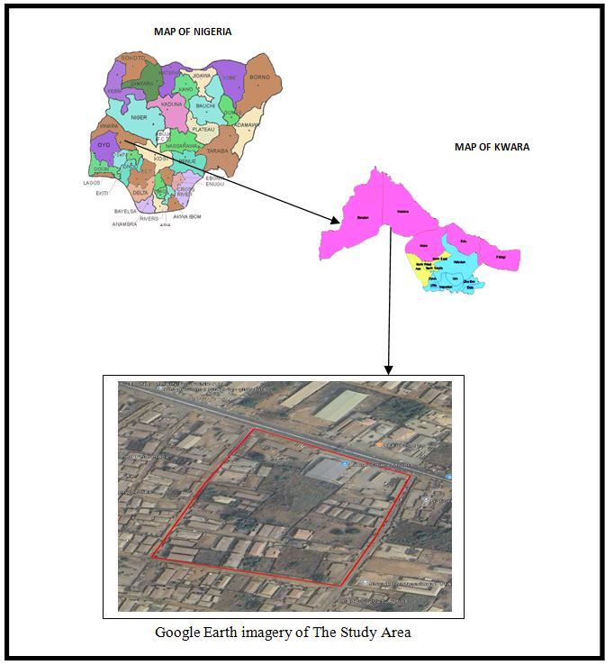

1.8 Personnel
Matric No Role
1. HND/23/SGI/FT/0013 Author
2. HND/23/SGI/FT/0006 Member
3. HND/23/SGI/FT/0007 Member
4. HND/23/SGI/FT/0009 Member
5. HND/23/SGI/FT/0011 Member
6. HND/23/SGI/FT/0012 Member
7.HND/23/SGI/FT/0014 Member

Chapter Two

2.0 LITERATURE REVIEW
A literature review of Land Information Systems (LIS) would encompass various studies and research papers on the development, implementation, and impact of LIS on land administration, management, and governance. Here's a brief overview:

Key Components of LIS
1. Land registration: Recording of land ownership and rights.
2. Land mapping: Spatial representation of land parcels and boundaries.
3. Land use planning: Management of land use and development.

Land Records and Title Registration
Maintenance of comprehensive and robust land records which are easily accessible by stakeholders is one of the most important issues facing governance today. "Land Records" itself is a general term and can include records such as the register of lands, Records of Rights (RoRs), tenancy and crop inspection register, mutation register, disputed cases register, etc. It can also include geological information regarding the shape, size, soil type of the land, and economic information relating to irrigation and crops (Ministry of Electronics and Information technology India [MeitY], 2011.
In Nigeria, the federal government developed a land information management system which is not only a land records system but its features also include:
ⅰ. A central control and monitoring of remote sites from the headquarters via the internet.
- Large data storage capacity of 10,000,000 records within an expandable system.
- Multi-user functionality: Up to 1000 users sharing same database.
- System entities are linked together within the relational database system.
- C of O to land to owner and to other transactions.
- Appropriate statistics and reports in both textual and map forms for policy action.

On the other hand, UNFIG (1999) defined land registration as the process of recording rights in land either in the form of registration of deeds or the registration of title to land, and adjudication as the process whereby the ownership and rights in land are officially determined.
Dale and McLaughlin (1999) averred that land registration provides the means for recognizing formalized property rights, and for regulating the character and transfer of these rights. Registries take note of certain interests in land including information about the nature and spatial extent of these interests and the names of the individuals to whom these interests relate. In Lesotho, the registration system focuses on the land with the unique identifier obtained from cadastral surveying (Selebalo, 2004).
Title registration systems is an authoritative record of the rights to clearly defined units of land as vested for the time being in some particular persons or bodies, and of the limitations, if any, to which these rights are subject and kept in a public office. With certain unavoidable exceptions, known in the English system as ‘overriding interests’, all the material particulars affecting the title to the land are fully revealed merely by a perusal of the register which is maintained and warranted by the State (Simpson, as cited by Selebalo, 2004).
To ensure that the land records under the title registration systems are authoritative and warranted by the State requires the lengthy processes of adjudication and surveying to cadastral standards, which are usually rigorous. The processes of land registration in many African countries can be quite time consuming; it still takes over six months to obtain a registered title (Steyn, 2003). It is therefore not surprising to find that there have been a number of initiatives to bypass the formal land registration system and to create land records that can be used for development projects.
In Nigeria, land instrument registration is the predominant land record. The Land Registration Act No. 36 of 1924 as variously amended is the major law regulating land registration in Nigeria, and it has been adopted and re-enacted in most states under different nomenclatures (Nuhu, 2009). The Land Instruments Registration Laws of the various states and the federation have been expressly ratified by S. 48 of the Land Use Act of 1978 to the extent of their conformity with the Act. Section 315(5)(d) of the 1999 Constitution provides for the sanctity of the Land Use Act. The Constitution thus gave the Land Use Act a strong footing. These laws prescribe for the establishment of a land registry in the respective state under a land registrar charged with the responsibilities of registering instruments affecting land in the state and keeping the registers, books and files in relation thereto safe.

Types of Land Registration Systems
There are three main types of land registration systems:
1. Private Conveyancing,
2. Registration of Deeds, and
3. Registration of Title.

Private Conveyancing
In a private conveyancing system, land transactions are handled under private arrangement. Interests in land are transferred by the signing, sealing and delivery of documents between private individuals with no direct public notice, record, or supervision. The pertinent documents are held either by the individual to the transaction or by an intermediary such as a notary. In such a system, the state has little control over the registration process (save for regulating the intermediaries), and there is little if any security for errors or fraud. This system is known to be invariably slow and expensive (Dale & McLaughlin, 1999). Despite these serious limitations, notarial versions of private conveyancing are still in operation in some parts of Latin America.

Registration of Deeds
Under this system, a public repository is provided for registering documents associated with property transactions (deeds, mortgages, plans of survey and so forth). There are three basic elements in deeds registration: the logging of the time of entry of a property document, the indexing or referencing of the instrument, and the archiving (i.e., storing) of the document or a copy there of .Many versions of deed registration system exist today; however, they all center on three core
principles (Nichols, 1993), which are:
ⅰ. Security: Registration of a document in a public office provides some measure of security against loss, destruction, or fraud.
- Evidence: Registered documents can be used as evidence in support of a claim to a property interest (although they cannot provide an assurance of title).
- Notice and priority: Registration of a document gives public notice that a property transaction has occurred and, with exceptions, the time of registration provides a priority claim.

Deeds registration provides a means for registering title documents only; it does not register title to a property. Registration is often not compulsory and, as a general rule, many rights are not registered. Reviewing and assessing all the documents required to determine the validity of a claim to ownership can often be extremely tedious and expensive to undertake, and sometimes open to disputes (Dale & McLaughlin, 1999).
Registration of deeds is the predominant system of land registration in Nigeria today. Each state in Nigeria has its own Land Instruments Registration Law (Imhanobe, 2007).

Registration of Title
In this system, the register describes the current property ownership and the outstanding charges, obligations and liens. Here, registration is usually mandatory, and the state plays an active role in examining and warranting transactions. In most countries where this system obtains, the entry in the register becomes the proof of ownership. This is because in most cases, once a title is issued, it becomes irreversible. If someone with a better claim to the land resurfaces and establishes his claim, he does not recover ‘his property’ but rather has a remedy against the state in indemnity (Burdon, 1998).
There are various types of title registration system; the best known is that introduced by Sir Robert Torrens in Australia in the latter half of the nineteenth century. The Torrens registration system is based on three well known principles, namely:
ⅰ. The mirror principle: The register reflects accurately and completely the current state of title; hence, there is no need to look elsewhere for proof of title.
- The curtain principle: The register is the only source of title information, which means a curtain is drawn blocking out all former transactions; there is no need to go beyond the current record to review historical documents.
- The insurance principle: The state handles the veracity of the register and for providing compensation in the case of errors or omissions, thus providing financial security for the owners.

Title registration systems show a significant improvement over the rudimentary deeds registration systems. However, these title registration systems have been criticized for being often too expensive and cumbersome to implement and also for the length of time required for state examination and approval of the title and survey evidence. Some overriding interests that are not specifically registered gradually diminish the significance of the mirror principle. The details on the title certificate may not reflect all the rights as they exist on ground (Dale & McLaughlin, 1999).
The title registration system is unfortunately not popular in Nigeria (Olubodun & Onukwuli 2010). It was operated only in some parts of the old colony of Lagos, which include the present day Lagos Island, Victoria Island, Apapa, Ikoyi, Yaba, Surulere and some parts of Mushin (Imhanobe, 2007). Despite this, registration of titles is still valid under our laws.

Land Use/Physical Planning
Land use or physical planning can be described as a process aimed at achieving orderly physical development with the overall aim of evolving a functional and liveable environment where individual and common goals can be achieved. In urban centres, the essence of land use planning is to ensure that urban activities are organized and developed in physical space with due consideration for the protection of the public interest which include health, safety, convenience, efficiency, energy conservation, environmental quality, social equity, social choice and amenity (Adeagbo, 1998; Nnah et al., 2007).
It can also be described as the systematic assessment of land and water alternative patterns of land use and other physical, social and economic conditions in such a way as to encourage land users to select options that increase productivity and meet societal needs in a sustainable manner (Onibokun, 1985). This means that it is an art and science of organizing the use of land for the greater good of the society. Land use planning could therefore be expressed as physical planning. This is because physical planning attempts to achieve an optimal spatial coordination of different human activities for the enhancement of quality of life Olajuyigbe & Rotowa, 2011).
Summarily, physical planning involves the reconciliation of land uses; provision of the tight site for the right use; control of development; provision of facilities, services and public goods; preservation, protection and conservation of resources; and preservation of heritage sites, among others (Oduwaye, 2009). The use of information communication technology (ICT) in physical planning is not new; it has been in fact contemporary with the development of computers themselves. The investment in research on urban models around the 1950s and 1960s was very intense and led to the development of some important models that were applied for the first time to real world case studies. An example is the Lowry Model (Lowry, 1964). These complex, aggregated models were aimed not only to research but also to help some highly capacitated public agencies to start understanding urban and regional areas as systems that could be controlled as machines. The period was described as the era of systems planning. The 1980s brought to the limelight three instrumental features that were decisive for rebounding the interest of planners on new tools that from then on were beginning to be named as ICT:
i. Microcomputers which made the use of powerful computational and visualization resources cheap and available to everyone,
ii. More capable database technology, which allowed the use of larger and better datasets, and
iii. The development of GIS as the first powerful tool to deal with data and cartography in an explicit visual manner.
The 1990s and the 2000s were the coming to age decades of the development of new ICT in planning. After a rapid diffusion of the use of GIS among all levels of planning agencies, professionals understood that they could take the next step towards exploring new tools and new approaches that would not only make use of GIS but also benefit from their popularity to interest the practitioners, a wide set of new tools and decision support systems based on many different concepts coming from different areas of knowledge—from physics to mathematics, from life sciences to economic theory. At the same time, computation became increasingly more visual, and brand new technology was used to create the first feasible virtual environments.
During these years, spatial and urban systems came to be regarded as complex ones; new disciplines were summoned, with researchers from all backgrounds becoming involved in the study of urban matters. This brought an entire new perspective to the field. Complexity became a central perspective in urban research, spanning from the more perceivable social, institutional and governance perspectives (closer to planning practitioners) to the mathematical and geographical perspectives (closer to researchers). The scenario gave birth to a wide set of ICT tools that are currently available for planning and policy design. They range from the use of advanced GIS, with new and more sophisticated methods of spatial analysis, to the enhanced capacity of providing valuable visualization (both on 2D and on 3D), to the development of new modeling tools based on several approaches, from cellular automata (Pinto & Antunes,2010) and agent-based simulation (Wise & Crooks, 2012), to discrete choice based models (Kakaraparthi & Kockelman, 2011), and to simulations based on optimization (Koomen et al., 2011). The development of 3D environments is also experiencing a significant increase based on the LIDAR technology (Yu et al., 2010) but mainly driven by the industry from which many platforms emerged, allowing the creation of highly realistic virtual environments (for example, the ESRI City Engine and the widely used Google Earth).
Additionally, the application of GIS in land use planning is well established (Fedra, 1995; Alshuwaikhat & Nassef, 1996; Brazier & Greenwood, 1998; Cromley & Hanink, 1999; Bojorquez-Tapia et al., 2001; Ball, 2002; Hoobler et al., 2003; Malczewski, 2004 and Trung et al., 2006). Notably however, Trung, Tri, Mensvoort, and Bregt (2006) applied GIS in three different land planning approaches:
ⅰ.The participatory land use planning (PLUP) which strongly considers the local people perceptions and beliefs for land utilizations.
- The guidelines for land use planning by FAO enhanced with multi-criteria evaluation (FAO-MCE), and
- The land use planning and analysis system (LUPAS) using interactive multiple-goal linear programming.
GIS plays a crucial role in the application of these approaches. In PLUP for instance, GIS helps to integrate the acquired spatial entities and attribute data from farmer discussions and analyzes the changes not only in biophysical land cover but also in farmers’ perception on land utilizations. In FAO-MCE, GIS is used to combine biophysical and socio-economic characteristics and to perform multi-criteria evaluation. In LUPAS, an optimization model was developed. The model is linked with a GIS for data input and results presentation. The land use planners can (as has been established) use the model to explore different land use scenarios with different objectives and constraints, both biophysically and socio-economically.

Empirical Review on Land Information Management Systems
In this review, we identified existing land information management systems that will at a glance display contributions made so far in this sector. However, since timely completion of activities involved are yet to be achieved with existing models especially in land registration; stakeholders still yearn for further improvement in the systems. It still takes weeks and months to secure approval from any government agency in Nigeria on land registration; an improvement on the system is imperative.

Ducker (1987) studied technical, economic and institutional issues surrounding the multipurpose land information system. His focus was on ways of modernizing land records through application of geographic information systems in land administration and possible problems the proposed system may face in implementation. The study noted institutional and economic constraints as major barriers in the implementation of the multipurpose land information system.

Enemark and Sevatdal (1999)—on their work titled Cadastres, Land Information Systems and Planning: Is decentralization a significant key to sustainable development?—evaluated the interrelationships of different land systems: land tenure system, land value system, land use control and land development system. They noted that the design of adequate systems in the areas of land tenure and land value would lead to the establishment of an efficient land market.
On the other hand, the design of adequate systems in the areas of land-use control and land development would lead to an effective land-use administration. They averred that the combination of an efficient land market and an effective land-use administration would consequentially form the basis for a sustainable approach to economic, social and environmental development. The cadastral identifications of land parcels permeate through the land administration and land management systems and provide the basic infrastructure for running the interrelated systems within the areas of land tenure, land value and land use.
As a result of this development, the traditional surveying, mapping and land registration focus moved away from being primarily provider-driven to now being clearly user-driven. However, each of the systems (involved in the interrelated systems) includes tasks and processes that impose quite different demands on the cadastral system. The success of a cadastral system is a function of how well it achieves these broad social and economic objectives.
Fourie (1999) looked at developing cadastre and land information systems for decision makers in the developing world. The study emphasized that African countries should design land information management systems without a cadastral layer due to the cost implications associated with putting up such a structure. He therefore recommended a national spatial framework solely for visualization.
Due to challenges such as cadastral maps problems and the insufficiency of paper maps and land registers, Ibraheem (2012) proposed the development of computerized land and geographic information systems (LIS/GIS). The system is poised on digital cadastral maps and digital cadastral data bases (DCDB). The methodology involved several phases which include data collection and conversion, LIS structure and analysis, and the assessment of the accuracy of the digital maps. The results showed that the developed system can present the structure and information content of the digital maps as well as its differences with analogue maps. This digital cadastral map can be the basis for additional thematic layers, successively converting it into a complex system for management of administrative units. Ibraheem developed a large- scale land information system (LIS) by using geographic information systems (GIS) and field surveying. His work portrayed the problems of analogue cadastral maps, observing that the existing cadastre which consists of paper maps and land registers was highly insufficient. He recommended the creation of a land information system and a digital map.
Pindiga and Orisakwe (2013) developed a land information system of Tumpure residential and commercial layout in Akko Local Government Area of Gombe State. They created and tested a multimedia relational database of the attributes of the individual parcels and properties and linked them to the polygonized spatial positioning GIS software. On the other hand, video clips of properties within the studied neighborhood were obtained and linked to GIS software and the system developed afterwards was found to be efficient. The study recommended the use of Arc 3.2 GIS software in land administration.
Port Harcourt since its inception and it has not meaningfully assisted the government in physical planning and revenue generation. Manual land registration from their findings is prone to abuses, time consuming and inefficient. The study discovered that since the implementation of integrated land information management in Rivers State, the government’s internal revenue in the land sector improved and delays associated with land administration greatly reduced.

Abbas, Ben-Yayork and Muhammad (2014) developed a Land Information System (LIS) for providing a better and more efficient system for land management in Tsaunin Kura Residential Layout in Chikun Local Government Area of Kaduna State, Nigeria in response to the absence of an electronic way of land administration. The system developed can maintain and track changes, detect errors and make online corrections.
Kurwakumire (2014) made conceptual contributions to digital cadastres facilitating land information management. According to his work, modernization of cadastral systems in municipalities through technological reforms to improve access to cadastral information, as
well as modernization of deed generating processes, can greatly reduce time required for land transactions.
Delays in land registration encouraged Wanjohi and Mutua (2015) to develop a Web Based Integrated Land Information System (WBILIS) for ownership, value and taxation using the Ministry of Lands, Housing and Urban Development, Kenya to demonstrate the application of the system. The system aimed at providing an effective land information collection, storage and dissemination platform for the Ministry of Lands, Housing and Urban Development. The WBILIS contained information on parcel ownership, land use, taxation, location boundaries, land value, encumbrances and many more. It demonstrated a streamlined flow of land information within the Ministry ensuring there was a well structured process of collecting, storing and disseminating land information.

Deane, Owen, and Quaye (2017) summarized all the required activities on “The Ghana enterprise land information system (GELIS) as a component of national geospatial policy” that can enable Ghana to develop a comprehensive land administration system that will ultimately lead to a national spatial data infrastructure. The policy implementation plan was not an academic exercise; it was rather a practical and operational solution to well known and acknowledged sets of problems designed to ensure greater effectiveness and efficiency across many units within the land sectors. The study carried out an extensive review of the current GELIS (under land administration project 1) noting all the inherent problems and current public needs; on the basis, an integrated comprehensive Ghana land information management system was developed (under land administration project 2). Critical stakeholders and their individual roles were identified; the linkage of all units and demonstration of the systems functionality was vividly elucidated.

Emengini, Akpata and Ejikeme (2017) developed a Cadastral Information System (CIS) which can be used to organize land records, holdings and descriptions of both spatial and non-spatial entities of parcels and land information. The (CIS) has the capabilities that allow recording, storage, update and retrieval at any time of all land related information.

3D Land Administration: A Review and a Future Vision in the Context of the Spatial Development Lifecycle by Kalogianni, Oosterom, Dimopoulou and Lemmen (2020) looked at the possibility of improving 2D based systems used to define legal and other spatial boundaries relating to land interests. The study noted that the built environment is increasingly becoming spatially complex; land administrators are presently challenged by the unprecedented demand to utilize the space above and below the earth’s surface and the relationship between people and land in vertical space can no longer be unambiguously represented in 2D. They further submitted that in order to integrate different standalone systems for optimal service delivery, 3D data collaboration, sharing and reuse across sectors and disciplines in the life cycle is very crucial to enable new ways of data harmonization and use in any complex environment. Web-based system architecture was proposed in the study for a future 3D Land Administration System.
From the above studies, it is evident that land information management systems (LIMS) still function at different units especially where they are obtainable and no holistic and nationalistic view has been taken, especially in Nigeria. Most LIMS in place did not specify the actual information system adopted for its design but noted the importance of such systems in the land market.
More so, the human computer interaction perspectives of automation were not considered. This can be traced to the fact that most of the authors are not software specialists and/or land management experts. This review exposed the fact that specific activities that constitute the mandate of the Ministry of Lands have not been holistically covered in LIMS developed in Nigeria. The existing automations are only within specific units of the ministry and this explains the delay still experienced in completing documentations in the Ministry. Inter departments’ or units’ relationships in the Ministry have not been integrated in the systems;
hence, undue time is wasted to link departments or units especially when there is a need for their professional opinions on the subject applications.
This review reveals that available land information management systems are yet to solve the problem of delay in land title registration process; obtaining real time information for effective physical planning and reliable decision making is not only important in Nigeria but also across the globe. Indeed there is a need to fill this existing gap through the development of a robust system that can integrate and run the activities for the Ministry. Such a system must be web based for global accessibility and use system that can integrate and run the activities for the Ministry. Such a system must be web based ffor global accessibility and use.
Basically my opinion on this topic (LIS ) is;
Data Quality and Standardization: Ensuring data quality and standardization is crucial for effective LIS implementation, as it enables data sharing, integration, and analysis (Lemmen et al., 2015).

Data Quality
1. Accuracy: Ensuring that the data is accurate and reliable, with minimal errors or discrepancies.
2. Completeness: Ensuring that all required data is collected and stored, with no gaps or missing information.
3. Consistency: Ensuring that data is consistent across different sources and systems, with standardized formatting and coding.
4. Currency: Ensuring that data is up-to-date and reflects current land ownership, use, and other relevant information.
5. Relevance: Ensuring that data is relevant to the needs of stakeholders, including government agencies, landowners, and the public.

Data Standardization
1. Data Models: Developing standardized data models for land information, including data structures, relationships, and attributes.
2. Data Formats: Standardizing data formats for land information, including spatial data formats (e.g., shapefiles, GeoJSON) and attribute data formats (e.g., CSV, XML).
3. Classification Systems: Developing standardized classification systems for land use, land cover, and other relevant categories.
4. Metadata Standards: Establishing metadata standards for land information, including standards for data documentation, quality, and provenance.
5. Interoperability: Ensuring that data can be shared and integrated across different systems, platforms, and organizations.

Challenges and Limitations
- Data Quality and Availability: Poor data quality and limited data availability can hinder effective LIS implementation and operation (Lemmen et al., 2015).
2. Technical and Institutional Capacity: Insufficient technical and institutional capacity can impede LIS implementation and sustainability (Cagdas et al., 2016).
3. Financial Constraints: Limited financial resources can restrict LIS development, implementation, and maintenance (Khalil et al., 2017).

Future Directions

1. Integration with Emerging Technologies: Integrating LIS with emerging technologies, such as blockchain, artificial intelligence, and the Internet of Things (IoT), can enhance its effectiveness and efficiency (Yigitcanlar et al., 2020).
2. Open Data and Interoperability: Promoting open data and interoperability standards can facilitate data sharing and integration across different LIS and organizations (Rajabifard et al., 2002).
3. Capacity Building and Training: Providing capacity building and training programs can enhance technical and institutional capacity, ensuring effective LIS implementation and sustainability (Cagdas et al., 2016).
Here's a potential contribution to the literature review and a plan to achieve the project's aim:

my personal opinion on this chapter (Literature Review)
This study will contribute to the existing body of literature on Land Information Systems (LIS) by:

1. Applying LIS to a specific geographic area: Agaka filling station, part of Asa Dam, Ilorin, Kwara State, Nigeria, providing insights into the unique challenges and opportunities of implementing LIS in this region.
2. Integrating spatial data: Combining land use, land cover, and infrastructure data to create a comprehensive LIS for informed decision-making.
3. Evaluating the effectiveness of LIS: Assessing the impact of LIS on land administration, management, and sustainable development in the study area.

Achieving the Project's Aim
To achieve the aim of conducting a land information survey of Agaka filling station,part of Asa Dam, Ilorin, Kwara State, this project will:

1. Conduct a literature review: Review existing research on LIS, land administration, and sustainable development to inform the study's methodology and analysis.
2. Collect and analyze spatial data: Gather data on land use, land cover, infrastructure, and other relevant factors using Geographic Information Systems (GIS) .
3. Design and implement an LIS: Develop a comprehensive LIS for the study area, integrating the collected data and ensuring data accuracy, completeness, and accessibility.
4. Evaluate the effectiveness of the LIS: Assess the impact of the LIS on land administration, management, and sustainable development in the study area, identifying areas for improvement and potential applications.
5. Disseminate the findings: Share the results of the study through reports, presentations, and publications, contributing to the broader body of knowledge on LIS and land management.(upload my project to website to let other people know and see my opinion, contribution to (LIS) of that area).

By following this plan, the project aims to provide a comprehensive understanding of the land information needs and opportunities in Agaka filling station , part of Asa Dam, Ilorin, Kwara State, and to contribute to the development of effective LIS for sustainable land management.

CHAPTER THREE
3.0 METHODOLOGY
​The following are the methods adopted in carrying out land information system analysis of part of Asa-Dam area, Ilorin, Asa local government area,Nigeria.
3.1 RECONNAISSANCE
​This is the preliminary field inspection of the project site to be surveyed. It involves the overall view of the entire land in question or the project site in order to plan on how to go about the surveying operation to achieve the aim of the work in accordance with the survey rules and regulation pertaining to the order of job required (i.e. first. Second or third order), the reconnaissance was done by considering the purpose of the survey operation and method of observation. There are the two types of reconnaissance that are carried out are:-
• Field Reconnaissance
• Office Reconnaissance
3.2.1OFFICE RECONNAISSANCE
​Information about the study area like existing map/plan of the project site and preferably historical data of the site in question, letter of notification, necessary information equipment needed to carry out the survey and coordinates of control point was carried out under this section.
3.2.2FIELD RECONNAISSANCE
At this stage, we visited the project area and take note of the crucial points, locating of existing control points, drawing of the reconnaissance diagram and also the determination of the best method for the Survey.
3.3.1EQUIPMENT USED
Total Station and its accessories.
3.3.2 HARDWARE
1. Laptop Computer
2. Mouse
3, Printer etc.
3.3.3SOFTWARE
The following Software was used:
1. Microsoft word
2. Microsoft Excel
3. Note Pad
4. Google Earth
5. ArcGis 10.0

3.4 CONTROL CHECK
It is not enough to work from whole to part but it is equally expected that the set of controls to be used are properly checked to ascertain their suitability for the job.The insitu check for both linear and angular measurements as well as the coordinates.
Table 3.4.1: Coordinate of the observed and the original values of PT 31
PILLAR | NORTHING | EASTING | STATUS | REMARKS
PT 31 (KW/AW/ 1206) | 934630.687 | 668601.336 |  | ORIGINAL
PT 31 ( KW/AW/1206) | 934630.677 | 668601.356 | FIXED | OBSERVED
DISCREPANCY | 0.010 | 0.020

Table 3.4.2: Coordinate of the observed and the original values of PT 32
PILLAR | NORTHING(m) | EASTING(m) | STATUS | REMARKS
PT32 ( KW/RB/37) | 934634.584 | 668590.327 |  | ORIGINAL
PT32 ( KW/RB/37) | 934634.563 | 668590.349 | FIXED | OBSERVED
DISCREPANCY | 0.021 | 0.022
Table 3.4.3: Coordinate of the observed and the original values of PT 33
PILLAR | NORTHING(m) | EASTING(m) | STATUS | REMARKS
PT33 KW/RS/12210) | 934663.590 | 668506.841 |  | ORIGINAL
PT33 KW/RS/12210) | 934663.579 | 668506.861, | FIXED | OBSERVED
DISCREPANCY | 0.011 | 0.020

3.5.1 DATA SOURCE
Control coordinate were given from existing map, which is considered as secondary data. This was plotted using AutoCAD. There are two main source of data used primary and secondary source.
3.5.2PRIMARY SOURCE
This involve the collection of the X,Y and Z coordinate (Spatial data) using land surveying Technique with Total Station and its accessories.
3.5.3 SECONDARY SOURCE
This type of source that was gotten from the google earth application for land information system of part of Asa Dam Agaka area. Ilorin, Kwara State.
3.6.1​GEOMETRIC DATA ACQUISITION
This Involve the acquisition of both Northing, easting and Height value of-features that are present m Project Site. The Instrument was set on control one of
control point and back-sight and foresight to the other control points respectively after which the traversing was carried out and recorded such as ( angles & distances) . In the aspect of this project digital land survey method was adopted
3.6.2​ PERIMETER
This coordinate of the boundary pillar of the project site were obtained through perimeter traversing of the area
3.6.3DETAILING
​Detailing refer to fixing of features that are found in an area where survey operation had been carried out. Building, Roads, Electricity pole and other facilities located within the project area were detailed using land survey method.

3.6.4​ATTRIBUTE/ SOCIAL SURVEY
​This aspect of data acquisition entails the collection of other data which Such data were directly related to the features to which geometric data was acquired. They included building names, the purpose of which the building is used for etc.
​To collect attribute data, questionnaire Survey was employed. This involve oral interviews, reading information from sign posts, wall signs, virtual observation, etc.
3.7.1DATABASE CREATION/IMPLEMENT
For efficient and effective management of data in the computer environment, data item are usually arranged and stored in a database or databank. The content of this database could be in form of a text, number, polygon or graphics. The creation of this database involved the combination and storage of the acquired graphical and attributes data obtained in former designed GIS database of a generic structure for the purpose in spatial analysis and queries on project site
In the creation of a land information system data mode, a widely used technique called layering was employed. The features that are present within the project site have been classified into different layers in the AutoCAD software independently. The polyline entities were joined using the polyline tool while appropriate symbols were used for the point entities. These layers were then exported to ArcGIS environment where shape files was created using attributes fields as conceptualized in the schema. These attribute table were then populated accordingly with attributes values for each particular entity as observed in the field and from the social survey template (attached as appendix)
The personal Geo database was then created finally in Arc Catalog environment. Where other tables that are non-geometric where created while the already created shape files where imported. Relationship between these tables were also established and the tables were later populated in the Arc Map environment. The following are some of the table created
3.7.2DATABASE MANAGEMENT SYSTEM (DBMS)
​According to Dale and McLaughlin (1998), database management system was defined as a computer program to control the storage, retrieval and modification of data in the database. DBMS comprises of set of programmers which are used to maintain and manipulate the data orderly and acts as the central control over all the interactions. It is manages that data using alphanumeric data with limited capabilities of performing spatial queries
​A DBMS must allow the definition of data and their attributes and relationships as well as providing security and on interface between the end users and their application and the data themselves it reduces redundancy. Therefore, Arc GIS 10.0version was used to create, manipulate, maintain and access the database easily.
3.7.3​DATA QUALITY
Some forms of quality control and quality assurance were incorporated in the project at every phase. These include conformity with data templates, data competences and data accuracy. Conformity with data templates in this premises refers to the degree to which the captured data conformed with the designed templates, while data competence was understood as the degree to which the available data in the report and for which there are specific templates have been extracted.
3.7.4 ​DATA INTEGRITY
​The data captured as exactly downloaded into the system then exported to AutoCAD via notepad and eventually into Arc GIS. The process involves ensuring that the data in the database were accurate and setting of certain constraint to prevent inconsistency in the database.
3.7.5​DATA SECURITY
​Security is of great concern to land administration because of the legal implication of cadastral records. Security of the records is of almost importance to all concerned. This includes:
• Physical and system security
• Physical security: The use of burgling proof, firefighting equipment controlled access, proper records of the moment of personal and our of the office circuit break
• System Security: Uninterrupted power supply (UPS) will be used to control voltage, use of passwords and backups
In view of the foregoing, locking mechanism was adopted to protect the data in the database from unconscious deletion. Password was used to prevent unauthorized user from breaking into the database and a back up was created for the whole project on the rentable DVD.
Having succeeded in analysis the methodology employed in the execution of this project to arrive at the successful completion. It is equally necessary to examine the processes undertaken to ascertain the reliability and effectiveness of the created land information system

3.8.1​. DATA PROCESSING
AutoCAD and ArcGIS were used for plotting and database creation.
3.8.2. DRAFTING AND PLOTTING
​During plotting of the data, was firstly used to plot out all the points that are picked on the field. The downloaded data of those points were well arranged in the Microsoft excel. The following steps were carried out:
1. The data was save on the desktop for easy location
2. AutoCAD 2007 was launched
3. All the necessary parameters were set ranging from the drawing units, text, point style and others
4. The data was then located on the desktop through the Civil CAD and opened,
5. The refresh button was clicked and the data was refresh with a successful message displayed
6. Then the zoom extend was used to bring all the plotted point into view.
The Civil CAD plotted the coordinate along with their point ID and this make the detailing of the features (such as Roads, electric poles and other) quite easier when transfer into AutoCAD environment.

3.8.3​DATABASE CREATION PROCEDURES
​The plan in the AutoCAD format was added as data on ArchMap10.0. on Arc Catalog, a file Geo-database was created and subsequently a feature classes such as the line feature for the roads and others and polygon feature for the buildings.
Below are the procedures:
1. A folder was created for the project on the desktop and the plan with Dwgextension was saved in it,
2. ArcMap in ArcGIS10.0 software was launched
3. Then an empty new map which was displayed after loading was clicked on the minimize catalog on the right side was then maximize to view the ready created folder which contain the drawing in the AutoCAD format. The drawing was dragged from the folder and placed on the empty map and then the coordinate system was set.

CHAPTER FOUR
4.0SPATIAL ANALYSIS, DATA PROCESSING AND PRESENTATION
4.1 SPATIAL ANALYSIS
Spatial analysis is a specialized function that distinguish GIS from other information systems. It entails the examination of spatial and attributes characteristics of geographic features that are within the database to establish relationships from which spatial problems can be tackled. In this project work, spatial analyses were performed to select, combine and intersect existing geospatial data-sets in order to generate new information suitable for answering specific spatially-related questions.
The results from these analyses can be shown in a number of ways depending on the required output format. Where attribute information about map features are required, they can be presented as tables containing such valves as are needed from the query analysis. They can also be presented as maps with legend information showing the queried features and their topological relationships with other features shown on the map.

4.2. TESTING OF DATABASE
This is carried out to ascertain the quality of the database created, it was necessary to tryout the database so as to determine if information could be readily retrieved from it as required. Testing the database was important to determine whether the established relationships between features and their characteristics attributes are so represented on the database.

4.3.1 QUERIES
Queries are specific questions in the form of "what is where", "where is what", "when" or how long has it been there.This provides answer to the needed information through processing or manipulating spatial data.
4.3.2SPATIAL QUERY

Queries were designed for the purpose of retrieving information from the database. The queries performed in this project gave answers to certain generic questions asked from the database. This was made possible as a result of the implicit link of both the spatial and attributes data. The queries were based on the products from the analysis carried out on the database.

4.4​SINGLE CRITERION QUERY
A single criterion is carried out where one condition is used to design query. This condition is used to retrieve the information from the database. An example of a single criteria query is shown below
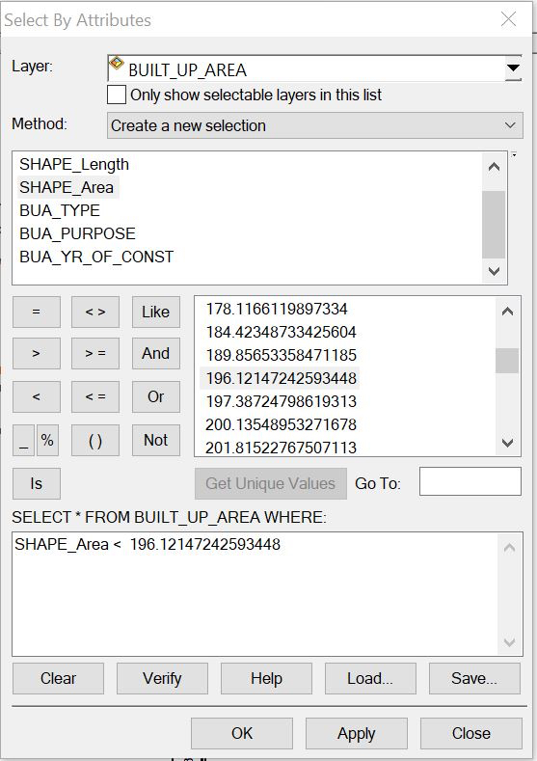

.

Figure: 4.4.1 Shows a single query made on the database of the project
Query 1: The query one is in interested in selecting or showing the built up area that have an area less than 196.12msq/m²
Syntax:built _up _area <196.12msq/m²
Figure: 4.4.2 showing the question made on the database for built _up _area <196.12msq/m²

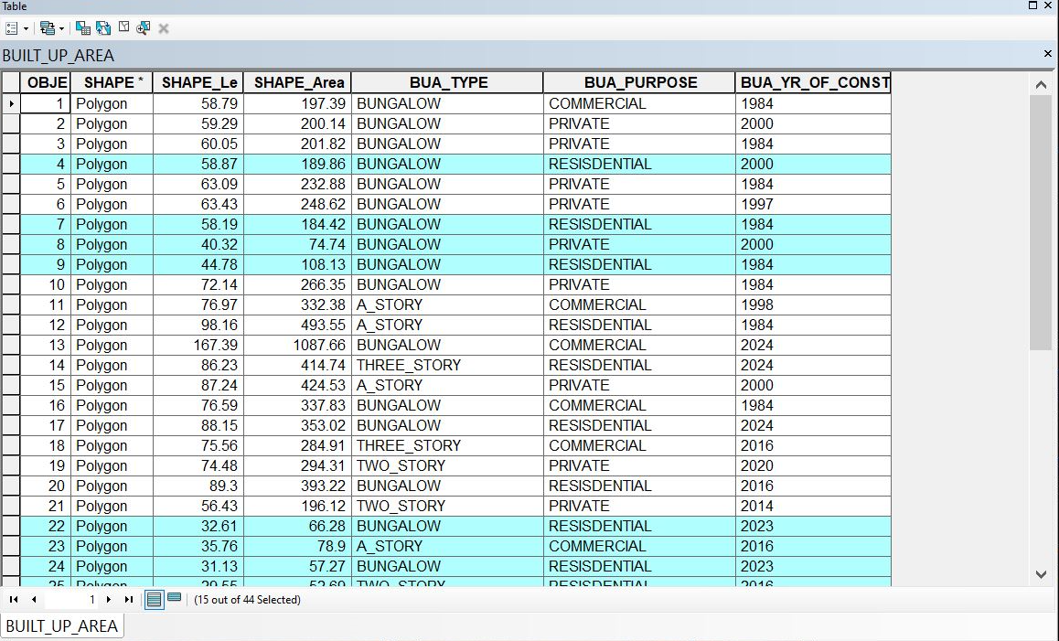

Figure: 4.4.3 showing the result of the query made on the database for built _up _area <196.12msq/m² in form of atable

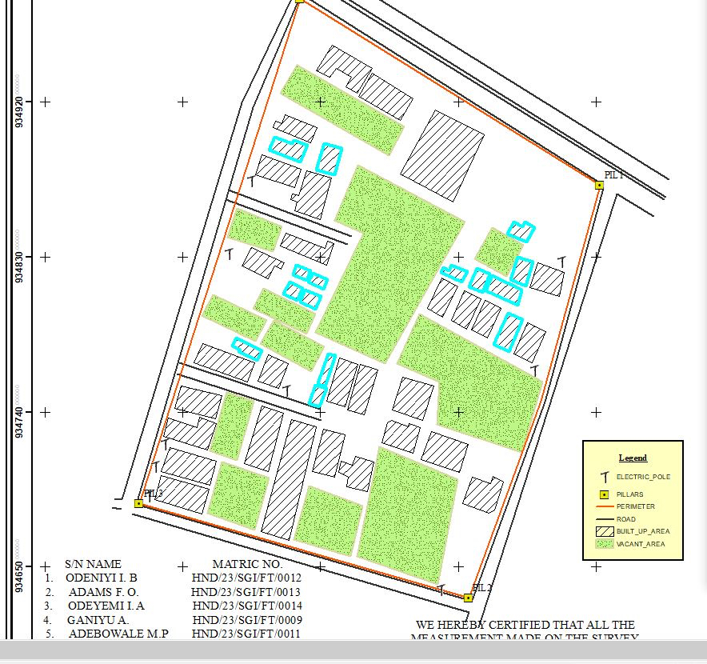

Figure: 4.4.4showing the result of the query made on the database for built _up _area <196.12msq/m²on the plan
Discussion of Result
Figure 4.4.3 and 4.4.4 Shows the built up area that have an area less than 196.12msq/m It consists of the syntax model or the query builder box, attribute table as well as the map of the selected plot in mint bluecolor. The result shows that 15 built_up_areaout of the 44built _up _area have an area less than 196.12msq/m²

4.5​MULTIPLE CRITERIA QUERY
The database created is then used for implementing several selection queries in determination of user-defined requirements such as built up area whose purpose are for commercial or private use, year of construction, type of building (bungalow,2 story, duplex etc.) and other security which will be effective in planning in such environment.

Query2: The query 2 is interested in showing the building area that are greater than 403.99m²and their purpose that are used for commercial
Syntax:built_up_ area > 403.99 m²ANDtheir purpose arefor commercial use.

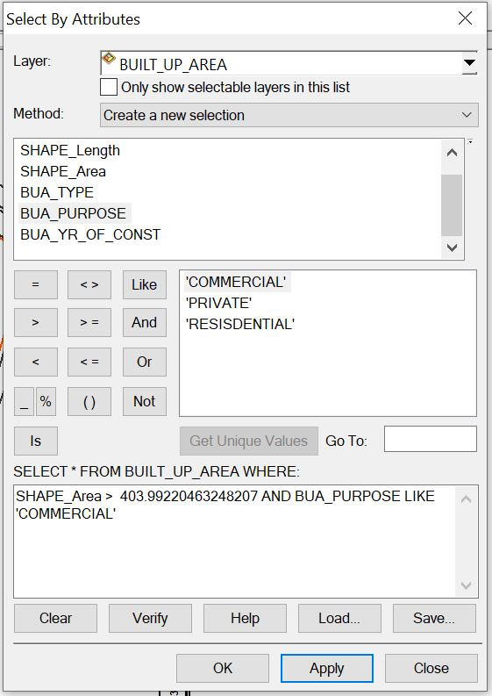
Figure:4.5.1 showing the question made on the databasefor built _up_ area > 403.99m² and their purpose are forcommercial use.

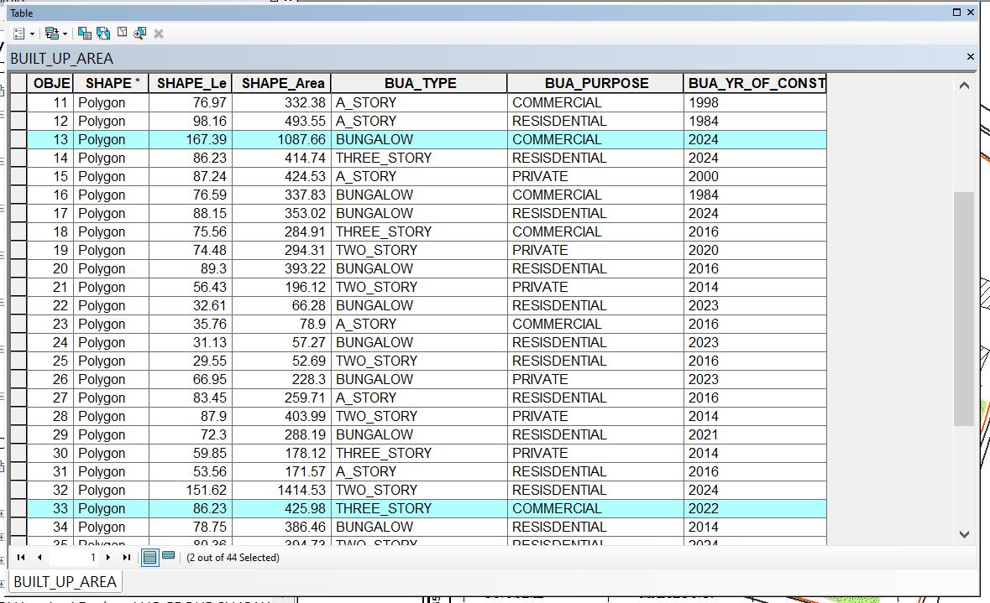

Figure: 4.5.2 showing the result of the query made on the databasefor built _up_ area > 403.99 m² and their purpose are for commercial usein form of a table
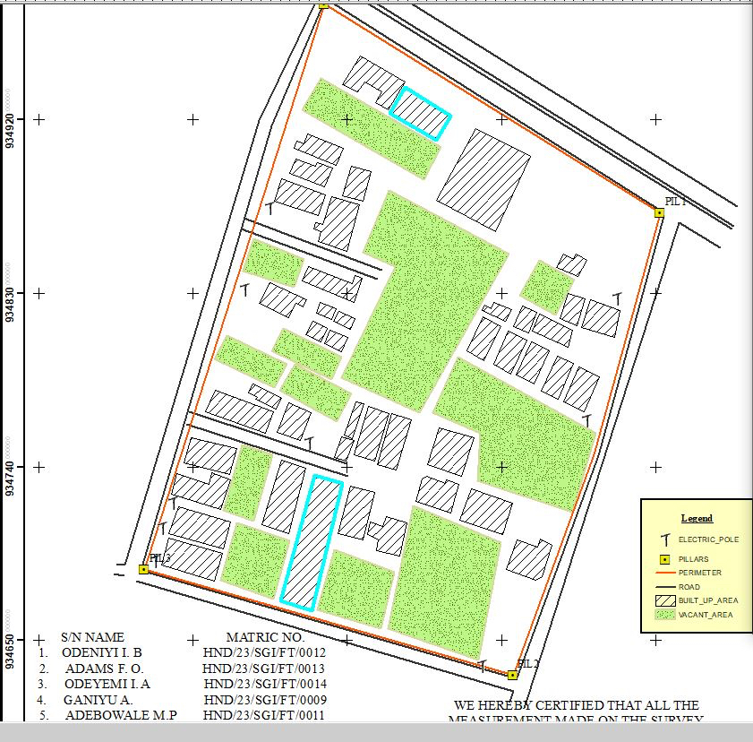

Fig: 4.5.3 showing the result of the query made on the database for built _up_ area > 403.99 m² and their purpose are for commercial use on the plan

Discussion of Result
Figure 4.5.2 and 4.5.3 Shows the built _ up _ area > 403.99㎡and purpose are commercial on the planIt consists of the syntax model or the query builder box, attribute table as well as the map of the selected plot in mint blue color. The result shows that 2built _up _area out of the 44 built _up _area have an area greater than 403.99 m² and their purpose are for commercial use.
Query3: The query 3 is interested in showing the vacant area less than or equal to 901.99m and are not fenced to query about the vacant area of land less than or equal to 901.13m²and are not fenced
Syntax:vacant_ area <= to 901.13m²AND are not fenced

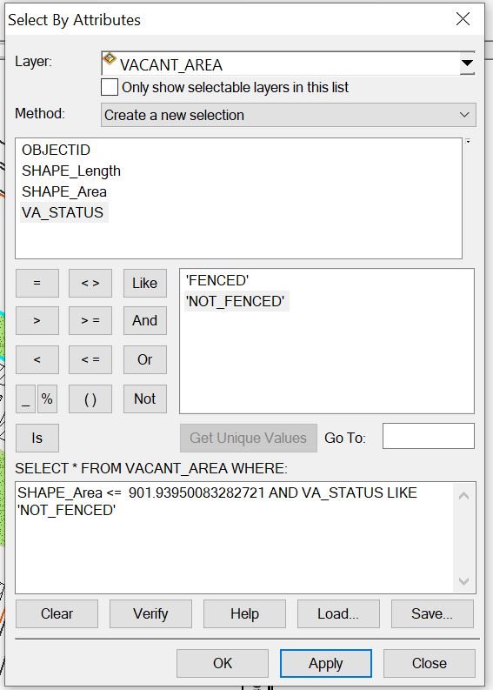

Figure: 4.5.6showing the question made on the database for vacant_ area less than or equal to 901.93m²and are not fenced

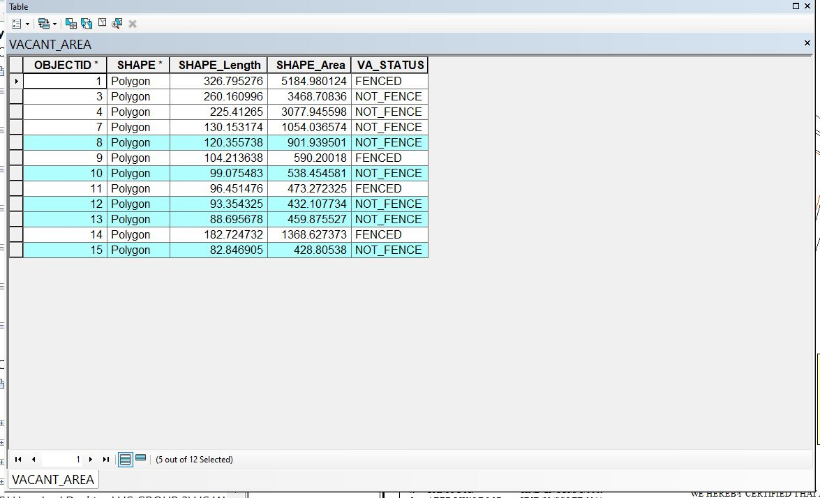

Figure: 4.5.7showing the result of the query made on the database for vacant_ area <= 901.13m²and are not fenced in form of a table
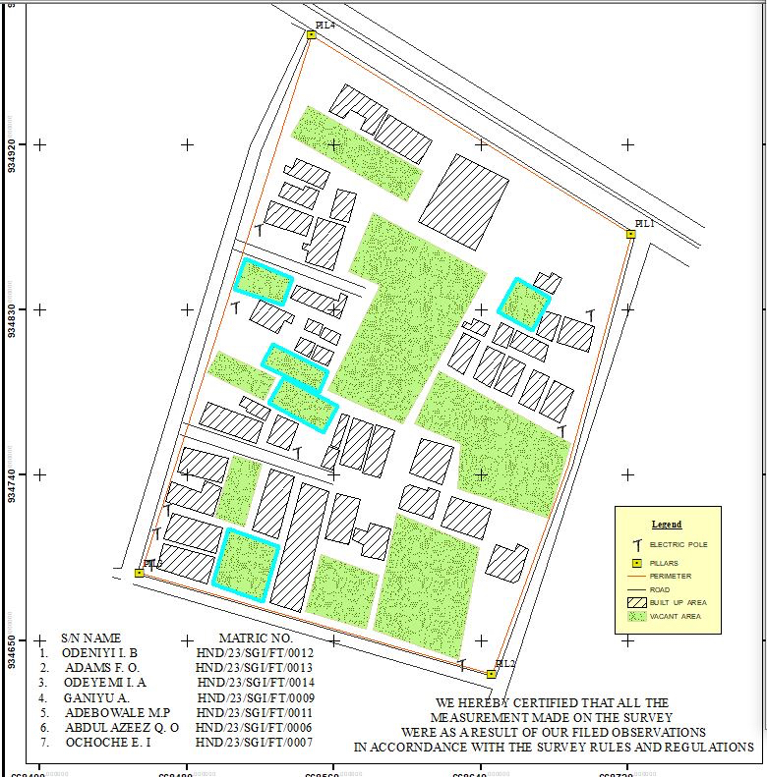
Figure: 4.5.8 showing the result of the query made on the database for vacant_ area <= 901.93m²and are not fenced on the plan.

Discussion of Result
Figure 4.5.7 and 4.5.8 Shows the vacant area less than or equal to 901.93m²and are not fenced on the plan It consists of the syntax model or the query builder box, attribute table as well as the map of the selected plot in mint blue color. The result shows that 5 vacant_area out of the 12vacant _area have an area less than 901.93m² and are not fenced.

4.6 RESULTS ANALYSIS
The results analysis gotten from this project can be used by authority in charge to facilitate planning on the land available to also know certain features about the area in question such as the type of building, the purpose of the building etc. The pie chart shows the representation of the features that existing the project site, it also shows the percentage of the each features.

Table 4.1: RESULTS ANALYSIS​
LOCATION | SIZE | PERCETAGE
Total built Up Area | 1285.2724 | 42.3%
Vacant area | 48165.342 | 52.2%
Total Road Distance (meters) | 1685.195 | 5.5%
TOTAL ROAD DISTANCE

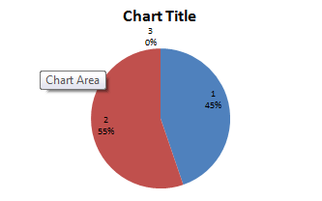
TOTAL BUILT-UPAREA
VACANT AREA

4.7APPLICATION OF PRODUCT
1. It facilitates the use of GIS for effective land management and physical planning.
2. It can be used for distribution of infrastructural facility in the study area.
3. It can be used for utility distribution, planning and operation.
4. The product will provide an integrated approach to analysis of land information.
5. It can be used for sustainable land development project in the study area
4.8 SPATIAL SEARCH
The database developed/created was queried in order to reduce the spatial variation in the various information categories ranging from built up area, vacant area, electric poles, and roads (as revealed by the database created) were used for the information system.
4.9 SPATIAL DEPENDENCE
Information system is not the same in every place, even within the project area, to talk of the whole institution neither the whole state, therefore, to detect the information increment/decrement within Part of AsaDam area,Agaka ( which is the study area) the strength of spatial relationships between the attributes must be established, the strength is known as "Spatial Dependence" and is based on Waldo Tabler's "First Law of Geography" whereby everything is related to everything else, but closer things are more related. Spatial dependence must be measured to establish a relationship limit between the environment and how the facilities is used by the people. This dependence willlikely changes over the study area as the environmental factors change (Haining, 2003). This is known as a spatial process, and when it changes across space it will non-stationery. This cannot be measured just by visually determining what is on ground because it is subjective and this must be done with a scientific approach to achieve a more concrete and precise information.\

Screen-shot showing the database created for the study area

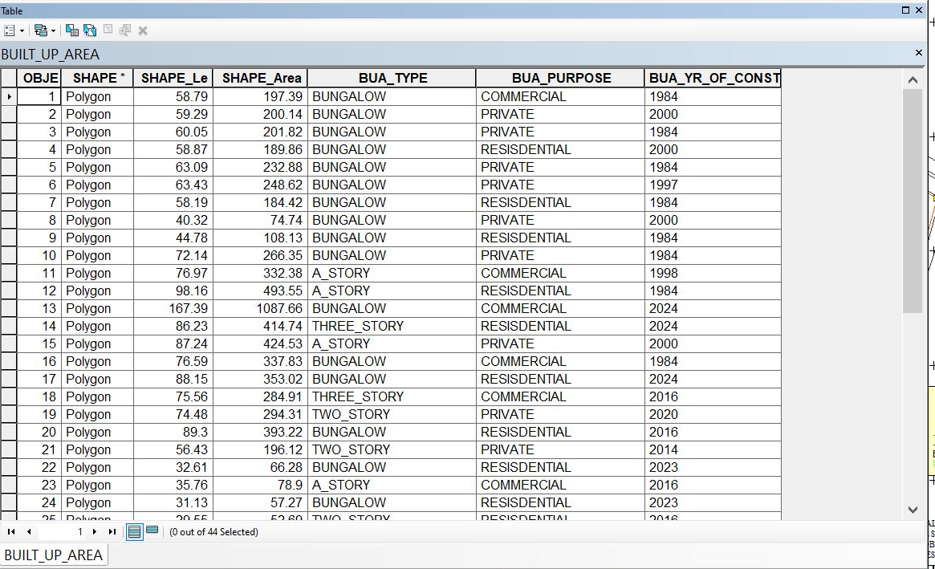

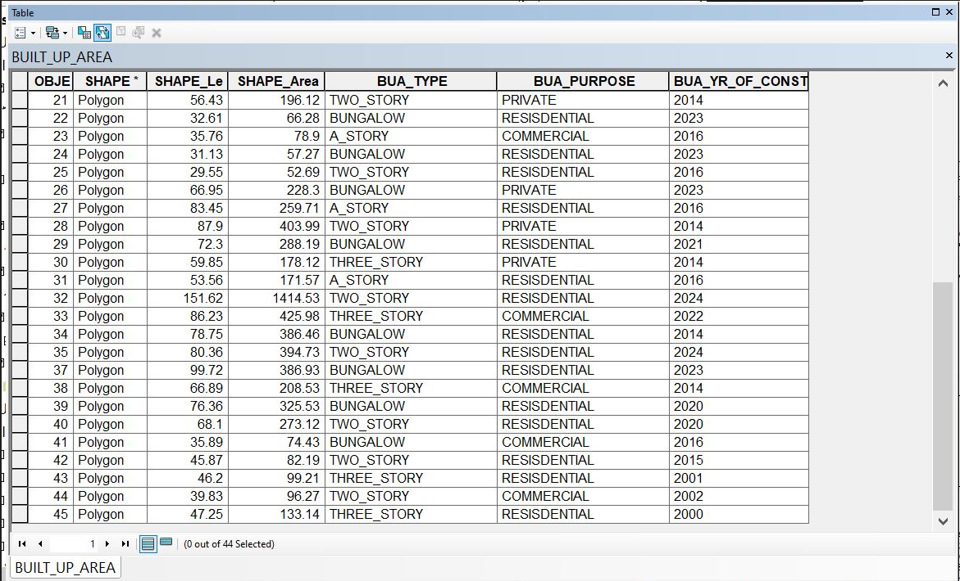

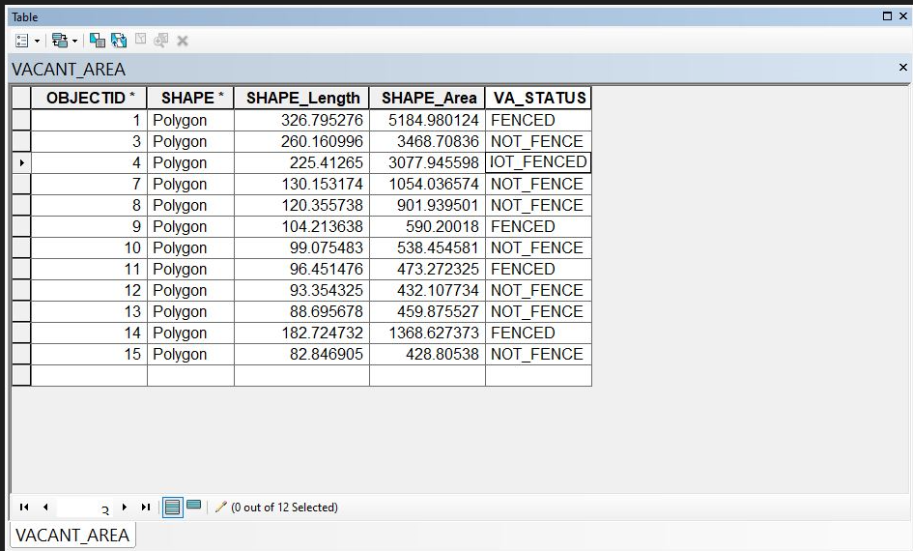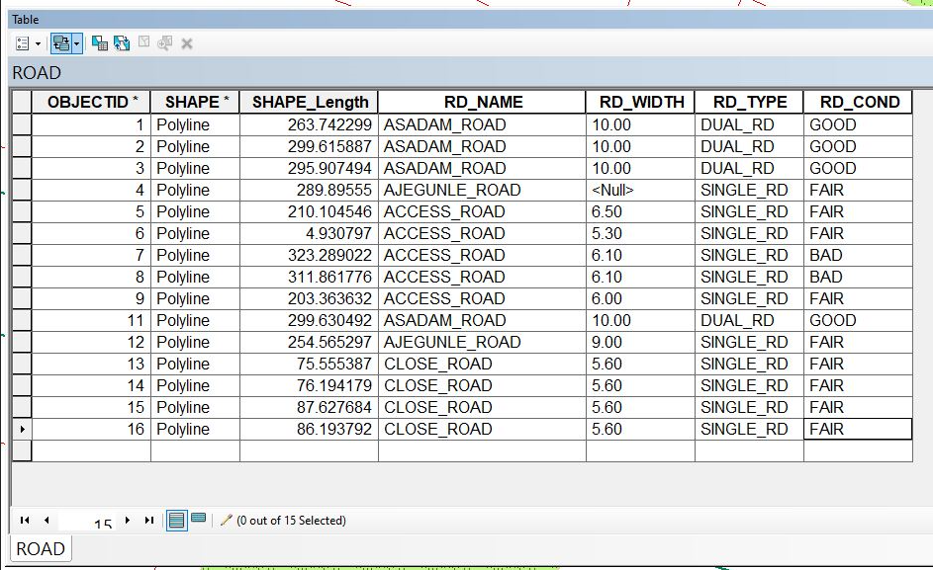
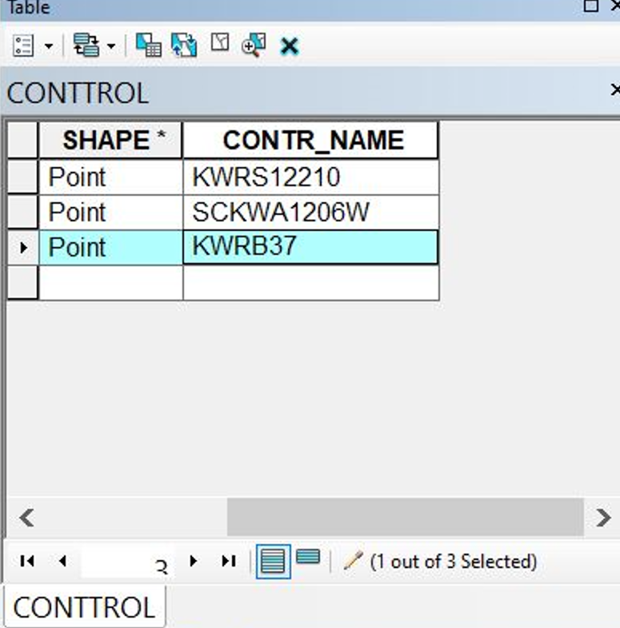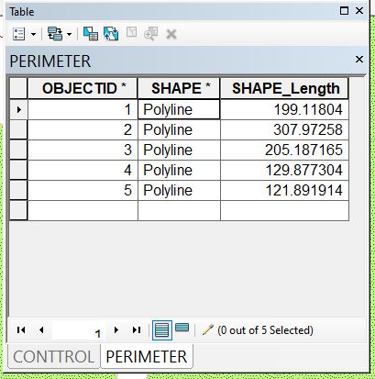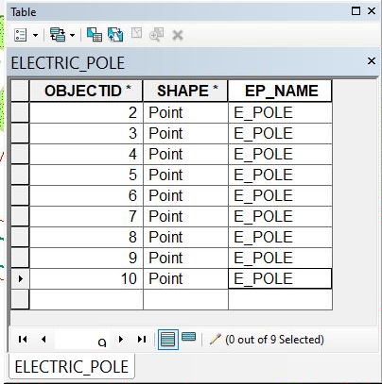

Chapter five
5.0 Costing
Costing in a survey project involves estimating and managing expenses associated with conducting the survey. This includes:

Cost Components
1. Personnel costs: Salaries, benefits, and training for surveyors, data analysts, and other staff.
2. Equipment costs: Purchase or rental of surveying equipment, software, and technology.
3. Fieldwork costs:l Travel, accommodation, and logistics for field data collection.
4. Data analysis and reporting costs: Software, personnel, and other expenses related to data processing and report preparation.

Accurate costing ensures survey projects are completed within budget, on time, and to the required quality standard
RECCI
PERSONAL/QUALITY | DAY(S) | UNITRATE(N) | TOTAL AMOUNT(N)
1 Senior Surveyor | 1 | 15,000.00 | 15,000.00
Assistant Surveyor | 1 | 8,000.00 | 8,000.00
Transportation | 1 | 7,000.00 | 7,000.00
Basic Equipment | 1 | 8,000.00 | 7,000.00
TOTAL |  |  | #38,000.00

BEACON= 2,100 × 5
= #10,500

BEACONING
PERSONAL/QUALITY | DAY(S) | UNITRATE(N) | TOTALAMOUNT(N)
1Assistant Surveyor | 1 | 8,000.00 | 8,000.00
Basic Equipment(6) | 1 | 8,000.00 | 8,000.00
Transportation | 1 | 7,000.00 | 7,000.00
TOTAL |  |  | #23,000.00

TRAVERSING
PERSONAL/QUALITY | DAY(S) | UNITRATE(N) | TOTALAMOUNT(N)
1 Assistant Surveyor | 2 | 8,000.00 | 16,000.00
Basic Equipment | 2 | 8,000.00 | 16,000.00
Transportation | 2 | 7,000.00 | 14,000.00
TOTAL |  |  | #46,000.00

DOWNLOADING DATA AND PLOTTING
PERSONAL/QUALITY | DAY(S) | UNITRATE(N) | TOTALAMOUNT(N)
1Senior Surveyor | 2 | 15,000.00 | 30,000.00
1AssistantSurveyor | 2 | 8,000.00 | 16,000.00
Transportation | 2 | 7,000.00 | 14,000.00
Consumables | 2 | 7,000.00 | 14,000.00
TOTAL |  |  | #74,000.00

INFORMATION PRESENTATION
PERSONAL/QUALITY | DAY(S) | UNITRATE(N) | TOTALAMOUNT(N)
1Assistant Surveyor | 1 | 8,000.00 | 8,000.00
Transportation | 1 | 7,000.00 | 7,000.00
TOTAL |  |  | #15,000.00

(1) # 38,000.00
(2) # 10,500.00
(3) # 23,000.00
(4) # 46,000.00

(5) #74,000.00
(6) # 15,000.00
TOTAL # 206,500.00
CONTINGENCIES=5%
206,500.00×5%÷ 100
= #10,325.00

V. A. T = 7.5%
206,500.00×7.5%÷100
= #15,487.50

MOBILIZATION AND DEMOBILIZATION =10%
206,500.00 × 10%. ÷ 100
= #20,650.00
ACCOMMODATION = 1.5%
206,500.00 ×1.5%÷100
= 3,097.50
TOTAL = 206,500.00
10,325.00
15.487.50
20,650.00
3,097.50
GRAND TOTAL = 256,060.00

5.1. Summary of conclusion

Land Information System (LIS) can provide us a better and more efficient system for land management.
A LIS is a digital system having spatial (graphical) and attribute data for each land holding since the two are maintained in a digital form, it is possible to edit, maintain, rectify and keep the record up to data with
least efforts. It can give reprieve to both land owners as well as the Government, which requires information for planning and implementation whereas people have
access to information regarding their own holdings; the government will be able to extract information for the entire area of interest. It will also be able to maintain and
track changes, detect errors, make online correction, and make land management a process dependent activity rather than people dependent.
Advancement in the information communication technology has lessened the burden of carrying about large paper in the name of maps or plans; one must also not trouble himself with searching through old and dusty cupboards for worn out or form hard copies of maps or plans which may only take the grace of God to find at the end of the day.
From the database, other derived maps are
possible due to the existence of the spatial database it is possible to get result of both spatial and non spatial question with ease from the database.
Currently in Nigeria, cadastral surveys are tied to different origins and the scale at which the plans are charted may vary from state to state. In order to have data compatibility, for a seamless database of our cadastral maps, there is need for national coordination in order to harmonies the origin, scale and accuracy of our plans.
There is need for awareness to be created at all level of government towards deriving the benefits of GIS technology in Kwara state and Nigeria as a whole.
There is also the need for amendment of
existing survey laws to accommodate the existence of new technologies.
A beginning has to be made and the first step in this direction is to provide the basic infrastructure. This can be done by making cadastral maps digital and also by taking the exercise of converting all record of rights in one language and again making the database available.
Success is a journey not a destination therefore one man’s success may be another’s beginning of the journey. There is need for projects like this to be carried out and improvements made upon.

5.2. Problem encountered
- Obstructions from passersby, moving vehicles; it is a major problem for us because it is a commercial area it slow down our work because we were obstructed by these factors.
- System Compatibility: Ensuring compatibility with existing systems and software.
- Data Quality: Ensuring accuracy, completeness, and consistency of land data.
- Residents are seeking clarification on our work within their property boundaries.

5.3. Recommendation
The capabilities of land information system and its usefulness for study area were
demonstrated through this research. Therefore;
1. I recommend that the State Government should acquire all the necessary computers, software and other relevant equipments for the implementation of land information system (LIS) operation in the relevant Ministries /Organization, such as Ministry of Land and Survey, etc.
2. The State Government should also directly embark on the conversion of their
hard copy information to softcopies. The Local Governments should also be directed to do the same thing so that the entire state land records can be fully automated.
3. The State Government should also embark on training and retraining of staff.
And also building of modern GIS Laboratory.
- Developing national land information management system which integrates the states’ land management systems as answer to the quest for national land database.

REFERENCE
Abbas, I., Ben-Yayork, D., & Muhammad, N. (2014). Land information system (LIS) as an effective and efficient residential layout management strategy. Global Journal of Human-Social Science, 14(3), 32-40.

Akingbade, A. (2005). Improvement of availability of land registration and cadastral information in Ondo State, Nigeria: In department of urban and regional planning and geo-information management, international institute for geo-science and earth observation (ITC.), 137. Enschede: ITC.

Alshuwaikhat, H.M., & Nassef, K. (1996). A GIS-based spatial decision support system for suitability assessment and land use allocation. Arabian Journal for Science and Engineering, 21, 525-543.

Ball, (2002). Bojorquez-Tapia et al., (2001).Brazier & Greenwood, (1998).

Brown, P.M., & Moyer, D.D. (1990-1996). Multipurpose land information systems: The guidebook. Federal Geodetic Control Committee. (NOAA).

Chrisman, N.R. (1987). Design of Geographic Information Systems Based on Social and Cultural Goals. PE&RS, 53(10), 1367-1370.

Cromley & Hanink, (1999). (No full reference provided)

Dale, R.F., & McLaughlin, J.D. (1988). Land Information Management. Clarendon Press, Oxford.

Dale & McLaughlin (1999). (No full reference provided)
Deane, Owen, & Quaye (2017). (No full reference provided)

Dueker, K.J., & Kjerne, D. (1989). Multipurpose Cadastre: Terms and Definitions. Technical Papers, 1989 ACSM-ASPRS Annual Convention, Vol. 5, pp. 94-103.

Ezra Paul Hamawa and Sunday Olayiwola, S.O. GIS. A tool in the hand of a digital map maker (AutoCAD and Arcview software application).

Huxhold, W.E. (1991). An introduction to urban geographical Information system, Oxford University Press.

Kakaraparthi & Kockelman, (2011).Koomen et al., (2011).

Kufoniyi, O.T. (1995). Spatial coincidence modeling automated Database updating and data consistency in vector GIS.

Kuhlman, K. (1993). Building a Framework to Characterize Land Records Modernization. URISA 1993 Annual Conference Proceedings, vol. 2, pp. 146-151.

Malczewski, (2004). Ministry of Electronics and Information Technology India [MeitY], (2011).

National Research Council (1983). Procedures and Standards for a Multipurpose Cadastre. National Academy Press, Washington DC.

Paul R. Wolf and Charles D. Ghilani. Elementary surveying, an Introductory to geometrics, eleventh edition.

Pinto & Antunes, (2010). The Land Instruments Registration Laws of the various states and the federation...

Trung, Tri, Mensvoort, and Bregt (2006).UNFIG (1999).

Ventura, S.J. (1995). The use of geographic information systems in local government. Public Administration Review, 55(5), 463-469.

Wise & Crooks, (2012).

Zwart, P.R. (1988). Some Observations on the Real Impact of Integrated Land Information Systems upon Public Decision Making in Australia. Papers from the 1988 Annual Conference of the Urban and Regional Information System Association, 1988, Vol. 1, pp. 68-79.

