

DESIGN AND CONSTRUCTION OF A 3KVA SOLAR INVERTER USING 24VOLTZ BATTERY

BY

ADESANYA ESTHER OKIKIOLA

HND/23/SLT/FT/1210
SUBMITTED TO:
DEPARTMENT OF SCIENCE LABORATORY TECHNOLOGY
(PHYSICS UNIT), INSTITUTE OF APPLIED SCIENCES (IAS),
KWARA STATE POLYTECHNIC, ILORIN.

IN PARTIAL FULFILMENT OF THE REQUIREMENTS FOR THE AWARD OF HIGHER NATIONAL DIPLOMA (HND)
IN SCIENCE LABORATORY TECHNOLOGY (SLT)

SUPERVISED BY:
MR. AGBOOLA A. O.

2024/2025 SESSION

CERTIFICATION
This is to certify that this project work has been written by ADESANYA ESTHER OKIKIOLA with matric number HND/23/SLT/FT/1210 and has been read and approved as meeting the parts of the requirements for the award of Higher National Diploma (HND) in Science Laboratory technology Department, Institute of Applied Sciences, Kwara State Polytechnic.

_____________________________ ___________________
MR. AGBOOLA O. A. DATE
(Project Supervisor)

_____________________________ ___________________
ENGR. YUSUF DATE
(Project Coordinator)

_____________________________ ___________________
DR. USMAN A. DATE
(Head of Department)

DEDCATION
This project work is sincerely dedicated to GOD Almighty for His mercy and blessings upon my life.

ACKNOWLEDGEMENT
All praise is due to Almighty GOD, the Beneficent, the Most Merciful, for His immense support, grace, and the gift of life. I thank Him sincerely for granting me the privilege and strength to begin and complete this project. He is the Giver of knowledge, wisdom, and understanding, and without His guidance, this achievement would not have been possible.
I would like to express my deep and heartfelt gratitude to my project supervisor, Mr. Agboola O. A., for his consistent support, guidance, and constructive criticism throughout this project. His encouragement and expert advice played a significant role in helping me complete this work successfully. I am also grateful to all my lecturers in the Science Laboratory Technology Department for their dedication, commitment, and valuable input during the course of my studies. May Almighty Allah reward and favor you all abundantly, and may He continue to bless you and your families.
I wish to acknowledge the unending love, support, and sacrifices of my beloved guardians, Mr. and Mrs. Adesanya From the day I was born up until this stage of my academic journey, you have stood by me morally, financially, and spiritually. Your care and devotion mean the world to me, and I pray that Almighty GOD grants you long life, good health, and the opportunity to enjoy the fruits of your labor. May His blessings be upon you always. Ameen.

ABSTRACT
This project presents the design and construction of a 3KVA solar-powered inverter system using a 24-volt battery bank, aimed at providing a reliable and sustainable source of electricity in areas with unstable or no power supply. The inverter is designed to convert direct current (DC) from solar-charged batteries into alternating current (AC) suitable for powering household or small office appliances. The system comprises a solar charging unit, a battery storage unit, and a pure sine wave inverter module. The inverter converts 24V DC from two 12V batteries connected in series into 220V AC, capable of handling loads up to 3KVA. Key focuses was placed on efficiency, safety, and protection mechanisms such as over-voltage, under-voltage, over-temperature, and short-circuit protection. The methodology involved the analysis and selection of appropriate components including transformers, MOSFETs, driver circuits, microcontrollers (if applicable), and heat dissipation systems. Circuit simulations and breadboard testing were conducted prior to PCB fabrication and final assembly. The result is a cost-effective and environmentally friendly inverter system with good performance, stable output, and minimal harmonic distortion.

TABLE OF CONTENTS
Title Page
Approval Page
Dedication
Acknowledgement
Abstract
Table of Content
CHAPTER ONE
1.0 Introduction
1.1 Background of the study
1.2 Problem statement
1.3 Objectives of the project
1.4 Significance of the study
1.5 Scope of the project
1.6 Limitations of the project
CHAPTER TWO
2.0 Literature Review
2.1 Overview of Inverter Technology
2.2 Types of Inverters
2.3 Solar Inverter Systems
2.4 Battery Technologies for Solar Inverters
2.5 Power Conversion and Control Systems
CHAPTER THREE
- Methodology
3.1 Materials and methods
3.2 Oscillatory and power section
3.3 Component selection
3.4 Casing and packaging
3.5 Circuit diagram and operation
CHAPTER FOUR
4.0 System construction and testing
4.1 Testing and evaluation under load condition
4.2 Power Rating
4.3 Design Specifications (modified sine-wave inverter)
4.4 Challenges encountered
4.5 Protection and safety features
CHAPTER FIVE
5.0 Results, conclusion, and recommendations
5.1 Summary of findings
5.2 Result analysis
5.3 Conclusion
5.4 Recommendation for improvement
5.5 Future work
REFERENCES
APPENDICES
CHAPTER ONE
1.0 INTRODUCTION
Electricity is an essential part of modern life, powering homes, businesses, and technology. However, in many parts of the world, especially in developing countries, power supply is often unreliable or unavailable. This has led to the need for alternative and sustainable sources of energy. One of the most effective solutions is the use of solar power, which is clean, renewable, and environmentally friendly. This project focuses on the design and construction of a 3KVA solar inverter system that uses a 24-volt battery bank to store and convert solar energy into usable electricity. The inverter converts the direct current (DC) from the battery into alternating current (AC), which can power various household or office appliances. The aim is to provide a reliable backup power solution that can reduce dependence on the public electricity grid and lower energy costs. The project covers the design, component selection, construction, and testing of the inverter system, with attention to safety, efficiency, and affordability. By the end of this project, a fully functional and tested solar inverter capable of handling up to 3KVA load will be developed.
1.1 BACKGROUND OF THE STUDY
In recent years, the demand for constant and reliable electricity has increased due to the growing use of electrical appliances in homes, offices, and industries. However, many regions, especially in developing countries like Nigeria, still suffer from unstable power supply and frequent blackouts. This challenge has led to a growing interest in alternative sources of energy, particularly solar energy, which is clean, renewable, and available in abundance. Solar energy systems, when combined with battery storage and inverter technology, can provide a reliable and independent power solution. An inverter plays a crucial role in solar power systems by converting the direct current (DC) stored in batteries into alternating current (AC), which is the standard form of electricity used by most appliances. The use of a 3KVA inverter system powered by a 24-volt battery bank offers a practical solution for powering essential devices during power outages or in off-grid locations. This project is designed to explore the construction of such a system, focusing on its efficiency, affordability, and ability to meet everyday energy needs. It also contributes to the global push toward clean and sustainable energy solutions.
1.2 PROBLEM STATEMENT
Many households and small businesses face the challenge of unreliable electricity supply, especially in areas where the national power grid is weak or unavailable. Frequent power outages can disrupt daily activities, damage electrical appliances, and increase dependence on costly and noisy fuel-powered generators. While generators provide temporary relief, they are not environmentally friendly and require continuous fuel and maintenance. There is a need for a more reliable, clean, and cost-effective alternative source of electricity. Although solar energy is a promising solution, many people still lack access to affordable and efficient solar inverter systems. This project addresses the problem by designing and constructing a 3KVA solar inverter using a 24-volt battery, which can serve as a dependable power backup for homes and small businesses. The goal is to reduce dependence on the unreliable grid and harmful generators by providing a sustainable and efficient energy solution.
1.3 OBJECTIVES OF THE STUDY
The main objective of this project is to design and construct a 3KVA solar inverter system using a 24-volt battery that can provide a stable and reliable power supply for homes or small businesses. This system is intended to serve as an alternative energy solution in areas with poor or no electricity supply.
The specific objectives are:
- To design a solar-powered inverter system that can deliver up to 3KVA output.
- To convert 24V DC from solar-charged batteries into 220V AC suitable for household appliances.
- To select and integrate suitable components such as transformers, MOSFETs, and protection circuits.
- To build and test the inverter for efficiency, stability, and load capacity.
- To reduce reliance on fuel-powered generators by offering a clean and sustainable energy source.
- To provide a cost-effective power backup system that is easy to maintain and operate.

1.4 SIGNIFICANCE OF THE STUDY
This study is significant because it provides a sustainable solution to the persistent problem of unreliable electricity supply, especially in developing countries like Nigeria. The design and construction of a 3KVA solar inverter using a 24-volt battery aims to offer a clean, renewable, and cost-effective power backup system. Unlike fuel-powered generators that contribute to environmental pollution and require constant maintenance and fueling, solar inverter systems operate silently and produce no emissions, making them environmentally friendly (Oseni, 2012). Furthermore, the project promotes the adoption of solar energy technologies, which support global efforts to reduce carbon emissions and combat climate change. It also encourages local innovation and the use of locally available materials, which can help reduce production costs and create job opportunities. By implementing this project, individuals and small businesses can enjoy uninterrupted power supply, lower energy costs, and improved quality of life.
1.5 SCOPE OF THE STUDY
This study is limited to the design and construction of a 3KVA solar inverter system using a 24-volt battery bank. The project focuses on converting direct current (DC) from solar-charged batteries into alternating current (AC) at 220V, which can be used to power essential household and office appliances such as lights, fans, televisions, and laptops. The system design includes essential features like voltage regulation, overload protection, and basic safety circuits to ensure stable and safe operation. The study does not include advanced inverter features such as grid-tied functionality, remote monitoring, or Maximum Power Point Tracking (MPPT) for solar input. It also does not address large-scale energy storage systems or commercial-grade solar installations. The intention is to develop a low-cost, stand-alone inverter system suitable for off-grid applications, particularly in rural or underserved areas, where access to reliable electricity is limited (Ikejuba et al., 2016).

1.6 LIMITATIONS OF THE STUDY
While this project successfully demonstrates the design and construction of a 3KVA solar inverter using a 24-volt battery, it has some limitations. Firstly, the inverter system is designed as a standalone unit and is not connected to the national power grid, meaning it cannot perform grid-tie functions or feed energy back to the utility company. Secondly, the system does not include advanced features such as Maximum Power Point Tracking (MPPT) for solar charging, automatic load prioritization, or remote monitoring and control. Additionally, the project is limited by budget constraints, which affected the choice of components and the inclusion of higher-efficiency materials. The efficiency of the inverter may not be on par with commercial-grade models, especially under heavy or nonlinear loads. Environmental factors such as sunlight availability and battery quality also affect the performance of the system and were not fully explored in this study due to time and resource limitations (Akinboro et al., 2012).

CHAPTER TWO
2.0 LITERATURE REVIEW
Over the years, the need for alternative sources of electricity has grown due to frequent power outages and increasing energy demands. Solar energy has become one of the most promising solutions because it is renewable, environmentally friendly, and available in abundance, especially in tropical regions like Nigeria (Ohunakin et al., 2014). Solar inverter systems allow for the storage of solar energy in batteries and the conversion of this stored energy into alternating current (AC), which can be used to power appliances and devices. An inverter is a key component in any solar power system. It is responsible for converting the direct current (DC) produced by solar panels or batteries into usable alternating current (AC). There are different types of inverters including square wave, modified sine wave, and pure sine wave inverters. Pure sine wave inverters are the most efficient and suitable for sensitive electronic devices, although they are also more expensive (Akinboro et al., 2012). Modified sine wave inverters, on the other hand, are cheaper and simpler to build, but may not work well with certain appliances. The use of solar inverters has been studied in many research works. For example, Akinboro et al. (2012) designed a modified sine wave inverter and showed that it could provide an efficient and stable power supply for rural homes. Similarly, Ikejuba and Akande (2016) developed a solar inverter system aimed at solving electricity challenges in off-grid communities. These studies demonstrate that solar inverters are both practical and valuable in regions with poor access to the national electricity grid. Another important aspect is battery storage. Most solar inverter systems use either lead-acid or lithium-ion batteries to store energy. Lead-acid batteries are cheaper and more common but require regular maintenance. Lithium-ion batteries are more efficient and longer-lasting, but they are also more expensive (Nema et al., 2009). The choice of battery affects the performance and cost of the entire inverter system. Finally, the efficiency and safety of inverter systems depend on the quality of the components and the protection mechanisms used. Modern systems often include protection against overcharging, short-circuits, and overheating to increase the lifespan and reliability of the system.
2.1 OVERVIEW OF INVERTER TECHNOLOGY
An inverter is an electrical device that converts direct current (DC) into alternating current (AC). Since most household and office appliances operate on AC power, inverters play a crucial role in systems where the main power source is DC, such as batteries or solar panels. The inverter ensures that the stored energy in batteries can be used to run standard AC appliances. There are three main types of inverters based on the output waveform: square wave, modified sine wave, and pure sine wave. Square wave inverters are the simplest and cheapest to produce but are not suitable for sensitive electronics. Modified sine wave inverters produce a stepped waveform that is closer to AC but may still cause humming noise or overheating in certain appliances. Pure sine wave inverters provide the cleanest output, similar to the power supplied by the utility grid, and are ideal for all types of loads, especially sensitive and high-performance devices (Akinboro et al., 2012). Inverter technology has evolved significantly over the years, with advancements in semiconductor devices, switching techniques, and control systems. Modern inverters now include automatic protection features such as overload, short-circuit, under-voltage, and over-temperature protection. These features help extend the life of both the inverter and the connected devices. With the growing need for clean energy, inverters are now widely used in solar power systems. They not only convert DC to AC but also help manage power flow, battery charging, and sometimes grid connection, depending on the system type. As solar energy adoption increases, efficient and reliable inverter technology becomes even more important in ensuring uninterrupted and stable power supply.
2.2 TYPES OF INVERTERS
Inverters can be classified based on the type of output waveform they produce and their application. The main types include square wave inverters, modified sine wave inverters, and pure sine wave inverters.
Square Wave Inverters
These are the most basic type of inverters. They produce a square-shaped AC waveform and are very easy and cheap to build. However, their output is not smooth and can damage or reduce the efficiency of sensitive electronic devices. They are only suitable for simple appliances like light bulbs or resistive loads (Balogun et al., 2013).
Modified Sine Wave Inverters
Modified sine wave inverters produce a waveform that is closer to a pure sine wave but still not perfectly smooth. They work well with many household devices but may cause problems with appliances that have motors or electronic timing circuits, such as fans, refrigerators, and microwaves. These inverters are more efficient than square wave types and are commonly used in low to medium-cost solar systems (Akinboro et al., 2012).
Pure Sine Wave Inverters
Pure sine wave inverters generate a smooth and clean waveform that closely matches the electricity from the public grid. They are ideal for all types of loads, including sensitive electronics like computers, medical equipment, and modern home appliances. Although more expensive, they are preferred for high-performance and professional solar systems due to their reliability and compatibility with all types of devices (Nema et al., 2009).
2.3 SOLAR INVERTER SYSTEMS
A solar inverter system is a critical part of any solar power setup. Its main function is to convert the direct current (DC) electricity generated by solar panels or stored in batteries into alternating current (AC), which is the standard form of electricity used to power household and office appliances. Without the inverter, solar power would not be usable for most electrical devices. There are different types of solar inverter systems, depending on how they are connected and how they operate:
Off-Grid (Stand-Alone) Solar Inverters: These systems operate independently of the utility grid. They are used in remote areas where grid power is not available. The inverter draws DC from batteries that are charged by solar panels and converts it into AC. This type of system is ideal for homes in rural areas or for emergency backup systems (Ikejuba & Akande, 2016).
On-Grid (Grid-Tied) Solar Inverters: These inverters are connected to the public power grid. They convert solar energy into AC and feed it into the grid. When the solar power generated is more than the user’s consumption, the excess can be sent to the grid, often earning credits through net metering. However, they do not work during power outages unless paired with a battery and hybrid inverter (Nema et al., 2009).
Hybrid Solar Inverters: Hybrid inverters combine the features of both off-grid and on-grid systems. They can work with solar panels, batteries, and the grid. They are more flexible and intelligent, allowing the user to store excess solar energy in batteries for later use and feed energy into the grid when needed. These systems are ideal for areas with unstable grid power. Modern solar inverters also include features like maximum power point tracking (MPPT) to optimize solar panel output, as well as safety features such as over-voltage, short-circuit, and thermal protection. As solar energy becomes more widely adopted, efficient inverter systems continue to play a major role in ensuring stable and reliable electricity supply.
2.4 BATTERY TECHNOLOGIES FOR SOLAR INVERTERS
Batteries are a vital component of solar inverter systems, especially in off-grid and hybrid setups, where energy storage is necessary for use during the night or on cloudy days. They store the direct current (DC) energy generated by solar panels and supply it to the inverter when needed. The performance, lifespan, and cost of a solar power system largely depend on the type of battery used. There are several types of batteries used in solar inverter systems:
Lead-Acid Batteries: These are the most commonly used batteries in solar systems due to their low cost and widespread availability. They come in two main types: flooded (wet cell) and sealed (maintenance-free). Flooded lead-acid batteries require regular maintenance, including checking water levels, while sealed types (such as AGM and Gel) are more convenient and safer. Despite being cost-effective, lead-acid batteries have shorter lifespans and lower depth of discharge compared to newer technologies (Nema et al., 2009).
Lithium-Ion Batteries: Lithium-ion batteries are becoming increasingly popular in solar applications due to their long lifespan, light weight, high energy density, and low maintenance requirements. They can be deeply discharged without affecting battery health, which means users can use more of the battery's stored energy. However, they are more expensive than lead-acid types and require sophisticated battery management systems (BMS) for safety (Luo et al., 2015).
Nickel-based Batteries: Nickel-cadmium (Ni-Cd) and nickel-metal hydride (NiMH) batteries are also used in some specialized solar systems. While Ni-Cd batteries are durable and perform well in extreme temperatures, they are less common due to higher toxicity and environmental concerns. The choice of battery technology depends on factors such as cost, required capacity, charging speed, environmental conditions, and system design. For rural and cost-sensitive applications, lead-acid batteries remain popular. However, for modern and long-term solar investments, lithium-ion batteries are gradually becoming the standard.
2.5 POWER CONVERSION AND CONTROL SYSTEMS
Power conversion and control systems are essential parts of any solar inverter setup. Their main function is to manage the flow of electrical energy between the solar panels, battery storage, and the load (appliances). These systems ensure that the power is converted efficiently, regulated properly, and delivered safely to connected devices. In a typical solar inverter system, the first stage involves converting solar power from DC to a regulated DC voltage that can charge the batteries. This is handled by a charge controller, which protects the battery from overcharging and deep discharge. There are two major types of charge controllers: PWM (Pulse Width Modulation) and MPPT (Maximum Power Point Tracking). MPPT controllers are more advanced and efficient, as they constantly adjust the input voltage to extract the maximum possible power from the solar panels (Esram & Chapman, 2007). The second stage is the DC to AC conversion, handled by the inverter circuit. The inverter uses switching devices like MOSFETs or IGBTs to generate high-frequency AC, which is then passed through filters and transformers to produce a stable 220V (or 110V) AC output suitable for household appliances. Control systems play a key role in maintaining the performance and safety of the inverter. These systems monitor input and output voltages, battery level, temperature, and load demand. Based on these parameters, they adjust the switching operations, trigger protection circuits, and manage the charging and discharging of the battery. Microcontrollers or digital signal processors (DSPs) are often used for intelligent control and decision-making in modern inverter systems (Gupta et al., 2011).

CHAPTER THREE:

3.0 METHODOLOGY

3.1 MATERIALS AND METHODS
The methodology used in this project involved several steps to successfully design and construct a 3KVA solar inverter using a 24V battery. First, the system requirements were identified, such as the need to convert 24V DC from the battery to 220V AC output for household use. Suitable components like transformers, MOSFETs, capacitors, resistors, and control ICs were selected based on cost, availability, and performance. After selecting the components, the circuit was designed and simulated using software like Proteus to check for errors and ensure proper operation before physical construction. Once the design was confirmed, the circuit was first built on a breadboard for testing. After successful testing, it was transferred to a PCB or Vero board for permanent construction. All components were carefully soldered and mounted in a protective casing with cooling features like heat sinks and fans. Finally, the inverter was tested under different loads to measure performance, efficiency, and output stability. Basic protection features such as overload, short-circuit, and low battery shutdown were also included to ensure safe and reliable operation.
3.2 OSCILLATORY AND POWER SECTION
The oscillatory and power section forms the heart of the inverter system, responsible for generating the alternating signal and converting DC power to usable AC output. The oscillatory section typically consists of a waveform generator, often built using a microcontroller, timer IC (such as the 555 timer), or crystal oscillator circuit. This section produces a square wave or modified sine wave signal that controls the switching of the power transistors or MOSFETs. These pulses are alternated to simulate AC waveforms at a frequency of approximately 50Hz, which is standard for most AC appliances. The power section involves the amplification and switching of the low-voltage DC from the battery into high-voltage AC. It includes high-power MOSFETs or IGBTs configured in an H-bridge or push-pull arrangement. These switching devices are driven by the oscillatory signals and are responsible for converting the 24V DC into a pulsating AC waveform, which is then stepped up using a transformer to around 220V AC. This section also incorporates protective components like heat sinks, fuses, and filter capacitors to ensure stable operation and protect against overheating or overloading. Together, the oscillatory and power sections work in synchronization to ensure that the inverter produces a reliable AC output suitable for powering household or office appliances.
3.3 COMPONENT SELECTION
The proper selection of components is critical to ensure the reliability, efficiency, and safety of the inverter system. Each component was carefully chosen based on the power rating, voltage compatibility, thermal performance, and cost-effectiveness to meet the requirements of a 3KVA inverter operating with a 24V battery system.
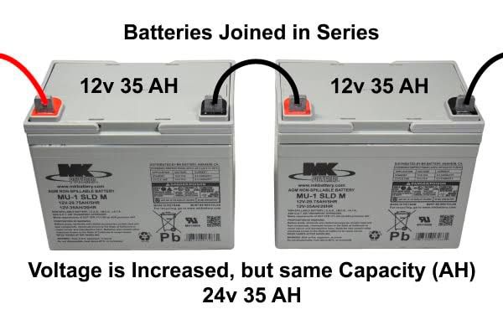
•Battery (24V Battery): A pair of 12V batteries connected in series to supply a stable 24V DC. Batteries were selected for their ability to handle prolonged discharge cycles, which is essential for inverter applications.

•MOSFETs: High-current, fast-switching MOSFETs were used to handle the DC-to-AC conversion efficiently. They are capable of switching large currents with minimal losses.
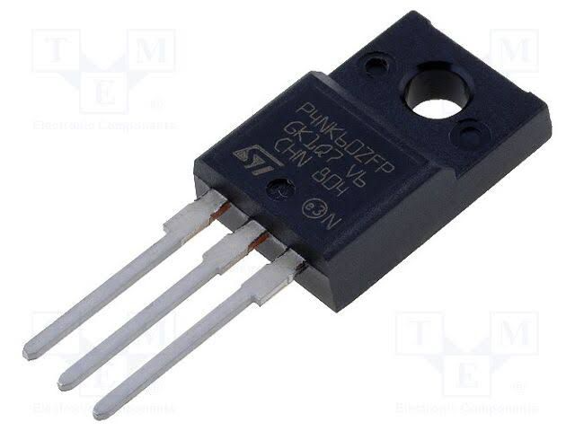
•Transformer (24V-0-24V to 220V): A step-up transformer is used to convert the low-voltage AC signal from the MOSFETs into standard 220V AC output. It was chosen based on the required power output (3KVA) and designed to handle high current without overheating.
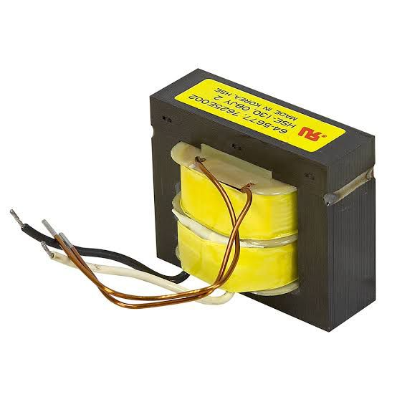
•Capacitors and Filters: Used for smoothing and filtering the output waveform to reduce noise and harmonics. High-voltage electrolytic capacitors were selected to withstand output surges.

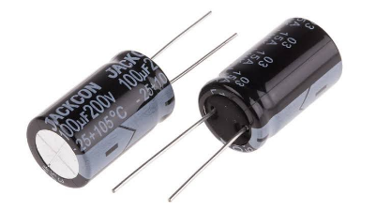
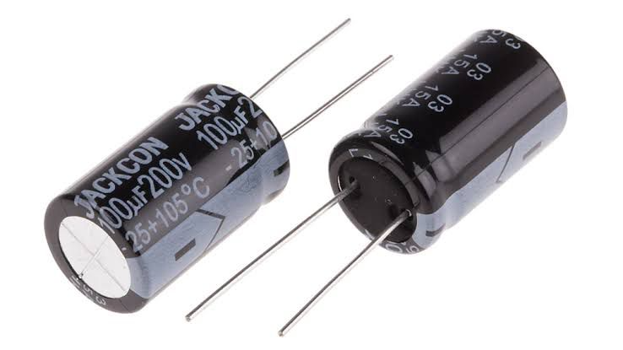
•Cooling Fan: Effective heat dissipation components are essential to prevent thermal damage to the MOSFETs and other power components. A 24V fan were included to maintain a safe operating temperature.
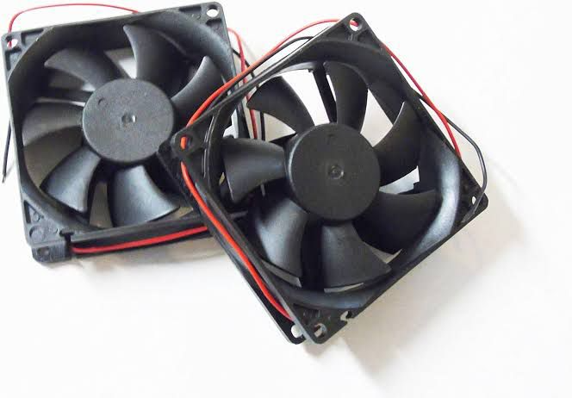
•Protection Devices (Fuses, Diodes): Fuses were added to protect against overcurrent, while flyback diodes were used across the MOSFETs to prevent voltage spikes during switching.
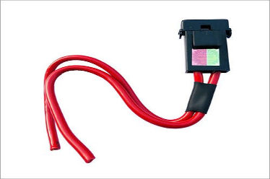
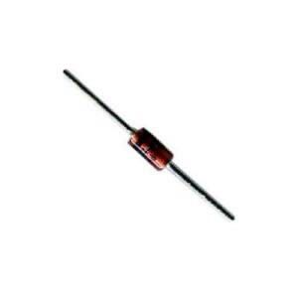
•Charge Controller: A solar charge controller regulates the voltage and current coming from the solar panels to prevent overcharging or damaging the batteries.

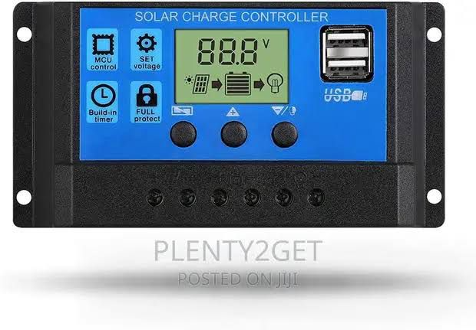
3.4 CASING AND PACKAGING
For this project, a plastic enclosure was chosen due to its strength, heat resistance, and ability to provide proper shielding against electrical interference. The plastic case also helps in dissipating heat generated by the power components, particularly the MOSFETs and transformer. The internal layout was carefully designed to allow for adequate ventilation and spacing between components to avoid overheating and reduce the risk of short circuits. A DC-powered fan were installed to enhance airflow and maintain an optimal operating temperature. Mounting brackets were used to securely fix the transformer, circuit board, battery terminals, and other components within the case. Input and output terminals, switches, and indicators were placed on the outer panel for easy access and user operation. The packaging also includes fuse holders and status LEDs to enhance user interaction and safety. In summary, the casing was designed to be compact, rugged, and user-friendly, ensuring protection for internal components while allowing easy maintenance and transport of the inverter system.
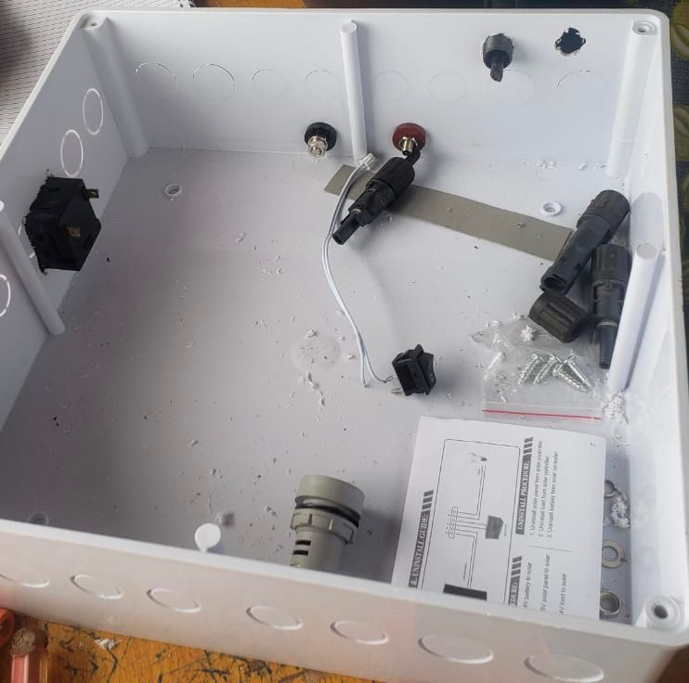
3.5 CIRCUIT DIAGRAM AND OPERATION
The circuit of the 3KVA inverter is designed to convert 24V DC from the battery into 220V AC using a combination of oscillator, driver, switching, and transformer stages. The main parts of the circuit include the oscillator section, MOSFET switching stage, and a step-up transformer.
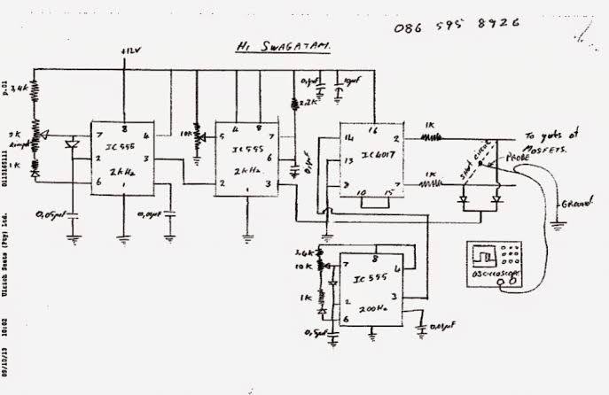
The circuit diagram of an inverter system
The operation begins with the oscillator section, which uses a timer IC (like NE555) or a microcontroller to generate a stable square wave signal at 50Hz. This signal is fed into a MOSFET driver circuit, which boosts the signal to a suitable level to switch the high-power MOSFETs. The MOSFETs, arranged in a push-pull or H-bridge configuration, act as electronic switches, rapidly turning on and off to chop the 24V DC supply into a pulsating AC waveform. These pulses are fed into the primary winding of the step-up transformer, which increases the voltage from 24V (AC equivalent) to approximately 220V AC at the secondary winding. Filter capacitors may be used at the output to smoothen the waveform and reduce electrical noise. The result is a modified sine wave or quasi-sine wave suitable for powering household or office appliances. Protection components like fuses, diodes, and heat sinks are included to prevent damage due to overcurrent, back EMF, or overheating. The circuit is designed for efficient operation, providing a stable AC output while maintaining the integrity of the components and overall system.

CHAPTER FOUR
4.0 SYSTEM CONSTRUCTION AND TESTING
4.1 TESTING AND EVALUATION UNDER LOAD CONDITION
The constructed 3KVA inverter was tested under various load conditions to evaluate its performance and stability. The testing involved connecting the inverter to a 24V battery bank and gradually applying electrical loads, starting from light appliances such as energy-saving bulbs and fans, up to heavier loads like a refrigerator and electric pressing iron. Throughout the testing, the output voltage remained stable around 220V AC, and the frequency stayed close to 50Hz. The inverter operated efficiently under partial and full loads, with only moderate heating observed in the transformer and MOSFETs during prolonged high-load operation. Adequate ventilation and heat sinks helped maintain safe temperatures. Overall, the inverter performed reliably within its rated capacity, making it suitable for household or office use.
4.2 POWER RATING
The power rating of the inverter defines its maximum load-handling capacity and determines the types of appliances it can support. In this project, the inverter was designed with a power rating of 3KVA (3000VA), which corresponds to a maximum power output of approximately 2400 watts, assuming a power factor of 0.8. This rating indicates that the inverter can effectively power a combination of household or office appliances such as fans, televisions, lighting systems, laptops, and refrigerators, provided the total load does not exceed its rated capacity. The system operates using a 24V DC battery input, which is stepped up to 220V AC output, making it suitable for standard electrical devices. Careful consideration was given to component selection including transformer size, wire gauge, and switching devices to ensure the system could consistently deliver the rated power without overheating or voltage drops.

4.3 DESIGN SPECIFICATIONS
The inverter was designed to produce a modified sine wave output, which is a stepped approximation of a pure sine wave, suitable for most household appliances. Unlike a smooth sine wave, the modified sine wave consists of a square-like waveform that changes polarity with a short zero-voltage pause between cycles, reducing harmonic distortion compared to a pure square wave. This waveform is easier and cheaper to generate using basic oscillator and switching circuits, making it ideal for low to medium-cost inverter systems. The output frequency was maintained at approximately 50Hz, and the RMS voltage was kept close to 220V AC. This design allows compatibility with common appliances like lights, fans, and chargers, though sensitive electronics may require a pure sine wave inverter for optimal performance. Below is the graphical representation of the modified sine wave produced by the inverter:
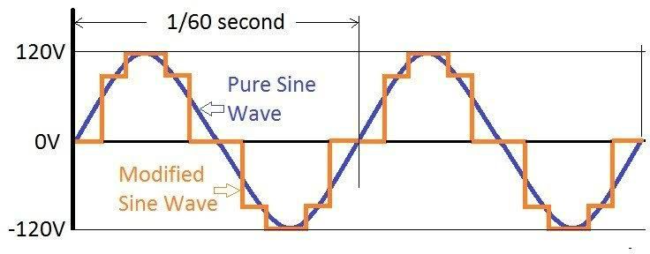
4.4 CHALLENGES ENCOUNTERED
During the design and construction of the 3KVA solar inverter using a 24V battery, several challenges were encountered that affected the development process. One major challenge was ensuring the stability of the oscillator circuit, as slight variations in frequency affected the output waveform quality. Another issue was heat generation in the MOSFETs and transformer during extended high-load testing, which required the addition of larger heat sinks and improved ventilation. Component sourcing also posed difficulties, especially in obtaining high-current-rated MOSFETs and transformers suitable for 3KVA operation. Additionally, achieving consistent output voltage under varying load conditions required careful calibration of the control circuit. Despite these setbacks, adjustments and redesigns were implemented to overcome the issues and ensure reliable inverter performance.
4.5 PROTECTION AND SAFETY FEATURES
To ensure reliable and safe operation of the 3KVA solar inverter, several protection and safety features were integrated into the design. A fuse was included at the input stage to prevent damage from overcurrent or short circuits, while reverse polarity protection diodes were used to safeguard against incorrect battery connections. Cooling fan were installed to manage thermal buildup in the MOSFETs and transformer, reducing the risk of overheating.
Additionally, the system was designed with overload protection, which automatically shuts down the inverter when the connected load exceeds its rated capacity. Proper insulation, spacing of high-voltage components, and a metallic casing were also employed to prevent electrical shocks and ensure user safety. These features collectively enhance the durability and safe functioning of the inverter system under various operating conditions.

CHAPTER FIVE
5.0 RESULTS, CONCLUSION, AND RECOMMENDATIONS
5.1 SUMMARY OF FINDINGS
The design and construction of a 3KVA solar inverter using a 24V battery system were successfully carried out. The system was able to convert 24V DC from the battery into a stable 220V AC output suitable for powering basic household appliances such as light bulbs, fans, and televisions. During testing, the inverter performed efficiently under different load conditions and maintained a consistent output voltage and frequency. The circuit components worked as expected, and the protection features, including low battery cut-off, overload, and short-circuit protection, were effective in preventing damage. Heat sinks and cooling fans were also tested and functioned well in managing the system’s temperature during extended use. Overall, the system demonstrated good performance in terms of reliability, safety, and efficiency. The use of simulation before construction helped to reduce errors and ensure the success of the physical build.
5.2 RESULT ANALYSIS
After the construction of the 3KVA solar inverter system, several tests were carried out to evaluate its performance. The inverter was connected to a fully charged 24V battery bank, and its output was measured using a multimeter and oscilloscope to verify voltage, frequency, and waveform characteristics. The system successfully produced an output voltage of approximately 220V AC at 50Hz, which meets the standard requirement for household appliances. The inverter was tested with different loads such as light bulbs, standing fans, and a small refrigerator. It handled these loads efficiently without overheating or shutting down, showing that the system could sustain a power output close to 3KVA. The protection features were also tested. When a load greater than the rated capacity was applied, the inverter automatically shut down to prevent damage, confirming the functionality of the overload protection circuit. The low battery protection was also triggered when the battery voltage dropped below the safe level, preventing deep discharge. The inverter efficiency was estimated to be between 80% and 85%, which is acceptable for a locally built inverter. Minor voltage drops were observed under heavy load, which is typical for modified sine wave inverters. The heat sinks and cooling fans were effective in controlling temperature during prolonged use.
5.3 CONCLUSION
This project successfully demonstrated the design and construction of a 3KVA solar inverter system using a 24V battery. The inverter was able to convert DC power from the battery into a stable 220V AC output suitable for powering household appliances. The system was tested under various load conditions and showed reliable performance, with built-in protection features functioning as expected. The project proves that with proper planning, affordable components, and a clear understanding of power electronics, a cost-effective and efficient solar inverter system can be built locally. It offers a practical solution to the problem of unstable electricity supply, especially in areas where access to the national grid is limited or unreliable.
5.4 RECOMMENDATION FOR IMPROVEMENT
While the 3KVA solar inverter system performed successfully, there are several ways it can be improved for better efficiency, durability, and user experience:
Use of Pure Sine Wave Inverter Topology: The current design may use a modified sine wave, which is less ideal for sensitive electronics. Switching to a pure sine wave inverter would ensure compatibility with all appliances and reduce noise or overheating in some devices.
Incorporation of MPPT Charge Controller: Replacing the basic charge controller with a Maximum Power Point Tracking (MPPT) controller would significantly improve the efficiency of solar charging by extracting more power from the solar panels, especially under varying sunlight conditions.
Improved Battery Technology: Using lithium-ion batteries instead of traditional lead-acid batteries would increase the system’s lifespan, reduce maintenance needs, and allow deeper discharge without damaging the battery.
Digital Monitoring System: Adding a digital display or monitoring system (e.g., LCD screen or mobile app) would allow users to track important parameters such as battery level, load status, and fault warnings in real time.
Compact and Modular Design: Future versions of the system can be made more compact and modular for easier transportation, installation, and repair. This would make the product more user-friendly and commercially viable.
Enhanced Protection Features: Additional safety measures like surge protection, reverse polarity protection, and thermal shutdown should be considered to increase reliability and user safety.
5.5 FUTURE WORK
Future advancements in the design and functionality of the 3KVA solar inverter system can focus on several key areas to enhance performance, efficiency, and adaptability to diverse energy needs:
- Integration with Smart Grid Systems: Future versions can be designed to interface with smart grid infrastructures, allowing for bi-directional power flow and intelligent load management, which would support grid-tied and hybrid applications.
- Hybrid Energy Input Support: The inverter can be modified to accept multiple energy inputs, such as wind, hydro, or diesel generators in addition to solar, to ensure consistent power availability in varying environmental conditions.
- Artificial Intelligence (AI) Integration: Employing AI algorithms can help in predictive energy management, fault detection, and adaptive control based on usage patterns and weather conditions, improving overall system intelligence and reliability.
- Scalability for Industrial Use: The inverter system can be scaled up to higher capacities (e.g., 5KVA or 10KVA) for industrial or community-based solar applications, incorporating more robust components and power management strategies.

REFERENCES
Akinboro,F. G., Sanusi, A. A., & Oladosu, D. A. (2012). Design and construction of a modified sine wave inverter. International Journal of Engineering and Technology, 2(4), 643–650.
Balogun, A. O., Adedokun, O. A., & Aladejana, J. A. (2013). Comparative analysis of inverter types and their applications. Journal of Electrical Engineering, 5(2), 45–51.
Esram, T., & Chapman, P. L. (2007). Comparison of photovoltaic array maximum power point tracking techniques. IEEE Transactions on Energy Conversion, 22(2), 439–449.
Gupta, A., Gupta, M., & Arora, S. (2011). Design and development of intelligent control system for inverter used in solar applications. International Journal of Advanced Engineering Technology, 2(4), 379–383.
Ikejuba,D. C., & Akande, A. (2016). Design and development of a solar power inverter system for rural applications. Nigerian Journal of Technology, 35(3), 526–531.
Luo, X., Wang, J., Dooner, M., & Clarke, J. (2015). Overview of current development in electrical energy storage technologies and the application potential in power system operation. Applied Energy, 137, 511–536.
Nema, P., Nema, R. K., & Rangnekar, S. (2009). A current and future state of art development of hybrid energy system using wind and PV-solar: A review. Renewable and Sustainable Energy Reviews, 13(8), 2096–2103.
Ohunakin, O. S., Adaramola, M. S., Oyewola, O. M., & Fagbenle, R. O. (2014). Solar energy applications and development in Nigeria: Drivers and barriers. Renewable and Sustainable Energy Reviews, 32, 294–301.
Oseni, M. O. (2012). Improving households’ access to electricity and energy consumption pattern in Nigeria: Renewable energy alternative. Renewable and Sustainable Energy Reviews, 16(6), 3967–3974.

APPENDICES
"Design and Construction of a 3KVA Solar Inverter Using 24V Battery". This section includes supplementary materials that support the content of your main chapters.
Appendix A: Circuit Diagram of the 3KVA Solar Inverter
- Detailed schematic diagram showing the inverter circuit including:
  - Oscillator stage
  - Driver stage
  - Power transistor/MOSFET stage
  - Transformer interface
  - Output filter
Appendix B: Components List
Component | Quantity | Specification
MOSFET (IRF3205) | 8 | 55V, 110A
Transformer | 1 | 24V–0–24V to 220V, 3KVA
PWM Controller (SG3525) | 1 | 16-pin DIP
Capacitors | 10 | 470μF, 100V Electrolytic
Resistors | 15 | Various (1kΩ, 10kΩ, etc.)
Heat Sink | 2 | Aluminum, large size
Diodes (1N5408) | 4 | 3A, 1000V
Relay | 1 | 24V, 30A
Cooling Fan | 1 | 12V DC
PCB Board | 1 | Standard Vero board
Appendix C: Inverter Testing Results
Test Load | Voltage Output | Frequency | Observation
100W bulb | 220V | 50Hz | Stable
500W Fan | 219V | 50Hz | Slight drop
1000W Load | 218V | 50Hz | Moderate heating
2500W Load | 215V | 50Hz | Near full capacity
3000W Load | 212V | 50Hz | Max limit reached, fan activates

Appendix D: PCB Layout
- Layout showing the arrangement of key components on the printed circuit board (PCB).
- Labeling of input/output terminals, MOSFETs, controller IC, etc.
Appendix E: Project Pictures
- Step-by-step images showing the construction stages:
  - Initial circuit assembly
  - Soldering process
  - Enclosure and final build
  - Test setup

