DESIGN AND CONSTRUCTION
OF SINGLE-PHASE TRANSFORMER TRAINER

BY
AROUNDEGBE JAMIU BAMIDELE
HND/23/EEE/FT/0066

A PROJECT REPORT SUBMITTED TO
THE DEPARTMENT OF ELECTRICAL/ELECTRONIC
ENGINEERING,
INSTITUTE OF TECHNOLOGY, KWARA STATE
POLYTECHNIC, ILORIN

IN PARTIAL FULFILLMENT OF THE REQUIREMENT FOR THE AWARD OF HIGHER NATIONAL DIPLOMA(HND) IN ELECTRICAL/ ELECTRONICS ENGINEERING KWARA STATE POLYTECHNIC, ILORIN
SUPERVISED BY
ENGR. T. A. MUSTAPHA
JUNE, 2025

CERTIFICATION
This is to certify that this project work was carried out and submitted by Aroundegbe Jamiu Bamidele of Matric No: HND/23/EEE/FT/0066 to the department of Electrical/Electronic Engineering is accepted having confirm with the requirement for the award of Higher National Diploma (HND) program in Electrical/Electronic Engineering.
____________________________ ____________________________

ENGR. T.A. MUSTAPHA
PROJECT SUPERVISOR Date:
_____________________________ ______________________________

ENGR. Z.A ABDULKADIR
PROJECT CO-ORDINATOR Date:
________________________________ ________________________________ ENGR. O.A.LAWAL.
HEAD OF DEPARTMENT Date:
_______________________________ _______________________________
EXTERNAL EXAMINER

DEDICATION
This project is dedicated to almighty God and my parents MR. & MRS AROUNDEGBE who had contributed immensely to my success in life, may almighty God continue to shower you with his immense blessings on each and everyone of them. [AMEN].

ACKNOWLEDGEMENT
Firstly, All thanks, praise and adoration is due to the uncreated creator of every creatures; the first without a beginning, the last without end, and the all knowing who teaches pen how to write, who also teaches man what he knows not, for his protection, guidance and abundant blessing bestowed on me throughout my project.
My profound gratitude goes to my project supervisor ENGR. T.A. MUSTAPHA, project coordinator and the entire workshop technical for their support and their unquantifiable advice given towards the success of the project.
In addition, I also acknowledge the support of my brothers, sisters for their moral support from the beginning of the PROJECT.
Thank you all.

ABSTRACT
Many tertiary institutions in Nigeria have limited access to technological equipment, especially in terms of practical equipment in the laboratory. This limitation causes students to be unable to think quickly, and has technological impact on the society during and after graduation. This project report presents the design and construction of a single-phase transformer trainer for educational purposes. The trainer is designed to provide a hands-on learning experience for students by allowing them to understand the principles and operation of transformers, effectively measure and perform different transformer tests. The trainer includes a step-down transformer, measurement instruments, and a load bank, enabling students to conduct experiments and demonstrations. The project aims to support students’ practical activities and to enhance students' understanding of transformer theory and applications, providing a practical learning experience in electrical engineering education. The objectives of this work were accomplished, and the trainer designed is reliable. Hence, it can be used to bridge and give better interpretations to concepts in the field of Electrical/Electronic Engineering irrespective of the population at a particular period.

TABLEOFCONTENT
Title page ………………………………………. i
Certification …………………………….………. ii
Dedication ……………………………………… iii
Acknowledgement …………………………….. iv
Abstract …………………………………………. v
Table of contents ……………………………..… vi
List of table ……………………………………. x
List of figures …………………………………. xi

CHAPTER ONE: INTRODUCTION
1.1 Background Information 1
1.2 Aim of the Project 3
1.3 Objectives of the Project. 3
1.4 Statement of The Problem 3
1.5 Significance of the Project 4
1.6 Scope and Limitation of the Project 4

CHAPTER TWO: LITERATURE REVIEW
2.1 Introduction 5
2.1.1 Transformer 5
2.1.2 Single Phase Transformer 5
2.1.3 Faraday's Law of Electromagnetic Induction. 6
2.1.4 Single-Phase Transformer Construction and Working Principle. 6
2.1.5 Primary Windings 7
2.1.6 Secondary Windings 7
2.1.7 Classification of Transformer Based on Voltage Levels. 7

2.2 Arduino LCD Display 8 CHAPTER THREE: DESIGN AND METHODOLOGY
3.1 Design and Methodology 9
3.2 Single-Phase TransformerTrainer 9
3.2.1 Power Supply 9
3.2.2 Output 10
3.2.3 Wire Selection 11
3.2.4 Insulation 11
3.2.5 Core Sheets 12
3.3 Assembling of A Single-Phase Transformer 12
3.3.1 Frame Construction 14
3.3.2 Procedure for The Construction of Single-Phase Transformer Trainer 14
3.4 Testing
3.5 Experiments
3.5.1 Experiment 1: Voltage and Turns Ratio Test for Step-Up And Step-Down
Transformer. 14
3.5.2 Experiment 2: Open Circuit Test (Core Loss Test) 16
3.5.3 Experiment 3: Short Circuit Test (Copper Loss Test) 18
3.5.4 Experiment 4: Transformer Efficiency Test (Load Test) 20
3.5.5 Experiment 5: Voltage Regulation of a Transformer 22
CHAPTER FOUR:
4.1 Testing, Result and Discussion 24
4.2 Testing of the Components 24
4.3 Soldering and Rearrangement of Components 24
4.4 Testing and Results 24
4.4.1 Experiment 1: Voltage and Turns Ratio Test of a Single-Phase
Transformer 24
4.4.2 Experiment 2: Open Circuit Test (Core Loss in a
Transformer) 26
4.4.3 Experiment 3: Short Circuit Test (Copper Loss Test) 27
4.4.4 Experiment 4: Transformer Efficiency Test 28
4.4.5 Experiment 5:Voltage Regulation of a Transformer (Load Test) 30
CHAPTER FIVE:
5.1 Conclusion 31
5.2 Recommendation 31
References 32

LISTOFTABLES

Table Page
Table 4.1 Comparing Step-Down (2:1) and Step-Up Turn Ratio of
Transformer. 25
Table 4.2 Open Circuit Test (Core Loss in a Transformer) 26
Table 4.3 Short Circuit Test (Core Loss Test) 27
4.3.1 Comparison of Open Circuit and Short Circuit Test. 28
Table 4.4 Transformer Efficiency Test 29
Table 4.5 Voltage Regulation of a Transformer (Load Test) 30

LIST OF FIGURES

Figure Page
2.1 Single-Phase Transformer Core 6
2.2 Arduino LED 8
3.1 Block Diagram of a Single-Phase Transformer Trainer 9
3.2 Output Digital Display 10
3.3 Paper binding Tape 11
3.4 The Core T and I Sheet 12
3.5 Transformer Circuit Board Internal Connection 13
3.6 Front view of Single-Phase Transformer Trainer 14
3.7 Circuit Diagram of Voltage and Turns Ratio 15
3.8 Open Circuit (No Load Test) 17
3.9 Short Circuit Test (Copper Loss Test) 19
3.10 Circuit Diagram for Transformer Efficiency 21
3.11 Circuit Diagram for VoltageRegulation 23

CHAPTERONE

1.0 INTRODUCTION 1.1 BACKGROUND INFORMATION
Trainer means an object that can train, teach and educate. A single-phase transformer trainer is a self-contained set of electrical and electronic circuits that can be interlinked/ switch on by students to create a multifunctional and flexible trainer instructional aid in the power and machines laboratory. This transformer trainer provides a set of components modules which are specially designed for performing certain experiments in such a way to understand the principles and operation of transformers. It effectively measures and perform different transformer tests.
In any learning institution it has been proven that practical bridges and gives a better interpretation and understanding to the theories. For this reason, practical works can be made efficient by developing practical models and training systems for practical hands on (Nasir, Syed Zain 2018).
Transformers play a critical role in the transmission and distribution of electrical power by efficiently stepping voltage levels up or down to meet system requirements. Their importance in electrical systems—ranging from power generation stations to household appliances—makes them a key topic in electrical and electronics engineering education.
A single-phase transformer is one of the simplest types of transformers, primarily used in residential, light commercial, and educational applications. It operates on the principle of electromagnetic induction, transferring electrical energy between two circuits through a magnetic field. In academic environments, it becomes essential not only to study these theoretical concepts but also to understand how transformers behave in practical settings under varying load conditions.
However, students often struggle to connect textbook theory with real-world application without hands-on experience. To bridge this gap, a transformer trainer serves as an instructional tool that simulates real operating conditions in a safe, controllable environment. A well-designed trainer allows students to perform practical tests such as open-circuit, short-circuit, efficiency, and load regulation tests.
This project aims to design and construct such a trainer, incorporating measurement instruments, safety features, and accessible terminals. The trainer will be housed in a durable casing with clearly labeled components, allowing for multiple experiments and visual demonstration of transformer principles. This practical approach enhances student engagement and deepens understanding of key transformer characteristics, such as voltage transformation ratio, efficiency, losses, and the effects of different load types.
This report outlines the design and construction of a single-phase transformer trainer which is an is an essential educational tool used in electrical engineering laboratories to demonstrate the principles of transformer operation, including voltage transformation, turns ratio, efficiency, and losses.Also, the project supports engineering education by enabling effective and safe transformer experimentation in the laboratory, preparing students for industry-standard knowledge and practices.

1.2 AIM OF THE PROJECT
The aim of this work is to design and construct a single-phase transformer trainer system that can be used for practical purpose in the laboratory

1.3 OBJECTIVES OF THE PROJECT
The objectives are:
- To design and demonstrate and understand transformer principles such as turns ratio, voltage transformation, and efficiency.
- To analyze transformer performance on open circuit and short circuit test • To evaluate transformer efficiency and losses like no-load losses, load losses, and voltage regulation.
- To develop practical skills in transformer operation and measurement.

1.4 STATEMENT OF THE PROBLEM
The lack of practical, hands-on experience with transformers in educational settings hinders students' understanding of transformer principles and operation, leading to a gap between theoretical knowledge and real-world application Some of the available Transformer trainer makes use of the analogue measuring instrument with a continuous varying data output display unit where individuals need to work at a very close range to view results whereby parallax error could occur during the time of taking reading from this continuous and fluctuating varying data output.There is therefore a critical need for an affordable, customizable, and safe single-phase transformer trainer that enables students to conduct meaningful experiments, measure performance characteristics accurately, and develop practical skills in transformer operation and analysis. Such a solution would bridge the current educational gap while remaining cost-effective for institutional adoption.

1.5 SIGNIFICANCE OF THE STUDY
The significance of this study lies in its potential to enhance the learning experience of students by providing hands-on experience with single-phase transformers, equipping them with practical skills, and bridging the gap between theoretical concepts and real-world applications, ultimately leading to improved student outcomes and better preparation for careers in electrical engineering.

1.6 SCOPE AND LIMITATIONS OF THE STUDY
This study is limited to the design and construction of a single-phase transformer trainer intended for educational use in electrical engineering laboratories. The trainer covers basic transformer operations such as step-up and step-down voltage transformation, open-circuit and short-circuit testing, efficiency analysis, and load variation demonstrations. It is designed to operate at standard laboratory voltage levels (e.g., 230V/24V, 50Hz) with moderate current ratings suitable for academic experiments. However, the trainer does not support high-power industrial applications, three-phase transformer systems, or advanced digital data acquisition features. Additionally, the design prioritizes safety and simplicity over precision measurement, so it may not be suitable for highly accurate or specialized testing. Despite these limitations, the trainer serves as a robust educational tool for illustrating fundamental transformer principles in a controlled and safe environment.

CHAPTER TWO

LITERATURE REVIEW
2.1 INTRODUCTION
This chapter is a description of some of major components that are used in the design and construction of a single-phase transformer trainer. It highlights the principle of operation employed by these components.

2.1.1 Transformer
It is a static electrical device which transforms the electrical energy from one electrical circuit to another without any change of frequency through the process of electromagnetic induction. It is interesting to note that the transfer of energy from one circuit to another takes place with the help of mutual induction that is flux induced in the primary winding gets linked with the secondary winding (Engineering World, 2019).

2.1.2 Single Phase Transformer
A single-phase transformer is a power transformer that operates on single phase alternating current. It consists of a primary winding connected to the source of supply and a secondary winding to provide electric power to the load. The two windings are wound around a common magnetic core made of laminated silicon steel sheets which provides a low reluctance path for the magnetic flux. Single phase transformers convert the alternating voltage from one circuit to another without any direct electrical connection between the two circuits. A typical single-phase transformer uses single-phase AC, meaning it operates with a voltage cycle that moves in sync over time. This type of transformer works based on Faraday's law of electromagnetic induction, which states that a change in magnetic flux through a coil induces a voltage in the coil.

2.1.3 Faraday's Law of Electromagnetic Induction
Faraday's law states that an electromotive force (EMF) is induced in any closed circuit when there is a change in the magnetic flux through the circuit. This electromagnetic induction effect is the basis for the working of single-phase transformers. When an alternating current flow through the primary winding, it produces an alternating magnetic flux around the core. According to Faraday's law, this changing flux induces an EMF in the secondary winding.
2.1.4 Single-Phase Transformer Construction and Working

Principle
A single-phase transformer is a high-efficiency piece of electrical equipment, and its losses are very low because there isn’t any mechanical friction involved in its operation. Transformers are used in almost all electrical systems, from low voltage up to the highest voltage level. It operates only with alternating current (AC) because direct current (DC) does not create any electromagnetic induction.
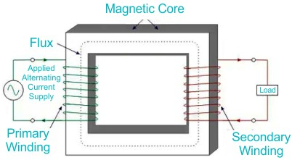
Figure 2.1: Single Phase Transformer Core
The primary coil of the transformer receives the voltage which is alternating in nature. The alternating current flowing in the coil produces a continuously changing and alternating flux which is produced around the primary winding. Then we have the other coil or the secondary coil which is near to the primary coil which get linked to the primary because some alternating flux gets linked. As the flux is changing continuously it induces an EMF in the secondary coil according to Faraday’s law of electromagnetic induction. If the secondary side circuit is closed a current will flow and this is the most basic working of a transformer, (Marshall Brain & Charles W. Bryant. 2007) The three main part of any transformer are:
i. The primary winding ii. Secondary winding iii. The magnetic core.

2.1.5 Primary Winding
This is the main winding where the incoming alternating current is expected. Depending on the fact that the transformer is either a step up or step-down transformer the winding construction changes accordingly.

2.1.6 Secondary Winding
This is the winding in which the flux produced by the primary winding get linked. In this case also depending on the fact that the transformer is either a step up or step-down transformer the winding construction changes accordingly.
2.1.7 Classification of Transformer Based onVoltage Levels
● Step-Up Transformer
As the name suggest, step up transformer are used to increase the voltage at the secondary side of the transformer. This is achieved by having a greater number of turns in the secondary side of the transformer as compared to the primary side of the transformer.
●Step- Down Transformer
As the name suggest, step down transformers
are used to decrease the voltage at the secondary side of the transformer. This is achieved by having a smaller number of turns in the secondary side of the transformer as compared to the primary side of the transformer.

2.2. ARDUINO LCD DISPLAY
The Arduino LCD (Liquid Crystal Display) module is a widely used output device that allows microcontrollers like Arduino to display text, numbers, and simple graphics. The most common type is the 16x2 LCD, which shows 16 characters per line across 2 lines, though other sizes (e.g., 20x4) are also available. These displays are popular due to their low power consumption, ease of interfacing, and clear visibility.
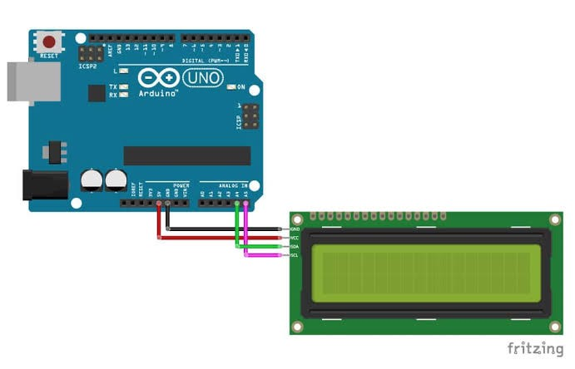
Figure 2.2: Arduino LCD

CHAPTERTHREE

3.1 DESIGN AND METHODOLOGY
This chapter deals with the entire procedures and designsinvolved in the design of all the electrical/electronic component
of Single-phase transformer trainer.

3.2 SINGLE PHASE TRANSFORMER TRAINER
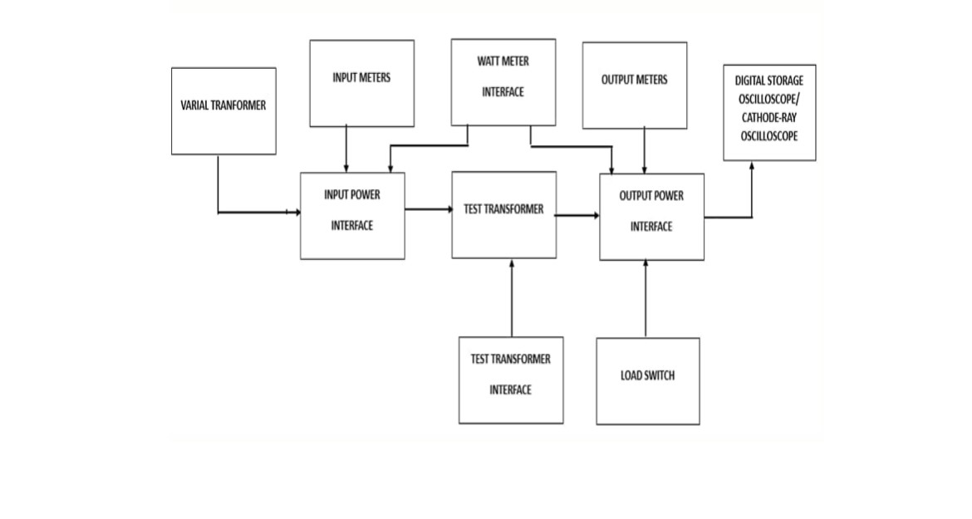
Figure 3.1: Block diagram of a single-phase transformer trainer Source: Engineering World (2019).

3.2.1 Power Supply
The power supply in the mother board is to supply a voltage of 5V DC to the LCD display on the transformer trainer. This task is accomplished by rectifying AC to DC and then smoothening the rectified voltage to remove AC ripples before it is regulated to 5V using IC voltage regulator.
The power supply supplies 12v and 2A by using two voltage regulators connected in parallel. It also supplies 5v for powering the LCD and the current sensor. In achieving this, the power from the authorities has to be stepped down, filtered and regulated. The power supply unit consist of the following components:
i. Transformer ii. The rectifier circuits iii. Smoothing capacitor iv. The regulators 3.2.2 Output
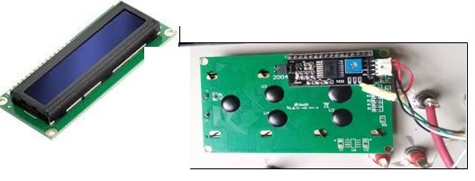
Figure 3.2: Output Digital Display
Source: Raj, Aswinth (2015)
The output from the trainer is connected to LCD to display the result of various experiment performed on the trainer. The trainer and the LCD are linked via the digital pin on the Arduino board.

3.2.3 Wire Selection
The selection of SWG (Standard Wire Gauge) wire in a transformer is a critical aspect of transformer design, particularly for the winding of coils. The wire gauge chosen impacts various transformer characteristics such as resistance, current-carrying capacity, and space utilization The SWG of the wire should be chosen to handle the expected current in the winding without excessive heating.Higher SWG values indica te thinner wire, which may have lower current-carrying capacity.
Primary current = 4
Secondary current = 2A
Using table; Primary Winding = 17 SWG
Secondary Winding =19 SWG

3.2.4 Insulation
Insulation materials are crucial in transformers to prevent electrical breakdown and ensure the safe and reliable operation of the device. The insulation between primary and secondary windings is essential to avoid short circuits and maintain the electrical integrity of the transformer. We have used paper binding tape for the purpose as shown in the figure below.

Figure 3.3: Paper Binding Tape

3.2.5 Core sheets
Inserting core E sheets is the next step in the construction of the core of a transformer. The core E sheets, typically made of laminated silicon steel, form the magnetic circuit that allows the efficient transfer of magnetic flux. These lamination stampings when connected together form the required core shape. For example, two “E” stampings plus two end closing“I” stampings to give an E-I core forming one element of a standard shell-type transformer core. These individual laminations are tightly butted together during it’s construction to reduce the reluctance of the air gap at thejoints producing a highly saturated magnetic flux density.

Figure 3.4: The Core E and I Sheet

3.3 ASSEMBLING OF A SINGLE-PHASE TRANSFORMER

3.3.1 Frame Construction
The trainer is enclosed in a square shape cast wooden frame with a vertical position slightly bent backwards. The meters are mounted on a vertical section while the mimic diagram data is covered with vanished ½ plywood board screwed into the meter frame. The front panel where the meters are mounted is covered with velvet cloth to enhance its ecstatic. The trainer frame rests on four legs, the material for the Trainer construction was chosen with the utmost regard to their reliability,durability, maintainability and readability attributes.

3.3.2 Procedures for the construction of the single-phase transformer trainer
The procedures for the construction of the transformer trainer are as follow;
- The wooden frame is first cut into require size of 60cm by 43cm by58cm to form a skeletal frame of how the trainer will look like.
- The pointed board of the transformer shows the parameters of the transformer circuit to required shape and length.
- The placing of the sockets at the relevant areas to show the current,voltage and power is done by the drilling to give the reading for the connection to the ammeter, voltmeter and wattmeter of the board.
- Wiring of the socket after drilling is done so that the readings can be shown at the ammeter and voltmeter.
- Placing the ammeter, voltmeter, circuit breaker and toggle switch was done at their respective position.
- The wiring was done in such a way that a return path was made so that a complete circuit was established.
- After the connection of the equipment it is then wrapped with suitable leather to give it ecstatic y
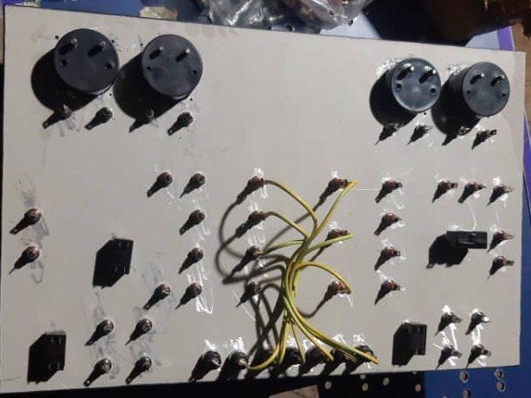

Figure 3.5: Transformer circuit board internal connection
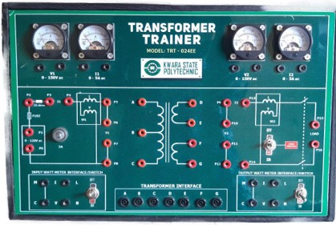
Figure3.6:Front view of a Single Phase Trainer

3.4 TESTING The following tests were carried out during and after the construction
- Continuity test:The continuity test was carried out to check for disconnection and open circuit in the work using a multimeter.
- Power consumption:The voltage across each component and the entire circuit was measured when the system was powered.
- System Testing and Integration:After the design and implementation stage, the system was tested for durability and effectiveness and also to ascertain if there is need to modify the design. The system was first assembled using breadboard. All the component where properly soldered to the ferro board and test were carried out at various stages.To ensure proper functioning of the components,
they were tested using a digital multimeter to ensure that they were within the tolerance value. Faulty components were discarded.
  - SOME OF THE EXPERIMENTS THAT CAN BE CARRIED OUT ON THE CONSTRUCTED TRAINER.
3.5.1 Experiment 1: Voltage and Turn Ratio Test for Step down and Step

up Transformer
Objective: To measure the primary and secondary voltages and currents of a transformer

Equipment Required
- Transformer trainer (TRT – 024EE)
- AC power supply (0-120V adjustable)
- Voltmeters (1 and V2 on the panel)
- Connecting wires (patch chords)

Diagram;
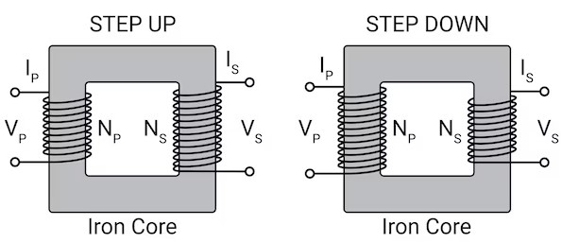

Figure 3.7: Circuit Diagram of Voltage Turn Ratio
Apparatus:
 Single-phase transformer trainer
 Multimeter (for cross-checking)
 Load (resistor or lamp)
 Connecting wires
Theory:
The performance of a transformer largely depends on the accuracy of its turn or voltage ratio. Therefore, the transformer ratio test is essential. To ensure safety, voltage should only be applied to the high voltage (HV) winding. It helps to understand how a step up or step- down transformer works.
Procedures:
- Step-Down Transformer (2:1):
  - Primary Connection: Connect the primary winding (220 V) to the AC supply.
  - Secondary Connection: Leave the secondary winding (110 V) open.
  - Measurements:
  - Primary voltage (Vp ), current (Ip), and input power (Pin ).
  - Secondary voltage (Vs).
  - Record: Vp =220 V, Ip =0.1 A, Pin =22 W, Vs =110 V.
- Step-Up Transformer (1:2):
- Primary Connection: Connect the primary winding (110 V) to the AC supply.
- Secondary Connection: Leave the secondary winding (220 V) open.
- Measurements:
  - Primary voltage (Vp), current (Ip ), and input power (Pin ).
  - Secondary voltage (Vs).
  - Record your observations in a table.

3.5.2 Experiment 2: Open Circuit (Core loss Test)
Objective: To measure the no-load current and core loss in a transformer. Equipment Required
- Transformer trainer
- AC power supply (0-120V adjustable)
- Wattmeter (W1)
- Voltmeter (V1)
- Ammeter (I1)
- Connecting wires
Theory:
The open circuit test, also known as the no-load test, determines the core losses of a transformer, which include hysteresis losses and eddy current losses in the transformer core. Hysteresis losses arise due to the repetitive magnetization and demagnetization of the core material during each AC cycle, while eddy current losses occur due to circulating currents induced within the conductive core material.
This test also helps calculate the magnetizing reactance (Xm) and the excitation current (Im), both of which characterize the magnetization behavior of the transformer core under no-load conditions. By applying a rated voltage to the primary winding with the secondary winding open, the no-load current drawn by the transformer is measured, providing critical insights into the efficiency and performance of the transformer.
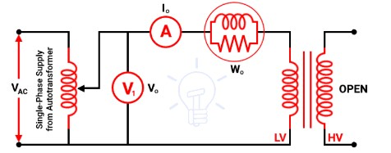

Figure 3.8: Open Circuit (No load test)
As shown in the above figure, the primary winding (low voltage winding) is supplied by rated voltage and frequency and the secondary winding is kept open. A voltmeter V0, an ammeter I0, and a wattmeter W0 are connected in the primary winding. The secondary winding is kept open and the current that passes through the secondary winding is zero. And the load is not connected. Hence, the current that passes through the primary winding is no-load current I0. The current that passes through the primary winding is measured by an ammeter that gives the value of no-load current.
No-load power W0 = V1 I0 Cos ϕ0 = Iron loss (3.1)
IW = I0 Cos ϕ0 (3.2) IM = I0 Sin ϕ0 (3.3)

Procedure
1. Connect the variac transformer input winding to the mains power supply 2. Connect the variac transformer output winding to point P0 and P1o n the transformer trainer unit. Keep the knob of the variac transformer at zero position.
- Connect ammeter I1 to points P2 and P4 to measure the input current
- Interface the test transformer to its labeled input points 5. Use points P5 and P8 throughout the experiment as your input voltage source to supply power to the transformer at specific inputs
6. Connect the primary winding terminal A to P5 and B to P8 7. Leave the secondary winding terminals (D, E, F, and G) open.
- Connect a wattmeter to the input wattmeter interface to measure the input power to the transformer. Keep the wattmeter switch at the
ON position
- Connect a voltmeter V1 across points P6 and P7 to measure the primary voltage
- Turn on the power supply and gradually increase the voltage to the rated value.
- Record the primary voltage, no-load current, and input power.
- Calculate the core losses using the wattmeter reading.
- Repeat the test for different voltage levels below the rated voltage to observe the variation in core losses and magnetizing current.

3.5.3 Experiment 3: Short Circuit Test (Copper Loss Test)
Objective: To determine the copper losses, equivalent resistance, and impedance of the transformer.

Equipment Required
- Transformer trainer (TRT – 024EE)
- AC power supply (0-30V adjustable)
- Ammeter
- Wattmeter
- Voltmeter
- 10-ohm resistance
- Connecting wires (patch chords)
Theory:
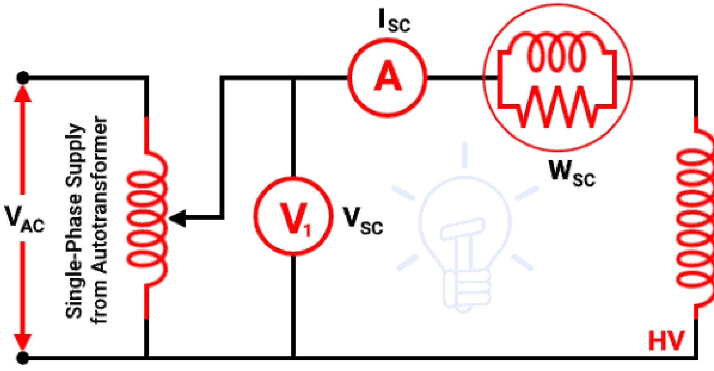
The short circuit test, also known as the copper loss test, is conducted to determine the copper losses in a transformer. Copper losses occur due to the resistance of the primary and secondary windings and depend on the load current. This test also helps calculate the equivalent impedance and resistance of the transformer windings. Circuit Diagram:

Figure 3.9: Short Circuit Test (Copper Loss Test)
A low voltage winding is short-circuited using a thick wire. An ammeter is connected to measure the rated load current. An ammeter, a voltmeter, and a wattmeter are connected in the high voltage side as shown in the above figure Primary winding is the high voltage winding and secondary winding is the low voltage winding. The high voltage winding is supplied by the reduced input voltage from a variable supply source. The supply voltage gradually increases until full-load primary current flows through the primary winding. The current that passes through the windings is a full-load current. So, a copper loss that occurs during a test is a normal full-load copper loss. And the wattmeter indicates the full-load copper loss. The secondary winding is short-circuited. So, the secondary voltage (output voltage) is zero.
Procedure:
1. Connect the variac transformer input winding to the mains power supply 2. Connect the variac transformer output winding to point P0 and P1 on the transformer trainer unit. Keep the knob of the variac transformer at zero position.
- Connect ammeter I1 to points P3 and P4 to measure the input current A 10-ohm resistance is connected in series with the primary winding to limit the current.
- Interface the test transformer to its labeled input points
- Use points P5 and P8 throughout the experiment as your input voltage source to supply power to the transformer at specific input voltage
- Connect the primary winding terminal A to P5 and B to P8
- Connect a wattmeter to the input watt meter interface to measure the input power to the transformer. Keep the input watt meter switch at the ON position 8. Connect a voltmeter (V1) across points P6 and P7 to measure the primary voltage
- Short the secondary winding terminals (D and E).
- Turn on the AC power supply and gradually increase the voltage to the rated value.
- Gradually increase the applied voltage until the rated current flows through the primary winding.
- Record the following readings:  Primary current (Isc)
 Applied voltage (Vsc)
 Input power (Psc)
- Calculate the copper losses using the wattmeter reading.
- Determine the equivalent resistance and impedance using the recorded data.

3.5.4 Experiment 4: Transformer Efficiency Test (Load Test)
Objectives:
- To determine the efficiency of a single-phase transformer under different loading conditions.
- To analyze the variation of efficiency with load and power factor.
- To plot efficiency curves for different power factors.

Apparatus Required
- Single-phase transformer
- Voltmeter (AC), Ammeter (AC), and Wattmeter.
- Resistive load bank or rheostat.
- AC supply (regulated).
- Connecting wires.
- Multimeter (optional, for verification of readings).
Theory:
Transformer efficiency test experiment typically involves setting up a circuit, applying a known voltage and current, measuring the output power, and calculating the efficiency. The efficiency is the ratio of output power to input power, expressed as a percentage. The test involves both open-circuit and short-circuit tests, as well as a load test, to determine the transformer's performance characteristics
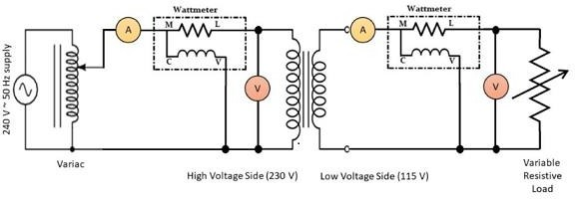

Circuit Diagram
Figure 3.10: Circuit Diagram for TransformerEfficiency Precautions:
- All connections should be neat and tight.
- Connecting leads should be perfectly insulated.
- There should be no error in ammeter and voltmeter.
- The range of instruments should be carefully chosen. Procedure:
- Set up the transformer with an appropriate input voltage.
- Measure the input voltage (primary side) and current using the respective meters.
- Measure the output voltage and current on the secondary side.
- Calculate the input power as Pin =Vprimary × Iprimary. (3.4)
- Calculate the output power as Pout=Vsecondary ×
Isecondary. (3.5)
- Compute the efficiency using the formula:
η = (Pout / Pin) ×100 (3.6)
- Record the results and observe how efficiency changes with different loads. Expected Results: The efficiency should be close to 100%, with slight losses due to the transformer's internal resistance.

3.5.5: Experiment 5: Voltage Regulation of a Transformer
Objective: To study the voltage regulation of a single-phase transformer by varying the load.
Apparatus:
 Single-phase transformer trainer
 Voltmeter and ammeter (built into the trainer)
 Variable resistor (load)
 Connecting wires
Procedure:
- Set the primary voltage to a fixed value (e.g., 100V).
- Measure the no-load secondary voltage (open-circuit).
- Apply a load to the secondary side and measure the secondary voltage under load.
- Record the no-load and full-load voltages.
- Calculate the percentage voltage regulation using the formula:
Voltage Regulation= ((Vno_load – Vfull_load) / Vfull_load) ×
100 (3.7)
- Repeat the experiment for different load values and plot the voltage regulation curve.
Expected Results: Voltage regulation will increase as the load increases.
- Circuit Diagram:
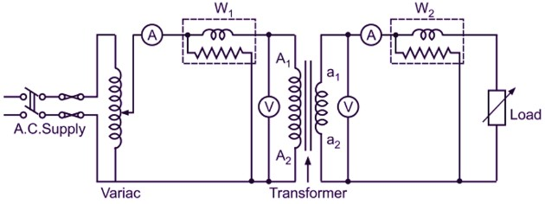
Figure 3.11: Circuit Diagram for Voltage Regulation

CHAPTER FOUR

4.1 TESTING, RESULTS AND DISCUSSION
In the process of design and construction of single-phase transformer trainer, there are four major stages involved. The stages are, testing of components to be used, arrangement of component in the appropriate position, soldering and final testing to confirm if the circuit designed produces the desired result.

4.2 TESTING OF THE COMPONENTS
The components used for the construction were purchased according to the design specification and tested to ascertain its performance. The polarity and pin arrangement of some of the components were noted.

4.3 SOLDERING AND ARRANGEMENT OF COMPONENTS
Soldering is a process of joining two or more metals together by application of heat and solder to join the components. Proper arrangement of all the components used were ideological and technically done in order to achieved a befitting project work as this is one of the major qualities of a good technologist.

4.4 TESTING AND RESULT

4.4.1 Experiment 1: Voltage and Turn Ratio Test of a single-phase Transformer
Calculation:
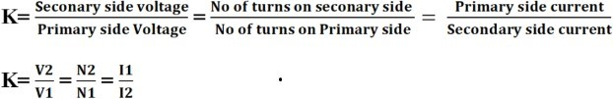
Calculate the transformation ratio using (4.1)
If K is greater than 1 then it is a step-up transformer and if less than 1 then it is a step-down transformer but if its equal to 1 then it is an isolation transformer
OBSERVATION TABLE:

Table 4.1: Comparing Step-Down (2:1) and Step-Up (1:2) Turn ratio of Transformers
Parameter | Step-Down Transformer (2:1) | Step-Up Transformer (1:2)
Turns Ratio | Ns /Np =2:1 | Ns /Np =1:2
Primary Voltage  (Vp ) | 220 V (Input) | 110 V (Input)
Secondary  Voltage (Vs ) | Theoretical: 110 V | Theoretical: 220 V
 | Actual (No Load): 110 V | Actual (No Load): 220 V
 | Actual (Loaded): 108 V | Actual (Loaded): 215 V
Primary  Current (Ip ) | Theoretical: 1 A | Theoretical: 2 A
 | Actual (Loaded): 1.05 A | Actual (Loaded): 2.1 A
Secondary  Current (Is ) | Theoretical: 2 A | Theoretical: 1 A
 | Actual (Loaded): 1.95 A | Actual (Loaded): 0.95 A
Input Power (Pin ) | 220 V × 1.05 A ≈ 231W | 110 V × 2.1 A ≈ 231W
Output Power (Pout ) | 108 V × 1.95 A ≈ 210.6W | 215 V × 0.95 A ≈ 204.25W
Efficiency (η) | 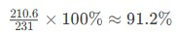 | 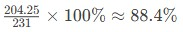
Losses | Core losses: 20 W  Copper losses: 0.4 W | Core losses: 20 W  Copper losses: 6.75 W
DISCUSSION:
The table underscores the inverse voltage-current relationship in transformers and the impact of practical inefficiencies:
- Step-down transformers excel in efficiency (>94%>94%) and voltage regulation (<2%<2%) under load.
- Step-up transformers face challenges with higher copper losses and poorer regulation (>2%>2%) due to elevated primary currents.
- Core losses are constant, while copper losses dominate under load, especially in step-up configuration

4.4.2 Experiment 2: Open Circuit (Core loss in a Transformer)
Objective: To measure the no-load current and losses in a transformer.
Calculations:
- Core Losses (W) = Wattmeter Reading (W)
- Magnetizing Reactance (Xm) = Vi / Io(Ohm) (4.2)
- Core Loss Resistance (Rc)= Vi² /Pc (4.3)
Where, Vi: Applied primary voltage (Volts) Pc: Core losses (Watts) Observation Table:

Table 4.2: Open Circuit (Core loss in a Transformer)
Paramet er | Symbol | Value | Unit | Formula
Input  Voltage  (Primary  ) | Voc | 230 | V | Measured  directly
No-Load  Current | Ioc | 0.2 | A | Measured using an ammeter
Core  Loss (No-Loa d Power) | Pcore | 30 | W | Measured using a wattmeter
Core  Loss Resistanc e | Rc | 1763 | Ω | 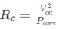
Magnetiz ing Reactanc e | Xm | 1513 | Ω

Discussion
 Core Loss (Pcore ): 30 W (constant for the transformer at rated voltage).
 No-Load Current (Ioc ): 0.2 A (2% of rated current for a 1 kVA transformer).
 Power Factor:
 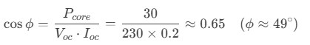In dicates the phase lag between voltage and no-load current.
 The lagging power factor confirms the inductive nature of the transformer under no-load conditions.
 Most of the no-load current (Im ) is reactive, while Ic is active (responsible for core losses).
4.4.3: Experiment 3: Short Circuit (Copper loss test)

Observations Table Table 4.3: Short Circuit (Copper loss test)
Paramet er | Symbol | Value | Unit | Formula
Input  Voltage  (Primary  ) | Vsc | 15 | V | Reduced voltage applied to primary
Short-Cir cuit  Current | Isc | 4.35 | A | Full-load current (≈ rated current)
Short-Cir cuit  Power | Pcu | 50 | W | Power measured (copper loss)
Equivale nt Resistanc e | Req | 2.65 | Ω | 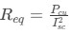
Equivale nt  Leakage Reactanc e | Xeq | 3.2 | Ω | 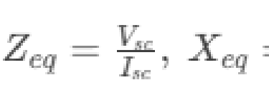

Discussion
- Copper Losses:
  - Pcu=50 W represents total winding resistance losses at full load.
  - Copper losses vary with the square of the load current (Pcu∝ I2Pcu ∝ I2).
- Equivalent Resistance (Req ):
  - Combines primary and secondary winding resistances referred to the primary side.
  - Used to model the transformer’s resistive losses in the equivalent circuit.
- Leakage Reactance (Xeq ):
  - Represents the combined leakage flux reactance of primary and secondary windings.
  - Affects voltage regulation and fault current levels.
- Impedance Voltage (Vsc ):
  - A low voltage (15 V) is applied to circulate full-load current in the windings.

Table 4.3.1 Comparison Open-Circuit Test and Short Circuit Test
Parameter | Short-Circuit Test | Open-Circuit Test
Purpose | Measure copper losses | Measure core losses
Secondary Condition | Short-circuited | Open-circuited
Applied Voltage | Low (5–10% of rated voltage) | Rated voltage (230 V)
Losses Measured | Copper losses (Pcu ) | Core losses (Pcore)
Key Parameters | Req , Xeq | Rc , Xm

4.4.4 Experiment 4: Transformer Efficiency Test Transformer Efficiency Test Results
Transformer Rating: 1 kVA, 230/115 V
Frequency: 50 Hz
Primary Winding (HV): 230 V
Secondary Winding (LV): 115 V
Observation Table:

Table 4.4: Transformer Efficiency Test
Loa d (%) | Input  Voltage  (V) | Input  Current  (A) | Input  Power  (W) | Output  Voltage  (V) | Output  Current  (A) | Output  Power  (W) | Efficienc  y (%)
0%  (NoLoa d) | 230 | 0.2 | 30 | 115 | 0 | 0 | 0%
25% | 230 | 1.1 | 70 | 113 | 2.17 | 245 | 89.3%
50% | 230 | 2.2 | 135 | 112 | 4.35 | 487 | 92.6%
75% | 230 | 3.2 | 190 | 110 | 6.52 | 717 | 94.1%
100  % | 230 | 4.35 | 250 | 108 | 8.70 | 939 | 93.6%
125  % | 230 | 5.4 | 315 | 105 | 10.87 | 1142 | 92.3%
Discussion
1. Efficiency Trend:
o Efficiency peaks at 94.1% near 75% load (typical for transformers). o Efficiency decreases slightly at overload (125%) due to increased copper losses (I²R).
- Voltage Regulation: o Output voltage drops from 115 V (no-load) to 105 V (125% load) due to winding resistance and leakage reactance.
- Losses:
o Core Losses: Constant at 30 W (measured during no-load test). o Copper Losses: Increase with load, e.g., at 100% load
4.4.5 Experiment 5: Table 6: Voltage Regulation of a Transformer (Load Test) Observation Table:
1 Resistive (R) 4.00 230.0 220.0 4.55 % 2 Inductive (L) 4.00 230.0 215.0 6.98 %
3 Capacitive (C) 4.00 230.0 235.0 -2.13 %
Table 4.5: Voltage Regulation of a Transformer (Load Test)
Discussion:
- Resistive Load gives moderate voltage drop.
- Inductive Load causes more voltage drop due to lagging power factor.
- Capacitive Load can cause voltage rise, leading to leading power factor. Meaning the current leads the voltage and reduces the voltage drop. Capacitive current neutralizes or partially cancels this inductive effect.

CHAPTER FIVE
CONCLUSION AND RECOMMENDATION

5.1 Conclusion
The single-phase transformer trainer was successfully designed and constructed, meeting the specified aim and objectives. The single-phase transformer trainer enables experiments such as transformation ratio test, open circuit test to measure core losses, short circuit test to measure copper losses, and load tests to evaluate efficiency and voltage regulation of the single-phase transformer. Finally, the project demonstrates the importance of transformers in electrical power systems and provides a valuable learning tool for students.

5.2 Recommendation
Future projects could focus on designing and constructing three-phase transformer trainers or transformers with different ratings and specifications by incorporating additional features such as temperature monitoring, overcurrent protection, and digital displays for easier data collection.
In addition, future projects could also explore designing transformers with different ratings, configurations, or materials to expand the scope of experimentation and learning. Moreover, integrating the trainer with data acquisition systems or simulation software could provide more comprehensive insights into transformer performance and behavior.

REFERENCES
Brynat, W, (2018). Voltage Sensor.
http://www.scangaule.com/help/scanway_ep2/DC_Voltage_Sensor.htm
Ciletti, M. D., Irwin, J. D., Kraus, A. D., Balabanian, N., Bickard, T. A., and Chan, S. P. (1993). Linear circuit analysis. In Electrical EngineeringHandbook, edited by R. C. Dorf. Boca Raton: CRCPress. (pp.82– 87) IEEE 100: the authoritative dictionary of IEEE standards terms. - 7th ed.ISBN0-7381- 2601-2.
Damirch, Mohammad (2019). Interfacing ADS1015 12-Bit ADC with Arduino retrieved
from https://electropeak.com/learn/interfacing-ads1015-12-bit-adc-with-arduino/
Electrical Technology – Polarity Test on Transformer retrieved from https://www.electricaltechnology.org/2022/03/polarity-test-of-transformer.html
Electrical Workbook – Load Test on Transformer retrieved from https://electricalworkbook.com/load-test- on-transformer/ (Retrieved:
21/09/2023)
Eloprocus Electronic.(2013). Current sensor working and it Application retrieved from https://www.engineeringworldchannel.com/transfor mer-definition/ (Retrieved: 21/09/2023)
Flanagon W. (1993) Handbook of transformer design and application McGraew hill, Singapore
HiTech. (2019) . Frequency Response of Sensor retrieved from https://www.hitecsensors.com/technical/frequency-response-of-sensors
/ (Retrieved: 21/09/2023)
Nasir, Syed Zain (2018).Introduction to Resistors retrieved from https://www.google.com/amp/s/www.theengineeringprojects.com/2018
/01/introduction-to-resistors.html/%3famp=1
Michael, V.D, Geschichie (2006) der electro technical
volume 9 VERLAG Berlin Offenbach
GermanRaj, Aswinth (2015). 16×2 LCD display Module retrieved from https://circuitdigest.com/article/16x2-lcd- display-module-pinout-datasheet (Re trieved: 21/09/2023)
Say, M.G(1984) Alternating Current Machine Halstel Press, London.
Saitrin,S.(2016). Principles Behind Resistive Sensor retrieved
from https://www.slideshare.net/saitrinathsaka01/principle-behind-resistive-sensors
Sing, Abraham siyon (2012). Different types
of
transformers retrieved from https://www.electrically4u.com/different-types-of-transformer/z (Re trieved: 21/09/2023)
Ukpabi, W. J. (2008) in digenization of technology, its relevance in promoting industrialization of Nigeria: lecture delivered on the occasion of 50th Anniversary.
Zait,Anat. (2018). An Introduction to ArduinoUno Pinout retrieved from https://w ww.google.com/amp/s/www.circuito.io/blog/arduino-uno-pinout.amp/Retrieved: 21/0
9/2023)

