DESIGN AND IMPLEMENTATION OF AN INTEGRATED WEB-BASED PLATFORM FOR STAFF PROFILES, REPOSITORIES, AND CONTENT MANAGEMENT

(A CASE STUDY OF KWARA STATE POLYTECHNIC)

BY

SAKA LATEEF OLASHILE
HND/23/COM/FT/0120

SUBMITTED TO:

DEPARTMENT OF COMPUTER SCIENCE

INSTITUTE OF INFORMATION AND COMMUNICATION TECHNOLOGY

KWARA STATE POLYTECHNIC, ILORIN

IN PARTIAL FULFILLMENT OF THE REQUIREMENT FOR THE AWARD OF HIGHER NATIONAL DIPLOMA (HND) IN COMPUTER SCIENCE

SUPERVISED BY
DR. ABDULRAHMAN T. A.
JUNE, 2025.

CERTIFICATION

This is to certify that this project research was carried out by [Put your name] with the matriculation number [Put your matric number] has been read and approved as meeting part of the requirements for the Award of Higher National Diploma (HND) in Computer Science.

____________________________ _____________________
DR. ABDULRAHMAN T.A Date
Project Supervisor

____________________________ _____________________
MR. OYEDEPO F.S Date
Head of Department

____________________________ _____________________
External Supervisor Date

DEDICATION

This project work is dedicated to the glory of God, my parents, and siblings.

ACKNOWLEDGEMENT

All praise to the Almighty God. We want to thank the Lord for our continued existence on earth and for giving us the strength, knowledge and strength to complete our programme successfully.

We also want to appreciate our project supervisor, Dr. Abdulrahman Tosho, whose support, patience and guidance helped in the attainment of this project work. We pray that God will bless and keep him in perfect peace. Our sincere appreciation also goes to all other lecturers in the department, for their teaching, consistency in class, support, and guidance throughout our programme.

We also want to say a BIG THANK YOU TO our parents and siblings for their love, support, help and guidance as we journeyed through school. Their financial support, prayers on bended knees, advice and understanding has helped us scale through. It is my prayer to God that he will keep us all together in ove, peace, health, and in love.

TABLE OF CONTENTS
Title Page
Certification
Dedication
Acknowledgements
Abstract
Table of Contents
CHAPTER ONE: GENERAL INTRODUCTION
1.1 Background to the Study - - - - - - - - - - - - - - - - - - - - - - - - - - - - - - - - - - - - - - - - - - - 1
1.2 Statement of the Problem - - - - - - - - - - - - - - - - - - - - - - - - - - - - - - - - - - - - - - - - - - - 2
1.3 Aim and Objectives - - - - - - - - - - - - - - - - - - - - - - - - - - - - - - - - - - - - - - - - - - - - - - 2
1.4 Significance of the Study - - - - - - - - - - - - - - - - - - - - - - - - - - - - - - - - - - - - - - - - - - 3
1.5 Scope of the Study - - - - - - - - - - - - - - - - - - - - - - - - - - - - - - - - - - - - - - - - - - - - - - - 3
1.6 Organization of the Report - - - - - - - - - - - - - - - - - - - - - - - - - - - - - - - - - - - - - - - - - - 4
1.7 Definition of Terms - - - - - - - - - - - - - - - - - - - - - - - - - - - - - - - - - - - - - - - - - - - - - - - 4
CHAPTER TWO: LITERATURE REVIEW
2.1 Review of Related Works - - - - - - - - - - - - - - - - - - - - - - - - - - - - - - - - - - - - - - - - - - - 6
2.2 Review of General Texts - - - - - - - - - - - - - - - - - - - - - - - - - - - - - - - - - - - - - - - - - - - 7
2.3 Historical Background - - - - - - - - - - - - - - - - - - - - - - - - - - - - - - - - - - - - - - - - - - - - - 8
CHAPTER THREE: METHODOLOGY AND SYSTEM ANALYSIS
3.1 Research Methodology - - - - - - - - - - - - - - - - - - - - - - - - - - - - - - - - - - - - - - - - - - - 10
3.2 Analysis of the Existing System - - - - - - - - - - - - - - - - - - - - - - - - - - - - - - - - - - - - - 11
3.3 Problems of the Existing System - - - - - - - - - - - - - - - - - - - - - - - - - - - - - - - - - - - - - 12
3.4 Description of the Proposed System - - - - - - - - - - - - - - - - - - - - - - - - - - - - - - - - - -- 12
3.5 Advantages of the Proposed System - - - - - - - - - - - - - - - - - - - - - - - - - - - - - - - - - - - 13
CHAPTER FOUR: SYSTEM DESIGN AND IMPLEMENTATION
4.1 Design of the New System
4.1.1 Output Design - - - - - - - - - - - - - - - - - - - - - - - - - - - - - - - - - - - - - - - - - - - - - - 14
4.1.2 Input Design - - - - - - - - - - - - - - - - - - - - - - - - - - - - - - - - - - - - - - - - - - - -- - - - 20
4.1.3 Database Design - - - - - - - - - - - - - - - - - - - - - - - - - - - - - - - - - - - - - - - - - - - - - 23
4.1.4 Process/Procedure Design - - - - - - - - - - - - - - - - - - - - - - - - - - - - - - - - - - - - - 25
4.2 System Implementation
4.2.1 Programming Language Used - - - - - - - - - - - - - - - - - - - - - - - - - - - - - - - - - - - - 25
4.2.2 Hardware Requirements - - - - - - - - - - - - - - - - - - - - - - - - - - - - - - - - - - - - - - - - 25
4.2.3 Software Requirements - - - - - - - - - - - - - - - - - - - - - - - - - - - - - - - - - - - - - - - - 26
4.2.4 Implementation Strategy - - - - - - - - - - - - - - - - - - - - - - - - - - - - - - - - - - - - - - - 27
4.3 System Documentation
4.3.1 Program Documentation - - - - - - - - - - - - - - - - - - - - - - - - - - - - - - - - - - - - - - - 28
4.3.2 User Manual / Operating Instructions - - - - - - - - - - - - - - -- - - - - - - - - - - - - - - - 28
4.3.3 System Maintenance Guidelines - - - - - - - - - - - - - - - - - - - - - - - - - - - - - - - - - - 29
CHAPTER FIVE: SUMMARY, CONCLUSION, AND RECOMMENDATIONS
5.1 Summary of Findings - - - - - - - - - - - - - - - - - - - - - - - - - - - - - - - - - - - - - - - - - - - - 30
5.2 Conclusion - - - - - - - - - - - - - - - - - - - - - - - - - - - - - - - - - - - - - - - - - - - - - - - - - - - 30
5.3 Recommendations - - - - - - - - - - - - - - - - - - - - - - - - - - - - - - - - - - - - - - - - - - - - - - - 31
References - - - - - - - - - - - - - - - - - - - - - - - - - - - - - - - - - - - - - - - - - - - - - - - - - - - - - 32
Appendices
Appendix A: Program Flowchart - - - - - - - - - - - - - - - - - - - - - - - - - - - - - - - - - - - - - - 34
Appendix B: Source Code - - - - - - - - - - - - - - - - - - - - - - - - - - - - - - - - - - - - - - - - - - - 39

ABSTRACT

There is a growing trend to offer academic information to users via websites. Contemporarily, the users (i.e., students, lecturers or administrative staff) greatly rely on the websites to perform various academic tasks, including admission, access to learning management systems, and links to other relevant resources. The users vary from each other in terms of their technological competences, objectives, and frequency of use. This project work was designed and implemented to provide the easiest way to perform various academic tasks, to proffer solutions to the problem of the existing system , and designed considering different dimensions, so that everybody can be accommodated. This system was developed using web development tls such as HTML (Hypertext Markup Language), CSS (Cascading Style Sheet), and JavaScript for the frontend while PHP (Hypertext Preprocessor) programming language was used as an engine and MYSQL was used to create database. Waterfall model is chosen as the software deployment mode for this research work because it enables one section of the design to be completed before moving to another section. Kwara State Polytechnic is the case study of the project work; where all the necessary data were collected in the process of designing the system.

CHAPTER ONE

GENERAL INTRODUCTION
1.1 BACKGROUND TO THE STUDY
Kwara State Polytechnic, like many other tertiary institutions, faces the growing challenge of effectively managing diverse types of information, including staff profiles, research materials, administrative documents, student records, and other content crucial for its smooth operation. Traditional methods, often relying on paper-based systems or disparate digital platforms, are increasingly inadequate in today's digital age. These outdated approaches can be inefficient, prone to errors, difficult to access, challenging to update, and often lack necessary security features. A centralized, web-based platform offers a compelling solution by providing a single point of access, streamlining administrative processes, fostering collaboration, and enhancing the visibility of the institution's intellectual output. This integrated approach improves efficiency, promotes transparency and accountability, and facilitates seamless communication among staff, students, and the wider community. Such platforms offer advanced search capabilities and personalized experiences, tailoring content to individual user needs. This need is echoed in research conducted within the institution itself, such as the work of Akewusola Lanre on Management Information Systems and Effectiveness, which highlights the importance of robust information management in achieving institutional goals. In today's competitive higher education landscape, institutions must leverage technology like integrated web-based platforms to improve efficiency, transparency, and accessibility.
This project aims to address these needs by developing and implementing a comprehensive platform tailored to Kwara State Polytechnic, serving as a central hub for all essential information, enabling better resource management, enhanced communication, and promotion of academic achievements. By embracing modern information management practices, Kwara State Polytechnic can strengthen its position as a leading institution. This aligns with the concepts discussed in sources like (Calvo et al., 2007) which explores the benefits of centralized academic portals. Furthermore, the challenges of managing diverse research resources, as highlighted in (Kubik & Kwiecień, 2020), underscore the need for a robust, integrated platform. The importance of secure and efficient student information management systems, as discussed in (Falebita, 2022), further emphasizes the relevance of this project. Developing a user-friendly content management system, as touched upon in (Liu et al., 2011), is crucial for ensuring easy updating and accessibility of information. Finally, the concept of a knowledge portal for higher education, as explored in (Syaripudin et al., 2019), provides a valuable framework for this project. Specifically, research on Management Information Systems in Nigerian universities (Olorunsola, 1997) provides valuable context for this project.

1.2 PROBLEM STATEMENT
Kwara State Polytechnic’s current information management systems face several challenges that hinder access, collaboration, and knowledge sharing. Key information such as staff profiles, research outputs, and administrative documents is scattered across departments and platforms, making it difficult to obtain a complete and timely overview. This fragmentation reduces efficiency and delays decision-making. Research repositories and other essential content are not easily accessible or discoverable by staff, students, or external stakeholders, limiting the visibility and impact of the institution’s academic contributions. Managing website content is also inefficient, often requiring technical expertise and leading to outdated or inconsistent information. In addition, the lack of integration among existing systems creates redundancy, data inconsistencies, and makes accurate reporting difficult.
Finally, the absence of a centralized platform hampers collaboration, making it hard for staff and students to share research, work together on projects, and engage in knowledge exchange.

1.3 AIM AND OBJECTIVES
The aim of this project is to design and implement an integrated web-based platform to address the information management challenges at Kwara State Polytechnic, thereby enhancing access, collaboration, and knowledge sharing among staff, students, and external stakeholders. This aim will be achieved through the following objectives:
- Consolidate staff information into a unified, searchable database, improving accessibility and facilitating efficient management of staff profiles. This directly addresses the issue of fragmented information.
- Create a user-friendly digital repository for storing, accessing, and disseminating research publications, articles, and other academic materials, enhancing visibility and promoting collaboration. This tackles the problem of limited accessibility and discoverability.
- Implement a user-friendly CMS to streamline the process of updating and managing website content, ensuring information remains current and readily available. This directly addresses the cumbersome content management challenge.
- Integrate the staff database, research repository, and CMS into a single, seamless platform, eliminating data redundancy, improving data consistency, and enhancing user experience. This objective tackles the lack of system integration.
- Implement robust security measures, including user authentication and role-based access control, to protect sensitive information and ensure data integrity. While not explicitly mentioned in the problem statement, security is a crucial aspect of any information management system, aligning with best practices discussed in resources like (Falebita, 2022).
- Conduct a thorough evaluation of the platform's effectiveness in addressing the identified problems, using metrics such as user satisfaction, system usage, and improvements in information access and collaboration. This adds a crucial element of assessment and feedback to the project.

1.4 SIGNIFICANCE OF THE STUDY
This study is significant as it aims to enhance the overall efficiency and effectiveness of information management at Kwara State Polytechnic. By introducing an integrated platform, administrative processes will be streamlined, and access to staff profiles, research outputs, and institutional content will be greatly improved for all stakeholders. The platform will also foster better collaboration among staff, encouraging knowledge sharing and resource exchange. Furthermore, it will boost the visibility of the institution’s research activities and intellectual contributions, while supporting the broader goal of modernizing its information management practices.

1.5 SCOPE OF THE STUDY
This study will focus on the design and implementation of the web-based platform for Kwara State Polytechnic. It will encompass the development of the database, repository, CMS, and user interface. The project will also include testing and evaluation of the platform. The scope is limited to Kwara State Polytechnic and does not extend to other institutions.

1.6 ORGANIZATION OF THE REPORT
This report is structured as follows:
- Chapter One: This chapter provides the context for the study, including the background, problem statement, aim and objectives, significance, scope, report organization, and definition of key terms.
- Chapter Two: reviews relevant literature on web-based platforms, staff profile management, digital repositories, and content management systems, providing a theoretical foundation for the project. This aligns with the approach taken in works like (Liu et al., 2011) which explores similar themes in the context of university platforms.
- Chapter Three: details the research methodology employed, analyzes the existing system at Kwara State Polytechnic, highlighting its problems, and describes the proposed system, outlining its advantages. This analytical approach resonates with the work presented in (Kubik & Kwiecień, 2020), which emphasizes the importance of understanding existing systems and their limitations.
- Chapter Four: covers the design and implementation of the new system, including output design, input design, database design, procedure design, implementation techniques, hardware and software support, and system documentation.
- Chapter Five: summarizes the study's findings, concludes the report, and offers recommendations for future work.
1.7 DEFINITION OF TERMS
- CMS: A content management system that enables users to create, manage, and update digital content without technical expertise (Liu et al., 2011).
- Administrator: An individual with full control and access rights within a system.
- Database: A structured and electronically stored collection of data for efficient retrieval and management.
- Implementation: The process of executing a plan or decision within a system or project.
- Academic Institution: An organization dedicated to education and research, granting academic degrees.
- Portal: A web-based platform that consolidates information from various sources into a unified interface for users.
- Staff Profile: A digital record of a staff member’s academic qualifications, research interests, and professional contributions.
- Research Repository: A digital archive for storing, managing, and sharing research outputs (Kipnis et al., 2019).
- Web-based Platform: Software accessed via a web browser, enabling remote and flexible use.
- User Authentication: The process of verifying a user’s identity to ensure secure system access (Falebita, 2022).
- System Integration: The coordination of different software systems to enable seamless data sharing and functionality.

CHAPTER TWO
LITERATURE REVIEW

2.1 REVIEW OF RELATED WORKS
The review of related works discusses existing web-based platforms for staff profiles, repositories, and content management within educational institutions, analyzing their functionalities, strengths, and weaknesses.
LEARNING MANAGEMENT SYSTEMS
LMS platforms like Moodle, Blackboard, and Schoology are central to managing educational content and resources. They facilitate course delivery, assessment, and communication. (Al.Menshawy, 2013) explores the effectiveness of LMS platforms, particularly concerning social programs and e-learning. While LMS platforms excel in student-focused activities, their suitability for staff profiles and research repositories requires careful consideration. (Abdous, 2013) suggests alternative learning environment interfaces for LMS, which might offer better integration for staff profiles. Traditional LMS often struggle with decentralization and open tools, potentially limiting their adaptability to evolving institutional needs. (Al.Manhrawy, 2013) discusses these limitations in the context of social programs and e-learning. Integrating staff profiles into a predominantly student-centric platform also raises concerns regarding user experience and access control. Further research is needed to explore the feasibility and effectiveness of adapting existing LMS for comprehensive staff and research management. (Brinson, 2017) discusses remote and virtual labs.
DIGITAL REPOSITORIES
Digital repositories are essential for preserving and disseminating research publications and datasets within academic institutions. Platforms like Harvard Dataverse, Kaggle, Mendeley, Open Science Foundation, and Zenodo offer various features for data management, metadata standards, and accessibility. A detailed analysis of these platforms, focusing on their specific features, metadata standards, and accessibility, is crucial for selecting a suitable repository solution. (Data Observation Network for Earth, 2024), while focused on Earth science data, offers insights into the importance of data management and accessibility in research.
CONTENT MANAGEMENT SYSTEMS
CMS platforms play a vital role in managing website content and enabling non-technical users to update and maintain websites. Analyzing popular CMS platforms and their integration capabilities with other systems is essential for developing a cohesive platform. Seamless integration between the chosen CMS, LMS, and digital repository is crucial for creating a unified and user-friendly experience. (Machajewski et al., 2018) discusses the role of faculty in LMS usage. (Data Management Education Materials, 1 C.E.) offers educational materials related to data management.

2.2 REVIEW OF GENERAL TEXT
This section explores the broader literature on web-based platform design, development, system integration, security, and data management.
Web-based platform design and development: Designing user-friendly and accessible web interfaces is crucial for ensuring a positive user experience. Best practices in web design should be considered, focusing on usability, accessibility, and responsiveness. (Dede, 2009) discusses immersive interfaces, which might inform design considerations for engaging and user-friendly platforms. (Gökçearslan et al., 2024) discusses AI chatbots in education.
Database design and management: Principles of database design, data normalization, and efficient data retrieval are crucial for building a robust and scalable platform. Proper database design ensures data integrity, consistency, and efficient data management. (Khamis et al., 2016) discusses DataONE's development of content and educational resources.
System integration: Strategies for integrating different software systems and databases are crucial for ensuring data consistency and seamless functionality. Exploring different integration approaches, including APIs and data synchronization methods, is essential.
User authentication and security: Securing web platforms and protecting sensitive data are paramount. Implementing robust authentication and authorization mechanisms, data encryption, and regular security audits are essential for maintaining data security and user privacy.
Data redundancy and data quality: Minimizing data redundancy and ensuring data quality are vital for maintaining data integrity and reliability. Strategies for data validation, data cleaning, and data governance should be implemented.

2.3 HISTORICAL BACKGROUND
The early days of computer use in education saw limited applications, primarily focused on administrative tasks and basic programming instruction. As technology advanced, the potential for using computers to enhance teaching and learning became increasingly clear. The rise of the internet in the 1990s marked a turning point, enabling the development of online learning platforms and digital repositories. (Abdulahi, 2025) mentions prior projects related to information management, including computerized payroll systems and network management, reflecting this evolution. These early systems, while not web-based, laid the groundwork for the integrated platforms we see today.
Several factors have driven the adoption of web-based platforms in education. The increasing availability and affordability of computers and internet access played a significant role. The demand for flexible and accessible learning opportunities, coupled with the desire to personalize education, further fueled the adoption of online learning platforms. (Apuke & Iyendo, 2018) highlights the importance of internet access for research and learning among university students, demonstrating the growing reliance on online resources. The COVID-19 pandemic accelerated this trend, forcing institutions to rapidly adopt online learning solutions. (Egielewa et al., 2021) discusses the challenges and experiences of Nigerian higher education institutions during this period. While the pandemic highlighted the limitations of existing infrastructure and digital literacy gaps, it also underscored the potential of web-based platforms to bridge geographical barriers and provide access to education in times of crisis. (Béché, 2020) discusses how Cameroonian institutions leveraged various technologies, including learning management systems and mobile phones, to deliver education during the pandemic.
Focusing on Kwara State Polytechnic, (Abdulahi, 2025) details the author's experience in various projects, adding further context to the history of information management at the institution. Initiatives like the development of a computerized payroll system (Abdulahi, 2025) and the exploration of network management systems (Abdulahi, 2025) demonstrate the Polytechnic's early engagement with information technology. Further research into specific projects, such as student result processing and hospital management systems mentioned in (Abdulahi, 2025), could reveal valuable insights into the evolution of information management practices at the Polytechnic. Investigating the adoption of specific web-based platforms at Kwara State Polytechnic, such as the portal mentioned in (Kwara State Polytechnic Portal, 2025), could further enrich this historical background. This would provide a more nuanced understanding of the challenges and successes experienced by the institution in its journey towards digital transformation. (2024) provides an overview of the Polytechnic's establishment and mandate, which can be used as a starting point for researching its historical use of technology.
Examining the role of the Institute of Information and Communication Technology (The Title Is Not Present in the Provided Text. The Text Only Mentions “Institute of Information and Communication Technology”., 2024) within Kwara State Polytechnic could also shed light on the institution's focus on technology integration in education. Furthermore, exploring the availability and accessibility of interactive whiteboards and other educational technologies (Umar et al., 2023) could provide valuable context regarding the historical adoption of technology-enhanced learning at the Polytechnic. By combining these various sources and conducting further research into specific projects and initiatives, a comprehensive historical background on the adoption of web-based platforms at Kwara State Polytechnic can be developed.
CHAPTER THREE
METHODOLOGY AND SYSTEM ANALYSIS

3.1 RESEARCH METHODOLOGY
This research employed a case study approach to investigate staff profile management practices at Kwara State Polytechnic. The research adopted a descriptive design.
This design enables the collection of detailed information regarding the existing methods of managing staff profiles and academic repositories within the institution. It provided insights into user needs, system requirements, and content management challenges, which guided the design and development of the proposed solution.

3.1.1 SYSTEM DEVELOPMENT METHODOLOGY
The Waterfall Model was chosen due to its sequential approach, where each phase depends on the deliverables of the previous one. The model ensures clarity of structure and documentation, which is beneficial for academic research. The phases include:

3.1.2 REQUIREMENT ANALYSIS
This phase involved gathering all necessary functional and non-functional requirements through interviews and questionnaires. Requirements such as user registration, profile management, file upload/download, content categorization, and admin control were documented.

3.1.3 DATA COLLECTION METHODS
To accurately understand the problem and requirements, both primary and secondary data sources were used:
- Interviews: Conducted with administrative staff, lecturers, and IT personnel to understand current processes and challenges.
- Questionnaires: Distributed among selected staff members to gather insights on desired features and common system issues.
- Observation: A review of how staff profiles and academic content are currently managed within the institution.
- Document Review: Analysis of institutional guidelines, departmental procedures, and existing tools or documentation.

3.1.4 TOOLS AND TECHNOLOGIES USED
To build a modern, scalable, and user-friendly platform, the following technologies and tools were used:
- HTML5: Used for structuring the web pages with semantic, accessible markup.
It forms the foundational layout for all content displayed on the platform.
- CSS3: Handled styling and responsive layouts across devices using media queries.
Enhanced the UI with consistent themes, transitions, and animations.
- JAVASCRIPT (React.js): React was used to build a fast, component-based, interactive frontend. It enabled efficient UI rendering and seamless interaction with backend APIs.
- NODE.JS: Served as the backend runtime for executing server-side logic in JavaScript. Provided a scalable and high-performance environment for web operations.
- EXPRESS: Used to create RESTful APIs with clear routing and middleware logic.
Enabled smooth request/response handling and backend functionality.
- MongoDB: Served as the NoSQL database to store staff profiles, content, and metadata. Its flexibility allowed easy modeling of academic and administrative data.
- FIGMA: Used for UI/UX design and prototyping of the entire platform layout.
Allowed real-time collaboration and visual feedback before development.
- POSTMAN: Used for testing all backend API routes and verifying data exchange.
Helped in debugging, documenting, and validating each endpoint.
- GIT & GITHUB: Git tracked all code changes locally, while GitHub supported remote collaboration. Used for source control, and project versioning.

3.2 ANALYSIS OF THE EXISTING SYSTEM
The current system of managing staff profiles and academic repositories at Kwara State Polytechnic is largely manual or semi-digital, with data stored in isolated formats such as:
- Spreadsheets
- Paper records
- Departmental computers
- Google Drive or similar shared storage (without central coordination)
This fragmented approach has led to inconsistencies, inaccessibility, and a lack of a centralized data management system. There is no integrated portal to manage staff information, upload academic materials, or track updates in a structured manner.

3.3 PROBLEMS OF THE EXISTING SYSTEM
The existing system suffers from several critical problems:
- Decentralization of Data: Staff information and academic files are scattered across departments and personal systems.
- Inefficient File Sharing: No structured means to share news and information, research papers, or academic content with students or other staff.
- Lack of Search Functionality: Difficulty locating specific files or staff details quickly.
- Manual Updates: Frequent errors due to manual entry and updates across various formats.
- Security Risks: Files are vulnerable to unauthorized access, accidental deletion, or data loss due to poor backup strategies.
- No Version Control: Inability to track updates or maintain version history for content.
- Limited Accessibility: Staff cannot easily update their profiles or upload documents remotely.

3.4 DESCRIPTION OF THE PROPOSED SYSTEM
The proposed solution is a web-based platform designed to centralize and streamline the management of staff profiles, academic repositories, and digital content within Kwara State Polytechnic. Key features include:
- User Accounts: Role-based access for administrators, academic staff, and non academic staff.
- Profile Management: Each staff member can manage their own digital profile, including bio, research, qualifications, and more.
- Repository System: Upload and categorize institutes, with the detailed information about the institute like departments, communities, department courses, publications, news and reports.
- Search and Filter Tools: Quick access to staff information or academic content using keywords and filters.
- Content Management Dashboard: Admin interface to approve uploads, manage users, and oversee the entire system.
- Cloud-Based Storage: Centralized, secure, and accessible storage.
- Responsive Design: Accessible across desktops, tablets, and smartphones.

3.5 ADVANTAGES OF THE PROPOSED SYSTEM
The new system offers several advantages over the existing process:
- Centralized Data Access: A single, unified platform for all departments and users.
- Enhanced Collaboration: Information can be passed across easily and staff can update their profiles without going through multiple channels.
- Improved Security: Role-based access and backup protocols help protect sensitive information.
- Time and Cost Efficiency: Reduces reliance on paperwork and manual updates.
- Remote Accessibility: Enables staff to manage content and profiles from any internet-enabled device.
- Version Control: Ensures that updated files do not overwrite important earlier versions.
- Scalability: Future features like student access, internal messaging, or analytics can be integrated easily

CHAPTER FOUR
SYSTEM DESIGN AND IMPLEMENTATION
4.1 SYSTEM DESIGN
The system design phase translates the requirements gathered in Chapter 3 into a structured blueprint for development. The design ensures the platform is user-friendly, scalable, secure, and responsive, addressing the challenges of the existing system, such as data decentralization, inefficient content management, and limited accessibility.

4.1.1 OUTPUT DESIGN
The output design defines how data is presented to users through the platform’s interface. The platform, accessible at https://iict.kwarastatepolytechnic.edu.ng, features the following outputs:
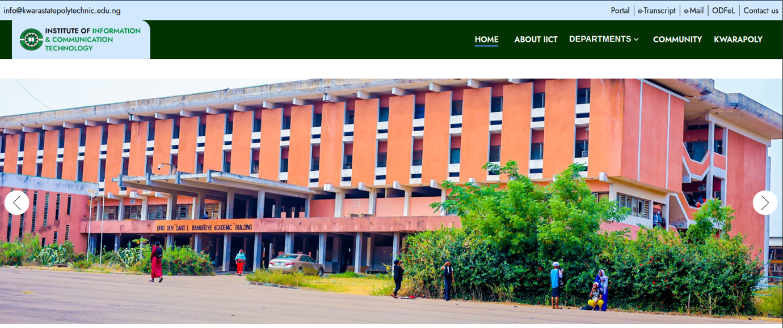
Fig 4.1: Homepage (the platform that provides an overview of the system and easy navigation to key features. It offers quick access to important sections such as login, announcements, staff profiles, research updates, and system notifications)
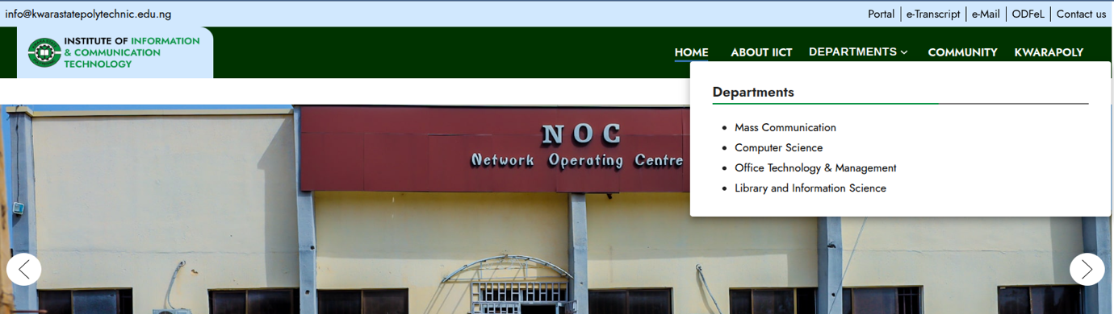
Fig 4.2: Department Menu List (displays a structured list of all departments within the institution. It allows users to easily navigate to department-specific pages containing information such as staff profiles, research activities, and academic programs.)
- Staff Profile Pages: Each staff member has a dedicated profile displaying their bio, qualifications, research interests, publications, and contact details. The profiles are searchable and filterable by department, role, or expertise.
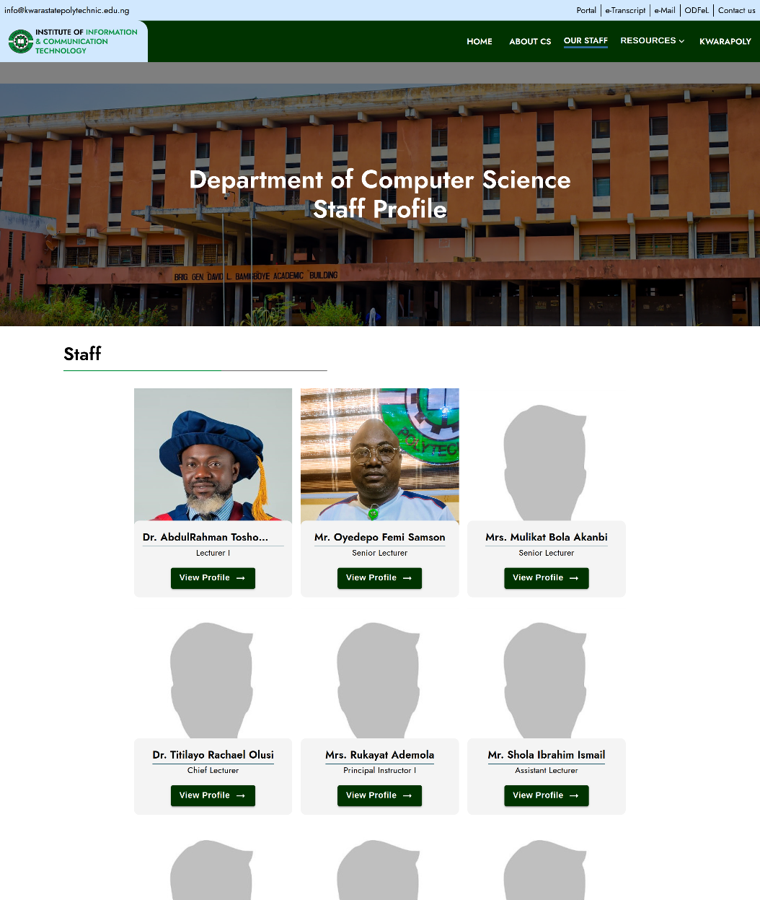
Fig 4.3: Computer Science Staff Profile List Page (displays a compiled list of all staff members in the Computer Science department. Each profile includes key information such as name, designation, qualifications, research interests, and contact details, enabling easy access to academic and professional backgrounds.)
- Research Repository Interface: Displays categorized academic content (e.g., publications, reports, news) with metadata such as title, author, date, and department. Users can download or view documents in a clean, organized layout.
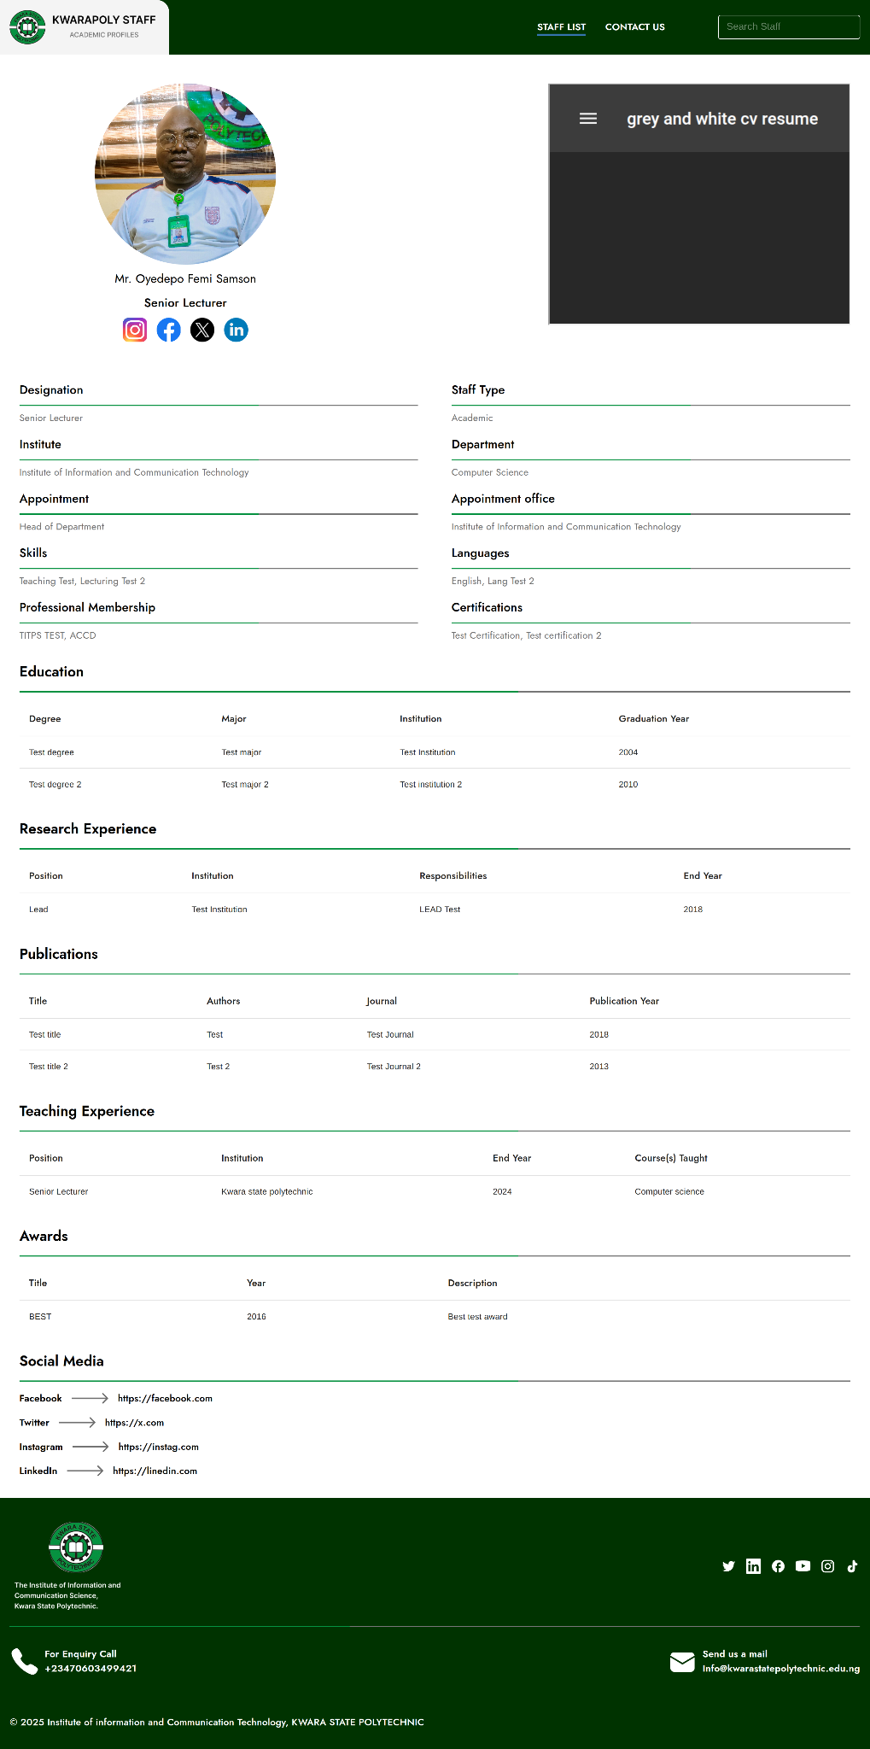
Fig 4.4: Staff Repository Public Page (provides public access to staff research outputs, publications,
and academic contributions. It promotes transparency, enhances research visibility, and supports collaboration within and outside the institution.)
- Content Management Dashboard: An admin interface shows pending uploads, user management options, and system analytics (e.g., user activity, content views).
- Search Results: A dynamic search page presents results based on keywords, with filters for departments, content types, or publication dates.
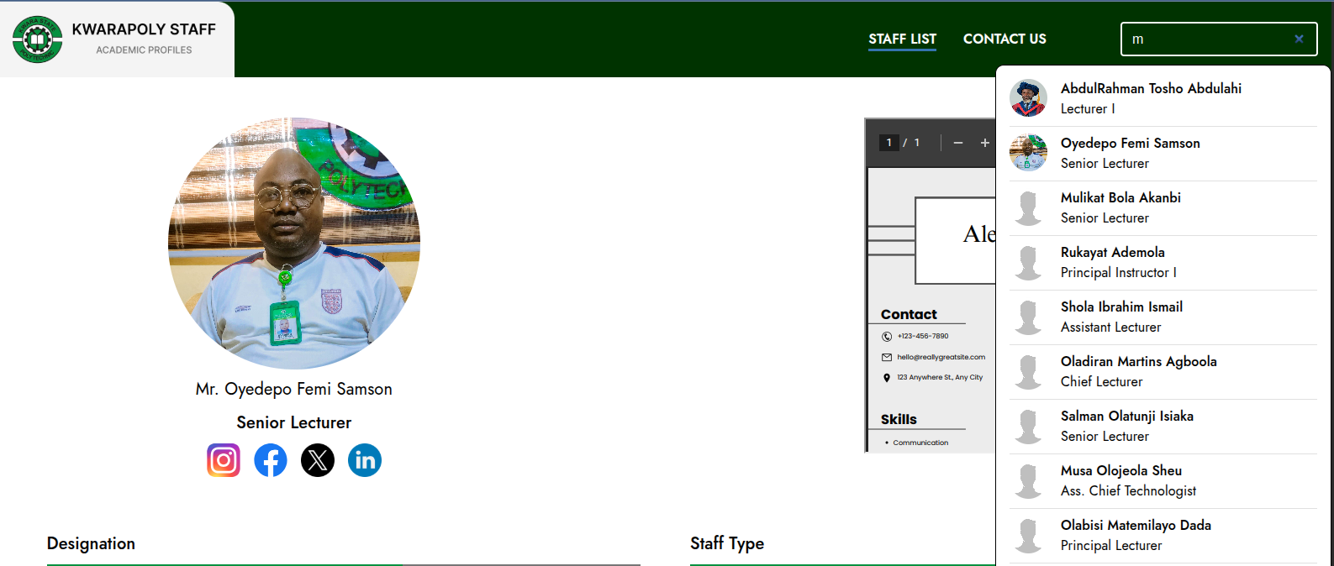
Fig 4.5: Search Result UI (This interface displays the results of user search queries, presenting relevant information in a clear and organized manner.)
- Responsive Layout: Outputs are optimized for desktops, tablets, and smartphones using CSS3 media queries alongside Material UI, ensuring accessibility across devices.
The output design was prototyped using Figma, ensuring a consistent theme with the institution’s branding (e.g., colors, fonts) and intuitive navigation.
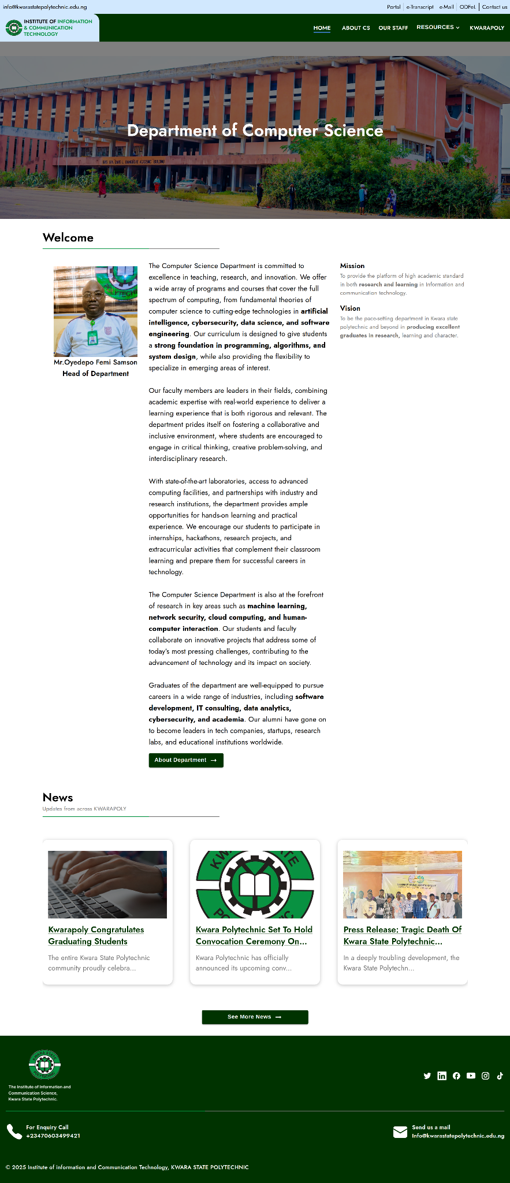
Fig 4.6: Desktop View of Computer Science Homepage (the full-screen version of the Computer Science department’s homepage as viewed on a desktop device. It features an organized layout with access to departmental news, staff profiles, academic programs, research highlights, and quick navigation menus for users)
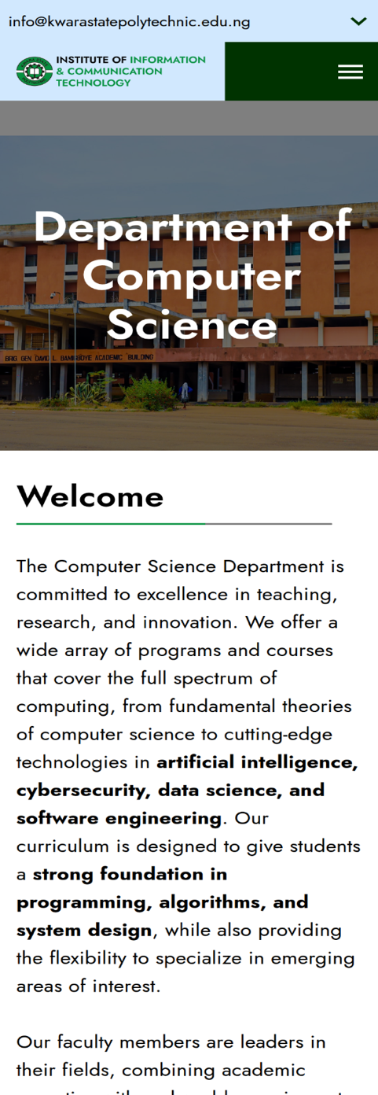
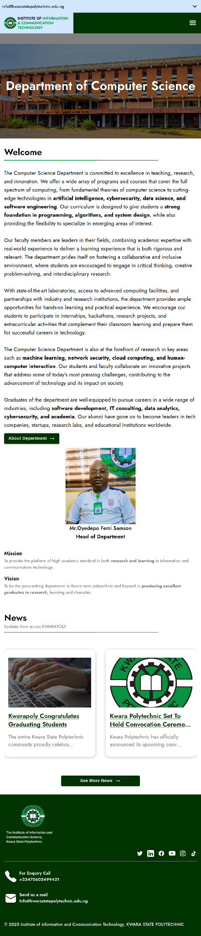
Fig 4.7: Tablet and Mobile View of Computer Science Homepage(an optimized version of the Computer Science department’s homepage designed for tablet and mobile devices. It maintains core content and navigation features with a responsive layout that ensures readability and usability on medium-sized and small-sized screens.)

4.1.2 INPUT DESIGN
The input design specifies how users interact with the platform to enter or update data. The platform includes the following input mechanisms:
- User Registration Form: Collects user details (name, email, role, department) for account creation, with validation for required fields and email format.
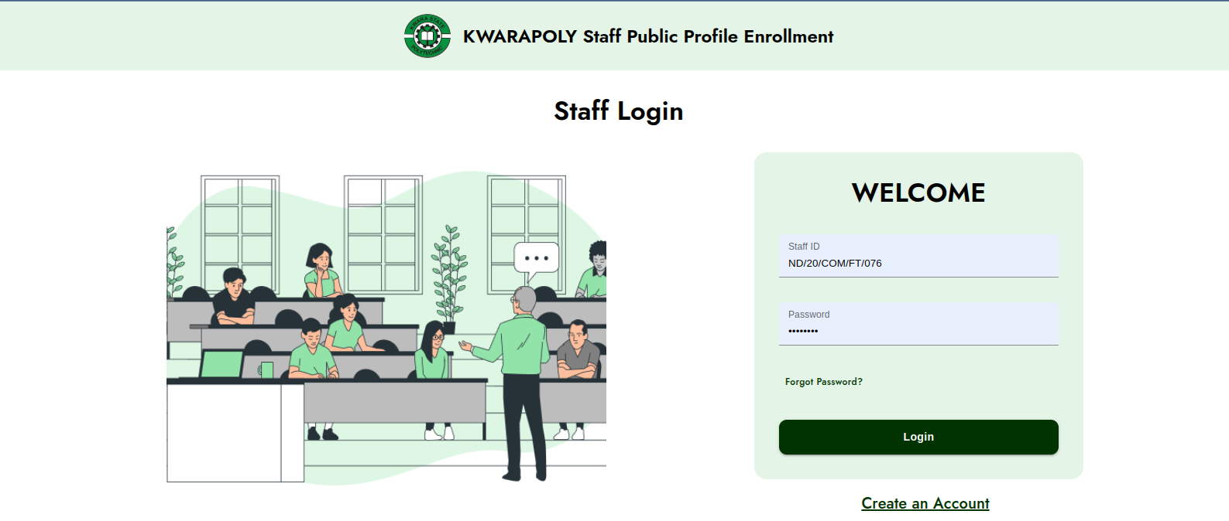
Fig 4.8: Staff Login Page (provides a secure authentication interface for staff members to access the system. It requires valid login credentials (e.g., staff ID and password) to ensure authorized access to staff-specific features such as profile management, content updates, and administrative tools.)
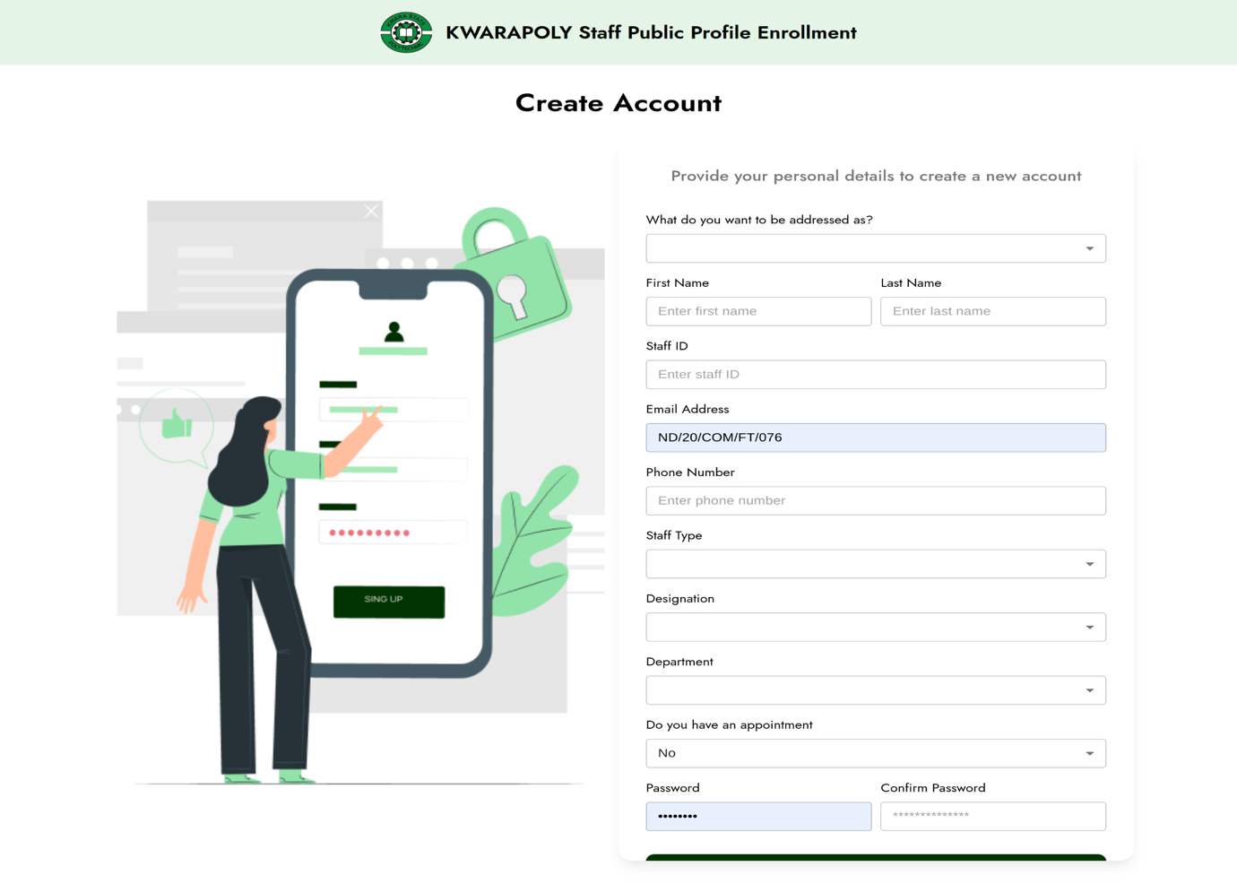Fig 4.8: Staff Register Page (allows new staff members to create an account by entering their personal and professional details. The information collected during registration is used to generate staff profiles and grant appropriate access privileges within the system.)

- Profile Update Form: Allows staff to input or edit their bio, qualifications, research interests, and upload profile images. File uploads are restricted to specific formats (e.g., PDF, JPEG) and size limits.
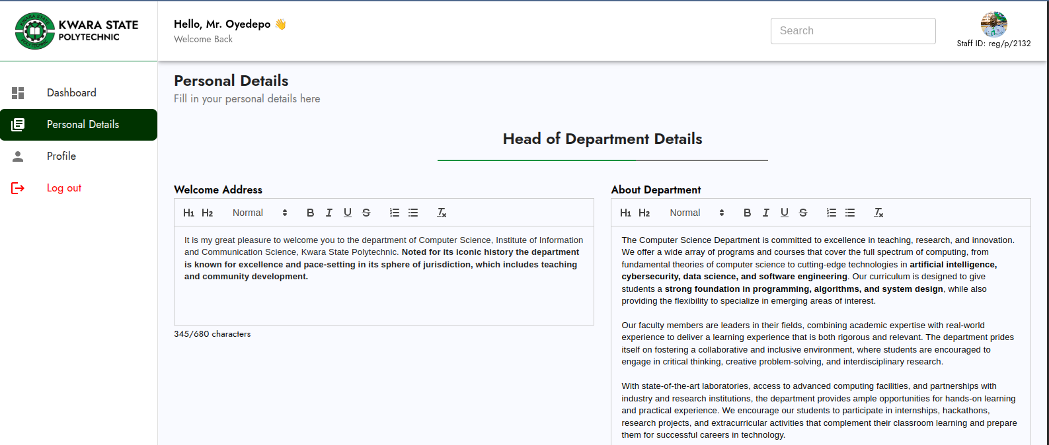
Fig 4.9: Staff Profile Update Page (enables staff members to modify and update their personal and professional information, such as contact details, qualifications, research interests, and publications. It ensures that profile data remains accurate and up to date within the system.)
- Content Upload Form: Enables staff to upload academic materials (e.g., publications, reports) with metadata fields like title, category, and description.
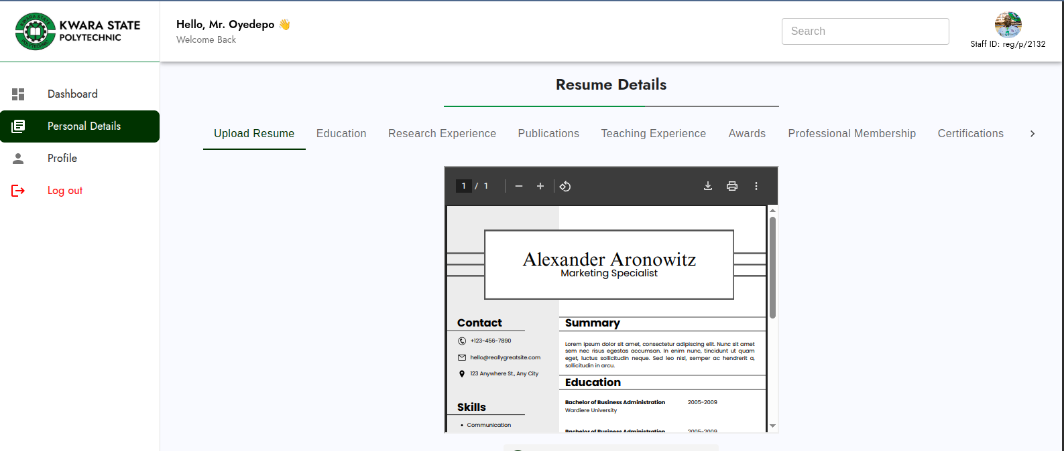
Fig 4.10: Staff Academic Update Page (allows staff members to update their academic-related information, including qualifications, certifications, teaching subjects, research contributions, and publications. It ensures that academic records are current and accurately reflected in the system.)
- Search Bar: A text input for keyword-based searches, supporting autocomplete suggestions for frequent queries (e.g., staff names).
Fig 4.11: Search Input field
- Admin Controls: Input fields for managing users (e.g., role assignment, account deactivation) and content (e.g., approval status, categorization).
Inputs are designed to be intuitive, with client-side validation (via React.js) to minimize errors and server-side validation (via Express) for security.

4.1.3 DATABASE DESIGN
The platform uses MongoDB, a NoSQL database, to store staff profiles, academic content, and metadata. The database is designed to be flexible, scalable, and efficient, addressing the issue of data redundancy in the existing system. The main collections are:
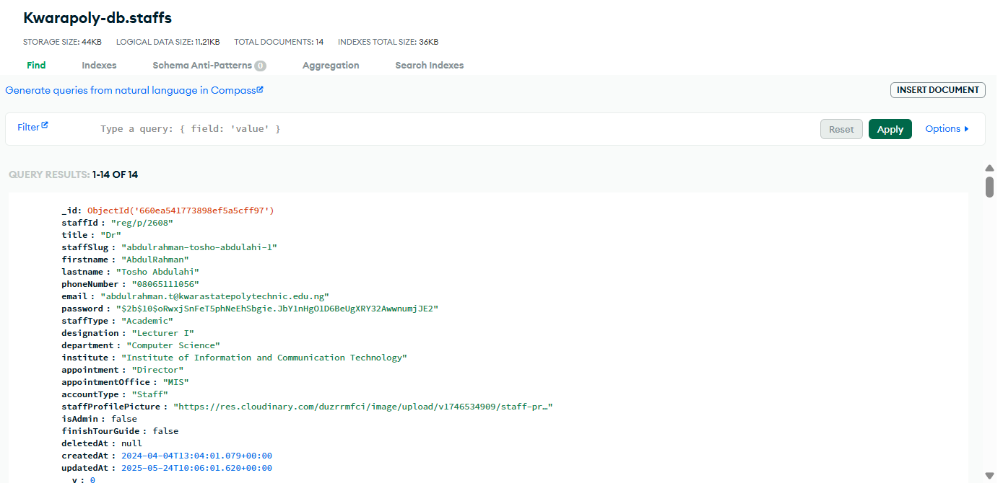
Fig 4.12: Staff Database (centralized system that stores and manages detailed information about all staff members, including personal details, academic qualifications, departmental roles, and research activities. It supports easy retrieval, updates, and reporting for administrative purposes.)
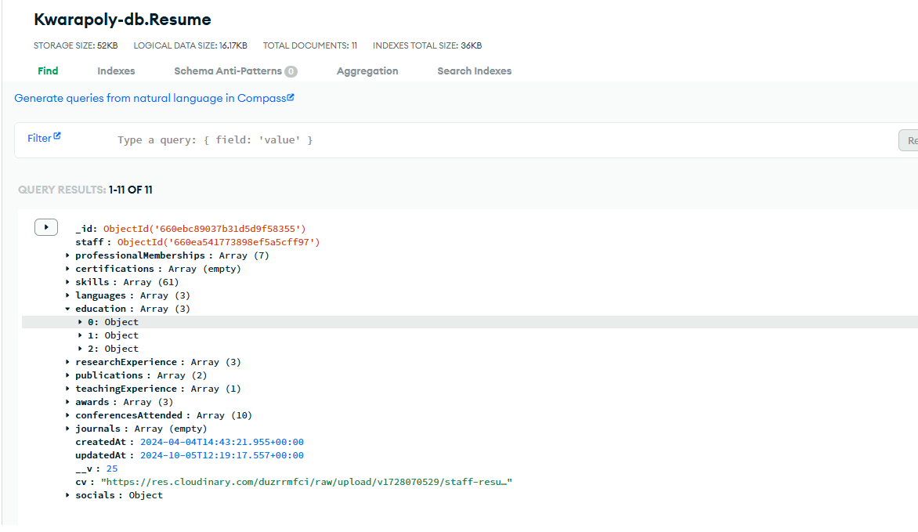
Fig 4.13: Resume Database (a centralized digital repository that stores staff resumes, making it easy to access, manage, and search academic and professional profiles for institutional and recruitment purposes.)
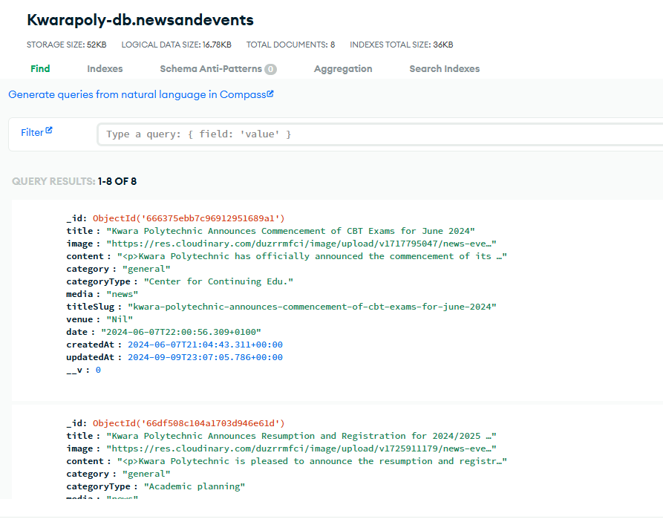
Fig 4.14: News and Event Database (centralized repository for storing and managing information related to institutional news, announcements, and upcoming events. It enables timely updates and ensures consistent dissemination of information to all users.)

4.1.4 PROCEDURE DESIGN
This section outlines the key workflows within the platform, illustrated using Data Flow Diagrams (DFDs) and flowcharts via draw.io:
- User Authentication: Staff log in using ID and password, verified with JWT. Admin access is controlled via role-based access.
- Profile Management: Staff update their profiles through a form. Sensitive changes (e.g., qualifications) require admin approval.
- Content Upload and Approval: Uploaded content is marked “pending” until reviewed by an admin, then approved or rejected. Approved content becomes publicly visible.
- Search Functionality: Keyword searches are handled by MongoDB text search, with filters by department or content type.
- Content Management: Admins manage content, roles, and system activity through a centralized dashboard.
These processes ensure secure and efficient communication between the frontend, backend, and database.

4.2 SYSTEM IMPLEMENTATION
The implementation phase involved developing, testing, and deploying the platform using the technologies and tools outlined in Chapter 3. The platform is live at iict.kwarastatepolytechnic.edu.ng and other several institute pages.

4.2.1 CHOICE OF PROGRAMMING LANGUAGE
The platform was built using the following languages and frameworks:
- HTML5 & CSS3: For structured, accessible, and responsive page layouts.
- JavaScript (React.js + TypeScript): Used for a dynamic, component-based frontend. TypeScript improves code safety and maintainability.
- Material UI: Provides pre-built, responsive UI components based on Material Design.
- Node.js + Express: Backend stack used to build scalable RESTful APIs and handle routing and logic.
- MongoDB: A NoSQL database used for flexible data storage and complex queries, including search and filtering.
These technologies were chosen for their compatibility, performance, and alignment with modern web development standards. The use of TypeScript with React.js and Material UI specifically improved the frontend’s robustness and visual consistency, making the platform more maintainable and user-friendly.

4.2.2 HARDWARE SUPPORT
The platform is hosted on a cloud server managed via cPanel, with the following hardware requirements:
- Server: A virtual private server (VPS) with at least 4GB RAM, 2 CPU cores, and 50GB SSD storage to handle API requests, database operations, and file storage.
- Client Devices: Any device with a modern web browser (e.g., Chrome, Firefox, Safari) and internet access. Minimum client requirements include 2GB RAM and a 1GHz processor for smooth rendering of the React-based frontend.
- Network: A stable internet connection with at least 1Mbps bandwidth for accessing the platform and downloading content.
The cloud-based infrastructure ensures scalability and reliability, with automatic backups to prevent data loss.

4.2.3 SOFTWARE SUPPORT
The platform relies on the following software:
- Operating System: Linux (Ubuntu) on the server for hosting Node.js and MongoDB.
- Web Server: Apache (via cPanel) for serving the frontend and routing API requests.
- Database: MongoDB Atlas for cloud-based storage and management.
- Development Tools: Visual Studio Code for coding, Postman for API testing, Figma for UI design, and Git/GitHub for version control.
- Dependencies: npm packages for React.js (e.g., axios for API calls, react-router-dom for navigation), Express (e.g., cors, jwt), and MongoDB drivers.
These tools ensure a robust development and deployment environment, with regular updates to maintain security and performance.

4.2.4 IMPLEMENTATION TECHNIQUES
The implementation followed the Waterfall Model, with the following techniques:
- Frontend Development: React.js components were developed for reusable UI elements (e.g., profile cards, search bar). React Router was used for client-side navigation, and Axios handled API calls to the backend.
- Backend Development: Express was used to create RESTful APIs (e.g., /api/users, /api/content) with endpoints for CRUD operations. Middleware ensured authentication (JWT) and input validation.
- Database Integration: MongoDB was integrated using the Mongoose ODM for schema definition and query optimization. Text indexes were created for efficient search functionality.
- Testing: Unit tests were conducted using Jest for frontend components and Postman for API endpoints. User acceptance testing involved staff and admins to verify usability and functionality.
- Deployment: The platform was deployed via cPanel, with domain mapping to iict.kwarastatepolytechnic.edu.ng. GitHub was used for continuous integration, with automated builds for updates.
- Security: HTTPS was enabled for secure communication, and passwords were hashed using encrypt. Role-based access control restricted sensitive operations to admins.
The iterative testing and feedback process ensured the platform met user requirements and addressed the problems of the existing system.

4.3 SYSTEM DOCUMENTATION
System documentation provides guidance for users, administrators, and developers to operate and maintain the platform.

4.3.1 PROGRAM DOCUMENTATION
The source code is documented with comments explaining key functions, components, and API endpoints. The GitHub repository includes a README file with:
- Setup Instructions: Steps to install dependencies (e.g., npm install), configure environment variables (e.g., MongoDB URI, JWT secret), and run the application (npm start).
- API Documentation: A list of endpoints (e.g., POST /api/users/register, GET /api/content), their parameters, and response formats, generated using Postman.
- Component Structure: A diagram of React components and their hierarchy, created using Figma.
The codebase is organized into folders: /client (React frontend), /server (Node.js/Express backend), and /docs (additional documentation).

4.3.2 OPERATING THE SYSTEM
The platform is accessible via iict.kwarastatepolytechnic.edu.ng. Operating instructions include:
- User Guide:
  - Login: Enter staff ID and password on the login page. New users register via the registration form.
  - Profile Management: Navigate to the profile section to update bio, qualifications, or upload a photo.
  - Content Upload: Use the repository section to upload files and enter metadata. Track upload status in the dashboard.
  - Search: Use the search bar to find staff profiles or content by keywords or filters.
- Admin Guide:
  - Access the admin dashboard to approve content, manage users, or view analytics.
  - Use the user management section to assign roles or deactivate accounts.

4.3.3 MAINTAINING THE SYSTEM
Maintenance tasks ensure the platform remains secure, scalable, and up-to-date:
- Regular Updates: Update npm packages and MongoDB drivers to the latest stable versions using npm update.
- Backups: MongoDB Atlas automatically backs up data daily. Manual backups can be exported via cPanel.
- Performance Monitoring: Use MongoDB’s profiling tools to optimize slow queries and add indexes as needed.
- User Feedback: Collect feedback via a form on the platform to identify bugs or feature requests. Implement updates via GitHub pull requests.
The IT department at Kwara State Polytechnic is responsible for ongoing maintenance, with support from the development team for major updates.

CHAPTER 5

SUMMARY, CONCLUSIONS, AND RECOMMENDATIONS
This chapter provides a comprehensive summary of the project, highlighting the key aspects of the design and implementation of the integrated web-based platform for Kwara State Polytechnic. It presents conclusions drawn from the development process and the platform’s impact on addressing the identified challenges. Finally, recommendations are offered for future improvements and potential expansions to enhance the platform’s functionality and institutional benefits.

5.1 SUMMARY
This project developed a web-based platform to address information management challenges at Kwara State Polytechnic, such as fragmented data, limited accessibility, and insufficient collaboration tools. The platform, accessible via iict.kwarastatepolytechnic.edu.ng, centralizes staff profiles, research repositories, and content management, streamlining access, collaboration, and institutional knowledge sharing.
The system was designed and implemented using React.js (TypeScript), Material UI for the frontend, and Node.js with Express for the backend. Data storage was managed using MongoDB, with security handled through JSON Web Tokens (JWT) and HTTPS protocols. The application features a responsive user interface, secure role-based access, and a structured content approval workflow to ensure data integrity and administrative control.
The solution effectively reduces redundancy, improves information retrieval, and provides a scalable and user-friendly interface. Testing and feedback confirmed the platform's success in enhancing data accuracy, staff engagement, and system-wide collaboration, aligning with the institution’s goal of digital transformation and operational efficiency.

5.2 CONCLUSIONS
The integrated web-based platform marks a major improvement in information management at Kwara State Polytechnic by resolving issues such as decentralized data, manual content updates, and limited accessibility. With a centralized database and responsive interface, staff profiles and academic content are now easily accessible across devices. The platform fosters collaboration through profile management and research repositories, enhancing academic visibility and engagement. Its content management system allows non-technical users to maintain information easily, while administrators ensure content quality and consistency. Robust features like user authentication, role-based access, and cloud hosting provide security and scalability, supporting long-term growth. Overall, the project aligns with the institution’s goal of leveraging technology for academic excellence, and its success is supported by a structured development process, modern tools like React.js and MongoDB, and positive user feedback confirming its usability and impact.

5.3 RECOMMENDATIONS
To further enhance the performance and usability of the developed web-based platform, the following recommendations are proposed:
i. The platform should be extended to allow student access. This would enable students to view staff profiles, access academic resources, and participate in institutional activities through features like dashboards and discussion forums.
ii. Internal features such as messaging systems, event calendars, and analytics dashboards should be integrated to improve communication, transparency, and performance tracking.
iii. Advanced search capabilities using machine learning algorithms should be implemented to enhance result relevance and enable personalized content recommendations.
iv. Native mobile applications for iOS and Android should be developed to support offline access and push notifications, thereby increasing accessibility and user engagement.
v. Regular training sessions should be organized for staff and administrators to ensure effective platform usage and reduce dependency on technical support.
vi. Establishing continuous feedback channels will help gather user insights, while routine updates will ensure the platform remains secure, up-to-date, and user-centered.
vii. Integration with other institutional systems such as student information systems and payroll databases will streamline operations and minimize data redundancy.

REFERENCES
Al.Manhrawy, D. M. N. T. (2013). Learning Management Systems, Social Programs and Their Effectiveness in E-Learning. Mediterranean Journal of Social Sciences, 4, 96–105. https://doi.org/10.5901/mjss.2013.v4n11p96
Boltayevich, E. B., & Primova, M. H. (2023). Development of an information system for organizing and managing the educational process based on smart technologies. E3S Web of Conferences, 413, 3010. https://doi.org/10.1051/e3sconf/202341303010
Calvo, R. A., Carroll, N. L., & Ellis, R. A. (2007). Curriculum Central: a portal for the academic enterprise (Vol. 17, Issue 1, p. 43). Inderscience Publishers.
DataONEorg. (2018). The Education modules. https://github.com/DataONEorg/Education
Falebita, O. S. (2022). Secure Web-Based Student Information Management System. Cornell University.
Gardiyawasam, T., & Dias, G. K. A. (2017). AN ONLINE VIRTUAL EDUCATIONAL CENTER. International Journal of Research -GRANTHAALAYAH, 5(1), 22. https://doi.org/10.29121/granthaalayah.v5.i1.2017.1686
Hou, C., Thompson, C. A., & Palmer, C. L. (2014). Profiling open digital repositories in the atmospheric and climate sciences: An initial survey. Proceedings of the American Society for Information Science and Technology, 51(1), 1. https://doi.org/10.1002/meet.2014.14505101121
Kubik, T., & Kwiecień, A. (2020). Resolving dilemmas arising during design and implementation of digital repository of heterogenic scientific resources. Multidisciplinary Digital Publishing Institute, 11(1), 215.
Liu, C., Wang, M., & Guang, A. W. (2011). Research and Implementation of Self-Publishing Website Platforms for Universities Based on CMS. International Journal of Advanced Pervasive and Ubiquitous Computing, 3(3), 32. https://doi.org/10.4018/japuc.2011070104
Liu, S., Yang, Y., & Shi, X. (2021). Research and design of E-portfolio for education practice growth of normal university students. In Proceedings of the 2020 International Conference on Modern Educational Technology (ICMET 2020) (p. 1581). https://doi.org/10.1145/3456887.3459725
Olorunsola, R. (1997). Management information systems in Nigerian universities. Aslib Proceedings, 49(5), 113. https://doi.org/10.1108/eb051456
Sneha, J. M., & Nagaraja, G. S. (2014). Virtual learning environments—A survey. arXiv. https://doi.org/10.48550/arXiv.1402
Syaripudin, U., Rahman, T. K. A., & Ramdhani, M. A. (2019). Model of knowledge portal system for higher education: Literature review. IOP Conference Series: Materials Science and Engineering, 1402(6), 66042.

APPENDIX A

PROGRAM FLOWCHART
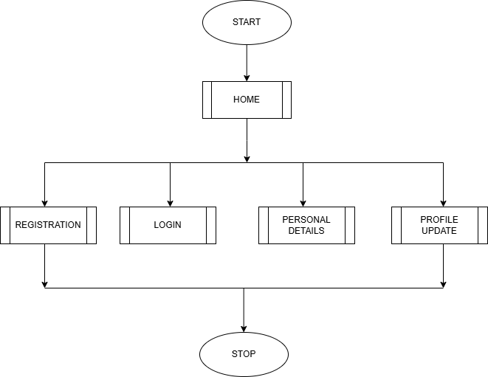

REGISTRATION
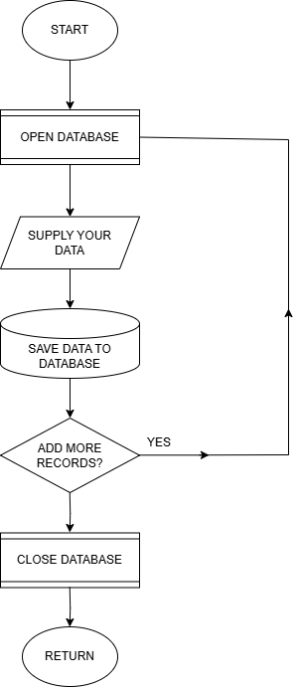

LOGIN
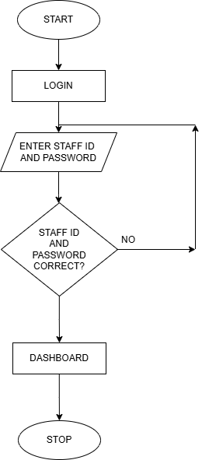

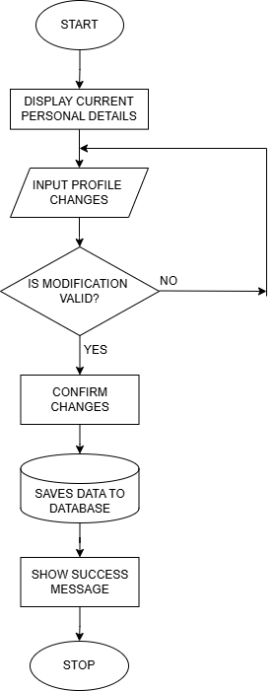
PERSONAL DETAILS

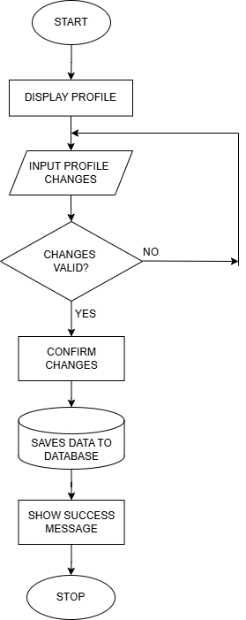
PROFILE UPDATE

APPENDIX B
PROGRAM SOURCE CODE
<!DOCTYPE html>
<html lang="en">
<head>
<title>Kwarapoly Portal</title>
<meta charset="utf-8">
<meta name="viewport" content="width=device-width, initial-scale=1">
<link rel="shortcut icon" href="images/kplogo.png"/>
<link rel="stylesheet" type="text/css" href="css/bootstrap.min.css">
<link rel="stylesheet" href="css/sp8ecial.css">
<link rel="stylesheet" href="css/style.css">
<link rel="stylesheet" type="text/css" href="font/all.css">
<script src="https://code.jquery.com/jquery-3.2.1.slim.min.js" integrity="sha384-
KJ302DKtIkvYIK3UENzmM7KCkRr/rE9/Qpg6aAZGJwFDMVNA/GpGFF93hXpG5KkN"
crossorigin="anonymous"></script>
<script src="https://cdnjs.cloudflare.com/ajax/libs/popper.js/1.12.9/umd/popper.min.js" integrity="sha384-
ApNbgh9B+Y1QKtv3Rn7W3mgPxhU9K/ScQsAP7hUibX39j7fakFPskvXusvfa0b4Q"
crossorigin="anonymous"></script>
<script src="https://maxcdn.bootstrapcdn.com/bootstrap/4.0.0/js/bootstrap.min.js" integrity="sha384-
JZR6Spejh4U02d8jOt6vLEHfe/JQGiRRSQQxSfFWpilMquVdAyjUar5+76PVCmYl"
crossorigin="anonymous"></script>
</head>
<body class="bg-grey">
<nav class="navbar navbar-expand-lg py-lg-3 navbar-dark sticky-top" style="background-color:
rgb(2, 156, 90);">
<div class="container">
<!--logo-->
<a href="homepage.html" class="navbar-brand mr-lg-5">
<img src="images/me.png" alt="" class="logo-dark" height="60" />
</a>

