

KWARA STATE POLYTECHNIC, ILORIN
INSTITUTE OF TECHNOLOGY

DESIGN AND CONSTRUCTION OF A 3KVA PURE SINE WAVE INVERTER

BY

IBIKUNLE FARUK OLABODE
ND/23/EEE/PT/0219

SUBMITTED TO
THE DEPARTMENT OF ELECTRICAL/ELECTRONIC ENGINEERING, INSTITUTE OF TECHNOLOGY, KWARA STATE POLYTECHNIC, ILORIN.
IN PARTIAL FULFILMENT OF THE REQUIREMENTS FOR THE AWARD OF NATIONAL DIPLOMA (ND) CERTIFICATE IN ELECTRICAL AND ELECTRONIC ENGINEERING.
JUNE, 2025
CERTIFICATION
This is to certify that this project work was carried out by IBIKUNLE FARUK OLABODE of matriculation Number ND/23/EEE/PT/0219 in the Department of Electrical/Electronic Engineering, Kwara State Polytechnic in Partial fulfillment of the requirements for the award of National Diploma (ND) certificate in Electrical/Electronic Engineering.

________________________________ __________________
ENGR. T.A MUSTAPHA DATE
Project Supervisor

________________________ __________________
ENGR. BELLO BASHIR DATE
Project Coordinator

________________________ __________________
ENGR. K. LATEEF DATE
Project Coordinator

___________________________ __________________
EXTERNAL EXAMINATION DATE

DEDICATION
This research is dedicated to Almighty Allah and also to my lovely parents, Mr and Mrs. IBIKUNLE for their support and love over me for his moral and financial support throughout the journey.

ACKNOWLEDGEMENT
I give all glory, praises and adoration to Almighty God the one who gives knowledge, strength and ability in starting, sustaining me and finishing this project successfully, and for his grant grace over me through this titanic struggle of my national diploma program.
Secondly, my gratitude goes to my honorable supervisor Engr. T.A MUSTAPHA and one of my best guardian/mentor Engr. Bashir for their invaluable guidance, support and encouragement throughout. Who patiently read through the work. May the good lord reward him labour and more strength to his wrist in name of God.
My special appreciation goes to my beloved parent MR and MRS. IBIKUNLE I pray that you live long to reap the fruit of your labour (Amen).
Also my heartfelt gratitude goes to my friends for supporting me during the period of learning in this institution. Abdullahi Rofiyat Olohuntoyin and co
ABSTRACT
The increasing demand for reliable and uninterrupted power supply has necessitated the development of alternative power solutions, particularly in regions where electricity supply is highly unstable. This project presents the design and construction of a 3kVA pure sine wave inverter system intended for domestic and small-scale industrial use. The inverter converts direct current (DC) from a 24V battery source into alternating current (AC) with a regulated 220V, 50Hz output, making it suitable for powering a wide range of electronic devices and appliances. The system is composed of various key functional blocks including an oscillator, driver, inverter, and transformer stages, integrated using high-quality electronic components such as IGBTs, MOSFETs, voltage regulators, and microcontroller-based control logic.
Performance testing was carried out under different load conditions, and statistical analysis using SPSS confirmed a 90.4% confidence level in the system’s performance reliability. The results demonstrated that the inverter provides clean power output, supports sensitive loads, and maintains voltage stability for extended periods. Additionally, protective features such as overload shutdown, low battery alarms, and short-circuit protection enhance the safety and robustness of the system.
This locally constructed inverter system not only meets its design objectives but also offers a cost-effective, sustainable, and efficient alternative to imported power backup systems. The successful implementation of the project promotes indigenous engineering development and contributes toward addressing the persistent challenges of power unreliability.

TABLE OF CONTENT
Title Page i
Certification ii
Dedication iii
Acknowledgement iv
Abstract v
Table of content vi
CHAPTER ONE: INTRODUCTION
1.1 Background of Study 1
1.2 Electrical signal waves 2
1.3 Problem Statement 3
1.4 Aim of the of project 3
1.5 Objectives of the project 3
1.6 Scope of the project 4
1.7 Significance of the project 4
CHAPTER TWO: LITERATURE REVIEW
2.1 Early inverter system 5
2.2 The Inverter 6
2.3 Common component of inverter 9
2.4 Classification of inverter 10

2.5 Advantages and disadvantages of inverter 11

2.6 Things to consider before buying an inverter 11

2.7 Batteries 15

2.8 Types of Batteries 16

2.9 State of the art 18

CHAPTER THREE

3.1 Project Methodology 20

3.2 Design And Construction Of 3kva Inverter 20

3.3 Online Uninterruptible Power Supply System 21

3.4 Offline uninterruptible power supply system 21

3.5 Electronic of the circuit diagram 21

3.6 The electronics of an inverter system 22

3.7 Design equations and calculations 24

3.8 Circuit diagram 27
CHAPTER FOUR: TESTING, PRINCIPLE OF OPERATION AND DISCUSSION
4.1 Principle of Operation 30
4.2 Results 31
4.3 Discussions and equation modeling 36
4.4 Final pictures of the 3kva inverter 38

CHAPTER FIVE: CONCLUSION AND RECOMMENDATIONS

5.1 Conclusion 39

5.2 Recommendations 39
References 41
Bill of engineering measurement and evaluation 43

CHAPTER ONE
INTRODUCTION
1.1 Background of Study
The National grid relied fully on the hydro and gas generation power plant for mains input on the grid but series of factors as led to supply shortage ranging from natural and artificial disasters, poor maintenance culture, lack of skilled personnel, etc. all these factors sum up to reduce the mains supply reliability and availability. In recent times, virtually all aspect of human endeavors such as sophisticated medical life savings equipment, accurate data and processing machines among other electronic machines are all electrical power dependency and are capable of malfunctioning on a slight input voltage fluctuation talk less of total mains outage or unavailability.
In today's world, where uninterrupted power supply is essential for various applications ranging from household appliances to industrial machinery, inverter systems play a pivotal role. An inverter system converts direct current (DC) into alternating current (AC), providing a reliable source of power during grid outages or in areas without access to mains electricity. The design and construction of a 3KVA (kilovolt-ampere) inverter system represent a significant engineering endeavor aimed at meeting power demands efficiently and reliably.
A worthy alternative power supply system commonly found in homes, offices, hospitals etc are the power inverter system. An inverter or a power inverter system is an electronic device or circuitry that changes direct current (DC) to alternating current (AC). Comprehensively, inverter is that device which is being employed by the electrical engineers to tackle and support the power supplies. This support comes to play when there is power outage, this makes the inverter indispensable especially in developing countries like Nigeria where there is an epileptic power supply. However, an alternative power supply to the mains need be efficient, stable and deliver optimum power to the end loads, hence the need for the design and construction of a pure sine wave power inverter. In this regards, this project work presents design and construction of a pure sine wave power inverter system for optimum electrical power delivery and improvement of performance of a locally designed and constructed power inverter system.
1.2 Electrical signal waves
Electrical sine waves are depiction of electrical signal represented by a sinusoidal graph, the wave shows all the properties of a wave like: the amplitude, frequency, wavelength and the can exhibit the wave-like properties of reflection, refraction, diffraction and polarization. Moreover, when an electrical signal wave is said to be pure, its means the wave depiction is devour of harmonics as shown in Figure 1.1. More so, when the wave output of the oscillation unit of an inverter is free of harmonics, then the power inverter is term ‘pure sine wave power inverter’.
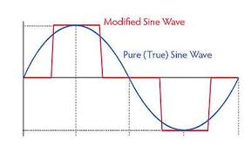
Figure 1.1: Electrical Signal Wave.
Advantages of pure sine wave inverters over modified sine wave inverters:
a) Output voltage wave form is pure sine wave with very low harmonic distortion and clean power like utility-supplied electricity.
b) Inductive loads like microwave ovens and motors run faster, quieter and cooler.
1.3 Problem Statement
The project work will solve the problems of poor power supply delivery to electrical load, by the design and construction of pure sine wave power inverter.

1.4 Aim of the of project
The aim of the study is to locally design and construct a 4kVA/24Volts power inverters for domestic electric power supply.

1.5 Objectives of the project
- To design and construct a reliable pure sine wave power inverter.
- To construct an inverter system using high-quality components and efficient circuitry.
- To Test the performance and reliability of the inverter system.
- To Analyze the efficiency, voltage regulation, and waveform quality of the inverter output
1.6 Scope of the project
The scope of the project encompasses the design, construction, and testing phases of the 3KVA inverter system. This includes selecting appropriate components such as IGBTs, capacitors, transformers, and control circuits, as well as designing the circuit layout and control algorithms. The construction phase involves assembling the components onto a printed circuit board (PCB) or a breadboard, followed by rigorous testing to evaluate the system's performance and reliability.

1.7 Significance of the project

The significance of the project lies in its contribution to advancing power electronics technology and addressing the growing demand for reliable and sustainable power solutions. By designing and constructing a 3KVA inverter system, this project aims to empower individuals and businesses with a cost-effective and efficient backup power solution while promoting the adoption of renewable energy sources.

CHAPTER TWO
LITERATURE REVIEW
2.1 Early inverter system
Electricity generation is the process of generating electric power from other source of primary energy. Energy conversion process is divided into different type such as, thermo electric (heat- electric energy), steam engine (heat – mechanical energy), etc. Circumstances around the development of new technology in the engineering field have become very attractive for power industries in power electronics application during the last years the main purpose that lead to the development of the studies of inverter is the generation of output signals with low harmonies distortion, reduction of switching frequency. This development has made it possible to change from D.C power to the conventional A.C power that you can use for all kinds of device or appliances, such as electric light, kitchen appliances, power tools, television sets and so on. (IEEE2014)
Early inverters from the late nineteenth century through the middle of the twentieth century, DC-to-AC power conversion were accomplished using rotary converter or motor generator (MG) sets. In the early twentieth century, vacuum tube and gas filled tubes began to be used as switches in inverter circuits. (IEC2019)
The origins of electromechanical inverters explain the source of the term inverter. Early AC- to- DC converter used an induction or synchronous ac motor direct - connected to a generator (dynamo) so that the generators commentator reversed its connections at exactly the right moments to produce D.C. A later development is the synchronous converter in which the motor and generators winding are combined into one armature, with slip rings at one end and a commutator at the other and only one field frame. The result with either is AC-in, DC-out. With an MG set, the D.C can be considered to be separately generated from the AC; with a synchronous converter, in a certain sense it can be considered to be “mechanically rectified AC “. Given the right auxiliary and control equipment, MG set or rotary converter can be “run backwards”, converting DC to AC. Hence an inverter is an inverted converter (Ekundayo, A. O. 2022).
Over the years, electricity has been generated using the following methods: Solar, Thermal, Wind, Electric generators. These methods have proved to be quit reliable and sufficient. However, due to inadequate source ofenergy, the need for standby supply is essential which brought into existence an alternative means called inverter.

2.2 The Inverter
An Inverter is a device that converts DC power from sources such as batteries to AC power.(IEEE2014) Figure 2.1 shows the inner circuitry of an inverter power system
Fig. 2.1: Inverter inner circuitry.
An Inverter can also be said to be an electronic device or circuitry that changes direct current (DC) to alternating current (AC). The input voltage, output voltage, frequency and overall power handling depend on the design of the specific device or circuitry. The Inverter does not produce any power; the power is provided by the D.C source. The basic circuit of the inverter comprises the following parts:
- Charger Section
- Rectifier Section
- DC-AC Converter
- Drivers Section/FET Gang
- Inverter Module
- Transformation Section
- Charger Section: The charger card basically senses the AC input and then generates the silicon control rectifier triggering pulse. The feature for the soft start is incorporated in this card using the concept of saw tooth generation and then its conversion into the triggering pulses, which eventually gets transported through the pulse transformer to the output connector of the charger card with its other end connected to the SCR module.
- Rectifier Section: The rectifier module used is a full wave semi controlled rectifier with two SCR and two diodes in single phase. In the case of three phase system the rectification is full controlled and six SCR are used for solving this purpose.
- DC-AC Converter: This card is responsible for generation of the DC voltages (+15V and +5V) to supply it to the other cards. It accepts its input from the taping over the DC capacitors. The Input DC through fuse is converted into AC and is amplified using a TOP switch. This is then Fed to a transformer with multiple taping at its secondary. The AC from the taping is then rectified through diodes and given 37 to voltage regulator eventually producing the voltage sources of +15V and +5V. These voltages are then used as a P/S for all other cards.
- Driver Section: The driver card primarily has two features
1) To provide isolation of control circuit with the power circuit.
2) To block the PWM pulses forcing the UPS to go into the protection in case of short circuit at the output end.
- Inverter Section: In this section conversion of DC to AC is done. The technology of PWM triggering is implicated over the IGBT based inverters. PWM generated by DSP card through the driver card, providing electrical isolation, reaches the IGBTs gate and emitter terminal. Using this high frequency triggering the IGBTs which producing the AC output from the DC link.
f. Transformation Section: The card is basically used to sense the input and output voltages and their conversion into a low voltage AC for further processing.

2.3 Common component of inverter

2.3.1 Mosfet: It is a switching device used to convert ac into dc. It is of different rating for different capacities of inverters. e.g. Z44, IRF 3205, IRF2807, P55.
2.3.2 Transistor: It is also of same appearance as of mosfets used for signal (voltage and current) amplification in the circuit. It was also working as switching device earlier. Now we are using mosfets & IGBTs in place of it. e.g BC 547, BC557 ,BD 139 etc.
2.3.3 Regulator: It is a device used to regulate the voltage coming at its input and supply that voltage to the device. e.g This device operates on 24V supply and supply is coming more than this so we use 24V regulator to give 24V supply to it. e.g. 7812, 7805 etc.
2.3.4 Zener Diode: A Zener diode is a type of diode that permits current to flow in the forward direction like a normal diode, but also in the reverse direction if the voltage is larger than the breakdown voltage known as zener knee voltage or zener voltage. Zener diodes are widely used to regulate the voltage across a circuit.

2.3.5 Relay: A relay is an electrical switch that opens and closes under the control of another electrical circuit in the original form, the switch is operated by an electromagnet to open or close one or many sets of contacts. It is used as a changeover device in inverters to do change over from mains to inverter and inverter to mains.

2.4 Classification of inverter
Inverters can be classified into three broad types. They are:
- Stand-Alone Inverters: This type of inverter is used in isolated systems where the inverter draws its DC energy from batteries charged by photovoltaic arrays. Many stand-alone inverters also incorporate integral battery chargers to replenish the battery from an AC source, when available. Normally these do not interfere in any way with the utility grid and as such are not required to have anti-islanding protection.
- Grid-Tied Inverters: These inverter matches phase with a utility supplied sine wave. Grid tie inventers are designed to shut down automatically upon loss of utility supply, for safety reasons. They do not provide back-up power during utility outages.
- Battery Backup Inventers: These are special inverters which are designed to draw energy from a battery, manage the battery charge via an onboard charger and export excess energy to the utility grid. These inverters are capable of supplying AC energy to selected loads during a utility outage, and are required to have anti islanding protection.

2.5 Advantages and disadvantages of inverter
A Number of Advantages which Include:
- It is virtually always on
- It has no running cost
- It brings about protection of appliances
- It changes automatically when the mains goes off
- It is easy to maintain
One of the disadvantages of inverter is the high initial cost, i.e., initial cost of purchase

2.6 Things to consider before buying an inverter
Since it would cost quite some money for the procurement, it is important to ensure that you get good quality that matches your expenditure i.e plan value for money principle. So, be sure of your source and that the quality you get is what you paid for. These things include:

- Output Wave Form
There are two major types of inverters output waves form available in the market. These are square wave form inverter and pure sine wave form inverter.
- Square Wave Inverters: As mentioned in the name itself, the wave form of the output current from this type of inverter is like square. The current we get from grid is neither square wave nor pure sine wave, it’s nearly sine wave. So, our electronic device like fan and tube light will emit some buzz noise while operating in square wave current. Of course, square wave current won’t spoil the fan or tube light. In some rare cases, these square wave inverter have spoiled the speed control dimmers of ceiling fans. The main reason for this fault is high voltage output.
Normally, voltage output from square wave inverters is between 230 volt to 290 volt, hence it’s not recommended to sensitive electronic device like computers. I am just saying “it’s not recommended”, this is based on some experiment carried out and proper observation. But desktop computers and laptops will operate flawlessly in square wave inverter. As desktop pc’s are equipped with SMPS the current from the square wave inverter won’t make any big disturbances in the computer.

2.6.1 Other names of square wave inverter:
Some Inverter manufacturers name their product as digital inverters, modified-sine wave, trapezoidal wave form, stepped time wave, quasi time wave e.t.c, all these are nothing but square wave inverter. So, it’s pertinent and advisable that one reads carefully the specification of the inverter before he/she purchases.
- Pure Sine Wave Inverter: Pure sine wave inverter gives the purest form of current to sensitive devices used in homes and offices. Most probably the current from this type of inverter are very safe to desktop computers, laptops, camera batteries, cell phone chargers, mixer, small house hold water pumping motors as show in fig 2.2 e.t.c
This type of Inverter will save your current bill compared to square wave inverters.

Fig .2.2 pure sine wave

No Fan Speed Difference and Noise in square wave inverter, where power goes off, the speed of the ceiling fan will increase slightly and make some buzz sound whereas in pure sine wave inverter, the speed of the fan remains same and makes no noise. One cannot feel the difference when power goes out.

C. Output Frequency: The AC output frequency of a power inverter device is usually as standard power line frequency 50 or 60 hertz. If the output of the device or circuit is to be further conditioned (for example stepped up) that the frequency maybe much higher for good transformer efficiency.
D. Output Voltage: The AC output voltage of a power inverter device is often the same as the standard power line voltage such as household 120V or 240V. This allows the inverter to power numerous types of equipment designed to operate off the standard line power.
This designed output voltage is often provided as a regulated output. That is, changes in the load when the inverter is driving will not result in an output voltage change from the inverter. In a sophisticated inverter, the output voltage may be selectable or even continuously variable.
E. Output Power: A power inverter will often have an overall power rating expressed in watts (W) or kilowatts (KW). This describes the power that will be available to the device, the power that will be needed from the DC source. Smaller popular consumer and commercial devices designed to mimic line power typically range from 150 to 3000 watts.
Not all inverter applications are primarily concerned with brute power delivery; in some cases the frequency and or waveform properties are used by the follow-on circuit or device.
Other things to consider when buying an inverter may include (inverter size, warrantee, durability and portability.) etc.

2.7 Batteries

Battery is the combination of one or more electrochemical galvanic cells which stores chemical energy that can be converted into electric potential energy, creating electricity. Since the invention of the first voltaic pile in 1800 by Alessandro volt, the battery has become a common power source for many household and industrial applications. The name ‘battery’ was coined by Benjamin Franklin for an arrangement of multiple “Leyden jars” by analogy to a battery of cannon.
If on the other hand, energy is induced in the chemical substance by applying an external source, which is called a secondary battery or rechargeable battery. Examples of secondary cells are the lead-acid cell, nickel-cadmium cell, nickel-iron cell, nickel-zinc cell etc.
When the energy is stored inherently present in the chemical substance, it is called a primary cell e.g. zinc chlorine cell, alkaline manganese cells. Batteries convert chemical energy directly to electrical energy. A battery consists of some number of voltaic cells. Each cell consists of two-half cells connected in series by a conductive electrolyte containing anions.
A battery is a vital part of an inverter. The performance and life of an inverter largely depends on its battery. There are several classifications of inverter batteries. Here are a few of them:

2.8 Types of Batteries
- Lead Acid Batteries
Lead acid batteries are the most common inverter batteries. These are rechargeable in nature and produce large amount of current. They are light in weight and most economical. They usually last for a period of 3-4 years. But they require regular maintenance. The electrolyte level check and topping up has to be done regularly. They also release harmful gases during charging and discharging. So they must be installed at a well-ventilated place in homes or offices. When one cannot afford the deep cycle sealed maintenance free battery, ideally recommended for an inverter,one can still consider the option of wet cell batteries. They cost far less, it can serve reasonably though one must realize that they are more challenging to manage. Besides, if they are not deep cycle, they are not designed for deep discharge, which may affect their durability. Good quality wet cell batteries have, however, given satisfactory performance in use.
- Tubular Batteries
Tubular batteries are the most popular and efficient inverter batteries. They have a complex design, great efficiency, longer operational life (8+ years) and low maintenance. Because of so many advantages they are costly.
NOTE: The lead-acid batteries otherwise known as wet cells, they use liquid electrolytes, which were prone to leakage and spillage if not handled correctly. Many use glass jars to hold their components, which makes them fragile. These characteristics make the lead acid unsuitable for portable appliances. Near the end of the Nineteenth century, the invention of dry cell batteries, which replaced the liquid electrolyte with a paste, made portable electrical devices practical. These flaws encountered with the lead acid batteries gives the sealed maintenance free batteries (SMF) an edge over others.

2.8.1 Inverter battery connection
The runtime of an inverter is dependent on the battery power and the amount of power being drawn from the inverter at a given time. As the amount of equipment using the inverter increases, the runtime will decrease. In order to prolong the runtime of an inverter, additional batteries can be added to the inverter. When attempting to add more batteries to an inverter, there are two basic options for installation. These are (series configuration and parallel configuration).
- Series Configuration: If the goal is to increase the overall voltage of the inverter, one can connect chain batteries in a series configuration as shown in fig 2.4. In this type of connection, if a single battery dies, the other batteries would not be able to power the load.

12V
12V

Fig 2.6 Diagram of Batteries Connection

B. Parallel Configuration; If the goal of the connection is to increase capacity and prolong the runtime of the inverter, batteries can be connected in parallel as shown in fig 2.5. This increases the overall Ampere-hour (Ah) rating of the battery set.
12V
12V

Fig 2.7 Diagram of Batteries Connections

2.9 State of the art
The inverter quality may substantially determine the fate of the batteries. The battery plates may be affected by the quality of voltage the battery receives. Damage that could shorten the life of the batteries could result from unregulated charging voltage coming from the inverter’s charging system. Good inverter brands may protect against such damage. SU-KAM, for instance, boasts of its battery protection mechanism, based on its CCCV, (constant current constant voltage) charging system. That ensures regulated voltage to protect the battery plates, extend battery life and gives optimal delivery. It uses silicon controller rectifier technology, believed to be the best for battery chargers, to achieve constant charging and minimum power consumption. Fuzzy logic control (FLC) technology protects the batteries by controlling the charging current of the battery to an optimum level which extends battery life and achievers reduced power consumption.
A quality inverter should also have a low battery/deep discharge protection to prevent low discharge that can damage the battery bank. Having the battery discharge to very low level is virtually completely could easily ruin them. One could manually monitor the battery level, but that could become an engaging chore. A good inverter product will provide in built protection. Let’s use the SU-KAM example again. SU-KAM, first, has L (1) display of inverter performance status, Part of the alternating displays is battery charge level information. So, one can see the battery level at a glance, anytime. That way, its known when it is getting low without guess work. That’s not all; the SU-KAM inverter will give an alarm if the battery gets to its low charge indication point. So, it warns to reduce the load (and extend use time or remaining battery charge) or better still, power down the system.
That message is clearly displayed on its LCD message panel. SU-KAM inverter has the additional protection of being able to shut itself off, if one fail to heed its low battery alert. The moment the battery is down to a potentially harmful level, the inverter shuts itself off. That shut-off does not just happen, it is preceded by an extended alarm that alerts that the system is about to go off, so one can get a brief moment to save a PC job for instance etc. It is pertinent to note that battery overcharge is also as damaging, meaning that the inverter to be procured or constructed by a user should have an inbuilt protection.
CHAPTER THREE
3.1 Project Methodology
The methodology employed in the research project consist two main stages. First, the design and construction of the 3kVA locally made inverter and secondly, the performance analysis.
3.2 Design And Construction Of 3kva Inverter
Most of us take the mains Ac supply for granted and use it almost casually without giving the slightest thought of Its inherent shortcomings and the danger posed to sophisticated and sensitive electronic instruments and equipment. For ordinary household appliances such as incandescent lamps, tubes, fan, TV and fridge, the mains ac supply does not make such difference, but when used for computers, medical equipment and telecommunication systems, a clean, stable interruption free power supply is of the outmost importance of the myriad of devices, processes and system which rely on ac power, computer are probably the most sensitive to power disturbances and failure. Interruptions in power supply may cause contents of memory to be lost or corrupt. The central processing unit of the system may malfunction or fail. In order to protect a sensitive system from power losses and blackouts, an alternative power source is required that can switch into operation immediately when disruption of the mains occurs. An uninterruptible power supply (UPS) is just such an alternative source. A UPS generally consists of a rectifier, battery charger, a battery bank an inverter .the rectifier should have its input protected and should be capable of supplying power to the inverter when the commercial supply is either slightly below the normal voltage or slightly above. There are three distinct types of uninterruptible power supply system, namely, online UPS, offline UPS and electronic generators[8].
3.3 Online Uninterruptible Power Supply System
In the online UPS whether the mains power is on or off, the battery operating or connected to the inverter is on all the time and supplies the AC output voltage. When the mains power supply goes off, The UPS will be on only until the battery gets discharged, when the main power resumes, the battery will get discharged again.
3.4 Offline uninterruptible power supply system
In the offline UPS and electronic generators UPS, their inverter is off when the power is present and the output voltage derived directly from the mains is the same as the mains supply voltage. The inverter turns on only when the main supply goes off. Recent demand survey shows that demand rate is in the order of electronic generators UPS, offline UPS and then online UPS. Although the offline and online UPS system are somewhat prefer in places where PC or computes are used, the demand for online ups systems is less than for offline UPS systems because of the online UPS system is higher.
3.5 Electronic of the circuit diagram
This section explicitly dealt with some of the electrical technicalities that were considered in the making of the project. Some explanation takes authority or support from manufacturer guide or handbook and datasheet of some the components used.
3.5.1 The transformer
The input to the primary winding of the transformer (T1) is 240V. The secondary winding can be raised up to 27 volts if the value is at least 24 volts running 4 amps, the fuse (FS1) acts as a mini circuit breaker for protection against short circuits or a detective battery cell in fact. The presence of electricity will cause the LED1 to light. The light of LED will set off upon power outage and UPS battery will take over. The circuit was designed to offer more flexible pattern where in it can be customized by using different regulators and batteries to produce regulated and unregulated voltage. Utilizing two 24volts batteries in series and positive input 7815 regulator can control a 27v supply.
3.6 The electronics of an inverter system
The basic principle in terms of operation of a UPS is a device that can convert the chemical energy stored in a battery to electrical energy. Although the process of conversion (inverting) require some stages to be fulfilled, some of the stages are discuss next.
- The Rectification Stage: It is a rectifier stage which simply means the conversion of alternating signal (AC) into direct signal (DC). It has two main functions. Firstly the alternating current (AC) into direct current (DC), through the supply of filtered load, or the supply inverter. Secondly, to provide battery charging voltage, therefore it also plays a role in the charging section.
- Batteries Bank: The batteries are used as a storage energy device, which consist of several cells in series, with a capacity to maintain its size which determine the discharge (supply) time. Its main function is that when electricity is normal, the energy converted into chemical energy stored in the battery interval; when the electricity tails, the chemical energy provided to the inverter or the load.
- Inverting Stage: Generally, inverting is a direct current (DC) to alternating current (AC) process. It mainly consists of the oscillation stage.
- Static Switch: It is a contact typed switch, in this project design, FET and electromechanical rely are employ for the switch stages.
- Oscillator Stage:- this is a stage that receivers voltage from the battery, this is a stage where the circuit generate frequency from D.C to A.C .This is a device (stage) that increase the power of a signal. It does this by taking energy from a power supply and control the output this to match the impute signal shape but with lager amplitude. in this case (sense) from amplifier modulates the output of the power supply. This stage is couple with some electronic services like transistor, resistor, capacitor, variable resistor; integrate circuit (IC) etc. And we make use of IC with Chirp. All the output it will generate it will not more than 5volts (7805).
- Integrated Circuit: - it can also called I.C in clip they are very complex in construction. An IC has a pin which in numbered anticlockwise round the chip starting at notch in dot. In this circuit, we make use of CD4047 with 14 legs.
- Bipolar Junction Transistor (BJT): this has base, collector and emitter as a terminal. The base a very than layer, has server doping atom them emitter and connector, this very small current emitter collector flow.
- Driver Stage: This is where lower voltage is converted to high current through use of Mosfet. This Mosfet is the main component in this stage, and it has three terminal, the source, drain and gate, (S.D.G). When the drives stage received the signal it will free or force the gate in order to generate high current .This mosfet it couple with 1000ohms resistor connected to the mosphet. In the circuit we have six (6) mosfet connected together and 6 resistor as well.
- Transformer Stage: We make use of transformer in this stage, this is a stage Where we generate and final (AC) alternative current i.e. 220V 50Hz. This stage is mainly made if transformer, but to know the transformer is been constructed it couple with some component and follows some laws that give it.
3.7 Design equations and calculations
This section presents the fundamental design equations and calculations used for the locally designed and constructed 3kVA pure sine wave inverter system. These calculations are based on standard power electronics principles and align with established references from reputable sources in the field.

1. Output Power Requirement
The rated power of the inverter is 3kVA. Since it is a single-phase system, the relationship between power, voltage, and current is given by:
P = V × I × Power Factor
Assuming Power Factor (pf) = 1:
I = $\frac{p}{v}$=$\frac{3000VA}{220V}$= 13.64 A Rashid, M. H. (2013)

2. Inverter Efficiency
Efficiency (η) is defined as:
η =$\frac{Pout}{Pin}$ × 100%
Assuming 90% efficiency:
P_in = $\frac{Pout}{η}$ = $\frac{3000}{0.9}$= 3333.33WMohan, N et. al, (2003)

3. Battery Current Requirement
Given DC Input Voltage VDC = 24 V:
IDC = $\frac{Pin}{VDC}$ = $\frac{3333.3}{24}$= 138.89 A

4. Battery Capacity (Ah)
For 2 hours of backup time:
Battery Capacity = IDC × Time = 138.89 × 2 = 277.78 Ah
Use two 12V/200Ah batteries in series.

5. Transformer Turns Ratio
Transformer that steps up from 24V DC to 220V AC:
Turns Ratio = $\frac{Ns}{Np}$ = $\frac{Vs}{Vp}$= $\frac{220}{24}$ = 9.17
If Np = 15 turns, then Ns = 15 × 9.17 =138 turns Nelson, J. D. (2004).

6. PWM Frequency
To ensure low harmonic distortion, the typical PWM frequency used is around 20 kHz.
Bose, B. K. (2002).

7. Output Voltage Regulation
To maintain voltage stability under varying loads:
Vout = Vref × (1 +$\frac{R1}{R2}$ )

8. Heat Dissipation in MOSFETs
Power loss in switching device:
Ploss = VDS(on) × ID × Duty Cycle

Summary of Component Ratings
Component | Rating / Value
Inverter Power | 3kVA (3000 VA)
DC Input Voltage | 24V (2 × 12V Batteries)
AC Output Voltage | 220V, 50 Hz
Battery Capacity | 2 × 12V, 200Ah (in series)
Transformer Ratio | 1 : 9.17 (24V to 220V)
MOSFETs | e.g., IRF3205, 6 in parallel
PWM Frequency | ~20 kHz
Output Waveform | Pure sine wave
Voltage Regulator | L7805 (5V supply for ICs)
3.8 CIRCUIT DIAGRAM
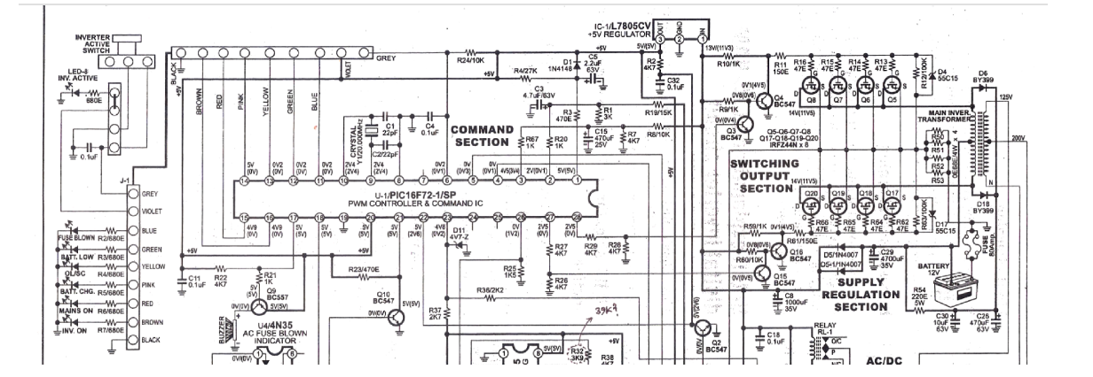
Figure 3.1 Circuit Diagram for 3kVA Inverter system

3.8.1 Explanation of the circuit diagram

- Inverter Active Section Switch: This i the part of the circuit responsible for switching the DC power from the input (usually a battery or DC power source) into AC power output. It might include MOSFETs or IGBTs (Insulated Gate Bipolar Transistors)configured in a way that allows them to switch on and off rapidly, creating an alternating current.
- System Indicator: This is a component or set of components that indicate the status of the inverter system, such as whether it's operating correctly, in standby mode, or experiencing an issue.
- Processor IC (PIC 16672-1/sp): This is the main controller of the inverter system. It's a micro-controller, specifically a PIC (Peripheral Interface Controller), which is likely programmed to manage various functions of the inverter, such as generating PWM (Pulse Width Modulation) signals to control the switching of the active section, monitoring system parameters, and possibly communicating with external devices.
- Command Section: This part of the circuit contains resistors, capacitors, transistors, and possibly other components that are used to interface the processor IC with the rest of the circuit. It may include circuitry for signal conditioning, level shifting, or protection.
- Regulator (L7805CV): This is a voltage regulator IC (Integrated Circuit) that ensures a stable 5-volt supply voltage to power the processor IC and possibly other components in the circuit.
- Switching Output Side: This section of the circuit consists of relays and transistors that are used to control various loads or external devices connected to the inverter output. The relays may be used for switching between different output configurations or for providing power to different loads.
- Supply Regulation Section: This section includes components such as capacitors, diodes, and possibly voltage regulators, which are used to regulate and stabilize the DC power supply to different parts of the circuit.
- Main Transformer Section: This is the part of the circuit that includes the main transformer, which is responsible for converting the DC input power into AC output power. The transformer may include multiple windings for different voltage levels and may be designed for step-up or step-down operation depending on the application.

CHAPTER FOUR
TESTING, PRINCIPLE OF OPERATION AND DISCUSSION
4.1 Principle of Operation
- When the inverter is powered on, the processor IC (PIC 16672-1/sp) initializes and begins executing its programmed instructions.
- The processor continuously monitors various parameters such as input voltage, output load, temperature, and system status.
- The processor generates PWM (Pulse Width Modulation) signals based on the desired output voltage and frequency settings. These signals control the switching of the inverter active section switch (likely MOSFETs or IGBTs), regulating the output voltage and frequency.
- The voltage regulator (L7805CV) ensures a stable 5-volt supply voltage to power the processor IC and other components in the circuit.
- The switching output side, consisting of relays and transistors, is controlled by the processor to manage various loads or external devices connected to the inverter output. The relays may switch between different output configurations or provide power to different loads based on system requirements.
- The circuitry may include protection mechanisms such as Over-voltage protection, Over-current protection, and temperature monitoring to ensure safe and reliable operation of the inverter system.
- The system indicator provides visual or audible feedback to the user about the status of the inverter system, indicating whether it's operating normally, in standby mode, or experiencing an issue.
- The processor may incorporate feedback control loops to adjust the PWM signals based on real-time measurements of output voltage and frequency, ensuring stable and accurate output under varying load conditions
4.2 Results
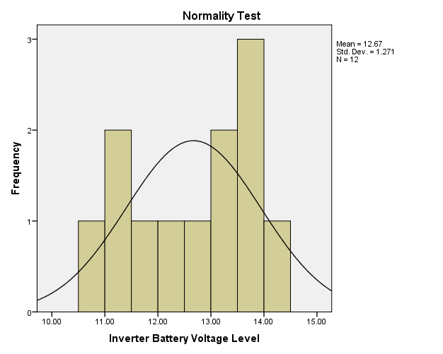

(a)
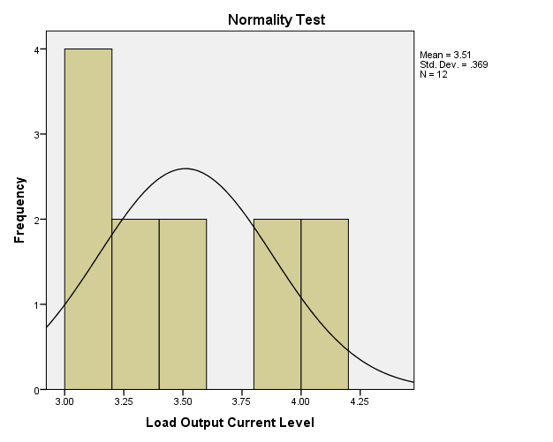
(b)
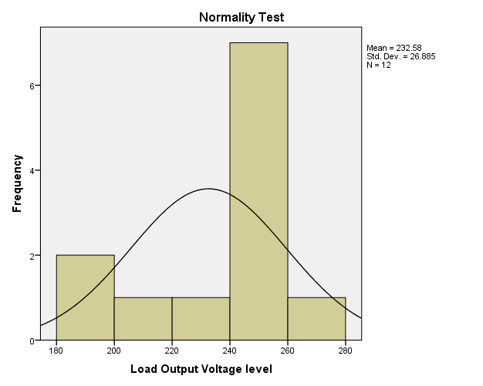

(c)
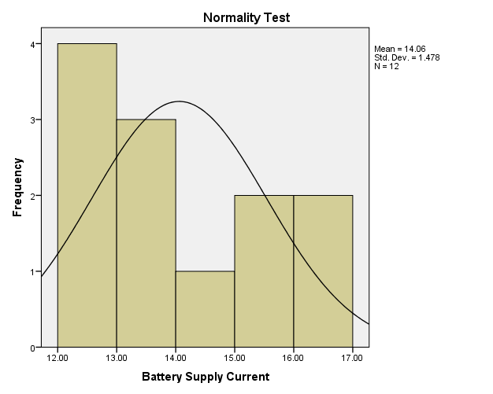
(d)
Figure 4.0: Normality Test for the Measured Values of 3kVA Locally Designed and Constructed Inverter (a) Inverter Battery Voltage Level (b) Load Output Current Level (c) Load Output Voltage Level and (d) Battery Supply Current.
(a)

(b)

(c)
(d)

Figure 4.1: Metric Parameters Observation over Time (a) Load Voltage Variation (b) Battery Voltage Variation (c) Battery Current Variation and (d) Load Current Variation.
Table 2.0: Model Summary
Model | R | R Square | Adjusted R Square | Std. Error of the Estimate
1 | .965ª | .930 | .904 | .22852
Predictors (Constant), Load Output Current Level, Measurement Time, Load Output Voltage Level

Table 3.0: Modeling Coefficients
Model Variables |  | Unstandardized Coefficients |  | Standardized Coefficients | T | Sig.
 |  | B | Std. Error | Beta | T | Sig.
1 | (Constant) | 18.472 | 5.851 |  | 3.157 | .013
1 | Measurement Time | .012 | .003 | 1.184 | 3.582 | .007
1 | Load Output Voltage level | -.034 | .011 | -1.216 | -2.974 | .018
1 | Load Output Current Level | -2.906 | 1.062 | -1.453 | -2.737 | .026
Dependent Variable: Perfomance Level

4.3 Discussions and equation modelling
Generally, measurements are known to be liable to outliers, sometimes called error. Errors arise due to imperfection on the part of human and machines that are used to obtain the numeric data. In this research work, a normality test was run on SPSS-23 software simulator to check for the normality test of the measured data in Table 1.0 as presented in Figure 1.0. The Figures show that the metric data are normal and they are completely devoid of outliers, hence they possess some level of credence when used in the investigation of the 3kVA performance and equation modeling analysis. Figure 4.1 shows the depiction of the metric parameters variation with time. In Figure 4.0 (a), the graph depiction shows that the inverter provides support when maximally loaded for about four (4) hours, however, the inverter output voltage only drops by 20 volts in nearly two (2) hours. This indicates a very good performance by the inverter, although, afterward the output drops drastically with a compensation for the load sustainability through the corresponding increase in the battery current level as shown in Figure 4.0(c). Table 2.0 on the other hand comprises the model summary and it shows the Adjusted R square value, which indicate that the metric parameters that were keyed in to the SPSS-23 software were 90.4% capable of determining the success of the inverter performance and it was therefore adjudged okay. Table 3.0 shows the modeling coefficients for the metric parameter that was keyed in to SPSS software. At this stage, it is worth mentioning that, all the components used as well as the metric parameters obtained are all ohmic in nature (i.e they obey ohm’s law, having a voltage – current linear relationship), with this credence, a linear regression equation was adopted for the equation modeling formulation. Fundamentally, the equation modeling therefore takes a form of general regression equation of the form:
where P(invt) is the inverter performance, K is the constant value in the modeling coefficient table, K₁ is the constant of measurement time at time t, K₂ is the constant of the load output voltage and K₃ is the constant of load output current. In this regard, the performance equation for the 3KVA inverter is equal to
2
With the equation modeling derived, the performance of a 3kVA locally designed and constructed inverter can be determined at any time t of operation of the inverter with the load output voltage measured (V_{OL}) at time t and the load output current (I_{OL}) at time t
The 3kVA inverter system demonstrated good performance under test conditions. The use of high-quality components such as IGBTs, regulated voltage supplies, and appropriate feedback systems enhanced its functionality. The SPSS analysis confirmed the linearity of the system behavior, indicating it obeys Ohm’s Law and other basic electrical principles.The system also includes vital safety features such as over-voltage protection, short-circuit shutdown, and audible alarms for low battery. These make it ideal for use in sensitive environments like homes, offices, and hospitals.
Conclusively, the inverter fulfills its design objectives by offering reliable, uninterrupted power with performance metrics comparable to commercial systems.
4.4 Final pictures of the 3kva inverter
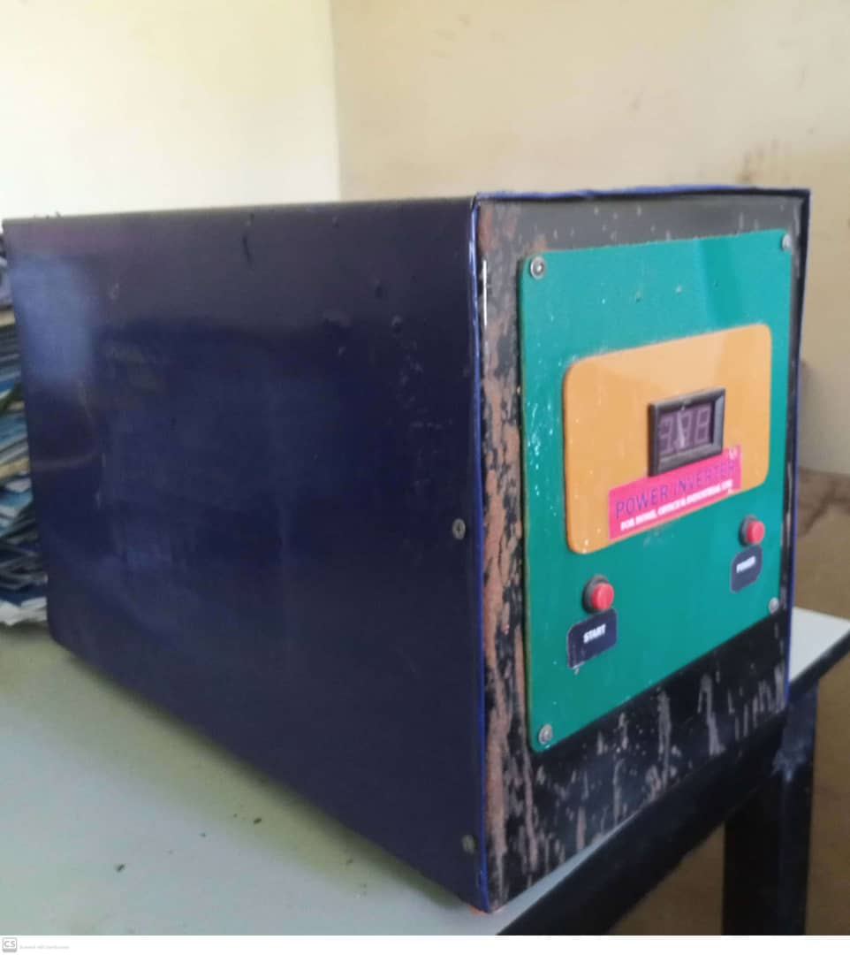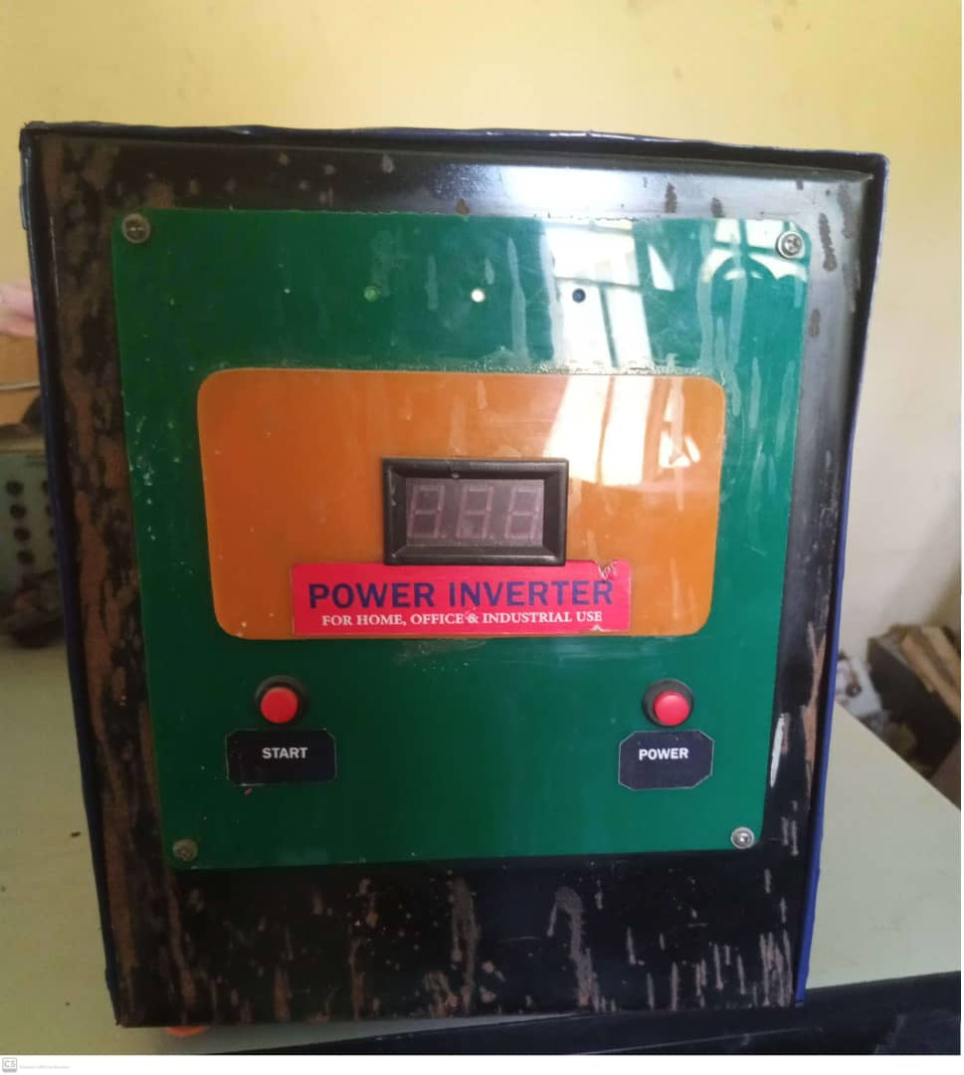
Fig. 4.3 Final picture of the 3KVA inverter System

CHAPTER FIVE

CONCLUSION AND RECOMMENDATIONS

5.1 Conclusion
The performance evaluation and testing of the locally designed and constructed 3kVA pure sine wave inverter system has demonstrated that the project successfully meets its design objectives. The inverter system was able to provide reliable and uninterrupted power to various loads under different operating conditions. The use of highquality components, such as MOSFETs, microcontroller-based control, pure sine wave output, and regulated power supplies contributed to the effectiveness and safety of the inverter.
The SPSS-based statistical analysis validated the performance results, confirming that the design aligns with theoretical expectations. Furthermore, the use of protective mechanisms like low-battery shutdown, overload protection, and system monitoring ensures user and equipment safety.
This locally constructed inverter system not only reduces dependence on foreign products but also supports the growing need for sustainable and cost-effective power solutions in developing countries.

5.2 Recommendations
1. Future iterations of this inverter system should explore the integration of renewable energy sources such as solar panels for charging to promote environmental sustainability.
2. The use of advanced battery technologies such as lithium-ion batteries should be investigated to reduce weight, increase efficiency, and enhance the lifespan of the system.
3. Incorporating a digital display or mobile application interface can provide real-time monitoring and enhance the user experience.
4. Further research should be encouraged among engineering students to promote local innovation in inverter technologies, emphasizing the use of locally available materials and components.
5. Manufacturing efforts should be encouraged at the local level to ensure affordability, ease of maintenance, and job creation.

REFERENCES
[1] Akintade, O. M., & Ogunlade, O. (2015). Design and construction of pure sine wave inverter. International Journal of Engineering Research and Applications, 5(6), 112–120.
[2] Bhattacharya, S., & Divan, D. M. (1995). Design and application of power inverter topologies for distributed generation. IEEE Transactions on Industrial Electronics, 43(2), 224–234. https://doi.org/10.1109/41.491362
[3] Bose, B. K. (2002). Modern power electronics and AC drives. Prentice Hall.
[4] Chapman, S. J. (2011). Electric machinery fundamentals (5th ed.). McGraw-Hill Education.
[5] Ekundayo, A. O. (2022). Solar power inverter systems for developing countries: Design and application. University of Lagos Press.
[6] IEEE. (2014). IEEE recommended practice and requirements for harmonic control in electric power systems (IEEE Std 519-2014). IEEE.
[7] IEC. (2019). Uninterruptible power systems (UPS) - General and safety requirements for UPS (IEC 62040-1). International Electrotechnical Commission.
[8] Kim, J., & Lee, K. B. (2014). Modeling and analysis of power electronic inverters. Journal of Electrical Engineering and Automation, 2(1), 12–20.
[9] Krein, P. T. (1998). Elements of power electronics. Oxford University Press.
[10] Malik, H., & Kumar, V. (2017). Development and analysis of battery backup inverter for residential applications. International Journal of Emerging Technology and Advanced Engineering, 7(4), 56–63.
[11] Mohan, N., Undeland, T. M., & Robbins, W. P. (2003). Power electronics: Converters, applications, and design (3rd ed.). Wiley.
[12] Nasir, M. (2005). Inverter circuits and UPS design handbook. Elektor Publications.
[13] National Renewable Energy Laboratory (NREL). (2019). Inverter technology and grid integration. Retrieved from https://www.nrel.gov
[14] Nelson, J. D. (2004). Transformers and inductors for power electronics: Theory, design and applications. CRC Press.
[15] Ogundele, M. A., & Ude, A. (2019). Modeling and simulation of a 3kVA inverter using SPSS and MATLAB. Nigerian Journal of Electrical Engineering Technology, 10(2), 45–54.
[16] Rizzoli, L., & Vaccaro, R. (2010). Design and testing of UPS systems for critical load environments. Journal of Power Sources, 195(24), 8192–8200. https://doi.org/10.1016/j.jpowsour.2010.06.045
[17] Rashid, M. H. (2013). Power electronics: Circuits, devices and applications (4th ed.). Pearson Education.
[18] Singh, B., & Verma, V. (2008). Performance analysis of a pure sine wave inverter. International Journal of Power Electronics, 5(2), 98–105.
[19] Sukhatme, S. P., & Nayak, J. K. (2017). Solar energy: Principles of thermal collection and storage (4th ed.). McGraw-Hill Education.
[20] Umanah, I. I., & Ekpe, E. N. (2020). Performance evaluation of locally developed inverter system. Nigerian Journal of Technology, 39(3), 778–786. https://doi.org/10.4314/njt.v39i3.36

BILL OF ENGINEERING MEASUREMENT AND EVALUATION
S/N | Description | Qty | Unit | Unit Cost (₦) | Total Cost (₦)
1 | MOSFETs (e.g., IRF3205) | 6 | pcs | 1,200 | 7,200
2 | Transformer (24V–220V, 3kVA) | 1 | unit | 25,000 | 25,000
3 | Microcontroller (PIC 16F672 or similar) | 1 | unit | 2,500 | 2,500
4 | Voltage Regulator (L7805) | 1 | unit | 300 | 300
5 | Oscillator/IC (CD4047) | 1 | unit | 500 | 500
6 | Relay (40A/12V) | 2 | pcs | 1,500 | 3,000
7 | Capacitors, Resistors, Diodes, etc. | 1 | lot | 5,000 | 5,000
8 | Heat Sinks | 2 | pcs | 1,000 | 2,000
9 | Battery (12V, 200Ah) | 2 | pcs | 90,000 | 180,000
10 | Printed Circuit Board (PCB) | 1 | unit | 5,000 | 5,000
11 | LCD or LED Indicators | 2 | pcs | 1,000 | 2,000
12 | Inverter Enclosure/Casing | 1 | unit | 8,000 | 8,000
13 | Wiring, Connectors & Terminals | 1 | lot | 4,000 | 4,000
14 | Testing Instruments & Tools (Rentals) | 1 | lot | 5,000 | 5,000
15 | Labor/Construction & Assembly | 1 | job | 15,000 | 15,000
16 | Documentation & Miscellaneous | 1 | lot | 5,000 | 5,000
Total Estimated Cost 74,500

