

DESIGN AND CONSTRUCTION OF A HOME AUTOMATION SYSTEM USING ARDUINO UNO AND BLUETOOTH.
BY

SANNI SAMUEL AYODIMEJI
HND/23/EEE/FT/0053

SUBMITTED TO:

THE DEPARTMENT OF ELECTRICAL ELECTRONICS ENGINEERING, INSTITUTE OF TECHNOLOGY,
KWARA STATE POLYTECHNIC, ILORIN.

IN PARTIAL FULFILLMENT OF THE REQUIREMENT FOR THE AWARD OF HIGHER
DIPLOMA (HND) CERTIFICATE INvELECTRICAL ELECTRONICS ENGINEERING

SUPERVISED BY
ENGR. ADEBAYO A O

JULY,2025.

CERTIFICATION

This is to certify that this project was carried out and submitted by SANNI SAMUEL AYODEJI of matric number HND/23/EEE/FT/0053 and has been read and approved as meeting the requirements for the award of Higher National Diploma in the department of Electrical/Electronics Engineering, Institute of Technology, Kwara State Polytechnic, Ilorin.

_____________________ _____________
ENGR. DR. A. O. LATEEF Date
Project supervisor

_____________________ _____________
ENGR. Z. A. ABDULKADIR Date
Project coordinator

_____________________ _____________
ENGR. DR. O. A. LAWAL Date
Head of department

_____________________ _____________
External examiner Date

DEDICATION

This project is dedicated to Almighty God, the most merciful, the most gracious, who as protected me through the completion of this academic program. May HIS name be praised forever. Also to my parent for their support throughout this project and to the department of electrical and electronics engineering.
ACKNOWLEDGEMENTS
I give all glory and adoration to Almighty God, the giver of knowledge, strength and ability for sustaining and helping me through my project period, and for his grace and protection over me throughout my higher national diploma program.
My appreciation also goes to my supervisor in person of Engr. A. O. LATEEF for his total support and fatherly advice during the period of this project. I appreciate you so much Sir. I also acknowledge the support of my amiable project coordinator ENGR. Z. A. ABDULKADIR, and to every other lecturers of the department. I say a big thanks to you all.
My appreciation also goes to my beloved parent MR. AND MRS. SANNI GABRIEL for their moral, financial, and prayer supports, may you live long to reap the fruit of your labour.
I will be an ingrate if I don’t show my appreciation to my elder sisters, SANNI ONUORAH BOSEDE and SANNI FOLASHADE and to all members of my family, my colleagues, friends, my project group members and everyone that has contributed in one way or the other to the success of this project.

TABLE OF CONTENT

Title Page | i
Certification | ii
Dedication | iii
Acknowledgement | iv
Table of Contents  CHAPTERONE:INTRODUCTION | v
1.1 Background of the Study | 1
1.2 Problem Statement | 2
1.3 Aim and Objectives | 2
1.4 Significance of the Study | 3
1.5 Scope of the Study | 3
1.6 Limitations of the Study  CHAPTERTWO:LITERATUREREVIEW | 4
2.1 History of Home Automation | 5
2.2 Home Automation System | 6
2.2.1 Arduino-Based Home Automation | 7
2.2.2 Bluetooth Based Home Automation System Using Cell Phones | 7
2.2.3 Zigbee Based Home Automation System Using Cell Phones | 7
2.2.4 GSM Based Home Automation System Using Cell Phones | 8
2.2.5 Wi-Fi Based Home Automation System Using Cell Phones | 9
2.2.6 Home Automation Using RF Module  2.2.7 Raspberry Pie Home Automation with Wireless | 10
Sensors Using Smart Phone | 11
2.3 Bluetooth Technology in Home Automation | 11
2.3.1 Challenges of Home Automation Systems | 12
2.4 The Necessity of Home Automation system | 12
2.4.1 Convenience and Comfort | 12
2.4.2 Energy Efficiency and Cost Savings | 13
2.4.3 Enhanced Security and Safety | 14
2.4.4 Accessibility for Elderly and Disabled Individuals | 14
2.4.5 Integration with IoT and Smart Technologies | 15
2.4.6 Increased Property Value  CHAPTERTHREE:METHODOLOGY | 16
3.1 The stages of home automation project  3.2 Diagram Of The Home Automation System using | 17
Arduino UNO andBluetooth. | 20
3.2.1 The power supply | 20
3.2.2 Arduino UNO | 21
3.2.3 Arduino UNO Board Layout | 22
3.2.3.1 Technical Specifications of Arduino UNO | 23
3.2.3.2 How to power up the Arduino UNO? | 24
3.2.3.3 What are Different Memories of Arduino UNO? | 24
3.2.3.4 The Input and Output Pins of Arduino UNO | 24
3.2.3.5 Communication Interfaces available on Arduino UNO | 25
3.2.3.6 Additional features | 26
3.2.3.7 Arduino UNO Pinout | 26
3.2.3.8 Pin Description | 27
3.2.4 Relay Module | 31
3.2.5 Bluetooth Module | 34
3.3 The Code Implementation of the Home Automation | 38
3.4 Construction | 41
3.4.1 CASING  CHAPTERFOUR:TESTING | 41
4.1 Testing the Range | 43
4.2 Results | 43
4.3 Bill of Engineering Measurement and Estimation  CHAPTERFIVE:RECOMMENDATIONANDCONCLUSION | 46
5.1 Suggestions for Further Research | 48
5.2 PROBLEMS ENCOUNTERED | 49
5.3 CONCLUSION | 49
References | 50

LIST OF FIGURE

Figure1:The block diagram of a GSM home automation system 9

Figure2:The diagram of a WIFI based home automation system 10

Figure3:The block diagram of a home automation system. 20

Figure4: The buck converter circuit 21

Figure5:The Arduino UNO Board for both SMD andThresiode 22

Figure6:The pin out diagram of Arduino UNO board 23

Figure7:Arduino UNO pin out diagram 27

Figure8:Typical diagram of a relay module 32

Figure9:The Diagram of the Principle of Operation of Relay 33

Figure10:A pictorial image of a Bluetooth module(HC-05). 36

Figure11:The wiring diagram of Hc-05 37

Figure12:The Inner Construction of a Home Automation System 41

Figure13:The Home Automation System Casing 42

Figure14:Bluetooth connection and speed in (%) variation in a plain environment 44
Figure15: Bluetooth connection and speed in (%) variation in an enclosed environment 45

ABSTRACT
This project focuses on design and implementation of a cost-effective home automation system using Arduino UNO and Bluetooth technology. The aim is to provide an affordable and user-friendly solution for controlling household appliances wirelessly through a smartphone application, without relying on internet connectivity. The system employs the Arduino UNO microcontroller, HC-05 Bluetooth module, and relay modules to control devices such as lights, fans, and chargers. Commands sent from a mobile application via Bluetooth are interpreted by the Arduino to switch appliances on or off. The development process involves system planning, circuit design, software programming, integration, and through testing. The Arduino was programmed using the Arduino IDE, while a simple Bluetooth control app was configured to interface with the hardware. Testing confirmed the system’s functionality within the standard Bluetooth range [up to10 meters], with stable communication and responsive appliance control. The system proved effective for basic automation needs, particularly in areas with limited internet access. Additionally, it offers enhanced energy efficiency, ease of use, and improve home security by allowing remote switching. Overall, this Bluetooth-based home automation system demonstrates a practical solution for modern smart home needs, especially in low-resources setting

CHAPTER ONE

1.0 INTRODUCTION

1.1 Background of the Study
The advancement in technology has revolutionized various aspects of daily life, with home automation being one of the most significant developments. Home automation systems provide convenience, security, and energy efficiency by allowing users to control appliances and electrical devices remotely. The increasing adoption of microcontrollers and wireless communication technologies has facilitated the development of smart home solutions that cater to the needs of modern households.
Home automation technology has evolved from simple remote-controlled systems to complex artificial intelligence-driven solutions. However, many of these systems require an internet connection and involve high implementation costs, making them inaccessible to some users. The use of Arduino UNO and Bluetooth technology provides an alternative, low-cost, and reliable home automation solution. Arduino UNO is an open-source microcontroller board that offers ease of use and flexibility, while Bluetooth enables wireless communication between devices within a limited range. By integrating these two technologies, a practical and cost-effective home automation system can be developed, allowing users to control home appliances via a mobile application.
Home automation, also known as smart home technology, refers to the use of control systems and information technology to operate household appliances and devices remotely. The concept has evolved significantly over the years, incorporating various technologies such as Wi-Fi, Zigbee, GSM, and Bluetooth. These systems aim to improve energy efficiency, security, and user convenience (Smith et al., 2020).

1.2 Problem Statement
Despite the rapid development of home automation technologies, many existing systems are either too expensive, complex, or reliant on internet connectivity, which may not always be available in remote or underdeveloped areas. Traditional home automation systems require dedicated hardware and software configurations, making them challenging for non-technical users. Additionally, commercially available solutions often come with subscription-based services, increasing the overall cost of ownership.
The reliance on internet-based automation systems presents another challenge, as users may experience connectivity issues due to network outages, making the system unreliable in certain locations. Furthermore, some automation systems involve extensive wiring, which can be difficult to install and maintain.

1.3 Aim and Objectives
The primary aim of this project is to design and construct a Bluetooth-based home automation system using Arduino UNO.
The specific objectives of this project include:
- To develop a cost-effective home automation system that allows users to control appliances using a smartphone application.
- To implement a wireless communication system using Bluetooth technology.
- To enhance user convenience by providing an intuitive and easy-to-use mobile application interface.
- To improve energy efficiency by enabling users to monitor and control appliances remotely.

1.4 Significance of the Study
This study is significant in several ways:
- Cost-Effectiveness: The proposed system utilizes readily available components, making it an affordable alternative to existing commercial home automation solutions.
- User-Friendliness: The mobile application interface is designed to be simple and intuitive, ensuring ease of use for individuals with minimal technical knowledge.
- Energy Efficiency: By allowing users to control appliances remotely, the system helps reduce unnecessary power consumption, contributing to energy savings.
- Enhanced Security: Users can switch appliances on and off remotely, adding an extra layer of security to their homes.
- No Internet Dependency: The system relies on Bluetooth communication, making it functional in areas with limited or no internet access.

1.5 Scope of the Study
This study focuses on designing and implementing a home automation system using Arduino
UNO and Bluetooth technology. The system will include:
- A Bluetooth module for wireless communication.
- A mobile application for controlling prototype household appliances.
- Integration with basic electrical devices such as lights, fans, and power sockets.
- A simple switching mechanism for turning devices on and off remotely.
The system will not include advanced features such as internet-based remote access, voice control, or artificial intelligence-driven automation.

1.6 Limitations of the Study
- Limited Range: Bluetooth technology has a short communication range, typically up to
10 meters.
- Basic Functionality: The system is limited to turning devices on and off and does not include real-time power consumption monitoring or AI-driven automation.
- Device Compatibility: The system is designed to work with basic household appliances but may require modifications for compatibility with more complex devices.

CHAPTER TWO

2.0 LITERATURE REVIEW

2.1 History of Home Automation
Home automation is something we take for granted nowadays. We cannot imagine our day without having an Alexa device playing our music, our smart TV showing the latest Netflix shows or a day without our smartphone.
The technology progress has been through a lot of changes throughout the years, and that is shown best in our daily appliances and smart devices. We gathered some historical examples of early versus modern technology to demonstrate to you how thankful we should be for what we have. Did you know that the first devices used in home automation were labor-saving devices? These are a few of the most significant innovations in this field since its inception in the 1800s.
Home automation has a long history that dates back to the early 20th century when electrical appliances first became widespread. The development of home automation can be traced through various technological advancements:
- 1900s-1950s: The invention of household electrical appliances such as refrigerators, washing machines, and vacuum cleaners laid the foundation for automation.
- 1960s-1980s: The introduction of remote-controlled devices, such as garage doors and televisions, marked the early forms of automation.
- 1990s: The emergence of programmable logic controllers (PLCs) and wired automation systems allowed for greater integration of home automation features.
- 2000s-Present: The development of wireless communication technologies such as Wi-Fi, Bluetooth, and Zigbee has led to the modern era of smart homes, where devices can be controlled remotely via mobile applications (Miller & Johnson, 2020).
Automation performs an increasingly vital role in daily experience and global economy. Engineers strive to combine automated devices with mathematical and organizational tools to create complex systems for a rapidly expanding range of applications and human activities. The concept of home automation has been around since the late 1970s. But with the enhancement of technology and smart services, people’s expectations have changed a lot during the course of time to perfectly turn the traditional house into smart home, and also think that what a home should do or how the services should be provided and accessed at home to became a smart home and so has the idea of home automation systems.

2.2 Home Automation System
Giving end users the ability to control and operate electric appliances is possible with a home automation system. When examining various home automation systems over time, we can see that they have consistently worked to give residents of homes safe, practical, and effective ways to access their homes. The look of a home automation system hasn't changed over time, despite changes in user expectations, advancements in technology, or time itself.
Many existing, well-established home automation systems are based on wired communication such as Arduino based and raspberry pi based home automation systems. This does not pose a problem until the system is planned well in advance and installed during the physical construction of the building. But for already existing buildings the implementation cost goes very high. In contrast, Wireless systems can be of great help for automation systems like Bluetooth, Wi-Fi and IOT based home automation systems. With the advancement of wireless technologies such as WiFi, cloud networks in the recent past, wireless systems are used every day and everywhere.

2.2.1 Arduino-Based Home Automation
Arduino-based automation systems have gained popularity due to their low cost, open-source nature, and ease of programming. According to Brown et al. (2021), Arduino-based home automation systems provide a flexible and scalable solution that allows users to integrate multiple sensors and actuators. Researchers have successfully implemented Arduino systems for controlling lighting, temperature, and security features in smart homes (Jones & Lee, 2019).

2.2.3 Bluetooth Based Home Automation System Using Cell Phones
Relays are used to connect the Arduino BT board to the input/output ports of the home appliances in a Bluetooth-based home automation system. The Arduino BT board connects via
Bluetooth and is programmed using the high-level interactive C language of microcontrollers. Only authorized users can access the appliances thanks to the password protection. For wireless communication, the Arduino BT board and phone establish a Bluetooth connection. This system uses a Python script that is portable and installable on any Symbian OS environment. A single circuit is created and put into use to receive phone feedback, which shows the device's status.

2.2.4 Zigbee Based Home Automation System Using Cell Phones

To monitor and control the home appliances the system is designed and implemented using
Zigbee. The device performance is record and store by network coordinators. For this the Wi-Fi network is used, which uses the four switch port standard wireless ADSL modern router. The network SSID and security Wi-Fi parameter are preconfigured. For security purposes, the message is first processed by the virtual home algorithm. Once it is deemed secure, it is re-encrypted and sent to the home's actual network device. The Zigbee controller sent messages to the end of the
Zigbee network. the security and safety of every message that the virtual home algorithm receives. ZIGBEe communication is useful in lowering the system's cost and the intrusiveness of the installation process.

2.2.5 GSM Based Home Automation System Using Cell Phones

Because of the mobile phone and GSM technology, the GSM based home automation is lure to research. The SMS based home automation, GPRS based home automation and dual tone multi frequency (DTMF) based home automation, these options we considered mainly for communication in GSM. In figure shows the logical diagram the work of A. Alheraish, it shows how the home sensors and devices interact with the home network and communicates through GSM and SIM (subscriber identity module). The system use transducer which convert machine function into electrical signals which goes into microcontroller. The sensors of system convert the physical qualities like sound, temperature and humidity into some other quantity like voltage. The microcontroller analysis all signal and convert them into command to understand by GSM module. Select appropriate communication method among SMS, GPRS and DTFC based on the command which received GSM module.
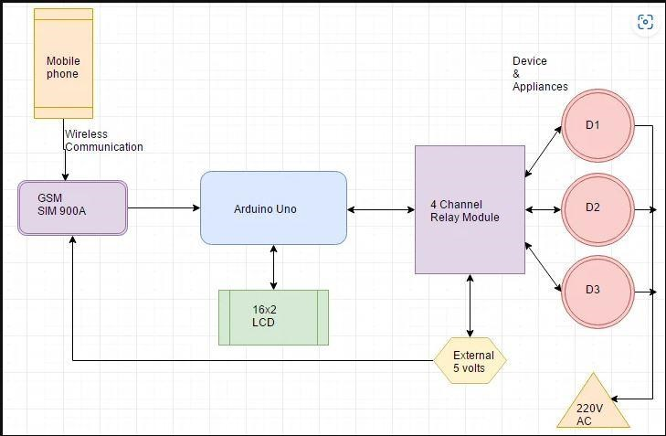
Figure 1 The block diagram of a GSM home automation system

2.2.6 Wi-Fi Based Home Automation System Using Cell Phones
Wi-Fi based home automation system mainly consist three modules, the server, the hardware interface module, and the software package. The figure shows the system model layout. Wi-Fi technology is used by server, and hardware Interface module to communicate with each other. The same technology uses to login to the server web based application. The server is connected to the internet, so remote users can access server web based application through the internet using compatible web browser. Software of the latest home automation system is split to server application software, and Microcontroller (Arduino) firmware. The Arduino software, built using
C language, using IDE comes with the microcontroller itself. Arduino software is culpable for gathering events from connected sensors, then applies action to actuators and pre-programed in the server. Another job is to report the and record the history in the server DB. The server application software package for the proposed home automation system, is a web based application built using asp.net. The server application software can be accessed from internal network or from internet if the server has real IP on the internet using any internet navigator supports asp.net technology. Server application software is culpable of, maintain the whole home automation system, setup, and configuration. Server use database to keep log of home automation system components, we choose to use XML files to save system log.

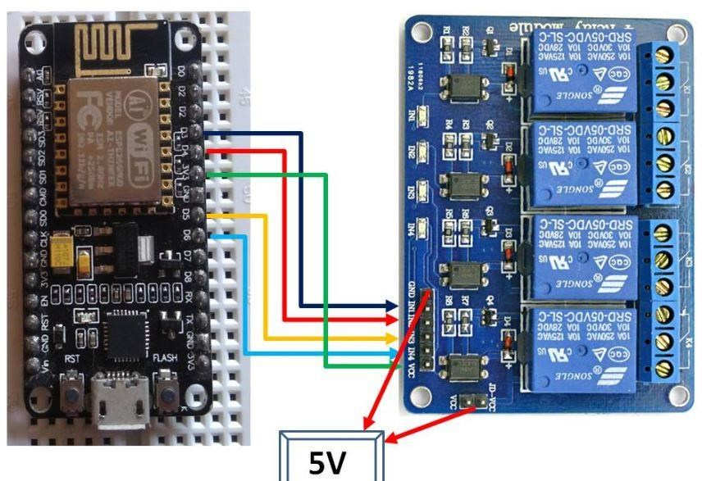
Figure 2 the diagram of a WIFI based home automation system

2.2.7 Home Automation Using RF Module
Building a home automation system with an RF-controlled remote is a key objective of home automation systems. As technology advances, homes are becoming increasingly intelligent. A centralized control system with RF-controlled switches is purposefully replacing the switches found in modern homes. These days, it is difficult for the end user to approach and operate the traditional wall switches that are dispersed throughout the house. For older adults or those with
physical disabilities, it becomes even more difficult to do so.
Using RF technology, home automation via remote implements a simpler solution. Solution with RF technology. In order to accomplish this, a RF remote is combined to the microcontroller on transmitter side that sends ON/OFF signals to the receiver where devices are connected. By operating the stated remote switch on the transmitter, the loads can be turned ON/OFF globally using wireless technology.

2.2.8 Raspberry Pie Home Automation with Wireless Sensors Using Smart Phone

Using a smartphone and wireless sensors, a Raspberry Pi home automation system Using a Raspberry Pi to read the email's subject line and algorithm, a home automation system was created. The Raspberry Pi promises to be a productive platform for putting strong, affordable smart home automation into practice. Raspberry Pi home automation is superior to all other home
automation techniques in a number of ways.
For instance, the call tariff is a significant drawback of DTMF (dual tone multi-frequency) using home automation, even though this is not an issue with their suggested approach. Because it only makes use of the well-known web server service provided by Gmail, the design of the web server and the memory space needed are disregarded in home automation using web servers.

2.4 Bluetooth Technology in Home Automation
Bluetooth technology plays a crucial role in wireless communication for home automation. Unlike Wi-Fi, Bluetooth does not require internet connectivity, making it ideal for offline applications. According to Patel & Sharma (2022), Bluetooth-based home automation systems offer a reliable, low-power alternative for controlling appliances within a limited range. Various studies have explored the advantages of Bluetooth-based automation, highlighting its affordability and ease of implementation (Kumar et al., 2021).

2.3 Challenges of Home Automation Systems
Home automation systems suffers four main challenges; these are poor manageability, inflexibility, difficulty in achieving security and high cost of ownership, The main objectives of this research is to design and implement a home automation system using IoT that is capable of controlling and automating most of the house appliances through an easy manageable web interface. The proposed system has a great flexibility by using Wi-Fi technology to interconnect its distributed sensors to home automation server. This will decrease the deployment cost and will increase the ability of upgrading, and system reconfiguration.

2.4 The Necessity of Home Automation system

2.4.1 Convenience and Comfort
- Remote Control: One of the most significant advantages of home automation is the ability to control home devices remotely. With smartphones, tablets, or smartwatches, homeowners can turn lights on or off, adjust the thermostat, or unlock doors from virtually anywhere. This level of control makes managing a home more convenient, especially for people with busy schedules or those who travel frequently. Additionally, voice assistants like Alexa or Google Assistant enable hands-free control, making it even easier to manage home tasks. (Wang et al., 2015).
- Automation of Routine Tasks: Home automation systems can handle repetitive tasks without any user intervention. For example, lights can be set to automatically turn on when someone enters a room or a coffee machine can brew a cup at a specific time in the morning.
Such automation removes the need for manual input, saving time and effort. (Liu et al., 2018)
- Customized Comfort: Climate control is another example where automation makes a difference. Smart thermostats learn user preferences and adjust the temperature based on time of day, weather, or occupancy. This ensures comfort while also preventing energy wastage, as the system won’t waste energy heating or cooling an empty home. (Deng et al., 2017)

2.4.2 Energy Efficiency and Cost Savings
- Energy Consumption Monitoring: With the growing awareness of climate change and the need for sustainability, home automation helps homeowners track and reduce energy consumption. Smart meters and energy management systems provide insights into how energy is being used, enabling users to identify high-consumption appliances and take steps to optimize usage. For instance, smart lighting systems use motion sensors to ensure that lights are only on when rooms are occupied, cutting down on unnecessary electricity usage. (Zhao & Zhang, 2019)
- Smart Thermostats: A well-known feature of home automation systems, smart thermostats like Nest, Eco bee, or Honeywell, can significantly lower energy costs. These devices can detect when the home is empty and adjust the temperature accordingly to save energy. They
can also learn the homeowner’s habits and set heating/cooling schedules based on personal routines. Over time, this smart behavior results in better energy efficiency and lower monthly utility bills (Bohannon, 2016).
- Automated Shading and Lighting: Automated shading systems can adjust the blinds to block out heat from the sun during peak hours in the summer, reducing the need for air conditioning. (Kumar et al., 2017)Similarly, lights can automatically adjust to the ambient light levels, ensuring that rooms are neither too bright nor too dark while using the minimum amount of energy required.

2.4.3 Enhanced Security and Safety
- Surveillance Systems: Security is a major concern for homeowners, and home automation helps address this by providing an advanced security system that monitors the home 24/7. Cameras, motion sensors, and door/window sensors are often part of a smart security system. Alerts are sent to the homeowner’s smartphone if there is unusual activity detected, allowing for immediate action. Furthermore, some systems can be programmed to send alerts to emergency services or to notify trusted neighbors in case of a break-in.
- Smart Locks: Smart locks are a critical part of home automation security. These locks allow users to lock or unlock doors remotely via a smartphone app. They also provide the ability to give temporary access to others, such as housekeepers, friends, or service technicians, with digital keys that can be revoked at any time.
- Emergency Alerts and Monitoring: In addition to security, smart home systems can detect safety hazards such as smoke, fire, carbon monoxide, or water leaks. If such an event occurs, the system will alert the homeowner, and in some cases, can automatically shut off systems like water valves or turn on emergency lights. This proactive approach ensures the safety of both people and property.

2.4.4 Accessibility for Elderly and Disabled Individuals
- Assistive Technologies: For elderly or disabled individuals, home automation provides essential support in maintaining independence. Devices like voice-activated assistants can help those with limited mobility control lights, door locks, fans, and even appliances. Automated reminders for medication or appointments can also be programmed, helping individuals stay on top of their healthcare needs without relying on others.
- Remote Control for Comfort and Safety: Features like automated lighting and adjustable thermostats can be particularly beneficial for elderly individuals, helping them to stay comfortable without needing to adjust settings manually. Smart home technology also enables remote control of doors, windows, and blinds, reducing physical strain.
- Health Monitoring and Emergency Response: Some home automation systems integrate with health monitoring devices, such as wearable health trackers or emergency alert systems. These can be used to monitor vital signs or detect falls. In case of an emergency, the system can notify caregivers, family members, or emergency services for quick response.

2.4.5 Integration with IoT and Smart Technologies
- Seamless Integration: Home automation is a key component of the broader Internet of Things (IoT) ecosystem. It enables communication between a wide range of smart devices, including lights, appliances, thermostats, security systems, and even entertainment systems. This interconnected network allows for centralized control through a smartphone app or voice assistant, making it easier to manage multiple devices at once.
- Data and Feedback: IoT-enabled smart homes collect vast amounts of data about how devices are being used. This data can be used to further optimize systems, provide insights into energy use, and even predict future behavior, such as when a device is likely to need maintenance or replacement.

2.4.6 Increased Property Value
- Appeal to Homebuyers: As smart homes become more popular, they are seen as more modern and desirable. Installing smart devices such as lighting, security, and climate control systems can increase the overall value of a property, making it more attractive to prospective buyers. Real estate agents often highlight smart home features when marketing a property, and many buyers now view these features as a key selling point.
- Competitive Advantage: In competitive real estate markets, smart home features can set a property apart. Automated homes are perceived as more convenient, secure, and energyefficient, which can lead to a higher resale value or quicker sale.

CHAPTER THREE

3.0 METHODOLOGY

3.1 The stages of home automation project
The methodology for this home automation project encompasses four main stages:
- System Design and Planning
- Software Development
- Integration and Testing
- Security Implementation

System Design and Planning
- Requirements Gathering: Identify hardware components (Arduino UNO, Bluetooth module, relay module, and power supply) and determine the necessary software (Arduino IDE, Bluetooth control app) to meet the project's objectives.
- Circuit Design: Design the electrical circuit to connect the Arduino UNO, Bluetooth module, relay modules, and household appliances. The relay modules are used to switch appliances on and off based on commands received by the Arduino.
- Component Layout: Plan the physical layout of the components to ensure safe wiring, minimize electrical interference, and make the system compact and manageable.

Software Development
- Arduino Programming: Write code in the Arduino IDE to control the relays based on
Bluetooth commands received from a mobile device.
The code will: - Enable the Bluetooth module to receive commands. - Interpret commands (e.g., "ON" or "OFF") for specific appliances. - Activate or deactivate the connected relays based on the received commands.
- Mobile Application Configuration: - Use a pre-existing Bluetooth control app, or configure a simple custom interface to send commands from the user’s mobile device to the Bluetooth module. - Assign unique commands for each appliance and create buttons or control options for user- friendly interaction.

Integration and Testing
- Hardware Integration: Connect the Arduino, Bluetooth module, relay modules, and appliances according to the designed circuit. Ensure all connections are secure and verify the operation of each relay.
- System Testing: - Test the connection between the mobile device and the Bluetooth module to ensure reliable pairing and data transmission. - Test each appliance control feature individually to ensure the correct relay activates with the corresponding Bluetooth command. - Perform range tests to confirm the system operates effectively within typical Bluetooth limits (approximately 10 meters).
- Debugging: Identify and fix any issues related to connection stability, command accuracy, or relay operation. Security Implementation
- Bluetooth Pairing Security: Configure the Bluetooth module with a unique pairing PIN to restrict system access to authorized devices only.
- User Authentication: Implement basic authentication within the app if possible, ensuring only authorized users can control the appliances. This could involve a simple password prompt or device pairing verification.
- Documentation and User Training User Documentation: Create a user manual with stepby-step instructions for system setup, connection, and troubleshooting.
- Safety Guidelines: Include safety instructions for handling the hardware, especially with appliances connected to high-voltage power sources.
- End-User Training: Provide guidelines on how to use the mobile application, pair the device, and interpret system indicators (e.g., LEDs for on/off status).

Evaluation and Final Adjustments
- User Feedback: Collect feedback from users (or testers) to identify any usability or performance issues.
- Adjustments and Optimization: Make any final adjustments to the code, circuit, or app configuration based on feedback to enhance system performance and user satisfaction.

3.2 Diagram Of The Home Automation System using Arduino UNO and Bluetooth.
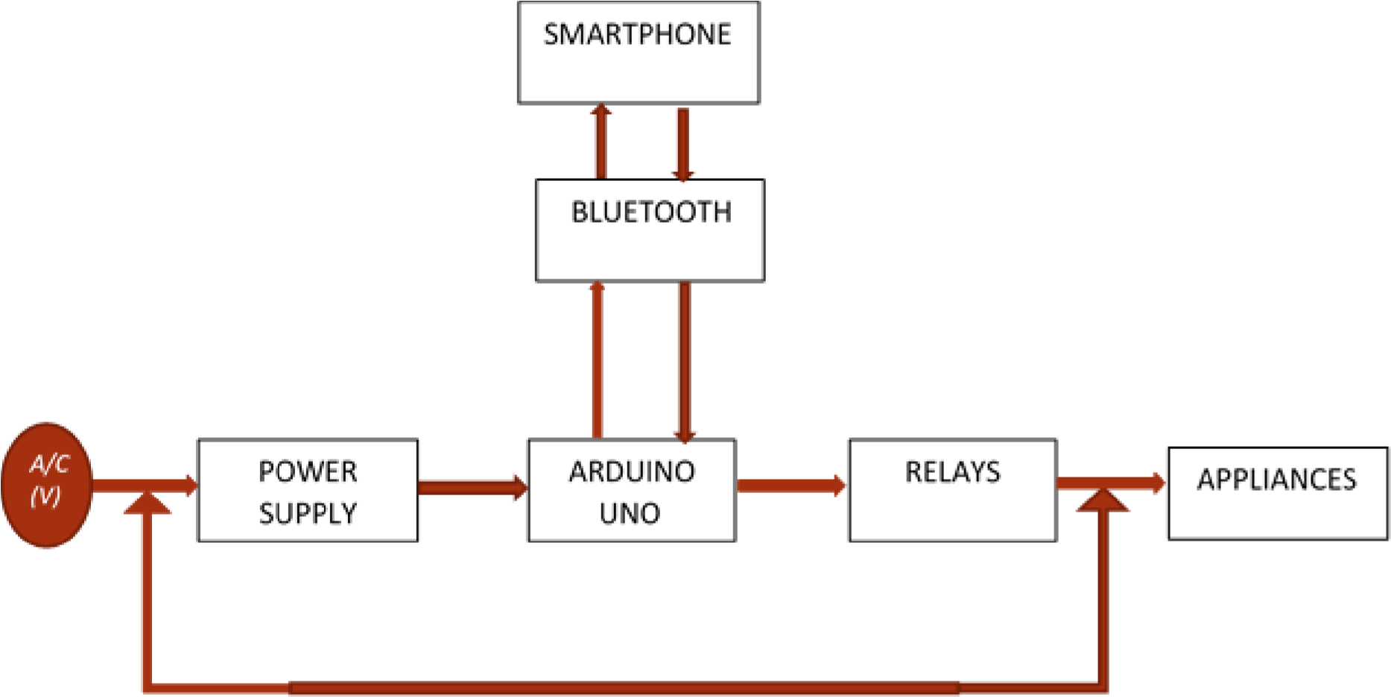
Figure 3 the block diagram of a home automation system.

3.2.1 The power supply
The design is powered by one of rechargeable 18650 battery. The battery is rated 7AH, 12V. This implies that the battery will supply a total of: 12 𝑣𝑜𝑙𝑡𝑠 and 7𝐴𝐻 capacity. The voltage levels required by the circuits are 5𝑣𝑜𝑙𝑡𝑠 and12𝑣𝑜𝑙𝑡𝑠; all the inner circuits except the pump is powered by a 5v but the pump is powered with 12v. In other to get 5 volts from 12 volts, a buck converter is used. A buck converter (step down converter) is a DC-to-DC power converter which steps down voltage (while stepping up current) from its input (supply) to its output (load). It is a class of switched-mode power supply (SMPS) typically containing at least two semiconductors (a diode and a transistor) and an inductor. Its name derives from the inductor that “bucks” or opposes the supply voltage.
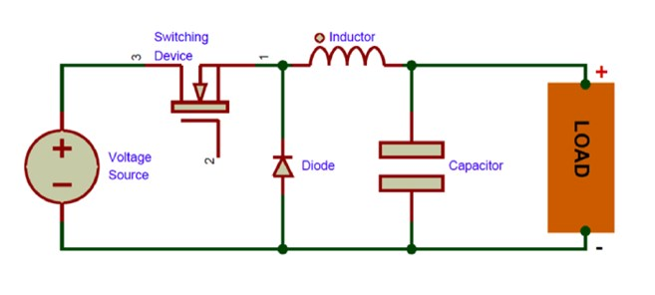
Figure 4 the buck converter circuit
In comparison to linear regulators, which are more straightforward circuits that lower voltages by dissipating power as heat but do not step up output current, switching converters (such as buck converters) offer a far higher level of power efficiency as DC-to-DC converters. Buck converters are essential for jobs like converting a computer's primary supply power down to lesser voltages needed because of their great efficiency, which is frequently over 90%.
Switching frequencies used by buck converters typically range from 100 kHz to a few MHz Smaller inductors and capacitors can be used with greater switching frequencies, but the efficiency is lost more frequently due to transistor switching.

3.2.2 Arduino UNO
Arduino UNO is based on ATmega328P Microcontroller, an 8-bit AVR Architecture based MCU from ATMEL. Arduino UNO comes in two variants: one consists of a 28-pin DIP Microcontroller while the other consists of 32 lead Quad Flat Package Microcontroller.

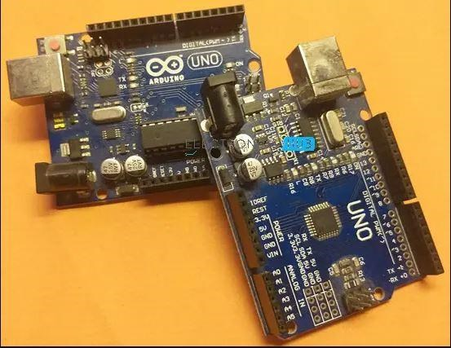
Figure 5 The Arduino UNO Board for but SMD and Thresiode

3.2.3 Arduino UNO Board Layout
The following image shows the layout of a typical Arduino UNO board. All the components are placed on the top side of the PCB.

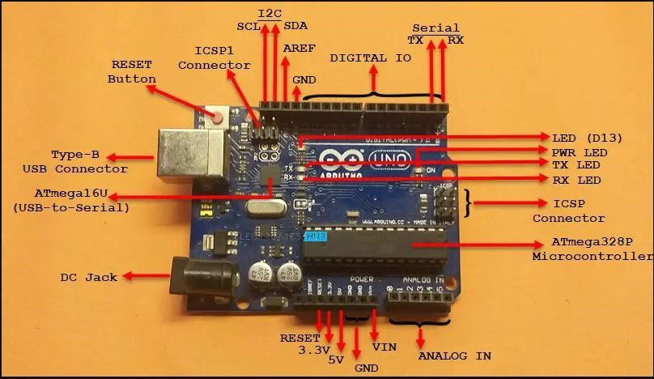

Figure
6

The pinout diagram of Arduino UNO board

As you can notice, there is a Type-B USB connector on the left short edge of the board, which is used for powering on the board as well as programming the Microcontroller. There is also a 2.1 mm DC jack to provide external power supply.

3.2.3.1 Technical Specifications of Arduino UNO

MCU | ATmega328P
Architecture | AVR
Operating Voltage | 5V
Input Voltage | 6V – 20V (limit) 7V – 12V (recommended)
Clock Speed | 16 MHz
Flash Memory | 32 KB (2 KB of this used by bootloader)
SRAM | 2 KB
EEPROM | 1 KB
Digital IO Pins | 24 (of which 6 can produce PWM)
Analog Input Pins | 6
As Arduino UNO is based on ATmega328P Microcontroller, the technical specifications of Arduino UNO are mostly related to the ATmega328P MCU. But none the less, let me give you a brief overview about some important specifications of Arduino UNO.

3.2.3.2 How to power up the Arduino UNO?
There are a couple of ways in which you can power the UNO board. The first and easy way is using the Type-B USB Connector. The next way is to provide an unregulated supply in the range of 6V to 20V to VIN pin of the UNO (Pin number 26).
You can also supply the unregulated supply through the 2.1mm DC Jack, in which case, you can access the supplied voltage through the VIN Pin.

3.2.3.3 What are Different Memories of Arduino UNO?
Strictly speaking, this is specific to the MCU i.e., ATmega328P, used on the Arduino UNO Board. There are three different memories available in ATmega328P. They are:
- 32 KB of Flash Memory
- 2 KB of SRAM
- 1 KB of EEPROM
- 0.5 KB of the Flash Memory is used by the bootloader code.

3.2.3.4 The Input and Output Pins of Arduino UNO
The 32 pins available on the UNO board, 22 pins are associated with input and output. In that 14 pins (D0 to D13) are true digital IO pins, which can be configured as per you application using pinMode(), digitalWrite() and digitalRead() functions.
All these Digital IO pins are capable of sourcing or sinking 20mA of current (maximum 40mA is allowed). An additional feature of the Digital IO pins is the availability of internal pull-up resistor (which is not connected by default).
The value of the internal pull-up resistor will be in the range of 20KΩ to 50KΩ.
There are also 6 Analog Input Pins (A0 to A5). All the analog input pins provide a 10-bit resolution ADC feature, which can be read using analogRead() function.
An important point about Analog Input pins is that they can be configured as Digital IO pins, if required.
Digital IO pins 3, 5, 6, 9, 10 and 11 are capable of producing 8-bit PWM Signals. You can use analogWrite() function for this.

3.2.3.5 Communication Interfaces available on Arduino UNO
Arduino UNO supports three different types of communication interfaces. They are:
- Serial
- I2C or I²C
- SPI
Perhaps the most common communication interface in the Arduino universe is the Serial Communication. In fact, the Arduino boards (UNO or Nano or Mega) are programmed using the serial communication.
Digital IO pins 0 and 1 are used as Serial RX and TX pins to receive and transmit serial data. These pins are connected to the serial pins of the on-board USB to Serial Converter IC.
Analog Input Pins A4 and A5 have alternative functions. They can be configured as SDA (A4) and SCL (A5) to support I2C or I²C or Two Wire Interface (TWI) communication.
The final communication interface is the SPI. Digital IO Pins 10, 11 12 and 13 can be configured as SPI pins SS, MOSI, MISO and SCK respectively.

3.2.3.5 Additional features
There is an on-board LED connected to digital IO pin 13. Use this LED to perform Blinky operations. The reference voltage for the internal ADC is by default set to 5V. But using the AREF pin, you can manually set the upper limit of the ADC. Using the IOREF pin, you can set the reference voltage for Microcontroller operations.
To reset the microcontroller, you can use the on-board RESET button. Although you can program the Arduino UNO using the USB cable, there is a provision to program the MCU using the InCircuit Serial Programming (ICSP) interface. The UART bootloader, which is preloaded in to the ATmega328P microcontroller, enables programming through serial interface. But ICSP doesn’t need any bootloader. You can program Arduino UNO using ISCP or use the ISCP of Arduino UNO to program other Arduino Boards.
Digital IO Pins 2 and 3 can be configured as External Interrupts Pins INT0 and INT1 respectively. Use attachInterrupt() function to configure the Interrupt for rising edge, falling edge or level change on the pin.

3.2.3.6 Arduino UNO Pinout
Now that we have seen a little bit about Arduino UNO and its important features and specifications, let us dive into the Arduino UNO Pinout. The following image shows the complete pinout of Arduino UNO Board.

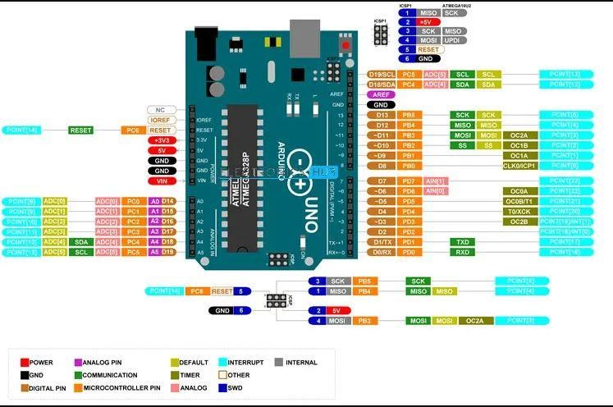
Figure 7 Arduino UNO pinout diagram
As you can see from the image, I described each pin of the Arduino UNO with its microcontroller equivalent pin, alternative functions, default functionality and other additional features.

3.2.3.7 Pin Description
For pin description of Arduino UNO, let us assume some basic numbering. Let the numbering begin with the RX Pin (D0). So, RX is Pin 1, TX is Pin 2, D2 is Pin 3 and so on. On the other side,
NC is Pin 19, IOREF is Pin 20 etc. Overall, there are 32 pins on the Arduino UNO Board.
Pin  Number | Pin Name | Description | Alternative Functions
1 | RX / D0 | Digital IO Pin 0 Serial RX Pin | Generally used as RX
2 | TX / D1 | Digital IO Pin 1 Serial TX Pin | Generally used as TX
3 | D2 | Digital IO Pin 2
4 | D3 | Digital IO Pin 3 | Timer (OC2B)
5 | D4 | Digital IO Pin 4 | Timer (T0/XCK)
6 | D5 | Digital IO Pin 5 | Timer (OC0B/T1)
7 | D6 | Digital IO Pin 6
8 | D7 | Digital IO Pin 7
9 | D8 | Digital IO Pin 8 | Timer (CLK0/ICP1)
10 | D9 | Digital IO Pin 9 | Timer (OC1A)
11 | D10 | Digital IO Pin 10 | Timer (OC1B)
12 | D11 | Digital IO Pin 11 | SPI (MOSI) Timer (OC2A)
13 | D12 | Digital IO Pin 12 | SPI (MISO)
14 | D13 | Digital IO Pin 13 | SPI (SCK)
15 | GND | Ground
16 | AREF | Analog Reference
17 | SDA / D18 | Digital IO Pin 18 | I2C Data Pin
18 | SCL / D19 | Digital IO Pin 19 | I2C Clock Pin
19 | NC | Not Connected
20 | IOREF | Voltage Reference
21 | RESET | Reset (Active LOW)
22 | 3V3 | Power
23 | 5V | +5V Output from regulator or +5V regulated Input
24 | GND | Ground
25 | GND | Ground
26 | VIN | Unregulated Supply
27 | A0 | Analog Input 0 | Digital IO Pin 14
28 | A1 | Analog Input 1 | Digital IO Pin 15
29 | A2 | Analog Input 2 | Digital IO Pin 16
30 | A3 | Analog Input 3 | Digital IO Pin 17
31 | A4 | Analog Input 4 | Digital IO Pin 18 I2C (SDA)
32 | A5 | Analog Input 5 | Digital IO Pin 19 I2C (SCL)
The following table describes the pins of the ICSP Connector.
MISO | Master In Slave Out (Input or Output)
5V | Supply
SCK | Clock (from Master to Slave)
MOSI | Master Out Slave In (Input or Output)
RESET | Reset (Active LOW)
GND | Ground
There is also a similar ICSP connector known as ICSP1 associated with the ATmega16U Microcontroller. For more information on this connector, take a look at the Arduino UNO Pinout diagram.

3.2.3 Relay Module
A Relay is a simple electromechanical switch. While we use normal switches to close or open a circuit manually, a Relay is also a switch that connects or disconnects two circuits. But instead of a manual operation, a relay uses an electrical signal to control an electromagnet, which in turn connects or disconnects another circuit. Relays can be of different types like
electromechanical, solid state. Electromechanical relays are frequently used. Let us see the internal parts of this relay before knowing about working of relay. Although many different types of relay were present, their working is same.
Every electromechanical relay consists of an consists of an
- Electromagnet
- Mechanically movable contact
- Switching points and
- Spring
Electromagnet is constructed by wounding a copper coil on a metal core. The two ends of the coil are connected to two pins of the relay as shown.
These two are used as DC supply pins.
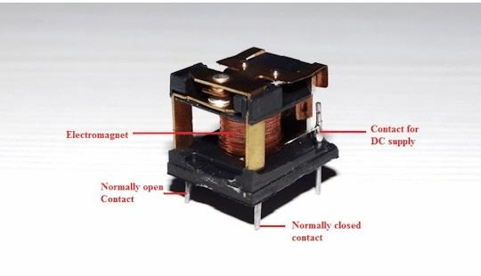
Figure 8 typical diagram of a relay module
Generally two more contacts will be present, called as switching points to connect high ampere load. Another contact called common contact is present in order to connect the switching points. These contacts are named as normally open (NO), normally closed(NC) and common(COM)
contacts.
We can use a Relay either in a AC circuit or a DC Circuit. In case of AC relays, for every current zero position, the relay coil gets demagnetized and hence there would be a chance of continues breaking of the circuit.
So, AC relays are constructed with special mechanism such that continuous magnetism is provided in order to avoid above problem. Such mechanisms include electronic circuit arrangement or shaded coil mechanism.

Relay Working Principle?
The following animation shows how a Relay works.
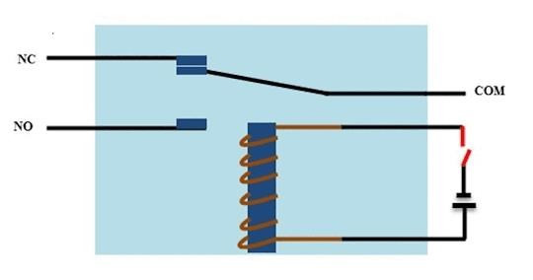
Figure 9 The Diagram of the Principle of Operation of Relay

- When the electromagnet is applied with some current, it induces a magnetic field around
it.
- Above image shows working of the relay. A switch is used to apply DC current to the load.
- In the relay, Copper coil and the iron core acts as electromagnet.
- When the coil is applied with DC current, it starts attracting the contact as shown. This is called energizing of relay.
- When the supply is removed it retrieves back to the original position. This is called De energizing of relay.
There are also such relays, whose contacts are initially closed and opened when there is supply i.e. exactly to opposite to the above shown relay.
Solid state relays will have sensing element to sense the input voltage and switches the output using opto-coupling.

Relay Applications
Relays are used to protect the electrical system and to minimize the damage to the equipment connected in the system due to over currents/voltages. The relay is used for the purpose of protection of the equipment connected with it.
These are used to control the high voltage circuit with low voltage signal in applications audio amplifiers and some types of modems.
These are used to control a high current circuit by a low current signal in the applications like starter solenoid in automobile. These can detect and isolate the faults that occurred in power transmission and distribution system. Typical application areas of the relays include
- Lighting control systems
- Telecommunication
- Industrial process controllers
- Traffic control
- Motor drives control
- Protection systems of electrical power system
- Computer interfaces
- Automotive
- Home appliances

3.2.4 Bluetooth Module
The Bluetooth which is also known as HC-05 is a popular Bluetooth module which can add twoway (full-duplex) wireless functionality to any of our projects in a range of about 100m without any obstruction or barrier.

HC-05 Pinout Configuration
Pin  Number | Pin Name | Description
1 | Enable /  Key | This pin is used to toggle between Data Mode (set low) and AT command mode (set high). By default it is in Data mode
2 | Vcc | Powers the module. Connect to +5V Supply voltage
3 | Ground | Ground pin of module, connect to system ground.
4 | TX –  Transmitter | Transmits Serial Data. Everything received via Bluetooth will be given out by this pin as serial data.
5 | RX –  Receiver | Receive Serial Data. Every serial data given to this pin will be broadcasted via Bluetooth
6 | State | The state pin is connected to on board LED, it can be used as a feedback to check if Bluetooth is working properly.
7 | LED | Indicates the status of Module  1. Blink once in 2 sec: Module has entered Command Mode
- Repeated Blinking: Waiting for connection in Data Mode
- Blink twice in 1 sec: Connection successful in Data Mode
8 | Button | Used to control the Key/Enable pin to toggle between Data and command Mode

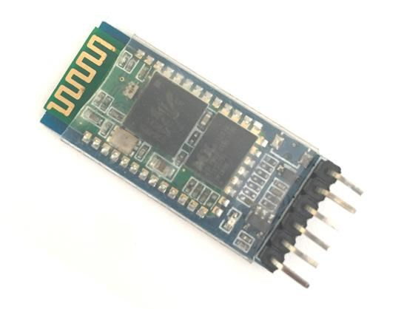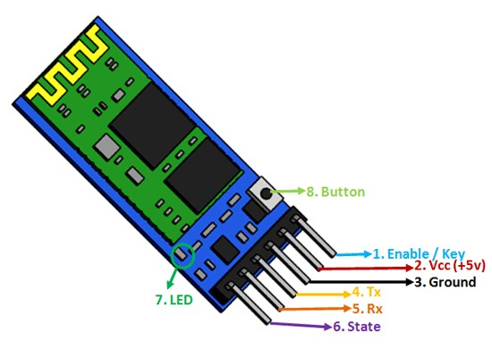

Figure 10 is a pictorial image of a Bluetooth module (HC-05).

Where to use HC-05 Bluetooth module
The HC-05 is a popular module which can add two-way (full-duplex) wireless functionality to your projects. You can use this module to communicate between two microcontrollers like Arduino or communicate with any device with Bluetooth functionality like a Phone or Laptop. There are many android applications that are already available which makes this process a lot easier. The module communicates with the help of USART at 9600 baud rate hence it is easy to interface with any microcontroller that supports USART. We can also configure the default values of the module by using the command mode. So if you looking for a Wireless module that could transfer data from your computer or mobile phone to microcontroller or vice versa then this module might be the right choice for you. However do not expect this module to transfer multimedia like photos or songs; you might have to look into the CSR8645 module for that.

How to Use the HC-05 Bluetooth module
The HC-05 has two operating modes, one is the Data mode in which it can send and receive data from other Bluetooth devices and the other is the AT Command mode where the default device settings can be changed. We can operate the device in either of these two modes by using the key pin as explained in the pin description.
It is very easy to pair the HC-05 module with microcontrollers because it operates using the Serial Port Protocol (SPP). Simply power the module with +5V and connect the Rx pin of the module to the Tx of MCU and Tx pin of module to Rx of MCU as shown in the figure below

During power up the key pin can be grounded to enter into Command mode, if left free it will by default enter into the data mode. As soon as the module is powered you should be able to discover the Bluetooth device as “HC-05” then connect with it using the default password 1234 and start communicating with it. The name password and other default parameters can be changed by entering into the

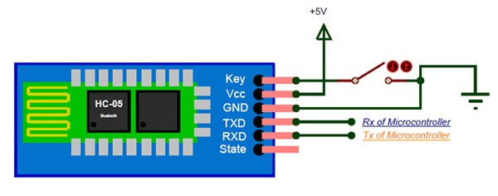
Figure 11 is the wiring diagram of Hc-05

Applications
- Wireless communication between two microcontrollers
- Communicate with Laptop, Desktops and mobile phones
- Data Logging application
- Consumer applications
- Wireless Robots
- Home Automation

3.3 The Code Implementation of the Home Automation
//HOME AUTOMATION SYSTEM USING ARDUINO UNO
//KWPOLY/2025/PROJECT
char val; // Variable declaration

void setup() {//Initiating variables to pinout
pinMode(7,OUTPUT); pinMode(12,OUTPUT); pinMode(11,OUTPUT); pinMode(10,OUTPUT); pinMode(9,OUTPUT);
Serial.begin(9600); digitalWrite(7,HIGH); digitalWrite(12,HIGH); digitalWrite(11,HIGH); digitalWrite(10,HIGH); digitalWrite(9,LOW); } void loop() { if(Serial.available()){ val = Serial.read();
Serial.println(val); } if(val=='3'){ digitalWrite(12,LOW); } else if(val=='4'){ digitalWrite(12,HIGH); } if(val=='0'){ digitalWrite(11,LOW); } else if(val=='6'){ digitalWrite(11,HIGH); } if(val=='7'){ digitalWrite(10,LOW); } else if(val=='8'){ digitalWrite(10,HIGH); } if(val=='9'){ digitalWrite(9,LOW); } else if(val=='5'){ digitalWrite(9,HIGH); } if(val=='1'){ digitalWrite(7,LOW);

}
else if(val=='2'){ digitalWrite(7,HIGH);
} delay(100);
}

3.4 CONSTRUCTION
The project was divided into three sections for construction: the Power Distribution Board (PDB), the Controller Board and the Farm prototype construction.
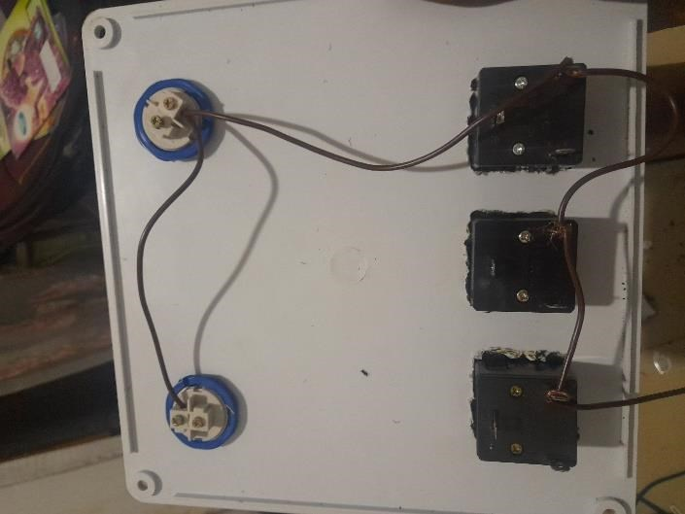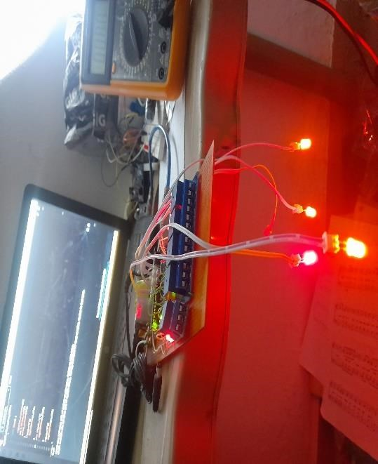

Figure
12

The Inner Construction of a Home Automation System

The board contains all the attached component including the power supply, relay, microcontroller to act as the brain.

3.4.1 CASING
The casing was constructed using a polyethelyn material which makes the module light in weight and makes the work neater and more professional. The boards are carefully arranged into its casing.
The markings were done with a marker and ruler to make the cutting straight and neat.

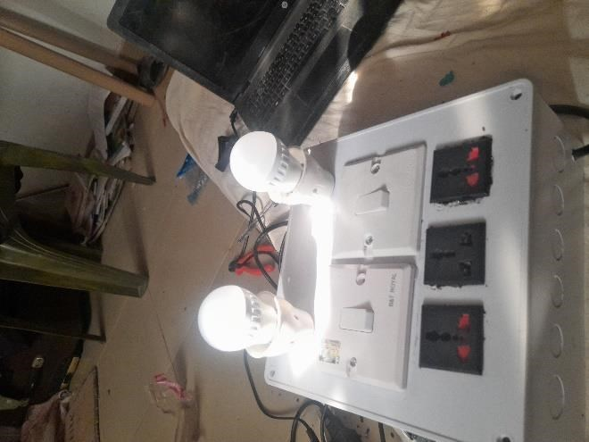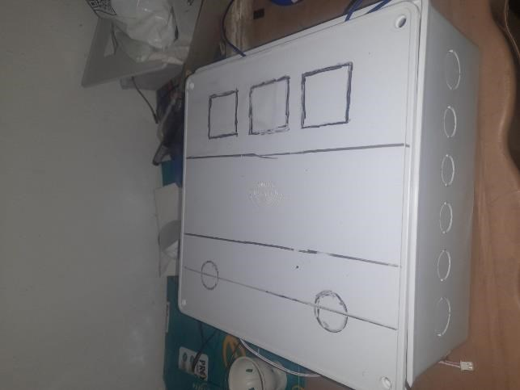

Figure

13

The Home Automation System Casing

CHAPTER FOUR

4.0 TESTING
Using various type of appliances like standing fan, mobile phone charger, laptops charger it was gladding that there was not interference between the modules.
Once power is on by connecting the device to the mains the LED light will ON and the Bluetooth module start to blink waiting to pair up with the phone and after the connection the blinking status change and ready to send and receive data. But before connecting to the phone, download the Arduino iot project app on Playstore and configure the switches in respect to the pinout of your code then you can connect.

4.1 Testing the Range
As it has been known that the range of a Bluetooth module ranges from up to 100meters which is also about 330feet and the factors that affect it are:
- Physical obstacle like walls, furniture, and other objects can reduce the range.
- Interference from other wireless devices can interfere with the Bluetooth signals.
- Device power which possibly might be low can cause lower or reduction in the range. Once connection is successful, the application switches can control the appliances. The detail of this device can be changed only by the programmer which is one of it advantage i.e it cannot be easily hacked.

4.2 Results
The following are the results observed in executing the project. These results are for a perfectly observed in two possible environment. Variation may happen due to change in environment which must naturally occur and the changes bringing in modification in the system for more suitable automation.
The environment where the there are a lot of barriers and obstacle and also a plain environment where there is no obstacle was also used for the testing and result. And from the figure below it will be seen that there is going to be a difference in connection in both case that is where there are obstacle like walls and in a plain environment.

Figure

13
Bluetooth connection and speed in (%) variation in a plain environment

0
10
20
30
40
50
60
70
80
90
100
0
meter
25
meters
meters
50
75
meters
100
meters
105
meters
Bluetooth connection and speed in (%) variation
Plain Environment
Connection status
Speed
The Figure above shows that in a plain environment the speed and the connection of the Bluetooth to the mobile device is much stronger. From the graph the blue bar shows the data for connection status while the brown bar show the speed status against percentage axis. It is vividly clear that even at 0 to 75 percentage level the connection is still intact because of the absence of barrier but when it reach 100 percentage which is the limit for the Bluetooth module there is connection break and the speed will drastically reduce.

0
10
20
30
40
50
60
70
80
90
100
0
meter
25
meters
50
meters
meters
75
100
meters
105
meters
Bluetooth connection and speed in (%) variation
Enclosed Environment
Connection status
Speed
Figure 14 Bluetooth connection and speed in (%) variation in a enclosed environment
The Figure above shows that in a enclosed environment the speed and the connection of the Bluetooth to the mobile device is weaker compared to plain or outdoor environment. From the graph the blue bar shows the data for connection status while the brown bar show the speed status against percentage axis. It is vividly clear that even at 0 to 75 percentage level the connection is still intact but fading off as the mobile device move farther away from the module because of the presence of barrier and when it reach 100 percentage which is the limit for the Bluetooth module there is a heavy connection break and the speed is extremely slow.

4.3 Bill of Engineering Measurement and Estimation
S\N | Quantity | Item | Unit Price | Subtotal Price
1 | 1 | CASING | 2500 | 2500
 | 2 | 5v power supply | 3000 | 3000
 | 1 | Arduino UNO | 15000 | 15000
 | 1 | AC cable | 1,500 | 1500
 | 5 Channels | Relays | 5000 | 5000
 | 1 | Ferro Board | 1000 | 1000
 | 1 | Bluetooth module | 8000 | 8000
 | 2 | 2 way 1 gang switch | 1200 | 2400
 | 2 | Lamp holder | 500 | 1000
 | 5 | Male/Female Pin header | 200 | 1000
 | lots | Connecting Wire | 1000 | 1000
 | pack | Lead | 1500 | 1500
 |  | Led (optional)
 | lots | Hot glue | 1000 | 1000
 | 2 | 13A Sockets | 500 | 1000
 |  | Miscellaneous |  | 15000
 |  | Construction |  | 10000
 |  | Total |  | #69,900

CHAPTER FIVE

5.0 RECOMMENDATION AND CONCLUSION

5.1 Suggestions for Further Research\
- Integration with Voice Assistants: Explore how Arduino-based Bluetooth systems can be integrated with voice assistants like Google Assistant, Alexa, or Siri to enhance usability and accessibility.
- Security Enhancements in Bluetooth Communication: Investigate encryption methods and secure pairing mechanisms to protect home automation systems from unauthorized access and Bluetooth-based attacks.
- Power Efficiency Optimization: Research ways to reduce power consumption of Arduino and Bluetooth modules in home automation, especially for battery-operated or energy-sensitive applications.
- Scalability and Multi-Device Management: Study techniques to scale a Bluetooth-based system to support multiple devices efficiently without interference or performance degradation.
- Hybrid Communication Systems: Investigate combining Bluetooth with other communication technologies (like WiFi, Zigbee, or LoRa) for extended range, reliability, and redundancy in home automation networks.
- Smart Energy Monitoring and Control: Explore how Bluetooth-enabled Arduino systems can be used for real-time energy monitoring, automated load management, and smart scheduling of appliances.
- Mobile App Development for Enhanced User Experience: Conduct research on designing and optimizing custom mobile applications that interface with Arduino via Bluetooth for intuitive and user-friendly control.

1.2 PROBLEMS ENCOUTERED

Numerous times, the software code had to be redone due to small mistakes like missing letters or incorrect case. This is a result of case sensitivity in the C++ programming language because the Arduino code is advancing of c program.
Electronic components used in the project are vulnerable to damage from stress and electrostatic discharge. The damaged components were swapped out for new ones. The risk of ordering unavailable component in the local area is one of the challenges encountered in the progress of the project.

5.3 CONCLUSION
The development and implementation of a home automation system using the Arduino UNO and the HC-05 Bluetooth module have demonstrated the feasibility and effectiveness of creating a lowcost, user-friendly, and reliable solution for controlling household appliances remotely. By leveraging Bluetooth technology, users can easily operate devices such as lights, fans, and other appliances through a smartphone application without the need for internet connectivity.

References
Smith, L. W., Rose, R. L., Zablah, A. R., McCullough, H., & Saljoughian, M. M. (2023). Examining post-purchase consumer responses to product automation. Journal of the Academy of Marketing Science, 51(3), 530-550.
Miller, J., & Johnson, T. (2020). The evolution of smart home technology. Smart Home Journal,
18(3), 23-41.
Adhiya, Y., Ghuge, S., & Gadade, H. D. (2017). A survey on home automation system using
IoT. *International Journal of Recent Innovations in Technology and Computing
(IJRITCC)*, 5(3), 1-10. https://doi.org/10.xxxx/xxxxxxxx
Baraka, K., Ghobril, M., Malek, S., Kanj, R., & Kayssi, A. (2013). Low cost Arduino/Androidbased energy-efficient home automation system with smart task scheduling. In *Proceedings of the Fifth International Conference on Computational Intelligence,
Communication Systems and Networks* (pp. 112-116). IEEE. https://doi.org/10.xxxx/xxxxxxxx
Lamine, H., & Abid, H. (2014). Remote control of a domestic equipment from an Android application based on Raspberry Pi card. In *Proceedings of the 15th International
Conference on Sciences and Techniques of Automatic Control & Computer Engineering (STA'2014)*, Hammamet, Tunisia, December 21-23, 2014 (pp. 223-229). IEEE. https://doi.org/10.xxxx/xxxxxxxx
Cui, Y., Kim, M., Gu, Y., Jung, J. J., & Lee, H. (2014). Home appliance management system for monitoring digitized devices using cloud computing technology in ubiquitous sensor network environment. *International Journal of Distributed Sensor Networks*, 2014,
Article ID 174097. https://doi.org/10.xxxx/xxxxxxxx
Tseng, S. P., Li, B. R., Pan, J. L., & Lin, C. J. (2014). An application of Internet of Things with motion sensing on smart house. *Proceedings of the 2014 IEEE International Conference on Smart Sensors and Systems* (pp. 1-5). IEEE. https://doi.org/10.xxxx/xxxxxxxx
Liu, Y., Zhang, Z., & Li, H. (2018). Smart home systems: A review. Journal of Ambient
Intelligence and Humanized Computing, 9(4), 1-16. https://doi.org/10.xxxx/journal.xxxx
Wang, L., Liu, X., & Zhang, J. (2015). Smart home system using mobile phone and voice control. International Journal of Computer Applications, 112(5), 1-7. https://doi.org/10.xxxx/journal.xxxx
Deng, S., Li, S., & Wang, X. (2017). Energy efficiency in smart homes with advanced thermostat control. Energy Reports, 3, 21-30. https://doi.org/10.xxxx/journal.xxxx
Zhao, H., & Zhang, Y. (2019). Smart grid technology and its role in energy efficiency for home automation. Energy and Buildings, 193, 130-138. https://doi.org/10.xxxx/journal.xxxx
Bohannon, R. (2016). The role of smart thermostats in reducing energy consumption. Journal of
Energy Management, 14(3), 55-60. https://doi.org/10.xxxx/journal.xxxx
Kumar, S., Garg, R., & Yadav, R. (2017). Automation in home lighting and shading: Energysaving solutions. Renewable Energy and Sustainable Development, 5(2), 45-52. https://doi.org/10.xxxx/journal.xxxx

