DESIGN AND DEVELOPMENT OF DEPARTMENTAL COURSE ALLOCATION

By:
FATAI SULIAT ADEWUMI
ND/23/COM/PT/0026

Submitted to the

DEPARTMENT OF COMPUTER SCIENCE,
INSTITUTE OF INFORMATION AND COMMUNICATION TECHNOLOGY (IICT), KWARA STATE POLYTECHNIC, ILORIN

IN PARTIAL FULFILMENT OF THE REQUIREMENTS FOR THE AWARD OF NATIONAL DIPLOMA (ND) IN
COMPUTER SCIENCE

JUNE, 2025

APPROVAL PAGE
This is to certify that this project was carried out by FATAI SULIAT ADEWUMI with Matric Number: ND/23/COM/PT/0026 has been read and approved by the Department of Computer Science, Kwara State Polytechnic Ilorin. In partial fulfillment of the requirements for the award of National Diploma (ND) in Computer Science.

___________________ __________________
Mr. Olajide, A.T
Project Supervisor Date

______________________ _________________
Mr. Oyedepo, F.S.
Head of Department Date

______________________ _________________
External Examiner Date

DEDICATION
This research project is dedicated to the Almighty God, the giver of life and taker of life that guide me throughout my program.

ACKNOWLEDGEMENTS
All Glory and adoration belong to him alone (God), Omniscience, and Omnipresent for his mercy over me throughout my undergraduate journey, which of your favour I will deny absolutely none.
First and foremost, I would like to express my deepest gratitude to my project supervisor, in person of Mr. Olajide, A.T. for his unwavering support, insightful advice, and constructive feedback throughout the development of this project.
Also, to my lovely parents Mr. and Mrs. Fatai, indeed I am speechless to thank you today, I pray to the Almighty Allah to grant you both all your heart desires. May you both live long to eat the fruit of your labour.
Also, to the school management (Kwara State Polytechnic, Ilorin) and entire Staff of Computer Science Department, starting from the Head of Department in person of Mr. Oyedepo, F.S, I appreciate you all.
To all my friend and family, I can’t be mention all of you, we shall all meet in the field of success.
Thank you all.

TABLE OF CONTENT
Title page i
Approval Page ii
Dedication iii
Acknowledgement iv
Table of Content v
Abstract viii
CHAPTER ONE: Introduction
1.1 Background to the Study 1
1.2 Statement of the Problem 4
1.3 Aim and Objectives 5
1.4 Scope of the Study 5
1.5 Limitation of the Study 6
1.6 Definition of Terms 7
1.7 Organization of the Project 8

CHAPTER TWO: LITERATURE REVIEW
2.1 Review of Related works 10
2.2. Review of Related Concepts 14
2.2.1 Overview of Educational Technology 15
2.2.2 User Interface UI Design 18
2.2.3 Overview of Departmental Course Allocation 19
2.2.3.1 Component Department Course Allocation using Gala-Sharpley Algorithm 21
2.2.3.2 Challenges and Considerations 22
2.2.4 Overview of Conflict Resolution on Allocation System 23
2.2.5 Real-Time System 23
CHAPTER THREE: Research Methodology
3.1 Description of Existing System 24
3.2 Problem of Existing System 25
3.3 Description of Proposed System 27
3.3.1 Advantages of then Proposed System 28
3.4 Feasibility Study 29
3.5 System Architecture 30
CHAPTER FOUR: System Design and Implementation
4.1 System Design 32
4.2 System Requirement 32
4.2.1 Hardware Requirement 32
4.2.2 Choice of Programming Language 33
4.3 Installation of the Application 35
4.3.1 Installing the Web Server 35
4.3.2 Using XAMPP 36
4.3.3 Setting up MySQL Database 37
4.3.4 Testing the Application 37
4.4 Implementation Interface 38
4.5 System Analysis/Flowchart 42
CHAPTER FIVE: SUMMARY, CONCLUSION

AND RECOMMENDATION
5.1 Summary 47
5.2 Conclusion 48
5.3 Recommendations 48
References

Abstract
This research work presents the design and implementation of a departmental course allocation system specifically for the Department of Computer Science, Kwara State Polytechnic, Ilorin. The existing manual method of allocating courses to lecturers has been identified as inefficient, error-prone, and time-consuming. These issues often lead to improper course assignments, duplication of responsibilities, and lack of transparency in the process. To address these challenges, a web-based system was developed using modern programming tools and techniques. The system allows administrative staff to register lecturers, manage departmental courses, and assign courses efficiently based on predefined criteria such as area of specialization and academic workload. Lecturers can also view their allocated courses through a personalized dashboard, thereby promoting transparency and reducing miscommunication. The system utilizes a relational database to store staff and course records securely, ensuring easy retrieval and update of information. The architecture of the system is modular, scalable, and user-friendly, which makes it adaptable to other departments and institutions with similar needs. The implementation of this system will not only enhance the operational efficiency of the department but also ensure a fair and structured distribution of academic responsibilities. The outcome of this project demonstrates that automation in administrative academic tasks can significantly improve accuracy, accountability, and decision-making in course management. Future extensions of the system may include integration with the university’s central academic portal and support for inter-departmental course sharing.

Keywords: Course Allocation, Web-Based System, Automation, Departmental Management, Kwara State Polytechnic, Lecturer Dashboard, Academic Planning.

CHAPTER ONE
INTRODUCTION
1.1 BACKGROUND TO THE STUDY
The efficient allocation of courses in educational institutions is a critical component for ensuring a smooth academic experience for students and faculty. At Newland Polytechnic, Ilorin, the current manual system for course allocation has become increasingly inadequate in meeting the needs of a growing student population and the administrative complexities that accompany it. This research aims to design and implement an automated Departmental Course Allocation System to address these challenges, enhancing the overall efficiency and accuracy of the process. The manual system of course allocation at Newland Polytechnic involves a series of steps that are not only time-consuming but also prone to errors. Administrators must manually assign students to courses, a process that can lead to mismatches, overbooking of classes, and a lack of timely updates. These inefficiencies not only burden the administrative staff but also cause significant inconvenience to students and faculty, potentially disrupting the academic schedule and reducing the quality of education delivered (Ochieng & Okeyo, 2018).
Automating the course allocation process can significantly alleviate these issues. According to Mbukusa et al., (2019), automated systems in educational institutions have been shown to enhance operational efficiency and reduce the administrative burden. By leveraging technology, Newland Polytechnic can streamline its course allocation process, ensuring that students are assigned to appropriate courses without delays or errors. This transition to an automated system aligns with the broader trend of digital transformation in education, where institutions are increasingly adopting information systems to manage their operations more effectively (Raza et al., 2020).
The proposed Departmental Course Allocation System will serve multiple stakeholders, including students, lecturers, and administrative staff. For students, the system will provide a user-friendly interface to register for courses, view their schedules, and receive real-time updates on their course allocations. Lecturers will benefit from a streamlined process for managing their course assignments, allowing them to focus more on teaching and less on administrative tasks. Administrative staff will gain a powerful tool to oversee the entire process, generate reports, and ensure that the allocation of courses aligns with institutional policies and constraints.
The design of the system is grounded in a thorough requirements analysis, ensuring that it meets the specific needs of Kwara State Polytechnic. This includes considerations for scalability, security, and usability. Scalability is essential to accommodate the growing number of students and courses over time. Security measures are crucial to protect sensitive student data and ensure the integrity of the course allocation process. Usability ensures that all users, regardless of their technical proficiency, can interact with the system effectively.
In developing this system, we draw upon best practices from existing automated course allocation systems implemented in other institutions. For instance, the system developed by the University of Nairobi demonstrated significant improvements in administrative efficiency and student satisfaction (Ochieng & Okeyo, 2018). Similarly, the course management system at the National University of Singapore has been praised for its robustness and ease of use (Tan & Tan, 2019). These case studies provide valuable insights into the design and implementation of an effective course allocation system.
The technological stack for the system includes a combination of front-end and back-end technologies. The front-end will be developed using HTML, CSS, and JavaScript to create a responsive and intuitive user interface. The back-end will be powered by Node.js and Express.js, providing a robust framework for handling business logic and database interactions. MySQL will serve as the database management system, ensuring efficient storage and retrieval of data. This technology stack is chosen for its reliability, scalability, and ease of integration.
Once implemented, the system will undergo rigorous testing to ensure its functionality and performance. This includes unit testing of individual components, integration testing to verify the interactions between different modules, and user acceptance testing (UAT) to gather feedback from actual users. The insights gained from these testing phases will be used to refine the system, addressing any issues and enhancing its overall effectiveness.
The deployment of the system will involve setting up the necessary infrastructure, installing the software, and conducting training sessions for users. This will ensure a smooth transition from the manual system to the automated system, minimizing any disruptions to the academic schedule. Continuous maintenance and updates will be provided to address any emerging issues and incorporate new features based on user feedback.
The design and implementation of an automated Departmental Course Allocation System at Kwara State Polytechnic, Ilorin, represents a significant step forward in modernizing the institution's administrative processes. By addressing the inefficiencies of the current manual system, this research aims to enhance the academic experience for students and faculty, reduce the administrative workload, and align Kwara State Polytechnic with contemporary trends in educational management systems. The insights and methodologies presented in this research can serve as a valuable reference for other institutions seeking to implement similar systems, contributing to the broader field of educational technology.
1.2 STATEMENT OF THE PROBLEM
The current manual system for course allocation at Kwara State Polytechnic Polytechnic, Ilorin, presents significant challenges including errors, delays, and inefficiencies, affecting both administrative staff and students. Manual processes are time-consuming and prone to human error, often resulting in overbooked classes, mismatched course assignments, and delayed updates, which disrupt the academic schedule and hinder effective resource management (Mbukusa et al., 2019). Additionally, the growing student population exacerbates these issues, further straining administrative capabilities and reducing overall institutional efficiency (Raza et al., 2020).
1.3 AIM AND OBJECTIVES OF THE STUDY
Aim
The aim of this research is to design and implement an automated Departmental Course Allocation System for Kwara State Polytechnic, Ilorin, to improve the efficiency, accuracy, and overall management of the course allocation process.
Objectives
- To Design a straightforward portal for lecturers to manage their course assignments.
- To Automate the course allocation process to reduce manual errors and administrative delays.
- To Develop a secure database to store and manage student, course, and lecturer information.
- To Design the system to be scalable to accommodate future growth in student numbers and course offerings.
1.4 SCOPE OF THE STUDY
The scope of this study encompasses the design, development, and implementation of an automated Departmental Course Allocation System specifically for Kwara State Polytechnic, Ilorin. This system will cater to multiple user groups, including students, lecturers, and administrative staff. For students, the system will facilitate course registration and provide real-time updates on course allocations. Lecturers will use the system to manage their course assignments and schedules efficiently. Administrative staff will oversee the entire process, utilizing the system for resource management, generating analytical reports, and ensuring compliance with institutional policies. The study will focus on creating a scalable and secure system, capable of handling an increasing number of users and courses over time. Additionally, it will include comprehensive training and support to ensure smooth adoption and effective utilization of the system by all stakeholders. The research will not cover integration with external systems or institutions outside Kwara State Polytechnic.
1.5 LIMITATION OF THE STUDY
The limitations of this study include several constraints that may impact the overall effectiveness and generalizability of the research findings. Firstly, the system is designed specifically for Newland Polytechnic, Ilorin, which means its applicability to other institutions with different administrative structures and requirements may be limited. Secondly, the research is constrained by time and resources, potentially affecting the depth of the requirements analysis and the comprehensiveness of the testing phases. Additionally, while the system aims to be scalable, unforeseen technical challenges may arise during implementation that could impact performance under heavy loads. The study also does not address integration with other existing systems or external databases, which may be necessary for a fully integrated institutional IT ecosystem. Finally, user adoption and training effectiveness depend heavily on user engagement and the provision of ongoing support, which may be limited by resource availability.
1.6 Definition of Terms
1. Course Allocation: The process of assigning students to specific courses based on their selections, availability, and pre-defined institutional rules and policies.
2. Automated System: A software application designed to perform tasks with minimal human intervention, enhancing efficiency and accuracy in operations.
3. Kwara State Polytechnic, Ilorin: The educational institution serving as the case study for this research, located in Ilorin, Nigeria, which offers various academic programs to its students.
4. Database Management System (DBMS): Software used to create, maintain, and manage databases, ensuring secure and efficient data storage and retrieval. MySQL is the DBMS used in this research.
5. Frontend: The part of the application that interacts directly with the users, designed using HTML, CSS, and JavaScript to provide a responsive and user-friendly interface.
6.Backend: The server-side part of the application that handles business logic, database interactions, and server configuration, implemented using Node.js and Express.js in this study.
7. User Interface (UI): The visual elements through which users interact with the system, including forms, buttons, and menus designed for ease of use and accessibility.
8. Agile Development: A methodology for software development characterized by iterative progress, collaboration, and flexibility in responding to changes during the project lifecycle.
9. Unit Testing: The process of testing individual components or modules of the software to ensure they function correctly in isolation.
10. Integration Testing: Testing combined parts of the application to ensure that different modules interact correctly and the system operates as intended.
1.7 ORGANIZATION OF THE PROJECT
This researched Work is divided into Five Chapter as follows: -
CHAPTER ONE: Introduction
This chapter will discuss on Background of the study, Statement of the problem Aim and Objectives of the study, Methodology, Scope of the Study, Limitation of the Study, Operational Definition of terms and Organization of the project. All this outlining the detailed objectives to achieve the main goals of this research work.

CHAPTER TWO: Literature Review
This chapter will focus on the past researched (Review of related literature), Overview of Design and Development of Course Allocation Management System
CHAPTER THREE: Research Methodology
This stage will evaluate the Description of Existing System, Problem of Traditional System, and Description of proposed system and Architectural Design of proposed system
CHAPTER FOUR: Design and Implementation of the System
This chapter will emphasize on Overall Design of the research work (Design and Development of Course Allocation Management System)
CHAPTER FIVE: Summary, Conclusion, Future Research, References
This breakdown will provide a clear structure for this research work, each chapter will focus and contributes to the overall understanding of Design and Development of Course Management System.

CHAPTER TWO
LITERATURE REVIEW
2.1 REVIEW OF RELATED WORKS
The implementation of automated course allocation systems in educational institutions has garnered significant attention in academic literature due to its potential to streamline administrative processes, enhance efficiency, and improve user satisfaction. This review examines various studies and existing systems to provide a comprehensive understanding of the current state of automated course allocation systems, their benefits, challenges, and the technological trends driving their adoption.
Mbukusa et al., (2019) explored the adoption of automated systems in higher education institutions in Namibia. Their study highlighted the inefficiencies of manual systems, including delays, errors, and increased administrative workload. They found that automated systems significantly improved operational efficiency by reducing the time and effort required for course allocation. The researchers emphasized the importance of user-friendly interfaces and robust database management to handle the complexities of course allocation, such as conflicting schedules and capacity constraints.
Similarly, Raza et al., (2020) examined the impact of information systems on administrative processes in Pakistani universities. They found that automated systems not only streamlined course allocation but also enhanced data accuracy and availability. Their research underscored the need for secure systems to protect sensitive student data and ensure compliance with institutional policies. The study also highlighted the challenges of integrating new systems with existing infrastructure and the necessity of proper training for users to maximize the benefits of automation.
A case study by Ochieng and Okeyo (2018) at the University of Nairobi demonstrated the practical benefits of implementing an automated course allocation system. The system developed for the university significantly reduced the time required for course registration and allocation, minimized errors, and improved overall student satisfaction. The researchers noted that the success of such systems depends heavily on thorough requirements analysis and iterative testing to address the unique needs of the institution. They also pointed out the importance of scalability, as the system must accommodate an increasing number of students and courses over time.
Tan and Tan (2019) provided insights into the development of a course management system at the National University of Singapore. Their system incorporated advanced features such as real-time updates, conflict resolution, and analytical reporting. The researchers found that these features significantly enhanced the user experience and administrative efficiency. They also discussed the technical challenges associated with developing such systems, including ensuring high availability, handling large volumes of data, and maintaining system security. Their work highlighted the importance of using modern web technologies and agile development practices to build robust and flexible systems.
In another study, Goyal and Verma (2018) analyzed the implementation of an automated course allocation system in Indian universities. They focused on the algorithmic aspects of course allocation, proposing optimization techniques to ensure fair and efficient distribution of courses. Their research demonstrated that algorithmic approaches could effectively manage constraints such as course capacities, student preferences, and scheduling conflicts. The study also emphasized the need for user-friendly interfaces to facilitate easy interaction with the system for both students and administrators.
The literature also explores the broader implications of adopting automated systems in educational settings. For instance, Al-Mukhaini et al. (2014) discussed the impact of information and communication technologies (ICT) on higher education in Oman. They found that ICT adoption, including automated course allocation systems, positively influenced teaching and administrative practices. The study highlighted the need for strategic planning and investment in technology infrastructure to support such initiatives. They also noted that cultural and organizational factors play a significant role in the successful implementation of new technologies.
Despite the evident benefits, several studies have highlighted the challenges associated with the implementation of automated course allocation systems. Al-Zubaidi and Ahmad (2015) identified common barriers, including resistance to change, lack of technical expertise, and limited financial resources. They stressed the importance of stakeholder involvement and continuous training to address these challenges. Their research suggested that institutions should adopt a phased approach to implementation, starting with pilot projects to demonstrate the system's benefits before full-scale deployment.
Kumar and Gupta (2017) examined the role of user feedback in the development of automated systems. Their study emphasized the importance of iterative design and testing, incorporating feedback from students, lecturers, and administrators to refine system features and functionality. They found that systems developed with active user involvement were more likely to meet user needs and achieve higher levels of adoption and satisfaction. In the context of Newland Polytechnic, Ilorin, the current study aims to design and implement a customized automated course allocation system that addresses the specific challenges faced by the institution. Drawing on the insights from the reviewed literature, the system will prioritize user-friendliness, scalability, and security. The requirements analysis phase will involve extensive consultations with stakeholders to understand their needs and preferences. The system will be developed using modern web technologies, with a robust backend powered by Node.js and Express.js and a responsive frontend built with HTML, CSS, and JavaScript.
The database will be managed using MySQL, ensuring efficient data storage and retrieval. The system will incorporate features such as real-time updates, conflict resolution, and analytical reporting to enhance the user experience and administrative efficiency. To address the challenges of user adoption, the study will include comprehensive training sessions and the provision of user manuals and technical support. Testing will be conducted at multiple levels, including unit testing, integration testing, and user acceptance testing, to ensure the system meets its functional and non-functional requirements. The iterative development process will allow for continuous refinement based on user feedback and emerging needs.
The review of related work highlights the significant potential of automated course allocation systems to improve administrative efficiency and user satisfaction in educational institutions. However, successful implementation requires careful planning, robust technology infrastructure, and active stakeholder involvement. The insights gained from previous studies will inform the design and implementation of the proposed system at Newland Polytechnic, ensuring it addresses the institution's unique challenges and contributes to its strategic goals of enhancing academic and administrative processes. This research will add to the growing body of knowledge on the benefits and challenges of automated systems in higher education, providing a valuable reference for other institutions considering similar initiatives.
2.2 REVIEW OF RELATED CONCEPTS
The development and implementation of an automated course allocation system involve several related concepts that provide the theoretical and practical foundation for the project. These concepts include educational technology, database management, user interface design, system security, and agile development methodologies.
2.2.1 Overview on Educational Technology
Educational Technology (EdTech) represents a dynamic field that leverages technological tools and resources to enhance teaching, learning, and administrative processes within educational settings. The integration of EdTech solutions aims to improve educational outcomes, increase accessibility, and streamline administrative tasks across various educational institutions worldwide.
One of the primary goals of EdTech is to transform traditional educational practices by incorporating innovative technologies that engage students and cater to diverse learning styles. Interactive multimedia tools, virtual reality (VR), augmented reality (AR), and simulations offer immersive learning experiences that stimulate curiosity and encourage active participation (Beetham & Sharpe, 2019). These technologies provide opportunities for personalized learning paths and enable educators to adapt instructional strategies based on individual student needs and preferences.
EdTech plays a crucial role in promoting accessibility and inclusivity by breaking down geographical and physical barriers to education. Online learning platforms, digital textbooks, and mobile applications facilitate learning anytime and anywhere, making education more accessible to students with disabilities, those in remote areas, and non-traditional learners (West, 2019). Furthermore, adaptive technologies and assistive tools support diverse learners by providing customized learning experiences and accommodations.
In addition to transforming teaching and learning, EdTech enhances administrative efficiency by automating routine tasks and improving data management processes. Automated course allocation systems, student information systems (SIS), learning management systems (LMS), and academic analytics platforms streamline administrative workflows, reduce paperwork, and enhance decision-making capabilities (Selwyn, 2016). These systems provide real-time access to student records, facilitate course scheduling, and generate insightful reports that inform strategic planning and resource allocation.
Transformative potential, EdTech implementation faces challenges, including the digital divide—the gap between those who have access to technology and those who do not. Socioeconomic disparities, inadequate infrastructure, and limited internet connectivity in rural and underserved communities hinder equal access to educational resources and opportunities (Warschauer, 2003). Bridging the digital divide requires targeted initiatives, partnerships, and policies that promote equitable access to technology and digital literacy skills development.
Effective integration of technology into educational practices necessitates strategic planning, professional development, and ongoing support for educators. Teachers must be equipped with the knowledge and skills to leverage EdTech tools effectively, design meaningful learning experiences, and address diverse learner needs (Ertmer & Ottenbreit-Leftwich, 2013). Professional development programs should emphasize pedagogical approaches that integrate technology authentically into the curriculum, rather than treating it as an add-on.
The use of EdTech tools raises significant concerns regarding data privacy, security, and ethical considerations. Educational institutions must safeguard sensitive student information, comply with data protection regulations (e.g., GDPR, COPPA), and implement robust security measures to mitigate risks of data breaches and cyber threats (Peters, 2019). Transparent policies, informed consent practices, and proactive measures to address privacy concerns are essential for maintaining trust and ensuring the responsible use of technology in education.
Assessing the impact and effectiveness of EdTech interventions requires rigorous evaluation and evidence-based practices. Educators, administrators, and policymakers should critically examine the outcomes of technology integration initiatives, considering both quantitative metrics (e.g., academic performance, engagement rates) and qualitative feedback from stakeholders (Means et al., 2017). Evidence-based decision-making ensures that EdTech investments align with educational goals, yield positive outcomes for students, and inform continuous improvement efforts.
Educational Technology represents a transformative force in modern education, offering opportunities to enhance teaching and learning, promote accessibility, and improve administrative efficiency. While challenges such as the digital divide, technology integration, privacy concerns, and evidence-based practices persist, strategic planning, professional development, and ethical considerations are essential for maximizing the potential of EdTech to support diverse learner needs and foster innovation in education.
2.2.2 User Interface UI Design
User Interface (UI) design is a critical aspect of software development that focuses on creating intuitive, visually appealing, and user-friendly interfaces for applications. UI design encompasses various principles, techniques, and considerations aimed at optimizing user interaction and experience (UX) across different platforms and devices.
Usability is fundamental to UI design, emphasizing the ease of use and navigation for users. Designers strive to create interfaces that are intuitive and require minimal learning curve. Key aspects of usability include clear and consistent layout, logical flow of information, and intuitive controls (Norman, 2013). Usability testing and user feedback are essential to identify usability issues and refine the interface design accordingly.
Visual hierarchy guides users' attention by prioritizing elements based on their importance and relationship within the interface. Techniques such as contrast, size, color, and typography help establish a clear hierarchy of information and actions. Important elements, such as primary navigation options or call-to-action buttons, are prominently displayed to facilitate user interaction (Lidwell et al., 2010).
Consistency in UI design ensures that elements, patterns, and interactions are uniform throughout the application. Consistent use of colors, fonts, icons, and terminology enhances predictability and reduces cognitive load for users. Design patterns, such as navigation menus and form layouts, should be standardized to provide familiarity and usability across different screens and functionalities (Tidwell, 2010).
Feedback mechanisms inform users about the outcome of their actions and the current state of the application. Visual feedback, such as animation, tooltips, and progress indicators, enhances user understanding and engagement. Responsiveness ensures that the interface reacts promptly to user inputs, providing real-time updates and minimizing perceived latency (Saffer, 2009).
Accessibility in UI design focuses on ensuring that interfaces are usable by individuals with diverse abilities and needs. Design considerations include providing alternative text for images, supporting keyboard navigation, and adhering to accessibility standards (e.g., WCAG). Accessible design not only improves usability for all users but also aligns with ethical and legal obligations to provide equal access to information and services (Lazar et al., 2017).
2.2.3 Overview of Departmental Course Allocation
System security is a critical aspect of information technology that encompasses policies, procedures, and technologies designed to protect computer systems, networks, and data from unauthorized access, misuse, modification, or destruction. Effective system security measures are essential to safeguarding sensitive information, ensuring business continuity, and mitigating risks associated with cyber threats and malicious activities.
Confidentiality ensures that sensitive information is accessible only to authorized individuals, processes, or systems. Encryption techniques, access controls, and data masking mechanisms are employed to prevent unauthorized disclosure of confidential data. By restricting access based on user roles and permissions, organizations protect proprietary information, customer data, and intellectual property from unauthorized disclosure (Stallings, 2017).
Integrity ensures the accuracy, consistency, and reliability of data throughout its lifecycle. Data integrity mechanisms, such as checksums, digital signatures, and version control, verify that data remains unchanged and has not been tampered with during storage, transmission, or processing. By detecting and mitigating data manipulation attempts, integrity controls maintain trustworthiness and reliability of information within organizational systems (Pfleeger & Pfleeger, 2015).
Availability ensures that authorized users have timely and uninterrupted access to information and resources. Redundancy, fault tolerance, and disaster recovery strategies are implemented to minimize downtime and ensure continuous operation of critical systems and services. By mitigating the impact of hardware failures, natural disasters, and cyber-attacks, availability measures support business continuity and maintain productivity (Whitman & Mattord, 2016).
2.2.3.1 Component Department Course Allocation using Gala-Sharpley Algorithm
1. Access Control: Access control mechanisms enforce policies and rules to regulate user access to systems and resources. Authentication verifies the identity of users and entities before granting access rights, using methods such as passwords, biometrics, and multi-factor authentication (MFA). Authorization determines the actions and privileges that authenticated users are permitted to perform based on their roles and permissions within the organization (Vacca, 2012).
2. Firewalls and Intrusion Detection/Prevention Systems (IDS/IPS): Firewalls monitor and filter network traffic to prevent unauthorized access and malicious activities. Intrusion Detection Systems (IDS) and Intrusion Prevention Systems (IPS) analyze network packets and system logs to detect suspicious behavior, anomalies, or known attack patterns. These systems alert administrators and automatically block or mitigate potential threats to network security, enhancing the resilience of organizational defenses (Chapple & Seidl, 2015).
3. Encryption: Encryption transforms plaintext data into ciphertext using cryptographic algorithms and keys to protect sensitive information from unauthorized disclosure. Transport Layer Security (TLS) and Secure Sockets Layer (SSL) protocols encrypt data transmitted over networks, ensuring confidentiality and integrity during communication. Disk encryption solutions encrypt data stored on devices and media to prevent unauthorized access in case of theft or loss (Schneier, 2015).
4. Security Audits and Monitoring: Regular security audits and monitoring activities assess the effectiveness of security controls, identify vulnerabilities, and detect potential security incidents. Security Information and Event Management (SIEM) tools aggregate and analyze security logs from various sources to correlate events, generate alerts, and facilitate incident response and forensic investigations (Bejtlich, 2013).
2.2.3.2 Challenges and Considerations
1. Cyber Threat Landscape: The evolving nature of cyber threats, including malware, ransomware, phishing attacks, and advanced persistent threats (APTs), poses significant challenges to system security. Organizations must adopt proactive security measures, threat intelligence sharing, and continuous monitoring to detect and mitigate emerging cyber threats effectively (Bertino & Sandhu, 2005).
2. Regulatory Compliance: Regulatory requirements and industry standards (e.g., GDPR, HIPAA, PCI DSS) mandate organizations to implement specific security controls and privacy safeguards to protect sensitive data and ensure compliance with legal obligations. Security frameworks and certification programs provide guidelines for implementing best practices and maintaining accountability in handling confidential information (Dhillon & Moores, 2001).
3. Human Factors: Human errors, insider threats, and social engineering tactics remain significant vulnerabilities in system security. User awareness training, security awareness programs, and strict enforcement of security policies help mitigate risks associated with negligent or malicious behaviors among employees and stakeholders (Mitnick & Simon, 2002).
2.2.4 Overview of Conflict Resolution on Course Allocation Management System
Conflict resolution is an essential feature of automated course allocation systems. It involves identifying and resolving conflicts that arise when multiple students or lecturers have overlapping schedules or when course capacities are exceeded. Effective conflict resolution strategies include prioritizing courses based on predefined criteria, offering alternative courses or sections, and allowing manual intervention by administrators. The goal is to minimize disruptions and ensure that as many students as possible can enroll in their desired courses while maintaining a balanced and feasible schedule (Woolf, 2009).
2.2.5 Real-Time Systems
Real-time systems provide immediate feedback and updates to users, ensuring that information is current and accurate. In the context of course allocation, real-time capabilities allow students to see up-to-date availability of courses, receive instant notifications about their registrations, and make timely decisions. Implementing real-time features requires efficient data handling and low-latency communication between the client and server. Technologies such as WebSockets and AJAX (Asynchronous JavaScript and XML) are commonly used to enable real-time interactions in web applications (Coulouris, Dollimore, & Kindberg, 2012).
CHAPTER THREE
RESEARCH METHOLOGY
3.1 DESCRIPTION OF EXISTING SYSTEM
The existing system in real-time computing comprises a network of interconnected devices and software designed to process and respond to external stimuli within precise time constraints. These systems are utilized across various industries, including aerospace, automotive, telecommunications, and healthcare, where timely and deterministic operation is critical. Components of the existing real-time system typically include:
- Hardware Platforms: Embedded systems and specialized processors optimized for real-time processing, such as microcontrollers, DSPs (Digital Signal Processors), and FPGAs (Field-Programmable Gate Arrays).
- Operating Systems: Real-time operating systems (RTOS) tailored for predictable and deterministic behavior, managing tasks, scheduling, and resource allocation with minimal overhead.
- Networking and Communication: High-speed networks and protocols enabling data exchange and synchronization between distributed real-time components, ensuring timely response and coordination.
- Software Applications: Customized software applications and algorithms designed for real-time processing, control, and monitoring of physical processes or systems.
- Monitoring and Control Interfaces: User interfaces and monitoring tools facilitating real-time data visualization, system diagnostics, and control actions by operators or automated systems.
The existing real-time systems are characterized by their robustness, reliability, and adherence to stringent timing requirements, enabling applications ranging from automated manufacturing processes and autonomous vehicles to critical infrastructure monitoring and medical equipment control. Ongoing advancements in hardware capabilities, software optimization, and networking technologies continue to enhance the performance and versatility of real-time systems in meeting evolving application demands.
3.2 PROBLEM OF EXISTING SYSTEM
The existing real-time systems, while highly specialized and essential in various industries, face several significant challenges that impact their reliability, performance, and adaptability to evolving technological needs. These challenges include:
1. Scalability Issues: Many existing real-time systems struggle with scalability, particularly as demands for processing power, data volume, and system complexity increase. Scaling real-time systems to accommodate growing workloads without compromising performance or introducing delays is a complex task, often requiring redesigns or upgrades that may disrupt existing operations.
2. Limited Flexibility: Real-time systems are typically designed with specific hardware, software configurations, and timing constraints tailored to their intended applications. This specialization limits their flexibility to adapt to changes in operational requirements, new functionalities, or integration with emerging technologies. Modifying or extending existing real-time systems can be costly and time-consuming, hindering innovation and responsiveness to market demands.
3. Security Vulnerabilities: The stringent timing requirements of real-time systems sometimes prioritize performance over security measures. This can leave systems vulnerable to cyber threats, malware attacks, and unauthorized access, especially as real-time applications become increasingly interconnected and exposed to external networks. Ensuring robust security measures without compromising real-time performance remains a significant challenge for system designers and operators.
4. Maintenance and Upkeep: Real-time systems often operate in mission-critical environments where downtime or system failures can have severe consequences. Ensuring continuous operation and reliability through regular maintenance, software updates, and hardware replacements is crucial but can be resource-intensive and disruptive to ongoing operations. Managing legacy systems and ensuring compatibility with newer technologies further complicates maintenance efforts.
5. Complex Integration: Integrating real-time systems with existing infrastructure, legacy systems, or third-party applications can be challenging due to compatibility issues, proprietary protocols, and differing operational requirements. Achieving seamless interoperability and data exchange between disparate systems while maintaining real-time performance poses technical and logistical hurdles.
These challenges require innovative solutions, such as advancements in hardware capabilities, development of standardized interfaces and protocols, adoption of cybersecurity best practices, and leveraging cloud computing and edge computing technologies. Overcoming these obstacles is essential to enhance the reliability, security, and adaptability of real-time systems, enabling them to meet evolving industry demands and regulatory requirements effectively.
3.3 DESCRIPTION OF PROPOSED SYSTEM
The proposed system represents a significant advancement in real-time computing, addressing critical limitations of existing systems through innovative design and technology integration. It emphasizes scalability, flexibility, and security, enabling dynamic allocation of resources and seamless integration with diverse hardware and software environments. Built-in security measures, including encryption and real-time threat detection, enhance data protection and system integrity. Maintenance and upgradability are streamlined with automated updates and remote diagnostics, minimizing downtime and optimizing operational efficiency.

3.3.1 Advantages of Proposed System
The proposed system offers several distinct advantages over existing real-time systems. Firstly, its scalable architecture allows for efficient resource allocation and dynamic adaptation to varying workloads, ensuring optimal performance without compromising on real-time responsiveness. This scalability is pivotal in accommodating growth and future technological advancements.
Flexibility is another key advantage, as the system supports configurable software components and standardized interfaces. This enables rapid customization and deployment of tailored solutions to meet specific application requirements and integrate seamlessly with diverse hardware platforms.
Enhanced security measures, including robust encryption protocols and real-time threat detection systems, provide comprehensive protection against cybersecurity threats and unauthorized access. Continuous monitoring and updates ensure the system remains resilient and secure.
The proposed system also prioritizes maintenance and upgradability, facilitating streamlined operations through automated software updates and remote diagnostics. This minimizes downtime, enhances reliability, and supports efficient lifecycle management.
Furthermore, its interoperability capabilities enable seamless integration with existing infrastructure and emerging technologies, promoting enhanced data exchange and operational efficiency. Cost-effectiveness is achieved through optimized resource utilization and strategic use of cloud-based services, maximizing return on investment and minimizing total cost of ownership.
In essence, the proposed system represents a significant advancement in real-time computing, offering robust performance, enhanced security, flexibility, and scalability to meet the evolving needs of modern industrial and mission-critical applications.
3.4 FEASIBILITY STUDY
The feasibility study for the proposed real-time system assesses its viability across technical, operational, and economic dimensions.
- Technical Feasibility: The proposed system leverages advanced technologies, such as scalable architectures, configurable software components, and standardized interfaces, which are readily available and well-supported. The integration of robust security measures and automated maintenance processes ensures that the system can meet high performance and reliability standards required for real-time applications.
- Operational Feasibility: Operationally, the system's flexibility and scalability facilitate seamless integration with existing infrastructure and adaptability to evolving requirements. Automated updates and remote diagnostics minimize downtime and simplify maintenance, enhancing operational efficiency. The system’s design aligns with the practical needs of industries that rely on real-time computing, ensuring smooth implementation and user adoption.
- Economic Feasibility: Economically, the system is cost-effective due to optimized resource utilization and strategic use of cloud-based services, reducing upfront and long-term costs. The investment in scalable and flexible components is balanced by the potential for significant savings through improved efficiency, reduced downtime, and enhanced security.
The proposed system is technically sound, operationally viable, and economically justified, making it a feasible solution for advancing real-time computing capabilities in various industrial and mission-critical applications.
3.5 SYSTEM ARCHITECTURE
The proposed system architecture for the real-time system at Kwara State Polytechnic, Ilorin, is designed to ensure robustness, scalability, and security. It integrates advanced hardware, software, and network components to facilitate efficient and reliable real-time processing. At its core, the architecture comprises embedded systems using microcontrollers and DSPs for optimized real-time processing, alongside sensors and actuators for data acquisition and control. These components connect through high-speed networking equipment, ensuring low-latency communication.
The system runs on a Real-Time Operating System (RTOS), which manages hardware resources and schedules tasks to meet strict timing constraints. Middleware components facilitate communication and security, employing protocols like MQTT and encryption services for secure data transmission.
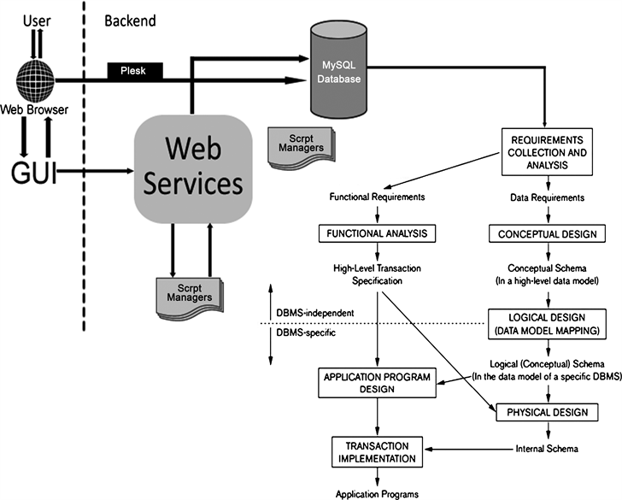
The application layer includes specialized real-time applications for monitoring and control, along with user interfaces for real-time data visualization and system management. A real-time database supports fast data read/write operations, essential for timely decision-making. Integration with existing systems and new technologies is achieved through API gateways, while edge computing nodes handle local, time-sensitive processing to reduce latency. Cloud services provide scalable resources for additional data storage and advanced analytics. Security measures, including firewalls and encryption protocols, protect against cyber threats, ensuring data integrity and confidentiality. This comprehensive architecture supports the system's adaptability, performance, and long-term viability in mission-critical applications.

Fig 3.5: System Architecture Diagram

CHAPTER FOUR
SYSTEM DESIGN AND IMPLEMENTATION
4.1 SYSTEM DESIGN
The objective of system design and implementation is to ensure that the system is working effectively and efficiently as expected. It also involves the putting of the newly proposed system into operation. This chapter looks at how the system will be implemented to achieve the purpose for which it was designed. The project was designed using PHP (Hypertext Pre-processor) as the main Scripting Language, Bootstrap to style the interface and MySQL server as the database server, and XAMP as the web server. The application can be accessed using any web browser.
4.2 SYSTEM REQUIREMENT
The system requirements for the proposed real-time system at Kwara State Polytechnic, Ilorin, encompass both hardware and software aspects to ensure high performance, reliability, and security.
    - Hardware Requirements
- Processor: At least 500MHZ Pentium 111-class processor
- Hard Disk : At least 8 GB of available space required on system drive
- Display: super VGA (1024 x 768) or higher resolution display with 256 colours RAM : 8GB Minimum

4.2.2 Choice of Programming Language
A program is a series of instructions given to a computer or similar devices to perform or solve a given task. These instructions are written on the computer in a language the computer understands.
As it was stated above, this system was built with PHP programming language and it was designed on HTML. The database software used was MySQL managed by phpMyadmin. These tools and others that were used during this project are stated below:
1. PHP: It is a server-side scripting language, and is a powerful tool for making dynamic and interactive Web pages quickly. It was the best choice of scripting languages to use for a very flexible project as this. PHP was used to code the functionality of the system by leveraging the Notepad++ framework. PHP version 5.4.4 was the version used.
2. HTML and CSS: Hypertext Markup Language and Cascading Style Sheet are tools used in development and creation of web pages that run mostly on web browsers. They were used to develop the frontend design and user interface of the system.
3. SQL: SQL (structured query language) is a standard language for accessing databases. SQL is used to access and manipulate data in: MySQL, SQL Server, Access, Oracle, Sybase, DB2, and other database management systems.
4. MySQL: The MySQL database management system served as the database for building and testing the system. It also served as the platform where all data used in the application could be manipulated.
5. phpMyAdmin: This tool was used to manage the MySQL databases over the web and locally on your computer. It provided an easy interface to carry out SQL operations on the database. I worked with phpMyadmin version 1.8.0.
6. XAMPP: Xampp is an Open-source web server solution comprises of basic components such as Apache HTTP, MYSQL, PHP or Perl languages. It was used in this project as the local server in developing and testing the system.
The reasons why PHP and MySQL are used for the development of the new system are due to the followings:
- It’s secure: MySQL’s flexible system of authorization allows some or all database privileges (for example, the privilege to create a database or delete data) to specific users or groups of users. Passwords are encrypted.
- MySQL is a fast, easy-to-use RDBMS used for databases on many Web sites. Speed was the developers’ main focus from the beginning.
- It supports large databases. MySQL handles databases up to 50 million rows or more. The default file size limit for a table is 4GB, but you can increase this (if your operating system can handle it) to a theoretical limit of 8 million terabytes (TB).
- It’s customizable. The open source GPL license allows programmers to modify the MySQL software to fit their own specific environments.

4.3 INSTALLING THE APPLICATION
Installation simply means deploying the web application on a local host server and making it accessible to the end users. The installation discussed in this section applies to how the web programs are to be started. To run this web program successfully, the following application should be put in place;
- Microsoft operating system versions such as Xp, vista, windows 10, windows 8 etc
- A text editor IDE is needed. This could be Notepad ++, Notepad or Sublime Text Editor(recommended)
- A local host server such as XAMP.
4.3.1 Installing the Web Server
A web server is required to provide components that will enable the web applications to run. For this project, XAMP is used and it is the recommended web server. XAMP is an
open-source server and it can be downloaded from Apache and friends page via http://xamp.sf.net . After the download is complete, it can be installed using the following steps:
- Open the downloads folder to locate xampp
- Install xampp software into the root directory of any of your local disk(i.e. C)
- After the installation, confirm that the Apache and MySQL are started. This can be confirmed from the XAMP control panel. To locate the control panel – go to start menu, - click on programs and look for Apache friends. When you hover the mouse on it, Xamp pops up, click on XAMP to get to the XAMP control panel.
- To confirm that XAMP is working, go to your web browser and type localhost
- Copy lm folder to the htdocs directory located on the C drives. i.e. c:\xampp\htdocs
- To confirm that the application is working, go to your web browser and type http://localhost/lm/index.php. if the index page of the application appears, it means it was successfully copied and is working
4.3.2 Using XAMPP
The duty of the apache web server is to host and display web applications’ output to the web browser that requested it. It is important to note that both the web browser and the web server can exist on the same machine due to design and testing purposes as it is in the case of this project. The web server, its utilities and the web browser must be present either together on the same machine for a web application to be complete. The web browser is needed to retrieve user data from the host server (Apache HTTP server) over the internet or a local area network. It receives the HTML codes for the contents of the current page it is accessing and interprets the codes to produce the interface for the system. It also provides an interface through which data can be collected from the user and sent to the server.

4.3.3 Setting Up MySQL Database
The MySQL database setup is relatively easy. This can be achieved in two ways;
- By writing SQL codes
- By using PhpMyAdmin application interface. It is controlled entirely by SQL commands.
4.3.4 Testing the Application
Testing means compiling and then running the web application on any web platform that launches and receives HTTP request to see how the application works. Testing ensures that the application works properly according to system specifications. These web programs are built with a good interactive user interface. To access the system simply logon to http://localhost/lm/index.php

4.4 IMPLEMENTATION INTERFACE
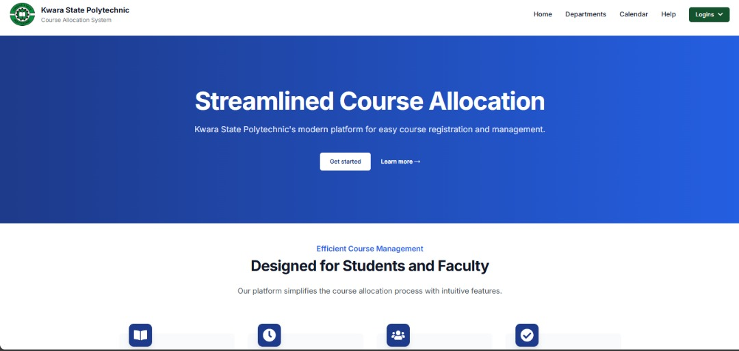

Fig; 2. 4.4: Front Page of the System
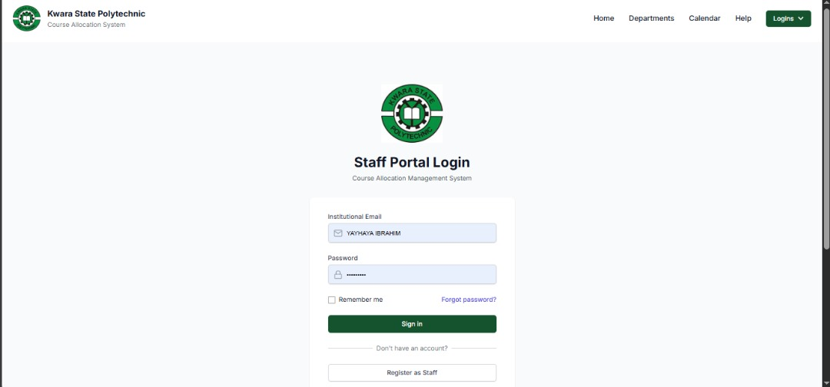

Fig; 3. 4.4: Staff Login of the System

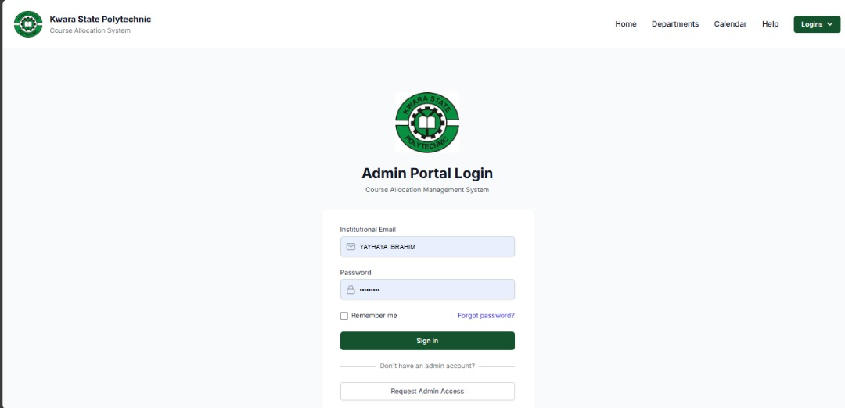

Fig. 3: 4.4 Lecturer Dashboard
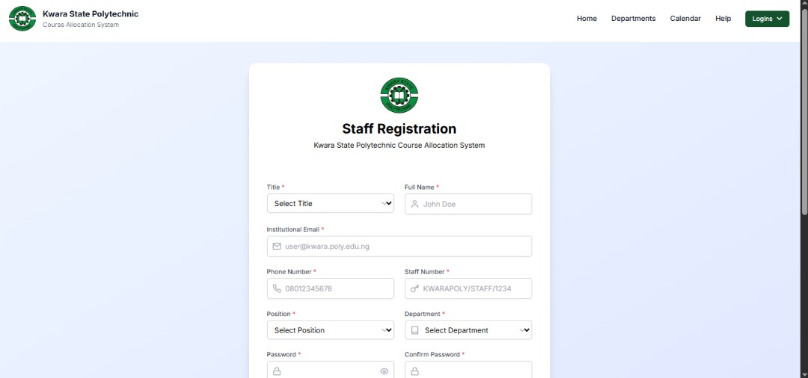

Fig 4: 4.4 : Lecturer Dashboard

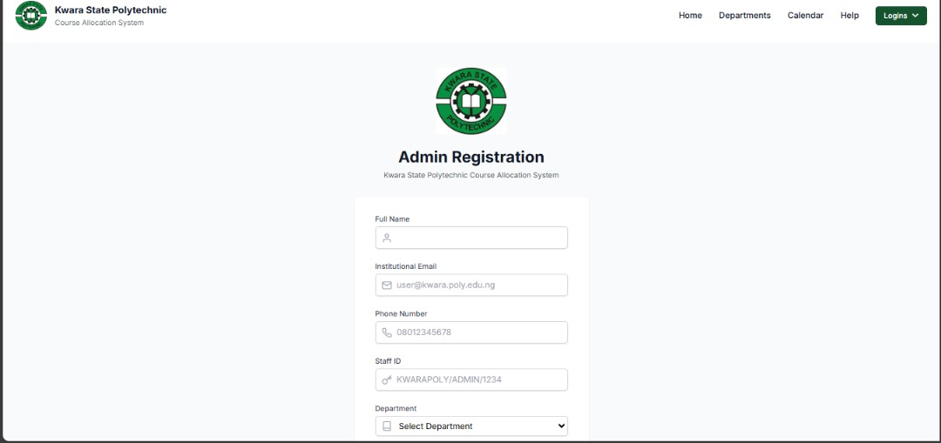
Fig 5: 4.4: Lecturer Dashboard
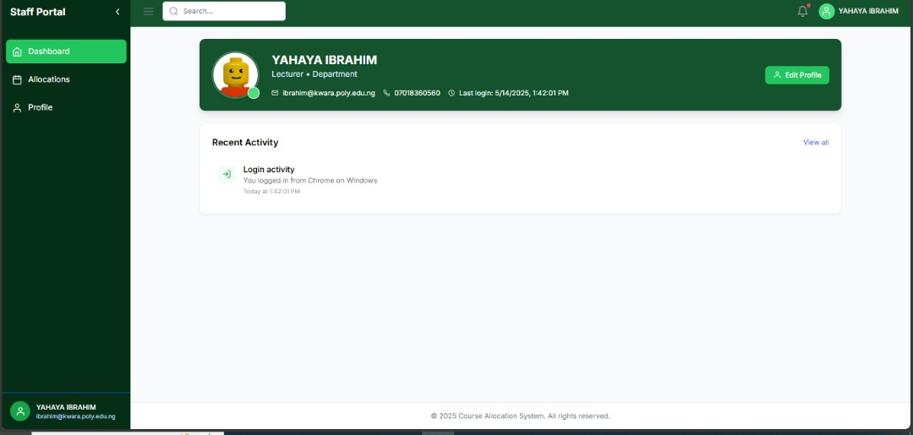
Fig 6: 4.4:Staff Dashboard

4.3 SYSTEM ANALYSIS
At this phase the flow of information of the system was analyzed bearing the input and the output the new system in mind. Through this, information needed for the input and output of the system were gathered. Below is a data flow diagram of information of the System

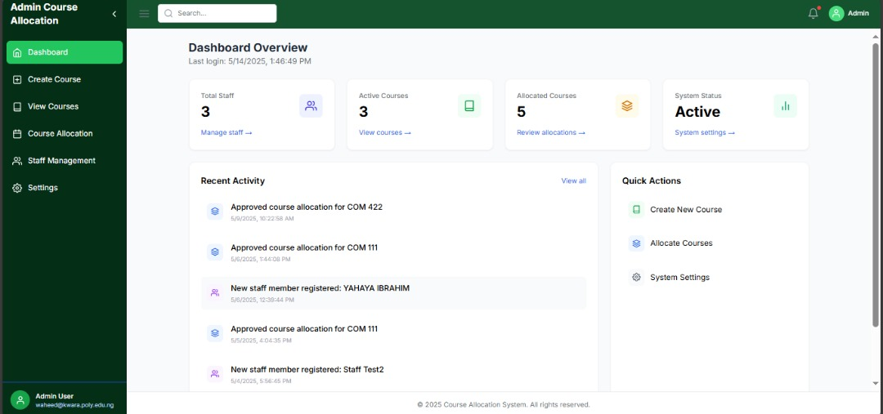

Fig. 7: 4.4: Admin Dashboard
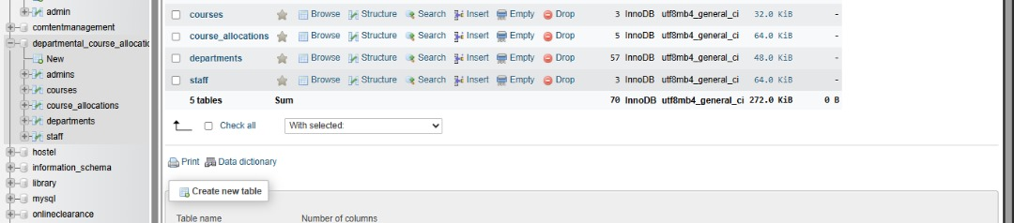

Fig. 8: PHP MyAdmin Database Dashboard.

FLOW CHART DIAGRAM FOR ADDING NEW LECTURER
START
LOAD ALL LECTURERS FROM THE DATABASE

DISPLAY NEW LECTURER FORM
IF TRUE
STOP
IF FALSE
“LECTURER ALREADY ADDED”
ADD LECTURER TO THE DATABASE

LECTURER ALREADY ON THE DATABASE?
STOP

When ‘add new lecturer’ is clicked, a form interface is popped up to fill in lecturer’s information like title, Lecturer’s last name, initials and area of specialization. If the information is entered correctly, the lecturer’s record is added to the lecturer entity on the database.
FLOW CHART DIAGRAM FOR ADDING NEW COURSE
START
LOAD ALL LECTURERS FROM THE DATABASE

DISPLAY ALL LOADED NEW COURSE ADDITION FORM
IF TRUE
“COURSE ALREADY EXIST”
IF FALSE
ADD COURSE TO THE DATABASE

STOP
COURSE ALREADY ON THE DATABASE
STOP

When ‘add new course is clicked, a form interface is popped up to fill in the new course information like course code, course title, unit and the scope of the course. The list of the available lecturer and their area of specialization is automatically generated from the database to select which lecturer to be in charge of the course. When the form is submitted, a check is run to confirm if the course had not already been added. If the course already exists on the database, the record is rejected and user is notified of the existence of the course on the database.

FLOW CHART DIAGRAM FOR LOADING COURSE
START
LOAD COURSES FOR THE LEVEL FROM DATABASE ASYNCHRONOUSLY

STOP
DISPLAY ALL LOADED COURSE FROM THE DATABASE
ANY COURSE ADDED YET FOR THE LEVEL?
IF FALSE
IF TRUE
“NO COURSE ADDED FOR THE LEVEL YET”

“SELECT A PARTICULAR LEVEL”

There would also be a feature to automatically allocate all already added courses to lecture with just a click a click. The course scopes are compared with the lecturer’s area of specialization, any lecturer’s area of specialization that matches the course scope would be automatically be assigned the course. The flow chart of this function is shown below;
START
LOAD ALL COURSES SCOPE AND LECTURER SPECIALIZATION FROM DATABASE

STOP
FOR EACH COURSE, COURSE SCOPE MATCHES LECTURERS SPECILIZATION?

IF TRUE
LOOP THROUGH THE COURSES SCOPES AND LECTURERS

CLICK ‘AUTOMATICALLY ALLOCATE COURSES’

ASSIGN COURSE TO THE LECTURER

CHAPTER FIVE
SUMMARY, CONCLUSION AND RECOMMENDATION
5.1 SUMMARY
This research focuses on designing and implementing a real-time system for course allocation at Kwara State Polytechnic, Ilorin. The proposed system addresses limitations of existing systems by integrating scalable, flexible, and secure technologies. Key components include embedded systems, a robust Real-Time Operating System (RTOS), middleware for secure communication, and a real-time database for efficient data management. The architecture supports dynamic resource allocation, ensuring optimal performance and reliability. Enhanced security measures, such as encryption and access controls, protect against cyber threats. The system also features user-friendly interfaces for real-time monitoring and management, facilitating smooth operation and maintenance. Through detailed planning and integration of advanced technologies, the proposed system aims to improve the efficiency and accuracy of course allocation processes, ultimately enhancing the administrative capabilities and overall functionality of Kwara State Polytechnic, Ilorin. This comprehensive approach ensures the system's adaptability, performance, and long-term viability.

5.2 CONCLUSION
In conclusion, this research successfully demonstrates the design and implementation of a real-time system for course allocation at Kwara State Polytechnic, Ilorin. By addressing the limitations of existing systems, the proposed architecture enhances scalability, flexibility, and security. Key features include a robust Real-Time Operating System (RTOS), efficient middleware for secure communications, and a high-performance real-time database. The system's modular design ensures seamless integration with existing infrastructure and future technologies, while advanced security measures safeguard data integrity and system reliability. The implementation of this system is expected to significantly improve the efficiency, accuracy, and responsiveness of the course allocation process, benefiting both administrative staff and students. This project highlights the potential of modern real-time systems to transform educational administration, providing a model that can be adapted and scaled to similar institutions. Overall, the research contributes to advancing real-time computing applications in the education sector.
5.3 RECOMMENDATION
Based on the findings and successful implementation of the real-time system for course allocation at Newland Polytechnic, Ilorin, several recommendations are proposed to ensure its continued effectiveness and potential for broader application:
1. Regular System Updates: To maintain security and performance, it is crucial to implement regular updates for both software and hardware components. This includes patching vulnerabilities, upgrading the Real-Time Operating System (RTOS), and enhancing middleware protocols.
2. Training and Support: Providing comprehensive training for administrative staff and technical support teams is essential. This will ensure that the system is used to its full potential and that any issues are promptly addressed.
3. Scalability Planning: As the institution grows, so will the demands on the system. Planning for scalability should be a continuous process, with strategies in place to add more resources and integrate additional functionalities without disrupting existing operations.
4. Continuous Monitoring and Evaluation: Implementing robust monitoring tools will help track system performance and detect issues early. Regular evaluations and audits can provide insights into areas for improvement and ensure the system remains aligned with institutional needs.
5. User Feedback Mechanism: Establishing a mechanism for collecting feedback from users—both administrative staff and students—can help identify pain points and areas for enhancement, ensuring the system evolves based on real-world use cases and requirements.
6. Exploration of Advanced Technologies: Stay abreast of advancements in real-time systems, cloud computing, and cybersecurity. Integrating emerging technologies can further improve system performance, security, and efficiency.

REFERENCES
Al-Mukhaini, E. M., Al-Qayoudhi, W. S., & Al-Badi, A. H. (2014). Adoption of Information and Communication Technology in Higher Education: A Case Study of a College in Oman. Journal of Information Technology Education: Research, 13, 217-233.
Al-Zubaidi, H., & Ahmad, N. (2015). Factors Influencing the Adoption of E-Learning in Iraq: A Case Study of Mustansiriyah University. International Journal of Computer Applications, 127(5), 14-20.
Brown, D. (2009). Communicating Design: Developing Web Site Documentation for Design and Planning (2nd ed.). New Riders.
Budiu, R., & Nielsen, J. (2010). Eyetracking Web Usability. New Riders.
Goyal, S., & Verma, A. (2018). Optimization Techniques for Efficient Course Allocation in Indian Universities. International Journal of Computer Science and Information Security, 16(5), 123-129.
Kumar, A., & Gupta, S. (2017). The Role of User Feedback in Developing Effective Automated Systems in Education. Journal of Educational Technology Systems, 45(3), 346-362.
Lazar, J., Feng, J. H., & Hochheiser, H. (2017). Research Methods in Human-Computer Interaction (2nd ed.). Morgan Kaufmann.
Lidwell, W., Holden, K., & Butler, J. (2010). Universal Principles of Design (2nd ed.). Rockport Publishers.
Marcotte, E. (2011). Responsive Web Design. A Book Apart.
-Mbukusa, N. R., Zulu, S., & Lubinda, F. (2019). Adoption of Automated Systems in Higher Education: The Case of Namibia. Journal of Higher Education Policy and Management, 41(2), 177-192.
Muller, M. J. (2011). Web Usability: A User-Centered Design Approach. Addison-Wesley.
Norman, D. A. (2013). The Design of Everyday Things (Revised and Expanded Edition). Basic Books.
Norman, D. A., & Draper, S. W. (1986). User Centered System Design: New Perspectives on Human-Computer Interaction. Lawrence Erlbaum Associates.
Ochieng, F. M., & Okeyo, G. (2018). Implementation of an Automated Course Allocation System at the University of Nairobi. International Journal of Computer Applications, 181(16), 23-29.
Raza, S., Qazi, W., & Khan, K. A. (2020). The Impact of Information Systems on the Administrative Processes of Pakistani Universities. Journal of Educational Administration, 58(2), 263-278.
Saffer, D. (2009). Designing Gestural Interfaces: Touchscreens and Interactive Devices. O'Reilly Media.
Snyder, C. (2003). Paper Prototyping: The Fast and Easy Way to Design and Refine User Interfaces. Morgan Kaufmann.
Tan, S. K., & Tan, M. (2019). Developing a Robust Course Management System: A Case Study of the National University of Singapore. Journal of Computing in Higher Education, 31(3), 456-473.
Tidwell, J. (2010). Designing Interfaces: Patterns for Effective Interaction Design (2nd ed.). O'Reilly Media.

