PROJECT REPORT ON

PERIMETER AND DETAIL SURVEY

OF

OLD INSTITUTE OF ENVIRONMENTAL STUDIES (IES) AND VILLAGE, KWARA STATE POLYTECHNIC ILORIN ALONG OLD JEBBA ROAD,MORO LOCAL GOVERNMENT AREA, KWARA STATE.
BY
NINIOLA MUTIAT OMOWUNMI
ND/23/SGI/FT/024

A PROJECT WORK SUBMITTED TO THE DEPARTMENT OF SURVEYING AND GEO-INFORMATICS, INSTITUTE OF ENVIRONMENTAL STUDIES, KWARA STATE POLYTECHNIC, ILORIN
IN PARTIAL FULFILLMENT OF THE REQUIREMENT FOR THE AWARD OF NATIONAL DIPLOMA IN SURVEYING AND GEO-INFORMATICS

JUNE , 2025
CERTIFICATE
I hereby certified that all information given in this research project were obtained as a result of observation and measurement made by me that the survey was carried out in accordance with the survey rules, supervisor and departmental instruction.

…………………………. ……………………….
NINIOLA MUTIAT OMOWUNMI DATE ND/23/SGI/FT/024

CERTIFICATION
This is to certify that I NINIOLA MUTIAT OMOWUNMI with matric no; ND/23/SGI/FT/024 a student of Surveying & Geo-Informatics Department has actually carried out the field work in connection with this project and it was carried out in accordance with survey rules and regulations and department instructions.

…………………………….. ….………………
SURV ABDULSALAM AYUBA AND
SURV. OGUNTAYO BERNARD DATE
PROJECT SUPERVISOR

…………………………….... ….………………
SURV. AWOLEYE RAPHAEL .S DATE
PROJECT CO-ORDINATOR

………………………………. ….………………
SURV. AMBIMBOLA ISAU DATE
HEAD OF DEPARTMENT

………………………………. ….………………
SURV. J.O OPALEYE
EXTERNAL SUPERVISOR DATE
DEDICATION
This project is dedicated to Almighty Allah, the magnificent, the over merciful to my lovely parents for their supports towards the successful completion of this project.
ACKNOWLEDGEMENT
I also give thanks to my project supervisors in the person of Surv. Abdulsalam Ayuba And Suvr. Benard Oguntayo for their strictly and through supervision. I will like to thank all lecturers of this noble department starting from H.O.D Surv. Abinbola isau, Surv. A. Ayuba, Surv. Bello Felix Diran, Surv. Williams Kazeem, Surv. A.O. Akinyede, and also the Director of special duty
Surv. A.G. Aremu and other supportive staff of the department of Surveying and Geo-informatics, Kwara State Polytechnic, Ilorin. To my group I appreciate all members of the starting from my group leader: Fagbohun Isaac Olamide to Oyeniyi moshood Akinola, Awoyemi Mariam Deborah, Musa Oladimeji Zulu, Raheem Rokibat Anike, Abdulrosheed Olayinka, Sheu Rokibat Ayoka, I pray all our effort shall not be in vain and we shall all meet in our dreamlands (Amen).

TABLE OF CONTENTS
TITLE PAGE i
CERTIFICATION ii
DEDICATION iii
ADKNOWLEDGEMENT iv
ABSTRACT vi
TABLE OF CONTENT vii
LIST OF FIGURES ix
LIST OF TABLES x
CHAPTER ONE
1.1 INTRODUCTION 1
  - AIM OF THE PROJECT
  - STATEMENT OF THE PROBLEM 3
  - OBJECTIVES OF THE PROJECT 3
  - SCOPES OF THE PROJECT 3
  - PROJECT SPECIFICATION 4
  - PERSONNEL INVOLVED 4
1.8 PROJECT LOCATION 5
CHAPTER TWO
2.1 LITEATURE REVIEW 6
CHAPTER THREE
3.1 METHODOLOGY 9
3.2 RECCONNAISANCE 9
3.2.1 FIELD RECCI 10
3.2.2 PLANNING 11
3.3 CONTROL POINT AND LINEAR ACCURACY 12
3.4 EQUPMENT USE AND SYSTEM SELECTION 12
3.5 DATA SOURCE 13
3.5.1 GEOMETRIC DATA ACQUISITION 14
3.5.2 ATTRIBUTE DATA ACQUISITION 14
3.6 DATA DOWNLOADING AND EDITING 15
3.7 DATA PROCESSING 15
3.8 DATA BASE MANAGEMENT (DBMS) 16
3.9 BACK/AREA COMPUTATION 16
CHAPTER FOUR
4.1 DATA ANALYSIS 17
4.2 INFORMATION PRESENTATION 20
4.2.1 COMPOSITE PLAN 25
4.2.2 DETAILING 27
CHAPTER FIVE
5.0 SUMMARY 28
5.1 PROBLE ENCOUNTER DURING SURVEY EXERCISE 28
5.3 CONCLUSION 28
5.2 RECOMMENDATIONS 29
REFERENCE
APPENDIX

ABSTRACT
This project report focused on various method used in execution of perimeter and detailing survey of old institute of environmental studies (ies) and village, kwara state polytechnic ilorin along old jebba road,moro local government area, kwara state. the product was carried out using the basic survey operation include reconnaissance which involves field and library reconnaissance survey followed by data acquisition which involves their order theodolite traversing total station for detailing, but we use total station. All the data acquired from the field we deduced computed and adjusted accordingly to specification and result were analysed and found to be within the expected accuracy. Finally computed data were presented in graphical form in digital using civil CAD software and comprehensive report on how the whole operation was carried out was finally written.

CHAPTER ONE
INTRODUCTION
1.1 BACKGROUND OF STUDY
The science and art of making all essential measurement to determine the relative position of point and or physical and cultural detail above on or beneath the surface of the earth and to depict them in a usable form to establish the position of point and/or details is called surveying. Surveying has been an element in the development of the human environment since the beginning of the recorded history , the planning and execution of most forms of construction requires it, it is also used in mapping and the definition of legal boundaries for land ownership.
Kwara State polytechnic Ilorin. Student hostel accommodation. The girls hostel of kwara State polytechnic was designed for female accommodation only, while is the largest within the area. With this fact there will be need for perimeter and details base map of the area to know the position of each building and the area covered for security purposes, decision making and future development. For the fact above female hostel kwara State polytechnic Ilorin along west end road, Ilorin East local government area of kwara State, mostly established boundaries so as to be useful for future purpose the detailing will help to have the view of artificial feature of the particular area.
Perimeter and detailing survey which is the subject of the study goes in line with boundary demarcation and facilities inventory take.
Perimeter and detailing survey is a type of land survey that defines the boundaries of a particular parcel of land or real estate property. This survey maps a ship using a minimum width of 15feet.Tis requires surveying the entire perimeter of the said real estate to determine the exact average and geometry of the property and identify any easement that may be present within the land. Also, perimeter survey is used to identify the location of old boundaries documentation and survey pins or they used to set up new ones. A perimeter survey does not identify the features and improvement that exist within a property such garages, sheds, dwelling, surface utilities, road way pool and visible bodies of water, only features that fall within the 15foot width around the boundary perimeter will be depicted. Also perimeter survey resolve conflicts on maps and deeds description and shows structures such as fences, hedges, yards and walls.
Perimeters surveys are cadastral. The measurements were taken and plotted in order to produce a register able cadastral instrument. Detail survey is the survey of the positions of permanent natural
features within the area.
Details survey is used to determine and locate the features and improvement on a parcel of land,
the word “features” here means nothing natural and man -made features on a pieces of land, in this project, perimeter and details survey is the main aspect of survey that would be considered in new of this perimeter survey is a specific Type of survey that measured the distance along boundary line of a given land.
A perimeter survey is important to find out the exits location of the landed property and property determine the extent of such land and also the extent of Encroachment can be evaluated in case of the landed property is in dispute. Perimeter and details survey is a survey that requires transferring of the details on the limits of the heights, depicting all details on the limit of the landed property, which consists of both natural and artificial features. It also refers to a cadastral survey because it contains coordinate all corners point of the boundaries and determination of relative position of both natural and artificial features on the Earth’s surface and addicting them by means of conversation symbols on the plan.
Perimeter and detailing survey is a view data collection work, we need to pick up raw data such as ground level, drain, lamp hole, and other permanent features on the ground. Detailing survey can also be carried out to evaluate the developed underdeveloped portion of area. Detailing survey is important in decision making.
An adequate and accurate perimeter and detailing measurement is one of the most important elements of any post construction processes. A finished structure determine the exact position, shape, size and specific uses for each, this normally occurs because of unforeseeable on site.
Perimeter can be define as the path or boundary that surrounds a shape. It can also be define as a length of the outline of a shape.
  - STATEMENT OF THE PROJECT
Land dispute among the others land owners is due to irregular boundary line between the project area and neighboring, in other to assist the school authority plan for future expansion and development of the project area, there is need for an up to date perimeter and detailing survey.
Due to insufficient control point in the kwara state polytechnic Ilorin execution of survey operations in the school premises are stressful and time taking. Establishment and extension of more third order control point will help to alleviate this problem. Therefore the project would provide relevant data for further planning and development of schools in order to resolve the problem of dispute in future.
1.2.AIM OF THE PROJECT
The aim of this project is to carry out the perimeter and detailing survey of old institute of environmental studies (ies) and village, kwara state polytechnic ilorin along old jebba road,moro local
GOVERNMENT AREA, KWARA STATE. of Kwara State polytechnic Ilorin to determine the artificial features other study area.
  - OBJECTIVES OF THE PROJECT
The following lists are the aims of objective of the project.
- To fixed the details within the study area.
- Perimeter traverse to determine the position, shape, and the size of the site.
- Production of plan showing the boundary lines and all details of the area.
- To identify the existing features on the study area.
- To use total station to determine the x, y and z coordinate of selected point.
- Data processing.
- Production of model plan'
- Detailing plan.
- Perimeter plan.
- To write a comprehensive report for the project.
  - SCOPE OF THE STUDY
The project scope is as followed:

- Reconnaissance (office and field ).

- Detailing by total station method.
- Boundary demarcation.
- Perimeter traversing.
- Computation and field reduction.
- Plan production (analog and digital).
- Project report writing, the perimeter and detail map of this project shall contains all
- structures, (building) play ground, fence land scaping, drainage and any other artificial
- Features found within the study area.
1.6 SPECIFICATION OF THE PROJECT
The following are the specification to be ascertained in the project:
- The conservation station must be inter visible and should be established where it would not be disturbed.
- The linear accuracy should not less than 1:5000.
- The control check must be done.
- The angular misclosure for the traverse should not exceed to 30”.
- Linear measurement should be recorded to the third decimal places of meter (nearest millimeter).
- Using total station for accurate method on both angular and linear measurement.
    - STUDY AREA
The exact location of the project area is part of kwara state polytechnic I.e OLD INSTITUTE OF ENVIRONMENTAL STUDIES (IES) AND VILLAGE, KWARA STATE POLYTECHNIC ILORIN ALONG OLD JEBBA ROAD,MORO LOCAL GOVERNMENT AREA, KWARA STATE., which falls on the Longitude 008d 33’ 20” N. Latitude 004d 38’ 14.028”E Longitude 008d33’21”N. Latitude 004d 38’ 14.584”E Longitude 008d 33’ 18”N. Latitude 004d 38’ 14.364”E Longitude 008d 33’ 18.820”N. Latitude 004d 38’ 14.302”E.
1.8. PERSONNEL
Group A members are the personnel involved in the excursion of this project and it's surveying and geo-informatics ND2 Student namely below:
SN |  | MATRIC NO | ROLE
1. | NINIOLA MUTIAT OMOWUNMI | ND/23/SGI/FT/024 | AUTHOR
2. | OYENIYI MASHOOD AKINOLA | ND/23/SGI/FT/019 | Member
3. | SHEU ROKIBAT AYOKA | ND/23/SGI/FT/020 | Member
4. | OJO SERAH ADESOLA | ND/23/SGI/FT/021 | Member
5. | FAGBOHUN ISAAC OLAMIDE | ND/23/SGI/FT/014 | Member
6. | AWOYEMI MARIAM DEBORAH | ND/23/SGI/FT/025 | Member
7. | RAHEEM ROKIBAT ANIKE | ND/23/SGI/FT/026 | Member
8. | ISHOLA ABDULROSHEED .O | ND/22/SGI/FT/028 | Member
9. | MUSA ZULU OLADIMEJI | ND/23/SGI/FT/017 | Member

CHAPTER TWO
LITERATURE REVIEW
According to Godfrey Hoffman Hodge (2013) the described a perimeter survey as a type of land survey that defines the perimeter boundaries of a particular parcel of real estate property. This survey maps a trip along the boundaries using a minimum width of 15 feet. This requires surveying the entire perimeter of the said real estate in order determine the exact acreage and geometry of the property and identify any easements and enrichment that may be present within the land. This present will require with installation of monument to mark the boundary corners of the land for future references.
This requirement can be present within the waved through a written agreement between the surveyor and home over.
Perimeter survey and use to identify the locating of old boundary monumentation and survey pins, or they can be used to set up new ones (godfrey-hodge 2013).
Perimeter surveying in the services that can be performed by Professional and land, firm such as (godfrey-hoffman-hodge) in Connecticut to ensure reliable accurate and detailed surveying result.
According to dashes (1987) he described as the type of survey made purposely for producing plan showing property boundaries or plan on which area necessary for the assessment for the property or land taxes may be computed it also reoffered to as legal surveying because such surveyors forms the basis of a statutory registration of ownership and other right land.
Canada surveyor (2021) a detail survey is carryout to locate all features in a piece of land. This includes both natural and man-made structures. Natural features include vegetation of all stork-rocks, trees, stumps and sarong man-made structures include anything built above the ground building walls, driveways, and utilities and so on. Another further of a detail survey is that take a look at the elevation of the land any contours on the land.
Features included in a detail survey include but are not limited to;
- Contours
- Site coordination
- Location of features
- Ridge and guitar height
- Outline and neighboring building
- Leveling
- Spots level
KEY TAKE WAYS
A perimeter survey is a type land survey that defines the perimeter boundaries of particular parcel of real estate property (godfrey Hodge 2013)
According to our jurovich surveying or detail survey is defining the location and height of any numbers of verities of features on the property in question. A contour plan along with the physical features located are show all relevant site in formation typically site level the location of features urban services and infrastructures existing trees, existing buildings, structures and retaining walls and frontages works (such as foot paths, overhead power, kerbed and channel). (Microsoft Encarta 2009).
- Property beacons means beacons emplaced on the boundaries of parcel of the land for the purpose of defining or demarcating the boundaries (SURCON 2009)
- Coordinate means each of the numerical values use to indicate the position of a point.
- The position of the any point in relation to source axes usually interest at result anglers (J.D dashe1987)
- Control is the system of relatively precise measure ment by the translation leveling to determine distance or elevation (trateys, 2013)
ESSENCE OF A PERIMETER AND DETAIL
Survey dashes (19870 saw a perimeter and detail survey produce to provide the following.
- To determine the extent of individual holding to avoid to disputed of the land.
- To provide vital imprecation which must be preserved for land management and maintaining both of natural and artificial features.
- To locate portions of land of the physical surface of earth together with detail and it by means of survey beacons and showing the survey one plan.
- To determine the extent, size, value, ownership, of the land.
WAYS OF IMPROVING PERIMETER AND DETAIL SURVEY
with today technologies it is possible to generate personal map and plan on a own computer digital techniques will continue to influence map making enable more rapid production of accurate and current map.
The earlier in the process the survey in the undertake in the earlier development constraint by the identify in the early stage of the design process price to committing significant resources to the project. The detail survey ideally be undertaking prior to preparation of proposal plan. Having a contour and detail survey will provide with all of the site and conditions in a manner which is both accurate and up to date.
The establishment of mark to control construction or to indicted land boundaries further analyses that surveying has been on essential element in the development of man environment for so many countries that its importance is often forgotten is imperative requirement in planning and execution of nearby every form of constitution were it principle modern uses are in the field or transportation, building appointment of land and communication inside which man can do without development is to mention in an environment owing to the above stated and confirmed fact below are some notable terminologies we have been defined;
- Beacons means a permanent survey mark of any kind made of concrete iron or store and include pillars and boundary point so made (SURCON 2009).
- Demarcation means the defining of the boundary line on the ground by emplacement of property beacons or by such other method as these regulations permit (SURCON 2009).
- Boundary means a line marketing the limit of an area or an imaginary line which marks the confines or line of division of two continues plots.
- Property means something of values that is owned by someone be it land or parent indeed perimeter and detail survey is greatly hampered by non-availability of good horizontal control, in view of this perimeter and detail survey can be improved upon by establishing basic horizontal control network by geodetic triangulation precise traverse or global positional system (GPS)
- THEREFORE
We were to carryout perimeter and detail survey of girls hostel kwara state polytechnic Ilorin
So as establish the boundary and to have his size, the shape and area covered of the particular area. The detail survey will help to have the map of both natural and artificial feature on both site by using total station method, which is known as third order control have (x, y, z) coordinate the operation that will involved in project execution include the following.
- Reconnaissance both in office and field
- Total station for detail fixating/coatoring
- Computation
- Plan production
- Traversing
- Reconnaissance:- these will involved visiting site and take the coordinate point of site.
- Total station:- this surveying instrument has two similar but opposite function. We were using total station for fixing detail and run the traverse have accurate measurement and minimize the time taking also for determination of existing relative horizontal and vertical position such as that use for the processing of mapping.
- Traversing:- this is the measurement of angle between successive line or bearing of each line and the length of each line in a square meter order (dashed 1987).

CHAPTER THREE
- METHODOLOGY
Methodology is a system or principle used is solving problem, with specific component such as task, method technique and tools.
This is also the techniques used to achieve the aims and objectives of this project work, the execution of this project was based on the following basic principles of surveying.
- Working from whole to part.
- The principle of choosing the method of survey most appropriate to meet the desire result.
- The principle of provision of adequate check to meet the require accuracy.
- RECONNAISSANCE
Reconnaissance which is the first stage and vital aspect of any survey work
Carried out is as well the preliminary stage of this project.
This also is the initial operation or preliminary investigation undertaken by the surveyor in order to have a thorough overview of the site before the commencement of the actual survey ,it can also be abbreviated as “recci’’ as the project was concerned the reconnaissance was carried out in two ways.
- Field reconnaissance
- Office reconnaissance

    - Field or Site Reconnaissance
This involves the actual [physical] visit to the site and was carried out before the actual operation. This project site was visited by the group in order to have a prior knowledge as well as true picture of the site and to ascertain the information collected during the office planning. The boundaries were marked with wooden peg driven into the ground to avoid disturbance or removal, taking into consideration the following factors.
- Inter-visibility of the selected traverse station.
- Safety of the selected station for future reference.
- Accessibility of the stations.

    - Office Reconnaissance
This involves knowing the type of instrument, purpose and accuracy required for the survey to be carried out. Information related to the given project was collected from various sources such as project supervisor. The specification/ instructions and coordinates of the control stations were collected from the department of surveying and geo-informatics Kwara State Polytechnic.

TABLE 1 Co-ordinates of control used.
STATION | EASTINGS (M) | NORTHINGS(M) | HEIGTHS (M)
KW/PT/2001 | 679647.447 | 946677.273 | 383.29
SC/KW/FRS/4404 | 679449.408 | 946699.489 | 378.88

3.2 INSTRUMENT TEST
HORIZONTAL COLLIMATION TEST
The aim of this test was to be sure that the line of sight is perpendicular to the trunion axis.
Procedure:
The Total Station instrument was set over a point and all necessary temporary adjustments (centering, leveling and focusing) performed. Then the configuration menu of the total station was accessed by pressing down the menu key for about two seconds and the calibration sub-menu and consequently the horizontal collimation test was chosen. This test was done by sighting and bisecting a well-defined vertical target about 100m away and taking the horizontal readings on face left and face right. From the analysis of the results, the total station was in good adjustment.
VERTICAL INDEX ERROR TEST
This adjustment ensures that the vertical circle reading is exactly 90° when the line of sight is horizontal. Any deviation from this figure is termed vertical index error.
Procedure:
The instrument was set over a point and necessary temporary adjustments (centering, leveling and focusing) performed. The vertical index error test was carried out by sighting a target at a distance of about 120m on face left. The vertical circle reading was recorded and on face right the target was sighted and bisected again and the vertical circle reading recorded.

3.2.1 IN-SITU CHECK FOR CONTROL
In-situ checks observations (angular and linear) were executed for the purpose of verifying the integrity of the existing controls. The following observational schedules were executed:
The instrument was set on KW3001PT and angular observations were made to targets on KW3002PT as back station and SC/KW/FRS/4404 as forward station.

FC3184S

The results of the observations as shown below confirm that the controls were still in their original positions and therefore suitable for use.

TABLE 2 IN-SITU CHECK DATA ANALYSIS (control pillars).
STATION | COORDINATE (m) | KNOWN VALUES (m) | MEASURED VALUES  (m) | DIFFERENCE  (m)
SC/KW/FRS/4404 | NORTHING  EASTING | 946677.273  679467.447 | 946699.489  679449.408 | 0  0  0
KW/PT/2001 | NORTHING  EASTING | 946677.273  679467.447 | 946699.489  679449.408 | -0.005m  +0.004m

.
.
KW/PT/2001

SC/KW/FRS/4404

FIGURE 3.2.1 Diagram Showing Control Used

3.2.2 DATA ACQUISITION
This involves the processes in acquiring the data needed for the project. This involves the actual making of measurements and recording of observed data on the field. There are different methods of acquiring data in the site with different instrument such as Total station, Theodolite, Compass, Level Instrument etc.
3.2.3 Geometric Data Acquisition.
These are positional data, that is, they are data having the [x, y, and z] coordinates which is possible to locate their position on the surface of the earth.
3.2.4 Attribute Data Acquisition.
These data are acquired by social survey, these are data used for defining the purpose of features located on the earth surface.
3.2.5 EQUIPMENT USED/SYSTEM SELECTION AND SOFTWARE
This comprises of two components, namely: the hardware components and software components.
HARDWARE COMPONENT: These are the physical equipment used for the execution of the project and they are:
- Total station (MATO)and its accessories
- Steel tape
- Nails and bottle corks
- Field book and pen
- Personal computer
- pegs

SOFTWARE USED FOR DATA PROCESSING
- AutoCAD 2017 for plotting the boundary and detailing
- Note Pad, and Microsoft Excel (for Script preparation, editing and restructuring of data and report writing).

3.2.6 SETTING OUT OF PERIMETER BOUNDARY
Based on the office planning and field reconnaissance conducted, the instrument was first set on Control Pillar KW3001PT being the closest control and all temporary adjustment performed. The coordinate of the control point KW3001PT was key into the instrument.KW3002PT was sighted as back sight.
The coordinates of the station KW3002PT was key-in the instrument via the keyboard. The instrument then computed the bearing between the two stations for orientation. Then coordinates of points to be set out were entered into the total station and the setting out program of the instrument was used to get the angle to turn in order to face the direction of the point after orientation, the instrument was rotated until horizontal angle read 0° 00’ 00”, reflector was held along the direction and distance between the instrument and the reflector was measured. The instrument displayed the remaining of the point to be fixed distance as either positive or negative. Positive distance means that the reflector should move away from the instrument by that amount while negative distance means that the reflector should move towards the

instrument. When the horizontal angle read 0°00’ 00” and measured distance displayed 0.000m this marked the exact position to be set out.
3.3 MONUMENTATION
The beacons measuring 18cm by 18cm by 75 cm were molded in-situ with a mixture of 1:2:3 of cement, sand and gravel respectively. A 12mm diameter Iron rod defines the center of the beacon was placed. The perimeter boundary line was cleared to ensure inter-visibility between the beacons. The numbering of the beacons was carried out after molding in a clockwise pattern with an arrow pointing to the succeeding station. Also, numbering as carried out accordingly as they were in the Title Deed Plan (TDP).However, the beacons were prefixed with identification mark KP220 where KP represents Kwara State Polytechnic.

KP
P T

220

FIGURE 3.2.2: PLAN VIEW

18cm
18cm
●
8cm Above ground level

12 mm iron rod

76cm

68cm
Beneath ground level

FIGURE 3.3: PROPERTY BEACON

3.4 PERIMETER TRAVERSING
After the demarcation, capping and numbering of the beacons, the actual data acquisition using the total statio SOKKIA51OT commenced. The traverse started from KWPT2001with SC/KW/FRS/4404as reference point. The total station was set up over control KWPT2001, centered, leveled and telescope focused to eliminate parallax. The parameters of the instrument station i.e. station name, height of instrument over the station mark, and the XYZ coordinates of the station were keyed in. The reference control point was then bisected and the station name SC/KW/FRS/4404, height of target over the station mark, and the XYZ coordinates of the station were key in. Though the total station was set in coordinate mode it actually measured and recorded horizontal readings, vertical readings and distances automatically into the internal memory of the instrument on both faces which it used to compute and display coordinates. At every set up of the total station, the temporary adjustment was carried out and the following parameters measured:

- Height of the back target
- Height of the fore target
- Distance to back and fore station
This is the determination of bearing and distance of series of connected lines from known coordinated point so as to obtain coordinate of the newly established station.
This include the following with formula
- Linear measurement : the difference between the coordinates were first derived using (∆E=E2-E1, E3-E2) etc. and the distance of end traverse leg was obtained using the formula: distance =√(∆E)^2 +(∆N)^2
- Angular measurement: to calculated the bearing after the difference in coordinates has been derived, the formula is Bearing=Tan-1 ∆E/∆N.
3.4.1. TABLE 3 Coordinates of the boundary
The coordinates are as follows
S/n | Easting | Northing
1 | 679582.728 | 946429.840
2 | 679448.029 | 946465.672
3 | 679434.376 | 946560.036
4 | 679449.408 | 946699.489
5 | 679647.447 | 946677.273

3.5 DETAIL SURVEY
Detailing of all features (both natural and man-made) within the site was made by shooting ray to fixing with the instrument.
The instrument was set up on station PB220,switched on and adjustments were carried out. Then, “Job” and “Station Name” were set in the instrument so as to recall the coordinates of the boundary point from the instrument’s memory. Also, heights of instrument above the instrument station
and heights of reflectors were measured with steel tape and stored in the instrument’s memory. A reflector placed on beacon PB221 was bisected for orientation. The Total station was instructed to compute the bearing between the two stations after input of the orientation station name PB221. One of the site assistant placed a reflector at the edge of a building , the reflector’s cross hair was bisected with that of the telescope of the total station and “DIST” key was pressed for measurement, display and recording. Then the width of the scream was measured with a 50meter steel tape. The same procedure was adopted in detailing the express way by setting on a boundary beacon PB221 and orienting PB222.In this case, all the edges of the carriage way and some buildings were picked.

CHAPTER FOUR

4.0 DATA PROCESSING
After the acquisition of the site data, Microsoft Excel 2007 Software was used to type the final coordinates of all points except the unwanted part of the data like the temporary controls which were later transported to Note pad and AutoCAD software 2017.

4.1 RESULT ANALYSIS
The data was analyzed and found to meet with the departmental standards and this is the main traverse result extracted from field, then it was arranged accordingly as the observation was held in the field. The results are as follows.
4.2 Table 4: Back Computation
DE DN
From station | Observed (B) | Horizontal (D) | -  E | +  E | Sum | -  N | +  N | Sum | Easting | Northing | To station
 |  |  |  |  |  |  |  |  | 679602.388 | 946505.003 | A
A | 26°4’17.96” | 117.53 |  | 51.65 | 51 |  | 105.567 | 51 | 679550.736 | 946339.439 | B
B | 144°16’26” | 196.65 |  | 114.83 | 165 | 159.65 |  | 165 | 679435.907 | 946559.084 | C
C | 5°29’33.26” | 141.04 | 13.50 |  | 178 | 140.40 |  | 178 | 679449.408 | 946699.489 | D
D | 96°24’2.49” | 199.28 | 198.04 |  | 376 |  | 22.22 | 376 | 679647.408 | 946677.273 | E
E | 14°39’28.53” | 178.07 |  | 45.06 | 421 |  | 172.27 | 421 | Easting | Northing | F
F |  |  |  |  |  |  |  |  | 679602.388 | 946505.003 | A

4.3 Table 5: COMPUTE FOR TOTAL AREA USING DOUBLE LATITUDE AND DEPARTURE
∆E | ∆N | Easting | Northing
+134.699 | -35.832 | 679582.728 | 946429.840
+ 13.653 | -94.364 | 679448.029 | 946465.672
-15.032 | -139.453 | 679434.376 | 946560.036
-198.039 | +22.216 | 679449.408 | 946699.489
+64.719 | +247.433 | 679647.447 | 946677.273

Source: Writer, 2025
+134.699
+134.699 × -35.832 = -4826.535

+269.398
+013.653
+283.051
+013.653 × -94.364= ̵ 1288.352
+296.704
- 015.032
+281.672
-015.032 × ̵ 139.453= +2096.257
+266.640
-198.039
+068.601
-198.039+068.601
-198.039 × +22.216 = ̵ 4399.634
-129.438
+ 064.719
-064.719
+ 0.64.719 × +247.433 = +16013.616
0.00

SUM OF POSITIVE (+) - SUM OF NEGATIVE (-)
= 7595.352 - 10514.521
2
AREA = 4.265 square meters

4.4 GRAPHIC PLOTTING
This simply refers to the graphically representation i.e. plotting of plan. It was plotted using AutoCAD and other software in a computer system and a suitable scale was used to for the hard copy format. Presented information include boundary details and beg, conventional sign and symbol were also used in the plan.
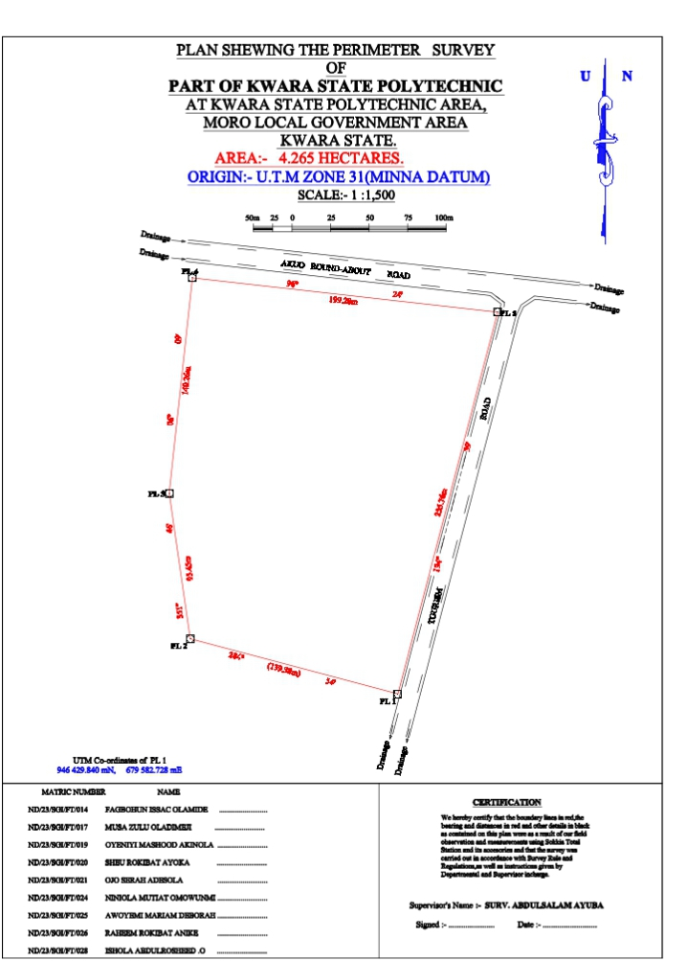
Fig 4.0 Perimeter Plan

Fig 4.1 Details Plan

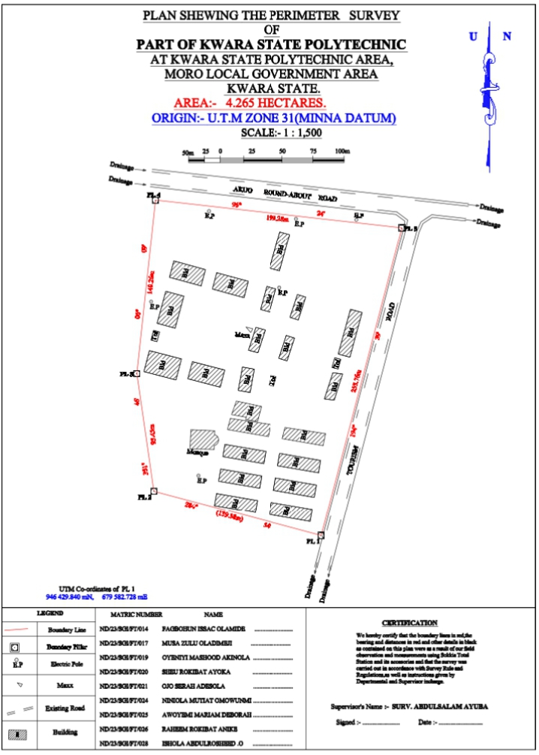

The digital plan was produced using AutoCAD software and these are procedures followed.
- Switch on the computer and allow it to boost
- Select notepad, from notepad, a script file for the coordinate p-line easting, northing was structured.
- File was saved with extension. SCR
- AutoCAD was launched.
- Format was clicked and set the unit then press “OK”
- Press “Tool” and select Run script to pick your saved file then press escape and press zoom, extent and the image was displayed.
- The boundary line was changed to Red and necessary editing was done.

CHAPTER FIVE
SUMMARY RECOMMENDATION AND CONCLUSION
5.1 SUMMARY
This project is located at girls hostel kwara state polytechnic Ilorin kwara state. The project was carried out in accordance with third order specification .
The reconnaissance survey was properly carried out both in office and field, this is done for proper planning of the operation by location initial controls that is within the project site for proper orientation, the instrument to be used and selection of traverse station in which the indelibility of the selected were put into consideration and finally, drawing of sketched diagram of the area to be surveyed. The field operation included perimeter traverse and detailing survey. Therefore; data processing was done and the plan was produced finally in digital format title plan showing all the feature of the area.
5.2 RECOMMENDATION
I hereby recommend this particular project practical to be done often and often to update the infrastructure features in the society for the development of the particular area.
Also, it should be carried out in school for the next development in the school premises,
More over it is necessary for every surveying and Geo informatics student to be able to carried out this particular practical.
Based on the results and conclusion the following recommendation are being made
The research was undertake at female hostel accommodation of kwara state polytechnic Ilorin kwara state.
Therefore the results obtained is a good state by using total station method. This is being recommended that the school management should try to provide more equipment for the student s.
The school management should give proper supervision to the any project and to be monitoring committee that will be looking into the reestablishment of disturb control.
If one has a choice to use either one of the instrument for provide control level in engineering survey the digital level should be preferred as it is more practice and faster
Survey organization should be encouraged to change total station as it more automated thus reducing chances of making blunder (gross errors) that during ordinary spirit leveling.
5.3 PROBLEM ENCOUNTERED
The problem encountered on the site was the movement of student in the school premises and some social survey by the student in the school premises which leads to delaying of observation and causing distraction from focusing on the work to make it faster.
Also our practical was done in the raining season we have to be doing it under the rain.
Also, the gradation on the leveling slate it has almost faded away; there by making observed a little but hard.
5.4 CONCLUSION
In conclusion the project task and exercise has been successfully executed since the results of the above operation agreed with the requirements and accuracy of third order and the survey plan of the study area were produced the practical was done in accordance with survey rules and regulation and department instructions in carrying out the project conclusively the report writing was done on how the entire project was executed both field work.

REFERENCES
Oliver J.G Clending (1978) Principles of Surveying Working Ham Berkshire, England ppl.
Uren J and Price W.F (1994) Engineering survey, Richard and Day Limited Bungayi Suffork pp.8
Igbokwe (1999) Digital mapping-a big stride vol-12 no 1 Magazine of Nigeria institution of Surveying Students University of Nigeria chapter.

APPENDIX

ID | EASTING | NORTHING
PL1 | 679582.728 | 946429.840
PL2 | 679448.029 | 946465.672
PL3 | 679434.376 | 946560.036
PL4 | 679449.408 | 946699.489
PL5 | 679647.447 | 946677.273
BLD1 | 679549.274 | 946642.233
BLD1 | 679541.227 | 946644.456
BLD1 | 679549.407 | 946673.891
BLD1 | 679557.454 | 946671.668
BLD2 | 679606.155 | 946611.461
BLD2 | 679615.524 | 946608.893
BLD2 | 679605.691 | 946573.081
BLD2 | 679596.322 | 946575.649
BLD3 | 679564.348 | 946602.906
BLD3 | 679557.622 | 946604.990
BLD3 | 679563.626 | 946623.263
BLD3 | 679570.352 | 946621.179
BLD4 | 679541.131 | 946609.275
BLD4 | 679533.505 | 946611.284
BLD4 | 679538.580 | 946629.766
BLD4 | 679546.206 | 946627.757
BLD5 | 679498.379 | 946640.771
BLD5 | 679523.756 | 946633.877
BLD5 | 679520.271 | 946620.744
BLD5 | 679494.894 | 946627.638
BLD6 | 679463.996 | 946650.142
BLD6 | 679489.373 | 946643.248
BLD6 | 679485.888 | 946630.115
BLD6 | 679460.511 | 946637.009
BLD7 | 679457.544 | 946625.842
BLD7 | 679472.023 | 946621.924
BLD7 | 679465.087 | 946596.289
BLD7 | 679450.608 | 946600.207
BLD8 | 679529.818 | 946596.942
BLD8 | 679537.413 | 946594.907
BLD8 | 679531.409 | 946576.634
BLD8 | 679523.814 | 946578.669
BLD9 | 679554.668 | 946590.470
BLD9 | 679561.394 | 946588.386
BLD9 | 679555.390 | 946570.113
BLD9 | 679548.664 | 946572.197
BLD10 | 679592.068 | 946560.674
BLD10 | 679599.873 | 946559.664
BLD10 | 679593.075 | 946538.68
BLD10 | 679585.270 | 946539.689
BLD11 | 679519.000 | 946565.197
BLD11 | 679528.569 | 946563.532
BLD11 | 679525.179 | 946544.786
BLD11 | 679515.610 | 946546.451
BLD12 | 679478.939 | 946569.537
BLD12 | 679504.880 | 946562.819
BLD12 | 679501.237 | 946549.083
BLD12 | 679475.296 | 946555.801
BLD13 | 679444.388 | 946578.416
BLD13 | 679470.160 | 946571.719
BLD13 | 679465.756 | 946554.842
BLD13 | 679439.984 | 946561.539
BLD14 | 679510.302 | 946527.118
BLD14 | 679514.054 | 946537.943
BLD14 | 679534.343 | 946533.641
BLD14 | 679531.147 | 946521.705
BLD14 | 679521.697 | 946523.093
BLD14 | 679522.114 | 946524.897
BLD15 | 679509.302 | 946524.064
BLD15 | 679541.890 | 946519.170
BLD15 | 679539.930 | 946509.505
BLD15 | 679506.975 | 946515.133
BLD16 | 679553.651 | 946516.785
BLD16 | 679586.238 | 946511.89
BLD16 | 679584.278 | 946502.226
BLD16 | 679551.323 | 946507.854
BLD17 | 679504.954 | 946503.304
BLD17 | 679537.91 | 946497.676
BLD17 | 679536.226 | 946487.819
BLD17 | 679503.271 | 946493.447
BLD18 | 679549.303 | 946496.025
BLD18 | 679582.258 | 946490.397
BLD18 | 679580.575 | 946480.54
BLD18 | 679547.619 | 946486.168
BLD19 | 679545.936 | 946476.31
BLD19 | 679578.891 | 946470.682
BLD19 | 679577.208 | 946460.825
BLD19 | 679544.253 | 946466.453
BLD20 | 679501.588 | 946483.590
BLD20 | 679534.543 | 946477.961
BLD20 | 679532.859 | 946468.104
BLD20 | 679499.904 | 946473.732
BLD21 | 679498.221 | 946463.875
BLD21 | 679531.176 | 946458.24
BLD21 | 679529.493 | 946448.390
BLD21 | 679496.537 | 946454.018
BLD22 | 679542.569 | 946456.596
BLD22 | 679575.524 | 946450.968
BLD22 | 679573.841 | 946441.111
BLD22 | 679540.886 | 946446.739
MSQ | 679496.29 | 946502.143
MSQ | 679496.168 | 946499.145
MSQ | 679477.014 | 946499.605
MSQ | 679477.641 | 946514.971
MSQ | 679496.779 | 946514.133
MSQ | 679496.657 | 946511.135
MSQ | 679499.882 | 946506.709
TOI1 | 679447.828 | 946594.614
TOI1 | 679452.651 | 946593.297
TOI1 | 679450.521 | 946585.496
TOI1 | 679445.698 | 946586.813
TOI2 | 679593.536 | 946572.708
TOI2 | 679598.359 | 946571.391
TOI2 | 679596.229 | 946563.590
TOI2 | 679591.406 | 946564.907
E.P | 679492.26 | 946690.694
E.P | 679562.54 | 946684.428
E.P | 679610.758 | 946683.743
E.P | 679445.846 | 946617.55
E.P | 679483.807 | 946478.219
E.P | 679549.084 | 946628.813
RD | 679445.277 | 946712.177
RD | 679643.316 | 946689.961
RD | 679652.008 | 946683.482
RD | 679579.403 | 946403.808
RD | 679698.787 | 946684.724
RD | 679671.309 | 946687.806
RD | 679662.698 | 946681.966
RD | 679659.235 | 946674.342
RD | 679588.012 | 946402.041
RD | 679446.392 | 946722.115
RD | 679700.67 | 946694.575

