PROJECT REPORT
ON
ASBUILT SURVEYING OF PART OF
HONEYWELL ESTATE, OFF OKEOSE/OKEOYIROAD, ILORIN EAST LOCAL
GOVERNMENT AREA, ILORIN KWARA STATE
BY
OLONA IDRIS ANUOLUWA
HND/23/SGI/FT/0108
PROJECT SUBMITTED TO THE DEPARTMENT OF
SURVEYING AND GEO-INFORMATICSINSTITUTE OF ENVIRONMENTAL STUDIES
IN PARTIAL FUFILMENT OF THE REQUIRMENT
FOR THEAWARD OF HIGHER NATIONAL
DIPLOMA (HND) IN SURVEYING AND
GEO-INFORMATICS
JUNE, 2025

CERTIFICATE
I hereby certified that all the information given in this project were obtained as a result of observations and measurements made by me and that the survey was carried out in Accordance with Survey Rules, Regulations and Departmental instructions.
SIGNATURE OF STUDENT: ……………………………………

NAME OF STUDENT: OLONA IDRIS ANUOLUWA
DATE OF COMPLETION: ……………………………………….

CERTIFICATION
This is to certify that OLONA IDRIS ANUOLUWA with Matric No. HND/23/SGI/FT/0108 have satisfactorily carried out the survey duties contained in this project report under our direct supervision.
I hereby declare that he has conducted himself with due diligence, honesty andsobriety on the project.
……………………………… | …………………………….
SURV. AYUBA  PROJECT SUPERVISOR | DATE
…………………………….. | ………………………
SURV. R.S. AWOLEYE  PROJECT CO-ORDINATOR | DATE
…………………………….. | …………………………….
SURV. A.I ISAU  HEAD OF DEPARTMENT | DATE
…………………………….. | …………………………….
EXTERNAL SUPERVISOR | DATE

DEDICATION
This project is dedicated to Almighty God, my lovely parent and soul that started but never end the journey (late Mrs. Oyepeju Bilikisu Jamiu, Hajia Moridiyah and Auntie Halyrah) rest on.

ACKNOWLEDGEMENT
I give thanks and glory to my Creator for the privilege bestowed on me for the accomplishment of this project work and also a big thanks to the management of Kwara State Polytechnic for the privilege and opportunity given to me to study in their great institution.
A project of such scope as this could not have been done without the assistance of proven professionals, consultancies, advisors, well-wishers, family and friends.
My sincere gratitude goes to my Head of Department (HOD); A.I ISAU and my Supervisor; SURV.A. AYUBA for being my backbone right from the beginning of this project and all his support academically, morally, I really appreciate you sir. May Almighty God bless you sir (Amen).
I'm deeply grateful to my parents; MR and MRS OLONA for their unconditional love, support and wisdom. Their encouragement and sacrifices have been the driving force behind my endeavors. Thank you, Mom and Dad, for being my pillars of strength and inspiration. I dedicate this project to you, with love and appreciation.
Special thanks to my siblings and friend for your unwavering love, care, and dedication that has shaped me into the person I am today. Your selfless love and your influence and values have guided me throughout this project, and I'm forever grateful for your presence in my life.
May Almighty GOD bless you all (Amen).

ABSTRACT
This project presents the as-built survey of a section of Honeywell Estate, Ilorin, conducted to determine and document the precise positions and dimensions of existing features within the estate. The aim of the survey was to verify the conformity of built structures with the original design plans, support effective land administration, and aid in future planning decisions. Observations were processed using appropriate surveying software to generate accurate plans showing buildings, roads, drainage lines, and other physical developments. The resulting as-built plan provides a reliable spatial framework for property documentation, development control, and infrastructural assessments within the estate. This survey underscores the critical role of as-built mapping in estate management and urban development.

TABLE OF CONTENT
CERTIFICATE ii
CERTIFICATION iii
DEDICATION iv
ACKNOWLEDGEMENT v
ABSTRACT vi
CHAPTER ONE 1
1.0 INTRODUCTION 1
1.1 Background to the Study 1
1.2 Statement of the Problem 3
1.3 Aim and Objectives of the Study 4
1.3.1 Aim 4
1.3.2 Objectives 4
1.4 Study Area 4
1.5 Significance of the Study 5
1.5 PROBLEMS ENCOUNTERED 5
1.6 Scope and Limitations of the Study 6
1.6.1 Scope 6
1.7 Justification of the Study 6
1.8 PERSONNEL 7
1.9 PROJECTION LOCATION 8
CHAPTER TWO 9
2.0 LITERATURE REVIEW 9
2.1 Overview of the Chapter 9
2.2 Concept of As-Built Survey 9
2.3 Historical Development and Global Best Practices 12
2.4 Importance and Applications of As-Built Surveys 16
2.5 Methodological Approaches in As-Built Surveying 16
2.5.1 Traversing and Detailing 16
2.5.2 Total Station and GNSS 17
2.5.3 Integration with CAD and GIS 17
2.6 Role of As-Built Surveys in Estate Development 17
2.7 Challenges Associated with As-Built Surveys 17
2.8 Theoretical Framework 18
2.9 Empirical Review of Related Studies 18
2.10 Gaps in the Literature 19
2.11 Summary of the Chapter 19
CHAPTERTHREE 20
3.0 METHODOLOGY 20
3.1 PLANNING 20
3.1.1 OFFICE PLANNING (RECONNAISSANCE) 20
3.1.2 FIELD PLANNING (RECONNAISSANCE) 21
3.2 DATABASEDESIGN 23
3.2.1 VIEW OF REALITY 23
3.2.2 CONCEPTUALDESIGN 25
3.2.3 LOGICALDESIGN 26
3.2.4 PHYSICALDESIGN 26
3.3 EQUIPMENTUSED/SYSTEMSELECTIONANDSOFTWARE 27
3.3.1 HARDWAREUSED 27
3.3.2 SOFTWARECOMPONENT 28
3.4 INSTRUMENTTEST 28
3.4.1 HORIZONTALCOLLIMATIONTEST 28
3.4.2 VERTICAL IX ERNDEROR TEST 29
3.5 CONTROL CHECK 30
3.6 MONUMENTATION 32
3.7 DATA ACQUISITION 33
3.7.1 GEOMETRIC DATA ACQUISITION 34
3.7.2 TRAVERSING 34
3.7.3 DETAILING 34
3.7.4 ATRIBUTES DATA ACQUISITION 35
3.8 DATA DOWNLOADING AND PROCESSING 36
3.8.1 DATADOWNLOADINGANDEDITING 36
3.8.2 DATA PROCESSING AND DATA EDITING 36
3.5.1 Spatial Relationships 36
3.5.2 Overlay of plan 36
3.9 DATABASE IMPLEMENTATION 37
3.9.1 DATABASE MANAGEMENT SYSTEMS 37
3.9.2 DATABASE MAINTENANCE 38
3.9.3 BACK COMPUTATION Table 38
CHAPTER FOUR 40
4.0 RESULTS, ANALYSIS, AND DISCUSSION 40
4.1 TESTING OF DATABASE 40
CHAPTER FIVE 44
5.0 COST ESTIMATION, SUMMARY, CONCLUSION AND RECOMMENDATION 44
5.1 COSTING ANALYSIS 44
5.2 Summary of the Study 47
5.3 Conclusion 48
5.3 Recommendations 49
5.4 Areas for Further Research 50
REFERENCES 51
APPENDIX 54

LIST OF TABLES
Table.3.1 Coordinates of Controls 21
Table3.2: Building and its attribute 26
Table3.3: Road and its attributes 27
Table3.4: Trees and its attributes 27
Table3.5: Horizontal Collimation Data 29
Table3.6: Vertical Index Data 30
Table3.7: Table showing the back computation of the control coordinates 31
Table3.8: Table showing the distance observation result of the control check 31
Table3.9: TABLE showing the observation result of the control check 32

LIST OF FIGURES
Figure 1.0: Map showing project location 8
Fig.3.1: Reece diagram of the study area (not drawn to scale) 22
Fig.3.3. E-R Diagram (Entity relationship diagram) 25
Fig3.4; Horizontal Collimation and Vertical Index error test. 29
Fig.3.4: Pillar Description 33
FIGURE 3.5 SHOW THE DETAILING OBSEVATION 35
Fig4.1. showing the 2d plan architecture structure of the building 41
Fig4.2: showing overlaid of all building in block A 41
Fig 4.3: showing overlaid of all building of all block 42
Figure 4.4 Shows the Height of Drainages 43

CHAPTER ONE

1.0 INTRODUCTION

1.1 Background to the Study
An as-built survey is a fundamental aspect of land and engineering surveying, involving the detailed representation of structures and infrastructures exactly as they exist after construction is completed. It is primarily used to verify and record what has been physically constructed versus the initial design plan. The survey accurately captures the location, size, alignment, and orientation of various infrastructural features such as buildings, roads, drainage systems, and utility lines (Oluwatosin, 2018). This information is vital for urban planning, estate administration, infrastructure maintenance, property titling, and legal verification.
The term "as-built" describes the final state of a site or structure upon completion of a construction project. During construction, changes from the original design often occur due to practical constraints, technical challenges, or modifications requested by clients. These deviations, if not accurately documented, can lead to complications in future developments, maintenance, or legal matters (Ezeokoli et al., 2021).
In advanced economies, as-built documentation is an obligatory requirement in the construction lifecycle and is necessary before commissioning, handover, or issuance of occupancy permits. However, in Nigeria, the implementation of this practice is inconsistent, leading to problems like unauthorized developments, poor record-keeping, and disorganized urban growth. The importance of detailed and accurate spatial information has increased with the emergence of smart cities, Building Information Modeling (BIM), and Geographic Information Systems (GIS), all of which depend on high-quality geospatial data (Nwilo & Osanwuta, 2017).
Ilorin, the capital of Kwara State, is experiencing rapid urbanization due to its strategic location in North Central Nigeria. The migration of people from rural areas has increased the demand for housing and basic infrastructure. Consequently, residential estates like Honeywell Estate along the Oke Ose/Oke Oyi corridor have developed to accommodate this growing population (Ajayi & Olayemi, 2020). However, despite ongoing development, the absence of updated as-built surveys threatens the effective management of such estates. Stakeholders require current spatial data for proper decision-making regarding estate upgrades, maintenance, land titling, and service delivery (Adebayo & Ogunleye, 2019).
Furthermore, as-built documentation enhances legal clarity by validating land use and compliance with planning regulations. In areas where land ownership disputes are common, this survey aids in preventing encroachments and unauthorized modifications. In the case of Honeywell Estate, accurate as-built records can facilitate compliance with Kwara State’s urban policies and assist in acquiring legal permits such as the Certificate of Occupancy (Kwara State Ministry of Lands, 2022).
The procedure for an as-built survey includes reconnaissance, establishing control points, acquiring data using instruments like Total Stations and GNSS, processing the data using CAD and GIS platforms, and producing final as-built drawings. These deliverables are essential tools for professionals such as urban planners, estate managers, and developers.
This study also emphasizes the academic relevance of surveying practices in real-life applications, showcasing the importance of accurate spatial data in bridging the gap between theoretical designs and constructed environments.
Hence, the as-built survey of Honeywell Estate is a strategic initiative that supports planned urban development, efficient land management, and sustainable estate governance.

1.2 Statement of the Problem
Urban and peri-urban development projects in Nigeria frequently face the issue of disparity between original design drawings and the actual constructed structures. While changes during construction are often necessary, the lack of documentation for these deviations creates a significant information gap. This undermines effective spatial record-keeping and limits the ability of planning authorities to oversee developments accurately (Ezeokoli et al., 2021).
Honeywell Estate in Ilorin has seen considerable building activities, yet no comprehensive as-built survey has been undertaken to document the current state of buildings, drainage, and road networks. Without such updated data, there is a risk of overlapping land titles, misaligned infrastructure, and increased disputes over property boundaries. Estate managers lack a reliable basis for planning, and utility extensions may be misdirected due to inaccurate assumptions (Adebayo & Ogunleye, 2019).
Government regulatory bodies also face challenges approving developments without valid as-built records, which may result in unauthorized constructions and violations of building codes (Nwilo & Osanwuta, 2017). Additionally, integration into digital land systems like GIS becomes difficult in the absence of accurate geospatial data.
The general neglect of post-construction documentation—often driven by cost-saving motives or ignorance—further exacerbates the problem. Without a current spatial framework, effective estate management and emergency planning become nearly impossible.
Therefore, a detailed as-built survey is essential to bridge this gap, facilitate accurate estate documentation, and align development activities with urban policies.

1.3 Aim and Objectives of the Study

1.3.1 Aim
To carry out an as-built survey of Honeywell Estate along the Oke Ose/Oke Oyi corridor in Ilorin, Kwara State, in order to generate accurate spatial records for effective estate planning and management.

1.3.2 Objectives
The objectives of the study include:
- To acquire precise geospatial data on existing physical features including buildings, roads, and drainage.
- To compare the surveyed features with the initial estate layout plans.
- To produce accurate and updated maps using modern GIS and CAD tools.
- To offer planning recommendations based on the as-built survey outcomes.

1.4 Study Area
Honeywell Estate is situated in the Oke Ose/Oke Oyi axis within Ilorin East Local Government Area, Kwara State. Ilorin lies between latitude 8°26′N and longitude 4°35′E in Nigeria’s North Central geopolitical zone. The estate occupies a semi-urban region marked by rapid residential growth and infrastructural expansion. The area features a tropical climate with distinct wet and dry seasons and a landscape that is predominantly flat or gently sloped, making it conducive for construction (Kwara State Ministry of Lands, 2022).

1.5 Significance of the Study
The study provides a dependable spatial framework for estate management and infrastructure development. It helps identify design-execution variances, which can improve accountability and legal compliance. The final maps and plans serve as critical tools for land documentation, property valuation, and development control by government agencies (Nwilo & Osanwuta, 2017).

1.5 PROBLEMS ENCOUNTERED
i. Harsh weather condition as there is burning sun on the day of data acquisition
ii. Financial challenges
iii. Inexperience using of Arcmap.
iv. Minor instrument calibration errors and tripod instability due to uneven terrain affected some angle and distance measurements.
v. Occasional software crashes or data corruption.
vi. Miscommunication among team members regarding feature coding and measurement procedures led to duplication or omission of some feature.
vii. Fatigue and field stress contributed to occasional oversight during data logging and prism handling.

1.6 Scope and Limitations of the Study

1.6.1 Scope
This research is limited to Honeywell Estate and focuses on surveying buildings, roads, drains, and open spaces. The study involves data collection, spatial analysis, and map generation.
1.6.2 Limitations
Challenges may include restricted access to some areas due to construction activity, weather-related delays, and inconsistencies in original design documents.

1.7 Justification of the Study
The rapid pace of urban growth necessitates reliable spatial documentation for effective development control. As-built surveys are essential for maintaining legal compliance, planning infrastructure, and ensuring sustainability. This research adds value to the growing body of literature on estate development and supports structured land administration in Kwara State and beyond.

1.8 PERSONNEL
The following were the personnel who participated in the execution of the project.
NAME MATRIC NO REMARKS
1. IDRIS OLONA A. HND/23/SGI/FT/0108 AUTHOR
2. DADA OLUWAFRANMI. N. HND/23/SGI/FT/0122 MEMBER
3. TOMOYE PELUMI FAVOUR HND/23/SGI/FT/0119 MEMBER
4. TIJANI DAMILOLA. F. HND/23/SGI/FT/0100 MEMBER
5. IDOWU ABEEB LOLADE HND/23/SGI/FT/0106 MEMBER
6. OYEWUMI TOHEEB. O. HND/23/SGI/FT/0107 MEMBER
7. OBAMILA ODUNAYO FUNKE HND/23/SGI/FT/0101 MEMBER
8. ADEYINKA GRACE TOSIN HND/23/SGI/FT/0098 MEMBER

1.9 PROJECTION LOCATION
The project location is situated at HONEYWELL ESTATE opposite Government cemetery along oke oyi/oke ose road, Ilorin East local government area, Kwara State. Nigeria. It lies approximately within latitude 8° 33' 23.443"N and longitude 4° 40' 15.384"E with an approximate area of 7.18 hectares.
DIAGRAM OF THE PROJECT AREA `

+++++

Figure 1.0: Map showing project location

CHAPTER TWO

2.0 LITERATURE REVIEW

2.1 Overview of the Chapter
This chapter explores the theoretical and empirical literature surrounding as-built surveys, emphasizing their relevance to land administration, estate development, and infrastructure management. It covers foundational concepts, historical evolution, global and local practices, technological advancements, methodological approaches, and practical applications. The review also identifies gaps in the literature and provides a framework supporting the present study.

2.2 Concept of As-Built Survey
An as-built survey refers to the process of measuring and recording the physical characteristics of a construction project upon completion. It provides a detailed representation of the actual locations, dimensions, elevations, and orientations of infrastructural elements such as buildings, roads, and drainage systems as they exist on the ground, regardless of the original design specifications. The core function of an as-built survey is to verify and document any changes, modifications, or deviations that may have occurred during the construction process (Ghilani & Wolf, 2012; Alausa & Adaradohun, 2021).
The need for as-built surveys arises from the inherent complexity of construction activities, where practical site challenges, unforeseen conditions, and client-driven alterations often lead to variances between the proposed design and the final structure. These discrepancies, if not properly recorded, may result in conflicts, legal disputes, or misaligned utility installations. As-built surveys serve to fill this documentation gap, offering a reliable post-construction record for stakeholders such as engineers, urban planners, estate managers, and property owners (Clayton et al., 2016; Ezeokoli et al., 2021).
From a technical standpoint, an as-built survey employs advanced surveying equipment—such as Total Stations, GNSS receivers, terrestrial laser scanners, and UAVs (Unmanned Aerial Vehicles)—to collect spatial data with high precision. The data is then processed using Computer-Aided Design (CAD) and Geographic Information System (GIS) software to generate detailed maps and digital models. These outputs serve as reference documents that can guide estate planning, property valuation, renovations, and facility management activities (Teunissen et al., 2014; Lin et al., 2018).
Moreover, as-built surveys are not limited to documenting large-scale infrastructure or public utilities; they are equally important for residential estate development, particularly in peri-urban and rapidly growing areas. In such settings, where planning regulations are loosely enforced or constantly evolving, as-built records play a crucial role in enforcing building codes, maintaining orderly development, and issuing Certificates of Occupancy (Nwilo & Osanwuta, 2017). They also serve as baseline data for future land-use planning and re-zoning initiatives.
The significance of as-built surveys is further underscored in risk-prone regions. In countries like Turkey, for instance, where earthquakes are frequent, as-built surveys are integrated into building inspection processes to ensure compliance with structural safety regulations. Meydan Yıldız (2019) emphasizes that geomatics engineers are legally mandated to perform as-built documentation, which is later used for risk assessment and emergency planning. Similarly, in disaster-prone or flood-vulnerable communities, up-to-date as-built data helps emergency responders navigate complex layouts and improve evacuation strategies (Son et al., 2015).
In terms of legal and administrative relevance, as-built surveys provide authoritative evidence for dispute resolution and land adjudication. They are often used to confirm boundary lines, prevent encroachments, and support property titling processes. Without accurate as-built documentation, overlapping plots and multiple claims on a single parcel of land can emerge, especially in jurisdictions where cadastral systems are either outdated or poorly integrated with planning databases (Ezeokoli et al., 2021; Adebayo & Ogunleye, 2019).
An increasingly important application of as-built surveys is in the integration of spatial data into digital platforms. Technologies like BIM (Building Information Modeling) and GIS now demand precise, real-world inputs to support intelligent design, monitoring, and maintenance of buildings and infrastructure. As-built data provides the foundational layer for these systems, allowing engineers and architects to make data-driven decisions across the building lifecycle (Tang et al., 2010; Lin et al., 2018). The accuracy of these digital twins depends heavily on reliable as-built documentation.
Another dimension to the concept of as-built surveys is their use in monitoring construction quality. Through periodic as-built checks, developers and inspectors can identify deviations early, evaluate construction conformity, and recommend corrective actions before final commissioning. This quality assurance process is crucial in public sector projects where budget accountability and regulatory compliance are paramount (Clayton et al., 2016; Ivanchenko, 2021).
Despite their utility, the adoption of as-built surveys in developing countries remains limited due to several constraints—including high costs, lack of awareness, limited access to technology, and weak regulatory enforcement. In Nigeria, for example, many developers bypass the as-built stage entirely to reduce expenses or due to the absence of statutory requirements. Consequently, estate managers often operate without accurate base maps, leading to mismanagement, service disruptions, and planning inefficiencies (Nwilo & Osanwuta, 2017; Alausa & Adaradohun, 2021).
In summary, the as-built survey is not merely a technical documentation task but a strategic activity that bridges the gap between design and reality. It supports sustainable urban development by providing accurate, reliable, and up-to-date spatial data essential for planning, governance, and infrastructure maintenance. As urban centers like Ilorin continue to expand, incorporating as-built surveys into estate development practices becomes critical for legal compliance, efficient resource allocation, and integrated land administration (Sahely et al., 2019; Król et al., 2022).

2.3 Historical Development and Global Best Practices
The concept of as-built surveying has evolved significantly over centuries, rooted in the long-standing human need to measure, record, and manage land and infrastructure. In ancient civilizations such as Egypt and Mesopotamia, rudimentary forms of land measurement were already in use for purposes like agriculture, taxation, and temple construction. Tools such as knotted ropes, plumb bobs, and gnomons were employed to measure distances and align structures, albeit with limited precision (Ghilani & Wolf, 2012). These early practices laid the foundation for what would later become the modern discipline of surveying.
During the Greco-Roman period, surveying became more systematic and mathematical. The Romans, in particular, developed advanced surveying instruments such as the groma and chorobates, which facilitated road construction, aqueduct planning, and land division (Chekole, 2014). Although these tools were basic by today’s standards, they introduced the principle of documenting constructed environments, a precursor to contemporary as-built documentation.
The medieval and early modern periods saw the emergence of cadastral mapping, primarily for land taxation and ownership documentation. These early land records focused on property boundaries rather than built features. However, with the rise of structured urban planning in Renaissance Europe, architects and engineers began to place greater emphasis on recording actual construction outcomes as a means of verifying design conformity and managing urban growth (Ghilani & Wolf, 2012).
The industrial revolution marked a pivotal era for the development of as-built survey practices. The explosion in construction activity—from railroads to factories to urban housing—necessitated more accurate methods of recording what had been built. Manual techniques, such as field sketching, baseline measurement, and tape surveying, were commonly used. However, these methods were time-consuming and prone to errors, particularly in large-scale or high-density projects (Kala, 2009).
With the advent of theodolites and Electronic Distance Measurement (EDM) devices in the 20th century, surveying accuracy improved dramatically. These instruments allowed surveyors to capture angular and linear measurements with minimal error. Subsequently, the emergence of Computer-Aided Design (CAD) in the 1980s transformed how as-built data was recorded, visualized, and edited. Rather than relying on hand-drawn maps, surveyors could now produce and revise digital representations of built environments (Tang et al., 2010).
The integration of Global Navigation Satellite Systems (GNSS) in the late 20th and early 21st centuries marked another major breakthrough. Systems such as GPS, GLONASS, Galileo, and BeiDou provided georeferenced, real-time spatial data with centimeter-level accuracy when used in Real-Time Kinematic (RTK) mode. These technologies revolutionized field data collection and significantly reduced the time required for post-construction documentation (Teunissen et al., 2014). In areas with poor satellite visibility, GNSS is often complemented by Total Stations, which offer precise angular measurements for built-up environments.
Globally, as-built surveys have been institutionalized in most developed countries. In the United States, the Federal Geographic Data Committee (FGDC) sets standards for geospatial data, while local governments require as-built submissions as part of the permitting and final inspection process. Similarly, the United Kingdom mandates as-built surveys under its Building Regulations, with Local Planning Authorities enforcing the inclusion of as-built plans in property records (Clayton et al., 2016).
Poland provides a compelling example of regulatory integration. Under the Geodetic and Cartographic Law Act, every construction project must undergo geodetic inventory upon completion, and the data must be submitted to the Head Office of Geodesy and Cartography. The as-built documentation must adhere to strict national standards regarding coordinate systems and data formats, particularly GML (Król et al., 2022). These requirements ensure spatial consistency and integration into national cadastral systems.
In Turkey, as-built surveys serve both regulatory and disaster management purposes due to the country’s seismic vulnerability. The Turkish Building Inspection Law requires that certified geomatics engineers conduct as-built documentation to verify design compliance and assess earthquake readiness. The use of the GRS 80 ellipsoid and ITRF 96 coordinate system ensures data compatibility across projects (Meydan Yıldız, 2019). Such measures enhance structural safety and contribute to national disaster response strategies.
Ukraine has also embraced as-built surveying reforms, especially after 2020 when decentralization policies allowed local governments to oversee building inspections and spatial documentation. Despite challenges posed by the COVID-19 pandemic and political instability, the country now requires that as-built records be submitted for approval as a prerequisite for occupancy permits. This shift is part of broader efforts to modernize Ukraine’s geospatial infrastructure and align with European standards (Ivanchenko, 2021).
Emerging global best practices in as-built surveying now focus on digital innovation. Technologies such as Terrestrial Laser Scanning (TLS), Drone Photogrammetry, and Building Information Modeling (BIM) are becoming increasingly mainstream. TLS enables rapid capture of millions of 3D data points, creating detailed point clouds for complex structures. Photogrammetry using UAVs allows for fast, high-resolution aerial surveys of large areas. BIM integrates both geometric and semantic data, offering intelligent 3D models that facilitate planning, analysis, and maintenance (Tang et al., 2010; Lin et al., 2018).
In addition, cloud-based platforms and Artificial Intelligence (AI) are now being deployed to streamline as-built workflows. These tools enable real-time data sharing, automatic detection of design-construction mismatches, and integration with other digital systems like GIS and asset management databases. While these innovations are still emerging, they represent the future of as-built documentation and highlight the growing intersection between surveying, construction, and information technology (Lin et al., 2018).
In conclusion, the historical development of as-built surveying reflects humanity’s continuous pursuit of accuracy, order, and accountability in the built environment. From ancient rope-stretchers to laser scanners and BIM, the discipline has evolved in response to the demands of urbanization, engineering complexity, and regulatory oversight. Global best practices demonstrate that well-executed as-built surveys are essential not only for legal and technical compliance but also for resilience, sustainability, and smart city development.

2.4 Importance and Applications of As-Built Surveys
As-built surveys play a pivotal role across multiple sectors:
- Estate Development: Enables accurate record-keeping for layout validation and regulatory compliance (Adebayo & Ogunleye, 2019).
- Urban Planning and Land Titling: Supports property registration and allocation of land-use zones.
- Facilities Management: Facilitates repairs, renovations, and upgrades with minimal disruption (Lin et al., 2018).
- Disaster Management: Provides critical geospatial intelligence during emergency response operations (Son et al., 2015).
- Legal Documentation: Assists in dispute resolution, boundary demarcation, and issuance of Certificates of Occupancy (Ezeokoli et al., 2021).
- Taxation and Valuation: Offers base data for assessing property values and determining tax rates via GIS.

2.5 Methodological Approaches in As-Built Surveying

2.5.1 Traversing and Detailing
Traversing involves the establishment of control networks that serve as the spatial reference for measurements. Detailing focuses on capturing specific features like structures and utilities. These are often done using ray-shooting or polar methods (Chekole, 2014).

2.5.2 Total Station and GNSS
Modern surveys incorporate Total Stations and GNSS receivers to collect accurate 3D coordinates. RTK GNSS systems are particularly useful in open environments, while Total Stations are ideal for built-up or obstructed areas (Teunissen et al., 2014).

2.5.3 Integration with CAD and GIS
Surveyed data is processed and visualized using platforms such as AutoCAD for drafting and ArcGIS for spatial analysis. These tools enable overlaying as-built features on design plans, identifying mismatches, and updating digital cadastral databases (Adaradohun & Alausa, 2021).

2.6 Role of As-Built Surveys in Estate Development
As-built records are indispensable in estate management. They provide a blueprint for development control, allocation of plots, and utility provision. According to Nwilo and Osanwuta (2017), the absence of such documentation often leads to overlapping land claims, poorly aligned infrastructure, and inefficiencies in service delivery.
At Federal Polytechnic Ilaro, a study by Alausa and Adaradohun (2021) identified several undocumented features — such as water tanks and generators — highlighting the need for regular spatial updates. In similar urban estates, as-built data ensures that construction remains within legal limits and facilitates integration into urban GIS systems.

2.7 Challenges Associated with As-Built Surveys
Despite their importance, several barriers exist:
- Technical Constraints: Obstacles like vegetation, weather, or equipment malfunction may affect data reliability.
- Data Conflicts: Variations in coordinate systems can lead to inconsistent results (Król et al., 2022).
- Cost Factors: Developers may skip this phase to cut expenses, especially in informal housing projects.
- Policy and Enforcement Gaps: In Nigeria, the weak regulatory environment limits enforcement, leading to outdated or missing estate records (Adebayo & Ogunleye, 2019).
- Skill Shortages: Limited expertise and inadequate training on new technologies hamper the quality and consistency of surveys.

2.8 Theoretical Framework
This research adopts the Geospatial Infrastructure Framework (GIF), which advocates for accurate and accessible spatial data to enable sustainable land management, development control, and disaster response. Sahely et al. (2019) argue that spatial inaccuracies limit the effectiveness of urban planning. By ensuring data precision, as-built surveys directly support informed decision-making and infrastructure development.

2.9 Empirical Review of Related Studies
- Król et al. (2022) used RTK and tacheometry to conduct an as-built inventory of single-family homes in Poland, achieving high accuracy for land-use validation.
- Alausa & Adaradohun (2021) assessed the Federal Polytechnic Ilaro campus and revealed undocumented features, underscoring the need for regular spatial updates.
- Kala (2009) recommended standard tolerances for measurement errors to enhance consistency in as-built documentation.
- Tang et al. (2010) demonstrated the use of laser scans to generate automated BIM models for facility reconstruction, a growing trend in developed contexts.
These studies confirm the relevance of as-built surveys in ensuring legal, technical, and administrative compliance in construction and estate development.

2.10 Gaps in the Literature
Most research on as-built surveys focuses on industrialized nations. In Nigeria, there is a limited body of empirical work that integrates GIS and CAD for spatial analysis at the estate level. Studies often neglect the relationship between as-built documentation and broader estate management practices such as utilities planning, property valuation, and emergency preparedness. Furthermore, peri-urban environments like Ilorin are underrepresented in scholarly discourse.
This study addresses these gaps by implementing a technologically integrated, geospatially accurate as-built survey of Honeywell Estate to support future planning and policy formulation.

2.11 Summary of the Chapter
This chapter has examined the foundational principles, historical progression, global standards, methodologies, and practical applications of as-built surveys. It has identified the critical role they play in estate development, outlined associated challenges, and evaluated empirical studies across different contexts. The review concludes by identifying a literature gap, particularly in peri-urban Nigerian settlements, and establishes the relevance of this study in addressing these shortcomings.

CHAPTERTHREE

3.0 METHODOLOGY
The process followed to achieve the expected result is grouped into the following three stages;
- Planning
- Data acquisition
- Data processing

3.1 PLANNING
The following are the methods adopted in carrying out as-built survey of Honeywell estate off oke ose/oke oyi road Ilorin, olrin south local government area

3.1.1 OFFICE PLANNING (RECONNAISSANCE)
This includes the purpose, precision, and accuracy of the survey, the type of equipment used, and the best method engage for the survey carried out. It also involves the decision and collection of instruments needed for the work, acquisition of existing building plans for buildings studied, instrument test, work plan, and acquiring and evaluating of all relevant data used for the project. Other secondary data needed for the study, such as the available coordinates of the control network used, was gotten from the department of surveying and geo-informatics.

Table.3.1 Coordinates of Controls
Station | Northing(m) | Easting(m) | Height(m)
KPT 120X | 945235.040 | 682280.278 | 211.976
KWCS102 | 945738.095 | 683583.702 | 201.532
SC/KWEAS5072 | 945974.041 | 684070.314 | 200.087
Source: office of surveyor general kwara state

3.1.2 FIELD PLANNING (RECONNAISSANCE)
This starts by visiting the study area to be pre-informed about the state of the site, and to determine the work path, then to ground truth the information obtained during the office recce.

Fig.3.1: Reece diagram of the study area (not drawn to scale)

3.2 DATABASEDESIGN
The design of any database involves three stages namely;
i Conceptual design
ii Logical design
iii Physical design

3.2.1 VIEW OF REALITY
In database design, there is need for reality which is referred to as the phenomenon that actually exists, including all aspects which may or may not be perceived by individuals. The view of reality however, is the mental abstraction of the reality for a particular application or group of applications.
For this application, the view of reality is made of the as-built of the project. Since it is not possible to represent the real world, the only option is to conceptualize and model it in a specified manner to represent the real world. The area of interest to using this project Includes; Green serve, Roads, Electric poles, Trees, Water Facilities, Buildings, Football pitch, Streams.

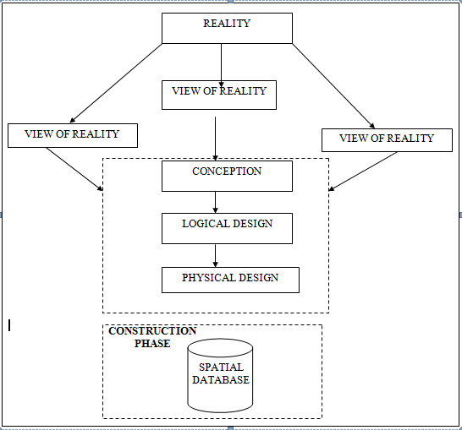
Fig.3.2 Design and Construction Phases in Spatial Database

3.2.2 CONCEPTUALDESIGN
Vector data model is the data type adopted for this project, which is represented, by points, lines and polygon. The identified entities are:-
      - Vegetation area (polygon)
      - Roads(line)
      - Trees(point)
      - Boundary line (polygon)
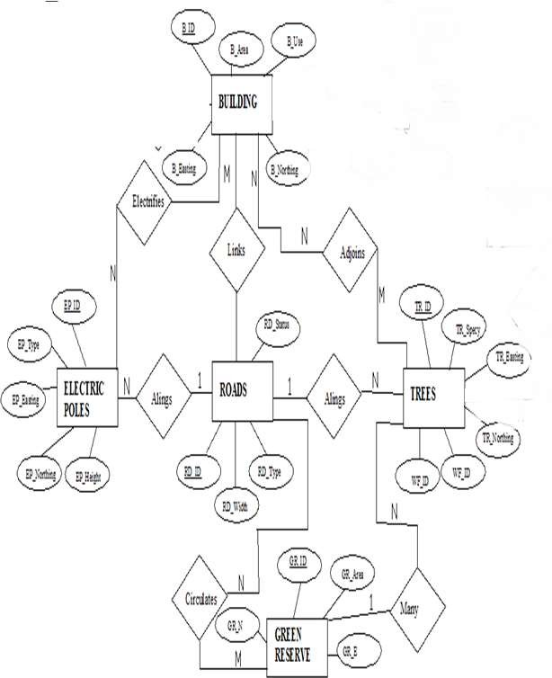
      - Buildings(polygon)

Fig.3.3. E-R Diagram (Entity relationship diagram)

3.2.3 LOGICALDESIGN
This is the design aspect of the database refers to the process of creating a conceptual framework or model that represents the structure and organization of spatial data within the system. It involves defining the data element, their relationship, and the rules for data manipulation and analysis. In this phase, the entities, their attributes and their relationships are represented in a single uniform manner in form of relation in such a way that would be no information loss and at the same time no unnecessary duplication of data. In this study, the logical database design is employed to generate a geo-relation database structure. Each entity has unique identifier in bold type. An attribute type or combination of attribute types that serves to identify an entity type is termed an identifier.
- Building(B_ ID, B_ Area, B_ Name, B_ Easting, B_ Northing)
- Roads(R _ ID, R _ Width , R _ Type, R- Condition, R_ Easting, R_ Northing)
- Tree(TR _ ID, TR_ spp, TR_ Importance, TR_ Easting, TR_ Northing)

3.2.4 PHYSICALDESIGN

Table3.2: Building and its attribute
ENTITY | DESCRIPTION
B_ID | Building Identification
B_name | Building Name
B_Area | Building Area
B_Easting | Building Easting
B_Northing | Building Northings

Table3.3: Road and its attributes
ENTITY | DESCRIPTION
R_ID | Road Identifier
R_ Length | Road Length
R_ Width | Road Width
R_ Type | Road Type
R_ Condition | Road Condition

Table3.4: Trees and its attributes
ENTITY | DESCRIPTION
TR_ID | Tree Identifier
TR_ Spp | Tree specy
TR_E | Tree_ Easting
TR_N | Tree Northing

3.3 EQUIPMENTUSED/SYSTEMSELECTIONANDSOFTWARE

3.3.1 HARDWAREUSED
- Total station
- 1reflector with a tracking rod.
- 1Tripod
- One(1)50m tape
- One(1)umbrella
- 1cutlass
- Hand held GPS
- Hammer
- Nails and bottle cover
- Field book and writing materials
- 1-NoofPersonalComputerHP655 and its accessories
- 1-NoofHP DeskJetK7100 A3 printer
- 1-NoofHPDeskJet 1110 A4printer

3.3.2 SOFTWARECOMPONENT
- Notepad.
- Microsoft Excel.
- AutoCAD2007
- Arc GIS10.2
- Microsoft Word.

3.4 INSTRUMENTTEST
To ensure the quality of the data, the Total Station employed for this project was tested for vertical index and horizontal collimation errors. These tests also aimed to verify the instrument’s efficiency and reliability. The procedure followed is outlined below.

3.4.1 HORIZONTALCOLLIMATIONTEST
This test was conducted to ensure that the line of sight was perpendicular to the trunnion axis. The Total Station was positioned over a specific point, and initial adjustments were made to ensure proper alignment, leveling, and focus (to eliminate parallax in the telescope). A vertical target was placed at a distance of 100 meters from the Total Station. To access the configuration menu of the Total Station, the menu key was pressed and held for approximately 2 seconds. From the main menu, the calibration sub-menu was selected, and within that, the horizontal collimation test option was chosen. The target was then observed and divided into two halves, with horizontal readings recorded for Face left and Face right. The readings are shown in Table 3.4.1 below.
Total Station
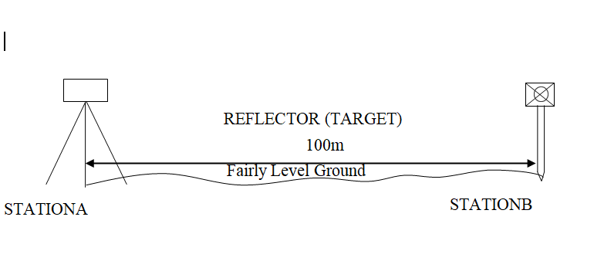

Fig3.4; Horizontal Collimation and Vertical Index error test.

Table3.5: Horizontal Collimation Data
Station | Target | Face | Hz Reading | Difference | Error
A | B | L | 38˚42‟32”
 |  | R | 218˚42‟35” | 180˚00‟03” | 03”
Source field work

3.4.2 VERTICAL IX ERNDEROR TEST
To perform the test, the Total Station was set up over a known point, and all necessary temporary adjustments were made to ensure proper alignment and functionality. A target was placed approximately 100 meters away, and the instrument was aimed at it. The target was first bisected using the face left position, and the corresponding vertical angle was recorded. The same process was then repeated using the face right position, and the resulting reading was also documented. The recorded values are presented below:

Table3.6: Vertical Index Data
Instrument Station | Target Station | Face | Vertical | Sum | Error
A | B | L | 90˚00‟00”
 |  | R | 270˚00‟02” | 360˚00‟02” | 02”
Source field work
3.4.3 ANALYSISOFCOLLIMATIONANDVERTICALINDEXDATA
The reading obtain during calibration were reduced to obtain new collimation and vertical errors.
Horizontal collimation={(FR–FL)–180}/2={(00˚00‟03”}/2=1.5”
Verticalcollimation={(FL+FR)–360}=(90˚00‟00”+270˚00‟02”)-360}=02”Theresult shows that the instrument is still in good working condition.

3.5 CONTROL CHECK
Three control beacons (KPT 120X, KWCS102 and SC/KWEAS5072) were used. In order to ascertain the in-situ of the control beacons, a check was carried out on them by observing the angle between them and comparing the result obtained with the computed angles from the giving coordinates.
The total station instrument was set on the control beacon KWCS102. After performing all the necessary temporary adjustment, the reflector was placed on the control beacon KPT 120X which served as the back station. The horizontal angular reading was taken and recorded while the instrument was on face left. The reflector was then taken to the control beacon SC/KWEAS5072 which serves as the forward station, the horizontal angle reading was then taken and recorded on both face left and face right. The reflector was taken back to the back station, the horizontal angle was then recorded on face right.

Table3.7: Table showing the back computation of the control coordinates
From STN | Bearing | Dist(m) | ∆N | ∆E | Northing(m) | Easting(m) | ToSTN
 |  |  |  |  | 945235.040 | 682280.278 | KPT 120X
KPT 120X | 68°53'46'' | 1397.130 | 503.050 | 1303.424 | 945738.095 | 683583.702 | KWCS102
KWCS102 | 64°07'57'' | 540.797 | 235.946 | 486.612 | 945974.041 | 684070.314 | SC/KWEAS5072
Source: office of surveyor general kwara state

Table3.8: Table showing the distance observation result of the control check
FROM | OBSERVED  DISTANCE  (m) | COMPUTED  DISTANCE  (m) | TO
KPT 120X | 1397.029 | 1397.130 | KWCS102
KWCS102 | 540.694 | 540.797 | SC/KWEAS5072

Table3.9: TABLE showing the observation result of the control check
STN | SIGHT | FACE | OBSERVEDHZANGLE | REDUCED HZANGLE | MEAN
 | KPT 120X | L1 | 357° 08'47''
KWCS102 | KPT 120X | L2 | 288° 14'07'' | 68° 54'40''
 | SC/KWEAS5072 | R2 | 108° 52'13'' | 68° 54'46''
 | SC/KWEAS5072 | R1 | 177° 46'59'' |  | 68° 54' 43''

Difference in angle (observed -computed)=68°54'43''-68°54'40''
=00° 00'03''
Since the allowable accuracy (angular) of third order traverse of one station is 00° 00' 30'' and the result obtained from the control check (00°00'03'') is less than allow able error. Therefore, the controls were angularly intact.

3.6 MONUMENTATION
The boundary of the area carved out was demarcated with the precast concrete beacons, after clearing the required line of sights. The identified points of changes in directions were dug and beacons were buried on it, leaving about 15cm part of the beacon above the ground Level. The beacons were buried at convenient distances as dictated by the nature of the boundary.

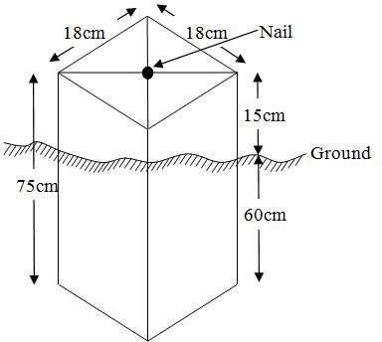

Fig.3.4: Pillar Description

3.7 DATA ACQUISITION

Data acquisition is a fundamental aspect of digital mapping. It involves collecting coordinate data of map features in a format compatible with computers. Various techniques exist for gathering topographical data, and the choice of method depends on several factors, including the data source, available hardware and software, desired level of accuracy, and the manpower involved. In addition to field and laboratory methods, data can also be obtained through social surveys.

In the context of this project, data acquisition refers to the methods and processes used to obtain the necessary data. The acquired data is categorized into two main types: geometric data and attribute data.

PRIMARYDATASOURCE
Field observation was the primary source of data for this project. Ground based method was used in acquiring data with the use of Total Station Instrument, which involved the collection of X, Y, Z data through coordinated Ground control Points (GCP) established at conspicuous points within the study area

SECONDARYDATASOURCE
An imagery of the area was acquired through Updated Google earth; this was used to ascertain the extent of coverage of the project area.

3.7.1 GEOMETRIC DATA ACQUISITION
This involves the acquisition of Nothings, Easting and Height value of features that are present on the project site. In the aspect of this project digital land survey method was adopted.

3.7.2 TRAVERSING
This is a series of connected straight lines, the length and direction of which are determined from measurements. This includes the distance measurement and angular measurements which include horizontal angle and vertical angle between points, whose direction between selected points is determined after some calculations. The total station computed directly the angle and distance measured on the site to determine the coordinates of the point with the aid of the processor. The total station was used to determine the coordinates of the boundary of the project site. The instrument was set on control ‘Y’ and adjustment (temporary) was done, the instrument was focused at the reflector on point ‘X’ to set orientation and point ‘Z’ was observed as the forward station. All other boundary point was observed as the reflector was placed on them.

3.7.3 DETAILING
Detailing entails fixing both natural and artificial feature that exists in the boundary. These include buildings, electric poles, footpaths, culverts, etc. In this project, details were fixed using the total station and its accessories using the ray shooting method.
Here, the ray shooting method was employed to effectively fix the details along the project area. Features such as roads, buildings, storex, etc. were fixed. To achieve this, the total station is set on the transferred point in the project boundary to bisect many edges of details and the reflector was placed at a known station for orientation before positioning it at each corner of the details. The coordinate of each corner is observed and recorded. The details taken include Road, Building, Storex, and Electric poles.

Orientation station
Building

Instrumentation

FIGURE 3.5 SHOW THE DETAILING OBSEVATION

3.7.4 ATRIBUTES DATA ACQUISITION
Attribute data is information about spatial features. They provide the characteristics, description and nomenclature about spatial objects. Thus the attributes data acquired includes names of buildings and their uses such as classrooms, roads, water facilities and prominent natural features likes river and trees found and vegetation were properly identified within and around the study area.

3.8 DATA DOWNLOADING AND PROCESSING

3.8.1 DATADOWNLOADINGANDEDITING
This is stage whereby all data acquired which were automatically stored in the Total Station were downloaded into personal computer. This was done with the aid of downloading cable connected to the computer and some associated complementing software installed on the System.

3.8.2 DATA PROCESSING AND DATA EDITING
These data were processed using AutoCAD 2007 where the acquired coordinate was plotted, and details fixed to depict the study area, after which were exported to Arc GIS 10.2 where digitizing was done, and the attribute data was used to create a database table in relationship to the details. This data table was queried to provide useful cadastral information.

3.8.3 Spatial Relationships
Spatial relationships are the relationship determined by the location, size, shape, and other features of spatial objects. The most common spatial relationships are distance relationships, direction relationship, and topological relationships.

3.8.4 Overlay of plan
The 2D plan of the building in the study was gotten from the ministry and was captured with a digital camera. After which, the captured image was added into the Arc GIS 10.2 environment as a geo-referenced raster image and the conversion to digital form was done by digitizing, then the overlay was done by putting on the two layers containing both files.

3.9 DATABASE IMPLEMENTATION
This phase involves the creation of the spatial database. Following the completion of the three design stages Reality, Conceptual, and Logical design the database was developed using ArcGIS10.2 software. This process entails integrating and storing both the acquired geometric (graphic) data and attribute data to enable spatial analysis and queries.
A database is an organized and integrated collection of data that is structured for efficient access and use by relevant applications, with data retrievable through various logical operations. Once the attribute table was populated manually via the keyboard, certain attributes such as the areas of settlements were automatically calculated and displayed using specific commands available in ArcGIS10.2.
Arc GIS was also used to link the graphic data with the attribute table, allowing for the execution of spatial queries and further analysis.

3.9.1 DATABASE MANAGEMENT SYSTEMS
Database management is a collection of software for creating, storing, manipulating, updating, organizing and querying of information in a database (Kufoniyi, 1998). It is a software package whose function is to manipulate a database on behalf of the user.
A good DBMS must provide the following functions:
- Storage and retrieval of data.
- Access to by several users at a time.
- A standardized interface between database and application programmed.
- Standardized access to data and separation of data storage and retrieval functions from the program using the data.
- Maintenance of data security and integrity.

3.9.2 DATABASE MAINTENANCE
Having created the database, proper maintenance practice was made to meet its stated objectives. The ability to include more data and remove irrelevant data was possible by way of maintenance. There is every need for the data to be updated regularly because of the physical changes that may occur on the landscape with time. Both security and integrity were also exercised to ensure maintenance and to meet its stated objectives.
Proper observance, updating and management of database ensure its currency and quality to stand a profound chance in Spatial Decision Support System (SDSS). The quality of any database depends on the currency and fitness for use as a decision support system (SDSS).The quality of database depends on its ability to generally fit and use as a decision system (DSS). The storage media should be from time to time justified if otherwise could necessitate data inaccessibility or physical deterioration of the storage media. Also care must be taken during populating any database system, as a database is only good as the data supplied. In archiving stable media should be used. Examples of these are
- Computer compatible tape reader
- Magnetic tape
- Optical disc and compact disc

3.9.3 BACK COMPUTATION Table

TABLE 3.10 SHOWS THE BACKWARD COMPUTATION
STN FROM | BEARING  ‘ ” | DIST  (m) | N | E | X | Y | STN  TO
 |  |  |  |  | 683827.457 | 946283.854 | PL1
PL1 | 66 1 55 | 303.145 | 123.146 | 277.005 | 684104.462 | 946407.843 | PL2
PL2 | 149 46 46 | 192.751 | -166.555 | 97.017 | 684201.479 | 946241.288 | PL3
PL3 | 155 17 55 | 50.039 | -45.426 | 20.985 | 684222.464 | 946195.862 | PL4
PL4 | 249 25 28 | 312.969 | -109.990 | -293.005 | 683929.459 | 946085.872 | PL5
PL5 | 332 44 31 | 222.713 | 197.982 | -102.002 | 683827.457 | 946283.854 | PL1

3.9.4 AREA COMPUTATION

TABLE 3.11 SHOWS Area Computation
Double Latitude | Departure | Multiplier
123.99 | -277.00 | -34,345.23
123.99
247.98
-166.55
81.43 | 97.02 | 7900.34
-166.55
-85.12
-45.43
-130.55 | 20.98 | -2738.94
-45.43
-175.98
-109.99
-285.97 | -293.00 | 83,789.21
-109.99
-395.96
+197.98
-197.98 | -102.00 | 20,193.96
+197.98
0.00

Total Area = {(-34,345.23--2738.94) + (7,900.34+83,789.21+20,193.96)}/2
Total Area = {(-37,084.174) + (111,883.51)}
Total Area = 74,799.336/2
Total Area = 37,399.668 SQ MTS

4.5 LINEAR ACCURACY COMPUTATION
Linear Accuracy = 1
{[SQRT (change in Northing) ² _{+ (change in Easting)} ²
_{Total Distance}
Linear Accuracy = 1
{SQRT [(0) ² ₊ ₍₋₅₅₄₎ ²]
_{1081.954}
Linear Accuracy = 1
{SQRT [306916]}
_{1081.954}
Linear Accuracy = 1
554
_{1081.954}
Linear Accuracy = 1
0.512036
Linear Accuracy = 1: 0.5

CHAPTER FOUR

4.0 RESULTS, ANALYSIS, AND DISCUSSION
GIS stands out from other information systems due to its powerful spatial analytical capabilities particularly overlay operations, buffering, spatial search, topographic analysis, and neighborhood and connectivity functions. These capabilities enable GIS to answer fundamental questions related to location, conditions, trends, routing, patterns, and modeling by manipulating and analyzing spatial data. In this project, the primary analyses conducted included overlay operations, topographic analysis, and spatial searches.

4.1 TESTING OF DATABASE
This is the test carried out to determine whether there exists a relationship between data modeled about entities in a spatial database as well as putting in to test its retrieval capabilities. This was done by designing a sample query with certain conditions attached and the query will began to see if desired result is achieved.
Analysis of Result
Data captured were full to ensure standardization of task. Coordinated point was used in order to produce information required and lastly to decision making and produce the output in digital form, while the attribute presented in tabular form. In most GIS operation package including arc view these include measurement techniques, query analysis and geometric operation in this project include questions such as:-
- Architectural planning
- Building overlay
The above listed queries are shown

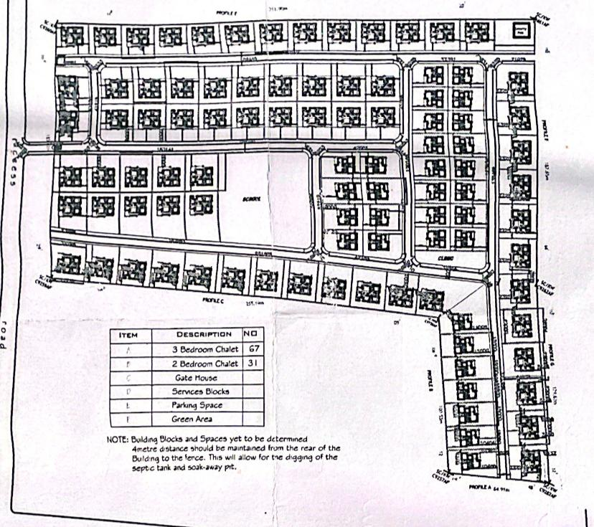

Fig4.1. showing the 2d plan architecture structure of the building
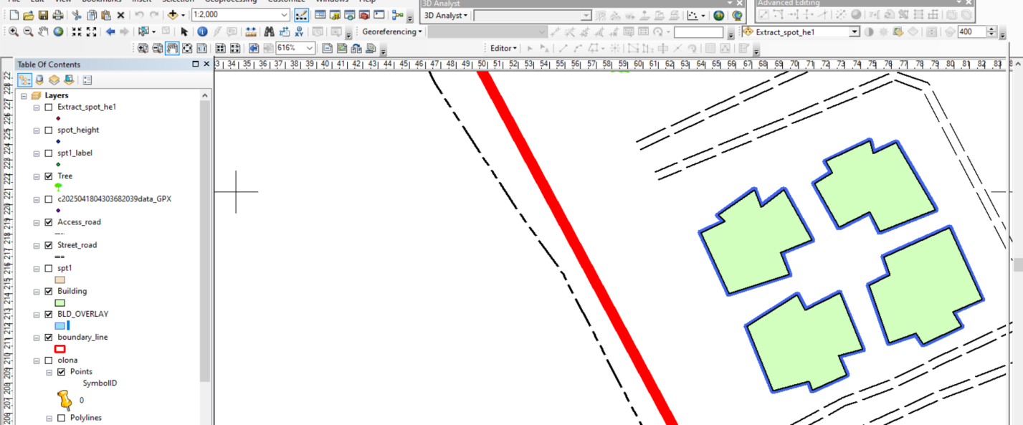
Note: - the 2d plan of the building in the study was gotten from the owner of the Honeywell estate and was captured with a digital camera. after which, the captured image was added into the Arc Gis10.2 environmental as a geo-referenced raster image and the conversion to digital form was done by digitizing then the overlay was done by putting on the two layers containing both files

Fig4.2: showing overlaid of all building in block A

Discussion of result (building overlay block A)
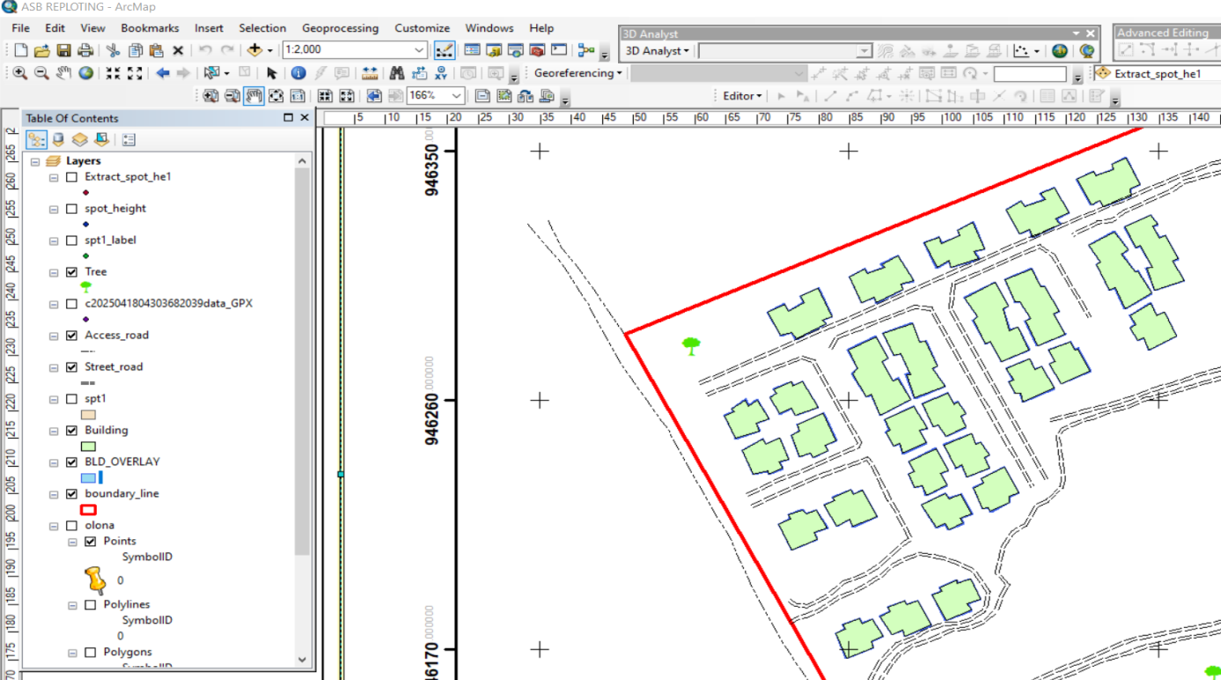
The blue line represents observed edges of the building while the black line represents the digitized edges of the building. It was noticed that the existing building archive design is the same with what we observed in field.

Fig 4.3: showing overlaid of all building of all block
Discussion of result (building overlay of building in all block)
The blue line represents observed edges of the building while the black line represents the digitized edges of the building. It was noticed that the existing building archive design is the same with what we observed in field. But some road paramount with existing architecture lay out while some not paramount, and all of the building shows in architecture plan are not built in land.

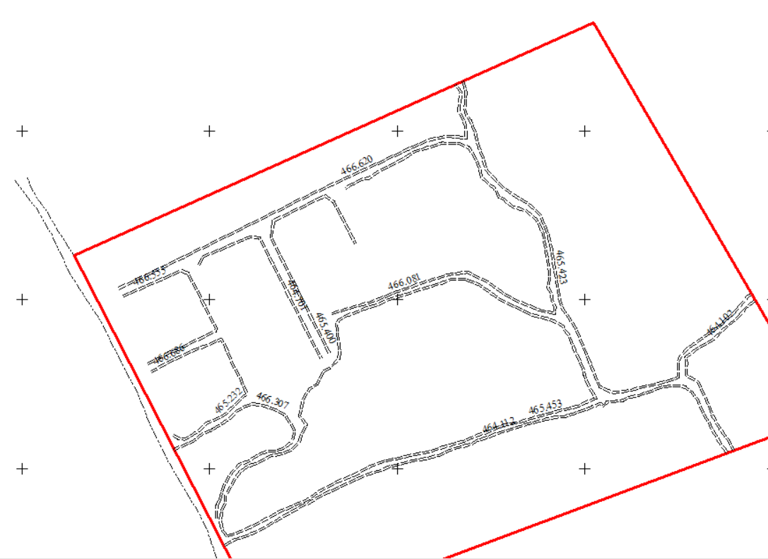

Figure 4.4 Shows the Height of Drainages
This height shows in the figure 4.4 above is the height of drainage were measured in sight with total stations

CHAPTER FIVE

5.0 COST ESTIMATION, SUMMARY, CONCLUSION AND RECOMMENDATION

5.1 COSTING ANALYSIS
Costing Analysis for As-Built Survey of Honeywell Estate
S/No | Item | Cost (₦)
1 | Instrumentation and Rent | 15,000.00
2 | Supervisor | 30,800.00
3 | Technologist | 22,783.67
4 | Technician (7 persons) | 106,323.77
5 | Basic Equipment | 46,027.61
6 | Transportation | 46,027.61
 | Subtotal | 266,962.66

Beaconing Materials
Item | Cost (₦)
5 Beacons @ ₦5,000 | 25,000.00

Beaconing/Emplacement Phase
S/No | Item | Cost (₦)
1 | Technician (7 persons) | 106,323.77
2 | Transportation | 46,027.61
3 | Basic Equipment | 46,027.61
 | Subtotal | 193,378.99

Data Acquisition Phase
S/No | Item | Cost (₦)
1 | Technologist | 22,783.67
2 | Technician (7 persons) | 106,323.77
3 | Basic Equipment | 46,027.61
4 | Transportation | 46,027.61
 | Subtotal | 221,162.66

Data Processing & Manipulation
S/No | Item | Cost (₦)
1 | Technologist | 113,918.35
2 | Technician (7 persons) | 531,618.85
3 | Personal Computer | 230,138.05
4 | Consumables | 69,645.00
 | Subtotal | 945,320.25

Information Presentation & Analysis
S/No | Item | Cost (₦)
1 | Supervisor | 92,400.00
2 | Technologist | 68,351.01
3 | Technician (7 persons) | 318,971.31
4 | Personal Computer | 138,082.83
5 | Consumables | 41,787.00
 | Subtotal | 659,592.15

Comprehensive Report Writing
S/No | Item | Cost (₦)
1 | Principal Surveyor | 154,000.00
2 | Technologist | 113,918.35
3 | Technician (7 persons) | 531,618.85
4 | Personal Computer | 230,138.05
 | Subtotal | 1,099,320.25

Total Cost = ₦3,410,737.00

5.2 Summary of the Study
This research undertook an as-built survey of Honeywell Estate situated along the Oke Ose/Oke Oyi corridor in Ilorin, Kwara State, to produce accurate and current spatial documentation of the estate’s physical features. The project was necessitated by the pressing need for reliable post-construction data to support estate management, legal compliance, and informed planning decisions.
The methodology involved several coordinated stages, including preliminary site assessments (reconnaissance), establishment of survey controls, rigorous instrument calibration, field measurements using a Total Station, and processing of the acquired data with AutoCAD and GIS software. Through this process, detailed coordinates of buildings, drainage networks, roads, and boundary features were collected and digitized.
Spatial analysis, database development, and mapping enabled the identification of design deviations and ensured that the surveyed data aligned with physical reality. Various computational assessments—such as area determination, linear accuracy checks, and database querying—confirmed the reliability of the results. The cost evaluation also gave a practical insight into the financial implications of conducting an as-built survey of this magnitude.
Overall, the study bridged the information gap between estate development and its actual constructed form, reinforcing the role of modern geospatial technologies in land administration and estate governance.

5.3 Conclusion
The completion of this as-built survey for Honeywell Estate has provided vital spatial data that can be used for effective planning, infrastructure maintenance, and legal documentation. The research:
- Accurately captured and recorded existing estate features.
- Highlighted inconsistencies between design drawings and real-world construction.
- Produced updated plans and maps with high precision.
- Employed modern digital tools for efficient data processing and analysis.
- Created a functional and queryable geo-database for estate management purposes.
This underscores the critical value of post-construction surveys in estate development, especially in fast-growing urban regions like Ilorin. Proper documentation of infrastructural elements fosters order, prevents disputes, and supports smart urban management.
In a context where estate layouts are often altered or undocumented, this project reinforces the necessity of integrating as-built surveys into routine construction and planning workflows to ensure data accuracy, enhance legal compliance, and promote sustainable urban development.

5.3 Recommendations
In light of the findings from this project, the following recommendations are made:
- Adopt As-Built Surveys as Standard Practice: Relevant authorities should make as-built documentation a mandatory component of estate approval and development certification processes.
- Update Estate Records Regularly: There should be a scheduled review and update of spatial data within estates to reflect changes due to new construction or renovations.
- Enhance Integration with Digital Systems: The spatial datasets from this survey should be incorporated into the Kwara State Geographic Information System (GIS) for improved urban planning and public service delivery.
- Capacity Development: Continuous training should be provided to surveyors and estate personnel to improve proficiency in using advanced survey equipment and GIS applications.
- Ensure Surveying Standards Are Maintained: All surveying work should comply with local and international standards to maintain uniformity and accuracy across documentation.
- Encourage Collaboration Among Professionals: Coordinated efforts among surveyors, urban planners, engineers, and legal authorities will improve the effectiveness of estate management using as-built data.
- Cost-Effective Approaches: Estate developers and government agencies should consider strategies like shared survey resources, digital automation, or public-private partnerships to reduce the financial burden of as-built surveys.

5.4 Areas for Further Research
While this study focused solely on Honeywell Estate, future investigations could:
- Compare as-built survey practices across different residential estates in Ilorin or other regions.
- Explore the integration of advanced tools such as drones, 3D scanning, and Building Information Modeling (BIM) with traditional survey methods.
- Evaluate how accurate as-built documentation impacts land valuation, tax computation, and legal title issuance.
- Investigate challenges in implementing as-built surveys in informal or unregulated housing developments.

REFERENCES
Adebayo, S. A., & Ogunleye, K. A. (2019). The challenges of effective estate management in Nigerian urban settlements. Nigerian Journal of Urban and Regional Planning, 7(2), 45–58.
Adaradohun, A. O., & Alausa, S. B. (2021). Geospatial analysis of as-built survey data for campus planning: A case study of Federal Polytechnic Ilaro. Journal of Geomatics and Planning, 11(3), 122–134.
Ajayi, O. F., & Olayemi, A. K. (2020). Urban expansion and housing development in Ilorin, Nigeria: Implications for sustainable planning. Journal of Environmental Management and Planning, 14(1), 88–102.
Alausa, S. B., & Adaradohun, A. O. (2021). Assessment of as-built survey practices in Nigerian tertiary institutions. Nigerian Journal of Surveying and Geoinformatics, 9(1), 65–76.
Chekole, G. (2014). Surveying techniques for engineering applications. Ethiopian Journal of Science and Technology, 2(1), 34–47.
Clayton, M. J., Johnson, R. E., & Song, Y. (2016). As-built documentation of buildings. Automation in Construction, 67, 29–40. https://doi.org/10.1016/j.autcon.2016.03.003
Ezeokoli, N. B., Onuoha, K. A., & Nnadi, F. N. (2021). The role of as-built surveys in legal land administration: A Nigerian perspective. Journal of Land Use and Development Studies, 5(2), 94–110.
Ghilani, C. D., & Wolf, P. R. (2012). Elementary surveying: An introduction to geomatics (13th ed.). Pearson.
Ivanchenko, I. (2021). Spatial data reform in Ukraine: Toward decentralized building inspection and geospatial verification. Eastern European Survey Review, 6(4), 77–89.
Kala, R. (2009). Measurement errors in as-built surveys: Tolerances and standard practices. International Journal of Surveying Engineering, 4(2), 112–119.
Król, K., Szulwic, J., & Oszczak, B. (2022). Integration of RTK and tacheometry in as-built documentation of Polish residential developments. Survey Review, 54(386), 327–341. https://doi.org/10.1080/00396265.2021.1875412
Lin, Y., Gao, Y., & Wu, M. (2018). Facility management using BIM and GIS integration: A review and future directions. Automation in Construction, 89, 94–103. https://doi.org/10.1016/j.autcon.2018.01.007
Meydan Yıldız, A. (2019). Building inspection laws and geospatial enforcement in earthquake-prone regions of Turkey. International Journal of Building Science and Safety, 7(2), 59–70.
Nwilo, P. C., & Osanwuta, D. A. (2017). Urban development and geospatial data integration in Nigeria: The role of as-built surveys. Journal of Nigerian Institute of Surveyors, 13(2), 33–50.
Sahely, H. R., Kennedy, C. A., & Adams, B. J. (2019). Geospatial infrastructure framework: Spatial data for sustainable development. Canadian Journal of Urban and Environmental Systems, 21(1), 55–70.
Son, H., Kim, C., Kim, H., & Kim, C. (2015). Disaster response with GIS-supported as-built surveys. Journal of Emergency Management and Planning, 10(3), 144–158.
Tang, P., Huber, D., Akinci, B., Lipman, R., & Lytle, A. (2010). Automatic reconstruction of as-built building information models from laser-scanned point clouds: A review of related techniques. Automation in Construction, 19(7), 829–843. https://doi.org/10.1016/j.autcon.2010.06.007
Teunissen, P. J. G., Montenbruck, O., & Odolinski, R. (2014). Real-time kinematic GNSS positioning: Trends, accuracy, and innovations. GPS Solutions, 18(3), 385–399. https://doi.org/10.1007/s10291-014-0360-2

APPENDIX
NORTHING EASTING ELEVATION POINT I.D
917077.357 726052.265 466.361 A1
917056.108 726040.409 465.352 A2
917072.805 726060.179 466.071 A3
917051.593 726048.197 465.159 A4
915053.0600 726038.880 465.080 B1
917042.186 726032.737 464.667 B2
917048.469 726046.528 465.308 B3
917037.732 726040.501 464.865 B4
917038.766 726031.025 464.532 C1
917028.020 726024.815 463.986 C2
917034.505 726038.812 464.651 C3
917023.621 726032.673 464.293 C4
917025.865 726020.798 463.798 D1
917017.815 726016.481 463.581 D2
917018.546 726030.204 464.084 D3
917012.381 726026.919 463.880 D4
917018.197 726010.815 463.403 DRAINAGE
917041.543 726024.149 464.746 DRAINAGE
917074.177 726042.012 466.174 DRAINAGE
917080.541 726052.044 466.457 DRAINAGE
917069.807 726070.461 466.161 DRAINAGE
917095.850 726017.412 466.896 A1
917095.810 726010.527 466.609 A2
917082.355 726034.474 466.728 A3
917074.478 726029.992 466.393 A4
917095.812 726001.694 466.308 B1
917095.812 725994.695 466.004 B2
917070.365 726027.738 466.253 B3
917062.474 726023.368 466.830 B4
917095.928 725974.880 465.193 C1
917096.021 725967.849 464.904 C2
917045.048 726013.696 465.070 C3
917037.177 726009.264 464.603 C4

917096.929 725931.892 463.179 D1
917097.235 725924.856 462.858 D2
917007.799 725991.856 463.093 D3
917000.000 725987.045 462.697 D4
917103.817 726008.505 467.031 Drainage
917092.494 726030.854 466.935 Drainage
917076.298 726036.311 466.424 Drainage
917055.363 706024.862 465.404 Drainage
917021.068 726005.573 463.499 Drainage
Building CD
917004.843 725996.779 462.820 a
916997.068 725992.188 462.340 b
916998.502 726007.570 462.805 c
916991.889 726004.993 463.021 d
917077.357 726052.265 466.361 A1
917056.108 726040.409 465.352 A2
917072.805 726060.179 466.071 A3
917051.593 726048.197 465.159 A4
915053.0600 726038.880 465.080 B1
917042.186 726032.737 464.667 B2
917048.469 726046.528 465.308 B3
917037.732 726040.501 464.865 B4
917038.766 726031.025 464.532 C1
917028.020 726024.815 463.986 C2
917034.505 726038.812 464.651 C3
917023.621 726032.673 464.293 C4
917025.865 726020.798 463.798 D1
917017.815 726016.481 463.581 D2
917018.546 726030.204 464.084 D3
917012.381 726026.919 463.880 D4
917018.197 726010.815 463.403 DRAINAGE
917041.543 726024.149 464.746 DRAINAGE
917074.177 726042.012 466.174 DRAINAGE
917080.541 726052.044 466.457 DRAINAGE
917069.807 726070.461 466.161 DRAINAGE
917057.181 726089.631 466.699 A1
917035.756 726078.137 465.664 A2
917053.016 726097.826 466.539 A3
917031.261 726086.501 465.391 A4
917032.494 726076.368 465.536 B1
917022.047 726069.781 464.957 B2
917028.248 726084.646 465.277 B3
917017.119 726078.969 464.914 B4
917048.331 726110.610 466.458 Drainage
917051.116 726101.126 466.440 A1
917029.677 726089.536 465.571 A2
917046.948 726109.387 460.530 A3
917025.277 7260097.689 460.610 A4

917026.233 726087.772 465.397 B1
917015.438 726081.930 464.904 B2
917021.812 726095.734 465.371 B3
917010.693 726091.024 464.922 B4
917002.471 726092.888 464.701 Drainage
917021.141 726103.313 465.400 Drainage
917038.138 726111.877 466.081 Drainage
917013.401 726106.348 465.232 Drainage
917024.013 726112.045 465.604 Drainage
917039.909 726127.173 465.516 Drainage
917071.486 726062.584 466.377 A1
917050.126 726050.925 465.566 A2
917067.128 726071.063 466.994 A3
917045.752 726059.413 466.017 A4
917046.918 726049.362 465.353 B1
917036.305 726043.590 464.843 B2
917042.606 726057.660 465.853 B3
917031.798 726051.854 465.559 B4
917032.858 726041.654 464.688 C1
917022.034 726035.727 464.373 C2
917028.253 726050.015 464.347 C3
917017.221 726044.702 464.812 C4
917017.246 726033.107 464.040 1
917010.602 726030.314 463.746 2
917012.387 726046.502 464.562 3
917004.360 726042.253 464.266 4
917060.568 726074.673 466.620 Drainage
917030.236 726059.223 465.423 Drainage
917001.534 726043.767 464.102 Drainage
916998.512 726049.158 464.112 Drainage
916034.047 726068.345 465.453 Drainage
917053.140 726078.458 466.307 Drainage
917059.031 726091.415 466.686 Drainage
917054.211 726099.820 466.555 Drainage

