A CRITICAL APPRAISAL OF THE ROLES OF BANKS TOWARDS DEVELOPMENT OF A BETTER BANKING HABIT IN NIGERIA
(A CASE STUDY OF UNION BANK PLC)

BY

SODIQ MUJEEB MAYOWA
HND /23/BFN/FT/0294

BEING RESEARCH PROJECT SUBMITTED TO THE DEPARTMENT OF BANKING AND FINANCE, INSTITUTE OF FINANCE AND MANAGEMENT STUDIES (IFMS), KWARA STATE POLYTECHNIC, ILORIN KWARA STATE.

IN PARTIAL FULFILMENT OF THE REQUIREMENT FOR THE AWARD OF HIGHER NATIONAL DIPLOMA IN BANKING AND FINANCE

MAY, 2025

CERTIFICATION
This is to certify that this project was carried out with the supervision and approved by the undersigned as having satisfied the condition required for the award of Higher National Diploma in Banking and Finance Institute of Finance and Management Studies Kwara State Polytechnic, Ilorin.

-------------------------- --------------------------
DR. OLOWONIYI A.O DATE
(Project Supervisor)

-------------------------- --------------------------
MRS. OTAYHOKE E.Y DATE
(Project Coordinator)

-------------------------- --------------------------
MR. AJIBOYE W.T DATE
Head of Department (HOD)

DEDICATION
This project work is dedicated to Almighty Allah and also to my parents, Mr. and Mrs. Sodiq

ACKNOWLEDGEMENT
First and foremost, my deepest acknowledgment goes to Almighty Allah, for his overwhelming love upon my life throughout my degree programme.
Secondly,
I wish to express my profound appreciation to my supervisor, Dr. Olowoniyi A. O for his vision and leadership in initiating this project and for his patience, suggestion, teachings and also for reading through my project report.
I sincerely appreciate my lovely Parents Mr. and Mrs. Sodiq, who has helped me financially and mentally, may Allah continue to bless you.
Finally, I appreciate all the lecturers of the department of Banking and Finance who helped me in one way or the other to make this project a success.
I also appreciate those that have contributed in one way or the other for the completion of this programme, I say may the good Lord bless you all. Amen.

TABLE OF CONTENT
Title page i
Certification ii
Dedication iii
Acknowledgement iv
Table of contents vi

CHAPTER ONE: INTRODUCTION
  - Background of the Study 1
  - Statement of the Problems 2
  - Research Questions 3
  - Objectives of the Study 3
  - Research Hypothesis 4
  - Significance of the Study 4
  - Scope of the Study 5
  - Operational Definitions of Terms 5
  - Plan and organization of the study 6

CHAPTER TWO:
2.0 Literature Review 7

CHAPTER THREE: RESEARCH METHODOLOGY
3.1 Preamble 19
3.2 Sources of Data 19
3.3 Population of the Study 19
3.4 Sampling Size and sampling techniques 20
3.5 Methods of Data Collection (Instruments) 20
3.6 Method of Data Analysis 20
Chapter Four:
4.0. Data Presentation Analysis and interpretation 22
Chapter Five: Summary, Conclusion and Recommendation
5.1 Summary of the findings 29
5.2 Conclusion 29
5.3 Recommendations 30
References 32

CHAPTER ONE
  - INTRODUCTION TO THE STUDY
The business of modern banking started in Nigerian in 1892 by the bank of British West African to which the standard bank of Nigeria limited now Union Bank Plc is a successor bank. There was no banking legislature of any and then neither a Central Bank now a ministry of finance emerged until 1958. Prior to 1952, there was all kind of speculative investor who stated mushroom banking business in Nigeria. Their bank usually operated for a while and after collecting deposits from their customers would suddenly disappear from their funds, resulting in large section of the banking community being swindled.
However, this period also witness the existence of reputation banks like the bank of British West African was prevalent then until about 1925 when Barclay bank acquired the colonial bank and opened a branch in Lagos in 1933, while the African Continental Bank Limited into being in 1947
Most of the banks operating in Nigeria at the periods were incorporated abroad and only come to do business in Nigeria and as such were basically foreign companies until the passing of them companies act 1968, part of which it made obligation for all foreign companies to register in Nigeria all the being wholly owned by the Nigeria Institution and individually. Basically, their activities center on commercial banking relating to the financial of export and imports and not much on industries.
On the order hand, the business of merchant banking did not come into being in any meaningful form until 1961 and outpost was opened in Nigeria by Hill Samuel and company, a United Kingdom Merchant bank under the name of Philip Hill Limited.
Also John Holt Limited Operated a kind of finance form in Nigeria around 1961 under the name of Nigeria around 1961 under the name of Nigeria around 1961 under the name of Nigeria acceptance. The two companies later merged under the Nigeria acceptance in 1969.
In August 1973 United Dominion Corporation (Nigeria) limited a wholly owned subsidiary of UDT. International which is in turn Wholly owned by limited Dominions Trust Limited a hire purchase business into that of merchant banking in a bid to accent the contravention their hire purchase regulations of 1968. Later the first national City Bank of Chicago Limited and chase merchant Bank Limited were established in Nigeria. Sometime in 1975 the Nigeria Industrial development bank of New York, baring brother of London and national insurance corporation of Nigeria transformed icon securities limited, Wholy owned subsidiary of Nigeria industrial development bank limited into Icon Limited
  - STATEMENT OF THE PROBLEM
The research work was based on a critical appraisal of the roles of banks towards development of a better banking habit in Nigeria.
However, in the course of this research work, answer will be provided to the following research problems. The problems facing the roles of banks in the development of Nigeria economy are as follows below:
- The strategies which banks use in enhancing its roles towards the development of the economy
- Lack of performance of the banks and insufficiency of funds towards discharging their duties.
- Finally, there are obstacles or challenges facing the roles of bank towards achieving its aims and objectives
  - RESEARCH QUESTIONS
This research work would examine the following question:
- What are the implications of roles of bank towards development of a better banking?
- What are the motives behind roles of bank development of Nigeria economy?
- Is a role of bank development of Nigeria economy survival strategy?
- what are the strength and weakness of role of bank development of Nigeria economy
- Do you think that the role of bank in the development will increase the standard of Nigeria economy?
  - OBJECTIVES OF THE STUDY
The research has point out various aims and objectives that can hinder the success of the roles of banks in developing the Nigeria Economy.
Therefore, the objectives of the study are as follows:
- To elucidate the reasons for roles of banks in development of Nigeria economy.
- To know or identify the factor that can lend to effectiveness of banks roles in the development of Nigeria economy.
- To highlight the problems facing the roles of banks in the development of the Nigeria economy.
- To provide relative solution to the roles of banks in the development of Nigeria economy.
  - RESEARCH HYPOTHESIS
The research hypothesis to the test in the course of this study is stated below:
H₀: the role of banks in the development of a better banking does not contribute to the operation of Nigeria banking sector
H₁: the role of banks in the development of a better banking contribute to the operation of Nigeria banking sector
1.5 SIGNIFICANCE OF THE STUDY
The role of banking in the development of Nigeria economy is the advance in technology and has particularly put the business world on an acceleration of development.
also the use of banking in the development of Nigeria dissemination and this have led to the use of internal problem, the installation of information technology infrastructure in financial transaction has necessitate some radical organization resulting bank staff thus keeping management worried that they have not achieved the desire integration of front and back office function. Thus the need gross for a research work the technology in banking corporation in Nigeria banking systems. In addition to other studies done on this topic this will be in additional knowledge to the effect or roles of bank in the development of Nigeria economy and also the level of information technology development on the Nigeria Banking system.
1.6 SCOPE AND LIMITATION OF THE STUDY
The study is the role of bank in the development of Nigeria economy (A case study of Union Bank Plc).
Therefore, the research work shall be restricted to the cover of the time constraint and also availability of data as the case study due to limitation of time finance and other problem been stated in the research problems.
However, an effort shall be made to ensure that the limitation would not contribute to the effectiveness completion and quality of this research work.
1.7. DEFINITION OF TERMS
Deposit Money Banks: otherwise known as commercial bank before are resident depository corporation and quasi corporation which have any liabilities in form of deposit payable on deman, transferable by cheque of otherwise for making payment. Hence the following also function of the deposit money banks. acceptance of deposits grating of loans and advances, provision for foreign exchange services etc.
Merchant banks: these are wholesales financial institution services provider for corporate bodies such as, manufacturing industry, commercial bank and other companies for medium and long term financing.
Loan: these are credit facilities in which financial institution extend to their customer in prior documentation and scrutinization must have taken place
Exchange Control: This is a mechanism by which a country seeks to conserve mobilize, centralize and rationalize its foreign exchange resources for settlement of international transaction in accordance with the priority of the country.
1.8 ORGANIZATION/PLAN OF THE STUDY
Chapter one covers introduction, statement of the problem, research question, objective of the study research hypothesis significance of the study, scope of the study, definition of terms and plan of the study.
Chapter two enclosed literature review, chapter three contains research methodology, sources of data, population of the study, sample size method of data collection, method of data analysis, limitation to methodology.
Chapter four shows data presentation, analysis and interpretation.
Chapter five include summary of findings, conclusion, recommendation and reference.

CHAPTER TWO
2.0 LITERATURE REVIEW
Given the unstable macro-economic environment which has prevailed in Nigeria in the last few years and great interest and concern this has generated among the professionals and the general public considered if appropriate to focus my project writing on "The role of banks in development of Nigeria economy" with a view of highlighting the banks responsibilities and its contribution within the board context of micro-economic management in the country.
Ogwuma, (1994) stated by providing a brief background on the generals objectives of banks from an international perspective, the bank has two major objectives.
- It performs some traditional functions such as the issue of currency, provision of banking service to the government, control of credit, acting as a lender of last resort and provision of banks. These functions come under its stabilization role in the economy.
- It promotes general economy development by implementing financial policy measures aimed at achieving specific national development objectives. These come under its development role. The role of the bank of Nigeria developing Nigeria economy as recorded vast structural change resulting in varying approaches to economic management. Economic management move from reliance to control mechanism in late 1960s and up to 1984 to a system of deregulation between 1986 and 1993 and bank to the use of control in 1994 to data.
The banks response has influenced it operation appropriately through the establishment of the relevant bureaucratic structure and technologies.
According to Adebayo (2002), economic developments in Nigeria since 1981 have been unique. The bank made critical input into the decision to modify the style of economic management in 1986 till 2002.

THE ROLE OF CENTRAL BANK IN THE DEVELOPMENT OF NIGERIA ECONOMY
Central Bank stands as the apex of the banking system of every country. It is the government representative in banking sector and act mainly as banker to the government. It has a very close association with both government and the banking sector in the economy, advising the government on monetary policy and implementing the policy on behalf of the government.
The central bank has directly and indirectly been playing important role in development of the Nigeria's money and capital market: to promote economic development, the central bank of Nigeria has contributed immensely to the creation and development of financial markets to mobilize and channel saving for economic growth. The central bank as created and matured the money and capital markets.
In order to aid the development of the money market, the central banks of Nigeria introduced Treasury bill in 1960 and Treasury certificate in 1968. Since the creation of this money market instrument, the central bank of Nigeria has been directly involved in their management. Other money market instrument handled at one time or the other includes certificate of deposit, baker unit fund and the call money fund. The bank also established clearing houses in Lagos and other Urban centers of facilitates interbank settlement and enhance the effectiveness of money market transaction.
The central bank has been directly involved in the creation and the development of the capital market institution such as the Nigeria stock exchange and the Nigeria Securities and Exchange Commission.
Researchers "exchange research level" not less than the aggregate of an amount representing 60% of the banks rates and coins in circulation together with an amount representing 35% of the bank other demand liabilities the bank was required to main not less than 80% of its asset in the form of external reserves to back the new Nigeria pound to be issued just before independence.
The reserve/ demand liabilities ratio was later reduced to 40%, while for foreign exchange reserves the bank new aims to achieve a minimum of foreign exchange reserve equal since 1986. at the end of the year, the stem rate stood at US $100 = N3.1828 while it moved down to US $100 = 4.1664 and US $100 = N4.7167 at the end of 1987 and 1988 respectively. At the end of 1989, the naira stood at US $ 100 - 7.58 less in the interbank market, thus bringing the rate of depreciation of Nigeria since the first audition in 1986 to nearly 80% and the value as at May 1991 has reached US $ 100 = N9.0866 and this had again increased the depreciation above the earlier 80percent. They had made the importation dearer for example the agricultural sector or economy witness a considerable boosting due to the fact that the policy show an increase in the movement of industrials to the fact that policy show an increase in the movement of industries to the agricultural and related activities.

THE ROLE OF COMMERCIAL BANK IN THE DEVELOPMENT OF ECONOMY
The history of commercial banking dated as far back as 1892. with the establishment of the African banking operation which was responsible for distribution of pounds sterling in Nigeria for British treasury.
Some instrument for the small scale industries that require this instrument for their production and this reducing their problems of facilities of production. This programme has be recorded a favorable result within the economy and had boosted on domestic industrial sector of the economy for instance some commercial banks have recently purchased some tractor which are been sub leased to farmers for mass production of food for populace:
The accept deposit from their customers credit facilities are given to their customers who are accredit worthy.
Some of the banks now include an executorships and trusteeship service as a facility to a customer.
They register share and handle new issue of shares.
They provide status enquiries service by obtaining opinion on the financial standing of people transacting business with their customers.

THE ROLES OF MERCHANT BANK IN THE DEVELOPMENT OF ECONOMY
The first merchant bank in Nigeria was Philip Hill (Nig) limited which started operation in Nigeria in July, 1969 it merged its activities with that of Nigeria acceptance limited to become
the only merchant bank in Nigeria until 1973m when a license to carryout merchant banking was issued to UDT (United Development trust bank Nigeria Limited). Later restructure and named Nigeria merchant bank limited.
Today, there were merchant bank in Nigeria. The merchant bank performs some roles which contribute to the development of Nigeria economy.
Firstly, in Nigeria the roles of merchants bank is not precisely defined as it has been an up and hill task for the monetary authorities to define their roles in developing economy whose capital market is not fully developed as a result, merchant banks were for a long time performing vitiating the same function as the commercial banks. The Central Bank in its annual monetary policy circulars.
CENTRAL BANK OF NIGERIA ROLES IN OTHER GOVERNMENT SPONSORED FINANCIAL INSTITUTIONS
The Central Bank has played active role in the promotion of development oriented banks such as Nigeria industrial development bank (NIDB) and the Nigeria bank for commerce and industry.
The Nigeria industries development bank was established in January, 1964 and specialist the provision of medium and long term financial for industries either by way of loan or taking up equity shares.
The Nigeria bank for commerce and industry establish in 1973 was set up to provide medium and long term financial loan or equity participation of indigenous enterprises engage industry and commerce.
Other development financial institution includes the Nigeria agricultural and cooperative bank and the federal mortgage bank. The central bank subscribes to the equity capital of these government sponsored financial institution which will be examined in more details.
The central Bank takes a step further in performing its role in National Economic policy formulating. Every year the Central Bank of Nigeria make a concrete contribution to the federal budget through the ministry of finance. The government of the central Bank is a member of the National Economic policy council and the productivity price and income policy Board. The Bank also makes important contribution to the development of Nigeria Economic in the area of economic research through its research development. In addition, it assists the government implementing its rural banking programme, which has helped considering the banking habit and development in the country.
However, the central bank maintaining external and external markets which have played a significant role in shaping the course of Nigeria economic growth development. Example of such external reserved, deregulation and monetary control.
According to Adekanye (2003) the bank is oblige to maintain adequate reserve in external assets mostly in gold, gold and other reserve currency boost Nigeria economy because the capacity to pay for our import depends largely on an export earning or earning from oversea investment, loans and gift from abroad and foreign investment in Nigeria. Management of Nigeria external reserve is very crucial for its own sovereignty.
Thus over the years the management of Nigeria external reserved aimed.
- Ensuring or conserving them. ,
- Safe guarding their value by keeping them in safe currency.
- Allocating them in the most optimum ways among Nigeria numerous competing demand for foreign exchange.
- Keeping them in as much as liquid forms as possible. The main objective of managing Nigeria external reserve was to ensure liquidity and confidence in Nigeria economy.
This period coincide with the issue of first indigenous currency as well as Nigeria civil war. The second period 1974 to date has been concern with the diversification of the country foreign reserve. This relate to issue of maintaining a portfolio of foreign receive that shields the country from wide fluctuating in the values of her reserve apart from wide us to meet our diverse foreign commitment without substantial losses. Bank help in actualize the management of Nigeria reserves and it help so much in developing the economy active supporting role, especially in the management of the foreign exchange market (FEM) implementation of financial sector reforms, management of domestic and external debt and introduction of open market operation (OMO). The bank also continues to promote financial intermediation through it support for institution and scheme such a,s the Nigeria deposit insurance corporation (NDIC), Nigeria export, import bank (NEIB), refinancing and rediscounting facility, export stimulation loan scheme, as well as the rural banking scheme
Nwankwo (2004), in appraising the performance of the banks, stresses that other matter most of the impact of the activities of the bank in Nigeria economy. In this regard, in which examine two aspects the effect of it action on all the overall target of economic policy and the international target variables.
With regard to the overall targets of policy, it is clear that micro-economic stability and sustainable growth have so far remain elusive. While inflation, GSP growth rate and development balance of payment have behaved contrary to expectation in recent years. I would want to caution that he exact impact of bank policies on the overall targets of economic policy is generally difficult to establish, owing to the complementary of monetary and banking policies with physical and other sectorial policies which are outside the control of the bank.
Anifowose (2003), also expressed the roles of banks the development of Nigeria economy in several ways, the period up to 1981-2006 could be regarded as the golden period for banks. It successfully took off as a virile institution and effectively carried out it traditional and functions of currency issue external reserve management and monetary control. In partnership wit the federal government, the bank has supported key financial aspect of the economy in the money.
Also, the commercial banking sector are doing fine in some other economy by giving short term and long term loan to the cost of the nations imports for four months.

EXCHANGE CONTROL IN NIGERIA
The major reason for exchange control in Nigeria to conserve the country's foreign exchange reserve. The authorities aim to achieve effective utilization of these scarce foreign reserves by ensuring that only essential import are allowed into the country.
The exchange control act was enacted in 1962. under the act, the federal ministry of finance is vested with overall responsibility for the administration of exchange control. The central bank of Nigeria has since been appointed it principle agent, while commercial bank, merchant banks bank, investment banks and some financial house, were appointed authorized dealers with the directives and instruction issue by the central bank, major hotels have also been appointed to the act as authorized buyers ate the central bank takes also further in developing the economic structural adjustment programme the aims of the central bank in devolving our currency include:
- Make the cost if imports very high in some cases very prohibitive and to the extent that is leads to reduction in importation.
- It facilitate export promotion because of rises in the cost of domestic production which result in acceleration of the development of local sourcing of productions inputs this programme was implemented by the central bank had recorded a considerable result if the budgeting review rate of importation in Nigeria had reduced greatly because of the exchange rate of Nigeria currency vi-vas the US dollar which has edge down world some small scale industries that requires this for their development in the domestic production.
The commercial bank also undergo a partnership business with small companies who cannot wholly finance their business and this has recorded of avoidable result in the economics of Nigeria because one can emphasize that the price of the electronic which prove exorbitant in the last three to four years have now been gping down considerably and by the end of 2004 the economy of Nigeria is expected to have witness a very favorable boosting and this return back to its normal position during the ear of petroleum boom.
Leasing is another contribution of Nigeria economy by the commercial banks in developing to the small scale sector of the economy. This is a process whereby the commercial bank buy.
Central banks as giving official support to the argument in financial circles that merchant bank would make a more tangible contribution to the country if they provided more specialist services such as equipment leasing and other co-operate services.
However, to fulfill the role mapped out for them merchant banks faces the problem of liquidity. The source and nature of funds available to them, outside their own capital and reserves are essentially short-term deposit payable within one year. In these circumstances, it is difficult for result affect of using short term funds to finance long-term project could be quite disastrous.
In summary, the roles of other parties federal and state government, private Nigeria and foreign investors and financial institution like insurance, stock exchange and other financial houses has also been very crucial.

CHAPTER THREE
3.0 RESEARCH METHODOLOGY
3.1 INTRODUCTION
This chapter is aimed at giving a description of tools, instrument and methods that will be used in presenting and analyzing data and information collected in subsequent chapters. It will also give an insight into areas of study such as population of the study, sample and sampling technique, method of data collection, methods of data presentation and analysis.
3.2 SOURCES OF DATA USED
Data can be defined as any information or facts gathered for the purpose of research.
There are basically two (2) types of data namely: the primary data and the secondary data.
Primary data refers to data or information that has been originally sourced through interviews, questionnaires, observations etc.
Secondary data consists of information extracted or obtained from published documents, that is, journals, gazettes and annual reports.
However, for the purpose of this project work, both primary and secondary data have been employed.
3.3 POPULATION OF THE STUDY
The population of this study constitutes all staff of union bank. It is practically impossible to cover the whole population as a result, sample was determined the size was limited to Union Bank of Ilorin Plc alone, which primarily constitute manager and staff of Union Bank Plc representing a sub-set of the population.
3.4 SAMPLE SIZE
The sample size of this study is twenty questionnaires which was distributed to various staff and members.
The large size has been chosen so as to have fair representation of entire population.
The sampling technique used in the research are systematic sampling which in involves selecting a sampling size from the population.
3.5 METHOD OF DATA COLLECTION
In this research study, questionnaires were used to collect various data used.
So also, the research has a personal interview with the corporate manager of the case study.
The questionnaires used were personally distributed. So also their various official, publication were used for this study and observation were made by the researcher.
3.6 METHOD OF DATA ANALYSIS
The method of data analysis is through historical and inferential method as well as simple regression method of statistical analysis.
Historical researches interpret past trends attitude events and facts. The purpose of this is to gain clearer perspective of the presents. On the other hand, a descriptive research specifies the nature of given phenomenon as well as proper analysis of variables under study in details. It also gives a picture of situation.
However, simple regression method of statistical analysis with be used (that is, regression will be runned) to explain or determining the impact of the Nigerian banking sector. Regression is concerned with obtaining a mathematical equation which describes the relationship between two variables.
The two variables used has been termed X and Y variables.
Hi: The Nigeria Deposit banks has great impact on the development of the Nigerian banking sector.
However, correlation co-efficient will also be calculated to show the degree of relationship.
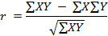

3.7 LIMITATION OF THE METHODOLOGY
Just as any other survey, the research was not without its "flaws" some of the problems emancipated from and the strike that affect the bank as the time of administering the personal interview.
So also, the transfer of some respondent from the sampled bank to other branches makes it difficult or the researcher to gather fully the questionnaires that are given to the respondents.

CHAPTER FOUR
4.0 DATA PRESENTATION, ANALYSIS AND INTERPRETATION
4.1 DATA PRESENTATION AND ANALYSIS
This chapter deals with presentation and analysis of the data gathered during the course of this study. It also cover the bio-data analysis of the respondent and the responses of the questionnaires administered. This will enable the purpose of the study to be achieved.
The interpretation of finding was examined from the various analysis
PRESENTATION OF DATA
Presentation is the formal display of the data collected in chapter three of the project work and the answer the respondent gave through the questionnaire distributed couple with a brief explanation in the pattern of response of such variables.
It is also a method of presenting the information, earlier collected to be physically understood by the researcher without much problem. Tabular form of data presentation was used for better explanation and understanding the project.
ANALYSIS OF DATA
Analysis of data is the breaking down of recorded research information into meaningful parts of critical examination and extraction of other wise hidden information and making inference about the relationship existing among the parts.
The relevant data below are extracted from the response of individuals all in connection with the topic at hand A CRITICAL APPRAISAL OF THE ROLES OF BANKS TOWARDS DEVELOPMENT OF A BETTER BANKING HABIT IN NIGERIA.
Individual respondent gave their opinion about the various question and suggestions in the questionnaire administered to them. The bio-data of the respondent is shown in the table 1-5 below.

TABLE 1: SEX
VARIABLE | RESPONSE | PERCENTAGE
MALE | 12 | 60
FEMALE | 18 | 40
TOTAL | 20 | 100
source: research survey, 2025
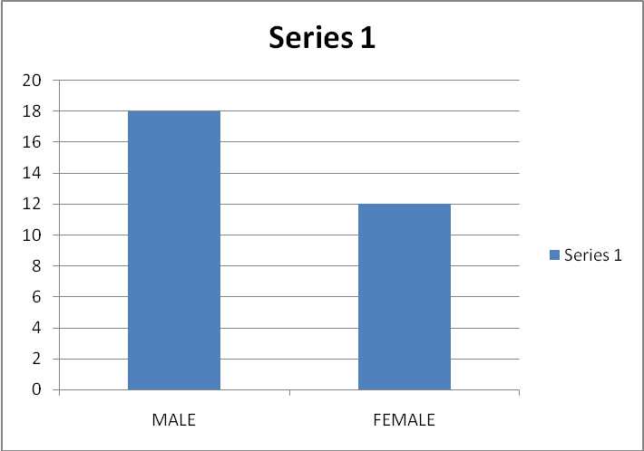
From the above, 60% of the respondents were male and 40% were female, which shows that the male respondents were more than the female.

TABLE 1: SEX
VARIABLE | RESPONSE | PERCENTAGE
Single | 2 | 10
Married | 18 | 90
TOTAL | 20 | 100
source: research survey, 2025
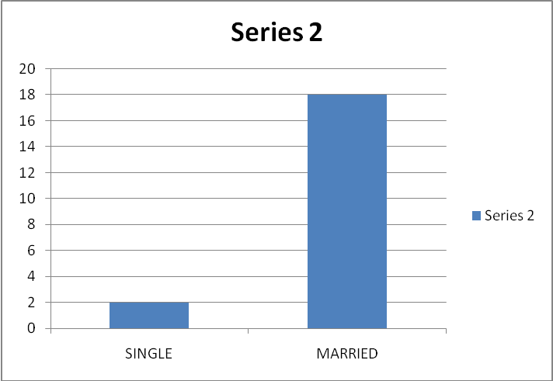
From the above table, 10% of the respondents were still single and 90% were Married and none were divorced, which shows that the married respondents were more than the single.

TABLE 3: Job status
VARIABLE | RESPONSE | PERCENTAGE
senior manager | 8 | 40
Deputy Manager | 2 | 10
Customer care officer | 2 | 10
Others | 8 | 40
Total | 20 | 100
source: research survey, 2025
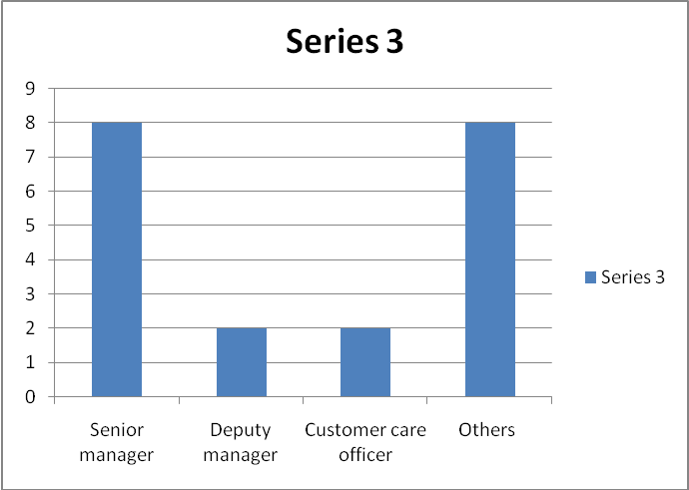
From the above, 40% of the respondents were senior manager and 10% were Deputy Manager, 10% were customer care officer and others experienced were the major respondent.

TABLE 4: Age of the respondent
VARIABLE | RESPONSE | PERCENTAGE
18 – 29 | - | -
30 – 39 | 12 | 60
40 and above | 8 | 40
Total | 20 | 100
source: research survey, 2025
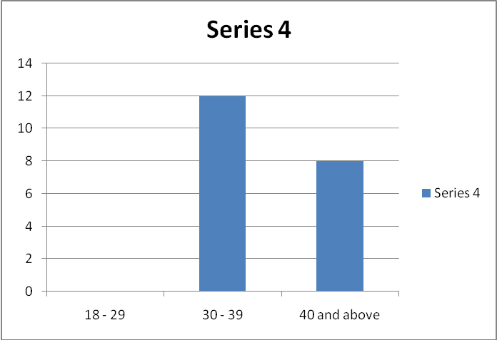
From the above, it is quite clear that none of the respondent were of the age range of 18 - 28 years, 30 - 29 years were 60% and 40% belonging to the range of 40 and above.
TABLE 5: EDUCATION OF THE RESPONDENT
VARIABLE | RESPONSE | PERCENTAGE
NCE | - | -
HN | 4 | 20
HND | 7 | 35
BSC | 9 | 45
TOTAL | 20 | 100
source: research survey, 2025
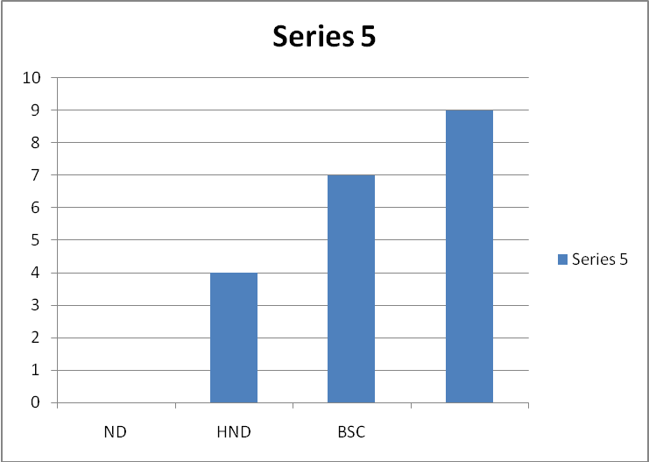
From the above, shows that none of the respondent belongs to NCE qualification, 20% held degree, 35% hold HND qualification while 45% hold B.sc qualification respectively.

INTERPRETATION OF ANALYZED DATA
Pending from section A, it shows that most of the respondent were male and most answered by the married respondents. It also shows that a larger part of the questionnaire were answered by senior manager and other, and they were between the age of 30 to 31 years of age and also 40% of them were older that is within the age of 40 years and above. It also shows that 45% of the respondents are of B.sc educational qualification.
The questionnaire administered has revealed that the roles of bank in the development of the Nigeria economy enhance efficiency and growth in the economy.
Finally, the questionnaire has revealed that there is significant role the banks participate in enhancing the development of the Nigeria economy.

CHAPTER FIVE
5.0 SUMMARY, CONCLUSION AND RECOMMENDATION
  - SUMMARY
The Nigeria banks have come of age in the history of Nigeria economy by making a great contribution to the development of Nigeria. Banks are obliged to maintain adequate reserve in external assets mostly in gold, gold-bultion and other reserve currency have which boosted the Nigeria economy because the capacity to pay for our import depends largely on a export earning banks makes a contribution to Nigeria economy through external reserve management and monetary control.
Quite apart from all the development of Nigeria economy, the present study shows that there is hope of expansion and better performance for the benefit of the economy.

- CONCLUSION
In conclusion this project discussed the roles of banks in the development of Nigeria economy. Though the economy of the country is now worst as well all can witness, yet the joint efforts of these banks have been of great measure to the Nigeria economy. But some business were concern with yielding result or profit particular to those who are benefiting directly or indirectly from the project and nation at large.
Therefore all banks must be encouraged and supported by the federal government especially those with development programme. In order to increase their effort and to increase the industrial aspects of Nigeria economy

- RECOMMENDATION
From the finding the researcher makes the following recommendations, which employed or used, will help banks in the development of Nigeria economy.
- In order to obtain more funds, the bank should mobilize financial resources through the capital market i.e. they should look out side the country for external loan from international financial institutions such as world bank and other organization. This may arises genuinely^ -when the economy goes sour, but under normal situation the check and balance on the facility granted should prevented its occurrence.
- The bank should endeavor to engage qualified personnel into their various department i.e. somebody who doe not know about granting of loan should not be put in loan section of the bank.
- Banks should also endeavor to improve their system of interacting with customers by making sure that the customer demand are met at the time required.
- The bank should also improve their potential facilities so as to gives against loss of customer s deposits and other valuable document kept with them, people should also be enlightened by the staff as to the extent of the safety of the deposits and this will in the long-run be increasing the bank deposits.
- Banks should continue to granting short, medium and long-term loans to customers either have little or more securities or collateral so as established industries.
- Bank should be engaged in programme s that can create employment for people.

REFERENCES
Adebayo, R.O (1999): Elements of banking. Vol 1 Ilorin Olad Publisher.
Adekanye Femi (2003): The element of banking in Nigeria, 2nd edition: Lagos, F and A publishing limited.
Adeoti, O.J (1996): comparative Banking system. Ilorin Kola media prints publisher.
Anifowose, O.K (2003): Elements of Banking, Bullion publication of central book of Nigeria.
Nwakowo; G.O (2004): The Nigeria financial system London, Macmillan press Limited.
Ogwuma, P (1994): Management Strategy and roles of community bank. Lagos, Longman Publication.
Olaloku, F.A (2004): Structure of the Nigeria Economy. Lagos Macmillian press.
Osayemehen, K.O (1952): Practical banking vol 2. Lending and Practical Lagos, F and A publisher limited.
UBA Website (may 17, 2013): Historical background of UBA. www.ubagroup.com/group/history.

