IMPACT OF MEDIA REPORTAGE OF CORRUPTION IN PUBLIC SECTOR AND ITS INFLUENCE AMONG NIGERIAN STUDENTS

BY

AGOHA VENESSA NKECHI
HND/23/MAC/FT/0712

A RESEARCH PROJECT SUBMITTED TO THE DEPARTMENT OF MASS COMMUNICATION, INSTITUTE OF INFORMATION AND COMMUNICATION TECHNOLGY (IICT), KWARA STATE POLYTECHNIC, ILORIN, KWARA STATE
IN PARTIAL FULFILMENT OF THE REQUIREMENTS FOR THE AWARD OF HIGHER NATIONAL DIPLOMA (HND) IN MASS COMMUNICATION

MAY, 2025.
CERTIFICATION
This is to certify that this project was carried out by AGOHA VENESSA NKECHI with Matriculation number, HND/23/MAC/FT/0712 carried out in Mass Communication department, Institute of Information and Communication Technology, Kwara State Polytechnic, Ilorin, and the work has been accepted in partial fulfillment of the requirement for the award of Higher National Diploma (HND) in Mass Communication.

______________________ _______________
MRS. SADIQ N. A. DATE
(Project Supervisor)

------------------------- -----------------------
MR. OLUFADI B. A DATE
(Project coordinator)

--------------------------- --------------------------
MR. OLOHUNGBEBE FATIU T DATE
Head of Department (H.O.D)

DEDICATION
This projects work is dedicated to Almighty God the maker of heaven and earth for His guidance and protection over my life and over my stay throughout my HND programme since the day I was born into this beautiful world. And also to my parent and everyone that has supported me through my academic life.

ACKNOWLEDGEMENT
Firstly, I want to thank God Almighty for his endless mercy and kindness, for seeing me through this journey for holding me strong and for making me come to the end with Hallelujah.
I'll like to appreciate my supervisor in person of Mrs. Sadiq Abimbola Nafisat, the H.O.D (Mr. Olohungbebe Fatiu T.) and all my lectures for the knowledge that they have impacted in me with so much efforts, I want to say your efforts are not unseen
I'll want to thank my family, my mommy and daddy Mr. and Mrs. Agoha for their financial support and also their endless prayers, and to my siblings Fiona Agoha, Kingel Agoha for their endless love and words of encouragement.
I won't fail to recognize my friends that became family, Deborah, Rokibat, Faith, Evelyn and Ayanfe for their love and support and for making school really fun and exciting for me
Lastly I'll like to appreciate Ife Mr. Edesiri Daniel Joseph Sunday for his love and support both financially and emotionally I say God be with you in Jesus name.

TABLE OF CONTENTS
Title page i
Certification ii
Dedication iii
Acknowledgement iv
Table of Content v
CHAPTER ONE
INTRODUCTION
1.1 Background to the Study 1
1.2 Statement of the Problem 5
1.3 Objectives of the Study 5
1.4 Research Questions 5
1.5 Significance of the Study 6
1.6 Scope/Limitations of the Study 6
1.7 Definition of Terms 6
CHAPTER TWO
LITERATURE REVIEW
2.0 Introduction 8
2.1 Conceptual Framework 8
2.2 Theoretical Framework 35
2.3 Empirical Review 40
CHAPTER THREE
RESEARCH DESIGN
3.1 Research Method 45
3.2 Population of the Study 45
3.3 Sample Size and Sampling Techniques 46
3.4 Instrumentation 46
3.5 Validity and Reliability of Research Instrument 47
3.6 Method of Administration of the Instrument 47
3.7 Method of Data Analysis 48
CHAPTER FOUR
DATA ANALYSIS AND RESULT
4.1 Analysis of Research Instrument 50
4.2 Analysis of Respondents Demographic 52
4.3 Analysis of Research Questions 53
4.4 Discussion of Findings 76
CHAPTER FIVE
SUMMARY CONCLUSION AND RECOMMENDATIONS
5.1 Summary 84
5.2 Conclusion 86
5.3 Recommendations 88
References 91

CHAPTER ONE

INTRODUCTION

1.1 Background to the Study
Corrupt practices did not begin today; as history is as old as the human race, corruption is as old as human existence. Corruption is a worldwide phenomenon and there is hardly any society without one form of corruption or the other M.Watts [2019:47].Nigeria often referred to as the “giant of Africa” is without contradiction caught up in the nest of corruption and other official malpractices. Corruption is a cankerworm that has eaten deep into the fabric of almost all public sectors in Nigeria. Today, there is hardly any public or political office holder in who does not have a certain corruption case leveled against him [Aderogba, 2021].
Corruption is anathema to development. Its effects cut across all spheres of life. According to President Muhammadu Buhari, corruption is the greatest form of human right violation. [Wikipedia, 2020].It is a dishonest attitude carried out by persons and institutions with institutionalized authority to acquire illicit funds and properties for private use. Ekiyor [2019] in his broad view of corruption defined it as the unlawful use of official power or influence by an official of the government either to enrich himself or further his course and/or any other person at the expense of the public, in contravention of his oath of office and/or contrary to the conventions or laws that are in force. It is very unfortunate that this menace knows not any time nor period; it happens anytime or period of any nation’s history.
Both youths and adults are involved in corruption[Aliyu O. 2019]The unending scot-free political venality among Nigerian politicians and stakeholders in public sectors has strengthen most Nigeria youths to the act of corruption such as betting, internet scam[Yahoo] etc.In tertiary institutions, the stint has annihilated students conscience and sense of morality towards examination malpractices, scouting for means of getting arbitrary scores beyond their capability, seeking to buy examination questions ahead of the examination, impersonation during examinations, preference of special/miracle centre schools’ than schools with integrity to write Secondary School Certificate Examination, using of ‘bottom power’ to pass examination and involvement in ‘runs’ of various categories, are affecting the development of the country[Ahmad, 2018].
Corruption has destroyed the entire Nigerian society and efforts aimed at reducing fraud in this society have not yielded much result. Corruption thrives in Nigeria and individuals severely affected by it are not willing to speak up or resist the practice of corruption. [Uzochukwu, Ekwugha & Ukwueze 2014, p.7].According to Nwaoble [2004] Nigeria is one of the very few countries in the world where a man’s source of wealth is of no concern to his neighbors, the public or the government. Wealthy people who are known to be corrupt are regularly counted and honored by communities, religious bodies, social clubs and other private organizations. This implies that people who benefit from the largesse of these corrupt people rarely also question [Lydia, 2014]. Although, the government of Nigeria claimed that it had channeled enormous financial and human resources towards the fight against corruption, the global rating of Nigeria as regards corruption leaves more questions than answers to the government [Premiumtimesng.com, 2020]
The fight against corruption in Nigeria has been a difficult task for the government and citizens of Nigeria. Interestingly, successive governments pursued policies against corruption and it was the main reason why the military made incursions into politics. Odekunle, [2007] in Moyosore, [2015] is of the view that every effort evolved at addressing the scourge has always been frustrated by the evolution of even more effective and sophisticated methods of corruption. At the virtual conference of Independent Corrupt Practices and other related Offences Commission [ICPC] on corruption, the Vice President Yemi Osinbajo said the fight against corruption is getting difficult daily and many will be discouraged in standing up against fraud [Adetayo, 2020].
The most focused and far-reaching war against corruption in Nigeria could be said to have started during the regime of the erstwhile president of Nigeria, Chief Olusegun Obasanjo especially with the establishment of the two Anti-graft bodies; The Independent Corrupt Practices and Related Offences Commission [ICPC] and the Economic and Financial Crimes Commission [EFCC].The establishment of the two bodies provided great impetus for the press to perform the constitutionally ordained role of effectively watching over the activities of the government so as to ensure efficient survive delivery. Despite the strident criticism that the war was biased and the agencies were being used to witch-hunt enemies of the government, the press still provided great support to the ant-graft agencies in its activities. The last sixteen years of democratic government show that corruption and corrupt related matters are among issues that are taken major reports and large sizeable percentage of spaces available in newspapers and news magazines.
The mass media apart from informing, entertaining and educating their audience also serve as watch dog of the society. In Nigeria, the independent press, by which we refer to the newspapers and the newsmagazines, have been actively involved in checking the excesses of governments and as well as others in positions of authorities. The mass media are crucial to opinion formulation and eventual outcomes of events as they are champions in the crusade against corruption [Bello H., 2014].They act as the eyes, ears and voices of the public, drawing rights often at considerable personal risk.
Some of the top corruption and scandal cases in public sector and reported by the Media in Nigeria 2015-2023 are listed below according to Oluwole, I. [2015, March]: N195 Billion Maina Pension Scam, Kerosene Subsidy Scam, $6bn Fuel Subsidy Scam, 123bn Naira Fraud – Stephen Oronsaye, Police Pension Fund Fraud, Stella Oduah car purchase scandal, NNPC missing $20billion naira, $15 million in Private Jet Arm Scandal, Abba Moro Immigration recruitment scandal, Crude Oil Theft Scandal, Arms scandal, Ekiti Gate, Ballot Papers, Pardon of Diepriye Alamieyesegha., Mohammed Abacha N446 Billion case, Farouk Lawan $3m bribery scandal., Diezanni Allison-Madueke Alleged Links with know front, Kola Aluko, N6Billion Bribe to Christian Religious Leaders, Nigeria’s Dasuki ‘arrested over $2bn arms fraud’ and False Asset declaration by Senate president.
On this backdrops, this study seeks to investigate the impact of media reportage of corruption in public sector and its influence among Nigerian students.

1.2 Statement of the Problem
The reality of corruption in the society especially within the public sector and the ills accompanied calls for this study. Since it exists in the society and societal values are passed from one generation to another, its influence on students and their [students] perceptions towards the social delinquency as reported by the media is sought.
The 2022 Corruption Perception Index by Transparency International ranked Nigeria 146 out of 180 countries analyzed. This rating is a sad development to the socio-economic advancement of Nigeria as foreign investors, and highly quoted companies would not want to invest and do business in Nigeria. Corruption has destroyed the entire system of governance in Nigeria [Okolo & Akpokighe, 2014], and this makes it difficult to fight and reduce crime to the barest minimum. Prof. Patrick Lumumba a frontline fighter against corruption in Africa said: “the African Continent has lagged in most facets of human development and its largest country; Nigeria has remained in poverty due to fraudulent activities in public service” [Ogundipe, 2016]. Internationally, Nigeria is a laughing stock because no country takes them seriously because of weak institutions caused by corruption. Since the inauguration of EFCC and ICPC as an anti-graft agents by the ACT 2000. It has ever been saddled with the responsibility of preventing and fighting corruption. However, much have been heard about EFCC and ICPC but little has been reported about those that have been prosecuted since 2000 and suspects on their watch list on a regular basis. Many also see EFCC and ICPC as tools in hand of ruling party to hand pick their opposition and to oppress. Similarly, little is known about various money and other recoveries made by the EFCC and ICPC therefore, this research intent to x-ray the role expected of mass media in reporting and disseminating the activities of EFCC and other anti-graft agencies.
In spite of the great role the media is expected to play in the fight against corruption in the society; it is however observed that there is still a marginal disproportion of coverage and reportage of corruption in developing countries like Nigeria.

1.3 Research Aim and Objectives
This research study is aimed at appraising the impact of media reportage of corruption in public sector and its influence among Nigerian students. The specific objectives launched towards achieving the research aim are:
- to determine public knowledge of media reportage of corruption in public sectors among Nigerian students
- to determine impact of media reportage of corruption in public sectors among Nigerian students.
- to assess perception of media reportage of corruption in public sectors among Nigerian students

1.4 Research Questions
- What is the public knowledge of media reportage of corruption in public sectors among Nigerian students?
- What impact do media reportage of corruption in public sectors have among Nigerian students?
- What are the perceptions of Nigerian students on media reportage of corruption in public sectors?

1.5 Significance of the Study
It is the belief of the research that this research study will be significant as it will increase knowledge and skills in the field of research. It will also provide crucial information that suggests for Nigerian students on how to avoid engaging in corruption, and is also a reference material for future research in this field. Media organizations and anti-corruption agencies will see this study beneficial as it will limelight news update on corruptions, recommend news ways to tack the social misdemeanor and bring culprits to book.

1.6 Scope of the Study
The study seeks to appraise the impact of media reportage of corruption in public sectors and its influence among Nigeria students. The study was streamlined in Ilorin, the capital city of Kwara State and covered respondents within the age bracket of 20-50 years. A hundred (100) of these respondents were selected among students and staff of Kwara State Polytechnic students, Ilorin. Survey research design was adopted by researcher to for data collection. The limitations of this study were restricted to time, finance, unavailability of literatures and respondents’ hesitancy during the field survey. However, the researcher ensured that the aforesaid limitations do not undermine the validity of the study.

1.7 Definition of Key Terms
i Media: are the communication outlets or tools such as radio, newspaper, television and internet use in information dissemination.
ii Corruption: It is the unlawful use of official power or influence by an official of the government either to enrich himself or further his course and/or any other person at the expense of the public, in contravention of his oath of office and/or contrary to the conventions or laws that are in force
iii Public sector: Also called the state sector, is the part of the economy composed of both public services and public enterprises. Public sectors include the public goods and governmental services such as the military, law enforcement, infrastructure, public transit, public education, along with health care and those working for the government itself, such as elected officials.
iv Students: a learner, or someone who attends an educational institution
v Reportage: the reporting of news or the typical style in which this is done in newspapers, or on TV and radio
vi Influence: the power to make other people agree with your opinions or do what you want

CHAPTER TWO

LITERATURE REVIEW

2.1 INTRODUCTION
Literature review is the process of exploring the existing literature to ascertain what has been written or otherwise published on chosen research topic, the previous research conducted and their impact on the present topic chosen. Arshed & Dansen (2015) stated that the purpose of a literature review relies on educating the researchers in the topic area and understanding previous formulated research before having the chance to introduce a new argument or justification in a field of study of interest. Therefore this chapter is divided into conceptual review, theoretical approach and empirical review.

2.2 CONCEPTUAL FRAMEWORK

2.2.1 The Concept of Media
The etymology of the word media hints at a rich philological history extending back to the Latin “medius” best exemplified in the familiar narrative topos of classical epic: “in medias res”. Albeit, the path by which this ancient word for “middle” came to serve as the collective noun for most advanced communication technologies is difficult to trace. [John Guillory, 2015]. According to philological record, the substantive noun medium was rarely connected with matters of communication before the later nineteenth century. The explosiveness of this word in the communicative environment of modernity has relegated the genesis of the media concept to a mystifying obscurity. [Wikipedia, 2023].
Media plays a catalytic role in transforming the society in a globalized world. It is one of the medium of communications that have brought the world into one single unit. As the word media derives from the Latin medium that means in the middle.
According to Hoag [2008] the media refers to traditional mass communication system and content generators as well as other technologies for mediated human speech. This would include traditional publishing [newspapers, periodicals, or books], traditional electronic media [broadcasting, broadband, cable, or satellite], motion pictures, video gaming, recorded music, advertising, and adaptations of the Internet for any of these media Information and messages are transferred from the sender to the receiver through a certain channel, known as media.
In the form of a spoken, written, or printed word or any sign, medium is what conveys a meaning. These could be coded in the form of electronic message. Besides this scientific understanding of the concept of media, there is a current common parlance of it, as a process or instrument designed to reach a large number of consumers as audience, readers, or viewers. In the common parlance, “media” and “mass media” are used almost interchangeably. The term “media” was first used with the advent of newspapers and magazines [Pushparaj 2014]
The media works as the tools that publicize information and entertainment to a large and vast number of populations. A number of Internet based newspapers, journals, and periodicals have already made their presence felt [Kumar 2008]. The web newspapers are becoming increasingly popular. And the net editions of almost all the major newspapers are as popular as their print editions. Mass media have helped in creating social awareness and have also provided people with an easy way of living life [Rajan 2011]. Thus, media refers various means of communication, its aim to reach a very large population, such as the entire population of country.

2.2.2 Types of Media
Media is devices of the communication which is useful to communicate and interact with a large number of audiences in various languages. One cannot separate himself from media. Media is used for the entertainment, communication and dissemination of information, advertising, marketing, and for expressing and sharing views, opinion, and ideas.
However, there are different types of media that are accustomed to the day and age. Whether its children, young people, or adults, everyone had their own share of media related exposure every day. According to Salvin Paul [2021], media can be categorized into three, viz:[i]print media;[ii]electronic media; and [iii]social media.
- Print Media:
One of the foremost sources of information earlier was the print media. The first printed newspaper appeared in Beijing, China, in the eighth century A.D. In India, the first newspaper Hicky’s Bengal Gazette appeared in English and edited and published by James Augustus Hicky, an ex-employee of the East India Company on January 29, 1780 [Vilanilam 2005]. The first wave of newspaper in Nigeria is traceable to 1859 when Henry Townsend, a missionary, established “Iwe-Iroyin’. The newspaper hit the street of Abeokuta and was published every 14-days, having 8-pages in total and sold for 120-cowries.
Traditionally the term print media refers to the distribution of printed works. It includes newspaper, magazines, booklets, barouches, house magazine, periodicals or newsletters, direct mailers, handbills or flyers, billboard, press releases, books, etc. Print media like newspapers and magazines influence people such as politicians and policy makers who often turn to print media for their news, intended to reach general public.
- Electronic Media:
The second is the electronic media that is kind of media which requires the user to utilize an electric connection to access it. It is also known as broadcast media. It includes television, radio, and telephones, etc. The invention of electronic media was a turning point in the history of communication process [Lee 2009]. Western Nigeria Television also known as WNTV was the first electronic media launched in Nigeria and the whole of Africa. The station played a significant role in beaming taped Yoruba traveling theatre productions to households. WNTS was created as a partnership between the Western regional government and a foreign firm. It was designed to be an educational tool for the masses and also a medium to beam local culture, foreign news and aims of the government to the homes of people in the region. Establishment of the station was enhanced by a constitutional change that removed broadcasting from an exclusive item to a concurrent item and political resolution of the regional premier, Obafemi Awolowo and the regional minister of Information, Anthony Enahoro.
- Social Media:
The third is the social media or can be called as new media. The emergence of Internet and mobile technology, a new way of news dissemination, started taking place. Today there are a number of social media sites in the form of blogs, social networks, microblogs, forums, wikis, photos, audio and video sharing.
Hjarvard [2013] opines that due to the advancement in technology, it is not only the journalists who become the news distributers. Anyone can publish news and opinions on the Internet and on the social networking media. Social media use web and mobile technologies to make communication as an interactive dialogue [Mathur 2012]. It allows the people with little knowledge about the technology to create and share content [Dar 2011].
Social media are a group of web-based applications that enable people to create and exchange information, pictures, videos, and social booking Social media is one area of communication that allows one to share views and opinions. A major point of difference between social media and conventional media is that the former allows instant responses, which is critical in moments of conflict. However, uncontrolled and irresponsible usage of this media is a great danger to the society [Baruah and Upadhyaya 2014].

2.2.3 Media Reportage
Collins dictionary defined media reportage as any photographing, recording, documentation or broadcasting of newsworthy content to the populace using any of the forms of media such as television, radio, print or the new media. Same news can be reported in different ways in various media platforms, though they apply the use of the characteristics of news when writing stories.
The difference in reporting is not because of the happenstance, but because of the demand of the medium and the target audience. For example, the print media relies more on words and photographs, whereas the television news requires visuals or videos, the radio news is delivered in the form of sound and the online news can present the news using all word, video, audio and photographs. In print news, where space is the concern, a sentence can be about 20-25 words, whereas in broadcast news, where time is a concern, a sentence usually contains 10-15 words. Similarly, People do not read information on the Web in the same way as they read a newspaper or watch television or listen to the radio. (Obianigwe. N. O. (2019)
According to Bello H. A. (2014), the unique nature of media and the way in which it is received by the public demand newspapers, radio, television and online media to adopt different reporting style. For example, we receive a newspaper everyday and it remains unchanged throughout the day. We can reread the story as much as we want. But in case of Television or Radio, the timing is important. The news need to have immediate feel. Reporting must be done on things that are happening now. Each news medium embodies a unique regime of content creation.
For a journalist working for TV News or Online media, every minute is deadline because, because news broadcasts could be made at any time of the day. However, for a newspaper reporter the deadline is fixed, since newspapers are printed once a day. This gives more time to the newspaper reporter to write their story and more in-depth reporting. Similarly, the Television has the advantage of showing video and hence required fewer words than print. Websites news reporting can cover text, audio, and video information, all of the ways traditional media are transmitted. Unlike the television or newspaper, the web news portals have more interactive approach by allow
addling, nepotism, fraud, speed money or embezzlement. Some writers develop this definition to include making corruption a cultural phenomenon (Natalie Melgar et al, 2010).

2.2.4 Corruption in Nigeria
The destructive impact of corruption in the lives of nations throughout the world is acknowledged. Corruption is perhaps the most important factor that is impeding the accelerated social economic transformation of developing and less developed countries [LDCS] of the world. In fact, it is recognized by development scholars that the level of reduction in corruption has a very direct link to the level of economic development of nations in the world.
Corruption is a world-wide phenomenon, element of corruption is found in almost all countries of the world. However, it must be said that the incidences of corruption are much more prevalent in developing countries like Nigeria as noted by Anderson H. Etal [1999:316] “The condition of these countries are such that corruption is likely to have different causes and consequences than in more developed countries are more conductive to the growth of corruption [Lydia, 2014].
In Nigeria today, there is hardly any public or political office holder who does not have a certain corruption case leveled against him. The trend has eaten deep into the fabric of the society. It has become order of the day in Nigeria. This phenomenon cuts across both the executive and the legislature which is supposed to check the executive arm.
Benjamen, S. A. (2017) stated that the case that readily comes to mind is the case of a legislature, Faruk Lawan captured on camera allegedly collecting bribe to influence the oil subsidy probe. Other cases are that of a former minister of Aviation, now senator elect, Mrs Stella Oduah alleged to have been involved in contract inflation in the purchase of vehicle; the popular $20billion unaccounted fund by the NNPC, N2billion police pension scam to mention a few.
Seeing the place corruption occupies in the Nigeria System, the former president of Nigeria chief Olusegun Obasanjo, initiated the economic and financial crimes commission [EFCC] under the chairmanship of ACP Nuhu Ribadu. The Economic and Financial Crimes Commission [EFCC] effort even though commendable has proved to be ineffective. This is because as attested by its leadership, the fight against corruption is too big to be left in the hands of the anti-graft agency. Since inception, the commission has been able to successfully prosecute highly placed government officials as well as those in the private sector accused of corrupt practices. The mass media apart from informing, entertaining and educating their audience also serve as watch dog of the society.(Omenka, I. J. 2016)
According to Alemika, E.E.O. (2012) cited in Ijewereme O and Dunmade E. (2014), corruption in Nigeria can be classified as follow:
- Private Corruption: By private corruption, we mean people outside government, private individuals engaging in unethical acts. These could be individuals outside organizations who commit acts of immorality (perversion, show of dementia, and acts of fraud or scamming). The other groups of people is persons in the organized private sector who may loot or carry out other acts of fraud in their companies or who colludes with those in government to perpetrate sharp financial practices. Private corruption has manifested in Nigeria as everyday bribery to obtain a desired objective, breaking of traffic laws, piracy, plagiarism, alteration of school grades, illegal inflation of petroleum pump prices by dealers, robbery, sexual gratification for higher grades or promotion, et cetera.
- Public Corruption: This is the familiar corruption that takes place in government or by government officials and their accomplices in the private sector. Another name for public corruption is official, grand or institutional corruption. This is the kind of corruption involving public office holders. In this case, persons in position of authority exploit the position to take from the commonwealth.
- Political corruption: This is the kind of corruption that obtains in the three arms of government in a democratic rule, namely, executive, legislative and judiciary. Corruption at this level is the highest because it involves state fund. The issues of personal and primordial attachments in appointment, award of contracts; as well inflation of contract monies, embezzlement of funds, and misappropriation of fund are critical examples of public corruption in the executive. The Federal cabinet in Nigeria has in recent times been in the news for high profile bribery scandals (the formal minister of petroleum Alson madueke and others). The judiciary becomes vulnerable when it looks away from an obvious case of crime, tries to downplay the veracity of a crime, or commits travesty of justice for a particular political interest. The Federal Court of Appeal has been in a state of crisis for some time leading to the suspension of its president on alleged complicity in election cases involving some western states which the president was said to have served the interest of a political party (Ketefe, 2012).

- Bureaucratic corruption: Corruption here is still at the level of government. It involves the technocrats and civil as well as public servants who implement government policies. These include the leadership and personnel in ministries, departments and agencies (MDAs). The corruption at this level is the worst as the allocation, release and use of money is executed by these government offices. The staff are the ones that propose and submit financial needs of the units or projects and they are the ones that transfer and effect payment. Corruption becomes rife at this point (Buhari ,2015). We have had cases of heads of ministries and parastatals busted and arraigned before competent courts and tribunals on charges of high profile stealing and fraud. Bureaucratic corruption also manifests in favouritism and nepotism in appointment, promotion and reward systems in public offices. Some persons get rapid promotion and rewards on the basis of family, friendship, ethnic or religious affiliations to the boss; while some never get promotion because of such frivolous considerations.
- Military corruption: This was obtainable in Nigeria during military dictatorship. Ironically, the military was an institution that saw itself as a corrective regime in the face of bad leadership and festering corruption. That was the original intention of the army when they struck in January 1966. But we also know that the counter-coup of July was an ethnic-motivated coup meant to avenge the assassination of some persons of northern extraction in the first coup. With this mentality, professionalism that formed the fulcrum of the “corrective” notion of the institution began to fade out as corruption gradually crept in. By 1971, the military had become debased as all sorts of allegations were raised against General Gown’s military ministers and state governors. It got worse with the Babangida and Abacha regimes which came under the spotlight as the two most corrupt leaderships in the country (Folarin, 2014).
- Other forms of institutional corruption: The other forms of institutional corruption include that in the media and entertainment industries and even in the labour movement. The media is particularly known for the graft or ‘brown envelope” syndrome in which news reports are only publishable when certain individuals or groups in the story pay their way; or when an image polishing is done for those who can pay the reporter for it; or negative stories are stepped down when money has been paid to destroy such story. In the entertainment industry, persons for musical or movie auditions may have to “sort” or “settle” with money or sexual gratification to be given roles in films even when they are good or very bad. Labour groups are sometimes compromised by government not to embark on industrial action or to betray the cause of the movement by “sorting” labour leaders through the fattening of their accounts (Folarin, 2014).

2.2.5 Causes of Corruption in Nigeria
Several reasons have been adduced for corruption in Nigeria, one of which is the sudden disappearance of good moral and ethical values. Nwaobi [2004] posited that Nigeria must be one of the very few countries in the world where a man’s source of wealth is of no concern to his neighbours, the public or the government. Wealthy people who are known to be corrupt are regularly courted and honoured by communities, religious bodies, social clubs and other private organizations. This implies that people who benefit from the largesse of these corrupt people rarely ask questions.
Sociological and/or cultural factors such as customs, family pressures on government officials and ethnicity constitute potential causes of corruption. In Nigeria, although traditional values of gift giving and tributes to leaders often lead to what Brownsberger [2003] describes as "polite corruption", the extent of such corruption is relatively small. Dandago [2008] revealed that traditional chieftaincy titles and membership of boards of directors of government-owned corporations are only for the‘influential’ individuals in the society who have ‘made it’ economically or politically. Most of those people ‘made it’ through enriching themselves fraudulently, but enjoy public respect and accolades. The most annoying thing is that honest and dedicated public servants, who have not accumulated dirty wealth, do not command much respect from the society. These attitudes serve to encourage anew-breed of public servants who engage in corrupt practices.
A number of authors [Wraith and Simpkins, 1963;Llyod, 1967; McMullan, 1961] have pointed out that Africans know the difference between a polite gratuity and a bribe and that traditional [Nigerian] culture does recognize that the community leader has a duty to his people, and that this bars systematic exploitation of office. Chabal and Daloz [2019] reasoned that in Africa, such factors as the obligations of mutual support, the imperatives of reciprocity, the importance of gift exchange, the payment of tribute, the need to redistribute, even the habits of cattle rustling, or, more generally, of plundering others, all have a bearing on the phenomenon of corruption on the continent today. There are also those who believe that modern bribery may not be seen as cognate with traditional gift giving since it takes place outside the context of a patron-client relationship. Ethnically, the poor man's bribe to the faceless power he will never meet again is completely distinct from his traditional gift to a patron.
A weak enforcement mechanism [e.g. lack of judicial independence; weak prosecutorial institutions] is another major cause of corruption in Nigeria. The forces, which deter corruption, are often weak as some, if not most, of the law enforcement agencies are themselves corrupt. In addition, rulers, politicians and civil servants are highly corrupt, and professional organizations may be incapable of sanctioning their members.
According to Maduegbuna [2015] the benefits of corruption are greater than the consequences of being caught and disciplined. High incidence of poverty, which according to National Bureau of Statistics [2005] is put at54.1% contributed in no small amount to the desperation of Nigerian to acquire wealth through any means. While the few employed received low wages, unemployment is high. The unemployed are mostly youths engaged in anti-social activities, such as cybercrime, drug peddling, prostitution, political thuggery, paid assassins, oil bunkering, kidnapping, militancy [Niger delta] among others; all in the name of money. Dandago [2008] observed that the poor salary levels of most public servants have not kept pace with inflation, which has eroded their purchasing power. It is also clear that the process of gaining power in Nigeria is either by armed force or the influence of money. Jimo et al. [2001] attributed corruption within the [African] region’s public administrations to over-centralization of power, lack of media freedom to expose scandals, the impunity of well-connected officials, and absence of transparency in public fund management, clientalism and low salaries.
Johnston [2007] identified weak political competition as a strong factor that helps to sustain corrupt practices. He opined that this has generally plays a role in sustaining most serious cases of entrenched political and bureaucratic corruption. He submitted that stronger political and economic competition could enhance accountability, open up alternatives to dealing with corrupt networks, and create incentives for political leaders to move against corruption.

2.2.6 Nigeria Public Sectors
The public sector, also called the state sector, is the part of the economy composed of both public services and public enterprises. Public sectors include the public goods and governmental services such as the military, law enforcement, infrastructure, public transit, public education, along with health care and those working for the government itself, such as elected officials.[WebFinance, Inc.2016].
According to the Institute of Internal Auditors [2011], the public sector consists of governments and all publicly controlled or publicly funded agencies, enterprises, and other entities that deliver public programs, goods, or services. After the achievement of independence by most African countries in the late 1950s and 1960s, the public sector was widely regarded as the pivot that would promote socioeconomic development. [Ayee, 2005].
The public sector might provide services that a non-payer cannot be excluded from [such as street lighting], services which benefit all of society rather than just the individual who uses the service. Public enterprises, or state-owned enterprises, are self-financing commercial enterprises that are under public ownership which provide various private goods and services for sale and usually operate on a commercial basis. Organizations that are not part of the public sector are either part of the private sector or voluntary sector. The private sector is composed of the economic sectors that are intended to earn a profit for the owners of the enterprise. The voluntary, civic, or social sector concerns a diverse array of non-profit organizations emphasizing civil society. In the United Kingdom, the term "wider public sector" is often used, referring to public sector organisations outside central government
The basic function of the public sector, which comprises a number of institutions for the making and implementation of decisions with regard to interests of various kinds, was to provide goods and services to citizens based on “realization and representation of public interests and its possession of unique public qualities compared to business management” [Haque, 2001]. With the support of donor countries, states had become involved in virtually every aspect of the African economy by the end of 1960 [Tanzi, 1995].
Nigerian Public Sector organizations are bureaucratic in nature; hierarchical and staffed mainly by permanent career officials. Employment and job security is guaranteed while promotion is largely based on seniority and remuneration is fixed. Private Sector organizations on the other hand, due to its focus on profit making, are sometimes hierarchical, but employ largely on merit. Incentives are motivated by efficiency and rewards increase for more efficient people. Promotion is to a large extent dependent on performance [Osemeke, 2011].
For example, when the NNPC was established, instead of recruiting personnel experienced in that industry [The Energy Regulatory Industry], staff was drawn from the Ministry of Mines and Powers. While such staff might have been technically qualified, their lack of adequate experience in modern business management made them less suitable for such roles. Similarly, the merger of the Electric Corporation of Nigeria and the Niger Dam Authority to form the Nigeria Electric Power Authority of suffering the same fate [Oyeneye, 2004].
Example of public sectors in Nigeria are not limited to:
- Nigerian Port Authority [NPA]
- Nigerian Communication Commission [NCC]
- Nigerian National Petroleum Commission [NNPC]
- National Teachers Institute [NTI]
- Power Holding Company of Nigeria [PHCN]
- National Universities Commission [NUC] e.t.c.

2.2.7 Corruption in the Nigeria Public Sectors
The Nigerian society has never been well governed because of impunity and corruption since it gained its political independence in 1960 (Oluwasanmi, 2007, Ebegbulem, 2009). Oluwasanmi, (2007); Imhonopi and Ugochukwu, (2013) are of the opinion that from the first democratic experiment in 1960 to military regimes and back to democracy as practiced in the country today, Nigeria has unfortunately been managed by corrupt leaders who are visionless, weak, parochial, morally bankrupt, narcissistic, egoistic, greedy and corrupt. The leadership from 1960 has criminally managed the country’s affairs, accumulate wealth at the expense of national development and throwing the people over the precipice where they now wallow in absolute poverty, illiteracy, hunger, rising unemployment, avoidable health crisis and insecurity (Ebegbulem cited in Imhonopi and Ugochukwu, 2013).
The Formal president Olusegun Obasanjo assumed office in 1999 as poor politician (all his bank accounts amounted to about N20,000) but eight years later he had refurbished and expanded a derelict agricultural (poultry) farm at Ota in Ogun State to be now worth hundreds of millions of naira (Oluwasanmi, 2007). Obasanjo now possesses educational institutions that run from primary level to university, he now has over two hundred millions of shares in various conglomerates, most especially Transcorp Nigeria Limited (Oluwasanmi, 2007). His effort at combating corruption made little or no impact in the war against political corruption as his friends and officials under him were corrupt (Ebegbulem 2012; Oluwasanmi, 2007).
Furthermore, corrupt leadership has also been visible in the past administration. The people of Nigeria and the world have observed the cluelessness and low credibility of the past Goodluck Jonathan administration. New York Times Newspaper of May 6th 2014 describes him as “leading a corrupt government that has little credibility”( Moris,2015). In a similar vein, Jonathan government was also described by former US Republican presidential nominee, Senator McKay as a practically non-existing government that has lost credibility in providing security of life and property (Ijewereme and Dunmade, 2014).
In addition, Hillary Clonton, the former US Secretary of State in separate events in New York City said the Nigerian government under President Goodluck Jonathan, squandered its resources, and indirectly helps corruption to fester in the troubled country ( Moris , 2015) . Falana (2012) opines that, under president Goodluck administration: “some of the governors and his party members under investigation posted their orderlies and relations to man departments in the EFCC”. Falana further posits that corruption is being carried out with impunity under past President Goodluck Jonathan administration to the extent that the war against corruption has been lost completely. The minister of petroleum, “Mrs. Daziani Allison Madueke has been indicted of corruption by five different investigative panel Committees reports at different time, yet she confidently remains in charge of the Ministry unperturbed” (Melaye, 2013), without the president demonstrating political will to bring the minister to book. Madueke has also being recently indicted (for squandering 10 billion naira on private jet maintenance expense) by the House of Representative. The house called her to defend the indictment; instead she took court injunction restraining the house from further investigation and indictment of her office (Ijewereme & Dumande,2014). Presently she was indicted in UK for money laundry and charge to court (Punch,2015).

2.2.8 Corruption and among Nigerian Students
Considering the effects of corruption among students in Nigeria, Memory and Memory [2013]x-rayed corrupt academic practices which, according to them, advertently or inadvertently, has plunged the Nigerian educational system into a tragic situation of endemic examination malpractices and other examination vices. They noted that if the menace of academic corruption is not addressed positively, the educational system will continue to produce half-baked graduates, poor tertiary education and decline of roles of universities, especially in the area of research and development.
Kaffenberger (2012) states that corruption within education systems changes the way in which education affects people. Many of the benefits of education, from cognitive learning to intangibles such as good citizenship and increased social cohesion, can be obstructed by a corrupt system, and corruption can infiltrate education systems in multiple ways.
There are several types of corruption that exist in the education system. Both Akaranga and Ongong’a (2013) in their study on phenomenon malpractices at the university included girrafing, collusion with the examiners among others. The anecdotal sources within Kikuyu Campus revealed, forms such as: switching of grades and changing of grades at the examination entrance office, students sitting for others in examinations, some students writing examinations in their rooms then collecting, duplication of term papers in the printing rooms where they are sold, exam leakages by the lecturers, use of “cheat sheets” in exam rooms. Most of these practices are captured by Akaranga and Ongong’a (2013) yet the switching of grades by the Information Technology officer in-charge of entering students’ grades has drawn my attention since it seems an emerging trend unknown to many people and it’s a straight violation of ethics.
Several researchers allude to these forms of corruption in education. Heyneman (2004) describes many types of education corruption among students such as: (i) the purchase of the questions prior to testing for those students taking standardized tests, (ii) established price for a passing score which students are expected to pay before the test, (iii) teachers requiring payment for a student to pass to the next grade and (iv) teachers offering afterschool tutoring for a fee, and then suggesting that students should attend in order to pass a class.
According to Godwin P. (2008), bribery and corruption continue as students move from primary school to higher levels of education in Nigeria. It can be common for university admission to require paying bribes to the admissions committees. Once accepted, university students may have to “pay bribes to have access to university-owned housing, access to their personal transcripts or a book in the library of which there are only a few copies”.
The study of corruption has been intensified particularly due to the impacts it has on individuals and the society. According to the Transparency international’s Corruption Perceptions Index (TI2012), it seems as if Sub-Saharan African countries are quite vulnerable to corruption. Yet Asia and Europe are not left aside. Britain which is known to have eliminated corruption according to CPI recently prosecuted some individuals who participated in corruption with the IEBC and KNEC. This concurs well with Padilla, C. Rene (2014) who argues that corruption is endemic in all levels of society, and has been a common practice among people in positions of power since the colonial days. This has got a negative impact on the public funds as well as causing destruction to the moral basis for governance by watering down the values of honesty during interactive service in any sphere of practical life with no repercussion.
Educational corruption in the developing world has gradually become a systemic and acceptable behavior, together with other forms of social, political and economic power (Altbach). Often, a few cases occur where students seek to bribe some lecturers in order to get good grades, approve a research project or qualify a level of study. This contributes to overall lazing and disservice to the public .Besides, if a politician can bribe a lecturer or a professor to undertake the task required to obtain degree to make him or her qualify to vie for a political office, whether senatorial, gubernatorial, and they get away with it, how do we expect the young generation to be convinced of the negativities of corruption? Coetzer& Snell (2012) in their work states that, “Corruption continues to permeate individual sub consciousness, workplace dynamics, societal norms and socialization of the maturing youth, who is the lifeblood of the next generation workforce.”
Corruption in education has severe consequences. In Nigeria, the disbursement of Free primary Education (SUBEB) and the Subsidized Secondary Education is often delayed due to corruption. Upon reaching its destination, issues of accountability and transparency in management of the funds are wanting among the school managers. Some principals and Head Teachers have been interdicted or faced demotion due to mismanagement of the school funds. This means that most of these monies fail to perform the purpose intended.
Studies in other countries have shown that that education corruption is worse than corruption in other areas. For instance, in Nigeria, corruption among police and customs officials: (i) has both illegal and immoral aspects (Heyneman, Anderson and Nuraliyeva, 2007) (ii) Education corruption harms young people and hurts their future prospects when, as minors, they have little to no recourse (iii) corruption also reduces the quality of education outcomes. By allowing students to bribe their way through the education system, corrupt systems (iv) produce graduates who have no real knowledge of the material (v) Students who choose not to participate incorruption may suffer and not be allowed to proceed, preventing them from achieving their potential (vi) Non-bribing students completing higher education can also be hurt through association with a corrupt institution. They may find it more difficult to obtain employment if their university has a reputation for corruption; potential employers are likely to assume the graduates bribed for grades rather than learning (Heyneman, 2008). (vii)The quality of education provision is also hurt by corruption. One study in Uganda, for example, found that on average schools received only 20 percent of the funds that the central government disbursed to them through capitation grants, which cover nonwage expenditures. The rest of the funds were captured by local government officials and politicians (Reinikka and Svensson, 2004).

2.2.9 Factors affecting media performance in combatting corruption:
How effectively media work and report on corruption depends on a number of critical factors such as freedom of media professionals to access, verify and publish accurate information, and independence of media houses and their ability to access independent sources of financing. Competition, outreach and credibility of media are other important factors affecting media performance [Nogara, 2009], each of these are examined accordingly by her as shown below.
Freedom of expression: Media freedom of expression is essential to investigate and report incidences of corruption in a professional, effective and ethical manner. Freedom House, which monitors the free flow of information to and from the public, measures press freedom in terms of the degree to which laws and government regulations influence news content; the degree of political influence or control over the context of the news system; the economic influences on the media exerted either by government or private entrepreneurs, and the degree of oppression of the news media [Brunetti and W eder,2003]. Cross-country data measuring the effects of press freedom on corruption have found that press freedom is positively correlated with lower levels of corruption [Brunetti and Weder, 2003; Ahrend, 2002].
Governments use a broad range of laws and actions aside from coercion to censure journalists, close publications, hamstringing finances, or simply encourage culture of self-censorship. Old colonial laws such as sedition and libel laws are frequently used to limit press freedom and discriminate against journalists in court cases. Under these laws, media often come under fire from government officials allegedly for giving a platform to “terrorists” and “enemies” of the state. Governments also exercise control over the media content through the licensing requirement, existing in many African countries, which imposes conditions on media conduct and can be easily revoked. The fear of being put in jail or the threat of expensive and damaging libel suits, the risk of the license being revoked or of losing advertising revenue and other financial resources all impose a burden on journalists and media houses, encouraging a culture of self-censorship.
Access to information: Access to information is at the heart of transparency and public accountability. Information flows may facilitate public oversight of government and increase the accountability of politicians for bad conduct. In most countries, citizens receive the information they need through the media, which serve as the intermediaries that collect information and make it available to the public. Without reliable access to information, the media are severely limited in their capacity to exercise their public accountability function. Laws and regulations, such as “Official Secret Acts” and similar devices, are often used by governments to limit press access to sensitive information for reason of national security in order to balance the citizens’ right to know and the State’s right and duty to protect its security. Under these laws and regulations, however, government soften enjoy considerable discretion to define what constitutes national security, which can easily be abused by governments to prevent opponents from expressing views through the media. Criminal defamation and libel laws, justified as necessary safeguards to privacy and security, are other legal instruments often used to provide special immunities and special rights to politicians and senior public servants, which prevent the media from doing their job.
Ownership: Private ownership is often associated withhigher levels of government accountability and performance. A study carried out by Djankov [2000] in 98countries researched the effects of media ownership on a variety of social and economic policy outcomes, including government accountability and corruption. The study found strong correlations between media ownership and whole range of policy outcomes, with a greater negative correlation between state ownership of newspapers and “good” outcomes. Countries with higher state ownership of the media also exhibit lower quality of regulations, with government media monopolies associated with particularly poor outcomes. The study concludes that government ownership of media restricts information flows to the public with negative effect on citizens’ rights, government effectiveness, and corruption; alternatively, increased private ownership of the media-through privatization or encouragement of entry - can advance political and economic goals. Competition from private media assures that alternative views are supplied to voters and prevents state-owned media from distorting the information they supply too heavily so that voters obtain, on average, unbiased and accurate information.
Private ownership of media, however, might not always produce the desired results on corruption, particularly when media privatization takes place in a poor country with small, entrenched business elites and where the state is the only source of advertising revenue. In Nigeria, private radio [Ray Power, Star FM, Barilla FM, Cool FM and Rock City FM among others], television stations [African Independent Television, Silver bird, Galaxy, Channels and MITV] newspapers [Guardian, This Day, The Nation, Nigerian Tribune, Compass] and Magazines [The News, Tell and News watch] owners, are often businessmen closely associated with the government, former presidents, ministers, ambassadors, commissioners and other ex-government official, who one way or the other still maintain their loyalty to the government in power. Among these private ownership of media, radio and television stations often difficult for private radio stations to expose corruption in public offices and perform an accountability role in the country because of their reliance on government patronage for revenue and the closeness of their owners to the government. Newspapers and magazines, on the other hand, tend to be more financially independent since they can also count on revenue from sales. This often leaves them with more resources to finance investigative research and to survive court battles defending against sedition or libel charges.
Competition: Intense competition in the media industry can also be a strong determinant of its effectiveness to combat corruption. An empirical study carried out by Suphachol Suphachalasai, [Suphachalasai, 2005], foundstrong evidence that competition in the media has a significant impact on the reduction of corruption, and competition can even be a stronger determinant than freedom of expression. The assumption of Suphachalasai’s model is that profit-maximizing media houses seek to print and sell corruption news. The greater the freedom and competition in the media industry, the more media houses will seek to print corruption news, and the higher the probability that a corrupt bureaucrat will be caught by media. Suphachalasai’s study also found that greater freedom and competition in the media industry might also have an indirect effect on corruption by influencing government’s behavior and affecting its decisions on the rules and regulations that ultimately determine the level of corruption. Consistent with Suphachalasai’s empirical evidence, Tell and The Newsmagazines have been in the forefront of reporting corruption in Nigeria. M any of the daily newspaper are fond of reporting corrupt act perpetrated by those they perceive, as enemies while corruption cases involving the close allied of their owner are not reported in the dailies Generally.
Outreach: Media outreach, the ability of media to reach and inform the public, is also critical to the effectiveness of media reporting on corruption. In African countries, the outreach of independent media is generally smaller than that of government-owned media, especially in rural areas. High publication and distribution costs and literacy barriers make it more difficult for private newspapers to circulate up-country. Newspaper readership, in general, is small and confined to the main urban areas. In Nigeria, only 10-25% of the population, mainly urban, reads newspapers. Radio has a hundred times wider penetration than newspapers, especially in remote areas, since nearly every home has access to a short wave radio set. Private radio outreach, however, tends to be local. In Nigeria, only government-owned Radio broadcasts nationwide. The outreach of private radio as a news provider is also limited by the type of programming. A majority of private radio programmes in Africa tends to focus on entertainment and religious contents rather than news, which limits the role of radio as instrument of public accountability. Recently in Nigeria, as in other African countries, call-in radio talk shows have become very popular. These programmes air discussions on abroad range of issues of public interest, including corruption, and have stirred unprecedented levels of public debate in the country. They have the potential to promote greater public accountability, but their format of free-flowing discussion is not conducive to investigative reporting.
Credibility: People’s trust in independent media is essential to compel action against corruption from the authorities or the public. Media reputation in this regard is hard to establish. Journalists need to earn public trust and confidence by demonstrating their independence, objectivity and professionalism each and every day. Private media have an especially hard time to establish their credibility in Africa where people are more reluctant to trust new sources of political information. Government owned media have historically a wider access, especially in remote areas, and a well-established reputation. Private media, on the other hand, struggle to access important and reliable political information and have not always the freedom to publish it. The reluctance of government officials to cooperate with independent journalists makes it difficult for media professionals to check the accuracy of their stories. This is often compounded by limited newsroom budgets and capacity of media houses to carryout thorough investigations. The low pay of journalist soften discourages the best qualified professionals to stay in the media or tempts some journalists to accept bribes to supplement their extremely meagre salaries, significantly affecting the quality of their reporting [Balikova, 1995;Vogl, 1999].
The private media’s primary aim to publish and sell news also feeds the public perception of a media bias against the government, especially in cases of corruption. In Nigeria, for example, private media have often been associated with the political opposition. A growing number of policymakers, officials and media practitioners are increasingly concerned that commercial and potentially corrupt media outlets in Africa might become a source of sensationalist, inaccurate and even false reporting, conducive to inflammatory sectarian or political tensions. A Afrobaro meter [2004] survey carried out in 15African countries [Afro barometer, 2004] shows that 53%of respondents expressed trust in the government broadcasting service and only 43% in private FM radio or television stations, while public and private newspapers scored 37 and 36% respectively.

2.2.10 Effects of corruption in Nigeria Public Sectors
Corruption has been and continues to be a destructive element in the governance of Nigeria and the perception of the country in the comity of nations. According to Maduegbuna[2005] effects of corruption in Nigeria include loss of government revenue, negative national image, poorgovernance, brain drain, electoral malpractices, poorinvestment climate, business failure, unemployment and poverty.
Dandago [2008] stated that corruption in Nigeria, just as in most other African countries, has currently become the greatest challenge to leaders and citizens, threatening to undermine effective governmental financial management. It is also a threat to both economic development and the process of establishing an enduring democracy in developing countries, like Nigeria. Nigeria’s widespread corruption has historical roots that we should critically reflect on if we are to succeed in controlling and gradually eliminating it. Ribadu [2006] opined that corruption is responsible for perpetual collapse of infrastructure and institutions; it is the cause of the endemic poverty in Africa; it is behind the underdevelopment and cyclical failure of democracy to take root in Africa. Corruption is worse than terrorism. Public officials who are corrupt should receive worse treatment than that reserved for terrorists.
Stople [2008] opined, “We need to pay attention to corruption because of its devastating effect on the economy”. The cost of corruption exceeds by far the damage caused by any other single crime." He stressed, “Corruption worsens the investment climate, undermines competitiveness of national economies. Corruption’s impact on foreign investment is considered to be particularly harmful for a developing economy. Corruption not only raises the initial costs of investment but also, by increasing risks and uncertainty, can reduce the incentive to invest. Foreign direct investment is vital to a developing country and it is crucial to provide acclimate for investments. Corruption makes it difficult fora low-income country to establish and maintain trustworthy and consistent economic conditions [ZeroTolerance Campaign, 2008].
Corruption also reduces economic growth, enhances inequalities, and reduces the government's capacity to respond to people's needs. All these swerve down to create poverty in the society." Corruption distorts economic and social development, by engendering wrong choices and by encouraging competition in bribery rather than in the quality and price of goods and services and, all too often, it means that the world’s poorest must pay for the corruption of their own officials and of multinationals ‘agents [Langseth et al., 1997].
Corruption leads to a growing gap between the rich and the poor and deepens poverty by enriching a few at the expense of fellow citizens. Under a corrupt system ,there is a concentration of wealth in the hands of a tiny minority of the population. Resultantly, income distribution becomes highly skewed. Closely associated with the concentration of wealth in the hands of a few, a distorted consumption pattern, aimed at meeting the luxurious lifestyle of the urban elite, emerges [ZeroTolerance Campaign, 2008].

2.3 THEORETICAL APPROACH
The study is espoused on Framing Theory

2.3.1 Framing Theory
Framing theory according to McQuail (2005, p. 555), is a philosophical postulation that explains “the way in which news content is typically shaped and contextualized by journalists.” Therefore, Framing Theory can be applied at both macro-level and a micro-level construct. The macro refers to the frame building and presentation of schemas which serve like a window through which readers can view issues such as corruption. Entman (1993, p. 52) further said that Framing Theory is talking about selecting “some aspects of a perceived reality and make them more salient in a communicating text, in such a way to promote a particular problem definition (regional, cultural or social), causal interpretation, moral evaluation or treatment recommendation for the item described.”
Concisely, the focus here is on media framing of corruption in public sector and its influence among the youth, which might contribute to regional, religious, cultural and social stereotype. Framing theory also takes salience into consideration. Salience is the act of making information more prominent, noticeable, meaningful or memorable in order to enhance the probability that the receivers of a message and process it and remember it (Entman, 1993).
Frames “introduce or raise salience or apparent importance of certain ideas, activating schemas that encourage target audiences to think, feel, and decide in a particular way.” The nexus between these theories and the study is that, issue-attention cycle theory contains crucial insight into what is currently happening in Nigeria public sectors today. Therefore, the issue-attention cycle as presented by Downs contains many practical uses such as understanding the media standpoint in corruption reportage.
Over long periods of time, corruption in Nigeria has potentially pique and drop on multiple occasions, with the media playing an influential role in exploring how this occur and investigative report on the effect of the phenomenon on the public. Thus, the theory holds a vital position in the understanding of how the media cover and report corruption in public sector in Nigeria. As such, media frames can also aid in changing the perception of the society on the coverage and reportage of corruption cases in Nigeria.
The theory serves the research goal in the context of understanding the type of issue that attracts prominence by the media. This is because ‘Issue Attention Cycle Theory and Framing Theory’ interrogate how media tend to pay attention or frame stories that affect the society in the public domain and how attention is been shifted to such issues.

2.4 EMPIRICAL REVIEW
There is a growing body of empirical research that explores the impact of media reportage of corruption in the public sector on Nigerian students. Several studies have examined the influence of media coverage on public perceptions of corruption, as well as its impact on attitudes, beliefs, and behaviors among Nigerian youth.
Akinyele and Oladeji (2019) investigated the influence of media reportage of corruption on the attitudes of Nigerian students towards corruption. The study found that students who were exposed to more negative media coverage of corruption had a more negative attitude towards corruption than those who were exposed to less negative coverage. The study also found that students who had experienced corruption or had family members who had experienced corruption were more likely to have a negative attitude towards corruption.
In contrast, a study by Idemudia and Ogunrinola (2019) found that media reportage of corruption in Nigeria had a limited impact on the attitudes and behaviors of undergraduate students towards corruption. The study suggested that the influence of media reportage on anti-corruption attitudes and behaviors was mediated by individual factors such as socio-economic status, family background, and personal values.
Onabanjo and Adewole (2019) explored the influence of media reportage of corruption on the behavioral intentions of Nigerian students. The study found that media reportage of corruption had a significant influence on the behavioral intentions of Nigerian students, with the majority of the respondents indicating a reduced likelihood of engaging in corrupt practices as a result of exposure to media reportage of corruption.
Another study conducted by Akpan and Akpan (2019) examined the relationship between media exposure and the perception of corruption among Nigerian university students. The study surveyed 400 undergraduate students from three universities in Nigeria and found that media exposure was positively associated with the students' perception of corruption. The study also found that the more media exposure the students had, the more likely they were to engage in anti-corruption behaviors, such as reporting instances of corruption.
Similarly, a study by Adepoju and Salami (2018) examined the influence of media reportage on the perception of corruption among Nigerian university students. The study found that students who were more exposed to media coverage of corruption had a more negative perception of the problem and were more likely to view it as a serious issue.
A study by Ogundele and Oyesomi (2018) investigated the impact of media reportage of corruption on the attitudes of Nigerian students towards corruption. The study found that media reportage of corruption had a significant impact on the attitudes of Nigerian students towards corruption, with the majority of the respondents expressing negative attitudes towards corruption. The study also found that exposure to media reportage of corruption increased the level of awareness of corruption among Nigerian students.
In a study conducted by Olorunnisola et al. (2018), it was found that media reportage of corruption in Nigeria had a significant impact on the attitudes and perceptions of university students towards corruption. The study revealed that exposure to media coverage of corruption led to increased awareness, understanding, and condemnation of corrupt practices among the students.
Furthermore, a study by Ibeanu and Okoli (2017) investigated the impact of media coverage of corruption on the civic consciousness of Nigerian youth. The study found that exposure to media reports of corruption led to increased awareness and concern about corruption among the youth. The researchers also noted that the media played a crucial role in shaping the opinions and attitudes of Nigerian youth towards corruption.
One study conducted by Ezeani and Odoemene (2017) explored the role of the media in the fight against corruption in Nigeria. The study surveyed 385 undergraduate students from three universities in Nigeria and found that the media had a significant influence on the students' perception of corruption. The students who were exposed to more media reportage of corruption had a stronger belief in the negative effects of corruption and were more likely to view it as a serious problem.
One study by Onabajo, Afolabi, and Osho (2016) investigated the impact of media coverage on the attitudes and perceptions of Nigerian students towards corruption in the public sector. The study found that exposure to media reports of corruption had a significant effect on students' perceptions of corruption, with increased exposure leading to greater awareness of the problem and a more negative attitude towards corrupt practices.
In conclusion, the empirical evidence suggests that media reportage of corruption in the public sector can have a significant impact on the attitudes and perceptions of Nigerian students towards corruption. However, the influence of media reportage on anti-corruption attitudes and behaviors is complex and may be mediated by individual factors. Therefore, further research is needed to better understand the relationship between media reportage of corruption and anti-corruption attitudes and behaviors among Nigerian students.

CHAPTER THREE

RESEARCH METHODOLOGY

3.1 Introduction
This section covers the methods used to address the objectives of the study. The section discusses the research design, research population and sampling technique, the instrument for data collection, the method of data analysis and the analytical software used for the study.

3.2 Research Design
This study adopted a survey research design, this was chosen based on the objectives of the study. Survey method is one of the oldest research methods as averred by Kerlinger & Lee [2000]. It is the process of collecting data from a population or a sample drawn from a population or with the purpose of investing relative incidence, occurrence or inter relationship among the variables of natural phenomenal.

3.3 Population of the Study
Wimmer and Dominick [2006] posited that population of a research study is a list of collection of subjects, objects, variables or concept in a defined environment which could be a group or class of variables, concept or phenomenal in a given study. The population of this study covered students of tertiary institutions in Kwara State. Hence, the target population of this study nosedived to approximately 20,000 students of Kwara State Polytechnic, Ilorin

3.4 Sample Size and Sampling Technique
Sample size is the study of population from which necessary data for its conduct would be obtained. (Issa, 2012). It can be reemphasized that, to study the entire population may be cumbersome, time consuming and of course very costly, hence a sample takes a fair portion as representative of the entire population. Hence, the sample size of this study is limited to two hundred (200) respondents.
The researcher adopted purposive sampling technique to select the 200 respondents among students in the department of Mass Communication, Computer Science and Office Technology Management; being the major departments in the Institute of Information and Communication Technology (IICT), Kwara State Polytechnic, Ilorin. Respondents were evenly selected among HND students of the departments as follows: one hundred (100) respondents in Mass Communication department; fifty (50) in Computer Science department; and fifty (50) in Office and Technology Management department.

3.5 Research Instrument
Questionnaire was used as the research instrument and primary source of data in this study. Saul Mcleod [2015] defined questionnaire as a research instrument consisting of a series of questions for the purpose of gathering information from respondents. The questionnaire was divided into three (3) parts. Part A conceptualized on introduction and familiarity of respondents to the topic understudy, part B contain items designed to obtain data on the research topic while part C sought the demographic profile of the respondents.

3.6 Validity and Reliability of the Instrument
In order to ensure that relevant items were included in the questionnaires, extensive and relevant literature were consulted before instrument for data collection was constructed; this is done in other to ensure content validity of questionnaires. A constructed questionnaire was given to the project supervisor for scrutiny. This was imperative in order to ensure validity of the research data.

3.7 Method of Administration of the Instrument
The data for this research work is collected through the administration of questionnaires to respondents in the study areas. This instrument was used to elicit demographic data for specific questions for the study. To ensure accurate data collection, questionnaires were administered by researcher to respondents in their various locations. The above instrument [questionnaire & observation] used has helped in collecting an aggregate amount of data used for the study.

3.8 Method of Data Analysis
The data obtained from the distributed questionnaires were retrieved and analyzed using an analytical software [IBM-SPSS21] and were shown by using simple percentage and cross tabulation table method of data presentation [chi-square -χ²].

CHAPTER FOUR

DATA PRESENTATION AND ANALYSIS

4.1 INTRODUCTION
This chapter is based on the presentation of collected data, analysis and discussion of findings obtained from two hundred (200) questionnaires administered to the respondents via google form. The data obtained from respondents were collated and analyzed using IBM-SPSS version 21; a social science package for data analysis and presented in table and chart. Statistical inferences were made via mean and standard deviation. Albeit, the presented data are based on the valid data supplied by 195-198 respondents out of 200. This is due to the fact that some questions were left unanswered (missing) by some respondents.

4.2 ANALYSIS OF RESEARCH INSTRUMENT

4.2.1 Analysis of Respondents’ Demographic

Table 1: Distribution of Respondents by Sex
Statistics
N | Valid | 197
N | Missing | 3
Mean |  | 1.3959
Std. Deviation |  | .49030

Variable |  | Frequency | Percent | Cumulative Percent
Valid | Male | 119 | 59.5 | 60.4
Valid | Female | 78 | 39.0 | 100.0
Valid | Total | 197 | 98.5
Missing |  | 3 | 1.5
Total |  | 200 | 100.0
Source: Field Survey, 2025
Analysis: From the table presented above, 119 (59.5%) of 200 respondents that participated in this field survey are Male, 78(39%) of the respondents are female while 3(1.5%) respondents did not pick any option to indicate their gender class. Hence, the data shows that a proportional representation of both genders participated in this study. The statistical inference of data supplied are: 1.3959 mean and 49030 standard deviation.

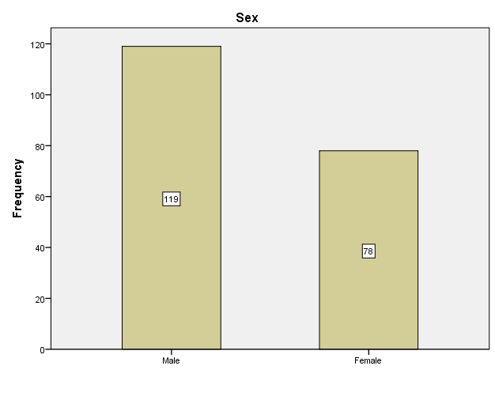
Figure 1

Table 2: Distribution of Respondents by Age
Statistics
N | Valid | 197
N | Missing | 3
Mean |  | 1.3553
Std. Deviation |  | .59388
Variable |  | Frequency | Percent | Cumulative Percent
Valid | 20-35 | 139 | 69.5 | 70.6
Valid | 36-45 | 46 | 23.0 | 93.9
Valid | 46 & above | 12 | 6.0 | 100.0
Valid | Total | 197 | 98.5
Missing |  | 3 | 1.5
Total |  | 200 | 100.0
Source: Field Survey, 2025
Analysis: The table above shows that 139 (69.5%) of 200 respondents that participated in the field survey were within the age range of 20-35 years, 46(23%) of the respondents were within 36-45 years, 12(6%) respondents are 46 years and above while 3(1.5%) respondents did not pick any option. Thus, the highest population of respondents that participated in this survey were within the age of 20 -35 years. The statistical inference of data supplied are: 1.3553 mean and .59388 standard deviation.
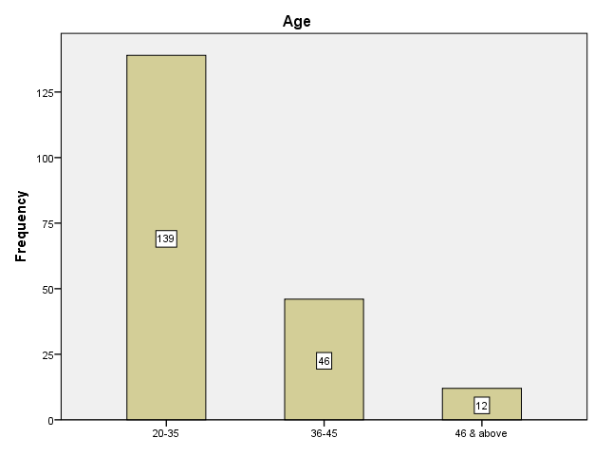
Figure 2

Table 3: Distribution of Respondents by Academic Level
Statistics
N | Valid | 198
N | Missing | 2
Mean |  | 2.7374
Std. Deviation |  | 1.11825
Variable |  | Frequency | Percent | Cumulative Percent
Valid | ND I | 30 | 15.0 | 15.2
Valid | ND II | 66 | 33.0 | 48.5
Valid | HND I | 28 | 14.0 | 62.6
Valid | HND II | 74 | 37.0 | 100.0
Valid | Total | 198 | 99.0
Missing |  | 2 | 1.0
Total |  | 200 | 100.0
Source: Research Survey 2025
Analysis: The table presented above shows that 30(15%) of 200 respondents that participated in the field survey are ND 1 students, 66(33%) are ND 2 students, 28(14) are in HND 1 level, 74(37%) are HND 2 students while 2 (1%) options were missing. Hence, this data is acceptable as the highest respondents are HND 2 students and virtually all the respondents are literates who have in-depth knowledge of the phenomenon understudy. The statistical inference of data supplied are: 2.7374 mean and 1.11825 standard deviation

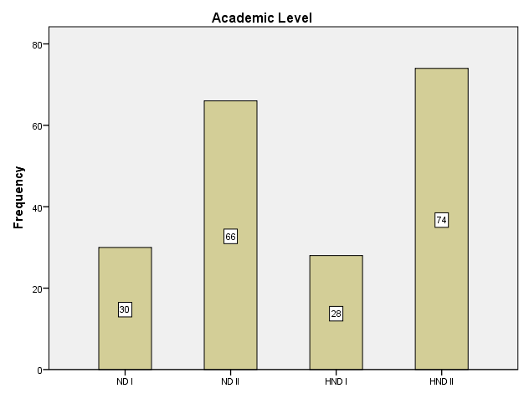
Figure 3
Table 4: Distribution of Respondents by Marital Status
Statistics
N | Valid | 195
N | Missing | 5
Mean |  | 1.5487
Std. Deviation |  | .71178
Option |  | Frequency | Percent | Cumulative Percent
Valid | Single | 113 | 56.5 | 57.9
Valid | Married | 57 | 28.5 | 87.2
Valid | Others | 25 | 12.5 | 100.0
Valid | Total | 195 | 97.5
Missing |  | 5 | 2.5
Total |  | 200 | 100.0

Source: Field Survey, 2025
Analysis: From the table presented above, 113 (56.5%) of 195 respondents that participated in the field survey were single. 57 (28.5%) of the respondents were married, 25 (12.5%) chose others while 5(2.5%) options were missing. However, the highest population of respondents that participated in this survey were single. The statistical inference of data supplied are: 1.5487 mean and .71178 standard deviation.
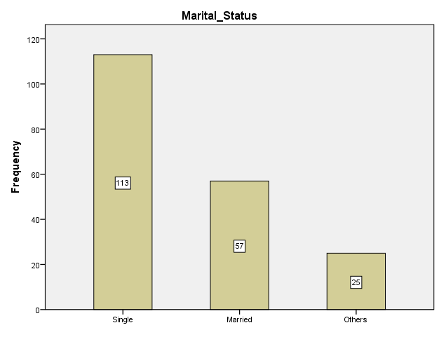
Figure 4

4.2.2 Analysis of Respondents’ Familiarity to Media Reportage of Corruption in Nigeria Public Sectors

Table 5: How often do you consume news related to the public sector in Nigeria?

Statistics
N | Valid | 198
N | Missing | 2
Mean |  | 2.1313
Std. Deviation |  | 1.10050
Options |  | Frequency | Percent | Cumulative Percent
Valid | Daily | 72 | 36.0 | 36.4
Valid | Few times a week | 60 | 30.0 | 66.7
Valid | Once a week | 38 | 19.0 | 85.9
Valid | Rarely | 24 | 12.0 | 98.0
Valid | Never | 4 | 2.0 | 100.0
Valid | Total | 198 | 99.0
Missing |  | 2 | 1.0
Total |  | 200 | 100.0
Source: Field Survey, 2025
Analysis: From the table presented above, 72(36%) of 200 respondents that participated in the field survey indicated that they consume news related to the public sector in Nigeria daily. 60 respondents representing 30% of 198 respondents attested that consume news related to the public sector in Nigeria few times a week. 38(19%) respondents consume news related to the public sector in Nigeria once a week, 24(12%) respondents rarely news related to the public sector in Nigeria while 4(2%) respondents have never news related to the public sector in Nigeria. 2(1%) respondents did not pick any option thereby it is considered missing. Hence, 97% of the respondents have consumed news related to the public sector in Nigeria. The statistical inference of data supplied are: 2.1313 mean and 1.10050 standard deviation

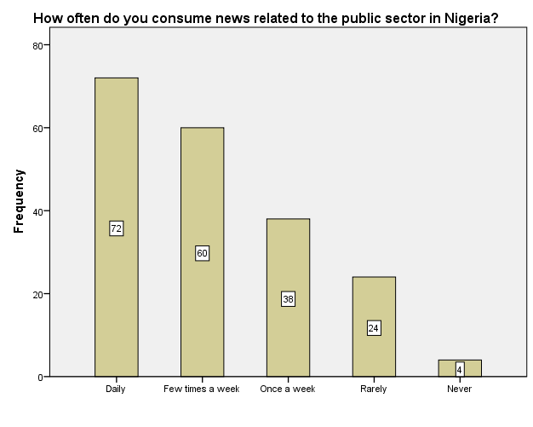

Figure 5

Table 6: Which source do you primarily use to get news about corruption in the public sector?
Statistics
N | Valid | 198
N | Missing | 2
Mean |  | 2.6263
Std. Deviation |  | 1.23885
Option |  | Frequency | Percent | Cumulative Percent
Valid | Television | 47 | 23.5 | 23.7
Valid | Newspaper | 48 | 24.0 | 48.0
Valid | Online news websites | 48 | 24.0 | 72.2
Valid | Social media platforms | 42 | 21.0 | 93.4
Valid | Radio | 13 | 6.5 | 100.0
Valid | Total | 198 | 99.0
Missing |  | 2 | 1.0
Total |  | 200 | 100.0
Source: Field Survey, 2025
Analysis: Table 6 above shows that 47 (23.5%) of 200 respondents that participated in the field surveyindicated that they primarily use to get news about corruption in the public sector on television. 48 (24%) respondents get their through newspaper, another 48(24%) respondents get news about corruption in the public sector via online news websites, 42(21%) of the respondents on social media platforms while 13(6.5%) primarily use to get news about corruption in the public sector on radio. Hence, majority of the respondents primarily use to get news about corruption in the public sector on television, newspaper, online websites and social media. The statistical inference of data supplied are: 2.6263 mean and 1.23885 standard deviation.
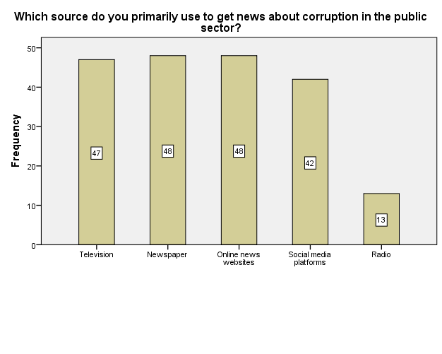
Figure 6

Table 7: How accurately does the media report corruption in the public sector?
Statistics
N | Valid | 198
N | Missing | 2
Mean |  | 2.4495
Std. Deviation |  | 1.15981
Options |  | Frequency | Percent | Cumulative Percent
Valid | Very accurate | 39 | 19.5 | 19.7
Valid | Accurate | 85 | 42.5 | 62.6
Valid | Neutral | 35 | 17.5 | 80.3
Valid | Less accurate | 24 | 12.0 | 92.4
Valid | Not accurate | 15 | 7.5 | 100.0
Valid | Total | 198 | 99.0
Missing |  | 2 | 1.0
Total |  | 200 | 100.0
Source: Field Survey, 2025
Analysis: The table presented above shows that 85(42.5%) of 200 respondents that participated in the field survey claimed that media report corruption in the public sector accurately. 39(19.5%) of the respondents admitted that media report corruption in the public sector very accurately. 24(12%) respondents claimed media report corruption in the public sector less accurately, 15(7.5%) admitted it is not accurate while 35(17.5%) of the respondents were neutral. The statistical inference of data supplied are: 2.4495 mean and 1.15981 standard deviation.
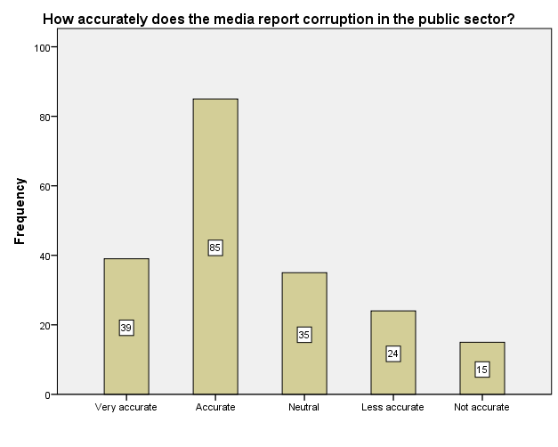
Figure 7

Table 8: How does media reportage of corruption in the public sector influence your perception of the issue?
Statistics
N | Valid | 197
N | Missing | 3
Mean |  | 2.2132
Std. Deviation |  | 1.25569
Option |  | Frequency | Percent | Cumulative Percent
Valid | Increases my awareness about corruption | 75 | 37.5 | 38.1
Valid | Makes me more skeptical about the public sector | 51 | 25.5 | 64.0
Valid | Motivates me to take action against corruption | 42 | 21.0 | 85.3
Valid | Makes me feel helpless and hopeless | 12 | 6.0 | 91.4
Valid | Doesn't influence my perception | 17 | 8.5 | 100.0
Valid | Total | 197 | 98.5
Missing |  | 3 | 1.5
Total |  | 200 | 100.0

Source: Field Survey, 2025
Analysis: In table 8 above, 75(37.5%) of 200 respondents that participated in the field survey alluded that media reportage of corruption in the public sector increases their awareness about corruption. 51(25.5%) respondents said it makes them more skeptical about the public sector, 42(21%) admitted that it motivates them to take action against corruption, 12(6%) respondents stated that it makes them feel helpless and hopeless while 17 (8.5%) respondents said it doesn't influence their perception. Highest populations of the respondents stated that media reportage of corruption in the public sector increases their awareness about corruption, motivates them to take action against corruption and makes them more skeptical about the public sector
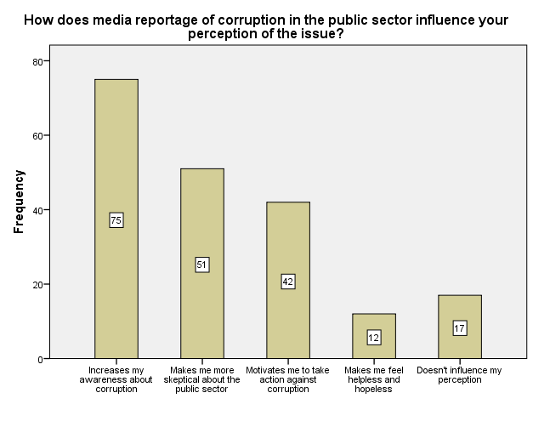
Figure 8
Table 9: Do media reports about corruption in the public sector influence your willingness to engage in corrupt practices?

Statistics
N | Valid | 196
N | Missing | 4
Mean |  | 1.9337
Std. Deviation |  | .73078

Options |  | Frequency | Percent | Cumulative Percent
Valid | Yes, I am likely to engage in corrupt practices | 59 | 29.5 | 30.1
Valid | No, it doesn't affect my behavior | 91 | 45.5 | 76.5
Valid | I am not sure | 46 | 23.0 | 100.0
Valid | Total | 196 | 98.0
Missing |  | 4 | 2.0
Total |  | 200 | 100.0
Source: Field Survey, 2025
Analysis: The table above shows that 59(29.5%) of 200 respondents that participated in the field survey claimed that they are likely to engage in corrupt practices due to media reports about corruption in the public sector. 91(45.5%) affirmed that media reports about corruption in the public sector will influence their behaviour or willingness to engage in corrupt practices. 46 (32%) respondents posed a neutral standpoint to this question.
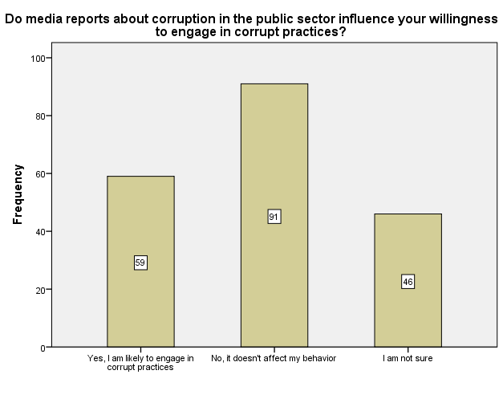
Figure 9
Table 10: How possibly are you to report corruption if you come across it in your daily activities?
Statistics
N | Valid | 197
N | Missing | 3
Mean |  | 2.3249
Std. Deviation |  | 1.19780

Option |  | Frequency | Percent | Cumulative Percent
Valid | Very possibly | 58 | 29.0 | 29.4
Valid | Possibly | 64 | 32.0 | 61.9
Valid | Neutral | 42 | 21.0 | 83.2
Valid | Less possibly | 19 | 9.5 | 92.9
Valid | Not at all | 14 | 7.0 | 100.0
Valid | Total | 197 | 98.5
Missing |  | 3 | 1.5
Total |  | 200 | 100.0
Source: Field Survey, 2025
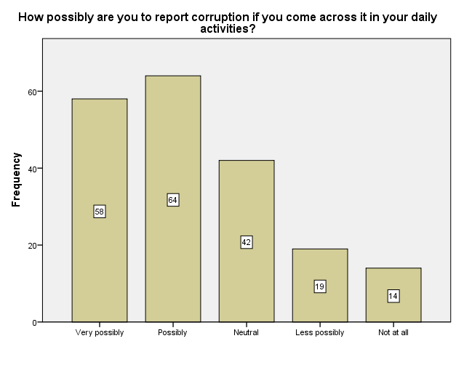
Analysis: The table presented above shows that 58(29%) respondents of 200that participated in the field survey affirmed that they can very possibly report corruption if they come across it in their daily activities. 64(32%) respondents said they can report corruption if they come across it in their daily activities. 42(21%) were neutral. 19(9.5%) of the respondents claimed that they are less possibly to report corruption if they come across it in their daily activities while 14(7%) picked not at all. From the table, over 60% of the respondents are likely to report corruption if they come across it in their daily activities.
Figure 10

4.2.3 Analysis of Statements in the Research Instrument

Table 11: The media effectively informs the public about corruption in public sectors.

Statistics
N | Valid | 198
N | Missing | 2
Mean |  | 1.6162
Std. Deviation |  | .78316

Option |  | Frequency | Percent | Cumulative Percent
Valid | Strongly agree | 106 | 53.0 | 53.5
Valid | Agree | 68 | 34.0 | 87.9
Valid | Undecided | 19 | 9.5 | 97.5
Valid | Disagree | 4 | 2.0 | 99.5
Valid | Strongly disagree | 1 | 0.5 | 100.0
Valid | Total | 198 | 99.0
Missing |  | 2 | 1.0
Total |  | 200 | 100.0
Source: Field Survey, 2025
Analysis: From the table above, 106 (53%) of 200 respondents that participated in the field surveystrongly agreed with the statement that the media effectively informs the public about corruption in public sectors. 68(34%) of the respondents agreed with the statement, 19(9.5%) were undecided, 4(2%) respondents disagreed with the statement, 1(0.5%) strongly disagreed that the media effectively informs the public about corruption in public sectors while 2(1%) respondents did not pick any of the options to indicate their level of agreement with the statement. Hence, highest percentage of the respondents (87%) admitted that the media effectively informs the public about corruption in public sectors. The statistical inferences of the data supplied are 1.6162 mean and .78316 standard deviation.
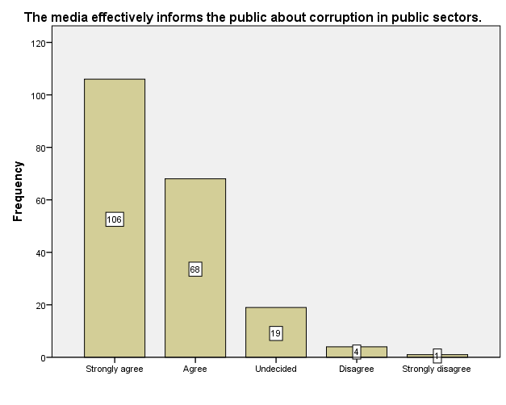
Figure 11

Table 12: Media reports on corruption in public sectors are accurate and reliable.

Statistics
N | Valid | 198
N | Missing | 2
Mean |  | 2.0354
Std. Deviation |  | .89202
Option |  | Frequency | Percent | Cumulative Percent
Valid | Strongly agree | 58 | 29.0 | 29.3
Valid | Agree | 90 | 45.0 | 74.7
Valid | Undecided | 37 | 18.5 | 93.4
Valid | Disagree | 11 | 5.5 | 99.0
Valid | Strongly disagree | 2 | 1.0 | 100.0
Valid | Total | 198 | 99.0
Missing |  | 2 | 1.0
Total |  | 200 | 100.0
Source: Field Survey, 2025
Analysis: The above table shows that 58(29%) of 200 respondents that participated in the field survey strongly agreed with the statement that media reports on corruption in public sectors are accurate and reliable. 90(45%) of the respondents agreed with the statement, 37(18.5%) were undecided, 11(5.5%) disagreed with the statement, 2 (1%) respondents strongly disagreed while 2(1%) respondents also failed to indicate their level of agreement with the statement. From the foregoing, 74% of the respondents admitted that media reports on corruption in public sectors are accurate and reliable. The statistical inferences of the data supplied are 2.0354 mean and .89202 standard deviation.
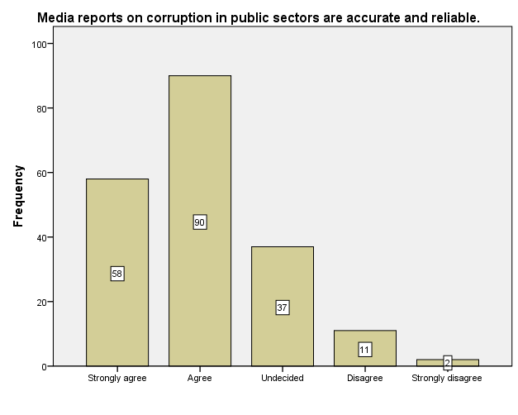
Figure 12
Table 13: The media plays a significant role in holding corrupt officials accountable.

Statistics
N | Valid | 197
N | Missing | 3
Mean |  | 2.1168
Std. Deviation |  | .98020

Option |  | Frequency | Percent | Cumulative Percent
Valid | Strongly agree | 59 | 29.5 | 29.9
Valid | Agree | 78 | 39.0 | 69.5
Valid | Undecided | 41 | 20.5 | 90.4
Valid | Disagree | 16 | 8.0 | 98.5
Valid | Strongly disagree | 3 | 1.5 | 100.0
Valid | Total | 197 | 98.5
Missing |  | 3 | 1.5
Total |  | 200 | 100.0
Source: Field Survey, 2025
Analysis: From the table above, 59(29.5%) of 200 respondents that participated in the field survey strongly agreed with the statement that the media plays a significant role in holding corrupt officials accountable. 78(39%) of the respondents agreed with this statement, 41(20.5%) were undecided, 16(8%) disagreed, 3(1.5%) strongly disagreed with the statement while 3(1.5%) of 200 respondents did not indicate their level of agreement with the statement. Hence, the highest percentage (68.5%) of the respondents claimed that the media plays a significant role in holding corrupt officials accountable. The statistical inference of data supplied in the table are 2.1168 mean and .98020 standard deviation.
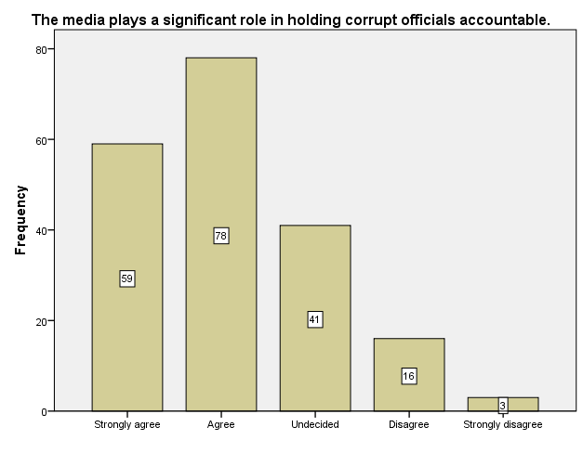
Figure 13
Table 14: I feel well-informed about corruption cases in the Nigerian public sectors through media coverage.

Statistics
N | Valid | 198
N | Missing | 2
Mean |  | 2.0455
Std. Deviation |  | 1.01908

Option |  | Frequency | Percent | Cumulative Percent
Valid | Strongly agree | 66 | 33.0 | 33.3
Valid | Agree | 83 | 41.5 | 75.3
Valid | Undecided | 29 | 14.5 | 89.9
Valid | Disagree | 14 | 7.0 | 97.0
Valid | Strongly disagree | 6 | 3.0 | 100.0
Valid | Total | 198 | 99.0
Missing |  | 2 | 1.0
Total |  | 200 | 100.0
Source: Field Survey, 2025
Analysis: Table 14 above shows that 66(33%) of 200 respondents that participated in the field survey strongly agreed that they feel well-informed about corruption cases in the Nigerian public sectors through media coverage. 83(41.5%) respondents agreed with this statement, 29(14.5%) were undecided, 14(7%) respondents disagreed, 6(3%) respondents strongly disagreed while 2(1%) respondents did not pick any option to indicate their level of agreement with the statement. However, 74.5% of the respondents admitted that they feel well-informed about corruption cases in the Nigerian public sectors through media coverage. Thus, the statistical inference of the data supplied are 2.0455 mean and 1.01908 standard deviation.
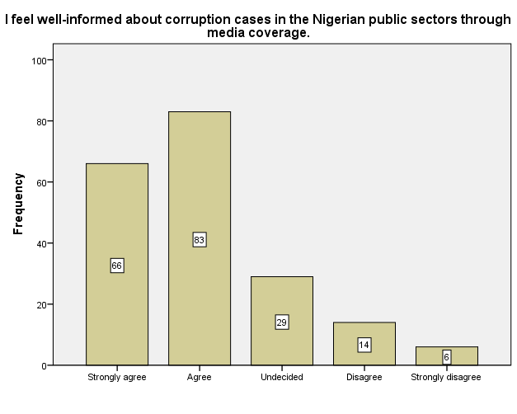
Figure 14
Table 15: Media coverage of corruption in public sectors has motivated me to take a stand against corruption in my daily life.
Statistics
N | Valid | 198
N | Missing | 2
Mean |  | 2.1212
Std. Deviation |  | 1.10166

Option |  | Frequency | Percent | Cumulative Percent
Valid | Strongly agree | 66 | 33.0 | 33.3
Valid | Agree | 75 | 37.5 | 71.2
Valid | Undecided | 34 | 17.0 | 88.4
Valid | Disagree | 13 | 6.5 | 94.9
Valid | Strongly disagree | 10 | 5.0 | 100.0
Valid | Total | 198 | 99.0
Missing |  | 2 | 1.0
Total |  | 200 | 100.0
Source: Field Survey, 2025
Analysis: From the table above, 66(33%) of 200 respondents that participated in the field survey strongly agreed that media coverage of corruption in public sectors has motivated them to take a stand against corruption in their daily life. 75(37.5%) of the respondents agreed with the statement, 34(17%) were undecided, 13(6.5%) disagreed, 10(5%) of the respondents strongly disagreed with the statement while 2(1%) respondents did not pick any option to indicate their level of agreement with the statement. However, highest population of the respondents (70%) claimed that media coverage of corruption in public sectors has motivated them to take a stand against corruption in their daily life. The statistical inference of data supplied in the table are 2.1212 mean and 1.10166 standard deviation.
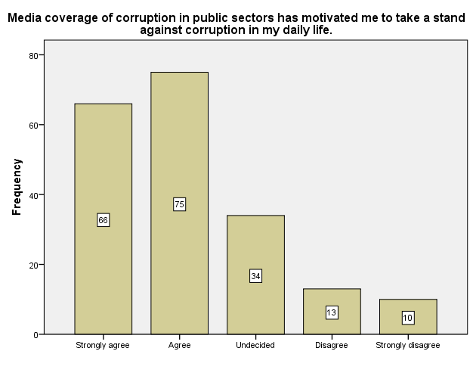
Figure 15
Table 16: Media reports on corruption in public sectors have increased my interest in studying issues related to governance, transparency, and accountability.

Statistics
N | Valid | 197
N | Missing | 3
Mean |  | 2.0305
Std. Deviation |  | .95783

Option |  | Frequency | Percent | Cumulative Percent
Valid | Strongly agree | 62 | 31.0 | 31.5
Valid | Agree | 88 | 44.0 | 76.1
Valid | Undecided | 30 | 15.0 | 91.4
Valid | Disagree | 13 | 6.5 | 98.0
Valid | Strongly disagree | 4 | 2.0 | 100.0
Valid | Total | 197 | 98.5
Missing |  | 3 | 1.5
Total |  | 200 | 100.0
Source: Field Survey, 2025
Analysis: From the table presented above, 62(31%) of 200 respondents that participated in the field survey strongly agreed that media reports on corruption in public sectors have increased their interest in studying issues related to governance, transparency, and accountability. 88(44%) of this respondents agreed with the statement, 30(15%) were undecided, 13(6.5%) disagreed with the statement,, 4(2%) strongly disagreed with the statement while 3(1.5%) respondents did not pick any option. However, the highest percentage (75%) of respondents that participated in the field survey admitted that media reports on corruption in public sectors have increased their interest in studying issues related to governance, transparency, and accountability. The statistical inference of data supplied are: 2.0305 mean and .95783 standard deviation.
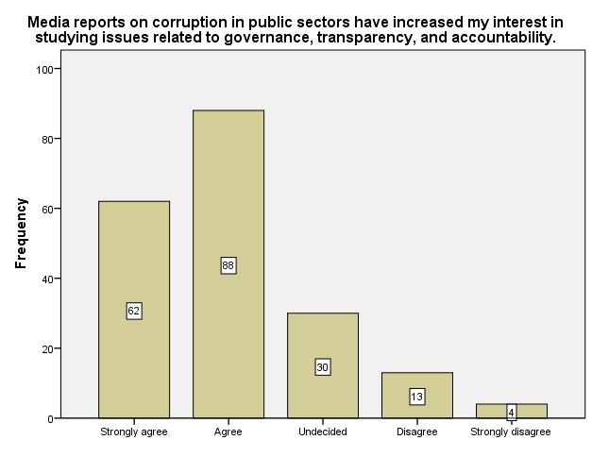
Figure 16
Table 17: Media reportage of corruption in public sectors has made me more inclined to participate in social and civic initiatives aimed at fighting corruption.
Statistics
N | Valid | 198
N | Missing | 2
Mean |  | 2.0000
Std. Deviation |  | 1.00253

Option |  | Frequency | Percent | Cumulative Percent
Valid | Strongly agree | 74 | 37.0 | 37.4
Valid | Agree | 70 | 35.0 | 72.7
Valid | Undecided | 39 | 19.5 | 92.4
Valid | Disagree | 10 | 5.0 | 97.5
Valid | Strongly disagree | 5 | 2.5 | 100.0
Valid | Total | 198 | 99.0
Missing |  | 2 | 1.0
Total |  | 200 | 100.0
Source: Field Survey, 2025
Analysis: From the table presented above, 74(37%) of 200 respondents strongly agreed that media reportage of corruption in public sectors has made them more inclined to participate in social and civic initiatives aimed at fighting corruption. 70(35%) of the respondents agreed with the statement, 39(19.5%) were undecided, 10(5%) disagreed, 5(2.5%) respondents strongly disagreed while 2(1%) respondents did not indicate their level of agreement with the statement. However, majority of the respondents (72%) admitted that media reportage of corruption in public sectors has made them more inclined to participate in social and civic initiatives aimed at fighting corruption.
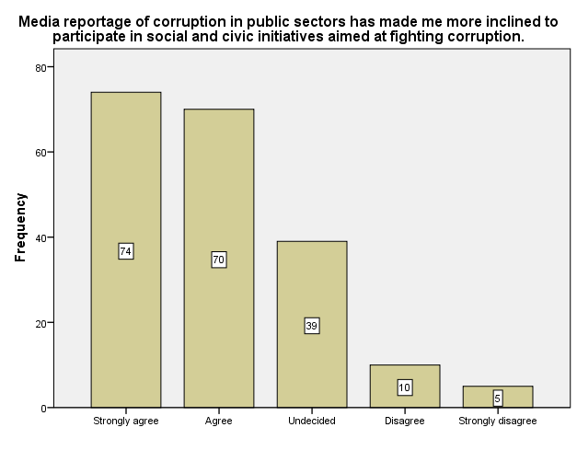
Figure 17
Table 18: Media coverage of corruption in public sectors has heightened my sense of responsibility as a citizen to promote ethical behavior and integrity.

Statistics
N | Valid | 197
N | Missing | 3
Mean |  | 2.0711
Std. Deviation |  | .99233

Option |  | Frequency | Percent | Cumulative Percent
Valid | Strongly agree | 63 | 31.5 | 32.0
Valid | Agree | 79 | 39.5 | 72.1
Valid | Undecided | 38 | 19.0 | 91.4
Valid | Disagree | 12 | 6.0 | 97.5
Valid | Strongly disagree | 5 | 2.5 | 100.0
Valid | Total | 197 | 98.5
Missing |  | 3 | 1.5
Total |  | 200 | 100.0
Source: Field Survey, 2025
Analysis: From the table above, 63(31.5%) of 200 respondents strongly agreed that media coverage of corruption in public sectors has heightened their sense of responsibility as citizen to promote ethical behavior and integrity. 79(39.5%) of the respondents agreed with the statement, 38(19%) were undecided, 12 (6%) of the respondents disagreed with the statement, 5(2.5%) respondents strongly disagreed with the statement while 3(1.5%) of the respondents did not indicate their level of agreement with the statement. The statistical inference of the data supplied are: 2.0711 mean and .99233 standard deviation.
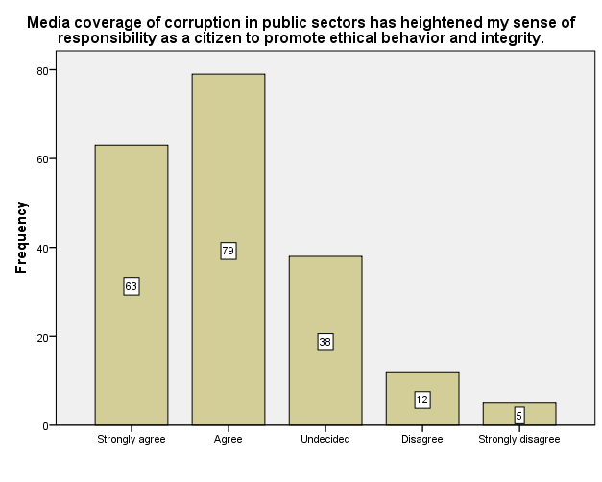
Figure 18

Table 19: Media reportage of corruption in public sectors is instrumental in creating awareness among the general public about the negative impacts of corruption on society.

Statistics
N | Valid | 198
N | Missing | 2
Mean |  | 2.0960
Std. Deviation |  | .94299

Option |  | Frequency | Percent | Cumulative Percent
Valid | Strongly agree | 55 | 27.5 | 27.8
Valid | Agree | 89 | 44.5 | 72.7
Valid | Undecided | 38 | 19.0 | 91.9
Valid | Disagree | 12 | 6.0 | 98.0
Valid | Strongly disagree | 4 | 2.0 | 100.0
Valid | Total | 198 | 99.0
Missing |  | 2 | 1.0
Total |  | 200 | 100.0
Source: Field Survey, 2025
Analysis: The table above shows that 55(27.5%) of 200 respondents strongly agreed with the statement that media reportage of corruption in public sectors is instrumental in creating awareness among the general public about the negative impacts of corruption on society. 89(44.5%) of the respondents agreed with the statement. 38(19%) respondents were undecided, 12(6%) respondents disagreed, 4(2%) respondents strongly disagreed with the statement while 2(1%) respondent did not pick any option to indicate their level of agreement the statement. However, majority of the respondents (72%) claimed that media reportage of corruption in public sectors is instrumental in creating awareness among the general public about the negative impacts of corruption on society. Hence, the statistical inference of data supplied are: 2.0960 mean and .94299 standard deviation.
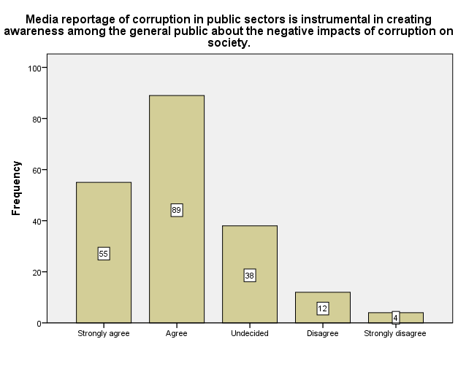
Figure 19
Table 20: Media reports on corruption in public sectors contribute to the erosion of public trust in government institutions and officials.
Statistics
N | Valid | 198
N | Missing | 2
Mean |  | 2.2424
Std. Deviation |  | 1.00850

Option |  | Frequency | Percent | Cumulative Percent
Valid | Strongly agree | 48 | 24.0 | 24.2
Valid | Agree | 81 | 40.5 | 65.2
Valid | Undecided | 49 | 24.5 | 89.9
Valid | Disagree | 13 | 6.5 | 96.5
Valid | Strongly disagree | 7 | 3.5 | 100.0
Valid | Total | 198 | 99.0
Missing |  | 2 | 1.0
Total |  | 200 | 100.0
Source: Field Survey, 2025
Analysis: The table above shows that 48(24%) of 200 respondents strongly agreed with the statement that media reports on corruption in public sectors contribute to the erosion of public trust in government institutions and officials. 81(40.5%) of the respondents agreed with the statement. 49(24.5%) respondents were undecided, 13(6.5%) disagreed, 7(3.5%) strongly disagreed with the statement while 2(1%) respondents did not indicate from the option given their level of agreement with the statement. Hence, highest percentage (64.5%) of the sample population alluded that media reports on corruption in public sectors contribute to the erosion of public trust in government institutions and officials. The statistical inference of the data supplied are: 2.2424 mean and 1.00850 standard deviation.
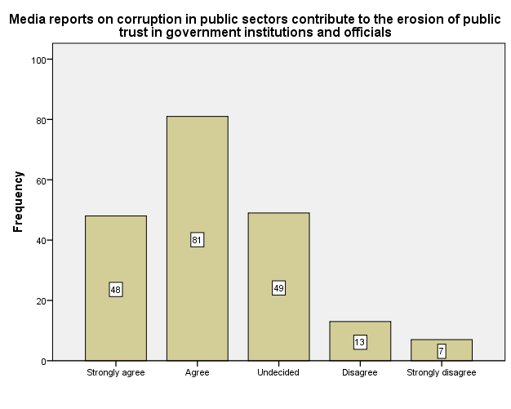
Figure 20
Table 21: Media coverage of corruption in public sectors focuses on sensationalism rather than providing objective and in-depth analysis.
 | Statistics
 | N | Valid |  | 197
 | N | Missing |  | 3
 | Mean |  |  | 2.5228
 | Std. Deviation |  |  | 1.18051
Option |  |  |  |  |  | Frequency | Percent | Cumulative Percent
Valid |  |  | Strongly agree |  |  | 42 | 21.0 | 21.3
 |  |  | Agree |  |  | 67 | 33.5 | 55.3
 |  |  | Undecided |  |  | 44 | 22.0 | 77.7
 |  |  | Disagree |  |  | 31 | 15.5 | 93.4
 |  |  | Strongly disagree |  |  | 13 | 6.5 | 100.0
 |  |  | Total |  |  | 197 | 98.5
Missing |  |  |  |  |  | 3 | 1.5
Total |  |  |  |  |  | 200 | 100.0
Source: Field Survey, 2025
Analysis: From the table presented above, 42(21%) of 200 respondents strongly agreed with the statement that media coverage of corruption in public sectors focuses on sensationalism rather than providing objective and in-depth analysis. 67(33.5%) of the respondents agreed with the statement. 44(22%) respondents disagreed, 13(6.5%) respondents strongly disagreed with the statement while 3(1.5%) of the respondents did not indicate their level of agreement with the statement. The statistical inference of the data supplied are: 2.5228 mean and 1.18051 standard deviation.
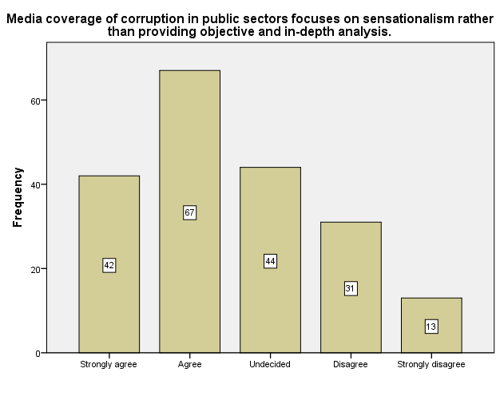
Figure 21
Table 22: Media reports on corruption in public sectors disproportionately highlight negative cases, leading to a skewed perception of corruption levels.
 | Statistics
 | N | Valid |  | 198
 | N | Missing |  | 2
 | Mean |  |  | 2.4747
 | Std. Deviation |  |  | 1.10691
Option |  |  |  |  |  | Frequency | Percent | Cumulative Percent
Valid |  |  | Strongly agree |  |  | 39 | 19.5 | 19.7
 |  |  | Agree |  |  | 73 | 36.5 | 56.6
 |  |  | Undecided |  |  | 49 | 24.5 | 81.3
 |  |  | Disagree |  |  | 27 | 13.5 | 94.9
 |  |  | Strongly disagree |  |  | 10 | 5.0 | 100.0
 |  |  | Total |  |  | 198 | 99.0
Missing |  |  |  |  |  | 2 | 1.0
Total |  |  |  |  |  | 200 | 100.0
Source: Field Survey, 2025
Analysis: The table presented above shows that 39(19.5%) of 200 respondents strongly agreed with the statement that media reports on corruption in public sectors disproportionately highlight negative cases, leading to a skewed perception of corruption levels. 73(36.5%) of the respondents agreed with the statement, 49(24.5%) were undecided, 27(13.5%) disagreed, 10(5%) respondents strongly disagreed with the statement while 2(1%) of the respondents did not pick any option to indicate their level of agreement with the statement. However, the majority of respondents that participated in the field survey alluded that media reports on corruption in public sectors disproportionately highlight negative cases, leading to a skewed perception of corruption levels. The statistical inference of data supplied are: 2.4747 mean and 1.10691 standard deviation.
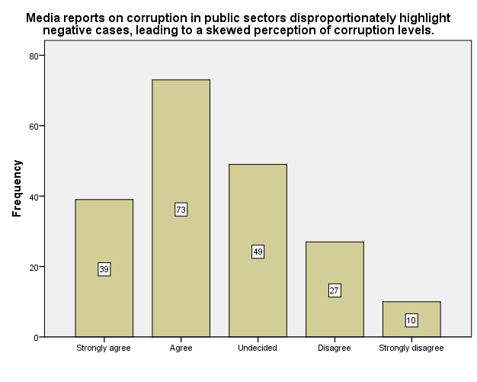
Figure 22

4.3 ANALYSIS OF RESEARCH QUESTIONS
RQ 1: What is the public knowledge of media reportage of corruption in public sectors among Nigerian students?
Research question one seek to investigate the public knowledge of media reportage of corruption in public. Table 5 to 7, 11 to 14 answered this question
Table 5 to 7
Table | Description of Items | Daily | Few time a week | Once a week | Rarely | Never | $$\overline{X}$$ | SD
5. | How often do you consume news related to the public sector in Nigeria? | 70 | 60 | 38 | 24 | 4 | 2.1313 | 1.10050
 |  | Television | Newspaper | Online News | Social Media | Radio
6. | Which source do you primarily use to get news about corruption in the public sector? | 47 | 48 | 48 | 42 | 13 | 2.6263 | 1.23885
 |  | Very Accurate | Accurate | Neutral | Less Accurate | Not Accurate
7. | How accurately does the media report corruption in the public sector? | 39 | 85 | 35 | 24 | 15 | 2.4495 | 1.15981

Table 11 to 14
Table | Description of Items | SA | A | U | D | SD | $$\overline{X}$$ | SD
11. | The media effectively informs the public about corruption in public sectors | 106 | 68 | 19 | 4 | 1 | 1.6.62 | .78316
12. | Media reports on corruption in public sectors are accurate and reliable. | 58 | 90 | 37 | 11 | 2 | 2.0354 | .89202
13. | The media plays a significant role in holding corrupt officials accountable. | 59 | 78 | 41 | 16 | 3 | 2.1168 | .98020
14. | I feel well-informed about corruption cases in the Nigerian public sectors through media coverage | 66 | 83 | 29 | 14 | 6 | 2.0455 | 1.01908
In table 5 to 7, respondents’ familiarity to media reportage of corruption in public sector was evaluated. From the 198 responses retrieved, 192 respondents have consumed news related to the public sectors in Nigera. 70 of the 192 respondents consume the news daily, 60 few time a week, 38 once a week and 24 rarely. Only 4 (2%) respondents has never consumed news related to the public sector in Nigeria. Also in table 6, 47 respondents get news about corruption in the public sector via television, 48 via Newspaper, another 48 via online news, 42 via social media platforms and 13 via radio. In table 7, 124 respondents maintained a positive standpoint that the media report corruption in the public sector with accuracy. While 35 were neutral, 24 admitted it is reported less accurately and 15 admitted that it is not reported accurately.
Sequentially, in table 11, majority of the respondents (174) admitted that the media effectively informs the public about corruption in public sectors while other respondents indicated a contrast view to the statement. Also in table 12, majority (148) of the respondents alluded that media reports on corruption in public sectors are accurate and reliable while other respondents were undecided and disproved the statement. In table 13, a total 137 respondents being the majority claimed that the media plays a significant role in holding corrupt officials accountable. 41 were undecided and others disproved the statement. Lastly in table 14,149 respondents also claimed that they feel well-informed about corruption cases in the Nigerian public sectors through media coverage.
In respect to the analyzed tables above, over 68% of respondents that gave responses to the questions and statements under research question one posed positive standpoints. The tables indicate that the public are aware of happenings in public sectors and consistently consume report about corruption in the Nigeria public sector. Base on the foregoing, it can however be affirmed that there are wide range of public knowledge about media reportage of corruption in Nigeria public sectors.
RQ 2: What impact do media reportage of corruption in public sectors have among Nigerian students?
Research question two seek explore the impact of media reportage of corruption in public on Nigeria students. Table 8&9, 15 to 18 answered this question.

Table | Description of Items | Increases my awareness about corruption | Makes me more skeptical about the public sector | Motivates me to take action against corruption | Makes me feel helpless and hopeless | Doesn't influence my perception | $$\overline{X}$$ | SD
8. | How does media reportage of corruption in the public sector influence your perception of the issue? | 75 | 51 | 42 | 12 | 17 | 2.2132 | 1.25569

 |  | Yes, I am likely to engage in corrupt practices | No, it doesn't affect my behavior | I am not sure | $$\overline{X}$$ | SD
9. | Do media reports about corruption in the public sector influence your willingness to engage in corrupt practices? | 59 | 91 | 46 | 1.9337 | .73078
Table 8 & 9
Table | Description of Items | SA | A | U | D | SD | $$\overline{X}$$ | SD
15. | Media coverage of corruption in public sectors has motivated me to take a stand against corruption in my daily life | 66 | 75 | 34 | 13 | 10 | 2.1212 | . 1.10166
16. | Media reports on corruption in public sectors have increased my interest in studying issues related to governance, transparency, and accountability | 62 | 88 | 30 | 13 | 4 | 2.0305 | .95783
17. | Media reportage of corruption in public sectors has made me more inclined to participate in social and civic initiatives aimed at fighting corruption | 74 | 70 | 39 | 10 | 5 | 2.0000 | 1.00253
18. | Media coverage of corruption in public sectors has heightened my sense of responsibility as a citizen to promote ethical behavior and integrity | 63 | 79 | 38 | 12 | 5 | 2.0711 | .99233

Table 15 to 18

In table 15 to 18, a total of 141 respondents indicated that media coverage of corruption in public sectors has motivated them to take a stand against corruption in their daily life.150 respondents alluded that media reports on corruption in public sectors have increased their interest in studying issues related to governance, transparency, and accountability, 144 respondents claimed that media reportage of corruption in public sectors has made them more inclined to participate in social and civic initiatives aimed at fighting corruption and 142 respondents also indicated that Media coverage of corruption in public sectors has heightened my sense of responsibility as a citizen to promote ethical behavior and integrity. In item 8, 75 respondents indicated that media reportage of corruption in the public sector increases their awareness about corruption, 51 stated that it makes me more skeptical about the public sector, 42 respondents said it motivates me to take action against corruption, 12 respondents inclined that it makes me feel helpless and hopeless while 17 of the respondents said ti doesn't influence their perception. Also in table 8, 59 respondents alluded that media reports about corruption in the public sector is likely to engage them in corrupt practices, 91 respondents claimed it doesn't affect my behavior while 46 respondents are not sure of the influence of media reportage of corruption in public sector on their behaviour. Base on the foregoing, the data supplied in the tables under research question two indicated that media reportage of corruption in public sector has significant impact among Nigeria students.

RQ 3: What are the perceptions of Nigerian students on media reportage of corruption in public sectors?
Research question three aims to discover the perception of Nigerian students on media reportage of corruption in public sector.Table 10, 19-22 answered this question
Table | Description of Items | Very possibly | Possibly | Neutral | Less Possibly | Not at all | $$\overline{X}$$ | SD
10. | How possibly are you to report corruption if you come across it in your daily activities? | 58 | 64 | 42 | 19 | 14 | 2.3249 | 1.19780

Table 10& 19-22

 |  | SA | A | U | D | SD | $$\overline{X}$$ | SD
19. | Media reportage of corruption in public sectors is instrumental in creating awareness among the general public about the negative impacts of corruption on society. | 55 | 89 | 38 | 12 | 4 | 2.0960 | .94299
20. | Media reports on corruption in public sectors contribute to the erosion of public trust in government institutions and officials. | 48 | 81 | 49 | 13 | 7 | 2.2424 | 1.00850
21. | Media coverage of corruption in public sectors focuses on sensationalism rather than providing objective and in-depth analysis. | 42 | 67 | 44 | 31 | 13 | 2.5228 | 1.18051
22. | Media reports on corruption in public sectors disproportionately highlight negative cases, leading to a skewed perception of corruption levels. | 39 | 73 | 49 | 27 | 10 | 2.4747 | 1.10691
In table 10, 58 the data supplied indicated that 122 of 198 respondents that answered the question are likely to report corruption if they come across it in their daily activities. In item 19-22, a total of 144 respondents admitted that media reportage of corruption in public sectors is instrumental in creating awareness among the general public about the negative impacts of corruption on society, 38 were undecided while other refuted the statement. 129 respondents admitted that media reports on corruption in public sectors contribute to the erosion of public trust in government institutions and officials, 49 were undecided while others disproved the statement. 109 respondents admitted that media coverage of corruption in public sectors focuses on sensationalism rather than providing objective and in-depth analysis, 44 were undecided while other refuted the claim. Lastly in table 22, a total 112 respondents alluded that media reports on corruption in public sectors disproportionately highlight negative cases, leading to a skewed perception of corruption levels. 49 respondents were undecided while other refuted the statement.
In sequel to the above-analyzed tables as grouped under research question three, data supplied indicated that respondents maintained several stances in respect to theirperceptions about Nigerian students and media reportage of corruption in public sectors. Base on the data given, closely 60% of the total sampledrespondents indicated a positive remark on their level of agreement with the statements contain in table 10, 19 to 22.

4.4 DISCUSSION OF FINDINGS
According to research question one, the result indicated that the public are aware of happenings in public sectors and consistently consume report about corruption in the Nigeria public sector. Hence, the study affirmed that there are wide range of public knowledge about happenings in Nigeria public sector as reported by the media and media reportage about corruption are often the major news usually digested by the public which can inadvertently affect Nigeria students. This finding corroborates with Nwuneli and Nwosu (2012), who in their study found out that media reports expose students to the realities of corruption within the public sector and can prompt students to defectfrom their own pre-exist ethical values and behavior. On the contrary, Adeyemi and Okorie (2009),alluded consistent reports of corruption cases by the media may develop a stronger commitment to integrity, honesty, and anti-corruption principles. The duo added that “such considerations can influence their future actions and decision-making, both in their personal lives and in their potential roles as future professionals and leaders”.
As regard research question two, analyzed data indicated that there are quite immeasurable implication of media reportage of corruption in Nigeria public sector on Nigeria students. The study find out that consistent media reportage of corruption in Nigeria public sector can lead to the following causal effect on Nigerian students: motivate them to take a stand against corruption, increasetheir interest in studying issues related to governance, transparency, and accountability, enhance inclinations to participate in social and civic initiatives aimed at fighting corruption etc. This finding however corroborates with the submission of Obianigwe. N. O. (2008), who alluded that “..Media reports on corruption can spark a desire for change among students. They may become more politically aware, engage in discussions, and join activism movements that demand transparency, accountability, and anti-corruption measures. This can lead to an increased focus on social justice and civic participation among students.”
As regard research question three, students’ perception of media reportage of corruption in public sector was sought. This study find out that Nigerian students perceive that media reports on corruption in public sectors will erode public trust in government institutions and officials, focus on sensationalism rather than providing objective and in-depth analysis, disproportionately highlight negative cases, leading to a skewed perception of corruption levels etc. James et al (2004:453), buttress the finding that “Media reports on corruption may not always provide a balanced view of the situation. Sensationalism, biased reporting, or selective coverage can distort the understanding of students, leading to a skewed perception of the issue. Without access to diverse and objective information, students may develop misconceptions or stereotypes that hinder their ability to analyze the situation critically”. Falana, F. (2012), emphasized more on the finding that media reports of corruption can foster a sense of skepticism and cynicism among students. “.they may develop a general distrust towards public officials and institutions, which can negatively impact their belief in the effectiveness of governance structures”. This skepticism can hinder their engagement in civic activities and discourage them from actively participating in public affairs.

CHAPTER FIVE

SUMMARY CONCLUSION AND RECOMMENDATIONS

5.1 Summary
This study is based on “the impact of media reportage of corruption in public sector and its influence among Nigerian students”. The study was organized in five chapters. The first chapter covers the introduction of the study, background to the study, statement of the problem (which exposed the problem the study identified and seek to resolve), research questions, the significant of the study, the scope of the study and operational definition of term. The second chapter focused on the conceptual framework, theoretical approach and review of related literatures. Framing theory of the mass media was adopted by the researcher in justification of claims. The third chapter focuses on the research method. A survey research design was considered most suitable for the study. A structured questionnaire instrument was adopted for collection and administered to total of two-hundred (200) respondents via electronic-means (Google form). The chapter four presented the data analysis and discussion of the findings. SPSS- version 21, a social science package was adopted for data analysis. The analysis was presented in tabular form using chi-square (x²) method of data analysis and aided with bar-chart for further illustration and interpretation of data. Finally, chapter five discussed the summary of the study, the conclusion of the study base on the outcome of the findings and recommendations of the study.

5.2 Conclusion
The critical challenge which the stubborn persistence and growing virulence of corruption poses to all Nigerians of integrity and conscience is, therefore, how to roll back the escalating phenomenon of corruption in our public life and terminate the culture of impunity that underpins it. Meeting this challenge will involve the mounting of a determined and robust struggle to change the constitutional and legal order and the power configuration in the Nigerian society such that the vast majority of marginalized Nigerian men and women are empowered to participate freely, actively and maximally in the politics, economy and overall culture of the society.
The necessary expedient of empowering the Nigerian working people vis-à-vis the corrupt and subversive political leader can be facilitated by pursuing the minimum political agenda of democratic governance. The constitutional entrenchment of the principle that the Nigerian people in their respective constituencies have the power to recall at any point in time any elected official who has been found by due process to abuse or betray the people’s mandate.
The role of the media is critical in efforts against corruption. As a result, there must be careful structuring of the relationship between anti-corruption officials and, in many cases, there must also be efforts to develop or enhance the capabilities of the media to ensure that they can function effectively as recipients of information about corruption, appraise such information in an independent manner, use it meaningfully as the basis of further communications and disseminate it to the general public.
In addition to independence and credibility, critical functions of the journalistic media include their ability to digest and render detailed technical materials accessible to the general population. This is essential to general awareness raising and public education, but also entails a high degree of responsibility and the exercise of discretion, since it necessarily involves editorial or “gatekeeping” exercises, in which the media must decide which information to report and which to leave out.

5.3 Recommendations
Based on the foregoing findings and conclusion, this study recommends that:
- The autonomy of the media is essential to enable it to assess Government information critically and objectively and to ensure its reports are credible to the population as a whole. Thus, Government contacts with the media must be transparent, and they must not compromise the essential autonomy of the media, either in practice or in public perceptions. Also critical to autonomy and objectivity is the separation of media ownership from Government or political factions or, if this is impossible, ensuring that there is a diverse media to represent a full range of political opinion. Similarly, the staffing of individual media should be multi-partisan, if possible.
- For the media to assess anti-corruption efforts critically and independently they must possess adequate technical, legal, economic and other expertise. In many cases, other sources, such as retained professional or academic experts, can supplement the knowledge of general media reporters. Training, awareness-raising and technical briefing of media personnel in anti-corruption efforts may also be useful.
- Owners of media houses most especially private owners should be explicit with their interests to their editors so the latter would make good use of their profession to fulfill their roles in the societyincluding that of fighting against corruption and anyother practices related to it. Also they should enabletheir journalists to perform their duties effectively sothat they would avoid any temptations of acceptinggifts, envelopes, fare or any other support that wouldinterfere with their free reporting.
- It is essential to raise awareness on the part of themedia of the causes, costs, levels, types and locationsof corruption in their country, as well as to explainthe on-going efforts of all stakeholders againstcorruption. Furthermore, journalists should be taughthow to evaluate and monitor Government activities,and informed about the achievements and standardsof anticorruption work in the region and at theinternational level. If journalists are to compare thevalidity of the policies of their own Government withothers and to report on them in the properperspective, such background information isessential. Internal diversity and pluralism within themedia community also develops a capability wherebythe media can report on corruption in their ownprofession.
- Media training should also focus on building aneffective information network. That includesinforming journalists about governmental and non-governmental institutions active in the field of anticorruption,about specific areas of responsibility,contact addresses and all other available information.If possible, representatives of those institutionsshould be chosen to inform journalists about theirwork, both the successes and the failures. Creating acontinuing and interactive exchange of ideas willcontribute towards building trust, and that shouldultimately guarantee unbiased reporting andencourage Government institutions to ensure an openinformation policy. Moreover, training ininvestigative journalism as area of specialization isimperative for journalist in the war againstcorruption.

REFERENCES
Adesina, F. (2008, December 9th). Journalists Role in Anti- corruption War. Nigerian Compass Asemah, E. (2009). Principles And Practice of Mass Communication. Jos: Future Press.\
Adebowale, Y. and A.M. Ali, 2009. Halliburton - U.S. Seeks Extradition of Briton in NLNG Bribe Scandal. This Day. Retrived from: http://www.africanloft. com/halliburton-bribery-scandal-nigerian-groupcollects- signatures-globally/. (Accessed date: May 9, 2009).
Adesina, F., 2008. Analyst Examine Journalist Role in Anti-corruption War. Nigerian Compass, 9 December. Afrobarometer, 2004. Afrobarometer round 2: compendium of comparative results from a 15- country survey. Working Paper No. 34.
Agbada, P., 2009. Brass LGA: Bayelsa Lawmakers Freeze Account Sack Care-taker Chairman. Beam Newspaper, 7(43). Retrived from: www.http://www.beamnewsonline.com/. (Accessed date: October 20-26, 2009).
Ahrend, R., 2002. Press freedom, human capital, and corruption, DELTA Working Paper, No. 2002-11,DELTA.
Akinseye-George, Y., 2000. Jurist Nigerian Co r r e s p o n d e n t . Re t r iv e d from: h t t p : //jurist.lawpitt.edu/world/nigeria.cor.2.html
Ameh, M., 2007. Between TI and Corruption Crusade in Nigeria. 28 October, Vanguard. Auyo, M.A., 1998. Corruption and its control in public and private corporate. Paper presented at a Seminar organized on Fraud Prevention and Control by Kag- Gift Consult, Central Hotel, Kano, Nigeria.
Ayoola, E., 2008. Contemporary Media Practice in Nigeria and Democracy. Media Right Agenda. January 5, Retrived from: www.mediarightagenda. org.
Bello H., H. A. (2014). Press coverage of Human Rights issues in Nigeria: A study of Daily Trustand Newswatch Magazine. Yankari journal Federal polytechnic Bauchi .
Bello-Imam, I.B., 2004. Corruption and NationalDevelopment. In: Bello-Imam, I.B. and M. Obadan,(Eds.), Democratic Governance and DevelopmentManagement in Nigeria’s Fourth Republic. Ibadan:Centre for Local Government and RuralDevelopment Studies, pp: 199-203.
Dandago, K.I., 2008. The constitutional fight againstcorruption in Nigeria: Is it enough? Int. J. Govt.Financ. Manage., 8: 61-70.Diamond, L., 1991. Political corruption: Nigeria’sperennial struggle.
Djankov, S., 2000. Who owns the media? PolicyResearch Working Paper 2620, World Bank.
Egbuna, B., 2007. Using the media to encouragetransparency and disclosure: The Nigerianexperience. A paper delivered at BroadcastingAssociation Regional Conference, Kenya.
Fagbadebo, O., 2007. Corruption, governance andpolitical instability in Nigeria. Afr. J. Polit. Sci. Int.Rela., 1(2): 028-037.
Gray, C.W. and D. Kaufmann, 1998. Corruption andDevelopment. Retrived from: www.worldbank.com/fandd/english/0398/articles/ 020398/html.
Griswold, W., 2000. Bearing Witness: Readers, Writersand the Novel in Nigeria, Princeton, New Jersey:Princeton University Press.
Groenendijk, N.S., 1997. A Principle-Agent Model ofCorruption. Crime Law Social Ch., 27: 217-218.
Guardian Reporter, 2006. Media Owners, Editors JoinAnti-Corruption Drive. Tanzania Guardian. 24thApril, Retrived from: www.ippmedia.com
Ikhilae, E., 2009. Court Nullifies Deportation of VaswaniBrothers, 32 Others. The Nation. Retrived from:http://cigbokwe.wordpress.com/2009/04/27/vaswanibrothers-and -tax-ev asion /. (Accessed date: MAY 5, 2023).
International Freedom of Expression Exchange, 2009.Journalist goes into Hiding, Fears for his Life.August 21, Retrived from: www.campaigns.ifex.org.
Jimo, H., T. Sy and D. Wade, 2001. West and West- Central Africa. In: Global Corruption Report. Berlin: Transparency International, pp: 81-94. Retrieved from: http://www.globalcorruptionreport.org.
Johnston, M., 1997. What can be done about entrenched corruption? Paper prepared the Annual World Bank Conference on Development Economics, Washington, D C, 30 April - 1 May.
Kaufmann, D., 1999. Presentation given to World Bank staff.
Kew, D., 2006. Nigeria. In: Tatic, S. (Ed.), Countries at the Crossroads. New York: Freedom House.
Klitgaard, R., 1996. Bolivia: H ealing Sick Institutions inLa Paz. In: Patrick, M. (Ed.), Governance and the Economy in Africa: Tools for Analysis and Reform of Corruption. University of Maryland Press: College Park.
Konie, G., 2003. National Reconciliation. The Post, A Zambian Newspaper, Wed. July 23. No. 2471, pp: 11. Langseth, P., J. Pope and R. Stapenhurst, 1997. The role of a national integrity system in fighting corruption. EDI Working Paper. The World Bank, Washington, D.C.
Llyod, P.C., 1967. Africa in Social Change. Baltimore:Penguin.
Lydia, M. (2014). Final year project on Corruption and Media coverage in Nigeria. Bauchi: unpublished
McQuil, D. (2005). Mass Communication Theories. London: Sage Publication.
Stapenhurts, R. (2000). The Media Role in Curbing Corruption. International Bank for Reconstruction and Development. NA: NA.
Sowunmi, F.A., M.A . Adesola and M .A. Salako, 2009.An appraisal of the performance of the economic andfinancial crimes commission in Nigeria. Int. J.Offender Ther., 10(1177). Doi: 10.1177/0306624X09341043.
Stapenhurst, R., 2000. The media’s role in curbingcorruption. A paper for International Bank forReconstruction and D evelopment.
Sternberg, E., 2000. Just Business: Ethics in Action, 2ndEdn., Oxford University Press, Oxford.
Stople, O., 2008. Corruption and anti-corruption inNigeria and beyond. A paper Presented at one-dayworkshop on ‘Reporting Corruption in Nigeria’organised by The United Nations Office On Drug andCrime(UNODC), in collaboration with the Economicand Financial Crimes Commission(EFCC) and theNigeria Union of Journalists (NUJ).
Suphachalasai, S., 2005. Bureaucratic corruption andmass media, environmental economy and policyresearch. Discussion Paper Series Number 05.2005,University of Cambridge.
Tanzi, V., 1998. Corruption around the World: Causes.Consequences, Scope, and Cures. IMF Staff Papers,45(4). Retrieved from: http://www.imf.org/external /pubs/FT/staffp/ 1998/12-98/pdf/tanzi.pdf,
The Economist (US), 2002. The short arm of the law -bribery and business: How big multinationalssidestep laws against bribery. March 2.
Transparency International, 2002. TransparencyInternational Corruption Perceptions Index 2002Berlin: Transparency International. Retrieved from:http://www.transparency.org/cpi/2002/.
UNITED NATIONS Office on Drugs and Crime, 2004.The Global Programme against Corruption UN Anti-Corruption Toolkit. 3rd Edn., The United NationsAnti-Corruption Toolkit.
USMAN, M. (2013). Corruption in Nigeria: A challenge of Good governance and sustainabledevelopment. European Scientific Journal 9(4):130-137.
Van Rijckeghem, C. and B. Weder, 1997. Corruption andthe rate of temptation: Do low wages in civil servicecause corruption? IMF Working Paper 97/73.International M onetary Fund: W ashington.
Vogl, F., 1999. Curbing corruption: The Media’s work.recommendations for action, TransparencyInternational Working Paper, presented at the 9thIACC.
Waliggo, J.M., 1999. The Historical Roots of UnethicalEconomic Practices in A frica. In: Kampala, G.J.,Rossouw and D. Carabine (Eds.), Fraud and theAfrican Renaissance. UM U Press, pp: 43-53.
Windsor, D. and K.A. Getz, 2000. Multilateralcooperation to combat corruption: normative regimesdespite mixed motives and diverse values. CornellInt. Law J., 33(3): 731-772.
World Bank [1989]. Sub-Saharan Africa: From crisis to sustainable growth. Washington D.C:The World Bank.
World Bank. (2013). Corruption Strategies Report. Washington,DC.
Yaqub, O. & Abubakar, S.O. [2005]. Conceptualizing good governance, corruption and democracyin L. Olurode & S.O. Akinboye [eds], Democracy, good governance and corruption in Nigeria.
Friedrich Ebert Shiftung [FES].

APPENDIX


KWARA STATE POLYTECHNIC, ILORIN
INSTITUTE OF INFORMATION AND COMMUNICATION TECHNOLOGY
DEPARTMENT OF MASS COMMUNICATION

QUESTIONNAIRE

Dear respondent,
This dissertation attempt to research the “Impact of Media Reportage of Corruption in Public Sector and Its Influence among Nigerian Students”.The study is exclusively an academic exercise. I humbly seek your indulgence to assist by filling the following questions as honestly as possible. I avow that all information given shall be treated with keen confidentiality and used for academic purpose only.
Thank you for your cooperation.
Agoha Vennessa
Facilitator

SECTION A
Media Reportage of Corruption in Nigeria Public Sectors

Instruction:Please tick (√) appropriately in the space boxes provided below or comment where necessary in gaps.
- How often do you consume news related to the public sector in Nigeria? (a) Daily [ ] (b) Few times a week [ ] (c) Once a week [ ] (d) Rarely [ ] (e) Never [ ]
- Which source do you primarily use to get news about corruption in the public sector? (a) Television [ ] (b) Newspapers [ ] (c) Online news websites [ ] (d) Social media platforms [ ] (e) Radio [ ]
- How accurately does the media report corruption in the public sector? (a) Very accurate [ ] (b) Accurate [ ] (c) Neutral [ ] (d) Less accurate [ ] (d) Not accurate [ ]
- How does media reportage of corruption in the public sector influence your perception of the issue? (a) Increases my awareness about corruption [ ] (b) Makes me more skeptical about the public sector [ ] (c) Motivates me to take action against corruption [ ] (d) Makes me feel helpless and hopeless [ ] (e) Doesn't influence my perception [ ]
- Do media reports about corruption in the public sector influence your willingness to engage in corrupt practices? (a) Yes, I am likely to engage in corrupt practices [ ] (b) No, it doesn't affect my behavior [ ](c) I am not sure [ ]
- How possibly are you to report corruption if you come across it in your daily activities? (a) Very possibly [ ] (b) possibly [ ] (c) Neutral [ ] (d) Less possibly [ ] (e) Not at all [ ]
SECTION B
Statements on Research Questions

Instruction: Tick (√) an option in the space boxes provided that best describe your level of agreement with the statements below in respect to the identified research questions.
Keywords: Strongly agree [SA]-Agree [A]-Undecided [U]-Disagree [D]-Strongly disagree [SD]

RESEARCH QUESTIONS | S/N | STATEMENTS | OPTIONS
RESEARCH QUESTIONS |  | STATEMENTS | SA | A | U | D | SD
RQ1: What is the public knowledge of media reportage of corruption in public sectors among Nigerian students? | 1. | The media effectively informs the public about corruption in public sectors.
 | 2. | Media reports on corruption in public sectors are accurate and reliable.
 | 3. | The media plays a significant role in holding corrupt officials accountable.
 | 4. | I feel well-informed about corruption cases in the Nigerian public sectors through media coverage.
RQ2: What impact do media reportage of corruption in public sectors have among Nigerian students? | 5. | Media coverage of corruption in public sectors has motivated me to take a stand against corruption in my daily life.
 | 6. | Media reports on corruption in public sectors have increased my interest in studying issues related to governance, transparency, and accountability.
 | 7. | Media reportage of corruption in public sectors has made me more inclined to participate in social and civic initiatives aimed at fighting corruption.
 | 8. | Media coverage of corruption in public sectors has heightened my sense of responsibility as a citizen to promote ethical behavior and integrity.
RQ3: What are the perceptions of Nigerian students on media reportage of corruption in public sectors? | 9 | Media reportage of corruption in public sectors is instrumental in creating awareness among the general public about the negative impacts of corruption on society.
 | 10 | Media reports on corruption in public sectors contribute to the erosion of public trust in government institutions and officials.
 | 11 | Media coverage of corruption in public sectors focuses on sensationalism rather than providing objective and in-depth analysis.
 | 12 | Media reports on corruption in public sectors disproportionately highlight negative cases, leading to a skewed perception of corruption levels.
SECTION C
Demographic Profile of Respondents

Kindly tick (√) the appropriate option in the space boxes provided.
- Sex: (a) Male [ ] (b) Female [ ]
- Age: (a) 20-35 [ ] (b) 36-45 [ ] (c) 46 and above [ ]
- Academic Level: (a) ND I [ ] (b) ND II [ ] (c) HND I [ ] (d) HND II [ ]
- Marital status: (a) Single [ ] (b) Married [ ] (c) Others [ ]

