EXPERIMENTAL ANALYSIS OF TORQUE-SPEED CHARACTERISTICS OF A DC MOTOR UNDER VARYING LOAD CONDITIONS.

BY
OMONIYI TEMITOPE ABIDEMI
ND/23/SLT/PT/0302

SUBMITTED TO THE DEPARTMENT OF SCEINCE LABORATORY TECHNOLOGY
(PHYSISY UNIT)
INSTITUTION OF APPLIED SCIENCE (IAS), KWARA STATE POLYTECHINC, ILORIN, KWARA STATE, NIGERIA.
IN PARTIAL FULFILLMENT OF THE REQUIREMENT
FOR THE AWARD OF NATIONAL DIPLOMA (ND)
IN SCIENCE LABORATORY TECHNOLOGY.

JULY 2025

CERTIFICATION
This is to certify that this project was an original work carried out in the Department of science laboratory technology (SLT). And has been prepared in accordance with the regulations governing the preparation and presentation of project in Kwara state polytechnic, Ilorin
_______________ _______________
Mr. YUSUF O.SAHEED DATE
(Project supervisor)
_______________ _______________
MR. LUKUMAN. A. DATE
SLT PT Coordinator
_________________ ___________
DR. ABDULKAREM USMAN DATE
Head of department

DEDICATION

This project is dedicated to Almighty God the father of the whole universe for his prominent grace and favour right from the beginning of this project to the Accomplishment of it. Right from the beginning to the end of my National Diploma in Science laboratory technology (SLT)

ACKNOWLEDGMENT
All glory is returned to Almighty God for his shower of blessing, and also for the Gift of knowledge and wisdom use in accomplishment of this project.
I am indebted to my project supervisor; in the person of (Mr. SAHEED YUSUF.O.) For his invaluable contribution and suggestion toward making this project a successful one, may Almighty God continue to enrich you with knowledge and your family sir. I also extend my gratitude to the (HOD. Mr abdulkarem usman) and lecturers in the Department of science Laboratory Technology for the knowledge impacted on me. I say thank you sir/ma.
Our gratitude goes to our respective and lovely parents for their immense contribution toward the accomplishment for this project with great emphasis on how caring they have been right from when we step into this world. May Almighty God fulfil your dreams and aspirations over.Us (Amin).

ABSTRACT
An essential electromechanical component, the direct current (DC) motor is used in a wide range of applications, from basic home appliances to complex industrial gear and electric cars. It is a key component of contemporary technology because of its comparatively easy controllable ability to transform electrical energy into mechanical energy. Optimizing a DC motor's application and guaranteeing effective operation require an understanding of its performance characteristics, especially its torque-speed connection under various load circumstances.
The experimental examination of these torque-speed properties is the main goal of this study. The intrinsic unpredictability of load circumstances found in practical applications is what inspired this study. When exposed to dynamic or variable loads, a motor that operates well under a constant load may behave very differently. It is essential to accurately describe this behavior in order to predict motor performance in a variety of settings and to create reliable control systems.
To comprehend and model the behavior of DC motors, a great deal of research has been done.

In the past, scientists have concentrated on creating theoretical models using basic electromagnetic principles and then testing these models with experimental measurements. They have successfully categorized the torque-speed curves for several DC motor types (shunt, series, and compound) and established the fundamental relationships between voltage, current, torque, and speed. These investigations frequently entail carefully monitored lab tests that provide

useful information on steady-state properties by measuring torque using tachometer and speed with optical encoders.
Nevertheless, a lot of current research frequently simplifies load circumstances and concentrates on hypothetical situations. Real-world applications entail complicated and dynamic loads, particularly in robotics and electric cars. This makes it difficult to use simplistic models to predict motor performance properly. Moreover, problems including temperature impacts, measurement errors, and the impact of control system dynamics are frequently not adequately addressed. These issues may lead to less-than-ideal motor performance, decreased effectiveness, and even system instability.
By performing a thorough experimental examination of a DC motor's torque-speed
Characteristics under a variety of dynamically varying load circumstances, this effort seeks to overcome these constraints. Our goal is to give a more thorough and accurate understanding of how motors behave in intricate operational situations. We will use a strong experimental set up to do this, which will include a programmable load system to simulate different load profiles, an optical encoder for exact speed measurement, and a tachometer for accurate torque measurement. In order to record data in real time and examine the motor's transitory reactions to abrupt changes in load, we will also make use of a data acquisition system. In order to improve control system design and boost overall system performance, we want to create a more accurate empirical model of the behavior of the DC motor by methodically changing the load and examining the torque-speed characteristics that arise.

TABLEOF CONTENT
CHAPETER ONE
1.0 Features of a DC motor.
1.1. With the aid of a diagram explain the torque speed characteristics of a DC motor.
1.3 Torque, Speed and Torque-Speed Curve and its equipment?
1.4 What is a DC motor?
1.5 Component of a DC motor.
1.6 Types of DC Motor.
CHAPTER Two
2.0 Torque speed characteristics of a DC Motor.
2.1 Concept of Torque speed characteristics.
2.2 Different types of Motors.
2.3 Description of the Load
2.4 Characteristics Affected by Factors
2.5 Varying Load Condition of a DC.
2.6 Experimental Analysis of a DC Motor
CHAPTER Three
3.0 Understand the motor(Centrifuge)
3.1 Torque and Current Relationship
3.2 Torque and Speed
3.3 Apparatus
3.4 Step Taking While Reading

CHAPTER Four
4.1 Discussion
CHAPTER Five
References.

CHAPTER ONE
1.0 INTRODUCTION
A defining instance of electromechanical engineering's enduring principles of electromagnetic energy conversion is the direct current (DC) motor. DC motors are essential to a wide range of technological applications, from the powerful driving of electric vehicles to the precise movements of robotic arms. The role they play as important parts of contemporary engineering systems has been formed by their relative efficiency, controllability, and simplicity. To maximize their use and guarantee dependable functioning in a variety of settings, it is essential to have a thorough understanding of their performance characteristics, especially the complex interaction between torque and speed under changing load situations.
In this study, the torque-speed characteristics of a DC motor under varying load conditions are thoroughly investigated experimentally. Although the basic ideas that drive DC motor operating are well accepted, putting them into practice in real-world situations can frequently be quite difficult. Because load profiles in applications are constantly variable, it is essential to fully comprehend how a DC motor reacts to these variations. The traditional method, which depends on static load testing and idealized models, usually fails to capture the detailed rapid movement that motors display under dynamic loads.
A strong basis for comprehending the basic connections between DC motor speed, torque, voltage, and current. The steady-state torque-speed curves for several DC motor types, including shunt, series, and compound motors, have been better understood thanks to our work. However, the impact of different load profiles, the influence of control system dynamics, and a brief reaction of DC motors to unexpected load changes are frequently not properly addressed. Static load testing and simplified models frequently fall short in predicting motor performance, which can result in less-than-ideal control schemes, decreased effectiveness, and even system instability. Also, it may become much more complex due to elements like measurement errors, temperature fluctuations, and sensor noise.
By carefully analyzing the torque-speed characteristics of a DC motor under a variety of changing load circumstances, this effort seeks to overcome these challenges. In order to facilitate the creation of more reliable and effective control systems, we aim to offer a more realistic and thorough understanding of motor behavior in specific operating situations.Our goal is to promote the development of DC motor-driven systems that are more robust, dependable, and efficient by bridging the gap between theoretical models and practical applications. (Electric Machinery Fundamentals by Stephen J. Chapman. et. al., 2012).

Features of a DC motor?
  - A DC motor's torque-speed characteristic is a basic relationship that explains how the motor behaves in various operating scenarios. A DC motor's torque is directly correlated with its armature current
And field flux. The back EMF, which opposes the applied voltage, controls the motor's speed. (Nasar, S. A. 2010).
  - Torque-Speed Characteristics of a DC motor?
A DC motor's torque-speed characteristics is an essential relationship that explains how a DC motor's speed varies with the applied load in its torque-speed characteristic. In essence, it is a graphical depiction of how well the motor performs under various operating circumstances. (Bose, B. K. et. al., (2010)

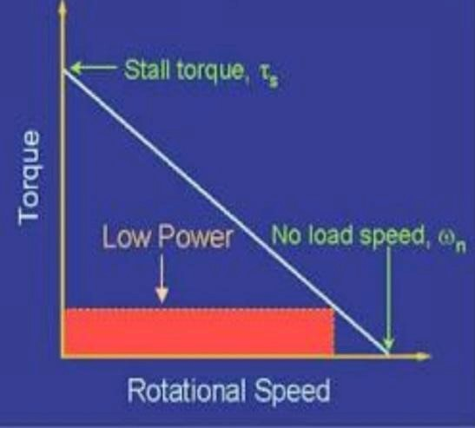
Figure 2: A Pictorial diagram of Torque Speed Curve for a DC motor
1.3 Torque, Speed and Torque-Speed Curve and its equipment?
An object's torque is defined as the force that rotates it around an axis. It is basically a force in linear motion's rotational equivalent. Formula: Force (F) × Distance (r) = Torque (τ) where F is the applied force. (also known as the lever arm or moment arm) r is the distance between the axis of rotation and the force application point.
In units: Pound-foot (lb·ft) or Newton-meter (N·m) measures. Speed is defined as the rate at which an object travels a certain distance. Since it lacks direction and simply has magnitude, it is a scalar quantity. The formula Units of measurement: meters per.second (m/s), kilometers per hour (km/h), miles per hour (mph), etc. Speed is equal to distance divided by time.
Curve of Torque-Speed is the relationship between a motor's torque and rotational. Speed is represented graphically by a torque-speed curve. (Nasar, S. A. 2010).
Equipment :
DC motor Variable DC power supply
Tachometer Load bank (e.g., brake dynamometer or variable resistor)
Ammeter, Voltmeter
Data acquisition system.
  - What is a DC motor?
Electric motors powered by direct current (DC) electricity are known as DC motors. It creates rotating motion by transforming electrical energy into mechanical energy. From little toys and gadgets to massive industrial machines, DC motors are employed in a wide range of applications.
(Electric Machinery Fundamentals" by Stephen J. Chapman 2009).
DC motors operate on the principle of electromagnetism.Which are:
- Magnetic Field: Permanent magnets and electromagnets, which are wire coils wound around a core, can both produce magnetic fields.
- Current-Carrying Conductor: A conductor, often a wire, that is carrying an electric current feels force when it is in a magnetic field.
- Force and Motion: This force causes the conductor to move. According to Fleming's Left-Hand Rule, the force's direction is dictated by the magnetic fields and currents directions.
- Rotation: The conductor of a DC motor is shaped into a coil or loop. The loop rotates as a result of the force acting on its many components.
- Commutation: Every half rotation, a device known as a commutator reverses the direction of the coil's current to maintain the rotation in the same direction. This guarantees that the coil will always be turned in the same direction by the force acting on it.

  - Components of a DC Motor.
1 .Stator: The motor's stationary component that generates the magnetic field. These could be electromagnets or permanent magnets
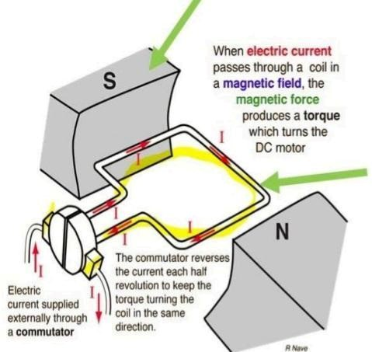
Figure 4: A Pictorial diagram of a DC Motor Stator.

2. The motor's rotating component, known as the rotor or armature, consists of wire coils wound around an iron core.
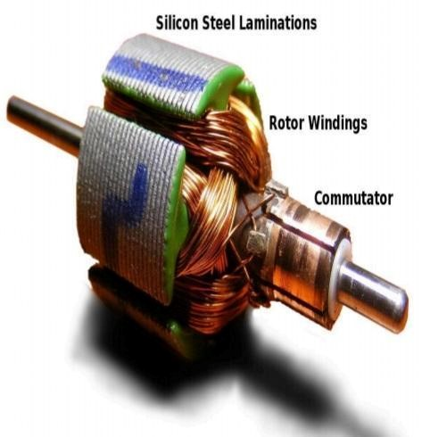
Figure 5: A Pictorial diagram of a DC Motor Rotor.

3. Commulator: A split ring that rotates with the armature to reverse the direction of the current and supply electrical connections to the coil.
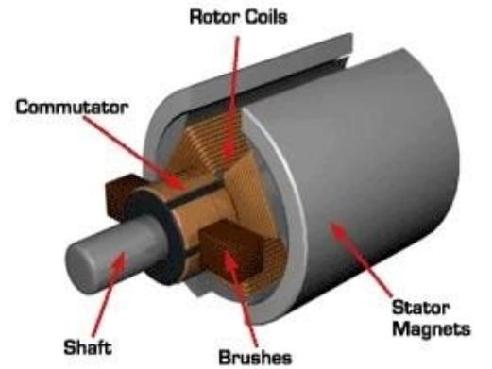
Figure 5: A diagram of DC Motor Commutator.

4. Brushes: Fixed contacts that provide the electrical connection to the coil by pressing up against the commutator.
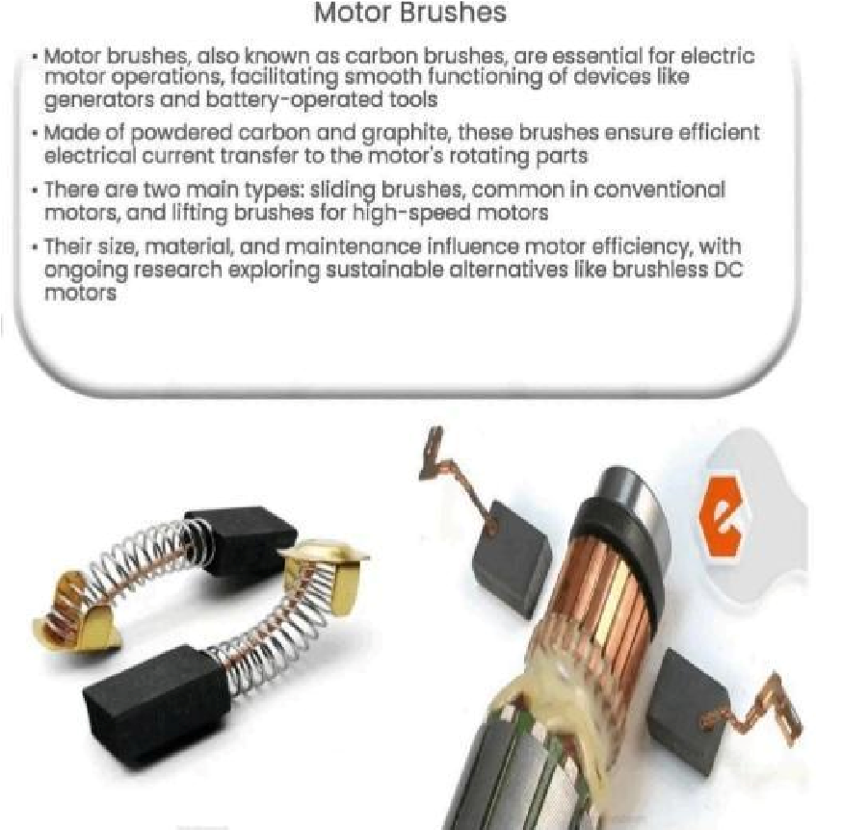
Figure 6: A Pictorial diagram of DC Motor Brushes.

  - Types of DC Motor
DC motors are broadly classified based on the field winding connections:
DC motor with series wound
Field Winding: Joined to the armature winding in series.
Features: High torque at startup. Load has a substantial impact on speed; as load increases, speed decreases dramatically.

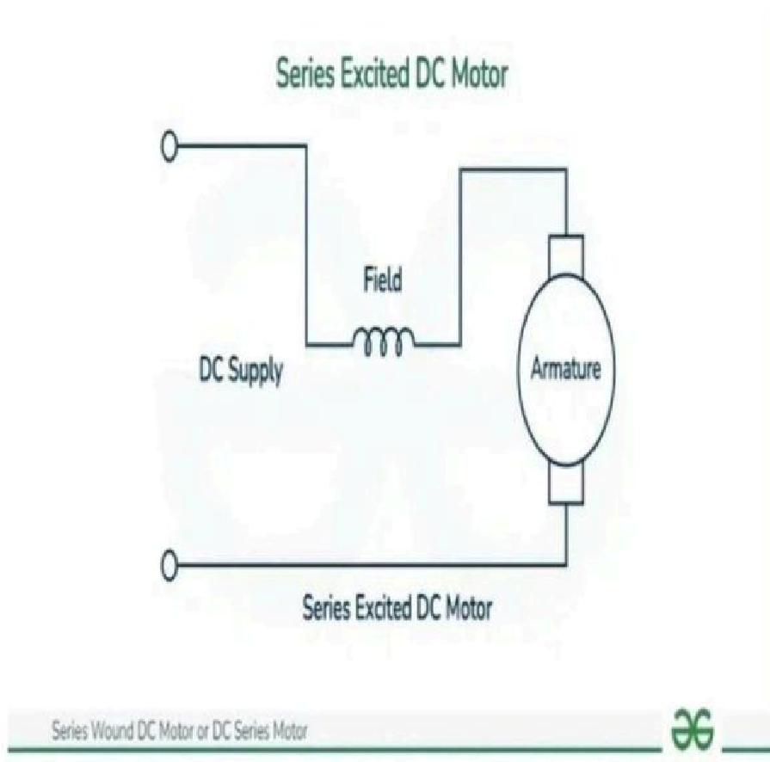

Figure 7: A Pictorial diagram of Series Wound DC Motor.

- Shunt Wound DC Motor

Field Winding: Attached to the armature winding in parallel.
Features: Consistent speed across a broad variety of loads. moderate torque at startup. Ideal for applications requiring a steady pace, such as blowers, pumps, and fans.
Not suitable for applications requiring continuous speed. utilized in devices that need a lot of beginning torque, like cranes, hoists, and traction motors in electric cars.

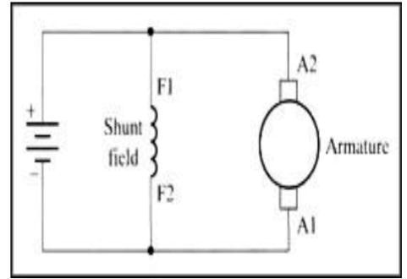

Figure 8: A Pictorial diagram of Shunt Wound DC Motor
2. Compound Wound DC Motor
Both shunt and series field windings are present.
Features: Blends the best features of shunt and series motors. strikes an excellent compromise between a generally consistent speed and a high starting torque. utilized in devices such as conveyors, rolling mills, and elevators.
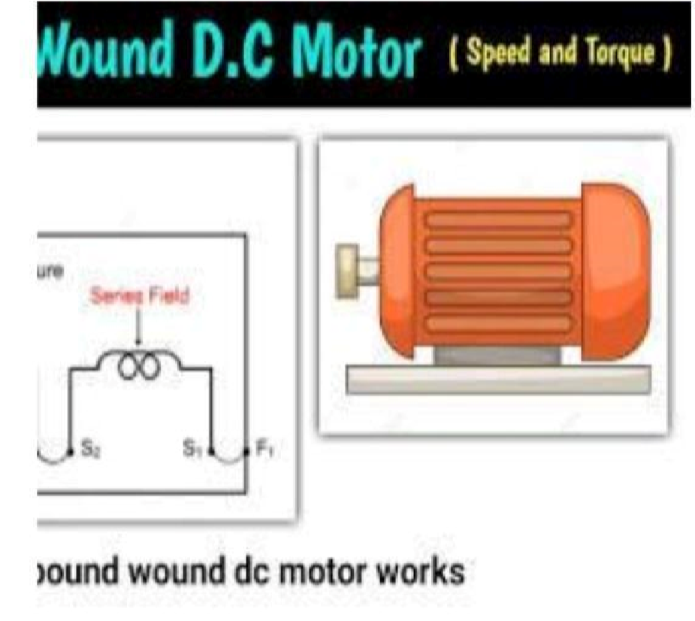
Figure 9: A Pictorial diagram of Compound Wound DC Motor
4. DC motor with permanent magnets
Field Winding: Produces the magnetic field using permanent magnets rather than electromagnets.
Features: Uncomplicated design. high effectiveness. extensively utilized in robotics, toys, and small gadgets.
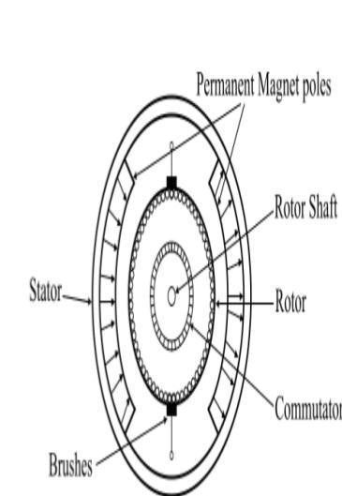
Figure 10: A Pictorial diagram of Permanent Magnet DC Motor. (Chapman, S. J. et. al., 2005).

Chapter Two

2.0 Torque speed characteristics of a DC Motor.
2.1 The concept of "torque-speed characteristics" is crucial to understanding the behavior of electric motors. It explains the connection between a motor's rotational speed and torque output.
In a variety of applications, this relationship is essential for choosing and managing motors. The important elements are:
Plotting the torque output of the motor against its rotational speed is a common way to illustrate torque-speed characteristics. This curve gives important details about how the motor performs under various load scenarios.
Importance:
Choosing the right motor for a given application requires an understanding of these features. Creating control systems to manage torque and motor speed. Estimating how well a motor will function under certain loads. Maximizing the motor's efficiency.
2.2. Different Types of Motors:
DC Motors: The torque-speed characteristic of DC shunt motors is usually somewhat linear. The speed drops linearly as the load torque rises. The characteristics of DC series motors are quite non-linear; they have low torque at high speeds and large torque at low speeds.
AC Induction Motors: The torque-speed curves of induction motors are more intricate and are frequently explained in terms of "slip." A number of variables, including frequency and rotor resistance, affect the curve's shape.("Electric Machinery Fundamentals" by Stephen J. Chapman: 2008).

2.3 Description of the Load :
1. Stall condition: The torque generated by the motor at zero speed, or while it is stationary.
2 .No-Load Speed: The motor's top speed when no load is applied.
3 Medium load: This represents a situation where the motor is required to produce a moderate amount of torque.
4 Heavy Torque: The highest torque the motor is capable of producing.

5 Light load: This refers to a situation where the motor is required to produce a relatively small amount of torque.
2.4 Characteristics Affected by Factors:
Voltage: Modifying the motor's voltage will have an impact on its torque-speed characteristics.
Load: The motor's speed will be greatly impacted by the mechanical load placed on its shaft.
Temperature: Changes in temperature can impact the motor's performance by changing its electrical and magnetic characteristics.

2.5 Varying Load Condition of a DC Motor.

The term "changing load condition" describes circumstances in which the DC motor's mechanical resistance varies over time.
In numerous real-world applications, this is commonly:
Robotics: A machine arm that can lift various weights. A mobile robot moving over rough ground.

Acceleration and deceleration in electric vehicles driving in level terrain and climbing hills.
Applications in Industry: Belts on conveyors that move different quantities of material. Cutting operations are carried out by machine tools with variable forces.

Effects of Different Loads

When the load on a DC motor changes:
1 Speed Fluctuations: The motor's speed tends to drop with increasing load. The motor's speed tends to increase as the load decreases.

2 Current Variations: The motor must draw greater current when the load increases. A lower current draw is the result of a decreased load.
3 Torque Changes: In order to match the load torque, the motor's output torque must change.
(Electrical Machines, Drives, and Power Systems" by Theodore Wildi: 2013).

2.6 Experimental Analysis of a DC Motor.
Essential components of Analyzing Experimental DC Motors: Characterization:
Determining the motor's primary performance metrics, including power output, efficiency, and torque-speed curves. Examining how the motor behaves in different operational conditions. Performance evaluation is the process of determining whether a motor is appropriate for a given application.
Determining possible drawbacks and places in need of development.

Control System Design: Compiling information to create and put into use efficient motor control systems.
To measure torque, a load (tachometer) applies a regulated mechanical load to the motor. The motor's rotational speed is measured by the speed sensor.

1.Current Sensor: Determines how much current the motor is drawing.
An apparatus that gauges the electrical current passing across a circuit is called a current sensor. When it comes to a DC motor, it measures how much current the motor draws from the power source. To understand the motor's load, efficiency, and overall performance, this measurement is required.

2.Sensor data is gathered and digitalized by the data acquisition system.
The processed output produced by sensors is referred to as sensor data. This comprises information from the speed sensor (such as an optical encoder), current sensor, and maybe additional sensors like temperature or voltage sensors in a DC motor experiment. Analog or digital electrical signals that represent the measured physical values are commonly used to represent sensor data. To derive useful information on the motor's performance, this data must be processed and understood.

3.Computer (Analysis): Creates reports and performance curves by processing and analyzing the data gathered.
The computer acts as the main processing unit for data analysis and visualization in an experimental DC motor system. It does a number of activities after receiving sensor data from the data acquisition system (DAQ), such as: processing and processing of data. Performance

measures, such as torque, power, and efficiency, are calculated. creating charts and graphs (such as torque-speed curves). Control the method design and data recording (Experimental study and analysis of wounded type D.C. motor with variable power supply" (Published in 2017)).

Chapter Three
3.0 Motor (Centrifuge)
Centrifuge is a device used to separate particles of different densities from a mixture by applying centrifugal forces.This forces make the particles move away from the center of rotation if not been put well.When spin it creates a force that pushes the spring balance away from the center of rotation.
It consists of a rotor that spins at high speed creating strong centrifugal forces.Is a crucial component used in various industrial and scientific applications for centrifugal pump and motor. They depend on the accurate and dependable functioning of electric motors, and serve as important instruments in many scientific and industrial areas. The centrifuge's acceleration, running speed, and general efficiency are all directly impacted by the motor's properties. The purpose of this observation is to give a solid understanding of the fundamental motor principles and factors to be taken into consideration when using centrifuges.
3.1 Torque and Current Relationship
Torque is directly proportional to current flowing through it. t°I
It can also be written as:
t=k×I
Where k is the motor constant.
T is the motor torque [Nm]
Relationship: °T=kt×I
Kt is the motor torque constant that measures how much torque the motor produces per unit. RPM torque is measured through the use of a tachometer.

3.2 Torque and Speed
Speed is the rate at which an object rotates.
RPM is the number of revolutions of the motor that completes in one minute.
Speed is inversely proportional to torque in the process that as torque increases speed decreases or torque decreases speed increase.
T°1/w
T = k × (V - k^1 × w)
3.3 Apparatus
Tachometer is a vital instrument used to measure the rotational speed of a shaft in revolution per minute [RPM].It measures the motor speed in RPM. It provides adequate speed control and stable experiment.
Load: is the mechanical resistance which the motor must overcome to perform it's intended function Is the external force that opposes the rotation of the motor.
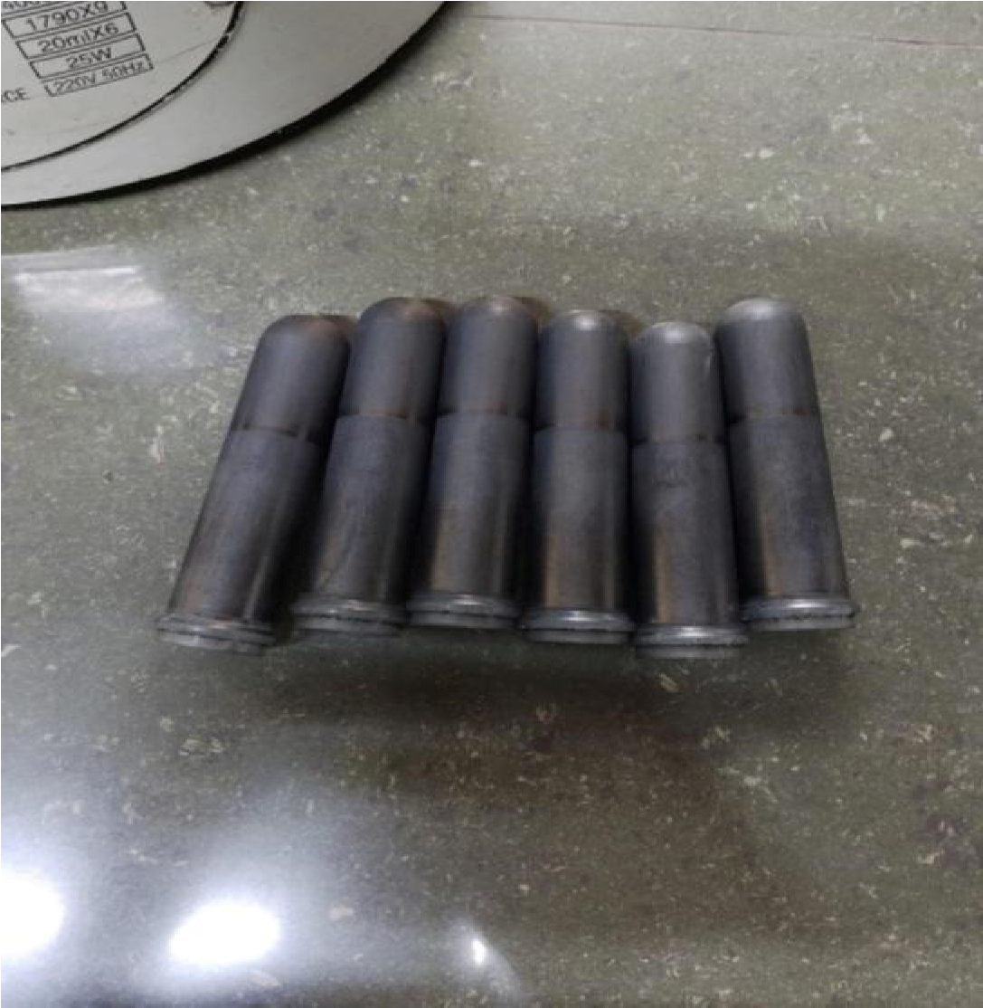
Figure 11: The diagram of load inside a Centrifuge Machine.

We went to three different laboratory hospitals that make use of a centrifuge machine to apply the practical by carrying out the no load,light load,medium load,heavy load and stall condition ten times in one minute interval.
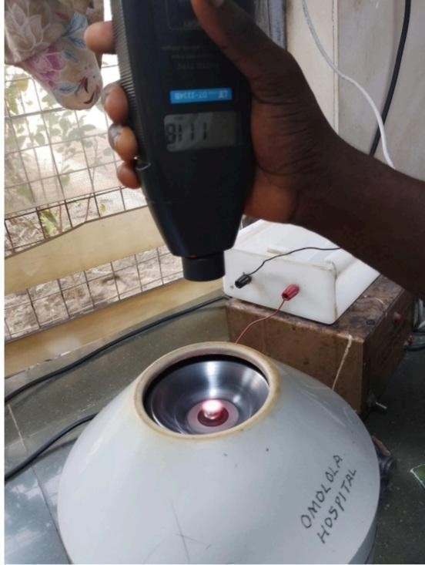
Figure 12: We measure the centrifuge RPM and torque RPM using a tachometer that takes place at Omolola hospital.

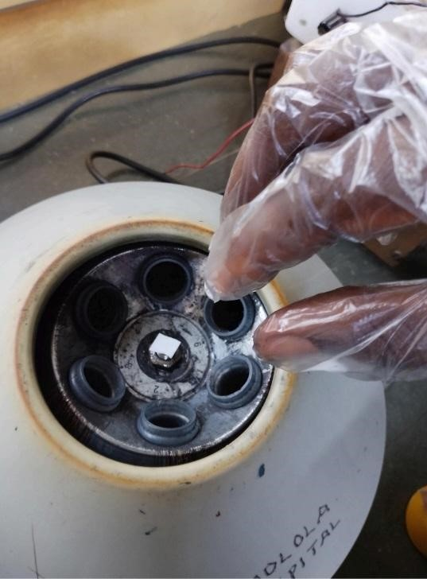

The centrifuge machine was filled with all the load to calculate the RPM of torque heavy loads.

Figure 13: Light load was filled in the centrifuge RPM of 500 to measure the Torque RPM for one minute.

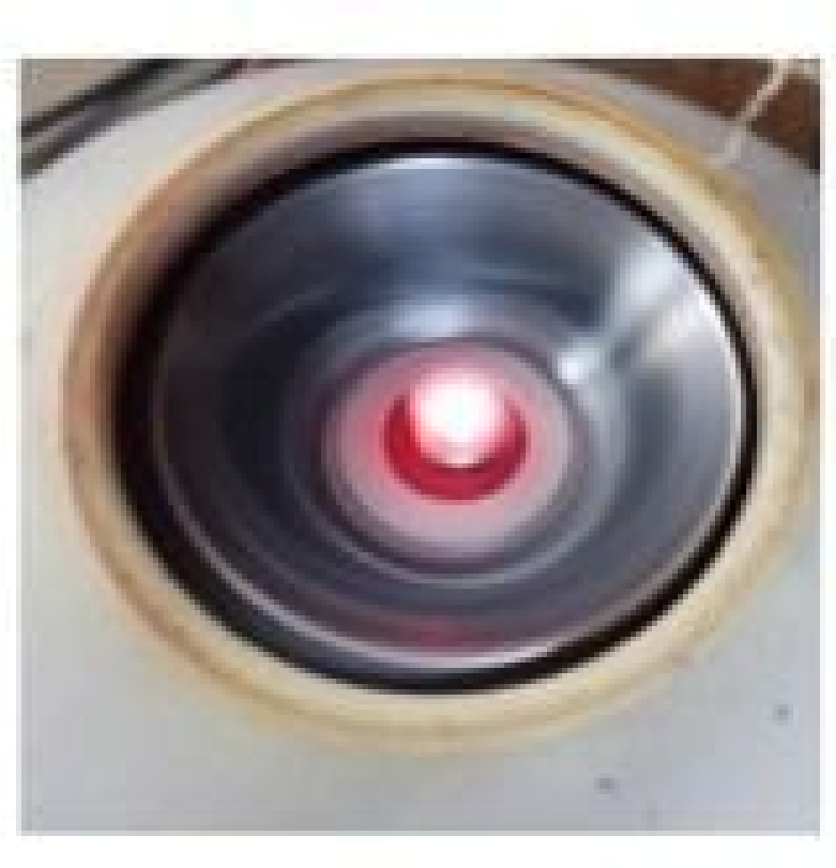
Figure 14: We measure the Torque RPM using a tachometer that takes place in Khadijat Memorial Hospital.

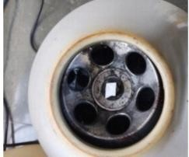
Figure 15: We measure the Torque RPM of no load using a tachometer which takes place in Bahmed Clinical/diagnostic Ltd.
3.4 Step Taking While Reading

Step 1: We take out all the load of the centrifuge machine then we calculate the Torque RPM if the Centrifuge RPM is 500 to 4000 using a tachometer machine to calculate rotation of the speed in one minute.
Step 2: We measure the light load by filling the centrifuge machine with two loads only to calculate the Torque RPM and the centrifuge RPM of 500 to 4000.
Step 3: We measure the medium load and heavy loads with four and six loads to calculate the speed.
Step 4: Then keep doing this for several minutes of different loads and centrifuge RPM in 10 times each loads.
Step 5:After measuring we notice that as the torque increases then speed decreases.

RESULTS:

The structured data table includes speed measurements (from both tachometers), current values, and theoretical torque values.
A torque-speed characteristic curve was plotted, showing an inverse relationship between torque and speed.
Structured Centrifuge Data Table
Load  Description | Tachometer  Reading  (RPM) | Centrifuge  RPM | Average  RPM | Current (A) | Torque (Nm)
NO LOAD | 1717 | 500 | 1108.5 | 13.0 | 0.65
NO LOAD | 2432 | 1000 | 1716 | 10.5 | 0.525
NO LOAD | 1924 | 1500 | 1712 | 8.0 | 0.4
NO LOAD | 4013 | 2000 | 3006.5 | 5.5 | 0.275
NO LOAD | 472 | 1500 | 986 | 12.8 | 0.64
NO LOAD | 2361 | 2000 | 2180.5 | 10.2 | 0.51
NO LOAD | 2253 | 2500 | 2376.5 | 7.6 | 0.38
NO LOAD | 2780 | 3000 | 2890 | 5.0 | 0.25
NO LOAD | 1380 | 1000 | 1190 | 12.9 | 0.645
NO LOAD | 3244 | 2000 | 2622 | 10.4 | 0.52
NO LOAD | 4457 | 3000 | 3728.5 | 7.9 | 0.395
NO LOAD | 6069 | 4000 | 5034.5 | 5.4 | 0.27
LIGHT LOAD | 1738 | 1500 | 1618 | 12.0 | 0.6
LIGHT LOAD | 2291 | 2000 | 2145.5 | 9.8 | 0.49
LIGHT LOAD | 3126 | 2500 | 2813 | 7.6 | 0.38
LIGHT LOAD | 2307 | 3000 | 2653.5 | 5.4 | 0.27
LIGHT LOAD | 1365 | 1000 | 1182.5 | 12.7 | 0.635
LIGHT LOAD | 2932 | 2000 | 2466 | 10.2 | 0.51
LIGHT LOAD | 3054 | 3000 | 3027 | 7.7 | 0.385
LIGHT LOAD | 3470 | 4000 | 3735 | 5.2 | 0.26
MEDIUM  LOAD | 2488 | 4000 | 3244 | 12.6 | 0.63
MEDIUM  LOAD | 1352 | 1000 | 1176 | 12.6 | 0.63
MEDIUM  LOAD | 1592 | 2000 | 1176 | 10.1 | 0.505
MEDIUM  LOAD | 4366 | 3000 | 3683 | 7.9 | 0.38
HEAVY  LOAD | 1637 | 500 | 1068.5 | 10.9 | 0.545
HEAVY  LOAD | 2041 | 1000 | 1520.5 | 9.2 | 0.46
HEAVY  LOAD | 1568 | 1500 | 1534 | 8.5 | 0.425
HEAVY  LOAD | 2670 | 2000 | 2335 | 7.8 | 0.32
HEAVY  LOAD | 2936 | 2500 | 2718 | 7.1 | 0.355
HEAVY  LOAD | 2624 | 3000 | 2718 | 6.4 | 0,32
HEAVY  LOAD | 2681 | 3500 | 2812 | 5.7 | 0.285
HEAVY  LOAD | 3202 | 4000 | 3601 | 5.0 | 0.25
STALL  CONDITION | 2063 | 500 | 1281.5 | 4.3 | 0.215
STALL  CONDITION | 1441 | 1000 | 1220.5 | 3.6 | 0.18
STALL  CONDITION | 1690 | 1500 | 1595 | 2.9 | 0.145
STALL  CONDITION | 2861 | 2000 | 2430.5 | 2.2 | 0.11
STALL  CONDITION | 2333 | 2500 | 2416.5 | 1.5 | 0.075
STALL  CONDITION | 2912 | 3000 | 2950 | 1.2 | 0.06
STALL CONDITION | 2314 | 3500 | 2907 | 1.5 | 0.075
STALL CONDITION | 4500 | 4000 | 4250 | 1.8 | 0.09

TABLE FOR ALL THE EXPERIMENTAL ANALYSIS OF DC MOTOR
IT BASE ON: NO LOOAD, LIGHT LOAD, MEDIUM LOAD, HEAVY LOAD, AND STALL CONDITION.
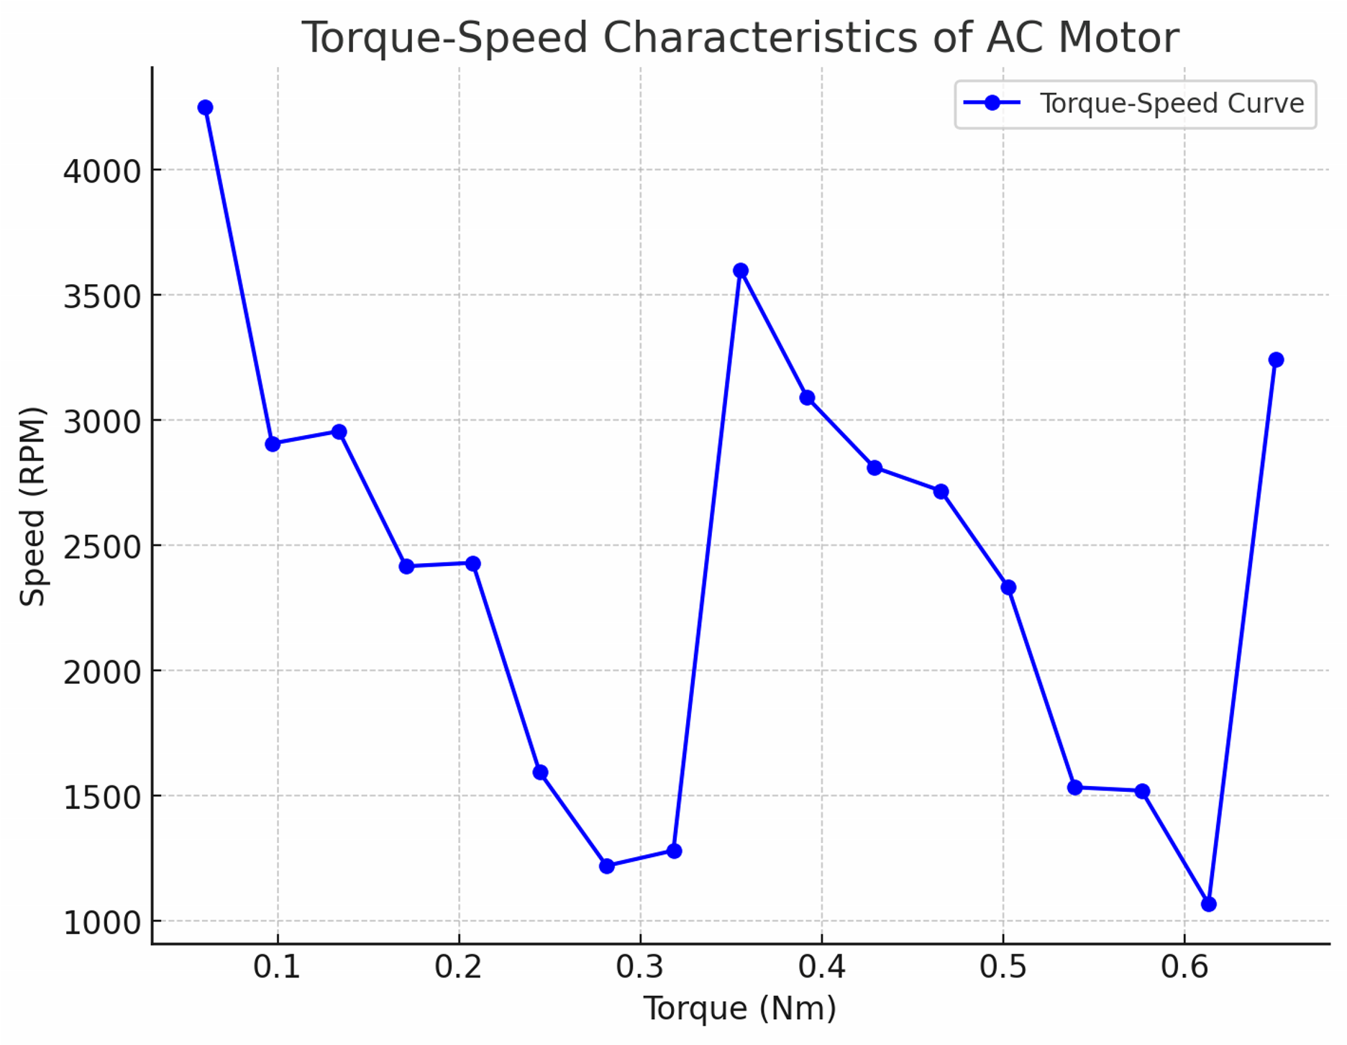
Graph: Graph of Torque Speed Characteristics of AC Motor
Graph: The Torque-Speed Curve for the AC motor based on the available data, plotted with torque on the X-axis and speed on the Y-axis, shows an inverse relationship.
. The curve follows the expected trend: as torque increases, speed decreases.
- The points represent different load conditions, showing the motor’s performance under varying torques.

Chapter Four
4.1 Discussion
This study of the experimental analysis of torque-speed variations in a DC motor is a fundamental process for understanding and optimizing its performance. This analysis involves observing and quantifying how the motor's speed changes in response to varying loads (torque).
In a DC motor, there's an inverse relationship between torque and speed. As the load (torque) increases, the motor's speed tends to decrease, and vice versa. Internal motor properties like armature resistance, magnetic field strength, and back EMF affect this connection.
Motor temperature can affect its performance. When conducting measurements, the motor must be allowed to acquire a steady working temperature. Reliable findings depend on the sensors' and data collecting system's accuracy. To choose the best motor for a certain application, one must be aware of the torque-speed characteristics. It aids in the design of control systems that, under various load situations maintain work speeds.
The torque-speed graph confirms that as torque increases, the motor speed decreases.No-load speed represents the maximum speed of the motor without any load applied.The stall condition was identified where the torque was maximum, and the speed approached zero.
The efficiency of the motor can be estimated using the relationship between input power (Voltage × Current) and output mechanical power (Torque × Speed). Deviations in the data could be attributed to measurement inaccuracies in tachometer readings or slight variations in applied load.

Chapter Five
CONCLUSION
In this project we are able to effectively illustrate an AC motor's torque-speed characteristics. The results support the inverse torque-speed relationship observed in AC motors and are consistent with theoretical predictions. When choosing motors for certain applications based on torque and speed requirements, these findings are helpful. This experiment successfully demonstrated the torque-speed characteristics of an AC motor. The findings align with theoretical expectations, confirming that AC motors exhibit an inverse torque-speed relationship. These results are useful for selecting motors for specific applications based on torque and speed requirements.

REFERENCES

1.Electric Machinery Fundamentals by Stephen J. Chapman (2012) and Electrical machines, Drives, and power systems by Theodore Wildi (2006).
2.Nasar, S. A. (2010). Handbook of electric machines (3rd ed.). McGraw-Hill).
3.Electric machinery Power electronics and motor drives 2008; advances in industrial applications.
4.Bose, B. K. (2010).
5.Power electronics and motor drives: advances in industrial applications. Elsevier. Chapman, S. J. (2005).

6.Electric Machinery Fundamentals" by Stephen J. Chapman 2009: A very popular and comprehensive textbook on electric machines, including DC motors).
7.Chapman, S. J. (2005). Electric machinery fundamentals (4th ed.). McGraw-Hill).
8.Electrical Machines, Drives, and Power Systems" by Theodore Wildi: 2013.

