
DEPARTMENT OF SCIENCE LABORATORY TECHNOLOGY

PRODUCTION AND ANALYSIS OF BIOLUBRICANT FROM A LOCAL VARIETY OF PALM KERNEL OIL (ADIN EKO)

By

Nosirudeen Samod Afolabi
HND/23/SLT/FT/0736

BEING A THESIS SUBMITTED TO

THE DEPARTMENT OF SCIENCE LABORATORY TECHNOLOGY (CHEMISTRY UNIT),
INSTITUTE OF APPLIED SCIENCES, KWARA STATE POLYTECHNIC ILORIN, KWARA STATE.
IN PARTIAL FULFILLMENT OF THE REQUIREMENT FOR THE AWARD OF HIGHER NATIONAL DIPLOMA (HND) IN SCIENCE LABORATORY TECHNOLOGY, KWARA STATE POLYTECHNIC ILORIN,
KWARA STATE
SUPERVISED BY: MR. O. E. ADEYEMO
2024/2025 SESSION
CERTIFICATION
This is to certify that this project work presented by Nosirudeen Samad Afolabu with Matriculation Number HND/23/SLT/FT/0736 has been read, approved and submitted to the Department of Science Laboratory Technology (Chemistry Unit), Institute of Applied Sciences, Kwara State Polytechnic, Ilorin.

____________________ ________________
MR. O. E. ADEYEMO DATE
Supervisor

____________________ __________________
DR. JAMIU WASIU DATE
HEAD OF UNIT

____________________ __________________
DR. USMAN ABDULKAREEM DATE
HEAD OF DEPT

____________________ __________________
EXTERNAL EXAMINER DATE
DEDICATION
I dedicated this project to Almighty Allah,the most merciful,for being my strength throughout the course of this project

ACKNOWLEDGEMENT

I would like to extend my sincere gratitude to my supervisor Mr. Adeyemo Elijah O. I appreciate his thoughtful contributions and encouragement throughout the course of this project. A special note of thanks goes to my family, brothers, and sisters and love once. Specifically my parents, Mr Nosirudeen Mumin and Mrs Afolake Rufai--whose love,patience and unwavering support, wordsofencouragement gave me the strength to see this project through. Thankyou all for being part of this journey and helping me bring this project to completion.
Contents
Title page
Certification
Dedication
Acknowledgements
Table of Content
Abstract
Table of Content
CHAPTER ONE
1.0 Introduction
1.1 Problem Statement
1.2 Aim and Objective of the Study
1.3 Justification of Study
1.4 Scope of the Study
1.5 Relevance of the study
CHAPTER TWO
2.0 Literature Review
2.1 Description of palm kernel oil extracts from traditional varieties
2.2 Sources and nature of lubricant oils
2.3 Categories and Sources of Various base stocks for formulation of lubricant oils
2.3.1 Categorized functions of Lubricants
2.4 Tribological Performance of Bio-Lubricants
2.5 Application and performance of bio-Lubricant
2.6 Market availability and benefits of bio-lubricants
2.6.1 Key benefits of bio-lubricant type in lubrication
2.7 The Collection and production of palm nut
2.7.1 The density clay bath
2.7.2 Gyratory Mechanical Screen
2.7.3 The Concept of Gyratory Mechanical Screen
2.7.4 Extraction of oil from kernel according to Margaret C
2.7.5 Pre-treatment of palm Kernels
2.7.6 Solid/Solid separation of debris from Kernels
2.8 Mechanical extraction of oil from Kernel
2.8.1 Crushing and Oil Expelling
2.8.2 The techniques involved in Michanical Extraction of oil
2.8.3 Mechanical Screw flow Diagram
2.9 Solvent extraction of oil from Kernel
2.9.1 Using immersion process for the solvent extraction
2.9.2 The concept used in solvent extraction of oil from kernel
2.10 The oil obtained while refining the palm kernel
2.10.1 Percentages of Acid values in crude palm kernel oil
CHAPTER THREE
3.0 Materials and methods
3.1 Reagents and apparatus
3.1.1 Reagents
3.1.2 Equipment and apparatus
3.2 Collection and preparation of sample
3.3 Purification of oil sample by column chromatography
3.4 Preparation of reagents
3.4.1 Preparation of 1% ^{w}/_{v} phenolphthalein solution
3.5 Trans-esterification of oil sample
3.6 Preparation of biolubricant samples
3.7 Characterization of biolubricants
3.8 Analysis of the biolubricants
3.9 Determination of some physical properties
3.10 Analysis of the biolubricant quality parameters
CHAPTER FOUR
4.0 Results and discussion
4.1 Results
4.2 Discussion
4.3 Conclusion
references as footnotes

Abstract
A sample of locally produced variety of palm kernel oil (PKO), called adin eko was transformed into a biolubricant using the fatty acid methyl ester (FAME) from the oil sample an trimethylolpropane (TMP). The biolubricant produced was analyzed for its quality parameters and the chemical components elucidated by GC-MS, FTIR analysis. The result showed that the biolubricant prepared had a quality comparable to ISOVG32 standard lubricant quality. The predominant carboxylic acids in the oil sample were identified to be hexanoate and octanoate. This work has established that the locally produced PKO variety is a potential feedstock for biolubricant- an environmental friendly product.
Keywords: biolubricant, palm kernel oil, fatty acid, lubricant quality

CHAPTER ONE
1.0 INTRODUCTION
Palm trees abound in Nigeria, especially in the Eastern and southern parts. Products from the palm trees are numerous and these are produced at different locations according to local arrangements and methods. Though palm oil and palm kernel oil are processed from the same fruit, which is pal, fruit. Palm kernel oil (PKO) has distinct properties like being full of lauric fatty acid which make it excellent compound for saponification reactions it is more stable than palm oil and sol can still maintain its peculiarities on storage for a longer time than palm oil. Palm kernel is also used for producing edible and non-edible products.¹
The edible one include: Confectionaries like margarine, biscuits, bread creamyicing, doughnuts and other similar food products. The non-edible products from palm kernel oil are candle, soap, cosmetics lubricants, ink for printing.

1. Enedoh, Joseph E, Chidi E, Stella I “Practical review of the stage in palm kernel oil production”. Journal of centre point 23, no. 2 (2017): 2141-03819.
Its usefulness is comparable to that of coconut oil and it is not associated with cholesterol or much of trans fatty acids palm kernel oil possesses inhibitory effect on staphylococcus aureus and streptococcus sp with beneficial effects due to the conversion of lauric acid to monolaurin in human or animal body².
The oil can be used as an ointment for the body to minimize infection by micro-organisms³.
1.1 PROBLEM STATEMENT
A vast array of lubricants are largely produced for use in machines and mechanical equipment. All these synthetic lubricants have been found to contribute to environmental pollution and contamination through their usage and disposal. This calls for the need to find alternative lubricants with less negative environmental impact. A worth substitute has been found in vegetable or plant oils. Oil (including PKO) process lubricating property.

2. Kamalu C, Oghome P. “Extraction and characterization of oil from premature palm kernel”. Journal of Agriculture, Engineering and Technology 16, no. 2 (2008): 29-33.
3. Ugbogu OC, Onyeagba RA, and Chigbu OA. “Lauric acid content and inhibitory effect of pal kernel oil on two bacterial isolates and candida albicans”. African Journal of Biotechnology 11, no. 5 (2006): 1045-1047.
However, the significant limitation of these lubricants is their narrow ability to resist to the industrial adoption of vegetable oil-based lubricants is their low oxidation stability, which can be fixed by adding additives or chemically altering the oil through transesterification, epoxidation, estolide production or hydrogenation. This project work therefore employs the use of PKO in producing biolubricants by altering its chemical structure through transesterification. This will contribute to the use of environmentally friendly lubricants with comparable lubricant ability to synthetic ones.
1.2 AIM OF THE STUDY
The aim of this project work is to prepare lubricant from one of the local varieties of palm kernel oil (PKO) locally produced and marketed within Ilorin metropolis.
Specific Objectives
The specific objective of the work is as follows:
- To procure sample of a locally produced variety of PKO (locally called Adin eko).
- To purify the PKO variety obtained by column chromatography
- To convert the purified PKO variety sample to its fatty acid methyl ester (FAME) by transesterification.
- To prepare the biolubricant from FAME of the PKO variety by treatment with trimethylolpropane.
- To determine the quality characteristic of the produced biolubricant from the PKO variety (Adin eko).
- To carry out spectroscopic analysis of the biolubricant (FTIR and GCMS).
- To elucidate the major fatty acid structures in the biolubricant produced.
1.3 JUSTIFICATION OF THE STUDY
On completion of this study, it will contribute to the economic benefits, and environmental factors.
- Economic benefits: In terms of economic benefits, the adoption of PKO (local variety) as a feedstock for biolubricant production will boost the economy of localities where the PKO are produced. It will add to the market value of the local PKO variety as well enhance the industrialization of our society, since the raw materials are locally available and can be sourced.
- Environmental factors: The biolubricant produced will not contribute to soil and atmospheric pollutions, since they can be degraded by microorganisms in the soil and atmosphere contrary, it may enrich the soil and eventually plants growing from such soil.
1.4 SCOPE OF STUDY
The scope of this project research work extends from the collection purification of sample production of biolubricants of palm kernel oil source. As well as analysis of its quality parameter and chemical nature.
1.5 RELEVANCE OF THE STUDY
The study is relevant as a means of providing environmentally friendly materials for technological and research wage a replacement for synthetic lubricants.

CHAPTER TWO
2.0 LITERATURE REVIEW
2.1 DESCRIPTION OF PALM KERNEL OIL EXTRACT FROM TRADITIONAL VARIETIES
Palm kernel oil extract from traditional varieties refers to the oil obtained from the seeds of the oil palm tree (Elaesis guineensis) using traditional extraction methods.
Traditional varieties of oil palm trees are often cultivated in local farms, particularly in tropical regions. The palm kernel is the seed found inside the fruit of the oil palm, and it is rich in oil. The oil extracted from these kernels is known for its high lauric acid content, which gives it unique properties.
The traditional extraction process typically involves several steps: harvesting, shelling drying, crushing, heating, pressing.
The oil obtained from traditional extraction methods tends to have a distinct flavor and aroma. It is often unrefined, retaining natural nutrients and antioxidants. The oil is typically golden yellow to brownish in color and has a thick consistency.
Traditional palm kernel oil is used in cooking, baking, and food preparation. It is also utilized in the production of soaps, cosmetics, and various industrial applications due to its moisturizing properties. Traditional palm kernel oil extraction is a labor-intensive process that yields a high-quality oil with various applications, deeply rooted in local culture and practices.
2.2 SOURCES AND NATURE OF LUBRICANT OILS
High molecular weight hydrocarbons that are building stocks for conventional lubricants are obtained from vacuum residue in the refinery. Unsaturated fatty acids are used as base stock in bio-lubricants, which until now have been based on vegetable oil. ⁴
Due to their weak heat stability and poor oxidation stability from the presence of oxidizable functional groups brought on by an unsaturated bond, pure

4. Woma T.Y, Lawal S,A, Abdulrahman, Olutoye M.A and Ojapab. “Vegetable oil Based Lubricants; Challenges and prospects”. Tribology online, 14 (2019): 60-70.
vegetable lubricants are found inappropriate for use in applications like lubricating fluids. ⁵
Vegetable oils can have their unsaturated fatty acid content decreased to make them appropriate for use in engines and make them equivalent to conventional lubricants via chemical modification methods like hydrogenation, transesterification and epoxidation ^{6,7,8}.

5. Srivyas, P.D. and Charoo, M.S. “A review on Tribological Characterization of Lubricants with Nano Additives for Automotive Applications”. Tribology in industry 40, (2018): 594-623.
6. Rajaganapathy, Vasudevan D. and Murugapoopathis: “Tribological and Rheological properties of palm and Brassica oil with inclusion of Cuo and Tio₂ Additives”. Materials Today Proceedings 37, (2021): 207-213.
7. Gad M.S. and Gadow, S.I. “Enhancement of combustion characteristic and Emissions Reductions of a Diesel Engine using Biodiesel and Carbon Nanotube”. Fullerenes, Nanotubes and Carbon Nanostructures 29, (2020): 267-279.
8. Liu Z, Li, J, Knothe G, Sharma, B.K and Jiang I. “Improvement of Diesel Lubricity by chemically modified Tung-oil-Based Fatty Acid Esters as Additives”. Energy and fuel 33, (2019): 5110-5115.
The various base stocks applied to make lubricating oils are listed in table 1 based on the literature reviewed. Depending on whether they are made of synthetic or mineral oil, the base oils are divided into five classes (I-V) by the American Petroleum Institute (API) ^{9,10}.
The categorization is also influenced by the oils sulfur content and hydrocarbon composition, thus makes bio-lubricant promising in lubricant formulation^{11, 12}.
They are categorized according to their working environment and role, like tribo-improvers, rheo-improvers and maintainers ¹³.

9. Gorla, G. Kour, S.M., Padmaja, K.V. Karuna, M.S.L. and Prasad, R.B.N “Preparation and properties Lubricant Base stocks from Epoxidized Karanja oil and its Alkyl Ester”. Journal of Industrial and Engineering chemistry Research 52, (2013): 16598-16605.
10. Minami I. “Molecular Science of Lubricant Additives”. Journal of Applied Sciences 7, (2017): 445.
11. Shah, Wogdt and Zhang S. “The Economic and Environmental Significance of Sustainable Lubricants”. Lubricants 9, (2021): 21.
12. Sarma, and Vinu, R,. “Current status and future prospects of Biolubricants: Properties and Applications”. Lubricant 10, (2022): 70.
13. Minami I. “Molecular Science of Lubricant Additives”. Journal of Applied Science 7, (2017): 445.
Lubricant tribological performance is improved by tribo-improvers, rheo-improvers are designed for base oils fluidity, while maintainers prevent the lubricants and machine parts from degrading, as well as the breakdown of the substance involved in the lubrication systems.
2.3 CATEGORIES AND SOURCES OF VARIOUS BASE STOCKS FOR FORMULATION OF LUBRICANTS OILS
2.3.1 Biomass base oil stocks^{14,15}
Sources: Bio-oils, lipids and oil produced from agro-residues and wasted
through thermochemical and catalytic processing are among the plant and animal-based oils.
Synthetic oil base stocks^{16,17}
Sources: Generated from petroleum crude oil using hydro-treating and hydro-
processing after chemical modification. They mostly consist of oils based on
14. Mannekote, Kailas, Venkatesh, K. and Kathyayin. “Environmentally Friendly functional Fluids from Renewable and sustainable sources- A Review”. Renewable and sustainable Energy Review 81 (2018): 1787-1801.
15. Chauhan, and Chhibber, V.K “Non-Edible oil as a source of Bio-lubricant for industrial Application: A Review”. International Journal of Engineering Science and Innovative Technology 2, (2013): 299-305.
16. Minami I, “Molecular Science of Lubricant Additives”. Journal of Applied Science 7, (2017): 445.
17. Sarma, and Vinu R. “Current status and future prospects of Biolubricnts. Properties and Application”. Lubricants 10, (2022): 70.
poly-olefins, silicones, polyolesters.
Mineral base oil Stocks^{18,19,20}
Sources: They are produced during the processing of crude oil, which include solvent refinement and hydrocracking. They might have a naphthenic, aromatic or paraffinic composition.
Re-refined base oil stocks^{21,22}
Sources: Obtained from refined petroleum products that have undergone

18. Chauhan and Chhibber V.K. “Non-Edible oil as a source of Bio-lubricant for Industrial Applications: A Review “. International Journal of Engineering Science and Innovative Technology 2, (2013): 299-305.
19. Liu, Knothe, Sharma and Jiang. “Improvement of Diesel Lubricity by Chemically modified Tung-oil based Fatty Acid Esters as Additives”. Energy and fuel 33 (2019): 5110-5115.
20. Sarma, and Vinu “Current Status and Future Prospects of Biolubricants. Properties and Applications”. Lubricants 10, (2022): 70.
acid/clay treatment to remove impurities and volatile and insoluble parts.
21. Chanhan and Chhibber, V.K. “Non-Edible oil as a source of Bio-lubricant for industrial Application: A review”, International Journal of Engineering Science and Innovative Technology 2, (2013): 299-305.
22. Rozina, Asif, Ahmad, Zafar, and AI, N “Prospects and potential of Fatty Acid Methyl Esters of some Non-Edible seed oils for use as biodiesel in Pakistan”. Renewable and Sustainable Energy Review 74, (2017): 687-702.
2.3.1 Categorized Functions of Lubricants²³
Lubricants can be categorized in to four; lubrication, cooling, cleaning and transmission power functions (Figure 2.1 below).
Lubrication: To form lubricating film between the moving parts, thus minimizes the contact by forming third body, thus transforming the sliding mechanism into rolling operation. This reduced friction and wear thereby serving energy and improve efficiency.
Cooling: Process good thermal conductivity thereby dissipates excess heat generated via friction away from the moving parts of the machine. This minimized the element damage which are caused by friction and wear.
Cleaning: Remove harmful products like debris, sludge, carbon and dirt. This increase rate of oxidation during lubrication. Finally help in smooth machine operation.

23. Anthony Chukwunonso Opia et al. “A Review on Bio-Lubricants as an Alternative Green Product:Tribological Performance, Mechanism, Challenges and Future Opportunities”. Tribology Online. 2023, 18, 2, 18-33.
Transmission power: Serves as power transfer medium in some machine, like hydraulic system and moving automatic transmission for generation of torque.
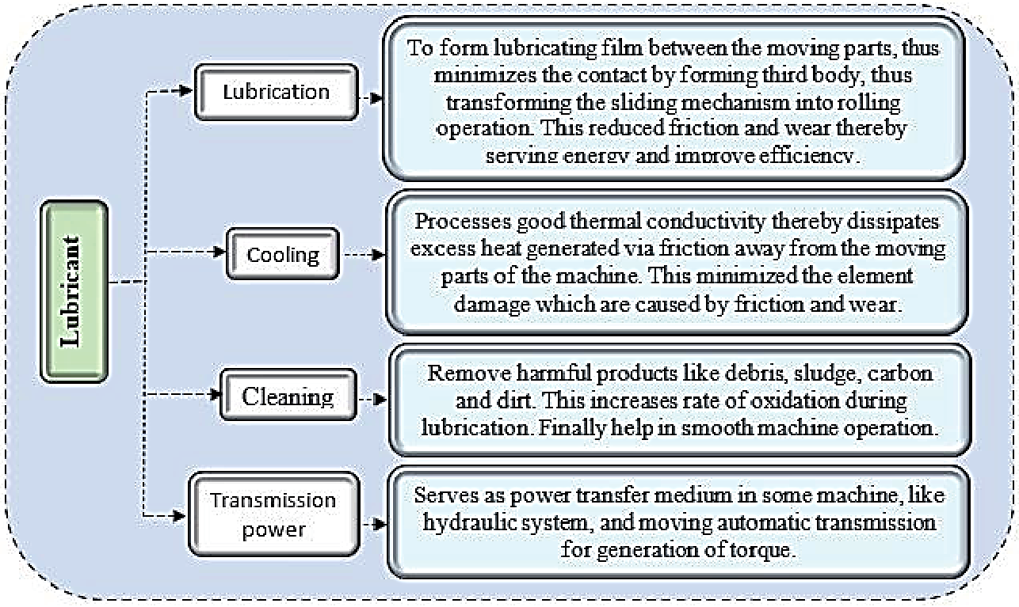
Figure 2.1: Categorized functions of lubricants
2.4 TRIBOLOGICAL PERFORMANCE OF BIO-LUBRICANTS
Some investigations had been conducted on different bio-lubricants under application of different NPs as additives, with recommended results as presented in table 4. Thottackkad, conducted tribological investigation using CuO NPs combined with coconut oil²⁴.
According to the findings, the CuO nanoparticle concentration that produced the lowest wear rete and friction coefficient was 0.34mass %. The viscosity and fire point increased when the nano-additive was applied while the surface roughness reduced²⁵.
On analysis conducted by Alves, employing Zinc oxide (ZnO) and copper oxide (CuO) as lubricant additives. The outcome found that both Zinc oxide and copper oxide NPs were rendered inactive as an anti-wear addition for soybean and sunflower oil due to the rise in friction coefficient and the presence of abrasive wear on the worn surface²⁵.

24. Thottacked, Perikinali, and Kumarapillai PiNo “Experimental Evaluation on the Tribological Properties of Coconut oil by the Addition of CuO Nanopenticles”. International Journal of procession Engineering and Manufacturing 13, (2012): 111-116.
25. Arumugam and Sriram. “Preliminary study of Nano-and Microscale TiO₂ Additives on Tribological Behavior of Chemically Modified Rapeseed oil”. Tribology Transaction 56, (2015): 797-805.
In another study by Arumugan and Sriram argued on the performance of micro-particle addition, TiO₂ NPs were added to chemically changed rapeseed. Comparing the TiO₂ micro-particles, TiO₂ NPs visibly observed to enhanced the lubricant lubrication performance^{26,25}.
Under nanoscale TiCO₂ of 6.9% and micro TiO₂, the COF of rapeseed oil blended additives yielded reduction by 15.2% and 6.9% respectively²⁷. Rani performed through experiment on biolubricant behaviour under additive of TiO₂, CeO₂, and ZrO₂ NPs, using rice bran oil as base lubricant. The result revealed that 0.5mass% CeO₂ and 0.3mass% TiO₂ respectively yielded the greatest COF and wear reduction²⁶. This was affirmed by Suthar, through analysis on AI₂ O₃ NPs mixed with jojoba oil with concentration of 0.1 mass%, thus minimal friction and wear was achieved compared the base lubricant²⁸.
26. Kumar, Afzaiand Ramis. “Investigation of Physicochemical and Tribological Properties of TiO₂ Nano-Lubricant oil of Different concentrations: Tribological 35, (2017): 6-15.
27. Suthar, Sigh, Surana, Rajubhai and Sharma, “Experimental Evaluation of the Friction and wear of Jojoba oil with Aluminum oxide (AI₂O₃) Nano-particles as an Additives”. Material Today: Proceeding 25, (2020): 699-703.
28. Rajubhai, Singh, Suthar and Surana, “Friction and wear Behavior of AI-7% Si Alloy Pin under pongamia oil with copper Nanoparticles as Additives”. Materials Today; proceedings 25, (2019): 695-698.

2.5 APPLICATION AND PERFORMANCE OF BIO-LUBRICANTS
Pongamia Oil: This found application in Anti-corrosive coating and power transformer applications.
The quality/performance of pongamia oil is that at medium loads, minimal frictional losses, low emissions, low specific fuel consumption and good break thermal efficiency^{29,30}.
Jatropha Oil: This found application in Biodiesel
The quality/performance of Jatropha oil, High VI, Little weight loss from wear or progressive weight reduction, and little friction^{31,32}.
Rapeseed Oil: This found application in hydraulic fluids, power transformer applications, grease.
29. Opia, Mohd Kameil, Syahrulh: I Abd Rahim B and Johnson. “Eichhorria Crassipes Transformation from problems to wide unique source of sustainable materials in Engineering Application.” IOP conference series: Material Science and Engineering 1051, (2021): 012-100.
30. Opia, Hamid, Syahrullail, Johnson, Mamah, Ali, Inmi, Hilm, Khan, and Rahim. “Effect of surfactants on the Tribological Behavior of organic carbon Nano-tubes particles Additive under Boundary Lubrication Conditions, “Tribology online 17, (2022): 19-31.
31. Jamal Inddin, Taliby and Snai. “Performance Comparative of Modified Jatropha Based Nanofluids in orthogonal Cutting process. “Evergreen, 8, (2021): 461-468.
32. Lugscheider, Berwulf, Barimani, Riester and Hilgers. “Magnetron Sputhered Hard Materials Coatings on Thermoplastic Polymers for clean Room Applications”. Surface and Coatings Technology 108-109, (1998): 398-402.
Quality/performance of Repaseed oil, improved cold flow characteristics, improved oxidation stability, and low coefficient of friction^{33,34}.
Palm oil: found application in metal working fluids (MWFs)
Quality/performance of Palm oil: High viscosity, low coefficient of friction, and less corrosive^{35,36}.
Sunflower Oil: found application in biodiesel fuel, Hydraulic oils, engine oils, paints, detergents.
Quality/performance of sunflower oil: High VI, higher flash point than same standard oils, greater lubricity, reduced evaporating loss, lower frictional coefficient, and non-toxic^{37,38}.

33. Opia, Kameil, Syahrullail, Johnson, Izmi, Mamah, Ali, Rahim and Veza. “Tribological Behavior of Organic Formulated Anti-wear Additive under High Frequency Reciprocating Rig and unidirectional orientations: Particles Transport Behavior and film Formation Mechanism. “Tribology International 167, (2022): 107-415.
34. Bhaumik, and Pethak. “A Comparative Experimental Analysis of Tribological properties between commercial Mineral oil and Neat Caster oil ushing Taguchi Method in Boundary Lubrication Regime”. Tribology in industry 38, (2016): 33-44.
35. Azman, Samion, Moen, Abdul Hamid and Musa. “The Anti-wear and Extreme pressure performance of CUO and Graphite Nanoparticles as an Additive in Palm oil”. International Journal of Structural Integrity 10, (2019): 714-725.
36. Koshy, Rajendrakumar, and Thottacked “Evaluation of the Tribological and Thermo-physical properties of Coconut oil Added with MoS₂ Nanoparticles at Elevated Temperature”. Wear 330-331, (2015): 288-308.
37. Opia, Hamid, Samion, Johnson, Rahim, and Abdulrahman. “Nano-Particles Additives as a promising Trend in Tribology, A Review on their Fundamental and Mechanisms on Friction and Wear Reduction”. Evergreen 8, (2021): 777-798.
38. Cortes, Sanchez, Gonzalez, Alcoutlabi, and Ortega, “The Performance of SiO₂ and TiO₂ Nanoparticles as Lubricant Additives in Sunflower oil”. Lubricants 8, (2020): 10.
Coconut oil: Found application in engine oil.
Quality/performance: Better lubricity, low coefficient of friction and high anti-wear³⁹.
Canola oil: Found application in transmission fluids, hydraulic fluids, penetrating oils.
Quality/performance: High VI, Higher flash point than some standard oils, greater lubricity, reduced evaporative loss, lower frictional coefficient and non-toxic⁴⁰.
Linseed oil: Found application in stains vanishes, paint
Quality/performance: high VI higher flash point than some standard oils, greater lubricity, reduced evaporative loss, lower frictional coefficient and non-toxic^{38, 6}.
Castor oil: Found application in greases, gear lubricants
Quality/performance: Low volatility, high level of antioxidant, and low deposit formation³⁹.
2.6 MARKET AVAILABILITY AND BENEFITS OF BIO-LUBRICANTS²⁵
Lubricants from vegetable source can be naturally used. They have several advantages, vegetable oils offer outstanding lubricity, which is significantly better than that of mineral oils. Furthermore, vegetable oils have a high VI. For instance, vegetable oils frequently have a VI of 223, but most mineral oils typically have a VI of 90-100. Vegetable oils have high flash points, which is another significant characteristic. Vegetable oils typically have a flash point of 326℃, while common mineral oils have flash temperature of 200℃ other benefits from the use of vegetable lubricants are summarized in table 2.1 below.

39. Opia, Kameil, Syahrullail, Mamah, lzmi, Hilini, Saleh, Rahim and Johnson. Effect of Concentration on the Tribological Behavior of Cyclic Heated Formulated Organic Carbon Nanotubes in Base Lubricant under Boundary Conditions”. Tribological online 16, (2021): 199-209.
Table 2.1: Key benefits of bio-lubricant type in lubrication
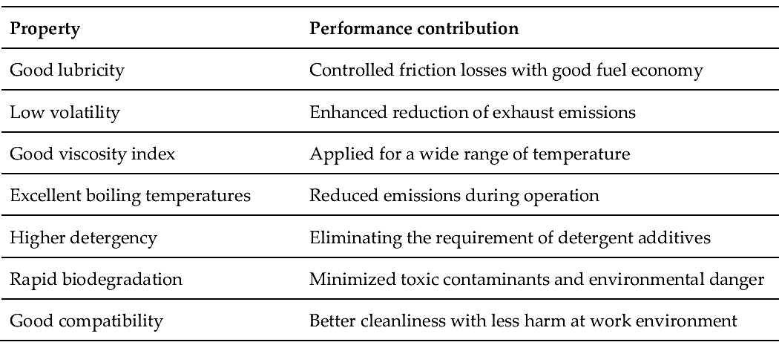
The global market for bio-lubricants is expected to be influenced by the expanding opportunities for sustainable solutions, such as green building and sustainable lubrication. The international market for bio-lubricants is anticipated to reach us 2.6 billion under a CAGR of 5.2% over the forecast timeline of 2020–2027, based on recent report by global industry Analyst Inc⁴⁰. The demand for biolubricants is still high, especially in Europe where it is encouraged by national and global branding regulations, subsidization and tax benefits⁴¹.

40. Zhu, Pan, Jia, L, Zhang and Yin, “Review on the stability mechanism and Application of water-in-oil Emulsions Encapsulating various Additives”. Comprehensive Reviews in Food Science and Food Safety 18 (2019): 1660-1675.
41. Global Industry Analysts, Production and Trade of Lubricants, United Kingdom (2010-2021). 2021.
2.7 THE COLLECTION AND PRODUCTION OF PALM NUT⁴²
The extraction of oil from palm kernel was carried out by cutting down the husks containing the palm fruits from the palm tree. The palm fruits besides madonna were detached from the husks by hand picking in dieting a solid/solid separation. Then the palm fruits with water added were heated to boiling point. Then using just mortar and pestle, the oily. Fleshy mesocarp was separated from the nuts by pressing the palm fruits together and swirling (Centrifuging) to release the nuts. Solid/solid separation took place as through an opening under the mortar, the nuts were pushed out or the mesocarp on top were removed (packed out) by hand. The nuts collected were cracked by cracking machine. The friction led to the breaking of the sucks that led to the release of the kernels. The kernels were next separated by till a solid/solid method from the shell by hand picking or if available and to leverage time, by density clay bath gyratory mechanical screen connected to the cracking machine.
42. M. C. Enedoh et. al. “Practical review of the stages in palm kernel oil production in Owerri North of Imo State, Nigeria (Elaeis Guineensis)”. Centrepoint Journal (Science Edition). 2017, 23, 2, 25-38
2.7.1 The Density Clay Bath⁴²
The cracked kernel nuts were swirled to separate the seed from the nuts. By density, the nut moved downwards while the shell remain on top.
2.7.2 Gyratory Mechanical Screen
In this mechanical method, the kernels and shells moved down along perforated and brown-lined barrel – like screen, made from iron sheet. The kernels were fine so they moved in when the screen was agitated while the shells being rough were caught up by the rough mesh which then on agitation pushed the shells out through the large mash.
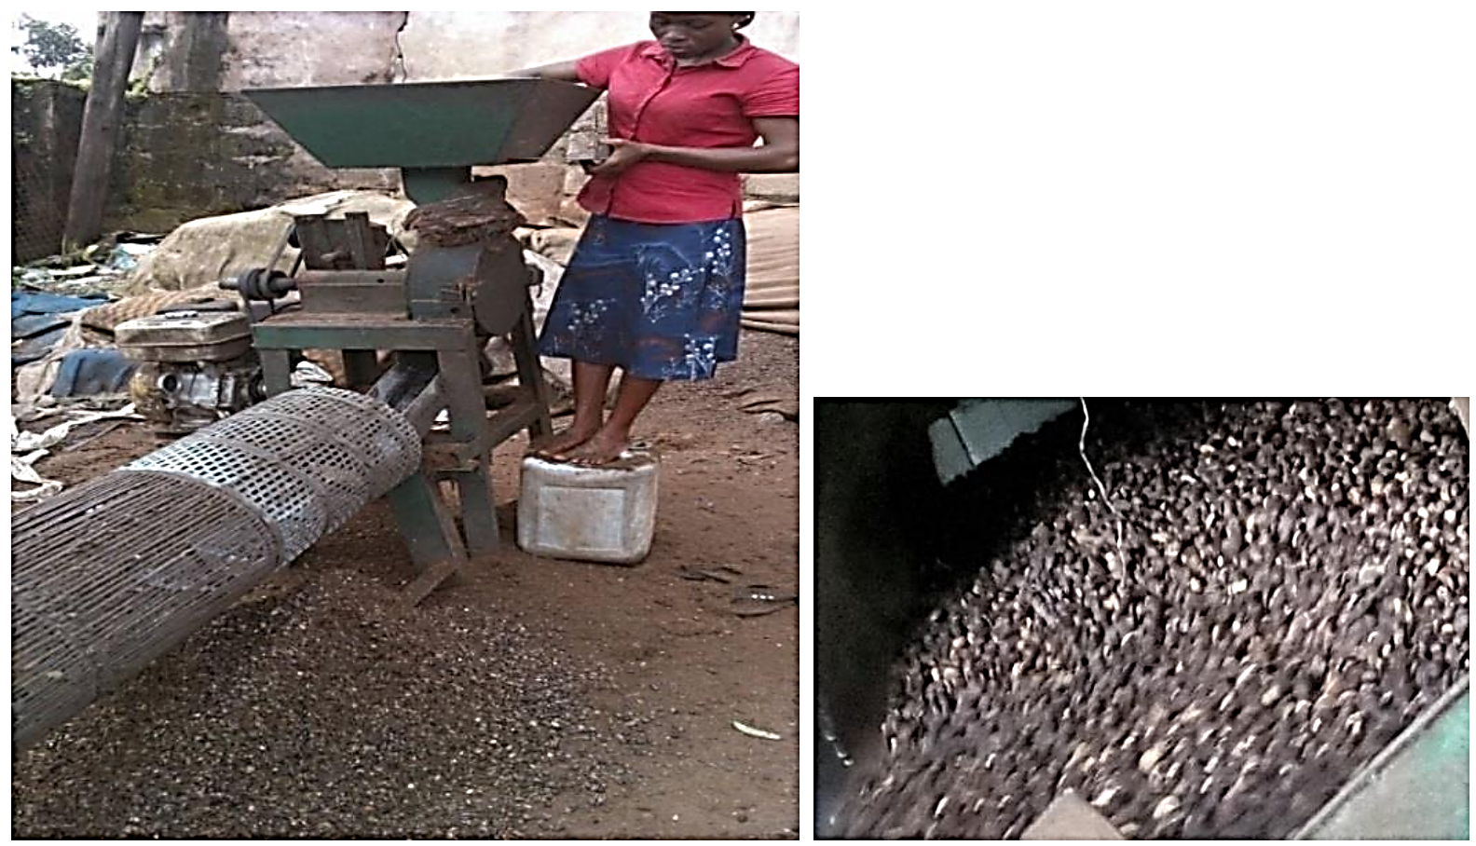
Figure 2.2: Gyratory mechanical screen where shells fall off through the screen and the kernels empty at the other end.
2.7.3 The Concepts of Gyratory Mechanical Screen⁴²
The concept: Kernels (K) are fine and less than the friction while smashed shells (S) are rough greater than the friction power.
With agitation rough shells dropped while the fine kernel moved on.

2.7.4 Extraction of oil from kernel
It was generally mechanical extraction first then solvent extraction followed. The sketch was:
2.7.5 Pre-treatment of Palm Kernels
Palm kernels pre-treatment requires adequate ventilation or aeration of the nuts during storage was done as that would ensure low moisture level and minimal or no microbial development, less there would be a degradation of the oil, mould growth contamination would lead to a biological and chemical degredation process resulting to high free fatty acid (FFA), color/odor and poor organic qualities of oil produced. When fully dried the kernels were bagged. ‘Margare C.
2.7.6 Solid/Solid separation of Debris from kernels
The kernels in began were poured in the feeding Gontamer and then magnetic separators were used to remove the metal debris from the kernel while vibrating screens using sidelong technique this technique were used to separate sand, tiny kernel sicks stones etc. ‘Magret C.
2.8 MECHANICAL OIL EXTRACTION
2.8.1 Crushing and Oil Expecting
Crushing and oil expelling start from the hopping the kernels were sent to the crusher/oil expeller were these nuts were first broken into smaller size (to increase the surface area). The broken pieces were flaked steam conditioned and crushed by mechanical mills. Crude palm kernel oil (PKO) was obtained via the oil expeller or a type of coarse filter. In the expeller a screw- type- machine that pressed oil seeds through a caged barrel-like cavity that is the mechanical solid phase extraction took place. This simply entails extracting oil by physics approach which is based on the pressure. That is extracting by mechanical screw press. About 65% or 70% is generally achieved.
2.8.2 The Techniques involved in Mechanical Extraction of Oil
- The technique involves the kernels entering from one side of the mechanical press.
- The press with much friction and pressure which was continuously supplied by the screw drives, moved and compressed the nuts leading to crushing.
- Oil was produced which seeped through the little opening in the machine while nut fibre solids could not pass through.
- Separation took place
- As the oil drains down wards, the cake produced were expelled through the other side.
2.8.3 Mechanical Screw Flow Diagram
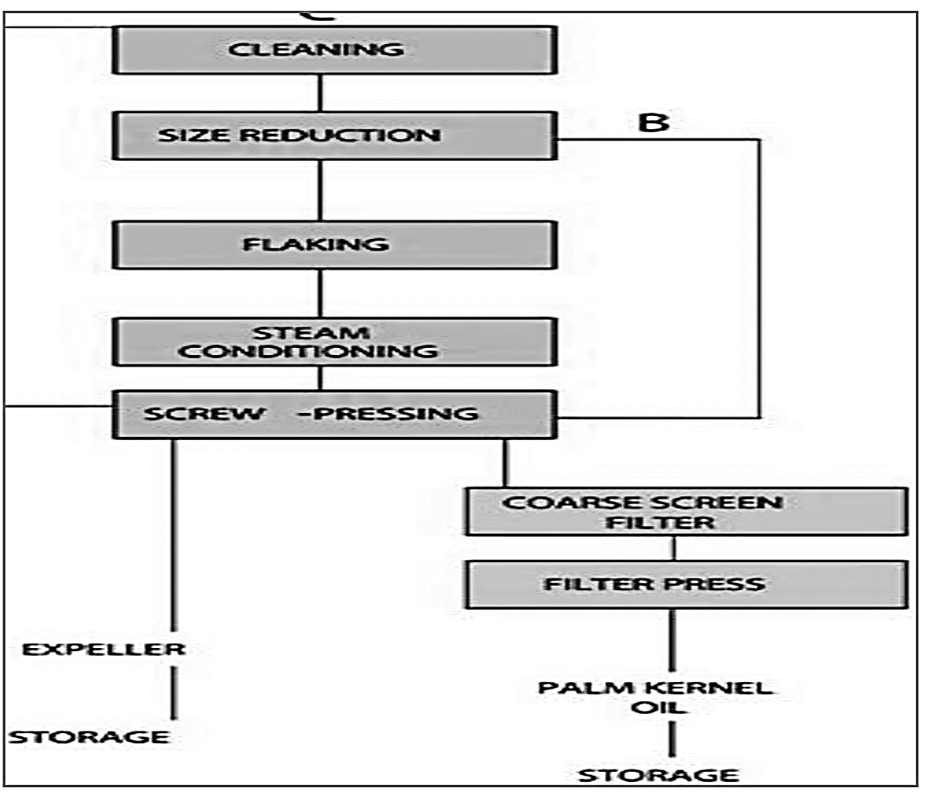
Figure 2.3: Mechanical Screw flow diagram
2.9 SOLVENT EXTRACTION OF OIL FROM KERNEL⁴²
The crushed and pressed nuts were formed into cake. The pressure involved in the expeller machine normally creates heat which ranges from 65 -100℃. The cake was removed from the machine bagged and taken out for further oil extraction.
It is important to note that mechanical extraction removed only about 60% of oil. Then hot water solvent was used to separate almost the remaining oil.
2.9.1 Using Immersion Process for the Solvent Extraction
This process is commonly used in Owerri. The cake was heated with hot water to make a paste for kneading by hand. Then it was immersed in the solvent (water) and heated again high temperature reduce solvent viscocity and moressed solubility in the solvent enough solvent was used to have elasticity of cake with no crumbling as stirring and agitation was continuously done to make for increased surface area. The heating continued to ensure the production of oil – saturated solvent coniscella which floated on top and was skinned off constantly.
2.9.2 The Concept used in Solvent Extraction of oil from Kernel
  - The concept used involve the following concept.
  - The solvent percolated through the soft cake dissolving the oil
  - The oil floating on top was skinned off always
  - The slurry was filtered with fine cloth
  - The oil was separated from water by simple distillation
2.10 THE OIL OBTAINED WHILE REFINING THE PALM KERNEL⁴²
The oil obtained was crude palm kernel oil (CPKO). The (CPKO) was degummed using citric acid or sulphuric acid. Impurities which included oxidized components, trace metals and coloring materials were particularly removed. Steam stripping (high temperature) neutralization was used to remove the free fatty acid and for deodorization. All these were carried out in a weekly constructed refining column. Inside the column, volatile components were removed by the combination of high temperature 240 - 250℃ low pressure and stripping action of steam.
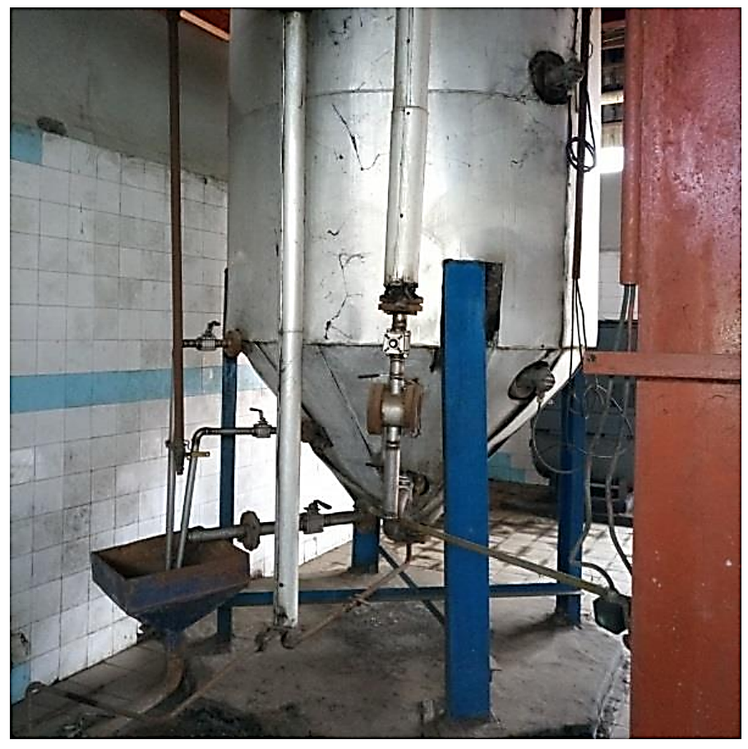
Figure 2.4: Locally constructed refining column
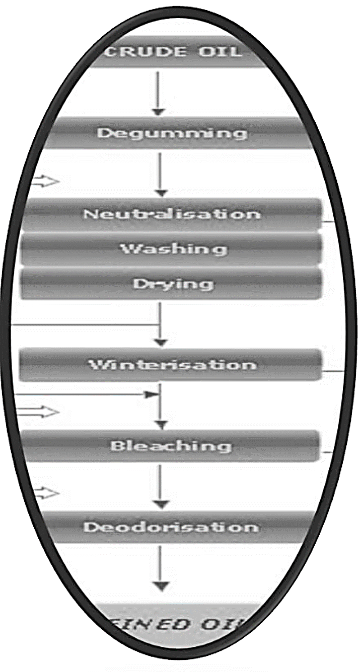
Figure 2.5: Filtration using fire mesh was carried out to obtain the desirable oil vegetable oil.
Table 2.3: Standard Chemical Values.
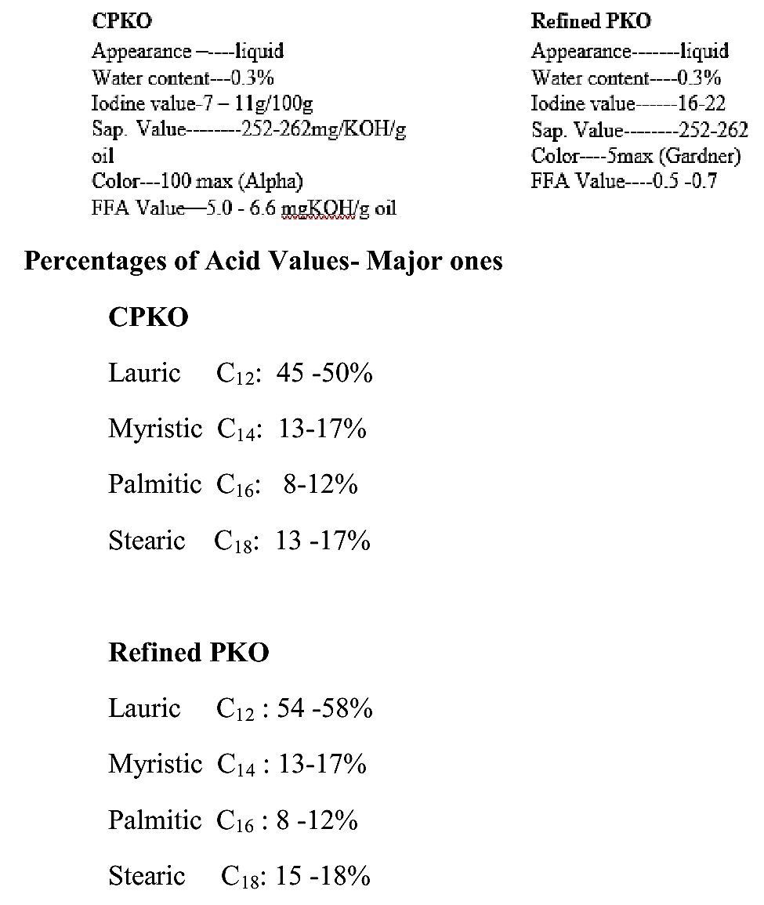

CHAPTER THREE
3.0 MATERIALS AND METHODS
3.1 REAGENTS AND APPARATUS
3.1.1 Reagents
All reagents used are of analytical grade and included: N-hexane, methanol (CH₃OH), sodium hydroxide (NaOH) pellets, sodium methoxide (NaOMe), sodium hydroxide, silica gel, activated charcoal, distilled water, Trimethylolpropane (TMP), phenolphthalein, alcohol ether, ethanol, potassium hydroxide (KOH),
3.1.2 Equipment and Apparatus
Soxhlet extractor, heating mantle, electric blender, beakers, funnel, round-bottom flask, measuring cylinders, column chromatography, separating funnel, distillation apparatus, thermometer, two-necked round bottom flask (500ml), anti-bumping stone, electric-mechanical stirrer, weighing balance, burete (50mL), pipette (25mL), and magnetic stirrer.
3.2 COLLECTION AND PREPARATION OF SAMPLE
The commercially available local variety of palm kernel oil (adin eko) produced by traditional method was purchased at OJA-OBA (translated as King’s market) in Ilorin, Kwara State, Nigeria. The sample was procured in plastic containers tightly stoppered. It was transported to the laboratory in same container and kept at ambient temperature until the time of use.
3.3 PURIFICATION OF OIL SAMPLE BY COLUMN CHROMATOGRAPHY
The oil sample was mixed with a few grams (2-3 g) of activated charcoal and stirred well for a period of time (about 5 minutes) with a glass rod. Silica gel was mixed with another small amount of activated charcoal in the ratio 10:1 respectively, and was packed (as the stationary phase) into fritted chromatography column that was initially clogged with cotton wool. The n-hexane which was the mobile phase was carefully poured into the column and kept a few centimeters above the top of the stationary phase. The mixture of the oil sample, activated charcoal and some volume of n-hexane were mixed and poured into the chromatography column and allowed to run through the stationary phase with n-hexane as a solvent The purified oil containing the solvent was collected into a beaker and redistilled to remove the solvent. The purified sample from each oil was collected and kept for analysis.
3.4 PREPARATION OF REAGENTS
3.4.1 Preparation of 1% ^{w}/_{v} Phenolphthalein Solution
1.00g of phenolphthalein powder was dissolved in 100ml of ethanol in a 100ml standard flask. This was used as the indicator solution.
3.4.2 Preparation of 1% w/v Sodium methoxide
1.00g of sodium methoxide was dissolved in 100ml of methanol. This Represent 1% w/v of the catalyst in the reactant.
3.4.3 Preparation of Potassium hydroxide
5.611g of potassium hydroxide was dissolved in small amount of distilled water. The solution was carefully and quantitatively transferred into a clean l L volumetric flask and made up to the mark with distilled water. This gave an approximately 0.1 M solution which was subsequently standardized.
3.5 TRANS-ESTERIFICATION OF OIL SAMPLE
The methyl esters of fatty acid in each oil sample using sodium methoxide NaOME catalyzed-transesterification with some modification such that the methoxide was prepared by dissolving sodium hydroxide granules in methanol. 1g of NaOH was dissolved in 20ml of methanol with electric hot plate. 100ml of each oil sample was heated to about 60ºC. The 20ml methanolic sodium hydroxide (NaOME) solution was poured into the hot oil and maintained at that temperature with vigorous stirring using magnetic stirrer for 10 minutes. Thus the conversion of each oil sample to its methyl ester was practically completed. It was later transferred to a separating funnel for separation of the bio-diesel from the glycerin by-product and other products. The set up (i.e. separating funnel and its contents) was left undisturbed to allow the fatty acid methyl ester to separate from other components. The lower phase containing the glycerol, unreacted methanol and catalyst was removed. The upper phase containing the methyl ester was then washed with distilled water severally. The emulsion produced was resolved adding few grams of sodium chloride (NaCl) crystals. The fatty acid methyl ester of each oil sample was collected and stored in labeled plastic container. The thevetia peruviana sample could not be transesterified to its FAME but rather it formed soap. This was due possibly to its high acid value. So no further work could be done on the thevetia peruviana seed oil as regard conversion to biolubricant in this work.
3.6 PREPARATION OF BIOLUBRICANT SAMPLES
100g of the FAME (Fatty acid methyl ester) of adin eko (oil) sample was weighed into a clean dry 500ml two-necked round bottom flask. The oil was heated initially to 60ºC and about 11.5g of TMP was added, followed by 44.35g of KOH (potassium Hydroxide). The entire mixture in the flask was heated to 130ºC and maintained at this temperature for an hour. The resulting biolubricant was allowed to cool and transferred into a 250ml beaker to further cool. The Biolubricant obtained was then kept in plastic reagent bottle for analysis and labelled AEKB.
3.7 CHARACTERIZATION OF BIOLUBRICANTS
The biolubricant samples were characterized by instrumental methods which include GC-MS and FTIR.
3.8 ANALYSIS OF THE BIOLUBRICANTS
The biolubricants were analysed for their physical properties (color and odor) and other quality parameters for lubricants.
3.9 DETERMINATION OF SOME PHYSICAL PROPERTIES
Color: The oil and biolubricant samples were observed organoleptically for its colors. Bio-lubricant golden yellow)
Odour: The odors of the oíls and biolubricant samples were also perceived by simply wafting toward the nostrils.

3.10 ANALYSIS OF THE BIOLUBRICANT QUALITY PARAMETERS
The following analyses were carried out on the biolubricants prepared; viscosities at 40°C and 100°C, other quality parameters of lubricants were analyzed and comparison of the parameters with various standard values of different grades was also carried out.

CHAPTER FOUR
4.0 RESULTS AND DISCUSSION
4.1 RESULTS
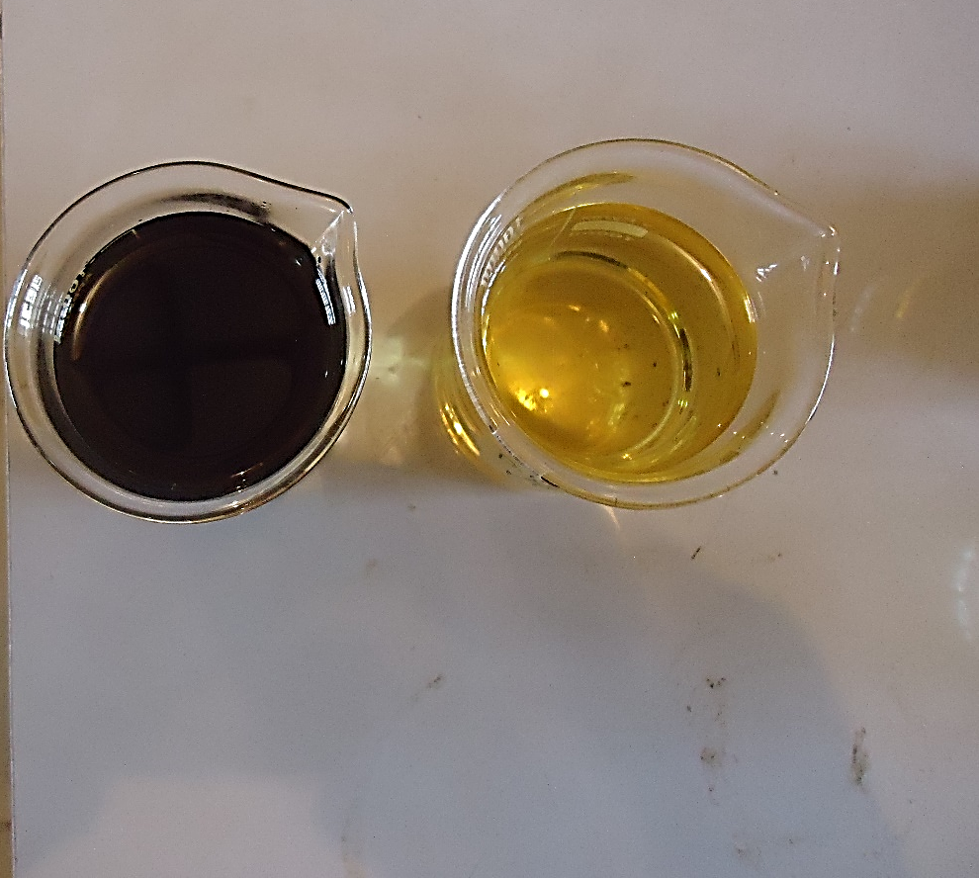
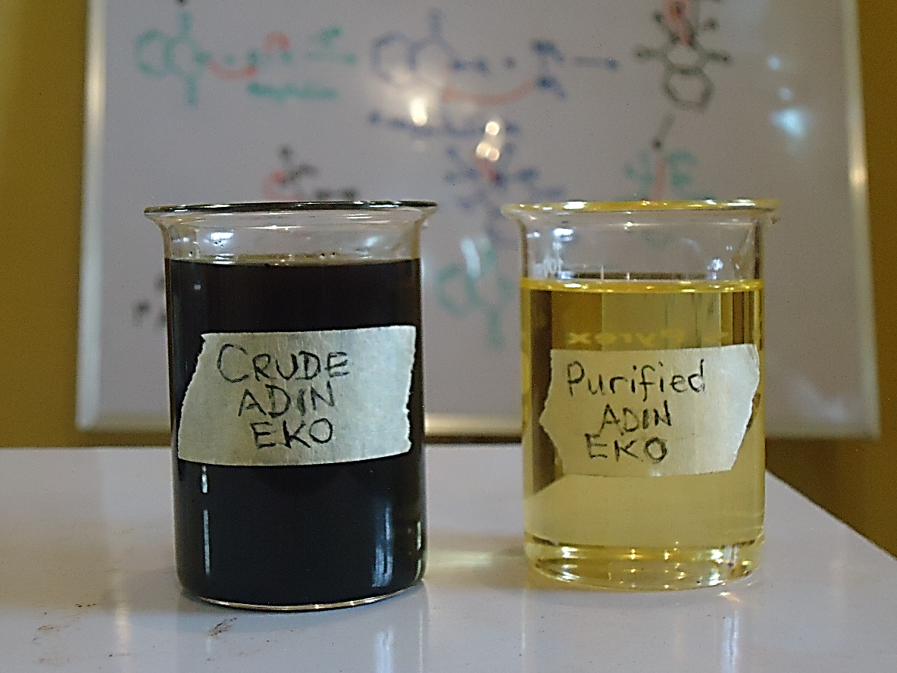
16
(a) (b)
Crude (unpurified) and purified samples of Adin Eko one of the local varieties of palm kernel oils. (a) Lateral view (b) overhaed view.
(a) (b)
Figure 4.1: Crude (unpurified) and purified samples of Adin Eko one of the local varieties of palm kernel oils. (a) Lateral view (b) overhead view.

Table 4.1: Result of Quality parameter of the bio-lubricants
Sample | Visc @ 40ºC (cSt) | Visc @ 100ºC (cSt) | Viscosity index (VI) | Flash point (ºC) | TBN  (mgKOH/g) | Pour point (ºC) | Crackle
Test methods | ASTM D445 | ASTM D445 | ASTM D2270 | ASTM D92 | ASTM D2896-11 | ASTM D97
AEKB | 29.62 | 5.43 | 120 | 126 | 6.16 | - | Passed
Standard | Visc @ 40oC (cSt) | Visc @ 100oC (cSt) | Viscosity index (VI) | Flash point (ºC) | TBN  (mgKOH/g) | Pour point (ºC) | Crackle
ISOVG 32 | $$>28.80$$ | >4.10 | 104 | - | - | <-10 | -
ISOVG 46 | > 41.40 | >4.10 | >90.0 | 220 | - | <-10 | -
ISOVG 68 | > 61.40 | >4.10 | >198 | - | - | <-10 | -
ISOVG 100 | >90.00 | >4.10 | >216 | - | - | <-10 | -
Mineral oil SN500 | 95.76 | 10.86 | 98 | - | - | <-31 | -

AEKB
Figure 4.2: FT-IR of adin eko biolubricant
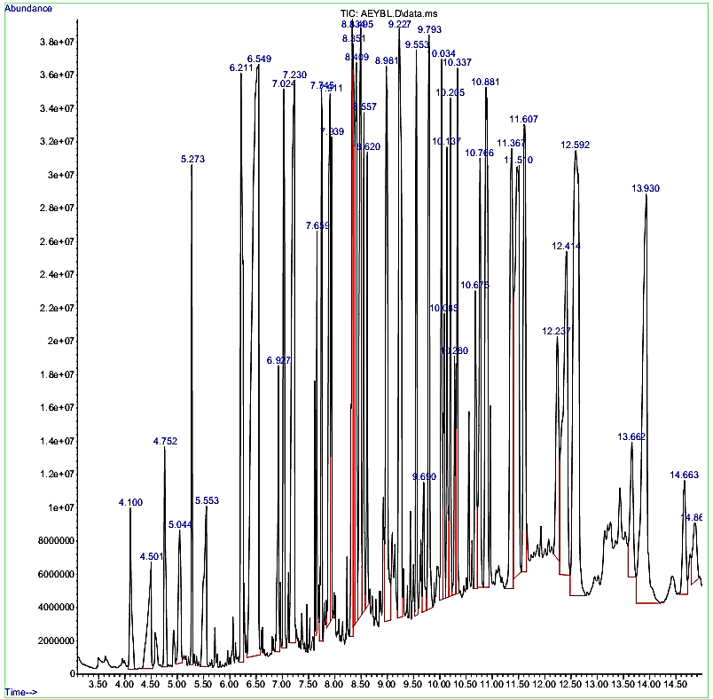
(a)
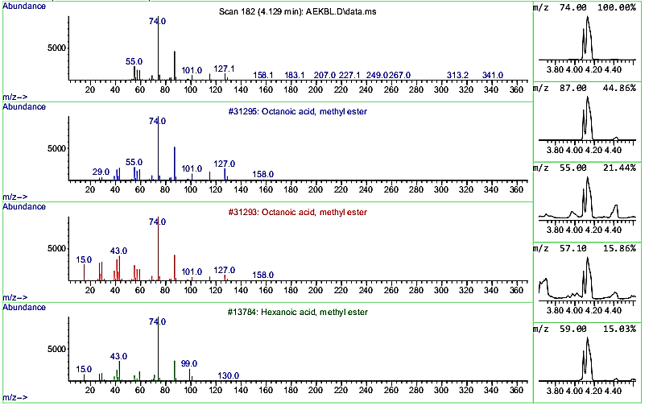
(b)
Figure 4.3: GC-MS spectrum of adin eko biolubricant. (a) Total scan (b) Dominant fatty acid identification

Table 4.2: Other chemical compounds in the adin eko biolubricant
S/N | STRUCTURES | NAMES
1 | 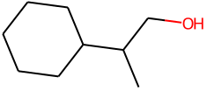 | beta -methylene-cyclohexane ethanol
2 | 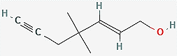 | (2E)-4,4-Dimethyl-2-hepten-6-yn-1-ol
3 | 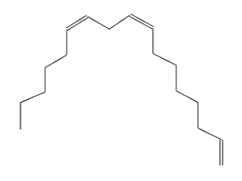 | 1 8 11-heptadecatriene (z z)-
4 | 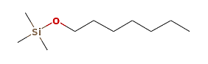 | 1-heptanol, TMS derivative
5 |  | 1-Hexacosanol
6 | 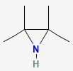 | 2,2,3,3-Tetramethylaziridine
7 | 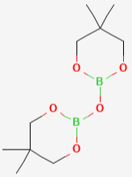 | 2,2'-Oxybis(5,5-dimethyl-1,3,2-dioxaborinane)
8 | 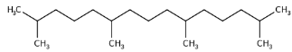 | 2,6,10,14-Tetramethylpentadecane
9 | 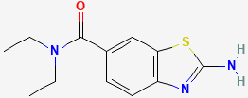 | 2-amino-N,N-diethyl-1,3-benzothiazole-6-carboxamid
10 |  | 2-azido-2,4,4,6,6-pentamethylhepta
11 | 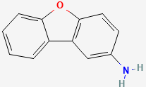 | 2-dibenzofuran amine
12 | 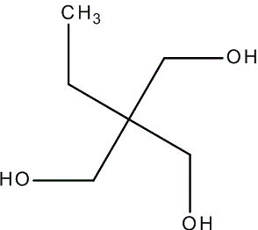 | 2-ethyl-2-(hydroxymethyl)-1,3-propanediol
13 | 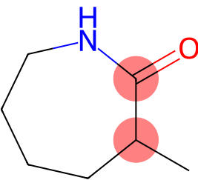 | 2H-azepin-2-one, hexahydro-3-methyl-
14 | 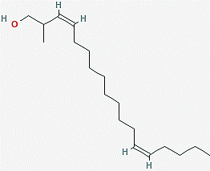 | 2-methyl-z z-3 13-octadecadienol
15 | 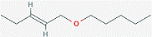 | 2-pentene,1-(pentyloxy)-,(E)-
16 | 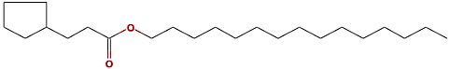 | 3-Cyclopentylpropionic acid, pentadecyl ester
17 | 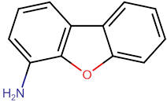 | 4-dibenzofuran amine
18 |  | 4-dodecyne
19 | 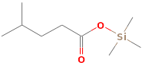 | 4-methylvaleric acid, TMS derivative
20 | 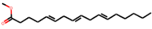 | 5,8,11-heptadecatrienoic acid,methyl ester
21 | 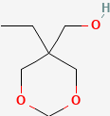 | 5-ethyl-1,3-dioxane-5-methanol
22 | 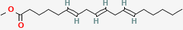 | 6,9,12-Octadecatrienoic acid, methyl ester
23 | 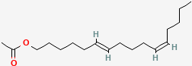 | 6,11-Hexadecadien-1-ol, acetate
24 | 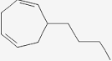 | 6-Butyl-1,4-cycloheptadiene
25 |  | 6-C14H26
26 | 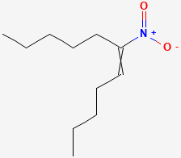 | 6-nitroundec-5-ene
27 | 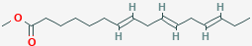 | 7,10,13-Hexadecatrienoic acid, methyl ester
28 | 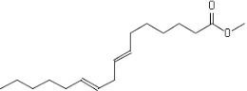 | 7,10-Hexadecadienoic acid methyl ester
29 | 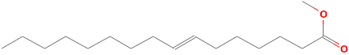 | 7-Hexadecenoic acid, methyl ester, (Z)-
30 | 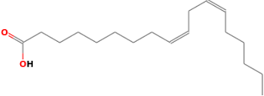 | 9,12-octadecadienoic acid (z z)-
31 | 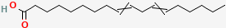 | 9,12-octadecadienoic acid (z)-6-C14H26
32 | 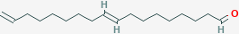 | 9 17-octadecadienal (z)- 2-hydroxy-1-(hydroxymethy
33 | 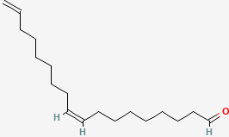 | 9 17-octadecadienal (z)-
34 | 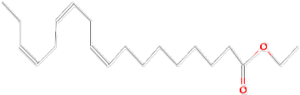 | 9,12,15-Octadecatrienoic acid, ethyl ester, (Z,Z,Z
35 | 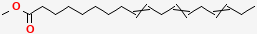 | 9,12,15-Octadecatrienoic acid, methyl ester, (9Z,1
36 | 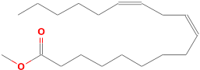 | 9,12-Octadecadienoic acid (Z,Z)-, methyl ester
37 | 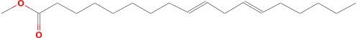 | 9,12-Octadecadienoic acid, methyl ester, (E,E)-
38 | 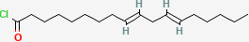 | 9,12-Octadecadienoyl chloride, (9Z,12Z)-
39 | 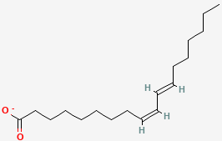 | 9-cis,11-trans-Octadecadienoate
40 | 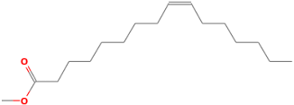 | 9-Hexadecenoic acid, methyl ester, (Z)-
41 | 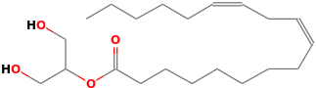 | 9-octadecadienoic acid (z)-2-hydroxy-1-(hydroxymet-
42 | 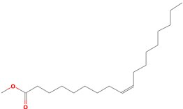 | 9-Octadecenoic acid (Z)-, methyl ester
43 | 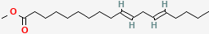 | 10,13-Octadecadienoic acid, methyl ester
44 |  | 11,13-dimethyl-12-tetradecen-1-ol acetate
45 | 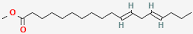 | 11,14-Octadecadienoic acid, methyl ester
46 | 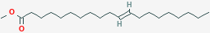 | 11-eicosenoic acid methyl ester
47 | 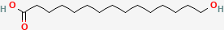 | 15-Hydroxypentadecanoic acid
48 | 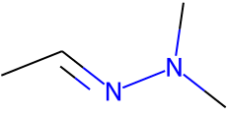 | Acetaldehyde, dimethylhydrazone
49 | 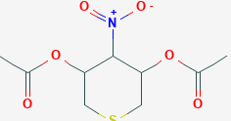 | acetic acid, 5-acetoxy-4-nutro tetrahydrofuran-3-y
50 | 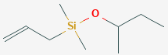 | allyl(2-butoxy)dimethylsilane
51 | 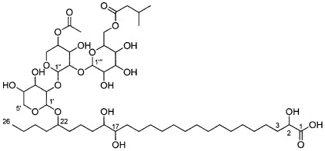 | Arabinitol
52 | 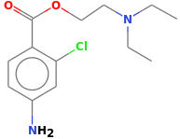 | benzoic acid, 4-amino-2-chloro-,-(diethylamino)eth
53 | 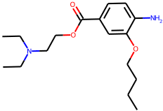 | benzoic acid, 4-amino-3-butoxy-,2-(diethylamino)et
54 | 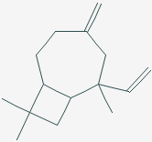 | bicyclo 5.2.0 nonane 4-methylene-2 8 8-trimethyl-2
55 |  | Bicyclo(2.2.1)heptane,_1-iodo-__
56 | 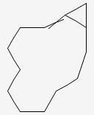 | Bicyclo(10.1.0)tridec-1-ene__
57 | 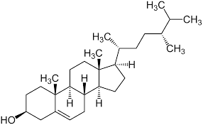 | campesterol
58 | 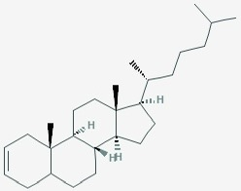 | Cholest-2-ene__
59 | 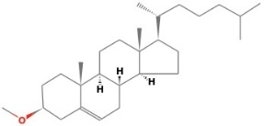 | cholest-5-ene, 3-methoxy-,(3.beta.)-
60 | 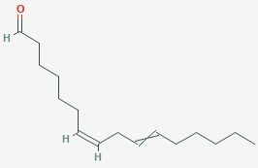 | cis cis 7,10 hexadecadienal
61 | 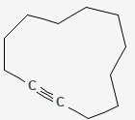 | Cyclododecyne__
62 | 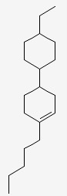 | cyclohexane,4-(4-ethoxycyclohexyl)-1-pentyl-
63 | 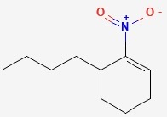 | cyclohexene, 6-butyl-1-nitro-
64 | 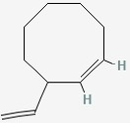 | Cyclooctene,_3-ethenyl-__
65 | 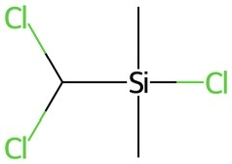 | Dichloromethyl-dimethyl-chlorosilane
66 | 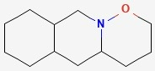 | Dodecahydro-1-oxa-9a-aza-anthracene__
67 | 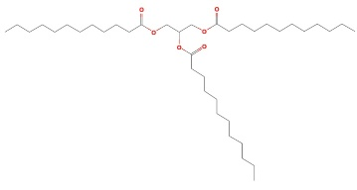 | dodecanoic acid 1 2 3 propanetriyl ester
68 | 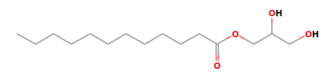 | dodecanoic acid 2 3 dihydroxypropyl ester
69 | 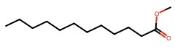 | dodecanoic acid methyl ester
70 | 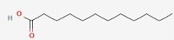 | dodecanoic acid
72 | 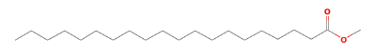 | eicosanoic acid methyl ester
73 | 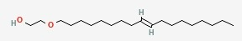 | Ethanol,_2-(9-octadecenyloxy)-,_(E)-__
74 | 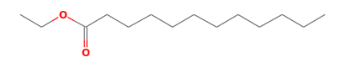 | ethenyl ester dodecanoic acid
75 | 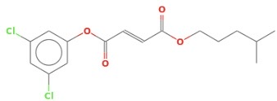 | fumaric acid, 3,5-dichlorophenyl isohexyl ester
76 | 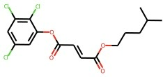 | Fumaric-acid-isohexyl-2-3-5-trichlorophenyl-ester
77 | 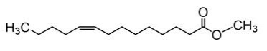 | heneicosanoic acid methyl ester
78 | 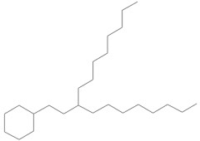 | Heptadecane,_9-(2-cyclohexylethyl)-__
79 | 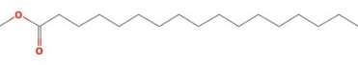 | Heptadecanoic_acid,_methyl_ester__
80 | 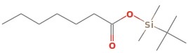 | Heptanoic_acid,_TBDMS_derivative__
81 | 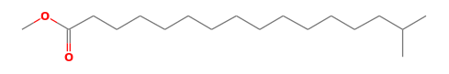 | Hexadecanoic_acid,_15-methyl-,_methyl_ester__
82 | 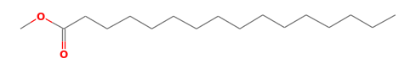 | Hexadecanoic_acid,_methyl_ester__
83 | 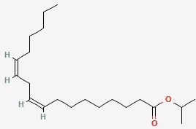 | isopropyl linoleate
84 | 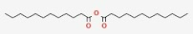 | lauric anhydride
85 | 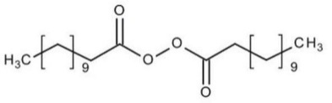 | Lauroyl_peroxide__
86 | 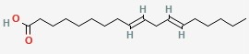 | linoelaidic acid
87 | 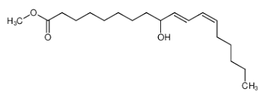 | methyl 10-trans 12-cis octadecadienoate
88 | 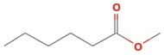 | Methyl ester hexanoic acid
89 | 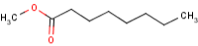 | Methyl ester octanoic acid
90 | 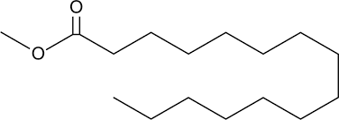 | methyl ester pentadecanoic acid
91 | 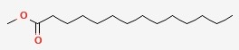 | methyl tetradecanoate
92 | 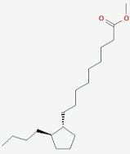 | methyl trans-9-(2-butylcyclopentyl)nonanoate
93 | 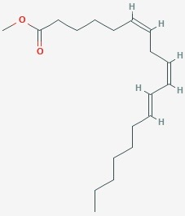 | Methyl_6-cis,9-cis,11-trans-octadecatrienoate__
94 | 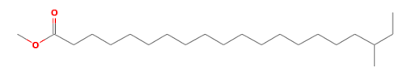 | Methyl_18-methylicosanoate__
95 | 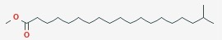 | Methyl_18-methylnonadecanoate__
96 | 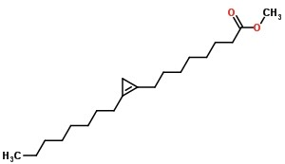 | methyl-2-octylcyclopropene-1-octanoate
97 | 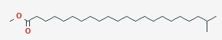 | methyl-21-methyldocosanoate
98 | 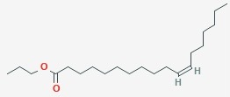 | n propyl 11 octadecenoate
99 | 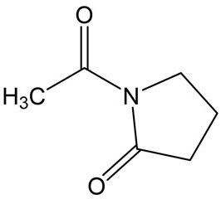 | n-acetylpyrrolidone
100 | 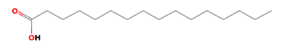 | n-Hexadecanoic_acid__
101 | 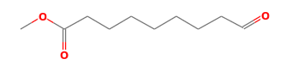 | Nonanoic_acid,_9-oxo-,_methyl_ester__
102 | 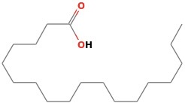 | Octadecanoic_acid__
103 | 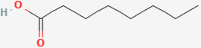 | Octanoic acid
104 | 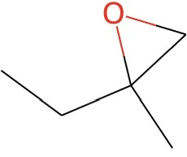 | oxirane,2-ethyl-2-methyl-
105 | 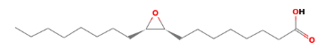 | oxiranedodecanoic acid,3-octyl-,cis-
106 | 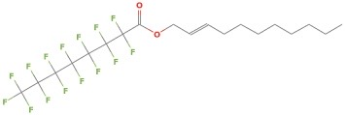 | Pentadecafluorooctanoic acid, undec-2-en-1-yl este
107 | 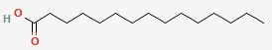 | pentadecanoic acid
108 | 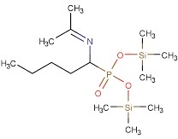 | phosphonic acid (1-aminopentyl)bis(trimethylsilyl)
109 | 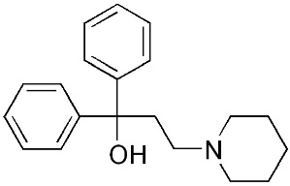 | Pridinol (1)
110 | 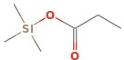 | Propanoic_acid,_TMS_derivative__
111 | 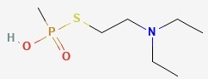 | S-(2-(Diethylamino)ethyl)_methylphosphonothioate__
112 | 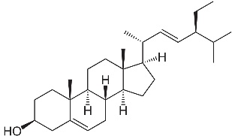 | Stigmasterin
113 | 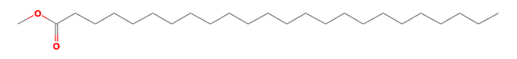 | tetracosanoic acid methyl ester
114 | 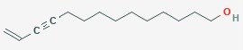 | Tetradec-13-en-11-yn-1-ol__
115 | 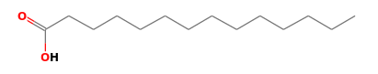 | tetradecanoic acid
116 | 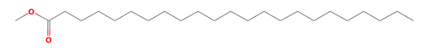 | tricosanoic acid methyl ester
117 | 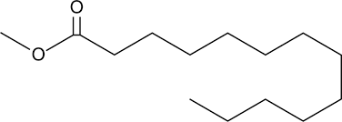 | tridecanoic acid methyl ester
118 | 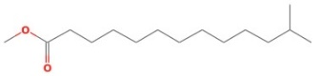 | Tridecanoic_acid,_12-methyl-,_methyl_ester__
119 | 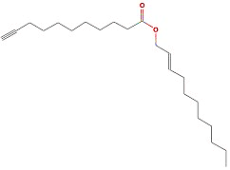 | undec-10-ynoic acid undec-2-en-1-yl ester
120 | 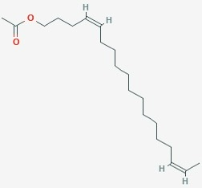 | Z,Z-4,16-Octadecadien-1-ol_acetate__

4.2 DISCUSSION
From Figure 4.1, the purified adin eko sample gave a golden yellow but less viscous oil compared to the dark and thick crude one from the local method. Adin eko was dark brown in colour before purification. The initial appearance of dark, viscous oil may be attributed to impurities such as burnt or charred particles from the kernel shell.
Adin eko, a type of palm kernel oil failed to retain the odour of the burnt fruit after conversion to biolubricant.
The AEKB FTIR spectrum, absorption between 3626cm⁻¹ and 3438cm⁻¹ established non-bonded O-H bond stretch, C-H bond stretch at 2380.72cm⁻¹ and C=O bond stretch of the carbonyl group at 1648cm⁻¹ and C-O bond stretch of alkyl substituent at 1028cm⁻¹. These absorption bands show the presence of esterified carboxylic acids in these prepared biolubricants. These acids definitely originated from the fatty acids in the local palm kernel oil (PKO) variety samples.
The GC-MS spectral of the biolubricants have also confirmed the predominant carboxylic acids esterified in AEKB are octanoic and hexanoic acids.
From the above spectroscopic analysis, the chemical structures of the biolubricant molecules in this study are proposed below:
Figure 4.4: Molecules responsible for the biolubricant action of AEKB
Table 4.1 shows the results of the qualities of the biolubricants when compared with values of standard lubricants. The quality parameters of the prepared biolubricants showed some agreement with standard values. At 40°C the viscosity of the prepared biolubricant (29.62cst) agrees with the ISOVG 32 standard which states that the values must be above 28.80cst while the values falls below acceptable values of other standards i.e. ISOVG 46, 68 and 100. For viscosity at 100°C the result shows that the value (5.43) is acceptable being comparable to those of all standard grades. For the viscosity index (VI) the result shows that the value (120) is greater than 90.0 acceptable for ISOVG 32 and 46 while it falls below the acceptable values of other standards i.e. ISOVG 68, 100. The flash point (%) of AEKB (126) falls below the acceptable value of ISOVG 46. Total base number (mgKOH/g) of AEKB is 6.16mgKOH/g while the product passed the crackle test.
Besides the fatty acid esters components of the biolubricant prepared from adin eko, several other chemical compounds were elucidated from the GC-MS analysis (Table 4.2 above). These compounds may not all possess luburicity property but may contribute to the viscosity of the lubricants.
4.3 CONCLUSION
The colours of the local palm kernel oils are slightly different before purification; After purification the colors changed to colorless, and golden yellow (for the palm kernel variety).
From this research work, it has been found that the commercial local varieties (adin eko) of palm kernel oil (PKO), can be suitable feedstocks for production of biolubricant either as neat or in blended form with synthetic ones. Improved refining will also enhance the quality of the biolubricant and the temperature of the biolubricant prepared is an important factor in determining the quality. The use of these local varieties of palm kernel oil will promote the local production and provides means of revenue generation.

