
DEPARTMENT OF SCIENCE LABORATORY TECHNOLOGY

PRODUCTION AND ANALYSIS OF BIOLUBRICANT FROM A LOCALLY PRODUCED COCONUT OIL (ADIN AGBON)

By

ANIYIKAYE ABDULRASAQ AYANKOLAWOLE
HND/23/SLT/FT/0009

BEING A THESIS SUBMITTED TO

THE DEPARTMENT OF SCIENCE LABORATORY TECHNOLOGY (CHEMISTRY UNIT),
INSTITUTE OF APPLIED SCIENCES, KWARA STATE POLYTECHNIC ILORIN, KWARA STATE.
IN PARTIAL FULFILLMENT OF THE REQUIREMENT FOR THE AWARD OF HIGHER NATIONAL DIPLOMA (HND) IN SCIENCE LABORATORY TECHNOLOGY, KWARA STATE POLYTECHNIC ILORIN,
KWARA STATE
SUPERVISED BY: MR. O. E. ADEYEMO
2024/2025 SESSION
CERTIFICATION
This is to certify that this project work presented by ANIYIKAYE ABDULRASAQ AYANKOLAWOLE with Matriculation Number HND/23/SLT/FT/0009 has been read, approved and submitted to the Department of Science Laboratory Technology (Chemistry Unit), Institute of Applied Sciences, Kwara State Polytechnic, Ilorin.

____________________ ________________
MR. O. E. ADEYEMO DATE
Supervisor

____________________ __________________
DR. JAMIU WASIU DATE
HEAD OF UNIT
____________________ __________________
DR. USMAN ABDULKAREEM DATE
HEAD OF DEPT

____________________ __________________
EXTERNAL EXAMINER DATE
DEDICATION
I dedicate this report first and foremost to Almighty Allah who has been there right from the beginning, Also to my late mother, Mrs Funmilayo Aniyikaye, may Almighty Allah grant her Aljanah Fridaus, and I also dedicate this to my Favorite Lecturer, Amiable supervisor of this project, Mr Adeyemo O Elijah for his continual impact of the knowledge.

ACKNOWLEDGEMENT
In the accomplishment of this project successfully, many people have bestowed upon me their blessings and constant support. I am utilizing this opportunity to thank all the people who have been concerned with this project.
My family comes first especially, My father, Alhaji Usman O
Aniyikaye, with my Elderly brothers and sister, Aniyikaye
AbdulWasiu, Aniyikaye Sikirullah, Aniyikaye Hammed and Bello Adijat, who have helped me with their Valuable suggestions guidance that has been very helpful in various phases, May almighty Allah enriched their pocket, grant them long life.
Also my lovely and supportive person I've ever met Oyelola
Oluwabusayomi, and also my lovely friends starting from Ahmad, Monday and so many other people for their contributions on my journey so far I'm so grateful to you all.
Lastly to Almighty Allah for making my dream comes true AL-hamdullilah.

Contents
Title page
Certification
Dedication
Acknowledgements
Table of Content
Abstract
Table of Content
CHAPTER ONE
1.0 Introduction
1.1 Problem Statement
1.2 Aim and Objectives of the Study
1.3 Justification of the Study
1.4 Scope of the Study
1.5 Relevance of the Study
CHAPTER TWO
2.0 Literature Review
2.1 Sources and Preparation of Lubricant oil
2.2 Properties of Bio-lubricant
2.3 Modification of Base Bio-lubricant
2.4 Tribological Performance of Bio-lubricant
2.5 Mechanism of Bio-Lubricant during Operation
2.6 Benefits of Bio-lubricant and Market Availability
2.7 Advantages and Disadvantages of Bio-lubricant
2.8 Applications of Bio-lubricant
2.9 Coconut oil
2.9.1 Methods of Preparation of Coconut oil
2.9.1.1 Solvent Extraction
2.9.1.2 Enzymatic Process
2.9.1.3 Wet Processing of Coconut
2.9.1.4 Copra Milling by Traditional Methods
2.9.1.5 Copra Processing by Continuous Process
2.9.1.6 Hydraulic Processes
2.9.2 Importance of Coconut as oil Seed
2.9.3 Biological Effects of Coconut oil
2.9.3.1 Anti-Microbial Effects of Coconut oil
2.9.3.2 Hypolipidemic Effects of Coconut oil
2.9.3.3 Effects of Coconut oil on Cardiovascular Health
2.9.3.4 Hepatoprotective Effects on Coconut oil
2.9.3.5 Effects of Coconut oil on metabolic syndrome
2.9.3.6 Anti-Cancer Effects of Coconut oil
2.9.4 Healing Properties of Coconut oil
2.9.5 Applications of Coconut oil
2.9.5.1 Edible Applications of Coconut oil
2.9.5.2 Non-edible Applications of Coconut oil
CHAPTER THREE
3.0 Materials and methods
3.1 Reagents and apparatus
3.1.1 Reagents
3.1.2 Equipment and apparatus
3.2 Collection and preparation of sample
3.3 Purification of oil sample by column chromatography
3.4 Preparation of reagents
3.4.1 Preparation of 1% ^{w}/_{v} phenolphthalein solution
3.5 Trans-esterification of oil sample
3.6 Preparation of biolubricant samples
3.7 Characterization of biolubricants
3.8 Analysis of the biolubricants
3.9 Determination of some physical properties
3.10 Analysis of the biolubricant quality parameters
CHAPTER FOUR
4.0 Results and discussion
4.1 Results
4.2 Discussion
4.3 Conclusion
References as footnotes

Abstract
In this study, a sample of coconut oil produced locally was purified and subsequently transformed into a biolubricant using the fatty acid methyl ester (FAME) from the oil sample and trimethylolpropane (TMP). The biolubricant produced was analyzed for its quality parameters and the chemical components elucidated by GC-MS, and FTIR analysis. The result showed that the biolubricant prepared from the coconut oilhad a quality comparable to ISOVG32 standard lubricant quality. The predominant carboxylic acids in the oil sample were identified to be octanoic, nonanoic and decanoic acids. This work has established that the locally produced coconut oil is a potential feedstock for biolubricant- an environmental friendly product.
Keywords: biolubricant, coconut oil, fatty acid, lubricant quality

CHAPTER ONE
1.0 INTRODUCTION
In industries (transportation and production) or any sliding operations lubricants are used to reduce wear and friction on interacting surfaces¹. Apart from minimizing wear and friction, lubricants also help prevent corrosion² distribute power, remove heat ³, and Provide a liquid seal at moving contracts. From large gear like industrial metal-rolling mills to small equipment like computer hard drives. Lubricants are employed in a variety of equipment to maintain dependable machine performance ⁴. Although not all lubricants are liquids, that way 19th century’s industrial growth generated a demand for liquid lubricants that quickly outpaced the supply of every other type, thus meeting the expectations ⁵.
1. Suryawanshi S.R. and Pathwar J.T. “Effect of TiO₂ Nanoparticles Blended with Lubricating oil on the Tribiological Performance of the Journal Bearing; Tribology in Industry 40, (2018): 370-391.
2. Shah R, Woydt. M and Zhang S. “The economic and Environmental Significance of Sustainable Lubricants”. Lubricants, No. 9 (2021): 21.
3. Wong V.M and Tung S.C. “Overview of automotive engine friction and reduction Trends-effects of Surface, Material and Lubricant-additive Technologies,” Friction. No. 4 (2016): 1-28.
4. Mannekote J.K, Kailas S.V, Ventatesh. K and Kathyayini. N. “Environmentally Friendly Functional fluids from renewable and sustainable sources. A Review”. Renewable and Sustainable Energy Reviews 81, (2018): 1787-1801.
5. Boroojeni K.G, et al.. “A Theoretical Bilevel Control Scheme for Power Network with large-scale penetration of Distributed Renewable Resources”, 2016 IEEE International Conference on electro Information Technology, (2016): 510-515.
In solving the lubrication challenges, mineral oil, a raw material made possible using petroleum source, was also produced. However, since ordinary base lubricant cannot withstand the working conditions, enhancement through inclusion of sui additives were introduced. In this synergistic approach, while the additives offers extra features to final product, base stocks contribute unique basic characteristics.
1.1 PROBLEM STATEMENT
The environmental impact of traditional lubricants is significant, with approximately 40% of all lubricants being discharged into the environment, particularly in developing countries where disposal regulations are often lacking. This creates a toxic working environment and leads to harmful pollutants being released into the air through practices such as burning lubricants for fuel. Additionally, the production of petroleum-based lubricants results in airbone poisons and harmful substances. Given these challenges, there is a pressing need for bio lubricants, which are derived from renewable source, to mitigate these environmental issues. However bio lubricants face their own challenges, including performance limitations, oxidation stability, compatibility with existing machinery, and higher production costs. Addressing these problems is essential for promoting the adoption of bio-lubricants as a sustainable alternatives⁶.
1.2 AIM AND OBJECTIVES OF THE STUDY
The aim of this study typically focus on addressing environmental and performance challenges associated with conventional lubricants. The specific objectives of the study is as follows:
- To collect samples of coconut
- To extract the coconut oil from coconut milk press-cake
- Studying the solvent extraction of residual oil from wet coconut meal using isopropanol
- Extraction of coconut oil from coconut paste by a new enzymatic process

6. Mobarak H.M, Niza M.E., Masjuki H.N, Kalam M.A, Ai Mahmud K and Habibullah. M, (2014). “The prospects of biolubricants as alternatives in automotive application renewable and sustainable energy reviews”, 2014, 33: 34-43, http://dx.doi.org/10.1016/j.rser.01.062.
- Filtration extraction of granulated coconut on a bench scale
- To carried out laboratory scale studied the preparation of a highly nutritious coconut flour from granulated coconut
- The desiccated coconut produced can be used for mechanical extraction of colourless, odourless coconut oil suitable for direct consumption.
1.3 JUSTIFICATION OF THE STUDY
On completion of this study, it is grounded in their environmental benefits, sustainability, health and safety improvements, economic viability, technological advancements, and regulatory compliance.
1.4 SCOPE OF THE STUDY
The scope of this project research includes their sources, (such as animal fats, coconut) chemical properties, performance, environmental impact, applications, and regulatory aspects. This multidisciplinary approach aims to enhance the development and utilization of sustainable lubricants.

1.5 RELEVANCE OF THE STUDY
The relevance of this project research is significant in promoting environmental sustainability, creating economic opportunities, ensuring regulatory compliance, enhancing performance and fostering innovation.

CHAPTER TWO
2.0 LITERATURE REVIEW ON COCONUT OIL
Philippines, Indonesia, India, Sri Lanka, Mexico, west Malaysia, and Papua and New Guinea are the 7 countries which produce major quantities of coconut in the world. Coconut is available in two forms viz, wet and dry materials commonly known as wet coconut and dry coconut or copra. The oil can be extracted from both these raw materials. However, in India and Sri Lanka, it is a general practice to use only copra for oil extraction and the oil is used for food and cosmetic purposes. In Philippines, the oil is extracted from wet coconut also and is known as virgin coconut oil. In some countries solvent extraction of the dry coconut followed by refining bleaching and deodorization is carried out to get the refined bleached and deodorized coconut oil. The technology for the production of coconut oil through expeller is well developed and many medium scale industries in India produce oil by this method. However, some small scale industries produce the oil by processing fresh coconut also using local expeller press. Problems of sediments and rancidity persist in these oils⁷.
2.1 SOURCES AND PREPARATION OF LUBRICANTS OIL
Conventional lubricants contain high molecular weight hydrocarbons derived from the vacuum residues in the refinery as base stocks. Unsaturated fatty acids are used as base stocks in bio-lubricants, which until now have been based on vegetable oil ⁸. Due to their weak heat stability and poor oxidation stability from the presence of oxidizable functional groups brought on by an unsaturated bond pure vegetable lubricants are found inappropriate for use in applications like lubricating fluids ⁹. Vegetable oils can have their unsaturated fatty acid

7. Cornelius J.A. “Coconuts: a review”. Trop. Sci 5, 1(1973): 15-37.
8. Woma T.Y, Lawal S.A, Abdulrahman A.S, Olutoye M.A and Ojapah M.M “Vegetable oil Based Lubricants” Challenges and Prospects”. Tribology online 14, (2019): 60-70.
9. Srivyas P.D and Charoo M.S. “A review on Tribological Characterization of Lubricants with Nano additives for Automotive applicatios”, Tribology in Industry 40, (2018): 594-623.
content decreased to make them appropriate for use in engines and make them equivalent to conventional lubricants via chemical modification methods like hydrogenation, transesterification and epoxidation ^{10,11,12}. To enhance the final lubricant formulation’s physical, chemical and thermal qualities, as well as stability through additives, added new feature to base stocks. Based on their function in lubrication systems, lubricant additives are derived into different categories: friction modifiers, anti-oxidation agents anti-wear. Additionally, they are categorized according to their working environment and role, like tribo-improvers, rheo-improvers, and maintainers ¹³. Lubricants tribological performance is improved by tribo-improvers, rheo-improvers are designed for base oils fluidity, while maintainers prevent the lubricants and machines parts from degrading, as well as the breakdown of the substance involved in the lubrication system.
10. Kerni L, Raina A and Haq M.I.U. “Friction and wear performance of olive oil containing Nano Particles in Boundary and Mixed Lubrication Regimes” wear 426-427, (2019): 819-827.
11. Gad M.S. and Gadow S.I. “Enhancement of Combustion Characteristics and Missions Reductions of a diesel engines using Biodiesel and Carbon Nanotube”, Furterene, Nanotubes and Carbon Nanostructure 29, (2020): 267-279.
12. Liu Z, Li J, Knothe. G, Sharma B.K and Jiang J. Improvement of Diesel Lubricity by Chemically Modified Tung-Oil-Based Fatty acid esters as additives”, Energy and Fuel 33, (2019): 5110-5115.
13. Minami I. “Molecular Science of Lubricant additives”. Applied Sciences, 7 (2017): 445.
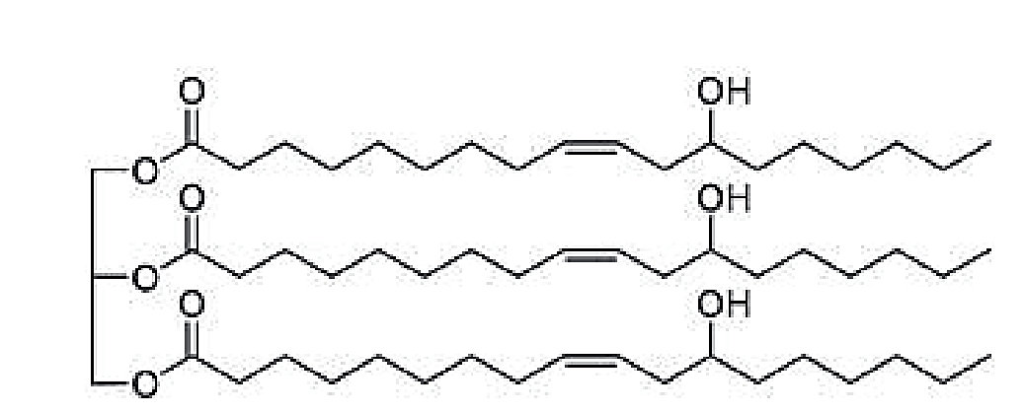
Figure 2.1: Chemical structure of most oil-base bio-lubricant showing triglyceride
2.2 PROPERTIES OF BIOLUBRICANTS
The major functions of biolubricants, i.e, reducing friction and wear, the dispersion of deposits, the inhibition of rust/corrosion, the dissipation of heat, and the sealing of critical contact joints, are reflected in the properties of the base oil. The base oil is expected to posses optimum viscosity and viscocity index, low volatility, low deposit formation, low temperature solidification, good hydrolytic and thermos-oxidative stability and biodegradability¹⁴. A good bio-lubricant should have its boiling point distribution towards high temperatures, high viscocity index, corrosion prevention capability,

14. Joseph P.V, Saxena D, and Sharma D.K. “Study of some Non-edible Vegetable oils of Indian origin for lubricant application J. Synth Lubr 24, (2007): 181-197.
high thermal stability, low freezing point, and high anti-oxidation potential¹⁵. While these are the preference characteristics of any biolubricant, specific applications to demand unique properties. For example (a) engine oil application demands low emissions of volatile organic compounds and polyaromatic hydrocarbons, (b) metal working fluids require good amplifiability, (c) hydraulic oils requires low compressibility and a quick release rate of air (d) transmission oils and gear oils requires high weld load, and (e) greases should possess good anti-wear and anti-scoring properties. The salient properties are explained in the following sections.
2.2.1 Viscosity
Viscosity is a key parameter that determines the time to replace the lubricant in a device. The viscosity depends on the factors such as the concentration of paraffins and the additives that affect the internal friction among the molecules, and it increase with the increase in the

15. Mobarak H.M, Niza Mohamed. E, Masjuki H.H, Kalam M.A, AI Mahmud K.A.H Habibullah. M and Ashraful A.M. The prospects of biolubricants as alternative in automotive applications”, Renew Sustain. Energy Rev 33, (2014): 34-43.
chain length of the hydrocarbon portion of the fatty acid or alcohol in ester-based biolubricants. Owing to increased hydrogen bonding interactions, the presence of hydroxyl groups in the lubricant formulation or the addition of polyols modifies the viscosity index ^{16,17,18}. The viscosity index (IV), a metric used by lubricant users and refiners, describes the effect of temperature changes on the viscosity of the oil ¹⁹.
2.2.2 Thermo-Oxidative Stability
Auto-oxidation of the lubricant is promoted due to localized high temperature caused by frictional heat generated by the rubbing of solid surfaces against each other.

16. Cecilia J.A, Ballesteros Plata D, Alves Saboya R.M, Travares de Luna F.M, Cavalcante C.L and Rodriguez – Castellon E. “An overview of the biolubricant production process: Challenges and Future Prospective”, Processes, 8 (2020): 257.
17. Saboya R.M.A Cecilia J.A, Carcia-Sancho C, Luna F.M.T, Sales A.V, Rodriguez-Castellon E and Cavalcante C.L. “Assesment of Commercial Resins in the Biolubricants Production from free fatty acids of caster oil”, Catal. Today 279, (2017): 274-285.
18. Saboya R.M.A, Cecilia J.A, Garcia-Sancho. C, Luna F.M.T, Rodrigue – Castellon E, Cavalcante C.L. “Wo3-Based catalysts supported on porous clay Heterostructures (PCH) with Si-Zr Pillars for synthetic esters production.” Appl. Clay Sci. 124-125, (2016): 69-78.
19. Verdier S, Coutinho J.A.P, Silva A.M.S, Alkilde O.F and Hansen J.A. “A Critical approach to viscosity index”, Fuel 88, (2009): 2199-2206.
This tends to alter the viscosity of the lubricant due to reactions that promote the cleavage of long chain hydrocarbon molecules. Therefore, due to exothermic oxidation and endothermic. Pyrolysis reactions, the thermo-oxidative stability of the lubricant decrease with usage ²⁰. Thermo-oxidative stability can be tested using the RPVOT test (ASTM D2272). This involves the evaluation of the oxidation stability of the biolubricants in the presence of a copper catalyst and water at 423k and 620kpa of oxygen.
2.2.3 Pour Point
Pour point is the temperature below which the lubricant loses its flowability. In biolubricants, it is related directly to the viscosity index. The presence of ternary alcohols, such as trimethyl propane (TMP), reduces the pour point of the biolubricant, even though it tends to reduce the thermo-oxidative stability of the lubricant²¹. It can be measured using ASTM D5949, which involves the determination of
20. Minami I. “Ionic Liquid in Tribology”, Molecules 14, (2009): 2286-2305.
21. Cecilia J.A, Baltesteros Plata. D, Alves Saboya R.M, Tavares de Luna F.M, Cavalcante C.L and Rodriguez-Castellon E. “An overview of the Biolubricant Production Process Challenges and Future Prospectives”, processes, 8 (2020): 257.
pour point by applying a burst of nitrogen gas into the lubricant sample, while simultaneously cooling it. It is usually performed in an automated instrument, which also detects movement of the surface of the test sample using an optical device.

2.2.4 Ecotoxicity
Ecotoxicity is a metric used to characterize the environmental toxicity of a lubricant formulation. It is a major property that determines whether a lubricant formulation can irreversibly affect living things. As aqeous ecosystems are prone to damage by the organic and hydrocarbon components of lubricants, it is vital to determine lubricant to water toxicity. This is defined as the potential of a lubricant to poison target organisms such as bacteria, algae, small fish, or laboratory rats, ASTM D6081-20 is the standard protocol to test the aquatic toxicity of the lubricant.
2.2.5 Hydrolytic Stability
The resistance of biolubricants to chemical attack, especially when water molecules are involved either as a reactant or a product, is characterized by hydrolytic stability. The ASTM D2619-21 standard test method is used to determine the hydrolytic stability of petroleum or synthetic-based hydraulic fluids. Biolubricants for use as insulation fluids require high water solubility and a high dielectric constant. Therefore, the assessment of hydrolytic stability becomes imperative.
2.2.6 Biodegradability
If a lubricant can be structurally decomposed by enzymes or microorganism through aerobic process, it can be considered biodegradable ²². A lubricant can be considered biodegradable if the precent degradation in a standard test exceeds a certain value. Vegetable oils are more biodegradable than mineral-based oils ²³. The environmental concern around the depletion of mineral reserves has sparked interest in biolubricants derived from natural triglycerides, as well as the fatty acid derived from them ²⁴. Biodegrability of the base fluid (or any other component) of an environmentally acceptable
22. Haase, K.D, Heynen A.J and Laane N.L.M. “Composition and application of isosteric acid”, Fat Sci. Technol. 91, (1989): 350-353.
23. Mobarak H.M, Niza Mohamad. E, Masjuki H.H, Kalum M.A, AI Mahmud K.A.H, Habibullah M, and Ashraful A.M. “The prospects of Biolubricants as Alternatives in Automotive Applications”, Renew. Sustain Energy Rev. 33, (2014): 34-43.
24. Kamalakar. K, Rajak A.K, Prasad R.B.N and Karuna M.S.L. “Rubber Seed oil-based biolubricant base stocks: A Potential Sources for hydraulic oils”, Ind. Crop. Prod 51 (2013): 249-257.
lubricant (EAL) depends on both its molecular properties and the test method utilized ²⁵. Importantly, the chemical composition of base oils can change during the application of lubricants, i.e, when they are subjected to varying temperature, air humidity, metals and pressure.
2.3 MODIFICATION OF BASE BIOLUBRICANT
The objective of bio-lubricant research has been to comprehend the connection between chemical assembly and molecular structure and to address the shortcomings of both natural and manufactured lubricants for instance, bio-lubricant made of branched fatty acids like isosteric acid, display outstanding low-temperature performance, including a low pour point, low viscosity, good chemical stability, and flush point ^{26,27}. Polyunsaturated C₁₈ fatty acids are thermally isomerized and then hydrogenated to produce isosteric acid. Only the inside of the molecule has branching sites. Similar to that, 12-
25. Battersby N.S “Biodegradable lubricants: What does ‘Biodegradable’ Really Mean?” Synth. Lubr 22, (2005): 3-18.
26. Syahir A.Z, Zalkifi N.W.M, Masjuki H.H, Kalam M.A, Alabdulkarem. A, Gulzar .M, Khuong L.S. and Harith M.H. “A review on Bio-Based Lubricants and their application”, Journal of Cleaner Production, 168(2017): 997-1016.
27. Eck N.J. and Waltman L. “Software Survey: VOS viewer, a Computer Program for Bibliometric Mapping”, IOP Conference Series: Materials Science and Engineering 68, (2013): 152-157.
hydroxystearic acid, which is produced by hydrogenating ricin oleic acid, can also employed. As was previously mentioned, the performance of the biolubricant is improved by eliminating the double bonds and glycerol molecules form the triacylglycerols.
In the modification several approaches are used including esterification/transesterification, hydrogenation²⁸, oligomerization/ estoloides and epoxidation but in course of this research, only transesterification synthesis of formulation of fatty acids methyl esters and ethylene glycol di-esters were considered.
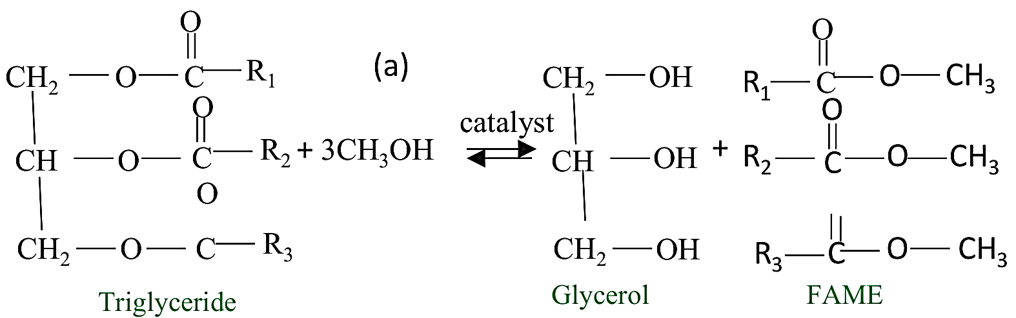

28. Zhu J. Su. Y, Chai. J, Muravev. V, Kosinov. N and Hensen E.J.M. “Mechanism and Nature of active sites for methanol Synthesis from CO/CO₂ on Cu/CeO₂” ACS Catalysis 10, (2020): 11532-11544.
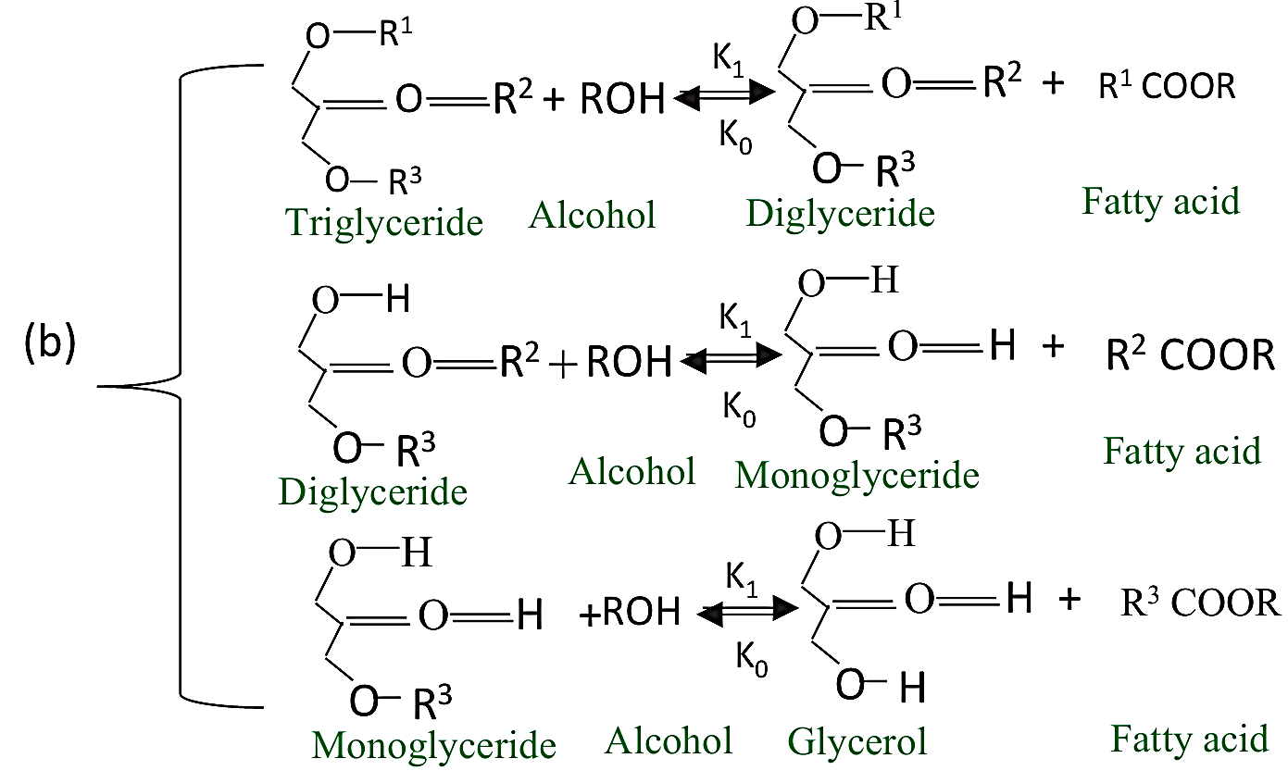
Figure 2.2: Triglycerides reaction to produce FAMEs via Transesterification technique
2.4 TRIBOLOGICAL PERFORMANCE OF BIO-LUBRICANTS
Some investigation had been conducted on different bio-lubricants under application of different NPs as additives, with recommended results as presented in table below.

Table 2.1: Summary of tribological qualities of some bio-lubricants and their applications.
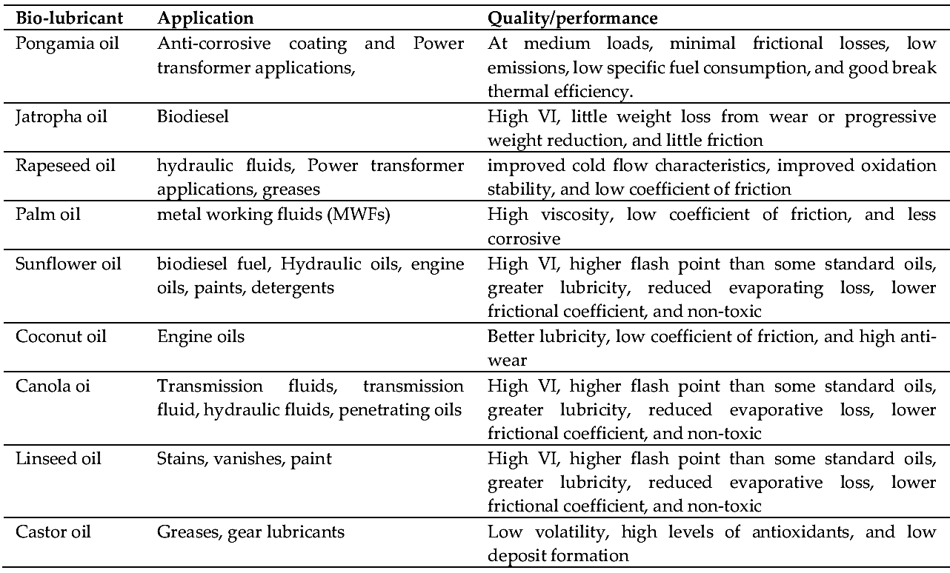
Thottackad²⁹, conducted tribological investigation using CuO NPs combined with coconut oil. According to the finding, the CuO nanoparticle concentration that produced the lowest wear rete and friction coefficient was 0.34 mass%.
The viscosity and fire point increased when the nano-additive was
29. Thottackad. M.V. Perikinali R.K and Kumarapillai P.N. “Experimental Evaluation on the Tribological Properties of Coconut oil by the addition of CuO Nanoparticles,” International Journal of Precision engineering and manufacturing 13, (2012): 111-116.
applied, while the surface roughness reduced ³⁰. On analysis conducted by ³¹. Employing zinc oxide (ZnO) and copper oxide (CuO) as lubricant additive. The outcome found that both Zinc oxide and copper oxide NPs were rendered inactive as an anti-wear addition for soybean and sunflower oil due to the rise in frication coefficient and the presence of abrasive wear on the worn surface, in another study by Arumugan and Srilam argued on the performance of microparticle addition ³². TiO₂ NPs were added to chemically changed rapeseed. Comparing the TiO₂ microparticles, TiO₂ NPs visibly observed to enhanced the lubricant lubrication performance ^{32,33}. Under nanoscale TiO₂ of 6.9% and micro TiO₂, the COF of rapeseed oil blended additives yielded reduction by 15.2% and 6.9% respectively ³⁴. Performed through experiment on biolubricant behavior under additives of TiO₂, CeO₂ and ZrO₂ NPs using rice bran oil as base lubricant.
30. Alves S.M., Barros. B.S, Trajano M.F, Ribeiro K.S.B and Moura. E. “Tribological Behavior of Vegetable oil-Based Lubricants with Nanoparticles of oxides in Boundary Lubrication Conditions”, Tribology International 65, (2013): 28-36.
32. Arumagam S and Sriram G. “Preliminary Study of Nano-and Micro Scale TiO₂ additives on Tribological Behavior of Chemically Modified Rapeseed oil”, Tribology Transactions 56, (2013): 797-805.
33. Kumar M, Afzal. A and Ramis M.K. “Investigation of Physiochemical and Tribological Properties of TIO₂ Nano-Lubricant oil of different Concentration”, Tribological 35, (2017): 6-15.
34. Rani S. “The Tribological Behavior of TiO₂, CeO₂ and ZrO₂ Nano Particle as a Lubricant additive in Rice Bran Oil”, International Journal of Scientific and Engineering Research, 7 (2016): 708-712.
The result revealed that 0.5 mass % CeO₂ and 0.3 mass% TiO₂ respectively yielded the greatest COF and wear reduction. This was afformed by ³⁵ through analysis on Al₂O₃ NPs mixed with jojoba oil with concentration of oil mass% thus minimal friction and wear was achieved compared the base lubricant. Again, ³⁶ carried out tribological investigation utilizing CuO blended with pongumia oil. The result observed that 0.075 mass% of CuO was the optimal concentration to the based lubricant used with excellent wear and friction reduction. Again, copper and h-BN NPs were added to apoxidized olive oil during tribological investigatory work by ³⁷.

35. Suthar K, Singh. Y, Surana A.R, Rajubhai V.H and Sharma. A. “Experimental evaluation of the friction and wear of Jojoba oil with aluminum oxide (Al₂O₃) Nano Particles as an additive,” Material Today: Proceedings 25, (2020): 699-703.
36. Rajubhai V.H, Singh Y, Suthar. K, and Surana A.R. ‘Friction and Wear Behavior of AI-7% Si Alloy pin under pongamia oil with copper Nanoparticles as additive”, Materials Today: Proceedings 25, (2019): 695-698.
37. Kerni L, Raina. A and Haq M.I.U. “Friction and wear Performance of olive oil containing Nanoparticles in Boundary and Mixed lubrication Regimes”, Wear 426-427 (2019): 819-827.
2.5 MECHANISM OF BIO-LUBRICANTS DURING OPERATION
Enhancement of physiochemical and tribological performance of bio-lubricant is through modification and inclusion of suitable additives. For good compatibility and performance of NPs in bio-lubricants, most of them were discovered to be of hydrophobic potential with ability repel oxidative agent. The investigatory study on lubricating strength of Eichhornia crassipes NPs (EC-NPs) further revealed that reduction in the size of EC into nanoscale changes from hydrophobic to amphiphilic (hydrophobic tail and hydrophilic heal) form ^{38,39} as a result of increase in surface area, thus illustrated in figure 2.1(a).

38. Opia A.C. Mohd KAMELI A.H, Syahrullail. S., Abd Rahim A.B and Johnson C.A.N. “Eichhornia Crassipes Transformation from Problems to wide unique Source of Sustainable materials in engineering application”, Iop Conference Series:” Material Science and Engineering 1051, (2021): 012-100.
39. Zhu Q, Pan. Y, Jia X, Li J, Zhang. M and Yin. L. “Review on the Stability mechanism and application of water-in-oil emulsions encapsulating various additives”, Comprehensive review in food Science and Food Safety 18, (2019): 1660-1675.

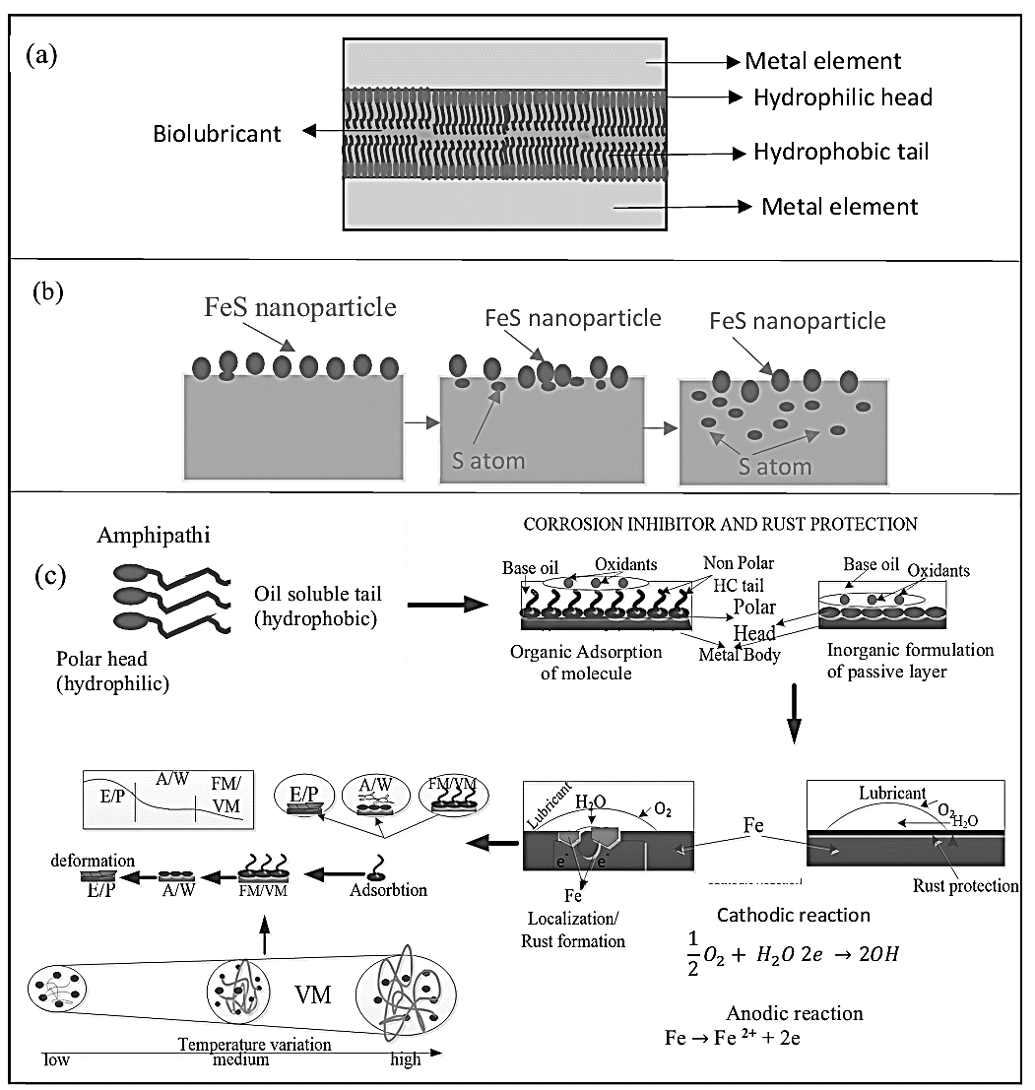
Figure 2.1: Arrangement of amphipathic additives inside bio-lubricant (a); diffusion of sulphur (S) atom of FeS NPs (b) and defensive operation of organic/inorganic additive in biolubricant against oxidation and rust (c) Note: Extreme pressure additive (EP); anti-wear additive (AW); Viscosity modifier (VM), friction modifier (FM).
Also, the diffusion behavior of the FeS NPs on the sliding material
surface was conducted by ⁴⁰, illustrating the sulfur (S) atom diffusion resulting in friction reduction, thus illustrated in Figure 2.1 (b) while figure 2.1 (c) illustrated the defending mechanism of additives in biolubricants during operations. The behavior of various additives during operation are demonstrated in Figure 2.1 (c), owing to the degradation effect.
Rust and corrosion are both electrochemical processes that result in the oxidative deterioration of metallic materials. The corrosion process that most characterizes lubrication systems is galvanic corrosion ⁴¹. In a nutshell, the mechanism, is as follows. An oxide layer typically covers metal surfaces. The oxide is removed by the tribological process, exposing metal surfaces. Between metal and metal oxide, there is a difference in electrical potential. Galvanic cells are created when a conductive liquid occurs

40. Zhou L.H, Wei X.C, Ma Z.J and Mei B. “Anti-Friction Performance of FeS Nanoparticle Synthesized by Biological method”, Applied Surface Science 407, (2017): 21-28.
41. Minami. I. “Molecular Science of Lubricant additives”, Applied Science, 7 (2017): 445.

between the surface ⁴². The metal atom increases its oxidation number, releasing electrons to form metal ions (this process is the oxidation of metal). An oxygen molecule in the system is reduced by the metal’s released electron.
2.6 BENEFIT OF BIO-LUBRICANT AND MARKET AVAILABILITY
Lubricants from vegetable source can be naturally used. They have several advantages and disadvantage as will be seen in the challenges which make the product lack some values in the market. Vegetable oils after outstanding lubricity, which is significantly better than that of mineral oils. Furthermore, vegetable oils have a high VI. For instance, vegetable oils frequently have a VI of 223, but most mineral oils typically have a VI of 90-100. Vegetable oils have high flash points of 326℃, while common mineral oils have a flash temperature of 200℃. Other benefits from the use of vegetable lubricants are summarized below.
42. Minami. I “Molecular Science of Lubricant additives”, Applied Science 7 (2013): 16598-16605.
Table 2.2: Key benefits of bio-lubricant type in lubrication
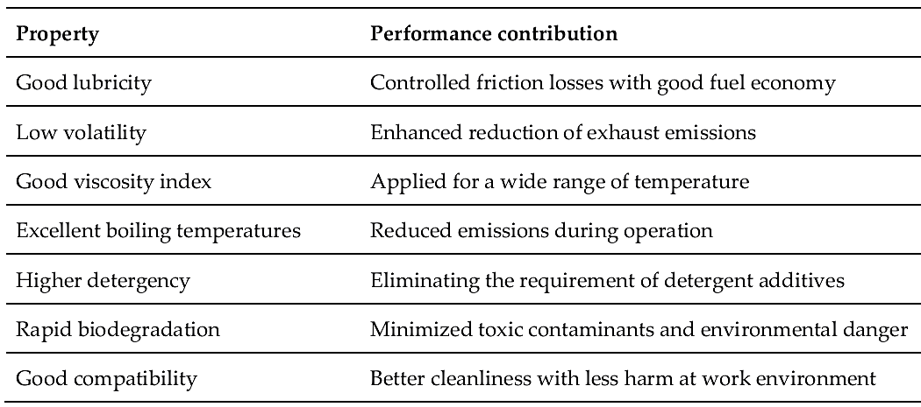
The global market for bio-lubricants in expected to be influenced by the expanding opportunities for sustainable solutions, such as green buildings and sustainable lubrication. The international market for bio-lubricant is anticipated to reach US$ 2.6 billion under a CAGR of 5.2% over the forecast timeline of 2020-2027, based on recent report by global industry Analyst ⁴³. The demand for bio-lubricants is still high, especially in Europe where it is encouraged by national and global branding regulations, subsidization and tax benefits, ⁴⁴.

43. Global Industry analysis Production and Trade of Lubricants in the United Kingdom, (2010-2021). 2021, 2021.
44. Global Industry analysts Production and Trade of Lubricants in the united kingdom, (2010-2021). 2021, 2021.
2.7 ADVANTAGES AND DISADVANTAGES OF BIO-LUBRICANTS
Table 2.3: Advantages and Disadvantages of Bio-lubricant^{45,46}
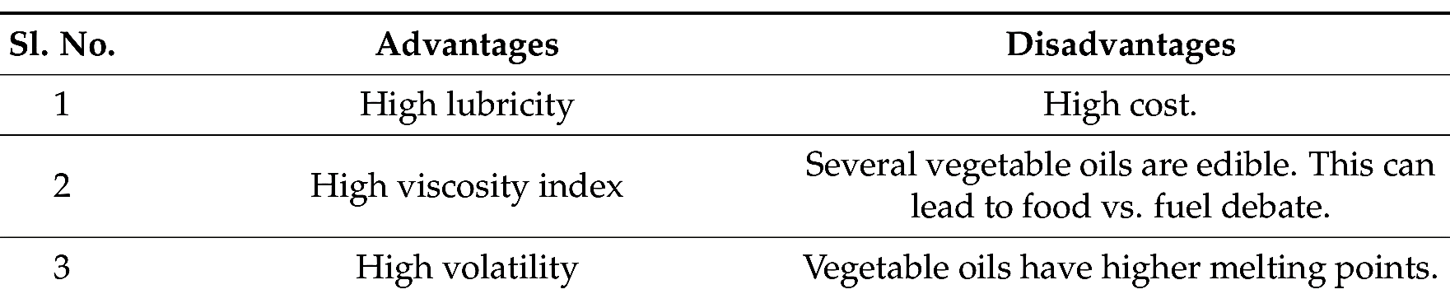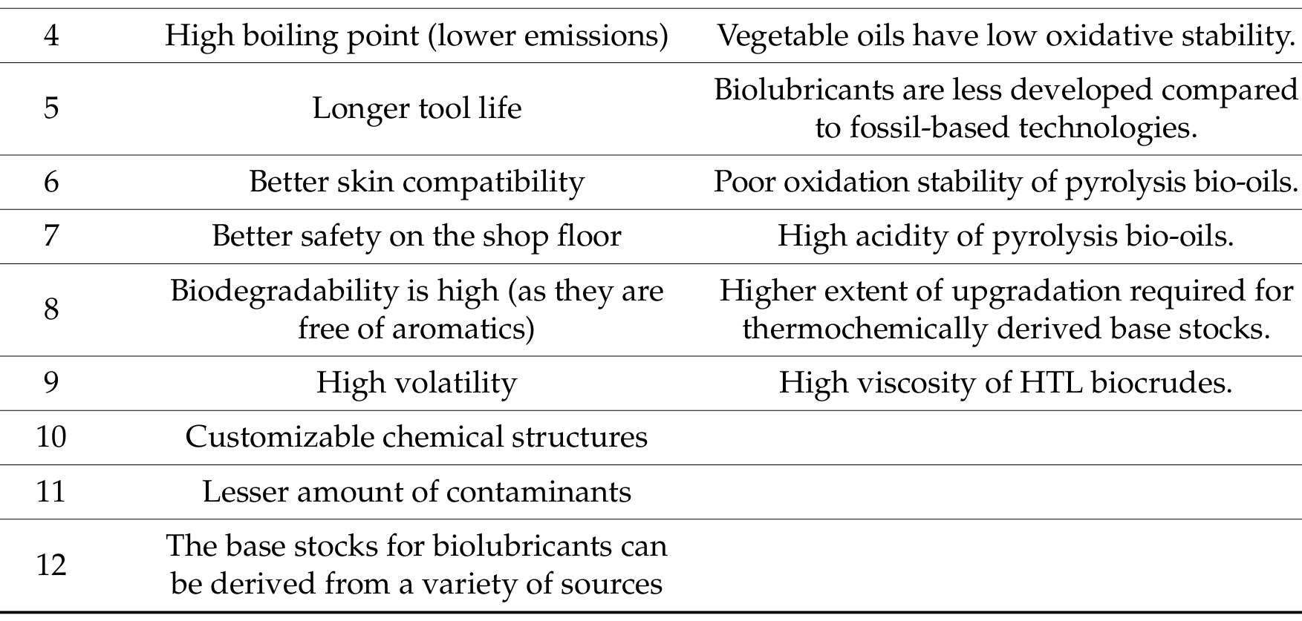
2.8 APPLICATIONS OF BIO-LUBRICANT
Engine oils tend to minimize the transport of contaminants and other particulate, and keep them away from the moving parts ⁴⁷. As

45. Cecilia J.A, Ballesteros Plata. D, Alues Saboya R.M, Traveres de Luna F.M, Cavalcante C.L and Rodriguez- Castellon. E. “An overview of the Biolubricant Production Process: Challenges and Future Perspective”, Processes, 8 (2020): 257.
46. Ho C.K, McAuley K.B. and Peppley B.A. “Biolubricants through renewable Hydrocarbons: A perspective for new opportunities”, Renew Sustain, Energy Rev. 113, (2019): 109261.
47. Liston T.V. “Engine Lubricant additives what they are and how they function”, Lubr, Eng. 48, (1992): 389-397.
engine oils undergo oxidative degradation and wear during service, it is vital to characterize the ageing of engine oils at simulated conditions to understand and evaluate the performance of existing oils and also design new formulations ⁴⁸. Researchers have employed pongamia oils as a compression ignition (CI) engine lubricant ⁴⁹, showing that it improves efficiency and unlike a mineral oil lubricant, can potentially eliminate the emission of trace metals, as it is devoid of any metal constituents.
Catton fluids control the temperature rise by giving adequate lubrication and cooling between the work piece and the tool ⁵⁰. Even through minerals oils are comparatively cheaper for this application, they exhibit poor performance due to low-temperature solidification, oxidative instability and loss of viscosity at elevated temperatures. They are also susceptible to explosion in the presence of an oxidizing agent. Importantly, the additives used to enhance the performance of
48. Jedrzejczyk M.A, Vanden Bosch. S, Van Aelst. J, Van Aelst. Kouris P.D, Moalin. M, Haenen G.R, Boot M.D, Hensen E.J and Lagrain. B “Lignin – Based additives for improved thermo-oxidative stability of Biolubricants”, ACS Sustain, Chem. Eng. 9(2021): 12548-12559.
49. Bekal S and Bhat N.R. “Bio-lubricant as an alternative to mineral oil for a CI Engine – An experimental investigation with pongamia oil as a lubricant”, Energy source part A recovery util. Enviorn. Eff. 34, (2012): 1016-1026.
50. Katna. R, Suhaib. M and Agrawal. N. “Nonedible vegetable oil-based cutting fluids for machining processes”, A review mater, manuf. Process 35, (2020): 1-32.
the lubricant may be dangerous to humans and the environment. Non-edible vegetable oils are biodegradable and are ultimately decomposed and mineralized into carbon dioxide and hydrogen by microbes. Biodegradability ensures the safe integration of biomaterial back into carbon cycle of nature. Non-edible vegetable oils degrade faster than mineral oils in the natural environment ^{51,52}.
The minimum quantity lubrication (MQL) is an environmental protection technology that employs a nozzle to spray a small amount of lubricating fluid and compressed gas into the cutting zone for the purpose of cooling and lubrication ^{53,54}. Discussed the temperature of the minimum quantity lubrication (MQL) milling of the 45 steep using cottonseed, palm, caster, soybean, and peanut oils base stocks. It was shown that the cottonseed and the palm oils exhibited a good cooling effect. This is due to the presence of short carbon chain length palmitic

51. Emmanuel. O.A. Kessington, O.O, Mudiakeoghene. O. “Biodegradation of vegetable oils”, A review Sci. Res. Essay, 4 (2009): 543-548.
52. Ghuge N.C, Dhatrak V.K and Mahalle. “A minimum Quality Lubrication Iosrjen, 2 (2012): 55-60.
53. Ghuge N.C, Dhatrak V.K and Mahalle. “A minimum Quality Lubrication Iosrjen, 2 (2012): 55-60.
54. Dong L, Li. C, Zhou. F, Bai. X, Gao. W, Duan Z, Li. X, Lv. X and Zhang. F. “Temperature of the 45 steel in the minimum Quality lubricant milling with different Biolubricants”, Int. J. Adv. Manuf. Technol, 113 (2021): 2779-2790.
acid in cotton seed and palm oils, which is conducive to the minimum quantity lubrication (MQL) milling.
Gear oils are necessary for industrial and automatic lubrication, wherein they are generally used in differentials, transmissions, power take-offs and non-drive applications. Besides the usual functions of lubricants, these oils are required to reduce noise, inhibit corrosion, transfer heat, and improve overall efficiency ^{55,56}. In order to obtain good protection in both the hydrodynamic and elastohydrodynamic regimes, strict viscosity regulation of the base oil is needed. While vegetable oils do not possess the required viscosity for the application, this limitation can be overcome by thermal polymerization of the oil by heating the oil in inhert ambrence to generate high molecular weight products ⁵⁴.

55. Mang. T, Freiler. C and Horner .D. “Metalworking Fluids”, In Lubricants and Lubrication, 2nd ed, Mang. T, Diesel. W, Eds. “Wiley VCH: Weinheim”, Germany, (2007).
56. Arca. M, Sharma B.K, Perez J.M and Doll K.M. “Gear oil Formulation designed to meet Bio-Preffered Criteria as well as give High Performance”, Int. J. Sustain Eng, 6 (2013): 326-331.
Table 2.4: Oils, their properties and their major applications
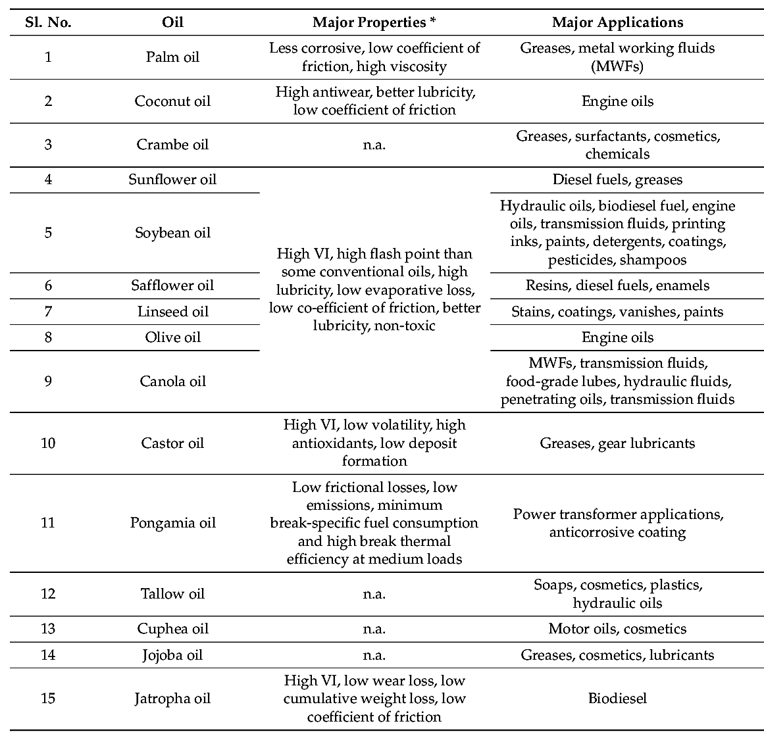
2.9 COCONUT OIL
Coconut oil is an edible oil that has been consumed in tropical countries for thousands of years. As it has a long shelf life and meting point of 76℉, it is used in baking industries. A negative campaign against saturated fats in general, and the tropical oils in particular, led to most food manufactures abandoning coconut oil in recent years in favor of hydrogenated polyunsaturated oils, particularly soy, which contain trans fatty acids. Studies done on population consuming diets high in coconut oil show on adverse effects on the health of the population⁵⁶.
Coconut, also known as Cocos Nucifera⁵⁷, a tree known for its many nutritional and medicinal properties has gained new found interest in western medicine. It is believed that certain parts of the coconut, for example, tender coconut water and kernel have medicinal qualities including but not limited to antibacterial antiviral, antifungal, antioxidant, low glycemic index, hepatoprotective, and immune system enhancement⁵⁸. Coconut oil is very commonly used as a tropical edible

56. Thampan P.K, Glimpses of Coconut industry in India, Coconut Development Board, Cochin 1988.
57. Debmandal. M and Mandal. S. Asian Pac. J. Trop. Med. 4, 3(2011): 241-247.
oil in many assign cultures and is composed of almost 90-95% saturated fatty acids⁵⁸. The health and nutritional benefits derived from coconut oil are both compelling and contradictory, mainly due to its high saturated fat content as relates to chronic diseases, especially those involving the cardiac system⁵⁹.
2.9.1 Methods of Production of Coconut oil
Different types of coconut oil for edible purpose are available viz, virgin coconut oil from wet coconut (unrefined grade); coconut oil from dry coconut (unrefined grade); and coconut oil by solvent extraction method (refined from coconut expeller cake). Virgin coconut oil is claimed to have more health benefits compared to coconut oil extracted from copra.
2.9.1.1 Solvent extraction
Cancel et al⁶⁰ has standardized condition for coconut oil extraction from coconut milk press-cake⁶¹ studied the solvent extraction
58. Burnett C.L. Int. J. Toxicol. 30, 3 (2011): 55-165.
59. Nevin K.G. and Rajamohan T. Clin. Biochem 39, 9(2004): 830-835.
60. Cancel L.E, Rosario Hernandez J.A, and Hernandez E.R. de. “Coconut oil extraction from coconut milk Press-Cake”, J. Agric Unipuereto rice 60, 3(1976): 281-293.
61. A. L. Gonzalez, et al. “Studies on Solvent extraction of residual oil from wet coconut meal using isopropanol”, Phillip. J. Sci. 102, ½ (1973): 31-43.
of residual oil from wet coconut meal using isopropanol. Bernardini⁶² has described a new single solvent direct extraction process (by CMB, Pomezia) which Obtiates and Buccat⁶³ studied the filtration-extraction of granulated coconut on a bench scale. Claudio et al⁶⁴ carried out laboratory scale studies on the preparation of a highly nutritious coconut flour from granulated coconut. Preliminary feeding expt. Indicate a PER comparable with casein prepared foods (cakes, doughnuts, cookies, pastries) with 20-30% wheat flour replaced by coconut flour obtained high taste rating.
2.9.1.2 Enzymatic Process
Coconut oil is extracted from coconut paste by a new enzymatic process⁶⁵ and the method used less energy than the conventional processes. A Srilankan inventor⁶⁶ has developed a simple method for making high quality coconut oil and desiccated coconut using more

62. Bernardini E. “Direct extraction of oil from oil seeds without Pressing”, Riv. Itali de. Sost. Gras 49, 8 (1970): 385-391.
63. Aliwalas A.R. and Buccat C.P. “Filtration- extraction of granulated Coconut on a bench scale”, Phillip .J. Sci. 96, 3 (1970): 215-285.
64. Claudio – TR, Capulso S.A, Gonzales A.L, Fuente F.S. de la, and Manalac G.C. “Laboratory Scale Studies on the Preparation of Coconut flour from granulated coconut”, Phillip J. Sci. 97, 1(1968): 45-56.
65. Thampan P.K, Glimpses of Coconut industry in India. Coconut Development Board, Cochin (1988).
66. Leonard. E, “Sri Lankan Inventor who makes life easier for his countrymen. (1983). Community, APCC/QS/45/83, 33-35.
manpower and little or no electricity, it involves breaking the coconut, scraping it and drying in a specially designed solar drier. The desiccated coconut produced can be used for mechanical extraction of colourless, odourless coconut oil suitable for direct consumption^{67,68} developed a simple process for producing coconut oil and food grade copra cake which has been potential. Nambiar⁶⁹ developed a method for the production of refined oil form the milk of fresh ripe coconuts and has been granted an Indian patent.
2.9.1.3 Wet Processing of Coconut
Nambiar (1977)⁷⁰ has developed a method of processing fresh ripe coconut to obtain refined oil and to simultaneously recover coconut products including solid coconut products for human consumption which has also been patented in India. Castellanos and Asturias⁷¹. Investigated the wet milling processes for the extraction of oil from
67. “Small-Scale oil extraction from groundnuts and copra. International Labour office”, United Nations Industrial development organization Technical Memorandum, United Nations Industrial development Organization, 4 (1983) xi+111pp. ISBN 922103503.4.
68. Mojica I.N. Jr. “Process for Producing Coconut oil and food grade copra cake”. (1978) Philippines-Patent 11661/C.
69. Nambiar T.V.P Method for the production of refined oil from the milk of fresh ripe coconuts. (1977), Indian-Patent.
70. Nambiar T.V.P. A method of Processing fresh ripe coconut to obtain refined oil and to simultaneously recover coconut products including solid coconut products for human consumption, (1977): India-Patent.
71. Castellanos P.S, and Asturias C.R. “Extraction of oil from fresh coconut”, Oleagineux 24, 1 (1969): 419-21: 24 (819) 505-09.

decorticated fresh coconut under a variety of experimental conditions to get oil of better quality and it required less refining⁷² identified the critical unit operations in the wet processing of fresh coconuts for the recovery of oil and food grade protein.
2.9.1.4 Copra Milling by Traditional Methods
The extraction of oil from copra is one of the oldest seed crashing operations. In India and Sri Lanka Copra is still crushed for oil extraction in the primitive chekkus as well as in rotary ghains, expellers and hydraulic presses.
The Chekku is a fixed wooden or stone mortar inside which revolves on a hard wooden pestle. The pestle is attached to a long pole which is moved round via bullocks, donkey or by human labor. About 20-40kg of copra can be handled by a chekku.

72. Hagenmaier R.D, Cater C.M and Mattil K.F. “Identification of the critical unit operation in the wet processing of fresh coconut for the recovery of oil and food grade protein”, Abstr. Papers. American Chemical Society, J. Amer. Chem. Soc. 162, (1971): AGFD8.
2.9.1.5 Copra Processing by Continuous Pressing
This is done with the help of expellers. The oil expeller is essentially a mechanical screw press in which the oil is expelled from the copra by the pressure exerted by a continuous rotating warm shaft in the barrel is built with openings to allow the escape of oil and these can be adjusted according to the types of seed being crushed. Traditionally, virgin coconut oil is produced by fermentation method, where coconut milk expelled from freshly harvested coconuts is fermented for 24-36hrs, and during this period, the oil phase. Further, the resulting wet oil is slightly heated for a short time to remove the moisture and filled-filtered. The main disadvantages of this process are low oil recovery and fermented odor, which masks the characteristic coconut flavor of the oil.
2.9.1.6 Hydraulic Process
These are used in the large installations. They are of two main types-open or Anglo-American presses and the closed or cage types presses. In this the space between the plates above ram and the head is divided by plates between which copra is put wrapped in press clothes.
The common method is to extract oil from copra or dry coconuts conventionally coconut oil is produced by expelling dry copra followed by refiring during which oil is exposed to high temperature. The copra based refined coconut oil or the solvent extracted and refined coconut oil will have a brand taste due to the refining processes.
2.9.2 Importance of Coconut as Oil Seed
The coconut palm is the most important parental source of oil, which is grown in India. The cultivation of coconut is spread over the entire coasted belt and also some interior tracts. Compared to all other oil seed crops coconut has the highest productivity as well as consistency in production compared to other oil seed crops coconut is less susceptible to abnormal climatic condition.
2.9.3 Biological Effects of Coconut oil
Historical information claims that coconut oil was the cure for illness in ancient India and China, treating anything from infections and disease, to nausea and toothaches. The creamy, soft texture of coconut oil has also been used as a skin moisturizer and as hair therapy, aiding in preventing and treatment of dry skin and damaged hair in the hot, tropic sun. claimed to guaranteed blemish and infection free skin as well as strong bones, Samoon mothers massage their children’s entire bodies frequently since infancy with the miracle oil. Coconut oil can also be rubbed on the gums of babies to ease the pain during teething. Jamaicans believes coconut oil to be valuable to hear health, and drank it as a tonic whenever sick⁷³.
2.9.3.1 Anti-Microbial Effects of Coconut oil
Coconut oil has been found to aid as an antibacterial, antifungal antiviral and antidermatophytic agents. It has been used in Ayurvedic medicine as well as in many other culture worldwide studies have been conducted to test the effects of coconut oil as an antimicrobial agent and findings for many support this thousand-year old universal remedy. By products of coconut oil breakdown result in the production of medium-chain fatty acids (MCFA) and monoglycerides (MG). it is these MCFA and MG that confer antimicrobial properties, by destroying pathogenic bacteria, virus, fungi and protozoa⁷⁴.

73. South Pacific Coconut oil: http://rudanetrading.com/au/ information/coconut-oil. Html (July 5th 2013).
74. Fife B. Agro food ind Hi Tec 24, 3 (2013): 7-10.

Coconut oil has been proven very successful and effective against viruses that lipid-coated, such as Epstein-Bar virus, influence virus, leukemia virus, hepatitis C virus, and cytomegalovirus (CMV), to name a few. It accomplishes this by interfering and discrupting the virus membrane, assembly, and maturation⁷⁵.
2.9.3.2 Hypolipidemic effects of Coconut oil
While cardiovascular disease is on the rise, mainly, due to its correlations with obesity, a growing epidemic across the globe, risk factors of cardiovascular disease include several components, such as diet, level of physical activity, psychological well-being, and other lifestyle components like smoking of these scientific evidence have indicated that dietary factors predominantly influence serum lipid concentrations⁷⁶. It is largely believed that certain dietary fats lower low density lipoprotein (LDL) Levels while assisting in elevating higher density lipoprotein (HDL) level in the blood. Clinical evidences have

75. Deb Mandal. M and Mandal. S. Asian Pac. J. Trop. Med 4, 3 (2011): 241-247.
76. Nevin K.G and Rajamohan. T. Clin Biochem 37, 9 (2004): 830-835.
also indicated that risk for cardiovascular disease increase dramatically when serum LDL is easily oxidized⁷⁶. There is new found interest in the cardio-protective effect of coconut oil as reported by the coconut research center in one study, coconut oil was reported to cause an increase in total cholesterol levels. However, it is noteworthy that some of the elevation in cholesterol levels is attributed to an increase in HDL or good cholesterol⁷⁷. Therefore, it is essential to understand the chemical composition of coconut oil in order to extrapolate the health benefit and clinical significance of consuming coconut oil as a heath promoting dietary fat.
2.9.3.3 Effects of Coconut oil on Cardiovascular Health
A recent study investigated the risk for cardiovascular diseases upon consumption of coconut oil in the Philippines, a country wherein coconut oil is abundantly used for cooking purposes. Coconut oil being extremely rich in saturated fats, the premise of this study was to

77. Fife. B. Agro food Ind Hi Tec 24, 3 (2013): 7-10.
investigate the effects of saturated fats in coconut oil and its atherogenic properties in a cohort of 1,839 Filipino women⁷⁸. The results of this study indicated that consumption of coconut oil did not elevate serum total cholesterol or serum triglycerides. However, measurement of coconut oil intake was calculated using self-reporting via two 24-hours dietary recalls. Thus, due to the nature of the designed practiced by the study and lack of ability to control various external and confounding variables, it would be safe to assume that additional clinical trials are required before health professionals are confidently able to prescribe coconuts oil consumption as it relates to being a cardio-protective agent.
2.9.3.4 Hepatoprotective Effects of Coconut oil
Liver is one of the largest and most importance organs in human body. The human liver is responsible for controlling carbohydrates storage and metabolism, protein synthesis, breakdown of red blood

78. Feranil A.B. Asia Pac. J. Clin. Nutr. 20, 2 (1971): 366-369.
cells, and detoxification⁷⁹. Despite the many advances in the medical field, western medicine has been unable to prevent and cure many chronic conditions, one being offering protection from much chemical and physiological damage to hepatic cells resulting from routine exposure to different nutrients, drugs, and environmental factors. In the most recent times, VCO has gained a lot of popularity in the clinical field, especially in relation to its anti-oxidant and cardo-protective properties. However, the understanding of the functional properties of coconut oil clinically within the human body requires sophisticated research methodologies. Data in animals suggest that VCO may induce a hepato-protective effect in addition to the antiviral, anti-inflammatory, and cardio-protective mechanism. Zakaria⁷⁹ investigated the hepato-protective effects of VCO on paracetamol induced liver damage in rats. The result indicated that treatment of the damaged rat liver with VCO significantly reduced liver damage concluding that coconut oil may indeed offer some hepato-protective effects. The

79. Zakaria Z.A. Evid. Based Complement Alternat. Med, 2011 (2011): 142739.
authors concluded that further in-depth studies are required to observe similar results in human⁷⁹.
2.9.3.5 Effects of Coconut oil on Metabolic Syndrome
There is a surge in chronic diseases, mainly stemming from presence of obesity, very little preventive cure is available through western medicine. Type 2 diabetes, hypertension, cardiovascular disease, and certain cancers are all chronic conditions, risk for which can be increased by what is deemed as metabolic syndrome a cluster of factors comprising of low levels of HDL, hyperglycemia, abdominal obesity, hypertion and high triglycerides⁸⁰. Although the pathogenesis of metabolic syndrome is complex, very little is known about the underlying mechanisms and successful prevention and treatment through western medicine. It has been observed that in animal (mice models), consumption of MCT such as those found in coconut oil may offer enhanced lipid oxidation and greater energy expenditure. A recent study suggested that consumption of MCT’s (Coconut and Milk)

80. Nagao K and Yanagita T. Phamacol Res 61, 3 (2010): 208-212.
resulted in greater elevation of post prandial oxygen consumption in healthy men as compared to LCT⁸¹. Hyperlipidemia, a classic condition associated with metabolic syndrome is one of the many leading causes of cardiovascular diseases and while there are numerous synthetic drugs available to treat the condition none come without the added risk of side effects sometimes debilitating and interfering with body processes and metabolism⁸².
2.9.3.6 Anti-Cancer Effects of Coconut oil
In 1987, Lim-Sylianco ⁸³ published a 50-year literature review showing the anti-cancer effects of coconut oil. In chemically induced cancers of the colon and breast. Cohen et al⁸⁴ showed that coconut oil was by far more protective than unsaturated oils. For example, 32% of corn oil eaters got colon cancer whereas only 3% of coconut oil eaters got the cancer. Animals fed unsaturated oils had more tumors. This shows the thyroid-suppressive and hence, immune-suppressive effects of unsaturated oils.
81. Seaton T.B. Am J.Clin Nutr 44, (5) (1986): 630-634.
82. Zakaria Z.A. Evid. Based Complement Alternat. Med 2011, (2011): 384-387.
83. Lim-Sylianco C.Y. “Anticarcinogenic effects of coconut oil”, Phillip J. Coconut studies 12, 2 (1987): 89-102.
84. L. A. Cohen, et al. “Dietary fat and mammary cancer, I. Promoting effects of different dietary fats on N-nitrosomethylurea-Induced rat mammary tumorigenesis”, J. Natl. Cancer Inst. 77, 1 (1986): 33-42.
2.9.4 Healing Properties of Coconut oil
Coconut oil is antiviral, antifungal (kills yeast too) and antibacterial. It affects and kills viruses that have a lipid (fatty) coating, such as herpes, HIV, Hepatitis C, the flu, and mononucleosis. It kills the bacteria that cause pneumonia, sore throats, dental cavities, urinary tract infections, meningitis, gonorrhea, food poisoning and many more bacterial infections⁸⁵. It kills the fungus/yeast infections that cause candida, ringworm, athletes food thrush, jock itch and diaper rash.
2.9.5 Applications of Coconut oil
Coconut oil has a long shelf life and is used in baking industries, processed foods, infant formulas, pharmaceuticals, cosmetics and as hair oil. The oil contains 92% of saturates consisting of medium chain fatty acids in the form of triglycerides, and about 8% of unsaturated consisting of oleic and limoleic acids as triglycerides. The oil has a small amount of unsaponifiable matter (<0.5%), is colorless and has a

85. S. Nandi, S. Gangopadhyay and S. Ghosh. “Production of Medium chain glycerides from coconut and palm kernel fatty acids distillates by lipase-catalyzed reactions”, Enz. And Microbial Technol 36, (2005): 725-728.
odor typical of the coconuts. The oil has a small amounts of tocopherols. The oil is known to have antiviral and antibacterial effects and excellent healing properties. It gets easily absorbed in the body and is a nature mimic of human breast milk fat and hence used in infant formulae.
2.9.5.1 Edible Applications of Coconut oil⁸⁶
Coconut oil has a high degree of saturated with a high content of saturated fatty acids. Because of high content of saturated fatty acids coconut oil is highly resistant to oxidative rancidity, coconut oil is used as a component of infant milk powders because of its easy digestibility and stable flavor coconut oil is extensively used in the food industries as a confectionary fat particularly in the preparation of ice cream. In initiation chocolates coconut oil is used in place of cocoa butter along with cocoa powder.

86. A. G. Gopala Krishna et al. “Coconut Oil: Chemistry, Production and Its Applications -A Review”. Indian Coconut Journal. 2010, 15-27
2.9.5.2 Non-Edible Applications of Coconut oil ⁸⁶
One of the major non-edible applications of coconut oil is in the soap industries, one important chemical derivative of coconut oil is methyl esters of coconut fatty acids, which are produced by treating coconut oil with methyl alcohol. These methyl esters constitute an important raw material for the chemical industries as they are more stable and are easier to separate by fractional distillation. Coconut oil has many other industrial uses in the pharmaceuticals, cosmetics, plastics rubber substitutes, synthetic resins etc. coconut oil has also been found useful for mixing with diesel. These mixtures in the proportion as 30:70 has given excellent road performance of diesel vehicles. Methyl esters of coconut oil fatty acids is also being used as lubricants and biodiesel in aviation industry.

CHAPTER THREE
3.0 MATERIALS AND METHODS
3.1 REAGENTS AND APPARATUS
3.1.1 Reagents
All reagents used are of analytical grade and included: N-hexane, methanol (CH₃OH), sodium hydroxide (NaOH) pellets, sodium methoxide (NaOMe), sodium hydroxide, silica gel, activated charcoal, distilled water, Trimethylolpropane (TMP), phenolphthalein, alcohol ether, ethanol, potassium hydroxide (KOH),
3.1.2 Equipment and Apparatus
Heating mantle, beakers, funnel, round-bottom flask, measuring cylinders, chromatography column, separating funnel, distillation apparatus, thermometer, two-necked round bottom flask (500ml), anti-bumping stone, electric-mechanical stirrer, weighing balance, burette (50mL), pipette (25mL), and magnetic stirrer.

3.2 COLLECTION AND PREPARATION OF SAMPLE
The commercially available locally produced coconut oil (adin agbon) produced by traditional method was purchased at OJA-OBA (translated as King’s market) in Ilorin, Kwara State, Nigeria. The sample was procured in plastic containers tightly stoppered. It was transported to the laboratory in same container and kept at ambient temperature until the time of use.
3.3 PURIFICATION OF OIL SAMPLE BY COLUMN CHROMATOGRAPHY
The oil sample was mixed with a few grams (2-3 g) of activated charcoal and stirred well for a period of time (about 5 minutes) with a glass rod. Silica gel was mixed with another small amount of activated charcoal in the ratio 10:1 respectively, and was packed (as the stationary phase) into fritted chromatography column that was initially clogged with cotton wool. The n-hexane which was the mobile phase was carefully poured into the column and kept a few centimeters above the top of the stationary phase. The mixture of the oil sample, activated charcoal and some volume of n-hexane were mixed and poured into the chromatography column and allowed to run through the stationary phase with n-hexane as a solvent The purified oil containing the solvent was collected into a beaker and redistilled to remove the solvent. The purified sample from each oil was collected and kept for analysis.
3.4 PREPARATION OF REAGENTS
3.4.1 Preparation of 1% ^{w}/_{v} Phenolphthalein Solution: 1.00g of phenolphthalein powder was dissolved in 100ml of ethanol in a 100ml standard flask. This was used as the indicator solution.
3.4.2 Preparation of 1% w/v Sodium methoxide: 1.00g of sodium methoxide was dissolved in 100ml of methanol. This Represent 1% w/v of the catalyst in the reactant.
3.4.3 Preparation of Potassium hydroxide: 5.611g of potassium hydroxide was dissolved in small amount of distilled water. The solution was carefully and quantitatively transferred into a clean l L volumetric flask and made up to the mark with distilled water. This gave an approximately 0.1 M solution which was subsequently standardized.
3.5 TRANS-ESTERIFICATION OF OIL SAMPLE
The methyl esters of fatty acid in each oil sample using sodium methoxide NaOME catalyzed-transesterification with some modification such that the methoxide was prepared by dissolving sodium hydroxide granules in methanol. 1g of NaOH was dissolved in 20ml of methanol with electric hot plate. 100ml of each oil sample was heated to about 60ºC. The 20ml methanolic sodium hydroxide (NaOME) solution was poured into the hot oil and maintained at that temperature with vigorous stirring using magnetic stirrer for 10 minutes. Thus the conversion of each oil sample to its methyl ester was practically completed. It was later transferred to a separating funnel for separation of the bio-diesel from the glycerin by-product and other products. The set up (i.e. separating funnel and its contents) was left undisturbed to allow the fatty acid methyl ester to separate from other components. The lower phase containing the glycerol, unreacted methanol and catalyst was removed. The upper phase containing the methyl ester was then washed with distilled water severally. The emulsion produced was resolved adding few grams of sodium chloride (NaCl) crystals. The fatty acid methyl ester of each oil sample was collected and stored in labeled plastic container. The thevetia peruviana sample could not be transesterified to its FAME but rather it formed soap. This was due possibly to its high acid value. So no further work could be done on the thevetia peruviana seed oil as regard conversion to biolubricant in this work.
3.6 PREPARATION OF BIOLUBRICANT SAMPLES
100g of the FAME (Fatty acid methyl ester) of each oil sample was weighed into a clean dry 500ml two-necked round bottom flask. The oil was heated initially to 60ºC and about 11.5g of TMP was added, followed by 44.35g of KOH (potassium Hydroxide).The entire mixture in the flask was heated to 130ºC and maintained at this temperature for an hour. The resulting biolubricant was allowed to cool and transferred into a 250ml beaker to further cool. The Biolubricant obtained was then kept in plastic reagent bottle for analysis and labelled COBL.

3.7 CHARACTERIZATION OF BIOLUBRICANTS
The biolubricant samples were analyzed for quality parameters and characterized by instrumental methods which include GC-MS and FTIR.
3.8 ANALYSIS OF THE BIOLUBRICANTS
The biolubricants were analysed for their physical properties (color and odor) and other quality parameters for lubricants.
3.9 DETERMINATION OF SOME PHYSICAL PROPERTIES
Color: The oil and biolubricant samples were observed organoleptically for its colors. Bio-lubricant golden yellow)
Odour: The odors of the oíls and biolubricant samples were also perceived by simply wafting toward the nostrils.
3.10 ANALYSIS OF THE BIOLUBRICANT QUALITY PARAMETERS
The following analyses were carried out on the biolubricants prepared; viscosities at 40°C and 100°C, other quality parameters of lubricants were analyzed and comparison of the parameters with various standard values of different grades was also carried out.

CHAPTER FOUR
4.0 RESULTS AND DISCUSSION
4.1 RESULTS
The tables below present the results of the physical properties, quality parameter and instrumental analysis of the biolubricant prepared from locally produced coconut oil.
Table 4.1: Result of appearance of sample before and after purification
Physical properties | Color before purification | Color after purification | Odor before purification | Odor after purification
Coconut oil sample | Off white | Colorless | Strong odor of rancid coconut oil | Odorless

Table 4.2: Result of Quality parameter of the biolubricants
Sample | Visc @ 40oC (cSt) | Visc @ 100oC (cSt) | Viscosity index (VI) | Flash point (ºC) | TBN  (mgKOH/g) | Pour point (ºC) | Crackle
Test methods | ASTM D445 | ASTM D445 | ASTM D2270 | ASTM D92 | ASTM D2896-11 | ASTM D97
COBL | 24.39 | 4.62 | 104 | 144 | 9.8 | - | Passed
Standard | Visc @ 40oC (cSt) | Visc @ 100oC (cSt) | Viscosity index (VI) | Flash point (ºC) | TBN  (mgKOH/g) | Pour point (ºC) | Crackle
ISOVG 32 | $$>28.80$$ | >4.10 | 104 | - | - | <-10 | -
ISOVG 46 | > 41.40 | >4.10 | >90.0 | 220 | - | <-10 | -
ISOVG 68 | > 61.40 | >4.10 | >198 | - | - | <-10 | -
ISOVG 100 | >90.00 | >4.10 | >216 | - | - | <-10 | -
Mineral oil SN500 | 95.76 | 10.86 | 98 | - | - | <-31 | -

Table 4.3: Result of instrumental analysis of biolubricant
Table 4.2: Other chemical compounds in the coconut oil (adin agbon) biolubricant
S/N | STRUCTURES | NAMES
1 | 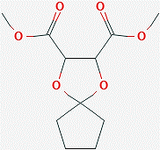 | 1,4-Dioxaspiro[4.4] nonane, 7-butyl- (R,R)-2,3-dimethyl-
2 | 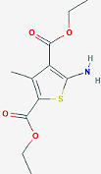 | 2,4-thiophenedicarboxylic acid, 5-amino-3-methyl-, diethyl ester
3 | 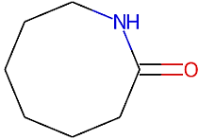 | 2-Azacyclooctanone
4 | 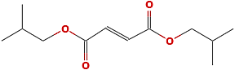 | 2-Butenedioic acid (E)-, bis(2-methylpropyl) ester
5 | 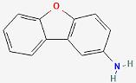 | 2-Dibenzofuranamine
6 | 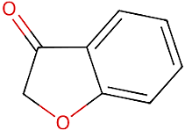 | 3-benzofuranamine
7 | 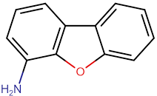 | 4-Dibenzofuranamine
8 | 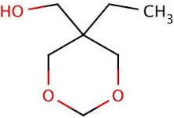 | 5-Ethyl-1,3-dioxane-5-methanol
9 | 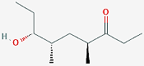 | 7-hydroxy-4,6-dimethyl nonan-3-one
10 | 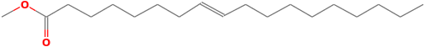 | 8-octadecenoic acid, methyl ester
11 | 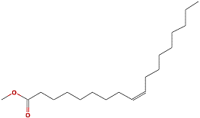 | 9-octadecenoic acid (z)-, methyl ester
12 | 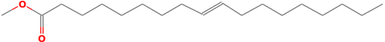 | 9-octadecenoic acid, methyl ester, (E)-
13 | 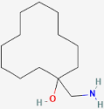 | cyclododecanol, 1-aminomethyl-
14 | 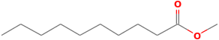 | Decanoic acid, methyl ester
15 | 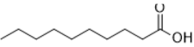 | Decanoic acid
16 | 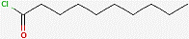 | Decanoyl chloride
17 | 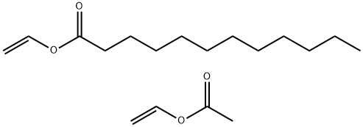 | Dodecanoic acid, ethenyl ester
18 | 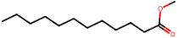 | Dodecanoic acid, Methyl ester
19 | 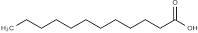 | Dodecanoic acid
20 | 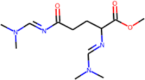 | D-Ornithine, N,N,'-bis (dimethylaminomethylene)-, methyl ester
21 | 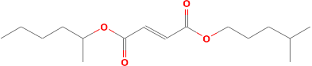 | Fumaric acid, 2-hexyl isohexyl ester
22 | 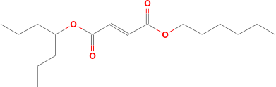 | furamic acid, 4-heptyl hexyl ester
23 | 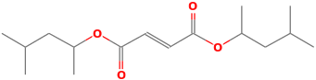 | Furamic acid, di(4-methylpent-2-yl) ester
24 | 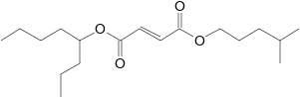 | furamic acid, isohexyl 4-octyl ester
25 | 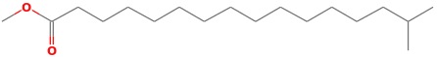 | hexadecanoic acid 15-methyl- methyl ester
26 | 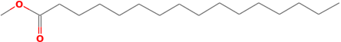 | hexadecanoic acid methyl ester
27 |  | Lauric anhydride
28 | 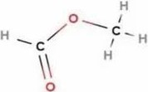 | Methyl ester
29 | 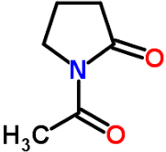 | N-Acetylpyrrolidone
30 | 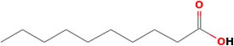 | n-Decanoic acid
31 | 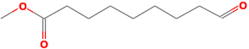 | Nonanoic acid, 9-oxo-, methyl ester
32 | 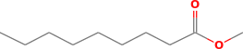 | Nonanoic acid, Methyl ester
33 | 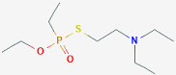 | o-(3-methylcyclohexyl) s-(2-diethylaminoethyl) ethylphosphonothiolat
34 | 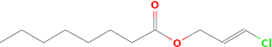 | Octanoic acid, 3-chloroprop-2-enyl ester
35 | 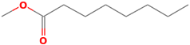 | Octanoic acid, methyl ester
36 | 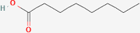 | Octanoic acid
37 | 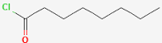 | Octanoyl chloride
38 | 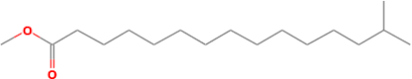 | pentadecanoic acid 14-methyl- methyl ester
39 | 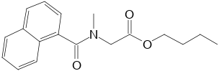 | sarcosine, N-(1-naphthoyl)-, butyl ester
40 | 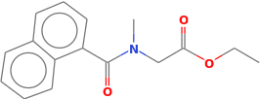 | sarcosine, N-(1-naphthoyl)-, ethyl ester
41 | 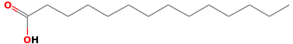 | tetradecanoic acid
42 | 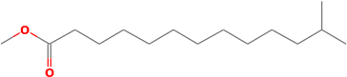 | tridecanoic acid 12-methyl- methyl ester
43 | 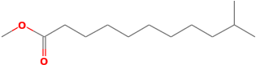 | Undecanoic acid, 10-Methyl-, Methyl ester

4.2 DISCUSSION
Table 4.1 shows the change in the physical all properties of the adin agbon achieved via purification from off white to pure white color due to the removal of impurities and removal of odor.
From Table 4.2, the results of the COBL viscosity at 40°C agrees only with the ISOVG 32 grade. While at 100°C the value agrees with all the grades. It however has lower values to that of the mineral oil used as based oil for synthetic lubricants.

4.3 CONCLUSION
This work shows that the locally produced coconut oil can be successfully transformed to biolubricant with comparable quality parameters to ISOVG 32 and 46 in certain respect. It thus can find industrial application in this area as a renewable feedstock.
And with further refining, the quality of the resulting biolubricant can be enhanced.

