INVESTIGATION INTO THE CAUSES OF PAVEMENT FAILURE IN KWARA STATE
(CASE STUDY OF KWARA STATE POLYTECHNIC ROAD)
BY
ATEWOLARA WAHEED OLADIMEJI
HND/23/CEC/FT/0079

SUBMITTED TO:
DEPARTMENT OF CIVIL ENGINEERING,
INSTITUTE OF TECHNOLOGY,
KWARA STATE POLYTECHNIC, ILORIN

IN PARTIAL FULFILMENT OF THE REQUIREMENT FOR
THE
AWARD OF HIGHER NATIONAL DIPLOMA (HND)
IN CIVIL ENGINEERING.

CERTIFICATION
This is to certify that this research study was conducted by ATEWOLARA WAHED OLADIMEJI (HND/23/CEC/FT/0079) and had been approved as meeting the requirement for the award of Higher National Diploma (HND) in Civil Engineering of the Department of Civil Engineering, Institute of Technology, Kwara State Polytechnic, Ilorin

------------------------------- ----------------------
ENGR. (MRS) K.O. OLORUNFEMI DATE
(Project supervisor)

-------------------------------- ------------------------
ENGR. A NAALLAH DATE
Head of Department
---------------------------------- ------------------------
ENGR.DR MUJEDU KASALI ADEBAYO DATE
External Examiner

DEDICATION
This project is dedicated to Almighty God, mentor and my role model for His mercies, favor, blessing, protection and upliftment of my life through completion of my program. It is also dedicated to my beloved family especially my beloved parent, MR AND MRS ATEWOLARA for their moral and financial support in making this project a reality, and also my mentor ENGR MRS K.O. OLORUNFEMI, may Almighty Allah be with them and let them reap the fruits of their labour (AMEEN)

ACKNOWLEDGEMENT
First of all, I give all honor, adoration and praise to the Almighty Allah, who has made it possible for me alive to this very moment and for seeing me through the year of my education.
My utmost thanks goes to my project supervisor, and also the H.O.D of the Department, ENGR. MRS. K.O OLORUNFEMI, for the successful completion of this project has been to her close supervision and assistance.
My sincere gratitude goes to my dear parent MR.AND MRS. ATEWOLARA for their moral, financial support and encouragement towards my success in the completion of my cause.
My special thanks go to the following people among many who contributed greatly and freely to the success of my programs, My honorable Grand parent mr & mrs Abdulrahmon , dearest mum MRS zainab abdulrahmon, My amiable small mom MRS. Muheenat Disu, my favourable brothers (Ahmod tijani, muh. Sidiq, abd.rosheed muh.fathiu, nurullah labak., esteve Anthony, nana khodijah, abd.muheez and more) my dearest friends (kaosar olayiwola, Apena lekan, Sheriff ayobami) thank you all for the prayer and financial support I really appreciate you all.

I am highly indebted to my beloved friends in school for their love, immensurable contribution, encouragement and solidly behind me in time of facing the challenges of academic rigor. THANK YOU ALL.

ABSTRACT
This project focuses on causes of pavement failure and their remedial measures at kwara state polytechnic road Ilorin kwara state. The soil samples were collected from different portions of the road, the photographs of failed sections b were taken, and test carried out on the soil sample were compaction test and California bearing ratio (CBR) Test. Some major structural defects observed on the roads are; potholes, cracking, reveling, blast erosion, edge deterioration and drainage from blockage. Causes of pavement failures were identified as ranging from; used of substandard materials, inadequate compaction, poor material strength due to the presence of refuse particle in the material used, poor maintenance, improper drainage and improper chamber of the road. Those problem mentions above can be rectified by not compromising standard of work during construction, proper maintenance practice from time to time and high quality control measure during construction and rehabilitation.

TABLES OF CONTTENTS
Title page i
Certification ii
Dedication iii
Acknowledgment iv
Abstract v
Table Contents vi
List of Tables ix
List of Figures x
List of Plates xi
Chapter One
1.0 Introduction 1
1.2 Statement of Problem 3
1.3 Aim and Objective 3
1.4 Scope of Study 3
1.5 Justification 4
1.6 Description of the Study 4
Chapter Two
2.0 Litrature Review 5
2.1 Pavement Failure 5
2.2 Failure of pavement and their causes 6
2.2.1 Structural failure
2.2.2 Functional failure
2.3 Factors to be considered in construction of road
2.3.1 Geological factor (Design)
2.3.2 Geotechnical Factors
2.3.3 Usage factor
2.4 Common Forms of Pavement Failure
2.4.1 Potholes
2.4.2 CRACKING
2.4.3 Reveling (Pitting)
2.4.4 Distortion and Wave
2.4.5 Peeling
2.4.6: Blast Erosion
2.5 Concept of investigation on causes of pavement failure
2.6 Causes of Pavement failure
2.7 Evaluation and investigation method for pavement
Chapter Three
3.0 Methodology
3.1 Reconnaaisance Survey
3.2 Collection of samples for Laboratory test
3.3 Laboratory test and Procedures
3.4 Compaction test
3.5 California Bearing Ratio test
3.6 Drainage condition of kwara state polytechnic Road
Chapter Four
4.0 Result and Discussion
4.1 Results of the Compaction test
4.2 Results of California bearing Ratio (CBR)
4.3 Discussion of Results
Chapter Five
5.0 Conclusion and Recommendation
5.1 Conclusion
5.2 Recommendation

LIST OF TABLE
Table 4.1 Result of density of soil sample
Table 4.2 Result of moisture content of the soil sample
Table 4.3 Result of density of the soil sample
Table 4.4 Result of moisture content of the soil sample
Table 4.5 Result of California bearing ratio(CBR) at kwara polytechnic
Table 4.6 Result of California bearing ratio(CBR) at kwara polytechnic
Table 4.7 Result of California bearing ratio(CBR) at kwara polytechnic
Table 4.8 Result of California bearing ratio(CBR) at kwara polytechnic

LIST OF FIGURES
Figure 1.1 Flexible pavement
Figureigure1.2 Rigid pavement
F 2.1 Flexible pavement
Figure 2.2 Rigid pavement
Figure 4.1 Graph of dry density against Moisture content
Figure 4.2 Graph of dry density against Moisture content
Figure 4.3 Graph of deflection of rings against penetration of plunger
Figure 4.4 Graph of deflection of rings against penetration of plunger
Figure 4.5 Graph of deflection of rings against of plunger
Figure 4.6 Graph of deflection of rings against penetration penetration of plunger

LIST OF PLATES
Plate 2.1: Potholes
Plate 2.1: Cracking
Plate 2.3: Reveling
Plate 2.4: Distortion and Wave
Plate 2.5: Peeling
Plate 2.6: Blast Erosion
Plate 4.1: Plate 4.1: Pothole on Road along IBASS at kwara state polytechnic
Plate 4.2: Blast erosion at IBASS opposite hall at Kwara State Polytechnic road
Plate 4.3 Debris in the drainage along CBT center
Plate 4.4 Debris at CBT center along yankari
Plate 4.5 Pothole in front of bank along central mosque
Plate 4.6 Blast Erosion along CBT center
Plate 4.7 Debris in front of central mosque

CHAPTER ONE
1. INTRODUCTION
Transportation systems are the backbone of modern economies and societies, enabling the movement of people and goods across varying distances with efficiency and speed. These systems are essential for economic development, trade, social interaction, and access to essential services. Among the different modes of transportation including road, rail, air, and sea road transport is particularly dominant in most countries due to its flexibility, accessibility, and the extensive network of roads that connect even the most remote areas. Road transport offers the convenience of direct point-to-point travel and the ability to serve a wide range of vehicle types, from private cars and motorcycles to trucks and buses, making it a critical part of daily life for millions of people around the world.
At the heart of road transport infrastructure lies the pavement, which refers to the surface materials and structural layers that make up roads, highways, and even runways. Pavement plays a central role in providing a safe, durable, and smooth surface for vehicles and pedestrians to travel on. It is the foundation of road transport systems, designed not only for comfort but also to bear the heavy and continuous loads imposed by traffic. The design and maintenance of pavement are critical for ensuring the safety, reliability, and efficiency of transportation networks. When pavement deteriorates, the consequences are severe ranging from increased maintenance costs to traffic delays and, most importantly, safety hazards for road users.
Pavement itself is typically made from durable materials such as asphalt or concrete, which are chosen for their ability to create a smooth surface that can endure years of heavy use. Asphalt, commonly used for flexible pavements, is a material that can absorb and distribute the stresses of repeated traffic loads by transmitting the weight through its various layers. This flexibility allows it to adapt to slight movements or shifts in the underlying soil or base. On the other hand, concrete, used in rigid pavements, is known for its strength and durability, maintaining its shape and structural integrity even under heavy loads, with minimal deflection or movement.
Pavement is generally classified into two main types: flexible pavements and rigid pavements. Flexible pavements, as the name suggests, are designed to flex and adjust under pressure. They are predominantly constructed using asphalt, which allows for the surface to bend slightly when subjected to traffic loads, preventing the development of cracks or damage by redistributing stresses throughout the layers beneath the surface. Flexible pavements are particularly useful in areas with heavy traffic or varying environmental conditions, as they are more adaptable to changes in temperature and loading.
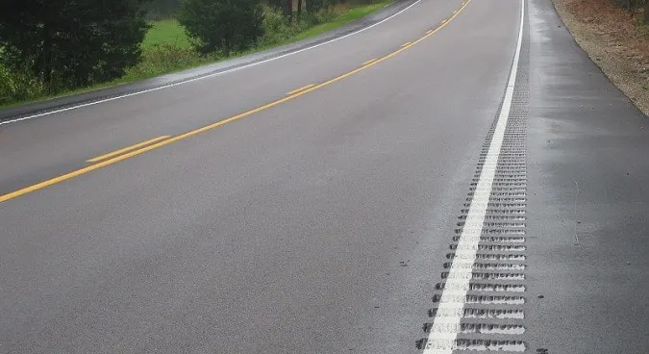
FIG1.1. FLEXIBLE PAVEMENT
In contrast, rigid pavements are made from concrete and are designed to remain firm and unyielding, even under the pressure of heavy vehicles like trucks and buses. The strength of concrete enables rigid pavements to withstand high traffic loads with minimal deflection, making them ideal for highways, airport runways, and other areas where durability and long-term performance are crucial. Although they are more expensive to install than flexible pavements, rigid pavements typically require less frequent maintenance and have a longer lifespan.
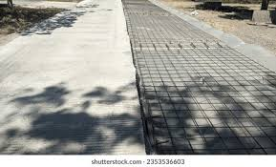FIG 1.2.RIGID PAVEMENT
1.1 STATEMENT OF THE PROBLEM
The failure of road pavement can manifest through a rapid and significant deterioration of the asphalt surface down the sub-grade and sub-base, resulting into the formation of numerous potholes, extensive cracking, and noticeable settlement in various sections. This rapid degradation are responsible for vehicle breakdown and damages, delay on roads accidents.
1.2 AIM AND OBJECTIVES
The aim of this project is to investigate into the causes of pavement failure at kwara state polytechnic road, along yankari, village Ilorin, Nigeria. The objectives are;
i. Identification of the pavement failure along Ilorin, Kwara state.
ii. Investigation of the causes of the pavement failure
iii. Suggestion to the possible solution
1.3 SCOPE OF THE STUDY
The scope of this project research work is to investigate the causes and solution of pavement failure at, kwara state polytechnic road Kwara State, Ilorin, Nigeria.
1.4 JUSTIFICATION OF THE STUDY
Due to the economic safety and environmental problems emanating from pavement failure, this study will enhance sustainable infrastructural development reduction of maintainance, cost of vehicle and enhances safety on road.
1.6 DESCRIPTION OF STUDY ARAE
KWARA STATE POLYTECHNIC ROUTE, WESTEND ROUNDABOUT, YANKARI,ILORIN, NIGERIA.

CHAPTER TWO
2.0LITERATURE REVIEW
2.1PAVEMENTFAILURE
Pavement failure has long been a critical issue in civil engineering, affecting transportation safety, economic activity, and infrastructure longevity. Understanding its causes and progression is essential for planning, design, construction, and maintenance of durable roads. This chapter reviews the historical literature on pavement failure, its types, causes, and key studies that have shaped current engineering practices.
The design and maintenance of pavements have evolved significantly over the centuries, reflecting advancements in material science, engineering principles, and transportation demands. The historical development of pavement design and the study of pavement failure are deeply rooted in the need to facilitate efficient movement of people and goods, dating back to ancient civilizations.
The earliest known paved roads were constructed by the Mesopotamians and later refined by the Romans. Roman roads, in particular, are widely recognized for their durability and engineering precision. These roads often consisted of multiple layers, including a base of large stones, a layer of crushed stone or gravel, and a surface made of tightly fitted paving stones. The layered structure and cambered profile allowed for drainage and load distribution, principles that still inform modern pavement design. Following the fall of the Roman Empire, road construction practices declined in much of Europe, and roads were largely neglected throughout the medieval period. It was not until the 18th and 19th centuries that modern road-building techniques were revived, particularly through the work of pioneering engineers such as John Metcalf, Thomas Telford, and John Loudon McAdam. McAdam, in particular, introduced a technique known as “macadamization,” which involved the use of compacted layers of small stones without binding agents. His methods greatly improved road durability and became the foundation for modern flexible pavement systems.
With the advent of motor vehicles in the early 20th century, existing road systems began to deteriorate rapidly under the increased axle loads and frequency of traffic. This necessitated the development of more robust pavement designs. Bituminous materials such as tar and asphalt were introduced as binders to improve cohesion and water resistance in flexible pavement. Concurrently, concrete pavements emerged as an alternative, particularly for high-traffic urban and highway applications due to their rigidity and load-bearing capacity.
The AASHO Road Test and Modern Design Methods is one of the most influential events in pavement engineering history was AASHO Road Test (1958–1960) conducted in Ottawa, Illinois, by the American Association of State Highway Officials. The goal was to understand the effects of traffic loading on pavement performance. The test led to the development of empirical design equations and the concept of the Present Serviceability Index (PSI), which quantifies pavement condition as a function of roughness and distress.
Despite these advancements, failures in pavement structures remained common. Initially, failures were broadly attributed to material wear or overloading. However, subsequent research revealed that most pavement failures are multifactorial, resulting from a combination of structural inadequacies, poor drainage, environmental conditions, and subgrade weaknesses. For example, in the 1970s and 1980s, researchers like Monismith and Tayabji emphasized the role of subgrade moisture and fatigue cracking in pavement failure mechanism.
By the late 20th century, the growing emphasis on preventive maintenance, performance prediction, and life-cycle costing brought new sophistication to pavement design and evaluation. This period saw the rise of pavement management systems (PMS), which allowed road agencies to track pavement condition, predict deterioration, and optimize maintenance interventions.
In the 21st century, pavement design has transitioned from empirical models to Mechanistic-Empirical (M-E) methods. The Mechanistic-Empirical Pavement Design Guide (MEPDG), developed in the early 2000s, combines the mechanics of material behavior under loads with empirical calibration based on field data. This approach enables more accurate predictions of pavement performance under diverse traffic and environmental conditions. Additionally, the development of advanced materials, such as modified bitumen, geosynthetics, and recycled pavement materials, has significantly enhanced the durability and sustainability of modern pavements. At the same time, non-destructive evaluation (NDE) tools, such as Falling Weight Deflectometers (FWD) and Ground Penetrating Radar (GPR), allow for early detection of potential failures, facilitating timely interventions .there are two type of pavement FLEXIBLE AND RIGID PAVEMENT.
FLEXIBLE PAVEMENT: Witozok (2004) reported that flexible pavement is the component of materials (layers), which consists of base course and sub-base course which rest upon the compacted sub-grade. Sub-base consist of ashes clinkers, shale or gravel. Failure in flexible pavement occurs as a result of shear development in sub grade, base course or surface. Gidigasu (2005) observed that flexible pavement consist a stone base with a surfacing of tar or bitumen coated stones. The sub-base reduces stress in the sub-grade and protects the sub-grade against early failure. Road base normally vary from 75 to 100mm thickness as how in
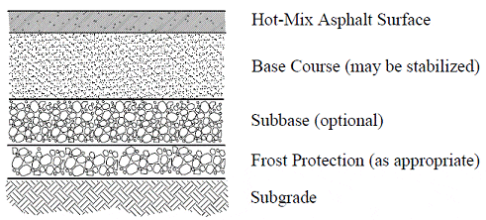
Fig. 2. 1. Flexible pavement

RIGID PAVEMENT: According to Witozok (2004) Rigid pavement consist of a base of granular materials 75 to 150mm thick with lean concrete of 100 to 200mm thick. The concrete slab normally 150mm thick with a mix ratio of 1:24 and water cement ratio not exceed 0.55. The slab would be reinforced with a layer of fabric reinforcement weighing not more than 2.5Kg/m². Gidigasu (2005) reported that rigid pavement are cement concrete roads used extensively and it must have sufficient strength to bridge over localized sub-grade failures and areas of inadequate support without deflection. The concrete slab normally 150 to 200mm thick of grade 30 and concrete with a strength of 30N/mm² Gidigasu (2008) also observed that distress of rigid pavement can be due to deterioration of the pavement which may include: breezing and thawing, alkali aggregate reaction, use of non-durable materials and also may be due to improper dowel alignment, curing, compaction, warping and expansion of stresses. Each layer of rigid pavement is shown below
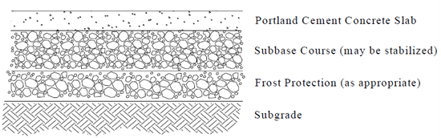
Fig. 2.2 Rigid pavement

2.2 Failure of Pavement and their Causes
According to various researchers, Pavement failure can be group in to two types as follows:
- Structural failure
2. Functional failure
2.2.1 Structural Failure
Structural failure is the type of failure that occur as a breakdown or total collapse of pavement materials that is unable to bear with the imposed load on the road. These may lead to uncomforted of passengers and high stresses on vehicle that pass over the fail pavement.
The deformation of this magnitude is often accompanied by cracking of wearing course, possibly with further cracking in bound layer at lower level. Structural failure occurs due to the following:
1. Excessive Stresses due to traffic: This arise in sub-grade leading to increased deformation with consequent failure of each layer. Bindra (2001).
2. Excessive Stresses due to Temperature: When the temperature is at the top of the concrete slab, it is higher than that at bottom, the slab tends to cause upward and corner lifted from sub-grade spot. So this may develop crack on the surface of pavement at initial stage and finally lead to collapse of the structure. Arumala (2007).
3. Failure due to weakness of sub-grade:- Unstable pavement may occur as a result of using too much organic soil for the sub-grade because water table of such sub-grade may rise up to the sub-base and this would lead to weakness of the soil, also reduce the strength of sub-grade and lastly total failure of sub-grade said Scheizer (2000).
2.2.2 Functional Failure
Function failure: Are the pavement failure that occur when the pavement is unable to perform its intended function without causing high stresses to the vehicles that are passing over the road pavement. Terzaghi (2006).
When vertical deformation of pavement is less than 20mm then, the flexible pavement should be resurfaced with bitumen. But when the surface developed potholes as a result of breakdown of bituminous layers, the functional failure has taken place. Scheizer (2006).
According to Anthony (2004), massive road or pavement failures are common on Nigerian roads after a few years of existence in service condition. All those failure could be caused in combination or separately by the following:
- Improper Drainage System: water is the major cause of pavement failure. Because when water flow on a pavement it weakens the asphalt and when vehicle passes over the weak sport, the asphalt began to crack. Gradually the crack becomes potholes and continuously it will expand. Anthony (2004).
- Excessive Traffic Level: This is due to inadequate, ignorance and indiscipline of people in the Country, where 5 passengers car would carry about 8 10 passengers, an estate road become the route to mini buses and heavy commercial Lorries. Using township roads as an unlimited carriage way. All those lead to general tendency to overstress the road pavement. Adeoti (2016)
- Poor Compaction: According to American Association of Highway officials (2002) that says every layers of the road need to compact together to support the stability of the road. Poor compaction can allow the easy percolation of water into sub-grade through the joints that not adequately sealed. It would reduce the strength of cache layers and also lead to shear of the pavement.
- Lack of proper materials. Agada (2000) reported that as a result of expecting too much profit from construction of road or taking of economical consideration into construction planning, it would lead to reduction or adjustment in the pavement thickness, using improper materials and management of money. Also, small reduction in thickness of pavement cause very large reduction in road life span.
- Maintenance of Practices: From Adeoti (2009) view of general abuse of usage coupled with total disregard for normal maintenance practices. Most meticulously designed and expertly constructed road are bound to become impassable at no distant future.
2.3 Factors to be considered in Construction of Road.
Arthur and Kendrik (2003) observed that road designers, Experts or Engineers and contractors must give serious consideration to the following factors, when planning and during the execution of the road projects to prevent different failure on pavement
- Geological Factor
- Geotechnical Factor
- Usage factor
2.3.1 Geological Factor (Design)
According to information provided by the geological survey of Nigeria (2000), majority of roads constructed in this country are carry out on residual soil (laterite) that are from weathering and decomposition of the rock. Those laterite consist of varying content of "Sillica" depend on the degree of weathering and decomposition experienced, so a thorough knowledge of the behavior and characteristics of laterite should be applicable in design and construction of road to reduce the frequency occurrence of pavement failure.
Gidigasu (2006) identified profile of soil residual or "laterite zone" i.e horizon where laterization is usually at its peak, the excavation depth should be extends to laterized ottled for the construction of road pavement and also to avoid being easily eroded or slide under moisture condition using the coastal plain sand on the construction of road pavement and very deep cuts. The coastal plain sands deposit was prevalent in the southern part of Edo, Ogun and Anambra State as well as the Northern parts of Lagos and River State. The construction of road on all grades of laterite profiles should take characteristic behavior and local variation in rock mineralogy, structure topography, erosion process, ground water and rainfall into consideration.
Gidigasu (2007) also reported that it is very essential to give proper consideration to drainage system and protection wherever cuts extending into the lower zone of laterite.
Meshida (2001) advised that combined influence of geology and geomorphology (relief and drainage) limit should not be ignored when laterite soils are being assessed for road construction.
2.3.2 Geotechnical Factors
The geotechnical factors concerns with design, materials used and integrity of construction practices adopted during the road construction process. The contractors and designers of road should have adequate geotechnical knowledge of the soil behaviors.
Terzaghi (2006): The apparent lack of appropriate knowledge of the behaviour of tropical soil and application of temperature climate soil parameters have resulted into good design based on wrong or inappropriate data, hence inefficient construction of many roads.
According to Gidigasu (2008), Horn and Scheizer (2009) laterite generally are under stress but the prosperity is greater at lower horizon soil than deposit of upper zone. When road is constructed on the lower horizon soil due to deep cut, it would lead to greater proportion of water drain downward andlead to destruction of soil fabric, to structural collapse, higher compressibility, erosion, rooting of road surface. It is essential that drainage channel be cognizance of the high temperature in order to ensure that finished road is capable of performing the role required from it.
2.3.3 Usage Factor
According to Ibrahim (2001) that reported that most of the role or limitation for road were ignored when the road were opened to traffic. Although economic considerations are taken in place of an appropriate design of road pavement. Adeoti (2016) contributed that ignorance and indiscipline of people in the country where an estate roads is turned to the route of mini buses and heavy commercial lorries, using 5 passenger car to carried about 8-12 passengers, township road used as an unlimited carriage way. All this system must be credicted to prevent further damage to the road pavement and to avoid expensive rehabilitation. However, Akogoke and Arumola (2007) give advice that enforcement of design limitation on every road during construction would reduce the rate of failure on the road pavement. Then regular conference to enlighten the community must be organized by both government and road engineers.
2.4 Common Forms of Pavement Failure
According to Anthony (2005): After a few years in service condition of Nigerians roads, most of the roads fails to perform their functions properly. These are common pavement failure.
- Potholes
- Cracking
- Reveling (Pitting)
- Distortion and Wave
- Peeling
- Blast Erosio
2.4.1 Potholes
Witozak and Yoder (2003) define potholes as the bowl-shape holes of various sizes on the road pavement, Saliu(2009) reported that potholes are steep holes of different sizes that affect the proper function of the pavement, therefore, we should ensure that potholes and localized failure are patched as soon as they appear on the road pavement.Plate 2.1
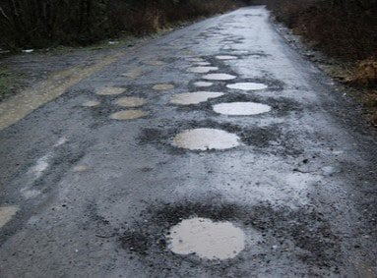
Plate2.1: Pothole

2.4.2 CRACKING
According to Highway Research Board (2000) Cracking are the structural
Weakness of pavement that occur due to the linkage of the water into the under laying structure and inadequate of binder content in pavement. Irick (2009) reported that continuous percolation of water into the pavement material can lead to series of small polygons resembling an alligator’s slim and interconnection of cracks. Cracked portions should be remove and replaced with well compacted and mixed asphalt as shown in Plate2.2.
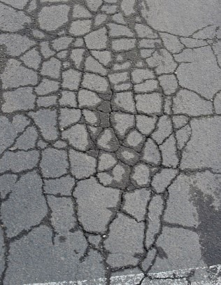
Plate2.2: Cracking

2.4.3: Reveling (Pitting)
Bindra (2010) reported that reveling are majorly caused by inadequate compaction, wet weather, too little asphalt and overheated asphalt. It can also be repaired by the use of adequate sand seal or slurry seal except under very high traffic volumes with speed traffic. Reveling should be treated before it become more extensive and require over-lay. Holepot(2010) analysis says that revealing occurs when the stone aggregate that was originally part of pavement begins to break free from its bonds with the asphalt. Over times as more and more aggregate breaks free from the asphalt, the asphalt loses significant load bearing capability and will begin to prematurely fail in the areas that have exhibited the most reveling and bears the most traffic loading shown in Plate 2.3.
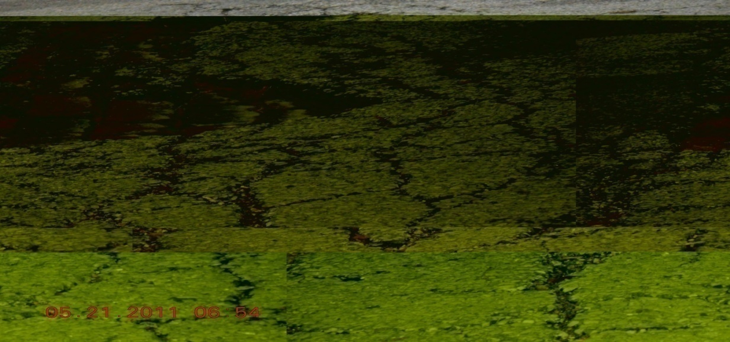
Plate2.3: Reveling
2.4.4 Distortion and Wave
According to Yoder and Witozok (2009). Distortion and wave are the
failure of pavement that deal with pavement surface. Adu (1991) defined distortion as any deviation in the pavement surface from its original shape. Then wave failure as the longitudinal or transverse undulations in the surface of the pavement. It consistsof alternate valleys and crests approximately 0.6m or more apart, as a result of poor compaction during the execution of construction of the road shown in Plate2.4.
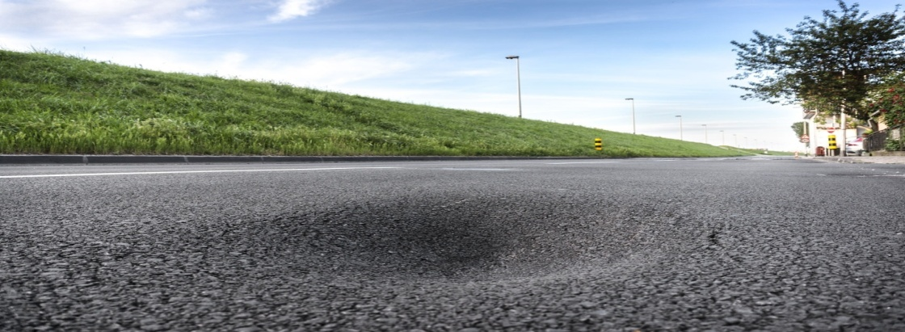
Plate2.4: Distortion and Wave

2.4.5 Peeling
Gaya (2010) reported that peeling occurs on pavement that had previously been overlaid with asphalt and the overlay of asphalt has began to fail due to underlying fatigue “reflecting” up through the overlay layer. After many years, the overlay layer oxidizes and becomes brittle and overlay now exhibits the fatigue failure as underlying asphalt, the pieces from the overlay tend to break free, exposing the original and fatigued asphalt beneath it. This can be corrected by complete removal and replacement of the entire failed area along with the underlying fatigued asphalt shown in Plate2.5.
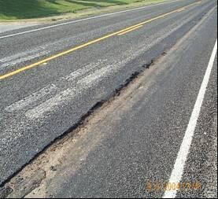
Plate2.5: Peeling
2.4.6: Blast Erosion
According to Highway Research Board (2000): Blast Erosion was expressed as the deep erosion or scouring of pavement in which a portion of structure is lost. Carey (2005) reported that blast erosion majorly occur as a result of inadequate chamber of the pavement, improper drainage system and Blockage of the drainage structure like culvert, Bridges and pipes.Carey (2005) also reported that all pavements should be properly chamber to at least 1% slope and adequate drainage system must provide to prevent frequency occurrence of Blast Erosion shown in Plate2.6.
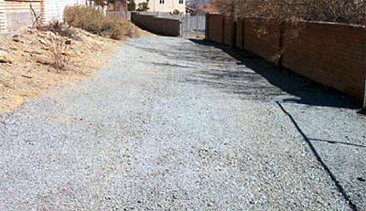
Plate2.6: Blast Erosion
2.5 CONCEPT OF INVESTIGSTION ON CAUSES OF PAVEMENT FAILURE
The investigation into the causes of pavement failure is a critical component of modern pavement engineering, aimed at identifying the underlying factors that compromise the structural integrity and serviceability of roadways. Pavement failure can be broadly defined as any form of structural or functional distress that prevents the pavement from serving its intended purpose, whether through cracking, rutting, potholing, or surface wear. These failures are not only costly to repair but also pose significant safety hazards and economic burdens due to disruptions in transportation. Therefore, systematic investigations are essential for diagnosing failure mechanisms, developing more resilient designs, and improving maintenance strategies. Pavement failures are typically classified as structural or functional. Structural failures result from the inability of the pavement layers to withstand traffic loads, often due to poor material quality, inadequate layer thickness, or weak subgrade conditions. Functional failures, on the other hand, include issues such as surface roughness, loss of skid resistance, or water ponding, which may not reflect structural inadequacy but still impair user comfort and safety (Huang, 2004).
The concept of pavement failure investigation encompasses a multidisciplinary approach, integrating geotechnical studies, material testing, traffic load analysis, drainage assessment, and environmental evaluations. One of the most common causes of pavement failure is inadequate drainage, which leads to water infiltration into pavement layers and subgrade soil. Moisture weakens the base and subgrade, significantly reducing their load-bearing capacity and resulting in premature deformation and cracking. In addition, poor construction practices such as insufficient compaction, use of substandard materials, or failure to adhere to design specifications can lead to early pavement distress. Repeated loading from heavy vehicles is another major contributor, as pavements subjected to axle loads beyond their design capacity undergo accelerated fatigue and rutting, particularly in flexible (asphalt pavements. Moreover, climatic conditions such as freeze-thaw cycles, extreme heat, or prolonged wet periods exacerbate material degradation, further contributing to failure.
To thoroughly investigate the causes of failure, engineers often carry out visual inspections, non-destructive testing (e.g., Falling Weight Deflectometer or Ground Penetrating Radar), core sampling, and laboratory testing of pavement materials. Data from these investigations are used to identify patterns of distress and determine whether the failure is due to design flaws, material deficiencies, environmental impacts, or operational overloads. Recent advancements in pavement forensics and mechanistic-empirical modeling have enhanced the ability to simulate field conditions and predict failure modes more accurately. These tools help agencies prioritize maintenance, design more durable pavements, and extend service life. Ultimately, the investigation into pavement failure is not only about diagnosing defects but also about understanding the complex interactions between materials, design, environment, and usage that lead to pavement distress over time. By systematically analyzing these factors, engineers can devise effective solutions to minimize recurrence and improve the sustainabilit and reliability of road infrastructure.
2.6 CAUSES OF PAVEMENT FAILURE
Pavement failure is a multifaceted issue influenced by a combination of structural, environmental, material, and operational factors. The most prevalent cause is inadequate structural design, where the pavement is not properly engineered to handle the anticipated traffic load or environmental conditions. This can lead to early fatigue and structural deterioration, especially under the stress of repeated heavy axle loads. Flexible pavements, for example, often experience rutting or alligator cracking when the subgrade or base layers lack sufficient strength or are not adequately compacted. The failure to incorporate mechanistic-empirical design principles, which consider stress-strain behavior and traffic repetition, frequently results in under-designed pavements that cannot sustain real-world usage (Huang, 2004). Another critical factor is the quality and compatibility of materials used in construction. The use of substandard asphalt binders, poorly graded aggregates, or improperly stabilized soils can significantly reduce the pavement’s resistance to deformation and moisture damage. Over time, these weaknesses manifest as surface raveling, stripping, or potholing, especially under cyclic loading and adverse weather conditions.
Environmental factors also play a significant role in pavement failure. In areas with seasonal freeze-thaw cycles, pavements are subjected to repeated expansion and contraction, which causes thermal cracking and frost heave. Similarly, regions with heavy rainfall or high groundwater tables often experience water infiltration, which saturates the subgrade and reduces its load-bearing capacity. Once the structural support is compromised, the pavement is more susceptible to deformation and cracking under traffic loads. Poor drainage design or clogged drainage systems exacerbate this issue by allowing water to accumulate and linger within pavement layers (Rahman & Loach, 2002). Additionally, oxidation of asphalt surfaces due to prolonged exposure to ultraviolet radiation makes the pavement brittle and prone to cracking. Such environmental degradation not only leads to surface defects but also accelerates the overall aging process of the pavement structure.
Construction practices significantly influence pavement performance and longevity. Improper layer thickness, inadequate compaction, insufficient curing of concrete, and failure to meet material specifications often result in premature distress. Construction delays, lack of quality control, and insufficient supervision contribute to inconsistencies in layer bonding and material placement, creating weak spots that become focal points of stress concentration under loading. Moreover, lack of maintenance and delayed rehabilitation interventions allow minor distresses to evolve into severe structural failures. For instance, unattended surface cracks can allow water ingress, which leads to subgrade weakening and the eventual collapse of the pavement layer system. Operational overloads are another critical factor roads designed for light or medium traffic may experience rapid deterioration if subjected to frequent heavy-duty truck traffic without reinforcement or structural upgrades.
Pavement failure is rarely the result of a single issue but rather the consequence of interrelated factors including under-design, material defects, environmental stressors, poor construction techniques, and neglect of routine maintenance. A comprehensive understanding of these causes is essential for developing resilient pavement systems and implementing effective pavement management strategies. Advancements in pavement monitoring technologies and mechanistic-empirical modeling have significantly improved the ability to diagnose these causes and prevent premature failure. Ultimately, addressing the root causes through better planning, material selection, construction standards, and proactive maintenance can ensure longer-lasting, safer, and more cost-effective road infrastructure.
2.7 EVALUATION AND INVESTIGATION METHODS FOR PAVEMENT FAILURE
The evaluation and investigation of pavement failure involve a systematic process aimed at identifying the underlying causes of distress, assessing the structural integrity, and determining appropriate rehabilitation strategies. These methods typically begin with a visual inspection to document surface distresses such as cracking, rutting, potholes, or bleeding, using standardized rating systems like the Pavement Condition Index (PCI) developed by the U.S. Army Corps of Engineers.
Non-destructive testing (NDT) techniques are commonly employed to assess subsurface conditions without damaging the pavement. Tools such as the Falling Weight Deflectometer (FWD) provide valuable data on pavement layer stiffness and structural capacity by simulating vehicular loads and measuring surface deflections.
Ground Penetrating Radar (GPR) and infrared thermography can also be used to detect moisture intrusion, voids, and delamination within the pavement layers. In more advanced assessments, core sampling and laboratory testing of extracted materials are conducted to determine the physical and mechanical properties of the pavement layers, such as asphalt binder quality, aggregate gradation, and subgrade strength. These tests help verify the presence of material deficiencies or deterioration mechanisms like stripping, fatigue cracking, or plastic deformation.
Pavement Management Systems (PMS) also play a critical role by analyzing long-term performance data and prioritizing maintenance actions based on cost-effectiveness and condition trends. A combination of visual assessments, non-destructive testing, material analysis, and performance modeling provides a comprehensive approach to diagnosing pavement failures and ensuring effective maintenance planning.

CHAPTER THREE
3.0 Methodology

The method adopted to achieve the aims objective of this project are;
3.1 Reconnaissance survey: a visit was made to the study area to investigate the causes of failure on the road pavement from west-end roundabout to village along yankari axis. The road pavement has a lane width 8m and a length of 1.1km. The road is constructed with Asphaltic surfacing; it is a surface dressed flexible pavement of single carriage way which has no shoulder. The visual inspection and photograph of distressed points at kwara state polytechnic road,along yakari village ,Ilorin was taken to show the failed sections.
3.2 Collection of samples for laboratory test
The samples were collected on the affected road at kwara state polytechnic road, along yankari, village, Ilorin, on the distressed portions with the aid of the hand Auger, Digger and Shovel.
3.3. Laboratory test and procedures
Compaction test and California bearing ratio test (CBR) were carried out on each samples
3.4 compaction test
Aims;
Compaction test was carried out to determine the relationship between the dry density and moisture content of the soil when fully compacted. To determine the permeability of the soil, to determine the shrinkage of water into the subgrade and to determine the shear strength of the soil
Apparatus:
The following instruments and apparatus were used to carried out compaction test on sample collected from kwara state polytechnic road, along yankari, village, Ilorin.
I. Compaction mould
II. Displace disk
III. 2.5kg Rammer
IV. Scrapper
V. Weighing balance
VI. Drying oven
VII. Collar
VIII. Graduated cylinder
IX. Soil Sample
Diagrams:
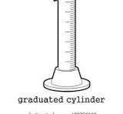 
Scrapper
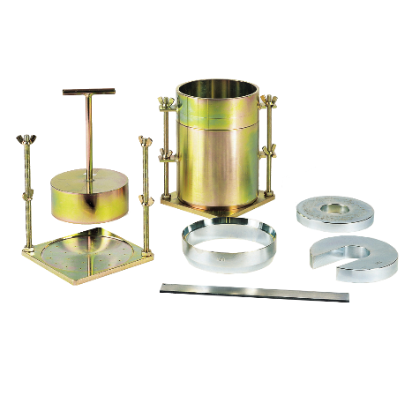
Mould, collar , displace disk and rammer.

Weighing balance
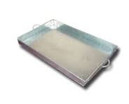
Tray

Drying Oven
Procedures:
The sample was obtained and pulverized, and then the soil was sieved through 4.75mm sieve (ASTM). 3.0kg of the soil passing the sieve 4.75mm was obtained and spread on a large tray properly.
The sample was divided into approximately three equal parts.
The first part of the sample was filled into the mould and using 2.5kg rammer, it was given 27 blow.
The second and third layer was treated the same (ensuring the last layer did not extend more than 6mm above the mould into the extension collar after compaction of the last layer).
The extension collar was removed and the excess soil was trimmed off with spatula, until the soil was perfectly flush with the top of the mould.
The mould with the compacted soil was weighted (without extension collar). The weight was recorded.
After weighing the sample with the mould, then the mould was emptied and a portion of sample was taken preferably from top, middle and bottom for moisture content determination.
After all lumps have been broken down, between 2% and 4% of water was added to soil in order to raised the water content of the soil.
Then the procedure was repeated until the weight of the soil plus mould dropped.
Also the moisture content of the sample, were determined for each of the trials.
Wet Density, Pw = (wt of mould + wet soil – wt of mould) / Volume
Dry Density, Pd = (wet density × 100) / (100 + moisture content)
3.5 CALIFORNIA BEARING RATIO (C.B.R) TEST
Aim: To evaluate the relative quality of sub grade for pavements.
Apparatus:
C.B.R mould, C.B.R machine, 2.5kg rammer scoop, surface weights, 4.75mm standard sieve, straight edge etc.).
Procedure:
6kg of soil passing 4.75mm sieve was obtained and was placed on a metal tray (air dried soil).
The mould was assembled by fixing it to the base plate and screwed on the extension collar; filter paper was placed on the base plate.
The amount of water equal to the optimum moisture content of the soil to be added was determined (this was the optimum moisture content from the compaction test.
The soil and water were mixed to achieve a good blend.
The soil was divided into five equal parts, each part was compacted into mould given it 61 blows of the rammer evenly distributed over the soil surface.
The amount of soil compacted into the mould was such that the final layer does not project beyond 6mm above the top of the mould into the extension collar.
The extension collar was removed and the excess soil was stroke off.
The mould was placed on the lower plate of CBR machine and the machine was adjusted until the piston makes contact with the sample (ensuring that no load was applied).
The penetration dial reading was adjusted until it makes contact with the top of the mould.
The dial gauges were adjusted to zero
A suitable gear was selected, so that the rate of penetration reading of 1.27mm was obtained per minute.
The proving ring reading (loading readings) at penetration reading of 0.25mm, 0.75mm.. 7.5mm were taken.
The mould was inverted and the step was repeated on the bottom and the readings were recorded on separate.
3.6 DRAINAGE CONDITIONS OF KWARA STATE POLYTECHNIC ROAD, WESTEND ROUNDABOUT, YANKARI ,ILORIN, NIGERIA.
The drainage facilities provided along the kwara state polytechnic road, village, Ilorin are in bad condition. The drainage are lined with collapsed blocked walls, blocked with debris is as shown in Plate 4.5

CHAPTER FOUR
4.0 RESULTS AND DICUSSION
The layout of kwara state polytechnic road, along yankari, village, Ilorin is as shown in the Figure 4.1. The various types of pavement failure on kwara state polytechnic road, along yankari, village, Ilorin is as shown in Plate 4.1, Plate 4.2, Plate 4.3 and Plate 4.4. The drainage conditions of kwara state polytechnic road, along yankari, village, Ilorin shown in Plate 4.5, Plate 4.6, Plate 4.7 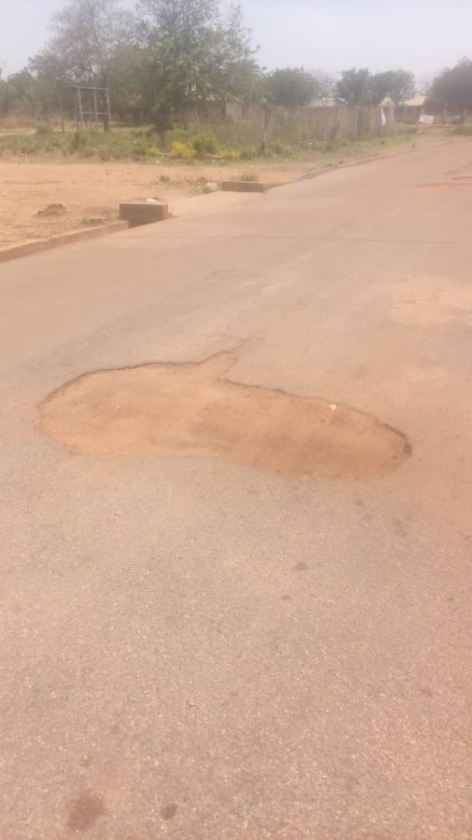
Plate 4.1: Pothole on Road along IBASS at kwara state polytechnic
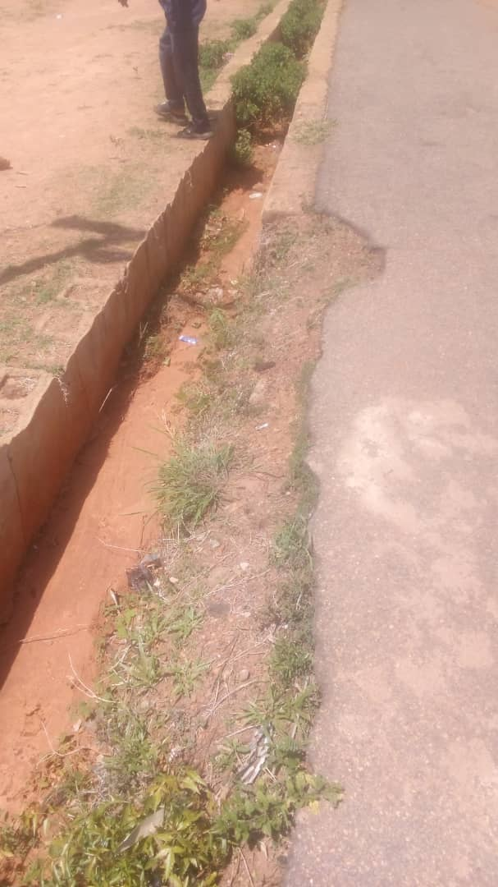
Plate 4.2: Blast erosion at IBASS opposite hall at Kwara State Polytechnic road, along yankari, village, Ilorin
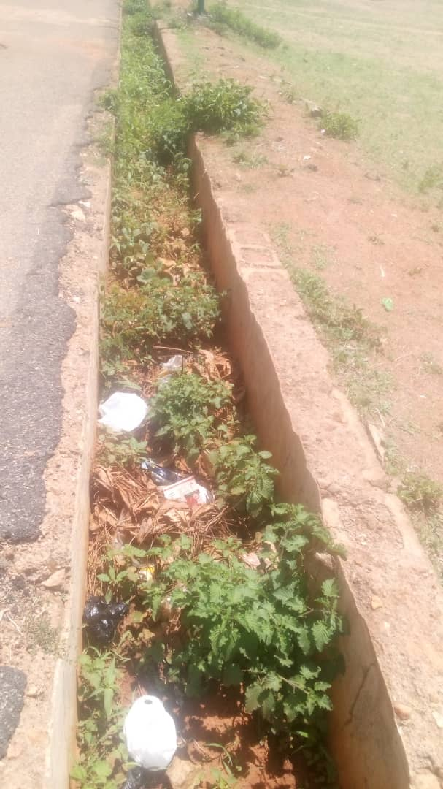
PLATE 4.3 Debris in the drainage along IBASS

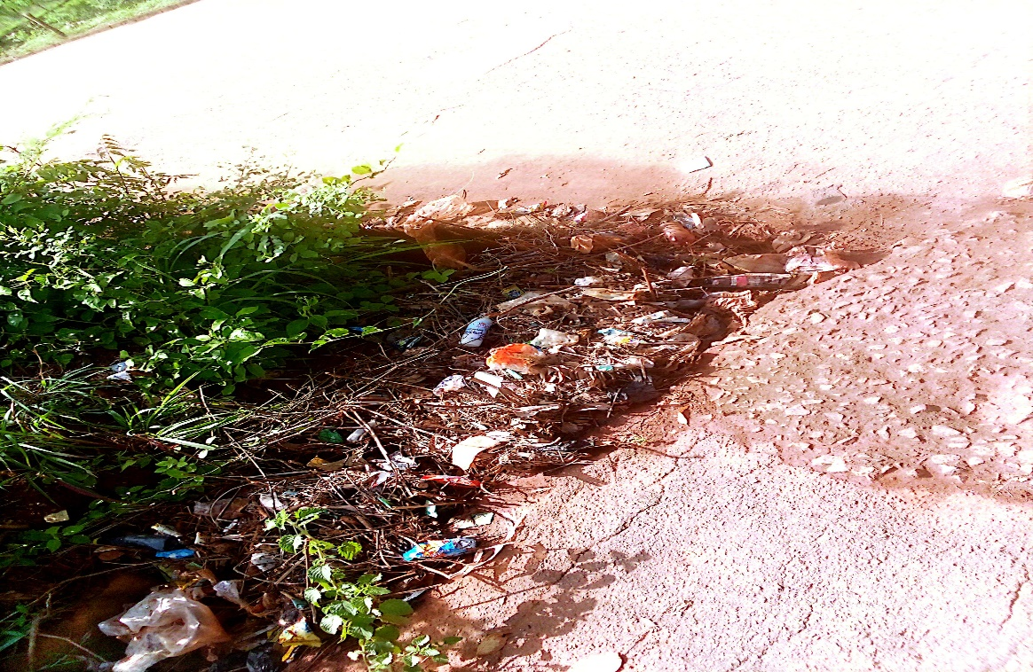
Plate4.4 Debrish at CBT center along yankari
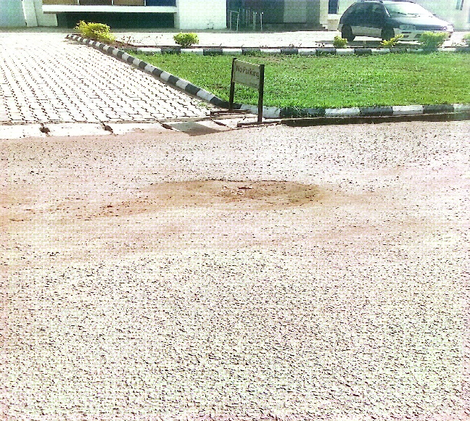
Plate 4.5 Pothole in front of bank along central mosque
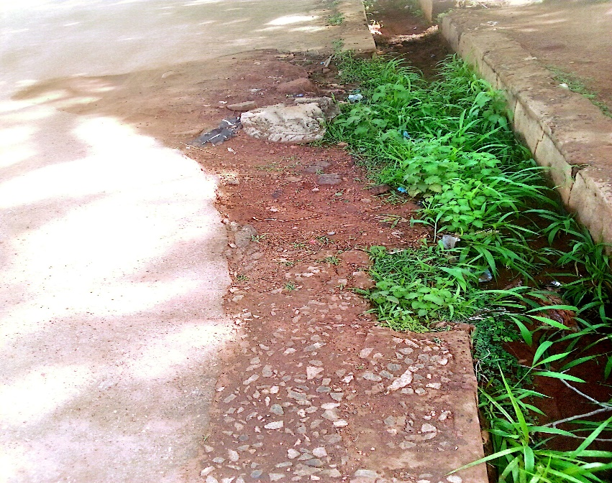
Plate 4.6 Blast Erosion along CBT center
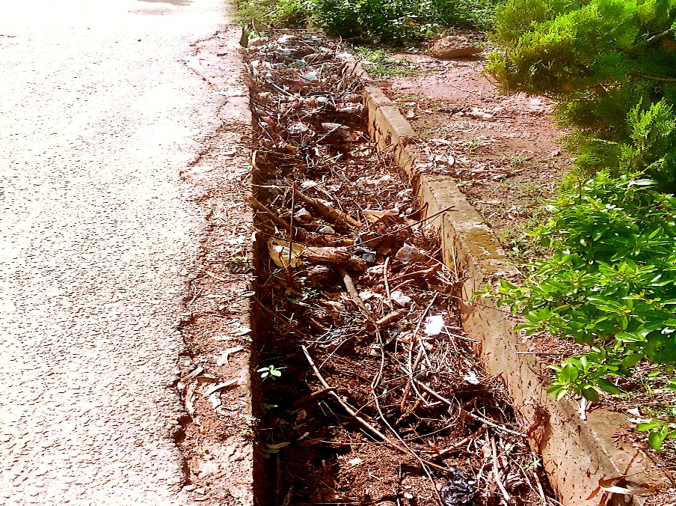
Plate 4.7 Debrish in front of central mosque
4.1 RESULTS OF THE COMPACTION
Compaction of the soil samples were carried out to deduce the maximum dry density (M.DD) and optimum moisture content (D.M.C) of the semple,The compaction was carried out using British Standard (85) compaction energy. The results it as presented in table 4.1 and 4.2
Table 4.1: RESULT OF DENSITY OF THE SOIL SAMPLE AT POINTS A (WEST-END ROUNABOUT)
VOLUME= 944cm³
Sample no | A1 | A2 | A3 | A4 | A5
Wt of mould + wet soil (W2) | 6375 | 6579 | 6756 | 6600 | 6500
Wt of m ould (W1) | 2630 | 2630 | 2630 | 2630 | 2630
Wt of wet soil (W2-W1) | 3745 | 3949 | 4126 | 3970 | 3870
Bulk Density | 3.97 | 4.18 | 4.37 | 4.21 | 4.09
Table 4.2: RESULT OF MOISTURE CONTENT OF THE SOIL SAMPLE AT POINT A (WEST-END ROUND ABOUT)
Container NO | A1 | A2 | B1 | B2 | C1 | C2 | D1 | D2 | E1 | E2
Wt of wet soil +container | 135.0 | 128.0 | 106.0 | 127.0 | 144.0 | 107.0 | 97.00 | 131.0 | 111.0 | 116.0
Wt of dry soil +container | 127.0 | 120.0 | 100.0 | 117.0 | 105.0 | 100.0 | 90.00 | 125.0 | 104.0 | 108.0
Wt of container | 25.5 | 24.0 | 25.0 | 26.0 | 25.0 | 26.0 | 25.0 | 25.0 | 25.0 | 25.0
Wt of dry soil (Wd) | 101.5 | 96.0 | 75.0 | 91.0 | 80.0 | 75.0 | 64.0 | 100.0 | 79.0 | 83.0
Wt of moisture (Wm) | 8.0 | 8.0 | 6.0 | 10.0 | 9.0 | 7.0 | 7.0 | 6.0 | 7.0 | 8.0
Moisture content (Wm/Wd*100) | 7.8 | 8.3 | 8.0 | 10.9 | 11.3 | 9.3 | 10.9 | 6.0 | 8.8 | 9.6
Average moisture | 8.1 |  | 9.5 |  | 10.3 |  | 8.5 |  | 9.2
Dry density | 3.67 |  | 3.81 |  | 3.96 |  | 3.88 |  | 3.75
CBR (mean of top and bottom | 62 |  | 79 |  | 73 |  | 52
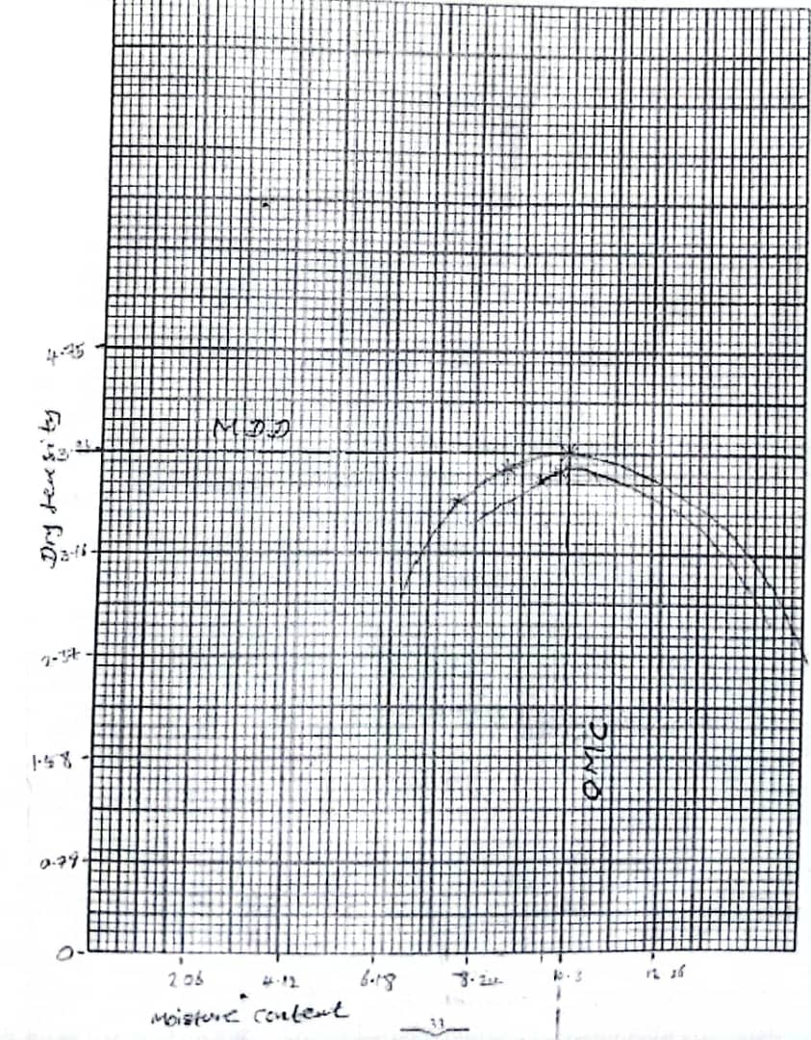
Fig 4.1: Graph of Dry Density against Moisture Content
No. of layer =3
No. of blow =27
Weight of rammer =2.7kg

Table 4.3: RESULT OF DENSITY OF THE SOIL SAMPLE AT POINT B (IBASS)
VOLUME =944cm³
^{Sample no} | ^{A1} | ^{A2} | ^{A3} | ^{A4} | ^{A5}
^{Wt of mould + wet soil (W2)} | ⁵³¹⁰ | ⁵⁴¹⁹ | ⁵⁷¹³ | ⁵⁶⁴⁵ | ⁵⁵¹¹
^{Wt of mould (W1)} | ²⁶³⁰ | ²⁶³⁰ | ²⁶³⁰ | ²⁶³⁰ | ²⁶³⁰
^{Wt of wet soil (W2-w1)} | ²⁶⁸⁰ | ²⁷⁸⁹ | ³⁰⁸³ | ³⁰¹⁵ | ²⁸⁸¹
^{Bulk Density} | ^{2.83} | ^{2.95} | ^{3.26} | ^{3.19} | ^{3.05}
Table 4.4: RESULT OF MOISTURE CONTENT OF THE SOIL SAMPLE AT POINT B (IBASS)
^{Container NO} | ^{A1} | ^{A2} | ^{B1} | ^{B2} | ^{C1} | ^{C2} | ^{D1} | ^{D2} | ^{E1} | ^{E2}
^{Wt of wet soil + container} | ^{91.0} | ^{90.0} | ^{89.5} | ^{88.3} | ^{92.1} | ^{79.7} | ^{89.0} | ^{95.9} | ^{91.5} | ^{99.5}
^{Wt of dry soil + container} | ^{85.4} | ^{79.3} | ^{70.5} | ^{77.9} | ^{80.3} | ^{68.1} | ^{70.4} | ^{80.3} | ^{79.6} | ^{84.2}
^{Wt of container} | ^{23.0} | ^{22.0} | ^{20.0} | ^{25.0} | ^{21.0} | ^{25.1} | ^{24.0} | ^{20.0} | ^{20.0} | ^{24.0}
^{Wt of dry soil (Wd)} | ^{62.4} | ^{57.3} | ^{50.5} | ^{52.9} | ^{59.3} | ^{43.1} | ^{46.4} | ^{60.3} | ^{59.6} | ^{60.2}
^{Wt of moisture (Wm)} | ^{5.6} | ^{10.9} | ^{19.0} | ^{10.4} | ^{11.8} | ^{11.8} | ^{18.6} | ^{15.6} | ^{11.9} | ^{15.3}
^{Moisture content (Wm/Wd*100)} | ^{8.9} | ^{19.1} | ^{37.6} | ^{19.6} | ^{19.8} | ^{27.3} | ^{40.1} | ^{25.8} | ^{19.8} | ^{25.4}
^{Average moisture} | ^{14.0} |  | ^{28.6} |  | ^{23.5} |  | ^{32.9} |  | ^{22.7}
^{Dry density} | ^{2.50} |  | ^{2.30} |  | ^{2.60} |  | ^{2.40} |  | ^{2.48}
^{CBR (mean of Top and bottom)} | ⁶² |  | ⁶⁸ |  | ^{82.5} |  | ⁵⁹
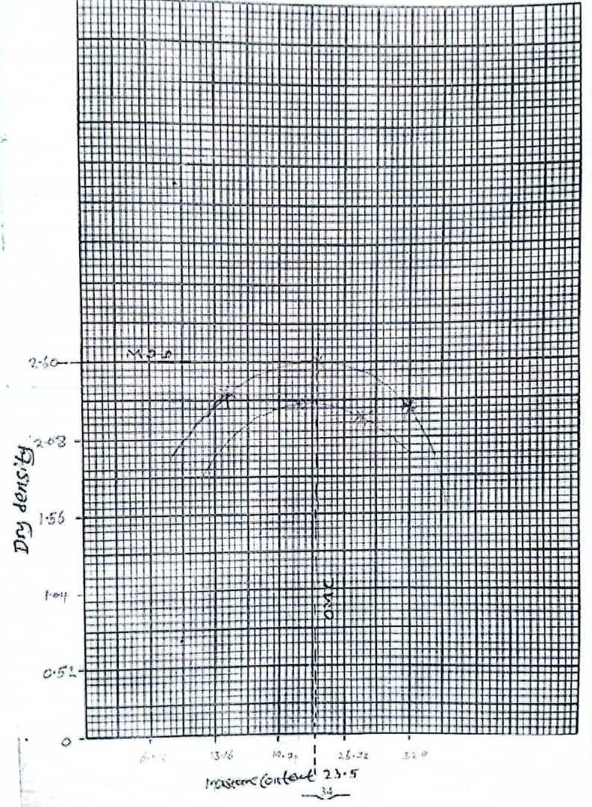
Fig 4.2: Graph of Dry Density against Moisture Content
No. of layer =3
Number of blow =27
Weight of rammer =2.5kg

4.2 RESULTS OF CALIFORNIA BEARING RATIO (C.B.R) TEST.
This is a penetration test used in evaluating the mechanical strength of natural ground.
The result is as presented in table 4.5 4.8 of lateritic soil using British Standard (BS).
Table 4.5: RESULT OF CALIFORNIA BEARING RATIO (C.B.R) AT POINT A (WEST-END ROUNDABOUT )
PENETRATING OF PLUNGER (INCHES) | LOAD ON PLUNGER  TOP BOTTOM
025 | 75 | 130
050 | 180 | 300
075 | 340 | 450
100 | 560 | 600
125 | 680 | 750
150 | 800 | 850
175 | 860 | 950
200 | 900 | 1010
225 | 1000 | 1050
250 | 1080 | 1150
Sample No= 1
Aver. Bearing value=63%
Top C.B.R=58%
Bottom=68%
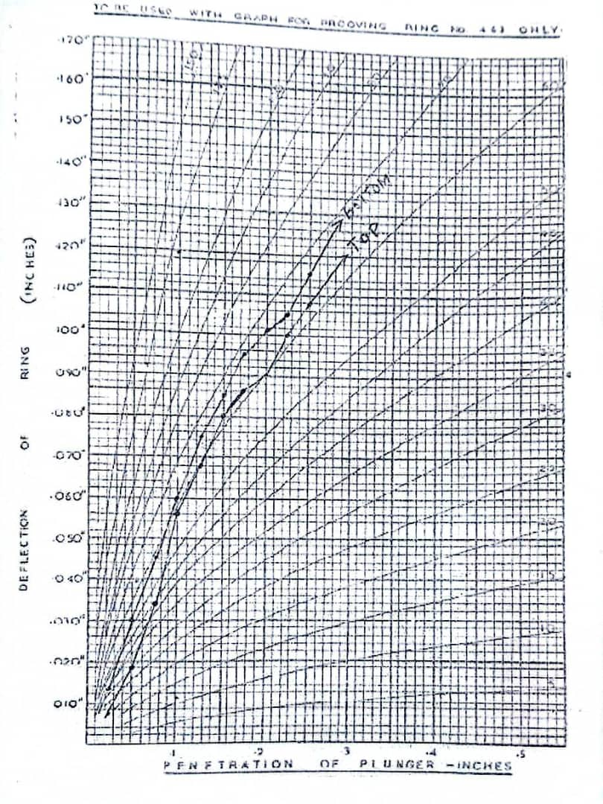
Fig 4.3:Graph of deflection of rings against penetration of plunger
Table 4.6: RESULT OF CALIFORNIA BEARING RATIO (CBR) AT POINT (WESTE-END ROUNDABOUT)
PENETRATING OF PLUNGER (INCHES) | LOAD ON PLUNGER  TOP BOTTOM
025 | 220 | 330
050 | 400 | 520
075 | 580 | 690
100 | 760 | 800
125 | 860 | 920
150 | 1000 | 1110
175 | 1100 | 1180
200 | 1160 | 1240
225 | 1120 | 1280
250 | 1280 | 1320
Sample No =2
Average bearing value =79%
Top C.B.R =77%
Bottom =81%
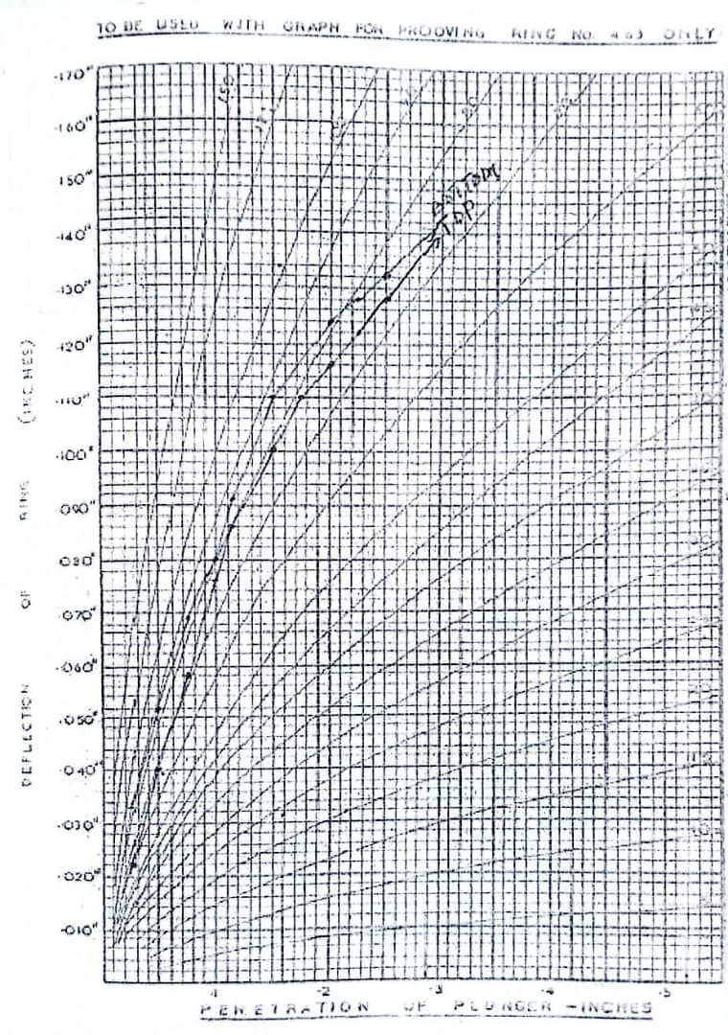
Fig 4.4:Graph of deflection of rings against penetration of plunger
Table 4.7: RESULT OF CALIFORNIA BEARING RATIO (CBR) AT POINT B (IBASS)
PENETRATING OF PLUNGER (INCHES) | LOAD ON PLUNGER  TOP BOTTOM
025 | 180 | 230
050 | 210 | 400
075 | 400 | 530
100 | 680 | 720
125 | 740 | 900
150 | 830 | 1020
175 | 940 | 1160
200 | 1040 | 1120
225 | 1160 | 1280
250 | 1200 | 1300
Sample No =1
Average bearing value =73%
Top C.B.R =68%
Bottom =78%
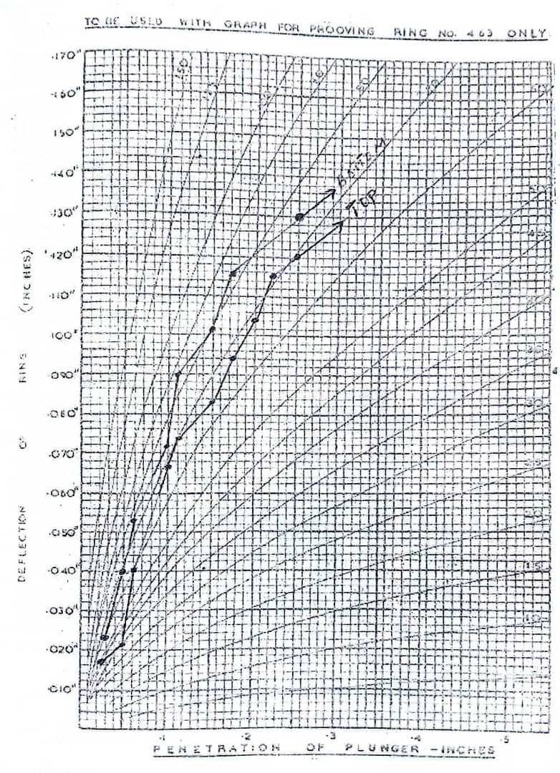
Fig 4.5:Graph of deflection of rings against penetration of plunger

Table 4.8: RESULT OF CALIFORNIA BEARING RATIO (CBR) AT POINT B (IBASS)
PENETRATING OF PLUNGER (INCHES) | LOAD ON PLUNGER  TOP BOTTOM
025 | 60 | 90
050 | 140 | 210
075 | 240 | 320
100 | 370 | 440
125 | 500 | 620
150 | 620 | 730
175 | 730 | 840
200 | 860 | 980
225 | 960 | 1056
250 | 1040 | 1140

Sample No =2
Average bearing value =52%
Top C.B.R =39%
Bottom =65%
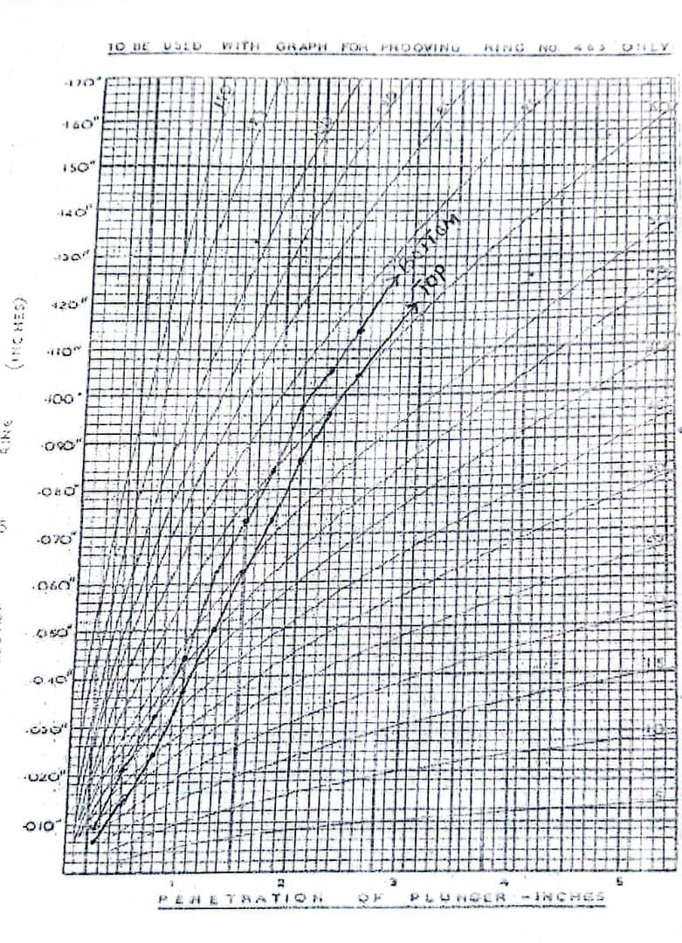
Fig 4.6:Graph of deflection of rings against penetration of plunger
4.3. DISCUSSION OF RESULTS
The photographs taken on Kwara state polytechnic road were analyzed for the causes and possible remedies for the pavement failure were provided. The obtained analysis of the test results carried out on various samples collected at Kwara State Polytechnic road, along yankari, village, Ilorin are presented in Table 4.1-4.6.
Kwara State Polytechnic road, along yankari, village,Ilorin sides drainage serve as water collector point for water runoff from other axis like AKUO given room for,pothole is as shown in plate 4.1, blast erosion due to improper compaction is as shown in plate 4.2, drainage blockage due to Flushing non-flushable items like wipes, soft drink cans, wasted papers materials .is as shown in plate 4.3, debris blockage due to Leaves, dirt, sand, and trash also accumulate in outdoor drains. including Paper towels, tissues, hair, food particles and more.
The result of the compaction test for the soil samples at point A(WEST-END ROUND) and point B(IBAS YANKARI) considered in this studies are presented as in Table 4.1 and Table 4.2 respectively. These tests were conducted in Civil Engineering Laboratory, Kwara State Polytechnic, Ilorin Nigeria. The dry density and the corresponding optimum moisture content for each of the soil samples is provided in table 4.3 and Table 4.4 The compaction was carried out to deduce maximum dry density (MDD) and optimum moisture content (OMC) of the sample. The value of maximum dry density of the samples is 3.96 kg/rn³ & 2.60kg/m³ while the optimum moisture content is 10.3% and 23.5% is as shown fig 4.1 and 4.2.
kwara state polytechnic road, along yankari, village, Ilorin soil sample conformed with AASHTO soil classification of dry density ranges from 1810kg/m³ to 3350kg/m³ and optimum moisture content ranges from 7.8-24.4%. Therefore, soil samples is good for base, sub base and sub grade materials.
The results of the test for the soil samples are presented in table 4.5 - 4.8.
These were then used to plot the relationship of load and penetration is as shown in fig4.3 to 4.4. The modules of Elasticity (Es) for the soil sample were evaluated using the CBR values obtained.
According to FMWH (1975) State that the value of California bearing ratio should be at least 83% in order to be useful for sub-grade, sub-based and base.
The result from the samples is 79% for Point A and 73% for Paint B. Therefore it was observed from the CB.R. result that the collected samples are not within the BS Specification, so the strength of those materials are not adequate enough for construction of pavement. These tests were conducted in Civil Engineering Laboratory, Kwara State Polytechnic, Ilorin Nigeria.

CHAPTER FIVE
5.0 CONCLUSION AND RECOMMENDATIONS
5.1 CONCLUSION
Based on the results of the reconnaissance survey major failures on kwara state polytechnic consist of cracking, potholes, drainage blockage, blast erosion, edge failure, rutting and reveling, caused by poor drainage facility and maintenance of the drain.
The California bearing ratio (C.B.R) been lower that the BS which specification can be show the low strength of the samples and the road can be standardized for rehabilitation.
5.2 RECOMMENDATIONS
From the results of this investigation, the following recommendations are hereby suggested as solution to correct the present and future failure.
i. Depressed, edge failure or potholes should be cut down into the sub grade and replaced with materials meeting Bs standard specification.
II. It is recommended that laboratory test should be carried out on borrow pit materials to be used for construction of road so as to known their suitability for the intending purposes which would or could reduce cost of maintaining such roads in the long run, if proper materials are selected or used, that could make roads stand a test of time
iii. Compaction should be adequate in order to attained necessary strength.
IV. Proper chamber of the road to direct the water to the drain
V. Resident engineers or contractor should always work in strict adherence to code of ethics of engineering profession so as to achieve or maintain best practices
VI. Crushed stone and asphaltic concrete surfacing that meet specification must be used.
VII. Refused in contact with rain water becoming acidic that weakens the pavement, road user should stop dropping it on the roads
VIII. Adequate drainage system and proper maintenance should be provide on the road sides.

REFRENCE
AASTHO, (2000); Road Test 5 (Pavement Research) Highway Research Board, Special Report 61E, Washington Dc.
Adegoke, E.G. and Arumola J.O. (2007); Soil Properties and Pavement Performance in Niger – Delta. A quarterly Journal of Engineering Geology, Port-Harcourt Nigeria.
Adeoti, K.A. (2016); Transportation Engineering Lecture note, Department of Civil Engineering, Kwara State Polytechnic, Ilorin.
Adu, P.B. (1991); Design of a Pavement of a Road Passing a Reclaimed Area, BSc.Project University of Ilorin, Ilorin Kwara State, Nigeria.
American Society for Testing Materials (2004); Annual Book of American Society for Testing and MaterialsStandard California, USA.
Anthony, W.C. and Agada (2003); Geotechnical characteristic of Some Residual soils and their Implication on Road Design in Nigeria. NGA Technical Lecturer, Lagos.
British Standard Institute (1975); Method of Testing Soil for Civil Engineeringpurpose London.
Gidigasu, A.A. and Schweitzer A.O. (2006); Soil properties and pavement, American Association of High way official.
Ibrahim,K.A. (2001): HND project report civil Engineering Department Federal polytechnic,offa Kwara state Nigeria

