AI-BASED DRONE OPERATION WITH SURVEILLANCE SYSTEM

BY:

HND/23/COM/FT/0400

Yakub Akeem Ademola

A Project Submitted to the Department of Computer Science, Institute of Information and Communication Technology, Kwara State Polytechnic, Ilorin

In Partial Fulfillment of the Requirements for the Award of Higher National Diploma (HND) in Computer Science

June, 2025
CERTIFICATION
This is to certify that this project was carried out by HND/23/COM/FT/0399,
has part of the requirements for the award of Higher National Diploma (HND) in Computer Science.

………………………………. ……………………………….
Mrs. Akanbi M.B Date
(Project Supervisor)

………………………………. ……………………………….
Mr. Oyedepo, F. S. Date
(Head of Department)

………………………………. ……………………………….
External Examiner Date

DEDICATION
With profound reverence and a heart full of gratitude, I dedicate this project to God Almighty, the Author and Finisher of all things. His infinite wisdom, boundless grace, and unwavering strength have guided me through every step of this journey, transforming challenges into triumphs and dreams into reality.I also dedicate this work to myself, as a testament to my perseverance, determination, and unwavering commitment to excellence. This milestone stands as a celebration of my growth and a reminder of the limitless possibilities that lie ahead.

ACKNOWLEDGEMENT
With a heart brimming with profound gratitude, I first and foremost give glory to Almighty God, whose boundless grace, divine wisdom, and unending strength have been my guiding light throughout this project. His inspiration and provision have sustained me, enabling me to overcome challenges and bring this work to a triumphant completion.
On a deeply personal note, I extend my heartfelt appreciation to my cherished parents, Mr. and Mrs. Yakub, whose unwavering love, sacrifices, and fervent prayers have been the cornerstone of my journey. Your steadfast belief in my potential has ignited my resolve and propelled me forward. To my siblings, particularly my dear brother Jamiu, your constant encouragement, uplifting words, and unyielding support have been a wellspring of motivation. I am also immensely grateful to my friends, whose camaraderie, laughter, and faith in me have enriched this experience beyond measure. Your collective presence has been an invaluable blessing, and I am forever thankful.
I owe a debt of gratitude to my esteemed supervisor, Mrs. Akanbi, whose exceptional guidance, profound expertise, and unwavering support have shaped this project into a work of substance and pride. Your patience, insightful feedback, and dedication to my academic growth have left an indelible mark on my heart, and I am truly honored to have been under your mentorship.
My deepest appreciation extends to the Head of Department, Mr. Oyedepo F.S., whose visionary leadership and encouragement have fostered an environment where academic excellence thrives. I am profoundly thankful to Dr. Agboola, Dr. Raji A.K., and Dr. Abduraman Tosho for their scholarly wisdom, invaluable guidance, and tireless commitment to nurturing my intellectual growth. To Mr. Isiaka, Mr. Saka, and Mr. Sadik K. Abubakar, I express my sincere gratitude for your generous support, insightful contributions, and encouragement, which have significantly enriched this project. Furthermore, I extend my heartfelt thanks to the entire staff of the Department of Computer Science, Kwara State Polytechnic, for their collective efforts, shared knowledge, and diverse contributions that have made this research possible. Your dedication to education is truly inspiring, and I am eternally grateful.
In closing, this project stands as a testament to the divine grace and collective support I have been privileged to receive. To everyone named and those whose quiet contributions have touched this journey, I offer my sincerest thanks. Your belief in me has transformed this endeavor into a shared triumph, and I am deeply humbled by your impact. May God richly bless you all.

TABLE OF CONTENTS
Title Page i
Certification ii
Dedication iii
Acknowledgements iv
Abstract v
Table of Contents vi
CHAPTER ONE: GENERAL INTRODUCTION
  - Background to the Study 1
  - Statement of the Problem 3
  - Aim and Objectives of the Study 3
  - Significance of the Study 4
  - Scope of the Study 4
  - Organization of the Report 5
CHAPTER TWO: LITERATURE REVIEW
2.1 Review of Related Works 6
2.2 Review of Related Concepts 10
2.2.1 Overview of Artificial Intelligence 10
2.2.2 Overview of Surveillance Systems 11
2.2.3 Overview Drone Technology 11
2.2.4 Artificial Intelligence in Surveillance 12
2.2.5 AI Based Drone Surveillance System 13
CHAPTER THREE: RESEARCH METHODOLOGY AND ANALYSIS OF THE EXISTING SYSTEM
  - Research Methodology 14
  - Analysis of the Existing System 14
  - Problems of the Existing System 15
  - Description of the Proposed System 15
  - Advantages of the proposed system 16
CHAPTER FOUR: DESIGN, IMPLEMENTATION AND DOCUMENTATION OF THE SYSTEM
  - Design of the System 17
    - Output Design 17
    - Input Design 21
4.1.3 Procedure Design 23
  - Implementation of the System 23
    - Choice of Programming Language 24
    - Hardware Support 24
    - Software Support 25
  - Documentation of the System 25
    - Program Documentation 26
    - Maintaining the System 26
CHAPTER FIVE: SUMMARY, CONCLUSION AND RECOMMENDATION
  - Summary 27
  - Conclusion 27
  - Recommendation 28
References
ABSTRACT
The integration of Artificial Intelligence (AI) in drone operations has revolutionized surveillance systems by enhancing precision, efficiency, and scalability. This project aims to implement the development and application of AI-based drone operations for surveillance purposes, highlighting their potential to improve security and monitoring across various domains. The project explores existing systems, identifies gaps, and proposes an advanced AI-driven drone surveillance framework that addresses current limitations. The findings underscore the advantages of real-time data processing, automated decision-making, and enhanced coverage capabilities, offering significant implications for public safety, environmental monitoring, and disaster management.

CHAPTER ONE
GENERAL INTRODUCTION
  - BACKGROUND TO THE STUDY
Drones, also known as Unmanned Aerial Vehicles (UAVs), have gained significant traction in recent years for their versatility and efficiency in various applications, including surveillance. Coupled with Artificial Intelligence (AI), drones have transformed from simple flying machines to sophisticated tools capable of performing complex tasks autonomously. In today’s world, security has become an increasingly important issue. Terrorism, crime, and other disruptive events have highlighted the need for more sophisticated security systems in a variety of settings, including cities, universities, and critical infrastructures (Ghazo & Hayajneh, 2023).
Hoang (2023) asserted that surveillance has been a critical component of security and monitoring systems for decades, traditionally relying on static cameras and human oversight. However, these Cgeneral onventional methods often face limitations such as restricted coverage, delayed response times, and vulnerability to tampering. The advent of drones equipped with AI technologies offers a promising alternative, enabling dynamic and proactive surveillance solutions. The integration of the Internet of Things (IoT), Artificial Intelligence (AI), and Unmanned Aerial Vehicle (UAV) technologies has shown promise in improving the efficiency and the productivity of security systems, leading to the development of smart security systems.
The rapid pace of technological development also raises questions about ethical considerations, privacy, and regulatory frameworks. As drones become more integrated into surveillance ecosystems, addressing these challenges is critical to ensuring their sustainable and responsible deployment. Currently, unmanned aerial vehicles (UAVs) are utilized in a wide range of applications, especially in surveillance systems. Drone surveillance involves visually monitoring an individual, a group, items, or a situation to prevent potential threats. The establishment of an efficient surveillance system with drone fleets necessitates the smooth integration of dependable hardware and sophisticated automation software. In buildings and factories, there is a high demand for smart security systems with drone applications. Drones perform significantly faster than patrol vehicles or security personnel, enabling them to promptly arrive at the location of an incident, thereby facilitating a swift remedial response (Singh et al., 2024).
One of the important thing advantages of our AI-based clever home security device is its potential to offer complete coverage of the whole property. Traditional safety structures often have blind spots or regions which might be tough to reveal efficiently. However, with using drones, we will be able to conquer those boundaries by imparting a dynamic and bendy surveillance answer which could patrol and monitor each nook of the belongings (Mohammed & Pasam, 2020).
In recent years, the growing sophistication of AI algorithms, such as deep learning and computer vision, has significantly enhanced the capabilities of drones in surveillance tasks. These advancements have allowed drones to autonomously identify and track objects, detect anomalies, and analyze large volumes of data in real-time. Such capabilities have expanded their applications across various fields, from urban security to wildlife conservation. The declining cost of drone hardware and the increasing accessibility of AI development platforms have democratized their usage, making them viable tools for small-scale and large-scale operations alike. This has led to a surge in interest from industries and governments aiming to enhance security, improve resource management, and respond more effectively to emergencies (Kumar et al., 2024).
This project digs into the potential of AI-powered drones to revolutionize surveillance systems, examining their applications, challenges, and benefits.
  - STATEMENT OF THE PROBLEM
The fast advancement of technology has affected monitoring and security. Among these technological advances, autonomous drones have revolutionized surveillance and security Despite their promising potential, these technologies have challenges and flaws requiring additional investigation. A significant research area for improvement in the ongoing discussion on autonomous drones is the need for a comprehensive framework incorporating them into established security systems. Despite advancements in drone technology, existing surveillance systems often suffer from inefficiencies such as limited operational range, delayed threat detection, and high dependency on human operators. There is a need for an autonomous, intelligent system that can address these issues by providing real-time monitoring, decision-making, and adaptability to various scenarios. This project aims to bridge these gaps by developing an AI-driven drone surveillance system.
  - AIM AND OBJECTIVES OF THE STUDY
The aim of this project is to design and evaluate an AI-based drone surveillance system that enhances operational efficiency. The objectives are to:
- design an AI-powered framework for autonomous drone operations;
- implement and test the proposed system in real-world scenarios;
- assess the performance and reliability of the system; and
- provide recommendations for future improvements and applications.

  - SIGNIFICANCE OF THE STUDY
The findings of this project hold significant implications for various sectors, including public safety, environmental monitoring, disaster response, and industrial security. By demonstrating the potential of AI-powered drones, this project contributes to the advancement of autonomous systems and their practical applications, offering cost-effective and scalable solutions to modern surveillance challenges.
  - SCOPE OF THE STUDY
This project focuses on the design, development, and evaluation of an AI-based drone surveillance system. It covers the integration of machine learning algorithms, real-time data processing, and autonomous decision-making capabilities. The research primarily targets applications in public safety, environmental monitoring, and disaster management while considering scalability for broader use cases.
1.6 ORGANIZATION OF THE REPORT
The project write-up is organized into five distinct chapters. Chapter one covers general introduction, which contains introduction to the project topic, statement of the problem, aim and objectives of the study, significance of the study, scope of the study and organization of the report. Chapter two covers the literature review, which contains review of related past works, overview of artificial intelligence, description surveillance system and other related concepts. Chapter three explains the project methodology which includes analysis of existing system, problems of the existing system, the description of the proposed system and advantages of proposed system. Chapter four explains the design, implementation and documentation of the system which contain system designed output design, input design, database design, procedure design, implementation of the system hardware and software support and documentation of the new system installation procedure, operating the system and system maintenance. Lastly, chapter five explains the summary of the research, recommendations, and conclusion.

CHAPTER TWO
LITERATURE REVIEW
2.1 REVIEW OF RELATED LITERATURE
Ghazo and Hayajneh (2023) developed an advanced IoT-AI security system with drone surveillance. The paper presented a cutting-edge smart security system prototype that addresses these limitations. The system is decentralized, by using lightweight algorithms to process images locally on smart cameras. This makes it more reliable and scalable, and it also enables new features such as crowd recognition, noise detection, intruder identification, and people counting. The system is also integrated with the Internet of Things (IoT), Artificial Intelligence (AI), and Unmanned Aerial Vehicle (UAV) technologies to improve further its performance and user experience. For example, the system can use drones to deploy cameras to remote or difficult-to-access locations, and it can use AI to analyze camera data in real time to identify potential threats. The proposed system has been tested on the Hashemite University campus, with cameras placed throughout the campus and a drone station located at the faculty of engineering. The test results have been encouraging, indicating that the system has great potential for improving security in a variety of settings. The paper also investigated and analyzed critical observations made throughout the implementation and testing phases. These observations can be used to guide the development of future security systems.
Kumar et al., (2024) implemented an enhancing home security with ai-driven drone surveillance. This researcher’s presented the design and implementation of an AI-based smart home security system using drone surveillance. Leveraging advances in artificial intelligence and drone technology, the system aimed to enhance home security through proactive threat detection and surveillance.
Hoang (2023) worked on smart drone surveillance system based on AI and on IoT communication in case of intrusion and fire accident. The system includes a Passive pyroelectric infrared detector for human detection and an analog flame sensor to sense the appearance of the concerned objects and then transmit the signal to the workstation via Wi-Fi based on the microcontroller Espressif32 (Esp32). The computer vision models YOLOv8 (You Only Look Once version 8) and Cascade Classifier are trained and implemented into the workstation, which is able to identify people, some potentially dangerous objects, and fire. The drone is also controlled by three algorithms distance maintenance, automatic yaw rotation, and potentially dangerous object avoidance—with the support of a proportional–integral–derivative (PID) controller. The Smart Drone Surveillance System has good commands for automatic tracking and streaming of the video of these specific circumstances and then transferring the data to the involved parties such as security or staff.
Kulkarni (2024) developed AI-Powered video analytics for border surveillance using drones. The research presented a cutting-edge system that automates the process of detecting and analyzing real-time changes in border environments. The system compares live drone footage with archived data to identify potential threats or irregularities, thus reducing human error and enhancing security effectiveness. Leveraging advanced computer vision algorithms and machine learning models, this AI-driven approach significantly improves situational awareness and allows for quicker, more accurate responses to security breaches. The paper also discussed the challenges associated with environmental factors, drone autonomy, and the need for multi-modal sensor integration. Future research directions focus on improving prediction models and autonomous drone swarming.
Swetha (2024) designed a drone-based surveillance system for port areas. The research introduces a novel approach to port area surveillance leveraging drone technology integrated with facial recognition capabilities. The proposed system is designed to autonomously detect and track individuals within the port vicinity, enhancing monitoring efficiency and response times. Through the fusion of advanced computer vision algorithms and unmanned aerial vehicles (UAVs), the system can identify individuals, follow their movements in real-time, and transmit high-definition recordings to administrative centers for further analysis. By employing drones equipped with facial recognition technology, this system offers a dynamic and flexible solution for port security, enabling proactive measures to mitigate potential threats and streamline surveillance operations. The integration of artificial intelligence algorithms ensures accurate identification and tracking of individuals while minimizing false positives. The research underscores the significance of innovative technological solutions in enhancing port security and presents a viable framework for the implementation of drone-based surveillance systems in port environments.
Jung et al., (2018) implemented an airborne video surveillance system. In the paper, the researchers presented a surveillance system implemented with a fleet of unmanned aerial vehicles (UAVs). A surveillance system implemented with a fleet of UAVs is easy to deploy and maintain. A UAV fleet requires little time to deploy and set up, and removing the surveillance is also virtually instant. The system deploys UAVs to the target area for installation and perform surveillance operations. The camera mounted UAVs act as surveillance probes, the server provides overall control of the surveillance system, and the fleet platform provides fleet-wise control of the UAVs. In the proposed system, the UAVs establish a network and enable multi-hop communication, which allows the system to widen its coverage area. The operator of the system can control the fleet of UAVs via the fleet platform and receive surveillance information gathered by the UAVs. The proposed system is described in detail along with the algorithm for effective placement of the UAVs. The prototype of the system was presented, and the experiment carried out showed that the system successfully perform surveillance over an area set by the system.
Mohammed and Pasam (2020) carried out a research on an autonomous drones for advanced surveillance and security applications in the USA. The research investigates the use of autonomous drones in sophisticated surveillance and security scenarios in the United States. The objective is to evaluate their efficiency, operational advantages, and related difficulties. The main goals are to assess the technical progress of drones, examine their incorporation into security systems, and tackle issues related to privacy and ethics. The study employed a secondary data review methodology to comprehensively analyze drone applications in different security domains, such as public event monitoring, border security, critical infrastructure protection, and search and rescue operations. The Analysis was based on case studies and existing literature. The primary discoveries demonstrate that drones significantly boost surveillance capabilities, enhance cost-effectiveness, and improve operational effectiveness. Nevertheless, technological constraints such as limited battery capacity, difficulties in transmitting data, privacy concerns, and the obstacles posed by regulations emphasize the need for meticulous management. The report highlights the need to create more stringent legislation, adopt strong privacy measures, and promote continuous technological advancement. Policy implications show the need for specific norms and standards to balance drone technology's benefits with ethical and legal problems. This will guarantee the responsible and efficient use of drones in security applications.

2.2 REVIEW OF RELATED CONCEPTS
2.2.1 Overview of Artificial Intelligence (AI)
Artificial Intelligence (AI) refers to the development of computer systems capable of performing tasks that typically require human intelligence. These tasks include learning, reasoning, problem-solving, perception, and language understanding. AI systems can analyze vast amounts of data quickly and make decisions or predictions based on that data. They achieve this through machine learning, where algorithms improve their performance with experience, and deep learning, which mimics the neural networks of the human brain. AI has become integral to numerous fields, such as healthcare, finance, transportation, and entertainment (Kumar et al., 2024).
AI operates across various levels, including narrow AI, general AI, and superintelligent AI. Narrow AI specializes in specific tasks, like virtual assistants or recommendation systems, while general AI aims to replicate human cognitive abilities across multiple areas. Superintelligent AI, though theoretical, represents machines surpassing human intelligence. AI's advancement has sparked debates about its potential to revolutionize industries and improve lives versus ethical concerns, such as bias, privacy, and potential job displacement.
The rapid growth of AI technologies is driven by advancements in computational power, availability of large datasets, and sophisticated algorithms. From self-driving cars to predictive analytics, AI is reshaping the world by automating complex processes and enabling new capabilities. However, the field faces challenges, including ensuring fairness, transparency, and ethical development, to maximize its positive impact (Ghazo & Hayajneh, 2023).

2.2.2 Overview of Surveillance Systems
Surveillance systems are technologies and methods used to monitor activities, behaviors, or information for security, operational efficiency, or data collection. These systems play a critical role in safeguarding public spaces, private properties, and sensitive infrastructure. They encompass a range of tools, such as closed-circuit television (CCTV) cameras, motion detectors, and biometric sensors, to gather and analyze data in real-time or for later review.
Modern surveillance systems have evolved to include advanced technologies like facial recognition, thermal imaging, and data analytics. They can monitor vast areas, detect anomalies, and trigger alerts automatically, reducing reliance on manual observation. Surveillance is widely used in law enforcement, retail, transportation, and critical infrastructure to prevent crime, improve safety, and ensure compliance with regulations.
However, surveillance systems raise significant ethical and legal concerns. Issues like privacy invasion, data misuse, and potential abuse of power highlight the need for strict governance and transparency. Balancing security needs with individual rights remains a critical challenge as surveillance becomes increasingly pervasive in everyday life (Mohammed & Pasam, 2020).
2.2.3 Overview of Drone Technology
Drone technology, or unmanned aerial vehicles (UAVs), involves the design, production, and deployment of aircraft without a human pilot onboard. Drones are controlled remotely or autonomously through onboard systems, enabling them to perform tasks ranging from aerial photography to military operations. This technology has gained prominence due to its versatility, cost-effectiveness, and ability to access hard-to-reach areas.
Drones are equipped with cameras, sensors, and other payloads, allowing them to gather data, deliver goods, or monitor environments. Their applications span industries such as agriculture, where they assist in crop monitoring and spraying; delivery services, providing swift transportation of goods; and emergency response, aiding search-and-rescue missions and disaster assessment. Advanced drones now incorporate AI, enabling them to navigate complex environments and perform tasks autonomously.
Despite their benefits, drones pose challenges related to safety, regulation, and privacy. Ensuring responsible use, preventing unauthorized access, and addressing airspace congestion are critical to fostering the technology’s growth. With ongoing advancements, drones are poised to revolutionize industries and play a crucial role in shaping future transportation and surveillance systems (Kulkarni, 2024).

Top of Form

2.2.4 Artificial Intelligence in Surveillance
AI has significantly enhanced surveillance systems by enabling them to process and analyze vast amounts of data in real time. Traditional systems relied heavily on human monitoring, which was prone to errors and inefficiencies. AI-powered surveillance, however, automates tasks like video analysis, anomaly detection, and predictive monitoring, improving accuracy and efficiency.
Key AI technologies in surveillance include facial recognition, behavior analysis, and object detection. For example, AI algorithms can identify individuals from video feeds, detect suspicious activities, and even predict potential security threats based on historical patterns. These capabilities have made AI indispensable in law enforcement, retail security, and public safety.
Despite its advantages, AI in surveillance raises concerns about privacy, bias, and accountability. AI systems can inadvertently reinforce biases if trained on unbalanced datasets, and their deployment in public spaces often sparks debates about surveillance overreach. Ensuring transparency, fairness, and ethical use is critical for balancing security benefits with individual rights (Swetha et al., 2024).
2.2.5 AI-based Drone Surveillance System
AI-based drone surveillance systems combine the power of artificial intelligence with the agility of drones to create highly efficient and autonomous monitoring solutions. These systems use AI algorithms for navigation, data analysis, and decision-making, allowing drones to operate with minimal human intervention. Equipped with advanced sensors and cameras, AI-driven drones can monitor vast areas, detect anomalies, and respond to incidents in real time.
Such systems are invaluable in applications like border security, disaster management, and wildlife monitoring. For instance, drones can patrol large territories, identify unauthorized intrusions, or track endangered species without disturbing their natural habitat. The integration of AI enhances these capabilities by enabling object recognition, motion detection, and predictive analytics.
However, deploying AI-based drone surveillance raises ethical and regulatory challenges. Concerns about privacy, airspace management, and the potential for misuse need to be addressed through robust policies and oversight. As technology advances, ensuring these systems are used responsibly and transparently will be key to unlocking their full potential for societal benefit (Kumar et al., 2024).

CHAPTER THREE
RESEARCH METHODOLOGY AND ANALYSIS OF THE EXISTING SYSTEM
3.1 RESEARCH METHODOLOGY
The researchers' guideline to build a fleet starts with the instructions to build a programmable Unmanned Aerial Vehicles (UAVs). Three main components of the system are the UAVs, a server, and the fleet platform. The fleet platform is a software developed to integrate multiple UAVs for an easier management. The concept of the UAVs and the server is both hardware and software, which will be fully covered in this chapter. In short, the UAVs act as probes that collect information of a designated area of interest, the server gathers, processes, and presents the information from UAVs, and the fleet platform provides a network and management. Overview of the proposed system is shown in Figure 3.1 below.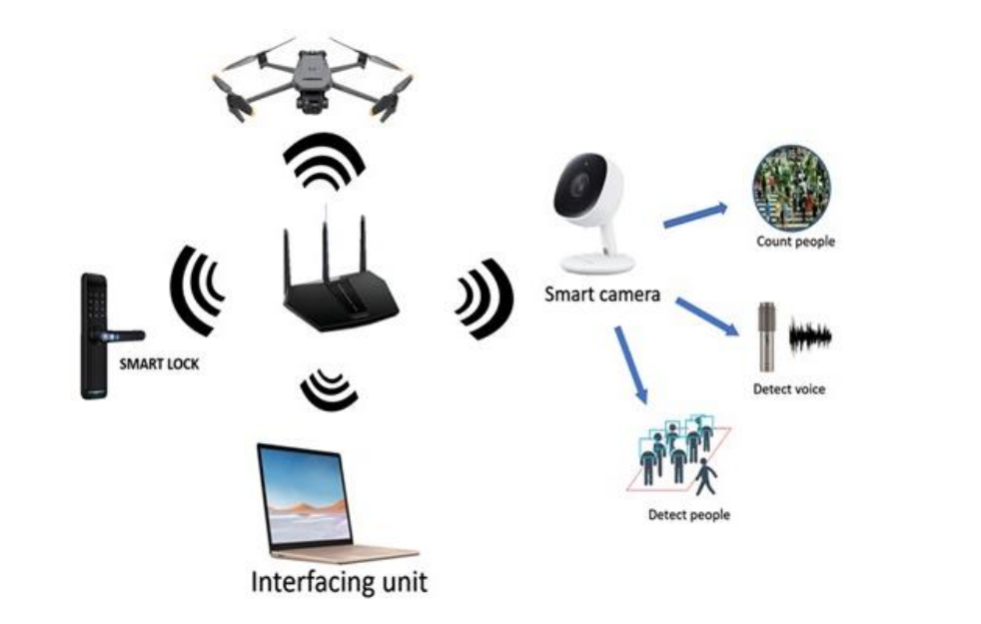
Figure 3.1: Smart AI-based Drone Security System Prototype
Materials and Methods
The drone is a continuous low humming sound. A quadcopter drone has four propellers and motors, a power distribution board, a frame, an electric motor controller (ESC), a flight controller, a battery, a receiver, a camera, and sensors. Pressure sensors measure the altitude or distance between the ground and the drone. The inertial measurement unit (IMU) sensors measure the accelerations and angles of the drone.
3.2 ANALYSIS OF THE EXISTING SYSTEM
The current drone surveillance systems face several challenges that hinder their overall effectiveness and adaptability. One major issue is the reliance on manual control, which not only limits operational efficiency but also introduces a higher risk of human error. This dependency often results in slower response times and reduced scalability, particularly in large-scale operations or rapidly changing environments. Furthermore, existing systems often struggle with inefficient data processing, delaying crucial analysis and decision-making processes that are vital in real-time surveillance scenarios.
Another significant limitation is the restricted coverage provided by many current systems. These systems are often constrained by limited battery life, operational range, and adaptability to dynamic conditions. Such constraints reduce their utility in scenarios requiring extensive monitoring or rapid deployment across diverse terrains. These shortcomings underscore the need for a more advanced, autonomous system capable of addressing these limitations through enhanced efficiency, adaptability, and real-time capabilities.
3.3 PROBLEMS OF THE EXISTING SYSTEM
Existing drone surveillance systems primarily rely on manual control and limited AI integration, restricting their efficiency and adaptability. Studies have highlighted the need for systems that can operate autonomously, process large datasets in real time, and adapt to dynamic environments. Problems of the existing system are:
- Dependency on human operators increases the likelihood of errors.
- Delayed threat detection and response times.
- Inability to adapt to dynamic environments.
- High operational costs and resource requirements.
3.4 DESCRIPTION OF THE PROPOSED SYSTEM
The proposed system leverages cutting-edge AI technologies to enhance the functionality and efficiency of drone-based surveillance. By integrating advanced computer vision algorithms, the system enables drones to identify and analyze objects in real-time, offering precise threat detection and immediate reporting capabilities. Machine learning models further optimize operations by learning from previous missions, improving decision-making and adaptability over time. These capabilities reduce reliance on manual input and significantly boost the system’s autonomy.
The framework also includes robust autonomous navigation features, allowing drones to operate seamlessly in diverse environments. Utilizing GPS integration and AI-driven obstacle avoidance systems, the drones can dynamically adjust their flight paths based on environmental changes and mission objectives. Additionally, edge computing ensures rapid data processing on-board, minimizing latency and enabling swift responses. This proposed system addresses the critical limitations of existing solutions by providing a scalable, adaptable, and highly efficient surveillance tool.
The proposed system integrates AI technologies such as computer vision and machine learning to enable autonomous drone operations.
3.5 ADVANTAGES OF THE PROPOSED SYSTEM
Advantages of the proposed system are:
- Improved Efficiency: Autonomous operations reduce human intervention.
- Enhanced Accuracy: AI-driven analysis minimizes errors.
- Cost-Effectiveness: Reduced operational costs through automation.
- Scalability: Adaptable to various applications and environments.

CHAPTER FOUR
DESIGN, IMPLEMENTATION AND DOCUMENTATION OF THE SYSTEM
4.1 DESIGN OF THE SYSTEM
The design of AI based drone operation with surveillance system integrates sensors, weather station, flir, and tetracam to capture the survey area. It features software and UAV platform for real-time monitoring, a microcontroller, calibrating panels for processing data and control of the drone, and sensors, for detecting objects. The system is housed in a protective enclosure to house all these materials.
4.1.1 OUTPUT DESIGN
The output design of the AI based drone operation with surveillance system, which is made up of Sensors and cameras. A sensor for detecting objects and a camera for capturing all objects detected. Things taken into consideration in determining the output of the developed system are represented below:
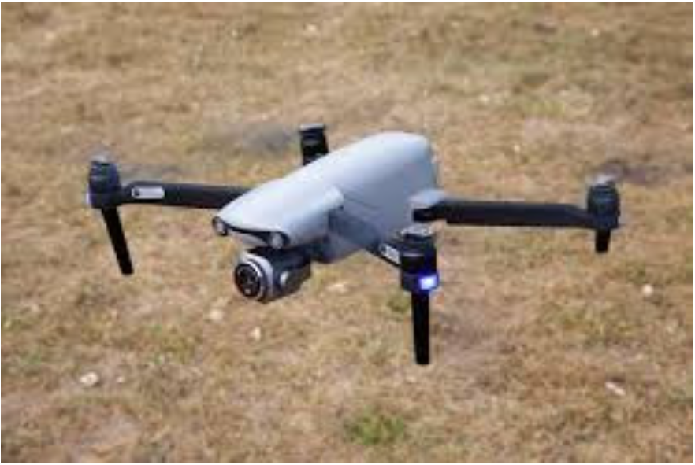
Figure 4.1: The Drone Surveillance System
The picture above is the AI based drone operation with surveillance system. The users or the administrator should be able to inspect an area when an abnormal situation is detected by the system. The drone has the ability to provide video stream to the users or administrator on request. However, since the bit rate of a video is quite high, the researchers employed a video rate adaptation to fully utilize the network. The surveillance module reports the video stream information to GCS whenever there is a request of video stream service.
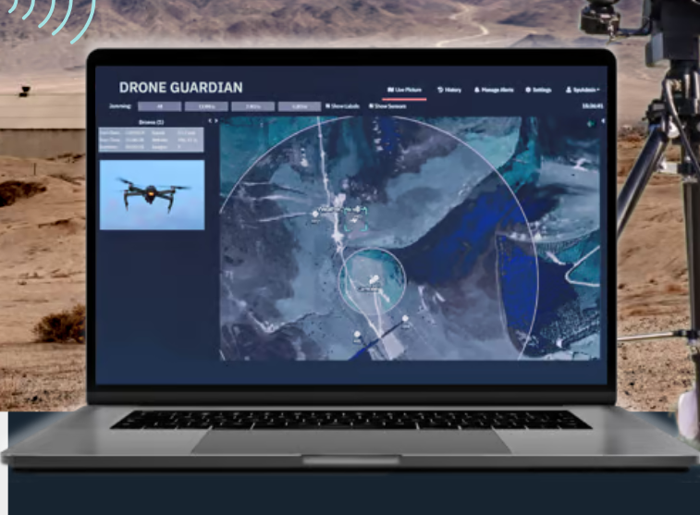
Figure 4.2: A Display Unit where the Drones is Monitored
The display unit is a system interface that allows operators to view and manage live data and video feeds from the drones during its operations. It plays a crucial role in ensuring the effective control and utilization of the drones for various tasks, such as surveillance.
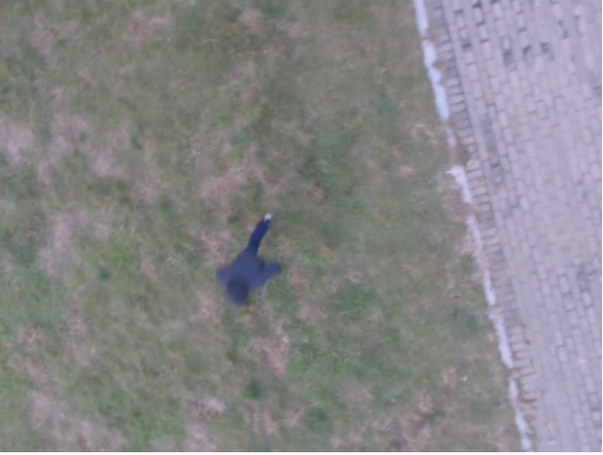
Figure 4.3: An Object Captured by the Drones during Surveillance
This is an image captured by the drones during the day surveillance with the help of the camera and sensors.
4.1.2 INPUT DESIGN
In this section, the input design of the AI based drone operation with surveillance system is presented which consists onboard cameras to capture, sensors to detect, track, and record details about the object, processor, and communication module for exchanging data between the drone and display unit. Below are the input of the developed system.
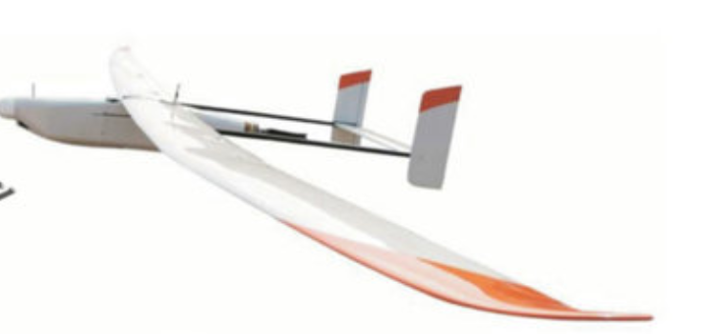
Figure 4.4: Enclosures
This is the Weatherproof enclosures of the system to protect cameras and sensors. It also shield components from dust, moisture, and chemicals and provide durability in harsh terrains.
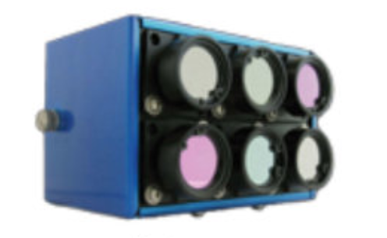
Figure 4.5: Tetracam Mini MCA-6
The Tetracam Mini MCA-6 is a specialized multispectral imaging sensor used in drone systems for agricultural, environmental, and research applications. It captures precise data across multiple spectral bands, enabling advanced analysis of vegetation health, environmental monitoring, and other applications where spectral information is critical.

Figure 4.5: Calibration Panels
Calibration panels are essential tools in drone-based imaging, particularly for applications involving remote sensing, photogrammetry, and multispectral imaging. These panels ensure the accuracy and consistency of data collected by drone sensors, enabling reliable analysis and decision-making.
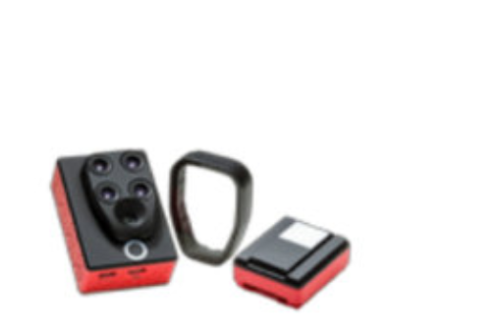
Figure 4.7: Parrot Sequoia
The Parrot Sequoia is a compact multispectral sensor designed specifically for environmental applications when integrated with drones. In this project it provided detailed multispectral and RGB imagery, allowing users to analyze vegetation health and monitor ecosystems.
4.2 IMPLEMENTATION OF THE SYSTEM
The implementation of the system involves assembling the hardware components, developing and integrating software for control algorithms, calibrating sensors and camera, connecting tetracam, and thoroughly testing the system to ensure it meets the desired specifications for efficient and reliable AI based drone surveillance system.
4.2.1 CHOICE OF PROGRAMMING LANGUAGE
The choice of programming language for the system depends on the Microcontroller and Raspberry Pi (Microprocessor) used. For Microcontroller, C++ is chosen which is often used in Pixhawk, STM32, and Arduino platforms; for Raspberry Pi, Python is preferred; and for ESP32, both C++ and MicroPython are suitable. These languages are selected for their compatibility with hardware, ease of use, and availability of necessary libraries.
4.2.2 HARDWARE REQUIREMENT
- Raspberry Pi (Microprocessor)
- Sensors
- Tetracam
- Flir E-60
- Display Unit
- Parrot Sequoia
- Calibration Panels
4.2.3 SOFTWARE REQUIREMENT
  - Flight Control Software: Open-source platforms like PX4 or ArduPilot are written in C/C++ and support advanced flight control features.
  - Image Processing: Python with OpenCV or TensorFlow can run on Raspberry Pi or NVIDIA Jetson to process live camera feeds.
  - Sensor Management: STM32 programmed in C/C++ for real-time sensor fusion and low-level control.
  - Communication: ESP32 or Raspberry Pi programmed with Python or C++ to handle data transmission over Wi-Fi or Bluetooth.
4.3 DOCUMENTATION OF THE SYSTEM
4.3.1 Program Documentation
The AI-based drone surveillance system's program documentation provides a comprehensive guide to understanding, configuring, and utilizing the system developed for the surveillance. It includes setup instructions for the development environment, details on hardware configuration, an overview of the software structure, explanations of functionality, definitions of configuration parameters, usage instructions, and troubleshooting guidance. This documentation serves as a valuable resource for developers and users, ensuring smooth implementation, operation, and maintenance of the smart waste bin system.
4.3.2 MAINTAINING OF THE SYSTEM
Maintaining the AI based drone surveillance system involves regular checks, updates, and occasional troubleshooting to ensure its continued functionality and efficiency. This entails inspecting hardware components for wear or damage, updating software to the latest versions, monitoring sensor data for irregularities, and conducting scheduled calibrations and battery replacements as needed. Troubleshooting efforts include diagnostic checks, component replacements, and meticulous documentation of maintenance activities to facilitate seamless operation and timely interventions.

CHAPTER FIVE
SUMMARY, CONCLUSION AND RECOMMENDATIONS
5.1 SUMMARY
This project explores the transformative potential of AI-powered drones in enhancing surveillance systems. By examining existing limitations, such as reliance on manual control and inefficient data processing, it underscores the critical need for more autonomous and adaptive solutions. The proposed framework integrates advanced AI technologies like computer vision and machine learning to enable real-time data analysis, autonomous navigation, and efficient threat detection, addressing current operational gaps effectively.
This project highlights the broader implications of AI-powered drones across diverse fields, including public safety, disaster management, and environmental monitoring. The scalability and adaptability of the proposed system offer a promising path forward for improving surveillance operations in dynamic and complex environments. This study not only provides a comprehensive analysis of the existing challenges but also lays the groundwork for innovative applications and future advancements in AI-driven drone technology. highlights the transformative potential of AI-powered drones in surveillance systems. By addressing the limitations of existing systems and proposing an advanced framework, it contributes to the growing field of autonomous systems.
5.2 CONCLUSION
The integration of AI into drone operations marks a transformative milestone in the evolution of surveillance systems. This advancement addresses critical challenges associated with existing systems, such as limited operational range, inefficiency in data processing, and heavy reliance on human intervention. By leveraging technologies like computer vision, machine learning, and autonomous navigation, the proposed AI-driven drone framework demonstrates significant potential to enhance real-time monitoring, decision-making, and adaptability to dynamic scenarios.
Moreover, the proposed system offers a scalable and cost-effective solution applicable across diverse fields, including public safety, environmental conservation, and disaster management. Its ability to operate autonomously and process data efficiently ensures improved accuracy and responsiveness. As the technology evolves, future research and development should focus on refining these systems, ensuring ethical deployment, and addressing regulatory challenges to fully realize the benefits of AI-powered drone surveillance systems. of AI into drone operations presents a significant leap forward for surveillance systems, offering enhanced efficiency, accuracy, and scalability. The proposed system demonstrates the potential to address current challenges and pave the way for innovative applications across various domains.
  - RECOMMENDATIONS
Based on the findings of this research, the following were recommended:
- Invest in research and development for advanced AI algorithms tailored for drone operations.
- Conduct extensive real-world testing to refine system performance.
- Explore collaborations between academia, industry, and government for practical implementations.
- Prioritize ethical considerations and regulatory compliance in system design.
REFERENCES
Ghazo, A. & Hayajneh, M. R. (2023). Advanced IoT-AI Security System with Drone Surveillance: Campus Smart Security Prototype, International Journal on Engineering Applications (I.R.E.A.). Vol. 11, Issue: 5. Pp. 2281-2282. https://doi.org/10.15866/irea.v11i5.24007 346 Alaa
Geng, L., Zhang, Y., Wang, P., Wang, J., Fuh, J. & Teo, S. (2020). UAV Surveillance Mission Planning with Gimbaled Sensors, In Proceedings of the 11th IEEE International Conference on Control Automation (ICCA). Vol. 8. Pp. 320-321. Taichung, Taiwan.
Hoang, M. L. (2023). Smart Drone Surveillance System Based on AI and on IoT Communication in Case of Intrusion and Fire Accident. Drones. Vol. 5. Pp. 69-71. https://doi.org/ 10.3390/drones7120694
Jung, J., Yoo, S., Gyu, W., Lee, R., Bae, M. & Kim, H. (2018). AVSS: Airborne Video Surveillance System, System, International Journal of Scientific & Engineering Research. Vol. 9, Issue: 5. Pp. 149-150. doi:10.3390/s18061939
Kumar, A. & Yadav, H. (2024). Enhancing Home Security with AI-Driven Drone Surveillance, Journal of Sensor Networks and Data Communications. Vol. 9, Issue: 4. Pp. 2456-2457. doi: https://doi.org/10.32628/CSEIT2063225 11
Shah, S. A., Lakho, G. M., Keerio, H. A., Sattar, M. N., Hussain, G., Mehdi, M., Vistro, R. B., Mahmoud, E. A., Elansary, H. O. (2023). Application of Drone Surveillance for Advance Agriculture Monitoring by Android Application Using Convolution Neural Network. Agronomy. Vol. 13, Issue: 3. Pp. 1764-1765.
Singh, A. V., Arige, R. K., Deore, V. & Neriya, J. (2024). A Study of Various Drone Based- A Surveillance System, International Journal of Advanced Research and Multidisciplinary Trends (IJARMT). Vol.1, Issue: 2. Pp. 4-5. doi: 10.1109/ECAI58194.2023.10193962.
Ugochukwu, N. A., Goyal, S. B., Rajawat, A. S., Verma, C. & Illés, Z. (2024). Enhancing Logistics with the Internet of Things: A Secured and Efficient Distribution and Storage Model Utilizing Blockchain Innovations and Interplanetary File System, in IEEE Access. Vol. 12. Pp. 4139-4152. doi: 10.1109/ACCESS.2023.3339754

