

PROJECT REPORT

ON

LAND INFORMATION SYSTEM OF URBAN ESTATE OPPOSITE GOVERNMENT CEMETERY AREA ALONG OKE OYI ILORIN KWARA STATE

BY
ADEKUNLE FLORENCE ARINOLA
HND/23/SGI/FT/0123

SUBMITTED IN PARTIAL FULFILLMENT OF THE REQUIREMENT FOR THE AWARD OF HIGHER NATIONAL DIPLOMA (HND) IN SURVEYING AND GEO-INFORMATICS TO THE DEPARTMENT FO SURVEYING AND GEO - INFORMATIS, KWARA STATE POLYTECHNIC ILORIN, KWARA STATE

JUNE, 2025

CERTIFICATE
I hereby certify that all the field work and information contained in this project report were obtained as a result of the observations and measurements carried out by me in the field and that the survey was executed in accordance with survey laws, regulations and departmental instructions.

ADEKUNLE FLORENCE ARINOLA
HND/23/SGI/FT/0123

STUDENT

CERTIFICATION
This is to certify that this project work was carried out by ADEKUNLE FLORENCE ARINOLA with Matriculation Number HND/23/SGI/FT/0123 under my supervision of SURV. AKINYEDE ADEBANJI according to survey rules and department instruction.

.................................................. ..................................................
SURV. AKINYEDE ADEBANJI DATE
PROJECT SUPERVISOR

.................................................. ..................................................
SURVEYOR R.S AWOLEYE. DATE
PROJECT COORDINATOR

.................................................. ..................................................
SURVEYOR A.I ISSAU DATE
HEAD OF DEPARTMENT.

.................................................. ..................................................

EXTERNAL SUPERVISOR. DATE

DEDICATION
This research work is dedicated to Almighty God.

ACKNOWLEDGMENT
Most importantly I'm very grateful to almighty God for His faithfulness, grace, mercy, and His steadfast love, for guiding me through the successful completion of my study, and above all for preserving my life up to date.
Also thankful and grateful to my supervisor SURVEYOR BANJI for his wonderful supervision and contributions despite his tight schedules he still found time to strengthen the quality of my work, I'm very grateful sir; God will continue to guide you sir.
I am grateful to SURVEYOR A.I ISSAU the head of department of surveying
and Goo-informatics , SURVEYOR R.S AWOLEYE Project coordinator, SURVEYOR KABIRU, SURVEYOR B.F DIRAN, SURVEYOR KAZEEM, SURVEYOR AYUBA ABDULSALAM, SURVEYOR A.G AREMU, SURVEYOR ASHONIBARE, other staff of the department (Teaching and Non-Teaching). May almighty Allah always abide with them.
My special thanks and gratitude also go to my parents MR&MRS AGEH ADEKUNLE They made it possible for me to achieve this goal, despite all the challenges that come to my way, they still show love, struggle, caring and tireless effort to make me achieve my aim, aimighty God will let you reap the fruit of your hard Labour (AMEN)
I can never forget my siblings AGEH ROTIMI(My best after Popz)He sacrifice a lot, stood by me and gave me the best of life I love you so much BLESSING, DEJI AND ADEWALE They’re all the best siblings in the world may almighty God be with
you all I pray all my aim to be a meaningful person will be achieved by God grace.
(AMEN)

ABSTRACT
A Land Information System (LIS) is a vital tool in modern surveying, providing a comprehensive framework for managing and analyzing land-related data. This project explores the development and implementation of LIS in surveying, highlighting its applications, benefits, and challenges. By integrating spatial data, attribute data, and analytical tools, LIS enables informed decision-making in land administration, urban planning, and environmental management. This study demonstrates the significance of LIS in promoting efficient land governance, sustainable development, and improved land management. This project investigates the design, implementation, and applications of Land Information Systems (LIS) in surveying, focusing on their role in promoting efficient land administration, sustainable development, and informed decision-making. By examining the integration of spatial data, attribute data, and analytical tools, this study highlights the benefits of LIS in enhancing land governance, reducing disputes, and improving land management practices. The research also explores the challenges and limitations of LIS implementation, including data quality, interoperability, and institutional capacity. The findings of this project contribute to a deeper understanding of the potential of LIS to support evidence-based policy-making and sustainable land use planning.

TABLE OF CONTENT
Title page. i
Certificate ii
Certification. iii
Dedication. iv
Acknowledgment. v
Abstract. vi
Table of Contents. vii
List of table ix
List of figures. x
CHAPTER ONE.
1.0 Introduction. 1
1.1 Background of the study. 1
1.2 Statement of the problem. 5
1.3 Aim and Objective. 6
1.4 The scope of the project. 6
1.5 Personnel. 7
1.6 Study area. 8
1.7 Specification of the project 9
CHAPTER TWO
2.0 Literature Review. 10
CHAPTER THREE
3.0 Methodology. 22
3.1 Database Design 22
3.1.2 Conceptual design 25
3.1.3 Logical design 27
3.1.4 Reconnaissance 28
3.1.5 Equipment use/System selection and software 29
3.1.6 Monumentation 30
3.1.7 Instrument check. 31
3.2 Data acquisition. 33
3.3 Data processing. 34
3.4 Preliminary Survey. 34
3.4.1 Area computation. 35
3.4.2 Linear Accuracy 36
3.5 Physical Design. 36
3.6 Database creation. 38
3.7 Database management system. 39
3.8 Data security. 40
CHAPTER FOUR
4.0 Analysis and information presentation 41
4.1 Testing of database 41
4.2 Analysis performed. 42
4.3 Single Criteria query. 43
4.4 Application of product. 48
CHAPTER FIVE
5.0 Cost estimation, summary, recommendation, and conclusion. 49
5.1 Summary 53
5.2 Recommendation. 53
5.3 Conclusions. 54
References. 55
Appendix. 57

LIST OF TABLES
Table 3.2: Road Entity and its attribute 27
Table 3.3: Polygon Entity and its attribute 27
Table 3.4 Control Check (Observed Values) 32
Table 3.5 Control Checks (Computed values) 32
Table 3.6 Back Computation of boundary coordinates 34
Table 3.7: Linear Accuracy 36
Table 3.8: Road Entity Data Structure 37
Table 3.9: Parcel Entity Data Structure 37
Table 3.11: Attribute table for Parcel 38
Table 3.12: Attribute table for Road 39
LIST OF FIGURES
1.6 Location map 8
3.1 Flowchart showing research methodology 22
3.6 Show Recce Diagram of the study area 29
3.11 Attribute table for parcel 38
3.12 Attribute table for road 39
4.1 Showing parcels greater than 1200m2 43
4.2 Showing parcels less than or equal to 700m2 44
4.3 Query for parcels less than or equal to 700m² with C of O 47
4.4 Query for parcels greatert ahn 1200m2 with C of O 48

CHAPTER ONE
- INTRODUCTION
Land is one of the most fundamental and valuable resources for individuals, communities, and nations. It serves as a base for housing, agriculture, industry, infrastructure, and ecological conservation. In many societies, land ownership is also a symbol of wealth, identity, and political power. Effective land management is therefore critical for economic development, environmental protection, and social stability (P Shipton, M Goheen - Africa, 1992).
However, managing land effectively requires accurate, accessible, and reliable information about land parcels—such as their location, boundaries, ownership, use, and value. This is where Land Information Systems (LIS) become essential.
1.1 BACKGORUND TO THE STUDY
According to (R Owusu Ansah - 2022) ALand Information System (LIS) is a tool used for collecting, managing, analysing, and disseminating land-related data. It combines spatial data (maps, coordinates) and textual data (ownership, land use, value) to support land administration and planning. The development of LIS is rooted in the need for accurate, up-to-date, and accessible information about land, which is a critical asset for individuals, governments, and businesses alike.

Historical Context
Historically, land administration relied on manual record-keeping systems, which were often fragmented, outdated, and prone to manipulation. This created challenges such as land disputes, inefficient land use, and corruption. With the advent of geographic information systems (GIS) in the mid-20th century and advances in computer technology, the idea of digitizing land records emerged. This led to the development of LIS in the 1980s and 1990s as part of broader land reform and e-governance initiatives, particularly in countries seeking to improve transparency, reduce disputes, and optimize land management (AOAkingbade - 2012).

Technological Evolution
Modern LIS incorporates satellite imagery, remote sensing, GPS technology, and powerful data analytics. It allows for real-time updates and integration with other systems such as tax databases, cadastral surveys, and urban planning tools. The system is essential for decision-making in land tenure, zoning, real estate development, and environmental conservation.(S Safavi - Glob. Chall. Environ. Clim. Change, 2024)

Importance in Governance and Development
An effective LIS contributes to:
- Efficient land administration: Streamlining processes like registration, valuation, and transfer of property.
- Security of tenure: Reducing land disputes through clear and transparent ownership records.
- Economic development: Supporting real estate markets, infrastructure projects, and agricultural planning.
- Environmental sustainability: Monitoring land use and supporting land conservation policies.
According to (R Joannides - 2023) A Land Information System (LIS) is an organized system of acquiring, storing, processing, and disseminating information about land. It integrates spatial data (e.g., maps, geographic coordinates) with non-spatial data (e.g., legal ownership, land use, value) using Geographic Information System (GIS) technology.
It is a subset of a broader geospatial information system, specifically tailored for land administration and management purposes.

Evolution of Land Records and LIS

Traditional Land Record Systems:
- Historically, land records were maintained in paper format, manually recorded by government officials or local authorities.
- These systems were often characterized by inaccuracy, incompleteness, and lack of accessibility, leading to inefficiencies in land transactions, disputes over ownership, and difficulties in land valuation or taxation.

The Shift Toward LIS:
- With the advancement of information and communication technology (ICT), particularly GIS, remote sensing, and database management, the shift toward digital systems began in the 1980s and 1990s.
- LIS evolved as a response to the need for digital transformation in land administration. It allowed for more efficient and transparent systems for land registration, titling, valuation, and planning.

Core Components of LIS
A LIS typically includes:
- Cadastral data: Information on parcel boundaries and ownership.
- Land use data: Information on how land is used (agricultural, residential, commercial, etc.).
- Topographical data: Natural and built features of the landscape.
- Legal and regulatory data: Land tenure laws, planning regulations, and zoning restrictions.
- Valuation data: Assessed land value for taxation or market purposes.

Applications of LIS
LIS is used across a wide range of sectors:
- Government: For property taxation, urban planning, land titling, and policy-making.
- Real estate: To support land transactions, valuations, and investment decisions.
- Agriculture: For land consolidation, crop monitoring, and farm planning.
- Environment: For managing protected areas, forest reserves, and climate change adaptation.
- Disaster management: Mapping risk zones and planning evacuation routes or reconstruction after disasters.

Global and Regional Trends
Many countries have recognized the importance of LIS and have launched national programs for land digitization, cadastral reform, and e-governance. For example:
- Rwanda and Kenya have developed advanced LIS platforms to support land reform and reduce corruption.
- India’s Digital India Land Records Modernization Programme (DILRMP) aims to digitize all land records across the country.
- The World Bank and UN-Habitat have promoted LIS as a tool for good land governance, particularly in developing countries.
Challenges in Implementing LIS
Despite its benefits, implementing LIS faces several challenges:
- High initial costs of development and infrastructure.
- Lack of technical expertise in some regions.
- Resistance to change from traditional systems and bureaucracies.
- Data inconsistencies and legacy records that are incomplete or inaccurate.
- Legal and institutional frameworks that may not support integrated land data systems.

8. Emerging Technologies in LIS
The field of LIS is being rapidly transformed by:
- Cloud computing: Enabling scalable and accessible LIS platforms.
- Blockchain: For secure and tamper-proof land transactions.
- Artificial Intelligence: For analyzing land use trends and detecting encroachments.
- Mobile GIS applications: Enhancing field data collection and citizen engagement.
1.2 STATEMENT OF PROBLEM
Due to the challenges faced in land management and administration, particularly in Nigeria, land administration faces significant challenges such as inefficiency, lack of accurate data, inadequate accessibility to land records, and poor management of land resources. The absence of an integrated and automated system to store, update, and retrieve land data often leads to confusion, land disputes, and ineffective policy implementation. The complexity of managing land ownership, boundaries, transactions, and land use further exacerbates issues like corruption, encroachment, and the illegal allocation of land.
This situation results in substantial economic losses, delays in infrastructure development, and an overall lack of transparency and accountability in land management processes. Traditional land management systems are outdated, paper-based, and prone to human error, making it difficult for land stakeholders, including government agencies, developers, and the general public, to efficiently access and manage land-related information. The absence of a comprehensive and digitized Land Information System (LIS) impedes sustainable development and poses a significant barrier to effective urban planning, investment, and governance in land-related matters.
This problem statement addresses key issues like inefficiency, poor data management, disputes, and outdated systems that can be alleviated with the implementation of a comprehensive Land Information System.
1.3 AIM AND OBJECTIVE
1.3.1 AIM
The aim of this project is to provide an integrated platform for managing, storing, and analyzing land-related data to support efficient land administration, planning, and decision-making.
13.2 OBJECTIVE
The following objectives were considered in order to accomplish the above aim
- Project planning
- Monumentation
- Data downloading and data processing
- Data analysis and information presentation
- Query
- Report writing
1.4 SCOPE OF THE PROJECT
The scope of the work involves detailed procedures for the development of Land Information System of Urban Estate Layout. It however entails the creation of functional Database of the present situation of the research Area and to display digital Information and to display Information such as Ownership details, Parcel information, Plot type, Land use, Status was developed and other attribute information. All these entities and attributes will form the base for database creation.
Base and significance of this project, the scope includes;
1. Project planning: which include office planning and field reconnaissance
2. Monumentation: (At least 5 hectares of land according to Higher National Diploma)
3. Data acquisition (geometric data with total station, social survey through oral interview for the purpose of query and building name and colors
4. Data processing: This includes downloading and processing of data using appropriate software (GIS software)
5. Information presentation: It involved plotting of survey data on both soft copy and hard copy showing correct location of a points.
1.5 PERSONNEL
NAME MATRIC NO REMARKS
8. ADEKUNLE FLORENCE A. HND/23/SGI/FT/0123 AUTHOR
2. AKEEM HAMID AJAGBE HND/23/SGI/FT/0074 MEMBER
3. AYODELE TAIYE OPEYEMI HND/23/SGI/FT/0072 MEMBER
4. ABOLADE BISOLA OPEYEMI HND/23/SGI/FT/0073 MEMBER
5. AFOLAYAN IFEOLUWA MARY HND/23/SGI/FT/0077 MEMBER
6. AYEGBOYIN QUDUS A. HND/23/SGI/FT/0071 MEMBER
7. ABDULQUADRI ABUBAKR S. HND/23/SGI/FT/0075 MEMBER
8. ABDULFATAI ABDULAFEEZ O. HND/23/SGI/FT/0120 MEMBER

1.6 STUDY AREA
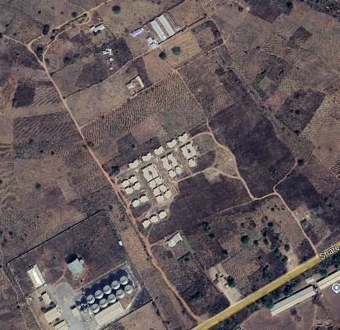
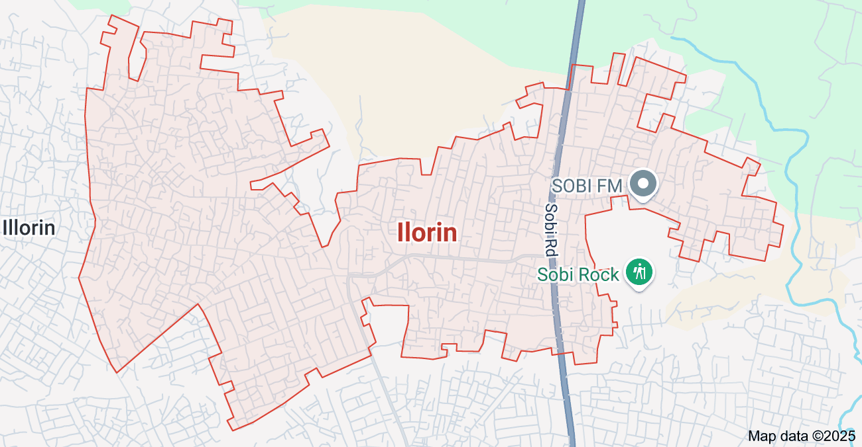
Urban estate opposite Government cemetery area along OKE-OYI ROAD OKE-OSE ILORIN, KWARA STATE, ILORIN East local government area. (683903E, 946221N). The project site is geographically defined by these parameters; Latitude 8° 33' 23.443"N and Longitude 4° 40' 15.384"E
N
ILORIN

URBAN ESTATE

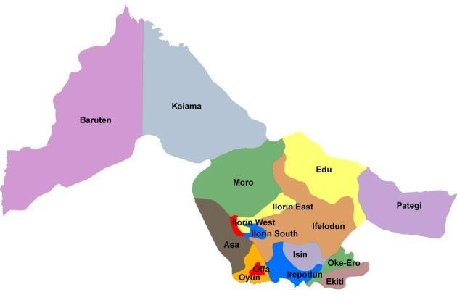
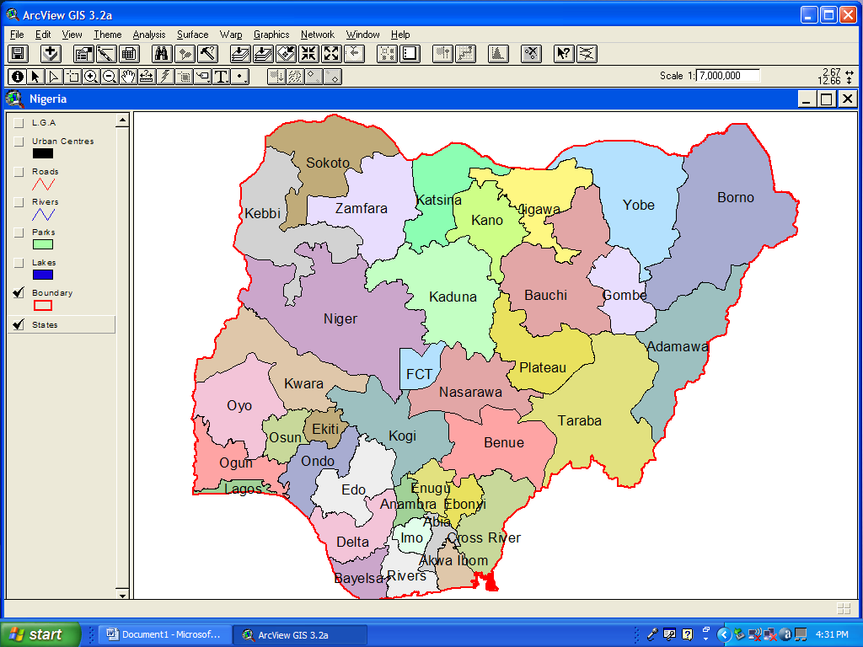
NIGERIA KWARA STATE

1.7 SPECIFICATION
The project speciation’s were referenced to the speciation for land information system using total station which was sources from the Higher National Diploma. The specification includes the following:
- Total station
- Minimum number of datum control required- three (3)
- Traverse should run between secondary or higher order control point.

CHAPTER TWO
- LITRERATURE REVIEW
2.1 Introduction to Land Information Systems
Land Information Systems (LIS) have emerged as critical tools in modern land administration, combining spatial and non-spatial data to support decision-making in areas such as land tenure, land use planning, property taxation, and environmental management. According to Dale and McLaughlin (1999), LIS is defined as a tool for legal, administrative, and economic decision-making and an aid for planning and development, which provides information on land ownership, use, and value.
The increasing complexity of land tenure systems and rapid urbanization have created a need for accurate, accessible, and integrated land data systems. LIS addresses this by offering a platform that merges cadastral, topographic, and legal data to enhance land governance.

2.2 Theoretical Foundations of LIS
The development of LIS is grounded in theories of spatial data infrastructure (SDI), land administration, and e-governance. The Land Administration Domain Model (LADM), standardized as ISO 19152, provides a conceptual framework for designing LIS systems that can handle various types of land tenure, including customary and informal rights (Lemmen et al., 2015).
Deininger et al. (2010) argue that efficient land administration supported by LIS is crucial for sustainable development, especially in countries with complex land tenure systems. The theoretical focus is on the integration of technology and institutional frameworks to improve land rights, enhance transparency, and reduce transaction costs.

2.3 Key Components of LIS in Literature

a. Cadastral Information
The cadastral layer forms the backbone of LIS, detailing the boundaries, dimensions, and ownership of land parcels. Williamson et al. (2010) note that a well-functioning cadastre underpins land markets, credit systems, and planning.

b. Geospatial Data Integration
GIS technology allows the integration of geospatial layers—such as topography, zoning, land use, and infrastructure—with textual data. This integration is essential for land planning and decision-making (Longley et al., 2011).

c. Legal and Administrative Data
LIS incorporates data on legal rights, restrictions, and responsibilities, supporting land registration and titling systems. This reduces land disputes and increases security of tenure (Zevenbergen et al., 2013).

2.4 Applications of LIS
Several scholars highlight the diverse applications of LIS:
- Land Tenure Security: By documenting and validating land rights, LIS promotes tenure security, particularly in developing countries. For example, in Rwanda, LIS helped achieve near-universal land registration within a few years (Ali, Deininger & Goldstein, 2015).
- Urban and Regional Planning: LIS supports planning authorities by providing spatially accurate data to guide development, infrastructure, and zoning decisions (Enemark et al., 2005).
- Property Taxation: LIS enhances land valuation and tax collection, leading to improved municipal revenues (Bird & Slack, 2004).
- Disaster Risk Management: Spatial data within LIS enables authorities to identify high-risk zones and plan for disaster response and mitigation (Van Westen, 2000).

2.5 Technological Advancements in LIS
Modern LIS incorporates a range of technological tools:
- Remote Sensing & UAVs: Used for updating land use and topographic data with high accuracy (Li et al., 2020).
- Blockchain Technology: Emerging as a tool for tamper-proof land records and reducing corruption in land transactions (Lemmen et al., 2019).
- Mobile Applications: Increasing community participation in land registration, especially in rural and informal settlements (Molen, 2002).
2.6 Challenges in Implementing LIS
The literature identifies several barriers to LIS implementation:
- Institutional Fragmentation: Lack of coordination between land administration bodies can hinder LIS development (Williamson et al., 2010).
- Data Quality Issues: Incomplete, outdated, or conflicting land records pose major challenges (Augustinus& Barry, 2006).
- High Implementation Costs: Developing LIS infrastructure can be expensive, especially for low-income countries.
- Legal and Cultural Constraints: In some regions, traditional land tenure systems are not easily captured by formal LIS structures (Toulmin, 2009

2.7 Case Studies from Literature
- Rwanda: Successfully implemented LIS as part of its land reform strategy, achieving systematic land registration and reduced disputes (Ali et al., 2015).
- India (DILRMP): The Digital India Land Records Modernization Programme aims to digitize and integrate all land records, though progress is uneven across states (Bandyopadhyay, 2013).
- Ghana and Kenya: Are working to digitize land records using LIS to reduce corruption and improve service delivery (Zevenbergen et al., 2013).

2.8 Gaps in the Literature
While extensive research exists on the technical and institutional aspects of LIS, several areas remain underexplored:
- The impact of LIS on gender equity in land rights
- Long-term sustainability and maintenance of LIS infrastructure
- Community-driven or participatory LIS models
- Interoperability of LIS with other national databases (e.g., civil registration, taxation)

2.9 LIS and Governance: Enhancing Transparency and Accountability
Scholars such as Bennett et al. (2012) emphasize the role of LIS in promoting good governance in land administration. By digitizing and centralizing land records, LIS minimizes bureaucratic opacity, reduces opportunities for corruption, and enables citizens to access information easily. This transparency enhances trust in public institutions.
A study by Zakout, Wehrmann, and Törhönen (2006) links the deployment of LIS with reduced discretionary power among land officers and faster service delivery. LIS platforms often include publicly accessible land registries and automated workflows, which reduce the human interaction component—a common source of manipulation and delay.

2.10 Participatory and Community-Based LIS
There is a growing body of literature advocating for participatory approaches to LIS, especially in rural and indigenous communities where customary land rights dominate. Barry and Meinzen-Dick (2010) argue that top-down LIS models often fail in such contexts due to a lack of local legitimacy.
Participatory LIS initiatives (sometimes called Pro-Poor LIS) involve local stakeholders in the mapping, recording, and validation processes. Examples include Social Tenure Domain Models (STDM), which allow for the recording of informal and overlapping land rights. These models, championed by UN-Habitat, are particularly useful in informal settlements and post-conflict settings (Augustinus, 2010).

2.11 Gender and LIS: Addressing Inequality in Land Rights
While LIS can be a powerful tool for equitable land governance, research shows that without explicit gender-sensitive design, it may perpetuate existing inequalities. According to Giovarelli et al. (2013), many LIS implementations have failed to address women's land rights, especially in patriarchal societies where titles are traditionally recorded in men’s names.
Recent studies emphasize the need for:
- Gender-disaggregated data in LIS
- Legal reforms to support co-ownership or joint titling
- Community awareness campaigns to promote women's land rights
The FAO (2021) has recommended integrating gender equity frameworks into LIS implementation to ensure women’s access to land is legally recognized and enforceable.

2.12 LIS and Land Markets: Supporting Economic Development
LIS plays a central role in the functioning of efficient land markets. Accurate land information reduces transaction risks, enhances land valuation, and supports land-based financing mechanisms. Deininger and Feder (2009) show that countries with robust LIS systems experience lower transaction costs and higher land productivity.
Moreover, financial institutions often rely on LIS to verify ownership and assess land value before issuing loans. This makes LIS a critical enabler of land as collateral, especially in emerging economies aiming to boost rural credit markets.

2.13 Environmental Management and LIS
Recent literature has explored the application of LIS in natural resource management and environmental sustainability. LIS helps governments track land degradation, deforestation, and land-use change. For instance:
- In Brazil, LIS is used to monitor illegal logging in the Amazon.
- In Kenya, LIS supports zoning policies to manage human-wildlife conflict areas.
LIS also supports climate change mitigation through carbon accounting (e.g., REDD+ initiatives), which depend on accurate, geospatially linked land use and ownership records (Larson et al., 2013).

2.14 Digital Transformation and LIS: Opportunities and Risks
Digital transformation has introduced new dynamics into LIS development:

a. Blockchain Integration
Blockchain technology is increasingly seen as a solution to land fraud and tampering. Countries like Georgia, Honduras, and India (pilot states) have tested blockchain-based land registries, with early results showing improved transparency and record immutability (Lemmen& Bennett, 2019).

b. AI and Machine Learning
These technologies enable automated detection of illegal land use changes or encroachments using satellite imagery and pattern recognition (Zhang et al., 2020). They can also streamline land classification for valuation and planning purposes.

c. Cybersecurity and Digital Exclusion
Despite these opportunities, digitizing land data introduces cybersecurity risks and may exclude digitally illiterate populations from accessing services. The literature stresses the need for data protection policies and inclusive digital literacy programs (UN-GGIM, 2020).

2.15 Comparative Studies: LIS Implementation Across Regions
A number of comparative studies have sought to understand the factors that lead to successful LIS implementation:
- Europe: Scandinavian countries like Sweden and Finland are often cited as models due to their unified cadastre and land registry, legal clarity, and strong public trust (Enemark et al., 2010).
- Africa: Implementation is often fragmented. However, Rwanda’s LIS is a standout, demonstrating how donor support, political will, and clear legal frameworks can produce high-impact systems (Ali et al., 2015).
- Asia: In India, the DILRMP aims to modernize land records, but literature points to delays, data mismatches, and institutional inertia as key bottlenecks (Bandyopadhyay, 2013).

2.16 Critical Synthesis
Across the literature, there is a consensus that LIS is not just a technical tool, but a socio-political system embedded in governance structures. While technology provides efficiency and transparency, institutional reform, legal clarity, community participation, and political support are equally critical for LIS success (Williamson et al., 2010; Bennett et al., 2012).
Furthermore, the shift from land management to land governance—which includes dimensions of justice, inclusion, and sustainability—requires LIS to be adaptive, integrated, and responsive to diverse land tenure realities.

2.17 LIS and Land Conflict Resolution
Land disputes are a major cause of civil unrest, especially in regions with overlapping tenure systems or historical grievances. According to Wehrmann (2008), unclear or undocumented land rights are a major contributor to conflict in Sub-Saharan Africa, South Asia, and Latin America.
LIS helps reduce such disputes by:
- Clarifying ownership and boundary data through integrated cadastral systems
- Providing legally recognized, transparent records for judicial and administrative decision-making
- Supporting alternative dispute resolution (ADR) methods through participatory land documentation
A study in post-war Liberia and Afghanistan (USAID, 2014) shows that even partial implementation of LIS with community verification mechanisms led to a significant reduction in land-related disputes and improved reconciliation.

2.18 Integrating LIS with Other National Information Systems
Modern land governance increasingly depends on the interoperability of LIS with other e-governance systems, including:
- Civil registration and vital statistics (CRVS) systems for verifying identity
- Taxation systems for calculating and collecting land/property taxes
- National spatial data infrastructure (NSDI) for broader spatial planning and development
Rajabifard et al. (2012) emphasize that LIS should not be a standalone system but part of a “land information ecosystem” that supports multi-sectoral data integration. This ecosystem enables holistic planning and policy decisions, such as linking land ownership to social safety nets or integrating disaster risk maps into land-use plans.

2.19 LIS in Climate Change Adaptation and Land Degradation Monitoring
Climate change has heightened the urgency for sustainable land use. LIS has been employed in:
- Identifying erosion-prone or flood-prone areas
- Tracking land use change over time
- Guiding resettlement and rehabilitation planning
In Bangladesh, for example, LIS is integrated into coastal zone management strategies that track land subsidence and saline intrusion (Islam &Walkerden, 2017).
In sub-Saharan Africa, LIS is used in conjunction with remote sensing to monitor desertification, deforestation, and agricultural productivity, helping countries report on SDG 15 (Life on Land) and the UNCCD's Land Degradation Neutrality targets.

2.20 The Role of LIS in Smart Cities and Urban Resilience
With rapid urbanization, cities face increasing pressure on land, infrastructure, and services. LIS forms the backbone of smart city infrastructure, helping manage:
- Urban property databases
- Infrastructure development (e.g., water, electricity, transport)
- Public space inventory and usage patterns
In Singapore and South Korea, LIS is integrated into real-time urban monitoring systems, linking building permits, zoning laws, and environmental impact data (Yeh & Li, 2001). This supports e-permitting, urban simulations, and automated compliance checks, accelerating development while ensuring sustainability.
In developing countries, cities like Nairobi and Kampala have started using simplified LIS models for informal settlements, helping local authorities plan service delivery and implement upgrading schemes.

2.21 Decentralization and LIS Implementation
Decentralization of land governance has become common in many countries, aiming to bring services closer to the people. However, this raises the question of how LIS is deployed and maintained at local levels.
Chigbu et al. (2017) argue that decentralized LIS must:
- Be affordable and user-friendly
- Support local land tenure norms
- Include training for local government staff and traditional leaders
- Allow for bottom-up data contributions
In Ethiopia, for example, the use of low-cost LIS tools by local land committees has been linked to a dramatic rise in tenure security and investment in land improvements.

2.22 Ethical, Cultural, and Social Considerations in LIS Development
A growing area of literature critiques the technocratic orientation of many LIS projects. Critics argue that:
- Technological solutions can disempower communities if not participatory.
- Digitization of land can lead to land grabs and commodification, especially when informal or communal land is converted into titled, tradable assets.
- There is a risk of digital dispossession when vulnerable populations are excluded from LIS due to illiteracy, lack of access, or policy bias.
To counteract this, Van Asperen&Zevenbergen (2007) recommend that LIS development should follow fit-for-purpose principles—adapting systems to local needs rather than imposing rigid, Western-style cadastral models.

2.23 Capacity Building and Institutional Sustainability
Institutional sustainability is critical for the long-term success of LIS. Many LIS projects face a common challenge: they function well during donor-funded phases but deteriorate afterward due to lack of funding, training, or political support.
Scholars emphasize:
- Continuous capacity development of land professionals (surveyors, registrars, planners)
- Retention of skilled personnel through career incentives
- Development of local technical support systems, such as open-source platforms (e.g., QGIS, OpenCadastreMap)
- Inclusion of LIS and land governance in university curricula to create a pipeline of qualified professionals

2.24 LIS in Humanitarian and Emergency Contexts
LIS has increasingly found application in humanitarian contexts, including:
- Post-disaster recovery (e.g., Haiti earthquake, Philippines typhoon)
- Refugee resettlement and land claims (e.g., Syria, South Sudan)
- Reconstruction and rebuilding land tenure systems after war (e.g., Bosnia, Kosovo)
The Global Land Tool Network (GLTN) has promoted flexible, emergency-responsive LIS tools to quickly document land claims and avoid secondary displacement, particularly among women, displaced people, and marginalized communities.

2.25 Conclusion
The study of Land Information Systems is increasingly relevant in today's world, where land-related issues intersect with economic development, urbanization, climate change, and social equity. A well-designed LIS supports transparent, efficient, and equitable land administration, which is essential for achieving sustainable development and good governance. As such, LIS is a multidisciplinary field involving geography, information technology, law, economics, and public administration.
CHAPTER THREE
3.0 METHODOLOGY
This refers to the systematic procedures or step-by-step methods followed when conducting operations related to a specific subject or case study. In surveying, it specifically denotes the processes used to plan, execute, and manage a survey project effectively.
RECONNISSANCE
FIELD / OFFICE

DATA ACQUISITION

ATTRIBUTE DATA
GEOMETRY DATA

DATA PROCESSING
DOWNLOADING / COMPUTATION / DATA

DATABASE
CREATION

QUERY

INFORMATION

Fig: 3.1 FLOW CHART SHOWING LAND INFORMATION SYSTEM PROCEDURE

3.1 DATABASE DESIGN
A database is an organized collection of related data managed as a single unit. It is designed to store persistent information relevant to an application, enabling efficient access through logical structures. Databases are typically structured and optimized to minimize redundancy, thereby supporting reliable storage and retrieval of related information. The database design phase acts as a blueprint or framework for building such systems and is therefore critical in database development.
In the context of Geographic Information Systems (GIS), the spatial database is fundamental to operations. The initial step in designing a GIS database is to determine user requirements. This step helps define the application’s scope, or the “view of reality,” and identifies the essential entities and their attributes prior to any field data collection. Establishing this foundation ensures the resulting database aligns with a conceptual model that represents the real world.
Database design, also known as data modeling, involves analyzing and representing real-world entities and their interrelationships in a manner that maximizes data utility while minimizing redundancy (Kufoniyi, 1998). A data model serves as an abstract representation of reality, including only those attributes deemed relevant to the intended application.
GIS database design generally involves two major phases:
- Design Phase
- Construction / Implementation Phase

The Design Phase
This phase comprises four key stages:
- View of Reality – A mental abstraction of the real world, focusing on components relevant to the application.
- Conceptual Design – Translating the view of reality into a structured model using entities and relationships.
- Logical Design – Defining how the conceptual model will be implemented within a database system.
- Physical Design – Designing the technical structure for efficient data storage and access.

3.1.1 View of Reality
Reality encompasses the world as it exists, including all phenomena, whether perceivable by humans or not. The view of reality is a selective focus on aspects relevant to the particular application, representing how real-world elements are conceptualized for database purposes. For instance, in this project, parcels are represented as area features, roads as line features, and blocks also as area features.

REALITY
VIEW OF REALITY
LOGICAL DESIGN

SPATIAL DATABASE

PHASE

Fig 3.2: Design and Construction Phases of a spatial database adopted by Kufoniyi (1998)

3.1.2 CONCEPTUAL DESIGN
The conceptual design represents how data is perceived and understood by end users—it is the human interpretation of the view of reality. This stage provides a clear and structured description of data types, relationships, and the appropriate modeling approach. In this design, two data representation models were adopted: the vector and tessellation (raster) data models.
At this point, the focus is on how the real-world problem is interpreted and modeled. It involves identifying the key spatial entities, determining their attributes, and establishing the relationships among them. The real-world phenomena were conceptualized using geometric structures such as points and lines, defined by coordinate pairs (x, y).
Constraints and spatial features were expressed through common GIS elements—for example:
- Buildings represented as polygons
- Roads and streams represented as lines
This conceptual abstraction sets the foundation for the subsequent logical and physical design phases.
ILORIN SOUTH LOCAL GOVERNMENTGOVERNMENT
URBAN ESTATE
BLOCKVIEW OF REALITY
PARCEL REALITYVIEW OF REALITY
BUILDINGDESIGN PHASE

ROAD DESIGNCONSTRUCTION

NODE
COORDINATE
USE
STATUS
TYPE
DEVELOPED
UNDEVELOPED

Fig 3.3: Entity Relationship Diagram adopted from Kufoniyi (1998).
RESIDENTIAL
Easting
Northing
NODE
Node Id

Fig. 3.4 Node Entity and its Attribute

P_Type
POLYGON
P_Use Use
P _Area
P-Address
P_Id
P_Status

Fig 3.5 Polygon object (parcel) and its attribute

3.1.3 LOGICAL DESIGN
This stage involves the representation of the data model—how the conceptual design is translated into a format suitable for storage and manipulation within a computer system. Also referred to as the data structure, this phase bridges the conceptual model and the actual implementation.
Using ArcGIS 10.1, the conceptual models were converted into structured datasets. The entity structure was employed to organize both area and line features, along with their associated attributes. This translation ensures that spatial entities and their characteristics are stored in a way that supports efficient querying, visualization, and analysis within the GIS environment.
Table 3.2: Road Entity and its attribute
Attribute name | Description
R_Id | Road identifier
R_type | Road type
R_Con | Road_Condition
Table 3.3: Polygon Entity and its attribute
Attribute name | Description
P_Id | Parcel identifier
P_Area | Parcel Area
P_Status | Parcel Status
P_use | Parcel Use
P_Owner | Parcel Owner
P_Address | Parcel Address

3.1.4 RECONNAISSANCE

Reconnaissance plays a critical role in the successful execution of any survey operation. It involves comprehensive planning and preliminary assessment of the project area to ensure efficient and effective fieldwork. As part of the preparatory stage, reconnaissance includes familiarization with and detailed study of the project site, as well as thorough examination of the condition and suitability of existing control points intended for use.
This stage comprises two main components:
- Office Planning – Preliminary planning conducted in the office, involving map analysis, equipment preparation, and formulation of survey strategies.
- Field Reconnaissance – On-site inspection to validate plans, assess terrain conditions, locate control points, and identify potential challenges.

3.1.4.1 Office Planning
Prior to fieldwork, a structured planning process was undertaken to ensure smooth and successful project execution. This phase involved detailed planning of the most effective approach, alongside gathering critical information and resources to support the project. Key activities included:
- Obtaining coordinates of existing control points
- Identifying necessary equipment such as GPS receivers, total stations, and field notebooks
- Collecting relevant background data about the project area

3.1.4.2 Field Reconnaissance
A field visit was conducted to inspect and assess the project site with the following objectives:
- Confirming the exact location of the project site
- Determining suitable positions for establishing new control points
- Defining project boundaries and identifying key boundary points
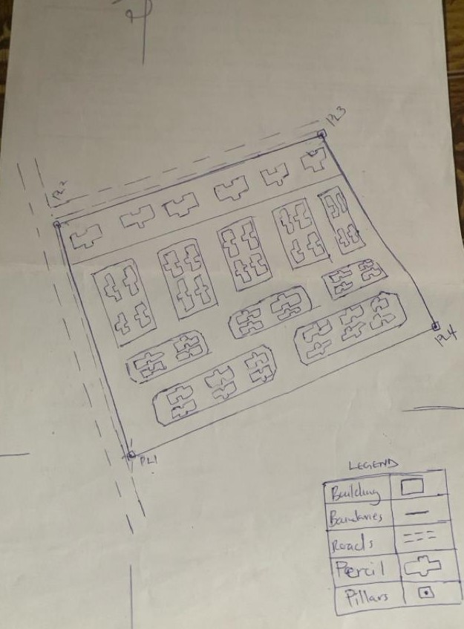
- Ensuring boundary points are clearly identifiable and unobstructed

Figure 3.6: shows the recce diagram of the study area

3.1.5 Equipment Used/ System Selection and Software

The equipment utilized for this project was sourced from two main avenues. Surveying instruments were obtained from the Department of Surveying and Geo-Informatics, Kwara State Polytechnic, while additional toolssuch as computers and relevant software packageswere provided by members of the project team.
The equipment was categorized into two groups:
- Hardware – This included physical tools and instruments such as:
  - Total Station
  - GPS Receivers
  - Measuring Tapes
  - Tripods
  - Field Notebooks
- Software – Digital tools used for data processing and analysis, including:
  - ArcGIS 10.1
  - AutoCAD
  - Microsoft Excel
  - Other supporting GIS or CAD software as needed

3.1.6 MONUMENTATION

Monumentation involves placing permanent location markers with identification numbers on the ground to mark boundaries or the intersection of survey points. These markers can be pegs, nails, iron rods, or concrete pillars of varying sizes, depending on the type and requirements of the survey.
2cm
3cm
Nail
13cm
15cm

Fig.3.7 A typical wooden peg and Nail

3.1.7 INSTRUMENT TEST
Before any survey instrument is taken out for survey work, the instrument to be used must be tested and found to be in good working condition. The aim of this test is to minimize the accumulation of errors in the field. CST/Berger (205) total station was used in acquiring data on the field test.

3.1.7.1 TEST FOR GPS
To test this equipment South Model of GPS sensor a wrist watch which has been rated against the pips of BBC was used. Reception signal from the satellite, the display of correct time broadcast, display of GDOP and date from a GPS and its accessories set outside were noted. The time signal was compared and found to be in agreement thus, the GPS was in perfect condition. This test was carried out to serve as a check; initially the GPS has been calibrated and configured by Federal, Oyo. The instrument was in continuous used and in good working condition. In fact, the instrument was used a day before this project was executed.
The following information was supplied prior to initialization.
- station identification
- height reading
- antenna offset reading
The receiver gathered data and this include phase data, receiver time and signal strength. The accuracy of this receiver was dictated by the warming up time used by reference oscillator for stability of the clock. The required stability of the receiver clock depends on the receiver design and how sophisticated the processing software is.

3.1.7.2 CONTROL CHECK
This is the operation that must be carried out on a set of controls to be used as a reference framework for any survey job. It was carried out by setting up the Total Station on the L30899 control station, back-sighting to L30898 and fore-sighting to L30900 (for orientation). The amount of discrepancy between the computed and the observed bearing and distances were used to determine that the coordinate values of the controls were in order.
The tables below show the values obtained from the computed and the observed values respectively.
L30898

L30899

L30900

Fig.3.9: Diagrammatic representation of checked angle and distances
TABLE 3.4 CONTROL CHECK (OBSERVED VALUES)
STATION | SIGHT | FACE | HORIZONTAL READING | ANGLE | DISTANCE(m)
L 30899 | L 30898 | L | 209º 46' 50" |  | 53.999m
L 30899 | L 30900 | L | 128º 59' 57" | 279º 13' 07" | 99.972m
Table 3.5 Control Checks (Computed values)
FROM STATION (A) | BEARING | DISTANCE | N(m) | E(m) | NORTHING (m) | EASTING (m) | TO  STATION (B)
 |  |  |  |  | 678266.86 | 939744.032 | L 30898
L 30898 | 76º 19' 32" | 53.999m | 13.002 | 53.441 | 678236.037 | 939791.738 | L 30899
L 30899 | 109º 53' 41" | 99.972m | -34.102 | 94.006 | 678224.051 | 939794.387 | L 30900

From computed values, forward bearing from L 30898 to L 30899 is 76º 19' 32" + 180º 00' 00" = 187º 19' 32"
Angle between the computed bearings = 109º 53' 41" + 187º 19' 32" = 279º 13' 13"
Angle between the observed bearings was deducted to be 279º 13' 07"
Check angle = Different between the computed angle and observed angle
= 279º 13' 13"- 279º 13' 07"= 000º 00' 06"

3.2 DATA ACQUISITION
Two types of data used for this study were spatial, attribute and non-spatial data. The spatial data include maps/plans of the study area and UTM MINNA DATUM coordinates, the attribute data are information about the plot owner, such as names address, sex, occupation, date of application, date of registration etc. obtained from the Ministry land files.
Data acquisition is the process of acquiring or obtaining data from the practical site. The primary source involved the acquisition of geometric (locational) data using South Differential Global Positioning System with the serial number SET550X 106489. While the collection of attributes (nonlocational) data through social surveys at the project site.

3.2.1 GEOMETRIC DATA ACQUISITION
The geometric data acquisition from the field was carried out with the use of South Differential Global Positioning System (SET550X 106489) with its accessories. Due to the scope of the project, the acquisition of the spatial data was carried out in two separate phases; boundary traverse with details and the traverse of the blocks with parcels.
Boundary traverse involved the perimeter traversing to demarcate the boundary of the project work. This involves taking measurements of all the points delineated along the boundary,thus establishing their X, Y values and the distances between adjacent points. Detailing involved the determination of the ‘X, Y’ of all the features located within the boundary of the work such features include stream, water reservoirs, roads etc. The traverse of blocks and parcels involve the measurement of the boundary points of blocks within the boundary thereby determining the positions of the parcels within each block and in the process laying out the roads linking each block and parcels.

3.2.2 ATTRIBUTE DATA COLLECTION
This aspect of data acquisition involves the collection of attribute data i.e. non-geometric data. Such data were directly related to the features to which geometric data was acquired. They included road names, building condition, parcel ownership, land use, pictures of the buildings, etc. Social survey was employed in the attribute data acquisition. This involved oral interviews, reading information from sign posts, wall signs, visual observations, etc. Pictures were taken using portable camera to capture images of features of interest.

3.3 DATA PROCESSING

3.3.1 DATA DOWNLOADING
It involves downloading of the data acquired from the South Differential Global Positioning System and editing of the downloaded data in preparation of script file for plotting.

3.3.2 DOWNLOADING PROCEDURE OF TOTAL STATION
The acquired data were stored in the memory of the South Differential Global Positioning System and downloaded via the system port of the equipment using external device, card reader.
3.3.3 BACK COMPUTATION OF THE PROJECT AREA

After the X, Y data of the boundary points was derived from the field, the back computation was carried out to obtain the bearing and distances between boundary points in an attempt to determine the size of land area covered. Below are the results of this back computation

3.4 PERIMETER SURVEY
The perimeter of the project area was traversed for the purpose of coordinating the boundary points. The total station was setup on the first control point L.30899, orientation was taken to another control point L.30900 after which the entire boundary was coordinated and this process were used for all other subsequent points.

Table 3.6 Back Computation of boundary coordinates
FROM | BEARING  (˚ ̍ ̎ ) | DIS (m) | N | E | EASTINGS  (E) | NORTHINGS  (N) | TO
 |  |  |  |  | 678266.86 | 939744.032 | P.1
P.1 | 25 00 53 | 177.155 | 160.538 | 74.910 | 678236.037 | 939791.738 | P.2
P.2 | 25 05 59 | 8.727 | 7,903 | 3.702 | 678224.051 | 939794.387 | P.3
P.3 | 103 02 55 | 416.831 | -94.111 | 406.068 | 678204.584 | 939801.514 | P.4
P.4 | 108 19 13 | 75.809 | -23.829 | 71.967 | 678186.283 | 939808.514 | P.5
P.5 | 141 06 10 | 309.821 | -241.126 | 194.544 | 678165.575 | 939815.951 | P.6
P.6 | 270 34 57 | 72.489 | 0.737 | -72.485 | 678148.605 | 939822.275 | P.7
P.7 | 272 57 29 | 247.838 | 12.790 | -247.508 | 678130.186 | 939829.384 | P.8
P.8 | 291 31 06 | 20.000 | 7.336 | -18.606 | 678098.65 | 939841.985 | P.9
P.9 | 291 27 02 | 256.328 | 93.738 | -238.573 | 678074.03 | 939851.362 | P.10
P.10 | 73 03 37 | 45.458 | 13.245 | -43.486 | 678055.502 | 939858.557 | P.11
P.11 | 271 05 13 | 88.913 | 37.280 | -80.720 | 678037.118 | 939865.28 | P.12
P.12 | 297 06 28 | 55.960 | 25.499 | -49.813 | 677990.517 | 939882.764 | PL.1

3.4.1 AREA COMPUTATION
The area computation was done using Autocad by clicking on the boundary points then enquiry icon pops up and the area was generated. The area was found to be 157948.607-meter square (15.795hectares)

3.4.2 LINEAR ACCURACY
Linear accuracy is use to test the quality of the job; the accuracy is approximately 1:88,000 based on this value obtained which is less than the maximum allowable linear accuracy of third order land survey (1: 5,000). Based on the value obtained and the allowable accuracy of third order land survey carried out according to survey rules, regulation and departmental instruction; therefore, the project is within the allowable limit
Table 3.7: Linear Accuracy
 | PILLAR NO | NORTINGS(m) | EASTHINGS (m)
INITIAL COORDINATE | L30899
CLOSING COORDINATE | L30899
Difference |  | -0.002 | 0.020
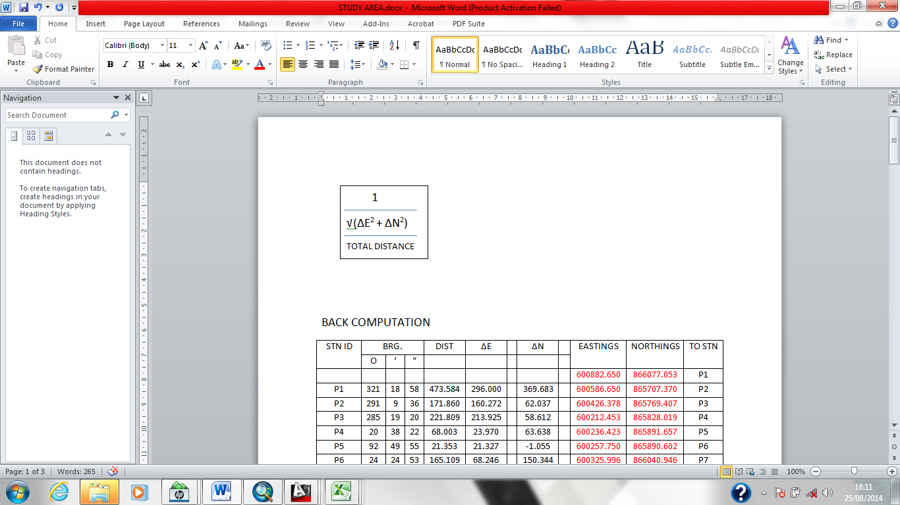 | TOTAL MISCLOSURE IN NORTHINGS (∆N) = -0.002
 | TOTAL MISCLOSURE IN EASTINGS (∆E) = 0.020
 | TOTAL DISTANCE = 1775.329
 | LINEAR ACCURACY = 1:88325.920
 | Approximately= 1:88,000

3.5 PHYSICAL DESIGN
This involved the representation of the data structure in the format of the implementation software i.e. ArcGIS10.2. The basic input data sets also had to be put in place. Since the data source was primary in nature with attribute data obtained by social survey method, the table created were then populated with the data acquired from the field (geometric and attribute) after taken care of necessary formatting and editing. The entities identified were used to form a relation database in ArcGIS10.2.
The selection of the implementation software was based on the following criteria such as;
- User Requirement Analysis
- Data Volume and Type
- Software Availability, etc.
But for this project, all the systems available at our disposal were capable of handling the issues involved.
Table 3.8: Road Entity Data Structure
ATTRIBUTE | DATA TYPE | WIDTH | DECIMAL
Road ID | String | 10 | -
Road Name | String | 10 | -
Road Type | String | 10 | -

Table 3.9: Parcel Entity Data Structure
Attribute | Data type | Width | Decimal | Null value
Object ID | Numeric | 6 | - | Yes
Shape Area | Double | - | - | Yes
P_Id | Double | 15 | - | No
P_Owner | Text | 255 | - | Yes
P_Status | Text | 255 | - | Yes
P_Address | Text | 255 | - | Yes
Attribute | Data type | Width | Decimal | Null value
P_Use | Text | 255 | - | Yes
C_of_O | Text | 255 | - | Yes
P_Block | Double | 15 | - | Yes
P_Road | Text | 255 | - | Yes
O_Sex | Text | 8 | - | No

3.6 DATABASE CREATION
The tables were created and populated in ArcGIS 10.2 and the attribute tables were linked with geometric data. See table 3.1

Table 3.11: Attribute table for Parcel
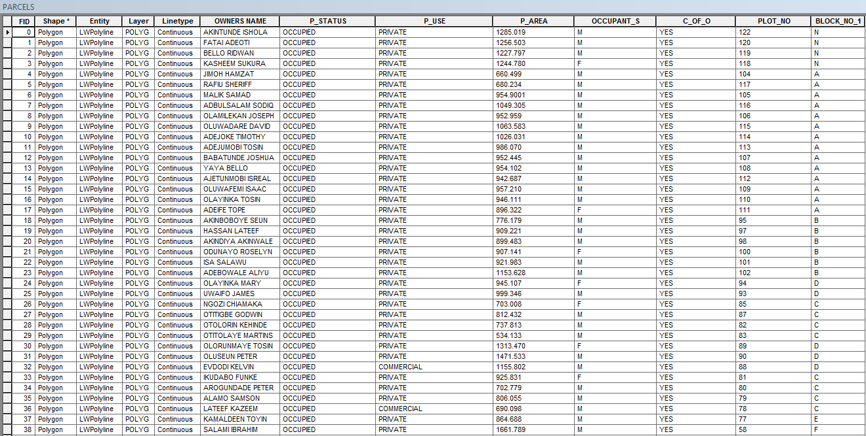

Table 3.12: Attribute table for Road
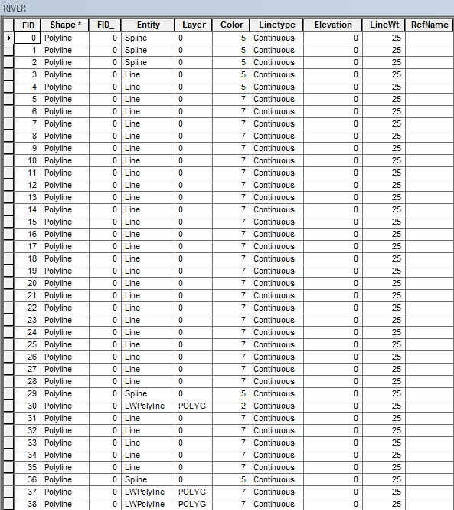

3.7 DATABASE MANAGEMENT SYSTEM
Database management system refers to the collection of software for organizing the information in a database. It is also a collection of set of programmed which are used to maintain and manipulate the data. It shares data orderly and acts as the central control over all the interactions. It manages the data using alphanumeric data with limited capabilities of performing spatial queries. A DBMS must allow the definition of data and their attributes and relationships as well as providing security and an interface between the end users and their applications and the data themselves, it reduces redundancy.

3.8 DATA SECURITY

Security is of great concern to land administration because of the legal implication of land records. Security of the records is of almost importance to all concerned. These include:
- Physical security: The use of burglary proof, firefighting equipment-controlled access, proper records of the moment of personal and out of the office circuit break.
- System Security: Uninterrupted power supply (UPS) will be used to control voltage, use of passwords and backups.

3.8.1 DATA INTEGRITY
This has to do with the relevance or importance of the data kept in a database. The Systems were programmed in such a way that the systems can warn operator in case of violation of integrity. The following are ways by which integrity can be enforced in a database;
- Entity: This places constraint on primary key values that ensures no attributes of a primary key is null.
- Referential Integrity: - This is a constraint on foreign key value that ensures that if foreign key exist in a relation, then either the foreign key must match the primary key value of some tuple in its’ relation or the foreign key value must be completely null.

3.8.2 DATABASE MAINTENANCE

The Database created was properly maintained. It was maintained such that the qualities of the database stand and depend on its currency and fitness for use as Decision Support System (DSS). The database should therefore be kept up to date as this is very essential for decision-making.

CHAPTER FOUR
- ANALYSIS AND INFORMSTION PRESENTATION
4.1 TESTING OF DATABASE
These are essential operations performed on a GIS database simply to retrieve information. The selection of various combinations of variable for examination are performed on data, is as a result of queries performed on GIS database, and new information produced as a result of data and results obtained. And the analyses are considered within the areas of single and multi-criteria analysis.

4.1.1 SPATIAL ANALYSIS
Spatial analysis deals with spatial pattern defining, the location relationships among points lines, polygon, surface and spatial processes that define the nature of these feature in terms of position distance and direction or the connectivity of the point. However, spatial analysis is allowing for the creation of new information about the features that were already been linked up in the database.

4.1.2 DATABASE IMPLEMENTATION
This is the implementation of the data model designed in the appropriate configuration. Database implementation involves the combination and the storage of the acquired graphical and attributes data obtained in formal designed GIS database of a generic structure for the purpose of usage in the spatial analysis and queries of the project site. Having designed a geometric data structure, the designed and created tables under physical design phase were populated with data. ArcGIS 10.2 was used to create, manipulate, maintain and access the database easily.
4.1.3 QUERY AND PRESENTATION OF ANALYSIS
Multi criteria query ask more than one question, such that, it locates a position and also relates to other things in the environment while single criteria ask for one them to determine the location of an object. Spatial search operations were used to demonstrate single and multi-criteria analysis. It answers questions like what is where? Where is what? And provides answers to the needed information through processing or manipulating spatial data. Spatial search also finds for attribute within the neighborhood and defined through this:
(i) Query by location
(ii) Query by attribute
QUERY B `Y LOCATION
This was used to retrieve geographic records form the information system by defining certain criteria. Two ways of doing these are: -
By defining a spatial query in the selected location in dialogue box, identify tool to chick on the feature.
QUERY BY ATTRIBUTE
This is the process of retrieving geographical information by defining a certain criterion. It was carried out through the use of structured query language (SQL) by ArcGIS.
4.2 ANALYSIS PERFORMED
The analyses performed in this project were based on relevant layer of composite plan. Fig 4.2 the analysis performed was
- To determine parcels of land greater than 1200m2
- To determine the parcels of land less than or equal to 700m2
- To determine the parcels of land less than or equal to 1100m2
- To determine the parcels for commercial purpose with C of O.
- To determine the parcels of land less than or equal to 700m2 with C of O
- To determine the parcels of land greater than or equal to1200m2 with C of O

4.3.1 SINGLE CRITERIA QUERY
Single criterion carried out where one condition is used to design query, e.g. select the entire parcels that perform single option. The products of single criteria are display below:

Analysis Name: Database extraction

Analysis Type: Single Criterion analysis.

Procedure: SELECTION*; SELECTION BY ATTRIBUTE*; PERCEL STATUS* = *; GET UNIQUE VALUE*; PARCEL GRATER THAN 1200m2
Syntax: - “Parcel status” >1200’

Result: -
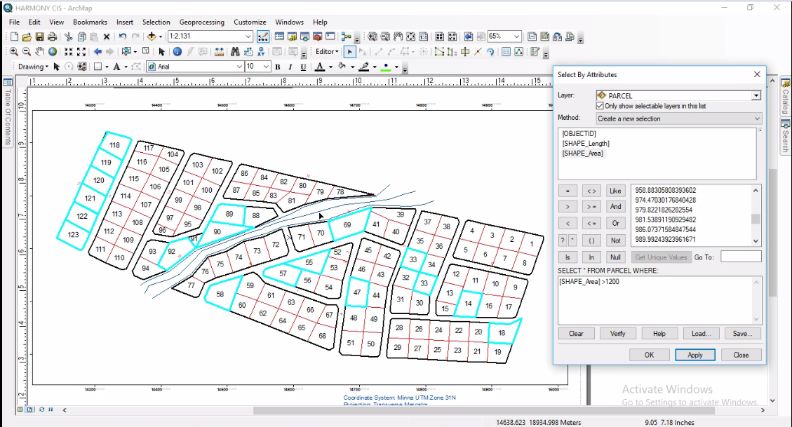
Fig 4.1:"Parcel Status" = 'PERCEL GREATER THAN 1200m2’
Discussion: The analysis shows the parcels that are greater than 1200m2 in the study area, 18 plots out of 123 parcels of land. This will help the authority/ decision maker of urban estate to assess these parcels of land above 1200m2 plot, for easy access.

Analysis Name: Database extraction

Analysis Type: Single Criterion analysis.

Procedure: SELECTION*; SELECTION BY ATTRIBUTE*; PERCEL STATUS* = *; GET UNIQUE VALUE*; PERCEL LESS THAN OR EQUAL TO 700m2’
Syntax: - “Parcel status” = '<=700m2’

Result: -

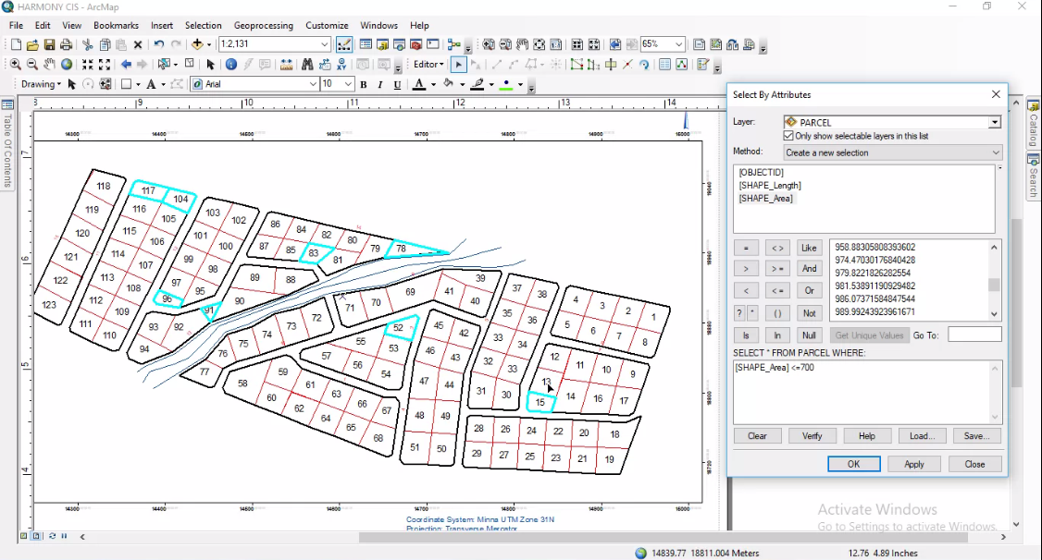
Fig 4.2:"Parcel Status" = ' PERCEL LESS THAN OR EQUAL TO 700m2’
Discussion: The analysis shows the parcels that are less than or equal to 700m2 in the study area, 8 plots out of 123 parcels of land.
Analysis Name: Database extraction

Analysis Type: Single Criterion analysis.

Procedure: SELECTION*; SELECTION BY ATTRIBUTE*; PERCEL STATUS* = *; GET UNIQUE VALUE*; PARCEL LESS THAN OR EQUAL TO 1100 m2
Syntax:-p area <=1100m2

Result:-

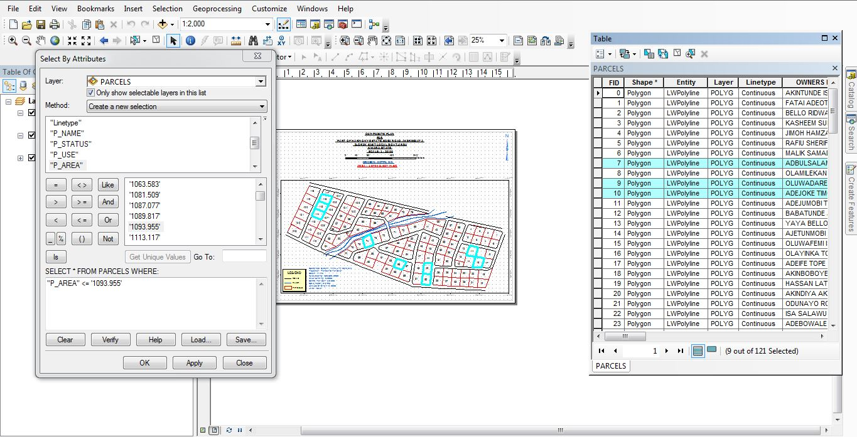
Discussion: The analysis shows the parcels that are less than or equal to 1100m2in the study area, 9 plots out of 123 parcels of land.

4.3.2 MULTIPLE CRITERIA QUERY
This is a situation where two or more conditions are used to design a query. The attribute data of two or more layers were combined to do multiple queries by joining data from another layer based on spatial location through selection by attribute in ArcGIS environment.

Analysis Name: Database extraction

Analysis Type: Multiple Criterion analysis.

Procedure: SELECTION*; SELECTION BY ATTRIBUTE*; PERCEL STATUS* = *; GET UNIQUE VALUE*; PERCEL FOR COMMERCIAL PURPOSE WITH C OF O’
Syntax:-p_use = commercial and c of o = yes
Result:-

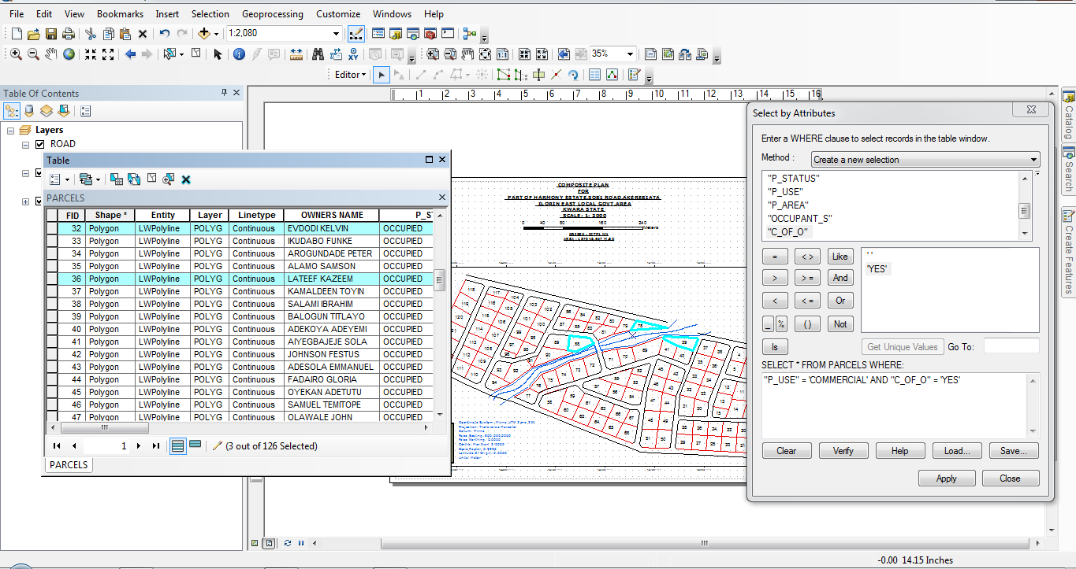
Discussion: Analysis shows that 3 parcels out of 123 parcels used for commercial purposes with c of o in the study area Analysis Name: Database extraction

Analysis Type: Multiple Criterion analysis.

Procedure: SELECTION*; SELECTION BY ATTRIBUTE*; PERCEL STATUS*=*; GET UNIQUE VALUE*; PERCEL LESS THAN OR EQUAL TO 700m2 WITH C OF O
Syntax: “p area <=700m2 and c of o
Result: -
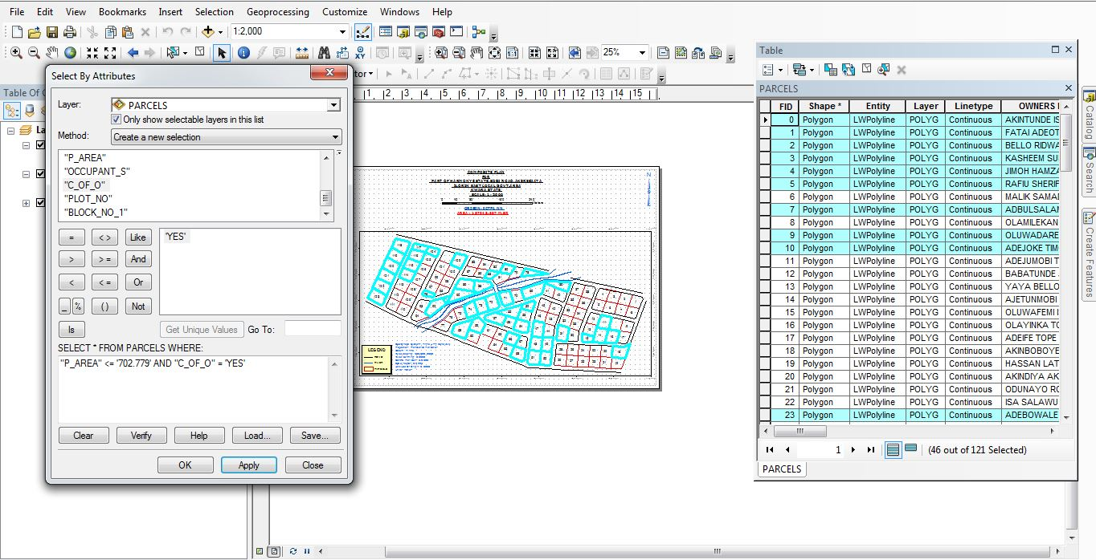
Fig.4.3: Query For parcel less than or equal to 700m2 with c of o
Discussion: Analysis shows that 46 parcels out of 123 parcels are less than or equal to 700m2 with c of o in the study area.

Analysis Name: Database extraction

Analysis Type: Multiple Criterion analysis.
Procedure: SELECTION*; SELECTION BY ATTRIBUTE*; PERCEL STATUS
*; = *; GET UNIQUE VALUE*; YES
Syntax: - “P area>=1200 and C of O “=’yes

Result: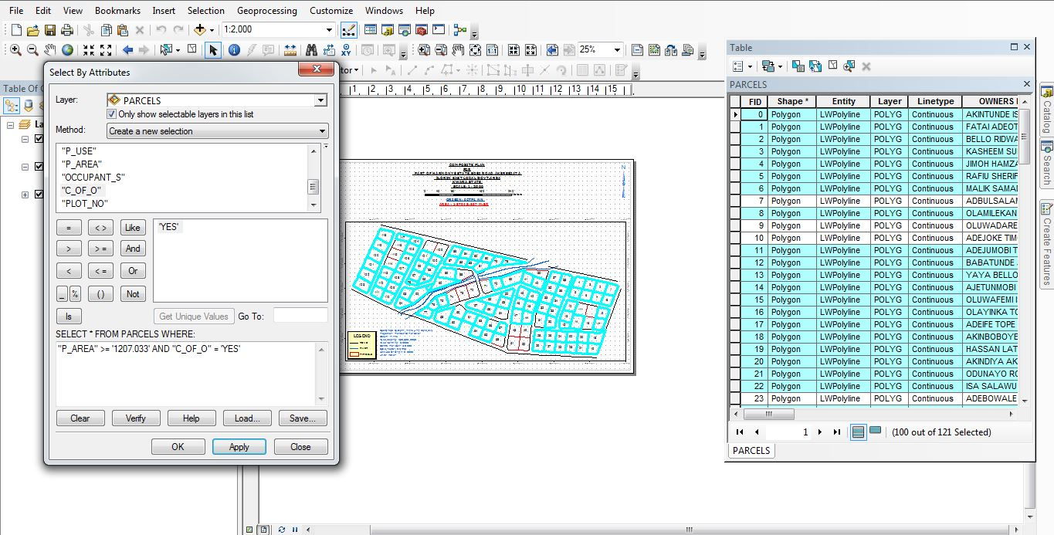
Fig 4.4 Query for parcels greater than 1200m2 with C of O
Discussion: Analysis shows that 103 plots out of 123 parcels are greater than 1200m2 with C of O.
4.4 APPLICATION OF PRODUCT
- It facilitates the use of GIS for effective land management and physical planning.
- It can be applying for generation of tax.
- It can be used for distribution of infrastructural facility in the study area.
- It can be used for decision making by authority in charge of the estate.
- It can be used for utility distribution planning operation.
- It can be used for sustainable land development project in the study area.

CHAPTE FIVE

5.0 COST ESTIMATION, SUMMARY, RECOMMENDATION ANDCONCLUSION
5.1 COST ESTIMATION
RECCONNAISSANCE
S/N | PERSONNEL | QTY | DAILY RATE | NO OF DAYS | REMARK
1 | Group leader | 1 | 5000 | 1 | 5000
2 | Ass group leader | 1 | 2500 | 1 | 2500
3 | Basic equipment | 1 | 25000 | 1 | 25000
4 | Transportation | 1 | 3000 | 1 | 3000
Subtotal = #35,500
Monumentation
S/N | PERSONNEL | QTY | DAILY RATE | NO OF DAYS | REMARK
1 | Group leader | 1 | 5000 | 1 | 5000
2 | Ass group leader | 1 | 2500 | 1 | 2500
3 | Skilled labor | 3 | 1500 | 1 | 4500
4 | Basic equipment | 1 | 25000 | 1 | 25000
5 | Transportation | 1 | 7500 | 1 | 3000
Subtotal = #40,000

Beaconing
S/N | PERSONNEL | QTY | DAILY RATE | NO OF DAYS | REMARK
1 | Group leader | 1 | 5000 | 1 | 5000
2 | Ass group leader | 1 | 2500 | 1 | 2500
3 | Basic equipment | 1 | 5000 | 1 | 5000
4 | Transportation | 1 | 3000 | 1 | 3000
Subtotal = #5,500
Beacon
S/N | PERSONNEL | QTY | DAILY RATE | NO OF DAYS | REMARK
1 | Group leader | 1 | 5000 | 1 | 5000
2 | Ass group leader | 1 | 2500 | 1 | 2500
3 | Beacon | 10 | 1000 | 1 | 10,000
4 | Transportation | 1 | 3000 | 1 | 3000
Subtotal = #19,500
Traversing
S/N | PERSONNEL | QTY | DAILY RATE | NO OF DAYS | REMARK
1 | supervisor | 1 | 6000 | 1 | 6000
2 | Group leader | 1 | 5000 | 1 | 5000
3 | Ass group leader | 1 | 2500 | 1 | 2500
4 | Skilled labour | 6 | 1500 | 1 | 10,000
5 | Basic equipment | 1 | 25000 | 1 | 5000
6 | Transportation | 1 | 10,500 | 1 | 10,500
Subtotal = #43,500
Contouring
S/N | PERSONNEL | QTY | DAILY RATE | NO OF DAYS | REMARK
1 | Supervisor | 1 | 6000 | 2 | 12,000
2 | Group leader | 1 | 5000 | 2 | 10,000
3 | Ass group leader | 1 | 2500 | 2 | 5000
4 | Skilled labor | 6 | 1500 | 2 | 20,000
5 | Basic equipment | 1 | 25000 | 1 | 5000
6 | Transportation | 1 | 10,500 | 2 | 21,000
Subtotal = #73,000
Data processing
S/N | PERSONNEL | QTY | DAILY RATE | NO OF DAYS | REMARK
1 | Group leader | 1 | 5000 | 1 | 5000
2 | Ass group leader | 1 | 2500 | 1 | 2500
3 | Basic equipment | 1 | 10,000 | 1 | 10,000
4 | Generator and fuel | 1 | 10,000 | 1 | 10,000
Subtotal = #27,500

Technical report
S/N | PERSONNEL | QTY | DAILY RATE | NO OF DAYS | REMARK
1 | Group leader | 1 | 5000 | 1 | 5000
2 | Ass group leader | 1 | 2500 | 1 | 2500
3 | Basic equipment | 1 | 10,000 | 1 | 10,000
4 | Generator and fuel | 1 | 10,000 | 1 | 10,000
Subtotal = #27,500
Sum total = 271,500.00

Contingency allowance = 271,500.00 X 5 = 13,575
100
VAT = 271,500.00 X 7.5 = 20,362.5
100

ACCOMODATION = 271,500.00 X 1.5 = 4,072.5
100
MOB/DEMB = 271,500.00 X 10 = 27,150
100

GLEARANCE TAX = 65, 159.5

  - SUMMARY
This project focused on the development of a Land Information System (LIS) for an urban estate located opposite the Government Cemetery along Oke-Ose/Oke-Oyi Road, Ilorin, in Ilorin East Local Government Area of Kwara State, Nigeria. The primary objective was to collect, process, and present spatial data that accurately represents the land terrain and features within and around the project site.
To achieve this, modern surveying technology was employed. Specifically, a CST/Berger (205) Total Station and its accessories were used for field data acquisition. The survey involved key techniques such as spot heighting and the fixing of topographic and built environment features across the project area.
The collected data were downloaded, systematically organized, and processed using standard surveying software. Tolerance tests were conducted to ensure accuracy and reliability of the data, and the results were found to be within acceptable limits.
The processed spatial data were then used to produce detailed LIS maps, which graphically illustrate the relative positions, elevations, and distribution of features within the estate. Finally, a comprehensive report was compiled and printed to document the methodologies, results, and applications of the project.
  - RECOMMENDATION
It is recommended that Land Information Systems (LIS) be incorporated into the practical and project-based curriculum for students in educational institutions. This integration will equip students with the technical skills and spatial understanding necessary for effective land terrain analysis and future project planning. Additionally, schools should invest in modern digital tools and geospatial technologies to support hands-on learning and enhance students’ capacity to apply LIS in real-world scenarios.
  - CONCLUSION
The study of Land Information Systems is increasingly relevant in today's world, where land-related issues intersect with economic development, urbanization, climate change, and social equity. A well-designed LIS supports transparent, efficient, and equitable land administration, which is essential for achieving sustainable development and good governance. As such, LIS is a multidisciplinary field involving geography, information technology, law, economics, and public administration.

REFERENCE
- Ali, D. A., Deininger, K., & Goldstein, M. (2015). Environmental and gender impacts of land tenure regularization in Africa: Pilot evidence from Rwanda. Journal of Development Economics.
- Dale, P., & McLaughlin, J. (1999). Land administration. Oxford University Press.
- Enemark, S., Williamson, I., & Wallace, J. (2005). Building modern land administration systems in developed economies. Journal of Spatial Science.
- Lemmen, C., Van Oosterom, P., & Bennett, R. (2015). The Land Administration Domain Model. Land Use Policy.
- Williamson, I., Enemark, S., Wallace, J., &Rajabifard, A. (2010). Land administration for sustainable development. ESRI Press.
- Zevenbergen, J., Augustinus, C., Antonio, D., & Bennett, R. (2013). Pro-poor land administration: Principles for recording the land rights of the underrepresented. Land Use Policy.
- Augustinus, C. (2010). Social tenure domain model: What it can mean for the land industry and for the poor. FIG Congress.
- Barry, M., &Meinzen-Dick, R. (2010). The spatial and institutional linkages of land tenure. Land Use Policy.
- Bandyopadhyay, D. (2013). Reforming land administration in India: Issues and perspectives. Economic and Political Weekly.
- Deininger, K., & Feder, G. (2009). Land registration, governance, and development: Evidence and implications. The World Bank Research Observer.
- Giovarelli, R., et al. (2013). Gender and land governance: Evidence from Ethiopia, Ghana, and India. World Bank.
- Lemmen, C., & Bennett, R. (2019). Blockchain for land administration: Hype or relevant? Land Use Policy.
- Larson, A. M., et al. (2013). Land tenure and REDD+: The good, the bad and the ugly. Global Environmental Change.

APPENDIX
ID | EASTINGS | NORTHINGS | HEIGHT
P1 | 678223.8871 | 940129.04 | 311.963
P2 | 678010.7717 | 939958.8882 | 311.735
P3 | 677998.0981 | 939930.4719 | 312.49
P4 | 678030.3085 | 939919.1424 | 312.229
P5 | 678040.6538 | 939947.3471 | 310.983
P6 | 678206.4002 | 940155.1631 | 311.295
P7 | 678204.0433 | 940130.0322 | 308.727
P8 | 678050.6528 | 940076.2466 | 310.979
P9 | 678249.6641 | 940149.6206 | 311.686
P10 | 678045.7845 | 940018.6731 | 310.714
P11 | 678040.387 | 940001.6869 | 309.894
P12 | 678033.5078 | 939983.4306 | 310.018
P13 | 678026.8932 | 939966.4972 | 310.986
P14 | 678059.2567 | 939940.4044 | 312.795
P15 | 678049.0702 | 939911.4854 | 314.948
P16 | 678076.6134 | 939934.5835 | 313.83
P17 | 678052.8224 | 939956.443 | 313.01
P18 | 678058.9078 | 939974.4347 | 312.533
P19 | 678067.6391 | 939992.1618 | 312.227
P20 | 678075.6295 | 940034.7598 | 312.366
P21 | 678048.1128 | 940037.2999 | 312.54
P22 | 678048.7478 | 940056.7732 | 312.106
P23 | 678252.0983 | 940126.1711 | 310.248
P24 | 678107.2702 | 940071.4276 | 311.14
P25 | 678105.0477 | 940051.2134 | 313.071
P26 | 678106.6352 | 940030.7082 | 314.224
P27 | 678103.9749 | 940031.0558 | 314.788
P28 | 678257.346 | 940141.7004 | 315.142
P29 | 678103.7283 | 940006.5287 | 315.237
P30 | 678075.2062 | 940012.3231 | 315.226
P31 | 678097.5371 | 939982.2929 | 314.905
P32 | 678089.1233 | 939963.2164 | 314.752
P33 | 678082.0325 | 939946.0713 | 314.545
P34 | 678096.4108 | 939926.7915 | 314.656
P35 | 678066.8502 | 939905.2941 | 315.763
P36 | 678086.436 | 939898.5022 | 315.539
P37 | 678092.3874 | 939941.4376 | 316.288
P38 | 678110.7709 | 939994.7147 | 316.44
P39 | 678118.8458 | 940053.7667 | 311.161
P40 | 678120.5391 | 940080.2251 | 309.836
P41 | 678146.9975 | 940050.38 | 310.313
P42 | 678144.2988 | 940007.8217 | 316.979
P43 | 678115.4609 | 939920.1558 | 316.887
P44 | 678105.195 | 939891.1574 | 316.841
P45 | 678123.9011 | 939884.9397 | 316.838
P46 | 678137.0368 | 939879.6074 | 318.434
P47 | 678146.5742 | 939921.3292 | 318.531
P48 | 678144.2458 | 940028.1549 | 312.673
P49 | 678149.9609 | 940075.78 | 309.705
P50 | 678179.3826 | 940069.6417 | 313.61
P51 | 678187.9286 | 940047.9128 | 316.046
P52 | 678175.3609 | 940044.665 | 316.84
P53 | 678185.5738 | 940024.6823 | 317.552
P54 | 678170.7571 | 940005.2817 | 317.914
P55 | 678181.9226 | 939992.9322 | 317.933
P56 | 678205.0066 | 939986.2416 | 317.983
P57 | 678200.8248 | 939974.4376 | 318.092
P58 | 678152.8155 | 939939.4528 | 318.351
P59 | 678173.2178 | 939965.1311 | 318.62
P60 | 678140.0654 | 939987.5016 | 319.544
P61 | 678098.1024 | 939960.6993 | 319.951
P62 | 678147.3168 | 939910.4985 | 320.364
P63 | 678156.2579 | 939917.5501 | 320.935
P64 | 678189.1678 | 939906.9186 | 320.847
P65 | 678194.0816 | 939925.1416 | 320.303
P66 | 678118.8458 | 939930.8542 | 319.988
P67 | 678158.9567 | 939958.4239 | 319.394
P68 | 678198.0812 | 939954.3805 | 318.672
P69 | 678165.8888 | 939980.5166 | 318.567
P70 | 678215.5016 | 940015.8655 | 319.324
P71 | 678174.7259 | 940023.4983 | 319.5
P72 | 678222.8802 | 940043.8911 | 319.803
P73 | 678224.5885 | 940152.833 | 308.619
PT 1 | 677996.0659 | 939928.4542 | 308.125
PT 2 | 678015.1633 | 939969.7276 | 310.5781
PT3 | 678036.824 | 940012.1661 | 309.517
PT 4 | 678046.4226 | 940091.2904 | 312.2569
PT 5 | 678072.6318 | 940180.4691 | 309.2145
PT 6 | 678181.4317 | 940158.3618 | 311.686
PT 7 | 678250.2935 | 940149.54 | 315.142
PT 8 | 678257.7321 | 940142.843 | 319.324
PT 9 | 678200.8248 | 939974.4376 | 320.303
PT 10 | 678198.0812 | 939954.3805 | 321.636
PT 11 | 678194.0816 | 939925.1416 | 315.2363
PT 12 | 678177.3224 | 939862.9887 | 314.369
SH 1 | 678156.8273 | 940097.2932 | 312.937
SH 2 | 678139.4376 | 940107.303 | 313.154
SH 3 | 678175.8995 | 940150.3599 | 309.062
SH 4 | 678120.8337 | 940127.4392 | 308.631
SH 5 | 678019.2155 | 939961.2792 | 309.796
SH 6 | 678021.2437 | 939974.6887 | 308.743
SH 7 | 678122.4608 | 940162.96 | 308.918
SH 8 | 678064.3789 | 940118.8295 | 310.767
SH 9 | 678225.2162 | 940095.1114 | 312.183
SH 10 | 678087.6507 | 940119.369 | 312.384
SH 11 | 678032.2003 | 939994.9791 | 309.28
SH 12 | 678045.4444 | 940063.4523 | 309.731
SH 13 | 678038.5445 | 940019.7398 | 311.863
SH 14 | 678116.9352 | 940111.0523 | 311.593
SH 15 | 678045.8909 | 940088.9476 | 309.517
SH 16 | 678093.7139 | 939963.1639 | 315.033
SH 17 | 678057.7217 | 939947.0524 | 314.372
SH 18 | 678122.8163 | 940017.7508 | 316.029
SH 19 | 678117.1823 | 940035.8986 | 314.277
SH 20 | 678115.1461 | 940084.3358 | 312.868
SH 21 | 678113.2724 | 940023.3274 | 314.463
SH 22 | 678171.4015 | 940018.296 | 315.665
SH 23 | 678153.8916 | 939924.0063 | 317.714
SH 24 | 678167.5446 | 939962.3643 | 317.811
SH 25 | 678128.6204 | 939924.1678 | 317.177
SH 26 | 678146.1886 | 939893.8623 | 318.511
SH 27 | 678159.6454 | 939941.5338 | 317.945
SH 28 | 678124.2366 | 940048.6235 | 316.734
SH 29 | 678125.589 | 940026.5466 | 315.827
SH 30 | 678108.6175 | 940009.2336 | 313.946
SH 31 | 678188.8257 | 940064.8975 | 315.213
SH 32 | 678165.4411 | 939909.4305 | 320.879
SH 33 | 678162.6565 | 939900.7976 | 320.81
SH 34 | 678156.3647 | 939883.4787 | 320.386
SH 35 | 678152.7852 | 939874.0005 | 319.936
SH 36 | 678175.1852 | 939866.8449 | 321.636
SH 37 | 678171.4438 | 939883.4967 | 321.911
SH 38 | 678180.2628 | 939896.6944 | 321.473
SH 39 | 678217.7268 | 940106.9425 | 319.056
SH 40 | 678206.6779 | 940063.4972 | 318.837
SH 41 | 678223.8458 | 940060.2054 | 317.844
SH 42 | 678104.3976 | 940168.4907 | 312.691
SH 43 | 678221.4394 | 940083.5203 | 312.618

