DESIGN AND IMPLEMENTATION OF A FOOD MENU MANAGEMENT SYSTEM

BY
OJO JOSHUA OPEMIPO
ND/23/COM/FT/0021

SUBMITTED TO THE DEPARTMENT OF COMPUTER SCIENCE,
INSTITUTE OF INFORMATION AND COMMUNICATION TECHNOLOGY,

KWARA STATE POLYTECHNIC, ILORIN
IN PARTIAL FULFILLMENT OF THE REQUIREMENTS FOR THE AWARD OF NATIONAL DIPLOMA (ND) IN
COMPUTER SCIENCE

JULY, 2025.
CERTIFICATION
This is to certify that this project was carried out by OJO JOSHUA OPEMIPO with the Matriculation Number: ND/23/COM/FT/0021 in the Department of Computer Science, Institute of Information Communication Technology, Kwara State Polytechnic, Ilorin, Kwara State.

…………………………………. ….………………………
MR. BOLAJI-ADETORO D.F. Date
Project Supervisor

…………………………………. ….………………………
MR. OYEDEPO, F. S. Date
Head of Department

…………………………………. ….………………………
External Examiner Date

DEDICATION
I dedicate this project work to the Almighty God who inspired me and directed my ways during my academic stay in the polytechnic.

ACKNOWLEDGEMENTS
All praise is due to the Almighty God, the Lord of the universe. I praise Him and thank Him for giving me the strength and knowledge to complete my ND program and also for my continued existence on Earth.
I appreciate the utmost effort of my supervisor, Mr. Bolaji-Adetoro D.F. whose patience, support, and encouragement were the driving force behind the success of this research work. He gave useful corrections, constructive criticisms, comments, recommendations, and advice and always ensures that excellent research is done. My sincere gratitude goes to the Head of the Department, Mr. Oyedepo, F. S., and other members of staff of the Department of Computer Science, Kwara State Polytechnic, Ilorin, for their constant cooperation, constructive criticisms, and encouragement throughout the program.
Special gratitude to my parents, who exhibited immeasurable financial, support, patience, prayers, and understanding during the period in which I was busy tirelessly with my studies, special thanks go to my lovely siblings too.
My sincere appreciation goes to my friends and classmates.

TABLE OF CONTENTS
Title page i
Certification ii
Dedication iii
Acknowledgments iv
Table of Contents v
Abstract vi
CHAPTER ONE: GENERAL INTRODUCTION
1.1 Background to the Study 1
1.2 Statement of the Problem 3
1.3 Aim and Objectives 3
1.4 Significance of the Study 3
1.5 Scope of the Study 4
1.6 Organization of the Report 4
CHAPTER TWO: LITERATURE REVIEW
2.1 Review of Related Works 6
2.2 Review of General Texts 10
CHAPTER THREE: RESEARCH METHODOLOGY AND
ANALYSIS OF THE SYSTEM
  - Research Methodology 14
  - Analysis of the Existing System 15
  - Problem of the Existing System 16
  - Description of the Proposed System 16
  - Advantages of the Propose System 17
CHAPTER FOUR: DESIGN, IMPLEMENTATION AND
DOCUMENTATION OF THE SYSTEM
  - Design of the System 19
    - Output Design 19
    - Input Design 20
    - Database Design 23
    - Procedure Design 24
  - Implementation of the System 24
    - Choice of programming language 25
    - Hardware support 25
    - Software Support 25
4.2.4 Implementation Techniques used in Details 25
  - Program Documentation 26
    - Operating the System 26
    - Maintaining of the System 26
CHAPTER FIVE: SUMMARY CONCLUSION AND
RECOMMENDATION
5.1 Summary 28
5.2 Conclusion 28
5.4 Recommendations 28
References 30

ABSTRACT
In the food service industry, the management and maintenance of food menus can be a complex and time-consuming task. Keeping menus updated and consistent across multiple platforms is crucial for providing accurate information to customers and enhancing their dining experience. To address these challenges, the design and implementation of a food menu directorate system can greatly streamline menu management processes. This system aims to centralize menu creation, editing, and organization, ultimately improving efficiency and reducing errors in menu updates. With the advent of digital solutions, restaurants, cafes, and other food establishments can now leverage technology to create a seamless and dynamic menu experience for their customers. Traditionally, managing food menus has been a manual and time-consuming process. Updating menus across multiple platforms such as websites, mobile apps, and physical menu boards can be challenging, leading to inconsistencies and errors in the information presented to customers. Furthermore, manual menu management can be inefficient, requiring significant effort from staff to make changes and ensure accurate communication of menu updates. Research methodology has many research dimensions and methods. The scope of research methodology is wider than research method. This is mainly adopted by the researcher in undertaking this research. Methodology is the underlying principles and rules that govern a system method, on the other hand it is a systematic procedure for a set of activities. Thus, from these definitions a methodology encompasses the methods used within a study.

CHAPTER ONE
INTRODUCTION
  - BACKGROUND OF THE STUDY
Menu directorate systems offer numerous benefits for food service establishments. Firstly, they provide a user-friendly interface that simplifies the process of creating and editing menus. Through an intuitive dashboard, restaurant staff can easily add or remove menu items, modify prices, and update descriptions. By streamlining these processes, the system minimizes the time and effort required for menu management, allowing staff to focus on other essential tasks in the restaurant (Smith, 2020).
In the food service industry, the management and maintenance of food menus can be a complex and time-consuming task (Smith, 2020). Keeping menus updated and consistent across multiple platforms is crucial for providing accurate information to customers and enhancing their dining experience. In addressing the challenges, the design and implementation of a food menu directorate system can greatly streamline menu management processes. The system aim to centralize menu creation, editing, and organization, ultimately improving efficiency and reducing errors in menu updates. With the advent of digital solutions, restaurants, cafes, and other food establishments can now leverage technology to create a seamless and dynamic menu experience for their customers (Brown & Davis, 2019).
Secondly, menu directorate systems facilitate seamless synchronization of menu updates across various platforms. For instance, when a menu item is added or modified in the system, the changes are automatically reflected on the restaurant's website, mobile app, and any digital menu boards. This synchronization ensures that customers have access to the most up-to-date and accurate menu information, regardless of the platform they choose to view it on. (Brown & Davis, 2019).
The design and implementation of a food menu directorate system offers numerous advantages for food service establishments. By centralizing menu management, providing a user-friendly interface, and enabling seamless synchronization across platforms, the system improves operational efficiency and ensures consistent and accurate menu information. The inclusion of a centralized database, role-based access control, and customizable layouts further enhances menu organization and customization. Real-time updates on menu availability and the generation of reports and analytics contribute to a better customer experience and enable data-driven decision-making for menu optimization, (Charlene Li, et al., 2020).
  - STATEMENT OF THE PROBLEM
Traditionally, managing food menus has been a manual and time-consuming process. Updating menus across multiple platforms such as websites, mobile apps, and physical menu boards can be challenging, leading to inconsistencies and errors in the information presented to customers. Furthermore, manual menu management can be inefficient, requiring significant effort from staff to make changes and ensure accurate communication of menu updates.
1.3 AIM AND OBJECTIVES
The aim of this project is to design and implement a food menu directorate system that addresses the challenges faced in managing and updating menus. The specific objectives of the system are as follows:
- Develop a user-friendly interface for creating and editing menus.
- Provide a centralized database for storing menu information and related details.
- Incorporate features to handle different menu categories, item descriptions, prices, and dietary information.
- Implement role-based access control to ensure appropriate user permissions for menu management.
- Facilitate easy customization of menu layouts and designs.
1.4 SIGNIFICANCE OF THE STUDY
The food menu directorate system offers several significant benefits for both food service establishments and their customers. Firstly, it improves operational efficiency by reducing the time and effort required to manage menus. Menu updates can be made quickly and easily, ensuring that customers receive accurate information about available dishes. Secondly, the system enhances customer experience by providing up-to-date and consistent menu information across various platforms. Customers can view menus online or through mobile apps and make informed decisions about their food choices. Real-time updates on menu availability help prevent disappointment due to out-of-stock items. Furthermore, the system enables better menu customization and layout design, allowing businesses to showcase their offerings in an appealing and organized manner. The ability to analyze menu performance and customer preferences through generated reports and analytics empowers businesses to make data-driven decisions regarding their menu offerings.
1.5 SCOPE OF THE STUDY
The scope of this study focuses on the design and implementation of a food menu directorate system. It encompasses the development of a user-friendly interface for creating and editing menus, as well as the establishment of a centralized database to store menu information. The system will incorporate features for different menu categories, item descriptions, prices, and dietary information.
1.6 ORGANIZATION OF THE STUDY
For easy study and proper understanding of this project write-up, It is planned and organized into five chapters. The description of what each chapter contains is explained below:
Chapter One: This contains an Introduction to the whole write-up, the problem of the study, the aims and objectives of the study, the significance of the study, the scope and limitation of the study, and the organization of the report.
Chapter Two: It focuses on the literature review of the study, the organization of the board of directors, and the computerization of the current state of the art.
Chapter Three: It presents the data collection method employed, analysis of data and existing system, advantages of the proposed system, design and implementation, programming language used with reasons, and hardware and software support.
Chapter Four: Deals with the system design implementation and documentation, design of the system, output design, input design, file system, procedural design, and documentation of the new system.

CHAPTER TWO
LITERATURE REVIEW
2.1 REVIEW OF RELATED WORK
Charlene Li, et al., (2020) review Online Food Delivery Platforms and their Impacts on Sustainability, They further explain that during the global 2020 COVID-19 outbreak, the advantages of online food delivery (FD) were obvious, as it facilitated consumer access to prepared meals and enabled food providers to keep operating. However, online FD is not without its critics, with reports of consumer and restaurant boycotts. It is, therefore, time to take stock and consider the broader impacts of online FD, and what they mean for the stakeholders involved. Using the three pillars of sustainability as a lens through which to consider the impacts, this review presents the most up-to-date research in this field, revealing a raft of positive and negative impacts. From an economic standpoint, while online FD provides job and sale opportunities, it has been criticized for the high commission it charges restaurants and questionable working conditions for delivery people. From a social perspective, online FD affects the relationship between consumers and their food, as well as influencing public health outcomes and traffic systems. Environmental impacts include the significant generation of waste and its high carbon footprints. Moving forward, stakeholders must consider how best to mitigate the negative and promote the positive impacts of online FD to ensure that it is sustainable in every sense.
Warlina and Noersidik (2020) Designing Web-based Food Ordering Information System in Restaurant. The purpose of this study is to provide a web-based ordering application that enables customers to place an order food and beverages in restaurant. This research used direct observation to observation in the field of the ordering procedure at the restaurant, the interview method is carried out to the customer, and data collected through research related to the ordering system and manufacturing information systems. Through research methods can be created a system of web-based food ordering information to be applied in the restaurants and know the customers' perception of the web-based ordering system. Web-based ordering application is handy for customers ordering food without having to queue up.
Rahman, (2019) Implements a Responsive Online Food Ordering Application with Social Media Integration. The aim of the project was to build a responsive online application for restaurant which helps customers to order foods online. Along with this, the application needs to be responsive as the application can be accessed through devices with different size of screens. One of big problem while ordering online is trust. Social media websites play a vital role to attract customers and make trust on their mind. Hence, Facebook API is integrated to the application. So, customers trust the quality and attract to order online when they see the reviews and likes of their friends and relatives who used the service earlier. To address this functionalities, a deep research has been made on the earlier works for automating the food ordering processes. Laravel 5.4 PHP framework has been used to develop the backend of the system and Bootstrap 4 framework used for developing the responsive frontend. After developing the system, different testing methods have been used to find bugs in the system and ensure the quality.
Chavan, et al., (2020) also Implement a Customizable Online Food Ordering System Using Web Based Application. Typically in a restaurant food order process involves several steps for ordering the food where firstly customer starting from browsing the paper based menu and then inform to the waiter for ordering items. Usually the process require that the customer has to be seated before starting. An alternative method for the customers is “Food Pre-Order System using Web Based Application” in which customer can be able to create the order before they approach the restaurant. Customer using Smartphone. When the customer approach to the restaurant, the saved order can be confirmed by touching the Smartphone. The list of selected pre-ordered items shall be shown on the kitchen screen, and when confirmed, order slip shall be printed for further order processing. The solution provides easy and convenient way to select pre-order transaction form customers.
Sinha, et al., (2021) reviewed Restaurant Management System, running a restaurant is hectic enough as it is, so why not make the day-to-day processes easier by having a system that will help ease the workload for you? There are so many day-to-day processes that restaurants have to deal with. These can range from scheduling in employees, managing HR, monitoring employee attendance to preparing for payroll and to keep record of transactions and database. In current marketplace, there is a great value for food, restaurants and its management. There is day by day increment on the number of restaurants and food places that are emerging today. It can be considered as a rapid growth in the field of business and food restaurants and its management system. The management system applied for every restaurant is different from the other one. Some restaurants may be bigger while the other may be smaller but every restaurant or hotel requires a management system and this is termed as Restaurant Management System. RMS that is, Restaurant Management Systems are the crucial technologies that enables a single outlet or enterprise to better serve its customers and aid employees with food and beverage transactions and controls. Restaurant management System is database program that keeps record of all transaction carried out in the restaurant on daily bases. The Restaurant Management System helps the restaurant management to keep adequate record of all transactions carried out and does that will still be carried out by the restaurant and maintain the database of the restaurant. While investing in elements such as marketing and décor will go a long way in advancing the growth of a restaurant, investing in the right technology also plays a huge role, with restaurant management software being among the “must haves”. Every restaurant out there, whether small, medium-sized, or large, will benefit greatly by switching from manual restaurant management processes to automated or software-based ones.
Abernethy, et al., (2020) proposed Restaurant Management System. This report documents the process of designing, developing and testing a software system to be used in a restaurant; usually given the name restaurant management system. The restaurant management system is there to help communication between all teams within a restaurant by minimising the probability of human errors.
Williams and Simmonds (2019) Design a Restaurant Management System. Teaching software engineering at the undergraduate level is an exciting and challenging undertaking. Students come to software engineering with a variety of technical and sift skills which have to be strengthened, honed and channeled to produce desirable results. This paper reports on the development of a restaurant management system as part of a first course in software engineering. Results and lessons learned are presented.
Kazakhstan, et al., (2019) proposed Menu Management System for Restaurants. In competitive business world, reducing operational cost and increasing productivity become paramount. Particularly, manpower is more expensive for restaurants in Europe. In this situation, an automated system can help to increase process efficiency, decrease order processing time and guarantee better Quality-of-Experience (QoE) for customers. This master project focuses on developing a menu management system and evaluating its effects on business process efficiency and customer satisfaction. It has three core items: requirements analysis, implementation and evaluation. As a starting point, a real business setting of a restaurant is identified based on selection criteria. The requirements are elicited from the partner restaurant and user survey. The user survey is conducted for understanding the users’ preferences on using mobile applications. The system is then designed and developed based on identified requirements, user survey and design principles of client-server application. The evaluation shows the effects of introduction of the automated system on order processing time and customer satisfaction. The system is evaluated using Six Sigma methodology, and statistical calculations are done using Minitab tool. The results show that average order processing time for drinks orders is reduced after the introduction of the automated system. Also, the customer QoE measured by evaluation forms has an above average score. Therefore, it is deduced statistically that the introduction of the automated system reduces the order processing time in the experimental setup.
Hassani (2020) reviewed High End Restaurant Management System. The Bistro high-end restaurant management software is a capstone project that aims towards developing an all-in-one application that addresses the various problems and challenges faced by high-end restaurant owners today. In order to achieve this goal, this project addresses various aspects of the modern bistro business in Morocco. It allows its users to access a variety of functionalities that are essential to the culinary business. This capstone project consists of five interfaces wrapped in one application: administrator’s, waiters’, chefs’, cooks’, and receptionists’ interfaces. Given that this project encapsulates more than one interface, it is by nature rich when it comes to the number of functionalities that are offered and these vary depending on the user’s role. For example, it allows the waiter to take user orders through a straightforward, user-friendly, and smooth interface. It also allows cooks to see the new pending orders, process them, and mark them as completed. All in all, this projects main aim is to reduce the time overhead in highend management restaurants by providing an alternative to the traditional management system based on physical record keeping and paper work
2.2 REVIEW OF GENERAL STUDY
Restaurant Menu Management Systems are designed to streamline and enhance the process of creating, updating, and managing menus in food establishments. These systems play a crucial role in improving operational efficiency, customer satisfaction, and profitability for restaurants of all sizes. By leveraging technology, restaurant owners and managers can easily control and optimize their menu offerings, pricing, and inventory management.
Here are some key aspects typically covered by restaurant menu management systems:
Menu Creation and Customization: Restaurant menu management systems provide tools and interfaces for creating menus with ease. They allow users to add and modify menu items, categorize them into sections (appetizers, entrees, desserts, etc.), and define prices, descriptions, and visuals for each item. Advanced systems may offer options for customization, such as adding dietary information, allergen labels, or dish-specific details.
Pricing and Promotions: Menu management systems enable restaurant owners to set and adjust prices for their menu items based on various factors like ingredient costs, market demand, or seasonal variations. These systems can also support promotional activities, such as happy hour discounts, lunch specials, or limited-time offers. The ability to dynamically update prices and promotions helps maximize revenue and attract customers.
Ingredient and Recipe Management: Efficient inventory management is crucial for restaurants, and menu management systems often integrate with inventory systems to ensure accurate ingredient tracking and supply chain management. By linking menu items to their respective ingredients and recipes, restaurant owners can monitor stock levels, automate purchase orders, and receive alerts when supplies run low. This integration helps prevent stockouts, reduce waste, and maintain consistent menu availability.
Menu Engineering and Analysis: Menu management systems can provide valuable insights into the performance of menu items. By analyzing sales data and customer preferences, these systems can identify popular dishes, highlight underperforming items, and assist in making data-driven decisions for menu optimization. Through this analysis, restaurants can identify trends, adjust offerings, and maximize profitability.
Integration with POS and Ordering Systems: Seamless integration between the menu management system and the point-of-sale (POS) system or online ordering platforms is essential. This integration ensures that changes made to the menu are immediately reflected across all platforms, preventing any discrepancies or confusion for customers and staff. Real-time synchronization helps maintain consistency and accuracy in menu presentation and order fulfillment.
Mobile Accessibility and Online Ordering: With the increasing popularity of online ordering and mobile apps, many restaurant menu management systems offer mobile accessibility and online ordering capabilities. These features enable customers to browse menus, place orders, and even customize their meals through user-friendly interfaces. Integrating online ordering with the menu management system simplifies the order management process and enhances the overall customer experience.
2.2.1 Full Service Restaurant
Tradition food orderprocess used in most full-service restaurants starting when a waiter brought the guests the paper-based menu, and then waiting for the guests to choose items from the menu and inform the waiter the order items. The process typically required the guests to be seated in the restaurant and a waiter to assist the ordering .One of the most widely used food ordering system is the conventional paper based system. In this system all records are stored on paper. The main drawback of this system is papers can get easily lost or damaged. There is also wastage of money, time and paper. Paper-based systems do not provide any form of dynamicity. Even a small change requires the re-print of entire menu-card. Also large amount of human efforts are required, this system is not work properly because it has some error and from a customer’s point of view it is time consuming.

2.2.2 Self Service Restaurant
This process required the guests to place order at the service counter in the restaurant. The guests shall have decision in advance, before presented at the counter, of which menu items to order. Menu catalog is mostly presented as posters placing behind the order counter.

2.2.3 Automated Food Ordering System
In order to reduce service cost and enhance customer experiences, few restaurants have invested in the service automation system. The automation system used to capture the food order from guests ranged in many forms but mostly comprise of an electronic device with a screen presenting the menu and accept user’s input for order placing First waiter takes the order from customer. After taking the order, waiter should enter that order in system where PC was set up. At the kitchen information was displayed on screen. The kitchen staff would then prepare the dishes according to order and after completion of order they would inform to waiter, who collected and delivered the dishes to the respective tables. The system was also informing the waiter about the availability of a dish. If a certain dish was not available then waiter was able to ask for changes or even cancel a customer’s order. After serving the order, bill was generated at the cash counter as per customer order. The management had full authority to access all details of the customer which are fed into the system.

With the improvement in the computer and communication technology, various systems were launched in market for the purpose of computerization of the food ordering system. Some of the existing systems are mentioned below:
- Personal Digital Asistants (PDA'S) Based System
A number of wireless systems like WOS, i-menu, FIWOS were developed when new technologies and approaches being introduced to automate the food ordering process. All the above systems were PDA- based. The feature of PDA systems was that customers or waiters key in ordering process. Using wireless technology there was easy communication between the PDA’s and server. But PDA based system also had several drawbacks. PDAbased system increased the restaurants expenditures. PDA systems also did not provide any real time feedback from customers. Menu cards in the PDA’s were not attractive and uninformative as it did not support images.

- Multitouch Technology
Multi-touch technology is an advance version to the existing touch technology where user has authority to control and perform operations concurrently on the electronic visual displays using multiple fingers inputs. Large displays such as from the tabletop and the wallscreen are deemed to be essentials for information visualization purposes when dealing with multiple users sharing the same display. It is reported that the social interaction is highly improved among users using a shared display and input. But there are certain limitations of the multi-touchable restaurant management systems. Touch screens available in the market are of capacitive, resistive types which are very costly. Limitations of capacitive touch screen are not able to operate with stylus until it is of conductive material. One more disadvantage of capacitive touch screen is it is expensive, offers less durability and short life. The drawbacks of resistive touch screen include its inability to support multi-touch gestures, its poor visibility in direct sunlight and its less durability. The technology can be susceptible to data-noise, it may be affected by large amounts of dirt and dust in the environment.
CHAPTER THREE
RESEARCH METHODOLOGY AND ANALYSIS OF THE NEW SYSTEM
3.1 RESEARCH METHODOLOGY
The process model we have used here is iterative model. The iterative model is a particular implementation of a software development life cycle (SDLC) that focuses on an initial, simplified implementation, which then progressively gains more complexity and a broader feature set until the final system is complete. When discussing the iterative method, the concept of incremental development will also often be used liberally and interchangeably, which describes the incremental alterations made during the design and implementation of each new iteration.
Unlike the more traditional waterfall model, which focuses on a stringent step-by-step process of development stages, the iterative model is best thought of as a cyclical process. The requirements of our project can be accomplished through iterative model.
Figure 3.1: System Design
Phases to be covered in iterative model for Restaurant Management System:
- Planning & Requirements: As with most any development project, the first step is go through an initial planning stage to map out the specification documents, establish software or hardware requirements, and generally prepare for the upcoming stages of the cycle.
- Analysis & Design: Once planning is complete, an analysis is performed to nail down the appropriate business logic, database models, and the like that will be required at this stage in the project. The design stage also occurs here, establishing any technical requirements (languages, data layers, services, etc) that will be utilized in order to meet the needs of the analysis stage.
- Implementation: With the planning and analysis out of the way, the actual implementation and coding process can now begin. All planning, specification, and design docs up to this point are coded and implemented into this initial iteration of the project.
- Testing: Once this current build iteration has been coded and implemented, the next step is to go through a series of testing procedures to identify and locate any potential bugs or issues that have cropped up.
- Evaluation: Once all prior stages have been completed, it is time for a thorough evaluation of development up to this stage. This allows the entire team, as well as clients or other outside parties, to examine where the project is at, where it needs to be, what can or should change, and so on.

3.2 ANALYSIS OF THE EXISTING SYSTEM
The analysis of the existing system involves a comprehensive assessment of how the food menu management is currently performed. This includes understanding the processes, procedures, and tools used for menu creation, updates, and distribution. The analysis can be conducted through interviews with staff members involved in menu management, observation of their workflow, and reviewing relevant documents such as menu templates and communication channels.
The goal of this analysis is to identify the strengths and weaknesses of the manual system. It helps in understanding the specific pain points, inefficiencies, and challenges faced by the staff members in managing the menus manually. Some common issues with manual systems may include time-consuming menu updates, inconsistencies in menu information across different platforms, difficulty in categorizing and organizing menu items, and lack of real-time updates on item availability.
3.3 PROBLEMS OF THE EXISTING SYSTEM
Based on the analysis of the manual system, a list of problems can be identified. These problems highlight the shortcomings and limitations of the current system that need to be addressed by the new menu directorate system. Some common problems of the existing system may include:
- Time-consuming menu updates: Manual menu updates require significant time and effort, leading to delays in reflecting changes to customers.
- Inconsistent menu information: Menu information may vary across different platforms, causing confusion and inconvenience for customers.
- Difficulty in organizing menu items: Categorizing and organizing menu items manually may result in inconsistencies and difficulties in navigating the menu.
- Lack of real-time updates: The existing system may not provide real-time updates on item availability, leading to customer dissatisfaction when items are unavailable.
- Limited access control: Manual systems often lack proper access control, resulting in unauthorized changes to the menu or potential errors.
3.4 ANALYSIS OF THE PROPOSED SYSTEM
The analysis of the new proposed system should consider how it addresses each of the identified problems of the existing system. For example, if the manual system suffers from time-consuming menu updates, the proposed system should offer streamlined processes for menu creation, editing, and updates. It should provide an intuitive user interface that allows staff members to make changes quickly and efficiently.
Additionally, the proposed system should address the issue of inconsistent menu information by ensuring seamless synchronization across various platforms. This can be achieved through automated updates that reflect changes in real-time across websites, mobile apps, and digital menu boards. By centralizing menu management, the new system can eliminate discrepancies and ensure that customers have access to accurate and up-to-date menu information. Real-time updates on item availability should also be a key feature of the new system. By integrating with inventory management systems, the proposed system can provide instant updates when items are out of stock or temporarily unavailable. This helps prevent customer dissatisfaction and enhances the overall dining experience.
3.5 ADVANTAGES OF THE NEW SYSTEM OVER THE EXISTING SYSTEM
The new proposed system offers several advantages over the existing manual system. These advantages contribute to improved efficiency, accuracy, and customer satisfaction. Some of the key advantages include:
- Time savings: The new system automates menu updates, reducing the time and effort required for manual changes. This allows staff members to focus on other important tasks and ensures that customers receive timely and accurate menu information.
- Consistency and accuracy: By centralizing menu management, the new system ensures consistent and up-to-date menu information across all platforms. This eliminates discrepancies and provides customers with accurate details about dishes, prices, and availability.
- Enhanced organization: The proposed system provides tools for effective categorization and organization of menu items. This improves menu navigation for customers and makes it easier for them to find their desired dishes.
- Real-time updates: With real-time updates on item availability, the new system minimizes the chances of customers ordering unavailable items. This reduces disappointment and enhances customer satisfaction.
- Improved access control: The new system incorporates role-based access control, ensuring that only authorized personnel can make changes to the menu. This enhances security and reduces the risk of unauthorized modifications.

CHAPTER FOUR
DESIGN, IMPLEMENTATION AND DOCUMENTATION OF THE SYSTEM
  - DESIGN OF THE SYSTEM
The proposed system is designed in modules with each modules working together to perform the electronic voting system in order to enhance the performance of the existing system as earlier discussed in chapter three.
The ability to analyze and give focus to the system is explained in the following formats which are output design, input design, database design, and procedure design.
    - OUTPUT DESIGN
The output and output to be extracted from the proposed system are shown below

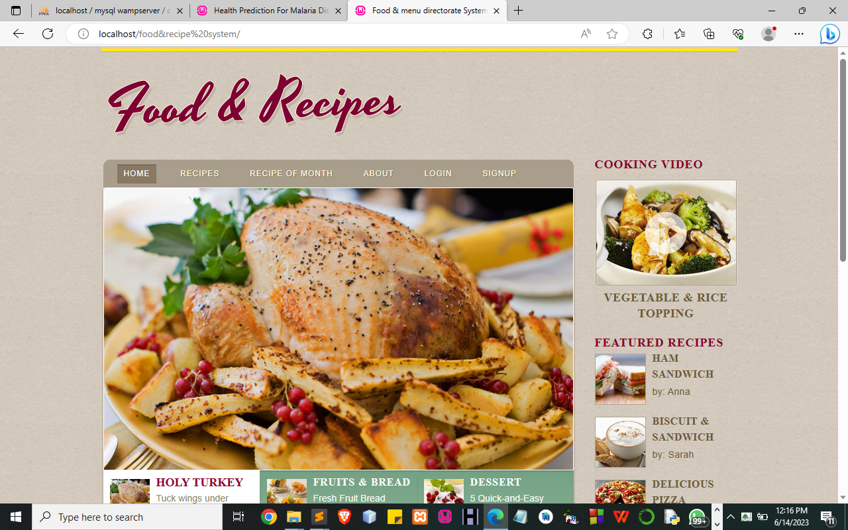
Figure 4.1: Index Page
This Page is the welcome page that displays the welcome content
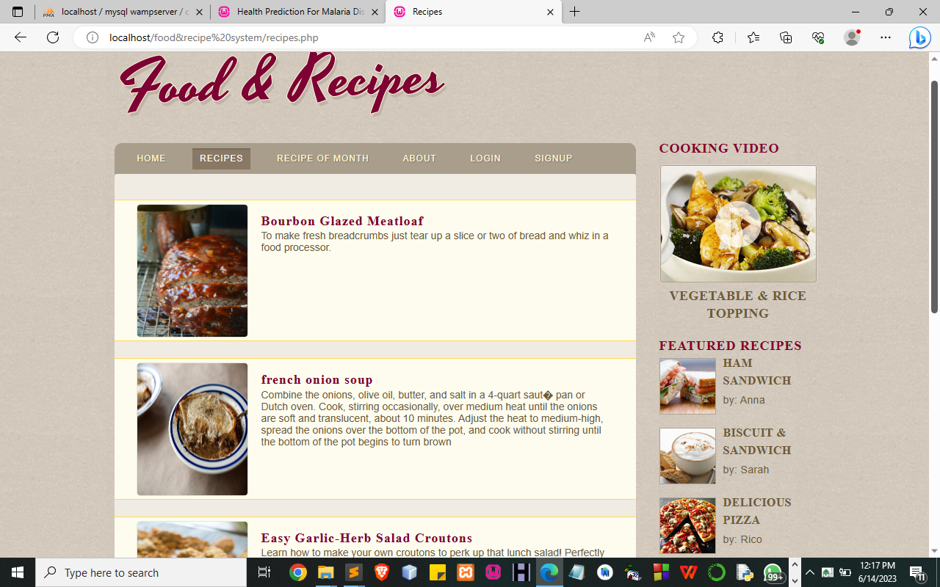 Figure 4.2: Recipe Page
This Page Display all recipe that is available by Admin using this system.
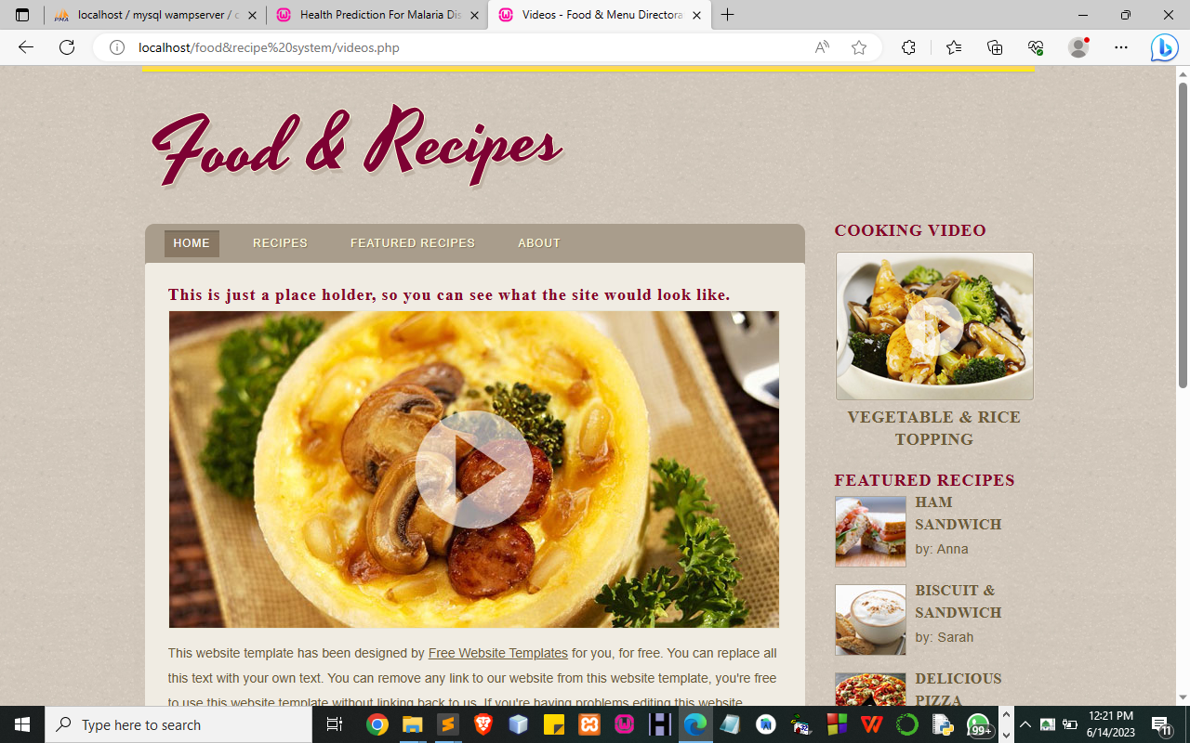
Figure 4.3: List of All Registered Patient Page
This page display all Patient added.
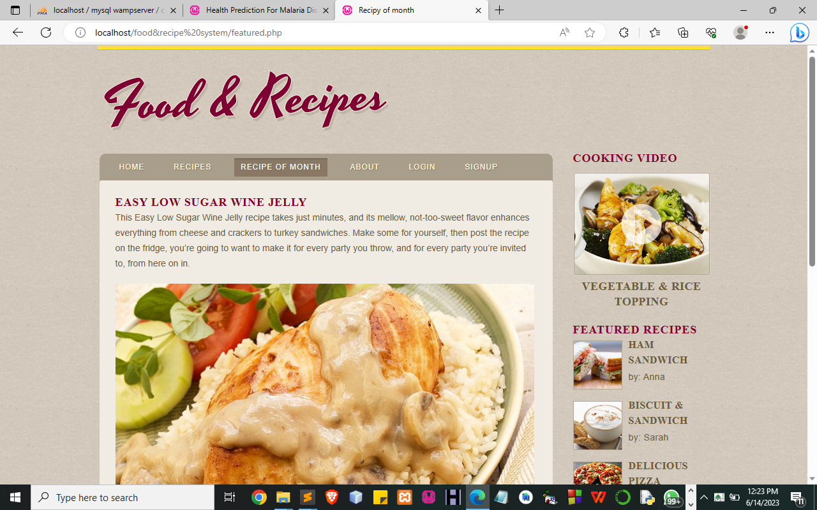
Figure 4.4: Recipe of the Month

4.1.2 INPUT DESIGN

It is also necessary to denote that data inputted into the computer for processing determines what the output will be. The inputs are used in collecting information from the student through the keyboard. Inputs are necessary information needed for processing to produce the expected outputs; which are supplied through the keyboard.
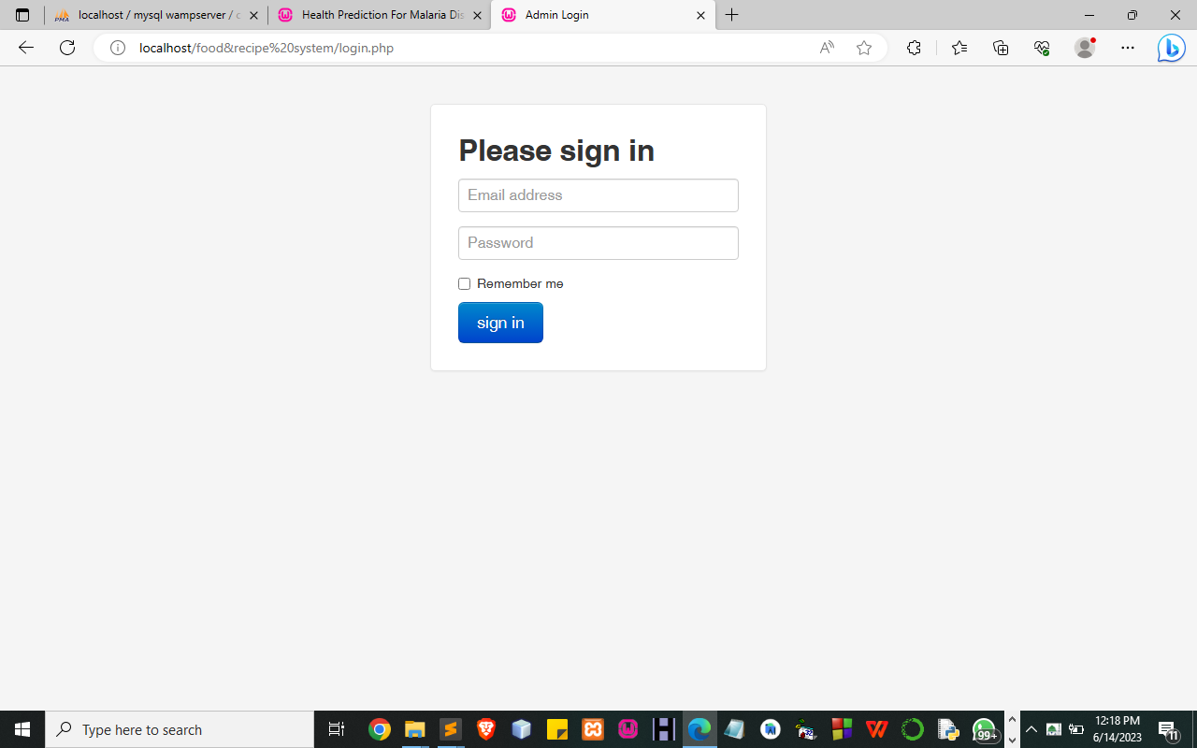
Figure 4.5: Login Page
This Page allows an authorized user to log into the system.
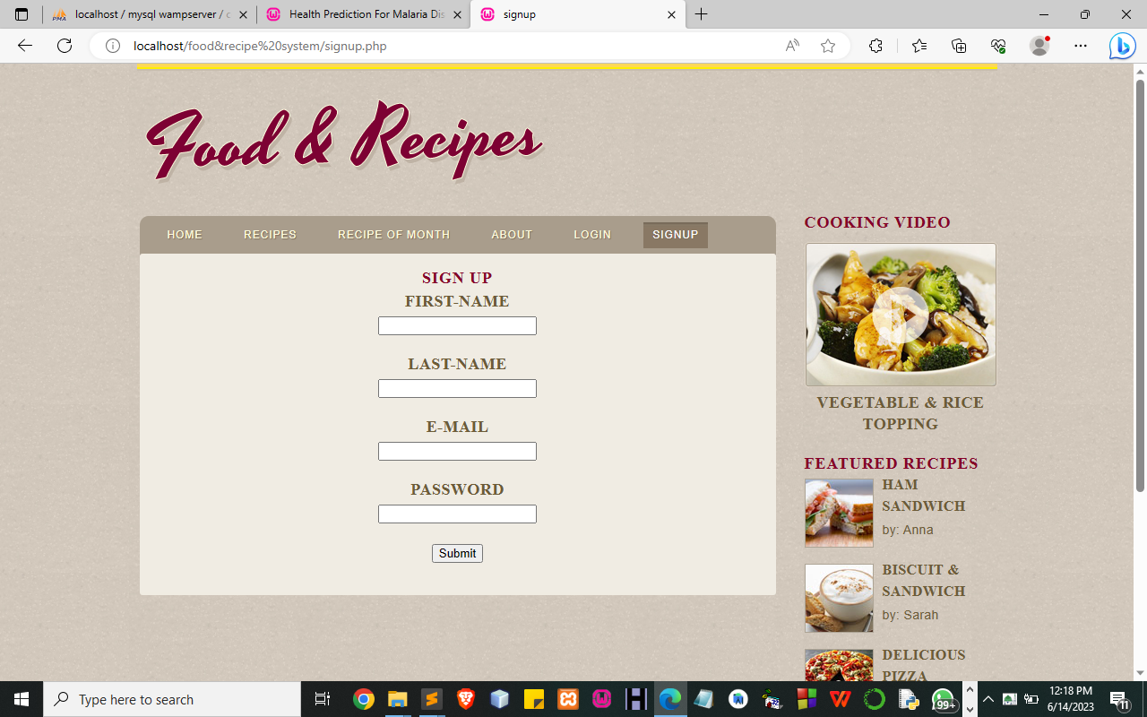
Figure 4.6: Registration Page
This Page allows the user to get access to the system.
4.1.3 DATABASE DESIGN
A database table is used for storing information about the files. The database used for this application is MySQL database. The files and their respective modes of access, as well as the information they hold, are given below;
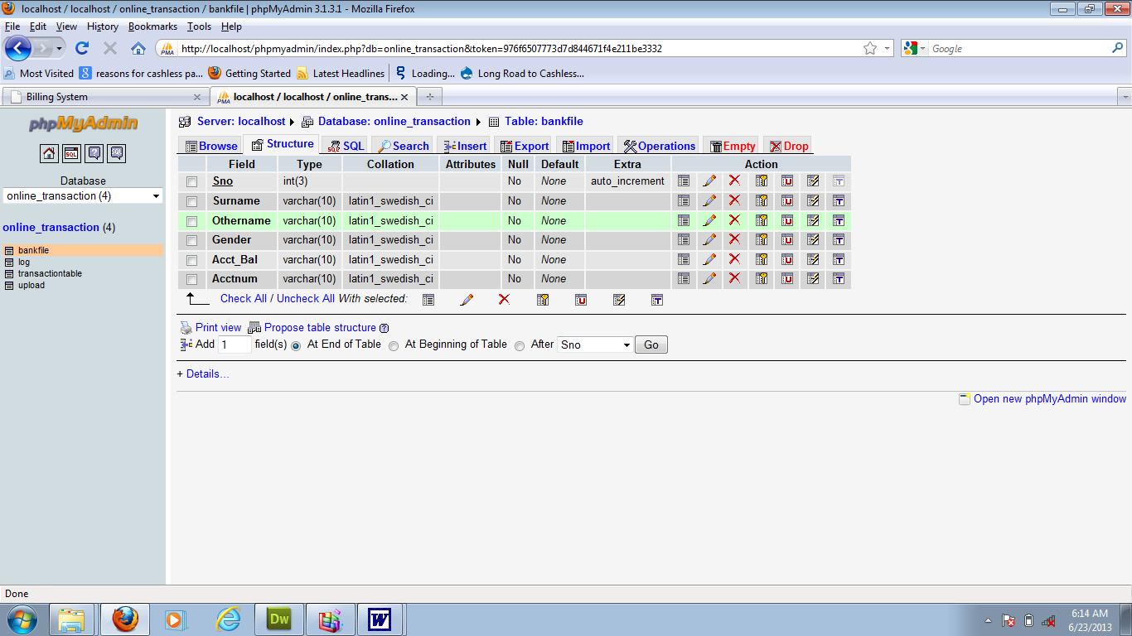
Table 4.1: Menu Registration Structure

Table 4.2: Admin Login Table structure
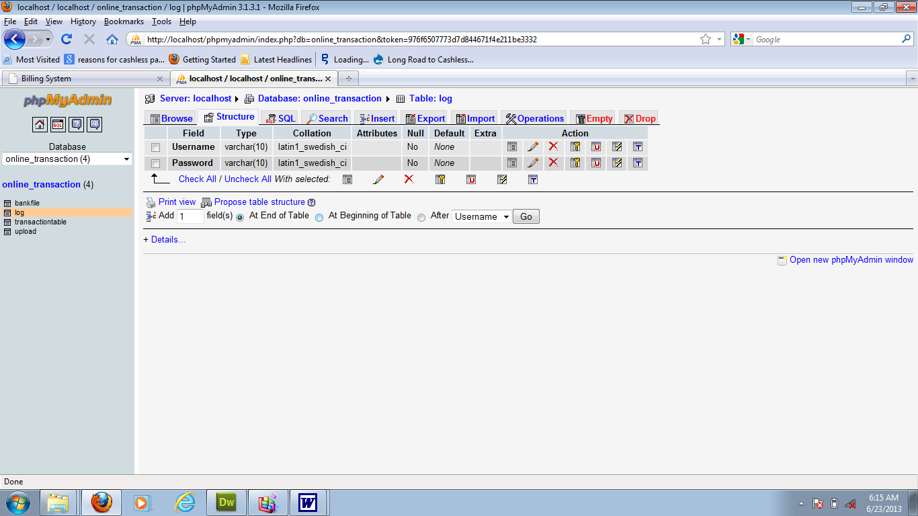

Table 4.3: Menu Data table
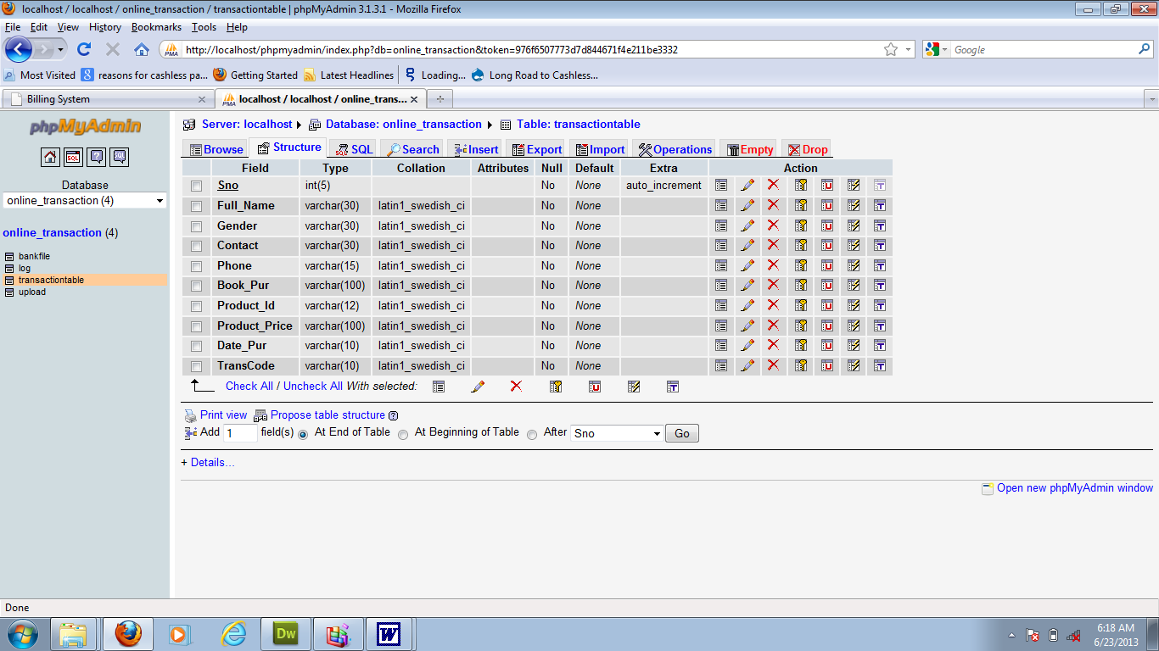
4.1.3 PROCEDURE DESIGN
Procedures are steps that verify the whole process i.e. which are everything put together to produce the desired output. This involves the organization of the source document and ends with the output result.
Documents are sent to various departments to be filled by the employees and later returned to the personnel department which are analyzed to determine which record goes into the computer.
After selecting the necessary data, this serves as input to the computer system.

4.2 IMPLEMENTATION OF THE SYSTEM
It is always good to develop new ideas, implement them on a computer, and eventually relish the satisfaction of achieving a successful result. The implementation process involves converting the system design into a complete and tested that is fully operational and that can be used by the system users to meet their business needs. During the implementation phase, the hardware and the software must be implemented.
The implementation of a system can be explained in six steps:-
- Review design specification
- Code, test, and document programs
- Train users
- Perform system test
- Convert to the new system
- Evaluate and maintain the new system
4.2.1 CHOICE OF PROGRAMMING LANGUAGE
The application is designed in the Sublime web development package which involves the use of PHP server-side scripting language, MYSQL for database management, and HTML 5(with other embedded functionalities) for the page design and layout settings. Hence, the program testing simply involves running it directly from a Mozilla Firefox web browser on a local host server provided by Apache 2.0 in WampServer 2.0 application.
In the preparation for the installation of the new system, the method of changeover is given serious consideration to determine the success of the new system. A suitable changeover technique for this system is a pilot changeover. The pilot changes over and operates by applying the new system bit by bit until it covers the whole of the operations. The result obtained from using the pilot method on a small portion of the operations would be used in determining the suitability of the feed system for the rest of the operations. This method is similar to testing a small sample of a distribution if the test yields a good result then the whole system because fully operational and the manual/existing system is eliminated.
4.2.2 HARDWARE SUPPORT
i. Minimum of Microcomputer Pentium II- Intel 533 MHZ processor, 128 MB RAM, 3.5GB HDD, 3.5” FDD, 14” VGA Monitor Windows 2000 Enhanced keyboard, mouse, and pad.
ii. Scanner
iii. Printer
iv. HP DeskJet 3820c series
4.2.3 SOFTWARE
I. Interface Design Language, windows Notepad for help interface design Hypertext Mark-up Language (HTML 5)
ii. MY SQL Database Management Software
iii. Programming PHP (Hypertext Pre-processor)
iv. Operating system window 07 professional
v. Graphic software paint shop and choosing these two formats GIF (Graphic Image Format)
vi. Scanner software, Mira scan
Web browser software MOZILLA
4.3 PROGRAM DOCUMENTATION
4.3.1 OPERATING THE SYSTEM
Step 1: Boot your computer and click on the start button on the taskbar
Step 2: Launch the Wamp server
Step 3: Log in to your Application
Step 4: Click on Options
4.1 Click on Dashboard (to view operations)
4.2 Click on Appointment (to add new Appointment)
4.3 Click on Edit (to make an update)
Step 5: Logout

4.3.3 MAINTAINING THE SYSTEM
The use of the term maintenance for software is different from other references to maintenance. Unlike the tires on your car, software does not “wear out”. If this is the case, then why does software maintenance account for such a high percentage of the Total Cost of Ownership for software?
The software maintenance definition refers to changes for defect correction, performance improvements, or adaptations to a changed environment (enhancements). According to this definition, if we build software that is defect-free, performs well, and contains user-controlled parameters to adjust processing rules in response to changing requirements then most maintenance would not be necessary.
Why does this happen? There are many reasons but the most common reasons are time constraints and lack of experience. Adding validation logic takes time. So, people make assumptions about the quality of in-bound data. Assumptions are also made about the volume of transactions and the impact on performance and the stability of the automated business processes. Finally, it is common for new software to be developed by younger developers who don’t understand the maintenance impacts of their designs.
The reality is that business requirements change and most of these assumptions are flawed. Transaction volumes increase, changing business processes require new transactions or new validation criteria, and software users will use the software incorrectly. The cost of software maintenance and the total cost of ownership can dramatically be reduced if developers build software that adjusted to changes in transaction volumes; validated all inbound data and provide user-configurable options for decision logic and data validation

CHAPTER FIVE
SUMMARY, CONCLUSION, AND RECOMMENDATION
5.1 SUMMARY
In summary, the design and implementation of a food menu directorate system offer numerous benefits for food service establishments. By centralizing menu management, providing a user-friendly interface, and enabling seamless synchronization across platforms, the system improves operational efficiency and ensures consistent and accurate menu information. The system addresses the limitations of the existing manual system, such as time-consuming updates, inconsistent information, difficulty in organizing menu items, and lack of real-time updates on item availability. The proposed system offers advantages such as time savings, consistency, enhanced organization, real-time updates, and improved access control.
5.2 CONCLUSION
The implementation of a food menu directorate system is a valuable investment for food service establishments. The system streamlines menu management processes, reduces errors, and enhances the overall dining experience for customers. By automating menu updates, providing consistent and accurate information across platforms, and enabling efficient organization and categorization of menu items, the system improves operational efficiency and customer satisfaction. The centralization of menu data, integration with inventory management systems, and role-based access control contribute to a more secure and efficient menu management process.

5.3 RECOMMENDATIONS
Based on the analysis and advantages of the proposed system, the following recommendations are made:
- Implementation: Food service establishments should consider implementing a food menu directorate system to streamline menu management processes and enhance customer experience. The system should be customized to meet the specific needs and requirements of the establishment.
- Integration: The new system should be integrated with existing technologies, such as inventory management systems, websites, mobile apps, and digital menu boards. This integration ensures seamless synchronization and real-time updates across various platforms.
- User Training: Proper training should be provided to staff members on how to use the new system effectively. This ensures smooth adoption and maximizes the benefits of the system.
- Regular Updates and Maintenance: The menu directorate system should be regularly updated and maintained to incorporate new features, address any issues, and ensure optimal performance. This includes keeping the menu information up to date and addressing any user feedback or suggestions.
- Continuous Improvement: Feedback from staff members and customers should be actively sought and used to identify areas for improvement. Regular evaluations and assessments should be conducted to optimize the system's functionality and usability.

REFERENCES
Al-Hunaity, A. N., Al-Sarayrah, M., & Al-Jarrah, O. Y. (2019). Design and Implementation of an Intelligent Restaurant Management System. Journal of Theoretical and Applied Information Technology, 97(20), 5709-5722.
Brown, A., & Davis, R. (2019). Enhancing Customer Experience through Menu Management Systems: A Case Study. International Journal of Contemporary Hospitality Management, 31(1), 321-338.
Choudhary, P., & Kulkarni, V. (2018). Menu Management System for Restaurants. International Journal of Engineering Research and Technology, 11(1), 54-59.
Goyal, V., & Singh, P. (2019). Design and Implementation of an Efficient Restaurant Management System. International Journal of Computer Applications, 182(48), 6-12.
Kumar, A., & Gangopadhyay, A. (2020). Design and Implementation of Menu Management System for Restaurants. In Proceedings of the 11th International Conference on Information and Communication Technology for Sustainable Development (ICT4SD) (pp. 1-5). IEEE.
Li, S., Guo, Z., & Yang, Y. (2020). Design and Implementation of a Smart Restaurant Menu Management System. In 2020 5th International Conference on Intelligent Information Technology and Security (ICIITS) (pp. 1-4). IEEE.
Liao, Y., & Tsai, S. (2020). Development of a Restaurant Menu Management System Using QR Code Scanning. In Proceedings of the 34th International Conference on Advanced Information Networking and Applications Workshops (WAINA) (pp. 141-144). IEEE.
Nguyen, P., & Nguyen, L. (2020). Design and Implementation of a Web-based Menu Management System for Restaurants. In 2020 RIVF International Conference on Computing and Communication Technologies (RIVF) (pp. 1-4). IEEE.
Roberts, L. (2017). Menu Management in the Digital Age: Maximizing Efficiency and Customer Satisfaction. Journal of Foodservice Business Research, 20(4), 397-408.
Sadhana, S., & Roshni, P. (2020). Design and Implementation of an Online Restaurant Management System. In Proceedings of the 2020 12th International Conference on Machine Learning and Computing (ICMLC) (pp. 69-73). ACM.
Smith, J. (2020). Streamlining Menu Management: The Benefits of a Digital Menu System. Journal of Hospitality and Tourism Technology, 11(4), 456-472.
Tseng, F., Huang, Y., & Lin, S. (2018). Design and Implementation of Restaurant Menu Management System Based on Cloud Computing. Journal of Applied Science and Engineering, 21(3), 465-474.
Zhen, Y., & Zhang, Q. (2020). Design and Implementation of Restaurant Ordering Management System Based on WeChat Mini Program. In 2020 2nd International Conference on Artificial Intelligence and Pattern Recognition (AIPR) (pp. 1-4). IEEE.

