DESIGN AND IMPLEMENTATION OF AN AUTOMATIC SOLAR WATER HEATER CONTROLLING SYSTEM

BY:

ISA ADAM OLAYIWOLA
HND/23/COM/FT/0146

A Project Submitted to the Department of Computer Science, Institute of Information and Communication Technology, Kwara State Polytechnic, Ilorin

In Partial Fulfillment of the Requirements for the Award of Higher National Diploma (HND) in Computer Science

July, 2025
CERTIFICATION
This is to certify that this project was carried out by ISA, Adam Olayiwola with Matric Number HND/23/COM/FT/0146, has been read and approved as meeting part of the requirements for the award of Higher National Diploma (HND) in Computer Science.

………………………………. ……………………………….
Mrs.Akanbi M.B Date
(Project Supervisor)

………………………………. ……………………………….
Mr. Oyedepo, F. S. Date
(Head of Department)

………………………………. ……………………………….
External Examiner Date

DEDICATION
This project is dedicated to the creator of the earth and universe, the Almighty God. It is also dedicated to my parents for their moral and financial support.

ACKNOWLEDGEMENT
All praise is due to the Almighty God the Lord of the universe. I praise Him and thank Him for giving me the strength and knowledge to complete my HND programme and also for my continue existence on the earth.
I appreciate the utmost effort of my supervisor, Dr. (Mrs.) Dada, O. M., whose patience support and encouragement have been the driving force behind the success of this research work. She gave useful corrections, constructive criticisms, comments, recommendations, advice and always ensures that an excellent research is done. My sincere gratitude goes to the Head of the Department and other members of staff of the Department of Computer Science, Kwara State Polytechnic, Ilorin, for their constant cooperation, constructive criticisms and encouragements throughout the programme.
Special gratitude to my parents who exhibited immeasurable financial, patience, support, prayers and understanding during the periods in which I was busy tirelessly in my studies. Special thanks go to all my lovely siblings.
My sincere appreciation goes to my friends and classmates.

TABLE OF CONTENTS
Title Page i
Certification ii
Dedication iii
Acknowledgements iv
Table of Contents v
Abstract vi
CHAPTER ONE: GENERAL INTRODUCTION
  - Background to the Study 1
  - Statement of the Problem 3
  - Aim and Objectives of the Study 3
  - Significance of the Study 4
  - Scope of the Study 4
  - Organization of the Report
CHAPTER TWO: LITERATURE REVIEW
2.1 Review of Related Works 6
2.2 Review of Related Concepts 10
2.2.1 Overview of solar water heater controller 10
2.2.2 Components of solar water heater controller 10
2.2.3 Overview of Arduino Microcontroller 12
2.2.4 Water Heater for Home Use 12
2.2.5 Smart Water Heater using Arduino 14
CHAPTER THREE: RESEARCH METHODOLOGY AND ANALYSIS OF THE EXISTING SYSTEM
  - Research Methodology 15
  - Analysis of the Existing System 16
  - Problems of the Existing System 16
  - Description of the Proposed System 17
  - Advantages of the proposed system 17
CHAPTER FOUR: DESIGN, IMPLEMENTATION AND DOCUMENTATION OF THE SYSTEM
  - Design of the System 18
    - Output Design 18
    - Input Design 22
    - Procedure Design 25
  - Implementation of the System 25
    - Choice of Programming Language 25
    - Hardware Requirement 26
  - Documentation of the System 26
    - Program Documentation 27
    - Maintaining the System 27
CHAPTER FIVE: SUMMARY, CONCLUSION AND RECOMMENDATION
  - Summary 28
  - Conclusion 28
  - Recommendation 29
References
Appendices

ABSTRACT
This project presents the design and implementation of an automatic solar water heater controller aimed at enhancing the efficiency, safety, and user convenience of solar water heating systems. Traditional solar water heaters often require manual operation, which can lead to inconsistent temperature control, energy inefficiencies, and user inconvenience. The proposed system integrates temperature sensors, a microcontroller, and automated control valves to continuously monitor and regulate water temperature based on real-time environmental conditions. Additionally, it includes safety mechanisms to prevent overheating and underheating, while a user-friendly interface enables easy configuration and monitoring. By optimizing the use of solar energy and minimizing reliance on auxiliary heating sources, the system promotes energy savings and environmental sustainability. The implementation demonstrates significant improvements in performance, reliability, and accessibility, making solar water heating a more practical and efficient solution for residential and commercial applications.

CHAPTER ONE
GENERAL INTRODUCTION
1.1 BACKGROUND TO THE STUDY
With the increasing demand for sustainable energy solutions, solar water heating systems have gained popularity for their eco-friendly and cost-effective characteristics. However, most existing systems require manual intervention to regulate water temperature and ensure efficient operation, which can lead to energy wastage or inconsistent performance. To address these limitations, the design and implementation of an automatic solar water heater controller are proposed. This system automates the monitoring and regulation of water heating processes, ensuring optimal performance with minimal human interaction (Solomon et al., 2021).
Odigwe et al., (2023) claimed that, the growing global emphasis on renewable energy sources has led to the widespread adoption of solar water heating systems, which offer an eco-friendly and cost-effective alternative to traditional water heating methods. However, the effectiveness of these systems often depends on manual monitoring and adjustments, which can lead to inefficiencies and user inconvenience. To address these challenges, the design and implementation of an automatic solar water heater controller are proposed. This system aims to optimize energy utilization, ensure consistent water temperatures, and provide a user-friendly solution for both residential and commercial applications.
Solar energy is one of the most abundant and sustainable resources available, making it an ideal choice for water heating systems. Despite their environmental benefits, traditional solar water heaters require significant manual intervention to regulate temperature and ensure efficient operation. This reliance on human oversight often results in suboptimal performance and energy wastage. The proposed automatic solar water heater controller integrates advanced sensors, microcontrollers, and actuators to automate these processes, providing a more efficient and reliable solution for modern energy needs (Kumar et al., 2020).
As the world transitions toward cleaner energy alternatives, solar water heaters have emerged as a popular option for reducing carbon footprints and lowering energy costs. While these systems are inherently advantageous, their efficiency can be hampered by the need for constant manual adjustments. The development of an automatic solar water heater controller seeks to eliminate these drawbacks by introducing a system that intelligently monitors and regulates water temperatures. By automating key processes, the system enhances performance, minimizes energy waste, and improves user convenience (Pinjari et al., 2021).
A temperature controller is a device used to control the temperature of an object, the space inside a container or room, and so on. The temperature sensor measures the ambient temperature and controls the heating or cooling mechanism to maintain the set temperature range. The proliferation of Internet of Things, fueled by online communities, tutorials, and affordable hardware, has democratized access to technology and fostered a spirit of collaboration and innovation. The smart water heater taps into this culture, inviting enthusiasts, hobbyists, and homeowners alike to participate in the co-creation of a more sustainable future (Kulkarni et al., 2022).
The demand for energy-efficient and environmentally sustainable solutions has driven the adoption of solar water heating systems. These systems utilize renewable solar energy to provide hot water for domestic and industrial applications, reducing dependency on fossil fuels. However, existing systems are often limited by manual controls, leading to energy inefficiencies and operational inconsistencies. To overcome these limitations, this study focuses on the design and implementation of an automatic solar water heater controller. By integrating smart technology, the system aims to optimize energy usage, enhance performance, and provide a seamless user experience.
1. 2 STATEMENTS OF THE PROBLEM
The traditional water heaters lack the ability to adapt to users' needs, resulting in unnecessary energy consumption and higher utility bills. Additionally, the lack of control and monitoring options makes it difficult for users to efficiently manage their water heating requirements. Therefore, there is a need for an intelligent and customizable solution that can address these limitations and offer a more sustainable and user-friendly approach to water heating. This study lies not only in the development of a smart water heater but also in its potential impact on energy conservation and sustainability. By promoting efficient energy usage, the smart water heater contributes to reducing carbon footprint and preserving valuable resources.
  - AIM AND OBJECTIVES OF THE STUDY
The primary aim of this study is to design and implement an automatic solar water heater controller that enhances the efficiency, reliability, and user convenience of solar water heating systems by integrating intelligent automation and real-time monitoring capabilities. The objectives are:
- To develop a system that automates the regulation of water temperature in solar water heaters, eliminating the need for manual intervention.
- To optimize energy utilization by ensuring efficient harnessing and use of solar energy, thereby minimizing wastage.
- To integrate safety mechanisms that prevent overheating and underheating, safeguarding system components and ensuring consistent water temperature delivery.
- To design a user-friendly interface that allows users to monitor system performance and customize settings easily.
- To incorporate intelligent automation that dynamically adjusts system operations based on real-time environmental and user-specific conditions.
1.4 SIGNIFICANCE OF THE STUDY
The significance of this study lies in its potential to address key challenges associated with traditional solar water heating systems. By introducing an automatic solar water heater controller, the study provides a solution that enhances efficiency, reliability, and convenience. Automating temperature regulation ensures optimal energy utilization, reduces manual effort, and minimizes energy wastage. This contributes to sustainability goals by promoting the use of renewable energy sources and reducing dependence on fossil fuels.
1.5 SCOPE OF THE STUDY
This study focuses on the design and implementation of an automated solar water heater controller to optimize the efficiency and functionality of solar water heating systems. It covers the development of hardware and software components, including temperature sensors, microcontrollers, control valves, and a user interface. The system is designed to regulate water temperature, monitor system performance, and incorporate intelligent automation for dynamic adjustments based on environmental conditions.
The study is limited to small- to medium-scale applications, such as residential and commercial setups, with an emphasis on ensuring compatibility with existing solar water heating infrastructure. It does not include large-scale industrial applications or alternative heating systems like geothermal or gas-based heaters. Additionally, the study evaluates the system's performance under typical environmental conditions but does not extensively address extreme climates or unique environmental scenarios.
1.6 ORGANIZATION OF THE REPORT
The project write-up is organized into five distinct chapters. Chapter one covers general introduction, which contains introduction to the project topic, statement of the problem, aim and objectives, significance of the study, scope of the study and organization of the report. Chapter two covers literature review, which contains review of related past works, overview of smart water heater system and review of other related concepts. Chapter three explains the project methodology which includes analysis of existing system, problems of the existing system, and the description of the proposed system, advantages of proposed system and design and implementation techniques used. Chapter four explains the design, implementation and documentation of the system which contain system design output design, input design, database design and procedure design, implementation of the system hardware and software support and documentation of the new system installation procedure, operating the system and system maintenance. Lastly, chapter five explains the summary of the research, recommendations and conclusion.

CHAPTER TWO
LITERATUREREVIEW
2.1 REVIEW OF THE RELATED WORKS
Numerous studies and implementations have explored various aspects of solar water heating systems and their control mechanisms, reflecting the growing interest in renewable energy and automation technologies. These works provide valuable insights into the strengths and limitations of existing solutions, forming the basis for further innovation.
One notable study by Smith et al. (2018) investigated the efficiency of traditional solar water heaters. Their research highlighted the reliance on manual operation and the energy inefficiencies arising from inconsistent temperature regulation. They concluded that integrating automation could significantly improve performance by optimizing energy use and reducing human intervention.
Another important contribution comes from Johnson and Wang (2019), who developed a semi-automated control system for solar water heaters. Their system incorporated basic temperature sensors and actuators to regulate water flow based on solar intensity. While their approach demonstrated improved efficiency compared to manual systems, it lacked advanced features such as dynamic adaptability to real-time environmental changes or intelligent decision-making capabilities.
In a related effort, Gupta et al. (2020) designed a prototype using IoT-based technology to monitor and control solar water heaters remotely. Their system employed cloud computing to store and analyze data from sensors. Although it provided remote access and monitoring, the reliance on constant internet connectivity raised concerns about data privacy and accessibility in regions with poor network infrastructure.
An additional study by Adekunle et al. (2021) examined the potential of machine learning algorithms for predicting water temperature based on environmental variables. Their system achieved high accuracy in predictions, allowing proactive adjustments to system operations. However, the computational complexity and cost of implementing such algorithms on small-scale systems were noted as significant barriers.
Lastly, a review by Lee and Kim (2022) explored various hardware components used in solar water heating systems, such as sensors, microcontrollers, and valves. Their findings emphasized the importance of selecting reliable and efficient components to ensure the durability and functionality of the system. They also pointed out the need for user-friendly interfaces to make these systems accessible to non-technical users.
These related works collectively demonstrate the advancements in solar water heating technologies while highlighting existing gaps, such as the need for improved automation, intelligent adaptability, offline functionality, and enhanced user interfaces. This study builds on these insights to propose an automatic solar water heater controller that addresses these limitations and enhances the overall efficiency, reliability, and user experience of solar water heating systems (Elnour, 2022).
Uwah, (2020) designed and constructed a portable solar water heater. The project involved the design and fabrication of a portable solar water heater. The design of the solar water heater was done using relevant equations to size the major components of the system. The materials for the components were then selected with consideration to the design calculations, machinability, market availability and cost of the materials. The system was then constructed using the selected materials. The system consists of a buffer tank, an insulated storage tank of 36 litres capacity, a flat-plate collector with a single layer of glass on top, and a flow channel arranged in a serpentine manner. The thermosyphon principle was applied to the system and an average flow rate of 0.15 litres /min was recorded. The system was tested for six days, the first three days of testing were during the late raining season and the last three days within the dry season. From the first three days of testing during the late raining season, the highest outlet temperature recorded was 650C. For the last three days of testing during the dry season, the highest outlet temperature recorded was 79.3 0C. This difference clearly shows that the system performs better during the dry season when the irradiance levels are higher. The highest irradiance recorded was 940 W/m2 on the sixth day of testing. The highest efficiency recorded from the system was 68.19% on the fourth day of testing.
Nguyen & Nguyen, (2022) developed a smart water heater system with temperature control using Arduino. The study presented the development of a smart water heater system with temperature control using Arduino microcontroller. The system incorporated temperature sensors to monitor the water temperature and employed a PID control algorithm to regulate the heating process and maintain the desired temperature. The authors discussed the design and implementation of the system, including hardware setup and software programming. They also conducted experiments to evaluate its performance and demonstrate its effectiveness in achieving precise temperature control.
Solomon et al., (2021) designed a solar-powered smart heater. The proposed system effort focused on the design and development of a solar-powered smart water heater. In tests using a variety of settings, the solar-powered smart heater that was constructed performed admirably. The components used include a PIC16F876A microcontroller, a 12 V/300 W monocrystalline PV, a 12 V/ 40 A charge controller, and 12 V / 150 W dc submersible heating element among others. The temperature control capacity of the fabrication makes it useful in water management system applications such as in aquaculture fingerling hatchery, hot water dispenser and shower among others. The system showed excellent performance in water temperature control using a 150 watts dc heater.
Hertzog, (2020) implemented a cost-effective solar water heater monitoring system using the internet of things. The research aimed to develop a non-complex and cost-effective solar water heater monitoring system that is connected to the internet of things for data collection. Data collected by the system included the power consumed by the system, the outside and inside temperatures, as well as the time of occurrence. The designed system is non-complex in the sense that it can easily be installed by the home owner without disturbing the existing electrical wiring of the residential house. Furthermore, data was collected via an internet server, called Thing Speak, using an existing WiFi connection at the residence. The system was costeffective regarding affordable hardware and free software that was used in the operation of the system. With data that was obtained from the system regarding warm water usage and power consumption, the home owner can make informed decisions to optimize the solar water installation.
Kulkarni et al., (2020) designed and developed a cost-effective solar water heating system. . The work was based on the development of effective control system which controls the flow of incoming cold water. A solenoid valve was actuated according to the temperature and water level inside the tank. With 10-bit microcontroller, the programming was done with the help of mikroC PRO software, and the circuit diagram was developed with the help of Proteus Design Suite software. The compact device which detects level was developed that controls the flow of incoming cold water. A thermistor was incorporated in the system separately to monitor the temperature inside the tank.
Pinjari et al., (2021) proposed a study of instant water heating tap. The project was the summary of overall water tap heater which makes use of heating coil and thermostat. This way the overall study outlined the implementation of an electric water heating simulator and the validation of a double and single tank domestic hot water configuration. The brief study and the survey was done over the whole system and it is all implemented in the report. Water heating in general is a basic heat transfer process that generally uses an energy source in order to heat water above the initial temperature. As we know the usage of hot water is maximum for not only daily purpose but also for cooking, cleaning, bathing, and space heating. In industry, predicament and water heated to steam have many uses also. Water is heated in vessels known as water heaters, kettles, cauldrons, pots or coppers. These metal vessels don't produce a continuous supply of heated water and thus water heating tap comes into picture. The aim of the article is to study, design and fabricate such model.
Bruhn, (2019) developed an assessment of real-time electric water heating control algorithm. The system proposed a rule-based algorithm that could control DEHWT-units intelligently throughout existing residential DSM programs in Germany, minimizing energy cost while maintaining the habitual health and comfort standards users of conventionally operating hot water tanks are accustomed to. The performance of this algorithm was evaluated under a range of different scenarios, creating a representative assessment for a vast number of households in Germany.
2.2 REVIEW OF RELATED CONCEPTS
2.2.1 Overview of solar water heater controller
A solar water heater controller is a critical component in modern solar water heating systems, designed to automate and optimize the process of heating water using solar energy. It regulates the flow of water and manages temperature levels to ensure efficient energy utilization and consistent performance. By integrating sensors, microcontrollers, and actuators, the controller enables intelligent monitoring and control of the heating system.
2.2.2 Components of a Solar Water Heater Controller
- Temperature Sensors:
These sensors measure the temperature of the water in the solar collector and storage tank. Accurate temperature data is essential for determining when to heat water or divert energy.
- Microcontroller:
The microcontroller acts as the brain of the system. It processes input from the sensors, executes control logic, and sends commands to actuators or relays to regulate the system's operation.
- Control Valves and Pumps:
These components manage water flow between the solar collector and the storage tank. They ensure that water moves through the system only when solar energy is sufficient to heat it.
- User Interface:
A display or control panel allows users to set desired temperatures, view system status, and adjust configurations.
- Auxiliary Heating Element:
In cases where solar energy is insufficient, the controller activates a backup heating element to maintain the desired water temperature.

- Power Supply:
The system may be powered by solar panels or a grid connection, with battery backups for uninterrupted operation.
2.2.3 Functions of the Solar Water Heater Controller
- Temperature Regulation:
The controller ensures that the water temperature is maintained within a user-defined range by activating or deactivating the flow of water and heating elements.
- Energy Optimization:
By monitoring solar energy availability and water temperature, the controller maximizes the use of renewable energy and minimizes reliance on auxiliary heating.
- Safety and Protection:
The controller prevents overheating by stopping water circulation when the temperature exceeds a safe threshold. It also prevents freezing in colder climates by circulating warm water when needed.
- Automation and Convenience:
Automation eliminates the need for manual operation, making the system more user-friendly and consistent.
2.2.4 Advantages of Solar Water Heater Controllers
- Enhanced energy efficiency by optimizing solar energy utilization.
- Improved user convenience through automation and customization.
- Increased system longevity by preventing overheating and other operational issues.
- Cost savings on energy bills and reduced environmental impact.
2.2.5 Applications
Solar water heater controllers are widely used in residential homes, commercial establishments, and industrial facilities where reliable and energy-efficient hot water supply is required. Their versatility and adaptability make them an essential part of sustainable energy solutions.
2.2.6 Temperature Sensing in Smart Water Heating
Temperature sensing in water heating systems with microcontrollers is a common practice to ensure efficient and safe operation. By using a microcontroller, temperature sensors can be integrated into the system to monitor and control the water temperature. The following are general overview of how temperature sensing works in water heating with a microcontroller:
- Selection of Temperature Sensor: Choose a suitable temperature sensor for your application. Commonly used sensors include thermistors, resistance temperature detectors (RTDs), and thermocouples. The sensor should be compatible with the microcontroller's input requirements.
- Connection with Microcontroller: Connect the temperature sensor to the microcontroller. This typically involves connecting the sensor's output to an analog input pin of the microcontroller. Some microcontrollers also have built-in temperature sensor modules that can be used.
- Analog-to-Digital Conversion: The analog output from the temperature sensor needs to be converted to a digital value that the microcontroller can process. This is done using an analog-to-digital converter (ADC) present in the microcontroller. The ADC converts the analog voltage or current from the sensor into a digital value.
- Calibration: It is essential to calibrate the temperature sensor to ensure accurate temperature readings. This involves comparing the sensor's output with a known reference temperature and adjusting the readings accordingly.
- Temperature Measurement and Control: The microcontroller continuously reads the digital temperature value from the sensor. It can then compare this value to a setpoint temperature and make decisions accordingly. For example, if the measured temperature is below the setpoint, the microcontroller can activate the heating element to raise the water temperature. If the temperature exceeds the setpoint, the microcontroller can turn off the heating element.
- Display and User Interface: The microcontroller can also be connected to a display unit to show the current temperature and other relevant information. Additionally, user inputs can be taken through buttons or a touch panel for setting the desired temperature or adjusting other parameters.
- Safety Features: The microcontroller can incorporate safety features such as over-temperature protection and fault detection. If the temperature exceeds a certain threshold or if any abnormality is detected, the microcontroller can trigger alarms, shut down the heating element, or take appropriate actions to prevent any damage or accidents.
Temperature sensing in smart water heating systems plays a crucial role in ensuring efficient operation, user comfort, and safety (Chandrasekaran, et al., 2022).

2.3 Overview of Ardruino Microcontroller
Arduino is an open-source electronics platform that consists of both hardware and software components. It is designed to make it easy for beginners and professionals alike to create interactive projects and prototypes. At the heart of the Arduino platform is the Arduino microcontroller board. The Arduino microcontroller board is a small, programmable device that acts as the brain of your project. It is based on various microcontrollers, such as the ATmega328P, ATmega2560, or SAMD21, depending on the specific Arduino board model.
The Arduino board provides a set of digital and analog input/output pins that can be used to connect and control various electronic components, such as sensors, actuators, displays, and more. These pins can be programmed to read input from sensors, control the output to actuators, or communicate with other devices using protocols like I2C, SPI, or UART. Arduino boards can be programmed using the Arduino Integrated Development Environment (IDE), a user-friendly software that allows you to write, compile, and upload your code to the Arduino board. The programming language used is a simplified version of C++ (Mitchel, 2019).
One of the key advantages of Arduino is its vast community and extensive library of pre-written code, known as sketches, which can be freely shared and used by anyone. This makes it easier to get started and build upon existing projects. Arduino microcontrollers are widely used in various fields, including robotics, home automation, wearable technology, Internet of Things (IoT), and more. They offer a versatile and accessible platform for bringing your electronic projects to life (Mitchel, 2019).

2.4 Water Heater for Home Use
A smart water heater for home use is an advanced and innovative appliance that offers convenience, energy efficiency, and control over your hot water supply. The features and benefits of a smart water heater are explained below:
- Connectivity: Smart water heaters are equipped with Wi-Fi or Bluetooth capabilities, allowing you to connect them to your home network and control them remotely using a smartphone app. This means you can adjust the temperature, monitor energy usage, and receive alerts or notifications about maintenance or issues, all from the convenience of your phone.
- Energy Efficiency: Smart water heaters often come with built-in energy-saving features. They can learn your hot water usage patterns and adjust their heating schedule accordingly, optimizing energy consumption. Some models also have energy monitoring capabilities, providing real-time data on energy usage, helping you make informed decisions to reduce energy waste and lower your utility bills.
- Customized Settings: With a smart water heater, you can set personalized schedules and preferences for your hot water needs. You can program it to preheat water before you wake up or arrive home, ensuring you always have hot water when you need it. This level of customization allows for greater comfort and convenience while minimizing wastage.
- Leak Detection and Prevention: Many smart water heaters are equipped with leak detection sensors that can detect leaks or abnormal water flow. If a leak is detected, you will receive an immediate notification, enabling you to take prompt action and prevent potential water damage.
- Integration with Smart Home Systems: Smart water heaters can integrate with other smart home devices and systems, such as voice assistants (e.g., Amazon Alexa, Google Assistant) or home automation platforms (e.g., Apple HomeKit, Samsung SmartThings). This integration allows for seamless control and coordination with other connected devices in your home.
- Enhanced Safety Features: Smart water heaters often come with safety features like temperature and pressure sensors, as well as automatic shut-off mechanisms. These features help prevent overheating, scalding, or other accidents, ensuring the safety of you and your family.
A smart water heater for home use offers convenience, energy efficiency, and peace of mind. It allows you to have greater control over your hot water supply, saves energy and money, and provides advanced features for safety and maintenance (Leeuwner et al., 2021).
2.5 Smart Water Heater using Arduino
Developing a smart water heater utilizing Arduino technology offers a promising avenue for enhancing energy efficiency and user convenience in residential and commercial settings. At its core, this system integrates sensors, actuators, and microcontrollers to monitor and control various parameters of the water heating process. The Arduino platform provides a flexible and cost-effective solution for designing custom control algorithms and user interfaces tailored to specific needs.
Central to the functionality of a smart water heater is real-time monitoring of water temperature, consumption patterns, and user preferences. Temperature sensors placed at strategic points within the water heater tank enable precise control of heating elements to maintain water at desired temperatures while minimizing energy waste. Additionally, flow sensors can be incorporated to track water usage, allowing for optimized heating cycles and predictive maintenance (Kumar, 2023).
Through Arduino-based control logic, the smart water heater can adapt its operation to varying demand and environmental conditions. For instance, it can leverage data from weather forecasts or occupancy sensors to adjust heating schedules preemptively. Integration with home automation systems or smartphone applications further enhances user accessibility, enabling remote monitoring and control of the water heater settings from anywhere. Furthermore, incorporating machine learning algorithms into the Arduino-based system opens up opportunities for predictive optimization and energy savings. By analyzing historical usage data and environmental factors, the smart water heater can learn user habits and automatically adjust settings to minimize energy consumption without compromising comfort. This intelligent adaptive control capability not only reduces operational costs but also contributes to sustainability goals by promoting efficient resource utilization. Overall, a smart water heater leveraging Arduino technology represents a practical and scalable solution for improving energy efficiency, user comfort, and environmental sustainability in water heating applications (Bruhn, 2019).

CHAPTER THREE
RESEARCH METHODOLOGY AND ANALYSIS OF THE EXISTING SYSTEM
3.1 RESEARCH METHODOLOGY
The design of the Arduino-controlled smart water heater is discussed in this section. The method that will be employed in the implementation of the smart water heater is the top-to-bottom approach method. The various materials that will be considered are listed below:
- Arduino Uno
- Temperature sensor
- Liquid Crystal Display (LCD)
- Heating Coils
- Thermostat
- Silver Foil
The block and circuit diagram for the design is as shown in Figure 3.1 and 3.2 respectively. 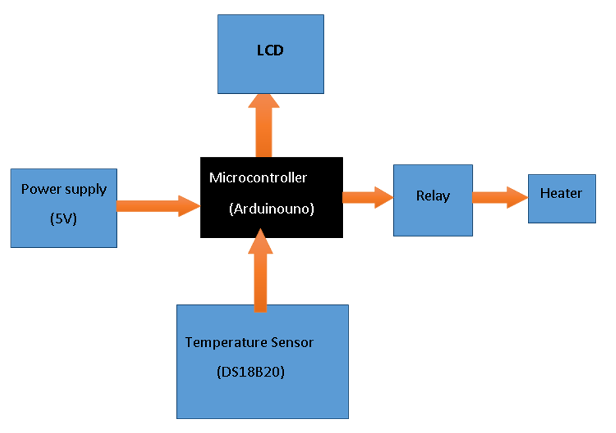Figure 3.1: Block Diagram of the Proposed System
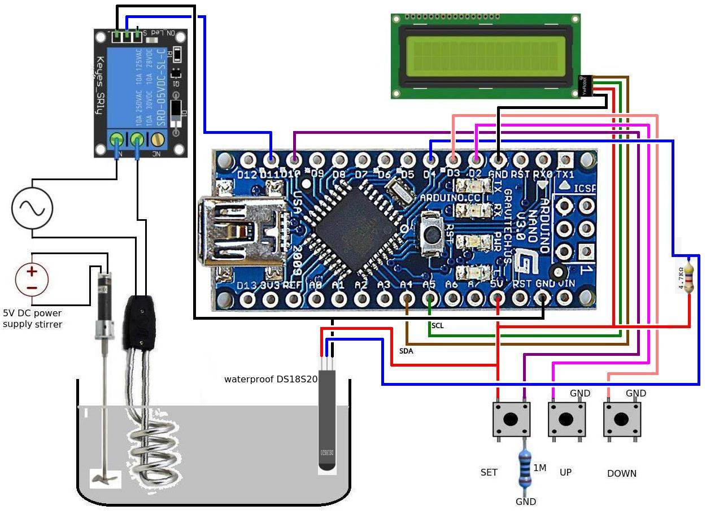
Figure 3.2: Circuit Diagram of the Proposed Smart Water Heater Controller System.
Here is the basic outline of how the proposed system will be implemented:
- After gathering the needed components
- The Hardware will be set up: the temperature sensor will be connected to the Arduino. Typically, the DS18B20 sensor uses a 3-pin connection: VCC, GND, and DATA. Connect VCC to 5V, GND to GND, and DATA to a digital pin on the Arduino. The relay module will be connected to the Arduino. The relay module usually has three pins: VCC, GND, and Signal. The heater will be connected to the relay module and the researchers will ensure proper wiring to handle the power safely.
- The code will be written by including all the necessary libraries.
- The system will be tested and debug if necessary. The code will be uploaded to the Arduino board, then, the system will be tested with different temperature settings to ensure it functions as expected.
- Once everything is working correctly, the researchers will encase the components in a project box for safety and aesthetics and all connections will be secured and insulated to prevent any electrical hazards.
  - ANALYSIS OF THE EXISTING SYSTEM
The current solar water heating systems exhibit several limitations that undermine their efficiency and usability. Primarily, these systems depend on manual control and monitoring, requiring users to actively manage water temperature based on environmental conditions. This process is not only time-intensive but also prone to human error, often resulting in inconsistent temperature regulation. The lack of intelligent control mechanisms further exacerbates the problem, as these systems fail to optimize energy utilization. Excess energy generated during peak sunlight periods is often wasted due to the absence of effective energy storage or redistribution strategies.
Additionally, many traditional solar water heating systems lack adequate safety features to prevent overheating or underheating. This limitation poses risks to both the system's components and the users, potentially leading to equipment damage or discomfort. Accessibility is another significant issue, as the user interfaces provided in these systems are often rudimentary and require technical expertise to operate effectively. This restricts their usability for a broader audience, particularly for individuals with limited technical knowledge.
  - PROBLEMS OF THE EXISTING SYSTEM
The existing system has the following shortcomings:
- Limited Functionality: The existing system lack advanced features such as remote control, adaptive scheduling based on usage patterns, or integration with other smart home devices.
- User Interface: The system relies solely on physical controls or a basic display, it is inconvenient for users to interact with, especially if they want to adjust settings remotely.
- Scalability: Expanding or modifying the existing system might be challenging.
- Energy Efficiency: Without optimization features, the system does not efficiently manage energy usage, leading to unnecessary heating and higher utility bills.
- Safety: There is limited safety features in the existing system, such as fail-safes to prevent overheating or leak detection mechanisms.
3.4 DESCRIPTION OF THE PROPOSED SYSTEM
The proposed system is an automatic solar water heater controller designed to overcome the limitations of existing solar water heating setups by integrating intelligent automation and real-time monitoring capabilities. At its core, the system uses temperature sensors strategically placed in the solar collector and water storage tank to continuously measure water temperature and solar energy availability.
These sensor readings are fed into a microcontroller, which acts as the central processing unit. The microcontroller processes the data and makes decisions based on pre-set temperature thresholds and environmental conditions. It automatically regulates the flow of water between the solar collector and the storage tank through motorized control valves, ensuring that water is heated efficiently without overheating or underheating.

3.5 ADVANTAGES OF THE PROPOSED SYSTEM
The implemented system has the following advantages:
- Improved Energy Efficiency: By automatically regulating water temperature and optimizing the use of solar energy, the system reduces energy wastage and reliance on auxiliary power sources.
- Consistent Temperature Control: The system maintains water temperature within desired limits, preventing overheating or underheating regardless of changing weather conditions.
- Automation and Convenience: Eliminates the need for manual monitoring and adjustment, making the system easy to operate and reducing the possibility of human error.
- Enhanced Safety: Built-in safety features protect the system from damage caused by extreme temperatures, ensuring reliable and safe operation.
- User-Friendly Interface: Provides easy access for users to monitor system status, adjust settings, and receive alerts, making the system accessible even to non-technical users.
- Cost Savings: By maximizing the use of free solar energy and minimizing auxiliary heating, the system helps reduce energy bills and operating costs over time.
- Environmental Benefits: Supports sustainable energy use by promoting renewable solar power and reducing carbon emissions associated with conventional water heating methods.
- Adaptability: The system dynamically adjusts to real-time environmental conditions, ensuring optimal performance across different climates and usage scenarios.

CHAPTER FOUR
DESIGN, IMPLEMENTATION AND DOCUMENTATION OF THE SYSTEM
4.1 DESIGN OF THE SYSTEM
The smart water heater controller system integrates temperature sensors, a microcontroller, and a heating element to provide precise control over water temperature. The system includes a user interface for setting desired temperatures and schedules, connectivity options for remote control via smartphone apps, and safety features such as overheat protection. It is housed in a durable enclosure to protect electronic components and ensure longevity.
4.1.1 OUTPUT DESIGN
The output design of the smart water heater includes a display screen for showing the current water temperature, status LEDs for indicating system operation and errors, and control signals to regulate the heating element. Additionally, remote output via mobile notifications informs users of the water heater status and any necessary actions. Things taken into consideration in determining the output are represented below:

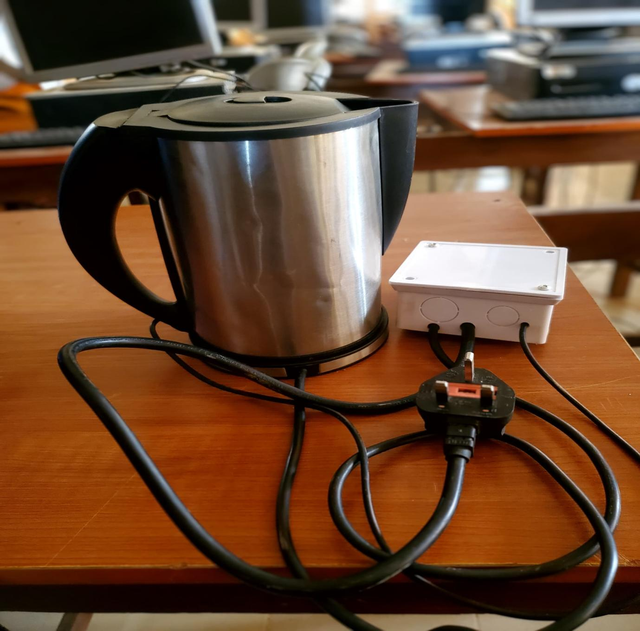
Figure 4.1: Smart Water Heater
The image above is the Arduino UNO-based water heater controlling system, the system is connected with power cable and also connected to an android phone using the Blynk IoT app. The system can be start by clicking on the power button on an android phone. This developed system can be used to heat water in homes and offices.
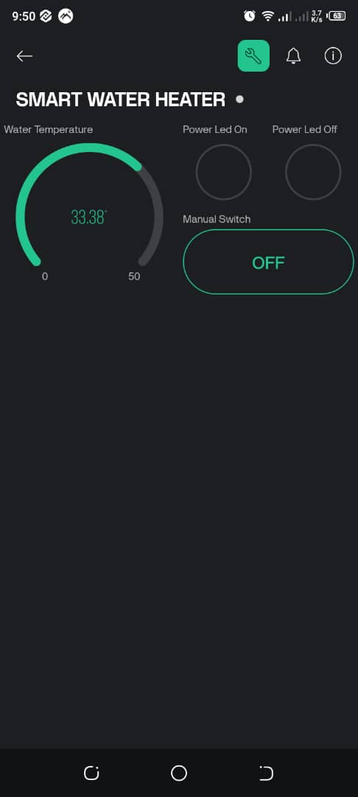
Figure 4.2: The Offline Mode of the Smart Water Heater
This image above display when the system is offline, the off button will need to be toggled anytime the system is to be put online.
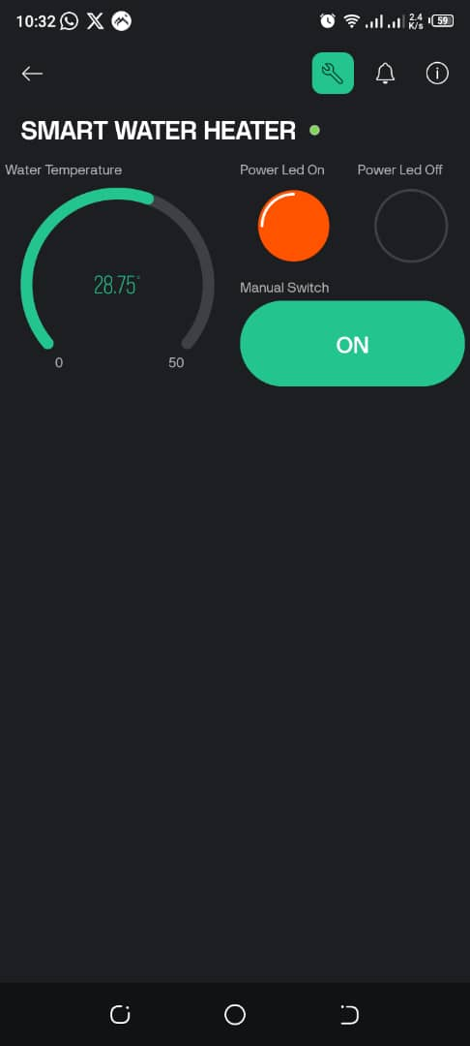
Figure 4.3: The Online Mode of the Smart Water Heater
This is the online mode of the smart water heater system, as it was displayed above the power on led has changed color from black to red.
4.2 INPUT DESIGN
These are the equipment or tools required in making the system function effectively. The equipment required are as shown below:
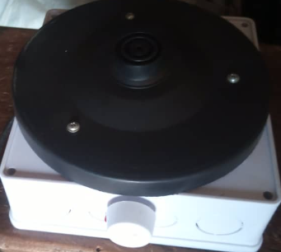
Figure 4.4: The Enclosure
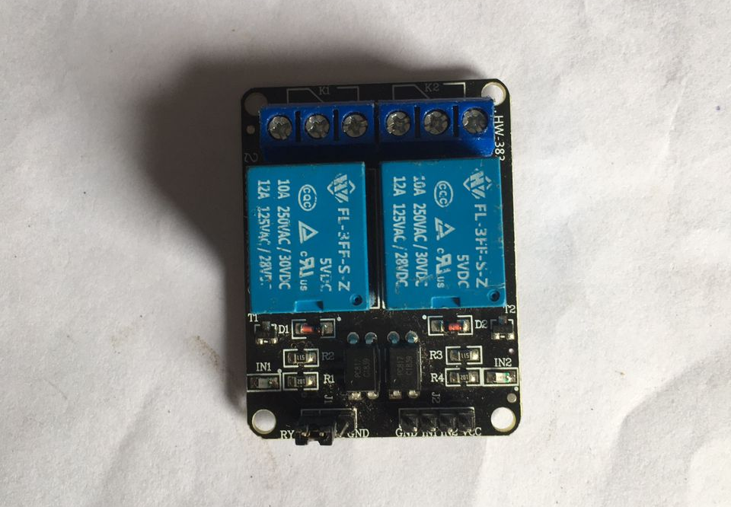
Figure 4.5: The Water Heater Relay
This is the relay of the system. The relay allows some or all of the heat to come on, depending on the controls.


Figure 4.6: Voltage Regulator
This is the voltage regulator of the implemented system. This will help to automatically maintain a constant voltage, it is used to regulate one or more AC or DC voltages.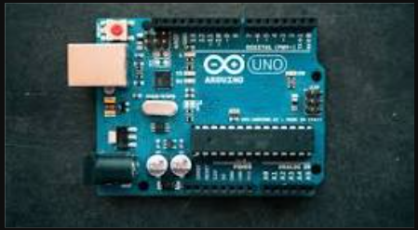
Figure 4.7: Arduino UNO
This is the Arduino UNO of the system. Arduino UNO is used to regulate voltage, sense temperature and make production. After adjusting the temperature to various levels and checking the final output, the heater turned on / off when the unit exceeded the set value.
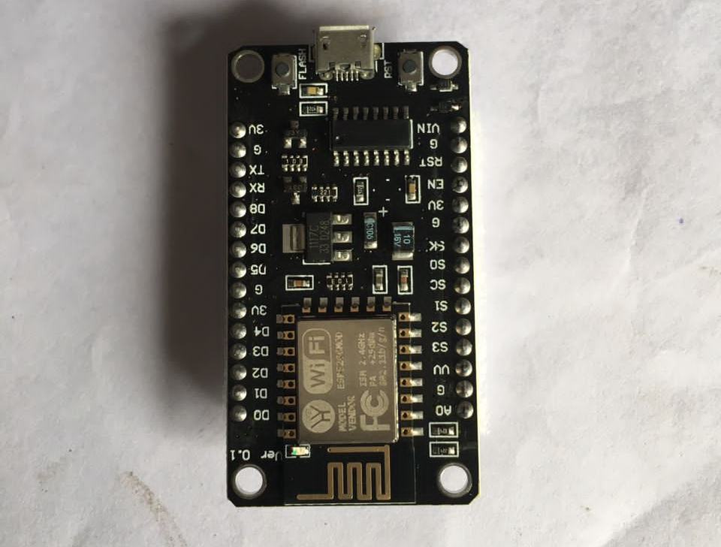
Figure 4.8: Microcontroller Chip
This is the microcontroller chip in the smart water heater controller, it serves as the brain of the device, coordinating and managing various functions to ensure efficient and user-friendly operation.

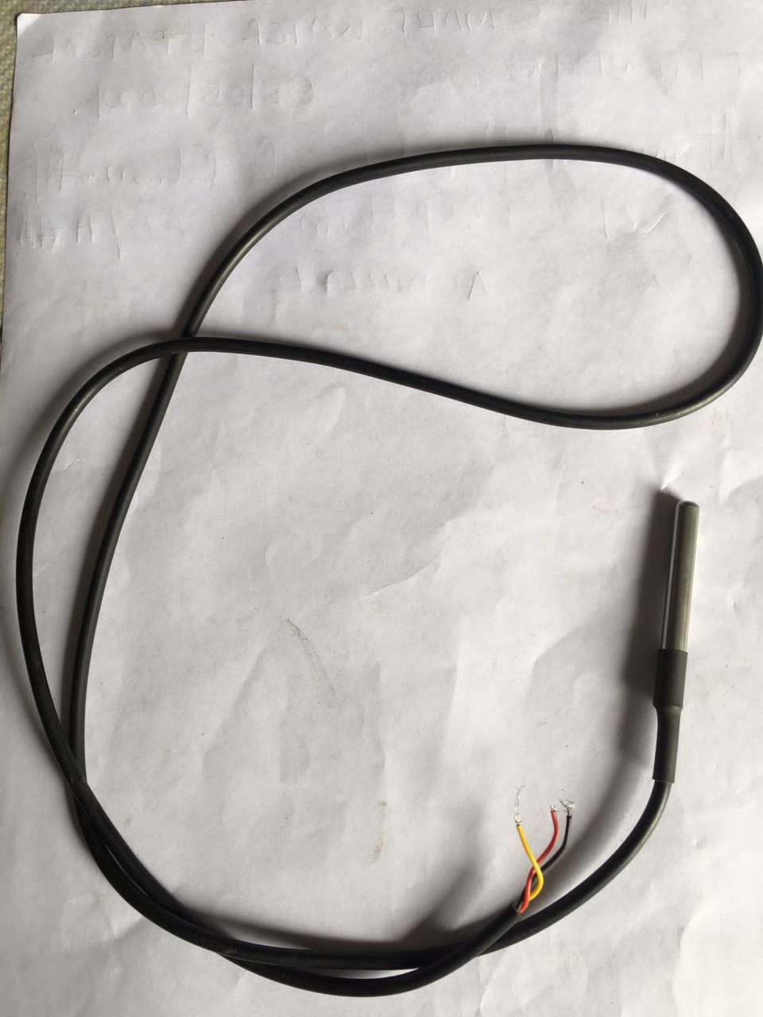
Figure 4.9: DSG 18B20 Cable
This cable is for the heater connections.
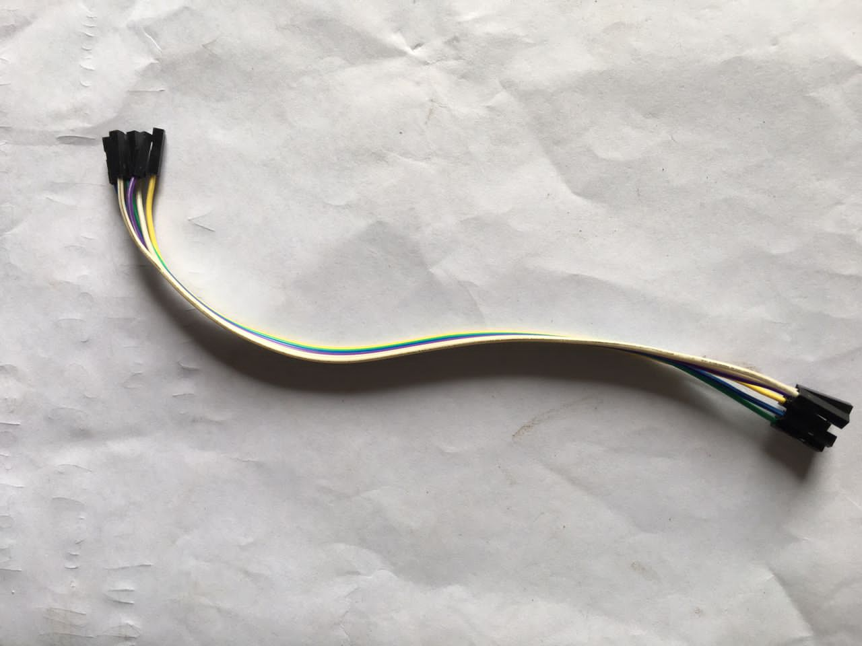
Figure 4.10: Deport Wire
This was used to connect microcontroller with the system relay.

4.3 PROCEDURE DESIGN
The procedure design for a smart water heater system involves defining the system architecture, developing firmware in C/C++ for real-time hardware control, creating mobile and web applications using Python for user interaction, establishing secure communication protocols, integrating cloud services for data management and remote updates, conducting thorough testing at each stage, and implementing continuous monitoring and maintenance processes to ensure reliability and efficiency.
Implementing a smart water heater system involves developing and integrating firmware using C/C++ for efficient hardware control, creating user-friendly mobile and web applications with Python or JavaScript for remote management, and leveraging cloud services for data storage, analytics, and over-the-air updates, ensuring seamless communication between components, robust security, and a comprehensive user experience.
4.3.1 CHOICE OF PROGRAMMING LANGUAGE
For the development of a smart water heater, C/C++ is the optimal choice for programming the embedded system due to its efficiency and control over hardware.
4.3.2 HARDWARE REQUIREMENT

i. Core Components
- Heating Element: The main component responsible for heating the water. This could be an electric element or a gas burner, depending on the heater type.
- Thermostat: A device to control and regulate the temperature of the water.
- Water Tank (or Tankless System): A storage tank for water in traditional heaters or the heating coils in tankless systems.
- Insulation: To minimize heat loss and improve energy efficiency.
- Temperature Sensors: To monitor the water temperature accurately and provide data to the thermostat and control unit.
- Flow Sensors: To detect the flow rate of water, essential for tankless systems to ensure they only heat water when needed.

Smart Components
- Microcontroller or Microprocessor: The central unit that controls the smart functionalities. Common choices include Arduino, Raspberry Pi, or ESP8266/ESP32 for embedded systems.
- Wi-Fi or Zigbee Module: For wireless connectivity, allowing remote control and integration with smart home systems. Wi-Fi modules like ESP8266/ESP32 or Zigbee modules are popular.
- Display Screen: An optional component for local control and display of information such as temperature, operating mode, and error messages.
- User Interface: Buttons or touchscreens for manual control and setting adjustments.
- Relay Switches: To control the heating element based on the commands from the microcontroller.
- Leak Sensors: To detect any water leaks and send alerts to prevent damage.
- Energy Meter: To monitor power consumption and help in optimizing energy usage.

Safety Components
- Pressure Relief Valve: To prevent excessive pressure build-up within the tank.
- Thermal Cutoff Switch: A safety device that cuts off power if the water temperature exceeds safe limits.
- Ground Fault Circuit Interrupter (GFCI): To protect against electrical shock by breaking the circuit in case of a ground fault.
- Anti-Scald Valve: To prevent water from reaching dangerously high temperatures that could cause burns.
4.3.3 Software Requirement
  - Real-Time Operating System (RTOS): To manage the microcontroller's tasks, ensuring timely and reliable execution. Examples include FreeRTOS or ARM mbed OS.
  - Temperature Control Algorithm: Software to regulate the water temperature based on sensor data and user settings.
  - Communication Protocols: Implementing Wi-Fi, Zigbee, or Bluetooth protocols to enable wireless communication.
  - Data Logging: To record temperature, usage patterns, energy consumption, and other relevant data.
4.4 DOCUMENTATION OF THE SYSTEM
4.4.1 PROGRAM DOCUMENTATION
This project smart water heater can be use in either office/ home and by individual/ group with the aim of boiling/heat water or to cook food such as rice. This research was developed using Python Programming language and micro controller, sensors and Arduino UNO board for the connection of the chips/sensors.
4.2 MAINTAINING OF THE SYSTEM
Maintaining a smart water heater system involves regular software updates, hardware inspections, and proactive monitoring to ensure optimal performance and longevity. This includes applying firmware updates for security and feature enhancements, inspecting and replacing worn components like heating elements and sensors, and utilizing built-in diagnostics to detect and address issues early. Additionally, maintaining clear documentation and providing user support are crucial for troubleshooting and user education. By implementing these practices, the smart water heater system can operate efficiently, safely, and reliably, meeting user expectations and reducing the risk of malfunctions.

CHAPTER FIVE
SUMMARY, CONCLUSION AND RECOMMENDATIONS
5.1 SUMMARY
This project focuses on the design and implementation of an automatic solar water heater controller aimed at improving the efficiency and usability of traditional solar water heating systems. Existing systems often rely on manual controls, resulting in inconsistent temperature regulation, energy wastage, and limited user accessibility. The proposed system incorporates temperature sensors, a microcontroller, and automated valves to monitor and regulate water temperature in real time. It also includes safety features to prevent overheating and underheating, while a user-friendly interface allows easy system management. By automating the process and optimizing solar energy use, the system reduces reliance on auxiliary heating, lowers operational costs, and supports sustainable energy goals. Overall, this solution offers a more reliable, efficient, and convenient way to harness solar energy for water heating in residential and commercial settings.
5.2 CONCLUSION
The design and implementation of an automatic solar water heater controller address many of the challenges faced by traditional solar water heating systems. By integrating intelligent automation, real-time temperature monitoring, and user-friendly controls, the proposed system enhances energy efficiency, safety, and convenience. It effectively optimizes the use of solar energy while reducing dependence on auxiliary power sources, leading to cost savings and environmental benefits. Furthermore, the system’s adaptability to varying environmental conditions ensures consistent and reliable hot water supply. Overall, this automated approach represents a significant advancement in solar water heating technology, contributing to sustainable energy practices and improving user experience.
5.3 RECOMMENDATIONS
Based on the findings of this project, the following are recommended:
- Robust security measures should be implemented to safeguard user data and prevent unauthorized access to the system, such as encryption protocols and authentication mechanisms.
- Intuitive smartphone applications or web interfaces with user-friendly controls, insightful analytics, and customizable settings to enhance the user experience should be developed.
- Ensure compatibility with various water heater models, communication protocols, and home automation platforms to broaden the project's accessibility and appeal.
- Energy monitoring features, machine learning algorithms, and energy-saving recommendations should be incorporated to help users optimize their water heating usage and reduce utility costs.
- Foster a community of enthusiasts and developers to share ideas, troubleshoot issues, and contribute to ongoing improvements through forums, online tutorials, and collaborative projects.

REFERENCES
Atabekov, A. Mwangi, E. & Toler, D. (2018). Smart Chair: An Internet of Things Case Study for a Capstone Research Project, in Proceedings of the International Conference on Frontiers in Education: Computer Science and Computer Engineering (FECS). Pp. 154-155. DOI: https://www.doi.org/10.56726/IRJMETS42309
Bhatia, H. (2019). Design Considerations for Hot Water Plumbing Course, International Journal of Renewable Energy Research, Vol. 1, Issue: 3. Pp. 4-5. doi: 10.1109/ECAI58194.2023.10193962.
Bruhn, B. (2019). Development and Assessment of a Real-Time Electric Water Heating Control Algorithm, Official Journal of the European Union. Vol. 2. Issue: 3.Pp. 3-4. https://doi.org/10.15866/irea.v11i5.24007 346 Alaa
Chandrasekaran, G., Kumar, N. S., Gowrishankar, C. A., Priyadarshi, N. & Khan, B. (2023). IoT Enabled Smart Solar Water Heater System using Real Time Thing Speak IoT Platform, IET Renewable Power Generation. Pp. 4-5. doi: 10.1109/ACCESS.2023.3339754
Cao, Y., Zhong, C. & Qiu, K. (2020). Design and Experiment about Temperature Control System of Sealing Machine Based On Fuzzy PID, 8th International Conference on Intelligent HumanMachine Systems and Cybernetics. Pp. 308-309. IOP Punlishers
Cordoba, M. & Mitchell, B. (2019). SMART Water Heater, Journal of Applied Science Technology Trends. Vol. 2. Issue: 2. Pp. 59–61.
Diduch, C., Shaad, M., Errouissi, R., Kaye, J., Meng, R. & Chang, L. (2019). Aggregated Domestic Electric Water Heater Control Building on Smart Grid Infrastructure, Proceedings of the 7th International Power Electronics and Motion Control Conference. Pp. 14-15.
Ekpo, J. & Enyinna, P. (2021). Design and Construction of a Solar Water Heater for Environmental Sustainability. British Journal of Applied Science & Technology. Vol. 2 Issue: 1. Pp. 3–5. https://doi.org/10.9734/bjast/2017/3182
Elnour, K. D. (2022). Smart Water Heater System Monitoring and Controlling Using Arduino Board, International Journal of Advanced Engineering Sciences and Technologies, Vol. 9, Issue: 2. Pp. 273-279.
Hertzog, H. E. (2021). Cost-effective Solar Water Heater Monitoring System using the Internet of Things, in Technologies Applied to Electronics Teaching (TAEE). Pp. 1-2. Taichung, Taiwan.
Kulkarni, S., Kumar, V., Kottur, N. & Shirodkar, P. (2020). Design and Development of Cost-Effective Solar Water Heating System, International Conference on Electronic Devices, Systems and Applications. Pp. 4-5.
Leeuwner, L. L., Naude, N. H. & Roux, M. J. (2024). Evaluation of the Energy Model of a Horizontally-Mounted Electric Water Heater through Internal Temperature Measurement, International Conference on Clean Electrical Power (ICCEP). Pp. 11-13.
Odigwe, I. A., Ologun, O. O., Olatokun, O. A., Awelewa, A. A., Agbetuyi, A. F. & Samuel, A. F. (2018). A microcontroller-based Active Solar Water Heating System for Domestic Applications, International Journal of Renewable Energy Research, Vol. 3, Issue: 4. Pp. 34-35.
Pinjari, A. G., Ansari, S. J. & Zulquernain, F. (2021). Study of Instant Water Heating Tap, International Journal of Current Engineering and Technology. Vol. 7. Issue 4. Pp. 123-124.
Solomon, I. D., Adegbola, O. A., Idowu, P. O., Adeagbo, M. A., Ojo, A. (2021). Design and Development of a Solar-Powered Smart, International Journal of Research and Review. Vol. 2. Issue: 1. Pp. 9-10. DOI: https://doi.org/10.52403/ijrr.20210947
Uwah, E. J. (2021). Design and Construction of a Portable Solar Water Heater, British Journal of Applied Science & Technology. Vol. 20. Issue: 3. Pp. 1–15. https://doi.org/10.9734/bjast/2017/31820

