DESIGN AND IMPLEMENTATION OF DOCTORS AND NURSES DUTY SCHEDULING SYSTEM USING ARTIFICIAL NEURAL NETWORK
(A CASE STUDY OF BALOGUN HOSPITAL, ILORIN)

BY
Adeosun Tomiwa Rebecca
HND/23/COM/FT/0340

A Project Submitted to the Department of Computer Science, Institute of Information and Communication Technology, Kwara State Polytechnic, Ilorin

In Partial Fulfillment of the Requirements for the Award of Higher National Diploma (HND) in Computer Science

July, 2025
CERTIFICATION
This is to certify that this project was carried out by ADEOSUN, Tomiwa Rebecca with matriculation number HND/23/COM/FT/0340 as part of the requirements for the award of Higher National Diploma (HND) in Computer Science.

_______________________ ___________________
Dr. (Mrs.) Dada, O. M. Date
(Project Supervisor)

_______________________ ___________________
Mr. Oyedepo, F. S. Date
(Head of Department)

_________________________ ____________________
External Examiner Date

DEDICATION
This project is dedicated to the creator of the earth and universe, the Almighty God. It is also dedicated to my parents for their moral and financial support.

ACKNOWLEDGEMENT
All praises is due to the Almighty God, the Lord of the Universe. I praise Him and thank Him for giving me the strength and knowledge to complete my HND programme and also for my continue existence on the earth.
I appreciate the utmost effort of my supervisor, Dr. (Mrs.) Dada, O.M., whose patience, support and encouragements have been the driving force behind the success of this research work. She gave useful corrections, constructive criticisms, comments, recommendations, advice and always ensures that an excellent research is done. My sincere gratitude goes to the Head of the Department and other members of staff of the Department of Computer Science, Kwara State Polytechnic, Ilorin for their constant cooperation, constructive criticisms and encouragements throughout the programme.
Special gratitude goes to my parents who exhibited immeasurable financial, patience, support, prayers and understanding during the periods in which I was busy tirelessly in my studies. Special thanks go to all my lovely siblings.
My sincere appreciation goes to my friends and classmates.

TABLE OF CONTENTS
Title Page i
Certification ii
Dedication iii
Acknowledgement iv
Abstract v
Table of Content vi
CHAPTER ONE: GENERAL INTRODUCTION
  - Background to the Study 1
  - Statement of the Problem 3
  - Aim and Objectives of the Study 3
  - Significance of the Study 4
  - Scope of the Study 4
  - Organization of the Report 5
CHAPTER TWO: LITERATURE REVIEW
2.1 Review of Related Works 7
2.3 Review of General Text 10
CHAPTER THREE: RESEARCH METHODOLOGY AND ANALYSIS
  - Research Methodology 14
3.1.1 Algorithm Adopted: K gram Algorithm 14
  - Analysis of the Existing System 16
  - Problems of the Existing System 16
  - Description of the Proposed System 17
  - Advantages of the proposed system 17
CHAPTER FOUR: DESIGN, IMPLEMENTATION AND DOCUMENTATION OF THE SYSTEM
  - Design of the System 18
    - Output Design 18
    - Input Design 19
    - Procedure Design 21
  - Implementation of the System 21
    - Choice of Programming Language 21
    - Hardware Support 22
  - Documentation of the System 22
    - Maintaining the System 22
CHAPTER FIVE: SUMMARY, CONCLUSION AND RECOMMENDATION
  - Summary 23
  - Conclusion 23
  - Recommendation 24
References 25
Appendices
Appendix 1 Main Menu Flowchart
Appendix 2 Registration Flowchart
Appendix 3 Doctor/Nurse Scheduling Flowchart
Appendix 4 Report Flowchart

ABSTRACT
Staff scheduling is found as a crucial part of staff management. Every scheduling problem is different from each other when considering the various constraints, which leads to the staff scheduling problem becoming more complex. This project deals with Artificial Neural Network approach to solve a specific Staff Scheduling Problem. The schedules are planned for 4 weeks with 30 numbers of doctor and nurses in the ward and each working day consists of 5 different shift types. Penalty is presented to indicate the level of importance for the constraints involved that are hard constraints and soft constraints. For solving the problem of scheduling, GUI is being introduced for the user friendly approach through Visual C Sharp and mySQL.
CHAPTER ONE
GENERAL INTRODUCTION
  - BACKGROUND TO THE STUDY
Hospital is an aspect that schedule plays a vital role for successful achievement of its curriculums. Hospital work take a succeeding step, each step has a specified duration of time and a mapped out work coed associated with it. The time stipulated to be utilized maximally to enable you cover the work load elaborately. The issue has to do with the analysis of the work load and time involved in a Hospital category and distributing the work load at time intervals. For maximum knowledge impact, it a great concern to the professorate in the field. This is where comprehensive medical duties schedule is always designed to suit the curriculum Zhao, et al., (2019).
Dousin (2019) claimed that medical duties schedule does not only involve the all capturing of time duties of medical personnel, it also involve the careful allocation of other resources like labour force and space available. When all these factors are not adequately taken care of, it lead to clashes which hinder the effective Hospital operation. Personnel scheduling, or staff scheduling is the process of constructing work timetables for its staff so that an organization can satisfy the demand for its goods or services. Hence, Scheduling problem is one of the optimization problem, and it relates to some other similar problems such as timetabling, sequencing and rostering. Health services pose a challenge for the automatic rostering systems.
Hospital is an aspect that duties scheduling plays a vital role for the successful achievement of its curriculums. Hospital work takes a succeeding step. Each step has a specified duration of time and a mapped out work coed associated with it. The time stipulated to be utilized is maximally to enable you cover the workload elaborately (Gondane and Zanwar, 2018).
According to Lekan and Oloruntoba (2017), appointment scheduling systems in the medical sector, guarantees the efficiency and timely access to health services. Timely access is important for realizing good medical outcomes. A medical duties scheduling system enables doctors and other specialists to schedule appointments with their patients. It is also an important determinant of patient satisfaction. The ability to provide timely access is determined by a variety of factors that include fundamental questions about how Scheduled patients are encountered. This includes primary and specialty care visits, as well as elective surgeries. In each of these environments, the process of scheduling appointments (assigning a specific time when the patient is scheduled to start receiving care) is different, which we will describe shortly. In addition, there are unscheduled encounters that include walk-ins and urgent or emergency cases. The former, occurring mostly in primary care clinics, can be directed to an alternate facility if the clinic in question is heavily booked. However, urgent specialty care and surgical patients often need to be treated as soon as possible. The goal of a well designed appointment system is to deliver timely and convenient access to health services for all patients. Appointment a system also smoothens work flow, reduce crowding in waiting rooms and allow health systems to honor patient and provider preferences while matching supply and demand.
Medical duties schedule does not only involve all capture of time duties to medical personnel. It also involves the careful allocation of other resources like labor force and space available. When all these factor sare not adequately taken care of, it leads to classes which hinder the effective Hospital operation. Design and implementation of doctors and nurses duty scheduling system look into the various aspect in healthcare centre whereby is allocated duty to a doctor at a particular period of time, in other to carryout his/her duty assigned. Healthcare duty scheduling for doctors and nurses is a software based program that manages doctors and nurses time durations at work and this system automatically assign duty to both doctors and nurses.
1.2 STATEMENT OF THE PROBLEM
The traditional ways of doctors and nurses duty scheduling system is known as the manual method of duty scheduling whereby paper/notice board are used as a roster/timetable. The problem associated with the old manual system of medical duties scheduling hindered effective table prediction. It takes a lot of time to process the volume of data involved manually. This makes analysis and synthesis difficult for human to carry out. The existing system wastes a lot of time. This delay affects or causes setback for the Hospital operation. The manual medical duties scheduling causes a lot of errors and clashes. This system aim to solve the problems mentioned above by developing a system that will schedule duty times for doctors and nurses using artificial neural network.
1.3 AIM AND OBJECTIVES OF THE STUDY
The aim of the study is to design and implement a doctor and nurse duties scheduling system. The objectives of the study are to:
- Develop a workable medical duties scheduling system;
- Develop a system that will serve as a reminder for doctors and nurses on duties.
1.4 SIGNIFICANT OF THE STUDY
The significant of the study are that:
- It will provide a possible solution to the problem of scheduling medical appointment duties at the said hospital.
- The study will serve as a useful reference material to other scholars seeking for information on the subject.
1.5 PURPOSEOF THE STUDY
This study is carried out with a view to producing a computerized medical duties scheduling system for balogun hospital to replace the manual medical duties scheduling. The new system will also produce a comprehensive and authentic medical duties schedule for doctors/nurses. This study also proves the capabilities of the computer in the area of processing concerning the Hospital sector. By implementing the computerized system, one would be able to obtain information needed at a particular point in time. Finally, the study was also carried out to the rode of medical duties schedule medical duties preparation in valves a lot of work in the area of processing (i.e allocation of available resources) to avoid clashes.
The major clashes that always occur are the doctors and nurses clashes. The Doctor clash takes place when two Doctors are assigned to work at the same period of time, likewise nurses’ clash. To handle this aspect successfully and to produce a reliable result, a more sophisticated machine like a computer has to be introduced. The computer with its sophisticated features will handle the medical time table preparation (processing) in an automatic way. It will automatically schedule time for each doctor and nurse according to pre-defined program instructions. This will lessen the work involved in the preparation of medical duties scheduling and aid in producing adequate and comprehensive medical duties scheduling.
1.6 ORGANIZATION OF THE REPORT
This is the overall organizational structure of the work as presented in this project. Chapter one of this project deals with the general introduction to the work in the project. It also entails the aim and objectives of the project, significance of the study, the methods used for data collection, the scope and limitation of the study. Chapter two contains with the literature review, computerization of current state of the art and discussion of related aspect of the project topic relative to computer technology. Chapter three covers the analysis of the existing system, description of the current procedure, problems of existing system (procedure) itemized, and description of the proposed system and the basic advantages of the proposed system. Chapter four entails design, implementation and documentation of the system. The design involves the system design, output design form, input design form, database structure and the procedure of the system. The implementation involves the implementation techniques used in details, choice of programming language used and the hardware and software support. The documentation of the system involves the operation of the system and the maintenance of the system. Chapter five centres on summary, conclusion and recommendations.

CHAPTER TWO
LITERATURE REVIEW
2.1 REVIEW OF RELATED WORKS
Zhao et al., (2019) worked on the design for the nursing scheduling system. The objective was to develop the connotation and the extension functions of the nursing scheduling system and improve the efficiency of the nursing management. The method is to expand the connotation and the extension functions of the nursing scheduling system, including the job description links and queries, the personal need submission, the shift constraints and reminders, the emergency allocation of the human resources and other connotative functions, and to extend the functions of the nursing data exchange and sharing. The results are that after using the nursing scheduling system, the head nurses' scheduling time was significantly shortened and their satisfaction with the nursing scheduling system was significantly improved (all P<0.01).The conclusion is that the development of the intension and the extension functions of the nursing scheduling system can realize the intellectualization and refinement of the nursing management and improve the management efficiency.
Gondane and Zanwar (2018) developed a staff scheduling in health care systems. The system deals with Genetic Algorithm (GA) approach to solve a specific Staff Scheduling Problem. The schedules are planned for 4 weeks with 30 numbers of nurses in the ward and each working day consists of 5 different shift types. Penalty was presented to indicate the level of importance for the constraints involved that are hard constraints and soft constraints. For solving the problem of scheduling, GUI is being introduced for the user friendly approach through MATLAB Version 7.10.
Lekan and Oloruntoba (2017) design and implemented a patient appointment and scheduling system. In the paper, a patient appointment and scheduling system was designed using Angular JS for the frontend, Ajax framework for handling client-server request and Sqlite3 and MYSQL for the backend. The current health care landscape desired efficiency and patient satisfaction for optimal performance. The outpatient of most clinics in developing countries is faced with plethora of issues. These include: overtime for doctors and nurses during clinic sessions, long waiting time for patients, and peak workloads for counter personnel. The quality of health care delivery has been threaten by overtime and peak work load. This paper focuses on developing a system to improve upon the efficiency and quality of delivering a web based appointment system to reduce waiting time.
Singh and Singh (2019) worked on nature inspired job scheduling for e-health services in mobile cloud computing. The proposed mechanism was to dynamically create a nature-inspired optimal job scheduling in E-health services for job completed within a minimum span of time and also resources utilization in an effective manner using the mobile cloud computing environment. A comparison of Genetic Algorithm (GA) and Variable Neighbourhood Search (VNS) with the proposed PSO algorithm was done for evaluating the performance. Empirical outcomes illustrate the importance of the proposed mechanism and have an ability to get a feasible and faster schedule with significant convergence speed.
Dousin (2019) proposed a work-life balance, employee job performance and satisfaction among doctors and nurses in Malaysia. The study examines the relationship between WLB practices on employee job performance as well as the mediating effect of job satisfaction in the relationship between work-life balance practices and employee job performance among doctors and nurses in East Malaysia. The study surveys 491 doctors and nurses in the East Malaysia states of Sabah and Sarawak in 2016-2017. Four hypotheses were tested with validated measures of WLB practices (flexible working hours and supportive supervision), job satisfaction and job performance. Findings revealed that flexible working hours and supportive supervision has a significant and positive impact to job performance. Job satisfaction positively mediates the relationship between flexible working hours and supportive supervision towards job performance. An effective WLB practices will improve employees’ job satisfaction which eventually increase their job performance and productivity. This study’s findings aim to assist the Malaysian healthcare industry in improving doctors’ and nurses’ attraction, retention and motivation.
Samah et al., (2018) developed a framework using an evolutionary algorithm for on-call doctor scheduling. A framework is presented to outline the steps of automating doctor scheduling process using an evolutionary algorithm. Particle Swarm Optimization (PSO) is applied within the framework to generate optimum work schedule for on-call doctors in emergency department at a public hospital in Malaysia. Currently, the doctor schedules are prepared by a head staff called captain who performs this tedious task manually where a lot of time is spent to perform this task. The main purpose of the research is to generate an optimum doctor schedule where the number of staff on duty is sufficed, individual preferences is fulfilled and all doctors are treated fairly. A systematic framework is established which can be applied to any automated on-call doctor scheduling system of emergency department in a Malaysian hospital.
Klusácek and Rudová (2020) designed a job scheduling simulator. This work described the Grid and cluster scheduling simulator Alea 2 designed for study, testing and evaluation of various job scheduling techniques. This event-based simulator is able to deal with common problems related to the job scheduling like the heterogeneity of jobs, resources, and the dynamic runtime changes such as the arrivals of new jobs or the resource failures and restarts. The Alea 2 is based on the popular Grid-Sim toolkit and represents a major extension of the Alea simulator, developed in 2007. The extension covers improved design, extended functionality as well as the improved scalability and the higher simulation speed. Finally, new visualization interface was introduced into the simulator. The main part of the simulator is a complex scheduler which incorporates several common scheduling algorithms working either on the queue or the schedule (plan) based principle. Additional data structures are used to maintain information about the resource status, the objective functions and for collection and visualization of the simulation results. Many typical objectives such as the machine usage, the average slowdown or the average response time are included. The paper concludes with an example of the Alea 2 execution using a real-life workload, discussing also the scalability of the simulator.
2.2 REVIEW OF RELATED CONCEPTS
2.2.1 Scheduling
Scheduling can be described as the process of assigning jobs to resources for some duration. Scheduling problems are ubiquitous, ranging from computer systems and networks, to production factories and patient appointments. Many of such problems are either solved by manual operation or using heuristics specifically designed to the context.
According to Ngoo et al., (2022), patient appointment scheduling can be classified into three:
- Single Batch Process: In this Appointment scheduling process, decisions are delayed until after receiving all appointment requests for a given period. This model is commonly used in surgery starting times, and allows scheduling with complete information, so that a perfect or near perfect solution can be found through discrete optimization or heuristic methods.
- Unit Process Appointments: In this appointment scheduling model, the processes are assumed to come one at a time and are scheduled at the time of the request arrival. Through this process, a perfect solution will unlikely be found, but may be approximated if the distribution of appointment request types is learned.
- Periodic Process Appointment: requests are kept in a buffer of fixed size and are scheduled once the buffer is full. This allows a better approximation to the optimal solution by considering optimal or near optimal solutions at each period.
2.2.2 Online Appointment Scheduling System
Online appointment scheduling system is a system through which a user or guest or simply, patients can access the website of the doctor, and through the online software, patients can easily make their appointments. In addition to that, patients can also provide additional information to the doctor, making the doctor aware of their situation and giving the doctor time to prepare the necessary information for when the patient’s arrives. An online scheduling system allows individuals to conveniently and securely book their appointments online. Compared to the usual queuing method, the web-based appointment system could significantly increase patient's satisfaction with registration and reduce total waiting time effectively (Aburayya, 2020).
Waiting Time
Waiting time refers to a period of time which a patient must wait in order for a specific action to take place, after that action is triggered or requested. It is defined as “the length of time from when the patient entered the outpatient clinic to the time the patient actually received his or her prescription. It is also described as the total time expended by a patient from registration until consultation with a doctor.
2.2.3Analysis of the Common Nursing Scheduling Methods
According to the needs of the nursing work, we should arrange the shifts reasonably, and ensure the adequate staff and the appropriate collocation. At the same time, a flexible scheduling scheme suitable for the emergency situations in the undergraduate departments should be formulated. Reserve the effective contact information for all nurses in the department, and replenish it in time when the additional nurses are on duty. Departments with insufficient temporary nurses’ submit the written requests to the nursing department. After verifying the facts, the nursing department supports the internal medicine system with the medical system (Samah, 2012).
Weekly Scheduling Method: The scheduling in a week is the method of the weekly scheduling. Generally, the head nurse of the ward arranges the nursing work according to the condition of the ward. The weekly shift arrangement is characterized by the short duty cycle and the flexibility of nurses. The head nurses can dynamically adjust the nurses according to their specific needs to make the rational use of the nursing manpower. Some unpopular shifts, such as the night shifts and the holidays, can be undertaken by the nurses in turn.
Periodic Scheduling Method: It is also known as the circular scheduling method. Generally, it takes four weeks as a scheduling cycle and one cycle. Its characteristic is that the mode of the shift arrangement is relatively fixed. Each nurse can know his own long shift in the future, so as to make their personal arrangements in advance, which can provide convenience for meeting the nursing work while taking into account the personal needs of the nurses. Because the periodic shift scheduling can save a lot of time for nurses, it also has the characteristics of saving time and labor. This method is suitable for the nursing units where the structure of the nurses in the wards is reasonable and stable, and the number and the severity of the patients do not change much. Many hospitals abroad use the periodic scheduling to meet the needs of different nurses (Samah, 2012).
Self-Scheduling Method: The nursing staff should select the specific working shifts according to their individual needs. This method is suitable for the nursing units with the higher overall maturity of nurses. Some foreign hospitals adopt this method. The self-scheduling can better meet the personal needs of the nurses, but it also brings some problems to the managers. The three-shift scheduling method is widely used. It divides the 24 hours of a day into three basic shifts. It is arranged according to the morning shift, the small night shift and the big night shift. Each shift works for 8 hours, usually by 7-8 nurses. The single three-shift system: Only one nurse is assigned in each shift, with helpers in the morning and the evening, and the proper day shifts. The responsible nurses handover the patients, illness and articles between the early, the small and the large nightshift nurses. It is mainly applicable to the ward where the number and the severity of the patients have little change and the workload of the night shift is less. The two-person three-shift system: Two nurses are arranged in each shift, and the day shift is arranged appropriately. The responsible nurses hand over the patients, the conditions and the articles between the early shift and the night shift. It is mainly suitable for the areas with more critical patients, the heavy nursing workload and the strong specialty (such as the cardiovascular medicine, the neurology, and the brain surgery and so on). That is, when the personnel for the key department stage are fully arranged, the surplus personnel are evenly distributed in other departments. Fill the intersection space and extend it as appropriate (referring to the possible extension of one according to the requirements of the diversion staff due to the need of the arrangement). Others practice in a department for a period of time, on the basis of not affecting the internship needs of the person and not exceeding the maximum number of the interns in the department. Therefore, when checking the results of the scheduling, the number of the departments in one week, two weeks and three weeks should be classified and checked, so as to achieve a balanced arrangement between the departments in the same internship time, in order to achieve the best state.
2.2.4 The Doctor and Nurse Scheduling Problem (DNSP)
The term doctor nurse scheduling problem is often accompanied and sometimes even interchanged with the term doctor/nurse rostering. To understand their meanings we must first define the difference between the scheduling and rostering.
Scheduling and rostering According to the research, the terms scheduling and rostering are defined as follows:-
- Scheduling is the allocation, subject to constraints, of resources to objects begins placed in space-time, in such a way as to minimize the total cost of some set of the resources used.
- Rostering is the placing, subject to constraints, of resources into slots in a pattern. In our case the nurse scheduling represents the generic problem, which covers tasks from long term planning to short term on-site duty assignments.

2.2.4.1 Types of Scheduling in Healthcare
According to Pinedo, scheduling plays an important role in most manufacturing, production and healthcare systems. Generally, there are two types of scheduling which are; cyclical and non-cyclical scheduling.
i. Cyclical Scheduling: Cyclical refers to the repetition. Cyclical scheduling is a kind of schedule that will recur in cycles for a certain period. This type of schedule is suitable for a company or an organization which has fixed schedule over a long period of time.
ii. Non-Cyclical Scheduling: Non-cyclical scheduling is a kind of schedule that keeps on changing. This type of schedule is not suitable for an organization that has a fixed schedule.
2.2.5 Artificial neural networks
Together with other disciplines such as rule-based expert systems, fuzzy expert systems, evolutionary computation and hybrid intelligent systems, ANNs fall within the field of artificial intelligence (AI). Most of the literature on AI, and particularly on ANNs, is written in computer science terminology and packed with complex matrix algebra and differential equations. This obviously lends AI and ANNs an aura of respectability and is probably the reason why intelligent systems have been, until recently, scarcely applied by non-computer scientists even though most ideas behind intelligent systems are amazingly simple and straightforward and there are numerous user friendly software packages (Negnevitsky, 2015). The motivation behind ANNs is of a biological nature and the model is the brain, a highly interconnected system of about 1011 nerve cells, called neurons. An ANN emulates this biological neural network, although on a rudimentary level, because it does not require the programming of tasks but generalizes and learns from experience. Current ANNs are composed of very simple processing elements that mimic the biological neurons and a certain number of connections between them.
CHAPTER THREE
RESEARCH METHODOLOGY AND ANALYSIS OF THE EXISTING SYSTEM
3.1 RESEARCH METHODOLOGY
The doctor and nurse scheduling system using artificial neural network will be designed and implemented using Microsoft visual C sharp for the frontend while MySql a relational database management system is used for the backend end system. Apache will be used as the server to provide basic functionality of the system service. C# will be used as a scripting language to program the server side that manipulates the knowledge in the database.
3.1.1 Method Adopted: Neural Network
The neural network proposed for the scheduling problem is composed of five types of processing unit: assignment units, day-off units, demand units, validation units and work-time units. The assignment units are represented in a 7 × m × n matrix, which indicates the solution space of the rostering problem. The output of the assignment unit (c, i, j ), Act_{cij} , indicates whether the i^{th} row in the roster is assigned to shift pattern j in day c. The assignment units in each layer represent the assignment plan in each day. Demand units and day-off units control the satisfaction of demand constraints and day-off constraints respectively. Validation units are indicators of valid assignments. Work-time units are controlling units for the achievement of the constraints of total working time. The overall structure of the network model and the arrangement of the assignment units are shown in figures 3.2 and 3.3, respectively.
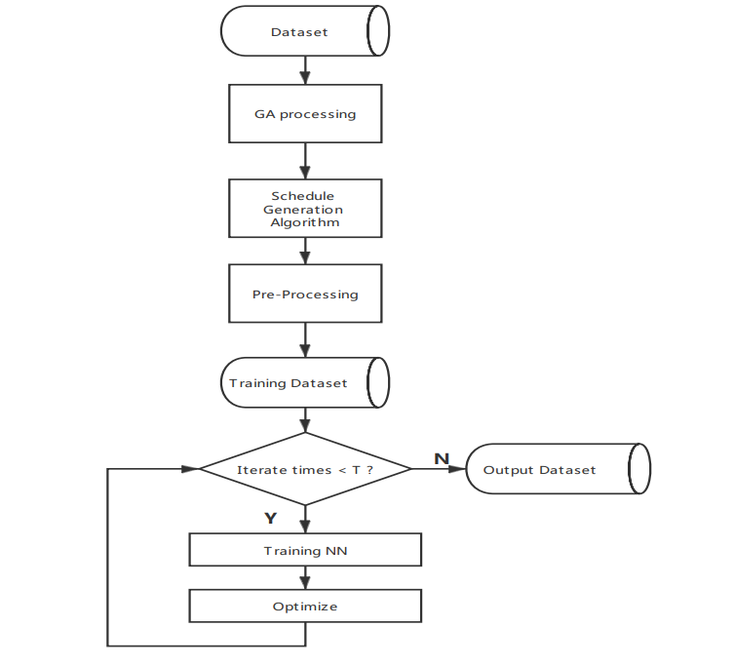
Figure 3.2: Optimal Model with Artificial Neural Network

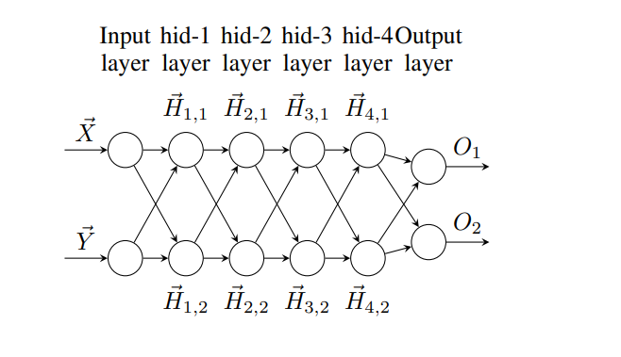

Figure 3.3: Neural Network for Hospital Scheduling
Algorithm: Improved Scheduling Algorithm
Initialize Worker-List, Workable-Set, Day-limit, Work-time-Set, Required-Number, Proficiency, for employees
Initialize Constraints
Initialize Counter1 as 0
while Counter1 < Day-limit do
Initialize Counter2 as 0
Initialize Container
while Counter2 < Require-Number do
assign Man using random(Member-list)
if Suitable(Man, Constraints) is True then
Add Man into Container
Increase Workable-Set[man] and Counter2
else assign New-Man
using Change-Order (Man, Worker-List, Workable-Set)
if Proficiency[Man] ≥ Proficiency[New-Man] then
Add Man into Container
Increase Workable-Set[Man] and Counter2
else Add New-Man into Container
Increase Workable-Set[New-Man] and Counter2
end if
end if
end while
Add Container into Work-time-Set
Increase Counter1
end while
Improved Scheduling Algorithm Source: (Mamta, 2019)
3.2 ANALYSIS OF THE EXISTING SYSTEM
In the past scenario, doctors and nurses scheduling are done manually, a paper will be given to the doctor/nurse, and this paper will contain their working schedule. In some other situation, a board will be mounted on the hospital wall where the schedule are written on. The doctors and nurses will have to check their scheduling card to know when they are on duty or they check the notice board available at the hospital. The traditional hospital scheduling system is not efficient enough for hospitals, as the doctors and nurses do have mixed up in their schedule. The old methods can be classified into categories which are paper grounded and verbal grounded. For paper based work, the admin comes and pens down each doctor and nurse date and time for their shift, this will then be passed to the doctors and nurses for confirmation.
3.3 PROBLEMS OF THE EXISTING SYSTEM
The traditional or existing system is a standalone process, the administration schedule doctors and nurses job time on paper or notice board. This existing method/process is less accurate, danger of doctor/nurse missing their schedule time; certain required report is not available, time consuming process, schedule time table paper being lost, and other problems that may occur in the using of this system. Therefore there is a need to develop a system that will eradicate the problems mentioned above.
3.4 DESCRIPTION OF THE PROPOSED SYSTEM
This system is a bunch of benefits from various points of views. As this new system is a computerized doctor and nurse scheduling. The problem addressed in this study is scheduling of a weekly roster for Balogun Hospital doctors and nurses. The task is to assign n duties to n doctors/nurses subject to a set of resources and regulatory constraints. Typical constraints include some specific duties cannot be followed by some other duties; there must be some days off in each roster; and so on. The solution can be expressed as an n-row roster. Each row shows duties in one week for a member of doctors and each nurse will roll to the duty in following row so that the load can be balanced over an n-day cycle time. The system will help the admin of the hospital to schedule day and time for each of their doctor and nurses.
3.5 ADVANTAGES OF THE PROPOSED SYSTEM
Doctor and nurse scheduling system have various advantages and some of its advantages are;
- More efficient and reliable.
- Less time consuming and easy access of job schedule.
- It allows the admin to view schedule and make changes before submitting the table on the system.
- Saves a lot of time, the manual method is very stressful and time consuming

CHAPTER FOUR
DESIGN, IMPLEMENTATION AND DOCUMENTATION OF THE SYSTEM
4.1 DESIGN OF THE SYSTEM
This is the computation of the particulars of a new system and the determination of what the new system would be and the function it is to perform. This may involve changing from one system to another or modifying the existing system operation.
The most challenging phase of the system life cycle is the change from manual operation to a faster and more accurate one; system design stage covers the technical specifications that will be employed in the implementation of the new system in order to modify the previous system. Some factors are put in consideration. These factors include input design, output design, definitions file and procedure designs and other documentation.
4.1.1 OUTPUT DESIGN
This incorporates the objectives of solving the existing system problems and challenges. This involves the structuring of the desired information and also to enhance efficient and effective computerized system for doctor and nurse scheduling system. Things taken into consideration in determining the output are represented below:


Figure 4.1: Main menu interface
This is the main menu interface that contain some clickable buttons that are use to navigate to other forms on the system. These buttons are admin, view time table, logout and exit.

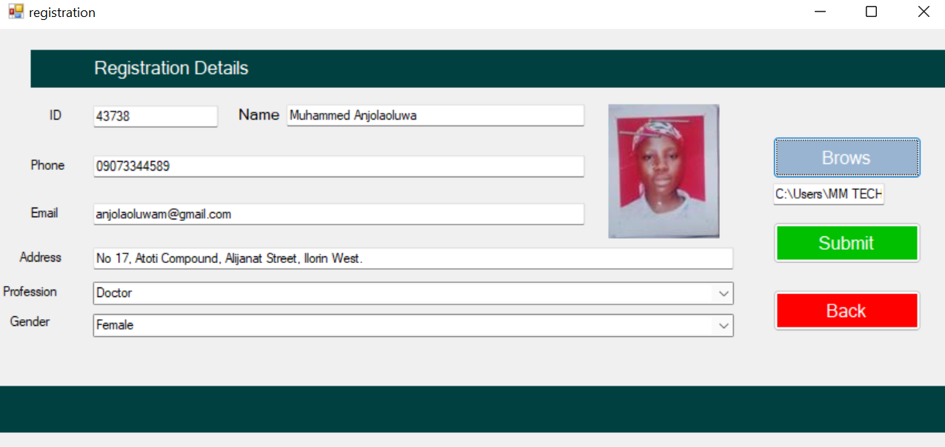

Figure 4.2: Registration page
This interface where doctors and nurses enter their information for proper documentation.
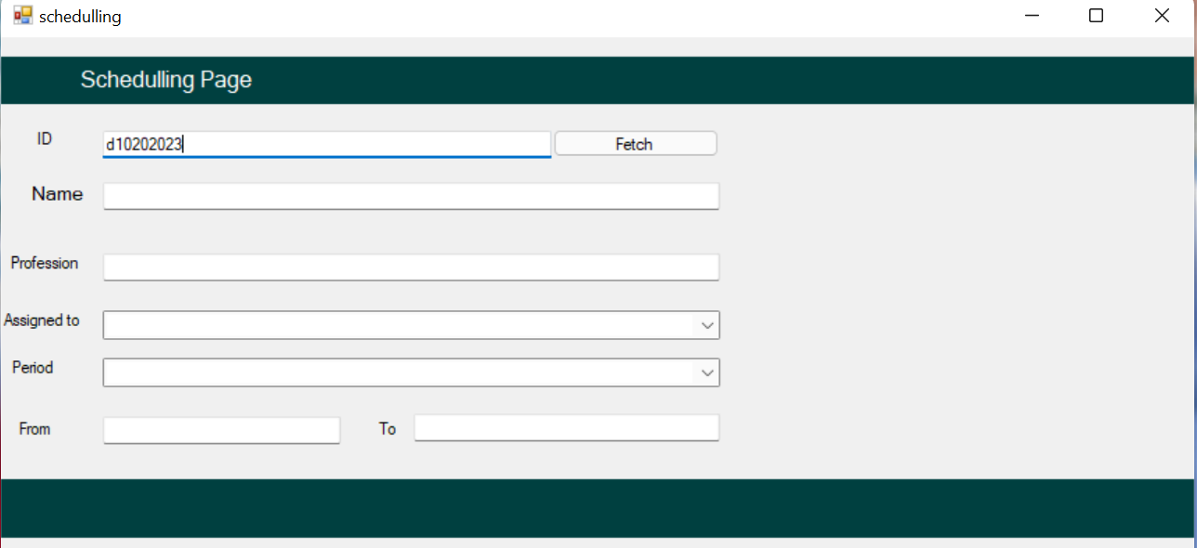
Figure 4.3: Search Record
This page is an area wheredoctors and nurses search for their shifting period.
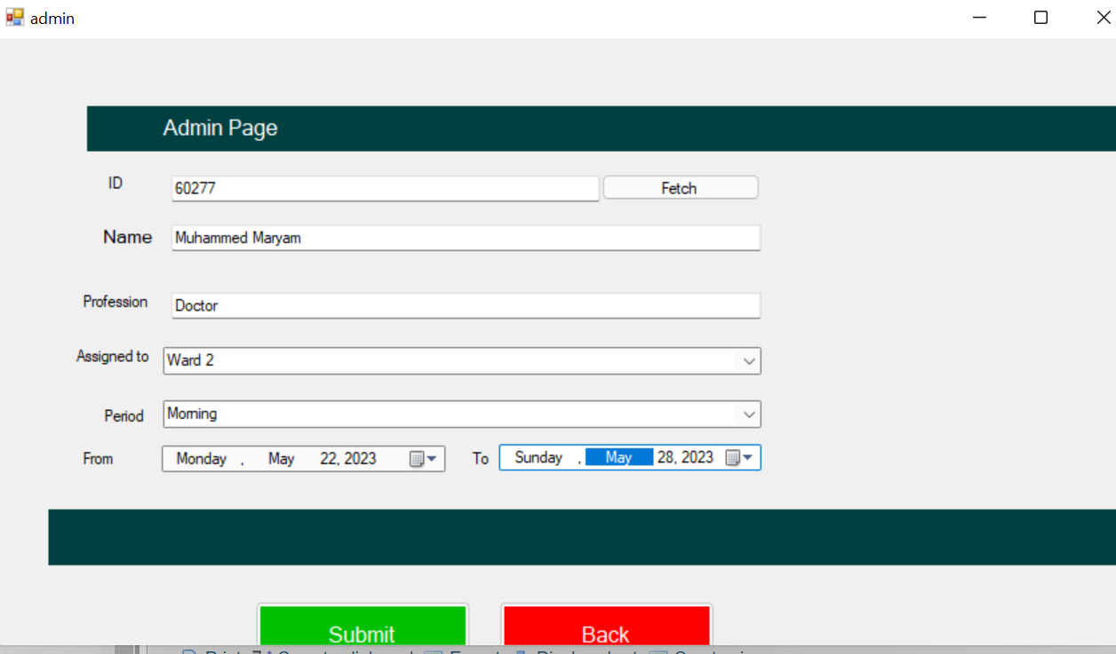
Figure 4.4: Admin
This is an interface where admin assign shifting to staffs
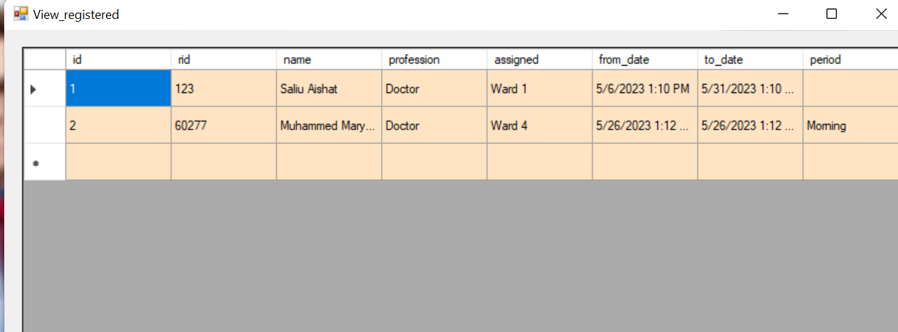Figure 4.5: Report
This is page that comprises all scheduled
4.1.2 INPUT DESIGN
The administrator is expected to course code and other information about the paper. He can achieve this by typing via the keyboard. The input required from the admin is the time, day, date and exam room/hall.
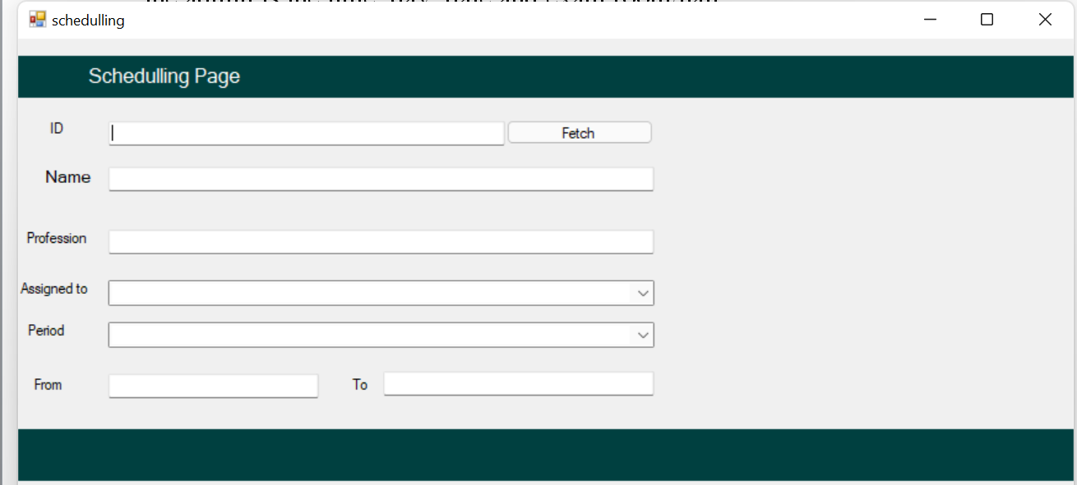
Figure 4.6: Scheduling Interface
This is a page where admin prepare schedule

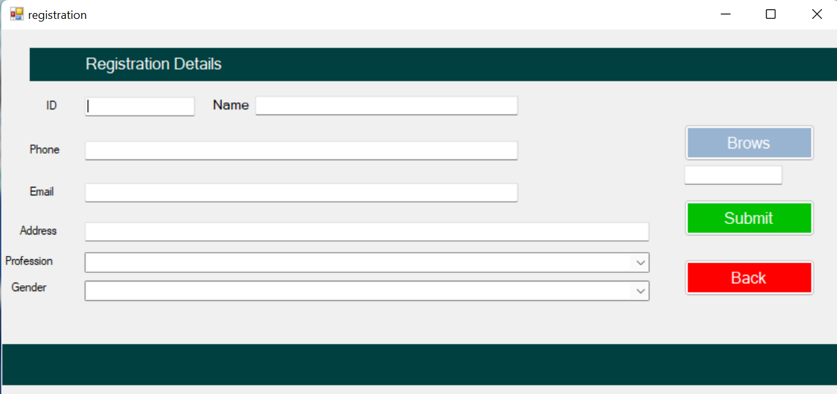
Figure 4.7: Exam Details Entering Page
This page allow doctors and nurses to supply their details
4.1.3 DATABASEDESIGN
The input file is processed against the output file to produce the required output and the" various file layout (designs) has already been given in the various pages, under the input design and the output design for the various modules respectively.
Table 4.1: Admin Table
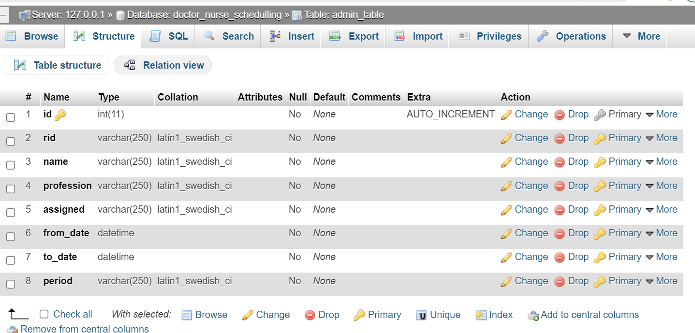

Table 4.2: Registration Table
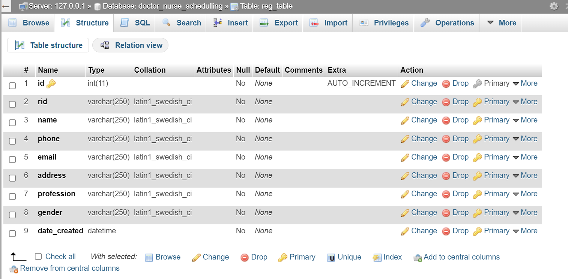
4.1.4 PROCEDURE DESIGN
These are the steps involved in unifying the whole process to produce the desired output. It involves computer procedures which start from the original input lessons to the output result file. This allows the processing of exam information and result to be possible. Menu is provided to aid user in the processing of the output file.

4.2 IMPLEMENTATION OF THE SYSTEM
This entails the choice of the programming language employed to implement the software which should-be suitable for automated time table generation. The software is designed for the use of computerized system for exam time tabling using random algorithm which should serve as an assistant. It is also expected to be used in conjunction with the Departments.

4.2.1 CHOICE OF PROGRAMMING LANGUAGE
The Application was developed in a .net (dot net) integrated development environment (.net IDE). The Application IDE is chosen following the fact that extracted information needs to be presented in an enhanced pictorial/graphical format and easy communication with the database for program flexibility in windows platform.
4.2.2 HARDWARE REQUIREMENT
- 500 Hz minimum with CD ROM drive etc.
- Hard disk of capacity 10GB Minimum
- 126-512 megabyte of RAM
- An Uninterrupted power supply (UPS)
- A voltage stabilizer
- A power generating set and so on.
4.2.3 SOFTWARE REQUIREMENT
- Window Operated system such as Windows 7
- Visual studio 2010
- Server Query Language (SQL).
4.3 DOCUMENTATION OF THE SYSTEM
4.3.1 PROGRAM DOCUMENTATION
The program is packaged for use in any system irrespective of either it runs visual studio application or not. After developing a program in Visual studio, there is a facility provided in Microsoft Visual Studio suite called “Package and Deployment Wizard” that is used in Visual studio application packaging and deployment.
Automated exam time table using random algorithm is packaged into an installable setup that can be run from any system.

4.3.2 MAINTAINING THE SYSTEM
The system maintenance refers to making modification to an already existing application/program without necessarily re-writing everything from start. Program maintenance of a program includes modification of the program to meet-up with certain requirements of the users. In this course, additional features can be added, errors corrected, ambiguous interfaces redesigned to eliminate confusions and unnecessary features removed.
Maintaining this program can be done in a Visual studio environment. Any future modification can be by re-running the program source code in a C# environment making necessary changes and updates and recompile the application into an upgrade version of the existing version of the mini word processing application. Further versions of this program can be named following their year of release or it can be given a different version number.

CHAPTER FIVE
SUMMARY CONCLUSION AND RECOMMENDATION
5.1 SUMMARY
The doctor and nurse job scheduling system has been developed and tested. The research developed the connotation and the extension functions of the doctor/nurse duty scheduling system in healthcare centre and improve the efficiency of the doctor/nurse management. The method is to expand the connotation and the extension functions of the doctor/nurse scheduling system, including the job description links and queries, the personal need submission, the shift constraints and reminders, the emergency allocation of the human resources and other connotative functions, and to extend the functions of the doctor/nurse data exchange and sharing. The system adopted the software development lifecycle and was developed using Visual C Sharp for the interface and MySQL a relational database management system for the database.
5.2 CONCLUSION
The development of the doctor and nurse scheduling system is a process of continuous improvement. The doctor/nursing system has been put on line to meet the basic nursing needs of the clinic at this stage. However, with the changing needs of the clinic, the system functions need to be constantly improved. In the daily operation of the nursing system, we also need to consider the problem of the system information security. An automated Appointment and scheduling software have been developed to address some of the challenges faced by medical workers. The benefits of implementing this technology would touch everyone involved in the scheduling process, as administrators and staff can conduct their tasks more efficiently and accurately, while customers and clients have the ability to book their appointments and reservations quickly and more conveniently. The proposed system aim at simplifying the task of the patient and the doctor. It will reduce long waiting time for patients and eradicate long queue .Patient also have freedom to fix their appointment and also book an appointment according to their preference. The system will deliver timely and convenient access to health services for all patients.
5.3 RECOMMENDATIONS
Based on the findings of the study, the followings recommended;
i. Adoption of the system: Every hospital should adopt this system to enhance effective doctor and nurse scheduling to reduce long waiting time for patients.
ii. User Training: Every staff or administrator who works on the system containing the scheduling should be trained on how to operate the new system to enhance effective system.
iii. More research should be conducted on the usefulness and effectiveness of doctor and nurse scheduling system.

REFERENCES
Aburayya, A., et al., (2020). Evolving a Hybrid Appointment System for Patient Scheduling in Primary Healthcare Centres in Dubai: Perceptions of Patients and Healthcare Provider, International Journal on Emerging Technologies. Vol. 11, Issue: 2. Pp. 251-260.
Ahmed, A., et al., (2017). Intelligent Algorithms for Optimal Selection of Virtual Machine in Cloud Environment, towards Enhance Healthcare Services, International Conference on Advanced Intelligent Systems and Informatics.Vol.2, Issue: 2. Pp. 89-90.
Dousin, O., Collins, N. & Kler, B., K.. (2019). Employee Job Performance and Satisfaction among Doctors and Nurses in Malaysia, International Journal of Human Resource Studies. Vol. 9, Issue: 4. Pp. 306-307.
Dror, G., et al., (2018). Theory and Practice in Parallel Job Scheduling, Journal of Computer Science & Computational Mathematics. Vol. 3, Issue: 6. Pp.34-35.
Feitelson, D. G. &Rudolph, L. (2016). Parallel Job Scheduling: Issues and Approaches, Journal of Computer Science & Computational Mathematics. Vol. 1, Issue: 2. Pp.4-5.
Gondane, M., S. & Zanwar, D., R. (2012). Staff Scheduling in Health Care Systems, Journal of Mechanical and Civil Engineering (IOSRJMCE). Vol. 1, Issue: 6. Pp. 28-40.
Hao, G., Lai, K., K. & Tan, M. (2014).A Neural Network Application in Personnel Scheduling, Annals of Operations Research. Vol. 1, Issue: 3. Pp. 4-5.
Klusácek, D. & Rudová, H. (2017). Alea 2–Job Scheduling Simulator, International Journal of Engineering. Vol. 1, Issue: 4. Pp. 6-7.
Ladstattera, L., Garrosab, E., Badeaa, C. & Morenob, B. (2019). Application of Artificial Neural Networks to a Study of Nursing Burnout, Ergonomics. Vol. 1, Issue: 2. Pp. 1–2.
Lekan, A. J., Oloruntoba, S., A. (2017). Design and Implementation of a Patient Appointment and Scheduling System, International Advanced Research Journal in Science, Engineering and Technology. Vol. 4, Issue 12.Pp. 36-37.
Liu, T. & Zhang, L. (2021). Apply Artificial Neural Network to Solving Manpower Scheduling Problem, International Advanced Research Journal in Science, Engineering and Technology. Vol. 2, Issue 4. Pp. 16-17.
Minwei, D., Weiju, C. &Roe, E. (2017).Summary and Reflection on the Nurse Scheduling. China Nursing Management, International Journal of Advanced Academic Research. Vol.8, Issue: 1. Pp. 99-100.
Mohammadi, M. M., Pasandideha, S. H. & Naderib, B. (2022). Operating Room Scheduling Optimization Based on a Fuzzy Uncertainty Approach and Metaheuristic Algorithms, International Journal of Engineering. Vol. 2, Issue: 3.Pp. 8-13.
Nazia, S. & Sarda, E. (2014).Online Appointment Scheduling System for Hospitals: An Analytical Study, International Journal of Innovations in Engineering and Technology (IJIET). Vol.2, Issue: 2. Pp. 9-10.
Samah, A., A., Zainudin, Z., Abdul-Majid, H. & Yusoff, S., N. (2015). A Framework using an Evolutionary Algorithm for On-call Doctor Scheduling, Journal of Computer Science & Computational Mathematics, Vol. 2, Issue: 3. Pp. 23-24.
Singh, R. (2019). Nature Inspired Job Scheduling For E-Health Services In Mobile Cloud Computing, International Journal of Computer Applications & Information Technology. Vol. 11, Issue:2. Pp. 123-124.
Strahl, J., P., F. (2015). Patient Appointment Scheduling System: with Supervised Learning Prediction Aalto, University School of Science, Pp. 7-8.
Zhao, Y., Liang, L., Wang, Y. &Cui, Y.(2017).Design for the Nursing Scheduling System Frontiers in Educational Research, International Journal of Innovations in Engineering and Technology (IJIET).Vol. 2, Issue: 10.Pp. 108-113.

Appendices: System Flowchart
Appendix 1: Main Menu Flowchart
Start

Main Menu

Schedule Doctor/Nurse Working Time

Doctor/Nurse Registration
Report

Record Modification

Stop

Appendix 2: Staff Registration Flowchart
Start
Is Record OK?
CLOSE DB
Another Record?
RETURN
Yes
Open Database

Accept Doctors’ Record

No
Save Record to DB

No
Yes

Appendix 3: Update Staff Record
Start
Display Record
Return
Open Database
Accept Doctor ID
Is Record Found?
Modify Another Record?
Close Database
Display Record Not Found
No
Yes
No
Search Doctor Record
Edit/Delete Record

Yes
Update Database
RECORD

Appendix 4: View Doctor Report Flowchart
START
Open Database
Display Main Menu

View Doctor Report
RECORD

Close Database
STOP

Appendix 5: Schedule Flowchart
Start

Open Database

Enter Doctor ID

Display Details

Is Record Found?
No

Yes
Assign Day and Time

Close Database

Stop

Appendix 6: Source Code
using System;
using System.Collections.Generic;
using System.ComponentModel;
using System.Data;
using System.Drawing;
using System.Linq;
using System.Text;
using System.Windows.Forms;
using System.IO;
using MySql.Data.MySqlClient;

namespace Fault_detection_in_Cloud
{
public partial class CreateData : Form
{
public void randomareg()
{
String rid = "Rec-001";
MySqlConnection mycon = new MySqlConnection(Class1.connectstring);
mycon.Open();
MySqlCommand cmd = new MySqlCommand("select Count(rid) from recor", mycon);
int i = Convert.ToInt32(cmd.ExecuteScalar());
mycon.Close();
i++;
textBox1.Text = rid + i.ToString();

}
public CreateData()
{
InitializeComponent();
randomareg();
}

private void button4_Click(object sender, EventArgs e)
{
Main_menu mm = new Main_menu();
}

private void button2_Click(object sender, EventArgs e)
{
//checking for empty fields............
try
{
if ((textBox1.Text.Trim().Equals("")) || (textBox2.Text.Trim().Equals("")) ||
(textBox4.Text.Trim().Equals("")) ||textBox4.Text.Trim().Equals("") || pictureBox1.Image.Equals(""))
{
MessageBox.Show("ALL FIELDS ARE MANDATORY!", "ALERT!", MessageBoxButtons.RetryCancel, MessageBoxIcon.Error);
textBox1.Focus();
return;
}
}
catch (FormatException ex)
{
MessageBox.Show(ex.Message);

