EFFECT OF STARCH ON THE BAKED STRENGTH AND BAKED HARDNESS OF DADA OKELELE CLAY BONDED CORE-SAND

BY
ABDULKAREEM SIKIRULLAHI OLAMILEKAN
ND/23/MET/FT/0073

BEING A PROJECT REPORT SUBMITTED TO THE
DEPARTMENT OF METALLURGICAL ENGINEERING
INSTITUTE OF TECHNLOGY
KWARA STATE POLYTECHNIC ILORIN.

IN PARTIAL FULFILLMENT OF THE REQUIREMENT FOR
THE AWARD OF NATIONAL DIPLOMA IN
METALLURGICAL ENGINEERING

JULY, 2025

CERTIFICATION
This is to certify that this report was compiled by ABDULKAREEM SIKIRULLAHI OLAMILEKAN with Matriculation Number: ND/23/MET/FT/0073 of the Department of Metallurgical Engineering Technology (I.O.T), Kwara State Polytechnic, Ilorin, for the National Diploma (ND) in Metallurgical
Engineering.
Approved by:

_________________________ _________________________
Engr. Alagbe, M. Date
Project Supervisor

_________________________ _________________________
Engr. Adegbite, A.D. Date
Head of Department

_________________________ _________________________
External Supervisor Date

DEDICATION
With a heart filled with excitement and a tongue full of thanks. We are dedicating this project work to the Almighty Allah for bestowing upon us the grace to complete our National Diploma successfully. May His name be praise forever.

ACKNOWLEDGMENTS
Firstly, I wish to express our profound gratitude to the Almighty Allah who has been the source of my strength and breathe since these years.
I thank my Project supervisor Engr. Alagbe, M. for creating time to read through my project.
My sincere appreciation goes to my H.O.D Engr. Adegbite, A.D for his support in the success of this project. My appreciation also goes to all the lecturers in Metallurgical Engineering Department for their impact.
My gratitude also goes to our parents for their moral and financial support. May Almighty Allah bless you all. Amen

ABSTRACT
The suitability of Dada Okelele clay as a clay bonded core sand was studied. Sand mixed containing 55-70% clay and 30.45% silica sand with 2% saw dust addition were used for the investigation. The effect of starch on the properties of this mixture was study in the range of 0.5 - 3 % starch addition. Testing of such properties as gas permeability and dry compression strength were carried out on AFS standard samples of these mixes.
The core sand mix contain 65% /35% clay/silica sand +2% saw dust + 1.5% starch possesses properties comparable with core sand used in local casting and could be in suitable substitute for these core sand mixes in use of present.

TABLE OF CONTENTS
Title page
Certification
Dedication
Acknowledgement
Abstract
Table of content
CHAPTER ONE
1.0 Introduction
1.1 Core Moulding/ Sand Moulding
1.2 Equipment’s and Materials Used in Core Making
1.3 Reasons for Using Core Sand
1.4 Functions of Binding Agent
CHAPTER TWO
2.0 Literature Review
2.1 Sand and Bindings
2.1.1 Green sand
2.2 Shapes of Foundry Sands
2.3 Binder
2.4 Main Properties of Moulding Sand
2.4.1 Sufficient gas permeability
2.4.2 Sufficient Strength
2.4.3 Sufficient Collapsibility
2.4.4 Sufficient Plasticity
2.4.5 Sufficient Refractoriness
2.5 Composition of Moulding Sand
2.5.1 Thin Casting
2.6 Type of Moulding Sand
2.6.1 Facing Sand
2.6.2 Banking Sand
2.6.3 System Sand
2.6.4 Moulding Flask
2.7 Preparation of Moulding Sand
2.8 Casting Process
2.8.1 Sand Casting
2.8.2 Die Casting
2.8.2.1 Principle of Gravity Die Casting
2.8.2.2 Principle of Pressure Die Casting
2.8.3 Centrifugal Casting
2.8.3.1 Semi Centrifugal Casting
2.8.3.2 True Centrifugal Casting
2.8.3.3 Centrifugal Process
2.8.4 Investment casting
2.8.4.1 Investment Flask Casting
2.8.4.2 Investment Shell Casting
2.8.4.3 Advantages of Investment Casting
2.8.5 Carbon Dioxide Moulding Process
2.9 Casting Defects
CHAPTER THREE
3.0 Experiment Procedure
3.1 Materials
CHAPTER FOUR
4.0 Results
4.1 Discussion
CHAPTER FIVE
5.0 Conclusion
5.1 Recommendations
References
CHAPTER ONE
1.0 INTRODUCTION
Foundry is an important section in any engineering construction company with no doubt in that. Through foundry we can produce various metal articles and semi-finish products by hot or which is generally known as powder metallurgy also welding and casting.
Foundry work is the branch of metal work in which diverse mal article are manufactured by means of melting glass or metal, specifically the method involves melting the solid metal and then pouring it into a previously making mould cavity (mould cavity is the impression left behind by the pattern after its removal from the rammed flask), and allowing it to solidify to take the shape or the form of the mould.
Foundry technology is a mass production method that enjoys a wide application in a flourishing national economy. In the developed countries of the world, foundry technology takes care of the production of the automobile spare parts, e.g.: engine blocks. Also, host of agricultural and household articles is produced by its method.
An important feature of the foundry is its ability to generate different grades of sand materials. The theory and practice which is known as casting.
1.1 Core Moulding/ Sand Moulding
Core is the consolidated mass of sand used to create internal cavities in moulds. Cores are used to create hollow areas in the mould that would otherwise be impossible to achieve.
Core making or making is the system by which fine grain size of silica is being mould with the addition of coal dust, sodium silicate and carbon dioxide only without the use of water or bentonite into different shapes.
The mixing should be done inside the care-mixer. The following materials help in making the core:
- Vent Pin: this is a materials that is use for creating holes that CO₂ (g) would pass through.
- Carbon Dioxide: this help to CO₂ (g) into the mould to make it hard.
- Wooden Hammer: this is used from shaking out the core from its box.
- Core Box: A container use to mould sand.
- Screen: This is used for sieving the fine grain size of silica sand such sand (fine sand) is later dried in a rotary drier to reduce the mixture to the barest minimum. The dried sand is later passed onto a rotary screen where proper separation is done. This prepared sand is further sent the mixer where it is mixed with clay the reconditioned sand the mixer blends the three types of sand together to form the moulding sand.
Secondly, the prepared moulding sand is poured into the moulding flask which normally houses the pattern i.e. where the pattern is been placed and the whole is properly rammed using a hand rammer or a pheumatic rammer.
After the ramming procedure, the pattern is clearly ejected from the flask leaving behind an empty cavity called "mould cavity". Such mould cavity is an exact impression of the pattern.
The mould cavity is later properly dressed such that it present a good finished surface for pouring procedure. The pouring of molten metal into such prepared moulding cavity is done by the aid of an appropriate gating system. Such gating is usually prepared by applying BERNOULLI’S THEOREM.
Bernoulli's theorem for calculating velocities in idealized the gating system help the foundry workers to predict the success of the gating designed. (Richard et al, 2006).
The formula is hereby given as:
$$\frac{v1^{2}}{2g}+ \frac{p1}{p} H1= \frac{v2^{2}}{2g}+ \frac{p1}{p} H2$$
Where V is the velocity of the liquid metal at two different parts 1 and 2 in m/s
G is the acceleration due to gravity in m/s
P is the stake pressure in kg/m²
P is the density of metal and measured in kg/m²
H is the height of liquid in m
Moulding mixtures preparation can be divided into four parts:
- Watering of sand
- Inter mixing of component
- Moistening
- Curing and loosing
1.2 Equipment and materials used in core making
To be able to mould successfully, the following equipment are available in the moulding section for moulding namely:
Moulding box:- A very important tool for moulding sand. The moulding boxes are of different sizes which are:
Small size 10 x 20 x 88 x 86cm
Medium size 10 x 76 x 76cmn
Big size 20 x 88 x 86cm
Shovel or spade - it is used for mixing of sand.
Other equipment used in the workshop are:
- Mould board
- Trowel
- Vent pin
- Moulding pin
- Pneumatic rammer
- Flat rammer
- Scrapers
- Reinforce pin
- Weight
- Plubage

There are some set of equipment installation that is used for the preparation and condition of mould and core sands. They are:
- Fluidized Drier
- Magnetic Separation
- Sand mill (mixer)
Fludized Bed Type Drier
Fluidized bed type drier is use for moulding sand. The mutual sand is used on a screen. Fluidized gasses are used on a screen. Fluidized gases at the top of an elevated pressure are supplied under the screen and raise a sand layer to form a fluidized bed. Intensive motion of the sand particle on them to ensures effective heat exchange between the hot gases and the sand particles getting dried quickly in the critical part of the dried particle loss velocity and start to settle. Dried sand flows through chute.
Magnetic Separator
There is a multi-pole electric magnet inside to drive the belt conveyor thrive ring that reclaimed sand from the knock-out grid. Metal particle are attracted by the electromagnet and passed against the conveyor bench that falls off at the end. Non-magnetic material i.e. used moulding mixture. It then falls of the belt ahead of the metal particle and collected the container earlier positioned.
Sand Mill (mixer)
Sand mill is used for intermixing of sand mixture to obtain a homogenous structure in which all sand with uniform thin layers of moisture clay or another binder enveloped grain. Among the varies types of these machines, the most popular ones are the Muller with vertical or horizontal wheels.
Aerators
An aerator has rotating shaft with paddles that pick up the mixture fed continuously through charging hole and throw it against freely hanging chain or rods. Belt conveyors into bunkers arranged above moulding machines then feed the bunked mixture.
1.3 Reason for using Core Sand
The preparation of mixture includes the preparation of initial moulding metals and reclaimed sands. Core sands are used mainly because of its good casting properties. The moulding and core sand constituent parts are normally supplied into the foundry workshop in different forms but before use, it is expected to be first dispersed of required moisture content and uniformly intermixed.
1.4 Function of binding agent
- It enhances good plasticity in moulds.
- It gives impact bond strength in mould.
- It offers foundry sand resistance to deformation.

CHAPTER TWO
2.0 LITERATURE REVIEW
2.1 Sand and Binders
The sand which may be either naturally or synthetic must possess sufficient strength to retain the mould shape both before and during entry of liquid metal into the mould.
They must also be refractory and be permeable enough to allow for the escape of steam and gases. The naturally occurring material used for moulding is called green sand.
2.1.1 Green Sand
Green sand is a siliceous material containing a portion of clay. The exact composition on green sand varies with the location of deposit and clay content may range from 5% -20%. The clay when moist act as a binding agent around silica grains to give the sand certain strength.
Blending dry silica sand with clay makes synthetic sands. Silica sand- usually collected from the coast of ocean, so as and is used for moulding (sand stone).
Bank sand-also found at river banks.
Lack sand-it is found near lake shores/beaches.
Note: All of these three types of sands are classified according to their size as boulders, cobbles, gravel, sand and silt.
Table 2.1: Type of sands according to their sizes.
Name
Boulders | 10-in diameter or layer
Cobbler | 2 ½ in 10in diameter
Gravel | 5 mesh sieve = 2 ½ in diameter
Sand | 250 – 10 mesh sieve
Silt | 70 micron – 250 mesh sieve

2.2 Shapes of Foundry Sands
There are four basic forms of foundry sands. They are:
- Angular Shape
- Round Shape
- Sub-Angular Shape
- Compound Shape
Angular shape: Tt has sharp edge and has angles. An angular shape is most useful when two of it comes together. They can easily form interlocking parts.
(a) Angular shape
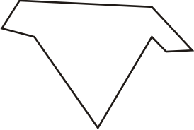

(b) Round

Sub-angular- some parts are very smooth and others are not

(c) Sub - angular

Compound - this consist of the combination of smooth surface and angular type.

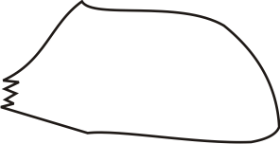
(d) Compound

Grain shape influence strength in two ways. Firstly, in relation to the way in the binder coats the grains and how the individual grains contact one another. For example, rounded grains have an even coating of binder and present good contact area to their neighbors but angular grains have uneven coating and poor areas of contact.
Secondly, to achieve optimum strength, moulding sand must be compacted in some ways to maximize their density and improve the Strength at the points of contact. Consequently, the sands should flow readily and this is a function of shape in the rounded grains flow more readily, than angular grains, which tend to interlock.
2.3 Binder
The properties of moulding sand are a function of the sand's characteristics and the binder used to bind the sand grains together to form mould. The sand directly affects such properties as refractoriness, permeability and expansion of the moulding sand. In addition, it influences binder demand, moisture demand (in clay bond sands) and flow-ability of the moulding sand, and there by the very important property of strength.
The quality of casting finish is a function of sand grains size and distribution-five grained sand produce the best surface finfish but at the direct cost of a reduction in permeability and our increase in binder and /or moisture demand.
Ponders are materials or inputs added to a mould to enable the mould sand stick together without breaking. Popular binders are:
- Clay
- Cereal (corn millet)
- Resins (gum)
- Bentonite, kaoline
Bentonite is colloidal clay derive from volcanic ash and employed as a binder in connection with synthetic sand or added to ordinary natural (clay bonded) sands where extra strength is required. All of these binders have refractive properties
2.4 Main Properties of Moulding Sand
Moulding sands are usually produce by mixing fresh silica and refractory clay with a definite amount of used and various activities. The moulding sand must adequately satisfy the following properties before it can be considered suitable for casting.
2.4.1 Sufficient Gas Permeability
Good or sufficient permeability means the ability of moulding sand to allow gases to pass through its whole thickness and escape.
It is expressed in volume per unit time (m³/s) for grey iron sand with the following gas permeability is usually used (Avner, 2006).
Grey iron-30-80m³/s cube/s
Steel-70-100m³/s, permeability
Bronze-Cu + Zn, Al, Si etc
Brass-Cu + Zn 30m/s
Al
Core-70-130m³/s cube/s

2.4.2 Sufficient Strength
Sufficient strength refers to the ability of moulding sand it withstand shock or wearing away under the action of the molten metal. That is. No destruction of the moulding sand should take place during converging and during pouring of molten metal. No washing of the mould cavity. When the mould is filled with molten metal, it breaks and the wall is subjected to a high metal plastic pressure.
If the sand is not strong enough to withstand this pressure, the mould cavity is enlarged and the cavity obtained oversize.
2.4.3 Sufficient Collapsibility
Collapsibility refer to the ability of the moulding sand to decrease in volume to some extent under compressive force developed by the mould sand may result in the formation of crack in the casting.
2.4.4 Sufficient Plasticity
Sufficient plasticity of moulding sand refer to the ability to acquired it's predetermined shape and to retain the shape when the pressure is removed.
High plasticity is required of the moulding sand to obtain a good Impression of the pattern in the mould.
2.4.5 Sufficient Reactiveness
The grains of the moulding sand must not melt, soften or sinter under the action of the high temperature developed when the molten is poured into the mould. Molten sand of the oxide of alkali or alkaline carth metal (Na₂O, K₂O, MgO and CaO) for example lowers the refractoriness of the silica and therefore their content is limited to 1.5% to 2% for steel casting (5%) for heavy grey iron casting and not more than 3% for ferric oxide (Fe₂O₃) may be allowed in moulding sand.
2.5 Composition of Moulding Sand
The composition of moulding sand could depend on the type of castıng that would be performed either in thin casting medium casting and thick casting. They all have different composition. The following could show the various composition sand of moulding performed.
2.5.1 Thin casting
91% of old sand, 25% of fine grain sand, 8% of bentonite, 6% of coal dust and 15 – 20 liters of water depending on humidity. Example of this product are paddles arm, fly wheel.

2.6 Types of Moulding Sand
There are various types of moulding sands, some of them are:
- Facing Sand
- Backing Sand
- System Sand
2.6.1 Facing Sand
Facing sand has directly contact with the molten metal. It must have high strength and refractiveness. It is made from the silica and clay without the addition of used sand. The layer of facing sand is usually about 20 - 30mm.
2.6.2 Backing Sand
Backing sand is use to back up the face and to fill the volume of the flask, repeatedly used moulding sand with a lathe addition of grain sands mainly employed for this purpose.
2.6.3 System Sand
The system sand apart from silica, clay and old condition sand in organic compound e.g. olivine (SiO₄), zircon, chromites + silica + clay + old used sand. System sand is used in mechanized foundry where machine moulding is employed.
Usually, the old mould is made up of this system sand. Hence, the strength permeability and refractoriness are usually higher than that of refractoriness other additives used in the foundry industries include pulverized coal, graphite, peat, wood flower and other organic matters.
2.6.4 Moulding Flask
The moulding flask is a tool used in moulding. They are made or fabricated accordingly to specifications. It is the rigidity and strength to the sand in moulding and in the case of permanent flask. In conveying and pouring the metal. The flasks are made of steel, cast iron or aluminum alloy.
A typical moulding flask has a typical forn. Load is normally applied in other to avoid lifting up of the cope by gas from the molten materials.
2.7 Preparation of Moulding Sands
Moulding sands are usually prepared by mixing fresh silica sand and refractory clay with a definite amount of used sand and followed with various additives of right proportion. For more details, go to core moulding.
2.8 Casting Process
There are many methods of casting employed in the industries. The major or most important processes include;
- Sand casting
- Ore casting
- Centrifugal casting
- Investment casting
- Carbon dioxide casting
- Others include dip casting, slush casting and corthias casting.
2.8.1 Sand Casting
Sand casting technique is the oldest foundry method of producing cast profile.
The major operations involve are;
- Sand preparation
- Sand blending
- Sintering of the sand mould and finally pouring of the liquid metal into

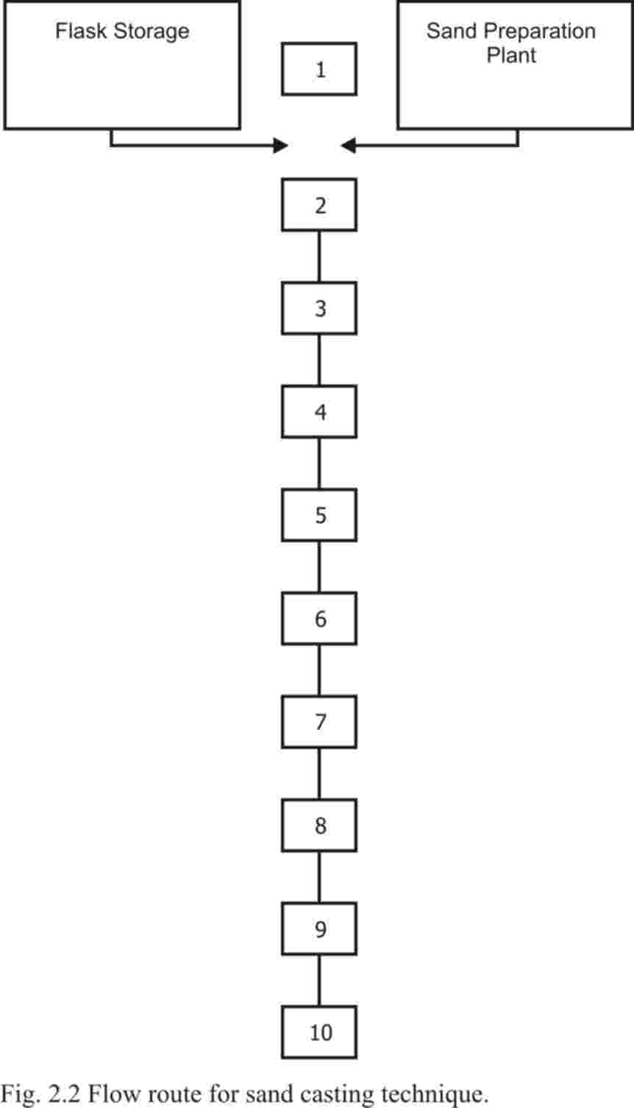

Fig: 2.2 Flow route for sand Casting technique.
- Pattern storage
- Pattern section
- Lifting of the cope drawing pattern and finish mould cavity
- Assembly mould
- Pouring of molten metal
- Cooling of the profile
- Shake out or removal of the profile from the mould
- Fettling and snagging
- Inspection:- use of microscope
- Finish product: - storage

2.8.2 Die Casting
The actual process of die casting is referred to a one step process because the metals is changed from the liquid to solid state in one step essentially there are pressure die casting method.
The die casting process is a permanent mould casting, involving the forcing of molten metal into a permanent mould cavity under pressure.
Metals used for die-casting include tin, lead, zinc and aluminum to a Small extent of copper and alloys.
2.8.2.1 Principle of Gravity Die-Casting
Gravity die-casting is very similar in principle to sand casting in that the design must include the riser head to feed solidification shrinkage. (Arise is used to feed metal to the casting and solidifies).
Gravity die-casting pours molten metal into the die and uses gravity to force the molten metal into the cavity. Gravity-poured castings are superior in metallurgical structure to the casting poured under pressure because gravity-set casting solidifies as the molten metal flows into the die progressively freezing the metal. Each freezing layer is fed by the liquid layer above it allowing the gases in the metal to escape through the molten metal and giving the casting a sound grin structure. Beside, a stronger metallurgical structure, gravity field has less total shrinkage.
The die or moulds that are usually used are made from steel or steel alloy. Other alloy element is Nickel/ Chromium/ Tungsten/ Cobalt.
Steel core may be used in the gravity die if is required to cast hollow shapes of simple design.

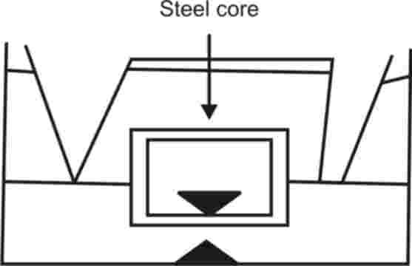

Hollow shapes of more complex designs can be made by gravity die casting with sand core insert. For example, the body of a domestic water tap is cast in this way.
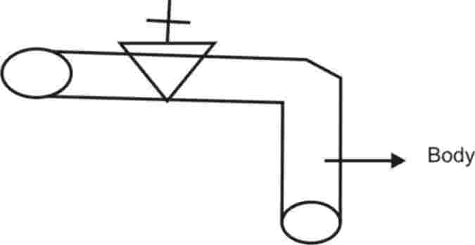

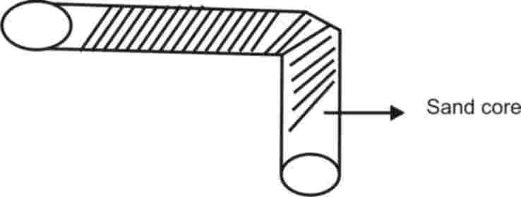

2.8.2.2 Principle of pressure die-casting
In the pressure fed die casting system, molten metal is injected under pressure into the die mould, The molten metal that comes in contact with the die surface solidifies immediately as in other type of casting process but gases cannot escape through the gating system because the gating system gas pressure force metal instead of allowing the air to come out. Since the entrap air 1s not allowed to escape it is force into the metallurgical structure of the metal casting proxy and weak casting.
2.8.3 Centrifugal Casting
We have three type of centrifugal casting they are:
Semi-centrifugal, centrifugal and true centrifugal casting.
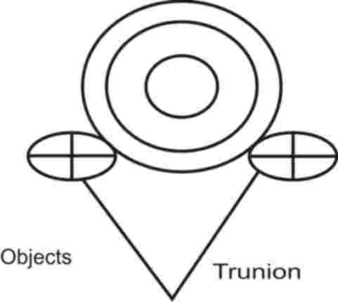
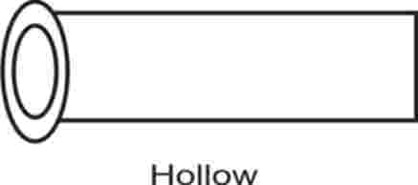

Centrifugal casting involves pouring metal into a revolving mould. It is employed in the casting of spherical shapes such as pipes, sheik and propellant.
D.K chernov first suggested the idea of centrifugal casting as far back in 1875. In the process while the moulding rotates above the axis (which may be horizontal, vertical or included at a suitable angle) molten metal is introduced so that the internal shape is formed by centrifugal action. The metal solidifies forming a hollow casting without the use of a centre core.
The speed of the centrifugal machine is generally calculated to obtain a radial force of molten which equal about 75-100 times the force of gravity in the case of sand mould but about 60 times in the force of gravity in the case of molten moulds.
To ensure the production of sand casting, the maximum number of revolution can be calculated by the (Campbell, 2003) formula.

N=$\frac{5560}{\sqrt{πR}}$ OR $\frac{5560}{\sqrt{R}}$
Where, N is the number of revolution,
R, is the radius
K, is the constant.
2.8.3.1 Semi Centrifugal Casting
Semi centrifugal casting uses centrifugal forces to cause the metal to flow from the centre spruce into one or more. Sand moulds, which are rotated around the same center axis. For example, all railroad wheels are produced by this method of centrifugal casting because they can be cast accurately and free of impurities.
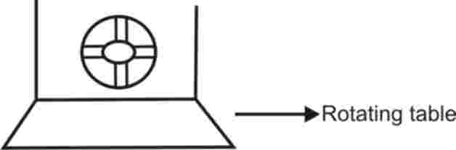

2.8.3.2 True Centrifugal Casting
As early made, true centrifugal casting are done by pouring liquid metal into a rotating mnould such that the molten metal settle on the wall of rotating mould. The non-metallic impurities in the mould moves towards the center by the cylinder and as such settle at the surface of the profile (inside surface) the inside of the finished profile is later cleaned off the non-metallic inclusions leaving a pure profile. The revolution per minute in this case is very high and differentials this method from the other two methods.

2.8.3.3 Centrifugal Process
The centrifugal casting method in that the casting itself is on the end of rotating arm or end gate. The rotation speed depends on a number of factors such as:
- The size of the casting.
- The kind of metal being used.
- Moulding medium (sand, metal and ceramic)
- The distance of casting it from pivot.
Here, the axis of the spruce B not the same as the profile.
The speed per revolution is less than any of those above. The more the profile the lesser the rotating speed.
2.8.2 Investment Casting
Investment casting is one of the semi-permanent casting techniques. Semi-permanent castings are those moulds that have long shelf life and can be used more than once.
Casting is categorized into two:
- Investment flask casting.
- Investment shell casting

2.8.4.1 Investment Flask Casting
The pattern for the investment flask casting is derived either from objects such as wax or molten plastics. One or more patterns may be attached to the spruce with wax being made to facilitate low flow rate.
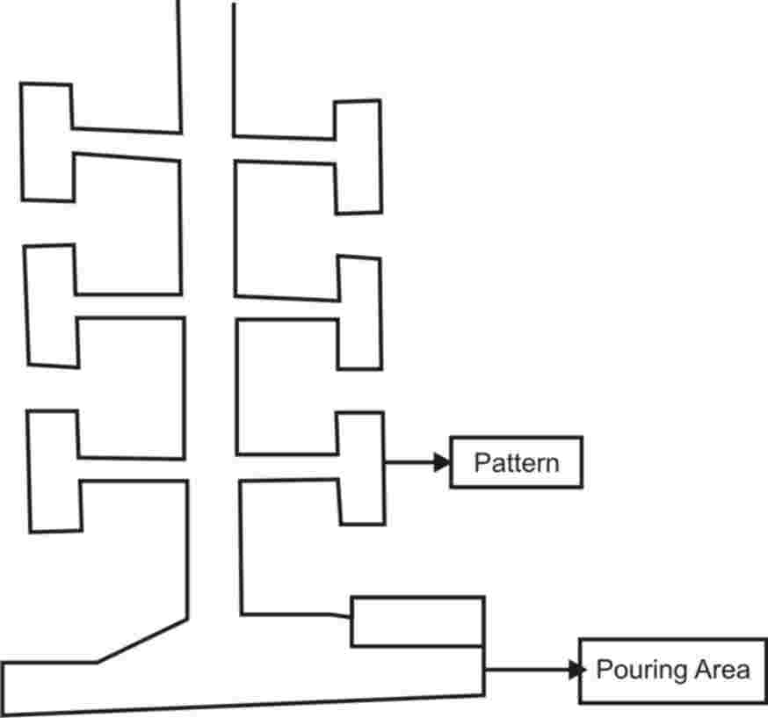

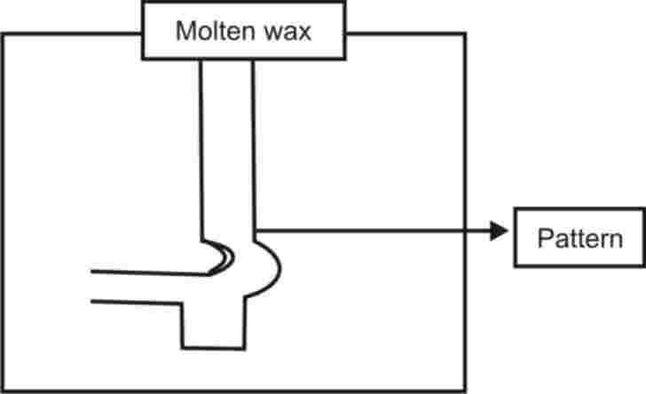

Fig.2.2 Investment Flask Casting.
Be reference to the above example, one or more pattern is attached to wax gate and then the completed pattern is placed upside down in a canister or flask that usually lined with asbestos paper. The investment is allowed to dry for sometimes before the complete canister is placed in a burnt-out oven.
There are many modification of investment casting e.g. charging the wax in the pattern to mercury, which is injected into a die pattern and then frozen. This modification is called Mercast System.
2.8.4.2 Investment Shell Casting
Investment shell casting goes through some of the same operations as investment flask casting. A pattern is developed by either caving a pattern from wax or by injected the pattern materials into die. Gates are attached as in the case of flask casting materials used for investment shell casting include;
- Rundom.
- Arclay.
- Silica flour.
- Silica glass.
- Zirconium.
These are the basic binders used in the creation of the investment slurry. The process of dipping the pattern into the liquid slurry and the sprinkling of refractoriness on the wetted pattern is repeated until there is a gradual built of a ceramic steel of 0,48cm to 1.59cm thickness. As in investment flask casting, pouring is accomplished by either static pouring vacuum pouring or centrifugal pouring.

2.8.4.3 Advantages of Investment Casting
- Very intricate form with underlets can be easily cast.
- A smooth surface can be cast with no parting line.
- Un-machinable articles can be cast with high dimension accuracy.
- The investment casting can be competitive when strength is needed.
- Much less tooling is required with investment casting-
- Casting process.
2.8.5 Carbon Dioxide Moulding Process
The basic procedure of the CO₂ process involves the mixing together of the fine silica sand and sodium silicate. The mixture is then poured in moulding flask containing the pattern to be reproduced and the entire mass rammed as in normal sand casting, several vents are the made into the rammed slurry to facilitate the influx of carbon dioxide into the mould.
The mould is then heated while a stream of CO₂ is passes or injected into it.
As a result of the presence of sodium silicate in the mixture, chemical reactions takes place between sodium carbonate and silica gel helps to cement together, he sand grains so at a very strong abrasive resistance mould is formed. Casting from this method usually have smooth surface with no sand particles punctuation the major disadvantage of thin process and the sand can no longer be used. This is economically in viable.
2.9 Casting Defects
Casting defects fall into two major groups.
- Shrinkage
- Sand inclusions
- Warping
- Mis-run
- Scabs
- Cold shut or cracks
- Stickers or hard spot
- Flask
- Cracks or heat spot
- Shrinkage: due to solidification, metals do shrinks and as a result of thin some cavities are left on the surface of the metal or profile.
- Sand Inclusion: as the name implies in the presence of the sand particle on the surface of the wearing away of the mould cavity by the molten metal during the pouring procedure or operation
- Warping: warping is absolutely movement away from the pattern shape. In this instance, the metal cools down at a rate, which is not uniform throughout the mass. This sets up stress, within the mass. Such that uneven surface are produced.
- Mis-Run: mis-run is a situation of incomplete filling of the moulding cavity. This could be done to a number of reasons. The most prominent of them is adequately fluidity of the metal.
- Scab: scabs are similar to cracks in the sense that both are lines of varying depth situated on the surface of casting excite that scabs are referred to finished of the mould or pattern.
- Cold Shut or Cracks: cold shut or wrinkled surface produced as a result of careless and hasty pouring of the liquid metal into mould. As a result of this, the metal produces a wrinkled surface on the cooling down. The old cracks could be straight or winding ruptures.
- Cross Joint: cross joints are produced as a result of miss-match of the cope and drag. This is a form dimensional accuracy.
- Stickers or Hard Spot: stickers or hard spots refer to the presence of hard un-machined area within or outside a profile with a bright fracture at various parts of the casting.
- Flash: flash is otherwise refers to as fins. This is produced as excessive protrusions in the casting. It only becomes a defect when it is extended to smooth surface of the casting.
- Crack or Hot Tears: the hot or crack tears are line of varying depth on surface of casting but so low enough to be machined. They are also formed as a result of rapid or uneven cooling of the metal.
The following defects are the internal defects found in the foundry industry.
Voids: formed as a result of gaseous inclusion that is entrapment of the gas into the metal structure.
In this case are deep sited in the metal.
Cow Shut or Cracks: this refers to wrinkled internal structure formed in the same way as the surface cold shut.

CHAPTER THREE
3.0 EXPERIMENTAL PROCEDURE
3.1 Materials
The materials used for the experiment consist of Dada Okelele clay Bounded Core Sand, starch and wood dust. All these materials are obtained from Ilorin Kwara State.

Table 3.1 Chemical Analysis of Materials
Chemical Compound | Dada Okelele Clay | Asa Dam Sand
SiO₂ | 47.22 | 98.1
AL₂O₃ | 18.37 | 0.67
Fe₂O₃ | 11.15 | 0.14
MgO₃ | 1.32 | -
TiO | 1.42 | -
CaO | 0.63 | -
K₂O | 3.01 | -
Na₂O | 0.04 | -
Loss of Ignition | 9.64 | -
Other | 7.19 | -
Total | 100.00 | 100.00
Samples dimensioning 50mm x 50mm heights were compacted by American foundry society (AFS) standard procedure. This procedure was repeated with starch content of 0.5, 1.0, 1.5. 2.). 2.5 & 3.0. Prepared samples where dried in an oven for about 2 hours at 110^{O}C and allowed to cool to room temperature (low temperature). The following tests were performed on the prepared samples.

- Baked Strength
Prepared samples for this test were heated to a temperature of 350^{O}C and left for 2 hours to scale. They were brought out and allowed to cool to room and then soaked for temperature and later tested for baked strength.
- Baked Hardness
Sample heated to a temperature of 350^{O}C soaked for 2 hours and allowed to cool to room temperature were used for this test. The surface of each sample was tested at from different point for hardness using the dieter hardness tester. Average values were taken and regarded.

CHAPTER FOUR
4.0 RESULTS AND DISCUSSION
4.1 Results
Table 4.1: Variation of Baked Strength with Starch
Starch % | Baked strength KN/M², Clay/Silica + 2% Saw Dust
% | 70/30% | 65/35% | 60/40% | 55/45%
0.5 | 690 | 685 | 605 | 590
1.0 | 710 | 705 | 650 | 640
1.5 | 750 | 640 | 610 | 595
2.0 | 715 | 635 | 590 | 580
2.5 | 655 | 630 | 575 | 565
3.0 | 640 | 620 | 520 | 510

Table 4.2: Variation of Baked Hardness with Starch
Starch % | Baked Hardness BH, Clay/Silica + 2% Saw Dust
% | 70/30% | 65/35% | 60/40% | 55/45%
 | 92.5 | 91.3 | 90.8 | 89.2
1.0 | 93.1 | 92.1 | 91.2 | 90.4
1.5 | 94.1 | 93.1 | 92.5 | 90.8
2.0 | 94.4 | 93.1 | 92.5 | 90.8
2.5 | 94.6 | 93.8 | 93.2 | 92.3
3.0 | 95.4 | 94.7 | 93.3 | 92.1
Starch content: the dried starch film at 350^{O}C around the binding power is still effective due to the short inter-particle distance. However, as the starch content increases. The dried film of starch becomes thicker. Increasing the inter-particle distance in the clay-silica wood dust system.

70% / 30% Clay/Silica + Saw Dust (KN/M²)
65% / 35% Clay/Silica + 2% Saw Dust (KN/M²)
60% / 40% Clay/Silica + 2% Saw Dust (KN/M²)
50% / 45% Clay/Silica + 2% Saw Dust (KN/M²)

BAKED STRENGTH
Figure 4.1 Effect of Starch on Baked Strength of Clay Bounded Core-sand

70% / 30% Clay/Silica + Saw Dust (KN/M²)
65% / 35% Clay/Silica + 2% Saw Dust (KN/M²)
60% / 40% Clay/Silica + 2% Saw Dust (KN/M²)
50% / 45% Clay/Silica + 2% Saw Dust (KN/M²)

BAKED HARDNESS
Figure 4.2 Effect of Starch on Baked Bounded of Clay Bounded Core-sand

4.2 Discussion
The effect of starch on the baked strength of the core-sand mixture is presented in figure. As shown, the backed strength increase initially attain a maximum and then decrease. These tends can be example as following: at lower starch content, the dried starch film at 35 around the binding power is still effective due to the shout inner-particle the dried film of starch becomes thicker. Increasing the inter-particle distance in the clay - silica wood dust system.
Figure 2 shows the effect of addition of starch on the backed hardness of the samples. It was observed that there is general increase in the baked hardness with increase in the starch content. Also the baked hardness increased with increasing clay content.

CHAPTER FIVE
5.0 CONCLUSION AND RECOMMENDATIONS
5.1 Conclusion
The compilation of the results of the tests carried out on the various mixes of the core sand has shown that 65% of Dada Okelele clay + Asa Dam silica sand + 2% wood dust + 1.5%. Starch possesses a comparable high quality.
Considering its economic value and high quality it is therefore concluded that this mix can be substituted for the existing core sand for use in iron foundry in Nigeria.
5.2 Recommendations
This project is therefore recommended to foundry operation in search of a less expensive alternative binder (starch) in replacement of the expensive binder such as bentonite (sodium silica), which is comparable and can be substituted in terms of quantitative value.

REFERENCES
Avner, S.H (2006): Introduction to physical metallurgy, 2nd Ed
MeGraw- Hill, New York.
Campbell, J. (2003): The New Metallurgy for Cast Metals, 2nd Ed
Repliha press Put. LTD, India, P. 147
Jain, R. K (2014): Production Technology, 18" Ed. Ghana, New
Delhi, P.89, 95, 116.
Kaushish, J.P (2013): Manufacturing processes, 2hd Bd. Asokuwk.
Ghosh, New Delhi, p. l68, 120.
Richard, W.H., Carl, R.L and Philip, C.R. (2016): Principles of
Metal casting 2nd Ed, Magraw-Hill, New Delhi, New York.
P 23. 84. 254.

