
A PROJECT REPORT
ON
SYNTHESIS AND CHARACTERIZATION OF GRAPHENE OXIDE

BY
AYODELE SODIQ OPEYEMI
HND/23/SLT/FT/1026

BEING A PROJECT REPORT SUBMITTED TO THE DEPARTMENT OF SCIENCE LABORATORY TECHNOLOGY (CHEMISTRY UNIT),
INSTITUTE OF APPLIED SCIENCES,
KWARA STATE POLYTECHNIC ILORIN

IN PARTIAL FULFILMENT OF THE REQUIREMENTS FOR THE AWARD OF HIGHER NATIONAL DIPLOMA (HND) IN SCIENCE LABORATORY TECHNOLOGY (SLT), KWARA STATE POLYTECHNC, ILORIN, KWARA STATE.
SUPERVISED BY:
MR. ABDULRAHMAN B.D
JULY, 2025

CERTIFICATION

This is to certify that this project was carried out by AYODELE SODIQ OPEYEMI with matric no. HND/23/SLT/FT/1026 submitted to the Department of Science Laboratory Technology, Biochemistry Unit, Institute of Applied Science (IAS), Kwara State Polytechnic, Ilorin, in partial fulfilment for the requirement of the award of Higher National Diploma (HND) in Science Laboratory Technology (SLT).

___________________ _______________
Mr. Abdulrahman B.D Date
(Project Supervisor)

___________________ _______________
Dr Jamiu Wasiu Date
(HOU, Chemistry)

___________________ _______________
Dr. Abdulkareem Usman Date
(Head of Department SLT)

___________________ _______________
External Examiner Date

DEDICATION

This project is wholeheartedly dedicated to Almighty God, for His grace, wisdom, and guidance throughout the course of this research.

I also dedicate this work to my beloved parents, whose unwavering love, support, and encouragement have been my greatest source of strength.

To my lecturers, colleagues, and friends who inspired and motivated me in the pursuit of knowledge, I deeply appreciate your contributions.

Finally, to all future researchers in the field of nanomaterials, may this work serve as a stepping stone toward greater discoveries.

ACKNOWLEDGEMENT

First and foremost, I express my profound gratitude to Almighty God for granting me life, strength, wisdom, and perseverance throughout the course of my studies and the successful completion of this research work.

I would like to sincerely thank my project supervisor, Mr. Abdulrahman B. D., for his invaluable guidance, constructive criticism, patience, and constant support throughout the course of this project. His insights and encouragement were instrumental in helping me achieve this milestone.

My heartfelt appreciation goes to my wonderful parents, Mr. and Mrs. Ayodele, whose unwavering love, prayers, and sacrifices have been the foundation of my journey. To my dear siblings, your encouragement and belief in me kept me motivated even in the most challenging times thank you for being my source of strength.

I am also grateful to my lecturers and the entire staff of the department for the knowledge imparted in me over the years. To my friends and colleagues, thank you for your support, companionship, and for making this academic journey a memorable one.

Finally, to everyone who contributed directly or indirectly to the success of this project, your impact is deeply appreciated.
TABLE OF CONTENT
Title page i
Certification ii
Dedication iii
Acknowledgement iv
Table of content v
Abstract viii
CHAPTER ONE 1
1.0 Introduction 1
1.1. Allotropes of Carbon 1
1.1.2. Fullerenes and Carbon Nanotubes 3
1.2 Properties of Graphene Oxide 5
1.2.1 Electronic Properties 5
1.2.2 Thermal Properties 5
1.2.3 Mechanical Strength 6
1.2.4 Flexibility/Elasticity 6
1.3 Statement of the problem 6
1.4 Justification 7
1.6 Aims and Objectives 7
CHAPTER TWO:LITERATURE REVIEW
2.1 Introduction 9
2.2 Synthesis of Graphene Oxide 10
2.2.1 Hummers Method: 10
2.2.2 Modified Hummers Method: 10
2.2.3. Staudenmaier Method: 11
2.3 Characterization of Graphene Oxide 11
2.3.1 X-ray Diffraction (XRD) 12
2.3.2 Raman Spectroscopy: 12
2.3.3 Fourier-Transform Infrared Spectroscopy (FTIR) 12
2.3.4. Scanning Electron Microscopy (SEM) and Transmission Electron Microscopy: 13
2.3.6. Thermal Analysis 13
2.4 Applications of Graphene Oxide 14
2.4.1.Electronics 14
2.4.2. Energy Storage 14
2.4.3. Biomedical Engineering 14
2.4.4 Composite Materials: 15
CHAPTER THREE:METHODOLOGY
2.1 Reagent and Apparatus 16
2.1.1 Reagents 16
2.1.2 Apparatus 16
3.3 Preparation of Graphene Oxide 16
CHAPTER FOUR:RESULT AND DISCUSSION
4.1 Fourier Transform Infrared Spectroscopy Result 18
4.2 X- ray Diffraction of Results 19
4.3 Scanning Electron Microscopy Result 21
Conclusion and Recommendation. 24
References 25

ABSTRACT
Graphene oxide (GO) is attracting attention for its unique properties and potential applications in electronics, energy storage, and biomedical engineering. This study synthesized and characterized GO, offering insights into its functional groups and structural properties using FTIR and X-ray diffraction (XRD) analyses.
FTIR analysis reveals characteristic peaks: 775 cm⁻¹ for C-H bending in aromatic compounds, 1051 cm⁻¹ for C-O stretching in epoxy or alkoxy groups, 1565 cm⁻¹ for C=C stretching in the graphene aromatic ring, 1722 cm⁻¹ for C=O stretching in carbonyl or carboxyl groups, 2341 cm⁻¹ for potential CO₂ adsorption, 2654 cm⁻¹ possibly due to overtones or combination bands, and 3042 cm⁻¹ for C-H stretching in aromatic compounds.
XRD analysis highlights structural characteristics with peaks at 9.19° (2θ) indicating oxygen-containing functional groups and increased interlayer distance. Peaks at 21.05° and 22.20° suggest partially reduced graphite oxide or residual graphite oxide domains, while peaks at 25.69° and 26.90° correspond to graphite-like structures and well-ordered graphitic domains.
SEM imaging at various magnifications showcases GO's microstructure and morphology. At 1500x, layered and wrinkled sheet-like structures are observed. At 250x, larger aggregates and clusters indicate incomplete exfoliation and strong interlayer interactions. At 500x, both large aggregates and smaller exfoliated sheets are visible, indicating a heterogeneous oxidation process.

CHAPTER ONE

Introduction

Graphene- based composite materials, it is essential to understand the structure/ properties of graphene and graphene's place in the family of Nano carbon materials. The intent of this chapter is to provide the reader with a general introduction to the various allotropes of carbon that range from the well-known diamond and graphite, to newly discovered Nano carbons such as fullerenes, single - walled carbon nanotubes, multi- walled carbon nanotubes, and graphene. Graphene is the basic building block of all forms SP2 hybridized carbon materials and is, therefore, of great interest both from the scientific and technological standpoint.

Allotropes of Carbon
The electronic structure of carbon gives rise to its ability to bond in many different configurations and form structures with distinctly different characteristics. This is clearly manifested in diamond and graphite [1], which are the two most commonly observed forms of carbon. Diamond forms when the four valence electrons in a carbon atom are sp3 hybridized (i.e., all bonds shared equally to four neighboring atoms), which results in a three-dimensional (3D) diamond cubic structure. Diamond is the hardest material known to humankind due to this 3D network of carbon-carbon (C-C) bonds. It is also special in that it is one of the very few materials in nature that is both electrically insulating and thermally conductive. On the other hand, graphite is the sp² hybridized form of carbon and contains only three bonds per carbon atom. The fourth valence electron is in a delocalized state, and is consequently free to float or drift among the atoms, since it is not bound to one particular atom in the structure. This creates a planar hexagonal structure (called graphene) and gives rise to the layered structure of graphite that is composed of stacked two-dimensional (2D) graphene sheets. Graphite contains strong covalent bonds between the carbon atoms within individual graphene sheets, which gives rise to its outstanding in-plane mechanical properties. However, the vander Waal's forces between adjacent graphene sheets in the layered structure are relatively weak and, therefore, graphite is much softer than diamond. Similar to diamond, graphite (in-plane) is a good conductor of heat; however, the free electrons present in graphite also endow it with high in-plane electrical conductivity, unlike diamond. The structure of diamond and graphite are depicted schematically in Fig 1.1
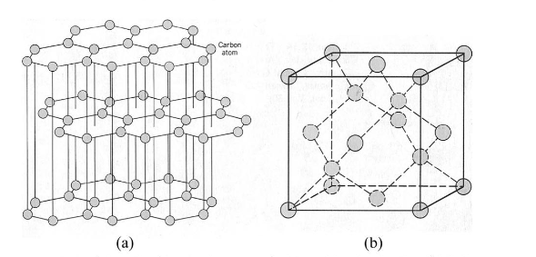
Fig 1.1: The structure of diamond and graphite

1.1.2. Fullerenes and Carbon Nanotubes
In the past three decades, the discovery of various exotic forms of nanocarbon materials has revolutionized carbon science. Prior to graphene, fullerenes and carbon nanotubes (CNTs) were the most prominent nanocarbon allotropes, both utilizing sp² hybridization of carbon to form molecules with tens or hundreds of carbon atoms. Fullerenes, discovered by Richard Smalley and Harold Kroto in the mid-1980s, have a structure resembling a soccer ball, with C₆₀ being the most common. This structure consists of 20 hexagon and 12 pentagon faces, where pentagonal defects create curvature, leading to stable, closed nanocarbon structures due to the high energy of dangling bonds.
Carbon nanotubes (CNTs), discovered by SumioIijima in 1991, are another form of novel carbon material. Single-walled carbon nanotubes (SWNTs) are essentially graphene sheets rolled into tubes and capped with pentagonal defects. These can have varying diameters and chiralities, with inter-shell spacing in multi-walled carbon nanotubes (MWNTs) being slightly larger than graphite. SWNT diameters typically range from 1-2 nanometers, while MWNTs are 20-40 nanometers. SWNTs can be either semiconducting or metallic, depending on their chiral vector, while MWNTs are generally metallic.
Fullerenes and CNTs are produced through methods such as laser ablation, arc discharge, and chemical vapor deposition, representing ideal one-dimensional structures with diverse potential applications.

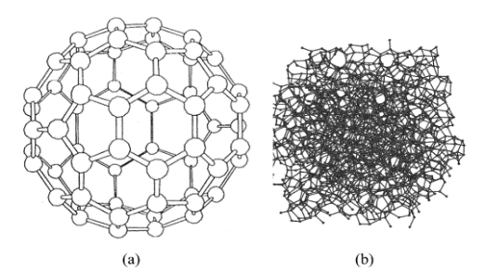

Fig 1.2. (a) Soccer ball-like shape of a Coo fullerene molecule showing the hexagonal graphite-like lattice with pentagon defects closing the spherical shell structure. (b) Molecular model of an amorphous carbon cluster. (Dresselaus, M. S. 1996).
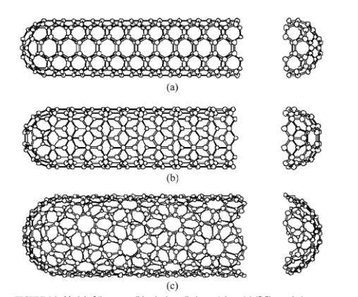

Fig 1.3: Model of three possible single-walled nanotubes; (a) (5,5) armchair nanotube, (b) (9,0) zig-zag nanotube, and (c) randomly oriented (10,5) nanotube. (Dresselaus M. S. 1996).

1.2 Properties of Graphene Oxide

1.2.1 Electronic Properties
Graphene has a delocalized pi-electron system across the entirety of its surface, the movement of electrons is very fluid. The graphene system also exhibits no band gap, due to overlapped pi-electrons, allowing for an easy movement of electrons without the need to input energy into the system. The electronic mobility of graphene is very high and the electrons act like photons, with respect to their movement capabilities. The electrons are also able to move sub-micrometer distances without scattering. From tests done to date the electron mobility has found to be in excess of 15,000 cm²V⁻¹s⁻¹, with the potential of producing up to 200,000 cm²V⁻¹s⁻¹. (Ajayan, P.M. et al 1996)

1.2.2 Thermal Properties
The repeating structure of graphene makes it an ideal material to conduct heat in plane. Interplane conductivity is problematic and typically other nanomaterials such as CNTs are added to boost interplane conductivity (Dresselhaus M.S et al, 2001). The regular structure allows the movement of phonons through the material without impediment at any point along the surface. Graphene can exhibit two types of thermal conductivity- in-plane and inter-plane. The in-plane conductivity of a single-layered sheet is 3000-5000 W m⁻¹ K⁻¹, but the cross-plane conductivity can be as low as 6 W m⁻¹ K⁻¹, due to the weak inter-plane van der Waals forces. The specific heat capacity for graphene has never been directly measured, but the specific heat of the electronic gas in graphene has been estimated to be around 2.6 μ J g⁻¹ K⁻¹ at 5 K (Novoselov K,S. et al, 2004)

1.2.3 Mechanical Strength
Graphene is one of the strongest materials ever discovered with a tensile strength of 1.3 x 10¹¹ Pa. In addition to having an unrivaled strength, it is also very lightweight (0.77 mgm⁻²). The mechanical strength of graphene is unmatched and as such can significantly enhance strength in many composite materials.

1.2.4 Flexibility/Elasticity
The repeating sp² hybridized backbone of graphene molecules allow for flexibility, as there is rotation around some of the bonds, whilst still providing enough rigidity and stability that the molecule can withstand changes in conformation and support other ions. This is a very desirable property as there are not many molecules that can be flexible and supportive at the same time. In terms of its elasticity, graphene has found to have a spring constant between 1-5 Nm⁻¹, with a Young’s modulus of 0.5 TPa (Park, S et al, 2009).

1.3 Statement of the problem
The synthesis and characterization of graphene oxide (GO) are crucial for advancing its applications in electronics, energy storage, and thermal management. However, current synthesis methods often result in GO with inconsistent properties, affecting its performance in composite materials. Additionally, comprehensive characterization techniques are needed to fully understand GO's structural and functional attributes. Without precise control over synthesis and thorough characterization, the potential of GO in enhancing thermal conductivity and other properties in polymer matrices remains underutilized, posing a significant barrier to its widespread application in advanced technologies.

1.4 Justification
The synthesis and characterization of graphene oxide (GO) are pivotal for unlocking its potential in various high-tech applications, particularly in thermal management for electronic devices. Achieving consistent and high-quality GO is essential to ensure its effective integration into polymer matrices, enhancing thermal conductivity and performance. Comprehensive characterization provides insights into GO's structural and functional properties, enabling optimization for specific applications. Advancing synthesis and characterization techniques will address current inconsistencies and improve the reliability and efficiency of GO-based composites, contributing significantly to the development of next-generation materials and technologies. This research is vital for realizing the full potential of GO in enhancing electronic device performance and longevity.

1.6 Aims and Objectives
The aim of this thesis is to advance the synthesis and characterization of graphene oxide (GO) throughComprehensive investigation and empirical analysis.
The Specific objectives includes to;
- Synthesized Graphene Oxide from graphite powder
- Characterized the synthesized graphene oxide

CHAPTER TWO

LITERATURE REVIEW

2.1 Introduction
Graphene oxide (GO) has emerged as a material of significant interest due to its unique properties and potential applications in various fields, including electronics, energy storage, and biomedical engineering. Understanding the synthesis methods and characterization techniques of GO is crucial for optimizing its properties and enhancing its performance in different applications. This literature review provides an overview of the common synthesis routes, key characterization techniques, and the potential applications of GO.
The synthesis and characterization of graphene oxide are critical for unlocking its full potential in various applications. While the Hummers method and its modifications are widely used for GO synthesis, ongoing research aims to develop more efficient and environmentally friendly methods. Comprehensive characterization techniques, including XRD, Raman spectroscopy, FTIR, SEM, TEM, AFM, and thermal analysis, are essential for understanding the structure and properties of GO. The unique properties of GO make it a versatile material for applications in electronics, energy storage, biomedical engineering, and composite materials. Future research should focus on optimizing synthesis methods, improving characterization techniques, and exploring new applications for GO to fully exploit its capabilities.

2.2 Synthesis of Graphene Oxide
Several methods have been developed for the synthesis of GO, each with distinct advantages and limitations. The most commonly used methods are the Hummers method, the modified Hummers method, and the Staudenmaier method.

2.2.1 Hummers Method:
The Hummers method is one of the earliest and most widely used techniques for synthesizing GO. It involves the oxidation of graphite using a mixture of potassium permanganate (KMnO₄) and sulfuric acid (H₂SO₄) . This method produces GO with a high degree of oxidation and a large number of oxygen-containing functional groups. However, it also generates significant amounts of hazardous by-products, such as manganese dioxide (MnO₂), which require careful handling and disposal.

2.2.2 Modified Hummers Method:
To address the environmental and safety concerns associated with the original Hummers method, researchers have developed various modifications. One such modification involves using phosphoric acid (H₃PO₄) in addition to sulfuric acid, which helps to reduce the formation of MnO₂ and improves the efficiency of the oxidation process. Another modification includes the use of milder oxidizing agents, such as hydrogen peroxide (H₂O₂), to reduce the environmental impact.

2.2.3. Staudenmaier Method:
The Staudenmaier method is another widely used approach that involves the oxidation of graphite using a mixture of concentrated nitric acid (HNO₃) and sulfuric acid, followed by the addition of potassium chlorate (KClO₃) . This method produces GO with a lower degree of oxidation compared to the Hummers method, but it also generates fewer hazardous by-products .

2.3 Characterization of Graphene Oxide
Comprehensive characterization of GO is essential to understand its structure, functional groups, and properties. Several techniques are commonly used for this purpose, including X-ray diffraction (XRD), Raman spectroscopy, Fourier-transform infrared spectroscopy (FTIR), scanning electron microscopy (SEM), transmission electron microscopy (TEM), atomic force microscopy (AFM), and thermal analysis.

2.3.1 X-ray Diffraction (XRD)
XRD is used to determine the crystalline structure and interlayer spacing of GO. The characteristic peak of GO typically appears around 10° (2θ), indicating an increased interlayer distance due to the presence of oxygen-containing functional groups . XRD analysis helps in distinguishing GO from graphite and assessing the degree of oxidation.

2.3.2 Raman Spectroscopy:
Raman spectroscopy provides information about the structural defects and disorder in GO. The D band (around 1350 cm⁻¹) and the G band (around 1580 cm⁻¹) are the most prominent features in the Raman spectrum of GO . The intensity ratio of the D to G band (I_D/I_G) indicates the level of disorder and the presence of defects in the GO structure.

2.3.3 Fourier-Transform Infrared Spectroscopy (FTIR)
FTIR is used to identify the functional groups present in GO. Characteristic peaks in the FTIR spectrum include the O-H stretching vibrations (around 3400 cm⁻¹), C=O stretching vibrations (around 1720 cm⁻¹), and C-O stretching vibrations (around 1050 cm⁻¹) . These peaks confirm the presence of hydroxyl, carbonyl, and epoxy groups, respectively .

2.3.4. Scanning Electron Microscopy (SEM) and Transmission Electron Microscopy:
SEM and TEM are used to analyze the morphology and layer structure of GO. SEM provides detailed images of the surface morphology, revealing the wrinkled and crumpled nature of GO sheets. TEM offers high-resolution images of individual GO layers, allowing the observation of the layer thickness and defects .

2.3.5. Atomic Force Microscopy (AFM)
AFM is used to measure the thickness and surface roughness of GO sheets at the nanoscale. AFM provides precise topographical information, which is essential for understanding the dispersion and interaction of GO in composite materials .

2.3.6. Thermal Analysis
Thermal analysis techniques, such as thermogravimetric analysis (TGA) and differential scanning calorimetry (DSC), are used to assess the thermal stability and decomposition behavior of GO . These techniques help in determining the temperature at which GO starts to decompose and the amount of weight loss associated with the removal of oxygen-containing groups.

2.4 Applications of Graphene Oxide
The unique properties of GO, such as its high surface area, tunable functional groups, and excellent mechanical strength, make it a promising material for various applications.

2.4.1.Electronics
GO is used in the fabrication of conductive films, transistors, and sensors. Its tunable electrical properties, achieved by controlling the degree of reduction, make it suitable for flexible and transparent electronic devices.

2.4.2. Energy Storage
GO-based materials are explored for use in batteries, supercapacitors, and fuel cells. The high surface area and good electrical conductivity of GO enhance the performance of electrodes in energy storage devices.

2.4.3. Biomedical Engineering
GO is used in drug delivery, biosensors, and tissue engineering. Its biocompatibility and ability to functionalize with various biomolecules make it an ideal candidate for biomedical applications.

2.4.4 Composite Materials:
GO is incorporated into polymer matrices to improve their mechanical and thermal properties. The high aspect ratio and strong interfacial interaction between GO and the polymer matrix enhance the overall performance of the composite materials.

CHAPTER THREE

MATERIAL AND METHOD

3.1 Reagent and Apparatus

3.1.1 Reagents:
Flake graphite powder, 98 wt.% H₂SO₄, KMnO₄, NaNO₃, deionized water, NH₃H₂O aqueous, dilute HCl aqueous, 30% H₂O₂ aqueous, and 80% hydrazine hydrate aqueous.

3.1.2 Apparatus:
Magnetic stirrer, Ultrasonicator, Centrifuge, Beaker, Glassy Carbon Electrode. Drying Ovum, Muffle furnace, weighing balance. pH meter.

3.3Preparation of Graphene Oxide:
Graphene Oxide Synthesis was carried out using the modified mnyipika et al method. Briefly,The prepared carbonized material was washed several times using HCl and water, and then dried in an air oven. For this process, 1g of the above powder was dissolved in 50 mL of concentrated H₂SO₄ while stirring in an ice bath at 5-10°C for 3 hours. After adding 0.5 g of NaNO3 to the solution, continuous stirring was maintained for 2 hours. Then, 3 g of KMnO4 was slowly added to the solution to keep the temperature below 15°C, and constant stirring was continued for 3 hours. The solution was then warmed to room temperature and stirred continuously in a water bath at 35°C-40°C for 1 hour.
The prepared solution was diluted with 30 mL of deionized water, ensuring that the temperature remained above 60°C. The solution was stirred for an additional hour, followed by the addition of 4 mL of H₂O₂ (30%), resulting in a color change from brown to dark yellow. The solution was further diluted with 200 mL of deionized water. The residual acids and impurities in the solution were completely removed by centrifugation for 30 minutes, followed by a water wash. Finally, the yellowish-brown suspension was ultrasonicated for 30 minutes and then dried.

CHAPTER FOUR

RESULT AND DISCUSSION

4.1 Fourier Transform Infrared Spectroscopy Result
The FTIR spectrum of graphene oxide (GO) exhibits several characteristic peaks that correspond to various functional groups. A peak at 775 cm⁻¹ can be associated with out-of-plane bending vibrations of C-H bonds in aromatic compounds. The peak at 1051 cm⁻¹, is attributed to C-O stretching vibrations, which are commonly found in epoxy or alkoxy groups. A significant peak at 1565 cm⁻¹, corresponds to C=C stretching vibrations from the aromatic ring of the graphenestructure .
Another prominent peak at 1722 cm⁻¹, is characteristic of C=O stretching vibrations, indicating the presence of carbonyl or carboxyl groups . The peak observed at 2341 cm⁻¹, may correspond to CO₂ adsorption, which can be present as a contaminant in the sample or the environment . The peak at 2654 cm⁻¹, is less common for typical graphene oxide and might require additional context for accurate assignment; it could be due to overtones or combination bands . Lastly, the peak at 3042 cm⁻¹, likely corresponds to the C-H stretching vibrations in aromatic compounds .

Fig 4.1: Fourier Transform Infrared Spectroscopy

4.2 X- ray Diffraction of Results
The X-ray diffraction (XRD) analysis of the graphite oxide sample reveals several key peaks that provide insight into its structural properties. The primary peak at 9.19° (2θ), with an intensity of 8.01 and a d-spacing of 9.62 Å, is characteristic of graphite oxide. This low-angle peak indicates the presence of oxygen-containing functional groups, such as hydroxyl and epoxide, which result in an increased interlayer distance [35]. Another notable peak at 21.05° (2θ), with an intensity of 66.65 and a d-spacing of 4.22 Å, may suggest the presence of partially reduced graphite oxide or residual graphite oxide domains [35]. The significant peak at 22.20° (2θ), with an intensity of 403.55 and a d-spacing of 4.00 Å, further corroborates the existence of a graphitic structure with some remaining oxygen functionalities .The peak observed at 25.69° (2θ), with an intensity of 64.23 and a d-spacing of 3.47 Å, corresponds to graphite-like structures within the graphite oxide, indicating some degree of reduction or graphitization (Rafiee ,J, Mi et al, 2012).
The most intense peak at 26.90° (2θ), with an intensity of 566.27 and a d-spacing of 3.31 Å, is typical of the graphitic carbon (002) plane. This peak indicates the presence of well-ordered graphitic domains in the sample (Seemann ,R et al, 2001).

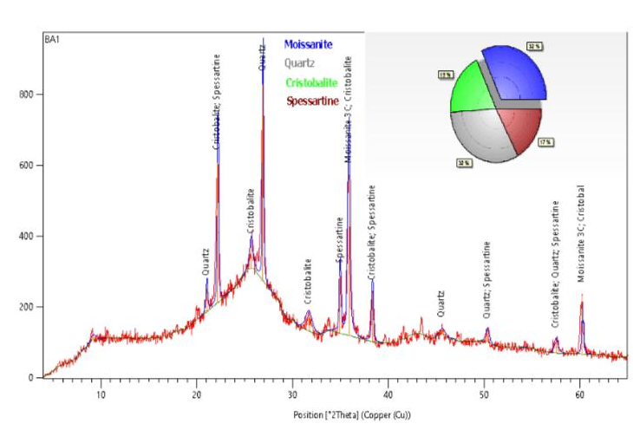
Fig 4.2: X-ray Diffraction of Graphene Oxide

4.3 Scanning Electron Microscopy Result
The SEM image at a magnification of 1500x reveals the microstructure of graphene/graphite oxide. The image shows layered and wrinkled sheet-like structures, which are typical for graphene oxide. These sheets appear to be crumpled and aggregated, indicating the presence of strong van der Waals forces and possible interactions between the layers. The rough surface morphology is consistent with previous observations of graphite oxide, where oxygen functionalities and defects contribute to the irregular appearance (Dreyer D.R et al,2010).
At a lower magnification of 250x, the SEM image shows larger aggregates and clusters of graphene/graphite oxide sheets. The bulky morphology suggests that the material has not been fully exfoliated, with some regions still retaining a more compact, graphite-like structure. The visible aggregation indicates strong interlayer interactions, which could be attributed to incomplete oxidation or reduction processes (Rafiee J, et al,2012). This level of magnification helps in understanding the overall bulk morphology and the extent of exfoliation achieved during synthesis.
The SEM image at 500x magnification provides an intermediate view, highlighting both the overall aggregates and some finer details of the sheet structures. The image shows a mixture of large aggregates and smaller, more exfoliated sheets. The presence of both compact and exfoliated regions suggests a heterogeneous oxidation process, with varying degrees of oxidation across the sample. This morphology is typical for partially oxidized graphite oxide, where some regions achieve complete exfoliation while others remain more intact.
(Israclachvili J.N 1992)

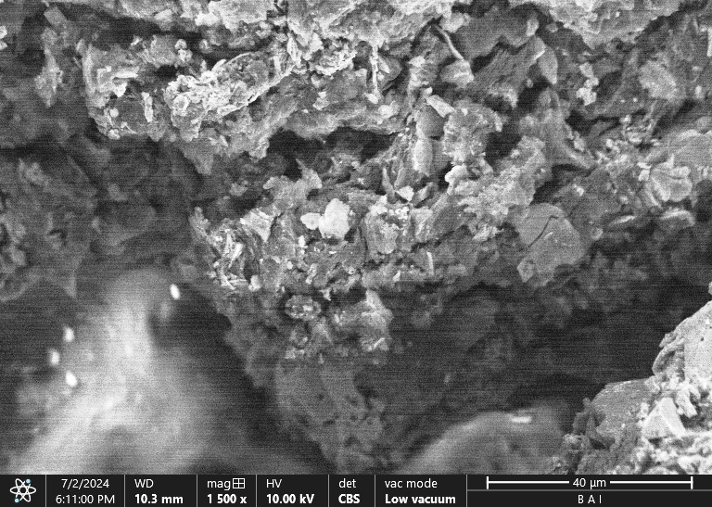
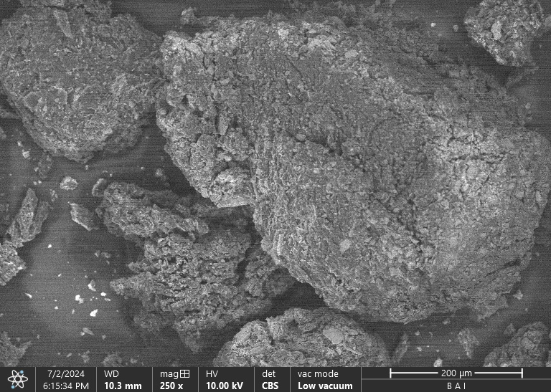
a. b.

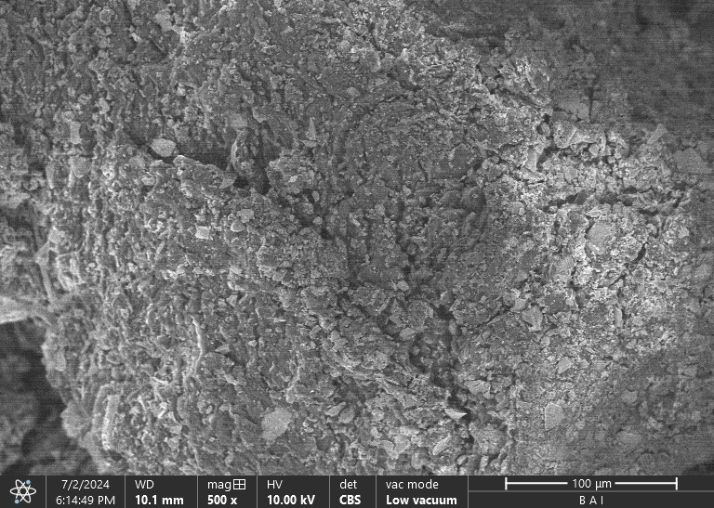
Fig 1.4: SEM image of Graphene Oxide:
(a) SEM image of Graphene Oxide at 250 magnification (b) SEM image of Graphene Oxide at 500 magnification (c) SEM image of graphene oxide

Conclusion and Recommendation.
The synthesis and characterization of graphene oxide (GO) reveal its complex structure and diverse functional groups, which are pivotal in determining its potential applications. The FTIR spectrum and X-ray diffraction (XRD) analysis provide essential insights into GO's chemical and structural properties. FTIR analysis identifies characteristic peaks corresponding to various functional groups, including C-H bending, C-O stretching, C=C stretching, and C=O stretching, which are integral to GO's functionality. The presence of these groups indicates the successful oxidation of graphite and the formation of GO. XRD analysis further elucidates the structural characteristics, with key peaks indicating the presence of oxygen-containing functional groups, partially reduced graphite oxide, and well-ordered graphitic domains. Scanning Electron Microscopy (SEM) imaging complements these findings by highlighting the microstructure and morphology of GO, revealing layered and wrinkled sheet-like structures, larger aggregates, and smaller exfoliated sheets. This comprehensive analysis underscores the importance of understanding GO's functional groups and structural properties to tailor its applications in advanced materials and technologies.
It can be recommended that;
1. Further studies should be carried on Optimization of Synthesis Process
2. Integration of Graphene oxide into Composite Materials for its electrical properties
3. Conduct some studies to evaluate environmental and health Impact Assessment

References
[1]. Callister, W. D. Materials Science and Engineering: An Introduction: John Wiley & Sons:
New York. 1997.
[2]. Kroto, H. W.; Heath, J. R.; O'Brien, S. C.; Curl, R. F.; Smalley, R. E. C60: Buckminster
fullerene. Nature 1985, 318, 162.
[3]. lijima, S. Helical microtubules of graphitic carbon. Nature 1991, 354, 56.
[4]. Dresselhaus, M. S.; Dresselhaus, G.; Eklund, P. C. Science of Fullerenes and Carbon Nanotubes; Academic Press: San Diego, 1996.
[5]. Ajayan, P. M. Nanotubes from carbon, Chem. Revs. 1999, 99, 1787-1795.
[6]. Dresselhaus, M. S.; Dresselhaus, G.; Avouris, Ph. Carbon Nanotubes: Synthesis, Structure,Properties, and Applications; Springer-Verlag: Berlin, 2001.
[7]. Novoselov, K. S. et al. Electric field effect in atomically thin carbon films. Science 2004,
306, 666-669.
[8]. Novoselov, K. S. et al. Two-dimensional gas of massless Dirac fermions in graphene. Nature2005, 438, 197-200.
[9]. Zhang, Y.; Tan, Y. W.; Stormer, H. L; Kim, P. Experimental observation of the quantum
Hall effect and Berry's phase in graphene. Nature 2005, 438, 201-204.

[10]. Li, D.; Kaner, R. B. Graphene-based materials. Science 2008, 320, 1170.
[11]. Geim, A. K.; Novoselov, K. S. The rise of graphene. Nat. Mater. 2007, 6, 183.
[12]. Schedin, F.; Geim, A. K., Morozov, S. V.; Hill, E. W.; Blake, P.; Katsnelson, M. I.; Novoselov,K. S. Detection of individual gas molecules adsorbed on graphene. Nat. Mater. 2007, 6, 652.
[13]. Elias, D. C.; Nair, R. R.; Mohiuddin, T. H. G.; Morozov, V.; Blake, P.; Halsall, M. P.;Ferrari, A. C.; Boukhvalov, D. W.; Katsnelson, M. I.; Geim, A. K., Novoselov, K. S. Controlof graphene's properties by reversible hydrogenation: evidence for graphane. Science 2009,323, 610.
[14]. Zhou, S. Y.; Gweon, G. H.; Fedorov, A. V.; First, P. N.; De Heer, W. A.; Lee, D. H.; Guinea,F; Castro Neto, A. H.; Lanzara, A. Substrate-induced bandgap opening in epitaxial graphene.Nat. Mater. 2007, 6, 770.15. Dato, A.; Lee, Z.; Jeon, K. J.; Erni, R.; Radmilovic, V.; [15].Richardson, T. J.; Frenklach, M.Clean and highly ordered graphene synthesized in the gas phase. Chem. Commun. 2009, 40,6095.16. Kuzmenko, A. B.; van Heumen, E.; Carbone, F.; [16].van der Marel, D. Universal optical conductance of graphite. Phys. Rev. Let. 2008, 100, 117401.
[17]. Kudin, K. N.; Scuseria, G. E.; Yakobson, B. I. C2F, BN, and C nanoshell elasticity from abinitio computations. Phys. Rev. B 2001, 64, 235406.
[18]. Lee, C: Wei, X., Kysar, J. W.; Hone, J. Measurement of the elastic properties and intrinsicStrength of monolayer graphene. Science 2008, 321, 385.
[19]. 19. Dong. X.; Shi, Y., Zhao Y; Chen D., Ye J; Yao Y.; Gao, E, Ni, .: Yu, T, Shen, Z.;Huang, Y; Chen, P; Li, L. Symmetry breaking of graphne monolayers by molecular decoRation, Phys, Rev. Lett. 2009, 102, 135501.
[20]. 20. Yavari, F: Kritzinger, C.; Gaire, C., Song, L.; Gulapalli, H.: Borca-Tasciue, T..Ajayan,P. M., Koratkar, N. T’unable band gap in graphene by the controlled adsorption of walermolEcule. Small 2010, 6, 2535-2538.
[21]. Rudberg, E.; Salek, P.; Luo, Y. Nonlocal exchange interaction removes hall-metallicity inGraphenenanoribbons. Nano Lett 2007, 7, 2211-2213
[22]. Son, Y. W: Cohen, M. L; Louie, S. G. Half-metalliegraphenenanoribbons. Nature 2006,444, 347
[23]. Zhang, Y: Tang, T; Girit, C;Hao, Z.; Martin, M. C.:Zettl, A.; Crommie, M. F, Shen, Y, R.:Wang, F. Direct observation of a widely tunable bandgap in bilayer. Nature 2009, 459, 820.
[24], Zhou, S. Y.; Siegel, D. A.; Fedorov, A. V; Lanzara, A. Metal to insulator transition in epiTaxialgraphene induced by molecular doping Phys. Rev. Lett. 2008, 101, 086402.
[25]. Park, S.; Ruoff, R. S, Chemical method for the production of graphene. Nat. Nanotech 2009,4,217-224.
[26]. Nair, R. R. et al. Fine structure constant defines visual transpareney of graphene. Science2008, 320, 1308.
[27]. Bonaccorso, F.. Sun, Z.: Hasan, T, Ferrari, A. C. Graphenephotonies and optoclectronics.Photonics 2010. 4.6|1-620.
[28], Roddaro, SPingue, P. Piazza, V..Pellegrini, V, Beltram, F. The optical visibility of graPhene: Interference colors of ultrathin graphite on SiO, Nano Lett. 2007, 7,2707-2710,
[29]. Chen, Z.; Ren, W; Gao, IL.; Liu, B., Pei, S.; Chen, H. Three-dimensional flexible and conducTive interconnected graphene networks grown by chemical vapour deposition. Nat. Mater.2011 424 428,
[30]. Li, X.:Zhang, G.: Bai, X.; Sun, X.; Wang. X.; Wang, E.; Dai, H. Highly conducting grapheneSheets and Langmuir Blodgett films. Nat. Nanotech 2008, 3, 538-542.
[31]. Li, X, Cai, W., An, J.; Kim S.; Nah, J.: Yang, D,;Piner, R. Velamakanni, A. Jung. I: Tutuc,E; Banerjee, S. K.; Colombo, L; Ruof, R. S, Large-area synthesis of high quality and uniFormgraphene films on Cu foils. Science 2009, 324, 1312-1314.
[32]. Li, X., Zhu, Y., Cai, W.: Borysiak, M., Chen, D..Piner, R D, Colombo, L.: Ruoff, R.S. Transfer of large-area graphene films for high-performance transparent conductive electrodes. NanoLett. 2009,9, 4359 4363.
[33]. Bae, S, Kim, H.; Lee. Y., Xu, X., Park, J.; Zhen, Y., Balakrishnan, J.; Lei, T., Kim, H; Song,Y; King, Y.; Kim, K:Ozyilmaz, B.; Ahn, J.; Hong, B; lijima, S. Roll-to-roll production of30-inch graphene films for transparent electrodes. Nat. Nanotech 2010, 5, 574-578.
[34], Eda, G; Fanchini,G; Chhơwalla, M. Large-area ultrathin films of reduced graphene oxide as a transparent and flexible electronic material. Nat. Nanotech 2008, 3, 270-274.
[35]. Rafiee, J, Mi, X., Gullapalli, H., Thomas, A. V., Yavari, F. Shi, Y..Ajayan, P. M. and Koratkar, N. A. Wetting transparency of graphene. Nat. Mater 2012, 11, 217-222
[36]. Israclachvili, J. N. Intermolecular and Surface Forces, 2nd Ed: With Applications to Colloidal and Biological Systems; Academic Press, 1992.
[37]. Seemann, R.; Herminghaus, S.; Jacobs, K, Dewetting patterns and molecular forces: A reconciliation. Phys. Rev. Lett. 2001, 86, 5$34-5537.
[38]. De Gennes, P. G. Wetting: Statics and dynamics. Rev. Mod. Phys. 1985, 57, 827-863.
[39]. Seemann, R.: Herminghaus, S: Jacobs. K. Gaining control of pattern formation of dewettingliquid films. J. Phys. Condens. Mater. 2001, 13. 49254938.
[40]. Chen, S., Brown, L.; Levendort, M.; Cai, W.: Ju, S.: Edgeworth; Li, X., Magnuson, C.;velamakanni, A., Piner, R., Kang, J.; Park, J.; Ruoff, R. S. Oxidation resistance of graphenecoated Cu and Cu/Ni alloy. 4CS Nano 2011, 5, 1321-1327.
[41]. Novoselov, K. S., et al. “Electric field effect in atomically thin carbon films.” Science 306.5696 (2004): 666-669.
[42]. Eda, Goki, and Manish Chhowalla. “Chemically derived graphene oxide: towards large-area thin-film Electronics and optoelectronics.” Advanced materials 22.22 (2010): 2392-2415.
[43]. Dreyer, Daniel R., Sungjin Park, Christopher W. Bielawski, and Rodney S. Ruoff. “The chemistry of graphene Oxide.” Chemical Society Reviews 39.1 (2010): 228-240.
[44]. Park, Sungjin, et al. “Hydrazine-reduction of graphite- and graphene oxide.” Carbon 49.9 (2011): 3019-3023.
[45]. Zhang, Jiali, et al. “Graphene oxide: a versatile nanoplatform for cancer immunotherapy.” Advanced materials 30.45 (2018): 1803516.
[46]. Hummers, W. S., &Offeman, R. E. (1958). Preparation of Graphitic Oxide. Journal of the American Chemical Society, 80(6), 1339.
[47]. Marcano, D. C., et al. (2010). Improved Synthesis of Graphene Oxide. ACS Nano, 4(8), 4806-4814.
[48]. Ferrari, A. C., & Robertson, J. (2000). Interpretation of Raman Spectra of Disordered and Amorphous Carbon. Physical Review B, 61(20), 14095-14107.
[49]. Eigler, S., & Hirsch, A. (2014). Chemistry with Graphene and Graphene Oxide—Challenges for Synthetic Chemists. AngewandteChemie International Edition, 53(30), 7720-7738.
[50]. Wang, Y., et al. (2008). Supercapacitor Devices Based on Graphene Materials. Journal of Physical Chemistry C, 112(11), 5166-5172.
[51]. Acik, M., Lee, G., Mattevi, C., Chhowalla, M., Cho, K., &Chabal, Y. J. (2010). Unusual infrared-absorption mechanism in thermally reduced graphene oxide. *Nature Materials, 9*(10), 840-845.
[52]. Stankovich, S., Dikin, D. A., Dommett, G. H., Kohlhaas, K. M., Zimney, E. J., Stach, E. A., ... &Ruoff, R. S. (2006). Graphene-based composite materials. *Nature, 442*(7100), 282-286.
[53]. Hummers, W. S., &Offeman, R. E. (1958). Preparation of graphitic oxide. *Journal of the American Chemical Society, 80*(6), 1339-1339.
[54]. Dreyer, D. R., Park, S., Bielawski, C. W., &Ruoff, R. S. (2010). The chemistry of graphene oxide. *Chemical Society Reviews, 39*(1), 228-240.
[55]. Wang, G., Yang, J., Park, J., Gou, X., Wang, B., Liu, H., & Yao, J. (2008). Facile synthesis and characterization of graphenenanosheets. *The Journal of Physical Chemistry C, 112*(22), 8192-8195.
[56]. Verdejo, R., Bernal, M. M., Romasanta, L. J., &López-Manchado, M. A. (2011). Graphene filled polymer nanocomposites. *Journal of Materials Chemistry, 21*(10), 3301-3310.
[57]. Shen, J., Hu, Y., Li, C., Qin, C., Shi, M., & Ye, M. (2009). Layer-by-layer self-assembly and covalent bonding of graphene oxide sheets on polyethylene terephthalate substrates. *Langmuir, 25*(11), 6122-6128.
[58]. Hummers, W. S., &Offeman, R. E. (1958). Preparation of graphitic oxide. *Journal of the American Chemical Society, 80*(6), 1339.
[59]. Chen, D., Li, L., &Guo, L. (2008). An environment-friendly preparation of reduced graphite oxide with gelatin. *Nanotechnology, 19*(43), 435609.
[60]. Dreyer, D. R., Park, S., Bielawski, C. W., &Ruoff, R. S. (2010). The chemistry of graphene oxide. *Chemical Society Reviews, 39*(1), 228-240.

