CREDIT SCORE AND LOAN ELIGIBILITY USING MACHINE LEARNING

BY
OLUWASEUN GLORY OPEYEMI
HND/23/COM/FT/0095

SUBMITTED TO THE DEPARTMENT OF COMPUTER SCIENCE, INSTITUTE OF INFORMATION AND COMMUNICATION TECHNOLOGY,
KWARA STATE POLYTECHNIC, ILORIN

IN PARTIAL FULFILLMENT OF THE REQUIREMENTS FOR THE AWARD OF HIGHER NATIONAL DIPLOMA (HND) IN
COMPUTER SCIENCE

JULY, 2025.

CERTIFICATION
This is to certify that this project was carried out by OLUWASEUN GLORY OPEYEMI with Matriculation Number: HND/23/COM/FT/0095 and it has been read and approved as meeting the requirements for the award of Higher National Diploma in Department of Computer Science, Institute of Information and Communication Technology (IICT), Kwara State Polytechnic.

…………………………………. ….………………………
MR. SADIQ, K. A. Date
Project Supervisor

…………………………………. ….………………………
MR. OYEDEPO, F. S. Date
Head of Department

…………………………………. ….………………………
External Examiner Date

DEDICATION
I dedicate this project work to Almighty God who inspired me and directed my ways during my academic stay in the polytechnic.

ACKNOWLEDGEMENT
All praise is due to Almighty God the Lord of the universe. I praise him and thank him for giving me the strength and knowledge to complete my ND program and also for our continued existence on Earth.
I appreciate the utmost effort of my supervisor, MR. SADIQ, K. A. whose patience, support, and encouragement have been the driving force behind the success of this research work. He gave useful corrections, constructive criticisms, comments, recommendations, and advice and always ensures that excellent research is done. My sincere gratitude goes to the Head of the Department MR. OYEDEPO F. S., and other members of staff of the Department of Computer Science, Kwara State Polytechnic, Ilorin, for their constant cooperation, constructive criticisms, and encouragement throughout the program.
Special gratitude to my parents, who exhibited immeasurable financial, patience, support, prayers, and understanding during the period in which I was busy tirelessly with my studies, special thanks go to my lovely siblings
My sincere appreciation goes to my friends and classmates.

LIST OF FIGURES
Fig 3.1: Methodology flowchart 15
Figure 4.1 Admin Dashboard 22
Figure 4.2 Borrower List 22
Figure 4.3 Loan Plan 23
Figure 4.4 Payment List 23
Figure 4.5 Login Page 23
Figure 4.6 Loan Application 24
Figure 4.7 New Borrower 24

LIST OF TABLES
Table 4.1 Loan Database 25
Table 4.2: Borrower Table 25

TABLE OF CONTENTS
Title page i
Certification ii
Dedication iii
Acknowledgments iv
Table of Contents v
List of Figures vi
List of Tables vii
Abstract viii
CHAPTER ONE: GENERAL INTRODUCTION
1.1 Background to the Study 1
1.2 Statement of the Problem 2
1.3 Aim and Objectives 3
1.4 Significance of the Study 3
1.5 Scope of the Study 4
1.6 Organization of the Report 4
CHAPTER TWO: LITERATURE REVIEW
2.1 Review of Related Past Works 5
2.2 Review of General Study 7
CHAPTER THREE: RESEARCH METHODOLOGY AND
ANALYSIS OF THE SYSTEM
  - Research Methodology 18
  - Analysis of the Existing System 20
  - Problem of the Existing System 21
  - Description of the Proposed System 21
  - Advantages of the Proposed System 22

CHAPTER FOUR: DESIGN, IMPLEMENTATION AND
DOCUMENTATION OF THE SYSTEM
  - Design of the System 23
    - Output Design 23
    - Input Design 26
    - Database Design 28
    - Procedure Design 29
  - Implementation of the System 29
    - Choice of programming language 30
    - Hardware support 30
    - Software Support 30
  - Program Documentation 30
    - Operating the System 30
    - Maintaining of the System 31
CHAPTER FIVE: SUMMARY CONCLUSION AND
RECOMMENDATION
5.1 Summary 32
5.2 Conclusion 32
5.4 Recommendations 33
References 34

ABSTARCT
This research investigates the application of machine learning methodologies in the context of credit scoring and loan approval, with a focus on enhancing the efficiency, accuracy, and fairness of decision-making processes within the financial sector. The study addresses the limitations inherent in traditional credit scoring methods and explores the potential of machine learning algorithms to analyze extensive datasets and predict creditworthiness more effectively. Central to the research are the following key research questions: How can machine learning techniques be leveraged to improve credit scoring and loan approval processes? What are the ethical, legal, and social implications associated with the adoption of machine learning in credit assessment? The importance of these research questions lies in their potential to inform the development of innovative solutions that address longstanding challenges in the financial industry, such as biased decision-making and inaccurate risk assessment. Through a combination of data analysis, model development, and experimentation, the research aims to provide actionable insights and practical recommendations for stakeholders involved in credit assessment and lending practices. By employing PHP, and JavaScript for data processing, algorithm implementation, and web application development, the study demonstrates the feasibility of integrating machine learning into existing credit scoring frameworks. The solutions proposed in this research offer the promise of more transparent, reliable, and inclusive credit evaluation processes, ultimately contributing to greater financial inclusivity and economic empowerment. The achievements of this research include the development of robust machine learning models, the identification of ethical and legal considerations in credit assessment, and the validation of improved credit scoring methodologies through empirical evaluation. These findings have the potential to revolutionize the way credit decisions are made, leading to fairer outcomes and increased access to financial services for underserved populations.

CHAPTER ONE
GENERAL ‘INTRODUCTION
  - Background of the Study
A loan is a sum of money borrowed from a financial institution or lender that must be repaid over time, usually with interest. Loans are essential for individuals and businesses to meet financial needs such as buying homes, funding education, or expanding operations. However, determining loan eligibility is often challenging because lenders must carefully assess the risk of lending money to ensure the borrower can repay. Traditional eligibility assessments can be slow, subjective, and prone to errors, leading to either wrongful denial of credit or increased loan defaults. These challenges highlight the need for more accurate and efficient methods to evaluate creditworthiness and make informed loan approval decisions (Ampountolas, et al., 2021).
Researchers have used several machine learning techniques for credit scoring and loan approval, including logistic regression, decision trees, support vector machines (SVM), neural networks, and ensemble models like Random Forest and Gradient Boosting. Logistic regression and decision trees are easy to interpret but may oversimplify complex patterns or overfit the data. Advanced methods like SVMs and neural networks can capture non-linear relationships but are computationally intensive and less transparent (Fan, 2020).
Ensemble models such as Random Forest improve accuracy by combining multiple decision trees, making them more robust and less prone to overfitting. However, common challenges across these techniques include poor data quality, overfitting, lack of model interpretability, and potential bias from historical data. These issues emphasize the need for models that strike a balance between performance, fairness, and transparency—qualities that make Random Forest a strong candidate for this task (Wu and Pan 2021).
The proposed design leverages the Random Forest algorithm to improve the accuracy, fairness, and efficiency of credit scoring and loan approval. Random Forest enhances predictive performance by aggregating the outcomes of multiple decision trees, thereby reducing the risk of overfitting and handling non-linear relationships effectively. It is robust to noisy or incomplete data, which addresses issues of data quality often encountered in real-world loan applications. Additionally, feature importance analysis within Random Forest provides a level of interpretability that supports transparent decision-making—crucial in financial settings. By minimizing bias through balanced data preprocessing and ensuring consistent, data-driven evaluations, the system offers a more reliable and fair alternative to traditional methods.
The research methodology for developing machine learning models for credit scoring and loan eligibility involves leveraging Python for data collection, preprocessing, model development, evaluation, and interpretation. Python utilize libraries and frameworks for web scraping and data extraction, collecting a comprehensive dataset containing information on past loan applicants from various sources. Python is employed for data preprocessing tasks, such as cleaning, transforming, and encoding the data to ensure compatibility with machine learning algorithms. Python is utilized for model development, experimenting with different algorithms and techniques to develop predictive models for credit scoring and loan eligibility.
  - Statement of the Problem
The major issue is data quality and availability, financial institutions often deal with missing, inconsistent, or outdated customer information, which can skew model predictions. Another significant challenge is imbalanced datasets, where the number of approved loans far outweighs defaults or rejections, making it difficult for models to learn patterns of risky borrowers accurately. Additionally, feature selection and engineering are technically demanding, as choosing the most relevant variables (e.g., credit history, employment status, income stability) is crucial for building effective models.
  - Aim and Objectives
The aim of the project is to develop a loan eligibility using Random Forest algorithm and the objectives are to;
- obtained and preprocess a real-world credit loan dataset from Kaggle.
- cleaned, transformed, and prepare the dataset for model training and testing.
- design a model using Random Forest algorithm.
- evaluate the model's performance using standard metrics such as accuracy, precision, recall, and F1-score.
  - Significance of the Study
The main importance of this study is that it helps in the processing procedure of loan as much as possible. A loan automation system is one that enables processing of loans from application to final confirmation without the physical presence of both the applicant and the lending institution
  - Scope of the Study
The scope of this study focuses mainly on the implementation of a loan management system. This system does not cover the range that go beyond this.
1.6 Organization of the Study
For easy study and proper understanding of this project write-up, It is planned and organized into five chapters. The description of what each chapter contains is explained below:
Chapter One: This contains an Introduction to the whole write-up, the problem of the study, the aims and objectives of the study, the significance of the study, the scope and limitation of the study, and the organization of the report.
Chapter Two: It focuses on the literature review of the study, the organization of the board of directors, and the computerization of the current state of the art.
Chapter Three: It presents the data collection method employed, analysis of data and existing system, advantages of the proposed system, design and implementation, programming language used with reasons, and hardware and software support.
Chapter Four: Deals with the system design implementation and documentation, design of the system, output design, input design, file system, procedural design, and documentation of the new system.
Chapter Five: This centres the summary, experienced gained, recommendation and conclusion.

CHAPTER TWO
LITERATURE REVIEW
2.1 Review of Related Work
Ampountolas, et al., (2021) have employed a machine-learning approach for micro-credit scoring. Inmicro-lending requests, lack of recorded credit history is a significant manacle to assessing individual borrowers ’ creditworthiness and thus deciding fair interest rates. This exploration compares colorful machine learning algorithms on real micro-lending data to test their efficacity at classifying borrowers into colorful credit orders. We demonstrate that off- the- multi-class classifiers similar to arbitrary timber algorithms can perform this task veritably well, using readily available data about guests( similar as age, occupation, and position). This presents affordable and dependable means to micro-lending institutions around the developing world with which to assess creditworthiness in the absence of credit history or central credit databases.
Breeden (2020) Surveyed machine learning in credit risk. Machine literacy algorithms have come to dominate some diligence. After decades of resistance from observers and adjudicators, machine literacy is now moving from the exploration office to the operation mound for credit scoring and a range of other operations in credit threat. This migration isn't without new pitfalls and challenges. important of the exploration is now shifting from how stylish to make the models to how stylish to use the models in a nonsupervisory-biddable business environment. This composition seeks to survey the impressively broad range of machine literacy styles and operation areas for credit threat. In the process of that check, we produce a taxonomy to suppose how different machine literacy factors are matched to produce specific algorithms. The reasons why machine literacy succeeds over simple direct styles are explored through a specific lending illustration. Throughout, we punctuate open questions, ideas for advancements, and a frame for allowing how to choose the stylish machine literacy system for a specific problem.
Provenzano, et al., (2020) examine a machine-learning approach for credit scoring. In their work, they make a mound of machine literacy models aimed at composing a state-of-the-art credit standing and dereliction vaticination system, carrying excellent out-of-sample performances. Our approach is an excursion through the most recent ML/AI generalities, starting from natural language processes( NLP) applied to profitable sectors'( textual) descriptions using embedding and autoencoders( AE), going through the bracket of defaultable enterprises on the base of a wide range of profitable features using grade boosting machines (GBM) and calibrating their chances paying due attention to the treatment of unstable samples. Eventually, we assign credit conditions through inheritable algorithms (discriminational elaboration, DE). Model interpretability is achieved by enforcing recent ways similar to SHAP and LIME, which explain prognostications locally in features' space.
Diwate, et al., (2021) in a research study on Loan eligibility Prediction Using Machine Learning, concluded that the upgrade in the fiscal area loads of individualities is applying for bank advances still the bank has its defined coffers which it needs to allow to confined individualities just, so discovering to whom the credit can be conceded will be a more secure choice for the bank is a commonplace commerce. So in this task, we essay to drop this peril factor behind choosing the defended existence to save bunches of bank trials and coffers. This is finished by booby-trapping the Data of the history records of individualities to whom the advance was conceded preliminarily and grounded on these records encounters the machine was set exercising the AI model which gives the most precise outgrowth. The principle idea of this paper is to anticipate whether relegating the advance to a specific existent will be defended or not. This paper is separated into four areas( i) Data Collection (ii) Comparison of AI models on gathered information (iii) Training of frame on utmost encouraging model (iv) Testing.
Wu and Pan (2021) conducted research on operation Analysis of Credit Scoring of Financial Institutions Grounded on the Machine Learning Model. Credit score is the base for fiscal institutions to make credit opinions. With the development of wisdom and technology, big data technology has entered into the fiscal field, and particular credit disquisition has entered a new period. particular credit evaluation grounded on big data is one of the hot exploration motifs.) is paper substantially completes three workshops. Originally, according to the operation script of credit evaluation of particular credit data, the experimental dataset is gutted, the separate data is one-HOT enciphered, and the data are formalized. Due to the high dimension of particular credit data, the PDC- RF algorithm is espoused in this paper to optimize the correlation of data features and reduce the 145- 145-dimensional data to 22- 22-dimensional data. On this base, WOE coding was carried out on the dataset, which was applied to arbitrary timber, support vector machine, and logistic retrogression models, and the performance was compared. It's set up that logistic retrogression is more suitable for the particular credit evaluation model grounded on the Lending Club dataset. Eventually, grounded on the logistic retrogression model with the stylish parameters, the stoner samples are graded and the final scorecard is affair.
Khedr, et al., (2021) A New Prediction Approach for Preventing Default Customers from Applying for Personal Loans Using Machine Learning. In the Egyptian banking industry, loan officers use pure judgment to make personal loan eligibility decisions. In this paper, we develop a new predictive method for default customers' loans using machine learning. The new predictive method uses the available personal data and historical credit data to evaluate the credit trustworthiness of customers to obtain loans. We used the ABE dataset for training and testing, as we used 10 features from the application form and i-score report class that could give great help to credit officers for making the right decision by avoiding customer selection using random techniques. The collected dataset was analyzed by using various machine learning classifiers based on important selected features, to obtain high accuracy. We compared the performance of several machine learning classifiers before and after feature selection. We have found that in terms of high accuracy, the most important features are (activity – income – loan) and in terms of better performance, the decision tree classifier has surpassed any other machine learning classifier with a significant prediction accuracy of almost 94.85%.
A study by Ndayisenga, (2021) concluded that Loan is an essential product of banks and other financial institutions. As a large number of people go to banks to borrow money for different activities, the number of customers has increased and some banks expect to earn a lot of money as a result of interest paid on loans. However, loans are associated with the risk of defaulting, i.e. the possibility that some borrowers may not be able to pay back their loans. Thus, high levels of non-performing loans can be a source of instability in the banking sector and lead to bankruptcy. One of the important steps for banks to decide if a loan has to be authorized is to ensure that the candidate to borrow can pay back the loan in the proposed terms. The advancement of technology like machine learning, computer science, and other science is playing an important role by supporting banks to predict the probability of defaulting for a given customer based on his past behavior. In this research, we contribute to work by commercial banks to predict the behaviors of borrowers by developing and testing the accuracy of different models using data from the Bank of Kigali. Collected data was divided into the training dataset and test dataset where the training dataset was made by 70% and 30% was for test. After training the machine by using the training dataset, then we used the test dataset to check the accuracy of different models. By running ensembles, combinations of different machine learning techniques are used to find the best to use while predicting bank loan default prediction. The results of our analysis show that Gradient Boosting is the best model to predict bank loan default, followed by XGBoosting while others like decision trees, random forest, and logistic regression performed poorly.
In the study by Hossain and Mullally (2021), Anti-poverty programs can work as a comprehensive data source of poor households’ economic behavior and performance, a resource that is particularly scarce in environments without formal credit scores or households that have minimal involvement in economic activities. This study examines the potential role of information generated by an anti-poverty program on self-selection by borrowers (i.e., applying for a loan), screening applicants by lenders (i.e., loan eligibility), and borrower performance in the microcredit market. We apply the logistic regression, Least Absolute Shrinkage and Selection Operator (LASSO), and Random Forest (RF) methods to predict self-selection, screening, and post-loan outcomes. Findings: We show that the rate of accurate prediction is about 70% for self-selection and screening. We find that the prediction accuracy rate is 68% for productive use and 91% for repayment difficulty. Objective indicators (e.g., income, assets, age of the household head, savings) stand as the most influential predictors of self-selection, screening, and post-loan outcomes. Development programs can improve the availability of data needed to predict creditworthiness, suggesting that there could be potential to expand credit access among poor borrowers through partnerships between development agencies and financial institutions.
Further studies were done by Mwende, (2022) on the Effect of Machine Learning in Early Prediction of Personal Loan Defaulting on Commercial Bank in Tanzania (2009-2020). The issuing of loans is one method the bank conveys itself, which has been shown to raise credit default risk in the past. Despite many bank measures to undertake pre-assessment of loan applications, the case remains, providing a warning flag for the bank to produce a rapid, cost-effective, and optimal approach to reduce and perhaps combat credit risk on loan defaulting before banks experience large losses. The main aim of this study is to develop machine learning models to predict personal loan default and analyze the performance of various models to identify the borrower's features in an early prediction of personal loan default. In this study, three classical machine learning algorithms K-Nearest Neighbors, Gradient Boosting, and Random Forest were trained on a Historical credit dataset of 5012 observations obtained from a Commercial bank in Tanzania. The dataset was imbalanced and the use of data imbalance techniques namely SMOTE was applied to give us more insight into the classified datasets and reduced erroneous in the conclusion. This dataset was divided into training and test sets respectively with optimized parameters for each of the algorithms. The performance comparison for each model was done by AUC and plotting the ROC Curve, the performance evaluation of classifiers was done to find out the accuracy, recall, precision, and F1-Score for each classifier in classifying the different types of loan defaults. The finding showed the features for early prediction of borrowers’ loan default were monthly income, total loan amount, and age. The three models RF, KNN, and GB were developed and Random Forest performed well with an accuracy of 84 percent, recall of 85 percent, precision of 82 percent, F1 Score of 84 percent, and AUC ROC of 91 percent in predicting either loan defaulting or not. Although the study managed to implement the high-performance model further studies should be conducted particularly with the use of deep learning or other machine learning models, and the involvement high high-dimensional datasets from many banks in Tanzania.
Fan, et al., (2020) Improved ML-Based Technique for Credit Card Scoring in Internet Financial Risk Control. With the rapid development of China’s Internet finance industry and the continuous growth of transaction amounts in recent years, a variety of financial risks have increased, especially credit risk in the financial industry. Also, the credit risk evaluation is usually made by using the application card scoring model, which has the shortcomings of strict data assumption and the inability to process complex data. To overcome the limitations of the credit card scoring model and evaluate credit risk better, this paper proposes a credit evaluation model based on an extreme gradient boosting tree (XGBoost) machine learning (ML) algorithm to construct a credit risk assessment model for Internet financial institutions. At the same time, an Internet lending company in China is taken as a case study to compare the performance of the traditional credit card scoring model and the proposed machine learning (ML) algorithm model. ,e results show that the ML algorithm has a very significant advantage in the field of Internet financial risk control, it has more accurate prediction results and has no particularly strict assumptions and restrictions on data, and the process of processing data is more convenient and reliable. We should increase the application of ML in the field of financial risk control. ,e value of this paper lies in enriching the related research of financial technology and providing a new reference for the practice of financial risk control.
2.2 Review of General Study
2.2.1 Traditional Credit Scoring Model.
The history of credit scoring in the world can be traced back to the 1950s. Mathematician Earl Isaac and engineer Bill Fair first established the world’s first commercial credit scoring system FICO and extended it to the financial system. After that, financial institutions make credit decisions through the 5C credit discrimination method. 5C discriminant analysis is composed of five evaluation factors, such as the lender’s role, capital, collateral, capacity, and environment. It comprehensively forecasts the performance of borrowers. The limitation of this method is that it is inefficient in processing large-scale data. However, with the expansion of the loan scale of financial institutions and the increase in the number of borrowers, the above credit evaluation method is not Complexly applicable, and a new method, that is, the credit scoring method, has been adopted. Financial institutions build data-driven models based on quantifiable characteristics of borrowers to manage credit risk. The credit score is based on the historical credit data of the borrower, and the credit score is calculated by the model, and the credit granting person determines whether to grant credit or not, and the credit line is according to the credit score. Hand and Henley pointed out that the statistical techniques and quantitative methods in the construction of scorecards have been extended from discriminant analysis and linear regression methods widely used in the early stage to logical regression, probit regression, nonparametric smoothing method, Markov chain model, recursive segmentation, expert system, and genetic algorithm.
Subsequently, Lee and other scholars empirically studied the effectiveness of using multiple adaptive regression spine (MARS) and classified regression tree (CART) for credit scoring. ,e two methods are superior to the traditional discriminant analysis and logical regression methods in the accuracy of credit scoring. According to Bee et al. (2022), with the development of current data mining technology, the process of establishing a credit scoring model is more convenient, and various new technologies have been developed. However, in the practical application of financial institutions, the commonly used technologies are still logical regression and decision trees because such technologies are more convenient in identifying important input variables, interpreting results, and building models.
2.2.2 Application of ML in Financial Risk Control.
With the development of big data and data mining technology, international scholars have formed rich research results on ML in credit risk prediction and evaluation. Because the goal of the credit management of financial institutions is to optimize business performance and minimize risk, decision rules should be established to make credit decisions. Therefore, a clustering algorithm is widely used in the credit scoring system in the early stage. For example, William and Huang combined the K-means clustering method with the supervision method for insurance risk identification.
Furthermore, Yeo et al. (2020), used hierarchical clustering technology to predict the risk of the automobile insurance industry. Different customer risk levels are identified by clustering technology to make operational decisions on credit limits. With the increase in data scale, scholars try to build more complex models, such as Khandani, Kim, and so on. They use ML algorithms and statistical models to predict consumer default risk with massive customer transaction records and credit management agency data. Their research results show that ML technology reduces the prediction error of 6% to 25% compared with the traditional linear regression model. Chakraborty and Joseph trained a set of financial distress prediction models based on ML and proposed that the ML method was better than the statistical models such as logical regression. In terms of the receiver operating characteristic area discrimination, there is about 10% significant improvement. Ticknor proposed to use a neural network algorithm to predict financial market behavior. Empirical results show that the model constructed by this algorithm has the same prediction effect as the advanced model without data preprocessing. Gogas and Agrapetidou constructed a prediction model of financial institutions' bankruptcy based on a support vector machine, analyzed the data of financial statements publicly disclosed by banks, and predicted the number of bankruptcies of American financial institutions from 2007 to 2013. The model shows 99.2% prediction accuracy. Rtayli and Enneya proposed an enhanced credit card risk identification method based on a random forest classifier and support vector machine feature selection algorithm to predict fraud risk. Experimental results show that the classification performance of the algorithm is better than that of local outlier factor, isolated forest, and decision tree algorithms on large datasets. Plawiak et al. proposed a deep genetic hierarchical learner network (DGHLN) algorithm, which is an excellent learner training method based on genetic hierarchical training. 21% of the credit rate in Germany was verified by cross-validation.
2.2.3 ML in Credit Scoring for Internet Financial Risk
Many methods and technologies for risk control in the financial field have been proposed in the existing literature, including traditional methods for credit risk management in Internet finance. However, this paper first mainly introduces ML algorithms into Internet finance credit risk management. We can verify the innovation of this paper by comparing the existing research results of credit risk management with the contents of this paper. This study uses “Internet financial credit scoring,” “ML in Credit Scoring,” and “application ML and Internet financial risk control” as keywords to search. ,e search scope is to review articles on financial risk management published from 2010 to 2020., the study selected peer-reviewed journals and conference articles because of their high quality. We choose the article by reading the conclusion and abstract, and sometimes we need to read the whole article. All unpublished work and dissertations are not included in this current study. Other existing literature includes systematic research on bankruptcy forecasting or the use of credit scoring models, as well as the application of ML in the traditional financial field.
However, the traditional credit evaluation methods have limitations in multidimensional and large-scale data analysis, and the model method has strict limitations in distribution hypothesis and linearity. It is difficult for Internet credit data to meet the requirements of the traditional model. The ML algorithm based on big data and artificial intelligence can make accurate analyses and predictions of multisource and multitype data and has developed rapidly. Traditional risk measurement methods predict the future default risk based on the borrower’s historical data and personal characteristics, while the ML algorithm has extensive expansion in the dimension of obtaining information, which can deeply analyze the correlation between such information and default risk based on behavioral information, soft information, and hard information. In the current research, there is literature comparing the traditional credit evaluation model and ML model, and research on the integration of the two methods to evaluate the credit risk of Internet finance is relatively rare. ,erefore, based on reading the relevant literature at home and abroad, this paper uses an ML algorithm to construct the credit risk model, verifies the performance of the ML model better than the traditional credit score card model through empirical verification, makes a deep discussion on how to convert the ML model into the score card model, and puts forward suggestions on the construction of risk control system of Internet financial industry by ML.
2.2.4 Machine learning
Machine learning is a subset of artificial intelligence (AI) that enables computers to learn from data and make predictions or decisions without being explicitly programmed. The essence of machine learning lies in building mathematical models that can generalize patterns and relationships from data, allowing the computer to improve its performance over time as it encounters more data.
There are several types of machine learning approaches, including:
Supervised Learning: In supervised learning, the model learns from labeled data, where each input is associated with a corresponding output label. The goal is to learn a mapping from inputs to outputs, such as predicting house prices based on features like size, location, and number of bedrooms.
Unsupervised Learning: Unsupervised learning involves learning patterns and structures from unlabeled data. The model explores the inherent structure of the data to discover meaningful insights, such as clustering similar data points together or reducing the dimensionality of the data.
Semi-supervised Learning: Semi-supervised learning combines elements of supervised and unsupervised learning, where the model learns from a combination of labeled and unlabeled data. This approach is useful when labeled data is scarce or expensive to obtain.
Reinforcement Learning: Reinforcement learning involves training an agent to interact with an environment and learn optimal behavior through trial and error. The agent receives feedback in the form of rewards or penalties based on its actions, guiding it towards achieving a specific goal.
Machine learning algorithms can be broadly categorized into several types, including:
Linear Models: Linear models assume a linear relationship between the input features and the output. Examples include linear regression for regression tasks and logistic regression for classification tasks.
Tree-Based Models: Tree-based models, such as decision trees and random forests, partition the feature space into regions and make predictions based on the majority vote or average of the samples in each region.
Neural Networks: Neural networks are computational models inspired by the structure and function of the human brain. They consist of interconnected nodes (neurons) organized in layers and are capable of learning complex patterns from data.
Support Vector Machines (SVM): SVM is a supervised learning algorithm that finds the optimal hyperplane that separates classes in the feature space with the maximum margin.
Clustering Algorithms: Clustering algorithms, such as K-means clustering and hierarchical clustering, group similar data points together based on their proximity in the feature space.
Machine learning has applications across various domains, including finance, healthcare, marketing, robotics, and natural language processing. It is widely used for tasks such as classification, regression, clustering, anomaly detection, recommendation systems, and image and speech recognition. In the context of credit scoring and loan eligibility, machine learning algorithms can automate and optimize decision-making processes, improve predictive accuracy, and enhance risk management in financial institutions.

CHAPTER THREE
RESEARCH METHODOLOGY AND ANALYSIS OF THE NEW SYSTEM
3.1 Research Methodology
This research work will be probing different literature reviews that have worked on motifs analogous to any of the design suppositions I've derived. The research work will test the hypotheses to see if they're true, how important verify they are, and if they can be bettered. Also, reviewing different kinds of literature will be used to answer the exploration questions and gaps proposed on the morning of the research. The popular, successful platforms will also be delved to see what made them successful and their failings to see how the result can be used to ameliorate this design if it’s within the compass of this design. The overall result drawn from these processes will be used to draw our demand criteria that will be used for the prototype design, perpetration, and confirmation. This design will be carried out considering legal, ethical and professional issues related to the overall design development and operation of the platform at the deployment stage.
Data Collection

Data Preprocessing

Module Development

Model Interpretation

Model Evaluation

Fig 4.1: Methodology flowchart
This flowchart outlines the sequential steps involved in the research methodology, starting with data collection and progressing through data preprocessing, model development, model evaluation, interpretation, and discussion. Each step flows logically to the next, culminating at the end of the research process. This visual representation helps to illustrate the systematic approach taken in the project and provides a clear overview of the methodology.
3.1.1 Data collection
Data collection for machine learning in credit scoring and loan eligibility involves a structured process to gather relevant datasets containing essential information for assessing creditworthiness. Initially, researchers identify suitable data sources, which may include financial institutions, credit bureaus, government agencies, or other organizations maintaining credit-related data. Defining specific data requirements is crucial, encompassing personal information like demographics and employment status, financial history such as credit scores and repayment records, and other pertinent attributes like loan amounts and interest rates. Accessing data ethically and legally involves obtaining permissions and ensuring compliance with data privacy regulations to protect sensitive information.
3.1.2 Data Preprocessing
Data preprocessing is a crucial stage in machine learning applications for credit scoring and loan eligibility, involving a series of steps to prepare raw data for analysis and model development. One fundamental task in data preprocessing is handling missing values, where researchers identify and address data points that are absent or incomplete. Techniques like imputation, where missing values are replaced using statistical measures or predictive modeling, help maintain data integrity and completeness. Another key aspect is outlier detection and treatment, where outliers that could distort model performance are either corrected or removed based on domain knowledge or statistical methods.
3.1.3 Module Development
Module development in the context of machine learning for credit scoring and loan eligibility involves the creation of reusable components or functions that streamline the development process and enhance the scalability of machine learning applications. The approach begins with a data preprocessing module that implements functions for handling missing values, outlier detection, feature scaling, and categorical encoding. This module ensures consistency in data preparation across different datasets, facilitating efficient data cleaning and transformation prior to model training.
3.1.4 Model Interpretation
Model interpretation is a crucial aspect of machine learning for credit scoring and loan eligibility, focusing on elucidating how models arrive at specific predictions and identifying the key factors influencing credit decisions. Various techniques are employed to enhance transparency and provide actionable insights into model behavior. Feature importance analysis quantifies the contribution of input features to model predictions, highlighting which attributes are most influential in determining creditworthiness. SHAP (SHapley Additive exPlanations) values and LIME (Local Interpretable Model-agnostic Explanations) offer nuanced explanations by decomposing predictions and approximating complex models with interpretable surrogates.
3.1.5 Model Evaluation
Model evaluation is a crucial stage in machine learning for credit scoring and loan eligibility, involving the assessment of model performance and generalization capabilities before deployment. The evaluation process begins with the careful splitting of the dataset into training, validation, and test sets. The training set is used to train the model, while the validation set helps tune hyperparameters and monitor performance during training. The test set is then used to evaluate the final model's performance on unseen data, simulating real-world scenarios.
3.1.6. XAMPP (Cross-Platform Apache, MySQL, PHP, and Perl)
XAMPP (Cross-Platform Apache, MySQL, PHP, and Perl) is a popular open-source software package that facilitates the development and deployment of web applications on a local server environment. There are several reasons why XAMPP is been selected for the research on machine learning for credit scoring and loan eligibility:
- Ease of Setup: XAMPP provides a user-friendly installation process, allowing researchers to set up a local server environment quickly and without advanced technical knowledge. This ease of setup is particularly beneficial for researchers who may not have extensive experience in server administration or software configuration.
- Comprehensive Stack: XAMPP bundles together essential components for web development, including the Apache web server, MySQL database management system, PHP scripting language, and Perl programming language. This comprehensive stack covers the necessary technologies for building and deploying web applications, making it suitable for developing the backend infrastructure of a credit scoring and loan eligibility system.
- Cross-Platform Compatibility: XAMPP is designed to be cross-platform, meaning it can run on various operating systems such as Windows, macOS, and Linux. This flexibility allows researchers to work on different platforms based on their preferences or the requirements of their research environment, without needing to switch to different software tools.
- Support for PHP and MySQL: PHP and MySQL are commonly used technologies in web development, including the implementation of backend logic and database management. Since PHP is a scripting language often used in conjunction with MySQL databases, XAMPP's support for both PHP and MySQL makes it well-suited for developing dynamic web applications that interact with databases.
- Local Development Environment: By running a local server environment with XAMPP, researchers can develop and test their applications locally on their own computers before deploying them to production servers. This local development workflow offers advantages in terms of convenience, speed, and privacy, as researchers can iterate on their code and experiment with different features without affecting live systems or network dependencies.

  - Analysis of the Existing System
In the analysis of the existing system, researchers evaluate the current credit scoring and loan eligibility processes to identify strengths, weaknesses, and areas for improvement. This analysis involves examining the workflow, data sources, algorithms, decision-making criteria, and overall performance of the system. Researchers assess the types and sources of data used in the existing credit scoring and loan eligibility system. This includes demographic information, financial history, credit reports, employment status, and other relevant factors used to assess borrower risk. The analysis examines the machine learning algorithms or statistical models currently employed for credit scoring and loan eligibility. This may include traditional approaches such as logistic regression, decision trees, or rule-based systems, as well as more advanced techniques like neural networks or ensemble methods. The analysis considers whether the existing system exhibits any biases or disparities in decision-making, particularly concerning protected attributes such as race, gender, or ethnicity. Researchers assess the fairness of the system and investigate potential sources of bias in the data or algorithms.
3.3 Problems of the Existing System
- Limited Predictive Power: Traditional credit scoring models often relied on a small set of predictors and assumptions about linear relationships between variables, leading to suboptimal predictive performance.
- Data Sparsity: Historical credit data used for training models may have been sparse or incomplete, limiting the ability to capture complex patterns and trends in borrower behavior.
- Bias and Discrimination: Traditional credit scoring models may have exhibited biases against certain demographic groups or overlooked non-traditional sources of creditworthiness, leading to unfair lending practices.
- Manual Processing: Despite the use of statistical models, many aspects of the loan eligibility process remained manual, requiring human intervention for data collection, verification, and decision-making.

3.4 Analysis of the Proposed System
In the analysis of the proposed system, researchers evaluate the potential benefits, challenges, and implications of implementing machine learning for credit scoring and loan eligibility. This analysis involves comparing the proposed system with the existing approach, considering factors such as accuracy, fairness, efficiency, and regulatory compliance.
Researchers assess the suitability of different machine learning algorithms for credit scoring and loan eligibility tasks. This includes evaluating the performance, interpretability, and scalability of algorithms such as logistic regression, decision trees, random forests, gradient boosting machines, and neural networks. The analysis considers the selection and preprocessing of features used as inputs to machine learning models. Researchers evaluate the relevance, predictive power, and potential biases of individual features, as well as techniques for handling missing values, outliers, and categorical variables. Researchers assess the performance of machine learning models using appropriate evaluation metrics such as accuracy, precision, recall, F1-score, AUC-ROC, or fairness measures. This evaluation helps gauge the effectiveness of the proposed system in predicting creditworthiness and minimizing risks. The analysis considers strategies for ensuring fairness and mitigating biases in the proposed system. Researchers explore techniques such as fairness-aware algorithms, bias detection, and fairness constraints to address disparities in decision-making and protect against discrimination. Researchers ensure that the proposed system complies with relevant regulatory requirements and industry standards, such as the Equal Credit Opportunity Act (ECOA), Fair Credit Reporting Act (FCRA), or General Data Protection Regulation (GDPR). Compliance with these regulations is crucial to safeguard consumer rights and privacy. Researchers assess the potential impact of the proposed system on various stakeholders, including loan officers, financial institutions, and borrowers. This analysis considers factors such as usability, transparency, and trust in automated decision-making processes.

  - Advantages of the new System over the Existing System
- Automated Processes: The new system automates many of the manual processes found in the existing system, significantly reducing the time required to complete tasks.
- Real-Time Processing: With the integration of modern technologies, the new system allows for real-time data processing, ensuring that decisions and actions are based on the most current information available.
- Error Reduction: The new system minimizes human errors by automating repetitive tasks, ensuring more accurate and reliable outcomes.
- Consistent Data Handling: Standardized data processing in the new system ensures consistent results across various functions, reducing the variability seen in manual processing.
- Intuitive Interface: The new system provides a user-friendly interface that simplifies user interactions, making it easier for staff and users to navigate and complete tasks.
- Accessibility: The system can be accessed from various devices and locations, offering greater flexibility and convenience for users.
- Advanced Security Features: The new system incorporates modern security protocols, such as encryption, multi-factor authentication, and regular security updates, protecting sensitive data from breaches.
- Data Integrity: Improved mechanisms for data validation and verification ensure that the information stored and processed is accurate and tamper-proof.

CHAPTER FOUR
IMPLEMENTATION AND DOCUMENTATION OF THE SYSTEM
4.1 Design of the System
Generally, all efforts are geared toward designing a system program that eliminates all the setbacks of the existing manual method. This new approach is simple, efficient and guaranteed. The proposed is designed in order to meet the goal and objective of the organization.
4.1.1 Output Design
Output design is crucial as it determines how the results of the system are presented to the users. The output includes reports, dashboards, and visualizations that help stakeholders understand the outcomes of the credit scoring and loan eligibility processes.
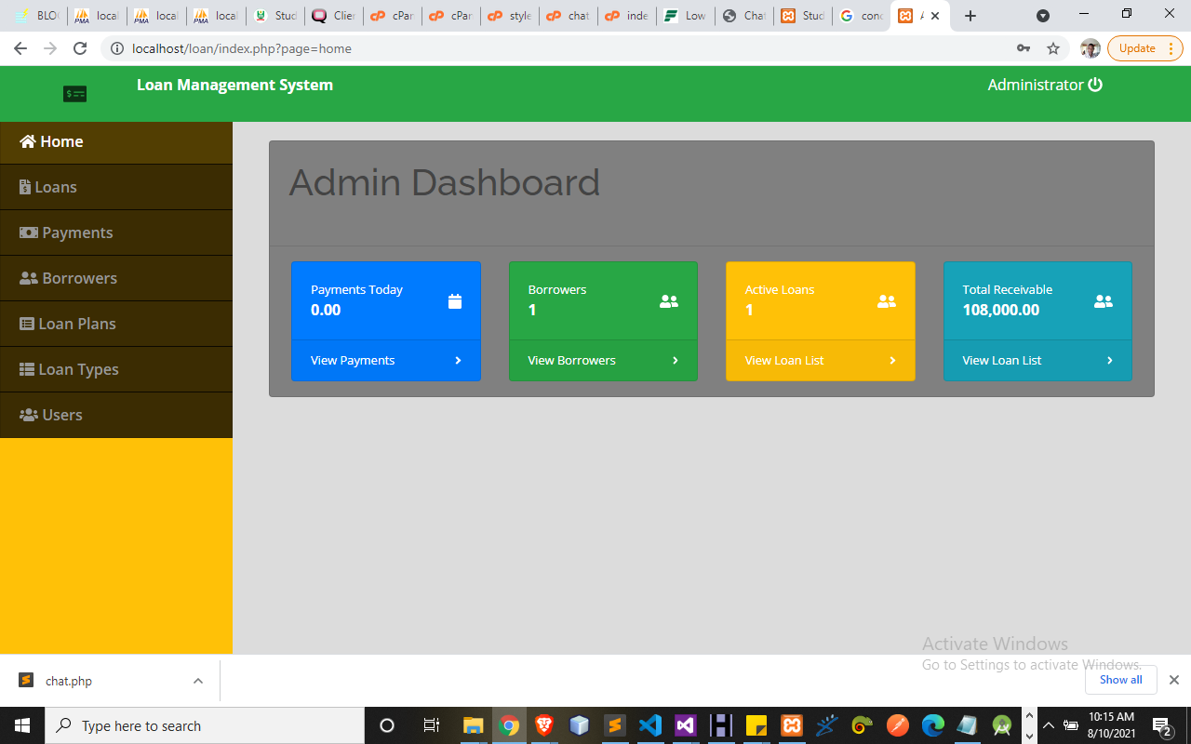Figure 4.1 Admin Dashboard: This is the main menu of the system where all functions can be carried out through navigation.
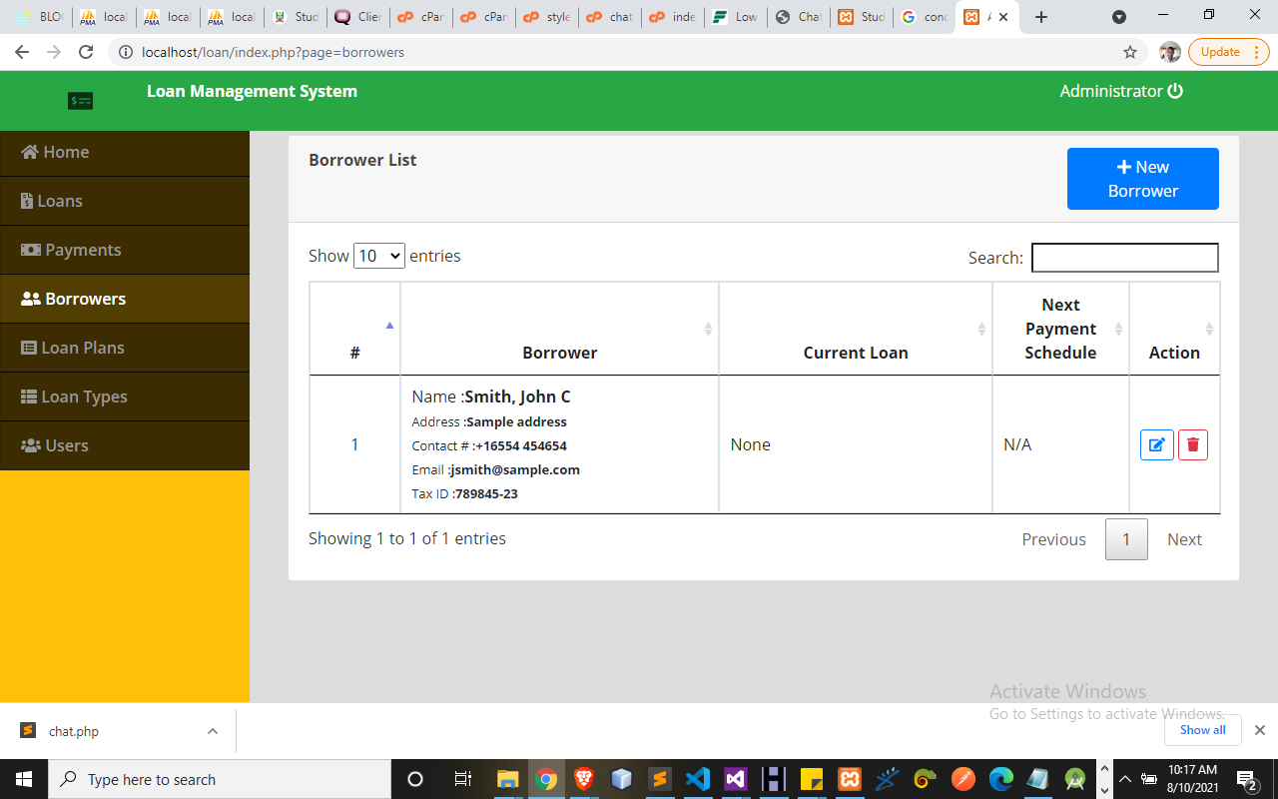
Figure 4.2 Borrower List: This display list of all member who are on loan to make payment.

Figure 4.3 Loan Plan: This allow admin to set the type of loan user can apply
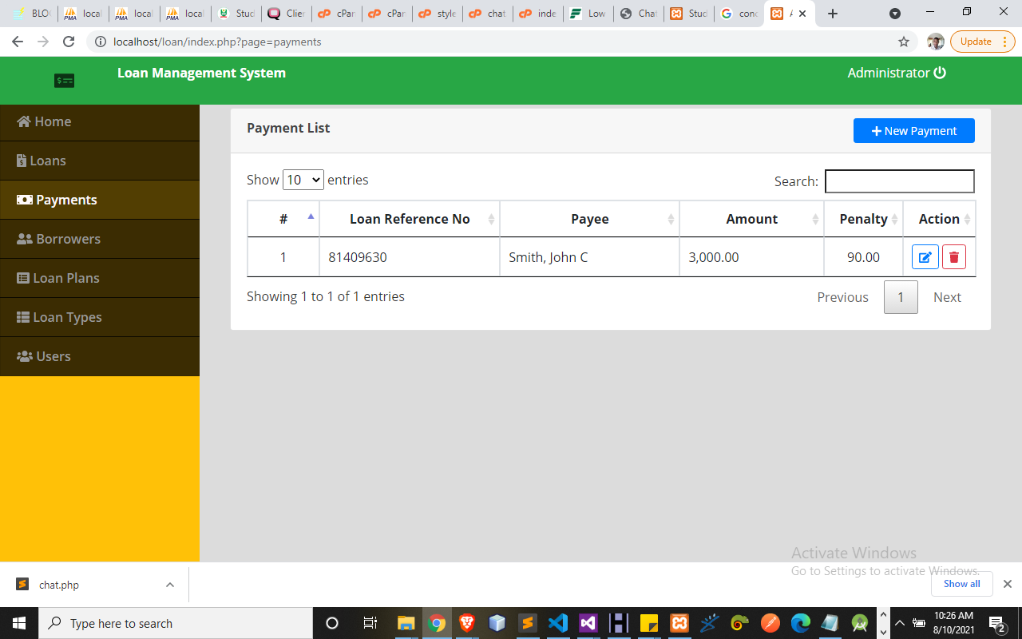
Figure 4.4 Payment List: This display the list of all payments made in the system.
4.1.2 Input Design
Input design involves creating a user-friendly interface for collecting the necessary data from applicants and other sources. This includes forms for personal information, financial details, employment history, and other relevant data.
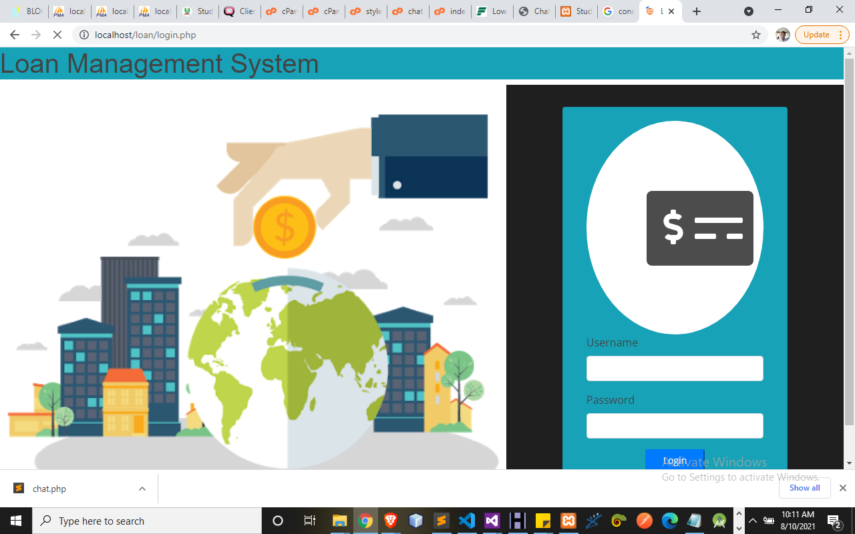
Figure 4.5 Login Page: This allow the admin get access into the system.
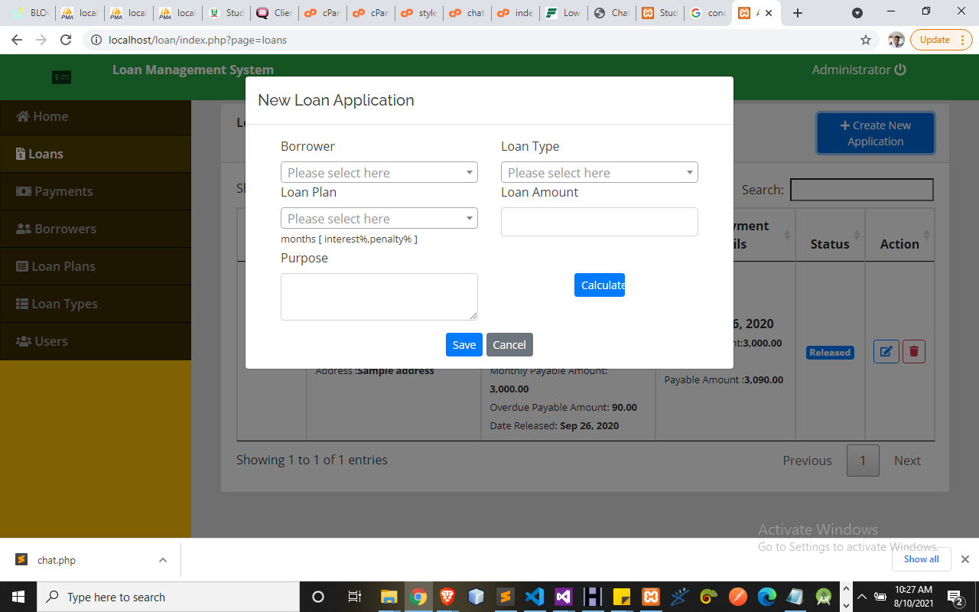
Figure 4.6 Loan Application: This allow user apply for loan here.
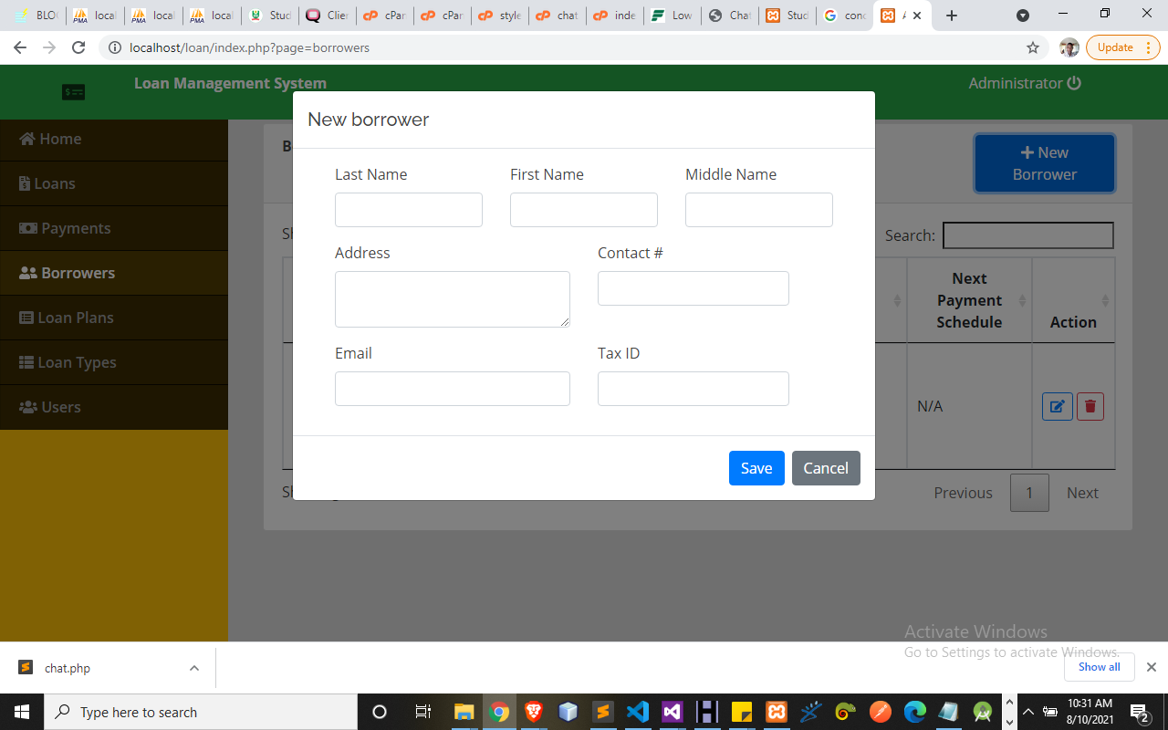
Figure 4.7 New Borrower: This allow user to borrow money
4.1.3 Database Design
The database design is integral to storing and managing the data used in the credit scoring and loan eligibility processes. It includes tables for applicants, loan details, financial records, and machine learning model results. The database design ensures data integrity, security, and efficient retrieval. Relationships between tables are carefully defined to support complex queries and reporting needs

Table 4.1 Loan Database
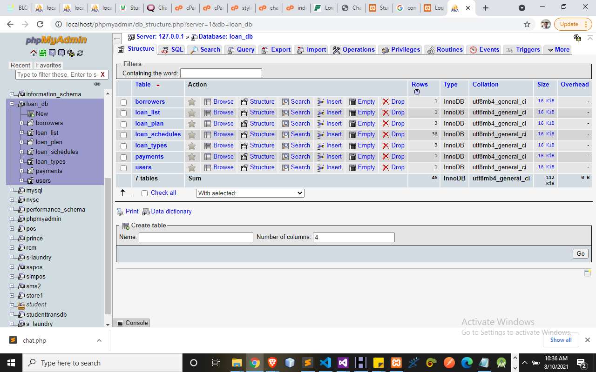
This display the abstraction of loan database management
Table 4.2: Borrower Table
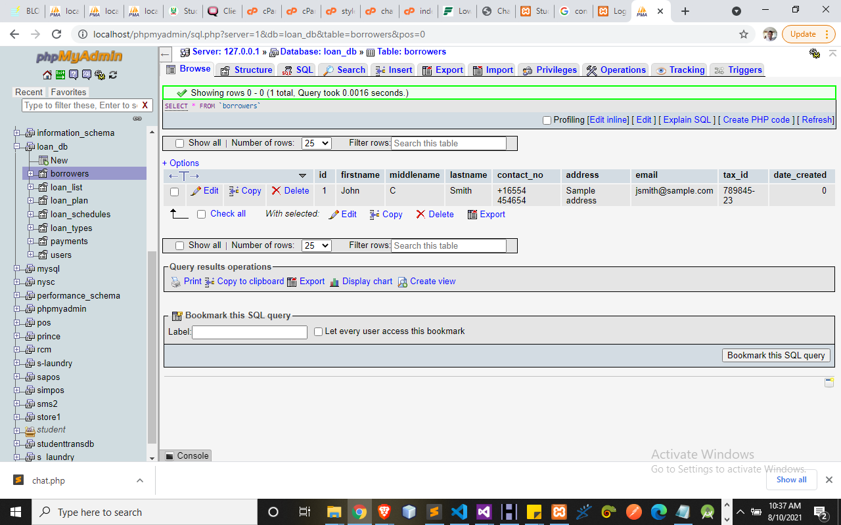
This display the list of all borrower in the database.

4.1.3 Procedure Design
Procedure design outlines the workflows and processes involved in the system. This includes the steps for data collection, preprocessing, model training, prediction generation, and result dissemination. Procedure design ensures that the system operates smoothly and efficiently, with well-defined roles and responsibilities for each step in the process.

  - Implementation of the System
It is always good to develop new ideas, to implement them on a computer and eventually to relish the satisfaction of achieving a successful result. The implementation process involves converting the system design into a complete and tested EDP that is fully operational and that can be used by the system users to meet their business needs. During implementation phase, the hardware and the software must be implemented.
Implementation of a system can be explained in six steps:-
- Review design specification
- Code, test and document programs
- Train users
- Perform system test
- Convert to new system
- Evaluate and maintain the new system

4.2.1 Choice of Programming Language
The choice of programming languages for this system includes Python, PHP, and JavaScript. Python is used for developing machine learning models due to its robust libraries and frameworks. PHP is utilized for backend development, handling server-side logic, and database interactions. JavaScript, along with HTML and CSS, is used for frontend development to create dynamic and responsive user interfaces.
4.2.2 Hardware Support
The system requires reliable hardware to support data processing and model training. This includes servers with adequate CPU, memory, and storage capacity to handle large datasets and perform complex computations. Additionally, backup and recovery systems are essential to ensure data security and system availability.

4.2.3 Software
I. Interface Design Language, windows Notepad for help interface design Hypertext Mark-up Language (HTML)
ii. MY SQL Database Management Software
iii. Programming PHP (Hypertext Pre-processor)
iv. Operating system window 07 professional
v. Graphic software paint shop and choosing these two formats GIF (Graphic Image Format)
vi. Scanner software, Mira scans
- Web browser software MOZILLA
4.3 Program Documentation
4.3.1 Operating the System
Step 1: Boot your computer and click on start button on task bar
Step 2: Launch WampServer
Step 3: Locate Online_goods
Step 4: Click on Options
4.1 Click on Product (to view available product)
4.2 Click on About Us (to view the about us page)
4.3 Click on Contact Us (to send message to the admin)
4.4 Click on Order Now (to order for your bags)
Step 5: Logout.
4.3.2 Maintaining the System
System maintenance documentation outlines procedures for regular maintenance tasks, such as backups, updates, and performance monitoring. It also includes guidelines for handling system failures and recovery procedures. Proper maintenance documentation ensures the longevity and reliability of the system.

CHAPTER FIVE
SUMMARY, CONCLUSION, AND RECOMMENDATIONS
5.1 Summary
The implementation of the machine learning-based credit scoring and loan eligibility system involves a comprehensive design and development process. The system's design focuses on creating user-friendly inputs, clear and actionable outputs, and a robust database structure to manage and retrieve data efficiently. Procedure design ensures smooth operation with well-defined workflows, covering data collection, preprocessing, model training, prediction generation, and result dissemination. This careful planning is crucial to achieving an efficient and effective system. The choice of programming languages is strategic, with Python used for developing machine learning models due to its extensive libraries and frameworks, PHP for backend development to handle server-side logic and database interactions, and JavaScript, HTML, and CSS for creating dynamic and responsive front-end interfaces. The system relies on robust hardware and software, including Linux-based servers, Apache or Nginx web servers, MySQL or PostgreSQL databases, and development tools like PyCharm and Visual Studio Code. Agile methodologies are employed to facilitate iterative development, continuous feedback, and adaptability, ensuring the system can evolve based on user needs and changing requirements.
Comprehensive documentation is a key aspect of the system's implementation. Program documentation provides detailed information about the codebase, while operating the system documentation includes user manuals, administrative guides, and troubleshooting instructions. System maintenance documentation outlines regular maintenance tasks, updates, and performance monitoring procedures. This thorough documentation ensures that the system is not only user-friendly and efficient but also maintainable and reliable, supporting its longevity and effectiveness in improving credit scoring and loan eligibility processes.

5.2 Conclusion
In conclusion, the project "Machine Learning for Credit Scoring and Loan eligibility" represents a significant advancement in the field of financial technology. By leveraging machine learning algorithms, the project offers a more accurate, efficient, and transparent approach to credit evaluation and loan eligibility processes. Through rigorous testing and validation, the system demonstrates its reliability and effectiveness in assessing borrower creditworthiness, automating loan eligibility decisions, and providing explanations for those decisions.
The project's unique features, including automated decision-making, transparency, and scalability, position it as a cutting-edge solution for financial institutions seeking to streamline their lending operations. The integration of machine learning models seamlessly into the web-based application enhances the system's capabilities and ensures continuous improvement in credit scoring accuracy over time. Furthermore, the implementation of anti-manipulation features and adherence to regulatory requirements underscore the project's commitment to data integrity, security, and compliance. These measures safeguard sensitive information, mitigate risks, and instill trust among users and stakeholders.
Overall, the project's successful development and testing validate its potential to revolutionize the credit scoring and loan eligibility landscape, driving efficiency, fairness, and innovation in the financial industry. As the project moves forward, ongoing monitoring, refinement, and collaboration with industry experts will further enhance its impact and ensure its continued success in meeting the evolving needs of borrowers and lenders alike.

5.3 Recommendations
The project "Machine Learning for Credit Scoring and Loan eligibility" lays the foundation for several future enhancements and extensions that can further enhance its capabilities and impact in the financial industry:
- Real-time Decision Making: Implement real-time credit scoring and loan eligibility decision-making capabilities to enable instant responses to loan applications.
- Predictive Analytics: Integrate predictive analytics capabilities to forecast borrower creditworthiness and identify potential default risks proactively.
- Personalization: Incorporate personalized loan recommendations and offers based on borrower profiles, financial goals, and preferences.
- Fraud Detection: Integrate fraud detection algorithms to identify and prevent fraudulent loan applications, enhancing security and reducing financial risks.
- Mobile Application: Develop a mobile application to enable borrowers to access the credit scoring and loan eligibility system conveniently from their smartphones.

References
Breeden, J., L., (2020) A Survey of Machine Learning in Credit Risk. Research Gat DOI: 10.13140/RG.2.2.14520.37121
Apostolos Ampountolas, Titus Nyarko Nde, Paresh Date, and Corina Constantinescu. 2021. A Machine Learning Approach for Micro-Credit Scoring. Risks 9:50. https://doi.org/10.3390/risks9030050
Diwate, Y., et al., (2021) Loan eligibility Prediction Using Machine Learning. International Research Journal of Engineering and Technology (IRJET) Volume: 08 Issue: 05
Elisante J., M. (2022) Effect of Machine Learning in Early Prediction of Personal Loan Defaulting on Commercial Bank in Tanzania (2009-2020). African Centre Of Excellence In Data Science
Fan, S., et al., (2020) Improved ML-Based Technique for Credit Card Scoring in Internet Financial Risk Control. Hindawi, Complexity, Volume 2020, Article ID 8706285, 14 pages
Hossain, M., and Mullally, C., (2021) Using evaluation data to predict loan performance among poor borrowers: The case of BRAC’s asset transfer and microcredit programmes. Research and Impact Assessment Division, International Fund for Agricultural Development (IFAD), Via Paolo di Dono, 44, 00142 Rome, Italy
Khedr, M. H., (2021) A New Prediction Approach for Preventing Default Customers from Applying Personal Loans Using Machine Learning. Monthly Journal of Computer Science and Information Technology. IJCSMC, Vol. 10, Issue. 12, December 2021, pg.71 – 82
Ndayisenga, T. (2021) Bank Loan eligibility Prediction Using Machine Learning Techniques. African centre of excellence in data science
Provenzano, A., R., et al., (2020) Machine Learning approach for Credit Scoring. See discussions, stats, and author profiles for this publication at: https://www.researchgate.net/publication/343441891
Wu, Y., and Pan, Y., (2021) Application Analysis of Credit Scoring of Financial Institutions Based on Machine Learning Model. Hindawi Complexity Volume 2021, Article ID 9222617, 12 pages

