SMART SOLAR BASED CBT EXAMINATION MONITORING SYSTEM
BY
JOSEPH BLESSING
HND/23/COM/FT/0025

A PROJECT SUBMITTED TO THE DEPARTMENT OF COMPUTER SCIENCE, INSTITUTE OF INFORMATION AND COMMUNICATION TECHNOLOGY.
KWARA STATE POLYTECHNIC, ILORIN KWARA STATE

IN PARTIAL FULFILLMENT OF THE REQUIREMENTS FOR THE AWARD OF HIGHER NATIONAL DIPLOMA (HND) IN COMPUTER SCIENCE

JULY, 2025

CERTIFICATION
This is to certify that this project was carried out by JOSEPH BLESSING with the matriculation number HND/23/COM/FT/0025 in the department of Computer Science, Institute of Information and Communication Technology, Kwara State Polytechnic Ilorin, Kwara State.

………………………….. …………………………
DR. AGBOOLA, O.M. Date
Project Supervisor

………………………….. …………………………
MR. OYEDEPO, F.S. Date
Head of Department

………………………….. …………………………
External Examiner Date

DEDICATION
This project is dedicated to the Almighty God who happens to be my source of wisdom and knowledge. May his holy name be glorified forever.

ACKNOWLEDGEMENT
My glorious gratitude goes to Almighty God, the Alpha and the Omega for his mercy, guidance and support through the successful completion of my academic years.
I express my profound gratitude to my supervisor, Dr. Agboola O. M. for his thorough supervision and contribution to the success of this work may God continue to bless you and reward you
. I also appreciate the Head of Department Mr. Oyedepo F. S. and other lecturers in the department who have contributed to the successful completion of my HND program.
My profound gratitude goes to the best parents in the world, the late Mr. A. Joseph and my wonderful mother, Mrs. C. Joseph whose immeasurable love and support in various forms have helped me become who I am today may my dear mother live long to reap the fruits of her labour in Jesus name.
I cannot but acknowledge the efforts of my beloved brothers, Joseph John and Joseph Emmanuel for their unquantifiable advice and encouragement given to me during the course of my study. May Almighty God bless them. Special thanks to my wonderful sisters, Mrs. Janet Mathias, Mrs. Elizabeth John, Joseph Hellen for their prayers and roles played in one way or the other towards my success. God bless you all.
Finally, I want to appreciate all my friends, you are numerous to mention. I love you all.

TABLE OF CONTENTS
Title Page…………………………………………………………………… i
Certification………………………………………………………………… ii
Dedication………………………………………………………………….. iii
Acknowledgements……………………………………………….………... iv
Table of Contents…………………………………………………..……….. v
Abstract………………………………………………………………………..vi
CHAPTER ONE: INTRODUCTION
1.1 Background to the Study………………………………………………… 1
1.2 Statement of the Problem……………………………………………… 3
1.3 Aim and Objectives………………………………………………………. 3
1.4 Significance of the Study…………………………………………………. 4
1.5 scope of the study…………………………………………………………. 4
1.6 Organization of the Study…………………………………………………. 4
1.7 Definition of Terms……………………………………………………….. 5
CHAPTER TWO: LITERATURE REVIEW
2.1 Review of Related Works ………………………………………………… 7
2.2 Review of General Texts………………………………………………….. 11

CHAPTER THREE: RESEARCH METHODOLOGY
3.1 Block Diagram of Solar Power System………………………………….. 16
3.2 Introduction………………………………………………………………. 16
3.3 System Design …………………………………………………………… 16
3.3.1 Hardware Components…………………………………………………. 17
3.4 solar power system components………………………………………….. 17
3.4.1 Solar Panel……………………………………………………………… 17
3.4.2 Charge Controller………………………………………………………. 18
3.4.3 Inverter…………………………………………………………………. 19
3.4.4 Solar Battery……………………………………………………………. 19
3.5 Components of CCTV System…………………………………………… 19
3.5.1 Security Camera………………………………………………………... 20
3.5.2 Recorders……………………………………………………………….. 20
3.5.3 CCTV Cable……………………………………………………………. 21
3.5.4 BNC Connector………………………………………………………… 21
3.5.5 CCTV Power Supply…………………………………………………… 22
3.5.6 Monitor…………………………………………………………………. 22
3.6 Transmission Medium for CCTV System………………………………... 22
CHAPTER FOUR: SYSTEM OPERATION, RESULTS AND DISCUSSION 4.1 Solar Power System Operation…………………………………………… 24
4.1.1 Solar Panel Installation Process………………………………………… 27
4.2 CCTV System Operation…………………………………………………. 29
4.2.1 Installation Process…………………………………………………….. 35
4.2.2 Tools and Equipment Required………………………………………… 36
4.2.3 Steps Taken…………………………………………………………….. 36
4.3 System Testing and Evaluation…………………………………………... 37
4.3.1 Solar Power System Testing…………………………………………… 37
4.3.2 Surveillance System Testing…………………………………………… 37
4.4 Results……………………………………………………………………. 37
4.5 System Integration and Overall Performance…………………………….. 38
4.6 Discussion of Findings…………………………………………………… 38
CHAPTER FIVE: SUMMARY, CONCLUSION AND RECOMMENDATION
5.1 Summary………………………………………………………………….. 39
5.2 Conclusion………………………………………………………………… 39
5.3 Recommendations………………………………………………………… 40
Reference……………………………………………………………………… 41

ABSTRACT
This project focuses on the design and implementation of a Smart Solar-Based CBT Examination Monitoring System, aimed at enhancing the reliability and integrity of CBT center. The system is developed to address key challenges such as power instability and inadequate examination monitoring, which are common in many CBT centers, especially in regions with unreliable electricity supply. By integrating renewable solar energy with intelligent surveillance, this system offers a sustainable and secure solution for managing CBT examinations. It reduces dependence on the national power grid, lowers operational costs, and enhances the credibility of examinations through effective monitoring. The Smart Solar-Based CBT Examination Monitoring System serves as a model for promoting sustainable and secure examination practices in educational institutions.
Keywords: Solar Energy, Smart Monitoring, CBT Examination, Surveillance System, Sustainable Solution.

CHAPTER ONE

INTRODUCTION

1.1 BACKGROUND TO THE STUDY
Computer-Based Testing (CBT) has revolutionized the way examinations are conducted, offering significant improvements in efficiency, accuracy, and accessibility. As educational institutions and examination bodies continue to adopt CBT for large-scale assessments, ensuring an uninterrupted power supply and robust monitoring systems has become critical for maintaining the integrity and smooth operation of these exams. The integration of renewable energy sources, such as solar power, with monitoring technologies can address these challenges effectively (Adeoye, 2019).
Electricity is critical for running CBT examination centers, powering computers, surveillance cameras, and other essential equipment. In many regions, especially in developing countries, unreliable electricity supply poses significant challenges to the smooth operation of CBT centers. To address this issue, solar power systems offer a viable and sustainable alternative. Solar power is a renewable and environmentally friendly energy source that ensures uninterrupted power supply while reducing dependence on the national grid (Mohamed & Lee, 2019).
Solar energy is a sustainable and environmentally friendly source of power that has gained global recognition as a viable alternative to fossil fuels. Its application in powering critical infrastructures, such as CBT examination centers, ensures reliability, particularly in regions where electricity supply is inconsistent or non-existent. Incorporating solar power systems with inverters and surveillance technologies, such as CCTV cameras, provides a holistic approach to addressing energy and security challenges in CBT centers (Adebayo, 2020).
Monitoring during CBT examinations remains a critical concern. Examination malpractices, technical issues, and administrative errors can undermine the credibility of the process. Traditional methods of invigilation are often insufficient to handle large-scale CBT exams effectively. A smart monitoring system integrated into the solar-powered framework can enhance invigilation by providing real-time surveillance, automated alerts, and detailed analytics. Technologies such as artificial intelligence (AI), Internet of Things (IOT), and cloud computing can further optimize the monitoring process, ensuring integrity and efficiency.
In the context of educational institutions and examination centre, the deployment of CCTV systems plays a critical role in maintaining order, monitoring candidates, and deterring examination malpractice. With the rise in CBT (Computer-Based Testing), where candidates take examinations simultaneously on computers, monitoring through human invigilators alone has proven to be insufficient. CCTV surveillance provides an unbiased, 24/7 monitoring solution that can capture real-time activities and allow for evidence-based reviews when irregularities are suspected (Okeke & Oladimeji, 2021).
Additionally, the integrity of examinations is paramount. The lack of effective surveillance in many CBT centers exposes the examination process to malpractice and misconduct. With the advancement in surveillance technologies, closed-circuit television (CCTV) cameras can be strategically deployed to monitor activities in real-time during examination sessions. When integrated into a solar-powered system, the surveillance mechanism becomes more reliable, especially in areas with inconsistent electricity supply (Eze & Mbah, 2021).
This project focuses on the design and implementation of a smart solar-based CBT examination monitoring system. By combining solar power with a well-structured CBT examination platform and surveillance technologies, this study aims to enhance the reliability, efficiency, and security of CBT operations in educational settings. The Smart Solar-Based CBT Examination Monitoring System is an innovative approach to modernizing the examination process. It offers a sustainable, efficient, and secure solution to challenges that hinder the effectiveness of CBT systems, particularly in regions with infrastructural limitations.

1.2 STATEMENT OF THE PROBLEM
Computer-Based Test (CBT) centers have become essential in modern education, offering speed, accuracy, and convenience in examination processes. However, several challenges threaten the efficiency and reliability of CBT centers. One major issue is the frequent occurrence of power outages, which disrupt examinations and lead to delays, system failures, or incomplete assessments. The lack of stable electricity in many regions, especially in developing areas, undermines the effectiveness of CBT centers.
Additionally, traditional monitoring methods used in CBT centers are often inadequate for preventing examination malpractice or addressing technical issues in real- time. This compromises the integrity of the examination process and raises concerns about the credibility of results. The reliance on non-renewable energy sources, such as generators, adds to operational costs and contributes to environmental degradation, further compounding the problem. These challenges highlight the need for an innovative and sustainable approach to addressing power and monitoring issues in CBT centers.

1.3 AIM AND OBJECTIVES
The aim of this research work is the design and implementation of solar power CBT examination monitoring system with the following objectives:
- Installation of solar panel, surveillance camera and inverter for monitoring the CBT examination center; and
- Connecting the installed system to batteries.

1.4 SIGNIFICANCE OF THE STUDY
The study is significant in addressing two critical issues in the operation of CBT centers: power reliability and examination monitoring. By utilizing solar energy, the system reduces dependency on conventional electricity grids, ensuring uninterrupted power supply even in regions with frequent outages. The use of inverters and energy storage solutions ensures consistent power availability during examinations, reducing disruptions and enhancing the efficiency of CBT operations.
Also, integration of surveillance cameras enhances the security of the examination process, reducing malpractice and increasing fairness.

SCOPE OF THE STUDY
This project focuses on the design and implementation of a smart solar-based CBT examination monitoring system for the Computer Science CBT Center at the Kwara State Polytechnic, Ilorin. The study covers the installation of solar panels, inverters, and surveillance cameras to ensure uninterrupted power supply and effective monitoring during examinations. It also includes the connection of the solar system to battery banks to provide backup power support in the event of low sunlight or grid failure. The project is limited to the physical infrastructure, as well as the power and monitoring systems within the specified CBT Center.

1.6 ORGANIZATION OF THE STUDY
This study is organized into five chapters. A brief idea of what each chapter contains is given here.
Chapter One introduces the background, statement of the problem, aim and objectives, significance of the study, scope of the study, organization of the study and definition of terms.
Chapter Two reviews related literature on CBT systems, solar power, and monitoring technologies.
Chapter Three outlines the methodology used in designing and implementing the system. Chapter Four presents the results and discusses the findings of the study.
Chapter Five summarizes the whole project work; it also gives the conclusion and recommendations for future work.

1.7 DEFINITION OF TERMS
- COMPUTER-BASED TEST (CBT): A method of conducting examinations using computers, where candidates answer questions electronically rather than on paper.
- SOLAR POWER SYSTEM: A system that converts sunlight into electricity using photovoltaic (PV) cells and typically includes components such as solar panels, an inverter, and batteries.
- SURVEILLANCE CAMERA: A video recording device installed in an area to monitor activities and ensure security.
- INVERTER: An electrical device that converts direct current (DC) from solar panels or batteries into alternating current (AC) for powering electrical devices.
- MONITORINGSYSTEM: A setup that observes and records activities in a specific environment to ensure compliance with rules and enhance security.
- EXAMINATION MALPRACTICE: Any fraudulent activity or misconduct by candidates or staff during an examination process, which compromises the fairness and credibility of the results.
- INTERNET OFTHINGS (IOT): A network of connected devices that communicate and share data. IOT is used in the monitoring system for real-time surveillance.
- UNINTERRUPTIBLE POWER SUPPLY (UPS): A power backup solution that provides continuous electricity in case of power outages. In this project, solar batteries act as a UPS.

CHAPTER TWO

LITERATUREREVIEW
2.1 REVIEW OF RELATED WORKS
Aris and Carmichael, (2021) proposed a study of implementation of a monitoring system to solar-powered houses. The research is aimed for solar panel system owners to have a more enhanced and capable status monitoring system by interfacing with Microsoft .NET framework. The general objectives of the study are to create an automated monitoring system that will help the homeowner make key decisions in maintaining his solar power system. Also, to give advanced notifications so it can wisely conduct preventive maintenance on the hardware installed. The methodology includes an application to draw running statistics from the inverter device. This includes solar panel, battery status information, and other indicators as provided by manufacturer through their design. The problem of the current system in place is that the components being monitored are quite limited. Including the fact that there is no suggestion from any system which area might need to be checked when the power being supplied is inadequate or there is a power shutdown. The findings show that the study will extend the efficiency of the solar power system, decreasing the owners’ expenses on equipment replacement. Conclusion, developing additional monitoring capabilities can be developed on top of some existing solar power systems. Based on the results of the study it is recommended that future capability for the system to be accessible also even if homeowner is far away from their home. Additional security setup using firewalls if the said monitoring system will have remote access features.
Mohd, Santosh, Suvama, and Anil (2017) conducted a study on electricity generation from solar energy. The aim is to review the potential, advantages, and growing significance of solar energy as an alternative source of electricity generation. Solar Energy is produced by the Sunlight is a non-vanishing renewable source of energy which is free from eco-friendly. Every hour enough sunlight energy reaches the earth to meet the world’s energy demand for a whole year. In today’s generation we needed Electricity every hour. It can easily drawn energy from direct sunlight. So it is very efficient and free of environmental pollution for the surrounding. Everyday earth receives sunlight above (1366W approx.) This is an unlimited source of energy which is available at no cost. The findings show the major benefit of solar energy over other conventional power generators is that the sunlight can be directly converted into solar energy with the use of smallest photovoltaic (PV) solar cells. The most advantages of solar energy is that it is free reachable to common people and available in large quantities of supply compared to that of the price of various fossil fuels and oils in the past ten years. Moreover, solar energy requires considerably lower manpower expenses over conventional energy production technology. Conclusion, solar energy has become increase more popular due to their economic benefits. By on Battery Backup, Solar Energy can even provide Electricity 24x7, even on cloudy days and at night. This also used with inter-grid System with Continuously Power supply. It has more benefits compared to other forms of energy like fossils fuels and petroleum deposits. It is an alternative which is promise and consistent to meet the high energy demand. Research on solar cells and solar energy is promising and has a future worldwide; therefore, it is recommended that further studies and investments be encouraged to maximize their potential.
Obi, (2022) presented a Solar Monitoring system Reliability: Challenges and Prospect for Modern Engineering. The aim is to design an IOT based solar power monitoring system that allows for automated solar power monitoring and control. One of the objectives in the design of the prototype system is to monitor various parameters of the solar panel including voltage, current, power and temperature. This system is designed using Arduino Nano controller. Problem of the study, solar power plants need to be monitored for optimum power output. And naturally, there are variations in power generation from solar power plant due to changes in temperature, solar irradiance, and others factors lowering the power output like faulty solar panels, connections, and dust accumulated on panels and other such issues affecting solar performance. The findings show that the system recognizes dust and failures of panels due to different problem. Conclusion, the study focused on examining some of the challenges of solar monitoring system reliability with a view of develops an effective framework in modern engineering and sustainability. The review of literature has made an attempt to address some of the problems of monitoring solar power inverter that users are facing today. Recommendation, a provision of advance remotely manages the Solar PV plants of various operations like remote shutdown, remote management is to be incorporate with this system later.
Edeoghon, Chibuzor, Ebu, Ohiocheoya, Chukwunweike, Ebikade, Efemena, Akinlade, Ekunife, Odey, and Enofe (2022) worked on design and implementation of an IOT-Based solar powered inverter control system. The aim is to remotely monitor and control a solar powered based inverter using the internet of things. The methodology employed in this project include a solar-powered inverter unit. The findings revealed that the solar panel works to convert solar energy coming from the sun into electrical energy which is needed to charge the battery. Power generation from Solar Photovoltaic plants is variable due to changes in solar irradiance, temperature, and other factors. Thus, remote monitoring is essential. The Charge controller is connected between the solar panel and the battery to regulate the power coming from a solar panel with the right voltage and current before going into the battery. It regulates the fluctuating output of the solar panel at any point be it at the sun’s high intensity or low. To ensure that batteries do not overcharge during the day and that power does not run back to the solar panel overnight and drain the batteries. The DC output from the battery will be sent into the inverter which does the conversion from DC to AC and to supply to the AC loads. Using inverters beyond their operating limit, either by choice or due to oversight or lack of knowledge, can contribute to inverter bridge failure. Over-current and Over-voltage can cause inverter failure. The researchers concluded that the system will be of great use to individuals who own solar powered inverters and would want to be able to control and Monitor their inverters regardless of their current location. It is recommended that this project be developed further to extend beyond the current scope and provide more realistic solutions to solar inverter system inefficiency. Future work should also aim to provide more helpful information regarding energy advancement, encouraging wider adoption and improving the overall effectiveness of solar powered inverter systems.
Kavitha and Malathi (2019) proposed a smart solar PV monitoring system. The IOT based solar energy monitoring system aimed to collect and analyzes the solar energy parameters to predict the performance for ensuring stable power generation. The main objective of the system is to determine optimal performance for better maintenance of solar PV (photovoltaic). The prime target of PV monitoring system is to offer a cost- effective solution, which incessantly displays remote energy yields and its performance either on the computer or through smart phones. The findings revealed that the proposed system is tested with a solar module of 125-watts to monitor string voltage, string current, temperature, and irradiance. Methodology of the study, this PV monitoring system is developed by a smart Wi-Fi enabled CC3200 microcontroller with latest embedded ARM processor that communicates and uploads the data in cloud platform with the Blynk application. Also the Wireless monitoring system maximizes the operational reliability of a PV system with minimum system cost. The monitored parameters show the optimized result that matches approximately with Electrical ratings of solar module tested under Standard Test Condition (STC). Conclusion, the proposed work helps to predict the performance of the Solar PV module through remote access. Recommendation, this can be extended for a large-scale solar plant to take preventive action by regularly monitoring the performance of the solar plant. It will be highly useful for the industrial and commercial application.

REVIEW OF GENERAL TEXTS
Uche, Martins and Francisca, (2020) presented a video surveillance in examination monitoring. This study aims to assess the efficacy of video surveillance systems in monitoring examinations in Nigerian tertiary institutions of learning. The objectives include evaluating how Closed Circuit Television (CCTV) systems can detect suspicious behaviors in real-time, examining their role in reducing examination malpractice, and determining how they complement the efforts of human invigilators. Additionally, the study seeks to identify the operational challenges associated with the deployment and use of CCTV systems in examination. The methodology of the research employed a combination of field surveys and document analysis to collect relevant data. Surveys were conducted among stakeholders in the education sector, including administrators and examination supervisors, to gather firsthand information. Document analysis was used to review existing records, studies, and reports on examination monitoring techniques and the use of surveillance systems. The problem of the study is that examination malpractice has become a serious concern in Nigerian tertiary institutions, threatening the integrity and core values of the educational system. Despite various measures such as the use of human invigilators, Candidate accreditation with photo albums, identity verification with ID cards, and biometric machines, the problem persists. These traditional methods have proven insufficient, necessitating the introduction of new technologies like CCTV surveillance to enhance monitoring and reduce malpractice. The findings of the researcher revealed that CCTV surveillance is gaining prominence in examination halls due to its ability to deter malpractice and provide reliable evidence for post-examination investigations. However, it also identified significant operational challenges that affect the successful deployment and use of CCTV systems, including funding limitations, technical expertise, and maintenance issues within institutions. In conclusion, video surveillance using CCTV systems presents a viable solution to the growing problem of examination malpractice in Nigerian tertiary institutions. The researchers recommend that regular checks and maintenance routines should be established to ensure the surveillance equipment remains functional, especially during critical examination periods.
Amaechi, Uchenna and Ugochukwu (2017) worked on Closed-Circuit Television Surveillance: An Antidote to Examination Malpractice in High Institutions in Nigeria. The aim of this study is to explore the effectiveness of closed-circuit television (CCTV) surveillance as a tool for curbing examination malpractices in Nigeria. The objectives is to identify common forms of examination malpractices in Nigerian institutions. Methodology employed in the study is descriptive research. The findings show that CCTV cameras, when installed in strategic positions in examination halls, can be used to monitor in real time the activities of both candidates and exam facilitators such as invigilators. Such unbiased machine monitoring or surveillance enhances proper invigilation of exams, ensures that participants in the examination conduct themselves properly in a transparent manner, and also beefs up confidence in the participants against molestation or wrong accusation of malpractice. It also gives the examiner confidence that his/her exam is free and fair and can be verified. Conclusion, having noted the increasing high rate of examination malpractice in Nigeria and the destructive side effect it has on Nigeria as a nation, it is pertinent that an urgent and lasting solution be proffered. It is in the light of this that this paper strongly recommends the deployment and use of CCTV surveillance to aid in examination invigilation during which most of the examination malpractices occur. It is believed that with CCTV, incidences of examination malpractice during exam will be drastically reduced as it has the capacity to ensure that examinations are properly monitored and recorded, serve as deterrence to potential offenders, and provide footage evidence to prove that a malpractice occurred or not.
Agnes, Amalia and Juniastel (2019) presented a Computer-Based Test (CBT) System for Student Academic Examination. The study focuses on the design and development of a digital assessment platform aimed at enhancing the efficiency and integrity of student examinations. The aim of the study was to create a CBT system that automates key examination processes such as question delivery, auto-submission, marking, and result reporting. The objectives included reducing human errors, curbing examination malpractice, and addressing logistical challenges associated with traditional examination formats. The methodology adopted was the Research and Development. (R&D) approach, utilizing the Thiagarajan 4-D Model: Define Design, Develop, and Disseminate. The system design was based on the Learning Management System (LMS) Moodle, which supported online question administration and report generation. Due to time limitations, the study concluded at the limited trial phase, yet provided substantial
insight into the system’s design and operational structure. Findings from the study highlighted that the CBT system significantly streamlined the examination process by eliminating issues such as result omission, limited venue capacity, inadequate invigilators, and manual grading errors. The system proved particularly effective in mass education evaluation. However, the study identified a gap the current CBT version only supports objective-based questions, limiting its capacity to assess deeper analytical or theoretical understanding. In conclusion, the study supports the CBT system as a practical and scalable solution to many challenges facing traditional examination methods. Researcher recommends that future research work should accommodate theory-based questions as opposed to only that the CBT system currently accommodates. Also, provision for video- based e-assessment can be investigated.
Raimon, Lido, Firmansyah, and Ratih (2020) designed and implemented a computer based test (CBT) in vocational education. This research is motivated by an analysis of the needs of the examination system that still uses conventional methods that require considerable time, cost, and effort and have not been able to synergize with technological developments. Methodology of the study, research on the development of Computer Based Test (CBT) Models Based on the web aims to develop a CBT model that can overcome the problems found in conventional tests. This type of research is development research (R & D) with software development procedures using the waterfall model. The stages of development consist of the needs analysis phase, the design stage, the implementation phase, and the testing phase. Research respondents were students of the information Systems study program. The results of this study were obtained online test kits to help the process of evaluating student learning outcomes with features: input test data, display an analysis of the completeness of the report, and print reports made for the completion of the learning assessment. The findings show that by using a database system, this online exam makes it easier for the exam system to display questions and assessments, making it easier for users to use it and for administrators to manage questions. The making of a Computer Based Test is an online testing tool for optimizing exam activities. Conclusion, the Computer Base Test system provides the benefit of not needing to duplicate test papers and saving time for examination corrections. The random function of the questions on the online examination system can reduce the cheating committed by examinees because the questions presented vary so that the examinees will receive different questions from one another. The recommendation from the study is for educational institutions to adopt computer-based testing systems to modernize examination practices.

Kaushalya, Swati, Shripad (2023) proposed an internet of things based solar power monitoring system using NodeMCU. The aim of this research paper is to design and implement a solar power monitoring system using an Arduino board. The objective is to monitor the performance of a small-scale solar power system in real-time. The methodology involves the design and implementation of hardware components and software programming for data acquisition and communication. Findings show that the system collects, processes, and visualizes real-time data from solar panels, batteries, and other system components, providing comprehensive monitoring capabilities for solar power system owners. The system is designed to be cost-effective and scalable, making it suitable for both residential and commercial applications. The research, demonstrate the feasibility and effectiveness of solar power monitoring system using NodeMCU. The findings contribute to the field of renewable energy management by offering an innovative approach to monitor and optimize solar power systems, promoting the wider adoption of renewable energy sources for a sustainable future. However, the system leaves a gap in its applicability to large-scale or industrial solar power systems. Conclusion, solar power monitoring system using NodeMCU offers a comprehensive and cost-effective approach to monitor and optimize solar power systems. Recommendation, the future scope of study includes incorporating machine learning algorithms, integrating with smart grid technologies, and supporting peer-to-peer energy trading, providing opportunities for further research and innovation in the field of renewable energy management.

CHAPTER THREE

RESEARCH METHODOLOGY
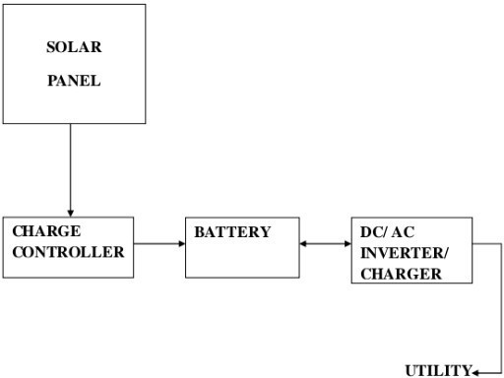
3.1 BLOCK DIAGRAM OF SOLAR POWER SYSTEM
FIG3.1 SOLAR SYSTEM BLOCKS DIAGRAM

INTRODUCTION
This chapter presents the design and implementation of a smart solar based CBT examination monitoring system. The system integrates solar power system and surveillance cameras (CCTV) system to ensure reliable and efficient monitoring of the examination process. The following sections will discuss the system design and the hardware components.
3.3 SYSTEM DESIGN
System design refers to the process of combining various components in a specific arrangement to enable the system to function as intended. In the context of our Smart Solar- Based CBT Examination Monitoring System, system design involves integrating the solar power system and CCTV system components to create a comprehensive system. This integration enables the system to perform its intended functions, including monitoring CBT examinations and utilizing solar power efficiently.

3.3.1 HARDWARE COMPONENTS
The hardware components required for the project include:
      - Solar Power System: Solar panels, charge controllers, inverter, and battery.
      - CBT Examination System Hardware: Computers, servers, networking devices ,and peripherals.
        - Surveillance System: CCTV cameras, Digital Video Recorders (DVRs) and monitor.

3.4 SOLAR POWER SYSTEM COMPONENTS
3.4.1 SOLAR PANEL
A solar panel is a device that is able to absorb sun rays and convert it into electrical energy precisely DC. The photovoltaic panel comprises silicon crystals, which react with the sun ray and under this process, convert the sun rays into electricity. They supply the electricity for charging the battery and for use by the appliances either directly or through an inverter. Solar panels are arrays of photocells made from semiconducting materials such as crystalline silicon or cadmium telluride. It is this semiconducting material that does the actual conversion. The conversion is done by a process called photovoltaic effect. The solar panels come in different sizes each with an output within the range of 100 to 365 watts. Its efficiency depends on the size as a more efficient panel with a similar rating with lower efficient panels will have a smaller size on comparison.
Multiple modules were used to produce more electricity and then any excess energy that was produced was stored in the battery for use during the cloudy/rainy weather. The panels are available in different size, voltage and amperage. They can be wired in series or in parallel. For this project, solar panels are wired in parallel. In a parallel connection, all positive (+) terminals are connected together and all negative (-) terminals are connected together, maintaining the same voltage while increasing current capacity.

3.4.2 CHARGE CONTROLLER
The charge controller is an electronic voltage regulator that was used to limit the rate at which electric current was being drawn in or out of the battery. This charge controller turns off the charge when the battery reaches the optimum charging point and turns on when it goes below certain level. It fully charges the battery without permitting overcharging while preventing reverse current flow. Over voltage may reduce the battery performance or lifespan, and may pose a safety risk. This charge controller shown system operation parameters, battery status and protection from over discharge. The charge controller is the brain behind the system. It monitors the electricity produced by the solar panel and then regulates the electricity that was used to charge the battery and prevent it from becoming over charged.
Proper charging was considered to prevent any damage to the batteries and thereby increasing the battery life and performance. There are two types of controllers that are widely available in the market; Pulse width Modulation (PWM) and Maximum Power Point Tracking (MPPT).
- Pulse width modulation (PWM): A pulse width modulation charge controller is set match the input power of the battery irrespective of the power generated by the panels. There is an inherent loss in power observed in this type of charger.
- Maximum Power Point Tracking (MPPT): This type of charger helps to get the optimum charging power for any given point of time and offers better efficiency than PWM.
Though the MPPT charge controllers enable you to have better efficiencies and provides more power than compared to PWM for similar condition, MPPT charge controllers are more expensive than PWM controllers. For this project, an MPPT charge controller was used. To select the size of charge controller one must know the voltage level of the system and the maximum operating current. It is a usual practice to oversize the controller for safety reasons.

INVERTER
The inverter convert the direct current (DC) voltage produced by the solar panels (and from the energy stored in the battery) into alternating current (AC) voltage. The inverter could also charge the battery by using an alternative source such as the mains or generator connected to the inverter when they are available.

3.4.4 SOLAR BATTERY
A battery is an electrochemical cell that produces DC from an electrochemical reaction to power a given load. A battery is made up of several cells. A cell is the working chemical unit inside the battery. A cell has three main parts: a positive electrode (terminal),a negative electrode and a liquid or solid separating them called the electrolyte. When a battery is connected to an electric current, a chemical reaction takes place in the electrolyte causing ions to flow through it in one direction while the electrons flow through the other current in the other direction.
The battery that was used in this project is a solar battery. Without the battery, the system could only power when the sun is shining. The power would interrupt each time the cloud passes, the system would become very frustrating. The solar battery provided constant electricity and the load discharges 80% of its charge.

3.5 COMPONENTS OF CCTV SYSTEM
The Closed Circuit Television (CCTV) system is made up of several parts or components.

3.5.1 SECURITY CAMERA
The security cameras of a CCTV system are clearly a vital component. A camera is used to capture videos or still images, which are then transmitted to a monitor for viewing and to a recorder for recording. But not all security camera types are designed equal, nor do they all have the same features. There are lots of security cameras in the market that are designed to support different applications and mounting options. Some of security cameras that exist today include network or I.P. camera, wireless camera, dome camera, bullet camera, PTZ camera et cetera. The power of a security camera depends on its pixel. CCTV cameras may employ one of two types of data transmission:
Network Cameras–Network cameras connect to IP-based networks, including the Internet, and provide remote viewing and recording. Network cameras are also available in high definition (HD) which can provide greater image detail.
Analog Cameras–Despite increasing use of digital network cameras, a market for analog cameras still exists. This may be due to the cost involved in upgrading and converting to a new transmission process. Analog cameras have options for high resolution, making them applicable for various surveillance needs. These cameras also have some cyber security advantage because the coaxial cable they are connected with would require physical account to breech.

3.5.2 RECORDERS
Recorders, also known as security DVR (Digital Video Recorder) are a key component in modern CCTV system. They are used to connect analog video to digital images which extends storage capacity, makes it easier to search through archived video, and allows surveillance operators to stream video over a network for remote viewing from multiple locations. Additional external hard drive may also be incorporated to the recorder which extends storage capacity even further.
Recorders are mainly of two types; standalone DVRs and NVRs. DVR stands for Digital Video Recorder and NVR stands for Network Video Recorder. Standalone DVRs record and stored images or videos sent by the CCTV cameras. A standalone DVR is not connected to any network but just a single computer system. NVRs perform the same function as standalone DVRs but are connected not to just a single computer but a whole network. The images or videos stored by NVRs can be viewed by anyone in the network. With NVRs it is easier to authorize who can view the videos or images over internet. For this project, a digital video recorder (DVR) was used.

3.5.3 CCTV CABLE
CCTV cable is the cable type used to attach the security cameras to the security DVR and their required power supply. Siamese CCTV is mostly used for installations. This is essentially two cables that are attached together to make one simple to install cable. A Siamese CCTV cable features an RG59 coaxial cable for transmitting video from the security cameras back to the security DVR, and an 18 gauge 2 conductor power cable that sends power from the security camera power supply to the camera itself. CCTV cable is durable and easy to install.

3.5.4 BNC CONNECTOR

The BNC (Bayonet Neill-Concelman) connector is a miniature quick connect or disconnect radio frequency connector used for coaxial cable. It features two bayonet lugs on the female connector, mating is fully achieved with a quarter turn of the coupling nut. BNC connectors are used with miniature-to-submarine coaxial cable in radio, television and other radio-frequency electronic equipment, test instruments and video signals. BNC connectors are terminated on the ends of the RG59 coaxial cable and allow a plug and play installation between the coaxial cable, security DVR, and each security camera. BNC connectors are really the strongest connector's in the market, plus they are most common for high bandwidth video applications. Once the coaxial cable of the CCTV cable has been terminated with a male BNC connector, connections can be made with the female BNC connectors that are on the back of the security DVR and the security camera.

3.5.5 CCTV POWER SUPPLY
The CCTV power supply will allow powering the security cameras. CCTV power supplies are available in 24VAC or 12VDC power types, and they are offered with different voltage strengths. CCTV power supplies are available in single, 4, 9, and 16 camera configurations. The CCTV power supply is where the power cable in the Siamese CCTV cable will be connected to on one end, while the other end is connected directly to the security camera.

3.5.6 MONITOR
To view video captured by the cameras, CCTV systems typically use monitors place data central location. The monitors are used much like a television, but have higher lines of resolution for improved picture quality. Monitors can be dedicated to review video from a single camera, or they can be configured to access multiple cameras at one time.

3.6 TRANSMISSION MEDIUM FOR CCTV SYSTEM
Once the image has been captured by a lens of a camera, it is then converted into an electrical signal, which is further taken to a switch, a monitor or a recording device. In order for the video signal to get from point A to point B, it has to go through some kind of transmission medium. The most common media used for video and data transmission in CCTV include coaxial cables, twisted pair cables, microwave links, RF open air transmission and Infrared facilities, telephone line and fiber optic cables. Among the lot, the coaxial cable and the wireless mediums are the most common for CCTV video signals. For this project, coaxial cable was selected as the transmission medium due to its cost-effectiveness, signal integrity, scalability and environmental constraints of the CBT center.

CHAPTER FOUR
SYSTEM OPERATION, RESULTS AND DISCUSSION
  - SOLAR POWER SYSTEM OPERATION
The solar power system is designed to provide a reliable and uninterrupted power supply to the CBT examination monitoring system, ensuring that both the CCTV surveillance cameras and CBT computers remain operational even in the absence of grid electricity.
The solar panels absorb energy from the sun and convert it into direct current (DC) electricity through the photovoltaic effect. When sunlight strikes the solar panel modules, it excites electrons, generating free charge carriers in the conduction and valance bands, leading to the production of electrical energy. The generated electricity is then transferred to a charge controller, which regulates the flow of electricity into the battery bank. The charge controller prevents overcharging by disconnecting the power supply when the battery reaches its maximum charging limit and reconnects when the voltage drops below a preset threshold. This regulations helps to prolong battery life and ensures efficient energy management. The stored energy in the battery serves as the primary power source for the system, but before it can be used to power CCTV cameras, computer systems, and other AC loads, it must be converted from DC to AC using an inverter. The inverter operates by periodically committing the direct current through a controlled oscillatory system, which then drives power electronic semiconductor switches such as transistors.
The switches are connected to a power transformer where the voltage is stepped up to the Required AC voltage level. In addition to converting DC to AC, the inverter is designed to charge the battery when there is a public power supply. This ensures continuous power availability, providing an alternative charging method when sunlight is insufficient.

The entire solar power system ensures that the CBT examination center remains powered at all times, guaranteeing that CCTV cameras monitor the examination hall continuously, prevents malpractice and maintaining the integrity of the examination process. The block diagram in fig 3.1 illustrates the flow of energy within the solar system energy generation to final consumption by the load.
Below are the diagrams of the materials used in the installation of the solar power system.
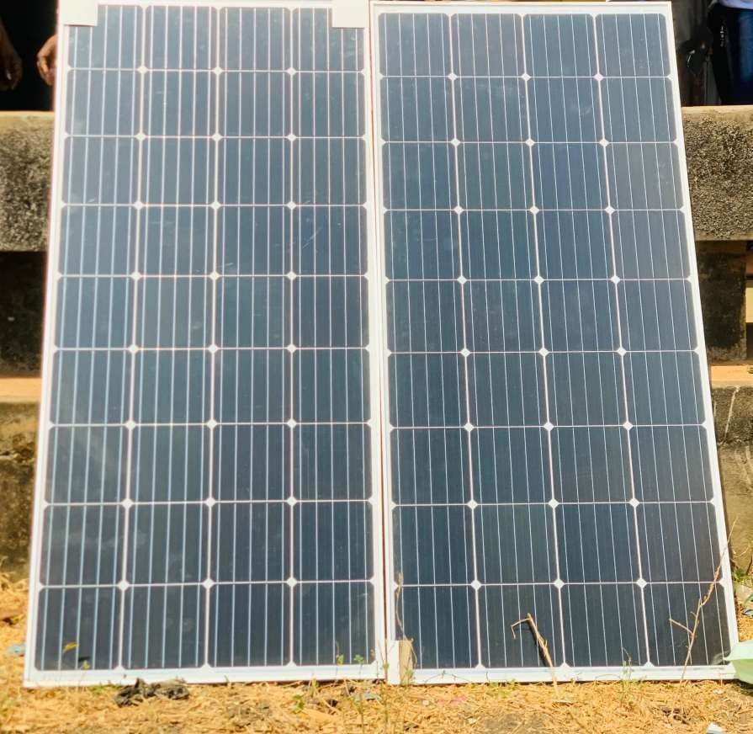

FIG 4.1 SOLAR PANNEL

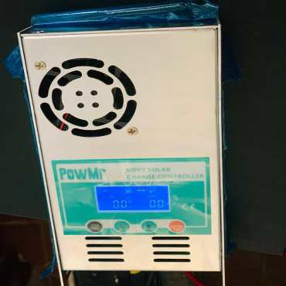
FIG 4.2 CHARGE CONTOLLER
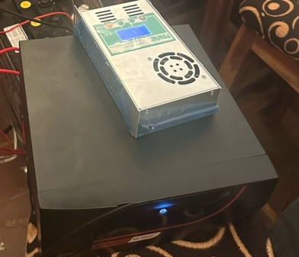

FIG 4.3 INVERTER

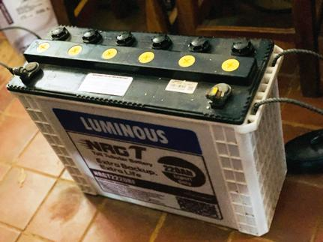
FIG 4.4 SOLAR BATTERY

SOLAR PANEL INSTALLATION PROCESS
The most common location for the installation of solar PV panels is the roof. Most roofs typically have the desired specifications for the installation so that panels get the maximum sunlight.
Nevertheless, if installation on the roof is not applicable or desired, the solar panels could also be mounted on the ground. You just need to make sure that there are no objects blocking access to the sun.
The following steps outlines the solar panel installation process:
- Setup Scaffolding
Before installation begins, scaffolding was erected to ensure the safety harness and other protective measure are also implemented.
- Install Solar Panel Mounts
Next, a solar panel mounting system was installed. This system serves as the structural base that supports the solar panels. The mounting structure was carefully positioned and tilted at an angle between 18 to 36 degrees to maximize sunlight absorption throughout the day.
- Install the solar panel
Once the mounting structure is secured, the solar panels are attached to the mounts. All bolts and nuts are tightened to ensure that the panels remain stable under various weather conditions.
- Wire the Solar Panels
After mounting the panels, electrical wiring was installed. MC4 connectors are commonly used because they are compatible with most solar panels. At this stage, the CBT center's electricity supply must be turned off to prevent electrical hazards during wiring.
- Connect Solar Panels to the Charge Controller
The solar panels are then connected to a charge controller, which regulates the power flow from the panels to the battery. This steps ensures optimal battery charging and prevents overcharging or deep discharge.
- Install the Solar Inverter
The solar inverter was installed and connected to the system. The inverter role is to convert the direct current (DC) generated by the solar panels into alternating current (AC),which was used to power computers, CCTV cameras and other electrical devices

in the CBT center. The inverter was preferably installed in a cool, well-ventilated area for maximum efficiency.
- Connect the Solar Inverter to the Battery Bank
The solar inverter was then connected to the battery storage system. The battery bank stores excess energy, ensuring continuous power supply during cloudy periods or at night.
- System Testing and Activation
Finally, the entire solar power system was tested for functionality. The system was switched on, and various parameters such as voltage, current output and power efficiency are measured using a multimeter to confirm that all the components are working correctly. After that, the solar panel installation process was completed.

4.2 CCTVSYSTEMOPERATION
The Closed Circuit Television (CCTV) system is an essential component of the smart solar based CBT Examination Monitoring System, ensuring continuous surveillance of the examination center to prevent malpractice and enhance security. The system consists of cameras that capture and transmit real-time video data to a monitor or a digital video recorder (DVR/NVR) for storage and future analysis.
The security cameras continuously capture video footage of the examination hall, using an open aperture and digital image sensors to process light into a continuous stream of images. These cameras can transmit signals either wirelessly or through cables, depending on the system configuration. The clarity of the captured footage is influenced

by the camera lens specification, which determine the field of view and zoom capabilities. For effective operation in varying light conditions, Infrared Light Emitting Diodes (IR LEDs) enables night vision, ensuring that surveillance remain uninterrupted even in low- light environments. Additionally, light sensors detect ambient brightness and automatically adjust camera settings to optimize image quality. The feature is particularly useful in examination centers with fluctuating lightning conditions. The recorded video footage is stored using Digital Video Recorders (DVRs) or Network Video Recorders (NVRs), depending on whether the system is analog or digital. The storage system relies on hard disk drives (HDDs) or cloud storage, ensuring that all recorded footage can be accessed and reviewed when necessary. The quality and efficiency of the recordings depend on factors such as frame rate, the number of cameras connected to the system, and the storage capacity of the recording device. To facilitate real-time monitoring, CCTV cameras are connected to display unit or monitor where exam supervisors can oversee activities within the examination center. Additionally, the system support remote access, allowing administrators to view live footage via a web browser or a mobile application ensuring greater flexibility in monitoring and supervision.
A key aspect of this system is its integration with solar power, ensuring uninterrupted operation even in areas with unstable electricity. The solar panels generate energy which is stored in the battery and converted to AC power by an inverter to keep the cameras and recording devices operational throughout the examination period. This sustainable approach minimizes reliance on the electrical grid and ensures that surveillance remains active without power interruptions. By combining CCTV surveillance with a solar power system, the monitoring system offers a cost-effective, reliable and scalable solution for ensuring the integrity of CBT examinations. The system not only deters malpractice but also provides recorded evidence for dispute resolution, making it crucial components of a secure examination environment.
Below are the diagrams of the components used in the installation of the CCTV system.

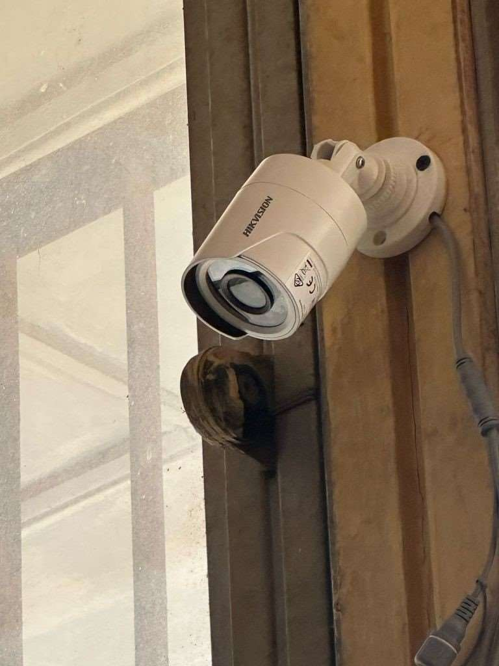
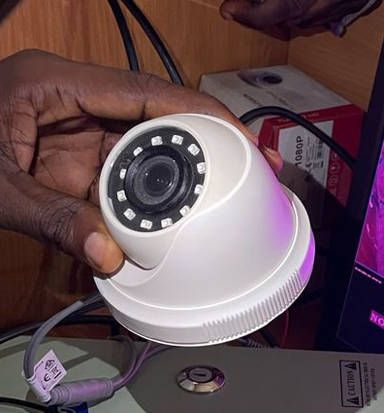
FIG 4.5 SECURITY CAMERAS

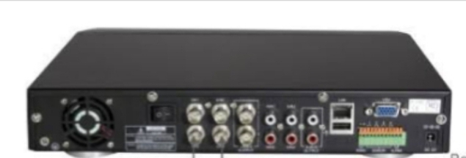
FIG 4.6 DIGITAL VIDEO RECORDER (DVR)
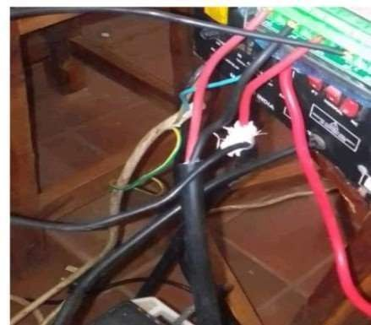

FIG 4.7 CCTV CABLE
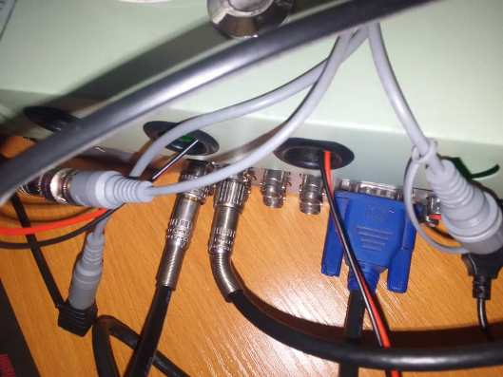
FIG 4.8 CONNECTORS
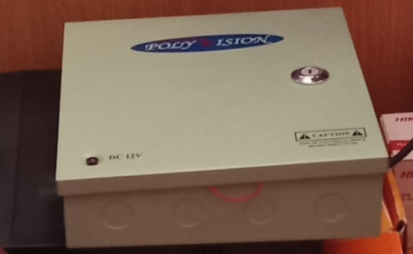

FIG 4.9 CCTV POWER SUPPLY
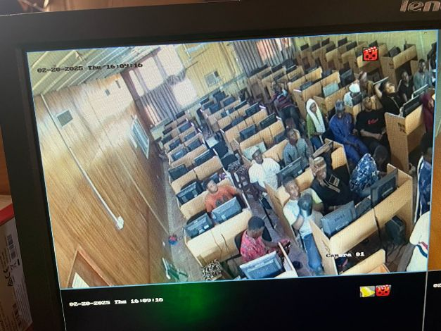
FIG 4.10 MONITOR

4.2.1 INSTALLATION PROCESS
The installation of a CCTV system is one that requires specific skills. We had to acquire certain knowledge on the procedure. We also checked out a professional in this specialty, to give us some valuable tips.
After evaluating the CBT center and estimating the quantity of materials necessary, we furthered to procuring them. The installation was an essentially vital part of the project, exposing us to new skills and a practical engineering experience.

TOOLS AND EQUIPMENT REQUIRED
- Ladder
- Safety bet
- Screws and Screw drivers
- Plastic clips
- Current testers
- Centre punches
- Pliers
- Scissors
- Blades

STEPS TAKEN
- The cables were transported to the ceiling, requiring someone under, using the ladder.
- They were distributed to the various marked points on the ceiling in the CBT center and pierced through using the punch to create the holes.
- The CCTV cable was connected to the BNC connector and power connector and then to the camera using both the power and the data connector of the camera.
- The other sides of the cables were trunked from the inside to be connected to their respective ports in the CCTV power supply.
- Blades and Scissors were used as well as pliers to fit the cables to BNC connectors.
- The BNC connector was connected to the data port in the DVR.
- The DVR was connected to the monitor through a power cord.

- A mouse was connected to the USB port in the DVR.
- The power supply was turned on, the DVR and the monitor are also turned on. The hard drive in the DVR was first formatted before recording is clicked.

SYSTEM TESTING AND EVALUATION
The implemented system was tested to ensure it met the project objectives. The following tests were conducted to evaluate its functionality, reliability and efficiency.

4.3.1 SOLAR POWER SYSTEM TESTING
The solar power system was tested to ensure it provides uninterrupted power supply to the CBT center. The battery backup system was tested to ensure it functions correctly during periods of low sunlight.

SURVEILLANCE SYSTEM TESTING
The surveillance cameras were tested to ensure they provide clear and real-time monitoring of the CBT center. The DVR was tested to ensure it records and stores footage correctly.

RESULTS
The system testing yielded successful results, confirming that all components functioned as expected: The solar panels generated sufficient energy to power the CBT center during daylight hours. The battery provided backup power during periods of low sunlight or at night. The inverter efficiently converted DC power from the solar panels and battery to AC power for the CBT equipment.

The surveillance cameras provided clear and comprehensive coverage of the CBT center. The DVR allowed administrators to monitor the examination process in real-tine. The system recorded and stored footage effectively, ensuring that any incidents during the examination could be reviewed.

SYSTEM INTEGRATION AND OVERALL PERFORMANCE
The integration of the CBT Examination system with solar power and surveillance system was successful. The system operated seamlessly, ensuring uninterrupted power supply and real-time monitoring of the examination process. The solar power system ensured that the CBT center had a reliable power supply, even in areas with inconsistent grid electricity. This eliminated disruptions during examinations and improved the overall efficiency of the process.
The surveillance system (CCTV cameras) provided administrators with real-time visibility into the examination process, enhancing security and reducing the risk of malpractice.

DISCUSSION OF FINDINGS
This project successfully achieved its objectives
The CBT Examination system was designed and implemented, providing reliable platform for conducting computer-based tests. Also, the solar power system including solar panels, charge controller, battery, and inverter was installed and integrated with the CBT center, ensuring uninterrupted power supply. Finally the surveillance cameras (CCTV) were installed and integrated with the DVR enabling real- time monitoring of the examination center.

CHAPTER FIVE
SUMMARY, CONCLUSION, AND RECOMMENDATIONS
  - SUMMARY
The Smart Solar-Based CBT Examination Monitoring System was designed and implemented to enhance the efficiency and security of Computer-Based Test (CBT) examinations. The project aimed to address the challenges of unreliable power supply and inadequate examination monitoring by integrating solar energy and surveillance technology. The system ensures an uninterrupted power supply through solar panels and enhances security using surveillance cameras, thereby improving examination integrity. The objectives of this project included: The design and implementation of a CBT examination system to facilitate seamless examinations. The installation of a solar power system, including solar panels, charge controller, inverters, and battery, to ensure an uninterrupted power supply. Also, the integration of surveillance cameras (CCTV) for real-time monitoring of examination activities to prevent malpractice and enhance security.
The system was successfully designed and deployed with solar energy providing backup power, while the surveillance cameras ensured real-time supervision of candidates. The implementation demonstrated the effectiveness of renewable energy in sustaining educational technology and improving exam security.

5.2 CONCLUSION
The Smart Solar-Based CBT Examination Monitoring System effectively addressed the primary issues associated with traditional CBT centers, including power failures and ineffective monitoring. The system provided a reliable alternative energy source through solar power, ensuring continuous operation of computers and surveillance equipment during examinations. The monitoring aspect, achieved through strategically positioned cameras, helped in detecting and deterring examination malpractices, thereby enhancing the credibility of the examination process. The project proved that integrating solar power with an examination monitoring system is not only feasible but also practical in locations with unstable electricity supply. By leveraging solar energy, institutions can reduce dependence on the national grid and lower operational costs. Furthermore, the use of surveillance cameras strengthens examination security, making it more difficult for candidates to engage in cheating or other forms of malpractice. Overall, this project demonstrates that solar-powered smart CBT monitoring systems can be an efficient, sustainable, and secure solution for modern examination processes in the department of computer science (CBT center), Kwara state polytechnic.

RECOMMENDATION
Based on the findings and implementation of this project, the following recommendations are proposed:
Expansion of Solar Power Capacity –Educational institutions should consider increasing the capacity of installed solar panels and batteries to support larger examination centers and ensure long-term sustainability.
Real-Time Remote Monitoring – Examination bodies should implement remote access to surveillance feeds, enabling real-time supervision by external examiners or administrator’s from different locations.

REFERENCES
Adeoye, A. (2019). The role of renewable energy in sustainable ICT infrastructure: A case study of Nigeria. Journal of Sustainable Development Studies, 12(4), 55–62.
Adebayo, T. (2020). Integrating solar power systems in educational institutions for sustainable development. Renewable Energy Journal, 28(3), 101–109.
Agnes M., Amalia F., & Juniastel R. (2019). Computer-based test (CBT) system for student academic examination. Journal of Digital Education and Learning Technologies,7(1),55-63.
Amaechi M.,Uchenna C.,&Ugochukwu E.(2017). Closed Circuit Television Surveillance: An Antidote to Examination Malpractice in High Institutions In Nigeria. Journal of education and practice, 8 (15), 1-9.
Aris,E.I.,&Carmichael,D.S.(2021). Implementation of a monitoring system to solar-powered houses. International Journal of Sustainable Energy Systems, 10(4), 112-120.
Edeoghon A.,Chibuzor J.,Ebu J.,Ohiocheoya R.,Chukwunweike O.,Ebikade G.,Efemena M., Akinlade E.,Ekunife O.,Odey N., &Enofe P. (2022). Design and implementation of an IOT- based solar-powered inverter control system. Journal of Renewable Energy and Control Systems,5(2),88-97.
Eze, C., & Mbah, P.(2021). Smart surveillance and power systems for CBT centers in Nigeria: A sustainable approach. African Journal of Information Systems and Technology, 7(1), 25–34.
Kaushalya T. Swati .S. & Shripad B.(2023).An internet of things based solar power monitoring system using Node MCU. International Journal of Renewable Energy Research and Applications, 11(1), 40-51.
Kavitha V.,&Malathi V.(2019). A smart solar PV monitoring system using IOT. International Journal of Smart Grid and Clean Energy, 8(3), 221-230.
Mohd A., Santosh B., Suvama L., & Anil T. (2017). A review on electricity generation from solar energy .International Journal of Engineering Sciences & Research Technology ,6(2), 32-39.
Mohamed, A.,& Lee, C.(2019). Solar energy solutions for powering ICT in developing countries. International Journal of Energy Research, 43(6), 2341–2353.
Obiageli O.N. (2022). Solar monitoring system reliability: Challenges and prospects for modern engineering. Nigerian Journal of Engineering Research, 8(1), 15-24.
Okeke,M.,&Oladimeji,K.(2021). The role of CCTV in enhancing examination security in CBT centers. Journal of Educational Technology and Security, 9(2), 88–97.
Raimon.E.,Lido.S.,Firmansyah.P.,EfriY.,& Ratih A.(2020). Design and implementation of a computer-based test in vocational education. International Journal of Educational Technology and Vocational Studies, 4(2), 90-98.
Uche, C. A., Irhebhude E. I., & Ogwueleka N. O. (2020). Video surveillance in examination monitoring: Efficacy and challenges in Nigerian tertiary institution. Journal of Educational Technology Development and Exchange, 12(1), 1-16.

