CHARACTERISTICS VARIATION OF WIND CHILL AND OUTDOOR RELATIVE HUMIDITY AT A TROPICAL STATION ILORIN, KWARA STATE, NIGERIA

BY

ADEDIRAN BALIQIS MOROMOKE
ND/22/SLT/FT/315

A RESEARCH PROJECT SUBMITTED TO THE DEPARTMENT OF SCIENCE LABORATORY TECHNOLOGY INSTITUTE OF APPLIED SCIENCE KWARA STATE POLYTECHNIC, ILORIN.

IN PARTIAL FULFILMENT OF THE REQUIREMENT FOR THE AWARD OF NATIONAL DIPLOMA (ND)IN SCIENCE LABORATORY TECHNOLOGY (PHYSICS UNIT).

JULY, 2025

CERTIFICATION
I t is hereby certified that this project work is original work of ADEDIRAN BALIQIS MOROMOKE under the supervision of DR. USMAN ABDULKAREEM and duly approved as having met the standard requirement laid down by the department of science laboratory technology institute of applied science, Kwara State Polytechnic, Ilorin. That the work has been accepted in partial fulfilment of the requirement for the award of National Diploma (ND) in science laboratory technology (physics Option).

___________________________ ___________________
Dr. Usman Abdulkareem DATE
(Project supervisor)

_______________________ _______________________
Mr. Salahu Bashiru DATE
(H.O.U Physics)

_______________________ _______________________
Dr. Usman Abdulkareem DATE
(Head of Department)

______________________________ _____________________
EXTERNAL EXAMINER DATE

DEDICATION
I dedicated this project to Almighty Allah who has made it possible for me to complete my National Diploma (ND) programme for His loving, kindness, protection.
I also dedicate this research to my parent Mr. and Mrs. Adediran for their parental care and to all my families and friends.

ACKNOWLEDGEMENT
A journey of a thousand miles begins with a step and end with success
I give thanks to Almighty God for giving me life and good health throughout this project work.

My profound gratitude goes to my amiable supervisor Dr. Usman Abdulkareem for his support and moral advice.

1 am also grateful to my caring parent Mr. and Mrs. Adediran for their financial, support and spiritual support throughout my programme. May Allah in His infinite mercy reward you all abundantly and grant you all your heart desires (Ameen)

TABLE OF CONTENTS
Title Page i
Certification ii
Dedication iii
Acknowledgement iv
Table of Contents v-vi
Abstract vii
CHAPTER ONE: INTRODUCTION
1.1 General Background 1
1.2 Relevance of Wind Chill 2
1.3 Outdoor Relative Humidity 2
1.4 Statement of the Research Problem 3
1.5 Objectives of this Research 4
1.6 Justification for the Research 4
1.7 Expected Contribution to Knowledge 4
CHAPTER TWO:
Literature Review 5
CHAPTER THREE: THEORETICAL BACKGROUND
3.1 Wind Chill 12
3.2 Outdoor Relative Humidity 14
CHAPTER FOUR: METHODOLOGY
4.1 Pre-Field Experimental Work 22
4.2 Site Description 23
4.3 Field Measurements 25
4.4 Data Acquisition and Reduction 25
4.4.1 Data Logging of the Sample Data 26
4.4.2 Pre-processing of the Raw Data 26
CHAPTER FIVE:
5.0 Results And Discussion 28
5.1 Characteristics of Wind Chill and Outdoor
Relative Humidity 28
CHAPTER SIX: SUMMARY AND CONCLUSIONS
6.1 Summary and Conclusions 33
References 34

ABSTRACT
The wind chill temperature is how cold people and animals feel when outside. Wind chill is based on the rate of heat loss from exposed skin caused by wind and cold. As the wind increases, it draws heat from the body, driving down skin temperatures and eventually the internal body temperature. Therefore, the wind makes it feel much colder.This research work was carried out at Ilorin metropolis. The instruments used for this research are a cup anemometer and a hygrometer probe. The measurements were taken over one week (25th May – 1st June, 2025). The data were recorded every 30 minutes and were reduced to hourly measurements. For the period under consideration, the highest value of wind chill for this research is 37°C.

CHAPTER ONE
INTRODUCTION
1.1 GENERAL BACKGROUND
Wind refers to the horizontal movement of the earth in response to differences in pressure. Wind is a three-dimensional vector that has the directions of north, southeast, and west in addition to vertical components and magnitude. For most operational meteorological purposes, the vertical component is ignored; surface wind is practically considered as a two-dimensional vector. Wind plays an important role in crop evapotranspiration and thus determines crop water use. The measurement of wind is thus necessary for studying the crop growth (NOAA, 2010).
Wind Chill is the temperature it “feels like” outside and is based on the rate of heat loss from exposed skin caused by the effects of wind and cold. As the wind increases, the body is cooled at a faster rate causing the skin temperature to drop. Wind Chill does not impact inanimate objects like car radiators and exposed water pipes because these objects cannot cool below the actual air temperature (NOAA, 2010).
The wind chill temperature is how cold people and animals feel when outside. Wind chill is based on the rate of heat loss from exposed skin caused by wind and cold. As the wind increases, it draws heat from the body, driving down skin temperatures and eventually the internal body temperature. Therefore, the wind makes it feel much colder (NOAA, 2010).
1.2 RELEVANCE OF WIND CHILL IN MICROMETEOROLOGY AND RELATED SCIENCES
Wind chill, also called wind chill factor, is a measure of the rate of heat skin air wind,” that is, the temperature.
1.3 OUTDOOR RELATIVE HUMIDITY
Humidity measurements at the Earth’s surface are required for meteorological analysis and forecasting, for climate studies, and for many special applications in hydrology, agriculture, aeronautical services, and environmental studies in general. They are particularly important because of their relevance to the changes of state of water in the atmosphere (Perry and Green, 2016).
Indoor and outdoor temperatures correlate well only at warmer outdoor temperatures. Outdoor RH is a poor indicator of indoor RH. The Outdoor relative humidity is the ratio between the amount of water vapor actually in the air and the maximum amount of water vapor required for saturation at that specific temperature (and pressure) (wikipedia.com). Relative humidity is the most common way for describing atmospheric moisture, but it does not describe the actual amount of water vapor in the air. Instead, it indicates how close the air is to being saturated. If all the other factors influencing humidity remain constant, at ground level the relative humidity rises as the temperature falls; this is because less vapor is needed to saturate the air (ASHRAE, 2016).
1.4 STATEMENT OF RESEARCH PROBLEM
Wind chill is the temperature at which water vapor condenses. It is an important weather variable used to estimate frost, fog, rain, snow, near-surface humidity, and other meteorological variables. Wind chill directly or indirectly contributes to the productivity of plants, crop damage during freezes, human comfort levels, and the loss of human life during heatwaves. As a result, this study therefore aimed to observe wind chill and outdoor relative humidity in Ilorin, Kwara State.

1.5 OBJECTIVES OF THIS RESEARCH
The aim of this research is to analyze wind chill data at a tropical location in Ilorin metropolis using graphical and statistical methods.
The specific objectives of this study are to:
- Measure the wind chill
- Measure the outdoor relative humidity
- Observe the diurnal variation of wind chill and outdoor relative humidity
1.6 JUSTIFICATION FOR THE RESEARCH
Characteristics variation of wind chill and outdoor relative humidity, such as we have in this study, is very useful in determining the amount of wind chill and outdoor relative humidity in Ilorin, Kwara State.
1.7 EXPECTED CONTRIBUTION TO KNOWLEDGE
The results of this study will provide the actual amount of wind chill and outdoor relative humidity data. This directly affects evapotranspiration and will be useful to agrometeorologists, climate modeling, and water resources management.

CHAPTER TWO
2.0 LITERATURE REVIEW
The wind chill temperature is how cold people and animals feel when outside. Wind chill is based on the rate of heat loss from exposed skin caused by wind and cold. As the wind increases, it draws heat from the body, driving down skin temperatures and eventually the internal body temperature. Therefore, the wind makes it feel much colder (NOAA, 2010).
Wind chills given in forecasts may seem milder than in the past. For example: A temperature of 0°F with 25 mph winds will give a wind chill of -24°F. Remember, the index is based on the actual impact of cold and wind on your skin. Knowing the time to frostbite is the key (NOAA, 2010).
James et al., (2009) presented wind power density forecast for the duration of one to ten days ahead. It can be generated from wind speed predictions produced by an atmospheric model. Author compared the resultant density forecast with advanced time series models built using wind speed data and observations. In this paper, we used the wind speed data at 10 meters height, recorded at the five wind turbines having different size and capacity for forecast evaluation.
Ling Chen and Xu Lai, (2011) reveals that ANN (Artificial Neural Network) models have a better accuracy compared to ARIMA (Autoregressive Integrated Moving Average) model to forecast short-term hourly wind speed. In this paper, wind speed time series, which consists of hourly mean values, are measured in China Wind Park. These wind speeds are collected by anemometers at 10 meters height and they are collected for every 3s over a 10 min interval time.
Peng and Lili, (2011) presented that wind speed is non-stationary and time-varying, so it is difficult to forecast. This model considers the heteroscedasticity, which is based on “changing variance,” so that it overcomes the traditional models and accuracy improves. A new genetic algorithm neural network model based on rough set is suggested in. This model has quite satisfactory effect and forecasting precision is higher. The importance of forecasting on power system operation and stability is discussed in.
Khan, (2009) developed a new application based on wavelets for wind forecasting. The advantage of wavelet-based forecasting is that it is not required to consider initial assumptions about the properties of time series and this approach can decompose the time series into different subseries which can be analyzed, separately predicted, and later recombined to get aggregate forecast. And a coefficient predictor technique of wavelets which can predict wind speed up to 24 hours has been developed.
Alexiadis et al., (1999) illustrates a technique for predicting wind speed power for several hours ahead, based on cross-correlation at neighboring sites. Here in this paper, two wind sites have been considered. Those wind sites are upwind and downwind, where wind velocity is from upwind to downwind. And this paper developed an ANN (Artificial Neural Network) that improves forecasting accuracy compared to persistence model.
Jie et al., (2011) discuss about HHT-ANN (Hilbert-Huang Transforms Artificial Neural Network) forecasting model which improves forecasting accuracy. This Hilbert-Huang Transforms (HHT) is to analyze the signal local property scale, which is the time interval between two adjacent maximum and minimum values and it depends on wavelet transformation.
Liang et al., (2009) proposed the two-layered artificial neural networks for estimating the actual wind speed from the previous values of the same variable. In this paper, we used ANN model for short-term wind speed prediction, which uses Back Propagation Algorithm (BPA), whose function is to reduce error. And this model is applied to a practical case to forecast wind speed at a wind farm in Jeju Island.
Yutong and Ka Wing, (2008) focused on novel models such as Ensemble Empirical Mode Decomposition (EEMD) and Support Vector Machine (SVM). This model will decompose the wind data into residue and some intrinsic mode function (IMF) components via EEMD which makes the corresponding time series more stationary. Finally, all forecasting results gathered to give forecasting result.
Catalao et al., (2011) proposed a method for short-term forecasting in Portugal. This method is a combination of wavelet transform (WT), PSO and ANFIS. The WT is used to decompose the wind power series into a set of better-behaved constitutive series. This method is effective and innovative. The average Mean Absolute Percentage Error (MAPE) and Normalized Mean Absolute Error (NMAE) results are good.
Potter and Negnevitsky, (2006) describes very short-term wind power prediction for generator in Tasmania, Australia. The application of an ANFIS to forecast wind time series. The ANFIS model results are less than 4% MAPE. The results are compared with the persistence model. In an advanced statistical method based on neural networks and fuzzy logic techniques which are used to forecast wind power output. A self-organized map classifies data into 3 different classes based on wind speed of the hour and for each class a different Radial Base Function (RBF) network is used for estimation.
Negnevitsky et al., (2009) presented an overview of key issues in wind power prediction and challenges faced for wind power generation. It also discusses about wind power prediction techniques, electricity price forecasting and in wind power forecasting. And it focuses on data mining techniques which can apply to analyze and evaluate wind data. This data mining technique is helpful in dense data cases also. A Taboo search method which is intelligent enough to achieve the global optimization is proposed in Han et al., (2007).
Miranda and Dunn, (2006) focuses on one hour ahead wind speed estimation using a Bayesian approach. In this paper, 2 years of wind data is modeled as an autoregressive process, and this result is compared with persistence method.
Songlin et al., (2010) discussed very short-term wind speed forecast based on historical data. In this paper, parameters which identify wind speed pattern are defined and wind pattern model is established. Inner Mongolia wind speed data is used to compare with the results. Songlin et al., (2010) is a new method for wind speed prediction based on wavelet and support vector machine (SVM). SVM is a supervised learning model and it is used for classification and regression analysis and it is associated with a complex mathematics. In Wavelet and support vector machine method first we decompose wind speed sequences into coarse components and next each wavelet component is individually forecasted with corresponding SVM models. Finally, forecasting results of wind speeds are obtained by wavelet reconstruction.
Bhaskar and Singh, (2012) is using adaptive wavelet neural network (AWNN) approach to decompose the signal and predict the wind speed for next 30 hours and thereafter feed-forward neural network (FFNN) is used for nonlinear mapping between wind speed and wind power output, which helps to transform wind speed to wind power forecast. A complete one year wind data of 10 min average has been taken from NREL website and that was converted to 1 hr wind data of 8760 samples for the analysis.

CHAPTER THREE
THEORETICAL BACKGROUND
3.1 WIND CHILL
Wind chill (popularly called wind chill factor) is the lowering of body temperature due to the passing flow of lower-temperature air. Wind chill numbers are always lower than the air temperature for values where the formula is valid. When the apparent temperature is higher than the air temperature, the heat index is used instead (wikipedia.com).
The wind chill temperature is how cold people and animals feel when outside. Wind chill is based on the rate of heat loss from exposed skin caused by wind and cold. As the wind increases, it draws heat from the body, driving down skin temperatures and eventually the internal body temperature. Therefore, the wind makes it feel much colder. If the temperature is 0°F and the wind is blowing at 15 mph, the wind chill is -19°F. At this wind chill temperature, exposed skin can freeze in 30 minutes.
A surface loses heat through conduction, evaporation, convection, and radiation, allowing for cooler air to replace the warm air against the surface. The faster the wind speed, the more readily the surface cools.
Alternative Approaches
Many formulas exist for wind chill because, unlike temperature, wind chill has no universally agreed-upon standard definition or measurement. All the formulas attempt to qualitatively predict the effect of wind on the temperature humans perceive. Weather services in different countries use standards unique to their country or region; for example, the U.S. and Canadian weather services use a model accepted by the National Weather Service (wikipedia.com).
The first wind chill formulas and tables were developed by Paul Allman Siple and Charles F. Passel working in the Antarctic before the Second World War and were made available by the National Weather Service by the 1970s. They were based on the cooling rate of a small plastic bottle as its contents turned to ice while suspended in the wind on the expedition hut roof, at the same level as the anemometer.
In the 1960s, wind chill began to be reported as a wind chill equivalent temperature (WCET), which is theoretically less useful. The author of this change is unknown, but it was not Siple or Passel as is generally believed. At first, it was defined as the temperature at which the wind chill index would be the same in the complete absence of wind. This led to equivalent temperatures that exaggerated the severity of the weather (wikipedia.com).
3.2 OUTDOOR RELATIVE HUMIDITY
Humidity measurements at the Earth’s surface are required for meteorological analysis and forecasting, for climate studies, and for many special applications in hydrology, agriculture, aeronautical services, and environmental studies in general. They are particularly important because of their relevance to the changes in the state of water in the atmosphere. The measurement of atmospheric humidity, and often its continuous recording, is an important requirement in agro-meteorology (Perry and Green, 2016).
Indoor and outdoor temperatures correlate well only at warmer outdoor temperatures. Outdoor Relative Humidity (RH) is a poor indicator of indoor RH.
The Outdoor Relative Humidity is the ratio between the amount of water vapor actually in the air and the maximum amount of water vapor required for saturation at that specific temperature (and pressure) (wikipedia.com).
Outdoor Relative Humidity is the most common way for describing atmospheric moisture, but it does not describe the actual amount of water vapor in the air. Instead, it indicates how close the air is to being saturated. If all the other factors influencing humidity remain constant, at ground level the relative humidity rises as the temperature falls; this is because less vapor is needed to saturate the air.
In normal conditions, the dew point temperature will not be greater than the air temperature, since relative humidity cannot exceed 100% (ASHRAE, 2016). When the moisture content remains constant and temperature increases, relative humidity decreases, but the dew point remains constant (Schiavon et al., 2013).
Humidity and Thermal Comfort
Along with air temperature, mean radiant temperature, air speed, metabolic rate, and clothing level, relative humidity plays a role in human thermal comfort. According to ASHRAE Standard 55-2017: Thermal Environmental Conditions for Human Occupancy, indoor thermal comfort can be achieved through the PMV (Predicted Mean Vote) model. The target range for relative humidity in air-conditioned buildings is generally 30–60% (ASHRAE, 2016).
In general, higher temperatures will require lower relative humidities to achieve thermal comfort compared to lower temperatures, with all other factors held constant. For example, with clothing level = 1, metabolic rate = 1.1, and air speed 0.1 m/s, a change in air temperature and mean radiant temperature from 20°C to 24°C would lower the maximum acceptable relative humidity from 100% to 65% to maintain thermal comfort conditions. The CBE (Center for the Built Environment) tool can be used to demonstrate compliance with ASHRAE Standard 55-2017 (ASHRAE, 2017).
Although outdoor relative humidity is an important factor for thermal comfort, humans are more sensitive to variations in temperature than they are to changes in outdoor relative humidity. Outdoor relative humidity has a small effect on thermal comfort outdoors when air temperatures are low, a slightly more pronounced effect at moderate air temperatures, and a much stronger influence at higher air temperatures.

Human Discomfort Caused by Low Outdoor Relative Humidity
In cold climates, the outdoor temperature causes a lower capacity for water vapor to flow. Although it may be snowing and the outdoor relative humidity is high, once that air comes into a building and heats up, its new relative humidity is very low (meaning the air is very dry), which can cause discomfort. Dry, cracked skin can result from dry air (James et al., 2009).
Low humidity causes tissue lining the nasal passages to dry, crack, and become more susceptible to penetration by rhinovirus and cold viruses. Low humidity is a common cause of nosebleeds. Indoor relative humidities should be kept above 30% to reduce the likelihood of the occupant's nasal passages drying out (Peng and Lili, 2011).
Humans can be comfortable within a wide range of humidities, depending on the temperature, from 30–70%, but ideally between 50% and 60%. Very low humidity can create discomfort, respiratory problems, and aggravate allergies in some individuals. In the winter, it is advisable to maintain relative humidity at 30% or above. Extremely low (below 20%) relative humidities may also cause eye irritation (James et al., 2009).
Buildings
For climate control in buildings using HVAC:
When the temperature is high and the relative humidity is low, evaporation of water is rapid; soil dries, wet clothes hung on a line or rack dry quickly, and perspiration readily evaporates from the skin. Wooden furniture can shrink, causing the paint that covers these surfaces to fracture.
When the temperature is low and the relative humidity is high, evaporation of water is slow. When relative humidity approaches 100%, condensation can occur on surfaces, leading to problems with mold.
Vehicles
The basic principles for buildings, above, also apply to vehicles. In addition, there may be safety considerations. For instance, high humidity inside a vehicle can fog windshields and cause shorting in airliners, submersibles, and spacecraft pressure systems.
Aviation
Airliners operate with low internal relative humidity, often under 20%, especially on long flights. The low humidity is a consequence of drawing in the very cold air with a low absolute humidity, which is found at airliner cruising altitudes. Subsequent warming of this air lowers its relative humidity. This causes discomfort such as sore eyes, dry skin, and drying out of mucosa, but humidifiers are not employed to raise it to comfortable mid-range levels because the volume of water required to be carried on board can be a significant weight penalty (wikipedia.com).
As airliners descend from colder altitudes into warmer air (perhaps even flying through clouds a few thousand feet above the ground), the ambient relative humidity can increase dramatically. Some of this moist air is usually drawn into the pressurized aircraft cabin and into other non-pressurized areas of the aircraft, and condenses on the cold aircraft skin. Liquid water can usually be seen running along the aircraft skin, both on the inside and outside of the cabin. Because of the drastic changes in relative humidity inside the vehicle, components must be qualified to operate in those environments. The recommended environmental qualifications for most commercial aircraft components are listed in RTCA DO-160.
Cold, humid air can promote the formation of ice, which is a danger to aircraft as it affects the wing profile and increases weight. Carburetor engines have a further danger of ice forming inside the carburetor. METARs, therefore, include an indication of relative humidity, usually in the form of the dew point.
Pilots must take humidity into account when calculating takeoff distances, because high humidity requires longer runways and will decrease climb performance.
Density altitude is the altitude relative to the standard atmosphere conditions (International Standard Atmosphere) at which the air density would be equal to the indicated air density at the place of observation, or, in other words, the height when measured in terms of the density of the air rather than the distance from the ground. "Density Altitude" is the pressure altitude adjusted for non-standard temperature.
An increase in temperature and, to a much lesser degree, humidity, will cause an increase in density altitude. Thus, in hot and humid conditions, the density altitude at a particular location may be significantly higher than the true altitude.

Measurement of Relative Humidity
A Hygrometer is a device used for measuring the humidity of air. The humidity of an air and water vapor mixture is determined through the use of psychrometric charts if both the dry bulb temperature (T) and the wet bulb temperature (Tw) of the mixture are known. These quantities are readily estimated by using a sling psychrometer.
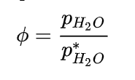

CHAPTER FOUR:
4.0 METHODOLOGY
This research work was carried out at a tropical location in Ilorin, Kwara State. The instruments used for this research are a Cup anemometer and a Hygrometer. The measurements were taken for one week (25th May – 1st June, 2025). The data were recorded at every 30 minutes and were reduced to hourly measurements.
The reduced data (hourly) was plotted against local standard time to show the diurnal variation of the measured data.
4.1 PRE-FIELD EXPERIMENTAL WORK
TESTING THE CUP ANEMOMETER
Before deploying the equipment in the field, the installations and test runs were carried out in the laboratory to ascertain that all the required parts of the equipment are available and functioning well before deploying to the field. The setup consists of a cup anemometer, a Hygrometer, and a display console (datalogger).

4.2 SITE DESCRIPTION
Ilorin is located within latitude 08°9′21″N, longitude 04°30′50″E and latitude 08°30′43″N, longitude 04°33′01″E. The study area is located within the Guinea savanna region of the country, which is characterized by deciduous trees of mixed traits, e.g., silk cotton, locust bean tree, and tall grasses also found in the area.
Ilorin, with a mean annual rainfall of 1,200 mm (Olaniran, 2002), is characterized by eight months of wetness and four months of dryness. The temperature in the town is uniformly high, and evaporation values range between 3.1 and 7.8 mm (Oyegun, 1983).
The township plays host to Kwara State as the Capital. It lies along the Lagos-Kaduna highway, it is approximately 306 km from Lagos, 600 km from Kaduna and about 500 km to the Federal Capital City. The area has been experiencing rapid urbanization since 1967 when it became the capital of Kwara State.

The extent of its built-up area between 1935 and 1963 was between 2-5 km², while in 1967 the land cover was about 8.37 km² (Jimoh, 2004), but it has today increased in multiple folds in the recent years.

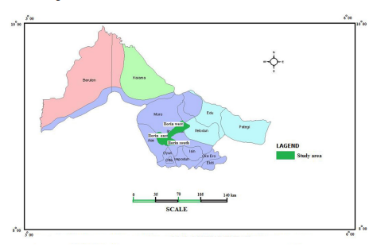

Ilorin and its environs are one of the fastest-growing areas in Nigeria. The Population Census (1991) puts the population at 619,310. It had a population of 809,171 in 2001 and 904,102 in the 2006 national census. This trend in population growth rate shows a rapid growth in population. The growth rate from 1991 to 2006 is at 5.11%, which is higher than most other areas in the country (Jimoh, 2004). The study area covered a total landmass of 205,088 Ha (2050.88 km²).

4.3 FIELD MEASUREMENTS
The Cup anemometer and Hygrometer probe were mounted on a pole, measured 5.2 m above the ground on the site (field). We used a measuring tape to measure a 5.2 m pole above ground level in Kwara State Polytechnic, Ilorin, Kwara State.
4.4 DATA ACQUISITION AND REDUCTION
This research work was carried out at Ilorin metropolis. The instruments used for this research are a cup anemometer and a hygrometer probe. The measurements were taken for one week (25th May – 1st June, 2025). The data were recorded at every 30 minutes and were reduced to hourly measurements.
Custom-built software for the operation, acquisition, and pre-processing of the raw data was used (WeatherSmart, 2017). In this software, the following parameters were configured: sampling time, average time, and data storage.

4.4.1 DATA LOGGING OF THE MEAN RADIATION FLUXES
In this project, the acquisition of the data was achieved by using WeatherSmart datalogger systems (measurement and control module). An RS232 connection to the computer for communication purposes was achieved by using a USB cable. The datalogger is wirelessly connected to all the sensing elements, thereby accepting their respective signals.
The transducers' signals were then sampled, digitized, and stored in the internal/expanded memory. The data, which were collated in ASCII format, were then reduced using a data reduction program, MicroCal Origin 7.1 Version. All the sensors used were sampled every 30 minutes, but later reduced to hourly data. The radiation measuring instruments were sampled at 10 Hz and subsequently averaged to produce hourly data statistics for the surface radiation fluxes.
4.4.2 PRE-PROCESSING OF THE RAW DATA
The data processing and presentation package, MicroCal Origin 7.1 Version, has been used for necessary computations and data reduction. After elimination of spurious data values, the data was reduced to 30 minutes, and then reduced to hourly data averages. The data thereafter were imported into the MicroCal Origin version 7.1 new worksheet, and a graphical presentation of the diurnal variability of the measured parameters was produced.

CHAPTER FIVE
5.0 RESULTS AND DISCUSSION
This study is aimed at observing the variation of wind chill and outdoor relative humidity. The estimations of wind chill of the earth’s surface were obtained as datasets from the field experimental measurement at Ilorin, the Kwara State capital. The field experiment was carried out from 25th May – 1st June, 2025.
5.1 CHARACTERISTICS OF WIND CHILL AND OUTDOOR RELATIVE HUMIDITY
For Day 1:
The result shows that there were constant readings of wind chill from 1600 to 2000 hours, after which it slightly dropped from 2100 and finally increased from 1200 to 2500 hours. The diurnal variation of both the wind chill and Outdoor Relative Humidity on this day was depicted in Figure 5.1.
For Day 2:
The result shows that there were slight constant readings of wind chill from 100 to 500 hours, after which it dropped from 1000 to 1600 hours and slightly increased from 1700 to 2000, then finally increased from 2200 to 2500 hours. The diurnal variation of both the wind chill and Outdoor Relative Humidity on this day was depicted in Figure 5.2.
For Day 3:
The result shows that there were fluctuations in the wind chill readings. The highest reading for this day is about 40°C, which occurs around 600 hours of the day. A major drop or decrease was found around 700 to 1400 hours. The diurnal variation of both the wind chill and Outdoor Relative Humidity on this day was depicted in Figure 5.3.
For Day 4:
The result shows that there were fluctuations in the wind chill readings. The highest reading for this day is about 37°C, which occurs around 700 hours of the day. A major drop or decrease was found around 650 to 1500 hours. It then maintained a normal reading from 1600 to 2300 hours, before it finally increased to 2500 hours. The diurnal variation of both the wind chill and Outdoor Relative Humidity on this day was depicted in Figure 5.4.

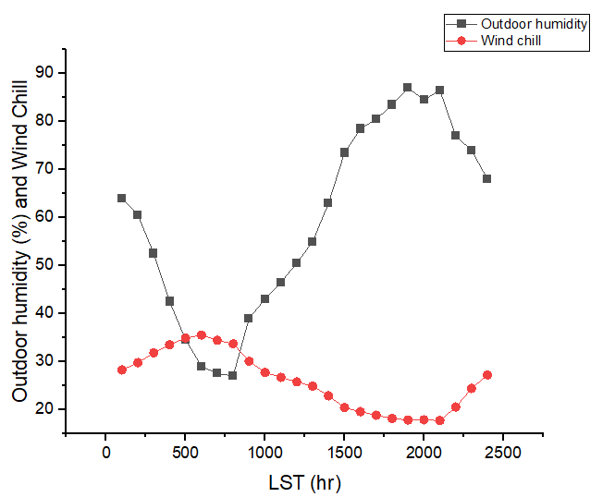

Figure 5.1: Diurnal variation of Wind Chill and outdoor relative humidity for(DOY115).

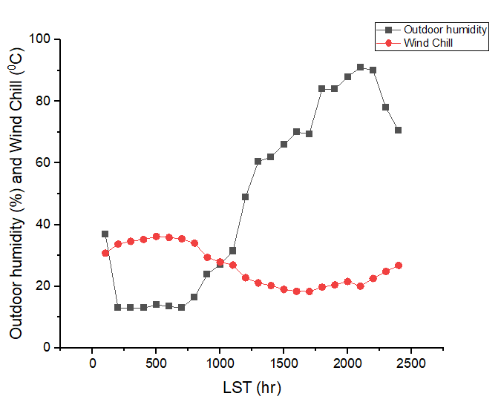
Figure5.2:Diurnal variation of Wind Chill and outdoor relative humidity for (DOY116).

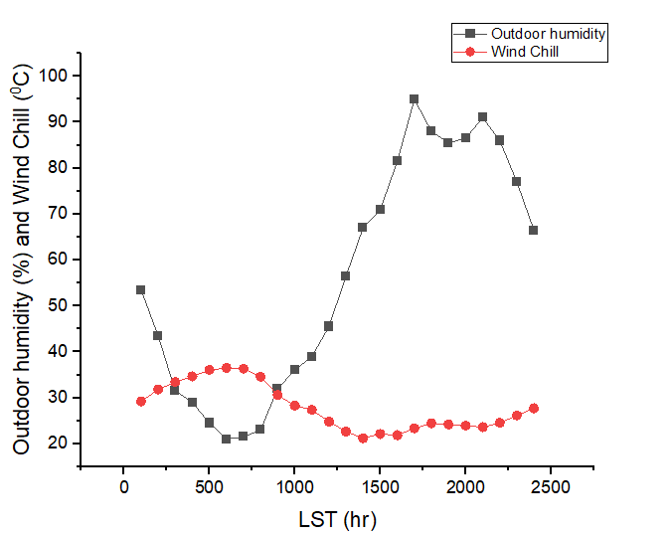
Figure5.3:Diurnal variation of Wind Chill and outdoor relative humidity for(DOY117).

CHAPTER SIX
SUMMARY AND CONCLUSIONS
Continuous measurements of Wind Chill and Outdoor Relative Humidity at an experimental site (08°09’21″N, 04°30’50″E) located at the Kwara State Polytechnic, Ilorin, Nigeria, were carried out between 25th May – 1st June, 2025. Using the direct measurement technique, these datasets were used to investigate the diurnal variation of the Wind Chill and Outdoor Relative Humidity.
From the results, for the period under consideration, the highest value of wind chill for this research is 37°C and the highest value of outdoor relative humidity is 98% on DOY 117.

REFERENCES
Alexiadis, M.C.; Dokopoulos, P.S and Sahsamanoglou, H.S. (1999). “Wind
speed andpower forecasting based on spatial correlation models”, IEEE Trans. Energy Conv., vol. 14, no. 3.
ASHRAE, (2016). “The impact of wind forecasting in power system
reliability”, ElectricUtility Deregulation and Restructuring and Power Technologies.
Bhaskar, K. and Singh, S.N. (2012). “AWNN Assisted Wind Power
Forecasting UsingFeed-Forward Neural Network”, IEEE Transa ctions on Sustainable Energy, Volume: 3, Issue: 2, pp. 306–315.
Catalao, J.P.S; Pousinho, H.M.I. and Mendes, V.M.F. (2011). “Hybrid
wavelet-PSO-ANFISapproach for short-term wind power forecasting in Portugal”, IEEE Trans. Sust. Energy, vol. 2, no. 1, pp. 50-59.
Han, S; Liu, Y. and Yang, Y. (2007). “Taboo Search Algorithm Based ANN
Model for WindSpeed Prediction”, Industrial Electronics and Applications, ICIEApp., pp. 2599-2602.

James, W.T., Taylor, P. and McSharry, E. (2009). “Wind Power Density
Forecasting UsingEnsemble Predictions and Time Series Models”, IEEE Transactions on Energy Conversion, vol. 24, no. 3, pp. 775-782.
Jie, S; Wei-Jen, L; Yongqian, L; Yongping, Y. and Peng, W. (2011). “Short
term wind powerforecasting using Hilbert-Huang Transform and artificial neural network”, Electric Utility Deregulation and Restructuring and Power Technologies (DRPT), pp. 162-167.
Jimoh, M.Y. (2004). Sprawl development in Ilorin Metropolis. M.Tech Thesis
submitted tothe Department of Urban and Regional Planning of Environmental Sciences, Ladoke Akintola University of Technology, Ogbomoso (Unpublished).
Khan, A.A. and Shahidehpour, M. (2009). “One day ahead wind speed
forecasting Usingwavelets”, Power Systems Conference and Exposition, pp. 1-5.
Liang, W; Jeongje, P; Jaeseok, C; Junmin, C. and Lee, K.Y. (2009). “A study
on wind speedprediction using artificial neural network at Jeju Island in Korea”, Transmission and Distribution Conference and Exposition: Asia andPacific, pp. 1-4.
Ling, C. and Xu, L. (2011). “Comparison between ARIMA and ANN Models
Used in ShortTerm Wind Speed forecasting”, Power and Energy Engineering Conference (APPEEC), pp. 1-4.
Miranda, M.S. and Dunn, R.W. (2006). “One-hour-ahead wind speed
prediction using aBayesian methodology”, Power Engineering Society General Meeting, pp. 1-6.
Negnevitsky, M; Mandal, P. and Srivastava, A.K. (2009). “An overview of
forecastingproblems and techniques in power systems”, Power & Energy Society General Meeting, PES'09, pp. 1-4.
NOAA, (2010). National Centers for Environmental Information, State of the
Climate:Global Climate Report for Annual 2010, published online.
Olaniran, O.J. (2002). Rainfall anomalies in Nigeria: The contemporary
understanding.55th inaugural lecture. University of Ilorin, Nigeria.
Oyegun, R.O. (1983). Water resources in Kwara State. Matanmi Publishers,
Ilorin.
Peng, L. and Lili, Y. (2011). “Short-term wind speed forecasting based on
Non-stationarytime series analysis and ARCH model”, ICMT, pp. 2549-2553.
Perry, D.W. and Green, R.H. (2016). Chemical Engineers' Handbook, Eighth
Edition.ISBN: 9780071422949.
Potter, C.W. and Negnevitsky, M. (2006). “Very short-term wind forecasting
for Tasmanianpower generation”, IEEE Transactions on Power Systems, vol. 21, no. 2, pp. 965-972.
Schiavon, M; Dall’acqua, S; Mietto, A., Pilon-Smits, E.A; Sambo, P. and
Masi, A. (2013).“Selenium fertilization alters the chemical composition andantioxidant constituents of tomato (Solanum lycopersicon L.)”, J. Agric. Food Chem. 61, 10542–10554. 10.1021/jf4031822.
Songlin, Z; Meiqin, M. and Chang, L. (2010). “Forecasting of wind speed
based on waveletanalysis and support vector machine”, Power Electronics for Distributed Generation Systems (PEDG), pp. 864-867.
www.wikipedia.com
Yutong, Z. and Ka Wing, C. (2008). “The impact of wind forecasting in power
systemreliability”, Electric Utility Deregulation and Restructuring and Power Technologies, pp. 2781-2785.

