SMART SOLAR BASED CBT EXAMINATION MONITORING SYSTEM

BY

JOSHUA JEREMIAH JOSEPH
HND/23/COM/FT/0086

A PROJECT SUBMITTED TO THE DEPARTMENT OF COMPUTER SCIENCE

INSTITUTE OF INFORMATION, COMMUNICATION AND TECHNOLOGY
KWARA STATE POLYTECHNIC, ILORIN.

IN PARTIAL FULFILMENT OF THE REQUIREMENT FOR THE AWARD OF HIGHER NATIONAL DIPLOMA (HND) IN COMPUTER SCIENCE

JULY, 2025.

CERTIFICATION
This is to certify that this project was carried out by JOSHUA JEREMIAH JOSEPH with the matriculation number HND/23/COM/FT/0086 in the department of Computer Science, Institute of Information and Communication Technology, Kwara State Polytechnic Ilorin, Kwara State.

………………………….. …………………………
DR. AGBOOLA, O.M. Date
Project Supervisor

………………………….. …………………………
MR. OYEDEPO, F.S. Date
Head of Department

………………………….. …………………………
External Examiner Date

DEDICATION
With most profound gratitude from my heart I dedicate this work to the Almighty God, the one whom without his guidance my journey so far in this great citadel of learning wouldn’t have become the reality it is today. And as well to my lovely parents and guidance

ACKNOWLEDGEMENT
All praise to God, the great fountain of everyman’s knowledge, the one whose supremacy is far beyond the reasoning and wisdom of men. I specially acknowledge him for his strength and divine knowledge that helped me from the day one of my admission up till the completion of my HND program.
I appreciate the tireless effort of my supervisor, Dr. Agboola, M.O. whose patience, support, and encouragement were the driving force behind the success of this research work. In his words, “I won’t let you rest till you do it right and get it right by yourself”. His corrections, constructive criticism, comments, recommendations, and advice were what lead the success and excellence of this research work. Few words I will qualify him with are INTEGRITY & PRINCIPLE which he doesn’t play with. My sincere gratitude also goes to the Head of Department, Mr. Oyedepo, F.S., and other member of staff of the Department of Computer Science, Kwara State Polytechnic, Ilorin for their constant cooperation, immense love, encouragement and support throughout the program.
Words alone will fail me and won’t be enough to express my deepest and most profound gratitude to my parents and guidance, Rev. & Mrs. Mathew Oluwaleke, Pst. & Mrs. Ezekiel Akinwade and most especially my mum Mrs. Uduak-Obong Ukpong, their immeasurable love, prayers, advice, care and great financial support where second to none all through my journey in school up till this point. Through thick and thin, through the hard times there’s never a day I called and they don’t answer. How would I forget their great council that has guide me through every decision I took up till this point. Special appreciations to my sister, Debby you are one amazing soul, thank you for the love and care.
My sincere and special gratitude goes to Luminous, wuraola and to all my great friends.

TABLE OF CONTENT
Title page i
Certification ii
Dedication iii
Acknowledgement iv
Table of content v
Abstract vi
CHAPTER ONE: GENERAL INTRODUCTION
1.1 Introduction and Background of study 1
1.2 Statement of the Problem 3
1.3 Aim and Objectives 3
1.4 Significance of Study 3
1.5 Scope of Study 4
1.6 Organization of the Report 4
1.7 Definition of Terms 5
CHAPTER TWO: LIETARETURE REVIEW
2.1 Review of Related Literature 6
2.2 Review of General View 10
CHAPTER THREE: RESEARCH METHODOLOGY AND
ANALYSIS OF THE SYSTREM
3.0 Introduction 15
3.1 System Design and Architecture 15

System Design Diagram
15
3.2 System Connectivity 16
3.2.1 Solar system connectivity 17
3.2.2 Surveillance System Connectivity 17
3.3 Hardware Components 17
3.3.1 Solar and Inverter system component 18
3.4 CCTV Surveillance System 19
3.4.1 CCTV surveillance system component 20
3.5 Power Management Implementation 21
CHAPTER FOUR: IMPLIMENTATION AND RESULTS
4.1 Introduction 22
4.2 Implementation and Installation Process 22
4.2.1 Solar and Inverter System Installation 22
4.2.2 Power Management setup 24
4.3 CCTV Surveillance system setup 26
4.4 Output and Result of the system 27
4.4.1 Solar Power Management 28
4.5 Conclusion 29
CHAPTER FIVE: SUMMARY, CONCLUSION, AND RECOMMENDATIONS
5.1 Summary 30
5.2 Conclusion 31
5.3 Recommendation 31
Reference

ABSTRACT
Ensuring the integrity of Computer-Based Testing (CBT) in higher education has become increasingly important due to the growing prevalence of examination malpractice and unreliable power supply. This project presents the development of a Smart Solar-Powered CBT Examination Monitoring System using CCTV cameras, implemented in the Computer Science Laboratory of Kwara State Polytechnic. The system is designed to provide continuous surveillance during examinations while utilizing solar energy as a sustainable and reliable power source. The methodology involved the integration of a solar energy system—comprising solar panels, charge controllers, deep-cycle batteries, and an inverter—with a closed-circuit television (CCTV) surveillance setup. High-resolution cameras were installed to monitor examination activities, with video feeds stored using a Network Video Recorder (NVR). The system was tested during live CBT sessions to evaluate its performance in real-world conditions, particularly during power outages. The results confirmed that the system delivered uninterrupted surveillance, improved monitoring efficiency, and significantly reduced instances of malpractice. The solar power supply ensured stable operation without dependence on the national grid, promoting energy sustainability and cost-effectiveness. Overall, the project offers a practical, scalable solution for educational institutions seeking to enhance examination security through smart technology and renewable energy integration.
Keywords: Smart Surveillance, Computer-Based Test (CBT), Examination Monitoring, Solar Energy, CCTV Cameras, Renewable Power, Educational Technology, Real-Time Monitoring, System Automation, Tertiary Institutions
CHAPTER ONE
  - INTRODUCTION AND BACKGROUD TO THE STUDY

The intent of every society is to produce young ones that are capable of taking the responsibilities and mantle of leadership in that nation. The basic way of harnessing and injecting this is through educational system and as society stand today, tertiary education becomes the foundation for this. The nation education system must be position in such a way that the expected breeds of graduate are produce. This can only become an achievable and reality goal through credible examination system. It is quite disheartening to see many graduates out there who cannot confidently defend the good results they graduate with from school, the big question is how did they pass the examination that offered them that result.
Examination all over the world is the basic tool for accessing the competency and capabilities of individual in every educational system. It is a means by which person’s ability, knowledge and skills in particular area or subject can be evaluated at a given time. It is a scale that weighs and measures an individual level of knowledge acquisition at the end of a learning period (Uche, Martins &, Francis, 2020).
An examination is also referred to by other terms as evaluation, test and assessment etc. Examination can be formal, informal or even hands – on practical exercises. Generally, a formal examination can be administered through oral interaction (interview), on paper (written), or by computer (Computer Base Test). Examination varies in style, requirements, rigor and conditions as well as context.
In Nigeria, millions of candidate participates in popular examinations such as the Senior School Certificate Examination (SSCE), Unified Tertiary Matriculation Examination (UTME) conducted yearly by various examination regulatory bodies which include West Africa Examination Council (WAEC), National Examination Council (NECO), Joint Admission and Matriculation Board (JAMB).
Over the years, the paper-pencil / pen based test has been used to conduct various assessments, but recently the computer based mode of testing has become popular (Nwazor, 2022 Abubakar & Adebayo, 2014 Joshua et al; 2014). Computer Base Test is taking of a test in computer instead on a paper. Computer Based Test also referred to as Computer based Assessment is any form of assessment or evaluation (formative or summative assessment) that is conducted electronically with the use of information technology (Simdol Technology, 2019). Olumorin, Fakomgbon, Fassasi ,Olowale & Olafare (2013) described CBT as a test or assessments that are administered by the use of computer through technological devices linked to the intranet and in certain cases internet. The above view sum up the concept of CBT as a form of organized system of assessment technique that involves the use of computer, intranet and internet in testing the learner. In respect to this research work having acknowledge what Examination is we shall be looking using effective and smart technologies like smart solar based closed circuit Television (CCTV) Surveillance camera to monitor exams.
Over the years, the problems of monitoring and tackling of examination malpractice both within the formal school settings and other examination bodies have become a growing concern to stake holders, including government, school administrators and the society at large
Several techniques such as the use of invigilators to monitor examination, accrediting candidates for examination with photo album from examination regulatory body’s use of candidate identity cards or biometrics machine have been made to salvage the situation in time past. These techniques however seem not to have yielded the desired result as the case of exams malpractice keep increasing. This lead to the introduction of video surveillance system intended at complementing the effort of human invigilators. Through video surveillance system the behavior and activities can be monitored using electronic equipment such as Closed Circuit Television (CCTV).
CCTV system is a surveillance infrastructure mounted at a predetermine location to ensure optimal coverage, which collect scene images that are transferred to a monitoring station or are stored for subsequent analysis and review , to prevent crime by deterring potential offenders, because of their awareness of the cameras that may be watching their activities. One of the objectives of using CCTV system is to detect suspicious behaviors in real time so that proactive measure can be taken. However, in examination scenarios in Nigeria, this is not the case because detection of infringements or suspicious behaviors in real time is subject to the operator uninterrupted surveillance. Some candidate perpetrates malpractice during examination and get away with it without being caught despite the installation of CCTV system. Amongst so many factors that contribute to this like compromise to bribery from the CCTV operator, human biasness, wrong positioning of surveillance camera and the absence of solar system in case the power is interrupted. Due to the state of the nation and educational system in Nigeria, many campuses and tertiary institution are plague with poor supply of electricity there by crippling the effectiveness of the CCTV surveillance camera, as this technology device requires a source of energy to function. Smart solar base cctv monitoring system makes use of solar energy to function.
Solar power also known as solar energy is the energy generated from the sun ray either directly or indirectly. This renewable energy makes use of solar Panels also known as photovoltaic (PV) cells to convert sunlight into electricity. This solar system comprises solar panels, solar charge controller, PV monitoring, DC cables and AC cables, Inverters and Battery. The solar panel also known as photovoltaic (PV) cells are used in capturing sunlight, The PV cells convert sunlight into Direct Current (DC) electricity and it is sent through an inverter, which convert into an Alternating Current (AC) electricity. The AC electricity is fed into the electrical grid and distributed to the destination that it wants to be used.
Smart solar based CBT Examination monitoring system i.e. a monitoring system is a monitoring system that uses a solar based CCTV surveillance camera to monitor the process of an examination, where live pictures, moment and activities during examination is being video and captured. As an edge over the existing system of monitoring exam, this research work becomes essential because the system will cover the gaps by providing evidence of student involved in any form of examination misconduct. Problems like power outage during the exams will also be resolved as the monitoring system is powered by a solar energy.

  - STATEMENT OF THE PROBLEM
Smart Solar Based CBT Examination Monitoring system is the kind of system where the student writing examination are being monitored to ensure there is no form of examination malpractice and misconduct and this system ensure that the exam is ordered and problem free
Over the years, several researchers have suggested ways examination could be monitored through the use of invigilators and exams officers, searching of students at the entrance of the examination centre, seizing of any form of technological or electrical devices like phone Bluetooth, and smart watch that could be used to carry out malpractice. But with all their efforts to monitor the exams student still carryout all sort of examination malpractice and misconduct like writing on slip of papers, on their laps, swindling of textbooks into the exam hall, and writing o currency etc.
In light of these gaps with the existing system, the proposed solution, Smart Solar Based CBT examination monitoring system will improve on this gap or overcome the existing problem by monitoring students during examination not just manually, but through the use of CCTV camera mounted at the examination centre, where live activities and every event during the exams is being monitored, captured and recorded over the surveillance camera. A student caught on the camera cannot deny being caught; this system will also overcome the gap of presenting concrete evidence of student caught in any act exams misconduct and malpractice.

  - AIM AND OBJECTIVES
The aim of this research work is the design and implementation of Smart Solar Based Examination Monitoring system with the following objectives:

- Installation of solar panels, surveillance camera (CCTV) and inverter for monitoring of CBT examination center; and
- Connection of batteries to the installed solar panels.

  - SIGNIFICANCE OF STUDY
If this research works on Smart Solar Based Examination Monitoring system is being carried out, covering the gaps of manual ways of monitoring exams and issue of power of interruption the following benefits will be achieve.
Security will be enhanced, solar based cctv camera provides a 24/7 surveillance, deterring students from cheating during the exams and other form of exams misconduct. They will be a real time monitoring which will which will allow the exam administrators to respond promptly to incident from live footage. Some CBT centers always suffer from theft, vandalism and other criminal activities, the presence of visible camera at the exam center can go a long way in preventing this crime.
This new system will also ensure an uninterrupted power supply through the use of solar system at the exams center. Solar Based CCTV cameras require minimal maintenance, and as such cost of expenses will be reduced. This new system will detect and prevent cheating during exams. A real time monitoring ensures that the exams are conducted honestly and fairly as such this new system will help boost exams integrity.
Examiners sometimes get physically attacked by students just to gain unauthorized access to exams materials, the deployment of this smart solar based monitoring system will help deter the attack and monitor the materials from theft.

  - SCOPE OF STUDY
The scope of this research work will focus on the computer science laboratory in kwara state polytechnic, Ilorin, Due to the poor supply of electricity to the school community

  - ORGANIZATION OF THE STUDY
Chapter one: The chapter one of this research work discuss about the Introduction, Statement of the problem, Aim and Objectives, Significance of the study, the scope of the study and Definition of terms.
Chapter two: The chapter two of this research work discuss about the Literature review, the review of related review, the review of the general view and other literature are all reviewed in this chapter.
Chapter three: This chapter of the research work involves the methodology use in the research work as well as discussion on the existing system and discussion on the full system.
Chapter four: the chapter four of this research work discuss about the Result ad discussion on the result.
Chapter 5: The chapter five of this work discuss about the summary, conclusion and recommendation.

  - DEFINITION OF TERMS
- Smart Monitoring System: Smart monitoring system is an advanced Technology system that enables real time monitoring, tracking, management of various assets and environment through camera surveillance.
- CBT: CBT stands for Computer Based Test. It refers to the use of computer devices to administer and score test, quizzes and exams.
- Solar Power: Solar power also known as solar energy is the conversion of sunlight into electricity, either by directly using photovoltaic (pv) or indirectly through concentrated solar power (csp).
- Examination: An examination is a formal assessment of student’s knowledge, skills, and understanding of a particular subject or course.
- CCTV Cameras: Close Circuit Television (CCTV) camera is a type of surveillance camera that transmits video signals to a specific limited set of monitors.
- Solar Panel: Also known as photovoltaic (pv) panel is a device that converts sunlight into electrical power.
- Inverter: An inverter is an electrical device that converts direct current (DC) power into Alternating current (AC) power.

CHAPTER TWO

LIETARETURE REVIEW

  - REVIEW OF RELATED LIETERATURE
Uche .C. Agwi, Martins E. Irhebhude, Francis N. Ogwueleka (Dec. 2020) worked on Video Surveillance in Examination Monitoring
Overtime, the problem of tackling examination malpractice both within the formal school settings and other examination body has become a growing concern to stake holders, including government, school administrators and the society at large. It has become so common that the core value of school system is now eroded and compromise. This has gotten so common that so many youths are no longer convinced about cultural value and the reward of diligence. Before exploring more in this field, it’s imperative we understand what examination is.
Examination all over the world is the basic tool for assessing the competency and capabilities of individuals in every educational system. It is a means by which a person’s ability, knowledge, and skills in a particular area or subject can be evaluated at a given time. It is a system that measures an individual’s level of knowledge acquisition at the end of every learning period. Generally a formal examination can be administered through oral interaction (interview), on paper (written test) or on a computer (Computer Base Test). Examination as well varies in style requirements, rigor and conditions as well as context.
As such, several techniques such as the use of invigilators to monitor examination, accrediting candidates for examination with photo albums from examination regulatory bodies the use of candidate’s identity cards, etc, have been made to reduce case of malpractice in the past. However, these techniques seem not to have yielded desired results as the case of examination is on the increase.
From the findings of the researchers, the problem of existing monitoring system was inadequate evidence for further prosecution. The candidate can easily deny being involved in such act, the hallway even become rowdy when the candidate resist being apprehended by the invigilator either by destroying the material evidence or refusing to fill or sign the malpractice form. In light of that, Amaechi (2017) proposed the use of CCTV surveillance as an antidote to examination malpractice in Nigeria high institutions stressing the benefits of deploying a surveillance system to monitor the examination process and how it can improve the overall reliability of the outcome of the examinations. Compared to the old system of monitoring examination, Atabong et al. (2010) affirmed that the excessive human involvement in examination management is responsible for the prevalence of examination malpractice.
The use of CCTV surveillance system for monitoring activities in the examination is undoubtedly gaining prominence because of its benefits which include providing evidence (undeniable ones) for investigative reason s and as such serving as deterrence to intending offenders since they are aware of being monitored. On this note it is therefore highly recommendable to deploy this system in our high institution for examination monitoring.

Amiuwu, Moses A, Ifeoma P (Phd), (2020), conducted a study on the Use of Close Circuit Television (CCTV) for Ensuring Quality Learning and Internal Policing in Early year center.
The symbiotic relationship between Educational Technology and are giving / learning situation is best described as that of “Egg and Hen” relationship. In other words education helps develop science and Technology, while technology on the other hand improves quality education. Ughemadu (2012) averred that the primary role educational technology plays in the care giving and teaching / learning process is essentially that of improving the process. Talking about quality learning and internal policing in early year centre through the use of Close Circuit Television (CCTV) surveillance camera, it is important to define the concept of Early Childhood Education (ECE). Charie, (2017) sees Early childhood education (ECE) as the education of children from birth through age 8 (which when quality care giving, policing and learning could not be guaranteed will mare or affect the Childs lifelong education, promote negative transfer and poverty). It is on this premise that Eziechina, Ugboaja and Esiagu, (2017) assert that “The single most important key to development and poverty alleviation is quality education. Any nation that wishes to achieve a sustainable development goal (SDG) in poverty alleviation and quality education alone can ensure that.
Therefore this research work was aimed at investigating the potentials of CCTV in early year centers to ensure quality learning with the objectives of examining the impact this monitoring system plays in producing a total child as well on the service delivery of the guidance. This study also investigated the effectiveness of CCTV camera surveillance in preventing and detecting incidents like bullying in the early year center. The methodology that was use in carrying out this research was a descriptive survey designed aimed at examining the effectiveness and impact of closed circuit television (CCTV) surveillance camera for monitoring and ensuring quality care giving in early year center. Considering the deployment of this new system of surveillance in the daycare center, the researchers discovered that this could assist care givers and guidance at the Early Child Education (ECE) centers on their daily jobs of fulfilling curricular objectives via learning, care giving, monitoring and proactive evaluation focused at building the child intelligence through proper supervision compared to the old way of delivering service s without being monitored.
The use of CCTV surveillance camera in public and private schools is only novel in less developed towns and rural areas in Nigeria, Base on this study it is therefore recommended that parents should work in synergy with school to provide CCTV surveillance camera for the sake of the safety of their children. Government agencies should also empower local technicians and artisans in making prototype of this foreign technological device at affordable cost.

Kamoru Olayiwola Usman, Solomon Babatunde Olaleye (June, 2020), Effect of Computer Base Test (CBT) On Learning Outcome of Colleges and Tertiary Institution students.
Examination is an important aspect of teaching and learning process in colleges and tertiary institution in Nigeria. Therefore, conducting examination involving large number of students could be a major challenge. Examination is the most widely used means of accessing learning capabilities of student. It is also the important part of education that allows lecturer evaluate their student after teaching them. There are numerous ways of conducting examination one of which is called computer based test (CBT). It is simply the use of computer hardware and software to test students’ on previously taught lessons. It majorly consists of multi-choice questions in objective format. Conducting examination for large classes is one the challenges facing tertiary institution especially when it involves pen and paper mode. In modern era, the world has experience tremendous interest in the CBT in academic activities, more importantly in student’s assessment. It also reported that the introduction of CBT into schools examination has controlled a very good level examination malpractice in Nigeria. Realizing how beneficially the deployment of this technology tool is to our educational system. This research work was aimed at assessing the effect of CBT Examination on the learning outcome of college and tertiary institution student with the objectives investigating the impact of CBT Examination on the learning outcome of student in colleges and tertiary institution, examining the relationship between CBT Examination and student performance. Through descriptive survey design and research questions the researchers found out that some supervisors assigned to monitor the CBT exams lack Information Communication Technology (ICT) practical knowledge, visually impaired students complain of unclear voice, erratic power supply during the CBT Examination coupled with high cost of diesel for alternative source of power and time duration allotted affect some student that are not smart, technical issues during exams, limited access to computers and limited train personnel. Smooth conduct of examination for general courses involving large number of student has been a major challenge in Nigeria tertiary institution. Computer Base Test (CBT) Examination with the use of ICT facilities is one of the recent innovation method s to overcome this challenge. On this light the following recommendation was made due to the challenges in the system, providing IT oriented personnel’s to supervise exams, installation of CCTV surveillance cameras and solar system, and government agencies should help from time to time in procurement of ICT equipment.
Amaechi .M. Eziechina, Uchena .C. Ugboaja, Ugochukwu .E. Esiagu (Dec, 2017), Close Circuit Surveillance: An antidote to examination malpractice in High institution in Nigeria. Most examination malpractice in Nigeria occurs while the examination is in progress, in form of bringing in unauthorized materials, writing on currency notes, identity cards, spying of others candidates in examination hall, substitution of answer sheets and impersonation. It is imperative and worthy and worthy of note that the important key for poverty alleviation, strengthening of citizenship values, and promoting of sustainable development in any nation is education. It is a powerful tool in reducing poverty level, unemployment and improving quality of life of the people. Having said this, any nation that is interested in development must intentionally in it educational system. The hall mark for this is establishing good learning facilities for student to assess their credibility and knowledge. On this light, this research is aimed at investigating the effectiveness of CCTV surveillance in reducing examination malpractice in Nigeria higher institution with the following objectives, accessing the effectiveness of CCTV surveillance system in detecting and preventing malpractice during examination, searching student to collect any form of exhibit that could be use in perpetrating malpractice and any form if exam misconduct. This research was carried out by focusing on a specific higher institution as a case study design. On the process of this research the researcher found out that deploying cctv camera as an examination monitoring system is effective in reducing malpractice because this device captures and monitor every single activity in the exams centers, as such students are aware they’re being monitored this will not only deter them from malpractice but every other misconduct during the exam, this system will also help students to become more responsible by devoting more time to prepare ahead of any exams, because if caught they would face the disciplinary committee which could lead to their expulsion. On this note it was therefore recommended that CCTV surveillance system should be implemented in our tertiary institution, Training and awareness should be carried out as well as regular maintenance and provision of solar system to power the facility
Ogbu Nwani Henry (July, 2016) worked on A model of university examination monitoring system. The intent of every society is to produce young ones that are capable of taking the responsibilities and mantle of leadership of that nation. The basic way of harnessing and injecting this is through educational system and as the society stands today, university and tertiary education becomes the foundation for this. For this to be achieved, the nation’s educational system has to be positioned in such a way that the expected breeds of graduate are produced. Not just graduates with good grades who can’t stand to defend their certificate, as most of them were gotten through fraudulent means, like malpractice and bribery. Over the years, the extent of students malpractice in examinations and resultant effects when confronted by invigilators or university security agent have been on the increase and devastating. And as such, they arose a need for an examination automated monitoring system which is the sole aim of this research work with the objectives of reducing and flushing out malpractice out of the school system. This system is designed and developed with webcams at the examination halls to capture the student face, posture and their movement during examination. It is also a system that is use in monitoring how examination is being conducted, this monitoring device is mounted at the exams hall (arena) they capture every moment and activities during exams and store live-fed videoed scenarios for screening and further usage. Considering the aforementioned method, the researcher discovered that the examination automated monitoring system was better than the manual way of monitoring and invigilating examination, because the recorded and captured evidence on the camera cannot be easily denied compared to eyes witness event which could easily be compromised or deny by the victim. Since the whole segment of the nation life, such as homes, school, society are fingered in the issues of examination malpractice, the government, nongovernmental organizations should organize enlightenment campaigns that will highlight the consequences of examination malpractice on the individual, school and the society at large. The main advantage of this system over the manual method of examination monitoring is that clear and undoubted evidence abound from the system. The awareness of being monitored deters the student from malpractice act. After exploring the field of research, the researcher recommends that this new system, “A model of university examination system be adopted and deployed into our tertiary institution.

  - REVIEW OF GENERAL VIEW
Senthil Kumar, Gerald Christopher and Rajarajarn Elango, (2020).
The IOT-Based Smart Monitoring Scheme for solar PV Application. The world’s population is gradually growing from 3.2billion in 1962 to 7.7billion in 2019, and this figure is expected to hit 10billion by 2050. As a result of this growing population, living standards of people, increasing demand of energy, water and food generate concurrent stress on the environment. The utilization of oil, gas and coal is expected to be in decline shortly. Amongst many issues, the generation of power is one of the predominant factors in many developing countries. Nowadays, due to the development of commercial and industrial sectors, the demand for energy is undoubtedly on the increase. Presently India is producing 1, 37,185Gwh energy by large utilization and consumption of fossil fuel which could lead to air pollution thereby becoming an environmental hazard.
Since the conservation of fossil fuel brings more harm on the environment, the adoption of sustainable energy has steadily enhanced predominant sectors of energy generation. According to the researchers, the best way energy demand could be satisfy was exploring this renewable energy resource. That is the act of extracting power from sunlight and converting it to electrical energy. On this light this research work was centered and aimed at using the Internet of Things (IOT) smart monitoring scheme for solar PV application. Inter of Things (IOT) is simply a structure of physical instruments, buildings, vehicle and other apparatus encapsulated in electronics, sensors, actuators that enables the collection and sharing of data between these objects. Smart sensors are hardware linked to devices that spot environmental circumstances and change it to signal form. A solar cell or Photovoltaic (PV) cell is designed to observe solar energy and produce electric power. This solar energy is easily obtainable from sunlight through the use of solar panels; this energy could use up completely and can be reusable. The solar panel is mainly used for converting solar energy (sunlight) directly into electric energy. The panels are made up of different absorbing materials and they differ based on the manufacturer and quality.
Installing a solar system is not just enough but monitoring it to ensure good performance, on this note through the use of IOT monitoring techniques the researchers found out that the new system of generating power, that is the utilization of renewable energy resources is better than the use of fossil fuel as it causes hazard to the environment through pollution of air and climate change. IOT Based smart monitoring system will increase the lifespan of the solar system as most of the intended challenges that affect the system will be detected by the smart sensors. Smart sensors with IOT and remote monitoring methods in solar PV system have been examined, the extreme benefit of using solar energy are availability, free energy and less environmental impact.

Arghadeep Ray, Oinam Bhophen Singh, (July, 2024). Green Energy for Smart security cabin using Solar panel.
Security cabin is an enclosed space generally used for shops, house, security guard, etc. It provides shelter as well as protection from sun, rain and winter. Security cabins are made of various materials such as mild steel, steel, wood, and PVC which protect which protect it from dust, moisture and weathering factors. They’re designed as a semi security post for security officers and personnel’s, usually placed at the entrance or designated position of organizations and institutions to stop and search against unauthorized intrusion or attempt by people to enter the premises by force. Just like every security post these facility is instrumental in monitoring who enter or leave the premises.
Green energy is any type of energy generated from natural resources, such as sunlight, wind or water respectively. As a source of energy, green energy often comes from renewable energy technologies such as solar energy, wind power, geothermal energy, biomass and hydroelectric power. Each of these technologies works in different ways, for instance the solar energy is gotten from the sunlight through the use of solar panels, and energy can also be generated using wind turbines and dams. In light of this research paper we shall be looking at solar energy.
Solar power, this common renewable energy source is usually produced using Photovoltaic (PV) cells also referred to as solar panel to capture the sunlight and turn it to useable energy (Electricity). Solar power can also be use to heat buildings and for, coking, heating up water, and lighting up the house amongst several other advantages. In regards to this research paper the aim is generating a green energy for smart security cabin with the objective of utilizing renewable resources like solar panels, solar charge controller, PV monitoring structure, DC cables, AC cables, inverter, 12V 150AH Battery and lightening protection to generate energy for the smart security cabin.
Solar panel is collection of solar (photovoltaic) cells, which are use to absorb the sun rays to generate electricity. These cells are arranged in a grid like pattern on the surface of the solar panel.
From the findings of the researcher, most of the security rooms are mainly located at the main entrance which in most cases are always distant from main building and a permanent structure are always very rare to be find in most institution. In cases like this temporary structure is required, as such portable security cabin becomes the solution to this quest as they can be used for diverse security challenges, leveraging to some extent the high demand for permanent and temporary security facility. Compared to the former temporary security post, security cabin stand an edge because its equip with materials and facilities that can give more comfort to the security personnel on duty, being powered with green energy, it will enhanced it features as it solve the issue of power outage, it comes in handy because of it portability as such it can be move from one place to another.

Daniel Paul Godwin, Modi Bala, Abdulfatai Habib (2018), Design and Analysis of an Electronic platform for Examination.
An e-examination platform or Computer Based Assessment Test (CBA or CBT) is considered to be an e-assessment and computer administered testing method for conducting examination. In this method of examination question answering are being stored electronically and recorded or assessed or in some cases both. The quest for this research paper was as the result of the higher number of student being admitted into the schools, as grading and marking can become a huge burden on the teacher and lecturer as the case maybe after every examination.
From inception examination has been one of the best system use in evaluating and assessing student knowledge level and how well they’ve been able to understand what have been taught. It equally serves as a mirror that reflects how well a student have been taught, evaluating both the teacher or lecturer competency and diligence over delivering their course. On this note, a standard-pre-test design was not utilize for the testing, rather the CBT here implies the use of devices like, computer, cellphones and ipad etc.
In recent times, CBTs have been introduced as the new assessment platforms in some tertiary institution within Nigeria. The medium is considered to be faster and efficient compared to the traditional paper and pencil approach. As efficient tools for assessment in schools, the researcher’s aimed the work on the design and analysis of an electronic platform for examination. CBT (Computer Base Test) are also used for semester examination, especially in cases where the number of students is much in a class. This said system also enables educators and trainers to author, schedule, deliver and report surveys, test and other type of examination. CBT could be built as standalone system or partly as virtual learning environments, assessable through the World Wide Web (www). This system is design with some inbuilt tools that enables automatic marking of questions, responses of multi choice format. The objectives of this system is to terminate the manual process of examinations called pencil-paper Test (PPT) into automated by developing a CBT system that will automatically replace the manual form of examination system, develop a CBT system that automatically generate examination question to mention but few amongst many others. The methodology that was use on this research was paper techniques, and questionnaire in data collection and from the result of their findings, they found out that Electronic platform for examination is the best compared to the manual way of writing exams in schools, as this new system saves times, cost and reduces the stress of marking and grading student. On this light it is highly recommended for schools and colleges.

Fanklin . O. Okorodudu, Getty .E. Izakpa (2023), ICT-Tools Based Examination Monitoring system, The Delta State University Example.
When applicant is writing examination, we keep an eye on them to ensure proper invigilation and prevent problem of cheating. Physical or remote invigilation is possible when using technology. For different examinations, it can also be paper-based or computer base test. Since remote invigilation of computer-based evaluations is difficult, many literary works have invested much effort into developing an automated system to carry out the procedure. Electronic invigilation (also known as invigilation for electronic-based examination) is focused on controls used to protect electronic exams, which are often given in a controlled environment. E-invigilation appears in numerous places as “ornament” to verify applicant’s ability to abide by the test rules. For example, Percval et al (2008) studied the capability of computer-based exams to pick up on deviation from routine practices by applicants. Since the introduction of ICT into education significant progress has been made but there are difficulties that must be addressed on the downside (Abubakar and Adebayo, 2014). According to Eromosele (2008), throughout time test malpractice has evolved from usual “giraffing” at neighbor’s workplace, utilizing note, key points, textbooks and handkerchiefs, add new evolution of cheating.
In university examinations, academic success of student is evaluated and the students degree of academic performance and knowledge is also determine (Suleiman, et al 2015). Omemu, (2015) said that learning is made easier when student are put through an assessment process to see whether they have absorbed the lesson while as well as showcasing to the teacher their contribution to the academic achievement of their student.
Malpractice in examination is one of the issues that hurt the credibility of this system. On this guise this research was carried out with the aim of integrating of technology devices into the examination system of tertiary institution by deploying CBT Examination and CCTV camera for surveillance. It is no longer news that the system of examination and education in the nation is corrupted and compromised. Most of the offenders caught on this act always have their way out through bribery and other corrupted practice as a result of desperation for getting certificates. Apart from this some student go as far as using highly sophisticated technology devices like smart watch, pen, Bluetooth, air pods to perpetrate this evil act of malpractice, the use of ICT tools like CCTV surveillance camera and tracker to search student at the entrance of exam center could go along way fishing out the culprit. Compared to the old system of invigilation, this new system captures live event that take place all through the examination process, thereby deterring intending offenders from the act. The captured footage are stored and as well viewed for further investigation.

O. Sarjiyus, (july,2019). Securing Computer Based Testing (CBT) System for Institutions in Nigeria.
Computer-based testing (CBT) is the application and use of electronic system in place of manual paper-and-pen method for any assessment related activity. Computer based testing system enables educational institutions and other organizations that need some kind of assessment to conduct and schedule surveys, quizzes tests and responses/results are electronically recorded and assessed. The target is to make examination or assessment process fair, faster and reliable. The paper based testing (PPT) method is characterized y massive leakages, impersonation, and demand for gratification by teachers; invigilators etc. hence, the need for computer-based testing arise.
However, the non-existence of a known standard of framework for the design, implementation and deployment of the software for administering the examination (CBT) makes some of the challenges associated with the manual examination process to persist. In Nigeria, most of the universities conducting computer based examination rely solely on software on the software vendors for the administration of the exams. A few that have managed to domesticate the conduct of the exams are either poorly managed or use porous, defective software. As such this research is focused and aimed at building security solutions into the CBT system, revolving around certain parameters as confidentiality, which means all questions / exams resources must be kept private and away from unauthorized third parties. Authenticity which means the candidate taking the test / exams is the right person who is supposed to sit for the exam not an impostor and integrity in other hand in the other hand which means that no part of the exam question have been tampered with, distorted, altered or corrupted in any way. The objective of the research is to make sure we have a corrupt free CBT exams system and every exam is written under due credibility and authenticity. The methodologies employed for this research design include studying of writing materials on security aspect of CBT such articles and lecture note as well as physical inspection of how the CBT system works with a view to finding leakages and vulnerabilities. The software methodology used for the research is the unified software development process. And on this light, the following observation was made by the researcher, CBT examination stands a higher chance of transparency and credibility compared to pen-to-paper examination. Securing computer based testing (CBT) system for tertiary institution provides a improved means for protecting examination question against unauthorized access compared to getting the software from unreliable vendors who would possibly leak the exam question to the public.

CHAPTER 3
RESEARCH METHODOLOGY
3.0 INTRODUCTION
This chapter of the research work describes the steps on how the connection for the smart solar based CBT examination monitoring system is carried out. That is the methodology use in connecting the solar panel to the inverter, battery, charge controller and the CCTV surveillance system respectively. It also highlights the different equipment (hardware component) that was use in carrying out the installation and their respective functions. It also reviews the systems design and Architecture.

3.1 SYSTEM DESIGN AND ARCHITECTURE
The system adopts a modular architecture, comprising three primary modules:
- Solar Power Generation and Management Module: This module of the system handles the generation, transmission and regulation of solar energy to power up the CBT facility. The following are some of the equipment that makes up this module, Solar panels, Inverter system, Charge controller, 6mm wire, Lithium ion battery which comes in different volt depending on the expected output.
- CBT Exam Monitoring and Data Acquisition Module: This module focuses on capturing and processing exam-related data, including student activity, environmental conditions, and potential anomalies. Some of the equipments that makes up this modules includes the CCTV cameras, video transmitting cable, power cable, monitors and power box etc
- Data Storage and Remote Monitoring Module: This module manages data storage, facilitates remote access, and provides real-time monitoring capabilities. One of the essential equipment in this module is the DVR (Digital Video Recorder)

System Design Diagram
This section of the research shows in details the connectivity in the system.

Desktop
CCTV
Sun
Camera
DVR
CPU
Solar panel
Power Box
Inverter
-
+

Charge Controller
-
+
-
+
-
+
6mm wire
Battery

Fig 3.1.1 System Design Diagram
The diagram in fig. 3.1.1 above is the system design diagram. It shows how the system is being connected and how it works. The Photovoltaic (solar panel) harvest energy from sun and by pass it to the charge controller where it convert the power to Direct Current (DC), this power is passed to the battery as DC and then to the inverter where the current is converted to AC (Alternative Current) what other devices can use.
3.2 SYSTEM CONNECTIVITY
The system connectivity of this research work is divided into two primary sections, the installation and connection of the solar which comprises of the solar panels, battery, charge controller, and inverter system and as well the connectivity of the surveillance system, which involve the CCTV camera.
    - SOLAR SYSTEM CONNECTIVITY
This section explains the step by step process that was involved in the installation of the solar system.
- Solar Panel Installation: The solar panels were strategically positioned to receive maximum sunlight, ensuring optimal energy generation. The type of the solar panel that was use for this experiment was a dark phase photovoltaic cell which work with low ray of sunlight and generate energy faster.
- Connecting the Panels together: After installing or placing the solar panel in a good location, the panel where connected in series and parallel form. By series connection, the positive (+) terminal of one panel is connected to the negative (-) terminal of the next one. And by parallel all positive nodes are connected together and negative respectively.
- Connection of Solar Panel to Charge controller: After the solar panel installation, the next thing is to connect the node of the DC wire to the charge controller in their corresponding pattern positive node to positive and negative node to negative.
- Charge controller and Battery Connection: Once the solar panels have been connected together in series and parallel form the next thing is to do is connect the charge controller to the battery, so that the energy coming from the solar panel can be well regulated so as not to overcharge the battery.
- Inverter and Battery Connection: After connecting the charge controller to the battery, the next thing to do is connect the inverter system to the battery. The work of the Inverter is to covert the current from the battery from DC to AC
- Inverter and Battery Connection: After connecting the charge controller to the battery, the next thing to do is connect the inverter system to the battery. The work of the Inverter is to covert the current from the battery from DC to AC

    - SURVEILLANCE SYSTEM CONNECTIVITY
This section explains the step by step process that was involved in the installation and connectivity of the CCTV camera
- CCTV Camera Installation: After installing and setting up our solar system, the next thing is to find the appropriate location to fix our cctv cameras to capture the exam hall
- Running Cables: After mounting the camera in your preferred location, the next thing is to run your cables (both power and video cable) from the camera to DVR, Monitor and power box respectively
- Network Infrastructure: A dedicated Wi-Fi network was established to facilitate seamless data transmission between the monitoring devices and the central server.

  - HARDWARE COMPONENTS

This section of the research is sub divided into two primary sections, which is the solar and inverter system component and he surveillance system component. All the equipment use during the installation is highlighted and their functions and the role they play both in the installation and the system.

    - SOLAR AND INVERTER SYSTEM COMPONENTS
- Solar Panels: Photovoltaic panels to convert sunlight into DC electricity. The solar panels are divided into several types but majorly in this part of the world people mostly use the mono-crystalline and the polycrystalline photovoltaic cell (PV). In most cases people identify it as the blue phase and the dark phase, the dark phase is mostly used in advance country because of the nature of their weather e.g. places like Canada, UK, the dark phase harvest energy fast compared to blue phase. The mono-crystalline cell can work with a low ray of sunlight, while the polycrystalline works or reserve energy anytime the sun is up and hot, this type of solar panel is mostly used in the northern part of Nigeria. The solar panel also comes in different voltage like 12volt, 24volt, and 48volt as the case may be based on the output device requirement. The type of Voltage use is dependent on the device specification. There are two mode of connections use for the solar panel; they can either be connected in series or parallel form.

- Series Connection:
In series connection, the solar panels are connected one after the other, with the positive terminal of one panel connected to the negative terminal of the other panel.
The Advantage of series connection is that Higher Voltage system can be achieved and Less current is require, reducing the wire size and loss. And the disadvantage is that, if one panel is shaded or faulty, the entire system is affected, and more so higher voltage systems can be more dangerous.

- Parallel Connection:
Panels connected positive-to-positive and negative-to-negative: In parallel connection, Solar panels are connected in parallel, with all positive terminals connected together and all negative terminals connected together. In other words positive (+) goes to positive while Negative (-) goes to Negative.
The Advantages of this kind of connection is that, if one panel is shaded or faulty, the system is not significantly affected and Lower voltage systems are safer and require less expensive wiring. And the disadvantage of this kind of connection is that it requires larger wire sizes and it always come with higher losses
- Charge Controller: The charge controller regulates the voltage and current from the solar panels to prevent overcharging of the battery. The charge controller are of two types:
- MPPT(Maximum Power Point Tracking ) : This kind of charge controller or device monitor and optimize the charging of batteries from solar panel , the voltage and current output of the solar panel, and Adjust the charging process to maximize the energy harvested .
- PWM (Pulse Width Modulation): This type of charge controller is not sensitive per say to stop charging the battery once the battery is full. They are easy to install and less expensive than MPPT charge controller.

- Battery: Stores the generated solar energy for continuous system operation, especially during low sunlight periods. The battery varies in types and voltage, and this is dependent on the device specification. The type of the battery includes the, Lithium ion Battery (12v, 24v, and 48v), flooded battery also known as the wet cell and Dry cell batteries respectively.

- Inverter system: The inverter converts DC (Direct Current) power from the battery to AC (Alternative Current) power for devices. The inverter system are of two types:
- Hybrid Inverter: This type of inverter system comes with an inbuilt charge controller; it is divided into two compartments, the charge controller and inverter compartments.
- Non-Hybrid Inverter: This kind of inverter doesn’t come with an inbuilt charge controller it only serves as a power reservoir.

- Camera/Surveillance System: Captures video and images for remote monitoring and anomaly detection.

- 6mm wire: 6mmwire is use to connect the solar panels to each other, to charge controller or the inverter. It is suitable for DC wiring in solar installations, including connections between solar panels, charge controller and battery bank. It can also be used for AC wiring during solar installations, including connection between the inverter and the grid tie to the electrical panel.
- Local Storage (Floppy Disk): Stores captured data and system logs.
- Power Distribution Unit: Distributes power to the various hardware components.

  - CCTV SURVEILLANCE SYSTEM
A CCTV (Closed-Circuit Television) surveillance system is a network of cameras and equipment used to monitor and record activities in a specific area. In respect to this research work, It is use to capture and keep record of events that happen before, during and after the exams and this record is transmitted to a particular location with the purpose of reviewing what happened in the past. The monitoring could also be real time
    - CCTV Camera Connectivity
Cables and Connectors
CAM 1
Desktop / TV
CAM 2
DVR
CAM 3
VGR CABLE
CAM 4
POWER BOX

Fig 3.3.1 CCTV camera connectivity
3.4.1 CCTV SURVEILLANCE SYSTEM COMPONENTS
- CABLES AND CONNECTORS: Connects cameras to the DVR and monitors. The example of this cables are coaxial, fiber optic, twisted pair and network cable.

- Cables
    - RG59 Coaxial Cable: Used for analog CCTV cameras, transmitting video signals over long distances.
    - RG6 Coaxial Cable: Similar to RG59, but with a thicker insulation, making it more suitable for longer cable runs.
    - UTP (Unshielded Twisted Pair) Cable: Used for IP CCTV cameras, transmitting data and power over Ethernet.
    - STP (Shielded Twisted Pair) Cable: Similar to UTP, but with shielding to reduce electromagnetic interference.

- Connectors
- BNC (Bayonet Neill-Concelman) Connectors: Used for analog CCTV cameras, connecting coaxial cables to cameras, DVRs, and monitors.
- RJ45 Connectors: Used for IP CCTV cameras, connecting UTP or STP cables to cameras, switches, and routers.
- DC Power Connectors: Used to connect power cables to CCTV cameras, providing power and data transmission.

- Consideration:
- Cable length: Choose cables with sufficient length to reach from the camera to the DVR or monitor.
- Cable quality: Select high-quality cables with good insulation and shielding to minimize signal degradation.
- Connector compatibility: Ensure connectors are compatible with the camera, DVR, and other equipment.

- CAMERAS: CCTV cameras capture video and images of the monitored area.

- DVR (Digital Video Recorder): Records and stores video footage from the cameras. A Digital Video Recorder (DVR) is an electronic device that records video and audio signals onto a digital storage medium, such as a hard drive or solid-state drive. This device record video and audio signals from various sources, such as TV channels, security cameras, or streaming services, it allow users to playback recorded content, often with features like fast-forward, rewind, and pause and DVR enable users to schedule recordings in advance, ensuring they don't miss their favorite shows or events.

- MONITORS: Displays live and recorded video footage.

- POWER SUPPLY: Powers the cameras, DVR, and other equipment.

- TOOL BOX: This box contains all the tools needed to install the CCTV camera like spanners, cutting pliers, and screws.
3.5 Power Management Implementation
- The solar panels will be sized to meet the average daily power consumption of the system.
- The charge controller will be configured to optimize battery charging and prevent overcharging.
- The battery capacity will be selected to ensure sufficient backup power for continuous operation during periods of low sunlight.
- Power consumption of all components will be optimized.
- A low power mode will be implemented when not in active use.

CHAPTER FOUR
DESIGN, IMPLIMENTATION AND RESULTS
  - INTRODUCTION
This chapter presents the results obtained from the implementation of the Smart Solar-Based CBT Examination Monitoring System. It details the steps taken during the implementation and installation phase, the performance evaluation of the system, and the results obtained after the installation.

  - IMPLEMENTATION AND INSTALLATION PROCESS
The implementation was conducted in a simulated examination environment to accurately assess the system's functionality. The implementation comprised the following key phases:
    - Solar And Inverter System Installation
- Solar Panel Installation: The solar panels were strategically positioned to receive maximum sunlight, ensuring optimal energy generation as showed in fig. 4.1
The type of the solar panel installed was a Dark phase photovoltaic cell, because it harvests energy fast and still function with a low ray of sunlight.

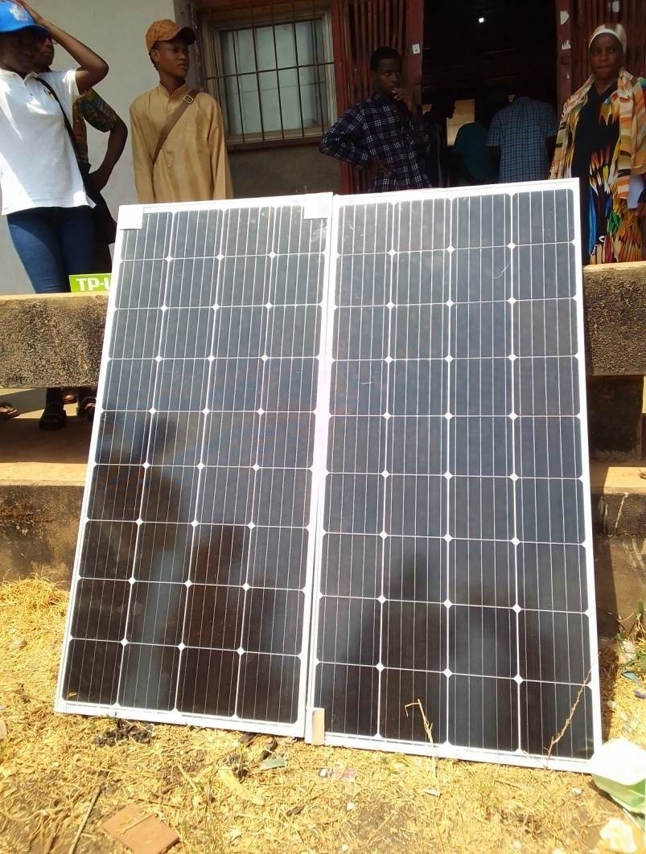
Fig. 4.1 Solar panel installation
- Series and Parallel connection of the Panel: After installing or placing the solar panel in a good location, connect the wire at the back of the solar in series and parallel form. By series connection, the positive (+) terminal of one panel is connected to the negative (-) terminal of the next one. And by parallel connection all positive (+) terminals are connected together that is positive to positive and all the negative (-) terminals are connected together that is negative to Negative with the DC wire (6mm wire) as shown in fig. 4.2

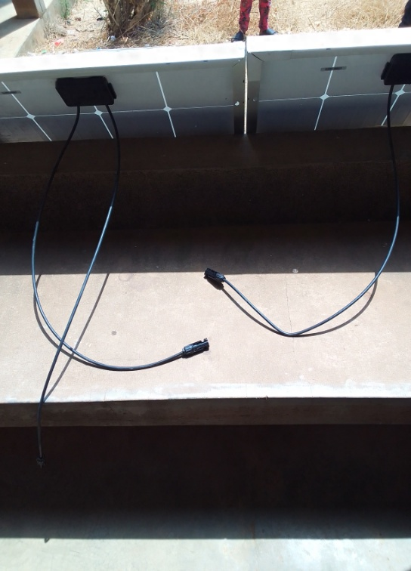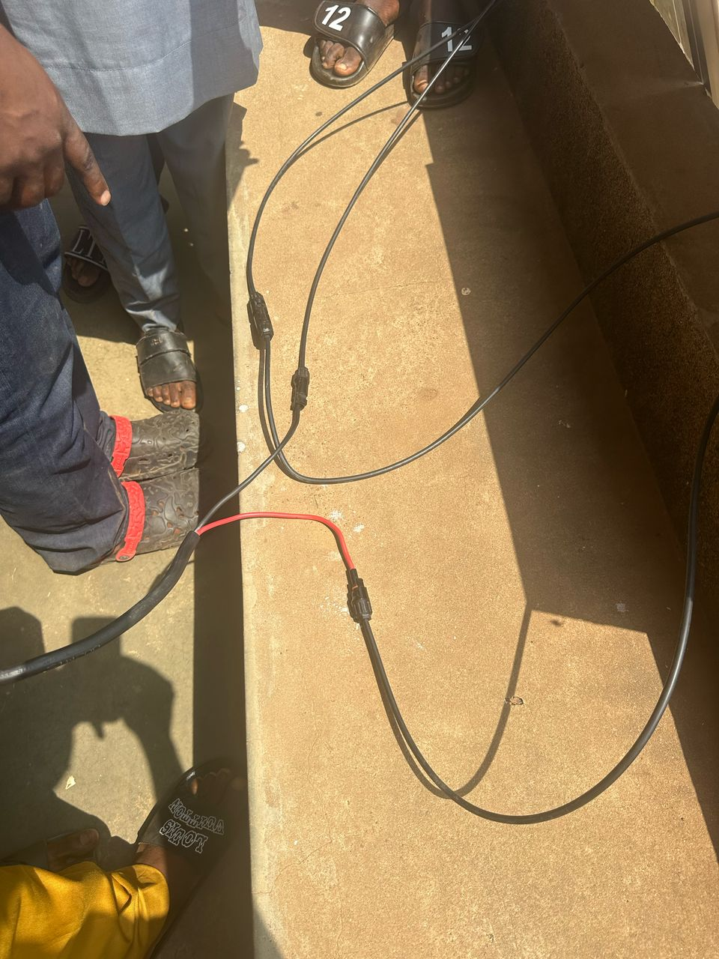
Fig 4.2 Series and Parallel connection of the solar Panel
- Connection of Solar Panel to Charge controller: After the solar panel installation, the next thing is to connect the node of the DC wire to the charge controller in their corresponding pattern positive node to positive and negative node to negative. As shown in figure 4.3
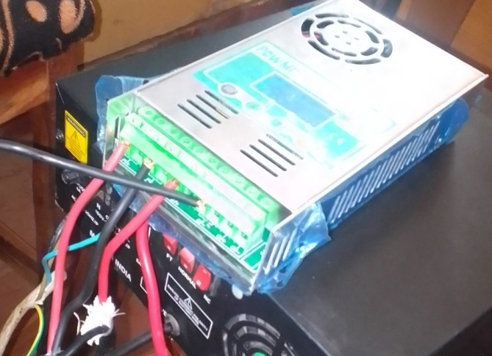
Fig 4.3 Connection of Solar Panel to Charge controller
    - Power Management Setup:
The solar charge controller and battery bank were installed and configured to regulate power flow and store excess energy. The system was calibrated to ensure a stable power supply for the electronic components.
- Charge controller and Battery Connection: Once the solar panels have been connected together in series and parallel form the next thing is to do is connect the charge controller to the battery, so that the energy coming from the solar panel can be well regulated so as not to overcharge the battery as shown below in fig 4.4.

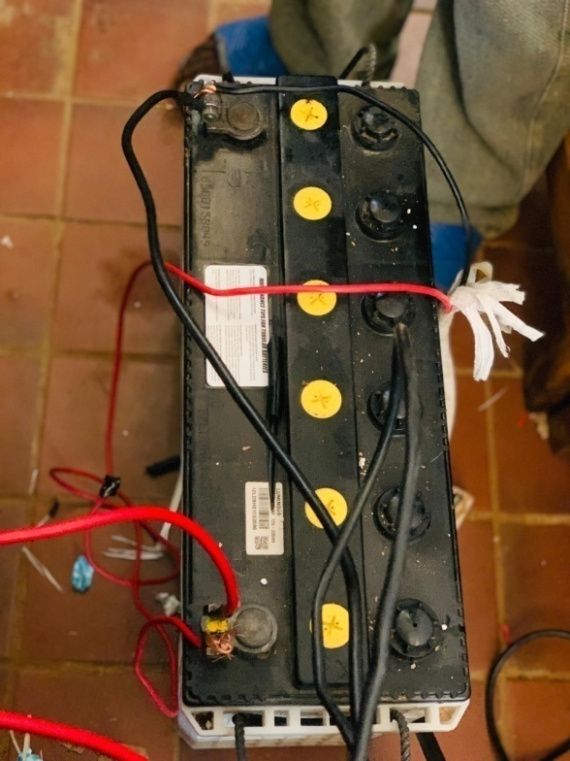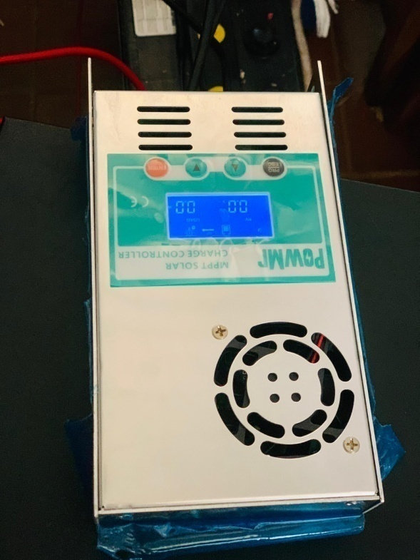
Fig 4.4 Charge controller and Battery connection
- Inverter and Battery Connection: After connecting the charge controller to the battery, the next thing to do is connect the inverter system to the battery. The work of the Inverter is to covert the current from the battery from DC to AC as shown in fig. 4.5
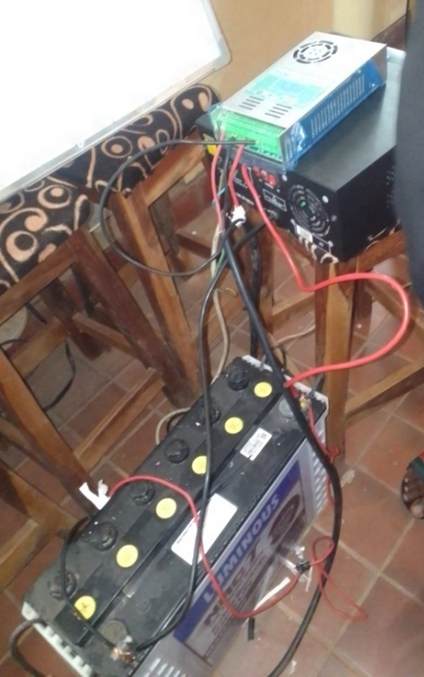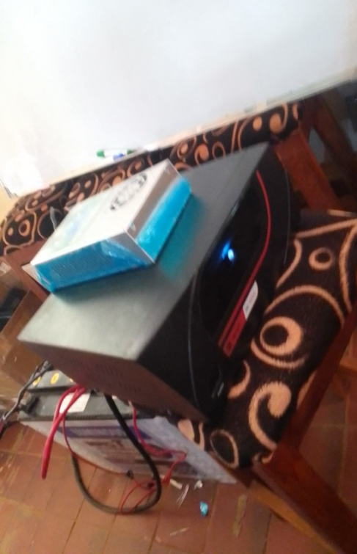
Fig 4.5 Inverter and Battery Connection
- Power Output Connection: Once the inverter is connected you can proceed to plug in devices, like your extension box, adaptors, and power box as shown in fig. 4.5 below
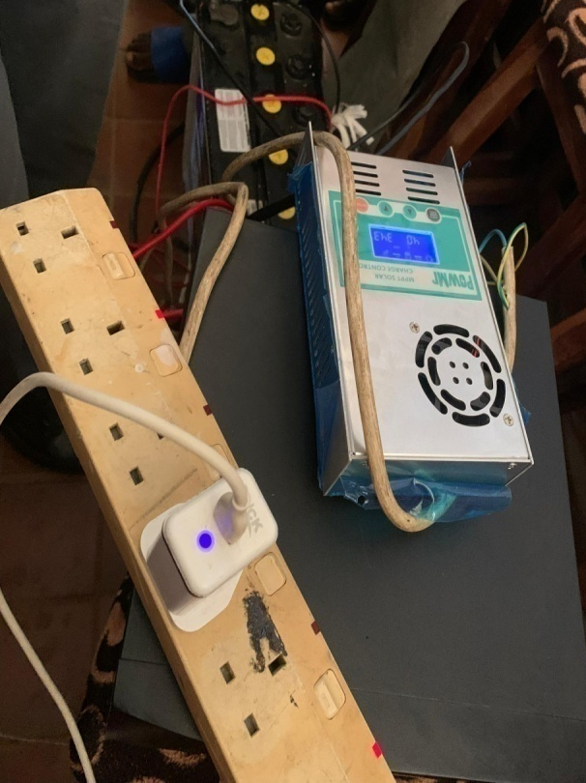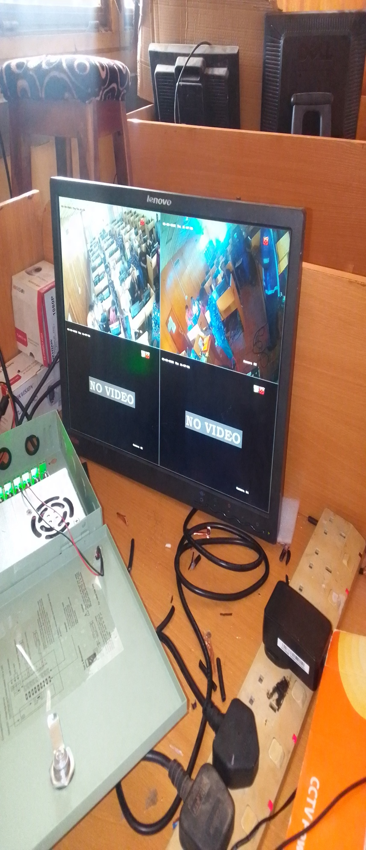
Fig. 4.6 Power Output Connection

  - CCTV SURVEILLANCE SYSTEM SETUP
- CCTV Camera Installation: Cameras were placed to provide comprehensive coverage of the examination hall, and sensors (temperature, light, and motion) were strategically positioned.
As showed in figure 4.1.3

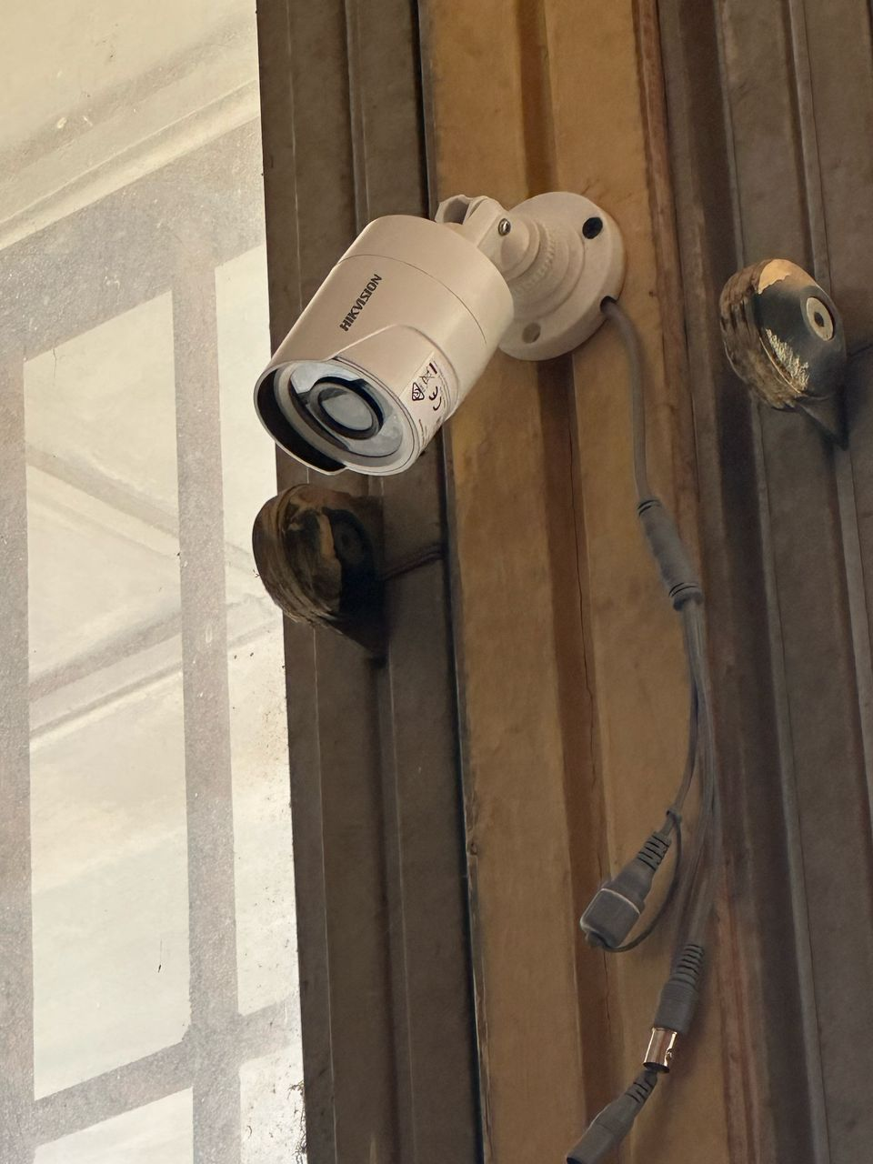

Figure 4.7 CCTV Camera Installations

- Running Cables: After mounting the camera in your preferred location, the next thing is to run your cables (both power and video cable) from the camera to DVR, Monitor and power box as showed in fig 4.8

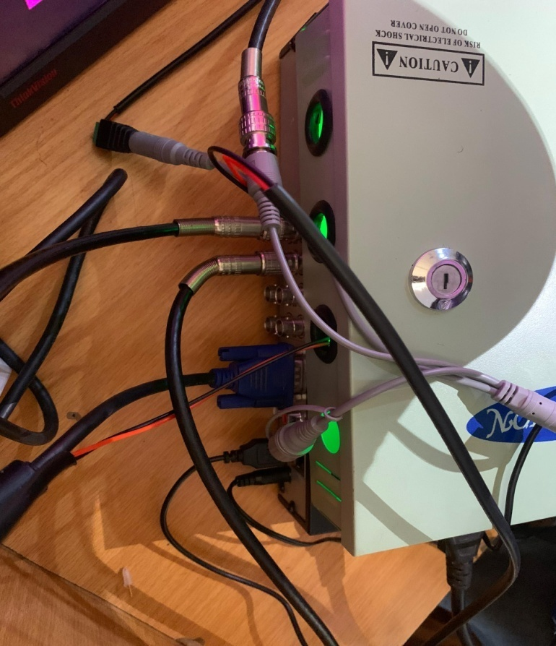
Figure 4.8 Running Cables
- Network Infrastructure: A dedicated Wi-Fi network was established to facilitate seamless data transmission between the monitoring devices and the central server.

System Testing:
  - Power System Testing: The solar power system was tested under varying sunlight conditions to evaluate its performance and ensure a stable power supply.
  - Monitoring System Validation: The cameras and sensors were tested to verify their accuracy and reliability.
  - CBT Examination Simulation: Pilot CBT examinations were conducted to evaluate the overall system performance and identify any potential issues.
  - OUTPUT RESULT OF THE SYSTEM

The evaluation of the system yielded the following results:

    - Solar Power System Performance:

- Consistent Power Supply: The solar power system provided a reliable and uninterrupted power supply throughout the examination period. The battery backup effectively compensated for fluctuations in sunlight.
- Energy Efficiency: Through careful observation during the installation process we accounted the system's ability to generate sufficient power to meet the energy demands of the examination hall. The system's power consumption was monitored to ensure efficient energy utilization.

    - Monitoring System Effectiveness:
- The real-time monitoring dashboard provided clear and comprehensive visibility of the examination hall.
- Comprehensive Surveillance: The CCTV cameras provided clear and detailed video footage, enabling effective surveillance of the examination hall as shown in fig 4.3.2

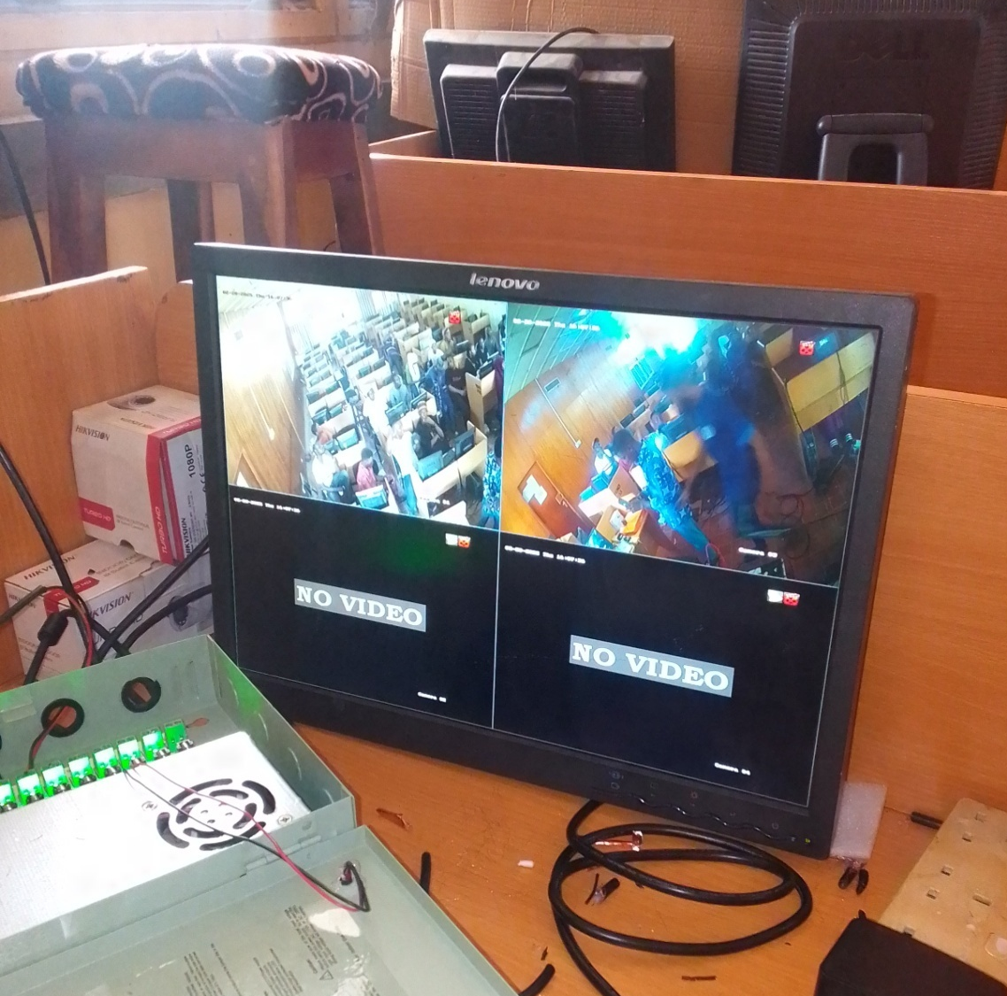

Fig 4.3.2 CCTV Camera Output
- Accurate Sensor Readings: The sensors accurately captured environmental parameters, providing valuable insights into the examination environment.
4.4 Conclusion
The Smart Solar-Based CBT Examination Monitoring System successfully demonstrated its ability to provide a reliable and efficient solution for monitoring examination activities. The system's integration of solar power, sensor networks, and data visualization tools enabled real-time monitoring and anomaly detection, enhancing the security and integrity of the examination process. The results obtained from the system's deployment and testing validated its performance and potential for wider adoption in educational institutions.

CHAPTER FIVE
SUMMARY, CONCLUSION, AND RECOMMENDATIONS
This chapter provides a concise summary of the project, draws conclusions based on the findings, and offers recommendations for future improvements and applications of the Smart Solar-Based CBT Examination Monitoring System.
5.1 SUMMARY
This project focused on the installation and implementation of a Smart Solar-Based CBT Examination Monitoring System. The primary goal was to create a reliable, sustainable, and efficient system for monitoring Computer-Based Test (CBT) examinations, enhancing security, and ensuring fairness in the conduct of the exams. The system integrated solar power system, CCTV surveillance system and a monitoring screen, Power box and DVR for transmitting records. This project is also an innovative solution aimed at enhancing the integrity, efficiency, and accessibility of Computer-Based Test (CBT) examinations, particularly in regions with unreliable power infrastructure. Leveraging renewable energy and intelligent monitoring technologies, this system addresses critical challenges faced by educational institutions and examination bodies in conducting secure and seamless digital assessments.
The under listed are some of the core problems the system addresses
- Unstable Power Supply: Frequent power outages disrupt examinations, leading to lost time, data corruption, and increased stress for candidates and administrators.
- Examination Malpractice: Cheating remains a significant concern, requiring robust and automated monitoring mechanisms.
- Manual Monitoring Inefficiencies: Human invigilators can be overwhelmed, leading to missed infractions and inconsistencies.
- Environmental Impact: Reliance on generators for backup power contributes to noise pollution and carbon emissions.
- Accessibility in Remote Areas: Lack of reliable power hinders the establishment of CBT centers in underserved communities
The proposed system will typically comprise the following key components:
- Solar Power Subsystem: Solar panels, charge controllers, inverters, and battery banks to provide a stable and sustainable power source.
- CBT Server and Client Computers: Standard CBT infrastructure for delivering the examinations.
- Smart Monitoring Devices: High-resolution cameras (for facial recognition and eye tracking), and monitoring of every activity before, during and after the exams.
- Networking Infrastructure: Wired or wireless network to connect all components and ensure seamless data flow.
- Database: To store examination data, candidate profiles, monitoring logs, and incident reports.
Expected Outcomes and Benefits:
Successful implementation of this project is expected to yield significant benefits, including:
- Increased Examination Integrity: Significant reduction in examination malpractice through proactive and automated monitoring.
- Enhanced Operational Efficiency: Streamlined examination administration and reduced reliance on manual invigilation.
- Uninterrupted Examinations: Elimination of disruptions due to power outages, ensuring a smooth testing experience.
- Cost Savings: Reduced operational costs associated with generator fuel and maintenance.
- Environmental Friendliness: Promotion of sustainable energy practices.
- Improved Accessibility: Facilitation of CBT centers in remote and underserved areas.
- Data-Driven Insights: Collection of valuable data for post-examination analysis and continuous improvement of examination processes.
The system was successfully implemented and tested, demonstrating its ability to enhance examination security and efficiency.
5.2 CONCLUSION
The Smart Solar-Based CBT Examination Monitoring System achieved its core objectives. The integration of solar power provided a reliable and sustainable energy source, reducing reliance on the grid and ensuring continuous operation. The CCTV surveillance system effectively monitored examination activities and environmental events, providing valuable real-time footage for security reasons and fairness in monitoring the examination.
The system's Installation and implementation highlighted several key benefits:
- Enhanced examination security through real-time monitoring and detection.
- Improved environmental monitoring, ensuring conducive examination conditions.
- Sustainable and cost-effective power supply through solar energy.
- Efficient data logging and reporting capabilities.
5.3 RECOMMENDATIONS
Based on the project's findings and limitations, the following recommendations are made:
- Optimization of Power Management: Implement advanced power management algorithms to maximize efficiency and ensure continuous operation during periods of low sunlight.
- Enhancement of Wireless Communication: Explore and implement more robust wireless communication technologies to improve signal strength and range, especially in large examination halls.
- Cost Reduction Strategies: Investigate cost-effective hardware alternatives and optimize system design to reduce implementation costs.
- Scalability Testing and Improvement: Conduct thorough testing to ensure the system's scalability for larger examination halls and multiple examination centers.
- Integration of Advanced Analytics: Integrate machine learning and artificial intelligence algorithms to automate anomaly detection and provide more insightful data analysis.
- Mobile Application Development: Develop a mobile application to enable administrators to monitor examinations remotely.
- Long-Term Data Analysis: Implement long-term data analysis to identify trends, improve security protocols, and optimize examination conditions.
- User Training and Support: Provide comprehensive training and support to ensure effective utilization of the system by administrators.

References
Agwi, U. C., Irhebhude, M. E., &Ogwueleka, F. N. (2021).Video surveillance in examination monitoring.SECURITY AND PRIVACY, 4(2). https://doi.org/10.1002/spy2.144
Aimiuwu, M. A., &Bosah, I. P. (2020).Use of Closed Circuit Television (CCTV) for Ensuring Quality Learning and Internal Policing in Early Years Centers. In JECAPE (Vol. 2, Issue 2). https://journals.unizik.edu.ng/index.php/jecape

Eziechina, A. M., Ugboaja, U. C., &Esiagu, U. E. (2017). Closed-Circuit Television Surveillance: An Antidote To Examination Malpractice in High Institutions In Nigeria. American Journal of Engineering Research (AJER), 6, 247–251. www.ajer.org

Godwin, D. P., Bala, M., &Habib, A. (2018).Design and Analysis of an Electronic Platform for Examinations.OALib, 05(11), 1–10. https://doi.org/10.4236/oalib.1104919

Henry, O. N. (2016). A MODEL OF UNIVERSITY EXAMINATION MONITORING SYSTEM.In IJRDO-Journal of Computer Science and Engineering.

Okorodudu, F. O., &Izakpa, G. E. (2023).ICT-TOOLS BASED EXAMINATION MONITORING SYSTEM; THE DELTA STATE UNIVERSITY EXAMPLE (Vol. 38, Issue 1).

OlayiwolaUsman, K., Olaleye, S., &BabatundeOlaleye, S. (2022). To cite this article: Kamoru OlayiwolaUsman, Solomon BabatundeOlaleye. Effect of Computer Based Test (CBT) Examination on Learning Outcome of Colleges of Education Students in Nigeria. Mathematics and Computer Science, 7(3), 53–58. https://doi.org/10.11648/j.mcs.20220703.14

Ray MCA Student, A., &Bhopen Singh Assistant Professor, O. (2024). Green Energy for Smart Security Cabin Using Solar Panel. In IUN Research Journal Peer-Reviewed Open Access Journal (Vol. 1, Issue 1).

Sarjiyus, O. (2019). Securing Computer Based Testing (CBT) System for Tertiary Institutions in Nigeria. Asian Journal of Research in Computer Science, 1–16. https://doi.org/10.9734/ajrcos/2019/v3i330094

Tripathi, S. L., Alvi, A., Subramaniam, U., Kumar Ramu, S., Christopher, G., Irudayaraj, R., & Elango, R. (2020).An IoT-Based Smart Monitoring Scheme for Solar PV Applications.

