DESIGN AND IMPLEMENTATION OFSMART SOLAR-BASED CBT EXAMINATION MONITORING SYSTEM

By
ARIBIDO PETER ENIOLA
HND/23/COM/FT/0178

A PROJECT SUBMITTED TO THE
DEPARTMENT OF COMPUTER SCIENCE,
INSTITUTE OF INFORMATION AND COMMUNICATION
TECHNOLOGY.
KWARA STATE POLYTECHNIC, ILORIN.

IN PARTIAL FULFILLMENT OF THE REQUIREMENTS FOR THE AWARD OF HIGHER NATIONAL DIPLOMA (HND) IN COMPUTER SCIENCE

June, 2025
CERTIFICATION
This is to certify that this project was carried out byARIBIDO PETER ENIOLA with Matriculation Number HND/23/COM/FT/0178, It has been read and approved as meeting part of the requirements for the award of Higher National Diploma in Computer,in the Department of Computer Science, Institute of Information and Communication Technology (IICT), Kwara State Polytechnic, Ilorin, Kwara State.

_________________________ _________________________
DR. AGBOOLA M.O (PhD) Date
Project Supervisor

_________________________ _________________________
F. S. OYEDEPO Date
Head of Department

_________________________ _________________________
External Examiner Date

DEDICATION
This project is dedicated to Almighty God, the owner and giver of wisdom, knowledge, and understanding, the sustainer of life, and God of the universe. Thanks to Him for sparing my life making it possible for me to pursue my education to this level successfully.
​I also give thanks to my loving and caring parents, MR. and MRS. ARIBIDO. God will let you eat the fruit of your labour in Jesus name, and to my loving and supporting sisters and brothers, I appreciate all your effort, I pray the Almighty God protection and mercy will never depart from you all. (AMEN)

ACKNOWLEDGMENT
All praise is due to Almighty God for His grace, guidance, and strength throughout the course of this project. I am profoundly grateful to numerous individualswhose support and contributions were vital to the successful completion of this work.
Foremost, I extend my sincere appreciation to Dr. AGBOOLA M.O (PhD)., whose exceptional guidance, expertise, and unwavering support were instrumental in navigating the complexities of this research. His valuable insights and constructive feedback greatly shaped the direction and quality of this project.
I am deeply thankful to my parents, Mr. and Mrs. ARIBIDO, for their constant encouragement, prayers, and moral support throughout this journey. Their words of wisdom and emotional backing kept me focused and motivated during challenging periods. My heartfelt appreciation also goes to my entire family and friends, whose patience and uplifting presence provided strength and inspiration at every stage of this endeavor.
I would also like to acknowledge the Head of the Department of Computer Science, Mr. Oyedepo F. S., along with other dedicated staff members of the department. Their insightful critiques and academic support were invaluable in refining the scope and content of this work.
Lastly, I am sincerely grateful to all the participants and respondents who willingly provided their time, data, and perspectives for this research. Their contributions played a crucial role in the empirical validation and practical relevance of this study.

ABSTRACT
This research presents the design and implementation of a Smart Solar-Based Computer-Based Test (CBT) Monitoring System aimed at mitigating examination malpractices in institutions where irregular power supply affects effective invigilation. Leveraging solar energy as an alternative power source, the system integrates Closed-Circuit Television (CCTV) cameras with photovoltaic (PV) modules, batteries, a charge controller, and an inverter to ensure uninterrupted monitoring during examinations. The study addresses the growing demand for sustainable and technologically advanced methods in examination supervision, especially in settings prone to electricity failure. The literature review underscores the importance and viability of solar-powered systems in various monitoring and surveillance applications. The methodology outlines the technical installation procedures for both the solar and CCTV components, including wiring configurations and component selection. The implementation phase validates the system’s functionality through successful real-world deployment, demonstrating stable performance and reliable video capture throughout exam periods. Conclusively, this system provides an environmentally friendly, cost-effective, and efficient solution to examination malpractice challenges and is recommended for broader institutional adoption in educational facilities.

Keywords:Photovoltaic(PV) Modules, Closed-Circuit Television (CCTV) cameras, A charge controller, Batteries, Inverter, Examination Malpractices.

TABLE OF CONTENT
Title Page i
Certification ii
Dedication iii
Acknowledgment iv
Abstract v
Table of Contents vi
CHAPTER ONE:
GENERAL INTRODUCTION
1.1 Background of the Study 1
1.2 Statement of the Problem 2
1.3 Aims and Objectives 2
1.4 Significance of the Study 3
1.5 Scope of the Study 3
1.6 Organization of the Study 3
1.7 Definition of Terms 4
CHAPTER TWO:
LITERATURE REVIEW
2.1 Review of Related Views 5
2.2 Review of General Texts 8
CHAPTER THREE: METHODOLOGY
3.1 Solar System Installation 13
3.1.1 Installation procedure for solar system 15
3.2 CCTV Installation 16
3.2.1 Installation procedure for CCTV 19
CHAPTER FOUR:
DESIGN AND IMPLEMENTATION OF THE SYSTEM
4.1 Design OfThe System 20
4.2 Implementation of the system 20
CHAPTER FIVE:
SUMMARY, CONCLUSION AND RECOMMENDATIONS
5.1 Summary 32
5.2 Conclusion 32
5.3 Recommendations 33
References 34

CHAPTER ONE
GENERAL INTRODUCTION
1.1 BACKGROUND TO THE STUDY
Solar Energy is best promising natural - renewable energy source for a green future, it has a lesser ecological impact as compared to other usual energy sources (Isha M et al., 2019). Electrical power plays an important part in the lives of countries today. Electricity can now be said as the lifeblood of today’s businesses, households, and forms of communication. Without it, we won’t be able to run our digital gadgets, computers, mobile communication devices and other things that depends on the electrical power. (Aris et al., 2021) In relation to electrical power, the high cost of using at home or in businesses has spurred a new growth in the power industry. Solar Power is mostly implemented by household owners to alleviate fluctuating prices of electricity (Aris et al., 2021) Solar Energy is the most abundant source of energy in the world. Solar Energy is not only an answer to today’s energy crisis but also an environmental friendly form of energy. Photovoltaic Generation is an efficient approach for using the solar energy. It’s a renewable energy source that can be harnessed using photovoltaics(PV): Solar Panels use PV cells to absorb sunlight and create electrical charges that flow. PV panels can be used on rooftops, or large solar farms. Components of solar panels include; Solar Panels, Photovoltaics Cells, Batteries, Inverters, One Charger Controller, DC breaker, Box Controller, etc.
The World is now in the fourth generation of industry revolutionaries (the 4.0 industrial revolution). The use of computers is used in education department in the last few decades. Computers are used in education from presenting the lesson to student examination (Agnes, et al., 2018). Computer Based Testing (CBT) has emerged as one of the recent “innovative” approaches to assessments most pursued by states. CBT is lauded as the answer to having speedier test delivery for state and district-wide assessments. CBT is the effective solution for a evaluation change in education. CBT has so many advantages,so made the CBT getting noticed and become interested to use in evaluation and all over the world (Agnes, et al., 2018). The use of CBT is an attempt to overcome these limitations and go some way to make course and assessments more interesting and useful processes for both teachers and students. The use of CBT can improve the efficiency and profitability of a academic institutions. It reduces the cost of stationeries and labour involved in conducting examination manually (Agnes, et al., 2018).
The use of CCTV (Closed Circuit Television) Surveillance cameras in public and private schools is only novel in more urban and modern areas in Nigeria. Most Tertiary Institutions are using it as alternatives in curbing examination malpractices and other examination ethic related offences (Aimiuwu, Bosah, et al., 2020). Base on the findings of this study, the sooner the uses of CCTV surveillance cameras becomes relevant, the better of our early years education system. It is also used as providing safety or security of properties and others. It should also be used in supervision of instruction and other essential educational or pedeagogical practices in every tier of education (Aimiuwu,et al., 2020). With this, use of CCTV surveillance cameras will help to ensure internal policing and quality care-giving.
With this comes the idea of Smart Based Solar CBT Monitoring System with a design and aim to use solar energy to be able to record every students taking the CBT examination that moment if the power supply that is powering the CCTV surveillance cameras goes off to make sure the exams are problem free.
1.2 STATEMENT OF THE PROBLEM
The Solar Based CBT Monitoring System; it is a type of system where the students writing examinations are being monitored to make sure the examinations is well conducted.
The problem of the current system is that the use of CCTV surveillance cameras over the years with inadequate power supply in the CBT examination centres has caused so many malpractices.
1.3 AIMS AND OBJECTIVES OF THE STUDY
This research is aimed at designing and implementing of Solar Power CBT Examination Monitoring System with the objectives of;
1.Installation of solar panels, surveillance cameras and inverter for the monitoring of the CBT examination centre.
2. Connecting the installed solar panels with batteries.

1.4 SIGNIFICANCE OF THE STUDY
The study is intended to benefit the following:
1. INVIGILATORS: The invigilators does not need to keep walking around and searching the students if he/she comes in with malpractices chips. The monitoring system (CCTV) is designed to help the invigilator watch over the students and help him notice any students engaging in malpractices. It would also help in ensuring the safety and security of the students in the CBT centres so the examination can be well conducted.
2. STUDENTS: Since the monitoring system (CCTV) would be able to pinpoint anyone or the root cause of the malpractices, it would help the students to be able to study well against the upcoming examination so as to not to be caught during the examinations. With the students knowing they won’t be any form of communication within themselves or carry out any form of malpractices during the exams would help them to always study hard so they can be well prepared for any upcoming examinations.
1.5 SCOPE OF THE STUDY
The scope of the study will encompass the CBT examination centre for computer science and Examination Halls for Computer Science.
1.6 ORGANIZATION OF THE STUDY
This paper is organized consisting of theses sections:
Chapter One discusses the Introduction, Aims and Objectives, Statement of the Problem, Significance of the Study, Scope of the Study, Organization of the Study, Definition of Terms.
Chapter Two discusses the Literature Review, Review of related view, Review of General View and other literatures.
Chapter Three discusses the Methodology, Discussion on existing system, Discussion on proposed system.
Chapter Four discusses the Results, Discussions of the result.
Chapter Five discusses the Summary, Conclusion and Recommendation and lastly, the References used in writing this paper.

1.7 DEFINITION OF TERM
Keywords: Solar Energy, CBT examination, CCTV Surveillance Cameras, Examination, Charge Controller, Battery, PTZ Cameras, Examination Malpractice, DVRs, Monitor.
Solar Energy: It is a renewable Energy source that harnesses the power of the sun’s rays to generate electricity or heat.
CBT Examination: A CBT (COMPUTER BASED TEST) Examination is a type of assessment that uses a computer to administer and score the test.
CCTV Surveillance Cameras: It is used to monitor and record activities in a specific area.
Examination: An Examination is a formal assessment of a person’s knowledge, skills, or abilities in a particular subject or field.
Charge Controller: Charge Controller optimize energy harvesting from solar panels and prevent over-charging or over-discharging of batteries.
Battery: Batteries provide backup power during outages or emergencies. Batteries stores
excess energy generated by solar panels.
PTZ Cameras: Pan-Tilt-Zoom (PTZ) where pan means rotate, Tilt means to move the lens up and down and zoom to zoom in or out in a part of image you are trying to capture. These are camera that can move, they are programmable and are manually controllable.
Examination Malpractice: It refers to any behaviour or action that comprises the integrity of an examination or assessment, including cheating, plagiarism, or other forms of academic dishonesty.
DVR (DIGITAL VIDEO RECORDER): It is an electronic device that records video footage from cameras or video sources in digital format.
MONITOR: The Monitor is a device which will take the video image and the outputs of it on the screen. A captured video or an image can be viewed on the monitor.

CHAPTER TWO
LITERATURE REVIEW
2.1 REVIEW OF RELATED VIEWS
Several researches have been directed towards the development of a fast and efficient way of monitoring students writing exams without laxity. Some of the research carried out and the views of several writers concerning the development of Solar-Powered CBT Examination Monitoring System orother related are as follows
Sindhu, Mallegowdaand Kanavalli (2019) worked on the research Lot based Solar Powered Irrigation System and Farm Monitoring. The aims and objectives of this research is that the technology should be user friendly which is reasonable in price as well as it should be efficient. It is developed to eliminate the problem faced in existing system. In a paper, mobile integrated smart automated irrigation scheme which includes soil and temperature sensors. The principle objective of the framework is to manage the water and take care of plants without human nearness and get the state of motor and the temperature status on mobile. The Methodology of the research is that the system consists of three sensorsi.e soil moisture sensor, luminosity sensor and temperature sensor. The soil moisture sensor senses the moisture content from the field. Luminosity sensor determines the light intensity on the plant. The Temperature sensor senses the temperature from the earth. Every sensor is structured so that it ought to have the threshold value which is acquired in an experimentation premise. The Gap of the research is that it has limited discussion on durability in extreme weather conditions. The study lacks detailed cost analysis and scalability for large scale farming. The findings of the research is that the system provides an automated irrigation which helps in analysing moisture level of the soil. The Recommendation of the research is that alarm framework can be utilized so as to alarm the farmers if the arise an occurrence of any abnormal activities. The Conclusion of the research is that the project is for farmers where they do not have the enough idea that how much amount of water is needed for theсгор.
Shirbhate and Barve(2019) did research on Solar Panel Monitoring and Energy Prediction for Smart Solar System. Solar Energy is the best promising natural-renewable energy source for a green future, it has a lesser ecological impact as compared to other usual Energy sources. The aims and objectives of this research is to develop a real time Solar panel Monitoring system for more energy utilisation; and to develop a prediction model for Solar energy management procedure. To develop a smart solar plant system, it is essential to get accurate PV(Photovoltaic) power forecasting results for efficient energy management. The methodology of the research is divided into 2; Monitoring system, it measures and displays the collected data by sensors and Solar Panels. It monitors temperature, humidity and generates Solar Power using smart devices. Prediction system, it works on historical data of Solar power collected by Monitoring system. There are six distributed Solar plants, one single panel with 315 Watts peak capacity and whole solar system having 435KW capacity. The system added with irradiance sensor, temperature sensor and wind speed sensor for Monitoring weather situations. The Gaps of the research is that HMM(Hidden Markov Model), which contains hidden variables, the challenges is to determine which sequence is underlying source of some sequence of observations. The findings of the research is that the designed system monitors panel level and anticipates error findings. We can analyse the weekly or monthly performances of panels. The Recommendations of the research is that Numerical Results shows that the proposed model achieves better Prediction accuracy than the simple Linear Regression Model. The Conclusion of the research is that Solar Energy is trustworthy and sustainable hence, the utilisation of this smart solar system is reliable, adequate and cost efficient.
Ignacio(2021) did research on a Study on the Implementation of a Monitoring System to Solar Powered Houses. Solar Power is mostly implemented by household owners to alleviate fluctuating prices of electricity and sometimes even going off-grid as to not depending on corporate subscriptions to power distributors. The specific objectives of this study is that, it monitors the health on most parts of the power system, if not all; provides statistics on the performance rating of the entire system. The Aim of the study is that the owner does not need further technical know-how on diagnosing Solar Panel setup and configuration problems and estimated fault spots. The Methodology of the Study, is that the system will include an application to draw running statistics from the inverter devices. This includes Solar Panel data, battery status information and other indicators as provided by manufacturer through their design. The problem of the study is that the components being monitored are quit limited. Including the fact that there is no suggestion from any system on which area might need to be viewed when the power supplied is inadequate. The findings of the study is that reports can be printed out and the owner can be able to compare the performance of the Solar Powe System on a daily, weekly, monthly and yearly basis. The Recommendation of the study is that future capability for the system to be accessible also even if the homeowner is far from his home. The conclusion of the study is that developing additional monitoring capabilites can be developed on top of some existing Solar power systems.
Ososanya (2015) did research on Design and Implementation of Solar Powered Smart Irrigation System. The aims and objectives of this project is to develop a system that will minimise the waste of water in an Agricultural Experiment station form. The smart system developed uses automated drip Irrigation and uses exact water required. The Methodology of this project is that the system is operated in two modes, either in a closed loop control mode where the micro controller operates the opening and closing of the solenoid valve for the required amount of water needed for the crops, based on the average soil moisture reading, or the agronomist (an expert soil management and field-crop production) remotely use the cloud data to trigger a channel by writing a specific value. The problem of the study is that weather conditions are not taken into consideration; the sub system are not able to operate in real time and remotely without human intervention. The findings of the study is that, A mobile App is developed using conduit services. Conduit is a website that allows you design a mobile app for personal or business purposes. The designed app allows users to check the status of the Irrigation project online from anywhere for as long as they have Internet access. The Recommendation of this project is that it designs a low cost power, drip irrigation system to control and reduce water waste in farming. The conclusion of this project is that, the design uses an automatic Irrigation system that can be tailored to the types of food crop being grown.
Tellawar, Chamat (2019) did a research on An IoT based Smart Solar Photovoltaic Remote Monitoring System. The aims and design of this study is to overcome the major disadvantage of electricity generation from the solar energy. The Methodology of this study is to monitor the output of the Photovoltaic(PV) system using the current and voltage value sensed by the arduino (micro controller). This system helps for efficient usage. The findings of this study is that an IoT based Monitoring will improve the energy efficiency of the system, reduce intervention and supervision time and facilitate network management. It has been proposed to collect data on important parameters of solar panels. The Recommendation of this study is that the remote Monitoring architecture for solar panels, the next step will be implement, test and achieve this IoT based system in order to obtain a reliable and secure system which allow data collection in real time.
2.2 REVIEW OF GENEREAL TEXTS
Manurung, Fildzah, Rajagukguk (2018) did a research on Computer Based Test (CBT) system for Student Academic Examination. CBT is the effective solution for a evaluation change in education (Piech and Gregg, 2018). CBT has many advantages, so made the CBT getting noticed and becomes interested to use in evaluation and education in all over the world. The Aims and Objectives of this research is to create and to know how to make CBT system for student examination and showed the effectivity of the system. The Methodology of the research was that it was conducted with some steps that is define consists of front end analysis, learner analysis, task analysis, concept analysis, specifying instructional analysis. Design consist of criteria test construction, media selection, format selection, initial design. Development consists of experts appraisal and development testing and disseminate. The instrument used to collect data was (1) CBT that has been developed with moodle software, (2) Instrument test, (3) CBT validation, (4) Test Validation, (5)Questionnaire for students, (6) the list of interview for students. The techniques to collect the data was observation, Questionnaire and interview. The findings of the research work should accommodate theory based questions as opposed to only that the CBT system currently accommodates. The Recommendation of the research work is that provision for video based e-assessment can be investigated. The Conclusion of the research is that a CBT is developed and proposed for students. The information system is an online examination system that delivers questions by the teacher to the students and generates the reports of the results of the students who take the examination as well as overall examination result summary based on the user's account.
Izuka,Bakare, Olurin,Ojo, Lottu (2023) did a research on Unlocking Solar Power for Surveillance: A Review of Solar Powered CCTV and Surveillance Technologies. The aim of this research is that these systems operate autonomously, relying on sunlight to generate electricity. The objective is to provide an all encompassing understanding of these innovatives systems, encompassing a spectrum of devices ranging from solar charged closed circuit Television (CCTV) cameras to Solar-Powered drones and sensor networks. The Methodology of the research work is that the system consists of technologies which can be broadly categorised into Solar-Powered CCTV cameras, drones and sensor networks. The Solar-Powered CCTV cameras have seen significant advancements in recent years. The system typically consists of a solar panel array, a charge controller, a battery bank, and high definition cameras. The Solar Panel Captures Sunlight and convert it into electricity (Hosenuzzaman et al., 2015). They are stored in the battery bank for continuous camera operations, even during night tile or cloudy conditions (Abas et al., 2018). The Solar-Powered drones also known as solar drones or solar UAVs (Unmanned Aerial Vehicle), represents a novel application of solar energy in surveillance. These drones are equipped with Photovoltaic panels on their wings or fuselage, allowing them to recharge their battery flight or in standby mode. They can fly for extended periods, covering large areas and collecting real time data without the need for frequent recharging or landing. The Solar-Powered sensor networks are gaining traction in surveillance. These networks comprises a multitude of sensors, such as motion detectors, environmental sensors, and acoustic sensors, powered by solar panels and equipped with wireless communication capabilities. The sensors collect data and transmit it to a central control station, enabling real time monitoring and alerting. The Gaps of this research work is that Solar-Powered Surveillance System require periodic maintenance, including cleaning of Solar panels, battery checks, and equipment inspections. In remote areas, maintenance can be logically challenging and costly. The findings of the research work is that Solar-Powered surveillance technologies offers sustainable and autonomous solutions across diverse applications for surveillance and monitoring needs. By carefully assessing these technologies; strengths, weakness, sustainability and organisation can make informed decisions to deploy the most appropriate solution for specific requirements. The Recommendation of the research work is that public-private collaboration and sustainable urban planning initiatives are expected to drive further the adoption and integration of Solar-Powered surveillance into diverse applications. In conclusion of this research work, it had explored three key Solar-Powered surveillance technologies: Solar-Powered CCTV Cameras, Solar drones, and Solar-Powered sensor networks. Each technology offers distinct strengths and weaknesses, making them suitable for a range of applications.
Aimiuwu, Mossend., and Bosah, (2020) did a research on Used of Closed Circuit Television (CCTV) for Ensuring Quality Learning and Internal Policing in Early Years Centres. The Aim and Objectives of this research is that it will assure faster achievements of the nation's curricular objectives and goals of setting up early year's education in the nations’ educational system, to use for several security measures and protection of the students. The Methodology of this research is that the study took descriptive survey design aimed at examining the impact of closed circuit Television (CCTV) Surveillance Camera for Monitoring and ensuring quality care giving I'm Early Year's centres in private Early Childhood care centres in Delta State. The study was piloted by three research questions and two hypothesis which were tested at a level of significance of 0.05. The Gap of this research is that the cost of running this advanced technology is high especially when natural phenomenon like thunder, lightning bolts and irregular power supply, cooling system for the CCTV System could obstruct it uses. Th findings of the research revealed that Closed Circuit Television (CCTV) surveillance cameras could assist Caregivers and Attendants at Early Child Care Education (ECCE) centres on their daily jobs of fulfilling curricular objectives video quality learning, policing, care-giving and evaluation geared towards developing the child's inmate intelligence. The Recommendation of the research work is that parents/guidance, early years educational providers and school proprietors, NGOs/NGAs and other relevant bodies should partner in providing CCTV surveillance cameras in every public and private (EECE) centres to monitor and ensure quality care-giving and policing of pupil's development progress. In Conclusion of this study, The Use of CCTV surveillance cameras in public and private schools is not only novel in less developed and rural areas in Nigeria. The sooner the use of CCTV surveillance cameras becomes relevant, the better of our early years education system.
Kavitha and Malachi (2019) did a research work on A Smart Solar PV (Photovoltaic) Monitoring System using IoT. The aims and objectives of this research is to determine optimal performance for better maintenance of solar PV(Photovoltaic); it is to offer a cost - effective solution which incessantly displays remote energy yields and its performance either on the computer or through smart phones. The Methodology of the research is that the real time Solar Energy Monitoring system is based on the three-layer architecture, The three stage architecture includes the Lower Layer: contains sensing and actuating devices like sensors, actuators, camera and controllers since it is a combination of sensing and processing layer. The Middle Layer which encompasses network layer with wired and wireless network like LAN, Bluetooth, Zigbee, 4G, Wi-Fi, etc acts as a gateway to route the packets (data) to the transport layer that contains TCP/IP, UDP, for further transmission of data to the upper end. The Application Layer which can store the real time data in a cloud platform for easier access, data visualisation and right decision making. The findings of the research is that it helps to predict the performance of the Solar PV module through remote access. The Recommendation of this research is that it can be extended for a large scale solar plant. In Conclusion of this research, An IoT based Virtual Solar Energy Monitoring System is developed using a low cost smart microcontroller. The cloud based Blynk application shows the measured solar parameter in real time through mobile.
Rekerako, Cotfas, Cotfas (2024) did a research work on Enhancing Security for IoT Based Smart Renewable Energy Remote Monitoring Systems. Renewable Energy sources are necessary due to rising global demand and the adverse environmental effects of burning fossil fuels. Renewable energy is produced from naturally replenishable sources such as solar radiation,wind,water flow, geothermal heat, and biomass. The Aim and Objective of this research is that it thoroughly investigates the enhancement of security measures in an IoT based solar energy remote Monitoring system. The Methodology of the research is that the architecture of this remote Monitoring system is specifically intended to efficiently and securely monitor the characteristics of solar energy, including voltage and temperature, in a solar system. In the Implementation of the security aspect of the study, two Photovoltaic (PV) parameters, namely, voltage and temperature were employed. It is worth noting that other photovoltaic (PV) parameters, such as current, light intensity, etc can also be incorporated using the same methodology. The technology offers a user friendly interface or dashboard that allows anyone to obtain real time data on the voltage and temperature of the Solar system. The Gaps of the research is that transferring data in their original, unencrypted form introduces substantial vulnerabilities into the system. An unencrypted data transmission may be useful by a malicious party, such as cybercriminal, to pose significant risks to th system's integrity and confidentiality. The findings of the research is that it demonstrates a comprehensive method to strengthen security for Smart Solar Energy Systems I remote Monitoring situations. The Recommendation of the research is that we will prioritise improving security and assessing the encryption performance, timing efficiency and overall efficacy compared to the current implementation. Moreover, other Photovoltaic (PV) parameters will be integrated I to the study. The conclusion of this research is that the study developed a new method to enhance the security of remote Monitoring systems for solar energy. It provided a user friendly dashboard, allowing real time monitoring of essential solar system data.

CHAPTER THREE
METHODOLOGY
The method of this research consists of 2(two) different parts which include the Solar System Installation and CCTV Installation;
3.1 SOLAR SYSTEM INSTALLATION
A solar energy system or a PV system is a power setup devised to supply the available solar power in the form of electricity. In this system, a solar panel is the main component. It is constructed in such a manner that it absorbs the sunlight as an energy source and uses it to supply electricity or provide heating. Solar panel has to be placed in the sun to generate electricity.
The three most common types of solar panels include; thin-film solar panels, monocrystalline panels, and polycrystalline panels that produce electricity from sunlight.
Monocrystalline cells contain pure silicon that are in cylindrical shapes. They are known as the most efficient type of solar panel in the market with a sleek appearance. To lower the cost and optimize the performance of a monocrystalline cell, four sides of the cylinder are cut out to make silicon wafers (silicon wafers are used for the fabrication of integrated circuits and, in photovoltaics, to manufacture solar cells). It allows free flow of electrons that results in high efficiency rates and must be mounted in a rigid frame to ensure protection.
Polycrystalline Cells (or multi – crystalline) cells are comprised of several small crystals called crystallite. They are of rectangular shape without having any rounded edges. These cells are less efficient and less expensive than monocrystalline cells but it is also required to be mounted in arigid frame.
Amorphous cells (thin-film) are formed by placing a thin film of non-crystalline (amorphous) silicon onto a wide range of surfaces. Due to amorphous nature, these are flexible. The panels are less efficient, require most space, and more tolerant to higher temperature. Also, they have shortest life span.
Panels are connected in some of these ways: series connected panels, parallel connected panels and series-parallel connected panels.
In series-connected panels, in case the requirement for voltage is more than that a panel can produce, then extra point is connected in series. Hence, for example, if a panel can provide 12V, then two such panels in a series connection can provide 24V. Similarly, three panels of 12V each connected in series will provide a total of 36V.
In parallel-connected panels, this is when the positive terminals of all panels are connected together and the negative terminals are connected together. When wiring the solar panels in parallel, the Amps (current) is additive, but the voltage remains the same. For example, if you had 4 solar panels in parallel and each was rated at 12V and 5amps, the entire array would be 12V and 20amps.
Battery stores the electrical charge produced by the solar panel during the day. Battery is also important because without energy storage, a solar PV system will not be able to deliver the energy to the load when there is no sunlight. Some batteries used in PV system include Lead Acid Battery, Lithium-ion, sealed Lead-Acid Battery and NickelCadium Batteries.
Lead Acid Battery is the most common battery that is used in PV applications. The name comes from the main components in the battery which are lead and sulphuric acid. These are rechargeable, can be easily replaced and maintained. The most common lead acid battery used in PV system is of Flooded Tubular Plate design, if the battery is wrongly treated, it would lead to a shorter lifetime. It offers reliable and long-lasting power for solar and hybrid energy system.
The mode of connection in batteries include series connection and parallel connection. In series connection, batteries are connected together in series when the required PV system is higher than the individual battery terminal voltage. Negative terminal of one battery is connected to the positive terminal of the other. Connecting batteries in series increases the voltage. In parallel connection, batteries connected in parallel when high current is required. The positive terminal of all batteries is connected as one and negative terminal of all the batteries are connected together as one. Connecting the batteries in parallel increases the capacity but the voltage remains the same.
Charge controller charges the battery, gives an indication when the battery is fully charged, it monitors the battery voltage. We have Pulse Width Modulation (PWM) and Maximum Power Point Tracking (MPPT) charge controller.
Pulse Width Modulation(PWM) charge controller functions by matching the panel voltage to the voltage of the battery and in the process, bring down the output voltage of the panel. It comes into action when the battery is full, once the battery reaches the target voltage, the battery is disconnected from the charge controller from the panel which ensures the efficient charging of battery and protects it from getting over charged. The Maximum Power Point Tracking (MPPT) charge controller is based on the latest technology and aims at getting the utmost benefit from the solar panel. It monitors the voltage of the battery, you can set, change time, adjust the voltage of the battery.
Charge controller must be connected between the battery and PV panels. The voltage of the battery is constantly under a check. Incorrect wiring can cause serious damage to controllers.
An Inverter convert the DC (Direct Current) voltage produced by the solar panels (and from the energy stored in the batteries) into AC (Alternating Current) voltage. It could also charge the batteries by using an alternative source such as when the generator connects to the inverter when they are available. It comes in so many voltages such as 12V, 24V, 48V, 96V, 120V and 240V. We have Hybrid and Non-Hybrid inverter. Hybrid Inverter comes with an inbuilt charge controller, it has high voltage and non-high voltage. Non-hybrid inverters do not come with an inbuilt charge controller.
3.1.1 INSTALLATION PROCEDURE FOR SOLAR SYSTEM
Arrange the photovoltaic PV modules: The solar array is usually best placed in perpendicular to the sun’s rays, which change continuously over the course of the day and season. Solar PV can also be mounted on the ground. After that, wire the panel according to the required need but weused the series connection (the voltages are added while the currents remain the same).
Charge controller: The next thing to do after the setting up the solar PV array is to connect the charge controller (is to ensure that the battery is not over-charged or over-discharged) directly from the output terminals of the solar PV. We made use of Maximum Power Point Tracking(MPPT) charge controller during connection. After the connection, we move to next step which is connecting the battery.
Battery: The batteries are properly connected either in series or parallel connection depending on your need, and then connect the battery to the charge controller at the port selected/indicated for it in solar charge controller. We used Flooded Tubular Battery during the connection. Then we connectthe inverter next.
Inverter: The next setup is the inverter, as we discussed above the inverter converts the DC supply from the solar PV into the battery to AC supply in order to power our AC loads. Connect the battery terminal to the inverter with 6mm cable. Finally, from the inverter you connect to the external load in the house. The rating of the inverter should be the same with rating of the PV array.
3.2 CLOSED CIRCUIT TELEVISION CAMERA (CCTV) INSTALLATION
Closed Circuit Television Camera (CCTV) refers to electronic monitoring systems which makes use of video cameras to capture, collect, record and relay visual information about the event of a given space over time. It is also used as providing safety or security of properties. Cameras are an essential component of any Closed-Circuit Television Camera (CCTV) system. We have some types of cameras; we have Network Cameras and Analog Cameras, Day/Night Cameras, Low Light or Night Vision Cameras. Network Cameras connects to IP based networks, including the internet and provide remote viewing and recording. Analog Cameras is a traditional surveillance camera that transmits videos signals in analog format. It uses coaxial cables.
The Closed-Circuit Television Camera (CCTV) consists of some various components which are; cables, storage, power supply, monitor/tv, cameras, router, switch, connectors, toolbox and personnel.
Wired Closed Circuit Television Camera (CCTV) systems use cables to connect cameras to other CCTV components. The three(3) types of CCTV system commonly used are coaxial cables, twisted pair cables and fiber optics cables. Coaxial Cables is the cable that is used to transmits high frequency signals. They are several types of coaxial cables designed. The common types are RG-59 which are often used for shorter distances and lower frequency applications like CCTV and RG-11 which are designed for long distance transmissions and outdoor CCTV installation services. Fiber Optics Cables can travel long distance and what transmits in it is light.
There are two main types of recorders; we have Digital Video Recorders (DVRs) and Network Video Recorders(NVRs). Nowadays, Digital Video Recorders (DVRs) or Network Video Recorders (NVRs) are used to record CCTV camera footage. Digital Video Recorders (DVRs) is where the video security cameras capturing is recorded, stored and managed. Typically, DVR's have 1 Channel, 4 Channel, 8 Channel, 16 Channels, 32 Channels and 64 Channels depending on which model purchased. It is designed for analog cameras. Network Video Recorders(NVRs) records digital video data transmitted over an IP network from multiple CCTV digital cameras. It is mostly designed for IP cameras.
Storage; either floppy disk or hard disk is a storage device which is used for storing the captured video with the use of a security camera to have it used later. These CCTV hard disks are fitted within the video recorders. So as to view the video recordings on the hard disk, it is directly connecting the DVR or NVR to monitor. We also have some storage devices; Direct Attached Storage (DAS) and Network Attached Storage (NAS).
Direct Attached Storage (DAS) is directly attached to a computer without having to go through a network. Network Attached Storage (NAS) records and access data in file format and consists of an engine that retrieves files from one or more storage devices.
The Monitor is a device which will take the video image and the outputs of it on the screen. A captured video or an image can be viewed on the monitor.
Switch is used to connect multiple devices together. We have Power Over Ethernet (PoE) switch and Non – Power Over Ethernet (Non – PoE) switch. Power Over Ethernet (PoE) is used to provide power and internet connection. It uses a single Ethernet cable to receive both power and transmits data. Non – Power Over Ethernet (Non – PoE) does not provide power over ethernet cables. They are used for data transmissions only and are often used with devices that have their own sources.
We have different types of cameras designed to perform, but cameras can be grouped into two (2) categories; fixed and pan-tilt-zoom (PTZ). Fixed/Static Cameras is positioned in order to have an image captured, typically one particular of interest. These cameras can be used indoors and outdoors. Pan-Tilt-Zoom (PTZ) where pan means rotate, Tilt means to move the lens up and down and zoom to zoom in or out in a part of image you are trying to capture. These are camera that can move, they are programmable and are manually controllable.
Lenses are available in different kinds; we have Wide Angle lens, Normal Lens, Telephoto Lens and Zoom Lens. The wide-angle lens gives you a wide field of view. The wider your field of view, the more of the scene you would be able to get. The normal lens offers a balance field of view, capturing a good mix of wide area coverage and details. The telephoto lens making it ideal for monitoring specific areas like hallways, parking lots, or entrances where you need to see details from a distance.
BNC Connectors allows you to connect your CCTV to your Digital Video Recorder (DVR). It works by using a rotating ring to securely connect two coaxial cables together.
The Closed-Circuit Television Camera (CCTV) Power Supply Box, it easily manage power to multiple CCTV cameras at a central point. It makes the camera installation to be neater.

3.2.1 INSTALLATION PROCEDURE FOR CLOSED CIRCUIT TELEVISION CAMERA
(CCTV)
We started by drilling holes for the camera brackets. We secured the camera using screws to ensure they are tightly fastened. Then, the CCTV coaxial cable is connected to the BNC connector and Power connector and then to the camera using both the power and the data connector of the camera. We made use of Pan-Tilt-Zoom (PTZ) during the installation. These are camera that can move, they are programmable and are manually controllable
The other sides of the coaxial cables were connected to the appropriate ports in the CCTV power supply box. We double checked all connection to ensure they are properly connected. Blades were used as well as pliers to fit the cables to the BNC connectors that were used.
The BNC connector is connected to the port in the Digital Video Recorder (DVR). The Digital Video Recorder (DVR) is then connected to the monitor. A mouse is then connected to the USB port in the Digital Video Recorder (DVR).
The power supply is turned on, the Digital Video Recorder (DVR) and the monitor are also turned on. Then the output of each camera was displayed in the monitor.

CHAPTER FOUR
DESIGN AND IMPLEMENTATION OF THE SYSTEM
4.1 DESIGN OF THE SYSTEM
The design of the system is the approach on how solar system was installed and how closed-circuit television camera (CCTV) was installed to perform the easy monitoring of students during examinations and also providing security for them.
4.2 IMPLEMENTATION OF THE SYSTEM
FIG 1.1 (SOLAR PANEL)
It shows the arrangements of the PV modules. It is usually placed in perpendicular towards the sun’s rays as shown below.
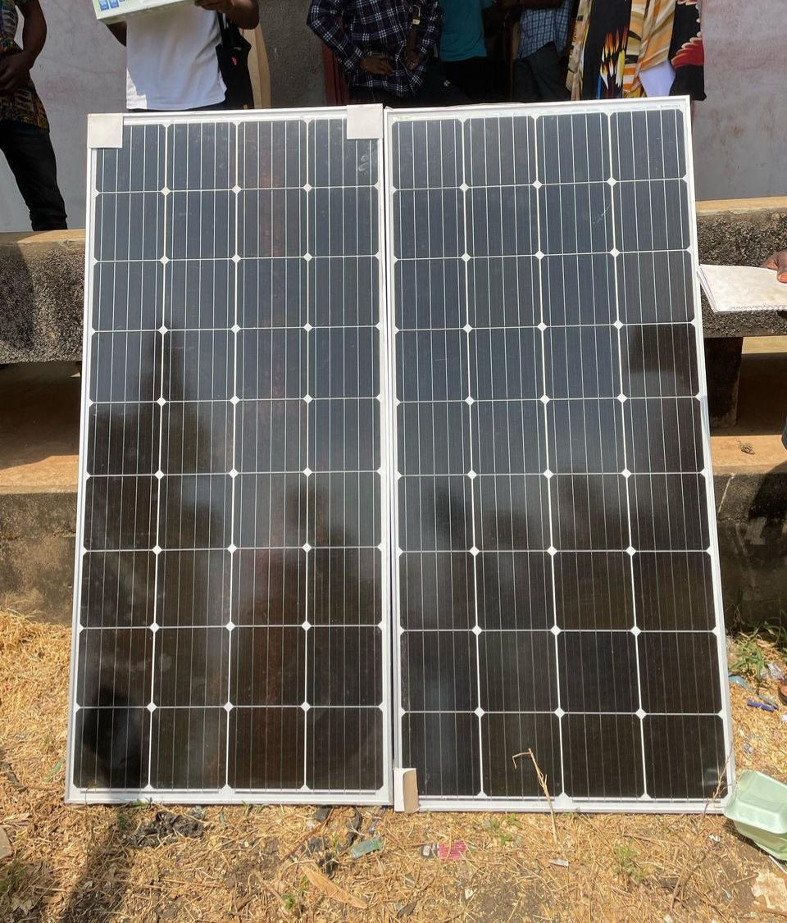

FIG 1.2 (WIRED SOLAR PANEL)
It shows how the panel was connected, series connection (the voltages are added while the currents remain the same) was used in the process as shown below.
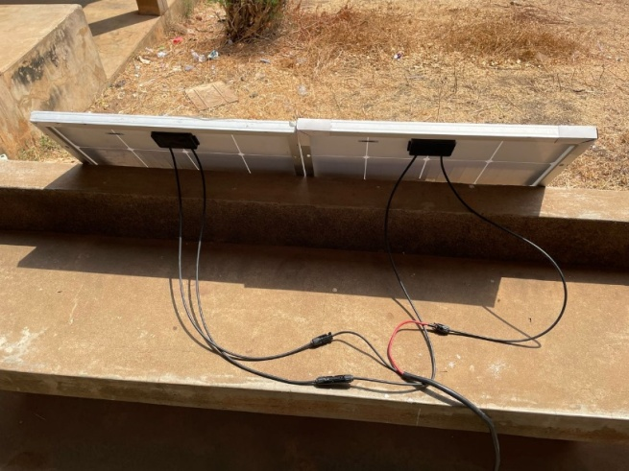

FIG 1.3 (BATTERY)
Battery stores the electrical charge produced by the solar panel during the day. We used Flooded Tubular Battery during the connection.

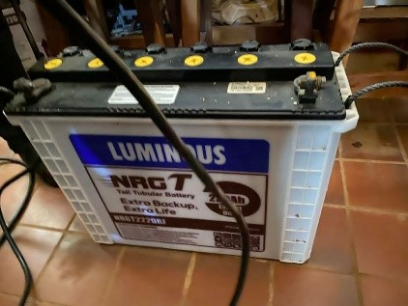

FIG 1.4 (CHARGE CONTROLLER)
Charge controller (is to ensure that the battery is not over-charged or over-discharged) directly from the output terminals of the solar PV. We made use of Maximum Power Point Tracking (MPPT) charge controller during connection as shown below.

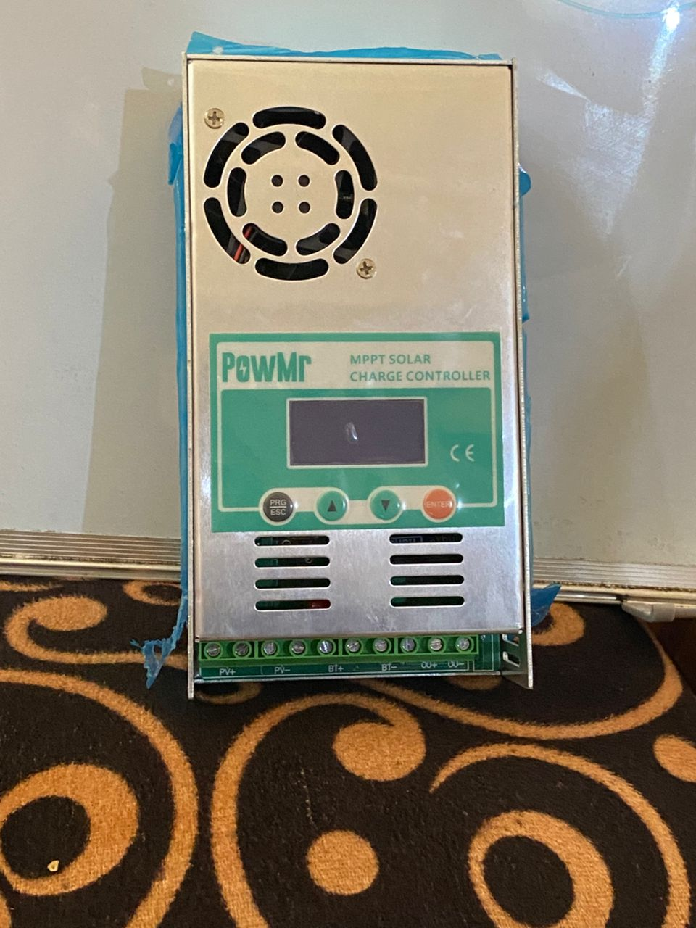

FIG 1.5 (INVERTER)
The inverter converts the DC supply from the solar PV into the battery to AC supply in order to power our AC loads.
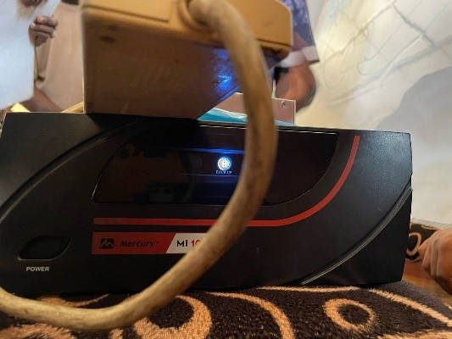

FIG 1.6 (INVERTER CONNECTION TO BATTERY)
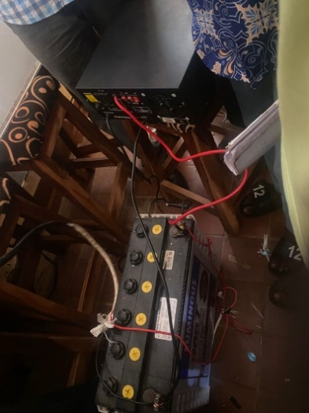
This show the connection of theinverter to the battery., from the inverter you connect to the external load in the house.

FIG 1.7 (BATTERY CONNECTION TO THE CHARGE CONTROLLER)
This shows the connection of the battery to the charge controller at the port selected/indicated for it in solar charge controller.
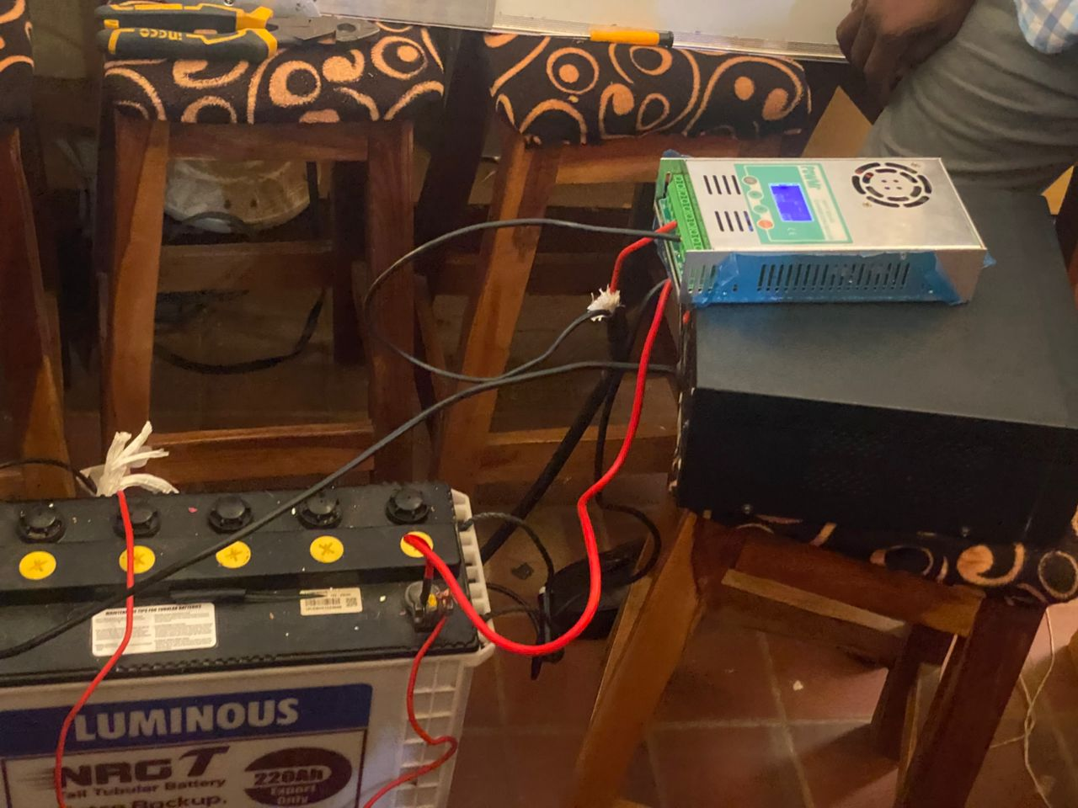

FIG 1.8 (PV MODULES CONNECTION TO CHARGE CONTROLLER)
This shows the connection of the PV modules to the charge controller and the connection of battery to the charge controller.
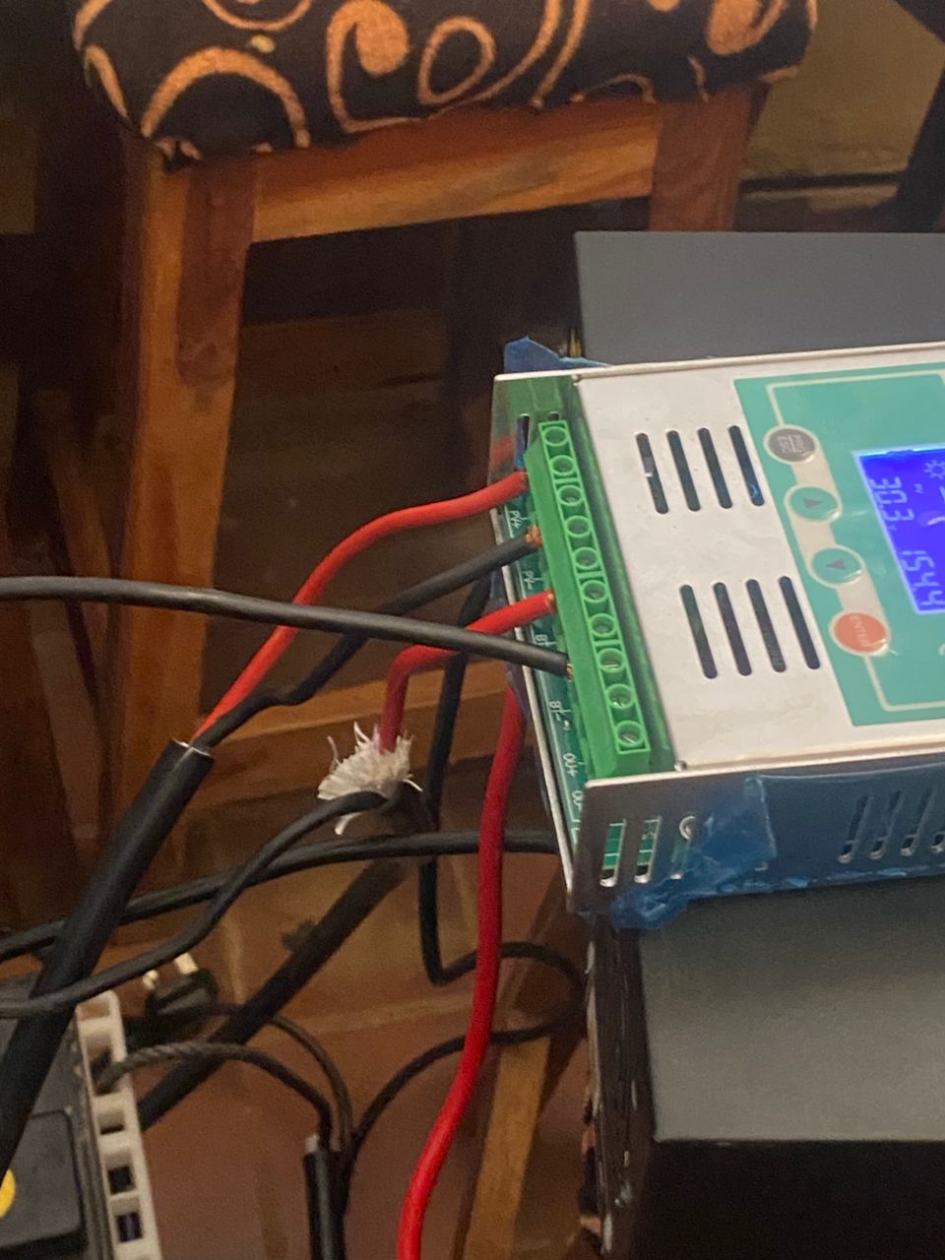
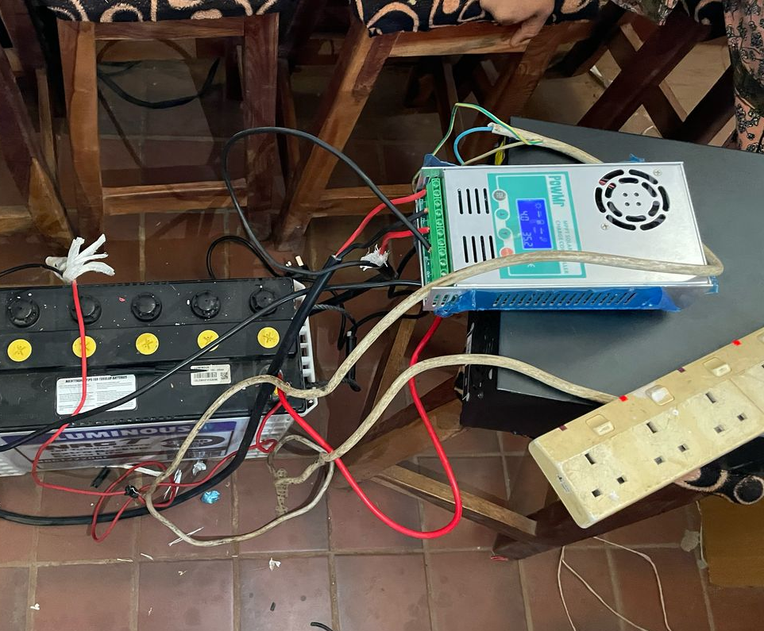

FIG 1.9 (OUTPUT OF THE CONNECTION FROM THE INVERTER)
This shows the output after the connectionfrom the inverter at the selected port for it at the inverter.
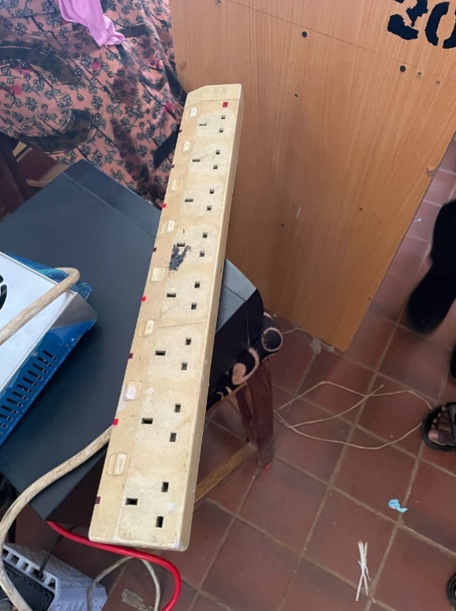

FIG 2.1 (SECURING THE CAMERAS)
Drilling holes for the camera brackets. We secured the camera using screws to ensure they are tightly fastened as shown below.
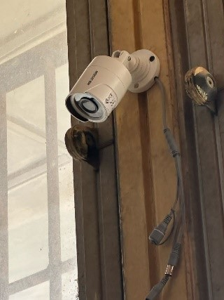
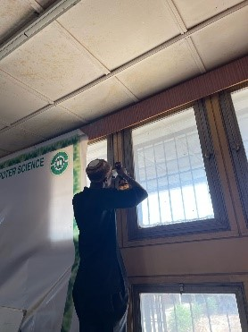

FIG 2.2 (COAXIAL CABLE CONNECTION TO THE BNC CONNECTOR)
Connection of the coaxial cable to the BNC connector as shown below.
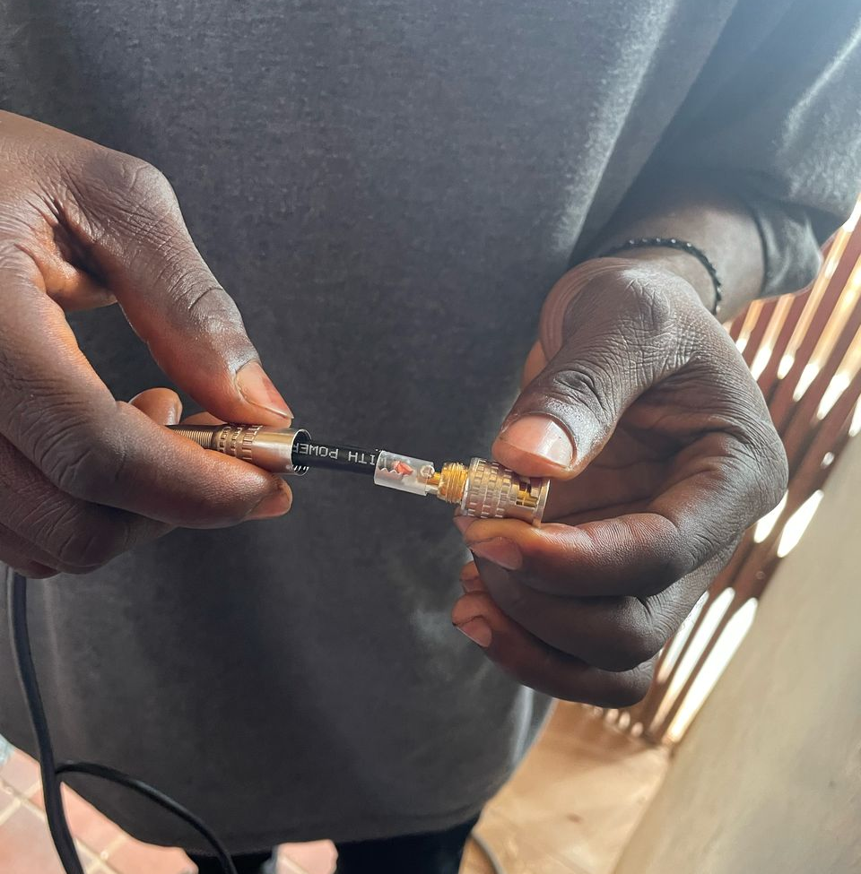

FIG 2.3 (CAMERA INSTALLATION 1)
This show the installation of the first Pan-Tilt-Zoom (PTZ) camera. These are camera that can move, they are programmable and are manually controllable.

FIG 2.4 (CAMERA INSTALLATION 2)
This show the installation of the second Pan-Tilt-Zoom (PTZ) camera. These are camera that can move, they are programmable and are manually controllable.
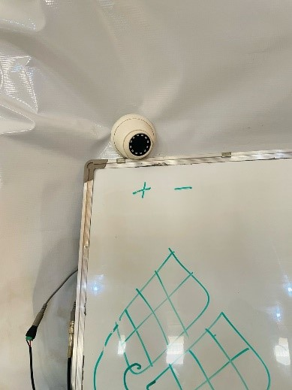

FIG 2.5(CONNECTION OF THE BNC CONNECTOR TO CAMERA 1)
This is the connection of the BNC connector to the Pan – Tilt – Zoom (PTZ) camera as shown below.
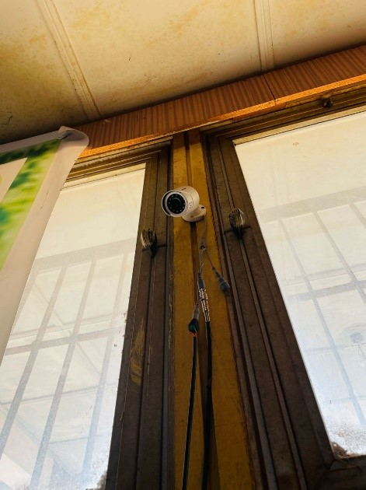

FIG 2.6 (CONNECTION OF THE BNC CONNECTOR TO CAMERA 2)
This is the connection of the BNC connector to the second Pan-Tilt-Zoom (PTZ) camera as shown below.

FIG 2.7 (CONNECTION OF COAXIAL CABLE TO POWER SUPPLY BOX)
This is the connection of the other end of the coaxial cable to appropriate ports in the CCTV power supply box. This is where the power cable in the CCTV cable will be connected to on one end, while the other end is connected directly to the security cameraas shown below.
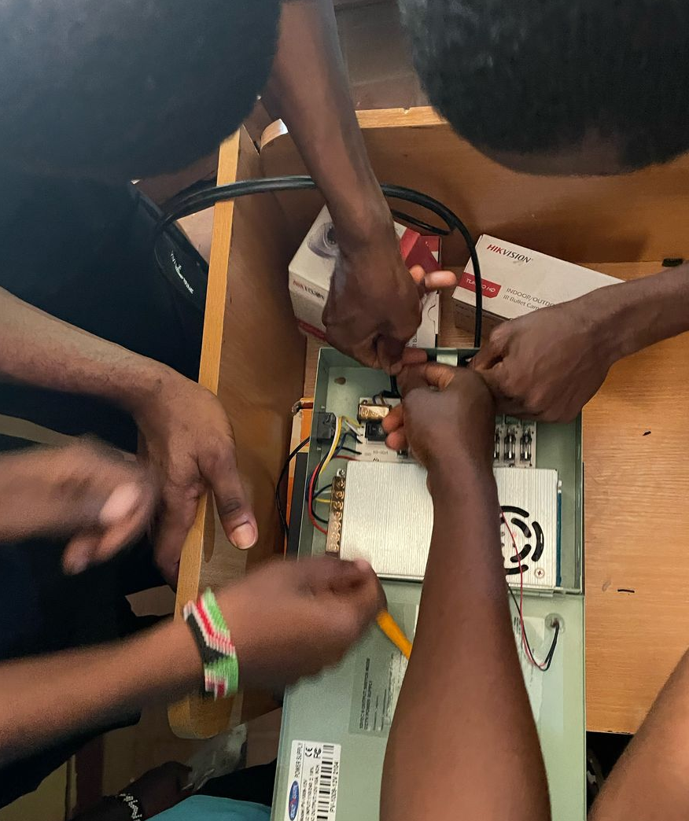

FIG 2.8 (THE DVR)
This is where the video security cameras capturing is recorded, stored, and managed. The security cameras have to be cabled back to the security DVR.Typically DVR's have 1 Channel, 4 Channel, 8 Channel, 16 Channels, 32 Channels and 64 Channels.
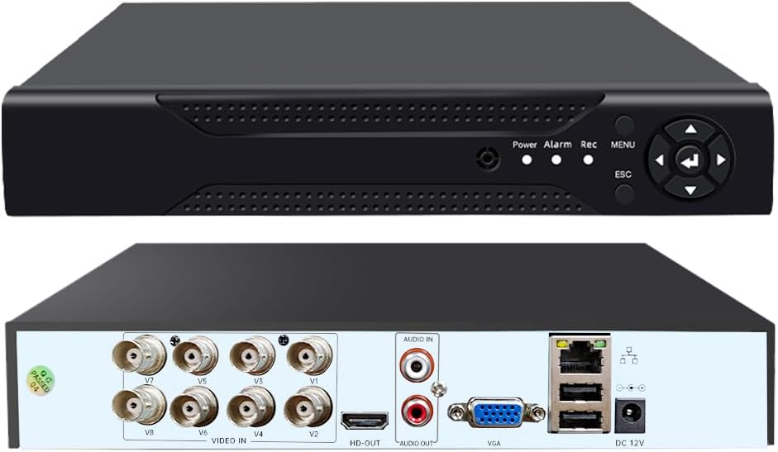

FIG 2.9 (THE MONITOR)
The Monitor is a device which will take the video image and the outputs of it on the screen. Monitors can be dedicated to review video from a single camera, or they can be configured to access multiple cameras at one time. This shows the output of Fig 2.3 and 2.4
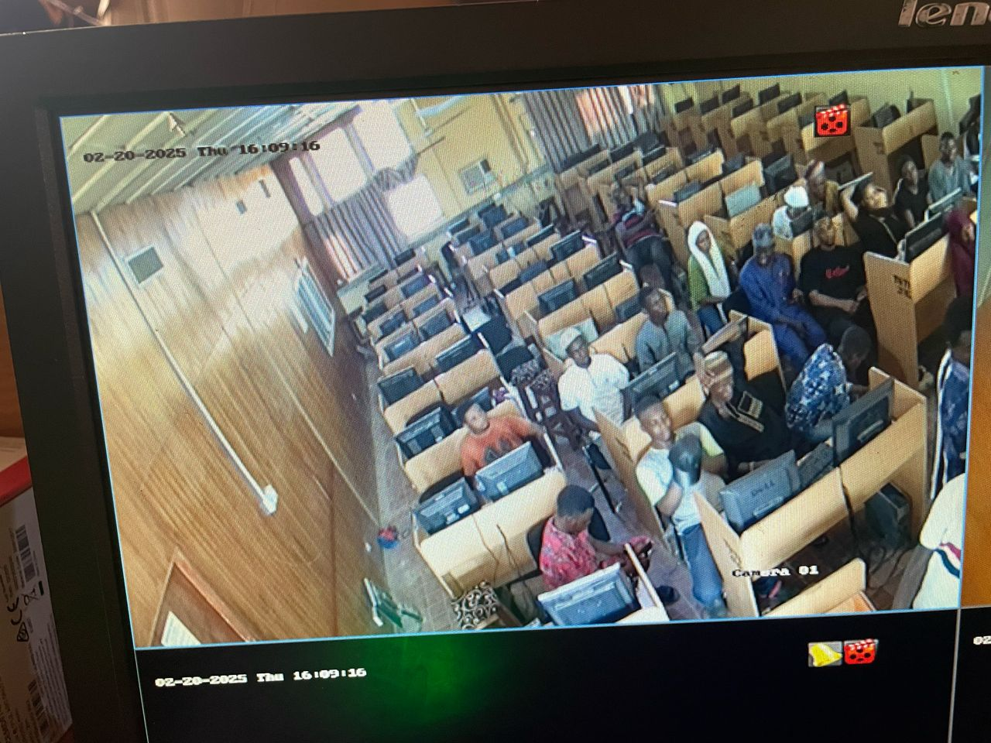

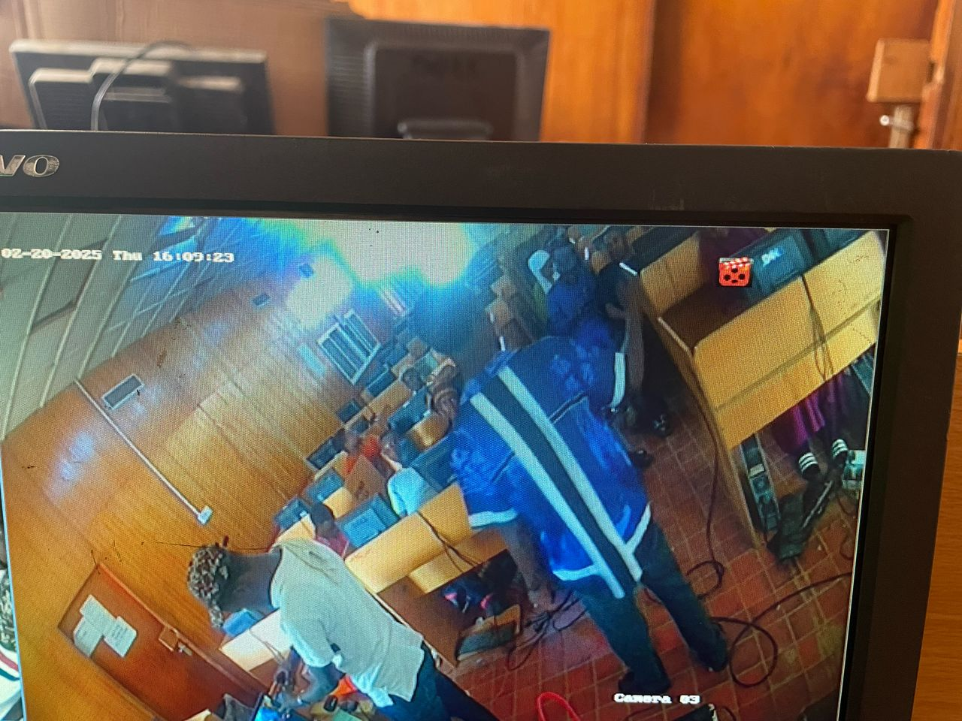
CHAPTER FIVE
SUMMARY, CONCLUSION AND RECOMMENDATION
5.1 SUMMARY
Chapter One described the Introduction, Aims and Objectives, Statement of the Problem, Significance of the Study, Scope of the Study, Organization of the Study, Definition of Terms.
Chapter Two discusses the Literature Review, Review of related view, and other literatures.
The installation of the CCTV and Solar System was carried out, following a sequential procedure as described in Chapter 3. The installation process initiated an experience that builds a knowledge in skill. The results after the installation were positive, therefore exams can be supervised via CCTV subsequently.
The results in Chapter 4 establish the aim of this research work. It is therefore concluded that the smart solar monitoring system is a more effective way for exams to be supervised than the normal manual process.
5.2 CONCLUSION
The Closed-circuit Television (CCTV) system and the Solar System and the Solar System was designed and installed in the CBT examination centre for exam purposes. This research elaborated on the designs of photovoltaic modules and the designs of camera as well as their installation.
Despite the importance attached to examinations in schools and society at large and the severe rules and regulations governing the conduct of examinations, complaints about malpractice are very rampant. In short, it has become very rampant in the nation’s educational system, which needs immediate attention. Due to inadequate power supply that helps in monitoring the students during examinations taken, we made sure we install a solar system to serve as another source of alternative energy beside the main power supply. The Solar System serves the electrical utilities of the CBT examination centres.

5.3 RECOMMENDATIONS
Smart Solar CBT Monitoring System would be recommended since it was a noiseless, it does not use fuel and it is environmental friendly. We recommend the use of the system for invigilation of exams in the upcoming academic session to further authenticate its effectiveness.

References
Aimiuwu, M. A., &Bosah, I. P. (2020).Use of closed circuit television (CCTV) for ensuring quality learning and internal policing in early years centers. Journal of Early Childhood and Primary Education, 2(2), 49–63. https://journals.unizik.edu.ng/jecape/article/view/460
Ignacio, A. E. (2021).A study on the implementation of a monitoring system to solar-powered houses. International Journal of Multidisciplinary: Applied Business and Education Research, 2(9), 811–818. https://ijmaberjournal.org/index.php/ijmaber/article/view/201
Manurung, A., Fildzah, A., &Rajagukguk, J. (2018).Computer based test (CBT) system for student academic examination. In Proceedings of the 2nd EAI International Conference on Computer Science and Educational Informatics (CSEI 2018). https://eudl.eu/doi/10.4108/eai.18-10-2018.2287186
Ososanya, E. T. (2015).Design and implementation of a solar-powered smart irrigation system. ASEE Annual Conference & Exposition. https://peer.asee.org/design-and-implementation-of-a-solar-powered-smart-irrigation-system
Shirbhate, I. M., & Barve, S. S. (2019).Solar panel monitoring and energy prediction for smart solar system. International Journal of Advances in Applied Sciences, 8(1), 1–8. https://ijaas.iaescore.com/index.php/IJAAS/article/view/19768.
Sindhu, M. R., Mallegowda, M., &Kanavalli, A. (2019).IoT based solar powered irrigation system and farm monitoring. International Journal of Engineering Research & Technology (IJERT), 8(9), 1–5.
Rekeraho, A., Cotfas, D. T., &Cotfas, P. A. (2024).Enhancing security for IoT-based smart renewable energy remote monitoring systems. Electronics, 13(4), 756. https://www.mdpi.com/2079-9292/13/4/756
Tellawar, M. P., &Chamat, N. (2019).An IoT based smart solar photovoltaic remote monitoring system. International Journal of Engineering Research & Technology (IJERT), 8(9), 1–5. https://www.ijert.org/an-iot-based-smart-solar-photovoltaic-remote-monitoring-system
Uchenna, I., Bakare, A. D., Olurin, J. O., Ojo, G. G., &Lottu, O. A. (2023).Unlocking solar power for surveillance: A review of solar-powered CCTV and surveillance technologies. Acta Electronica Malaysia, 2(2), 54–61. https://www.actaelectronicamalaysia.com/aem-02-2023-54-61/

