
A PROJECT
ON
COMPARATIVE EVALUATION OF ACCURACY AND RELIABILITYOF DIGITAL LEVELLING AND TOTAL
STATION EQUIPMENT TO DETERMINE THE HEIGHT MEASUREMENT
(A CASE STUDY OF PART OF KWARA STATE POLYTECHNIC)
BY
KAZEEM KABIRAT DAMILOLA
HND/23/SGI/FT/0079

SUBMITTED TO

DEPARTMENT OF SURVEYING AND GEO-INFORMATIC, INSTITUTE OF ENVIRONMENTAL STUDIES (I.E.S), KWARA STATE POLYTECHNIC, ILORIN.

IN PARTIAL FULFILLMENT OF THE REQUIREMENTS FOR THE AWARD OF THE HIGHER NATIONAL DIPLOMA (HND) IN SURVEYING AND GEO-INFORMATIC.

JULY, 2025.

DECLARATION
I hereby certified that all the information given in this project were obtained as a result of observations and measurements made by me and that the survey was carried out in accordance with Survey Rules, Regulations and Departmental instructions.

NAME: KAZEEM KABIRAT DAMILOLA
MATRICNO.:HND/23/SGI/FT/0079

SIGNATURE: ………………………………….

DATE OF COMPLETION: ……………………………………………….

CERTIFICATION
This is to certify that KAZEEM KABIRAT DAMILOLA with matriculation number HND/23/SGI/FT/0079 has satisfactorily carried out this project under our instructions and direct supervision.

SURV. A. G. AREMU _______________________
(PROJECT SUPERVISOR) SIGNATURE AND DATE

SURV. AWOLEYE R. S ________________________
(PROJECT COODINATOR) SIGNATURE AND DATE

MR. ABIMBOLA I. ISAU ________________________
(HEAD OF DEPARTMENT) SIGNATURE AND DATE

___________________________ ________________________
EXTERNAL MODERATOR SIGNATURE AND DATE
DEDICATION
I dedicate this project to Almighty God. Through every challenge and triumph, your presence has been my guiding light and steadfast support. Thank You for granting me the wisdom, knowledge, and patience to complete this goal.
ACKNOWLEDGEMENTS
My profound appreciation goes to God almighty for His protection, unfailing love, guidance and infinite mercy throughout the duration of this course.
My sincere appreciation to my able supervisor, Surv A.G. AREMU who devoted his time to go over every aspect of this project as well as the endless assistance given to me with the intricacies of the knowledge. He has proved himself a professional who has a keen interest in his student by rendering much technical advice and encouragement about the detailed aspect of the topical issues. God bless you sir.
My sincere gratitude also goes to My (H.O.D) MR. ABIMBOLA ISAU and other lecturers at the Department of Surveying Geo-informatics (SUR. A.G AREMU, SUR. R.S ASONIBARE, SUR. R.O AWOLEYE, SUR. BANJI, SUR. AYUBA, SUR. DIRAN, SUR. KAZEEM, SUR. KABIRU ), for nurturing me in my academic activities. May Almighty Allah continue to bless you all abundantly.
My gratitude also goes to my sister MISS KAZEEM OMODASOLA I can't express how deeply grateful I am for your sacrifices to sponsor my education. your cooperation and support both financially and spiritually throughout the period of my programme. Thank you for believing in me, always. Also, I wish to acknowledge the effervescent my project group students for their cooperation’s and understanding, God bless you all. (Amen)

ABSTRACT
The project compared and analyzed the data obtained using Total Station (TS) and level instruments in height measurement. To achieved the objective of the project, the perimeter boundary was determined using total station, and 20 points were established on the ground randomly with in the perimeter, and their X,Y,Z coordinates were determined using total station. The heights of the same points were determined as well using level instrument through the process of leveling and computations. The data obtained using the two instruments were saved in Microsoft excel and were imported in to AutoCAD for further processing in other to produce perimeter and detailed plans, as well to generate contour map of the project area. Based on descriptive statistics, it was found that the total station gave a minimum height of and 354.268m and a maximum of 356.736m, while digital Level gave a minimum height of 354.208m and a maximum of 356.680m, this indicates that both instruments gave a very close results hence both total station and digital level can be used in carrying out levelling for generating a height measurement. However, the time expenditure on each method revealed that the total station is faster than using digital level for height measurement. The main advantage of total station compared to a digital level is therefore the total station is faster in data capture, shorter time and safer means of data processing and the ability of data storage and retrieval electronically, and the telescope can be tilted to sight a point which the spirit level lacks.

TABLE OF CONTENTS
Cover page…………………………………………………………………………………….i
Declaration………..………………………………………………………………….………..ii
Certification…………………………………………………………………………….……..iii
Dedication……………………………………………………………………………….…….iv
Acknowledgement……………………………………………………………………….….....v
Abstract…………………………………………………………………………………….….vi
Table of contents ….…………………………………………………………………….vii-ix
CHAPTER ONE
- Introduction…………………………………………………………..…….………. ….1
1..1 Background to the study………………………………………….……...……….……1
1.2 Statement of the problem……………………………...…...................................……..3
1.3 Aim…………………………………………………………………..……….......…….4
1.4 Objectives …………………………………………………………….………………..4
1.5 Justification …….………………………………………………………...………….4
1.6 Significance of the Project……………………………………………………………..5
1.7 Pesonnel…………………………………………………………………….……..…...6
1.8 Study Area………………………………………………………….…………………..7
CHAPTER TWO
- Literature Review………………………………………………….……………….…..8
2.1 Digital Leveling Instruments……..…………..…………………….……..……….….11
2.2 Total Station Instrument………..….……………………………………….…………11
2.3 Comparison of Height Measurement Capabilities…………………,..………….……12
2.4 Literature Review on Comparison of Total Station and Levelling Instrument in Height Measurement ……………………………………………………………………….13
2.5 Project Review……………………………………………………………………....15

CHAPTER THREE

Methodology……………………………………….……..………………………….16

3.1 Reconnaissance………………………………………..……………………………...16
3.2 Beaconing……………………………………………………..…………….………..18

3.3 Instrumentation………………………………………………….………………...…19

3.4 Test of Instrument ……………………………………………..……………...……...21
3.5 Control Check………………..…………………………………..…………………...25
3.6 Data Acquisition …………………………………,……………….………..………...25
3.7 Perimeter, Detailing and Spot Heighting……………………………….…………….27

CHAPTER FOUR
- Data Downloading, Processing, Analysis and Discussion……………………………30
4.1 Data Download………………………………………….........................……………30
4.2 Data Editing……………………………………………………………….………..…30
4.3 Data Processing using Autocad 2007……………………………………...………….31
4.4 Results and Discussion……………………………………………………..…………31
4.5 Statistical Analysis……………………………………………………………………36
CHAPTER FIVE
5.0 Costing, Summary, , Recommendation and Conclusion…………………………...…39
5.1 Costing..........................................................................................................................39
5.2 Summary……………………………………………..………………………….……46
5.3 Recommendation …………………………………………………………………….46
5.4 Conclusion……………………………………………………………………............47
REFERENCES…….…………………………………………………………….….…....…48
APPENDIXDATA……………………………..……….…………………..……………….50

CHAPTER ONE
1.0 INTRODUCTION
1.1 Background to the Study
Height measurement is a fundamental aspect of surveying, providing crucial data for land development, engineering, and construction. The accuracy of elevation determination affects the structural integrity of buildings, road networks, and drainage systems. Surveying instruments such as digital levels and total stations are widely used to determine height, but their performance varies due to environmental, instrumental, and procedural factors (Uren & Price, 2010). Understanding the comparative accuracy and reliability of these methods is essential for selecting the best technique for specific projects.
Digital leveling is considered one of the most precise methods for height determination. It employs an electronic level instrument and a bar-coded staff to measure vertical distances, reducing human errors common in conventional leveling (Wolf &Ghilani, 2012). The technology ensures high precision by minimizing reading errors, making it ideal for precise engineering projects such as dam construction, bridge alignment, and geodetic surveys. However, digital leveling can be time-consuming and less efficient over long distances, which limits its use in large-scale projects (Kavanagh, 2014).
Total stations integrate electronic distance measurement (EDM) and angular measurement capabilities, allowing surveyors to determine both horizontal and vertical positions efficiently. Unlike digital levels, total stations are multifunctional, supporting a range of applications from topographic mapping to construction staking (Schofield & Breach, 2007). However, the accuracy of height measurement using total stations is influenced by factors such as instrument calibration, target reflectivity, and atmospheric conditions, leading to potential errors in elevation determination (Ghilani, 2017).
Several studies have compared digital leveling and total station equipment for height measurement. For instance, Alkan and Karslı (2011) analyzed the precision of both instruments and found that digital leveling provides superior vertical accuracy compared to total stations. Similarly, Ata and Arslan (2015) observed that while total stations offer greater flexibility, their elevation measurements are more susceptible to errors when compared to digital leveling techniques. These findings highlight the need for further comparative evaluations in different environments and project conditions.
In many institutions and construction sites, surveyors rely heavily on total stations due to their efficiency in collecting data over large areas. However, this preference sometimes leads to the compromise of vertical accuracy, especially in projects requiring precise elevation data (Ghosh, 2013). While total stations provide satisfactory results for general land surveying tasks, their limitations in height determination necessitate a more detailed assessment of their reliability when compared to digital leveling.
Environmental factors also play a significant role in determining the effectiveness of height measurement techniques. Atmospheric refraction, temperature variations, and humidity can distort EDM signals in total stations, leading to height discrepancies (Vaníček &Krakiwsky, 2015). Digital leveling, however, is less affected by these factors but can still be influenced by ground settlement and instrument instability. Understanding these environmental influences is critical in determining the best method for achieving precise height measurements in different field conditions.
Despite the widespread use of these instruments, there is limited comparative research on their performance in specific study areas, such as Kwara Polytechnic. Surveyors and engineers working within the region require reliable data to make informed decisions about instrument selection and survey methodology. By evaluating the accuracy and reliability of digital leveling and total stations in the study area, this research will provide valuable insights into their practical applications and limitations. Ultimately, this project will serve as a reference for the institutions and surveying professionals seeking to optimize their height measurement techniques. By understanding the comparative strengths and weaknesses of digital leveling and total stations, stakeholders can enhance project accuracy, reduce construction errors, and improve overall infrastructure planning.
1.2 Statement of Problem
The increasing reliance on modern surveying equipment, such as digital levelling and total station equipment, in educational and developmental projects at Kwara State Polytechnic highlights a critical need to evaluate their accuracy and reliability under local conditions. While these tools promise enhanced precision and efficiency compared to traditional methods, their performance can vary due to factors like operator expertise, equipment calibration, and environmental influences such as temperature and humidity (Schofield & Breach, 2017). Without a clear understanding of how these instruments perform in this specific context, there is a risk of adopting technologies that may not meet the institution’s practical and academic requirements, potentially leading to errors in topographic data critical for campus planning and student training.
In many institutions and construction sites, surveyors often rely on total stations due to their speed and multifunctionality, potentially overlooking the higher precision offered by digital leveling in elevation measurements. This reliance can lead to height discrepancies, affecting structural stability and site planning. Factors such as instrument calibration, atmospheric conditions, and operational limitations contribute to errors in both techniques. Despite advancements in technology, there is limited comparative analysis on the reliability of these instruments in real-world applications, particularly in the study area, Kwara Polytechnic.
This research aims to bridge this gap by evaluating the accuracy and reliability of digital leveling and total station equipment in determining height measurements within a selected part of Kwara Polytechnic. By conducting a comparative analysis, this study seeks to establish the best method for precise elevation determination. Understanding these differences will contribute to improved surveying practices, enhanced data reliability, and better planning for infrastructure development.
1.3 Aim of the Project
The primary aim of this project is to compare the accuracy and reliability of digital leveling and total station equipment in height determination, ensuring precise elevation measurements for surveying and construction applications in Kwara Polytechnic.
1.4 Objectives of the Project
To achieve the above stated aim, the following objectives must be observed.
- Compare the accuracy of digital leveling and total stations in height measurement.
- Assess their reliability under different conditions.
- Recommend the best method for precise height measurement.
1.5 Justification of the Project
Accurate height measurement is essential for various engineering and construction projects, as errors in elevation data can lead to structural failures and costly corrections. Digital leveling and total stations are widely used for this purpose, but their accuracy and reliability differ under various conditions. A comparative study will help surveyors and engineers understand the strengths and limitations of each instrument, ensuring that the most suitable method is chosen for precise height determination.
Despite the increasing use of total stations due to their speed and versatility, studies suggest that digital leveling provides superior accuracy in elevation measurements. However, many surveyors prefer total stations for convenience, potentially compromising precision in projects that require exact height data. This research is necessary to evaluate these differences and provide empirical evidence on the best approach for specific surveying applications.

1.6 Scope of the Project
This study focuses on comparing the accuracy and reliability of digital leveling and total station equipment for height determination within a selected part of Kwara Polytechnic. It will assess the performance of both instruments under different environmental and operational conditions, analyzing factors such as measurement precision, error margins, and ease of use. The study will be limited to field data collection, processing, and evaluation within the study area, providing recommendations for optimal height measurement techniques in surveying and construction applications.

1.7 Personnel
The listed below are the personnel involved in carry out the project;
NAME | MATRIC. NO.
Kazeem Kabirat Damilola | HND/23/SGI/FT/0079 | Writer
Ganiyu Akeem Abiodun | HND/23/SGI/FT/0076 | Member
Abdul Kareem Ramota Olawumi | HND/23/SGI/FT/0078 | Member
Adeoti Qudus Adebayo | HND/23/SGI/FT/0080 | Member
Adeleye Sheriffdeen Olawale | HND/23/SGI/FT/0081 | Member
Abdul Qudus Shukurah Temitope | HND/23/SGI/FT/0083 | Member
Ogunsuyi Babatunde Sunday | HND/23/SGI/FT/0118 | Member
Jimoh Halimah Titilayo | HND/22/SGI/FT/082 | Member
1.8 Study Area
Kwara State Polytechnic, located in Ilorin, Nigeria, serves as a major institution for technical and vocational education. It is situated at approximately latitude 8.4791° N and longitude 4.5418° E, covering a vast area that accommodates academic buildings, administrative offices, student hostels, and recreational facilities. The polytechnic was established to provide quality education in engineering, environmental studies, business, and technology-related fields, contributing significantly to workforce development in Nigeria. Its strategic location within Ilorin makes it an ideal study area for research in surveying and geospatial studies.
The institution's terrain consists of both flat and slightly undulating areas, making it suitable for studying height measurement techniques. With a mix of built-up structures and open spaces, Kwara Polytechnic provides a practical environment for evaluating digital leveling and total station accuracy.

1.9 Project Location
The project site is located inside Kwara state polytechnic Ilorin, Kwara state.
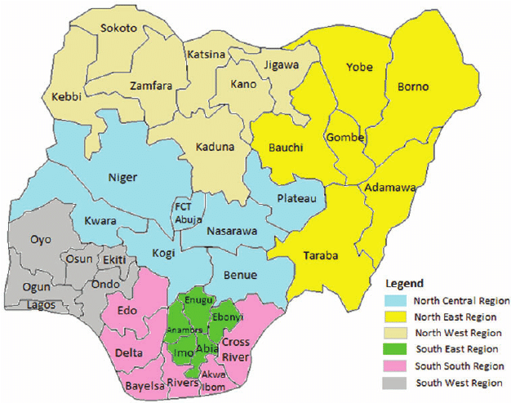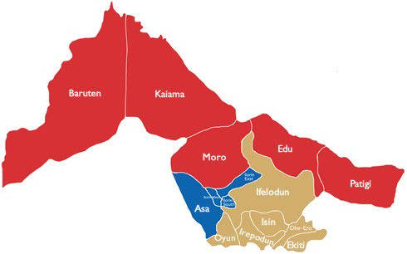
Map of Kwara State
Map of Nigeria
``
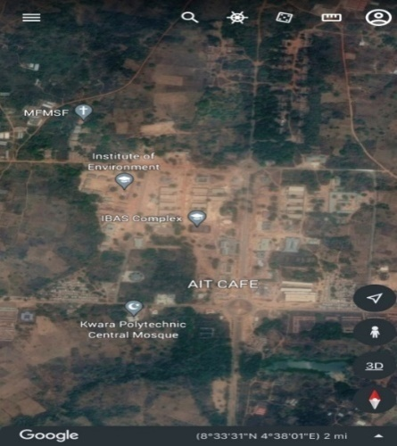
Figure 1.10: Study Area Map

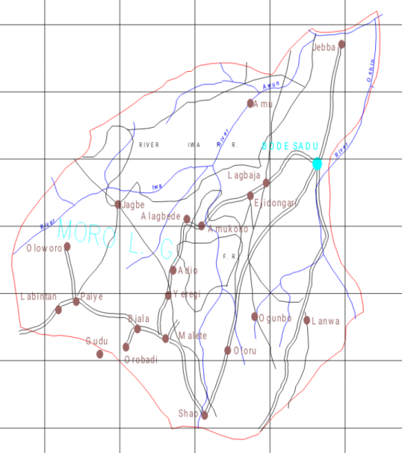

Google Imagery of the Study Area

Figure 1.10: Study Area Map
Map of Moro L.G.A
CHAPTER TWO

2.0 INTRODUCTION AND LITERATURE REVIEW
2.1 Introduction
Geodetic surveying is a specialized branch of surveying that considers the Earth's curvature to provide highly accurate positional and height data. Unlike plane surveying, which assumes a flat Earth over small areas, geodetic surveying accounts for the geoid, the actual shape of the Earth, and gravitational variations. This makes it essential for applications that require precise positioning over large distances, such as global mapping, engineering projects, and scientific research. One of the key aspects of geodetic surveying is its role in determining heights, which is crucial for infrastructure development, flood modeling, and environmental monitoring.
Height measurement in geodetic surveying is based on different reference surfaces, primarily the geoid, ellipsoid, and mean sea level (MSL). The geoid represents the Earth’s gravitational surface, closely matching MSL, while the ellipsoid is a mathematically defined smooth surface used in GNSS-based heighting. The difference between these surfaces introduces the need for conversion models, ensuring that height measurements are accurate and comparable across different regions (Hofmann-Wellenhof & Moritz, 2005).
Traditional leveling techniques, such as spirit leveling and trigonometric leveling, remain fundamental in geodetic surveying for height determination. Spirit leveling provides the highest accuracy by measuring height differences between benchmarks using a leveling instrument. Trigonometric leveling, on the other hand, calculates height differences using angles and distances, making it useful in rugged terrain. Despite their accuracy, these methods are labor-intensive and time-consuming.
The technique of using a total station involves setting up the instrument over a known point, sighting targets (prisms or reflectorless surfaces), and recording measurements, often stored digitally for real-time analysis (Uren & Price, 2010). This process, known as traversing or resection, establishes control points across a site, making it efficient for large areas, this efficiency is a critical factor in assessing total stations against the more labor-intensive levelling methods.
Total stations determine ellipsoidal heights primarily, derived from their coordinate system, though orthometric heights can be approximated with datum adjustments or geoid models (Hofmann-Wellenhof et al., 2008). This dual capability distinguishes them from level instruments, offering flexibility for geodetic and engineering applications
The establishment of national and global height reference networks ensures consistency in height measurements. Many countries use a vertical datum, such as the North American Vertical Datum 1988 (NAVD88) or the European Vertical Reference System (EVRS), to define height systems. These datums are based on long-term tide gauge observations, corrected for local gravitational variations, and continuously updated to account for geophysical changes like land subsidence and sea level rise (Drewes & Sánchez, 2019).
One of the biggest challenges in height measurement is gravitational variations, which affect how height is defined globally. Since gravity is not uniform across the Earth, heights measured in one region may not be directly comparable to those in another. Geodetic surveys use gravimetric data to refine geoid models and improve height accuracy. This is particularly important for scientific studies, such as monitoring glacier melting and ocean circulation (Kouba, 2009).
2.1.1 Height
Height determination in surveying is a fundamental aspect that influences the accuracy of topographic mapping, engineering projects, and geospatial analysis. The measurement of height, also known as elevation, is crucial in fields such as construction, hydrology, and navigation. Various methods exist for height determination, including differential leveling, trigonometric leveling, Total Station and Global Navigation Satellite System (GNSS)-based techniques.
Height plays a crucial role in terrain modeling, flood prediction, and infrastructure planning (Wolf &Ghilani, 2012). It provides critical information for designing roads, bridges, and buildings to ensure structural integrity and safety. Additionally, height data is essential in hydrological studies for understanding water flow and flood control mechanisms (Kavanagh, 2009).
The conventional methods of height determination include spirit leveling, barometric leveling, and trigonometric leveling. Spirit leveling, also known as differential leveling, is the most accurate but time-consuming method, commonly used in precise engineering projects (Mikhail & Gracie, 2001). Barometric leveling, based on atmospheric pressure readings, provides less accuracy and is mainly used for reconnaissance surveys. Trigonometric leveling, involving angular measurements, is suitable for areas with difficult terrain (Schofield & Breach, 2007).
Recent advancements in surveying technology have introduced Total Station, GNSS, LiDAR, and photogrammetric techniques for height measurement. GNSS-based height determination relies on satellite signals to obtain elevation values with high precision (Hofmann-Wellenhof et al., 2008). LiDAR technology uses laser pulses to measure distances and generate detailed elevation models, widely used in forestry and urban planning (Shan & Toth, 2009). Photogrammetry, utilizing aerial and satellite imagery, enables large-scale height mapping (Kraus, 2007).
In surveying, height is referenced to different surfaces, including the geoid, ellipsoid, and mean sea level (MSL). The geoid represents the Earth's equipotential surface, approximating MSL, and is commonly used for orthometric height determination (Featherstone et al., 2012). The ellipsoid is a mathematically defined surface used in GNSS-based height measurements, leading to ellipsoidal heights, which require conversion to orthometric heights for practical applications (Vaníček &Krakiwsky, 1986).
Height measurements are referenced to specific datums, such as the North American Vertical Datum (NAVD88) and European Vertical Reference System (EVRS). These datums provide a standard for height measurements across different regions (Drewes & Sánchez, 2019). Inaccurate height reference systems can lead to discrepancies in engineering and geospatial applications.
Differential leveling remains the most accurate height determination method, achieving millimeter-level precision (Wolf &Ghilani, 2012). However, factors such as instrument calibration, atmospheric conditions, and human errors can affect the accuracy of leveling observations. Proper techniques, including balancing backsight and foresight distances, help minimize errors (Kavanagh, 2009).
GNSS height measurements offer efficiency and coverage but require accurate geoid models for practical use. The accuracy of GNSS-derived heights is affected by satellite geometry, atmospheric delays, and signal multipath effects (Hofmann-Wellenhof et al., 2008). Combining GNSS with geoid models, such as EGM2008, improves the accuracy of height determinations (Smith et al., 2013).
LiDAR technology provides high-resolution elevation data, making it valuable for digital elevation model (DEM) generation. LiDAR-based height measurements are widely used in flood modeling, forestry, and urban planning (Shan & Toth, 2009). However, vegetation and surface reflectance can introduce errors, requiring proper data filtering and classification.
Unmanned Aerial Vehicles (UAVs) equipped with photogrammetric cameras offer a cost-effective solution for height mapping. UAV-based photogrammetry provides detailed terrain models, beneficial for agricultural, mining, and construction projects (Colomina& Molina, 2014). However, photogrammetric height determination requires accurate ground control points (GCPs) to ensure precision.
Height information is critical in hydrological studies, including flood risk assessment, watershed modeling, and drainage design. Digital Terrain Models (DTMs) derived from LiDAR and GNSS data assist in understanding water flow dynamics and erosion patterns (Tarboton, 1997). Accurate height measurements help in climate change studies by monitoring glacial retreat and sea level rise.
Engineering projects, such as road construction, bridge design, and railway alignment, rely on precise height measurements to ensure structural stability. Accurate elevation data aids in slope analysis and cut-and-fill volume calculations for earthworks (Schofield & Breach, 2007). Inaccurate height data can lead to design errors and costly project modifications.
2.1.2 Height System
The height reference network is a fundamental component of geodesy and surveying, providing a consistent framework for determining elevations across regions. It serves as a standardized system that ensures uniformity in height measurements, which is crucial for applications such as construction, flood risk assessment, and geospatial mapping. A well-defined height reference network allows for accurate elevation comparisons, helping engineers and scientists make informed decisions regarding land use, water management, and infrastructure development.
A height reference network is typically based on a vertical datum, which defines the zero-reference point for elevations. This datum can be established using mean sea level (MSL), the geoid, or an ellipsoidal surface. Traditional height systems often rely on MSL, derived from long-term tide gauge observations, while modern geodetic networks increasingly use geoid-based heights to improve consistency over large areas (Featherstone et al., 2012). The choice of reference datum impacts the accuracy and applicability of elevation measurements in different projects.
To maintain precision in height determination, height reference networks rely on benchmarks—permanently marked reference points with known elevations. These benchmarks form the foundation for differential leveling surveys, where height differences between points are measured with high accuracy. However, over time, benchmarks may shift due to natural factors like tectonic movements or subsidence, necessitating periodic adjustments and recalibrations of the network (Wolf &Ghilani, 2012).
The accuracy of height reference networks is influenced by several factors, including atmospheric effects, instrumental errors, and ground stability. Atmospheric refraction and gravitational variations can introduce small errors in elevation measurements, which must be corrected using advanced geodetic techniques. Additionally, ground deformation due to earthquakes or land subsidence can affect benchmark stability, requiring periodic updates to the reference network (Vaníček &Krakiwsky, 1986).
2.1.3 Level Instrument
Levelling is a fundamental surveying technique used to determine height differences between points on the Earth's surface. It is widely applied in construction, geodesy, and engineering projects where precise elevation data is essential. Various levelling instruments, including automatic levels, digital levels, and total stations, are used to achieve accurate height measurements. This review examines the types of levelling instruments, their precision, accuracy, applications, and limitations.
Levelling is crucial for establishing vertical control, designing infrastructure, and monitoring land deformation. The accuracy of height measurements directly affects the success of projects such as road construction, bridge alignment, and flood risk assessment (Ghilani, 2017). Modern levelling techniques ensure that height data remains consistent across various applications.
One of the most common leveling instruments is the spirit level, also known as a dumpy level. It consists of a telescope mounted on a tripod with a built-in bubble level to ensure proper horizontal alignment. The surveyor reads a leveling staff placed at different points to determine elevation differences. This method, called differential leveling, is highly accurate and widely used in construction and infrastructure projects, where precise height measurements are required (Wolf &Ghilani, 2012).
Another important leveling instrument is the automatic level, which improves upon the traditional dumpy level by incorporating an internal compensator that automatically maintains the instrument's horizontal line of sight. This feature reduces human error and increases efficiency in large-scale surveys. Automatic levels are commonly used in road and railway construction, as well as for monitoring land subsidence and settlement in engineering structures (Kavanagh & Bird, 2017).
The digital level represents a modern advancement in leveling technology. It uses electronic sensors and image processing to automatically read bar-coded leveling staff markings, eliminating manual errors and improving accuracy. Digital levels are widely used in geodetic applications, such as establishing national height reference networks and monitoring geological deformations. The automation of data collection also enhances productivity in large-scale height determination projects (Ghilani, 2017).
For high-precision applications, precise leveling is conducted using specialized instruments such as the geodetic level with invar leveling rods. This method is used for geodetic networks, subsidence monitoring, and scientific research requiring millimeter-level accuracy. Precise leveling plays a critical role in determining vertical movements of the Earth's crust, which is essential for tectonic studies and early warning systems for natural hazards (Torge & Müller, 2012).
In addition to traditional leveling methods, trigonometric leveling is an alternative approach that determines height differences using angular measurements and distances. This method employs theodolites or total stations, which measure vertical angles and distances to calculate elevation changes. Trigonometric leveling is particularly useful in rugged terrains where differential leveling may be impractical, such as mountainous regions and high-rise construction projects (Wolf &Ghilani, 2012).
The accuracy of leveling instruments is affected by several factors, including atmospheric conditions, instrument calibration, and human error. Refraction and temperature variations can distort light rays, leading to small errors in height measurements. Regular calibration of instruments and adherence to proper field procedures are essential to maintain accuracy. Advanced digital levels and electronic data recording systems help mitigate these errors by automating readings and corrections (Ghilani, 2017).

2.1.4 Total Station Instrument
Total stations are essential instruments in modern surveying, widely used for determining heights with high accuracy and efficiency. These instruments integrate an electronic theodolite and an electronic distance measurement (EDM) device, enabling precise three-dimensional coordinate determination. Unlike traditional levelling methods, total stations utilize trigonometric principles for height computation, making them more versatile in terrain where direct levelling is impractical. The ability to determine height through vertical angles and distances enhances their suitability for engineering, construction, and geodetic applications (Ghilani, 2017).
Height determination using total stations relies on trigonometric levelling, where the instrument records the vertical angle and the slant distance to the target point. The height difference is then calculated using the formula \(H = D \times \tan(\theta)\), where \(D\) represents the horizontal distance, and \(\theta\) is the measured vertical angle. This method is particularly useful in situations where direct levelling is not feasible, such as across water bodies or uneven terrain. By capturing precise angle and distance measurements, total stations ensure efficient and accurate elevation determination (Kavanagh & Bird, 2009).
Total stations are essential instruments in modern surveying, widely used for height determination through precise angular and distance measurements. These electronic devices integrate an electronic distance measurement (EDM) system with a theodolite, allowing surveyors to measure both horizontal and vertical angles alongside distances. By utilizing trigonometric principles, total stations enable surveyors to compute accurate height differences between points, making them indispensable in engineering, construction, and geodetic applications (Ghilani, 2017).
Height determination using a total station involves measuring the vertical angle and slope distance from the instrument to a target point. Using trigonometric formulas, the vertical component of the measured distance is computed, providing the height difference between the instrument's known elevation and the target point. This method, known as trigonometric leveling, is particularly useful in areas where direct leveling with traditional instruments, such as spirit levels, is impractical, such as steep or inaccessible terrains (Wolf &Ghilani, 2012).
To determine height accurately, total stations require a stable setup. The instrument is typically mounted on a tripod and precisely leveled using built-in bubble levels or electronic compensators. A reflector prism or a prism-less mode (using laser technology) is used to obtain distance measurements to the target point. Surveyors often use a benchmark (a known elevation point) to ensure accurate height determination by adjusting for any errors in measurements (Kavanagh & Bird, 2017).
One key advantage of using a total station for height determination is its high accuracy compared to conventional leveling instruments. Modern total stations can measure height differences with millimeter-level precision, making them suitable for applications like bridge construction, high-rise buildings, and geodetic surveys. The ability to integrate electronic data collection also minimizes human errors in reading and recording elevation values (Torge & Müller, 2012).
Total stations are also widely used in topographic surveying, where height measurements are crucial for creating digital elevation models (DEMs) and contour maps. These models help in planning infrastructure projects, analyzing drainage patterns, and assessing land suitability for various developments. Surveyors can efficiently collect multiple height measurements over large areas, significantly improving productivity compared to traditional leveling methods (Seeber, 2003).
Despite their accuracy, total stations are subject to systematic errors, such as atmospheric refraction and instrument misalignment, which can affect height measurements. Temperature, pressure, and humidity variations cause light beams to bend, introducing errors in distance and angle measurements. Surveyors mitigate these errors by applying atmospheric corrections and using calibration procedures to ensure reliable height determination (Ghilani, 2017).
Total stations are particularly valuable in engineering surveys, where they are used for precise height determination in projects like tunnel construction, railway alignment, and dam monitoring. Their ability to measure small vertical displacements ensures that structures remain stable and safe. In geotechnical studies, total stations help monitor land deformation, providing crucial data for preventing structural failures and natural disaster risks (Kavanagh & Bird, 2017).

2.2 LITERATURE REVIEW
2.2.1 Review on Comparison of Total Station and Digital Level Instrument Techniques in Height Measurement.
Levelling instruments, such as dumpy levels, automatic levels, and digital levels, have been the standard tools for height determination due to their ability to achieve millimeter-level accuracy. Scholars like Kavanagh & Bird (2009) emphasize that differential levelling is the most accurate method for determining height variations, as it minimizes errors associated with instrument and atmospheric conditions. The reliance on a stable horizontal line of sight makes levelling instruments ideal for high-precision applications such as construction, roadworks, and geodetic control surveys.
Digital level instrument is one of the most precise methods of height determination. It involves using a level instrument and a leveling staff to determine height differences between points. This method is commonly used in construction, road alignment, and geodetic surveys requiring high accuracy. However, it is labor-intensive, time-consuming, and limited in areas with difficult terrain or long-distance measurements (Wolf &Ghilani, 2012).
Total stations, in contrast, have been widely studied for their capability to measure height using electronic distance measurement (EDM) combined with angle readings. Researchers such as Schofield (2001) argue that total stations provide an efficient alternative to levelling instruments, particularly in areas where setting up multiple benchmarks is impractical. By utilizing trigonometric levelling, total stations allow surveyors to determine height without the need for direct line-of-sight levelling, making them advantageous in challenging terrains.
A comparative study by Hofmann-Wellenhof et al. (2008) highlights that total stations are highly efficient for determining heights over long distances, as they eliminate the need for multiple instrument setups. However, the accuracy of height measurements from total stations is dependent on the precision of angular readings and atmospheric corrections. In contrast, levelling instruments maintain consistent accuracy regardless of distance, making them preferable for engineering projects requiring high vertical precision.
Several scholars have noted that while total stations can achieve good height accuracy, they are more susceptible to errors introduced by instrument calibration, refraction, and curvature effects. Uren & Price (2010) explain that because total stations use EDM-based distance calculations, atmospheric variations can introduce discrepancies in height measurements, especially over long distances. Levelling instruments, on the other hand, are less affected by such environmental factors, which is why they are preferred for deformation monitoring and precise height control.

CHAPTER THREE
3.0 METHODOLOGY
Methodology is the systematic theoretical analysis of the methods applied to a field of study, it comprises the theoretical analysis of the body of methods and principles associated with a branch of knowledge. Typically, it encompasses concepts such as paradigm, theoretical model, phases and quantitative or qualitative techniques.
3.1 Reconnaissance
This has to do with framework of survey operation whereby all survey operations are going to base on.
Reconnaissance is also known as (Recce). Reco
nnaissance is examination of all part of an area accomplished insufficient detail to make generalization about the type and distribution of historical properties that may be present with a given project area. Also, is the process of having the general overview of the area to be surveyed with the view of determining the arrangement of the work such as method to employed, personnel to be involved, instrument to be used, scale at which plan/map is to be drawn. There are two stages of reconnaissance namely: Office and Field reconnaissance.
    - Field Reconnaissance
The first stage in this project was search for existing information in connection with the area in which the project was undertaken. Rough sketch diagram(recce) of the project area was drawn selecting and marking the approximate position of each point. To sum up, the reconnaissance facilitated the planning and execution of the actual survey as its takes into consideration, the possible problems that are likely to be encountered, and how such problems can be overcome or reduced to minimum.
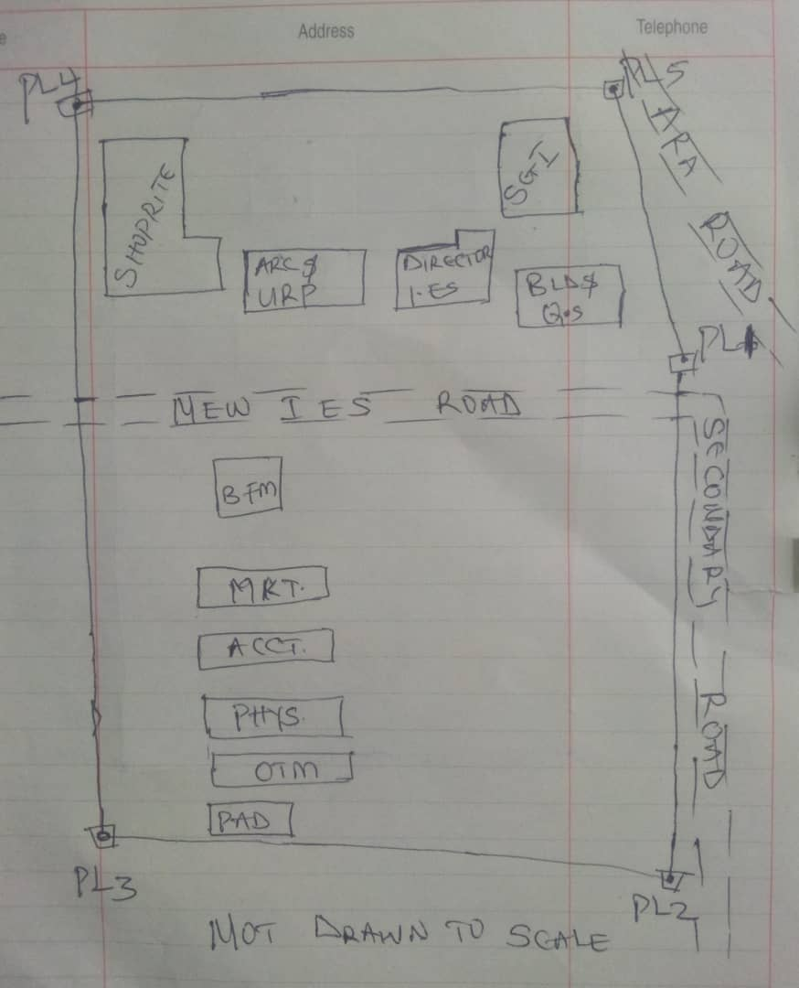

Recce diagram
3.1.2 Office Reconnaissance
Office reconnaissance/data gathering as the name implies is the exploratory survey, scouting or examination, to collect information necessary for the successful execution of the project. It can be simply define as making a preliminary survey before the actual mobilization for the project site. For the purpose of this project, the data search involved retrieving of the coordinate of three (3) existing control.
Pillar No. | Easting(m) | Northing(m) | Height | Location
KWPT 49 | 674341.289 | 937679.115 | 353.682 | Kwara Polytechnic
KWPT 50 | 674555.841 | 937618.402 | 354.903 | Kwara Polytechnic
Table 1: Show coordinates of existing and used control point.
3.1.3 Selection of Station
The boundaries as shown in the recce diagram were laid down by marking points on the ground (station).
The factors considered in selecting these stations include:
- Inter visibility between two points.
- Firmness of the ground at the selected point.
- Working convenience over the station.
- Points located where not disturbed.
3.2 Survey Rod
A survey rod is a physical marker, typically made of metal, used to mark the boundaries of a parcel of land. These markers are used to define the limits of a property and can be used as reference points for future surveys. Rods are durable and can be used in a variety of environments.
3.2.1 Survey rules guiding rod uses:
1. Placement: Rods should be placed at boundary corners or points of change in the boundary.
2. Visibility: Rods should be visible and easily identifiable
3. Durability: Rods should be durable and resistant to weathering.
4. Accuracy: Rods should be placed accurately, following the surveyed boundary.
5. Documentation: the location and description of rods or pegs should be documented in the survey records.

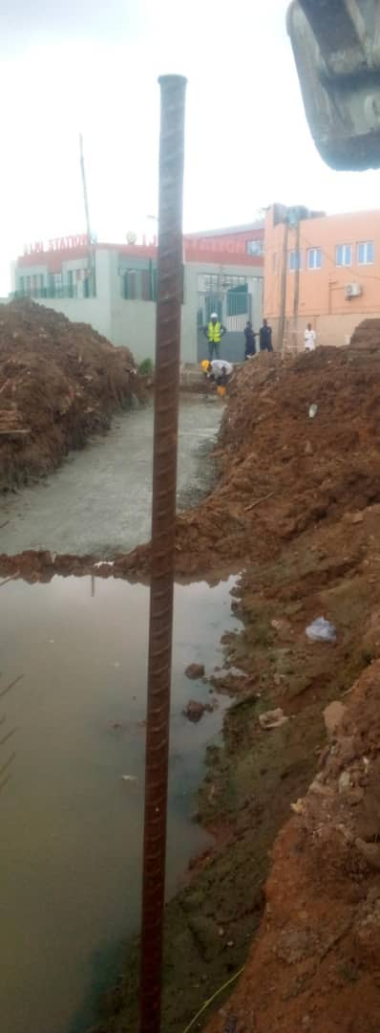

Figure 3.1: Graphical View of Cadastral Survey Rod
3.3 Instrumentation
It refers to the equipment and accessories employed for the successful execution of this project and they are as follows:
Hardware Used
- Stonex R2 Plus Total Station and its accessories
- Leica Digital Level instrument and its accessories
- Handheld GPS
- Hp Core i5 vPro 8th Gen Laptop
- Cutlasses
- Head-pan
- Nail and bottle cover
- 1 Hammer
- 1 Spade
- 1 Hand-trowel
Software Used
- AutoCAD 2007
- Golden Software Surfer 20.0
- Microsoft Office Excel 2013
- Microsoft Office Word 2013
Material Used
- Water
- Cement
Total Station:- It is an electronic or optical instrument used in modern surveying and building construction that used Electronic Distance Measurement (EDM). It is also known as electronic data collection and storage system of which all the data acquired on site is been stored and secured for office reconnaissance.
Digital Leveling:- It is considered one of the most precise methods for height determination. It employs an electronic level instrument and a bar-coded staff to measure vertical distances, reducing human errors common in conventional leveling.
Table 3.2: Equipment Description
S/N | Equipment | Uses
1 | Stonex R2 Plus Total Station | X, Y and Z coordinates of boundaries
2 | Leica Automatic Level | Determination of the reduced level
3 | Handheld GPS | X & Y coordinates of details
4 | Autodesk AutoCAD 2007 | Presentation of the boundaries
5 | Golden Software Surfer 20.0 | Contour and Generation of 3D model
6 | Microsoft Office Excel 2013 | X, Y and Y coordinates editing& program
7 | Microsoft Office Word 2013 | Report writing
3.4 Test of Instrument
For any survey job, testing of the instrument must be done before execution of the job, the instruments used for data acquisition were tested to ascertain whether they are in good working condition.
The following test were carried out,
3.4.1 Total Station
The total station instrument used (Stonex R2 Plus Total Station) underwent a two-phase check. Firstly, the vertical and horizontal angles were verified using pre-established control points within the school campus. Secondly, the electronic distance measurement (EDM) capability was tested for horizontal distances. The instrument passed all tests and was deemed suitable for use.
Below is the procedure for carryout the tests
3.4.1 Total Station
Instrument used in data acquisition was checked for integrity before moving them to site. Apart from check carried-out on Total Station, the following instruments were also checked: Tripod stand legs and their screw were confirmed okay, foot screws, focusing knob, vertical and horizontal knob for slow motion and clamp were all confirmed okay.
3.4.1.1 Horizontal Collimation Test
This error exists when the optical axis of the total station is not exactly perpendicular to the telescope axis. To test for horizontal collimation error, station A was selected and the instrument was set on it and leveled using three foot screws. Then, the telescope was rotated through 360°, but the bubble did not run out of the level tube centre which shows that the line of sight is parallel to the axis of the level tube.
Furthermore, the telescope was pointed to a target on station B in face left, then, pointed back to same target in face right; the difference in horizontal circle readings after averaging the result from both faces of the instrument was 180° except small variation is seconds which is permissible based on the allowable accuracy limit (least Count). The following results were displayed below.
Fairly Level Ground
STATION A
100m
REFLECTOR
(TARGET)
STATION B
Total Station

Fig 3.4.1.1: Horizontal Collimation and Vertical Index error test.
Table 3.4.1.1: Horizontal Collimation Data
Station | Target | Face | Hz Reading | Difference | Error
A | B | L | 38˚42’32”
 |  | R | 218˚42’35” | 180˚00’03” | 03”

3.4.1.2 Vertical Index Error Test
This test was performed to ensure that the vertical reading is exactly ninety degrees (90˚) when the line of sight is horizontal. Any deviation from this figure is known as vertical index error.
The Total Station was set over a point and necessary temporary adjustments were performed. A target set about 100m away from the Total station was sighted and bisected with the instrument on the face left and the reading was recorded. The target was also sighted and bisected on face right and the reading was also recorded. These readings are shown below
Table 3.4.1.2: Vertical Index Data
Instrument Station | Target Station | Face | Vertical | Sum | Error
A | B | L | 90˚00’00”
 |  | R | 270˚00’02” | 360˚00’02” | 02”

3.4.1.3 Analysis of Collimation and Vertical Index Data
The reading obtain during calibration were reduced to obtain new collimation and vertical errors.
Horizontal collimation = {(FR – FL) – 180}/2 = {(00˚00’03”}/2 = 1.5”
Vertical collimation = {(FL + FR) – 360} = (90˚00’00” + 270˚00’02”) - 360} = 02”
The result shows that the instrument is still in good working condition.
3.4.2 Digital Level Instrument
The level instrument employed for the research was Leica Digital level. Two pegs test was carried out on the digital level to check the collimation error of the instrument. The level instrument was set on a specific point A, with initial adjustments made for proper alignment, levelling, and focusing to eliminate parallax, it was now backsight on peg 1 and foresight on peg 2, the instrument was then now moved to another point B, and all the necessary adjustments were made, the peg 2 was bisected as backsight, and the peg 1 as foresight.

Level instrument STAFF (TARGET)

Fairly Level Ground
STATION A PEG 1
Fig3.4.1.1.: Horizontal Collimation error test
Table3.4.2.Horizontal Collimation Data
STATION | Remarks | BS | IS | FS | Diff.
A | Peg 1 | 1.734
A | Peg 2 |  |  | 2.042
 |  |  |  |  | 0.308
B | Peg 2 | 1.578
B | Peg 1 |  |  | 1.262
 |  |  |  |  | 0.316
 | Collimation Error |  |  |  | 0.008
The difference of the two-pegs test from 2 stations (0.008), shows the instrument is in good condition and can be used for the project.
3.5 Control Check
The control points were found along the road in Kwara State Polytechnic. In order to determine their correctness and their true position, one was used as station point KWPT 49 while the point KWPT 50 was used as the back sight. The coordinates obtained were compared with the received data from Department Field Data Records, the difference falls within the allowable accuracy of 3rd order survey job as can be seen in Table 3.3 below:
Table 3.3: Analysis of control check
PILLAR | COORDINATE | EASTING(m) | NORTHING(m) | HEIGHT(m)
KWPT 49 | RECEIVED | 674341.289 | 937679.115 | 353.682
KWPT 49 | OBSERVED | 674341.289 | 937679.115 | 353.682
KWPT 49 | DIFFERENCE | 0.000 | 0.000 | 0.000
PILLAR | COORDINATE | EASTING(m) | NORTHING(m) | HEIGHT(m)
KWPT 50 | RECEIVED | 674555.841 | 937679.115 | 353.682
KWPT 50 | OBSERVED | 674555.853 | 937679.097 | 353.691
KWPT 50 | DIFFERENCE | 0.012 | 0.018 | 0.009
Allowable accuracy |  | 0.600 | 0.600 | 0.600
3.6 Data Acquisition
Data acquisition in land surveying refers to the process of collecting and recording data about the land, its features, and boundaries. This can include:
- Geometric data acquisition
- Attribute data acquisition
3.6.1 Geometric Data Acquisition
Geometric data acquisition involves collecting data that defines the spatial relationships and positions of features on the land. This can include:
- Coordinates: Collecting X, Y, and Z coordinates of points on the land using instruments like total stations, GPS, and levels.
- Distances and angles: Measuring distances and angles between points on the land using instruments like total stations and tape measures.
- Elevations: Determining the height of points on the land above a reference datum using instruments like levels and GPS.
The geometric data of this project was obtained using the total station i.e. combination of electronic theodolite and the Electronic Distance Measurement (for X, Y, Z determination), and Level instrument (for height measurement) Geometric data are positional data, (i.e. they have the X, Y, Z) coordinates which make it easy to locate their actual position of features on the earth surface.
Here is a step-by-step procedure used for Total Station for geometric data acquisition:
Preparation
1. Setup: The Total Station was set over a known control point (KWPT 49).
2. Leveling: Level the instrument to ensure accurate measurements.
3. Orientation: It was done using two know control points KWPT 49(as occupy station) and KWPT 50(as backsight)
Data Collection
1. Target sighting: Sight the target (reflector) at the point to be measured.
2. Measurement: Determination of X, Y, Z of the target.
3. Recording: Record the measured data (coordinates).
4. Repeat: Repeat the process for each point to be measured.
Here's a step-by-step procedure used for Level instrument for data acquisition:

Preparation
1. Setup: The Level instrument was set on a stable surface, ensuring it's level and secure.
2. Leveling: Level the instrument using the built-in leveling mechanism.
3. Focus: The telescope was focused on the target (staff or rod).
Data Collection
1. Backsight: Took a backsight reading on a benchmark (KWPT 49).
2. Foresight: Take foresight readings on points to be measured, ensuring the staff is held plumb.
3. Reading: Record the readings, including the staff readings and points description.
4. Repeat: Repeat the process for each point to be measured.
3.6.2 Attributes Data Acquisition
Attribute data refers to information that describes the characteristics and properties of spatial features. It provides details such as names, classifications, and functions of geographic objects. In this study, the attribute data collected Include the names of buildings (e.g., lecture room of office), as well as information on roads. Handheld GPS was used to acquire attribute data for this project.
Handheld GPS units we used to gather attribute data by:
Collecting positional data: the GPS determines the location (LATITUTDE, Longtitude, and sometimes elevation) of the point where we standing.
Attaching attribute: you can then link attribute information to that location. This could be done by entering the information manually, (e.g. using the keypad on the GPS unit) or by uploading the data to a computer.
Saving the data: the GPS saves the location data along with the attributes, creating a dataset of points with associated information.
3.7 Perimeter, Detailing and Spot Heighting
Perimeter is the total distance covered along the boundary line and an area of land, the total distance covered is 1.214km. It is very important in order to get the exact location of a property. Traversing is a subordinate to perimeter and it may be defined as the process of connecting the series of lines with known bearing and distances (or XYZ).
The Total Station was carefully set up over control point KWPT49, with a back sight taken to point KWPT 50 after performing the necessary station adjustments, including cantering, levelling, and focusing, the KWPT50 (backsight) was measured and the observed coordinates was compared with given one, the difference is not significant and allowable. Then peg1 was established and measured in other to transfer the control to the site. The same procedure was repeated to determine the coordinates of the next point (peg2), and continued progressively until the site was reached. The radiation method was used for data acquisition, where two or more points were coordinated from a single instrument station.

The following steps outline the procedure:
- After completing temporary adjustments, the instrument was powered on, and a new job titled PRJT1 was created in the internal memory under the job menu.
- In the coordinate menu, orientation was established by inputting the coordinates of the instrument station and back sight.
- The height of the instrument and the reflector height were measured and entered into the instrument.
- The reflector at the back sight was accurately bisected before confirming the orientation.
- Once oriented, the reflector was aimed at the next target (nail), and the "OBS" (observe) function was selected. The three-dimensional coordinates (Easting, Northing, and Height) were displayed and saved by pressing "REC" (record). For subsequent observations, the "ALL" option was used to streamline the process.
- It was ensured that the centre of the prism on the reflector was properly aligned and securely mounted on the tripod to minimize height determination errors.
- Once all visible details, including boundary points, spot heights and building, had been observed from the current station, the instrument was relocated to the next control nail, and the temporary adjustments were repeated.
This process was systematically carried out until all boundary points and elevation data were captured. In this project, spot heights were not recorded at regular grid intervals but were instead collected randomly after it has been pegged. For each building, three corner points were surveyed. Upon completing the data acquisition phase, all relevant features were accurately recorded and positioned accordingly on the final site plan.

…………………………
HND/23/SGI/FT/0079

KAZEEM KABIRAT DAMILOLA
CHAPTER FOUR
4.0 DATA DOWNLOADING, PROCESSING, ANALYSIS AND DISCUSSION
This chapter provides a detailed overview of the procedures involved in data download, data processing, correction, and data analysis conducted on the acquired data from the site and data presentation.
4.1 Data Download
All the recorded data was stored in the memory of the total station. To download the data, the total station was connected to a computer using a wired cable and downloading software. The software parameters were configured to match those of the instrument. The instrument's menu was accessed, and the memory manager was selected. From there, the "send data" option was chosen, and the file named "PRJT1" was located and downloaded to the computer through the software. The data was saved with a ".txt" file extension on the desktop of the laptop for further processing.
4.2 Data Editing
The downloaded geometric data were further processed to convert them into usable formats and improve their accuracy. The resulting coordinate data were edited using Notepad and Excel software. This file was then imported into AutoCAD2007 for additional processing.

4.3 Data Processing using Autocad 2007
Before using AutoCAD, we processed the coordinate data observed in the field by first transferring it into Notepad, then copying it into AutoCAD. The following steps outline the process for handling the data in AutoCAD:
- Launch AutoCAD on the computer.
- Click "New" from the application menu to start a new drawing.
- Type UNITS in the command line and press Enter.
- Select the desired unit type (e.g., decimal, architectural, engineering).
- In the menu bar, select the "Polyline" tool.
- Copy the data from Notepad and paste it into AutoCAD.
- Type Z (for zoom) and press Enter, then type E (for extents) and press Enter to adjust the view.
- 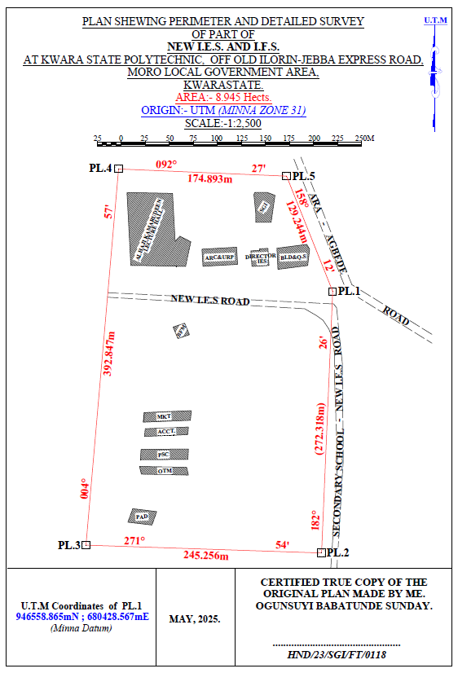
KAZEEM KABIRAT DAMILOLA
--------------------------------------
HND/23/SG/FT/0079
- Figure 3.7: Plan showing Perimeter and Detailed Survey.
- Area Computation using Cross Multiply Coordinates
- E1 N1
- E2 N2
- E3 N3
- E4 N4
- E5 N5
- E1 N6
- 680428.567 946558.865
- 680417.004 946286.792
- 680171.885 946294.956
- 680205.833 946686.334
- 680380.567 946678.865
- 680428.567 946558.865

- ∑ - ∑
- 2
- 460,787,138,011.03 – 460,786,959,116.36
- 2
- 178,894.67
- 2
- Area = 89,447.335 sqft
- Area = 8.945 hect.

4.4 Results and Discussion
Table 4.4: Total station and Digital level Spot height Readings and their differences
STATION | EASTING | NORTHING | HEIGHT |  | DIFF.
STATION | EASTING | NORTHING | T.S | LEVEL | DIFF.
PT1 | 680272.275 | 946497.781 | 355.749 | 355.715 | 0.034
PT2 | 680267.717 | 946479.907 | 356.403 | 356.362 | 0.041
PT3 | 680273.327 | 946450.469 | 354.811 | 354.772 | 0.039
PT4 | 680287.358 | 946434.349 | 354.268 | 354.208 | 0.060
PT5 | 680317.873 | 946433.648 | 355.036 | 354.984 | 0.052
PT6 | 680304.544 | 946455.727 | 355.710 | 355.668 | 0.042
PT7 | 680337.867 | 946463.436 | 355.448 | 355.386 | 0.062
PT8 | 680342.774 | 946441.708 | 356.295 | 356.240 | 0.055
PT9 | 680342.774 | 946441.708 | 356.736 | 356.680 | 0.056
PT10 | 680348.740 | 946443.460 | 355.971 | 355.931 | 0.040
PT11 | 680377.262 | 946451.836 | 355.725 | 355.673 | 0.052
PT12 | 680382.060 | 946482.711 | 355.318 | 355.277 | 0.041
PT13 | 680381.009 | 946518.108 | 354.819 | 354.766 | 0.053
PT14 | 680350.494 | 946509.345 | 355.174 | 355.128 | 0.046
PT15 | 680356.104 | 946484.813 | 355.033 | 355.005 | 0.028
PT16 | 680332.603 | 946480.960 | 355.228 | 355.188 | 0.040
PT17 | 680308.051 | 946470.796 | 355.517 | 355.464 | 0.053
PT18 | 680298.581 | 946490.422 | 355.834 | 355.802 | 0.032
PT19 | 680318.222 | 946506.191 | 355.726 | 355.678 | 0.048
PT20 | 680308.753 | 946526.168 | 356.148 | 356.096 | 0.052
Mean |  |  | 355.8163 | 355.7726 | 0.0437
Variance |  |  | 2.5758 | 2.5881 | 0.0123
Standard Deviation |  |  | 1.6049 | 1.6088 | 0.0039

Working Formulas for Mean, Variance and Standard Deviation Calculation
The mean is calculated as:
µ = ∑xi
n
µ= mean
xi = each point height
n = number of points
The variance is calculated as:
ꭤ²=∑(xi - µ)²
n
ꭤ²= variance
xi = each point height
µ= mean
n = number of points
The Standard Deviation is calculated as:
ꭤ = √ꭤ²
ꭤ= standard deviation
ꭤ²= variance
Mean calculation for Total Station Height readings
µ = ∑xi
n
µ=355.749+356.403+354.811+354.268+355.036+355.710+355.448+356.295+356.736+355.971+355.725+355.318+354.819+355.174+355.033+355.228+355.517+355.834+355.726+356.148
20
µ= 7116.326
20
µ=355.8163
Mean calculation for Reduced Level Height readings
µ=355.715+356.362+354.772+354.208+354.984+355.668+355.386+356.240+356.680+355.931+355.673+355.277+354.766+355.128+355.005+355.188+355.464+355.802+355.678+356.096
20
µ= 7115.452
20
µ = 355.7726
Mean calculation for Total Station Height readings - Mean calculation for level height readings 355.8163 – 355.7726 = 0.0437
ꭤ²=∑(xi - µ)²
n
ꭤ²=∑(xi - µ)²
n
0.0673²+0.5867²+1.0053²+1.5483²+0.5327²+0.2521²+0.1582²+0.4126²+0.9284²+0.0992²+0.1104²+0.1327²+1.0217²+0.6184²+0.7834²+0.4926²+0.2581²+0.0164²+0.0428²+0.3317
20
ꭤ²=51.516
20
ꭤ² =2.5758
Variance calculation for Reduced Level Height readings
0.576²+0.5894²+1.006²+1.5686²+0.5285²+0.2375²+0.1382²+0.4103²+0.9126²+0.0821²+0.1013+0.1104²+1.0102²+0.6014²+0.7695²+0.4818²+0.2443²+0.0071²+0.0289²+0.32047
20
ꭤ²=51.762
20
ꭤ² =2.5881
Variance calculation for total station – variance calculation for level height readings 2.5758 – 2.5881 = 0.0123
The Standard Deviation for Total Station Height readings:
ꭤ = √ꭤ²
ꭤ = √2.5758
ꭤ = 1.6049

The Standard Deviation for Reduced Level Height readings:
ꭤ = √2.5881
ꭤ = 1.6088
The standard deviation for total station – standard deviation for level height reading 1.6049 – 1.6088 = 0.0039

The table above shows the station Id, eastings, northings, total station height, digital level reduced level and the difference between the total station height and the digital level reduced level.
The comparison of the two pieces of equipment revealed variations within a specific range. The differences observed between the two pieces of equipment were found to be in the range of 0.028 to 0.062 meters. These differences indicate slight disparities in the measurements obtained from each instrument. Statistical analysis was performed to evaluate the mean, variance, and standard deviations of the observed differences. The mean difference was calculated to be 0.0437, indicating an average deviation between the measurements obtained by the two equipment. The variance, which quantifies the spread of the differences, was found to be 0.0123.
This value suggests that the variations in the measurements obtained by the two pieces of equipment were relatively consistent. The standard deviation, which provides a measure of the dispersion of the data, was determined to be 0.0039. This indicates that the differences between the measurements obtained from the two pieces of equipment had a moderate level of variability.
Overall, the results of the analysis demonstrate that there were slight variations between the measurements obtained from the two pieces of equipment. The mean, variance, and standard deviations provide insights into the magnitude and consistency of these differences, offering valuable information for assessing the accuracy and reliability of the equipment in question.

Figure 1:Bar chart showing heights obtained from the total station and level instrument

Figure 2:Histogram showing the difference in the two instrument’s result
The histogram presented above illustrates the distribution of deviations between the two methods being compared. The deviations are depicted in centimeter, showcasing the level of accuracy achieved by both methods. The histogram highlights that the deviations are tightly clustered and exhibit a consistent pattern.
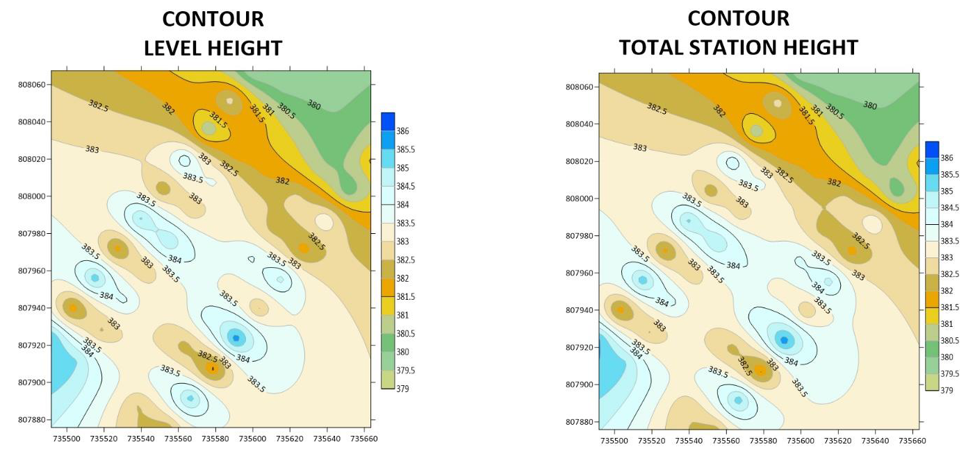Figure 3:. Showing the contour map obtained from the two instruments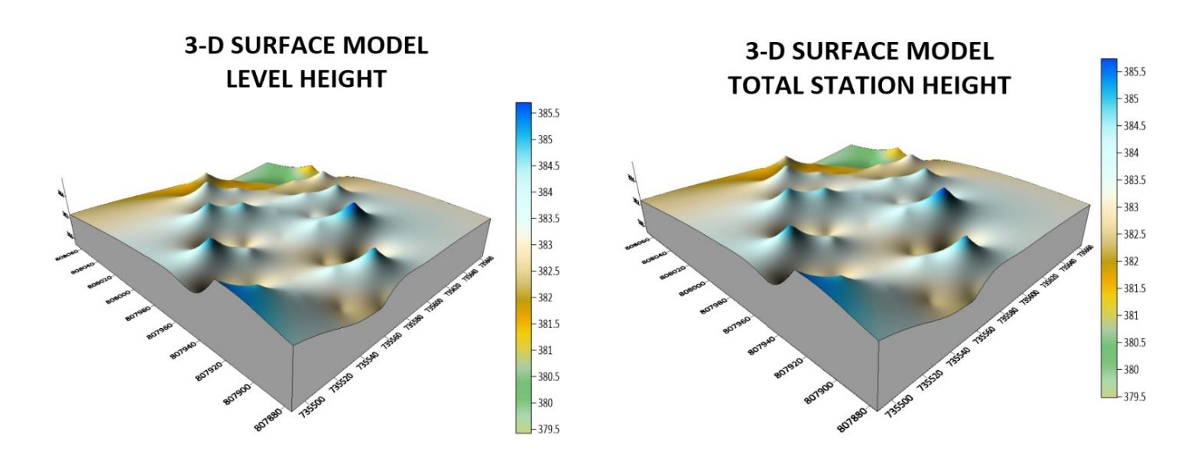Figure 4: Showing the 3D surface map obtained from the two instruments
3-D SURFACE MODEL USING TOTAL STATION
3-D SURFACE MODEL USING AUTO LEVEL
CONTOUR MAP USING TOTAL STATION
CONTOUR MAP USING AUTO LEVEL
The mean of the deviations, calculated to be 0.0437m, provides an indication of the average difference between the measurements obtained from the two methods. This value signifies a small average deviation, suggesting that the two methods generally yield similar results with minimal variation.
The histogram provides a visual representation of the data, allowing for a comprehensive understanding of the distribution of deviations. By examining the histogram, one can observe the concentration of deviations around the mean value, indicating a central tendency in the measurements obtained by the two methods.
The centimeter-level accuracy exhibited by the deviations underscores the precision of the measurement techniques employed. This level of accuracy is crucial, particularly in applications that require high precision, such as engineering, construction, or geospatial analysis. The contour maps presented above exhibit strikingly similar patterns, which serve as a testament to the high degree of precision achieved by the instruments used. The consistent and replicated patterns observed on the maps reinforce the reliability and accuracy of the measurements obtained.
The similarity in the contour patterns indicates that the instruments employed in the surveying process were able to capture the subtle variations in elevation with great precision.
This level of accuracy is crucial in applications such as topographic mapping, land surveying, and engineering, where even minor deviations can have significant implications. By displaying the contours of the surveyed area, the maps provide a visual representation of the landscape's topography and elevation changes.
The congruity in the contour lines across the maps signifies that the instruments effectively captured and recorded the elevation data, resulting in a reliable representation of the terrain
4.5 Statistical Analysis
A statistical investigation was carried out using Paired Two Samples as Means to test whether there is any significant difference in the performance of the two instruments for terrain height determination. The independent sample t-test is a member of the t-test family, which consists of tests that compare mean value(s) of continuous-level (interval or ratio data), normally distributed data (Hinton, 2004). The independent-sample t-test evaluates the difference between the means of two independent or unrelated groups. That is, we evaluate whether the means for the two independent groups are significantly different from each other.
Hypothesis
A hypothesis was set up and tested using an Independent – sample T-Test:
- Null Hypothesis: H0: There is no difference between the terrain height obtained from the total station and digital level instrument.
- Alternative Hypothesis: H1: There is a difference between terrain height obtained from total station and digital levelling instrument.
The null hypothesis is rejected if the calculated t value has a probability sig. (p) greater than the chosen significance level. An Independent sample T-Test was used in testing the hypothesis at a significance level of 0.05. Data analysis Package extension in Excel was activated and used in running the T-Test.
Table 4.5: T-Test: Two-Sample Assuming Unequal Variances
 | Digital Level | Total Station
Mean | 355.77262 | 355.81628
Variance | 2.588092118 | 2.575687471
Observations | 20 | 20
Pearson Correlation | 0.032104369 | 0.031950494
Hypothesized Mean Difference | 0.001605218 | 0.001597525
t Stat | 0.056215684 | 0.056208782
P(T<=t) one-tail | 0.145413689 | 0.144776257
P(T<=t) two-tail | 0.290982737 | 0.289552551
Sum | 7096.631 | 7095.814
Kurtosis | 2.049052417 | 2.0403051292
Skewness | 0.612867732 | 0.5907755549
Median | 354.772 | 354.811
Maximum | 356.680 | 356.736
Minimum | 354.208 | 354.268
Range | 2. 472 | 2.468
The statistical data provided supports our discussion by indicating a high degree of agreement and consistency between the digital level and total station measurements. The mean values are very close, the variances are similar, and the Pearson correlation coefficient indicates a strong linear relationship. The t-test results suggest that any observed difference between the two instruments' means is likely due to random variation rather than a significant discrepancy. After carrying out the project, we observe that digital level is more accurate than total station, although the different can be quite small.

CHAPTER FIVE
5.0 COSTING, SUMMARY, RECOMMENDATION AND CONCLUSION.
5.1 Cost Estimation of the Project
The project costing was based on number of variables which includes area to be covered, instruments, personnel, transportation and so on. However, another critical factor to be considered is the time duration in which the project was executed. The table below shows the duration the project was accomplished.
Table 5.1: Scheduled and Duration of the Project Execution
Description | Duration (Days)
Reconnaissance | 1
Beaconing / Monumentation | 1
Spot height points establishment | 1
XYZ acquisition of the spot height points (using TS) | 1
Height observation of the spot height points (using level instrument) | 1
Detailing (using handheld GPS) | 1
Data Downloading / Processing | 3
Plotting and Report Writing | 7
Submission of Report and Plan | 5
Total No. of Days Spent for the Project | 21

5.1.1 Project Costing Breakdown

Costing of this project was based on Professional Scale of Fees as approved by Nigerian Institution of Surveyor (NIS) in 2017 using 1996 Federal Government Approved Scale of Fees for Consultants in the Construction Industry. The prevailing inflation rate as at February 2023 was 21.91 % and this was applied to the cost estimate.
Table 5.2: Worked out Calculation for the grand Total Cost
S/N | OPERATION | RATE/DAY | NO OF DAYS | UNIT  COST (#) | AMOUNT (#)
1 | RECONNISSANCE(1 DAY)
 | 4 Technician | 15,189.11 | 1 | 15,189.11 x 4 | 60,756.40
 | 1 Skilled Labour | 9,468.61 | 1 | 9,468.61x 1 | 9,468.61
 | Transportation (Field vehicle + Driver / Mechanic + fuel | 46,027.61 | 1 | 46,027.61 x 1 | 46,027.61
 | Basic equipment (Hand held GPS etc.) | 46,027.61 | 1 | 46,027.61 x 1 | 46,027.61
 | SUB TOTAL |  |  |  | 157,546.00
2 | - BEACONS (5)  (standard Cadastral Beacon) | 5,000 per Beacon |  | 5,000 x 5 | 25,000.00
2 | - BEACONING/  MONUMENTATION (1 day)
2 | 6 Surveyors | 15,189.11 | 1 | 6x 15,189.11x 1 | 91,134.11
2 | 3 Skilled Labour | 9,468.61 | 1 | 3x 9,468.61x 1 | 28,405.83
2 | Transportation (Field vehicle + Driver / Mechanic + fuel) | 46,027.61 | 1 | 46,027.61 x 1 | 46,027.61
2 | Basic tools (Crow bar, Trowel, Shovel etc) | 13,929.00 | 1 | 13,929.00x 1 | 13,929.00
2 | SUBTOTAL |  |  |  | 179,496.55
3 | Spot Height Establishment  ( 1 DAY)
 | 2 surveyors | 15,189.11 | 1 | 2x15,189.11 x 1 | 30,378.22
 | 3 Unskilled Labour | 9,468.61 | 1 | 3 x9,468.61x 1 | 56,811.66
 | Basic Equipment | 46,027.61 | 1 | 46,027.61x1 | 92,055.22
 | Transportation (Field vehicle + Driver / Maintenance + Fuel) | 46,027.61 | 1 | 46,027.61 x 1 | 92,055.22
 | SUBTOTAL |  |  |  | 271,300.32
4 | XYZ ACQUISITION USING (TS)  (1 DAY)
 | 1 Senior Surveyor | 22,783.67 | 1 | 1x 22,783.67 x 2 | 45,567.34
 | 2 Surveyors | 15,189.11 | 1 | 2 x15,189.11 x 2 | 60,756.44
 | 2skilled Labour | 9,468.61 | 1 | 2 x9,468.61x 2 | 37,874.44
 | Basic Equipment | 46,027.61 | 1 | 46,027.61x 2 | 92,055.22
 | Transportation (Field vehicle + Driver / Maintenance + Fuel) | 46,027.61 |  | 46,027.61 x 2 | 92,055.22
 | SUBTOTAL |  |  |  | 328,308.66
5 | HEIGHT OBSERVATIION (LEVEL INSTRUMENT)  (1DAY)
 | 1 Senior Surveyor | 22,783.67 | 1 | 1x 22,783.67 x 2 | 45,567.34
 | 2 surveyors | 15,189.11 | 1 | 2 x15,189.11 x 2 | 60,756.44
 | 2skilled Labour | 9,468.61 | 1 | 2 x9,468.61x 2 | 37,874.44
 | Basic Equipment | 46,027.61 | 1 | 46,027.61x 2 | 92,055.22
 | Transportation (Field vehicle + Driver / Maintenance + Fuel) | 46,027.61 | 1 | 46,027.61 x 2 | 92,055.22
 | SUBTOTAL |  |  |  | 328,308.32
6 | DETAILING  (1 DAY)
 | 2 Surveyors | 15,189.11 | 1 | 2x 15,189.11x 1 | 30,378.22
 | 3 Skilled Labour | 9,468.61 | 1 | 3x 9,468.61x 1 | 28,405.83
 | Transportation (Field vehicle + Driver / Mechanic + fuel) | 46,027.61 | 1 | 46,027.61 x 1 | 46,027.61
 | Basic Equipment | 46,027.61 | 1 | 46,027.61x 1 | 46,027.61
 | SUBTOTAL |  |  |  | 150,839.27
7 | DATA DOWNLOADING  / PROCESSING  (3 DAYS)
 | 1 Senior Surveyor | 22,783.67 | 3 | 22,783.67 x 3 | 68,351.01
 | 2 surveyors | 15,189.11 | 3 | 2x15,189.11 x 3 | 91,134.66
 | Computer Accessories | 49,315.28 | 3 | 49,315.28 x 3 | 147,945.84
 | SUBTOTAL |  |  |  | 307,431.51
8 | PLOTTING AND REPORT WRITTING  (7 DAYS)
 | 1 Senior Surveyor | 22,783.67 | 7 | 1x22783.67 x 7 | 159,485.69
 | 2 surveyors | 15,189.11 | 7 | 2x15,189.11 x 7 | 212,647.54
 | Standard set (computer, plotter etc) | 65,753.70 | 7 | 1x65,753.70 x 7 | 460,275.90
 | SUBTOTAL |  |  |  | 832,409.13
9 | SUBMISSION OF REPORT AND PLAN  (1 DAY)
 | 1 Chief Surveyor | 30,800.00 | 1 | 30,800.00x 1 | 30,800.00
 | 2 surveyors | 15,189.11 | 1 | 2x 15,189.11x 1 | 30,378.22
 | 1 Computer | 46,027.61 | 1 | 46,027.61 x 1 | 46,027.61
 | Consumables | 13,929.00 | 1 | 13,929.00 x 1 | 13,929.00
 | SUBTOTAL |  |  |  | 121,135.41
COST OF TH]E PROJECT = |  |  |  |  | 2,676,775.17 |  |  | 1,379,346.77
ACCOMODATION(15% of the cost of the project) |  |  |  |  | 595,177.22
MOBILIZATION/DEMOBILIZATION (10% of cost of the project) = |  |  |  |  | 396,784.81
CONTINGENCIES (5% of cost of the project) = |  |  |  |  | 198,392.41
VAT (7.5% of the Total cost of the project)= |  |  |  |  | 297,588.61
ACTUAL BILL/ GRAND TOTAL = |  |  |  |  | 4,164,718.22
Hence, the total cost of expenditure used for comparative evaluation of digital levelling and total station equipment for height measurement project was estimated to be Four Million, One Hundred and Sixty Four Thousand, Seven Hundred Eighteen Naira, Twenty Two Kobo only.
5.2 Summary
The comparative evaluation of digital levelling and total station equipment for height measurement provides a thorough assessment of the accuracy and reliability of these two essential surveying tools. The project demonstrates that both digital levelling and total station equipment can achieve high accuracy and reliability, but with different characteristics and applications. The project highlights the importance of understanding the strengths and limitations of each tool, ensuring that the most suitable equipment is selected for specific projects. The results of this research contribute to the advancement of surveying practices, enhancing the accuracy and reliability of height measurements and informing the development of more effective surveying methodologies.
5.3 Recommendation
Based on the findings of this project, it is recommended that surveying professionals and researchers consider the environmental conditions and potential sources of error when selecting and using digital levelling and total station equipment. By understanding the potential sources of error and taking steps to mitigate them, professionals can ensure the accuracy and reliability of height measurements. Additionally, it is recommended that professionals use multiple measurement techniques and equipment to validate results and ensure accuracy.
5.4 Conclusion
This comparative evaluation has demonstrated that digital levelling and total station equipment are both essential tools for height measurement, each with its own unique capabilities and limitations. In conclusion, the results of this project highlight the importance of selecting the most suitable equipment for specific projects, taking into account factors such as range, precision, and environmental conditions. By understanding the strengths and limitations of digital levelling and total station equipment, surveying professionals can ensure the accuracy and reliability of height measurements, ultimately contributing to the success of their projects. This project's findings have significant implications for the advancement of surveying practices, enhancing the precision and reliability of height measurements in various fields.

REFERENCES
Audu, H.A.P., Tijjani, M.Y. (2017). Comparative Assessment of the Accuracy of the Elevation differences obtained from different Geomatics Techniques and Instruments. Nigerian Journal of Environmental Sciences and Technology Vol 1, No. 1 pp 136 - 145
Beshr, A.A.A.; Abo Elnaga, I.M. ( 2011). Investigating the Accuracy of Digital Levels and Total Stations for Purposes of Geodetic Engineering. Alex. Eng. J. 50, 399–405
FIG Congress: Comparative Study of Digital Levelling and Total Station for Height Measurement.
International Journal of Civil Engineering: Digital Levelling and Total Station: A Comparative Study in Surveying Applications.
Journal of Spatial Science: Accuracy Assessment of Digital Levelling and Total Station in Surveying.
Julius Omary. “Comparison between Total Station Levelling and Digital Levelling” Alexandria Engineering Journal. VOL.50:4. PP 399-405, 2018
Uren, J., & Price, W. F. (2010): Surveying for Engineers. Palgrave Macmillan.
W. Maembe, “Potential Application of Total Station Levelling as a Precise Geodetic Levelling” BSc. Thesis, Department of Geomantic Ardhi University Dare Salam Tanzania,2012.
W. Schofield and M. Breach, Engineering Surveying, Sixth Edition. Elsevier Ltd. Oxford U.K., 2007.

APPENDIX
ID EASTING NORTHING TS HEIGHT LEVEL HEIGHT
PL.1 680428.567 946558.865 356.128
PL.2 680417.004 946286.792 354.746
PL.3 680171.885 946294.956 353.013
PL.4 680205.833 946686.334 357.652
PL.5 680380.567 946678.865 356.849
SH1 680272.275 946497.781 355.749 355.715
SH2 680267.717 946479.907 356.403 356.362
SH3 680273.327 946450.469 354.811 354.772
SH4 680287.358 946434.349 354.268 354.208
SH5 680317.873 946433.648 355.036 354.984
SH6 680304.544 946455.727 355.710 355.668
SH7 680337.867 946463.436 355.448 355.386
SH8 680342.774 946441.708 356.295 356.240
SH9 680342.774 946441.708 356.736 356.680
SH10 680348.740 946443.460 355.971 355.931
SH11 680377.262 946451.836 355.725 355.673
SH12 680382.060 946482.711 355.318 355.277
SH13 680381.009 946518.108 354.819 354.766
SH14 680350.494 946509.345 355.174 355.128
SH15 680356.104 946484.813 355.033 355.005
SH16 680332.603 946480.960 355.228 355.188
SH17 680298.581 946490.422 355.834 355.802
SH18 680318.222 946506.191 355.726 355.678
SH19 680308.753 946526.168 356.148 356.096
SH20 680342.774 946441.708 356.736 356.680

SHOPRITE 680275.567 946584.865 , S.G.I 680364.567 946630.865
SHOPRITE 680229.567 946585.865 , S.G.I 680368.567 946658.865
SHOPRITE 680218.567 946585.865 , S.G.I 680360.567 946661.865
SHOPRITE 680214.567 946661.865 , S.G.I 680347.567 946661.865
SHOPRITE 680262.006 946660.833 , S.G.I 680346.567 946659.865
SHOPRITE 680264.633 946610.907 , S.G.I 680348.567 946639.865
SHOPRITE 680269.493 946616.306 , S.G.I 680348.567 946630.865
SHOPRITE 680281.021 946610.551 , S.G.I 680364.567 946630.865
SHOPRITE 680281.021 946610.551
DRCT. IES 680344.567 946584.865 , BLD&QS 680371.567 946581.865
DRCT. IES 680343.551 946601.098 , BLD&QS 680370.514 946603.802
DRCT. IES 680352.430 946601.591 , BLD&QS 680401.497 946607.815
DRCT. IES 680352.329 946603.210 , BLD&QS 680404.537 946602.905
DRCT. IES 680361.208 946603.703 , BLD&QS 680402.499 946585.830
ARC&URP 680328.567 946604.865 , BFM 680262.567 946521.871
ARC&URP 680292.567 946602.865 , BFM 680267.567 946509.867
ARC&URP 680293.684 946585.013 , BFM 680279.567 946513.862
ARC&URP 680329.684 946587.013 , BFM 680274.567 946525.865
MKT. 680215.442 946426.097 , ACCT.680262.660 946428.209
MKT. 680214.930 946436.134 , ACCT.680218.483 946419.645
MKT. 680263.075 946445.466 , ACCT.680218.891 946411.655
MKT. 680263.587 946435.430 , ACCT.680263.068 946420.219
PHYS. 680266.105 946405.563 , OTM. 680266.988 946386.384
PHYS. 680267.046 946394.755 , OTM. 680218.393 946380.018
PHYS. 680218.331 946387.08 , OTM. 680221.571 946372.409
PHYS. 680217.389 946397.897 , OTM. 680270.166 946378.775
PAD. 680240.402 946321.660
PAD. 680215.235 946320.874
PAD. 680218.077 946335.465
PAD. 680243.244 946336.252

