
A PROJECT
ON
COMPARATIVE EVALUATION OF ACCURACY AND RELIABILITY OF DIGITAL LEVELLING AND TOTAL
STATION EQUIPMENT TO DETERMINE THE HEIGHT MEASUREMENT
(A CASE STUDY OF PART OF KWARA STATE POLYTECHNIC)
BY
ABDUL KAREEM RAMOTA OLAWUMI
HND/23/SGI/FT/0078

SUBMITTED TO

DEPARTMENT OF SURVEYING AND GEO-INFORMATIC, INSTITUTE OF ENVIRONMENTAL STUDIES (I.E.S), KWARA STATE POLYTECHNIC, ILORIN.

IN PARTIAL FULFILLMENT OF THE REQUIREMENTS FOR THE AWARD OF THE HIGHER NATIONAL DIPLOMA (HND) IN SURVEYING AND GEO-INFORMATIC.

JULY, 2025.

DECLARATION
I hereby certified that all the information given in this project were obtained as a result of observations and measurements made by me and that the survey was carried out in accordance with Survey Rules, Regulations and Departmental instructions.

NAME:ABDUL KAREEM RAMOTA OLAWUMI
MATRICNO.:HND/23/SGI/FT/0078

SIGNATURE: ………………………………….

DATE OF COMPLETION: ……………………………………………….

CERTIFICATION
This is to certify that ABDUL KAREEM RAMOTA OLAWUMI with matriculation number HND/23/SGI/FT/0078 has satisfactorily carried out this project under our instructions and direct supervision.

SURV. A. G. AREMU _______________________
(PROJECT SUPERVISOR) SIGNATURE AND DATE

SURV. AWOLEYE R. S ________________________
(PROJECT COODINATOR) SIGNATURE AND DATE

MR. ABIMBOLA I. ISAU ________________________
(HEAD OF DEPARTMENT) SIGNATURE AND DATE

___________________________ ________________________
EXTERNAL MODERATOR SIGNATURE AND DATE
DEDICATION
I dedicate this project to Almighty God, whose guidance, strength, and blessings have been my constant source of inspiration and perseverance. Through every challenge and triumph, your presence has been my guiding light and steadfast support. Thank You for granting me the wisdom, knowledge, and patience to complete this goal.
ACKNOWLEDGEMENTS
As I stand at the threshold of this significant milestone, I am overwhelmed with gratitude and love for the people who have made this journey possible.
I earnestly express my deepest gratitude to my project supervisor Surv. A.G. AREMU for the guidance and patience throughout my research work indeed he is an epitome of a great Lecturer.
My sincere gratitude also goes to My (H.O.D) MR. ABIMBOLA ISAU and other lecturers at the Department of Surveying Geo-informatics (SUR. A.G AREMU, SUR. R.S ASONIBARE, SUR. R.O AWOLEYE, SUR. BANJI, SUR. AYUBA, SUR. DIRAN, SUR. KAZEEM, SUR. KABIRU ), for nurturing me in my academic activities. May Almighty Allah continue to bless you all abundantly.
My unreserved appreciation goes to my beloved parent, Mr. and Mrs. ABDULKAREEM for their un-measured words of encouragement, financial, moral and spiritual support given to me all through this program.
My profound gratitude goes to my wonderful friends and my group Member thanks for the good experience we have together.

.

ABSTRACT
This project undertakes a thorough comparison and analysis of the performance of Total Station and digital level instruments in determining terrain heights, with a focus on accuracy and reliability. Height observations are a critical component of surveying and geodetic science-related areas, and this project aimed to evaluate the effectiveness of these two instruments in obtaining accurate height measurements. A fieldwork was conducted within the Kwara State Polytechnic campus, Total station was used to measured the perimeter points and 20 stations were established randomly within the site perimeter, Total station and Digital level instrument were used to determine the height of those station (as spot height). The data obtained from digital leveling and Total Station measurements were carefully processed and analyzed, revealing that both instruments produced comparable results. The maximum and minimum heights obtained using the digital level instrument were 356.680m and 354.208m, respectively, while the Total Station instrument yielded maximum and minimum heights of 356.736m and 354.268m, respectively. The project found that the differences between the heights obtained using both instruments were relatively small, ranging from 28mm to 62mm. Importantly, the project concluded that both instruments can be used interchangeably for terrain height determination, given the absence of significant differences in their performance. The findings of this project contribute to the understanding of the capabilities and limitations of Total Station and digital level instruments in surveying and mapping applications, and have implications for the selection of instruments for specific projects.

TABLE OF CONTENTS
Cover page…………………………………………………………………………………….i
Declaration………..………………………………………………………………….………..ii
Certification…………………………………………………………………………….……..iii
Dedication……………………………………………………………………………….…….iv
Acknowledgement……………………………………………………………………….….....v
Abstract…………………………………………………………………………………….….vi
Table of contents ….……………………………………………………………………….vii-ix
CHAPTER ONE
- Introduction…………………………………………………………..…….………. ….1
1..1 Background to the study………………………………………….……...……….……1
1.2 Statement of the problem……………………………...…...................................……..3
1.3 Aim…………………………………………………………………..……….......…….4
1.4 Objectives …………………………………………………………….………………..4
1.5 Justification …….………………………………………………………...………….4
1.6 Significance of the Project……………………………………………………………..5
1.7 Pesonnel……………………………………….…………………………….……..…...6
1.8 Study Area………………………………………………………….…………………..7
CHAPTER TWO
- Literature Review………………………………………………….……………….…..8
2.1 Digital Leveling Instruments……..…………..…………………….……..……….….11
2.2 Total Station Instrument………..….……………………………………….…………11
2.3 Comparison of Height Measurement Capabilities…………………,..………….……12
2.4 Literature Review on Comparison of Total Station and Levelling Instrument in Height Measurement ……………………………………………………………………….13
2.5 Project Review……………………………………………………………………....15

CHAPTER THREE

Methodology……………………………………….……..………………………….16

3.1 Reconnaissance………………………………………..……………………………...16
3.2 Beaconing……………………………………………………..…………….………..18

3.3 Instrumentation………………………………………………….………………...…19

3.4 Test of Instrument ……………………………………………..……………………...21
3.5 Control Check………………..…………………………………...…………………...25
3.6 Data Acquisition …………………………………,……………….………..………...25
3.7 Perimeter, Detailing and Spot Heighting………………………………..…………….27

CHAPTER FOUR
- Data Downloading, Processing, Analysis and Discussion……………………………30
4.1 Data Download………………………………………….........................……………30
4.2 Data Editing……………………………………………………………….………..…30
4.3 Data Processing using Autocad 2007……………………………………...………….31
4.4 Results and Discussion……………………………………………………..…………31
4.5 Statistical Analysis……………………………………………………………………36
CHAPTER FIVE
5.0 Costing, Summary, , Recommendation and Conclusion…………………………...…39
5.1 Costing..........................................................................................................................39
5.2 Summary……………………………………………..………………………….……46
5.3 Recommendation …………………………………………………………………….46
5.4 Conclusion……………………………………………………………………............47
REFERENCES…….…………………………………………………………….….…....…48
APPENDIXDATA……………………………..……….…………………..……………….50

CHAPTER ONE
1.0 INTRODUCTION
1.1 Background to the Study
Surveying plays a crucial role in engineering, construction, and geospatial sciences, ensuring precise measurements for infrastructure development. Among the various surveying techniques, digital leveling and total station equipment are widely used due to their high accuracy and efficiency (Ghilani& Wolf, 2017). However, selecting the appropriate instrument depends on factors such as terrain, required precision, and project scope, necessitating a comparative evaluation of their accuracy and reliability in specific environments.
Digital leveling is a precise method of determining height differences between points using a digital level and a barcode staff. It minimizes human errors by automatically reading the staff and processing data, leading to enhanced precision and consistency (Uren & Price, 2019). This technique is commonly employed in construction projects requiring high vertical accuracy, such as road networks, bridges, and building foundations.
Total station equipment integrates electronic distance measurement (EDM), angle measurement, and data recording in a single instrument (Kavanagh & Glennon, 2020). It provides both horizontal and vertical measurements, making it suitable for a wide range of surveying applications, including topographic mapping, construction, and geodetic control networks. However, its accuracy may be influenced by atmospheric conditions, instrument calibration, and operator expertise.
The accuracy and reliability of surveying equipment are paramount, as errors in height measurement can lead to costly mistakes in construction and design (GhHilali & Yahya, 2019). In the context of Kwara State Polytechnic, where the terrain includes varied topography due to its location in Ilorin, the performance of digital levelling and total station equipment must be evaluated to determine their suitability for local conditions. Factors such as equipment calibration, operator skill, and environmental variables can significantly influence the outcomes of these tools, necessitating a comparative study.
Several studies have compared the accuracy of digital levelling and total station equipment. Research by Al-Kasasbeh et al. (2018) found that digital levelling achieves superior vertical accuracy compared to total stations, especially in long-distance levelling tasks. However, total stations offer advantages in speed and versatility, making them preferable for general survey applications.
Studies have highlighted the efficiency of total stations in reducing fieldwork time while maintaining acceptable accuracy (Osei &Amekudzi, 2021). The ability to store and process data digitally reduces human errors and enhances workflow efficiency. However, factors such as instrument calibration and environmental conditions can impact the reliability of measurements.
The choice between digital levelling and total station equipment is critical for surveying professionals. Understanding their strengths and limitations helps in selecting the appropriate instrument for specific tasks (El-Rabbany, 2019). This study aims to evaluate the comparative accuracy and reliability of both methods within part of Kwara State Polytechnic, Kwara State, to provide insights for optimal instrument selection in academic and professional surveying practices.
The study area, Kwara State Polytechnic, serves as a suitable environment for testing these instruments due to its diverse topography, infrastructural development, and academic engagement in surveying studies. By conducting precision measurements in various locations, the study assesses how factors such as terrain and instrument handling influence the performance of each method.
Furthermore, the findings of this study will contribute to the growing body of knowledge on surveying accuracy assessment, offering practical recommendations for future applications (Zhou et al., 2020). By comparing error margins, efficiency, and reliability, this research provides valuable insights for students, professionals, and researchers in the geospatial field.
1.2 Statement of Problem
The lack of localized comparative studies between digital levelling and total station equipment poses a challenge for decision-making regarding resource allocation and curriculum development at Kwara State Polytechnic. Although global studies suggest that both tools offer high accuracy, their reliability in terms of consistent performance and maintenance demands remains underexplored in the Nigerian tertiary education setting (Uren & Price, 2010). This knowledge gap could hinder the polytechnic’s ability to optimize its surveying practices, affecting the quality of infrastructural projects and the competence of graduates in the surveying and geo-informatics field, necessitating an empirical investigation to address these uncertainties.
1.3 Aim of the Project
This project aims to investigate the accuracy and reliability of Total station and levelling instrument and provide valuable insights for surveyors, engineers, and researchers seeking to optimize height measurement techniques.
1.4 Objectives of the Project
- Examine the differences in height measuring accuracy between digital leveling and total stations.
- Evaluate their dependability in various scenarios.
- Suggest the most accurate technique for measuring elevation.
1.5 Scope of the Project
This study compares the precision and dependability of total station and digital leveling equipment for determining height in a particular area of Kwara Polytechnic. It will evaluate how well both equipment works in various operational and environmental settings, looking at things like measurement accuracy, error margins, and usability. The study will only collect, process, and evaluate field data within the study area and offer suggestions for the best height measurement methods for use in building and surveying applications.

1.6 Justification of the Project
The evaluation of digital levelling and total station equipment at Kwara State Polytechnic is justified by the growing need for precise and reliable surveying data in both academic and practical applications within the institution. As a technical training hub, the polytechnic relies on accurate topographic information for campus development projects, such as constructing new facilities or maintaining existing infrastructure, where even minor errors can lead to significant financial and structural consequences (Kavanagh & Mastin, 2013).
Despite the increasing use of total stations due to their speed and versatility, studies suggest that digital leveling provides superior accuracy in elevation measurements. However, many surveyors prefer total stations for convenience, potentially compromising precision in projects that require exact height data. This project is necessary to evaluate these differences and provide empirical evidence on the best approach for specific surveying applications, particularly within the study area of Kwara Polytechnic.

1.7 Personnel
The project was assigned to and was successfully carried by the personnel listed below;
NAME | MATRIC. NO.
Abdul Kareem Ramota Olawumi | HND/23/SGI/FT/0078 | Writer
Ganiyu Akeem Abiodun | HND/23/SGI/FT/0076 | Member
Kazeem Kabirat Damilola | HND/23/SGI/FT/0079 | Member
Adeoti Qudus Adebayo | HND/23/SGI/FT/0080 | Member
Adeleye Sheriffdeen Olawale | HND/23/SGI/FT/0081 | Member
Abdul Qudus Shukurah Temitope | HND/23/SGI/FT/0083 | Member
Ogunsuyi Babatunde Sunday | HND/23/SGI/FT/0118 | Member
Jimoh Halimah Titilayo | HND/22/SGI/FT/082 | Member
1.8 Study Area
Kwara State Polytechnic is a significant provider of technical and vocational education and is situated in Ilorin, Nigeria. Spread across a wide area, it is roughly located at latitude 8.4791° N and longitude 4.5418° E.The institution's terrain consists of both flat and slightly undulating areas, making it suitable for studying height measurement techniques. With a mix of built-up structures and open spaces, Kwara Polytechnic provides a practical environment for evaluating digital leveling and total station accuracy.
1.9 Project Location
The project site is located inside Kwara state polytechnic Ilorin, Kwara state.
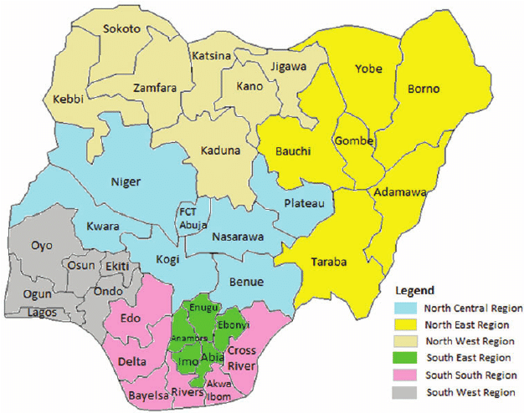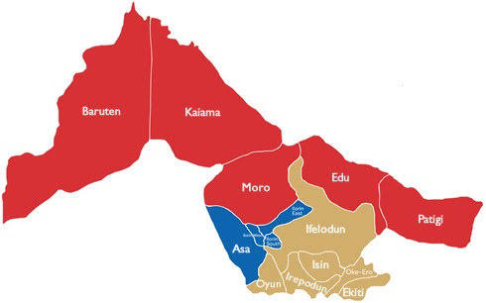
Map of Kwara State
Map of Nigeria
``

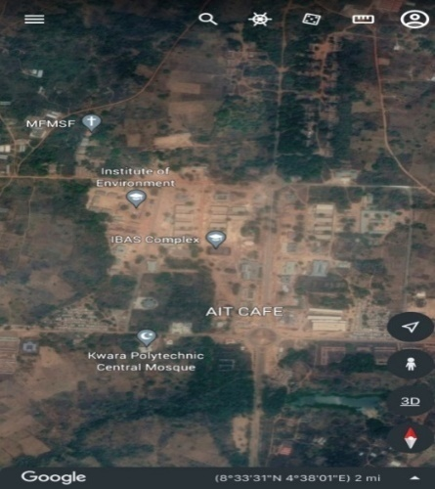
Figure 1.10: Study Area Map

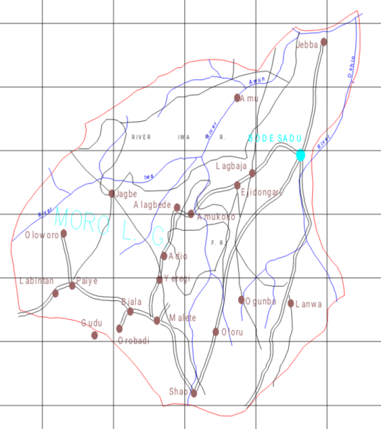

Google Imagery of the Study Area

Figure 1.10: Study Area Map
CHAPTER TWO

2.0 BASIC CONCEPT AND LITERATURE REVIEW
2.1 Basic Concepts
Height, as a fundamental concept in surveying, refers to the vertical distance of a point relative to a defined reference surface, such as the mean sea level, the geoid, or a local datum (Torge & Müller, 2012). In the context of evaluating digital levelling and total station equipment at Kwara State Polytechnic, height is a critical parameter, as both tools are designed to measure it—albeit through different methods. Understanding height’s role is essential for assessing how accurately these instruments capture elevation data needed for campus planning and infrastructure development.
In surveying, height is typically categorized into orthometric height, which is measured along the plumb line relative to the geoid, and ellipsoidal height, which is referenced to a mathematical ellipsoid approximating the Earth’s shape (Vaníček &Krakiwsky, 1986). Digital levelling excels at determining orthometric heights by directly measuring height differences, making it a go-to tool for precise levelling tasks. At Kwara State Polytechnic, where elevation data informs construction, this distinction helps evaluate whether digital levelling meets geodetic standards.
Total stations, on the other hand, measure height indirectly by combining distance and angle data, often yielding ellipsoidal heights when paired with GPS or adjusted to orthometric heights through additional computations (Anderson & Mikhail, 1998). This versatility makes total stations valuable for three-dimensional surveys, but their accuracy in height measurement depends on factors like trigonometric calculations and instrument setup, comparing this to digital levelling’s direct approach offers a practical angle for the this project.
Historically, the concept of height has been central to surveying since ancient times, with tools like the Egyptian merkhet and Greek dioptra used to establish elevations for monumental constructions (Bomford, 1980). Modern surveying builds on this legacy, refining height measurement through instruments like digital levels and total stations. For Kwara State Polytechnic, this evolution underscores the importance of testing contemporary tools against the timeless need for reliable height data.
Height measurement is heavily influenced by the reference datum chosen, as inconsistencies between local and global datums can skew results (Schofield & Breach, 2007). In Nigeria, where national geodetic networks may not fully align with international standards, tools like digital levelling and total stations must be evaluated for their ability to adapt to local height systems. This is particularly relevant for the polytechnic, where campus-specific datums might be in use.
Environmental conditions also affect height determination, as atmospheric refraction can bend light paths, impacting optical and electronic measurements (Uren & Price, 2010). In Ilorin’s tropical climate, with its heat and humidity, both digital levelling and total stations face challenges that could alter their height accuracy. Understanding these effects is key to assessing the tools’ reliability in the polytechnic’s setting.
The precision of height data is crucial for applications like flood risk assessment, road grading, and building foundations, all of which are pertinent to Kwara State Polytechnic’s infrastructure needs (Featherstone & Kuhn, 2006). Digital levelling’s strength lies in its ability to provide fine-scale height differences, while total stations offer broader spatial context. Comparing their performance in delivering usable height data ties directly to practical outcomes for the institution.
Height also intersects with geodetic surveying, where it is adjusted within control networks to ensure consistency across large areas (Ghilani& Wolf, 2014). For the polytechnic study, this means testing whether digital levelling and total stations can produce height measurements that integrate seamlessly with geodetic frameworks, a factor influencing their reliability for academic and professional use.
Ultimately, height as a basic concept bridges theory and practice, serving as a measurable benchmark for technological performance (Bannister et al., 1998). For Kwara State Polytechnic, exploring height through the lens of digital levelling and total station equipment offers insights into their accuracy and reliability, supporting both campus development and the broader surveying discipline.
2.1.1 Types of height
In surveying, height is a pivotal concept defined relative to various reference surfaces, and understanding its types is crucial when comparing digital levelling and total station equipment at Kwara State Polytechnic. The primary height types—orthometric, ellipsoidal, dynamic, and geoidal, each offer unique perspectives on elevation, influencing how these tools are evaluated for accuracy and reliability (Torge & Müller, 2012). This framework is essential for assessing their performance in delivering height data for the polytechnic’s academic and infrastructural needs.
1. Orthometric Height: This measures the vertical distance from a point to the geoid along the plumb line, accounting for gravitational variations (Vaníček &Krakiwsky, 1986). Digital levelling directly determines orthometric height by measuring precise height differences and referencing them to a geoid-based datum. At Kwara State Polytechnic, this makes digital levelling ideal for establishing accurate elevations for construction benchmarks and topographic profiles.
2. Ellipsoidal Height: Defined as the distance from a point to a reference ellipsoid, ellipsoidal height is a geometric measure commonly derived from satellite systems like GPS (Hofmann-Wellenhof et al., 2008). Total stations calculate ellipsoidal heights through trigonometric levelling, using slope distances and angles, often requiring GPS integration for precision. For the polytechnic, this capability supports large-scale mapping and coordinate-based projects.
3. Dynamic Height: This adjusts orthometric height for gravity differences, ensuring consistency in applications like water flow analysis (Bomford, 1980). Neither digital levelling nor total stations directly measure dynamic height; their outputs (orthometric or ellipsoidal) need post-processing with gravity data to compute it. While less common at Kwara State Polytechnic, dynamic height could apply to specialized engineering studies.
4. Geoidal Height: Geoidal height, or geoid undulation, is the separation between the geoid and the reference ellipsoid at a given point, reflecting the Earth’s irregular gravitational field (Featherstone & Kuhn, 2006). It isn’t directly measured by digital levelling or total stations but is derived by combining their outputs—orthometric height from digital levelling and ellipsoidal height from total stations—with geodetic models. At the polytechnic, understanding geoidal height aids in reconciling these measurements for geodetic accuracy.
2.2 Surveying Instruments
2.2.1 Level Instrument
Level instruments have long been a cornerstone of surveying techniques, primarily used to determine height differences between points on the Earth’s surface, making them indispensable for establishing elevations in projects like those at Kwara State Polytechnic (Schofield & Breach, 2007). These instruments operate on the principle of creating a horizontal line of sight, allowing surveyors to measure vertical distances relative to a reference datum. In the context of comparing digital levelling and total station equipment, understanding the level instrument’s role provides a baseline for assessing modern advancements in height determination.
The traditional optical level, one of the earliest forms of level instruments, consists of a telescope with crosshairs mounted on a tripod, paired with a levelling rod to read height differences (Uren & Price, 2010). Surveyors use it by setting up the instrument between two points, ensuring it is levelled with a built-in spirit bubble, and then recording rod readings to calculate elevation changes. This technique, known as differential levelling, remains a fundamental skill taught at institutions, forming the basis for more advanced methods.
Digital levelling, a modern evolution of the level instrument, enhances this technique by incorporating electronic sensors and barcode rods, automating the reading process (Anderson & Mikhail, 1998). Unlike optical levels, digital levels display measurements directly, reducing human error and speeding up data collection. For the polytechnic, this advancement makes digital levelling a key focus of study, as its precision in determining orthometric heights supports detailed topographic surveys and infrastructure planning.
The technique of levelling with these instruments involves a systematic process: setting up the level, taking backsight readings to a known elevation, and foresight readings to the point of interest, then computing the height difference (Kavanagh & Mastin, 2013). This method, whether manual or digital, ensures a closed loop of measurements to check for errors, a practice critical for reliability in applications at Kwara State Polytechnic, such as grading roads or designing building foundations.
Level instruments excel in establishing orthometric heights, which measure vertical distance from the geoid along the plumb line, aligning with geodetic surveying principles (Vaníček &Krakiwsky, 1986). Digital levelling, in particular, ties directly into this by providing high-accuracy data that can be referenced to local or national datums. For the polytechnic’s study, this capability positions the level instrument as a benchmark for evaluating total stations, which use a different approach to height determination.
Environmental factors, such as atmospheric refraction and temperature gradients, can affect level instrument accuracy by bending the line of sight (Ghilani& Wolf, 2014). Digital levels mitigate some of these issues with automated corrections, but in Ilorin’s tropical climate, both optical and digital levelling face challenges that the study can assess. This makes the technique’s reliability a key point of comparison with total stations, which rely on trigonometric calculations less sensitive to refraction.
Historically, levelling with instruments like the dumpy level or optical level was labor-intensive, requiring skilled operators to achieve precision (Bomford, 1980). The shift to digital levelling reflects technological progress, reducing training time and enhancing efficiency—advantages that Kwara State Polytechnic can leverage for both educational and practical purposes. This historical perspective highlights why evaluating digital levelling’s accuracy against total stations is relevant to modern surveying education.
The versatility of level instruments extends to their use in establishing control networks, where a series of benchmarks forms a reference for larger surveys (Featherstone & Kuhn, 2006). Digital levelling’s ability to produce consistent height differences makes it ideal for this task at the polytechnic, supporting campus-wide elevation frameworks. In contrast, total stations offer a broader spatial approach, suggesting a complementary rather than competitive role in such networks.
In practical applications, levelling with these instruments underpins tasks like flood risk assessment and site preparation, critical for infrastructure development (Torge & Müller, 2012). Digital levelling’s precision ensures reliable data for these purposes, while its comparison with total stations in the study can reveal trade-offs between speed, accuracy, and cost—factors influencing equipment choice in resource-limited settings like Nigeria.

2.2.2 Total Station
The total station is a highly advanced surveying technique that integrates electronic distance measurement (EDM), angular measurement, and data processing into a single instrument, revolutionizing modern surveying practices (Anderson & Mikhail, 1998). Widely used for determining both horizontal and vertical positions, it is a key tool in the comparative evaluation of accuracy and reliability at Kwara State Polytechnic. Its ability to provide comprehensive spatial data makes it a versatile technique for mapping, construction, and educational purposes in surveying.
A total station operates by combining a theodolite’s angle-measuring capabilities with an EDM to measure distances, allowing surveyors to calculate coordinates and heights trigonometrically (Schofield & Breach, 2007). The instrument emits a laser or infrared beam to a reflector, records the return time, and computes the slope distance, which, paired with vertical and horizontal angles, yields precise 3D positions. At Kwara State Polytechnic, this technique supports tasks like campus layout and topographic surveys, offering a contrast to the elevation-focused digital levelling.
The technique of using a total station involves setting up the instrument over a known point, sighting targets (prisms or reflectorless surfaces), and recording measurements, often stored digitally for real-time analysis (Uren & Price, 2010). This process, known as traversing or resection, establishes control points across a site, making it efficient for large areas. For the polytechnic study, this efficiency is a critical factor in assessing total stations against the more labor-intensive levelling methods.
Total stations determine ellipsoidal heights primarily, derived from their coordinate system, though orthometric heights can be approximated with datum adjustments or geoid models (Hofmann-Wellenhof et al., 2008). This dual capability distinguishes them from level instruments, offering flexibility for geodetic and engineering applications at Kwara State Polytechnic. The study can thus evaluate how well these height outputs align with practical needs like infrastructure design.
Historically, the total station emerged in the late 20th century as electronic technology advanced, replacing separate theodolites and EDM devices with an integrated solution (Bomford, 1980). This evolution reflects a shift toward automation and precision, reducing fieldwork time and operator effort—advantages that Kwara State Polytechnic can leverage for both training and project execution. Its modern relevance makes it a compelling subject for accuracy comparisons with digital levelling.
Environmental conditions, such as atmospheric interference or terrain obstacles, can affect total station measurements, though reflectorless models mitigate some challenges (Ghilani& Wolf, 2014). In Ilorin’s tropical climate, factors like heat haze or vegetation may test the technique’s reliability, providing a real-world context for the polytechnic study. This contrasts with levelling’s sensitivity to refraction, highlighting different strengths and weaknesses.
The total station technique excels in establishing three-dimensional control networks, integrating horizontal and vertical data into a unified framework (Featherstone & Kuhn, 2006). At Kwara State Polytechnic, this capability supports comprehensive campus mapping and ties into geodetic systems when paired with GPS, offering a broader scope than levelling’s vertical focus. The study can assess how this integration enhances overall survey accuracy.
Practically, total stations are used for staking out construction sites, monitoring structural deformations, and creating detailed maps—applications directly relevant to the polytechnic’s infrastructure goals (Kavanagh & Mastin, 2013). Their multifunctionality, however, comes with higher costs and training demands compared to digital levelling, a trade-off the study can explore in terms of reliability and resource efficiency.
In educational settings, the total station technique teaches students advanced surveying skills, from data collection to software integration (Torge & Müller, 2012). Its complexity offers a rich learning opportunity, preparing graduates for industry demands, while the study’s comparison with digital levelling can inform curriculum development by highlighting practical performance differences.
2.3 Literature Review on comparison of Total Station and Levelling Instrument Techniques in Height determination
Surveying plays a fundamental role in geospatial science, civil engineering, and construction by providing precise measurements for infrastructure development. Height determination is a critical aspect of surveying, influencing topographic mapping, engineering projects, and geodetic applications (Ghilani& Wolf, 2017). Various surveying techniques, including digital leveling, total station, and Global Navigation Satellite System (GNSS), are commonly employed for height measurement, each offering different levels of accuracy, efficiency, and reliability.
Digital levelling is a widely used method for height determination due to its high precision. It employs a digital level and barcode staff to minimize human errors and enhance measurement accuracy (Uren & Price, 2019). Digital leveling is particularly useful for projects requiring precise vertical control, such as road construction, dam engineering, and bridge foundations (Bannister et al., 2020). However, its efficiency is limited by fieldwork duration and operational constraints in rough terrains.
Total station surveying integrates electronic distance measurement (EDM) with angular observations to determine height differences efficiently. It offers rapid data collection, making it suitable for large-scale surveys (Kavanagh & Glennon, 2020). Although total stations provide relatively high accuracy in both horizontal and vertical positioning, factors such as atmospheric conditions, instrument calibration, and operator skill can influence measurement reliability (Abidin, 2021).
Comparative studies have shown that digital leveling remains the most accurate technique for height determination, particularly for short-range applications (Al-Kasasbeh et al., 2018). However, total station surveys offer a balance between accuracy and efficiency, making them suitable for engineering surveys where speed is essential (Darmawan et al., 2019).In infrastructure projects, the choice of surveying technique depends on factors such as required accuracy, project scale, and environmental conditions. For example, construction projects requiring sub-millimeter accuracy often rely on digital leveling, whereas topographic mapping and land surveys benefit from the versatility of total stations(Bello et al., 2023). Therefore, surveyors must carefully evaluate the trade-offs between precision, cost, and operational efficiency (Adeoye et al., 2022).
The increasing use of automation and artificial intelligence in surveying is further improving height determination accuracy. Modern total stations and digital levels feature automated data processing, error correction algorithms, and real-time data integration with GIS platforms (Saleh et al., 2021). These advancements contribute to better decision-making in engineering and geospatial applications.
Recent studies have also explored the impact of environmental conditions on the accuracy of surveying techniques. For instance, temperature fluctuations and atmospheric refraction can affect EDM measurements in total stations, leading to minor deviations in height calculations (Mahmood et al., 2022).
The role of human expertise in surveying remains crucial, despite technological advancements. Proper instrument calibration, error mitigation strategies, and data validation are necessary to ensure accurate height determination results (Kumar et al., 2023). Training and continuous professional development help surveyors optimize instrument use and apply best practices for error minimization in diverse field conditions (Nguyen et al., 2023).
In conclusion, height determination remains a critical aspect of surveying, with different techniques offering varying degrees of accuracy and efficiency. Digital levelling provides the highest precision, total stations offer a balance between speed and accuracy. Additionally, environmental conditions, cost considerations, and human expertise play vital roles in ensuring the accuracy and reliability of height measurements. A comparative evaluation of these methods helps surveyors select the most suitable technique for their specific needs, ensuring optimal results in geospatial and engineering projects (Bannister et al., 2020).
Research comparing the two instruments also indicates that total stations are better suited for topographic surveys where both height and horizontal positioning are needed simultaneously. Schofield (2001) explains that total stations allow surveyors to capture three-dimensional spatial data in a single setup, whereas levelling instruments require separate processes for horizontal and vertical measurements. This makes total stations more practical for large-scale mapping projects.
Another major factor scholars consider is the ease of data integration with modern surveying technologies. Hofmann-Wellenhof et al. (2008) note that total stations can be integrated with Geographic Information Systems (GIS) and Global Navigation Satellite System (GNSS) data, allowing for seamless geospatial analysis. Levelling instruments, while accurate, are less adaptable to such integrations unless used in conjunction with GNSS receivers.
Comparative studies also reveal differences in the application of these instruments in different terrains. Researchers such as Uren & Price (2010) argue that levelling instruments are best suited for flat or gently sloping terrain, where accurate benchmark elevations can be established. Total stations, on the other hand, perform better in rugged and mountainous areas, where direct levelling may be difficult or impractical.
In terms of cost analysis, various scholars have pointed out that levelling instruments are generally more affordable than total stations. Kavanagh & Bird (2009) mention that traditional levelling instruments have a lower initial cost, making them a cost-effective solution for small projects. However, the time-consuming nature of levelling surveys may offset this cost advantage in large-scale projects, where total stations provide a quicker alternative.
A study by Ghilani& Wolf (2017) compared the reliability of height measurements from both instruments and found that while levelling instruments consistently produced highly accurate results, total stations exhibited minor variations due to EDM-related errors. However, advancements in total station technology, such as improved angular encoders and compensators, have significantly enhanced their accuracy in height determination.
The effect of atmospheric conditions on measurement accuracy has been widely studied. Hofmann-Wellenhof et al. (2008) explain that total stations require careful consideration of temperature, pressure, and humidity adjustments to minimize EDM errors. Levelling instruments, being optically based, are less sensitive to these factors, making them more reliable in extreme weather conditions.
Scholars also examine the role of error correction techniques in height determination. Uren & Price (2010) highlight that both instruments require regular calibration and error checks to ensure accuracy. Total stations need periodic adjustments to their EDM units and angular measurement systems, while levelling instruments must be checked for collimation errors and bubble alignment.
The use of total stations for deformation monitoring has been extensively researched. Ghilani (2017) states that while levelling instruments are the preferred choice for precise settlement studies, total stations offer the advantage of monitoring both vertical and horizontal displacements simultaneously. This makes total stations more versatile in projects such as bridge movement analysis and landslide monitoring.

CHAPTER THREE
3.0 METHODOLOGY
Methodology is the systematic theoretical analysis of the methods applied to a field of study, it comprises the theoretical analysis of the body of methods and principles associated with a branch of knowledge. Typically, it encompasses concepts such as paradigm, theoretical model, phases and quantitative or qualitative techniques.
3.1 Reconnaissance
This has to do with framework of survey operation whereby all survey operations are going to base on.
Reconnaissance is also known as (Recce). Reconnaissance is examination of all part of an area accomplished insufficient detail to make generalization about the type and distribution of historical properties that may be present with a given project area. Also, is the process of having the general overview of the area to be surveyed with the view of determining the arrangement of the work such as method to employed, personnel to be involved, instrument to be used, scale at which plan/map is to be drawn. There are two stages of reconnaissance namely: Office and Field reconnaissance.
    - Field Reconnaissance
The first stage in this project was search for existing information in connection with the area in which the project was undertaken. Rough sketch diagram(recce) of the project area was drawn selecting and marking the approximate position of each point. To sum up, the reconnaissance facilitated the planning and execution of the actual survey as its takes into consideration, the possible problems that are likely to be encountered, and how such problems can be overcome or reduced to minimum.
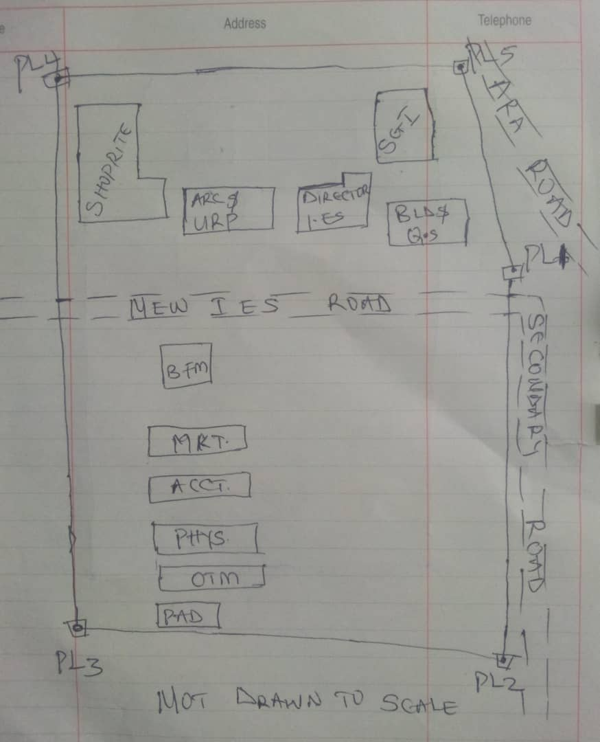

Recce diagram
3.1.2 Office Reconnaissance
Office reconnaissance/data gathering as the name implies is the exploratory survey, scouting or examination, to collect information necessary for the successful execution of the project. It can be simply define as making a preliminary survey before the actual mobilization for the project site. For the purpose of this project, the data search involved retrieving of the coordinate of three (3) existing control.
Pillar No. | Easting(m) | Northing(m) | Height | Location
KWPT 49 | 674341.289 | 937679.115 | 353.682 | Kwara Polytechnic
KWPT 50 | 674555.841 | 937618.402 | 354.903 | Kwara Polytechnic
Table 1: Show coordinates of existing and used control point.
3.1.3 Selection of Station
The boundaries as shown in the recce diagram were laid down by marking points on the ground (station).
The factors considered in selecting these stations include:
- Inter visibility between two points.
- Firmness of the ground at the selected point.
- Working convenience over the station.
- Points located where not disturbed.
3.2 Survey Rod
A survey rod is a physical marker, typically made of metal, used to mark the boundaries of a parcel of land. These markers are used to define the limits of a property and can be used as reference points for future surveys. Rods are durable and can be used in a variety of environments.
3.2.1 Survey rules guiding rod uses:
1. Placement: Rods should be placed at boundary corners or points of change in the boundary.
2. Visibility: Rods should be visible and easily identifiable
3. Durability: Rods should be durable and resistant to weathering.
4. Accuracy: Rods should be placed accurately, following the surveyed boundary.
5. Documentation: the location and description of rods or pegs should be documented in the survey records.

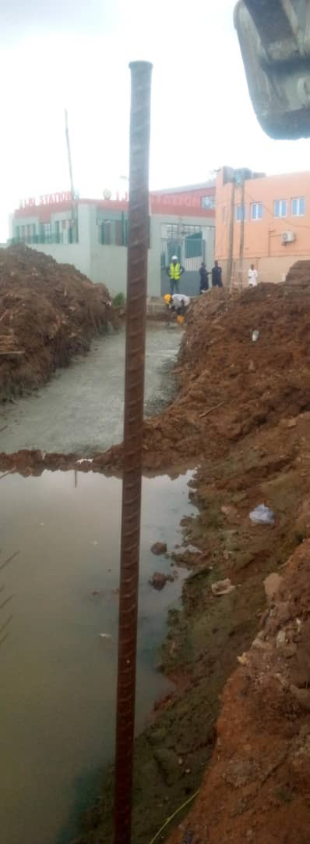

Figure 3.1: Graphical View of Cadastral Survey Rod
3.3 Instrumentation
It refers to the equipment and accessories employed for the successful execution of this project and they are as follows:
Hardware Used
- Stonex R2 Plus Total Station and its accessories
- Leica Digital Level instrument and its accessories
- Handheld GPS
- Hp Core i5 vPro 8th Gen Laptop
- Cutlasses
- Head-pan
- Nail and bottle cover
- 1 Hammer
- 1 Spade
- 1 Hand-trowel
Software Used
- AutoCAD 2007
- Golden Software Surfer 20.0
- Microsoft Office Excel 2013
- Microsoft Office Word 2013
Material Used
- Water
- Cement
Total Station:- It is an electronic or optical instrument used in modern surveying and building construction that used Electronic Distance Measurement (EDM). It is also known as electronic data collection and storage system of which all the data acquired on site is been stored and secured for office reconnaissance.
Digital Leveling:- It is considered one of the most precise methods for height determination. It employs an electronic level instrument and a bar-coded staff to measure vertical distances, reducing human errors common in conventional leveling.
Table 3.2: Equipment Description
S/N | Equipment | Uses
1 | Stonex R2 Plus Total Station | X, Y and Z coordinates of boundaries
2 | Leica Automatic Level | Determination of the reduced level
3 | Handheld GPS | X & Y coordinates of details
4 | Autodesk AutoCAD 2007 | Presentation of the boundaries
5 | Golden Software Surfer 20.0 | Contour and Generation of 3D model
6 | Microsoft Office Excel 2013 | X, Y and Y coordinates editing&program
7 | Microsoft Office Word 2013 | Report writing
3.4 Test of Instrument
For any survey job, testing of the instrument must be done before execution of the job, the instruments used for data acquisition were tested to ascertain whether they are in good working condition.
The following test were carried out,
3.4.1 Total Station
The total station instrument used (Stonex R2 Plus Total Station) underwent a two-phase check. Firstly, the vertical and horizontal angles were verified using pre-established control points within the school campus. Secondly, the electronic distance measurement (EDM) capability was tested for horizontal distances. The instrument passed all tests and was deemed suitable for use.
Below is the procedure for carryout the tests
3.4.1 Total Station
Instrument used in data acquisition was checked for integrity before moving them to site. Apart from check carried-out on Total Station, the following instruments were also checked: Tripod stand legs and their screw were confirmed okay, foot screws, focusing knob, vertical and horizontal knob for slow motion and clamp were all confirmed okay.
3.4.1.1 Horizontal Collimation Test
This error exists when the optical axis of the total station is not exactly perpendicular to the telescope axis. To test for horizontal collimation error, station A was selected and the instrument was set on it and leveled using three foot screws. Then, the telescope was rotated through 360°, but the bubble did not run out of the level tube centre which shows that the line of sight is parallel to the axis of the level tube.
Furthermore, the telescope was pointed to a target on station B in face left, then, pointed back to same target in face right; the difference in horizontal circle readings after averaging the result from both faces of the instrument was 180° except small variation is seconds which is permissible based on the allowable accuracy limit (least Count). The following results were displayed below.
Fairly Level Ground
STATION A
100m
REFLECTOR
(TARGET)
STATION B
Total Station

Fig 3.4.1.1: Horizontal Collimation and Vertical Index error test.
Table 3.4.1.1: Horizontal Collimation Data
Station | Target | Face | Hz Reading | Difference | Error
A | B | L | 38˚42’32”
 |  | R | 218˚42’35” | 180˚00’03” | 03”

3.4.1.2 Vertical Index Error Test
This test was performed to ensure that the vertical reading is exactly ninety degrees (90˚) when the line of sight is horizontal. Any deviation from this figure is known as vertical index error.
The Total Station was set over a point and necessary temporary adjustments were performed. A target set about 100m away from the Total station was sighted and bisected with the instrument on the face left and the reading was recorded. The target was also sighted and bisected on face right and the reading was also recorded. These readings are shown below
Table 3.4.1.2: Vertical Index Data
Instrument Station | Target Station | Face | Vertical | Sum | Error
A | B | L | 90˚00’00”
 |  | R | 270˚00’02” | 360˚00’02” | 02”

3.4.1.3 Analysis of Collimation and Vertical Index Data
The reading obtain during calibration were reduced to obtain new collimation and vertical errors.
Horizontal collimation = {(FR – FL) – 180}/2 = {(00˚00’03”}/2 = 1.5”
Vertical collimation = {(FL + FR) – 360} = (90˚00’00” + 270˚00’02”) - 360} = 02”
The result shows that the instrument is still in good working condition.
3.4.2 Digital Level Instrument
The level instrument employed for the research was Leica Digital level. Two pegs test was carried out on the digital level to check the collimation error of the instrument. The level instrument was set on a specific point A, with initial adjustments made for proper alignment, levelling, and focusing to eliminate parallax, it was now backsight on peg 1 and foresight on peg 2, the instrument was then now moved to another point B, and all the necessary adjustments were made, the peg 2 was bisected as backsight, and the peg 1 as foresight.
Level instrument STAFF (TARGET)

Fairly Level Ground
STATION A PEG 1
Fig3.4.1.1.: Horizontal Collimation error test
Table3.4.2.Horizontal Collimation Data
STATION | Remarks | BS | IS | FS | Diff.
A | Peg 1 | 1.734
A | Peg 2 |  |  | 2.042
 |  |  |  |  | 0.308
B | Peg 2 | 1.578
B | Peg 1 |  |  | 1.262
 |  |  |  |  | 0.316
 | Collimation Error |  |  |  | 0.008
The difference of the two-pegs test from 2 stations (0.008), shows the instrument is in good condition and can be used for the project.
3.5 Control Check
The control points were found along the road in Kwara State Polytechnic. In order to determine their correctness and their true position, one was used as station point KWPT 49 while the point KWPT 50 was used as the back sight. The coordinates obtained were compared with the received data from Department Field Data Records, the difference falls within the allowable accuracy of 3rd order survey job as can be seen in Table 3.3 below:
Table 3.3: Analysis of control check
PILLAR | COORDINATE | EASTING(m) | NORTHING(m) | HEIGHT(m)
KWPT 49 | RECEIVED | 674341.289 | 937679.115 | 353.682
KWPT 49 | OBSERVED | 674341.289 | 937679.115 | 353.682
KWPT 49 | DIFFERENCE | 0.000 | 0.000 | 0.000
PILLAR | COORDINATE | EASTING(m) | NORTHING(m) | HEIGHT(m)
KWPT 50 | RECEIVED | 674555.841 | 937679.115 | 353.682
KWPT 50 | OBSERVED | 674555.853 | 937679.097 | 353.691
KWPT 50 | DIFFERENCE | 0.012 | 0.018 | 0.009
Allowable accuracy |  | 0.600 | 0.600 | 0.600
3.6 Data Acquisition
Data acquisition in land surveying refers to the process of collecting and recording data about the land, its features, and boundaries. This can include:
- Geometric data acquisition
- Attribute data acquisition
3.6.1 Geometric Data Acquisition
Geometric data acquisition involves collecting data that defines the spatial relationships and positions of features on the land. This can include:
- Coordinates: Collecting X, Y, and Z coordinates of points on the land using instruments like total stations, GPS, and levels.
- Distances and angles: Measuring distances and angles between points on the land using instruments like total stations and tape measures.
- Elevations: Determining the height of points on the land above a reference datum using instruments like levels and GPS.
The geometric data of this project was obtained using the total station i.e. combination of electronic theodolite and the Electronic Distance Measurement (for X, Y, Z determination), and Level instrument (for height measurement) Geometric data are positional data, (i.e. they have the X, Y, Z) coordinates which make it easy to locate their actual position of features on the earth surface.
Here is a step-by-step procedure used for Total Station for geometric data acquisition:
Preparation
1. Setup: The Total Station was set over a known control point (KWPT 49).
2. Leveling: Level the instrument to ensure accurate measurements.
3. Orientation: It was done using two know control points KWPT 49(as occupy station) and KWPT 50(as backsight)
Data Collection
1. Target sighting: Sight the target (reflector) at the point to be measured.
2. Measurement: Determination of X, Y, Z of the target.
3. Recording: Record the measured data (coordinates).
4. Repeat: Repeat the process for each point to be measured.
Here's a step-by-step procedure used for Level instrument for data acquisition:
Preparation
1. Setup: The Level instrument was set on a stable surface, ensuring it's level and secure.
2. Leveling: Level the instrument using the built-in leveling mechanism.
3. Focus: The telescope was focused on the target (staff or rod).
Data Collection
1. Backsight: Took a backsight reading on a benchmark (KWPT 49).
2. Foresight: Take foresight readings on points to be measured, ensuring the staff is held plumb.
3. Reading: Record the readings, including the staff readings and points description.
4. Repeat: Repeat the process for each point to be measured.
3.6.2 Attributes Data Acquisition
Attribute data refers to information that describes the characteristics and properties of spatial features. It provides details such as names, classifications, and functions of geographic objects. In this study, the attribute data collected Include the names of buildings (e.g., lecture room of office), as well as information on roads. Handheld GPS was used to acquire attribute data for this project.
Handheld GPS units we used to gather attribute data by:
Collecting positional data: the GPS determines the location (LATITUTDE, Longtitude, and sometimes elevation) of the point where we standing.
Attaching attribute: you can then link attribute information to that location. This could be done by entering the information manually, (e.g. using the keypad on the GPS unit) or by uploading the data to a computer.
Saving the data: the GPS saves the location data along with the attributes, creating a dataset of points with associated information.
3.7 Perimeter, Detailing and Spot Heighting
Perimeter is the total distance covered along the boundary line and an area of land, the total distance covered is 1.214km. It is very important in order to get the exact location of a property. Traversing is a subordinate to perimeter and it may be defined as the process of connecting the series of lines with known bearing and distances (or XYZ).
The Total Station was carefully set up over control point KWPT49, with a back sight taken to point KWPT 50 after performing the necessary station adjustments, including cantering, levelling, and focusing, the KWPT50 (backsight) was measured and the observed coordinates was compared with given one, the difference is not significant and allowable. Then peg1 was established and measured in other to transfer the control to the site. The same procedure was repeated to determine the coordinates of the next point (peg2), and continued progressively until the site was reached. The radiation method was used for data acquisition, where two or more points were coordinated from a single instrument station.
The following steps outline the procedure:
- After completing temporary adjustments, the instrument was powered on, and a new job titled PRJT1 was created in the internal memory under the job menu.
- In the coordinate menu, orientation was established by inputting the coordinates of the instrument station and back sight.
- The height of the instrument and the reflector height were measured and entered into the instrument.
- The reflector at the back sight was accurately bisected before confirming the orientation.
- Once oriented, the reflector was aimed at the next target (nail), and the "OBS" (observe) function was selected. The three-dimensional coordinates (Easting, Northing, and Height) were displayed and saved by pressing "REC" (record). For subsequent observations, the "ALL" option was used to streamline the process.
- It was ensured that the centre of the prism on the reflector was properly aligned and securely mounted on the tripod to minimize height determination errors.
- Once all visible details, including boundary points, spot heights and building, had been observed from the current station, the instrument was relocated to the next control nail, and the temporary adjustments were repeated.
This process was systematically carried out until all boundary points and elevation data were captured. In this project, spot heights were not recorded at regular grid intervals but were instead collected randomly after it has been pegged. For each building, three corner points were surveyed. Upon completing the data acquisition phase, all relevant features were accurately recorded and positioned accordingly on the final site plan.

CHAPTER FOUR
4.0 DATA DOWNLOADING, PROCESSING, ANALYSIS AND DISCUSSION
This chapter provides a detailed overview of the procedures involved in data download, data processing, correction, and data analysis conducted on the acquired data from the site and data presentation.
4.1 Data Download
All the recorded data was stored in the memory of the total station. To download the data, the total station was connected to a computer using a wired cable and downloading software. The software parameters were configured to match those of the instrument. The instrument's menu was accessed, and the memory manager was selected. From there, the "send data" option was chosen, and the file named "PRJT1" was located and downloaded to the computer through the software. The data was saved with a ".txt" file extension on the desktop of the laptop for further processing.
4.2 Data Editing
The downloaded geometric data were further processed to convert them into usable formats and improve their accuracy. The resulting coordinate data were edited using Notepad and Excel software. This file was then imported into AutoCAD2007 for additional processing.

4.3 Data Processing using Autocad 2007
Before using AutoCAD, we processed the coordinate data observed in the field by first transferring it into Notepad, then copying it into AutoCAD. The following steps outline the process for handling the data in AutoCAD:
- Launch AutoCAD on the computer.
- Click "New" from the application menu to start a new drawing.
- Type UNITS in the command line and press Enter.
- Select the desired unit type (e.g., decimal, architectural, engineering).
- In the menu bar, select the "Polyline" tool.
- Copy the data from Notepad and paste it into AutoCAD.
- Type Z (for zoom) and press Enter, then type E (for extents) and press Enter to adjust the view.
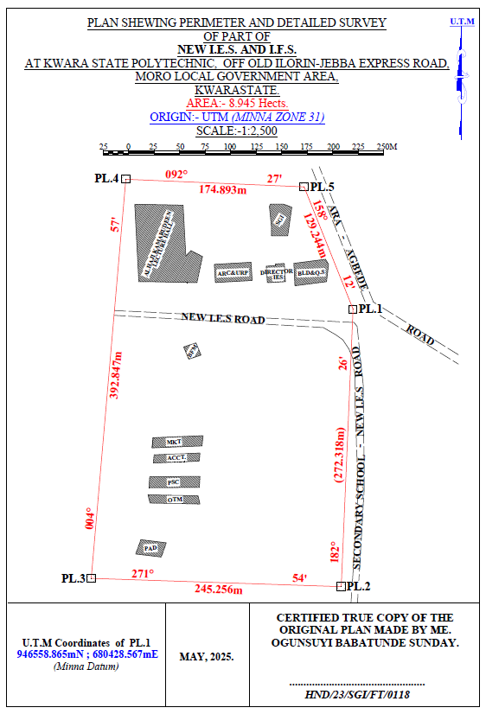
HND/23/SGI/FT/0078
ABDUL KAREEM RAMOTA OLAWUMI
GANIYU AKEEM ABIODUN
Figure 3.7: Plan showing Perimeter and Detailed Survey.

Area Computation using Cross Multiply Coordinates
E1 N1
E2 N2
E3 N3
E4 N4
E5 N5
E1 N6
680428.567 946558.865
680417.004 946286.792
680171.885 946294.956
680205.833 946686.334
680380.567 946678.865
680428.567 946558.865
∑ - ∑
2
460,787,138,011.03 – 460,786,959,116.36
2

178,894.67
2
Area = 89,447.335 sqft
Area = 8.945 hect.
4.4 Results and Discussion
Table 4.4: Total station and Digital level Spot height Readings and their differences
STATIONS | EASTING | NORTHING | HEIGHT |  | DIFF.
STATIONS | EASTING | NORTHING | T.S | LEVEL | DIFF.
PT1 | 680272.275 | 946497.781 | 355.749 | 355.715 | 0.034
PT2 | 680267.717 | 946479.907 | 356.403 | 356.362 | 0.041
PT3 | 680273.327 | 946450.469 | 354.811 | 354.772 | 0.039
PT4 | 680287.358 | 946434.349 | 354.268 | 354.208 | 0.060
PT5 | 680317.873 | 946433.648 | 355.036 | 354.984 | 0.052
PT6 | 680304.544 | 946455.727 | 355.710 | 355.668 | 0.042
PT7 | 680337.867 | 946463.436 | 355.448 | 355.386 | 0.062
PT8 | 680342.774 | 946441.708 | 356.295 | 356.240 | 0.055
PT9 | 680342.774 | 946441.708 | 356.736 | 356.680 | 0.056
PT10 | 680348.740 | 946443.460 | 355.971 | 355.931 | 0.040
PT11 | 680377.262 | 946451.836 | 355.725 | 355.673 | 0.052
PT12 | 680382.060 | 946482.711 | 355.318 | 355.277 | 0.041
PT13 | 680381.009 | 946518.108 | 354.819 | 354.766 | 0.053
PT14 | 680350.494 | 946509.345 | 355.174 | 355.128 | 0.046
PT15 | 680356.104 | 946484.813 | 355.033 | 355.005 | 0.028
PT16 | 680332.603 | 946480.960 | 355.228 | 355.188 | 0.040
PT17 | 680308.051 | 946470.796 | 355.517 | 355.464 | 0.053
PT18 | 680298.581 | 946490.422 | 355.834 | 355.802 | 0.032
PT19 | 680318.222 | 946506.191 | 355.726 | 355.678 | 0.048
PT20 | 680308.753 | 946526.168 | 356.148 | 356.096 | 0.052
Mean |  |  | 355.8163 | 355.7726 | 0.0437
Variance |  |  | 2.5758 | 2.5881 | 0.0123
Standard Deviation |  |  | 1.6049 | 1.6088 | 0.0039

Working Formulas for Mean, Variance and Standard Deviation Calculation
The mean is calculated as:
µ = ∑xi
n
µ= mean
xi = each point height
n = number of points
The variance is calculated as:
ꭤ²=∑(xi - µ)²
n
ꭤ²= variance
xi = each point height
µ= mean
n = number of points
The Standard Deviation is calculated as:
ꭤ = √ꭤ²
ꭤ= standard deviation
ꭤ²= variance
Mean calculation for Total Station Height readings
µ = ∑xi
n
µ=355.749+356.403+354.811+354.268+355.036+355.710+355.448+356.295+356.736+355.971+355.725+355.318+354.819+355.174+355.033+355.228+355.517+355.834+355.726+356.148
20
µ= 7116.326
20
µ=355.8163
Mean calculation for Reduced Level Height readings
µ=355.715+356.362+354.772+354.208+354.984+355.668+355.386+356.240+356.680+355.931+355.673+355.277+354.766+355.128+355.005+355.188+355.464+355.802+355.678+356.096
20
µ= 7115.452
20
µ = 355.7726
Mean calculation for Total Station Height readings - Mean calculation for level height readings 355.8163 – 355.7726 = 0.0437
ꭤ²=∑(xi - µ)²
n
ꭤ²=∑(xi - µ)²
n
0.0673²+0.5867²+1.0053²+1.5483²+0.5327²+0.2521²+0.1582²+0.4126²+0.9284²+0.0992²+0.1104²+0.1327²+1.0217²+0.6184²+0.7834²+0.4926²+0.2581²+0.0164²+0.0428²+0.3317
20
ꭤ²=51.516
20
ꭤ² =2.5758
Variance calculation for Reduced Level Height readings
0.576²+0.5894²+1.006²+1.5686²+0.5285²+0.2375²+0.1382²+0.4103²+0.9126²+0.0821²+0.1013+0.1104²+1.0102²+0.6014²+0.7695²+0.4818²+0.2443²+0.0071²+0.0289²+0.32047
20
ꭤ²=51.762
20
ꭤ² =2.5881
Variance calculation for total station – variance calculation for level height readings 2.5758 – 2.5881 = 0.0123
The Standard Deviation for Total Station Height readings:
ꭤ = √ꭤ²
ꭤ = √2.5758
ꭤ = 1.6049

The Standard Deviation for Reduced Level Height readings:
ꭤ = √2.5881
ꭤ = 1.6088
The standard deviation for total station – standard deviation for level height reading 1.6049 – 1.6088 = 0.0039

The table above shows the station Id, eastings, northings, total station height, digital level reduced level and the difference between the total station height and the digital level reduced level.
The comparison of the two pieces of equipment revealed variations within a specific range. The differences observed between the two pieces of equipment were found to be in the range of 0.028 to 0.062 meters. These differences indicate slight disparities in the measurements obtained from each instrument. Statistical analysis was performed to evaluate the mean, variance, and standard deviations of the observed differences. The mean difference was calculated to be 0.0437, indicating an average deviation between the measurements obtained by the two equipment. The variance, which quantifies the spread of the differences, was found to be 0.0123.
This value suggests that the variations in the measurements obtained by the two pieces of equipment were relatively consistent. The standard deviation, which provides a measure of the dispersion of the data, was determined to be 0.0039. This indicates that the differences between the measurements obtained from the two pieces of equipment had a moderate level of variability.
Overall, the results of the analysis demonstrate that there were slight variations between the measurements obtained from the two pieces of equipment. The mean, variance, and standard deviations provide insights into the magnitude and consistency of these differences, offering valuable information for assessing the accuracy and reliability of the equipment in question.

Figure 1:Bar chart showing heights obtained from the total station and level instrument

Figure 2:Histogram showing the difference in the two instrument’s result
The histogram presented above illustrates the distribution of deviations between the two methods being compared. The deviations are depicted in centimeter, showcasing the level of accuracy achieved by both methods. The histogram highlights that the deviations are tightly clustered and exhibit a consistent pattern.
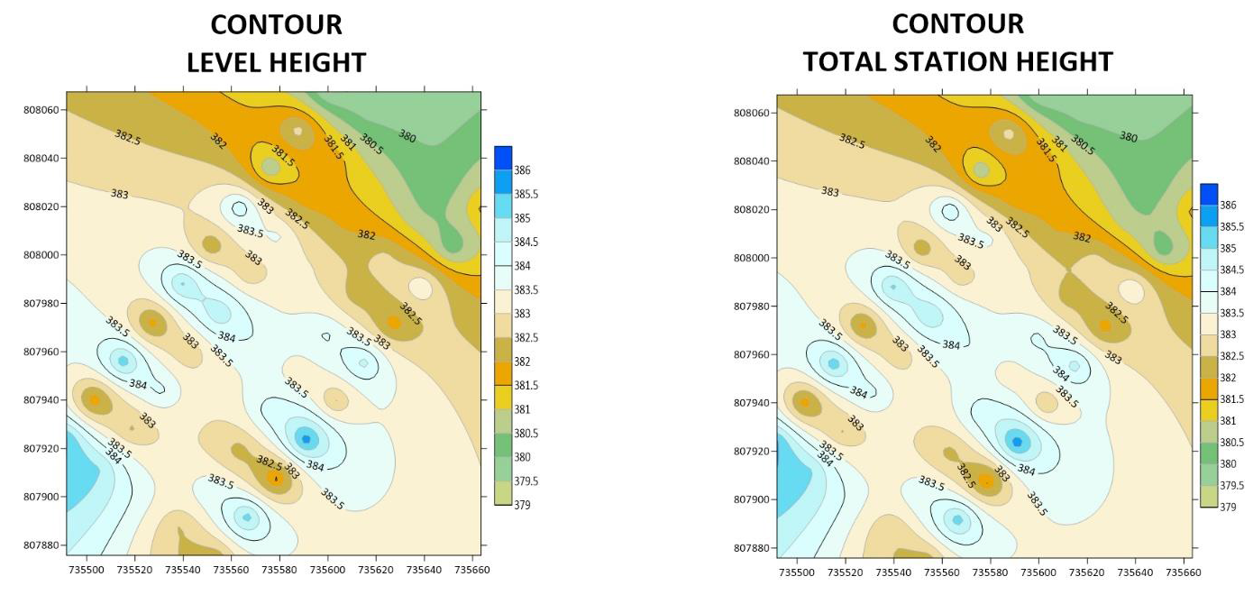Figure 3: Showing the contour map obtained from the two instruments.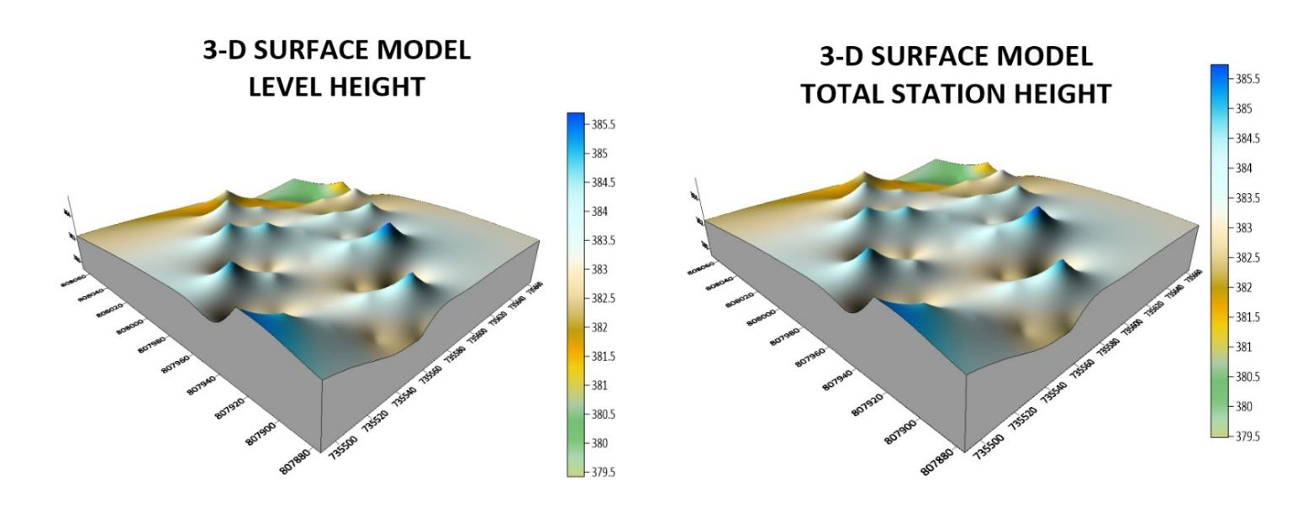Figure 4: Showing the 3D surface map obtained from the two instruments
3-D SURFACE MODEL USING TOTAL STATION
3-D SURFACE MODEL USING AUTO LEVEL
CONTOUR MAP USING TOTAL STATION
CONTOUR MAP USING AUTO LEVEL
The mean of the deviations, calculated to be 0.0437m, provides an indication of the average difference between the measurements obtained from the two methods. This value signifies a small average deviation, suggesting that the two methods generally yield similar results with minimal variation.
The histogram provides a visual representation of the data, allowing for a comprehensive understanding of the distribution of deviations. By examining the histogram, one can observe the concentration of deviations around the mean value, indicating a central tendency in the measurements obtained by the two methods.
The centimeter-level accuracy exhibited by the deviations underscores the precision of the measurement techniques employed. This level of accuracy is crucial, particularly in applications that require high precision, such as engineering, construction, or geospatial analysis. The contour maps presented above exhibit strikingly similar patterns, which serve as a testament to the high degree of precision achieved by the instruments used. The consistent and replicated patterns observed on the maps reinforce the reliability and accuracy of the measurements obtained.
The similarity in the contour patterns indicates that the instruments employed in the surveying process were able to capture the subtle variations in elevation with great precision.
This level of accuracy is crucial in applications such as topographic mapping, land surveying, and engineering, where even minor deviations can have significant implications. By displaying the contours of the surveyed area, the maps provide a visual representation of the landscape's topography and elevation changes.
The congruity in the contour lines across the maps signifies that the instruments effectively captured and recorded the elevation data, resulting in a reliable representation of the terrain
4.5 Statistical Analysis
A statistical investigation was carried out using Paired Two Samples as Means to test whether there is any significant difference in the performance of the two instruments for terrain height determination. The independent sample t-test is a member of the t-test family, which consists of tests that compare mean value(s) of continuous-level (interval or ratio data), normally distributed data (Hinton, 2004). The independent-sample t-test evaluates the difference between the means of two independent or unrelated groups. That is, we evaluate whether the means for the two independent groups are significantly different from each other.
Hypothesis
A hypothesis was set up and tested using an Independent – sample T-Test:
- Null Hypothesis: H0: There is no difference between the terrain height obtained from the total station and digital level instrument.
- Alternative Hypothesis: H1: There is a difference between terrain height obtained from total station and digital levelling instrument.
The null hypothesis is rejected if the calculated t value has a probability sig. (p) greater than the chosen significance level. An Independent sample T-Test was used in testing the hypothesis at a significance level of 0.05. Data analysis Package extension in Excel was activated and used in running the T-Test.
Table 4.5: T-Test: Two-Sample Assuming Unequal Variances
 | Digital Level | Total Station
Mean | 355.77262 | 355.81628
Variance | 2.588092118 | 2.575687471
Observations | 20 | 20
Pearson Correlation | 0.032104369 | 0.031950494
Hypothesized Mean Difference | 0.001605218 | 0.001597525
t Stat | 0.056215684 | 0.056208782
P(T<=t) one-tail | 0.145413689 | 0.144776257
P(T<=t) two-tail | 0.290982737 | 0.289552551
Sum | 7096.631 | 7095.814
Kurtosis | 2.049052417 | 2.0403051292
Skewness | 0.612867732 | 0.5907755549
Median | 354.772 | 354.811
Maximum | 356.680 | 356.736
Minimum | 354.208 | 354.268
Range | 2. 472 | 2.468
The statistical data provided supports our discussion by indicating a high degree of agreement and consistency between the digital level and total station measurements. The mean values are very close, the variances are similar, and the Pearson correlation coefficient indicates a strong linear relationship. The t-test results suggest that any observed difference between the two instruments' means is likely due to random variation rather than a significant discrepancy. After carrying out the project, we observe that digital level is more accurate than total station, although the different can be quite small.

CHAPTER 5
5.0 COSTING, SUMMARY, RECOMMENDATION AND CONCLUSION.
5.1 Cost Estimation of the Project
The project costing was based on number of variables which includes area to be covered, instruments, personnel, transportation and so on. However, another critical factor to be considered is the time duration in which the project was executed. The table below shows the duration the project was accomplished.
Table 5.1: Scheduled and Duration of the Project Execution
Description | Duration (Days)
Reconnaissance | 1
Beaconing / Monumentation | 1
Spot height points establishment | 1
XYZ acquisition of the spot height points (using TS) | 1
Height observation of the spot height points (using level instrument) | 1
Detailing (using handheld GPS) | 1
Data Downloading / Processing | 3
Plotting and Report Writing | 7
Submission of Report and Plan | 5
Total No. of Days Spent for the Project | 21

5.1.1 Project Costing Breakdown

Costing of this project was based on Professional Scale of Fees as approved by Nigerian Institution of Surveyor (NIS) in 2017 using 1996 Federal Government Approved Scale of Fees for Consultants in the Construction Industry. The prevailing inflation rate as at February 2023 was 21.91 % and this was applied to the cost estimate.
Table 5.2: Worked out Calculation for the grand Total Cost
S/N | OPERATION | RATE/DAY | NO OF DAYS | UNIT  COST (#) | AMOUNT (#)
1 | RECONNISSANCE(1 DAY)
 | 4 Technician | 15,189.11 | 1 | 15,189.11 x 4 | 60,756.40
 | 1 Skilled Labour | 9,468.61 | 1 | 9,468.61x 1 | 9,468.61
 | Transportation (Field vehicle + Driver / Mechanic + fuel | 46,027.61 | 1 | 46,027.61 x 1 | 46,027.61
 | Basic equipment (Hand held GPS etc.) | 46,027.61 | 1 | 46,027.61 x 1 | 46,027.61
 | SUB TOTAL |  |  |  | 157,546.00
2 | - BEACONS (5)  (standard Cadastral Beacon) | 5,000 per Beacon |  | 5,000 x 5 | 25,000.00
2 | - BEACONING/  MONUMENTATION (1 day)
2 | 6 Surveyors | 15,189.11 | 1 | 6x 15,189.11x 1 | 91,134.11
2 | 3 Skilled Labour | 9,468.61 | 1 | 3x 9,468.61x 1 | 28,405.83
2 | Transportation (Field vehicle + Driver / Mechanic + fuel) | 46,027.61 | 1 | 46,027.61 x 1 | 46,027.61
2 | Basic tools (Crow bar, Trowel, Shovel etc) | 13,929.00 | 1 | 13,929.00x 1 | 13,929.00
2 | SUBTOTAL |  |  |  | 179,496.55
3 | Spot Height Establishment  ( 1 DAY)
 | 2 surveyors | 15,189.11 | 1 | 2x15,189.11 x 1 | 30,378.22
 | 3 Unskilled Labour | 9,468.61 | 1 | 3 x9,468.61x 1 | 56,811.66
 | Basic Equipment | 46,027.61 | 1 | 46,027.61x1 | 92,055.22
 | Transportation (Field vehicle + Driver / Maintenance + Fuel) | 46,027.61 | 1 | 46,027.61 x 1 | 92,055.22
 | SUBTOTAL |  |  |  | 271,300.32
4 | XYZ ACQUISITION USING (TS)  (1 DAY)
 | 1 Senior Surveyor | 22,783.67 | 1 | 1x 22,783.67 x 2 | 45,567.34
 | 2 Surveyors | 15,189.11 | 1 | 2 x15,189.11 x 2 | 60,756.44
 | 2skilled Labour | 9,468.61 | 1 | 2 x9,468.61x 2 | 37,874.44
 | Basic Equipment | 46,027.61 | 1 | 46,027.61x 2 | 92,055.22
 | Transportation (Field vehicle + Driver / Maintenance + Fuel) | 46,027.61 |  | 46,027.61 x 2 | 92,055.22
 | SUBTOTAL |  |  |  | 328,308.66
5 | HEIGHT OBSERVATIION (LEVEL INSTRUMENT)  (1DAY)
 | 1 Senior Surveyor | 22,783.67 | 1 | 1x 22,783.67 x 2 | 45,567.34
 | 2 surveyors | 15,189.11 | 1 | 2 x15,189.11 x 2 | 60,756.44
 | 2skilled Labour | 9,468.61 | 1 | 2 x9,468.61x 2 | 37,874.44
 | Basic Equipment | 46,027.61 | 1 | 46,027.61x 2 | 92,055.22
 | Transportation (Field vehicle + Driver / Maintenance + Fuel) | 46,027.61 | 1 | 46,027.61 x 2 | 92,055.22
 | SUBTOTAL |  |  |  | 328,308.32
6 | DETAILING  (1 DAY)
 | 2 Surveyors | 15,189.11 | 1 | 2x 15,189.11x 1 | 30,378.22
 | 3 Skilled Labour | 9,468.61 | 1 | 3x 9,468.61x 1 | 28,405.83
 | Transportation (Field vehicle + Driver / Mechanic + fuel) | 46,027.61 | 1 | 46,027.61 x 1 | 46,027.61
 | Basic Equipment | 46,027.61 | 1 | 46,027.61x 1 | 46,027.61
 | SUBTOTAL |  |  |  | 150,839.27
7 | DATA DOWNLOADING  / PROCESSING  (3 DAYS)
 | 1 Senior Surveyor | 22,783.67 | 3 | 22,783.67 x 3 | 68,351.01
 | 2 surveyors | 15,189.11 | 3 | 2x15,189.11 x 3 | 91,134.66
 | Computer Accessories | 49,315.28 | 3 | 49,315.28 x 3 | 147,945.84
 | SUBTOTAL |  |  |  | 307,431.51
8 | PLOTTING AND REPORT WRITTING  (7 DAYS)
 | 1 Senior Surveyor | 22,783.67 | 7 | 1x22783.67 x 7 | 159,485.69
 | 2 surveyors | 15,189.11 | 7 | 2x15,189.11 x 7 | 212,647.54
 | Standard set (computer, plotter etc) | 65,753.70 | 7 | 1x65,753.70 x 7 | 460,275.90
 | SUBTOTAL |  |  |  | 832,409.13
9 | SUBMISSION OF REPORT AND PLAN  (1 DAY)
 | 1 Chief Surveyor | 30,800.00 | 1 | 30,800.00x 1 | 30,800.00
 | 2 surveyors | 15,189.11 | 1 | 2x 15,189.11x 1 | 30,378.22
 | 1 Computer | 46,027.61 | 1 | 46,027.61 x 1 | 46,027.61
 | Consumables | 13,929.00 | 1 | 13,929.00 x 1 | 13,929.00
 | SUBTOTAL |  |  |  | 121,135.41
COST OF TH]E PROJECT = |  |  |  |  | 2,676,775.17 |  |  | 1,379,346.77
ACCOMODATION(15% of the cost of the project) |  |  |  |  | 595,177.22
MOBILIZATION/DEMOBILIZATION (10% of cost of the project) = |  |  |  |  | 396,784.81
CONTINGENCIES (5% of cost of the project) = |  |  |  |  | 198,392.41
VAT (7.5% of the Total cost of the project)= |  |  |  |  | 297,588.61
ACTUAL BILL/ GRAND TOTAL = |  |  |  |  | 4,164,718.22
Hence, the total cost of expenditure used for comparative evaluation of digital levelling and total station equipment for height measurement project was estimated to be Four Million, One Hundred and Sixty Four Thousand, Seven Hundred Eighteen Naira, Twenty Two Kobo only.
5.2 Summary
The comparative evaluation of digital levelling and total station equipment for height measurement reveals that both tools have their advantages and disadvantages. Digital levelling offers high precision and accuracy, particularly in precise levelling tasks, whereas total station equipment provides flexibility and versatility in various surveying applications. The project demonstrates that the choice between these two instruments depends on the specific requirements of the project, including the range, precision, and type of measurement. The results of this research contribute to a deeper understanding of the capabilities and limitations of digital levelling and total station equipment, ultimately enhancing the accuracy and reliability of height measurements in various fields.
5.3 Recommendation
This project recommends that surveying professionals and organizations invest in both digital levelling and total station equipment, as both tools have distinct strengths and limitations. By having access to both tools, professionals can select the most suitable equipment for specific projects, ensuring the accuracy and reliability of height measurements. Furthermore, it is recommended that professionals stay up-to-date with the latest technological advancements and best practices in surveying, to ensure that they are using the most effective and efficient methods for height measurement.
5.4 Conclusion
This comparative evaluation has provided valuable insights into the accuracy and reliability of digital levelling and total station equipment for height measurement. The project's findings demonstrate that digital leveling excels in precise leveling tasks, while total station equipment offers versatility and flexibility in various surveying applications. In conclusion, the choice between these two tools depends on the specific requirements of the project, including the range, precision, and type of measurement. By selecting the most suitable equipment, surveying professionals can ensure the accuracy and reliability of height measurements, ultimately contributing to the success of their projects. This project's results have significant implications for the development of more effective surveying methodologies and the advancement of surveying practices.
REFRENCES
Audu, H.A.P., Tijjani, M.Y. (2017). Comparative Assessment of the Accuracy of the Elevation differences obtained from different Geomatics Techniques and Instruments. Nigerian Journal of Environmental Sciences and Technology Vol 1, No. 1 pp 136 – 145.
Beshr, A.A.A.; Abo Elnaga, I.M. ( 2011). Investigating the Accuracy of Digital Levels and Total Stations for Purposes of Geodetic Engineering. Alex. Eng. J. 50, 399–405.
Journal of Surveying Engineering (ASCE): Comparative Study of Digital Levelling and Total Station for Height Measurement.
Kavanagh, B. F. (2009).* Surveying with Construction Applications. Pearson Prentice Hall.
Maembe, w. (2012). Potential application of Total Station Levelling as a Precise Geodetic Levelling. B.Sc. Thesis, Department of Geomatics Ardhi University, Dar es Salaam, Tanzania.
Otoo-Kwofie, M. (2015). Height determination and its applications in engineering surveying. International Journal of Engineering Research and Technology, 4(9), 262- 272
Tata, H., Olatunji, R. I. (2020). Comparative Analysis of Change between Ellipsoidal Height Differences and Equivalent Orthometric Height Difference. Ghana Journal ofGeography, 12(1):132-144.

APPENDIX
ID EASTING NORTHING TS HEIGHT LEVEL HEIGHT
PL.1 680428.567 946558.865 356.128
PL.2 680417.004 946286.792 354.746
PL.3 680171.885 946294.956 353.013
PL.4 680205.833 946686.334 357.652
PL.5 680380.567 946678.865 356.849
SH1 680272.275 946497.781 355.749 355.715
SH2 680267.717 946479.907 356.403 356.362
SH3 680273.327 946450.469 354.811 354.772
SH4 680287.358 946434.349 354.268 354.208
SH5 680317.873 946433.648 355.036 354.984
SH6 680304.544 946455.727 355.710 355.668
SH7 680337.867 946463.436 355.448 355.386
SH8 680342.774 946441.708 356.295 356.240
SH9 680342.774 946441.708 356.736 356.680
SH10 680348.740 946443.460 355.971 355.931
SH11 680377.262 946451.836 355.725 355.673
SH12 680382.060 946482.711 355.318 355.277
SH13 680381.009 946518.108 354.819 354.766
SH14 680350.494 946509.345 355.174 355.128
SH15 680356.104 946484.813 355.033 355.005
SH16 680332.603 946480.960 355.228 355.188
SH17 680298.581 946490.422 355.834 355.802
SH18 680318.222 946506.191 355.726 355.678
SH19 680308.753 946526.168 356.148 356.096
SH20 680342.774 946441.708 356.736 356.680

SHOPRITE 680275.567 946584.865 , S.G.I 680364.567 946630.865
SHOPRITE 680229.567 946585.865 , S.G.I 680368.567 946658.865
SHOPRITE 680218.567 946585.865 , S.G.I 680360.567 946661.865
SHOPRITE 680214.567 946661.865 , S.G.I 680347.567 946661.865
SHOPRITE 680262.006 946660.833 , S.G.I 680346.567 946659.865
SHOPRITE 680264.633 946610.907 , S.G.I 680348.567 946639.865
SHOPRITE 680269.493 946616.306 , S.G.I 680348.567 946630.865
SHOPRITE 680281.021 946610.551 , S.G.I 680364.567 946630.865
SHOPRITE 680281.021 946610.551
DRCT. IES 680344.567 946584.865 , BLD&QS 680371.567 946581.865
DRCT. IES 680343.551 946601.098 , BLD&QS 680370.514 946603.802
DRCT. IES 680352.430 946601.591 , BLD&QS 680401.497 946607.815
DRCT. IES 680352.329 946603.210 , BLD&QS 680404.537 946602.905
DRCT. IES 680361.208 946603.703 , BLD&QS 680402.499 946585.830
ARC&URP 680328.567 946604.865 , BFM 680262.567 946521.871
ARC&URP 680292.567 946602.865 , BFM 680267.567 946509.867
ARC&URP 680293.684 946585.013 , BFM 680279.567 946513.862
ARC&URP 680329.684 946587.013 , BFM 680274.567 946525.865
MKT. 680215.442 946426.097 , ACCT.680262.660 946428.209
MKT. 680214.930 946436.134 , ACCT.680218.483 946419.645
MKT. 680263.075 946445.466 , ACCT.680218.891 946411.655
MKT. 680263.587 946435.430 , ACCT.680263.068 946420.219
PHYS. 680266.105 946405.563 , OTM. 680266.988 946386.384
PHYS. 680267.046 946394.755 , OTM. 680218.393 946380.018
PHYS. 680218.331 946387.08 , OTM. 680221.571 946372.409
PHYS. 680217.389 946397.897 , OTM. 680270.166 946378.775
PAD. 680240.402 946321.660
PAD. 680215.235 946320.874
PAD. 680218.077 946335.465
PAD. 680243.244 946336.252

