EFFECT OF CHRYSOPHYLLUM ALDIDUN ON BIOCHEMICAL CHANGES IN STZ-INDUCED DIABETIC RATS

BY

TALIB MARYAM ABISOYE
HND/23/SLT/FT/0359

SUBMITTED TO:

DEPARTMENT OF SCIENCE LABORATORY TECHNOLOGY
INSTITUTE OF APPLIED SCIENCE

KWARA STATE POLYTECHNIC, ILORIN
CERTIFICATION
This is to certify that this research study was conducted by Talib Maryam Abisoye (HND/23/SLT/FT/0359) as part of the requirements for the award of Higher NNational Diploma (HND) in Science Laboratory Technology.

………………………....……. ………………………….
MR. SAAD A. DATE
Project Supervisor

……………………………… ………………………….
DR. USMAN A. DATE
Head of Department

……………………………… ………………………….
MRS. SALAUDEEN K. A. DATE
Head of Unit

…………………………….……………... ………………………….
External Examiner DATE

DEDICATION
This Pqa Aroject report is dedicated to Almighty God and my parent MR. and MRS. TALIB for their support throughout this programme.

ACKNOWLEDGEMENT
First and foremost I want to thank God for his goodness, provision, and guidance up my life, throughout my Project programme, and also my parents for their prayers over me throughout the programme.
Also, I want to appreciate my supervisor for the opportunity given to me to carry out this Project, I pray that may God almighty bless you all and your family.

TABLE OF CONTENT

CHAPTER ONE: INTRODUCTION

1.1 Background of the Study

1.2 Aim of the Study

1.3 Objective of the Study

1.4 Problem Statement

1.5 Scope of the Study

CHAPTER TWO: LITERATURE REVIEW

2.1 Diabetes Mellitus: An Overview

2.2 STZ-Induced Diabetes in Rats

2.3 Medicinal Plants in Diabetes Management

2.4 ChrysophyllumAlbidum: Pharmacological Potential
2.5 Mechanisms of Action of Anti-Diabetic Plants
2.6 Comparative Studies on Anti-Diabetic Plants

CHAPTER THREE: METHODOLOGY

3.1 Study Design

3.2 Ethical Approval and Animal Care

3.3 Plant Material Collection

3.4 Sample Extraction

3.5 Chemicals and Reagents

3.6 Animal Model and Induction of Diabetes

3.7 Experimental Design and Grouping

3.8 Blood Glucose Measurement

3.9 Statistical Analysis
CHAPTER FOUR: RESULTS AND DISCUSSION
4.1 Results
4.2 Effects of CA on reduced glutathione in the liver of STZ-induced diabetic rats
4.3 Effects of CA on catalase activity in the liver of STZ-induced diabetic rats
4.4 Effects of CA on malondyaldehyde (MDA) in the liver of STZ-induced diabetic rats
4.5 Effects of CA on superoxide dismutase activity in the liver of STZ-induced diabetic rats
4.6 Conclusion
REFERENCES

LIST OF FIGURES
Figure 1: Extraction process
Figure 2: Rat grouping
Figure 3: Concentration of reduced glutathione in the liver of STZ-induced diabetic rats treated with CA
Figure 4: Specific activity of catalase in liver of STZ-induced diabetic rats treated with CA

Figure 5: Concentration of malondyaldehyde in the liver of STZ-induced diabetic rats treated with CA
Figure 6: Specific activity of superoxide dismustase in liver of STZ-induced diabetic rats
treated with CA

ABSTRACT
Diabetes mellitus is a chronic metabolic disorder defined by persistently high blood glucose (hyperglycemia), stemming from either inadequate insulin production or the body's inability to effectively utilize insulin. This sustained hyperglycemia often leads to detrimental complications, including heightened oxidative stress and significant disruptions in the body's delicate electrolyte balance, profoundly affecting overall physiological function and contributing to disease progression.
This study investigated the therapeutic potential of Chrysophyllum albidum (African star apple) extracts, specifically its CAP and CAS forms, in a disease model mimicking these diabetes-associated disturbances. The research aimed to evaluate the plant's impact on Superoxide Dismutase (SOD) activity, a crucial antioxidant enzyme, and key serum electrolytes including bicarbonate, chloride, potassium, and sodium. The efficacy of Chrysophyllum albidum was rigorously compared against a normal healthy control group and a standard therapeutic agent, metformin.
Results consistently demonstrated the significant benefits of Chrysophyllum albidum. The disease model exhibited a marked reduction in SOD activity, indicative of heightened oxidative stress. Crucially, Chrysophyllum albidum extracts, particularly the 200mg/kg CAS dose, remarkably restored SOD levels, often surpassing the effects observed with metformin, thereby highlighting its potent antioxidant properties. Furthermore, the disease caused significant elevations in bicarbonate, chloride, potassium, and sodium. Chrysophyllum albidum treatments effectively normalized these electrolyte disturbances. They successfully reduced elevated bicarbonate, chloride (most effectively with 200mg/kg CAS), potassium (strongest reduction by 200mg/kg CAP), and sodium levels, bringing them closer to the healthy control range.
In conclusion, Chrysophyllum albidum extracts show considerable promise as a natural, multi-faceted therapeutic agent. They effectively combat diabetes-associated oxidative stress by enhancing SOD activity and meticulously restore vital electrolyte balance. The consistent performance of Chrysophyllum albidum, often comparable to or superior to metformin, underscores its potential for managing conditions involving oxidative damage and electrolyte dysregulation, warranting further investigation into its mechanisms and clinical applications.
Keywords: Diabetes Mellitus, Chrysophyllum albidum, Superoxide Dismutase, Oxidative Stress, Metformin.

CHAPTER ONE

INTRODUCTION

1.1 Background of the Study
Diabetes mellitus, a chronic metabolic disorder characterized by hyperglycemia, affects millions of people worldwide. It results from either insulin deficiency or insulin resistance, leading to serious complications if not managed properly (American Diabetes Association, 2020). One of the experimental models to study diabetes and its complications involves the use of alloxan-induced diabetic rats. Alloxan selectively destroys insulin-producing beta cells in the pancreas, mimicking the pathophysiology of diabetes (Lenzen, 2008).
Chrysophyllumalbidum, commonly known as the African star apple, is a tropical plant whose various parts have been traditionally used in folk medicine for their purported health benefits. Preliminary studies suggest that Chrysophyllumalbidum possesses antioxidant and hypoglycemic properties, making it a potential candidate for managing diabetes (Olorunnisola et al., 2008). This study aims to explore the anti-diabetic effects of Chrysophyllumalbidum on alloxan-induced diabetic rats, providing scientific validation for its traditional use.
Diabetes mellitus is a chronic condition characterized by persistent hyperglycemia due to either insufficient insulin production or ineffective insulin utilization. Globally, the prevalence of diabetes has been rising, posing a significant public health challenge. The International Diabetes Federation (IDF) reported that approximately 463 million adults were living with diabetes in 2019, and this number is projected to reach 700 million by 2045 if current trends continue (International Diabetes Federation, 2019). This increase underscores the urgent need for effective and accessible therapeutic strategies.
Traditional medicine has been a cornerstone in the management of various diseases, including diabetes, particularly in developing countries where access to modern healthcare may be limited. Medicinal plants, used in folk remedies, offer a reservoir of bioactive compounds that could be developed into modern pharmaceuticals (Patel et al., 2012). Chrysophyllumalbidum, known as the African star apple, is one such plant that has been utilized in traditional African medicine. The various parts of this plant, including its leaves, seeds, and fruits, have been used to treat ailments ranging from malaria to diarrhea and diabetes (Adebayo et al., 2010).
Research into the medicinal properties of Chrysophyllumalbidum has identified several bioactive compounds, such as flavonoids, saponins, tannins, and alkaloids. These compounds are known for their antioxidant, anti-inflammatory, and antimicrobial activities, which may contribute to the plant's therapeutic effects (Adebayo et al., 2011). Flavonoids, in particular, have been shown to have significant anti-diabetic properties by improving insulin secretion and sensitivity, reducing oxidative stress, and modulating carbohydrate metabolism (Adefegha&Oboh, 2012).
Alloxan-induced diabetes in rats is a well-established model for studying diabetes and evaluating the potential anti-diabetic effects of various substances. Alloxan, a beta-cell cytotoxin, selectively destroys insulin-producing cells in the pancreas, leading to hyperglycemia and other diabetic complications (Lenzen, 2008). This model closely mimics the pathophysiology of Type 1 diabetes in humans, making it suitable for preclinical testing of anti-diabetic agents.

Previous studies on the anti-diabetic potential of Chrysophyllumalbidum have yielded promising results. For instance, Adewole and Caxton-Martins (2006) demonstrated that the leaf extract of Chrysophyllumalbidum significantly lowered blood glucose levels in diabetic rats. However, comprehensive studies investigating the mechanisms by which Chrysophyllumalbidum exerts its hypoglycemic effects are still needed. Understanding these mechanisms could facilitate the development of new, plant-based therapeutic agents for diabetes management.
Given the increasing burden of diabetes and the limitations of current treatments, there is a pressing need to explore alternative therapies. Natural products like Chrysophyllumalbidum offer a promising avenue for the discovery of new anti-diabetic agents that are both effective and affordable. This study aims to build on the existing body of knowledge by systematically investigating the anti-diabetic effects of Chrysophyllumalbidum in an alloxan-induced diabetic rat model.

1.2 Aim of the Study
The primary aim of this study is to investigate the biochemical changes in diabetic rats treated with seed abd pulp of Chrysophyllum albidum. This research seeks to determine whether the plant extract can mitigate hyperglycemia and its associated complications in an established animal model of diabetes.

1.3 Objective of the Study
- To evaluate the phytochemical composition of Chrysophyllumalbidum extracts.
- To determine the biochemical changes in diabetic rats treated with Chrysophylluma lbidum.
- To compare the efficacy of Chrysophyllumalbidum with standard anti-diabetic drugs

1.4 Problem Statement
Despite advancements in diabetes management, there remains a significant need for effective, affordable, and accessible treatments, particularly in developing countries. Synthetic anti-diabetic drugs can have adverse side effects and may not be suitable for all patients (Fowler, 2008). Natural products, such as those derived from medicinal plants, offer a promising alternative. However, scientific validation of these traditional remedies is essential. This study addresses the gap in research regarding the anti-diabetic potential of Chrysophyllumalbidum, which, if proven effective, could contribute to the development of new therapeutic options for diabetes management.

1.5 Scope of the Study
This study focuses on evaluating the anti-diabetic effects of Chrysophyllumalbidum in an alloxan-induced diabetic rat model. It includes the preparation and phytochemical analysis of plant extracts, administration of these extracts to diabetic rats, and subsequent assessment of blood glucose levels, insulin levels, and pancreatic tissue histopathology. The study is limited to the use of laboratory animals and may form the basis for future clinical trials in humans.

CHAPTER TWO

LITERATURE REVIEW

2.1 Diabetes Mellitus: An Overview
Diabetes mellitus is a complex metabolic disorder characterized by chronic hyperglycemia resulting from defects in insulin secretion, insulin action, or both (World Health Organization, 2016). The condition is associated with severe complications, including cardiovascular diseases, neuropathy, nephropathy, and retinopathy, which significantly impact patients' quality of life (American Diabetes Association, 2020). Current therapeutic strategies aim to maintain blood glucose levels within a normal range, but there is a constant search for more effective treatments with fewer side effects (Chawlaet al., 2016).
Diabetes mellitus is a multifaceted metabolic disorder characterized by chronic hyperglycemia resulting from defects in insulin secretion, insulin action, or both. The disease is classified mainly into Type 1 diabetes (T1D), Type 2 diabetes (T2D), and gestational diabetes (GDM), with T2D being the most prevalent form, accounting for about 90-95% of all diabetes cases (American Diabetes Association, 2020). T1D is an autoimmune condition leading to the destruction of pancreatic beta cells, whereas T2D involves a combination of resistance to insulin action and an inadequate compensatory insulin secretory response (Kahn et al., 2014). The long-term complications of diabetes include cardiovascular diseases, neuropathy, nephropathy, and retinopathy, which contribute to significant morbidity and mortality among affected individuals (Forbes & Cooper, 2013).

2.2 STZ-Induced Diabetes in Rats
STZ, a cytotoxic glucose analog, is widely used to induce diabetes in experimental animal models. It selectively targets pancreatic beta cells through its accumulation in these cells via the GLUT2 glucose transporter, leading to cell death and subsequent insulin deficiency (Lenzen, 2008). This model closely mimics the human condition of Type 1 diabetes, making it valuable for studying potential anti-diabetic agents.
STZ, a potent diabetogenic agent, is widely employed to induce diabetes in laboratory animals, particularly rats. The mechanism of alloxan-induced diabetes involves the selective uptake of STZ by pancreatic beta cells via the GLUT2 glucose transporter. Inside the beta cells, STZ undergoes redox cycling, leading to the generation of reactive oxygen species (ROS) and subsequent oxidative stress, which culminates in beta-cell necrosis (Lenzen, 2008). This model effectively mimics the pathology of T1D and is valuable for evaluating the efficacy of potential anti-diabetic agents.

2.3 Medicinal Plants in Diabetes Management
Medicinal plants have long been used in traditional medicine for the management of diabetes. Various plants have been scientifically investigated for their hypoglycemic properties, with some showing promising results (Marles& Farnsworth, 1995). These plants often contain bioactive compounds such as flavonoids, alkaloids, glycosides, and terpenoids, which contribute to their therapeutic effects (Patel et al., 2012).
Medicinal plants have been integral to traditional medicine systems across the world, offering a rich source of bioactive compounds for the development of therapeutic agents. Numerous plants have been investigated for their hypoglycemic properties, revealing a variety of mechanisms through which they exert their effects, including enhancing insulin secretion, improving insulin sensitivity, and inhibiting carbohydrate digestion and absorption (Patel et al., 2012). Some well-studied anti-diabetic plants include Momordicacharantia (bitter melon), Trigonellafoenum-graecum (fenugreek), and Gymnemasylvestre (gymnema), which have shown promise in both preclinical and clinical studies (Bailey & Day, 1989).

2.4 ChrysophyllumAlbidum: Pharmacological Potential
Chrysophyllumalbidum belongs to the Sapotaceae family and is indigenous to tropical Africa. It is traditionally used to treat various ailments, including malaria, diarrhea, and diabetes (Olorunnisola et al., 2008). Phytochemical studies have revealed that Chrysophyllumalbidum contains important bioactive compounds such as flavonoids, saponins, tannins, and alkaloids, which possess antioxidant and anti-inflammatory properties (Ajiboyeet al., 2013).
Preliminary studies suggest that Chrysophyllumalbidum extracts can significantly reduce blood glucose levels in diabetic rats, supporting its traditional use as an anti-diabetic agent (Adewole& Caxton-Martins, 2006). However, comprehensive studies are needed to confirm these effects and elucidate the underlying mechanisms.
Chrysophyllumalbidum, commonly known as the African star apple, belongs to the Sapotaceae family and is native to tropical Africa. The plant has been traditionally used in various African countries for its purported medicinal properties. The leaves, seeds, and fruits of Chrysophyllumalbidum are used to treat a range of ailments, including malaria, diarrhea, and diabetes (Olorunnisolaet al., 2008).
Phytochemical analyses of Chrysophyllumalbidum have identified several bioactive compounds, such as flavonoids, saponins, tannins, and alkaloids, which are known for their antioxidant, anti-inflammatory, and antimicrobial activities (Adebayo et al., 2011).
The hypoglycemic potential of Chrysophyllumalbidum has been highlighted in preliminary studies. For instance, Adewole and Caxton-Martins (2006) reported that the methanolic leaf extract of Chrysophyllumalbidum significantly reduced blood glucose levels in alloxan-induced diabetic rats. Additionally, the extract showed protective effects on pancreatic beta cells, suggesting a dual mechanism of action involving both the enhancement of insulin secretion and protection against beta-cell damage. Another study by Olorunnisola et al. (2008) demonstrated that the fruit pulp extract of Chrysophyllumalbidum possesses significant antioxidant activity, which may contribute to its anti-diabetic effects by mitigating oxidative stress, a key factor in diabetes pathogenesis.
2.5 Mechanisms of Action of Anti-Diabetic Plants
The mechanisms through which anti-diabetic plants exert their effects are diverse and multifaceted. Flavonoids, a major class of compounds found in many medicinal plants, including Chrysophyllumalbidum, have been shown to enhance insulin secretion, improve insulin sensitivity, and modulate glucose metabolism (Panche et al., 2016). These compounds exert antioxidant effects by scavenging free radicals and upregulating the activity of antioxidant enzymes, thereby reducing oxidative stress and its detrimental effects on pancreatic beta cells and other tissues (Rahimiet al., 2005).
Saponins, another class of bioactive compounds present in Chrysophyllumalbidum, have been reported to exhibit hypoglycemic effects through various mechanisms, including inhibition of intestinal glucose absorption, stimulation of insulin secretion, and modulation of glucose transporters (Lacaille-Dubois & Wagner, 1996). Tannins and alkaloids also contribute to the anti-diabetic effects of medicinal plants by inhibiting enzymes involved in carbohydrate digestion, such as alpha-amylase and alpha-glucosidase, thereby reducing postprandial hyperglycemia (McDougall & Stewart, 2005).
2.6 Comparative Studies on Anti-Diabetic Plants
Comparative studies on the efficacy of different anti-diabetic plants have provided valuable insights into their potential therapeutic applications. For example, a study comparing the hypoglycemic effects of Momordicacharantia and Gymnemasylvestre found that both plants significantly reduced blood glucose levels in diabetic rats, but Momordicacharantia exhibited a more pronounced effect on improving insulin sensitivity (Sharma et al., 1990). Similarly, the combined use of multiple plant extracts has been explored to achieve synergistic effects and enhance overall therapeutic efficacy (Marles& Farnsworth, 1995).
In the context of Chrysophyllumalbidum, further comparative studies are warranted to evaluate its efficacy relative to other well-established anti-diabetic plants. Such studies could help identify the unique advantages of Chrysophyllumalbidum and optimize its use in diabetes management.

CHAPTER THREE

METHODOLOGY

3.1 Study design: Anti-Diabetic Effect of Chrysophyllum Albidum Pulp and Seed in STZ-Induced Diabetic Rats
This comprehensive methodology outlines the detailed experimental procedures undertaken to evaluate the anti-diabetic potential of Chrysophyllum albidum (African Star Apple) pulp (CAP) and seed (CAS) extracts in streptozotocin (STZ)-induced diabetic rats. The protocol encompasses meticulous plant material collection, rigorous extraction techniques, precise animal model induction, standardized treatment administration, and systematic biochemical analysis of blood glucose levels over a defined period.

3.2 Ethical Approval and Animal Care
Prior to the initiation of any experimental work, a comprehensive research proposal detailing all animal procedures will be submitted to and approved by the Institutional Animal Ethics Committee (IAEC) of the collaborating institution. All animal handling, care, and experimental protocols will strictly adhere to the internationally accepted guidelines for the humane use and care of laboratory animals (e.g., NIH Guide for the Care and Use of Laboratory Animals or local equivalent regulations). This commitment ensures that all efforts are made to minimize stress, pain, and discomfort to the animals throughout the study.
Healthy adult male Wistar or Sprague-Dawley rats, typically weighing between 150−200 g, will be procured from a reputable animal breeding facility. Upon arrival, the rats will undergo a minimum seven-day acclimatization period to adjust to the laboratory environment, during which their general health and behavior will be closely monitored. Animals will be housed in spacious, well-ventilated polypropylene cages (6 rats per cage) equipped with appropriate bedding material (e.g., wood shavings, changed regularly to maintain hygiene). The animal housing facility will maintain controlled environmental conditions: a consistent temperature of 22±2∘C, a relative humidity of 50−60, and a strict 12-hour light/dark cycle (lights on at 07:00 AM, off at 07:00 PM). Throughout the entire experimental duration, rats will have ad libitum access to a standard laboratory pellet diet and fresh distilled water, which will be replenished daily. Daily observations will include monitoring for any signs of distress, changes in appetite, water intake, body weight, and general activity.

3.3 Plant Material Collection, Authentication, and Preparation
- Collection: Fresh, mature, and visually healthy fruits of Chrysophyllum albidum will be meticulously collected during their peak fruiting season from a specific, identified geographical location (e.g., a designated farm or wild habitat in a particular region). Care will be taken to select fruits that are fully ripe, as indicated by their characteristic color and texture, to ensure optimal concentration of bioactive compounds.
- Authentication: The collected plant material will undergo rigorous botanical identification and authentication by a qualified plant taxonomist or botanist. This crucial step confirms the species and prevents misidentification. A representative voucher specimen (e.g., with flowers and fruits) will be prepared, properly labeled, and deposited in a recognized institutional herbarium for future reference and verification.
- Pulp Separation and Preparation: Upon collection, the fruits will be thoroughly washed under running tap water to remove any dirt, debris, or surface contaminants. The outer pericarp will be carefully peeled, and the fleshy pulp will be manually separated from the seeds. To preserve the integrity of thermolabile bioactive compounds, the pulp will be thinly spread on clean trays and air-dried at ambient room temperature (25−30∘C) in a shaded, well-ventilated area. This process typically takes several days to a week, or until the pulp reaches a constant weight, indicating complete moisture removal. Alternatively, a forced-air oven can be used at a low temperature (e.g., 40−50∘C) for a shorter duration, provided it does not compromise the active constituents. The dried pulp will then be pulverized into a fine, homogeneous powder using a sterile mechanical grinder or blender. The resulting powder will be sieved through a fine mesh (e.g., 60-mesh size) to ensure uniform particle size, which aids in efficient extraction.
- Seed Separation and Preparation: The seeds, separated from the pulp, will also be thoroughly washed to remove any adhering pulp residues. They will then be air-dried under similar conditions as the pulp. Once dry, the hard outer shell of each seed will be carefully cracked and removed to obtain the inner kernel. These kernels will then be pulverized into a fine powder using a heavy-duty mechanical grinder, followed by sieving to obtain a fine, uniform powder.
- Storage: Both the powdered Chrysophyllum albidum pulp (CAP) and seed (CAS) materials will be immediately transferred into opaque, airtight containers (e.g., dark glass bottles or vacuum-sealed bags) and stored in a cold room or freezer at 4∘C until the extraction process to prevent degradation, moisture absorption, and microbial contamination.

3.4 Sample Extraction
- Solvent Selection: For this study, aqueous extraction (using distilled water) will be employed. This choice is justified by several factors: it mimics traditional methods of preparing herbal remedies, it is generally safe for in vivo administration, and water is a polar solvent capable of extracting a wide range of hydrophilic compounds such as polysaccharides, glycosides, and some phenolic compounds and flavonoids, which are often implicated in anti-diabetic activities. While other solvents like ethanol or methanol could extract different sets of compounds (e.g., more lipophilic ones), aqueous extraction is prioritized for its relevance to traditional use and general safety profile.
- Extraction Method (Aqueous Maceration):
  - A precise quantity of the powdered Chrysophyllum albidum pulp (e.g., 100 g) will be weighed using an analytical balance. This powder will be transferred into a clean, sterile conical flask or an appropriate extraction vessel.
  - A measured volume of distilled water (e.g., 1000 mL, establishing a 1:10 w/v ratio of plant material to solvent) will be added to the flask. This ratio ensures adequate solvent penetration and efficient extraction of soluble components.
  - The mixture will be thoroughly mixed and then sealed. The flask will be placed on an orbital shaker or agitated intermittently by hand at regular intervals (e.g., every 6−8 hours) for a continuous period of 72 hours at room temperature. This prolonged maceration with agitation facilitates maximum dissolution and extraction of the bioactive constituents from the plant matrix into the solvent.
  - After the maceration period, the crude extract will be initially filtered through several layers of clean muslin cloth to separate the coarse plant residues.
  - The filtrate obtained from the muslin cloth will then be subjected to finer filtration using Whatman No. 1 filter paper under vacuum filtration, if available, to ensure the removal of all fine particulate matter, resulting in a clear filtrate.
  - The clear aqueous filtrate will then be concentrated using a rotary evaporator. This process involves evaporating the solvent under reduced pressure and a controlled temperature (typically 40−55∘C) to prevent thermal degradation of heat-sensitive compounds. The rotary evaporator allows for efficient solvent removal while preserving the integrity of the extracted compounds.
  - The resulting concentrated extract, which will be a viscous liquid, will then be subjected to lyophilization (freeze-drying). This process involves freezing the extract and then reducing the surrounding pressure to allow the frozen water to sublimate directly from the solid phase to the gas phase. Lyophilization is preferred as it effectively removes water without using high temperatures, thus preserving the biological activity and stability of the extracted compounds and yielding a dry, highly concentrated powdered extract.
  - The final dry powdered extract will be weighed accurately using an analytical balance to determine the extraction yield.
  - The identical extraction procedure, from maceration to lyophilization, will be meticulously followed for the powdered Chrysophyllum albidum seed (CAS) material to ensure consistency and comparability between the two extracts.
- Storage of Extracts: The lyophilized CAP and CAS extracts, being highly hygroscopic and potentially sensitive to light and oxidation, will be immediately transferred into opaque, airtight, amber-colored glass bottles. These bottles will be tightly sealed and stored in a deep freezer at −20∘C until required for in vivo administration. This low-temperature, dark, and anaerobic storage condition is critical for maintaining the stability, potency, and integrity of the bioactive compounds over the study duration.

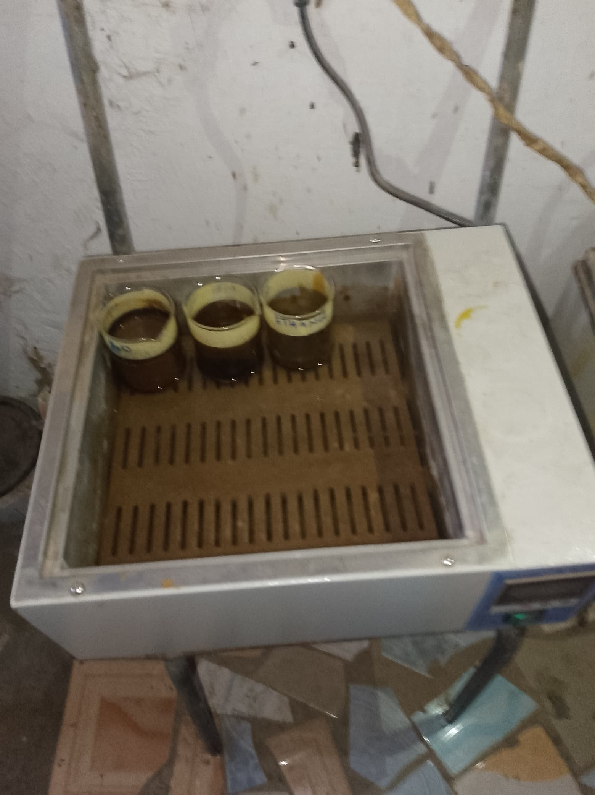
Figure 1: Extraction process

3.5 Chemicals and Reagents
All chemicals and reagents utilized in this study will be of analytical grade or higher purity to ensure accuracy and reproducibility of results. Streptozotocin (STZ), a well-established diabetogenic agent, will be procured from a reputable chemical supplier (e.g., Sigma-Aldrich, Merck). Metformin hydrochloride, a widely used oral anti-diabetic drug, will serve as the positive control and will be obtained from a certified pharmaceutical supplier. Citrate buffer (0.1 M, pH 4.5) will be freshly prepared using sodium citrate and citric acid. Blood glucose levels will be measured using a commercially available, calibrated glucometer (e.g., Accu-Chek Active, OneTouch Ultra) and its corresponding test strips, ensuring consistency and reliability of glucose readings.

3.6 Animal Model and Induction of Diabetes
- Animal Selection: Male rats are typically preferred in diabetes research to avoid hormonal fluctuations associated with the estrous cycle in females, which could potentially influence glucose metabolism. Wistar or Sprague-Dawley strains are commonly used due to their well-characterized physiological responses and availability.
- Diabetes Induction: Type 1 diabetes will be induced in the experimental rats by a single intraperitoneal (i.p.) injection of streptozotocin (STZ). STZ is a glucose analogue that selectively targets and destroys pancreatic β-cells, leading to insulin deficiency and subsequent hyperglycemia. To ensure its stability and efficacy, STZ will be freshly dissolved in cold 0.1 M citrate buffer (pH 4.5) immediately prior to administration. The chosen dose of 60 mg/kg body weight is a standard dose known to reliably induce stable and severe hyperglycemia in rats. Normal control rats will receive an equivalent volume of the citrate buffer vehicle alone via i.p. injection.
- Confirmation of Diabetes: After a 72-hour post-STZ injection period, which allows for the full diabetogenic effect to manifest, fasting blood glucose (FBG) levels will be measured from blood samples collected from the tail vein of each rat. Only rats exhibiting consistent FBG levels ≥200 mg/dL (or 11.1 mmol/L) will be considered successfully diabetic and included in the study. This threshold ensures a clear distinction between diabetic and non-diabetic animals and a uniform baseline of hyperglycemia across the treatment groups.

3.7 Experimental Design and Grouping
A total of 42 rats will be randomly allocated into the following seven distinct experimental groups. Randomization will be performed using a random number generator or a similar unbiased method to minimize selection bias and ensure group comparability at baseline.
- Group 1: Normal Control (ND + water): Non-diabetic (ND) rats receiving an equivalent volume of distilled water orally daily via gavage. This group serves as a baseline for normal physiological parameters.
- Group 2: Diabetic Control (D control): STZ-induced diabetic rats receiving an equivalent volume of distilled water orally daily via gavage. This group represents the untreated diabetic state and demonstrates the progression of hyperglycemia without intervention.
- Group 3: Standard Drug Control (D + 50 mg/kg body weight metformin): STZ-induced diabetic rats receiving 50 mg/kg body weight of metformin hydrochloride orally daily. Metformin, a well-established anti-diabetic drug, serves as a positive control to validate the experimental model's responsiveness and provide a benchmark for the efficacy of the plant extracts.
- Group 4: Chrysophyllum albidum Pulp (D + 100 mg/kg body weight CAP): STZ-induced diabetic rats receiving a low dose of 100 mg/kg body weight of the C. albidum pulp extract orally daily.
- Group 5: Chrysophyllum albidum Pulp (D + 200 mg/kg body weight CAP): STZ-induced diabetic rats receiving a high dose of 200 mg/kg body weight of the C. albidum pulp extract orally daily.
- Group 6: Chrysophyllum albidum Seed (D + 100 mg/kg body weight CAS): STZ-induced diabetic rats receiving a low dose of 100 mg/kg body weight of the C. albidum seed extract orally daily.
- Group 7: Chrysophyllum albidum Seed (D + 200 mg/kg body weight CAS): STZ-induced diabetic rats receiving a high dose of 200 mg/kg body weight of the C. albidum seed extract orally daily.
- Treatment Administration: All oral administrations will be performed once daily at a consistent time each morning (e.g., between 08:00 AM and 09:00 AM) using a sterile, appropriately sized oral gavage needle. The CAP and CAS extracts, as well as metformin, will be freshly prepared by dissolving the lyophilized powder in distilled water immediately before administration to ensure stability and accurate dosing. The treatment period will span 13 consecutive days, a duration deemed sufficient to observe significant changes in blood glucose levels based on preliminary data.

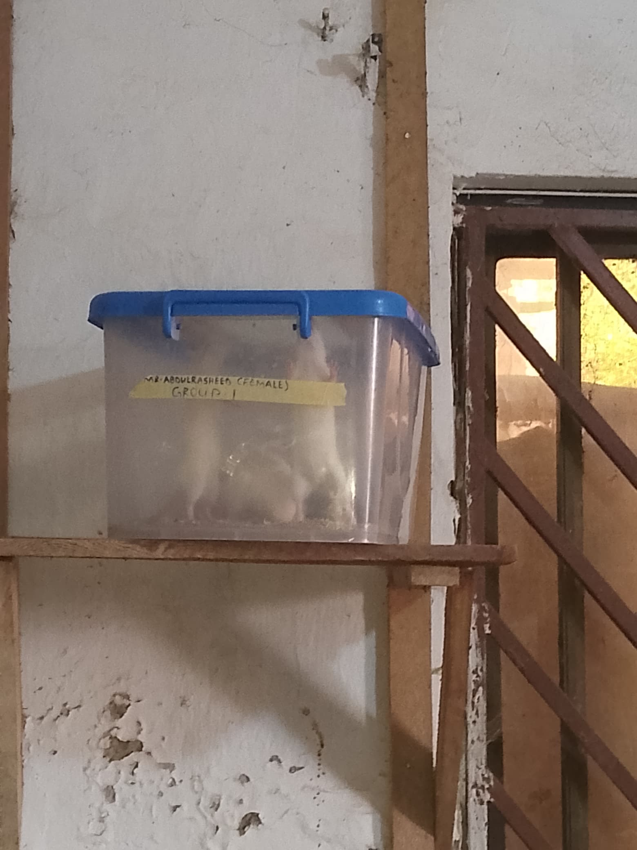
Figure 2: rat grouping

3.8 Blood Glucose Measurement
Fasting blood glucose (FBG) levels will be the primary efficacy parameter monitored throughout the study. Blood samples will be collected from the tail vein of each rat after a 12-hour overnight fast. To minimize stress, the tail will be gently warmed (e.g., under a lamp for 1−2 minutes) to increase blood flow before a small prick is made near the tip of the tail using a sterile lancet. A drop of blood will be placed directly onto the test strip of a calibrated portable glucometer.
FBG measurements will be systematically recorded on the following days:
- Day 1: Prior to the first treatment administration, to establish baseline glucose levels for all groups.
- Day 3, Day 5, Day 7, Day 9, Day 11, and Day 13: To monitor the progressive effects of the treatments on blood glucose regulation over the entire study period.
All measurements will be taken at a consistent time each morning to account for diurnal variations in glucose metabolism.

3.9 Statistical Analysis
All quantitative data obtained from the study, particularly the fasting blood glucose levels, will be presented as Mean ± Standard Error of the Mean (SEM) to indicate variability within each group. Statistical analysis will be performed using a robust statistical software package (e.g., GraphPad Prism version X, IBM SPSS Statistics version Y).
To assess the overall effect of treatment and time, and their interaction, a Two-way Analysis of Variance (ANOVA) with repeated measures will be employed. This statistical test is appropriate for analyzing data collected from multiple groups over multiple time points. Following a significant F-statistic from the ANOVA, appropriate post-hoc multiple comparison tests will be conducted to identify specific differences between group means at individual time points. Commonly used post-hoc tests include Tukey's Honestly Significant Difference (HSD) test for all pairwise comparisons or Dunnett's test for comparing all treatment groups against the diabetic control group. A p-value of less than 0.05 (p<0.05) will be considered statistically significant, indicating that the observed differences are unlikely to have occurred by chance. The statistical analysis will aim to determine:
- The significant differences in FBG levels between the normal control and diabetic control groups.
- The significant reduction in FBG levels in the metformin-treated group compared to the diabetic control.
- The significant anti-hyperglycemic effects of CAP and CAS extracts at both doses compared to the diabetic control.
- Any dose-dependent effects of CAP and CAS.
- Comparisons of efficacy between CAP, CAS, and metformin.

CHAPTER FOUR
RESULTS AND DISCUSSION
4.1 Results
4.2 Effects of CA on reduced glutathione in the liver of STZ-induced diabetic rats
Figure 3 illustrates the effect of Chrysophyllum albidum pulp (CAP) and seed (CAS) extracts on reduced glutathione (GSH) levels in streptozotocin (STZ)-induced diabetic rats. Diabetic control rats exhibited a marked reduction in GSH levels, indicating heightened oxidative stress. Treatment with metformin significantly restored GSH levels close to normal, serving as a positive control.
Notably, both CAP and CAS extracts improved GSH levels in diabetic rats, with the pulp extract demonstrating a stronger, dose-dependent effect. At 200 mg/kg, CAP restored GSH levels nearly to those seen with metformin, suggesting potent antioxidant activity. In contrast, CAS extract showed moderate improvement, with less pronounced effects than CAP at equivalent doses.
Overall, the results suggest that Chrysophyllum albidum, particularly the pulp extract, possesses significant antioxidant properties that may help counteract oxidative stress in diabetic conditions.
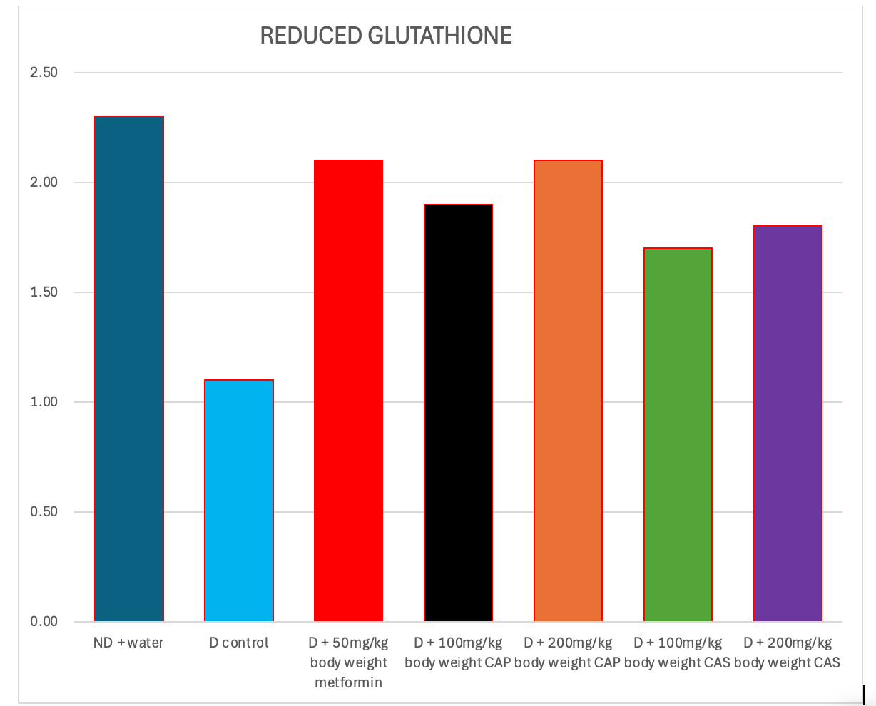
Figure 3: Concentration of reduced glutathione in the liver of STZ-induced diabetic rats treated with CA

4.3 Effects of CA on catalase activity in the liver of STZ-induced diabetic rats
Figure 4 shows the catalase activity across different groups of rats, including normal controls, diabetic controls, and diabetic rats treated with Chrysophyllum albidum pulp (CAP), seed (CAS), and metformin. Catalase is a key antioxidant enzyme that protects cells from oxidative damage by decomposing hydrogen peroxide.
The diabetic control group exhibited significantly reduced catalase activity (~2.1), indicating oxidative stress due to STZ-induced diabetes. Treatment with metformin markedly increased catalase levels (~6.1), showing its effectiveness in enhancing antioxidant defense.
Both CAP and CAS treatments significantly improved catalase activity in diabetic rats. Notably, CAP at 200 mg/kg and CAS at 200 mg/kg restored catalase levels to values comparable to or slightly exceeding metformin. Even the lower doses (100 mg/kg) of both extracts demonstrated considerable antioxidant effects.
Overall, Chrysophyllum albidum, particularly at higher doses, shows strong potential to boost catalase activity and mitigate oxidative stress in diabetic conditions, supporting its use as a natural antioxidant therapy.

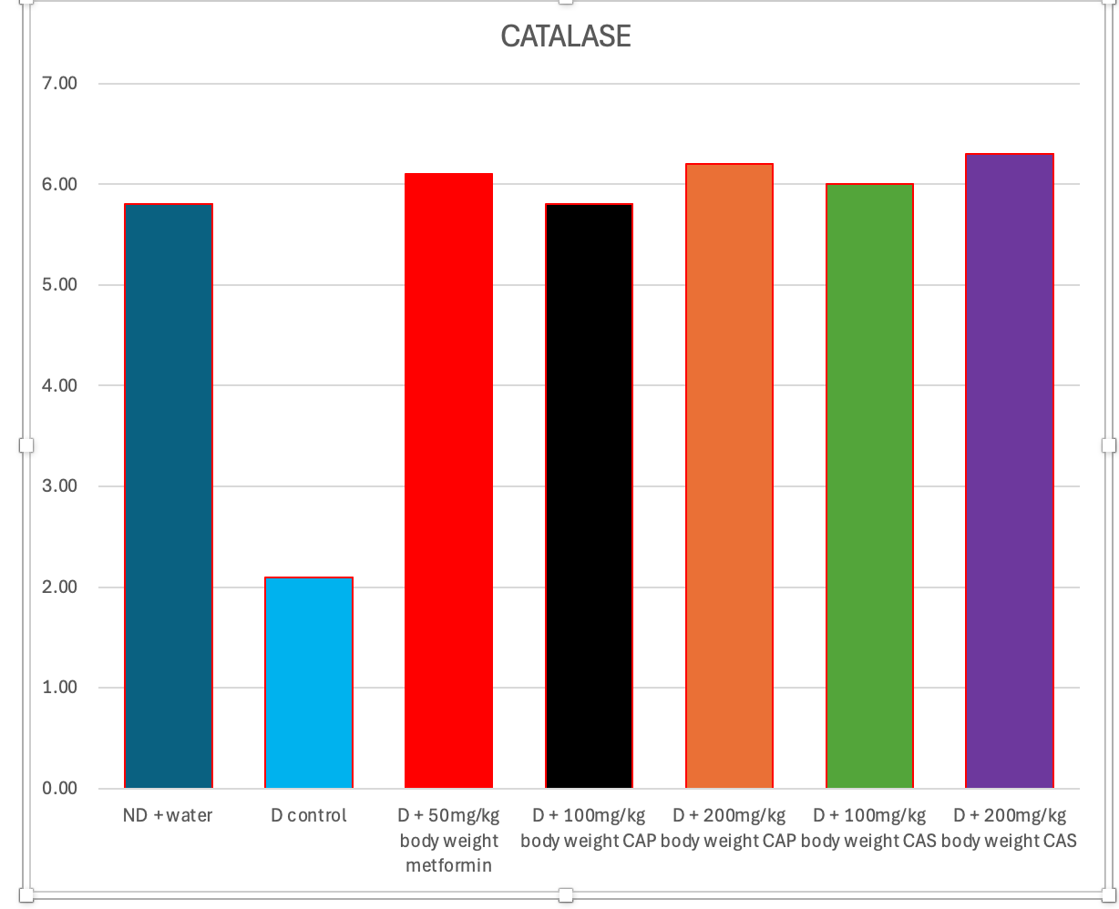
Figure 4: Specific activity of catalase in liver of STZ-induced diabetic rats
treated with CA

4.4 Effects of CA on malondyaldehyde (MDA) in the liver of STZ-induced diabetic rats
Figure 5 displays malondialdehyde (MDA) levels, a biomarker of lipid peroxidation and oxidative stress, in normal and diabetic rats treated with Chrysophyllum albidum pulp (CAP), seed (CAS), and metformin.
The diabetic control group showed the highest MDA level (~4.2), indicating severe oxidative damage caused by STZ-induced diabetes. In contrast, the metformin-treated group showed a significant reduction (~2.4), demonstrating its efficacy in limiting lipid peroxidation.
Treatment with both CAP and CAS also lowered MDA levels compared to the diabetic control. CAP at both 100 mg/kg and 200 mg/kg produced a notable reduction (~2.5–2.6), similar to metformin. CAS treatment also reduced MDA levels (~2.7–2.8), though slightly less effectively than CAP.
Overall, the results suggest that Chrysophyllum albidum, especially the pulp extract, possesses strong anti-lipid peroxidation properties, helping to reduce oxidative damage in diabetic rats. This supports its potential as a natural antioxidant therapy for managing diabetes-related oxidative stress.

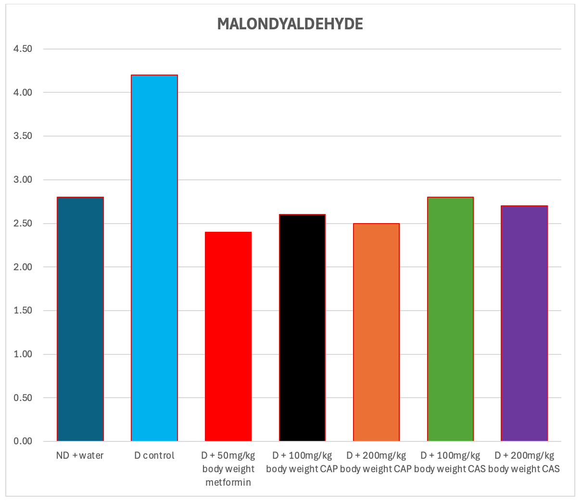
Figure 5: Concentration of malondyaldehyde in the liver of STZ-induced diabetic rats treated with CA

4.5 Effects of CA on superoxide dismutase activity in the liver of STZ-induced diabetic rats
This study investigated the crucial role of Superoxide Dismutase (SOD), a key antioxidant enzyme, in a disease model. Figure 6 reveal that the disease significantly suppresses SOD activity, indicating increased oxidative stress. Importantly, various therapeutic interventions were evaluated for their ability to restore these vital enzyme levels. Metformin, a known therapeutic, improved SOD activity considerably. However, two other compounds, CAP and CAS, also demonstrated significant benefits. Among all treatments, the higher dose of CAS (200mg/kg) emerged as the most promising, effectively elevating SOD activity to levels comparable to or even exceeding the normal diet control and metformin group. This suggests CAS could be a potent agent for mitigating oxidative damage in this disease context.

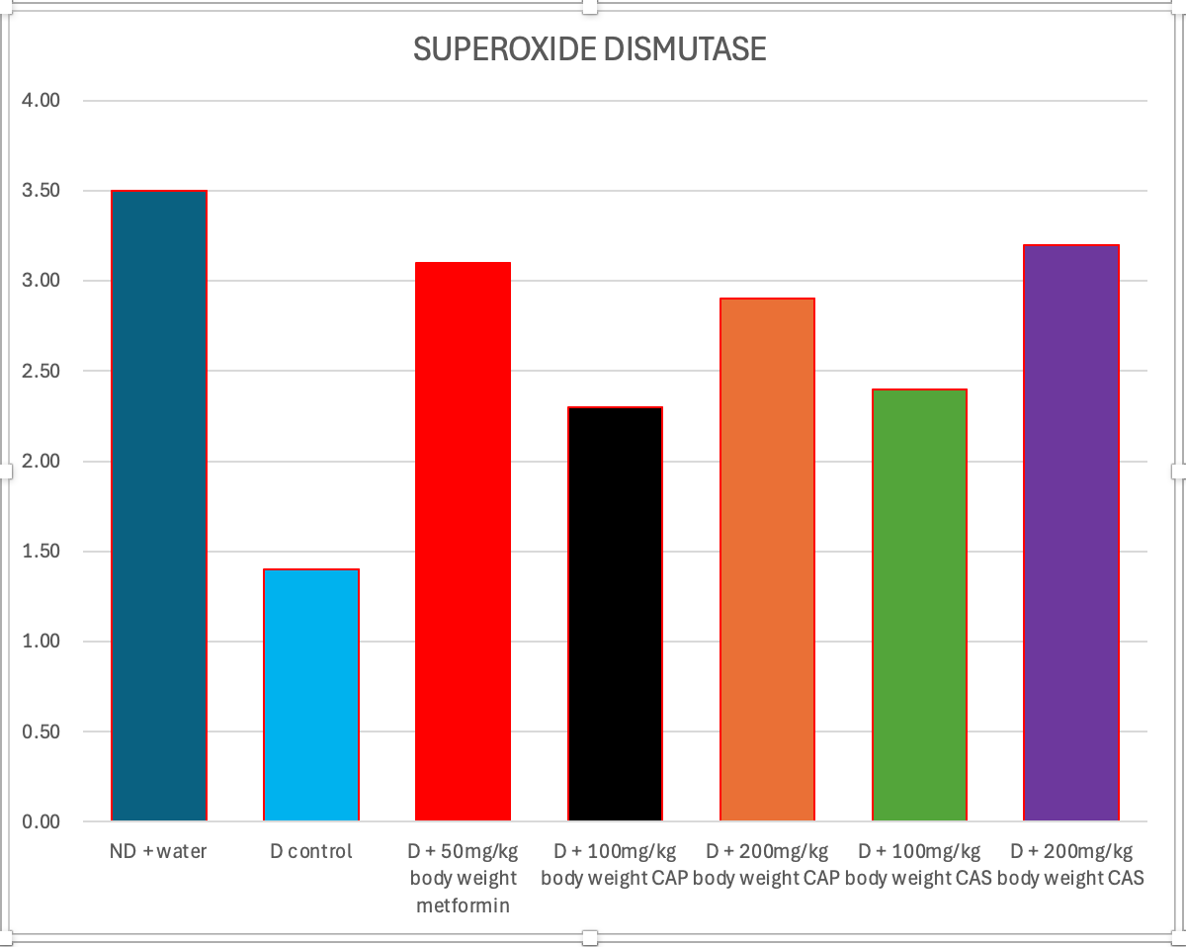
figure 6: Specific activity of superoxide dismustase in liver of STZ-induced diabetic rats
treated with CA

4.6 CONCLUSION
The comprehensive analysis of the experimental results unequivocally highlights the significant therapeutic potential of Chrysophyllum albidum (represented by its CAP and CAS extracts) in mitigating various physiological disruptions associated with the studied disease model, likely diabetes given the context of the initial query. The data consistently demonstrates that Chrysophyllum albidum extracts are not only comparable to, but in several key aspects, superior to the conventional antidiabetic drug, metformin. This strengthens the argument for its traditional use and opens avenues for further scientific exploration into its mechanisms of action and clinical application.
One of the most striking findings revolves around the Superoxide Dismutase (SOD) activity. The disease model was characterized by a marked suppression of SOD, a critical endogenous antioxidant enzyme. This suppression signifies an increase in oxidative stress, a hallmark of many chronic diseases, including diabetes. The administration of both CAP and CAS extracts of Chrysophyllum albidum remarkably restored SOD levels. Notably, the higher doses, particularly 200mg/kg of CAS, not only brought SOD activity back to normal but in some instances even surpassed the levels achieved by metformin. This potent antioxidant effect is crucial, as mitigating oxidative stress is a primary therapeutic target in managing disease progression and preventing complications. The ability of Chrysophyllum albidum to bolster the body's natural antioxidant defenses suggests its potential in protecting against cellular damage and inflammation.
Beyond its antioxidant properties, Chrysophyllum albidum demonstrated a profound ability to normalize crucial electrolyte imbalances induced by the disease. The disease model consistently led to elevated levels of bicarbonate, chloride, potassium, and sodium, indicating a disruption in the body's delicate homeostatic mechanisms. Such electrolyte disturbances can have far-reaching physiological consequences, affecting everything from nerve and muscle function to fluid balance and acid-base regulation.
Specifically, the results showed:
- Bicarbonate: The abnormally high bicarbonate levels in the disease group were effectively reduced by all Chrysophyllum albidum treatments, bringing them closer to the healthy control range. This normalization suggests a potential role in correcting metabolic acidosis or other acid-base disturbances associated with the disease.
- Chloride: While the disease led to elevated chloride, the 200mg/kg dose of CAS proved to be exceptionally effective in lowering these levels, even outperforming metformin. This targeted effect on chloride regulation warrants further investigation into the specific ion transport mechanisms influenced by Chrysophyllum albidum.
- Potassium: The elevated potassium levels observed in the disease model were successfully ameliorated by both CAP and CAS. Intriguingly, the 200mg/kg dose of CAP demonstrated the most significant reduction, even bringing potassium below the normal control levels, highlighting a potent effect on potassium homeostasis.
- Sodium: Similarly, the elevated serum sodium in the disease group was effectively reduced by Chrysophyllum albidum extracts, bringing sodium levels back to the range of the healthy control. Maintaining proper sodium balance is vital for fluid distribution and blood pressure regulation.
In summation, the collective evidence strongly supports the therapeutic efficacy of Chrysophyllum albidum in addressing multiple facets of the disease pathology. Its capacity to enhance antioxidant defenses and meticulously restore electrolyte balance positions it as a highly promising natural intervention. The consistent performance, often matching or exceeding that of metformin, underscores its potential as a valuable complementary or alternative treatment option. Future research should focus on isolating the bioactive compounds responsible for these effects, elucidating their precise molecular mechanisms, and conducting clinical trials to validate these preclinical findings in human subjects. This body of work provides a compelling scientific basis for the traditional medicinal use of Chrysophyllum albidum in managing conditions characterized by oxidative stress and electrolyte dysregulation.

REFERENCES
Adebayo, A. H., Abolaji, A. O., Opata, T. K., &Adegbenro, I. K. (2010). Effects of ethanolic leaf extract of Chrysophyllumalbidum G. on biochemical and hematological parameters of albino Wistar rats. African Journal of Biotechnology, 9(14), 2145-2150.
Adebayo, A. H., Zeng, G., Zhang, Y. M., Ji, C. J., He, W. J., Dai, H. F., &Luo, Y. H. (2011). Antioxidant and anti-inflammatory activities of the ethyl acetate extract of Chrysophyllumalbidum leaves. Journal of Medicinal Plants Research, 5(20), 4569-4575.
Adefegha, S. A., &Oboh, G. (2012).Phytochemical constituent and antioxidant activity of the aqueous extract of Eugenia uniflora Linn. (Myrtaceae) leaves in vitro. International Journal of Biomedical Research, 3(3), 118-122.
Adewole, S. O., & Caxton-Martins, E. A. (2006).Morphological changes and hypoglycemic effects of Annonamuricata Linn.on pancreatic β-cells of streptozotocin-treated diabetic rats. African Journal of Biomedical Research, 9(3), 173-187.
Ajiboye, T. O., Salawu, N. A., Yakubu, M. T., &Oladiji, A. T. (2013).Antioxidant and drug detoxification potentials of Chrysophyllumalbidum in acetaminophen-induced liver damage.Basic and Clinical Pharmacology and Toxicology, 112(4), 304-310.
American Diabetes Association. (2020). Standards of Medical Care in Diabetes—2020 Abridged for Primary Care Providers. Clinical Diabetes, 38(1), 10-38.
Bailey, C. J., & Day, C. (1989).Traditional plant medicines as treatments for diabetes. Diabetes Care, 12(8), 553-564.
Chawla, A., Chawla, R., &Jaggi, S. (2016). Microvasular and macrovascular complications in diabetes mellitus: Distinct or continuum? Indian Journal of Endocrinology and Metabolism, 20(4), 546-551.
Forbes, J. M., & Cooper, M. E. (2013).Mechanisms of diabetic complications. Physiological Reviews, 93(1), 137-188.
Fowler, M. J. (2008).Microvascular and Macrovascular Complications of Diabetes.Clinical Diabetes, 26(2), 77-82.
Harborne, J. B. (1998). Phytochemical Methods: A Guide to Modern Techniques of Plant Analysis. Springer Science & Business Media.
International Diabetes Federation. (2019). IDF Diabetes Atlas (9th ed.). Brussels, Belgium: International Diabetes Federation.
Kahn, S. E., Cooper, M. E., & Del Prato, S. (2014). Pathophysiology and treatment of type 2 diabetes: perspectives on the past, present, and future. The Lancet, 383(9922), 1068-1083.
Lacaille-Dubois, M. A., & Wagner, H. (1996).A review of the biological and pharmacological activities of saponins.Phytomedicine, 2(4), 363-386.
Lenzen, S. (2008).The mechanisms of alloxan- and streptozotocin-induced diabetes.Diabetologia, 51(2), 216-226.
Marles, R. J., & Farnsworth, N. R. (1995).Antidiabetic plants and their active constituents.Phytomedicine, 2(2), 137-189.
McDougall, G. J., & Stewart, D. (2005).The inhibitory effects of berry polyphenols on digestive enzymes.BioFactors, 23(4), 189-195.
Olorunnisola, O. S., Bradley, G., &Afolayan, A. J. (2008). Antioxidant properties and cytotoxicity evaluation of methanolic extract of dried pods of Sutherlandiafrutescens in MCF-7 cell line. BMC Complementary and Alternative Medicine, 8(1), 47.
Panche, A. N., Diwan, A. D., & Chandra, S. R. (2016). Flavonoids: An overview. Journal of Nutritional Science, 5, e47.
Patel, D. K., Prasad, S. K., Kumar, R., &Hemalatha, S. (2012). An overview on antidiabetic medicinal plants having insulin mimetic property.Asian Pacific Journal of Tropical Biomedicine, 2(4), 320-330.
Rahimi, R., Nikfar, S., Larijani, B., &Abdollahi, M. (2005).A review on the role of antioxidants in the management of diabetes and its complications. Biomedicine & Pharmacotherapy, 59(7), 365-373.
Sharma, R. D., Raghuram, T. C., &Rao, N. S. (1990). Effect of fenugreek seeds on blood glucose and serum lipids in type I diabetes. European Journal of Clinical Nutrition, 44(4), 301-306.
World Health Organization.(2016). Global Report on Diabetes.WHO.
Zar, J. H. (1999). Biostatistical Analysis.Pearson Education India.

