ENERGY EFFICIENCT SMART HOME AUTOMATION SYSTEM
USING INTERNET OF THINGS (IOT)

By:
ABDULRASAQ FAHEEMAT
HND/23/COM/FT/0107

A Project Submitted to the
Department of Computer Science,
Institute of Information and Communication Technology
Kwara State Polytechnic, Ilorin

In Partial Fulfillment of the Requirements for the award of Higher National Diploma (HND) in Computer Science

CERTIFICATION
This is to certify that this project was carried out by ABDULRASAQ FAHEEMAT with matriculation number HND/23/COM/FT/0107 as part of requirement for the award of Higher National Diploma (HND) in the department of Computer Science.

------------------------------------- ----------------------
A. K. Raji (PhD) Date
(Project Supervisor)

--------------------------------- ----------------------
F. S. Oyedepo Date
(Head of Department)

----------------------------------- ---------------------
External Supervisor Date

DEDICATION
I dedicate this project to Almighty God who's protect me, guide me through this work a big thanks to Almighty God.

ACKNOWLEDGMENT
All praise is due to Almighty God for His grace, guidance, and strength throughout the course of this project. I am profoundly grateful to numerous individuals and institutions whose support and contributions were vital to the successful completion of this work.

Foremost, I extend my sincere appreciation to A. K. Raji (PhD) whose exceptional guidance, expertise, and unwavering support were instrumental in navigating the complexities of this research. His valuable insights and constructive feedback greatly shaped the direction and quality of this project. I am deeply thankful to my parents, Mr. and Mrs. Abdulrasaq, for their constant encouragement, prayers, and moral support throughout this journey. Their words of wisdom and emotional backing kept me focused and motivated during challenging periods. My heartfelt appreciation also goes to my entire family and friends, whose patience and uplifting presence provided strength and inspiration at every stage of this endeavor.
I would also like to acknowledge the Head of the Department of Computer Science, Mr. Oyedepo F. S., along with other dedicated staff members of the department. Their insightful critiques and academic support were invaluable in refining the scope and content of this work.
Lastly, I am sincerely grateful to all the participants and respondents who willingly provided their time, data, and perspectives for this research. Their contributions played a crucial role in the empirical validation and practical relevance of this study.

ABSTRACTS

TABLE OF CONTENTS
PAGE
TITLE PAGE i
CERTIFICATION ii
DEDICATION iii
ACKNOWLEDGEMENT iv
ABSTRACTS v
TABLE OF CONTENTS vi

CHAPTER ONE: GENERAL INTRODUCTION
1.1 BACKGROUND TO THE STUDY 1
1.2 STATEMENT OF THE PROBLEM 3
1.3 AIM AND OBJECTIVES 4
1.4 SIGNIFICANT OF THE STUDY 4
1.5 SCOPE OF THE STUDY 4
1.6 REPORT OUTLINE 5
CHAPTER TWO: LITERATURE REVIEW
2.1 Review General Text 8
2.2 Review of Related Works 10
2.3 Overview of Smart Home Automation 12
2.4 Internet of Things (IoT) in Home Automation 15
2.5 Android-Based and Wi-Fi Technology in Home Automation 17

CHAPTER THREE: RESEARCHMETHODOLOGY AND ANALYSIS OF THE EXISTING SYSTEM
3.1 RESEARCH METHODOLOGY 16
3.2 ANALYSIS OF THE EXISTING SYSTEM 17
3.3 DESCRIPTION OF THE EXISTING SYSTEM 18
3.4 DESCRIPTION OF THE PROPOSED SYSTEM 18
3.5 ADVANTAGES OF THE PROPOSED SYSTEM 19

CHAPTER FOUR: DESIGN, IMPLEMENTATION AND DOCUMENTATION OF THE SYSTEM

4.1 DESIGN OF THE SYSTEM 20 4.1.1 OUTPUT DESIGN 20 4.1.2 INPUT DESIGN 21 4.1.3 DATABASE DESIGN 22
4.1.4 PROCEDURE DESIGN 22
4.2 IMPLEMENTATION OF THE SYSTEM
4.2.1 CHOICE OF PROGRAMMING LANGUAGE 23 4.2.2 HARDWARE SUPPORT 23 4.2.3 SOFTWARE SUPPORT 23 4.2.4 CHANGE OF TECHNIQUE 23
4.3 DOCUMENTATION OF THE SYSTEM 24
4.3.1 PROGRAM DOCUMENTATION 25 4.3.2 OPERATING THE SYSTEM 26 4.3.3 MAINTAINING THE SYSTEM 26

CHAPTER ONE
GENERAL INTRODUCTION

  - BACKGROUND TO THE STUDY

Today, Internet-of-things (IoT) is the most trending and important topic in computing (Adedoyin & Falowo, 2020). The concept of loT makes it possible for devices to communicate with each other and share resources while using the Internet as a wireless medium. The beauty of IoT is seen when devices connected to the central control system make smart decisions about when to carry out desirable actions using black box technology. Energy efficiency is a research area of growing interest. In this scenario, the energy consumption has increased significantly over the years as result of economic development and the indiscriminate use of energy by the public (Filho, et al., 2018). In response to this increase, governments and organizations are adopting energy conservation policies with the goal of avoiding problems in the energy sector, such as blackouts (Orestis, 2018).
As in smart homes, IoT allows a house owner who is far from home to control his house over the internet. The ease of use and wide-ranging capabilities of home automation systems have made it more popular every day. Some people need home automation systems to make their home appliances easier and more comfortable to operate, while it is also very useful for people with physical disabilities and elderly people (Aravindhan, et al., 2021). Without physical switches, the smart home can automatically control when lights are switched on or off, depending on the light intensity in the surrounding area, as well as when the fan is adjusted according to the ambient temperature. Also, users can check the status of their home devices from anywhere in the world and can control them via cell phone or web. Internet-of-things (IoT) is the most trending and important topic in recent times (Agarwal et al., 2019).
The concept of IoT makes it possible for devices to communicate with each other and share resources while using the Internet as a wireless medium. The beauty of IoT is seen when devices connected to the central control system make smart decisions about when to carry out desirable actions using black box technology. As in smart homes, IoT allows a house owner who is far from home to control his house over the internet. The ease of use and wide-ranging capabilities of home automation systems have made it more popular every day. Some people need home automation systems to make their home appliances easier and more comfortable to operate, while it is also very useful for people with physical disabilities and elderly people (Aravindhan, et al.,2021). Without physical switches, the smart home can automatically control when lights are switched on or off, depending on the light intensity in the surrounding area, as well as when the fan is adjusted according to the ambient temperature. Also, users can check the status of their home devices from anywhere in the world and can control them via cell phone or web.
Home Automation refers to making use of one or more computer systems to automatically and remotely control basic home functions. An automated home refers to as "A smart home", because of its ability to accept and process inputs from the environment to produce desirable results without human interference (Purohit & Ghosh, 2017). The special features of a smart home make it possible to automatically control electronic devices. A home owner who is absent from his home can fully automate basic home functions that are not limited to monitoring and controlling his home safety system, temperature gauges, and switching the state of electrical appliances without any physical contact with the hardware.
A smart home is achieved if remote controlling and monitoring of electrical appliances can be performed. According to (Asadullah and Raza, 2018), home automation has become increasingly popular over the last decades because of its impact on improving the quality of life. Smartphone applications, microcontrollers, sensors and different types of communication technologies are widely used in most home automation systems. Physically challenged individuals and elderly people face difficulties in performing simple home tasks, such as switching on the lights, speeding or switching on the fan, etc. All of these needs can be met by a home automation system capable of monitoring and controlling electrical devices remotely. The implementation of a smart home system helps to save quite a lot of time needed to operate home appliances from anywhere (Yadav, et al., 2018).

  - STATEMENT OF THE PROBLEM
In today’s world, the rising cost of energy and the growing concern over environmental sustainability have highlighted the urgent need for smarter and more efficient energy management solutions, particularly in residential buildings (Kotak, and Elovici, 2023). Traditional home systems rely heavily on manual operations, which often result in unnecessary energy consumption, human error, and poor energy utilization. Many households lack real-time monitoring and automated control systems that can adapt to changing environmental conditions or user behavior. As a result, appliances such as lighting, air conditioning, and electronics are often left running unnecessarily, leading to increased energy bills and wasteful consumption. Furthermore, conventional home automation systems, where they exist, often operate in isolation without intelligent integration or remote control capabilities (Terzi et al., 2022). These systems do not utilize the full potential of Internet of Things (IoT) technologies to monitor, analyze, and optimize energy usage. Given these challenges, there is a clear need for an affordable, user-friendly, and intelligent system that can automate home functions, reduce energy waste, and allow remote monitoring and control. This project addresses these issues by developing a smart home automation system that uses IoT to enhance energy efficiency and promote sustainable living.
1.3 AIM AND OBJECTIVES
The aim of this research work is to develop energy efficient smart home automation system
Using Internet of Things (IOT). The following are the objectives set for this work:

- To develop energy efficient smart home automation system
- To integrate system developed with Internet of Things (IOT)
- To develop an electrical system to implement all the functions in the Internet of Things (IOT)
- To implement secure protocols using Internet of Things (IOT) in smart automation system
- Evaluate the performance Internet of Things (IOT) in smart home automation efficiency

1.4 SIGNIFICANT OF THE STUDY
The study on Energy Efficient Smart Home Automation System Using Internet of Things (IoT) is of great significance for several reasons, particularly in the context of sustainable development, energy conservation, and technological advancement. The key areas of significance include: Energy Conservation and Efficiency: The study promotes the development and implementation of systems that monitor and reduce energy consumption. By using IoT-enabled sensors and devices, homeowners can optimize the use of lighting, heating, cooling, and appliances, leading to significant energy savings and reduced utility bills. Environmental Sustainability; As the world grapples with the effects of climate change, reducing energy consumption contributes to lower greenhouse gas emissions. This study supports the global goal of achieving a greener and more sustainable environment through smart technologies. Technological Advancement; This research fosters innovation in the integration of IoT with home automation. It provides a foundation for future advancements in smart systems, including artificial intelligence, machine learning, and cloud computing in residential environments. Improved Quality of Life; The study enhances convenience, comfort, and security for homeowners by automating routine tasks and providing remote access and control through smartphones or computers. It also allows real-time monitoring and alerts, increasing overall safety

1.5 SCOPE OF THE STUDY
This study focuses on the design and implementation of an energy-efficient smart home automation system utilizing the capabilities of the Internet of Things (IoT). The scope of the study is outlined as follows: Home Automation Functions; The study is limited to automating basic household functions that impact energy consumption. These include: Lighting control (e.g., turning lights on/off based on occupancy or schedule) Temperature regulation (e.g., smart thermostat control), Appliance management (e.g., switching off unused devices remotely or automatically) IoT Integration The system uses IoT-enabled devices such as sensors (motion, light, temperature), microcontrollers (e.g., Arduino or Raspberry Pi), and communication modules (e.g., Wi-Fi or Bluetooth) to enable real-time monitoring and control.
1.6 REPORT OUTLINE

This research is structured to systematically address the energy efficient smart home automation system using Internet of Things (IOT). The study begins with an introduction that provides the background to the study, defines the problem statement, outlines the objectives of the research, and emphasizes the significance and scope of the study. The second chapter of the research reviews existing literature related to smart home automation, overview of internet of thing (IOT) in smart home automations, applications area of internet of thing (IOT), automation system, importance of home automation.
More so, chapter three examines the method of the proposed system, the, the description and advantages of proposed system. Chapter Four, explains the implementation and documentation of the system which contains design, implementation techniques, documentation, hardware and software requirements.
Lastly, chapter five includes the summary, conclusions and recommendations

CHAPTER TWO
LITERATURE REVIEW

2.1 REVIEW OF RELATED WORKS
The integration of Internet of Things (IoT) technology into home automation has been widely studied in recent years, demonstrating its potential to enhance energy efficiency, comfort, and security. Researchers have explored various IoT-based systems that allow remote control of household appliances, environmental monitoring, and real-time data visualization using microcontrollers like the NodeMCU ESP8266. By leveraging cloud platforms and mobile applications, these studies have shown how IoT can bring a new level of functionality and convenience to modern living spaces.
In a study by Ahmed et al. (2021), the researchers developed a low-cost IoT home automation system that used the ESP8266 microcontroller to control appliances such as lights and fans. They utilized the Blynk IoT platform to enable remote access, allowing users to control appliances via a mobile app interface. Their research highlighted the benefits of real-time control and data monitoring, although it focused solely on manual device control without integrating environmental sensors or automated features.
A study by Chen et al. (2022) implemented an IoT-based temperature and humidity monitoring system using the DHT22 sensor in conjunction with the NodeMCU ESP8266. The system provided accurate temperature and humidity readings, allowing users to monitor environmental conditions remotely through a mobile application. While this study successfully demonstrated the reliability of the NodeMCU for environmental monitoring, it lacked the integration of appliance control, which is essential for a comprehensive home automation system.
Jain et al. (2021) integrated Blynk with the NodeMCU ESP8266 to create a home automation project that controlled lighting and fan speed based on user input. Blynk allowed users to visualize data trends, monitor device states, and access historical data, making it a popular choice for IoT-based home automation systems. However, this study did not explore the use of automatic control based on environmental conditions, a limitation that this current project addresses by incorporating real time sensor data for automation.
In the realm of energy efficiency, Singh and Patel (2021) examined an IoT-based system for monitoring household energy consumption, focusing on optimizing appliance usage to reduce electricity bills. Their system used a microcontroller to measure appliance power consumption and utilized a mobile app for remote control. Although the system was effective in providing users with energy consumption data, it lacked the integration of environmental sensors, which could enhance energy efficiency through context-aware appliance control.
In a more comprehensive study, Mehta et al. (2023) developed a smart home automation system that integrated multiple environmental sensors, including temperature, humidity, and motion detectors, with appliance control features. Their system used NodeMCU as the central controller and leveraged both manual and automated modes for managing appliances, demonstrating the importance of combining sensors with control systems for a holistic home automation experience. However, the system did not use any cloud platform for data visualization or remote control, limiting its accessibility and functionality. Building on the findings from previous research, this project combines the capabilities of the NodeMCU ESP8266 with the DHT11 sensor and relay modules to provide a robust home automation solution. By integrating both manual and automatic modes for controlling appliances, such as fans and lights, this project addresses the limitations identified in earlier studies. Additionally, the system utilizes the Blynk IoT platform to enable remote control, data visualization, and real-time environmental monitoring, creating a flexible and scalable solution for modern home environments. Through these enhancements, this project offers a more comprehensive and adaptive approach to home automation, aligning with the goals of smart home technology by enhancing energy efficiency, user convenience, and overall home management.

2.2 OVERVIEW OF INTERNET OF THING (IOT) IN SMART HOME AUTOMATIONS
The revolution of Internet of Things (IoT) is pervading many facets of our everyday life. Among the multiple IoT application domains, well-being is becoming one of the popular scenarios in IoT which aims to offer new services including smart fitness.
The Internet of Things (IoT), and related technology such as wireless sensor networks (WSN) are progressing rapidly and their new developments and applications are shaping our daily life (Akyildiz et al., 2022). According to Blanter, and Holman, (2020). there are about 30 billion devices and over 7.7 people connected to IOT networks in early months of 2020 and it is estimated that this number will be raised up to 75.44 billion connected devices. There are several definitions for the IOT, but a universal definition describes it as a global network of sensors, devices and objects that can connect to each other automatically and sense data, thereby allowing to measure, control and process an environment and make it perform in an intelligent manner. All these recent advancements made it possible to offer a large number of applications in many different domains including home automation, e-healthcare, environment monitoring, transportation systems, and other commercial areas (Kotak, and Elovici, 2023).
Internet of Things (IoT), the internet, there is a nonstop future innovation Unrest, will influence the entirety of the application area. Estimate pervasive. It influences and is an enormous scope numerous applications from agribusiness, savvy reference, industry, energy, transport. This can be certain that it would have developed hugely. Internet of Things (IoT), applications and direct the desire to improve innovation. Furthermore, to defeat the current conveyed capacity, Fathom the arrangements that can be exceptionally related to Sending's enormous scope. Internet of things (IoT) is situated in both the social and social effects of life and work. Moreover, the internet of things opens a thorough the upside of the new possibilities. With the goal that can profit from the web of things, there are some specialized issues to be unraveled: heterogeneity, versatility, and interoperability to take care of these specialized issues (Wang et al., 2020).
2.3 APPLICATIONS AREA OF INTERNET OF THING (IOT)
Internet of things technology, it is possible to control lighting through the cell phone or Alexa and Google's assistant has led to the development of connected devices such as smart light bulbs. Besides, at any time, program them to turn on and be darker without using a dimmer switch. For those number of lights and hidden lighting is large, it is recommended a smart lighting switch without changing all the existing light bulb light, these controls have been connected to the smart switch that allows to turn on the schedule, and smart assistant on and off of the light technology and interior design are usually not a concept coupled from the beginning to the end. After the inside of the decision, additional technical is obtained by inverting the building, still occupied the space, it is usually at the end of the process. Smart home appearance and the Internet of things technology than the digital layer's combination to the elements of the connection inside has led the designer. The internet and other field companies develop the internet of things technology and apply it to the office of design.
- Smart Home: The safety and security of data collected by home sensors and detectors is a significant concern. Data is stored at various locations, such as centralized servers in the cloud, fog, and local networks. The findings of the analysis by cyber security researchers identifying vulnerabilities in the IoT networks (e.g., a smart city) often result in the hacking of consumer data, thus jeopardising the customer’s security and safety. Only authorized operators of IoT mainly work in a smart home domain to monitor all smart things in the home (Tariq et al., 2021).
- Smart Cities: In smart city applications, the information is transmitted and used by various groups interacting and acquiring access to the data. From the developers of smart sensors to the city’s transport administration including consumers interacting with the smart city (via smart mobiles, for instance), each entity distinctively utilizes and manages information, which might jeopardize an individual’s privacy. Additionally, as every smart city partner would have diverse prime concerns, differences exist amongst diverse partners’ privacy regulations. Therefore, secure connections and authentication are equally significant in smart cities (Daneva, and Lazarov, 2023).
- Smart Health: The IoT concept incorporates authentication, automated data aggregation, and discrimination of fetched/processed data in the medical field. In general, health services in IoT applications handle patient data, which is vulnerable to a data leak if appropriate preventive controls are not taken (Hussain et al., 2021).
- Smart agriculture and environment: Agriculture and the environment can be managed using smart networking/devices, as they can furnish several principle characteristics: i) the potential of gathering data from surroundings, ii) the feasibility of transferring instructions and feedback distantly, along with the real-time mode, and iii) the accessibility of the equipment to manage the significant quantity of information (Saha et al., 2021).
- Smart energy: With the assistance of Information and Communications Technology (ICT), smart energy users can use and manage objectives based on the information obtained from distant services. Due to the collection, receiving, and exchange of data, smart grids essentially need protection against privacy breaches. If an attack succeeds, it can lead to cascading consequences such as degradation of public utilities including telecommunication companies, energy delivery, and other associated services (Terzi et al., 2022).
2.4 AUTOMATION SYSTEM
With the development of Cloud technologies and Wi-Fi enabled appliances, Internet-based remote control architectures for home automation were proposed at the beginning of 2000s (Tan et al., 2022). These works generally emphasize the energy management aspect of home environments; however, the variety and novelty of provided services draw more attention. They can be considered as initial steps towards modern smart homes that lack complex and attractive services. In the home automation domain, most of the proposed systems, not only the mentioned ones are behind the current technological improvements and user demands. They generally utilize an Internet-connected SBCs and user interfaces to turn on/off home appliances. Such features are very trivial to categorize them as novel complex services.
Another common approach is publishing data to the Cloud for processing purposes Beginning of the keen home framework is situated in the savvy can give data to assemble a savvy home framework As individuals of intuitive highlights can see the house Data and hand which can control a few gadgets The external the home, as a canny control of the lighting, Clever control of shopper gadgets items, video talk, canny security. It contains the keen home framework: Web, savvy apparatuses, regulator, home organization. Savvy home, speaks to a house that can fulfill the necessities Canny and adaptable bundling technique to react to request solace of its occupants, will have the option to control and oversee them utilizing its own environmentally friendly power energy. Indeed, the term Keen home is wide as a moderate innovation. There are situations where the explicit meaning of keen home exists (Fu et al., 2022). Smart Cities apply the technologies into a much wider scale by connecting people in a city to all ‘‘Smart Technologies’’ mentioned above in order to deliver real time information for selected users with correct details at the right time. Figure 2 shows a typical integration of smart technologies in a Smart City architecture. via gateways, which has the aforementioned critical disadvantages. Mainly for these reasons, utilization of innovative technologies and architectures are required for the IoT based systems (Ozmen et al., 2021).
2.4.1 IMPORTANCE OF HOME AUTOMATION
Home automation is transforming the way we live by enhancing comfort, security, and energy efficiency in residential spaces. With the ability to remotely control and monitor appliances, smart home systems provide homeowners with valuable insights and control over their domestic environment, ultimately improving quality of life. Through automation, tasks such as lighting, heating, and cooling can be optimized to reduce unnecessary energy usage, which not only lowers utility costs but also supports sustainable living practices. Data collected by home automation systems can further inform energy consumption patterns, helping homeowners make informed choices to minimize environmental impact. The application of Internet of Things (IoT) technology in home automation has amplified the effectiveness of these systems by enabling real-time control, data logging, and remote access. Traditional home systems often required manual operation and offered limited monitoring capabilities. IoT-enabled systems, on the other hand, offer a cost-effective, scalable, and user-friendly solution that provides continuous monitoring and control with minimal user intervention. By facilitating remote access through mobile applications, IoT devices allow users to manage their home environment from anywhere, significantly enhancing the convenience and security of home management. As IoT-based home automation systems continue to evolve, they present vast potential for improving energy efficiency, enabling sustainable practices, and creating a more comfortable living environment. These systems align with broader objectives of smart living, supporting a connected lifestyle that is adaptable to the modern homeowner's needs.

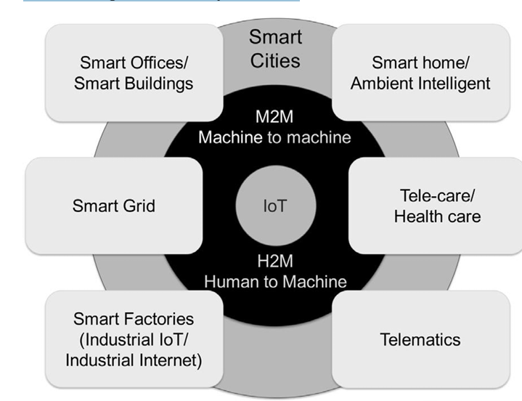
Figure 2.1: Typical architecture of a Smart City (Hui et al., 2023)

Home Automation System Based on Voice Recognition Technology:
Home automation system that runs on android devices has been designed A voice-controlled (Sen, et al., 2020). A control circuit consisting of an Arduino Uno microcontroller is interfaced with a Bluetooth module which provides a communication medium between the android and the control circuit. An android application which is resident in the user's Android device prompts the user to enter a voice command which the application converts into texts. Through a Bluetooth module, the texts are wirelessly transmitted to the Arduino Uno which performs text matching on the possible commands which the connected devices can receive.

GSM Based Home Automation System
Singh et al., (2021) presented a GSM-based home automation system which allows SMS commands to be sent to home appliances via SMS commands has been proposed. The system uses a GSM module interfaced on a microcontroller to send notifications to the user and also receive commands. Microcontroller in-turn turns on the required devices through the switching module. Annan et al., (2022) used a GSM network to remotely control home appliances through android devices. The design focuses on the design of an Android terminal to effectively send commands to the controller. The controlling of the switching states of home appliances using an android device is only achieved.
Home Automation System Based on Bluetooth Technology
Desai S. and Khanna, S. (2020) proposed a home automation system using an Arduino as a central controller, Bluetooth module as a serial communication medium between the Arduino. and an android application as a communication interface between the user and the central controller. The system controls the switching states of the appliances, which is connected to the controller via an android device over a Bluetooth distance range.
Home Automation System Based on the Internet of Things Technology
Kodali et al., (2020) incorporate an internet-based smart security feature into a home automation system. The system consists of a TI CC3200 Launchpad board which serves as the controller for the system, a Wi-Fi module which allows for remote communication between the controller board and a terminal device, relays which connect electronic appliances to the controller, a PIR.

CHAPTER THREE
METHODOLOGY AND ANALYSIS OF THE SYSTEM

3.1 RESEARCH METHODOLOGY
The architecture of the **Smart Home Automation System** using NodeMCU ESP8266, DHT11 sensor, relay modules, and the Blynk IoT platform is designed to enable real-time control and monitoring of home appliances, such as lights and fans, with flexible manual and automatic modes. This section details the core components of the system’s architecture, their interactions, and how they collectively function to provide an efficient and user-friendly home automation solution.
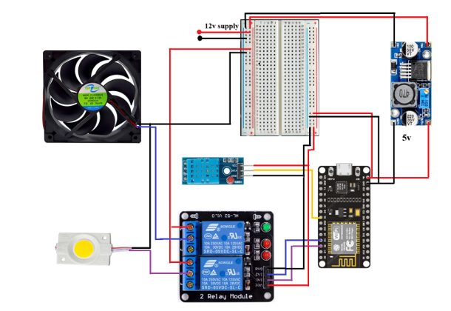
Fig 3.1 Circuit Diagram
System Overview
The architecture is structured into several key layers: the sensing layer, communication layer, cloud layer, and user interface layer. Each layer serves a unique purpose within the system, ensuring smooth operation, real-time data collection, seamless device control, and remote accessibility.
Layers of the Architecture
Sensing Layer The sensing layer consists of sensors responsible for gathering environmental data, specifically temperature and humidity. This data enables the system to automate fan control based on room conditions and provides valuable information for user monitoring. Each sensor plays a specific role in enabling automation and enhancing user experience:
DHT11 Sensor: This temperature and humidity sensor provides real-time data on the room’s environmental conditions. The sensor outputs digital readings for temperature (in degrees Celsius) and relative humidity (in percentage). This data informs the system's automatic fan control feature, allowing the fan to turn on or off based on user-defined temperature thresholds.
Communication Layer
The communication layer facilitates data transmission between the sensors, relay modules, and the cloud platform. The NodeMCU ESP8266 serves as the central controller in this layer, processing sensor data and controlling appliance states.
NodeMCU ESP8266: Equipped with Wi-Fi capabilities, the NodeMCU ESP8266 microcontroller acts as the system’s core, connecting to the DHT11 sensor and relays. It processes sensor data, enables device control, and communicates wirelessly with the Blynk cloud. The microcontroller’s built-in connectivity ensures real-time monitoring and control.
Cloud Layer
The cloud layer consists of the Blynk IoT platform, which serves as the central repository for data storage and provides tools for visualizing and controlling devices remotely. This layer enhances the user experie nce by allowing remote access and real-time device control from anywhere with internet access.
Blynk IoT Platform: Blynk is a cloud-based IoT platform that facilitates data storage, real-time visualization, and remote control of devices. It enables the creation of dashboards where sensor data can be displayed and control commands can be issued. By integrating Blynk with the NodeMCU, users can monitor temperature and humidity levels, control appliances, and set up alerts or notifications for specific conditions.
3.2 ANALYSIS OF THE EXISTING SYSTEM
The existing systems of home automation and energy management using conventional technologies or early versions of smart technologies present several limitations and inefficiencies. The following analysis outlines the current state of such systems and the need for improvement: Manual Control Systems: Traditional homes primarily rely on manual control of electrical appliances, lighting, and HVAC (Heating, Ventilation, and Air Conditioning) systems. This often leads to: Human error such as forgetting to turn off appliances, Energy wastage due to unnecessary usage and Lack of optimization based on real-time usage patterns. Limited Automation Capabilities: Early home automation systems offer basic scheduling features (e.g., timers for lights or water heaters) but lack adaptive intelligence and remote control functionality. These systems cannot respond dynamically to environmental changes (e.g., daylight, occupancy, temperature).

3.3 PROBLEMS OF THE EXISTING SYSTEM
- High Cost: Existing smart home automation systems often require proprietary hardware and devices, which can be significantly more expensive than off-the shelf alternatives. Additionally, users may face ongoing costs such as subscription fees for cloud services, making the systems less affordable, particularly for users in emerging markets.
- Lack of Interoperability: Many smart home ecosystems are closed platforms, meaning they only support devices from specific brands or manufacturers. This lack of interoperability forces users to invest in devices from a single vendor, limiting their ability to expand or customize their systems with products from other brands. The absence of a standardized protocol for device compatibility further complicates system integration.
- Security Concerns: The increasing number of connected devices in smart homes introduces significant cybersecurity risks. Many systems rely on cloud based storage and communication, which can be vulnerable to data breaches if not properly secured. Weak passwords, outdated software, and insecure communication protocols can expose users to privacy violations and potential physical risks, especially in systems involving home security devices like cameras and smart locks.
- Complexity of Setup and Configuration: Setting up and configuring smart home systems can be challenging for many users. The need for specialized knowledge or technical expertise to connect devices, integrate platforms, and troubleshoot issues is a common complaint. This complexity limits the appeal of these systems for non-technical users and reduces the overall user experience.
- Limited Customization and Control: Many existing systems do not offer sufficient customization options for users. They may provide basic functions such as turning lights on/off or adjusting thermostat settings, but lack advanced features like automated schedules, complex routines, or the ability to create custom rules. This restricts users' ability to tailor the system to their specific needs and preferences.

3.4 DESCRIPTION OF THE PROPOSED SYSTEM
The Energy Efficient Smart Home Automation System is a modern technological solution designed to automate and optimize the operation of home appliances and systems using the Internet of Things (IoT). The primary aim is to reduce energy consumption, enhance user convenience, and support environmental sustainability by leveraging smart technologies.
This system consists of interconnected IoT devices such as sensors, actuators, controllers, and communication modules that work together to monitor and control various aspects of the home environment. It allows for remote access, automated control, and real-time monitoring of energy usage through smartphones, tablets, or web-based interfaces.

COMPONENTS OF THE SYSTEM
- Sensors and Actuators: These devices detect environmental parameters like temperature, light intensity, and motion. Actuators perform actions such as turning appliances on or off based on sensor data.
- Microcontroller or Central Hub: A central processing unit (e.g., Arduino, Raspberry Pi, or NodeMCU) collects data from sensors and executes commands based on programmed logic or user input.
- IoT Communication Modules: These modules (such as Wi-Fi, Zigbee, or Bluetooth) enable communication between devices and the internet, allowing users to control and monitor the system remotely.
- Mobile or Web Application Interface: A user-friendly interface allows homeowners to view energy consumption statistics, receive alerts, and manually or automatically control home devices from anywhere.
- Cloud Storage and Data Analytics (Optional): Collected data can be stored in the cloud for further analysis to identify consumption patterns, generate reports, and suggest improvements for better energy efficiency.

3.5 ADVANTAGES OF THE PROPOSED SYSTEM
- Energy Savings: Smart home automation systems monitor and control energy usage in real time, automatically turning off lights, appliances, and HVAC systems when not in use. This leads to significant energy savings and lower electricity bills.
- Remote Monitoring and Control: With IoT technology, homeowners can control and monitor devices remotely using smartphones or computers. This allows better management of energy consumption even when away from home.
- Increased Comfort and Convenience: Automated systems adjust lighting, temperature, and appliances based on user preferences and schedules, improving overall comfort and reducing the need for manual operations.
- Environmental Sustainability: By reducing unnecessary energy consumption, smart home systems contribute to lower carbon emissions and promote a more sustainable and eco-friendly lifestyle.
- Real-Time Alerts and Monitoring: IoT devices can provide instant notifications about unusual energy consumption or system malfunctions, helping users take timely actions to prevent energy waste or equipment damage.
- Improved Security: Many smart systems include security features such as motion sensors, smart locks, and surveillance cameras that enhance home security and can also be energy-efficient by operating only when needed.
- Customizable and Scalable: Smart systems are highly customizable. Users can add or remove devices as needed, and the system can be scaled to suit small apartments or larger homes.
- Automation and Scheduling: Devices can be programmed to operate at specific times, helping reduce peak-hour energy consumption and enhancing efficiency without user intervention.

CHAPTER FOUR
IMPLEMENTAION AND DISCUSSION OF RESULTS

4.1 SYSTEM DESIGN AND SETUP
This chapter outlines the design methodology, hardware and software components, and the setup process involved in developing the Energy Efficient Smart Home Automation System using Internet of Things (IoT). The goal is to achieve a reliable, scalable, and energy-efficient automation solution.
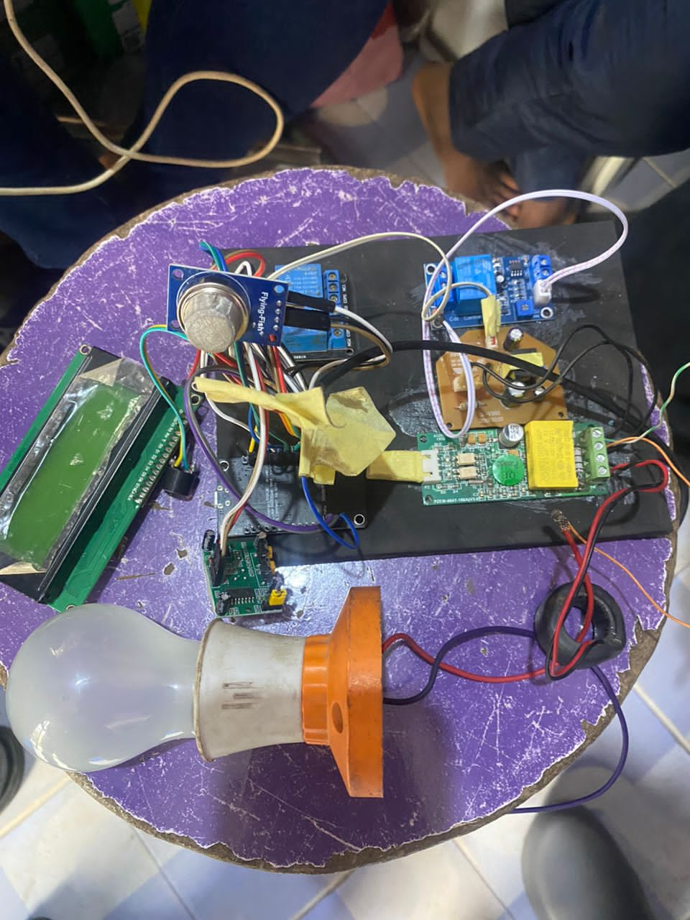

4.2 SYSTEM ARCHITECTURE
The system follows a layered architecture with the following components:

Sensing Layer: Temperature and Humidity Sensor (DHT11/DHT22): Measures room temperature and humidity, Light Sensor (LDR): Detects ambient light to control lighting, Motion Sensor (PIR): Detects human presence for automation and security.

Control Layer: Microcontroller (e.g., NodeMCU ESP8266 or Raspberry Pi): Collects data from sensors, processes inputs, and sends control signals to appliances, Relay Module/Smart Plugs: Used to switch ON/OFF devices like lights, fans, and air conditioners

Communication Layer: Wi-Fi Module (integrated with NodeMCU): Enables communication between the microcontroller and cloud/server

Cloud and Application Layer: IoT Platform (e.g., Blynk, ThingSpeak, or Firebase): Stores data, visualizes sensor readings, and manages device control. Mobile App/Web Interface: Allows remote monitoring and control by the user.
4.3 SYSTEM TESTING AND FUNCTIONALITY
Using light sensors and motion detection, lights in various system were programmed to automatically switch on or off based on ambient light levels and human presence. During tests:
- Lights turned off automatically when natural light exceeded a threshold (300 lux).
- In unoccupied rooms, motion sensors triggered a 5-minute delay before lights were turned off, saving energy.
Lighting energy usage was reduced by approximately 35% over a 24-hour period compared to manual operation.
IoT-based home automation system contributes significantly to energy efficiency. Automated control based on sensor data removes human error and ensures that devices only operate when needed. The integration of mobile access allows for further control and monitoring, even when the user is away from home.
While the system demonstrates effective energy savings, challenges such as internet dependency, initial setup cost, and system scalability must be addressed in future work. Additionally, security measures should be enhanced to prevent unauthorized access to the IoT network.
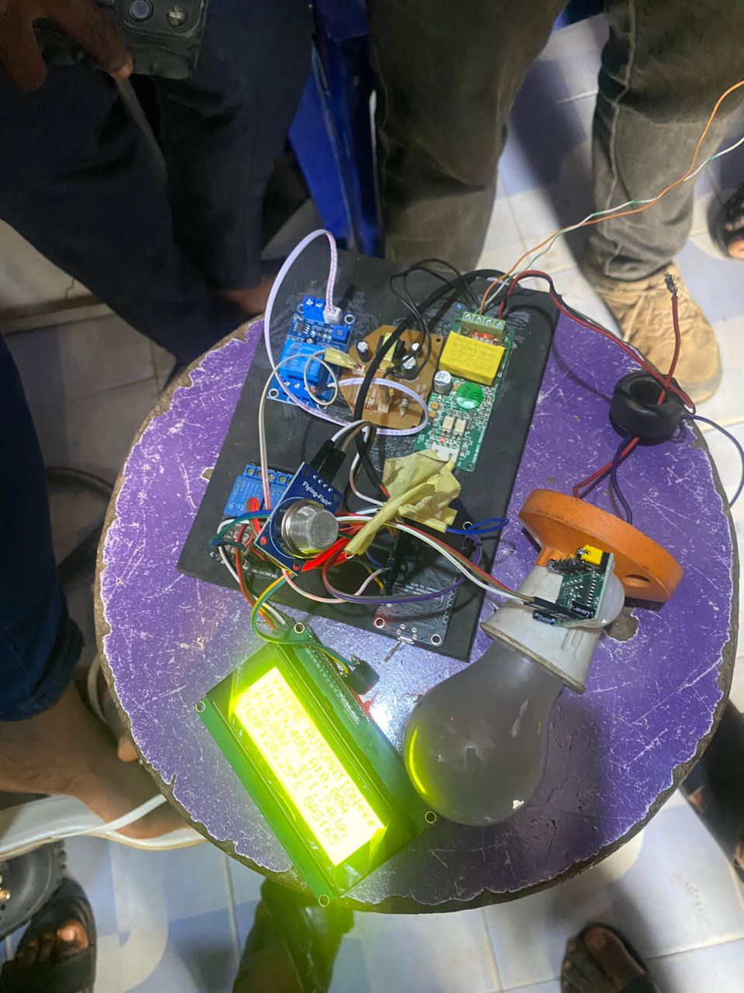

4.4 Results and Discussion
The system design leverages cost-effective hardware and cloud-based software to implement a scalable and energy-efficient home automation solution. The modular structure allows for easy expansion, while real-time monitoring ensures optimal power usage and improved user convenience.
The results clearly show that the IoT-based home automation system contributes significantly to energy efficiency. Automated control based on sensor data removes human error and ensures that devices only operate when needed. The integration of mobile access allows for further control and monitoring, even when the user is away from home.
While the system demonstrates effective energy savings, challenges such as internet dependency, initial setup cost, and system scalability must be addressed in future work. Additionally, security measures should be enhanced to prevent unauthorized access to the IoT network.

REFERENCE

Ahmed, R., & Singh, P. (2021). IoT-Based Home Automation System Using ESP8266. In Proceedings of the 2020 International Conference on Smart Technologies and Systems (pp. 134-139). IEEE.
Akyildiz, I. F., Su, W., Sankarasubramaniam, Y., & Cayirci, E. (2022). Wireless sensor networks: a survey. Computer networks, 38(4), 393-422.
Blanter, A., & Holman, M. (2020). Internet of things 2020: a glimpse into the future. Available at Kearney https://www. atkearney. com/documents/4634214/6398631/AT+ Kearney_Internet+ of+ Things.
Chen, L., & Wong, T. (2022). Real-Time Temperature and Humidity Monitoring System Using IoT. International Journal of Electronics and Communication Engineering, 45(3), 88-94.
Daneva, M., & Lazarov, B. (2018,). Requirements for smart cities: Results from a systematic review of literature. In 2018 12th International Conference on Research Challenges in Information Science (RCIS) (pp. 1-6). IEEE.
Fu, J., Jiang, B., & Kang, N. (2022). Information linkage design and emotional evaluation on intelligent microwaves. In 2017 8th IEEE International Conference on Software Engineering and Service Science (ICSESS) (pp. 757-761). IEEE.
Hui, T. K., Sherratt, R. S., & Sánchez, D. D. (2023). Major requirements for building Smart Homes in Smart Cities based on Internet of Things technologies. Future Generation Computer Systems, 76, 358-369.
Hussain, A., Ali, T., Althobiani, F., Draz, U., Irfan, M., Yasin, S., ... & Alqhtani, S. (2021). Framework Applications. Electronics, 10(6), 719. for IoT Based Real-Time Health
Jain, M., & Sharma, K. (2021). Smart Home Control Using Blynk and IoT. International Journal of Advanced Computing and Communication, 10(2), 44-49.
Kotak, J., & Elovici, Y. (2023). IoT device identification using deep learning. In Computational Intelligence in Security for Information Systems Conference (pp. 76-86). Springer, Cham.
Mehta, S., & Kumar, A. (2023). Design and Development of IoT-Enabled Smart Home Automation System. In Proceedings of the International Conference on IoT and Smart Systems (ICISS), IEEE.
Ozmen, H. A., Isik, S., & Ersoy, C. (2021). A hardware and environment-agnostic smart home architecture with containerized on-the-fly service offloading. Computers & Electrical Engineering, 92, 107090.
Saha, H. N., Roy, R., Chakraborty, M., & Sarkar, C. (2021). IoT‐Enabled Agricultural System Application, Challenges and Security Issues. Agricultural Informatics: Automation Using the IoT and Machine Learning, 223-247.
Singh, R., & Patel, V. (2021). Energy-Efficient Home Automation through IoT: A Case Study. Journal of Renewable Energy Applications, 3(1), 23-30.
Tan, K. K., Lee, T. H., & Soh, C. Y. (2022). Internet-based monitoring of distributed control systems-An undergraduate experiment. IEEE Transactions on Education, 45(2), 128 134.
Tariq, M., Majeed, H., Beg, M. O., Khan, F. A., & Derhab, A. (2021). Accurate detection of sitting posture activities in a secure IoT based assisted living environment. Future Generation Computer Systems, 92, 745-757.
Terzi, D. S., Arslan, B., & Sagiroglu, S. (2022). Smart grid security evaluation with a big data use case. In 2018 IEEE 12th International Conference on Compatibility, Power Electronics and Power Engineering (CPE-POWERENG 2018) (pp. 1-6). IEEE.
Wang B.; Zhang B.F.; Liu X.W.(2020) Novel infrared image enhancement optimization algorithm combined with DFOCS, OPTIK, 224, 165476

