Development of a Staff Leave Scheduling System using Tabu Search Algorithm

BY:
GIWA OLANREWAJU JAMIU
ND/23/COM/FT/0058

A Project Submitted to the Department of Computer Science, Institute of Information and Communication Technology, Kwara State Polytechnic, Ilorin

In Partial Fulfillment of the Requirements for the Award of National Diploma (ND) in Computer Science

JULY, 2025

CERTIFICATION
This is to certify that this project was carried out by GIWA, Olanrewaju Jamiu
with matriculation number ND/23/COM/FT/0058 in the Department of Computer Science, Institute of Information and Communication Technology, Kwara State Polytechnic, Ilorin.

_______________________ ___________________
Mr. Olajide A.T. Date
Project Supervisor

_______________________ ___________________
Mr. Oyedepo F. S. Date
(Head of Department)

_________________________ ____________________
External Examiner Date

DEDICATION
This project is dedicated to the creator of the earth and universe, the Almighty God. It is also dedicated to my parents for their moral and financial support.

ACKNOWLEDGEMENT
All praises unto Almighty God the Lord of the Universe. I praise Him and thank Him for giving me the strength and knowledge to complete my HND programme and also for my continue existence on the earth.
I appreciate the utmost effort of my supervisor, Mr. Olajide A.T., whose patience support and encourages have been the driving force behind the success of this research work. he gave useful corrections, constructive criticisms, comments, recommendations, advice and always ensures that an excellent research is done. My sincere gratitude goes to Head of the Department and other members of staff of the Department of Computer Science, Kwara State Polytechnic, Ilorin, for their constant cooperation, constructive criticisms and encouragements throughout the programme.
Special gratitude goes to my parents who exhibited immeasurable financial, patience, support, prayers and understanding during the periods in which I was busy tirelessly in my studies. Special thanks go to all my lovely siblings.
My sincere appreciation goes to my friends and classmates.

TABLE OF CONTENTS
Title Page i
Certification ii
Dedication iii
Acknowledgements iv
Abstract v
Table of Content vi
CHAPTER ONE: GENERAL INTRODUCTION
  - Background to the Study 1
  - Statement of the Problem 3
  - Aim and Objectives of the Study 3
  - Significance of the Study 4
  - Scope of the Study 4
  - Organization of the Report 5
CHAPTER TWO: LITERATURE REVIEW
2.1 Review of Related Works 7
2.3 Review of General Text 10
CHAPTER THREE: RESEARCH METHODOLOGY AND ANALYSIS OF THE EXISTING SYSTEM
  - Research Methodology 14
  - Analysis of the Existing System 16
  - Problems of the Existing System 16
  - Description of the Proposed System 17
  - Advantages of the proposed system 17
CHAPTER FOUR: DESIGN, IMPLEMENTATION AND DOCUMENTATION OF THE SYSTEM
  - Design of the System 18
    - Output Design 18
    - Input Design 19
    - Procedure Design 21
  - Implementation of the System 21
    - Choice of Programming Language 21
    - Hardware Support 22
  - Documentation of the System 22
    - Maintaining the System 22
CHAPTER FIVE: SUMMARY, CONCLUSION AND RECOMMENDATION
  - Summary 23
  - Conclusion 23
  - Recommendation 24
References 25
Appendices
Appendix 1 Main Menu Flowchart
Appendix 2 Registration Flowchart
Appendix 3 Leave Flowchart

ABSTRACT
Scheduling problems form a large class of optimization problems encountered in various industries and organizations. The problem that we consider belongs to the category of shift scheduling problems with tabu search algorithm. In general these problems consist in the process of assigning employees to activities in order to meet workload requirements, while observing legal regulations, and other company’s rules. Due to the exponential growth of the computational time as instances increase, exact methods are usually only applicable for small sized instances. Consequently, different optimization methods such as heuristics, have been developed and widely used to handle large scale practical problems. In this project, we focus on constraints concerning activities’ duration, which make the problem difficult to solve. We propose a tabu search approach to deal with the specific multi-activity shift scheduling problem taking into account workload requirements and activities’ duration constraints. Computational results show the effectiveness of the proposed approach compared to complex solver.
CHAPTER ONE
GENERAL INTRODUCTION
  - BACKGROUND TO THE STUDY
In order to succeed in company’s business, one of the vital factors contributing to productivity and service quality is human capital management. Various sectors have begun to see the management of human capital as central to their strategy for improving organizational performance. Human capital management involves different components such as recruitment, talent development, and determination of optimized working schedules. Multi-activity shift scheduling problems arise in the latter aspect and they consist of assigning employees to activities over a given time horizon, taking into account organizational, legal and social constraints. . In many cases, these problems consist not only in finding feasible assignments, but also assignments that optimize a given objective, for instance, the minimization of the overall costs and the maximization of employees’ preferences satisfaction (Musliu, 2018)
Rocha, (2016) explained scheduling as the process of allocating resources (such as time, people, equipment, and materials) to tasks or activities in a planned and efficient manner. The goal of leave scheduling is to ensure that the right resources are available at the right time to complete the necessary work, while minimizing costs and maximizing productivity. Scheduling is used in a wide range of contexts, from project management and manufacturing to transportation and healthcare. In each of these contexts, scheduling involves identifying the tasks or activities that need to be completed, estimating the time and resources required to complete them, and then creating a schedule that allocates those resources in the most efficient way possible. There are many different scheduling techniques and tools that can be used, depending on the specific context and the complexity of the scheduling problem.
Some common scheduling techniques include critical path analysis, Gantt charts, and resource leveling. Advanced software tools like Microsoft Project can be used for scheduling in complex projects, while simpler scheduling tools like calendar apps can be used for personal scheduling. Dousin, (2019) claimed that staff leave schedule does not only involve the all capture of time leave to organization personnel, it also involve the careful allocation of other resources like labour force and space available. When all these factors are not adequately taken care of, it leads to leave clashes which hinder the effective organization operation.
Personnel leave scheduling, or staff leave scheduling is the process of constructing leave timetables for its staff so that an organization can satisfy the demand for its goods or services. Hence, Scheduling problem is one of optimization problem, and it relates to some other similar problems such as timetabling, sequencing and rostering. Organization services pose a challenge for the automatic rostering systems. The scheduling of employees leave is a complex and time-consuming task. It is complex because it involves assigning the right people to be on a leave at the right time. It is conditioned by several legal, work and other organizational rules. And it often copes with conflicting objectives, such as the minimization of the labor costs or the workforce size and the satisfaction of the employees’ preferences, for example. It is time-consuming because it is a periodic task and it is still manually performed in most organizations (Xhafa, 2019).
According to Pan et al, (2017) tabu search is a metaheuristic optimization algorithm that is commonly used to solve combinatorial optimization problems such as staffs leave scheduling. In staff leave scheduling, the goal is to assign shifts to employees in a way that meets the operational requirements of the organization while minimizing costs or maximizing productivity. The tabu search algorithm works by iteratively exploring the search space of possible solutions and moving towards better solutions over time. It does this by maintaining a set of "tabu" or forbidden moves that prevent the algorithm from revisiting previously explored solutions or making moves that have led to poor results in the past.
The adopted tabu search algorithm will be used in scheduling staff leave, making sure required staff are not on leave at the same time.
1.2 STATEMENT OF THE PROBLEM
The existing method of staff leave scheduling system is the manual method of leave scheduling whereby paper and notice board are used as notification. The problem associated with the old manual system of leave scheduling hindered the organization effective operation. The problem is to efficiently schedule staff leaves requests in a way that ensures adequate coverage for all necessary tasks and minimizes disruptions to the normal workflow. This involves balancing the needs and preferences of individual staff members with the operational needs of the organization, while also taking into account factors such as the availability of other staff members, the timing of key events or projects, and any relevant labor laws or collective bargaining agreements. The goal is to create a fair and effective leave schedule that maximizes productivity and employee satisfaction while minimizing the impact on the organization's overall performance.
1.3 AIM AND OBJECTIVES OF THE STUDY
The aim of the study is to develop a staff leave scheduling system using tabu search algorithm. The objectives of the study are to:
- Develop a system that minimizes staff shortages;
- Implement a system that will maximize employee satisfaction using tabu search; and
- Design a system that reduce cost and ensure compliance with labor laws and policies.
1.4 SIGNIFICANT OF THE STUDY
Staff leave scheduling is important for several reasons:
Ensuring adequate staffing levels: By scheduling staff leave in advance, managers can ensure that there are enough employees available to cover shifts during the absence of other staff members. This can help prevent understaffing, which can lead to decreased productivity and quality of service.
Fairness and equity: Staff leave scheduling can help ensure that all employees are given equal opportunities to take time off work, while also ensuring that there is always adequate coverage in the workplace. This can help prevent resentment and dissatisfaction among employees who feel they are not getting their fair share of time off.
Planning and budgeting: By scheduling staff leave in advance, managers can better plan and budget for staffing needs, and can also avoid last-minute overtime costs or other expenses associated with unexpected absences.
Employee satisfaction: Giving employees ample time to plan and schedule their time off can help boost morale and job satisfaction. It can also help prevent burnout and reduce turnover rates, as employees are more likely to feel valued and supported by their employer
1.5 SCOPE OF THE STUDY
This study is carried out with a view of producing a computerized personnel leave scheduling system to replace the manual organization leave scheduling. The new system will also produce a comprehensive and authentic leave schedule for an organization staffs. This study also proves the capabilities of the computer in the area of processing concerning the organization sector. By implementing the computerized system, one would be able to obtain information needed at a particular point in time. This system will make sure a clash doesn’t occur during leave schedule.
1.6 ORGANIZATION OF THE REPORT
This is the overall organizational structure of the work as presented in this project. Chapter one of this project deals with the general introduction to the work in the project. It also entails the aim and objectives of the project, significance of the study, the methods used for data collection, the scope and limitation of the study. Chapter two contains with the literature review, computerization of current state of the art and discussion of related aspect of the project topic relative to computer technology. Chapter three covers the analysis of the existing system, description of the current procedure, problems of existing system (procedure) itemized, and description of the proposed system and the basic advantages of the proposed system. Chapter four entails design, implementation and documentation of the system. The design involves the system design, output design form, input design form, database structure and the procedure of the system. The implementation involves the implementation techniques used in details, choice of programming language used and the hardware and software support. The documentation of the system involves the operation of the system and the maintenance of the system. Chapter five deals with summary, conclusion and recommendations.

CHAPTER TWO
LITERATURE REVIEW
2.1 REVIEW OF RELATED WORKS
Napalit and Ballera (2021) designed an optimizing schedule using firefly algorithm with tabu search algorithm. The purpose of the paper was to test the fairness issue in the staff scheduling problem. The process adhered to the staff scheduling policies. With the use of metaheuristic algorithms that offers a high-quality solution in a reasonable amount of time for real-world situations; they are a fascinating field of research that has made significant advances in solving optimization problem. One of the newly methods in optimization are Swarm Intelligence algorithms; they were abstracted from the law of population cooperation providing a new way to solve problems. This paper explored the combination of Firefly Algorithm, a population-based algorithm, and Tabu Search, a local search-based algorithm. The FA and FA-TS experiment was tested and evaluated using two iteration stages to determine the best solution, initial and best fitness values, the improvements of fitness values, the number of movements, and execution time. The computational results obtained are compared from the standard FA and proposed FA-TS method. The comparison showed improved results that FA-TS evaluated the efficiency of the proposed technique compared to the standard FA in most criteria comparisons.
Olya (2022) designed a mult-iobjective human resource scheduling model using the tabu search algorithm. In the research, considering the high importance of these issues, the problems of scheduling and allocation of manpower in a real place are solved. To this end, the metaheuristic Tabu search algorithm was used with the aim of minimizing the duration of activity and the presence of all manpower. For this purpose, to achieve the objectives of the research, three different scenarios related to the required manpower and the minimum-maximum presence of manpower according to whether they are on leave or not are used.
Pan, et al, (2016) worked on solving a multi-activity shift scheduling problem with a tabu search heuristic. In the paper, the researchers focused on constraints concerning activities’ duration, which make the problem difficult to solve. We propose a tabu search approach to deal with the specific multi-activity shift scheduling problem taking into account workload requirements and activities’ duration constraints. Computational results show the effectiveness of the proposed approach compared to CPLEX solver. In general these problems consist in the process of assigning employees to activities in order to meet workload requirements, while observing legal regulations, and other company’s rules. Due to the exponential growth of the computational time as instances increase, exact methods are usually only applicable for small sized instances. Consequently, different optimization methods such as heuristics have been developed and widely used to handle large scale practical problems.
Xhafa, et al, (2019) proposed a tabu search algorithm for scheduling independent jobs in computational grids. The researchers presented in the paper a new tabu search (TS) algorithm for the problem of batch job scheduling on computational grids. They defined it as a bi-objective optimization problem, consisting of the minimization of the makespan and flowtime. Their TS is validated versus three other algorithms in the literature for a classical benchmark. They additionally considered some more realistic benchmarks with larger size instances in static and dynamic environments. We show that our TS clearly outperforms the compared algorithms.
Rocha, (2018) developed a staff scheduling problem. The research work described the development of methods for the automatic scheduling of employees, in particular for their simultaneous assignment to working shifts and days-off. The work focused on the design of a general integer programming (IP) model that, following an optimization approach, can be easily adapted and solve a wide set of different real-world problems. An innovative formulation of the sequence and consecutiveness constraints gives the model the flexibility to accommodate variable features of the problems. A cyclic approach ensured the generation of equitable and predictable work schedules. The application of the general model is illustrated with three real-world case studies and a collection of benchmark instances available in the literature. Computational results demonstrate the good performance of the model, achieving optimal solutions for the majority of the problems in useful time. A constructive heuristic is also developed for solving one of the case-studies. Based on a set of simple calculations, the proposed procedure reveals to be an efficient alternative to the IP optimization approach for solving the practical problem considered. The good performance achieved with tests on a set of larger computer generated instances confirms the robustness of this approximate approach.
Gondane and Zanwar (2018) developed a staff scheduling in health care systems. The system deals with Genetic Algorithm (GA) approach to solve a specific Staff Scheduling Problem. The schedules are planned for 4 weeks with 30 numbers of nurses in the ward and each working day consists of 5 different shift types. Penalty was presented to indicate the level of importance for the constraints involved that are hard constraints and soft constraints. For solving the problem of scheduling, GUI is being introduced for the user friendly approach through MATLAB Version 7.10.
Lekan and Oloruntoba (2017) design and implemented a patient appointment and scheduling system. In the paper, a patient appointment and scheduling system was designed using Angular JS for the frontend, Ajax framework for handling client-server request and Sqlite3 and MYSQL for the backend. The current health care landscape desired efficiency and patient satisfaction for optimal performance. The outpatient of most clinics in developing countries is faced with plethora of issues. These include: overtime for doctors and nurses during clinic sessions, long waiting time for patients, and peak workloads for counter personnel. The quality of health care delivery has been threaten by overtime and peak work load. This paper focuses on developing a system to improve upon the efficiency and quality of delivering a web based appointment system to reduce waiting time.
Singh and Singh (2019) worked on nature inspired job scheduling for e-health services in mobile cloud computing. The proposed mechanism was to dynamically create a nature-inspired optimal job scheduling in E-health services for job completed within a minimum span of time and also resources utilization in an effective manner using the mobile cloud computing environment. A comparison of Genetic Algorithm (GA) and Variable Neighbourhood Search (VNS) with the proposed PSO algorithm was done for evaluating the performance. Empirical outcomes illustrate the importance of the proposed mechanism and have an ability to get a feasible and faster schedule with significant convergence speed.
Klusácek and Rudová (2020) designed a job scheduling simulator. This work described the Grid and cluster scheduling simulator Alea 2 designed for study, testing and evaluation of various job scheduling techniques. This event-based simulator is able to deal with common problems related to the job scheduling like the heterogeneity of jobs, resources, and the dynamic runtime changes such as the arrivals of new jobs or the resource failures and restarts. The Alea 2 is based on the popular Grid-Sim toolkit and represents a major extension of the Alea simulator, developed in 2007. The extension covers improved design, extended functionality as well as the improved scalability and the higher simulation speed. Finally, new visualization interface was introduced into the simulator. The main part of the simulator is a complex scheduler which incorporates several common scheduling algorithms working either on the queue or the schedule (plan) based principle. Additional data structures are used to maintain information about the resource status, the objective functions and for collection and visualization of the simulation results. Many typical objectives such as the machine usage, the average slowdown or the average response time are included. The paper concludes with an example of the Alea 2 execution using a real-life workload, discussing also the scalability of the simulator.
2.2 REVIEW OF RELATED CONCEPTS
2.2.1 Overview of Scheduling
Scheduling can be described as the process of assigning jobs to resources for some duration. Scheduling problems are ubiquitous, ranging from computer systems and networks, to production factories and patient appointments. Many of such problems are either solved by manual operation or using heuristics specifically designed to the context.
According to Ngoo et al. (2022), patient appointment scheduling can be classified into three:
- Single Batch Process: In this Appointment scheduling process, decisions are delayed until after receiving all appointment requests for a given period. This model is commonly used in surgery starting times, and allows scheduling with complete information, so that a perfect or near perfect solution can be found through discrete optimization or heuristic methods.
- Unit Process Appointments: In this appointment scheduling model, the processes are assumed to come one at a time and are scheduled at the time of the request arrival. Through this process, a perfect solution will unlikely be found, but may be approximated if the distribution of appointment request types is learned.
- Periodic Process Appointment: requests are kept in a buffer of fixed size and are scheduled once the buffer is full. This allows a better approximation to the optimal solution by considering optimal or near optimal solutions at each period.
2.2.2 Staff Leave Overview
Staff leave refers to the time that an employee takes off from work, usually for personal or medical reasons, with the approval of their employer. Staff leave can come in different forms, such as annual leave, sick leave, maternity/paternity leave, compassionate leave, and study leave.
- Annual leave is the time an employee takes off from work for vacation or leisure, which is usually accrued over a period of time and is paid. Sick leave, on the other hand, is the time an employee takes off from work due to illness or injury, and is also paid.
- Maternity/paternity leave is the time an employee takes off from work after having a child or adopting one, and it is usually unpaid.
- Compassionate leave is the time an employee takes off from work due to a family emergency or bereavement, and it may be paid or unpaid depending on the employer's policy. Finally, study leave is the time an employee takes off from work to further their education or training, and it may be paid or unpaid depending on the employer's policy. It is important for employers to have clear policies and guidelines on staff leave to ensure that employees are aware of their entitlements and obligations. Employers may also require employees to provide evidence, such as medical certificates, to support their requests for leave.
Top of Form
Among the larger countries, China requires at least five days' paid annual leave and India requires two days of paid leave for every month worked. The United States mandates no minimum paid leave, treating it as a perk rather than a right Most countries have labour laws that mandate employers give a certain number of paid time-off days per year to workers. Canada requires at least two weeks, which increases to three weeks for employees that have worked for a certain number of years (In Saskatchewan this entitlement starts out at three weeks and increases to four weeks). An additional fourth week is provided to federally regulated workers after working for a further number of years.
In the European Union the countries can set freely the minimum, but it has to be at least equivalent to 4 working weeks. In the Netherlands this is achieved by mandating at minimum 4 times the number of contracted hours in a person's working week; e.g. if someone works 4 days of 7 hours a week, the annual leave hours a year is 112 at minimum Singh, (2019).
2.2.3Analysis of the Common Staff Leave Scheduling Methods
There are several common staff leave scheduling methods used by organizations as reported by Strah, (2015):
- Manual Request and Approval: This method involves employees manually submitting leave requests to their managers or HR department. Managers then approve or reject the request based on factors such as workload, staffing levels, and company policies.
- Online Leave Management System: This method involves using software or online platforms to manage employee leave requests and approvals. This method allows for real-time tracking of employee leave, and managers can easily view their team's leave schedules and make necessary adjustments.
- Self-Service Leave Management: This method involves allowing employees to manage their own leave requests and approvals through an online portal. This method is particularly useful for organizations with remote workers or flexible work arrangements.
- Annual Leave Rosters: This method involves creating an annual leave schedule or roster, which outlines when each employee is entitled to take their annual leave. This method is useful for organizations with a fixed staffing schedule or those that operate on a seasonal basis.
- First Come, First Served: This method involves approving leave requests on a first-come, first-served basis. This method can be effective for small teams or organizations with a limited number of employees.
- Seniority-based Leave Allocation: This method involves allocating leave based on an employee's length of service or seniority within the organization. This method can be effective for organizations with a large number of employees or those with a strong focus on employee retention Strah, (2015).
Top of Form
2.2.4 The Staff Leave Scheduling Problem
The staff leave scheduling problem involves determining the appropriate schedules for staff members to take time off work, while ensuring that there is adequate coverage and that the workload is evenly distributed. This can be a challenging task, especially for organizations with large teams and complex workflows.
Here are some steps that can be taken to address this problem:
- Determine the workload and staffing requirements: Before scheduling leave, it's important to have a clear understanding of the workload and staffing requirements for each day or shift. This will help ensure that there is adequate coverage during periods of staff absence.
- Create a leave request process: Establish a process for staff members to request time off work, including the amount of notice required and any limitations on the number of staff who can be off at the same time.
- Develop a leave scheduling system: Once leave requests have been received, develop a system for scheduling time off that takes into account workload and staffing requirements. This may involve using scheduling software or spreadsheets to ensure that coverage is evenly distributed and that the workload is manageable during periods of staff absence.
- Communicate the schedule: Once the schedule has been developed, communicate it clearly to staff members and ensure that everyone is aware of their scheduled time off. Make sure that any changes to the schedule are communicated promptly to avoid confusion or scheduling conflicts.
- Monitor and adjust: Finally, it's important to monitor the scheduling process and make adjustments as needed. This may involve revising the leave request process, adjusting the scheduling system, or revisiting workload and staffing requirements to ensure that they are accurate and up-to-date Feitelson & Rudolph, (2016).
2.2.5 Tabu Search Algorithm
Tabu Search is a metaheuristic algorithm is used for optimization problems. It was first introduced by Fred Glover in 1986. The algorithm is based on the idea of exploring the solution space in a systematic way by making use of a memory-based strategy to avoid revisiting previously explored solutions. The Tabu Search algorithm maintains a set of candidate solutions and iteratively searches the solution space by making small moves to explore new solutions. It uses a tabu list to keep track of the recent moves made and prevents the algorithm from revisiting solutions that have already been explored.
The main steps of the Tabu Search algorithm are as follows:
- Initialization: A starting solution is generated randomly or by some heuristic method.
- Evaluation: The quality of the starting solution is evaluated using an objective function.
- Neighborhood Search: A set of neighboring solutions is generated by making small changes to the current solution.
- Tabu Search: The algorithm selects the best solution from the set of neighboring solutions. It uses the tabu list to ensure that the algorithm does not select solutions that have already been explored. If a solution is on the tabu list, it is considered "tabu" and cannot be selected.
- Aspiration Criteria: If a tabu solution is found that is better than the current best solution, it can be selected if it satisfies some aspiration criteria.
- Updating the Tabu List: The tabu list is updated to include the recent moves made by the algorithm.
- Termination Criteria: The algorithm terminates when a stopping criterion is met, such as a maximum number of iterations or when the objective function reaches a certain value.
Tabu Search has been applied successfully to a wide range of optimization problems, including scheduling, routing, and facility location problems. It is a powerful and efficient algorithm that can find high-quality solutions in a relatively short amount of time Singh, (2019).
Top of Form
CHAPTER THREE
RESEARCH METHODOLOGY AND ANALYSIS OF THE EXISTING SYSTEM
3.1 RESEARCH METHODOLOGY
The staff leave scheduling system using tabu search algorithm will be designed and implemented using Microsoft visual C sharp for the frontend while MySql a relational database management system is used for the backend end system. Apache will be used as the server to provide basic functionality of the system service. C# will be used as a scripting language to program the server side that manipulates the knowledge in the database.
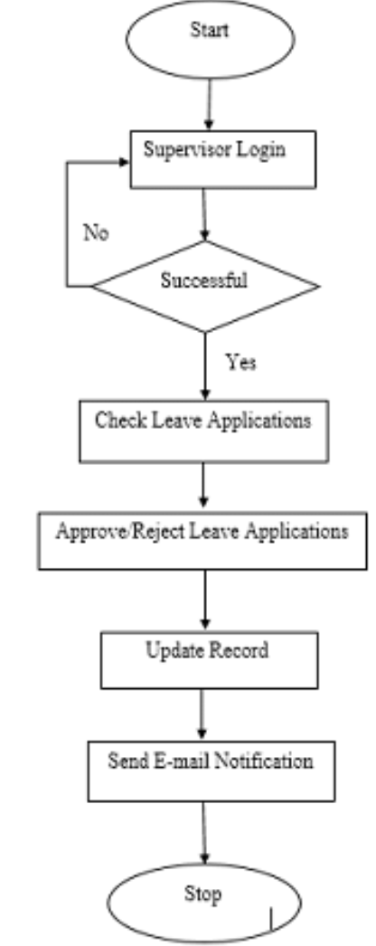
Figure 3.1: Staff leave framework
3.1.1 Algorithm Adopted: Tabu Search
Tabu search is a heuristic optimization algorithm used for solving combinatorial optimization problems. It was developed by Fred W. Glover in the late 1980s.
The Tabu search algorithm is a metaheuristic algorithm, which means it is a general problem-solving strategy that can be applied to different types of optimization problems. The algorithm starts with an initial solution and iteratively improves it by moving to neighboring solutions, while keeping track of a set of forbidden (tabu) moves to avoid cycling and explore diverse regions of the search space. The pseudocode is presented below:
1. Initialize the current solutions and define a set of tabu moves
2. Repeat until a stopping condition is met:
a. Generate a set of candidate solutions from the current solution s
b. Remove candidate solutions that violate the tabu moves
c. Evaluate the remaining candidate solutions and select the best one
d. Update the tabu moves based on the selected candidate solution
e. Set the current solution to the selected candidate solution
3. Return the best solution found during the search
Function TabuSearch():
s = InitialSolution()
tabu_moves = InitializeTabuMoves()
best_solution = s
while NotStoppingCondition():
candidate_solutions = GenerateCandidateSolutions(s)
tabu_candidates = RemoveTabuMoves(candidate_solutions, tabu_moves)
selected_s = SelectBestCandidate(tabu_candidates)
if Cost(selected_s) < Cost(best_solution):
best_solution = selected_s
UpdateTabuMoves(tabu_moves, selected_s)
s = selected_s
return best_solution
Tabu Search Algorithm Source: (Mamta, 2019)

3.2 ANALYSIS OF THE EXISTING SYSTEM
In the past scenario, staff leave scheduling is done manually, a letter or mail will be given or sent to a staff anytime his/her leave was approved, and this letter contains their leave schedule. In some other situation, a board will be mounted on the organization wall where the entire leave schedule is written on. Based on the analysis of these factors, it was identify that the current system is not working well and it needs improvements. The current system is slow and inefficient, so the researchers recommend implementing a new software system that can streamline the process and reduce processing times.
3.3 PROBLEMS OF THE EXISTING SYSTEM
The traditional or existing system is a standalone process, Manual staff leave scheduling can be a challenging and time-consuming task for employers and HR managers. Here are some of the problems that arises with this approach:
- Time-consuming: Manually scheduling staff leave is a time-consuming process that requires a lot of effort and attention to detail. HR managers have to check employee schedules, leave balances, and workloads to ensure that the right people are taking time off at the right time.
- Human error: Manual staff leave scheduling is prone to human error, such as double bookings or errors in leave balances. These errors can lead to confusion and frustration among employees and may even result in legal issues.
- Inflexibility: Manual staff leave scheduling can be inflexible, making it difficult to adjust schedules when employees need to take leave unexpectedly. It can also be challenging to accommodate last-minute requests for leave, which can lead to unhappy employees and reduced productivity.
- Lack of transparency: Manual staff leave scheduling can be opaque, making it difficult for employees to understand how leave requests are handled, and why their requests are approved or denied.
- Difficulties in tracking and reporting: Manual staffs leave scheduling can make it challenging to track and report on employee leave data. This information is essential for understanding workforce trends, planning for future staffing needs, and ensuring compliance with labor laws and regulations
- Manual staff leave scheduling can be a complex and time-consuming task that can lead to errors, inflexibility, and lack of transparency. Automated solutions, such as leave management software, can help mitigate these issues and streamline the process.
Top of Form
3.4 DESCRIPTION OF THE PROPOSED SYSTEM
This system is a bunch of benefits from various points of views. As this new system is a computerized doctor and nurse scheduling. The problem addressed in this study is staff leaves scheduling of annual leave for an organization personnel. The task is to assign leave to workers without affecting the workings of the organization or subject to a set of resources and regulatory constraints. Typical constraints include some specific duties that cannot be followed by some other duties; there must be some days off in each roster; and so on. The solution can be expressed as an n-row roster. Each row shows duties in months for a member of staff and each staff will get their leave anytime the admin feel it’s ok so that the load can be balanced over an n-day cycle time. The system will help the admin of the organization to schedule annual leave for staffs so that all staff won’t be on leave at the same time.
3.5 ADVANTAGES OF THE PROPOSED SYSTEM
Staff leave scheduling system have various advantages and some of its advantages are;
i More efficient and reliable.
ii Less time consuming and easy access of leave schedule.
iii It allows the admin to view schedule and make changes before submitting the table on the system.
iv Saves a lot of time, the manual method is very stressful and time consuming

CHAPTER FOUR
DESIGN, IMPLEMENTATION AND DOCUMENTATION OF THE SYSTEM
4.1 DESIGN OF THE SYSTEM
This is the computation of the particulars of a new system, the determination of what the new system would be and the function it is to perform. This may involve changing from one system to another or modifying the existing system operation.
The most challenging phase of the system life cycle is the change from manual operation to a faster and more accurate one. System design stage covers the technical specifications that will be employed in the implementation of the new system in order to modify the previous system. Some factors are put in consideration. These factors include input design, output design, definitions file and procedure designs and other documentation.
4.1.1 OUTPUT DESIGN
This incorporates the objectives of solving the existing system problems and challenges. This involves the structuring of the desired information and also to enhance efficient and effective of staff leave management system. Things taken into consideration in determining the output are represented below:

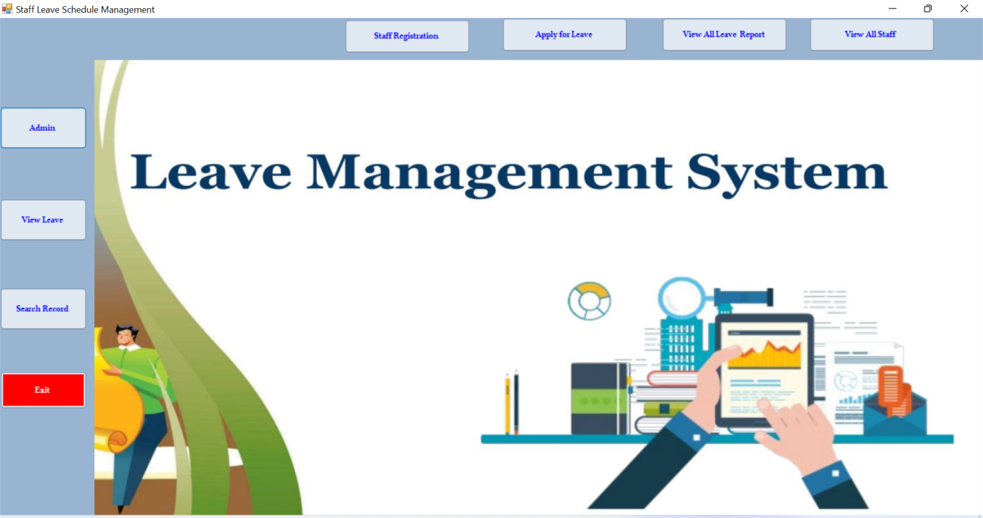
STAFF
Figure 4.1: Main Menu Interface
This is the main menu of the system; it contains some other sub-menus which user can be clicked to navigate to other pages
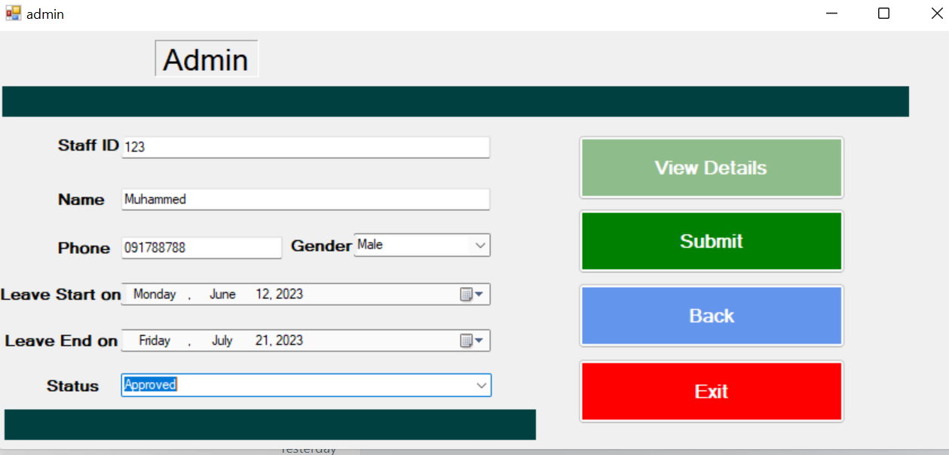
Figure 4.2: Administration page
This is a page where admin approved of reject leave applied by the staff
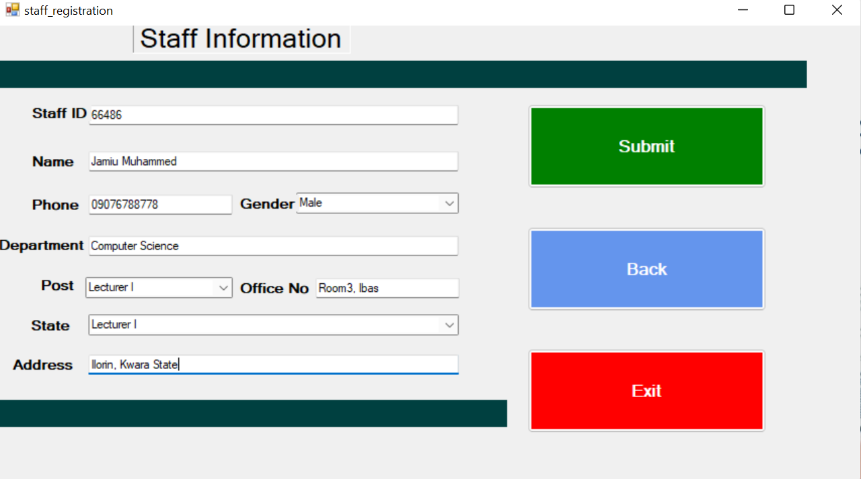
Figure 4.3: Staff Registration
This is a page where staff supplied their information for proper documentation
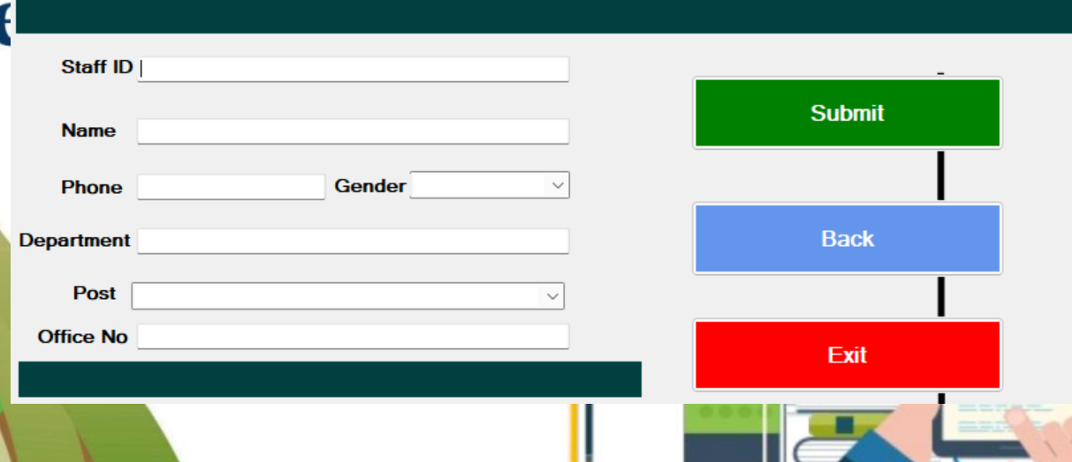
Figure 4.4: Leave Application Page
This is a page where staffs can apply for leave
4.1.2 INPUT DESIGN
The input to run this software is obtained from dynamic bus administrator. The administrator is expected to register every bus and driver. He can achieve this by typing via the keyboard or loading from the diskette. The input required from the student is their personal data. To the questions set by the administrator. It can serve as the various input layouts from the various modules first from the collection of data and module then from the prediction module and drivers respectively.
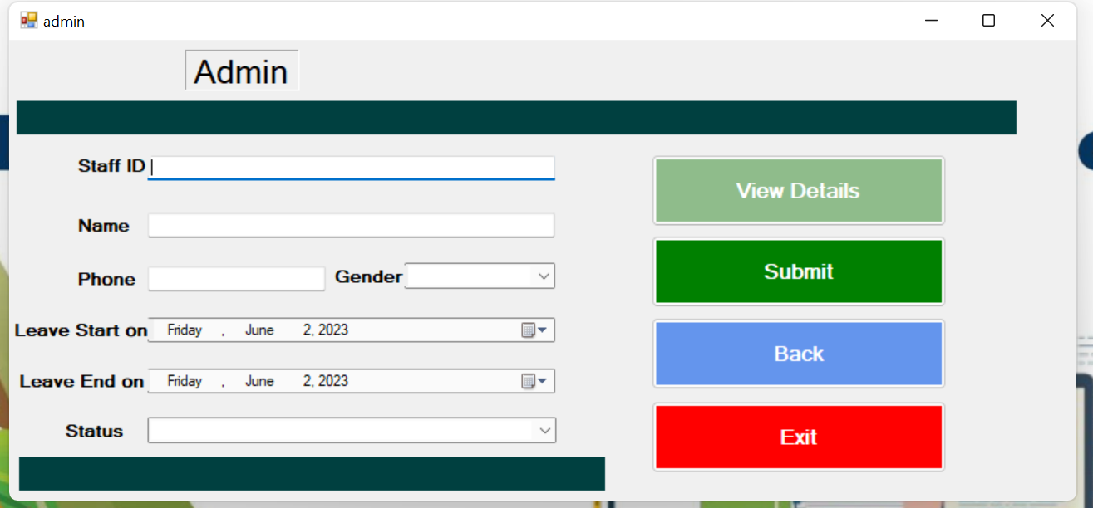
Figure 4.5: Admin Interface
This is the page where the admin can view all staffs that are applied for leave, approve or reject leave.
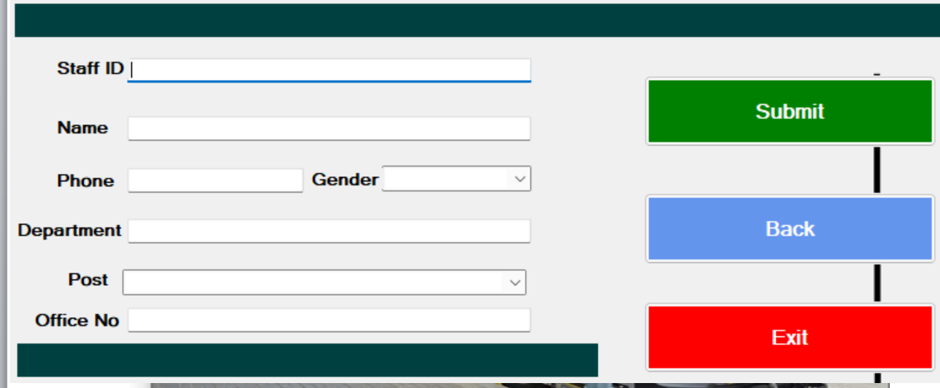
Figure 4.6: Leave Processing Page
This is the page where staff supplied their bio data information’s which will be saved/stored in the database for leave processing.
4.1.3 Database Design
This involves the list of tables used in the database design. The tables are listed as follows:
Table 4.1: Admin Table
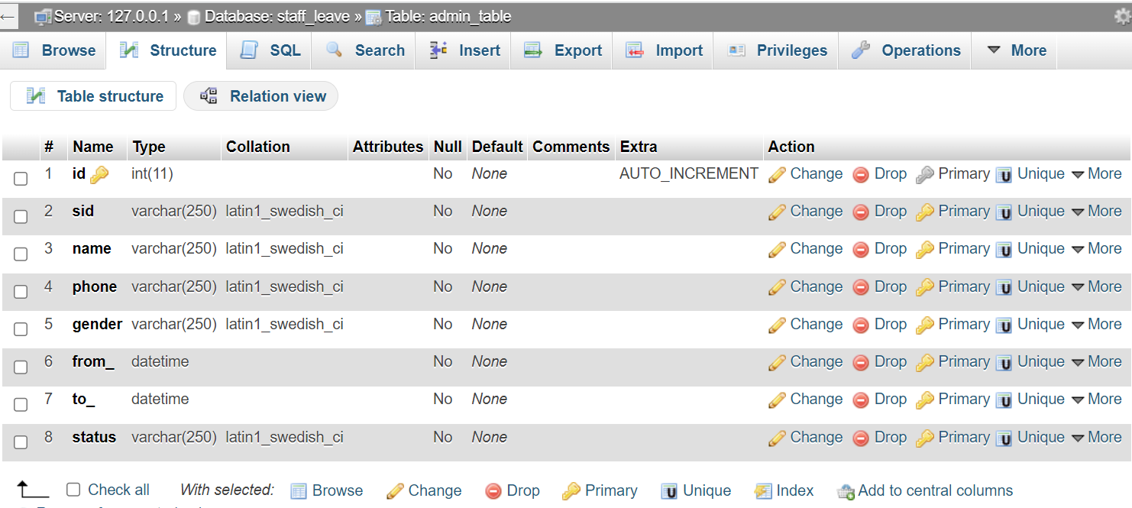
Table 4.2: Staff table
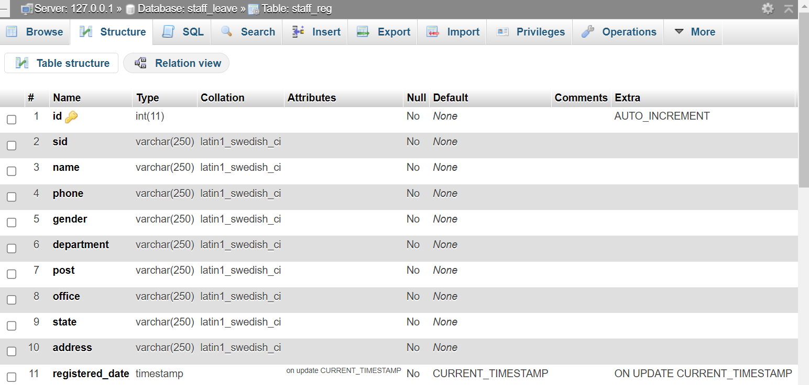
4.1.4 PROCEDURE DESIGN
These are the steps involved in unifying the whole process to produce the desired output. It involves computer procedures which starts from the original input lessons to the output result file. This allows the processing of the information and result to be possible. Menu is provided to aid user in the processing of the output file.
4.2 IMPLEMENTATION OF THE SYSTEM
This entails the choice of the programming language employed to implement the software which should be suitable for of staff leave management system. The software was designed to predict bus arrival time.

4.2.1 HARDWARE REQUIREMENT
Minimum of Microcomputer Pentium IV- Intel 1.5 GHZ processor, 1.0 GB RAM, 40GB Hard disk, 14” VGA Monitor Windows XP or higher, Enhanced keyboard, mouse and pad.
4.2.2 SOFTWARE REQUIREMENT
i. Windows Operating system such as Windows 7, Windows 8, Windows 10
ii. Visual Studio 2010 (Enterprise Edition which allows the Programmer to run all the necessary Data, which has been supplied.
4.3 DOCUMENTATION OF THE SYSTEM
After the program has been well tested with input and the output has already been known, the next is to install the software into the computer system for use.
The process of installing has been stated below:
- Insert the CD into the system through the CD-ROM after the computer is switch on
- Locate the CD drive directory in my computer and click it to open
- After open, locate setup.exe, and then click to install the program by following the necessary step in installing the program.
- Ensure full installing of the software for effective operation of the system.
After the program has been fully installed, the next thing is to locate the package installed and put it into operation. To locate the package for expiration purpose, the following steps are to be taken:
- Click on start menu from task bar. Then select all program
- From the display sub option, select by locating the software installed named Information to load the software.
4.3.1 PROGRAM DOCUMENTATION
The program is packaged for use in any system irrespective of either it runs Visual Studio Application or not. After developing a program in Visual Studio, there is a facility provided in Microsoft Visual Studio suite called “Package and Deployment Wizard” that is used in Visual studio application packaging and deployment.
The development of staff leave management system is packaged into an installable setup that can be run from any system.
4.3.2 OPERATING THE SYSTEM
To operate the system, the following algorithm must be followed:
- Switch the system on
- Allow it to boot
- Click on start menu
- Select the package name “Staff leave management system” and wait for the application to load.
- From the list of menu that appears on the application main page, user can
- Select any one to navigate and carry the operation of the menu item.
4.3.2 MAINTAINING THE SYSTEM
The system maintenance refers to making modifications to an already existing application/program without necessarily re-writing everything from the start. Program maintenance of a program includes modification of the program to meet-up with certain requirements of the users. In this course, additional features can be added, errors corrected, ambiguous interfaces redesigned to eliminate confusions and unnecessary features removed.
Maintaining this program can be done in a Visual Studio environment. Any future modification can be by re-running the program source code in a Visual Studio environment, making necessary changes and updates and recompiling the application into an upgrade version of the existing version of the mini word processing application. Further versions of this program can be named following their year of release or it can be given a different version number.
4.3.3 PROCEDURE DESIGN
The procedure design refers to the construct of the whole program, i.e. how each section functions individually and collectively as a whole to make up the whole execution of the program work/operate according to specification.
The system contains menus, each menu having different forms and they are controlled by modules.

CHAPTER FIVE
SUMMARY CONCLUSION AND RECOMMENDATION
5.1 SUMMARY
In this project the researcher have presented a Tabu Search (TS) implementation for leave scheduling of staffs in an organization. The staff leave scheduling system has been developed and tested. The research developed the connotation and the extension functions of the staff leave scheduling system to improve the efficiency of the organization and staff management. The proposed methods have been implemented and experimentally evaluated in examples from real life examples, which appeared in a broad range of organizations. Experimental results show that tabu search and strategy proposed in this project improves significantly the performances of tabu search based heuristic. This system enables staff to request for leave and the admin should grant the leave based on the work force needed at that particular time. The system adopted the software development lifecycle and was developed using Microsoft Visual C Sharp for the interface and MySQL a relational database management system for the database.
5.2 CONCLUSION
The development of the personnel leave scheduling system as a process of continuous improvement. The staff leave system has been put on line to meet the basic employer’s needs of the organization at this stage. However, with the changing needs of the clinic, the system functions need to be constantly improved. In the annual operation of the staff leave system; we also need to consider the problem of the system information security. An automated leave appointment and scheduling software have been developed to address some of the challenges faced by organization workers. The benefits of implementing this technology would touch everyone involved in the leave scheduling process, as administrators and staff can conduct their leave more efficiently and accurately, while customers and clients have the ability to book their appointments and reservations quickly and more conveniently. The proposed system is aimed at simplifying the task of the administrator and the workers. It will reduce long waiting time for staff to get a leave and eradicate the manual process. Admin also have freedom to fix their staff leave and also approved it according to their preference.
5.3 RECOMMENDATIONS
Based on the findings of the study, the following are recommended;
i. Adoption of the system: Every organization should adopt this system to enhance effective staff leave scheduling to reduce the problems of most staff being on leave at the same time.
ii. User Training: Every staff or administrator who works on the system containing the leave scheduling should be trained on how to operate the new system to enhance effective system.
iii. More research should be conducted on the usefulness and effectiveness of leave scheduling system.

REFERENCES
Aburayya, A., et al. (2020). Tabu search for solving personnel scheduling problem, International Journal on Emerging Technologies. 11(2). Pp. 251-260.
Ahmed, A., et al. (2017). Intelligent Algorithms for Optimal Selection of Virtual Machine in Cloud Environment, towards Enhance Healthcare Services, International Conference on Advanced Intelligent Systems and Informatics.2(2). Pp. 89-90.
Dousin, O., et al. (2019). Employee Job Performance and Satisfaction among Doctors and Nurses in Malaysia, International Journal of Human Resource Studies. 9(4). Pp. 306-307.
Dror, G., et al. (2018). Theory and Practice in Parallel Job Scheduling, Journal of Computer Science & Computational Mathematics. 3(6). Pp.34-35.
Feitelson, D. G. & Rudolph, L. (2016). Parallel Job Scheduling: Issues and Approaches, Journal of Computer Science & Computational Mathematics. 1(2). Pp.4-5.
Gondane, M., S. & Zanwar, D., R. (2012). Staff Scheduling in Health Care Systems, Journal of Mechanical and Civil Engineering (IOSRJMCE). 1(6). Pp. 28-40.
Hao, G., et al. (2016).A Neural Network Application in Personnel Scheduling, Annals of Operations Research. Vol. 1, Issue: 3. Pp. 4-5.
Klusácek, D. & Rudová, H. (2017). Alea 2–Job Scheduling Simulator, International Journal of Engineering. Vol. 1, Issue: 4. Pp. 6-7.
Ladstattera, L., et al. (2019). Application of Artificial Neural Networks to a Study of Nursing Burnout, Ergonomics. Vol. 1, Issue: 2. Pp. 1–2.
Lekan, A. J., Oloruntoba, S., A. (2017). Design and Implementation of a Patient Appointment and Scheduling System, International Advanced Research Journal in Science, Engineering and Technology. Vol. 4, Issue 12.Pp. 36-37.
Liu, T. & Zhang, L. (2021). Apply Artificial Neural Network to Solving Manpower Scheduling Problem, International Advanced Research Journal in Science, Engineering and Technology. Vol. 2, Issue 4. Pp. 16-17.
Minwei, D., et al. (2017). Summary and Reflection on the Nurse Scheduling. China Nursing Management, International Journal of Advanced Academic Research. Vol.8, Issue: 1. Pp. 99-100.
Napalit, A., P. & Ballera, M., A. (2023). Optimizing a Schedule Using Firefly Algorithm with Tabu Search Algorithm, International Journal of Engineering. Vol. 2, Issue: 3.Pp. 8-13.
Musliu, E. (2015). Applying Tabu Search to the Rotating Workforce Scheduling Problem, International Journal of Innovations in Engineering and Technology (IJIET). Vol.2, Issue: 2. Pp. 9-10.
Olya, R., M., et al. (2022). Designing a Multiobjective Human Resource Scheduling Model Using the Tabu Search Algorithm, International Journal of Advanced Academic Research. Vol. 2, Issue: 1. Pp. 19-20.
Pan, S., et al. (2016). Solving a Multi-Activity Shift Scheduling Problem with a Tabu Search Heuristic, Proceedings of the 11th International Conference on Practice and Theory of Automated Timetabling. Pp. 34-36.
Rocha, M., S. (2016). The Staff Scheduling Problem: a General Model and Applications, Proceedings of the 9th International Confenference on Practice and Theory of Automated Timetabling. Pp. 45-46.
Samah, A., A., et al. (2015). A Framework using an Evolutionary Algorithm for On-call Doctor Scheduling, Journal of Computer Science & Computational Mathematics, Vol. 2, Issue: 3. Pp. 23-24.
Singh, R. (2019). Nature Inspired Job Scheduling For E-Health Services In Mobile Cloud Computing, International Journal of Computer Applications & Information Technology. Vol. 11, Issue:2. Pp. 123-124.
Strahl, J., P., F. (2015). Patient Appointment Scheduling System: with Supervised Learning Prediction Aalto, University School of Science, Pp. 7-8.
Xhafa, F. & Carretero, J. (2019). A Tabu Search Algorithm for Scheduling Independent Jobs In Computational Grids, Computing and Informatics, Vol. 28, Issue: 10. Pp. 678-679.
Zhao, Y., et al. a2017).Design for the Nursing Scheduling System Frontiers in Educational Research, International Journal of Innovations in Engineering and Technology (IJIET).Vol. 2, Issue: 10.Pp. 108-113.

Appendices: System Flowchart
Appendix 1: Main Menu Flowchart
Start

Main Menu

Staff Registration
Schedule Staff Working Time

Modify Staff Record
Report

Stop

Appendix 2: Staff Registration Flowchart
Start
Is Record OK?
CLOSE DB
Another Record?
RETURN
Yes
Open Database

Accept Staff Record

No
Save Record to DB

No
Yes

Appendix 3: Update Staff Record
Start
Display Record
Return
Open Database
Accept Staff ID
Is Record Found?
Modify Another Record?
Close Database
Display Record Not Found
No
Yes
No
Search Staff Record
Edit/Delete Record

Yes
Update Database
RECORD

Appendix 4: View Staff Report Flowchart
START
Open Database
Display Main Menu

View Staff Report
RECORD

Close Database
STOP

Appendix 5: Schedule Flowchart
Start

Open Database

Enter Staff ID

Display Details

Is Record Found?
No

Yes
Assign Day and Time

Close Database

Stop

Appendix 6: Source Code
using System;
using System.Collections.Generic;
using System.ComponentModel;
using System.Data;
using System.Drawing;
using System.Linq;
using System.Text;
using System.Windows.Forms;
using System.IO;
using MySql.Data.MySqlClient;

namespace Fault_detection_in_Cloud
{
public partial class CreateData : Form
{
public void randomareg()
{
String rid = "Rec-001";
MySqlConnection mycon = new MySqlConnection(Class1.connectstring);
mycon.Open();
MySqlCommand cmd = new MySqlCommand("select Count(rid) from recor", mycon);
int i = Convert.ToInt32(cmd.ExecuteScalar());
mycon.Close();
i++;
textBox1.Text = rid + i.ToString();

}
public CreateData()
{
InitializeComponent();
randomareg();
}

private void button4_Click(object sender, EventArgs e)
{
Main_menu mm = new Main_menu();
}

private void button2_Click(object sender, EventArgs e)
{
//checking for empty fields............
try
{
if ((textBox1.Text.Trim().Equals("")) || (textBox2.Text.Trim().Equals("")) ||
(textBox4.Text.Trim().Equals("")) ||textBox4.Text.Trim().Equals("") || pictureBox1.Image.Equals(""))
{
MessageBox.Show("ALL FIELDS ARE MANDATORY!", "ALERT!", MessageBoxButtons.RetryCancel, MessageBoxIcon.Error);
textBox1.Focus();
return;
}
}
catch (FormatException ex)
{
MessageBox.Show(ex.Message);

