
KWARA STATE POLYTECHNIC
DESIGN AND CONSTRUCTION OF SIX INTERPHASE EXTENSION BOX WITH DIGITAL DISPLAY AND UNINTERRUPTIBLE UNIVERSAL SERIAL BUS PORT

BY

BOLAJOKO ISSA OLABODE ND/23/MCT/FT/0041

A PROJECT REPORT SUBMITTED TO THE DEPARTMENT OF
MECHATRONICS ENGINEERING, INSTITUTE OF TECHNOLOGY

IN PARTIAL FULFILMENT OF THE REQUIREMENTS FOR THE AWARD OF NATIONAL DIPLOMA IN MECHATRONICS ENGINGINEERING TECHNOLOGY ILORIN, NIGERIA

JULY, 2025.

CERTIFICATION
The undersigned certify that this report prepared by: Bolajoko issa Olabode ND/23/MCT/FT/0041, entitled: Design and construction of six interphase extension box with digital display and uninterruptible universal serial bus port , meet the requirements of the department of mechatronics Engineering for the award of National Diploma (ND) in Mechatronics Engineering, Kwara State Polytechnic, Ilorin.

…………………………… ………..……………..
ENGR. ABDULRAHEEM TUNDE J DATE
(Project Supervisor)

………………………… ……………………….
ENGR. RAJI Idowu Adebayo DATE
(Head of Department)

…………………………. …….…………………. DATE
(External Examiner)

DECLARATION
I hereby declare that this research titled Design and construction of six interphase extension box with digital display and uninterruptible universal serial bus port is my work and has not been submitted by any other person for any degree or qualification at any higher institution, I also declare that the information provided therein is mine and those that are not mine are properly acknowledged.

___________________ __________________
Student name Sign. and Date

DEDICATION
I dedicated this research work to Almighty God, for his unwavering support, encouragement and guidance throughout my academic journey. Their inspirations and belief in my abilities have been invaluable in completing this study.

ACKNOWLEDGEMENT
I would like to express my heartfelt gratitude to the following individuals who have supported me throughout this research journey.
First and foremost, I would like to thank my project supervisor ENGR. ABDULRAHEEM TUNDE J, for his guidance, expertise and unwavering support. His constructive feedback and encouragement were instrumental in shaping this study.
I would also like to extend my deepest gratitude to my loving family, who have been my rock throughout this journey. To parent, MR & MRS BOLAJOKO, thank you for your unconditional love, prayers and support. Your selflessness and dedication to our family are qualities that I admire and aspire too.

ABSTRACT
This project presents the design and construction of a six interphase extension box integrated with a digital display and an uninterruptible USB charging port. The primary aim is to provide a reliable, safe, and user-friendly multi-outlet power distribution unit that meets the growing demand for simultaneous powering and charging of multiple electronic devices. Traditional extension boxes often lack monitoring features and USB charging capabilities, resulting in inefficient energy use, device incompatibility, and potential electrical hazards.
The system developed in this project incorporates six independent power outlets (interphases), each designed to support standard household and office appliances. A digital voltage display is embedded to monitor real-time voltage supply, enhancing safety and user awareness. Furthermore, the unit is equipped with an uninterruptible USB port system backed by a rechargeable battery module. This ensures uninterrupted charging of mobile devices even during power outages, making the device particularly useful in regions with unstable power supply.

Key Innovations Include:
- Six Interphase Power Outlets:
  - Independent and well-spaced sockets that allow simultaneous connection of multiple electrical devices without interference or overloading.
- Digital Voltage Display:
  - Real-time monitoring of input voltage through a digital display enhances user awareness and helps protect sensitive devices from voltage irregularities.
- Uninterruptible USB Charging Ports:
  - Built-in USB ports powered by a rechargeable battery that continues to charge phones and other USB-powered devices during power outages.
- Integrated Battery Backup System:
  - A compact rechargeable battery system ensures uninterrupted USB power, eliminating dependence on the main power supply for small device charging.
- Smart Circuit Protection:
  - Incorporation of fuse protection, surge arrestors, and circuit breakers to safeguard appliances from electrical surges, overloads, and short circuits.
- Energy-Efficient Design:
  - Power-saving components and low-power digital display minimize energy wastage while maintaining full functionality.
- Modular and Portable Construction:
  - Lightweight, durable, and compact casing for ease of transport and installation in homes, offices, or classrooms.
- User-Friendly Interface:
  - Simple plug-and-use design with LED indicators and a clear digital readout for convenience and accessibility.
- Improved Aesthetic and Structural Durability:
  - Use of fire-resistant materials and well-organized internal wiring for safety and long-term use.

TABLE OF CONTENTS
TITLE PAGE I
CERTIFICATION II
DECLARATION III
DEDICATION IV
ACKNOWLEDGMENTS V
ABSTRACT VI
KEY INNOVATION VII
TABLE OF CONTENTS VI
CHAPTER ONE – INTRODUCTION
1.0 Introduction
1.1 Problem Statement
1.2 Aim
1.3 Objectives of the Study
1.4 Scope of the Study
CHAPTER TWO – LITERATURE REVIEW
2.1 Literature review
2.2 History of Electrical extension box
2.3 Component used for the product
2.3.1 Capacitor
2.3.2 Ceramic Capacitors
2.3.3 Electrolytic Capacitor
2.3.4 Regulator
2.3.5 Resistor
2.3.6 Crystal Oscillator
2.3.7 Transformer
2.3.8 Switch
2.3.9 Fuse
2.3.10 Liquid crystal display (LCD)
2.3.11 13A sockets
2.3.12 Universal Serial Bus (Port)
2.3.13 Lithium Battery
2.3.14 Relay
2.3.16 Transistor
Rectifier
CHAPTER THREE – DESIGN METHODOLOGY
3.0 Introduction
3.1 The block diagram of the project
3.2 Mode of constructing the project
3.3 calculation/ connection used for the design
3.2.2 Series Wiring Connection
3.4 circuit diagram of the project
CHAPTER FOUR – TESTING, RESULT, PROBLEMS ENCOUNTERED AND SOLUTON
4.1 Testing of the Components
4.1.1 Capacitor Testing
4.1.2 Transistor Testing
4.1.3 Transformer Test
4.1.4 Testing Of The Integrated Circuit
4.2 Final Project Testing
4.3 Result
4.4 Problem Encountered
4.4 Solution Proffered
4.4.1 Components Adaption
4.5.1 Soldering/Coupling Stages
4.5.2 Final Interface Of The Project

CHAPTER FIVE – CONCLUSION AND RECOMMENDATION
5.1 Conclusion
5.2 Recommendations for Further Work
REFERENCES

CHAPTER ONE
1.0 INTRODUCTION
Extension box is a multiple electrical sockets connected in parallel to each other and encased in a shockproof box. Extension sockets are built in an extension box, which makes use of electricity in our homes, offices and various other places convenient. When electricity gets to our homes, our electrical devices and appliances make use of it by plugging into a mains supply normally rated 220-240v, 50Hz. A single socket usually has one, two or three plug outlets, which has the advantage of being able to plug in two or three devices at a time. However, when you have a socket with only one outlet and you need to connect about four different devices at a time, we make use of an extension sockets box.
Technology is advancing every moment creating smarter devices. Every new device is trying to make activities easier and comfortable. Life will be awesome while using multi-purpose extension box. The multi-purpose extension box from the mains, the Live wire passes through the fuse, switch, and continues to all the other sockets. The Neutral wire passes just passes straight to the other pin in the sockets (in your case, the black wire).
If a tester is lighting up when brought in contact with the Earth terminals, it necessarily means there is a short between Earth and live terminals somewhere.
If you have a multi-meter, set it to 'buzz' (the option which lets you check continuity) and go on eliminating places of short. It should be straightforward to find it. Start from the exposed solder points.
Universal Serial Bus (USB) was originally developed and introduced in 1996 as a way of setting up communication between a computer and peripheral devices by replacing many varieties of serial and parallel ports.
USB connectors have become the standard connection method for devices such as keyboards, game pads & joysticks, scanners, digital cameras, printers and external hard drives.
Although designed for personal computers USB has become commonplace on other devices such as mobile phones, tablets, video game consoles, AC power adaptors, memory sticks and mobile internet access dongles.

1.1 PROBLEM STATEMENT
The need to save money and time with an allowance in the usage and powering of multiple devices even when the main socket outlet is far away from a user and in the case of power outage, there is need to design and construct an extension box with uninterruptible serial bus.
1.2 AIM
The aim of this project is to design and construct an extension box with an uninterruptible serial bus (USB) port.
1.3 OBJECTIVES OF THE STUDY
- To design a long an extension box circuit.
- To design an uninterruptible serial bus circuit.
- To aid student’s knowledge on electronic experiments.
- To aid student’s knowledge on the performance of electronic components.
1.4 SCOPE OF THE STUDY
The study of this project will cover the qualitative and quantitative analysis that is involved in the design and construction of an extension box with uninterruptible serial bus (USB) port.

CHAPTER TWO
2.1 LITERATURE REVIEW
This chapter explains the literature review of the previous project work on electrical extension box, its relevance and the detailed explanation of each of the major components that is used to achieve the results.
2.2 HISTORY OF AN ELECTRICAL EXTENSION BOX
Sockets for portable appliances started becoming available in the 1880s. A proliferation of types developed to address the issues of convenience and protection from electric shock. Today there are approximately 20 types in common use around the world and many obsolete socket types are still found in older buildings. When electricity was introduced into houses in the 1880s, it was primarily used for lighting. One common approach for other appliances (such as vacuum cleaners, electric fans, smoothing irons and curling tong heaters) was to connect to light bulb sockets using lamp holder plugs.[1] However, in Britain, there were recognizable two pin plugs and wall sockets appearing on the market as early as 1885.
As electricity became a common method of operating labor-saving appliances, a safe means of connection to the electric system other than using a light socket was needed. Thomas Tayler Smith, of London, received British patent 4162 in 1882 for an "Electric-Circuit Connection" to "enable the electric conductors conveying the current to one or more lamps, or along a flexible cord, to be rapidly and safely brought into connection with the line or main wires". Smith subsequently received U.S. Patent 311,616 for the same device in 1885.
According to British Author [2] there were British patents for plug and sockets granted to T.T. Smith in 1883 (No. 3883) and W. B. Sayers & G. Hookham in 1884, (No. 16655). Mellanby also writes that there were two-pin designs by 1885, one of which appears in the General Electric Company catalogue of 1889. Gustav Binswanger, a German immigrant who founded the General Electric Company, obtained a patent (GB189516898) in 1895 for a plug and socket using a concentric (co-axial) contact system.
Harvey Hubbell, On 26 February 1903, invented several early American electrical plug and socket arrangements, he filed two patent applications featuring 2-pin plugs and adaptors for using his plugs with existing designs of lamp sockets and wall receptacles [3]. Hubbell's first plug design had two round pins which differed from those already in use in Europe in that the tips of the pins had annular detents similar to those of present-day jack plugs to positively retain a plug in its socket. In one patent, U.S. Patent 774,250 a plug was used with a socket which screwed into a lamp holder (like the early lamp holder plugs). In the other patent U.S. Patent 776,326 the same type of plug was used with various three-way adaptors that could be connected to lampholders or "a receptacle of any ordinary type".
Hubbell evidently soon found the round pin design unsatisfactory as a subsequent U.S. Patent 774,251 filed on May 27, 1904 shows lamp holder adaptors similar to those of his first patent for use with plugs having coplanar (tandem) flat pins. Hubbell's catalogue of 1906 includes various three-way adaptors similar to those shown in the US 776,326 patent, but modified for use with the coplanar flat pin plugs.[4] The Chapman receptacle must have been in general use at the time, as it was the only type of non-lamp holder receptacle for which adaptors were supplied. The 1906 catalogue says of the Chapman adaptor: "The device avoids fastening the cords together as is necessary with the ordinary Chapman plug when used for more than one purpose." This suggests that Hubbell's original invention was prompted by his observation of the problem that arose with the use of this sort of receptacle and plug. Gradually wall sockets were developed to supplement those that screwed into lampholders.[5]
In 1912, Hubbell rotated his tandem pins by 90 degrees to arrive at the parallel flat pin configuration still widely used today (NEMA 1-15). A feature common to all of Hubbell's patented designs is the provision of detents to retain a plug in its socket. This would have been a desirable feature in the days before wall receptacles became widespread and, for many consumers, the only source of electricity was an electric light socket. Despite Hubbel's objections, other manufacturers adopted the Hubbell pattern (omitting Hubbell's detents as these did not affect interchangeability) and by 1915 the use of Hubbell's configuration was widespread.
In 1919, Hubbell unsuccessfully attempted to get an injunction to prevent other manufacturers from making receptacles and plugs to the dimensions used by himself.
The report of the court proceedings [6] includes a comprehensive review of the development of the art in the US prior to 1919, based on evidence presented to the Court. Separable plugs had been available for more than a decade prior to Hubbell's 1904 design.
The earliest presented to the court was the "Weston", (U.S. Patent 480,900 issued August 16, 1892, for which Hubbell had taken out a licence), another (unidentified) type following in 1897. Plugs per se with parallel flat pins, such as the "Fort Wayne" design were in common use by 1886, and flush receptacles, such as the "Bryant Electrical Company" design, by 1902. Hubbell had introduced its own parallel flat pin configuration in 1912. In 1915 there were from 15 to 20 different types of blades and from 15 to 30 different types of receptacles. The line of each was not interchangeable with competing lines. .... The existence of both "tandem" and parallel pin configurations had led to the introduction in 1914 of some receptacles having both configurations of slots and others having "T" slots. [7]
By 1915, Hubbell had sold about 13 million receptacles and plug bases/caps with tandem slots/pins, and about 1.25 million with parallel slots/pins, most of which were then still in active use, meaning that Hubbell's configurations were by far the most widely used.[citation needed]
Following the lead set by the lamp manufacturers in standardizing lamp bases, a conference of the plug and receptacle manufacturers, including Hubbell, was arranged with a view to agreeing a standard configuration. It was a time of great expansion in the use of electrical appliances such as fans, heaters, and cookers, as well as portable devices such as hair curlers and irons, and the public wanted interchangeability. Hubbell's parallel pin configuration was preferred, but Hubbell rebelled against standardization, and refused to agree, asserting that it had common law rights in the dimensions of its line. The other conference members pressed on regardless, and agreed to standardize on Hubbell's parallel flat pin configuration and dimensions. Hubbell's court action only served to confirm the legality of their activities, to the great benefit of the U.S. public.
In Britain, a 1911 book [8] dealing with the electrical products of A. P. Lundberg & Sons of London describes the "Tripin" earthed plug available in 2.5 amp and 5 amp models. The pin configuration of the "Tripin" appears virtually identical to modern BS 546 plugs. In her 1914 book electric cooking, heating, cleaning, etc. [8] Maud Lucas Lancaster mentions an earthed iron-clad plug and socket by the English firm of Reyrolle and Co.
The earliest American patent application for an earthed plug appears to be 11 January 1915 by George P. Knapp, on behalf of the Harvey Hubbell Company. U.S. Patent 1,179,728 covers the use of an earthing pin, which extends further than the other two contacts to ensure that it is engaged first. Knapp's design was obsoleted in the U.S. before the modern NEMA designations, but is still used in some other countries including China, Argentina and Australia. The configuration of the socket was not operable with existing two-contact unearthed plugs. Other earthed sockets that are widely used in the U.S. today are operable with unearthed plugs. It is sometimes claimed (e.g., in Illumin) [9] that the modern American version of the earthed plug, was invented by Philip F. Labre who was issued a U.S. Patent 1,672,067 for an earthed socket and plug in 1928. However, Labre's design is no more similar to the modern version than Knapp's earlier design.
The German Schuko-system plug is believed to date from 1925 and is attributed to Albert Büttner.[10] As the need for safer installations became apparent, earthed three-contact systems were made mandatory in most industrial countries. During the first fifty years of commercial use of electric power, standards developed rapidly based on growing experience. Technical, safety, and economic factors influenced the development of all wiring devices and numerous varieties were invented. After the two-prong electric plug was introduced in the 1920s, the three-pin outlet was developed.
This format was introduced in order to mitigate the effect of a short circuit event, as the supply would be neutralized with earth.[11] Gradually the desire for trade eliminated some standards that had been used in only a few countries. Former colonies may retain the standards of the colonizing country. Sometimes offshore industrial plants or overseas military bases use the wiring practices of their controlling country instead of the surrounding region. Some countries have multiple voltages, frequencies and plug designs in use, which can create inconvenience and safety hazards. Hotels and airports may maintain sockets of foreign standards for the convenience of travelers.
By 2018, there were 15 plug and socket types around the world. [12] De facto standards became formalized as official national and international standards. The earliest was believed to be British Standard 73 Wall plugs and sockets (five ampere (5A) two-pin without earthing connection) which was first published in 1915. The International Electrotechnical Commission in 1934 established technical committee TC 23 for electrical fittings. Only two meetings were held before the outbreak of the Second World War.[13] In mainland Europe, since 1951 the International Commission on the Rules for the Approval of Electrical Equipment (CEE) has published a standard (CEE 7 Specification for Plugs and Socket-Outlets for Domestic and Similar Purposes[13]) describing the plugs and sockets used. In 1953 the CEE published Technical Report 83 (later 60083), which was a listing of plugs and sockets then in use. In North America, the National Electrical Manufacturers Association (NEMA) publishes standards for plugs and sockets.
The international standard IEC 60884-1 defines the general requirements for plugs and sockets intended for household and similar purposes, IEC 60884-1 does not define specific plug and socket types, which are the subject of national standards in each country. IEC 60884-1 para 9.2 does stipulate "it shall not be possible, within a given system, to engage a plug with a socket-outlet having a higher voltage rating or a lower current rating". IEC 60884-1 para 6.1 defines the preferred voltage ratings for single-phase plugs and sockets as 130 V or 250 V. The foreword of IEC 60884-1 states: in order to promote international uniformity, IEC National Committees undertake to apply IEC Publications transparently to the maximum extent possible in their national and regional publications. Any divergence between any IEC Publication and the corresponding national or regional publication shall be clearly indicated in the latter.[14]
Consolidation of standards eases international trade and travel. For example, the CEE 7/7 plug has been adopted in several European countries and is compatible with both CEE 7/3 and CEE 7/5 sockets, while the unearthed and unpolarised CEE 7/16 Europlug is compatible with even more European and other socket types. In response to a suggestion that the European Commission introduce a common system across the whole of the European Union, the Commission's Regulatory Fitness and Performance (REFIT) programme issued a report in 2017. The report found that "the harmonisation of plug and socket outlet systems in Europe, by introducing changes in national wiring legislations (would have) important transitional periods (above 75 years)", and that the cost to "replace the old socket-outlets (and the corresponding plugs of the appliances being used)" was estimated at 100 billion Euro, "generating a huge environmental impact, producing some 700 000 tons of electrical waste".[15] The report does not recommend harmonising the plugs and socket-outlet systems in Europe.
IEC 60906-1 was originally published in 1986 as a common standard for plugs and sockets in countries using 230 V that could be accepted by many countries as their national standard, now or in the near future.[15] A modified version is used in Brazil, but IEC 60906-1 has been adopted only in South Africa (in 1993) becoming the "preferred configuration for new installations" in 2013. A statement released by the South African Bureau of Standards in 2016 said that the roll-out of the new standard would be gradual and that the implementation of a new standard could take "[up to] 50 years".[15]
IEC 60906-2 is based on the NEMA 5-15 and NEMA 5-20 plug and socket systems and was originally published in 1992. The object of this part of IEC 60906 is to provide a standard for a safe, compact and practical IEC 125 V system of plugs and socket-outlets that could be accepted by many countries as their national standard, now or in the near future. It is therefore recommended that any country in need of a new or replacement system for the nominal voltage range 100V to 130V a.c. adopt this standard as its only national standard.[15]
Some older industrial buildings in Spain used sockets that took a plug rated for higher current and had two flat contacts and a round earth pin, somewhat similar in design to the ones found on American plugs but larger in size. The two flat contacts are spaced further apart than on an American plug. No domestic appliances were ever sold with these plugs. The line and neutral measure 9 by 2 mm (0.354 by 0.079 in), and are 30 mm (1.181 in) apart. All three pins are 19 mm (0.748 in) long, and the earth pin is a cylinder of 4.8 mm (0.189 in) diameter.
Many older North American sockets have two different current and voltage ratings, most commonly 10 A 250 V/15 A 125 V. This has to do with a peculiarity of the National Electrical Code from 1923 to the 1950s. Originally, sockets were rated at 10 A 250 V, because the NEC limited lighting circuits to 10 A. In 1923, the code changed to allow lighting circuits to be fused at 15 A, but the previous 10 A rule still applied to circuits over 125 V.[15] The higher voltages were rarely used for lighting and appliances. Most sockets with this rating are of the "T-slot" type. Another obsolete socket, made by Bryant, 125 V 15 A and 250 V 10 A rating. A NEMA 5‐20 125 V 20 A or 6‐20 250 V 20 A plug with a missing earth pin would fit this socket, but a NEMA 2‐20 plug is slightly too big to fit.
In Australia, the same or similar T-configuration sockets are used for DC power sockets, such as in stand-alone power systems (SAPS), on boats and in police vehicles. Polarity is inconsistent. In the former Soviet Union, this socket was and still is commonly used for wiring in places where the voltage is lowered for safety purposes, like in schools, filling stations or in wet areas, and is rated 42 V at 10 A AC. Such an unusual connection is intended specifically to make the connection of standard higher-voltage equipment impossible.
The parallel and tandem socket accepts normal parallel NEMA 1‐15 plugs and tandem NEMA 2‐15 plugs. Both pairs of sockets are fed internally by the same supply. A more recent and common version of this type is the T-slot socket, in which the locations of the tandem and the parallel slots were combined to create T-shaped slots. This version also accepts normal parallel NEMA 1‐15 plugs and tandem NEMA 2‐15 plugs. Incidentally, a NEMA 5‐20, NEMA 6-15, or NEMA 6‐20 plug with a missing earth pin would fit this socket. This receptacle type has been unavailable at retail since the 1960s but still available from the manufacturer Leviton (model 5000-I) for replacement only and not for new installations.
Harvey Hubbell had patented the parallel blade plug in 1913, and patented a polarized version in 1916. He also patented the T-slot single outlet in 1915, and a duplex T-slot outlet in 1916 both meant to take his older 1904 tandem and newer parallel plug design. (Single: U.S. Patent 1,146,938; Duplex: U.S. Patent 1,210,176). Prior to the 1930s, when Hubbell's parallel blade plug received its official rating of 125v (and became the United States' general service electrical plug standard), all of his electrical connectors were used interchangeably on either 120 V or 240 V. The two blade tandem configuration plug received its official rating of 250 V in the 1950s but has been "banned" from use since the 1960s because of its lack of a ground or neutral.[citation needed]
The Tripoliki was virtually abandoned by the 1980s, but can still be found in unrenovated houses constructed before 1980. Previous to the large-scale adoption of Schuko plugs, this was the only way to use an earthed appliance in Greece. It can accept Europlugs, and also (but with no earth connection possible) French and German types.

2.3 COMPONENTS USED FOR THE PROJECT
For this project to be complete, there is a need to know the components used in the design. In electronics, the power system is designed in such a way that the equipment always has power so that it can function effectively. These components include:

- Resistor
- Transistor
- Transformer
- Switch
- Fuse
- Liquid crystal display (LCD)
- 13A sockets
- Rectifier
- Capacitor

2.3.1 CAPACITORS
Capacitor is a passive component that consists of two conducting surfaces separated by a layer of an insulating medium called di-electric. They are usually used to store electric charges.
2.3.2 CERAMIC CAPACITORS
Ceramic capacitor are the common types of capacitors used in most of the electrical instruments, as they are more reliable and cheaper manufacture.
These capacitors consist of ceramic or porcelain discs and are said to exist in a non-polarized from which is used in various types of industries. Ceramic material is known to be an excellent dielectric because of its poor conductivity and an efficient of the electrostatic fields.
2.3.3 ELECTROLYTIC CAPACITOR
An electrolytic capacitor is a type of capacitor that uses an electrolyte to achieve a larger capacitance than capacitor other capacitor types. An electrolyte is a liquid or gel containing a high concentration. Almost all-electrolytic capacitor are polarized, which means that the voltage on the positive terminal must always be greater than the voltage on the negative terminal.
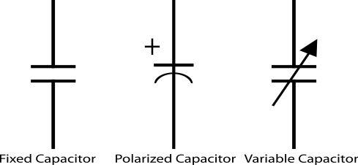
Fig.2.1 symbols of a capacitor
2.3.4 REGULATORS
A LM79805 regulator is a three terminal positive regulator with 5V fixed output voltage. The fixed regulator provides a local regulation, internal current limiting, thermal shut-down control, and safe area protection. Atypical diagram of a Regulator is shown in Fig. 2.3.
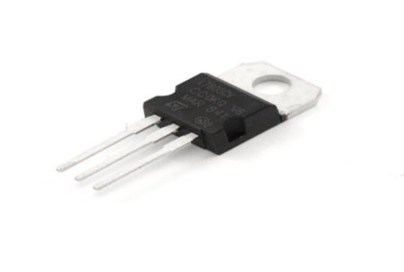
Fig. 2.2 A Regulator
2.3.5 RESISTORS
Resistors are passive elements used to oppose the flow of electricity in a circuit. The resistance of a resistor is measured in ohms. They are used to limit the current in the circuit and as a potential divider to achieve a specific value of voltage across a terminal. Resistors are either fixed or variable. A typical symbol of a resistor is shown in Fig. 2.3

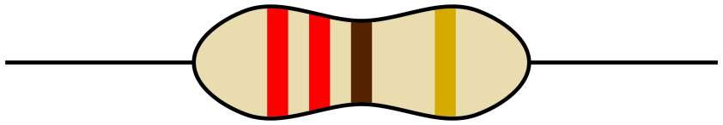
Fig. 2.3 Resistor

2.3.7 CRYSTAL OSCILLATOR
A crystal oscillator is an electronic circuit that uses the mechanical resonance vibrating crystal of piezoelectric material to create an electric signal with a precise frequency. This is often used to stabilize frequencies for radio transmitters and receivers. A typical diagram of crystal oscillator is shown in Fig. 2.4
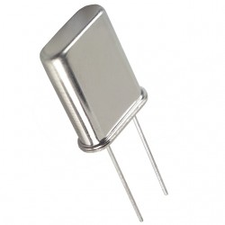
Fig. 2.4 Crystal Oscillator

2.3.8 TRANSFORMER
A current is a passive component that transfers electrical energy from one electrical circuit to another circuit, or multiple circuit. A varying current in any one coil of the transformer produces a varying magnetic flux in the transformer’s core, which induces a varying electromotive force across any other coils wound around the same core.
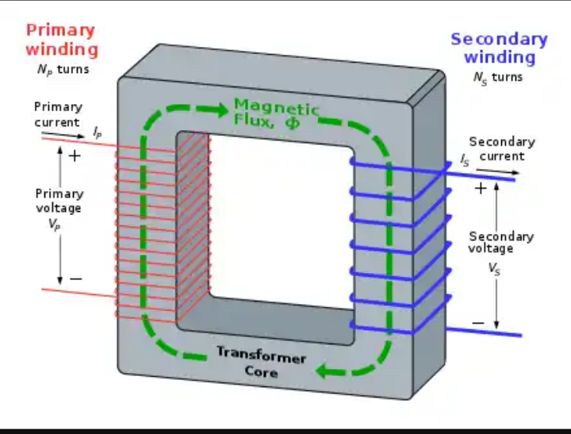
Fig. 2.5 Transformer winding

2.3.9 SWITCH
This electrical component can disconnect or connect the conducting path in an electrical circuit interrupting the electric current or diverting it from one conductor to another. The most common type of switch is an electromechanically device consisting of one or more sets of movable electrical contacts connected t external circuits, when a pair of contacts is touching current can pass between them, while when the contacts are separated, no current flow.
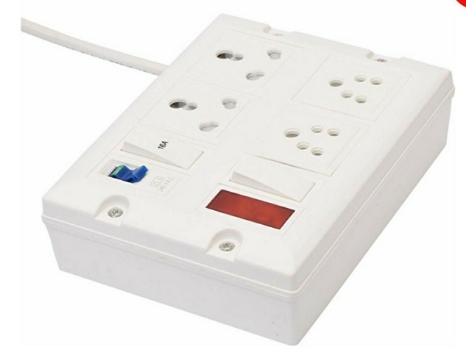
Fig.2.6 A typical switched socket

2.3.10 FUSE
This is an electrical safety device that operates to provide overcurrent protection of an electrical circuit. Its essential component is a metal wire or strip that melts when too much current flows through it, thereby stopping or interrupting the current.

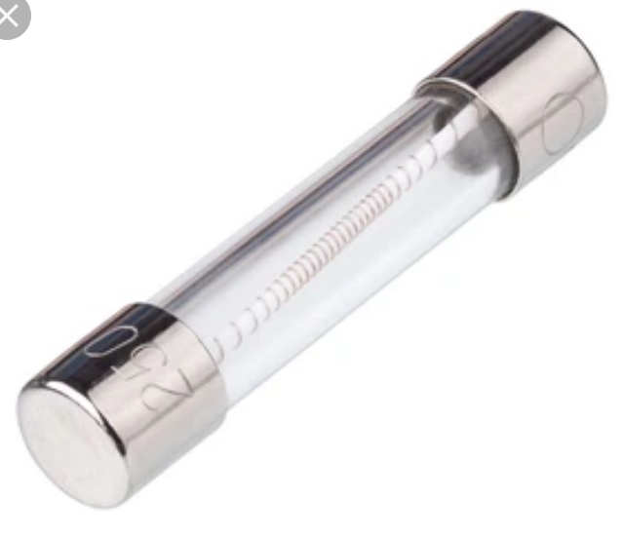
Fig.2.7 A fuse

2.3.11 LIQUID CRYSTAL DISPLAY
This is a flat panel display or electronically modulate optical device that uses the light – modulating properties of a liquid crystals combined with polarizers. Liquid crystals do not emit light directly, instead using a backlight or reflector to produce images in colour or monochrome.
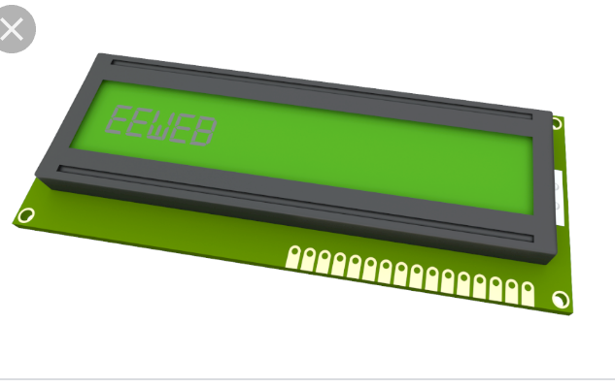
Fig.2.8 Liquid crystal display
2.3.12 13A SOCKET
This is a three (3) outlet with a (live, Neutral and Earth), it accommodates different electrical devices and aid their connections to the electricity before they can function properly. It helps in the connection of appliances rated between 700W and 3000W e.g dishwasher, micro wave, kettle, toaster machine, Iron e.t.c
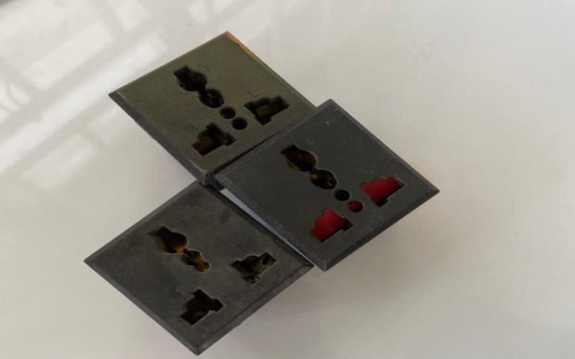
Fig.2.9 A typical 13A sockets

2.3.13 UNIVERSAL SERIAL BUS (PORT)
USB connectors have become the standard connection method for devices such as keyboards, game pads & joysticks, scanners, digital cameras, printers and external hard drives.
Although designed for personal computers USB has become commonplace on other devices such as mobile phones, tablets, video game consoles, AC power adaptors, memory sticks and mobile internet access dongles
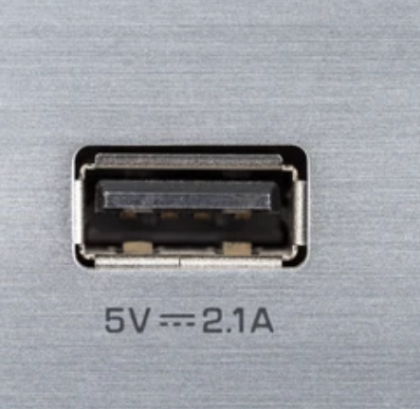
Fig.2.10 USB port

2.3.14 LITHIUM BATTERY
A lithium battery or a Li-ion battery is a type of rechargeable battery composed of cells in which lithium ions move from the negative electrode through an electrolyte to the positive electrode during discharge and when charging. The figure below shows a lithium battery
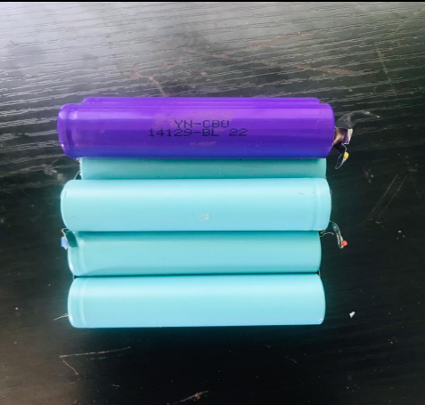
Fig.2.11 A lithium battery
2.3.15 RELAY
A relay is an electrically operated or electromechanical switch composed of an electromagnet, an armature, a spring and a set of electrical constants. The electromagnetic switch is operated by a small electrical current that turns a larger current on or off by either releasing or retracting the armature constant, thereby cutting or completing the circuit.
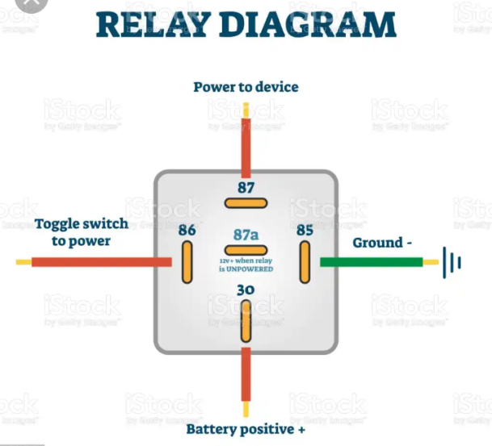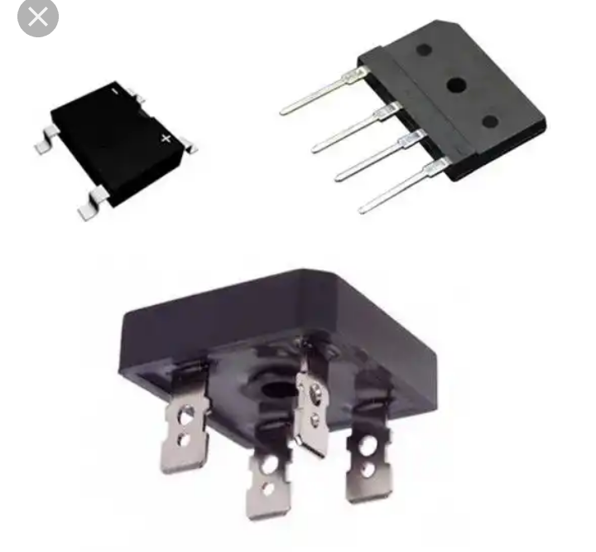
Fig.2.12 Relay
2.3.16 TRANSISTOR
Transistor are active component of integrated circuits, or ‘microchips,’ which often contain billions of these minuscule devices etched into their shiny surfaces. Deeply embedded in almost everything electronic, transistors have become the nerve cells of the information Age.
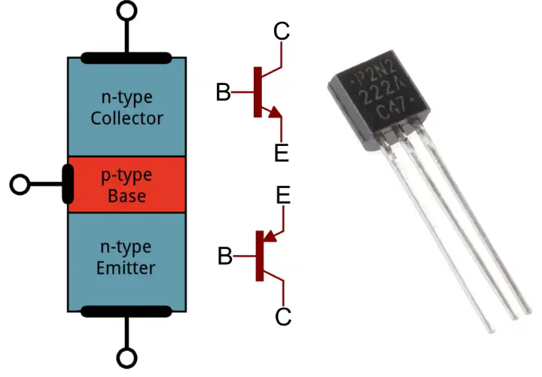 Fig.2.13 Transistor
    - RECTIFIER
A rectifier is a device that converts an oscillating two-directional alternating current (AC) into a single-directional direct current (DC). AC power is available at low cost. DC power is more expensive to produce. Therefore, a method of changing ac to dc is needed as an inexpensive dc source. AC power can be converted to DC power using rectifiers When ac power is converted to dc power using rectifiers, dc output contains un wanted alternating current components known as ripple. Many rectifier applications need that the ripple do not exceed a specified value. If the ripple exceeds the specified value, different unwanted effects appear in the system. Some of the unwanted effects are stray heating and audible noise. The ripple can be reduced using an output filter.

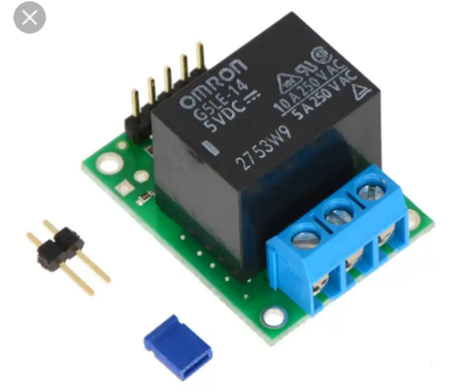Fig.2.15 Rectifier
CHAPTER THREE
DESIGN METHODOLOGY
3.0 INTRODUCTION
This chapter entails the design and calculations involved in the implementation of an extension socket with an uninterruptible universal serial bus port.

3.1 THE BLOCK DIAGRAM OF THE PROJECT

Rectifier
12V Step-down
Transformer
Batteries
Regulator
Micro
Controller
Universal Serial Bus port
USB
220
VAC
Switches/fuse
13A Electrical
Sockets

Fig. 3.1 Block diagram of the project

STAGES OF THE PROJECT
- An electrical voltage is fed from an alternating current circuit, a fuse is connected to prevent the excess flow of electric current
- The source energizes the six phases of the 13A sockets and a stepdown transformer receive its input from the input of the 13A socket
- The power from the step down transformer is rectified to change the state of the Alternating current (AC) to a Direct current (DC) to charge up the inbuilt battery (Lithium) which will store charges to be able to serve the universal serial bus ports when there is power outage
- The Micro-controller controls other electronic components in the circuit
- A regulator is connected to maintain a voltage level required from the battery to power the circuit as well as the micro-controller that requires 5V

3.2 MODE OF CONSTRUCTING THE PROJECT
The first thing is to create holes on the Adaptable box for the creation of an interface for the six phase 13A sockets and two for the USB ports, mapping out accurately and neatly aligned which fits the setting of an extension box. This is followed by measurement and cutting of cable length to be used for the extension box (The cable with thickness of 3.5mm in diameter is peeled by the use of pliers so as to bring out the cores to connect to the socket core. The cores are: the red cable (live), the black cable (neutral), yellow cable (earth) and each socket has its own independent switch. The designed circuit for the working operation of the USB port is arrange systematically with other components into the adaptable box. The box is screwed and readily available for use.

3.3 CALCULATION/ CONNECTION USED FOR THE DESIGN
3.2.1 Parallel Wiring Connection
The parallel connection entails connecting components of a circuit in parallel so that when a component is removed from the others, the circuit continues to work. In other words, both end of each cable are connected directly. Also, same voltage passes through the parallel connection and the current flowing through circuit is the sum of all the current flowing through the components.

V= V1=V2=V3₋₋₋₋₋₋₋₋₋₋₋₋Vn .1

The equivalent resistance of parallel connection is given as:
1/R_{T} = 1/R₁ + 1/R₂ ₋₋₋₋₋₋₋₋₋₋ 1/R_{n} .2

The total inductance of non-coupled inductors in parallel is equal to the reciprocal of the sum of the reciprocals of their individual inductances

1/L_{T} = 1/L₁ + 1/L₂ ₋₋₋₋₋₋₋₋₋₋ 1/L_{n} .3
The total capacitance of capacitors in parallel is equal to the sum of their individual capacitances
C_{T}= C₁ = C₁ = C₃ ₋₋₋₋₋₋₋₋₋₋₋₋C_{n} .4

3.2.2 Series Wiring Connection
Cables are connected in series when they are connected end to end. The series connection involves connecting components of a circuit such that when a component is removed, others stop working. This is because same current flows through the series connection and the voltage is the sum of all the voltage drops across the components.

I_{T}= I₁ = I₁ = I₃ ₋₋₋₋₋₋₋₋₋₋₋₋I_{n} .5
The equivalent resistance of series connection is given as:
R_{T}= R₁ = R₁ = R₃ ₋₋₋₋₋₋₋₋₋₋₋₋R_{n} .6

Total conductance of series circuits of pure resistors is given as
1/G_{T} = 1/G₁ + 1/G₂ ₋₋₋₋₋₋₋₋₋₋ 1/G_{n} .7
Also,the total inductance of non-coupled inductors in series is equal to the sum of their individual inductances
L_{T}= L₁ = L₁ = L₃ ₋₋₋₋₋₋₋₋₋₋₋₋L_{n} .8

The total capacitance of capacitors in series is equal to the reciprocal of the sum of the reciprocals of their individual capacitances

1/C_{T} = 1/C₁ + 1/C₂ ₋₋₋₋₋₋₋₋₋₋ 1/C_{n} .9

3.2.3 Resistivity
This is the resistance of a cable with unit length and unit cross sectional area. The resistance of a conductor depends on the nature of the material, temperature and size of the samples (length and cross-sectional area).
Mathematically,
Rα l/A .10
Where l=length A= cross sectional area
From equation 1
R=ρl/A .11
ρ=constant of proportionality also known as resistivity of the material measured in ohm meter (mΩ)
Electrical conductivity is a measure of the extent to which a material will allow current to flow easily through it when a potential difference is applied at a specific temperature. It is the reciprocal of resistivity given as
σ=1/ρ .12
Where
σ = electrical conductivity in (Ωm)⁻¹
The rate at which metals conduct electric current is a function of its resistance to current.
The resistance of a resistor is said to be linear if the current through the resistor is proportional to the potential difference across its terminals
From Ohm’s law
I=V/R .13
Also,
I=E/(R+r) .14
Where
I: main current in amperes,
V: applied voltage in volt,
r: internal resistance in ohm,
R: combined resistance in ohm, and
E: electromotive force in volt
The quantity Q of electric current I that passes through a metallic conductor for time t is given as
Q=It .15
While the electrical workdone when electricity flows from one point to another is given
W=IVt .16
The amount of electrical workdone also known as electrical power is given by the relation ;
P=I²R .17
P=V² /R .18

3.4 CIRCUIT DIAGRAM OF THE PROJECT

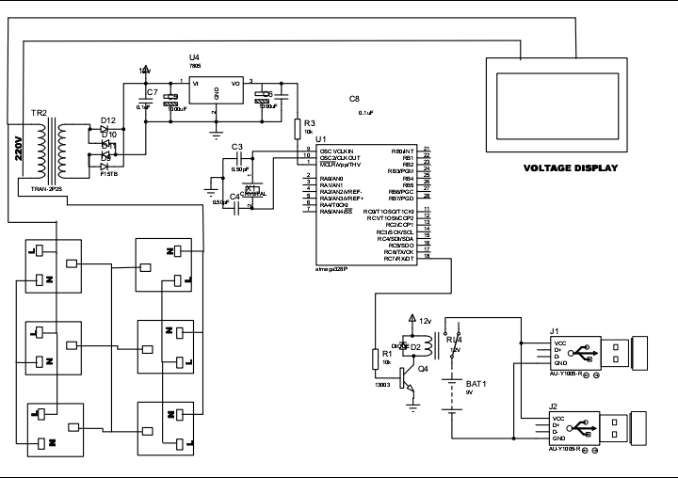

Fig. 3.2 Circuit diagram of the project

CHAPTER FOUR
4.0 TESTING, RESULT, PROBLEMS ENCOUNTERED AND SOLUTION
4.1 TESTING OF THE COMPONENTS
Before the construction of the Extension socket, test was carried out on each of component that was used for the design of the USB unit. These tests are needed to be carried out in order to know the condition, whether the component is in good condition. Tests was carried out on the following components;
- Capacitor
- Transistor
- Transformer
- Integrated circuit
4.1.1 CAPACITOR TESTING
We tested the capacitor in both charging and discharging ways, a connection was done from the two legs of the capacitor to the power supply in orther to store charge and later short circuited in order to be discharged. There was an electrical spark noticed during the short circuit test which affirmed the good condition of the capacitor
4.1.2 TRANSISTOR TESTING
The transistor has three terminals namely; the base, the emitter and the collector. A test was carried out to distinguish the three terminals.
4.1.3 TRANSFORMER TEST
A load and continuity test was carried out on the stepdown transformer to affirm its state before it was used.
4.1.4 TESTING OF THE INTEGRATED CIRCUIT
A continuity test was carried out on the integrated circuit. The state of the IC was known on the multimeter.

4.2 FINAL PROJECT TESTING
The testing of the device was done in stages; the arrangement of the electronic components is mounted on the vero board before it was transferred to the printed circuit board (PCB) for soldering and coupling.
The tests performed on the device includes;
- Charging fully the lithium battery through the step down transformer to ensure that a 12V is passed the USB circuit.
- Performance of continuity tests on various components on the printed circuit board to detect any form of short circuiting
- Switching on the device and testing the effectiveness of the USB port.
4.3 RESULT
An extension socket with an uninterruptible USB port was adopted and constructed with the help of the locally available integrated circuits. The performance evaluation of the design and construction was based on how efficient the USB works when there is power outage, the lithium battery has high quality cells, about 4000 to 5000 cycles can be delivered at 1C and 80% Depth of discharge (DoD).
4.4 PROBLEM ENCOUNTERED
The problems encountered during the design and construction of this project work discuss in two fashions. Firstly, the problem encountered due to unavailability of electrical components in the local market and secondly, the technical problem.

- UNAVAILABILITY OF COMPONENTS
Local components are known to be the second best when it comes to functionality, these components will fairly perform the role assigned for in the designed circuit. Thus, most of the components used were gotten far away South and East.

- TECHNICAL PERSONNEL
In the course of the design work, some technical shortcomings were lacking. This may lead to temporary stoppage in the design layout, pending the outcome of a possible solution.

4.4 SOLUTION PROFFERED
The solutions proffered are necessary so as get the project work completed within the stated period. Itemize next are the solution proffered to the problems encountered.

4.4.1 COMPONENTS ADAPTION
In the case of unavailability of some components part, component’s adaption was done. Components adaptation is the process of combining two or more components together to perform the function of an unavailable component. Likewise, some components were sort for from Lagos and other neighboring states.
4.5 FINAL CONSTRUCTION STAGE
The final project work is able to perform the function it is design and constructed for; the device is able to charge multiple devices at the same time, the USB ports works when there is power as well as during a power outage. Hence, the project works perfectly with the concept of a converter.

4.5.1 SOLDERING/COUPLING STAGES
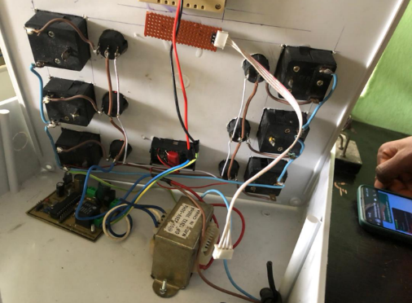
Fig.4.1. placing of the soldered project components

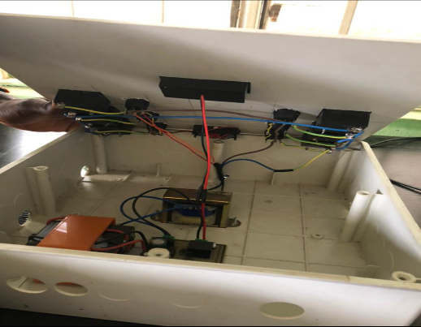
Fig. 4.2. Closing of the arranged soldered component of the project in the casing

4.5.2 FINAL INTERFACE OF THE PROJECT
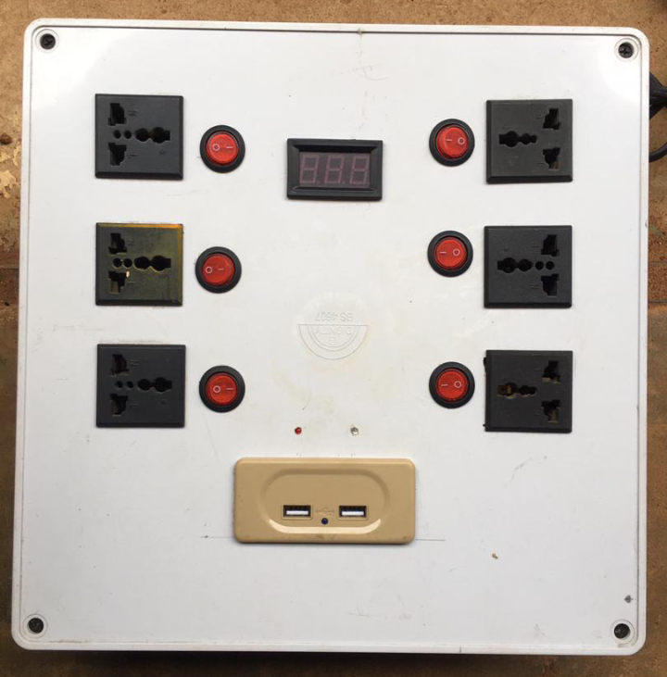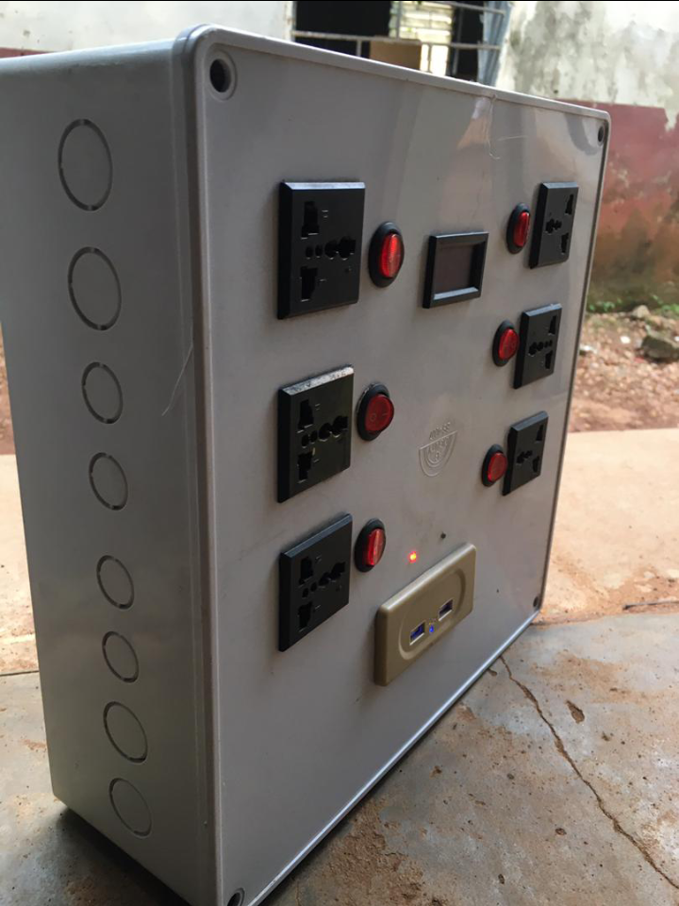

Fig4.3 final project interface

CHAPTER FIVE
5.1 CONCLUSION
The design and construction of an extension socket with an uninterruptible power supply has been achieved. The design successfully made use of electrical components available in our local market to carry out the designed. In addition, it is worth mentioning that the project will perfectly satisfy what it was constructed for; charging of multiple devices at the same time.

5.2 RECOMMENDATION
The implementation, construction and deployment of this project work have successfully achieved the aim and objectives initially set out through extensive tests and troubleshooting. The project work is solely base on acquiring the integrated circuit present in the acquired circuit. The IC’s can be order from outside the country in earnest, considering the fact that project work is within some gazette period for completion.
Also, encouragement should be given to engineering students to do more of this project work in the nearest future as it is well marketable in any sphere.

REFERENCES
[1] C.L. Strong Simon and Schuster, “The Scientific American Book of Projects for the Amateur Scientist” 1960. Pages 377-398
[2] Alistair E. Richie, Seth H. Washburn D. Van Nostrand, “The Design of Switching Circuits William Keister” 1951.
[3] Hao wang (1957), A variant to turing ‘s Theory of computing machine, JACM (Journal of the Association for computing machinery) 4, (June 23-25) 1954, pp 63
[4] Marvin Minsky , “ Recursive Unsolvability of post‘s problem ‘Tag’ and other Topics in theory of Turing machine”1960 pp. 437-455
[5] Calvin elgot and Abraham Robinson (1964) “Random Access stored program machines, an approach to programming languages, Vol. 11, No 4, (October, 1964) pp. 365-399
[6] Bishop, C. M. “Pattern recognition and machine learning”Royal Statistical Soc. Series B (Methodological) 48(3):259-302., 2006. 1st edition, Springer New York, 738 pages.
[7] Cheriyadat, A., Bright, E., Potere, D., Bhaduri, B., 2007., “Mapping of settlements in high resolution satellite imagery using high performance computing”. GeoJournal 69(1/2):119-129.

APPENDIX
BILL OF ENGINEERING MEASUREMENT AND EVALUATION (BEME)
S/N | LIST OF ITEM | DESCRIPTION | QTY | PRICE | AMOUNT
1. | LITHIUM BATTERY | 12V/3AH | 1 | 4000 | 4000.00
2. | LED | 5AH | 2 | 400 | 800.00
3. | SOCKETS | 13A | 6 | 500 | 3000
4. | TRANSFORMER | 12V | 1 | 3000 | 3000
5. | POWER CABLE | 2.5MM² | 1 | 1000 | 1000
6. | USB | PORTS | 2 | 1500 | 3000
4 | SWITCHES | LED | 6 | 150 | 900
3. | RESISTOR | 4.7K | 3 | 5 | 15.00
4. | RESISTOR | 100K | 1 | 5 | 5.00
5. | CAPACITOR | 0.1µF | 3 | 30 | 90.00
6. | CAPACITOR | 1000µF | 2 | 30 | 60.00
7. | SEVEN SEGMENT DECODER | CD4033 AND CD4027 | 4 | 300 | 1200
8. | FUSE | 3A | 1 | 200 | 200
8. | MICRO-CONTROLLER | ATMEGA328 | 1 | 3000 | 3000
9. | ULTRASONIC SENSOR | HC-SRO4 | 1 | 2000 | 2000
10. | CONNECTOR | 8 PINS | 2 | 300 | 600
11. | CONNECTOR SOCKET | 8 PINS | 4 | 50 | 200
12. | PLASTIC CASING |  |  | 1 | 3000
13. | CRYSTAL OSCILLATOR | 4 PIN | 2 | 100 | 200
14. | BOLTS AND NUTS |  | 6 | 40 | 240
15. | PRINTED CIRCUIT BOARD + DESIGN |  | 1 | 3500 | 3500
16. | COVER OF PCB |  | 1 | 200 | 200
17. | DRILLING BIT |  | 1 | 150 | 150
18. | SOLDERING IRON |  | 1 | 350 | 350
19. | MISCELLANEOUS |  |  | 3000 | 3000
20 | Soldering led |  | 1 | 300 | 300
21 |  |  |  | TOTAL | 34,010

