VOICE-CONTROLLED SMART FAN USING NATURAL LANGUAGE PROCESSING

BY
ZAKARIYA BARAKAT
HND/23/COM/FT/0222

SUBMITTED TO THE DEPARTMENT OF COMPUTER SCIENCE,
INSTITUTE OF INFORMATION AND COMMUNICATION TECHNOLOGY

KWARA STATE POLYTECHNIC, ILORIN.
IN PARTIAL FULFILLMENT OF THE REQUIREMENTS FOR THE AWARD OF HIGHER NATIONAL DIPLOMA (HND) IN
COMPUTER SCIENCE

JULY, 2025.

CERTIFICATION
This is to certify that this project was carried out by ZAKARIYA BARAKAT of Matriculation Number: HND/23/COM/FT/0222 and it has been read and approved as the meeting part of the requirements for the award of Higher National Diploma (HND) in Computer Science.

…………………………………. ….………………………
DR. RAJI, A. K. Date
Project Supervisor

…………………………………. ….………………………
MR. OYEDEPO, F. S. Date
Head of Department

…………………………………. ….………………………
External Examiner Date

DEDICATION
I dedicate this project work to Almighty God who inspired me and directed my ways during my academic stay in the polytechnic.

ACKNOWLEDGEMENT
All praise is due to Almighty God the Lord of the universe. I praise him and thank him for giving me the strength and knowledge to complete my HND program and also for our continued existence on Earth.
I appreciate the utmost effort of our supervisor, Dr. Raji, A. K. whose patience, support, and encouragement have been the driving force behind the success of this research work. He gave useful corrections, constructive criticisms, comments, recommendations, and advice and always ensures that excellent research is done. My sincere gratitude goes to the Head of the Department Mr. Oyedepo F. S., and other members of staff of the Department of Computer Science, Kwara State Polytechnic, Ilorin, for their constant cooperation, constructive criticisms, and encouragement throughout the program.
Special gratitude to my parents, who exhibited immeasurable financial, patience, support, prayers, and understanding during the period in which I was busy tirelessly with my studies, special thanks go to my lovely siblings
My sincere appreciation goes to my friends and classmates.

TABLE OF CONTENTS
Title page i
Certification ii
Dedication iii
Acknowledgments iv
Table of Contents v
List of Figures vi
List of Tables vii
Abstract viii
CHAPTER ONE: GENERAL INTRODUCTION
1.1 Background to the Study 1
1.2 Statement of the Problem 2
1.3 Aim and Objectives 3
1.4 Significance of Study 3
1.5 Scope of Study 4
1.6 Organization of the Report 4
CHAPTER TWO: LITERATURE REVIEW
2.1 Review of Related Works 5
2.2 Review of General Texts 9
2.3 Overview of Voice-Controlled Smart Fan 9
CHAPTER THREE: RESEARCH METHODOLOGY AND
ANALYSIS OF THE SYSTEM
  - Research Methodology 11
  - Analysis of the Existing System 16
  - Problem of the Existing System 16
  - Description of the Proposed System 16
  - Advantages of the Propose System 17

CHAPTER FOUR: IMPLEMENTATION AND DISCUSSION OF RESULTS
  - System Design and Setup 18

4.2 Hardware and Software Development 19

4.2.1 Hardware Components 19
4.2.2 Software Components 20
4.3 Testing and Evaluation 20
4.3.1 Voice Command Testing 20
4.3.2 Hardware Response Testing 21

4.4 Results and Discussion 21
CHAPTER FIVE: SUMMARY CONCLUSION AND
RECOMMENDATION
5.1 Summary 23
5.2 Conclusion 23
5.4 Recommendations 24
References 25

ABSTRACT
In recent years, the demand for smart and user-friendly home appliances has significantly increased, driven by advances in automation and artificial intelligence. This project presents the design and implementation of a Voice-Controlled Smart Fan using Natural Language Processing (NLP) to enhance comfort, accessibility, and energy efficiency. The system allows users to control the fan's operations such as turning it on/off, adjusting speed levels, and changing modes through simple spoken commands. A microphone captures the user's voice, which is then processed using speech recognition and interpreted by an NLP engine. The recognized command is passed to a microcontroller (e.g., Arduino or ESP32), which performs the required action via relays and motor control circuits. Python programming, along with open-source libraries for voice recognition and NLP, was used to handle command interpretation. The prototype was tested and evaluated for accuracy, responsiveness, and ease of use. Results showed that the system performed reliably in recognizing and executing basic commands with minimal delay. The project demonstrates the potential of integrating NLP with embedded systems to build intelligent and accessible home automation solutions, especially beneficial for the elderly and physically challenged individuals.

CHAPTER ONE

GENERAL INTRODUCTION

1.1 Background to the Study
The evolution of smart technology has brought transformative changes to the design and operation of household appliances, making them more efficient, responsive, and user-friendly. One such innovation is the smart fan, a modern version of the traditional electric fan equipped with features such as remote control, temperature and humidity sensors, automatic speed adjustment, and integration with home automation systems. Despite these advancements, many smart fans still rely on physical interfaces or mobile applications for control. These methods, while useful, can be inconvenient in certain scenarios, especially for elderly users, individuals with physical disabilities, or users engaged in other tasks such as cooking, reading, or working (Rani, et al, 2017).
Traditional fan operation through buttons or remotes presents a significant accessibility barrier. Even mobile app-based control, though more flexible, requires physical handling of a smartphone or tablet, which may not be ideal in all situations. In response to these limitations, voice-controlled systems have emerged as a promising alternative, enabling users to control devices using spoken language. This is made possible through voice recognition technologies and Natural Language Processing (NLP), a branch of artificial intelligence that allows machines to understand, interpret, and respond to human language in its natural form (Alexakis, et al, 2019).
With NLP, users can issue commands such as “turn on the fan,” “increase the speed,” or “set the fan to low,” and the system interprets and executes these instructions accordingly. Voice control enhances convenience, promotes inclusiveness, and aligns with the growing trend of smart, automated living environments. However, integrating NLP and voice control into smart fan systems is not without challenges. These include recognizing diverse speech patterns, accents, and languages; accurately interpreting user intent; integrating the system with hardware components like fan motors and regulators; and ensuring real-time responsiveness (Torad, et al, 2022).
To overcome these challenges, this project proposes the development of a voice-controlled smart fan using Natural Language Processing. The objective is to create an intelligent, interactive fan system that eliminates the need for physical contact, thus improving accessibility and enhancing user comfort. The solution involves the integration of various hardware and software components. A microcontroller (such as Arduino or Raspberry Pi) will serve as the central processing unit to control the fan based on interpreted voice commands. A voice recognition module, such as Google Speech API or offline tools like Vosk or CMU Sphinx, will be used to convert spoken language into text. The transcribed commands will be analyzed using an NLP engine such as Python’s NLTK, spaCy, or platforms like Dialogflow to understand user intent.
Once the command is interpreted, the microcontroller will send control signals to relay modules or motor driver circuits to turn the fan on or off or adjust the speed. Python will be used as the main programming language to integrate voice recognition, NLP, and hardware control. A microphone will be used to capture user voice inputs, while optional feedback mechanisms such as audio responses or LEDs can be added for improved interaction. The system workflow begins with the user issuing a command, which is captured and transcribed. The NLP engine processes this input and passes a structured command to the microcontroller, which then actuates the corresponding fan operation.

1.2 Statement of the Problem

Despite the growing popularity of smart home appliances, many electric fans still require manual operation or rely on mobile applications that demand physical interaction, which can be inconvenient, especially for the elderly, physically challenged individuals, or users engaged in multitasking. The lack of seamless, hands-free control limits the overall user experience and does not fully harness the potential of intelligent systems. Furthermore, existing voice-controlled systems are either too expensive, complex to implement, or lack proper integration with natural language processing, resulting in inaccurate command interpretation and poor responsiveness. These limitations highlight the need for an affordable, efficient, and user-friendly solution that utilizes voice control powered by Natural Language Processing (NLP) to enable intuitive and reliable interaction with fan systems. Addressing this problem will significantly improve accessibility, comfort, and energy efficiency in modern home environments.

1.3 Aim and Objectives
To design and implement a voice-controlled smart fan using Natural Language Processing (NLP) to improve comfort, accessibility, and automation in smart homes. The objectives are;
- To design a smart fan system that integrates voice recognition for hands-free operation.
- To implement Natural Language Processing techniques to accurately interpret user commands.
- To develop a control mechanism using a microcontroller (e.g., Arduino or Raspberry Pi) for fan speed regulation and power control.
- To ensure real-time processing and response to voice commands for smooth user interaction.
- To test and evaluate the system’s performance in terms of command accuracy, response time, and user satisfaction.

1.4 Significance of the Study
This study is significant as it addresses the growing need for intelligent, accessible, and user-friendly home automation solutions. By developing a voice-controlled smart fan using Natural Language Processing (NLP), the project promotes convenience and inclusivity, especially for individuals with physical disabilities, the elderly, and users who may be engaged in activities that limit their ability to operate appliances manually. The integration of NLP allows users to communicate with the system in natural spoken language, making interaction intuitive and efficient. Furthermore, the project demonstrates how affordable microcontroller-based systems and open-source technologies can be utilized to solve real-world problems, making smart home solutions more accessible to the average user. In addition, the outcome of this research may serve as a foundation for future development of voice-controlled appliances, contributing to advancements in smart home technologies, human-computer interaction, and artificial intelligence applications.

1.5 Scope of the Study
This study focuses on the design and implementation of a voice-controlled smart fan system using Natural Language Processing (NLP). The system will be developed to recognize and interpret basic voice commands such as turning the fan ON or OFF, adjusting speed levels (e.g., low, medium, high), and switching operation modes. The project scope is limited to English language voice inputs and will primarily support offline or semi-offline command processing for enhanced privacy and reliability.

1.6 Organization of the Study
This research project is organized as follows:
Chapter one introduces the background, problem statement, aim and objectives, significance, scope, and organization of the study.
Chapter two provides a review of relevant literature on smart fans, voice control systems, and NLP technologies.
Chapter three describes the system design, methodology, and hardware/software components used in the development.
Chapter four presents the implementation process, system testing, and performance evaluation.
Chapter five summarizes the findings, concludes the study, and provides recommendations for future work.

CHAPTER TWO

LITERATURE REVIEW

2.1 Review of Related Works
Several studies and projects have explored smart fan systems and voice-controlled appliances using various technologies. For instance, Rani, et al., (2017) Voice Controlled Home Automation System using Natural Language Processing (NLP) and Internet of Things (IoT). The primary objective of their project is to construct a fully functional voice based Home automation system that uses Internet of Things, Artificial Intelligence and Natural Language Processing (NLP) to provide a cost-effective, efficient way to work together with home appliances. There are many smart home solutions in the market that aim to automate the basic operations of these home appliances using various technologies such as GSM (Global System for Mobile), NFC (Near-Field Communication) etc. However, most of these systems focus on mimicking the basic operation of the electrical switch. Our project aims at providing a fully automated voice based solution that our users can rely on, to perform more than just switching on/off the appliances. The user sends a command through speech to the mobile device, which interprets the message and sends the appropriate command to the specific appliance. We plan on implementing four basic home appliances as a “Proof-of-Concept” for this project which includes Fan, Light, Coffee Machine and Door Alarms. The voice command given by the user is interpreted by the mobile device using Natural Language processing. The mobile device acts as a central console; it determines what operation must be completed by which appliance to fulfill the user’s request. The central console might likewise be either a desktop application, web application or a smart phone application as nearly all of the data transferred can be processed by the cloud. However, for the convenience of the user and increased mobile capabilities we will be using a smart phone in this project. The appliances are associated with the mobile device through an Arduino Board that establishes the concept of Internet of Things. The Arduino Boards are interfaced with the appliances and programmed in a manner that they respond to mobile inputs.

Torad et al., (2022) A voice controlled smart home automation system using artificial intelligent and internet of things. The objective of this work is to take a step further in this direction by incorporating voice control and artificial intelligence (AI) into internet of things (IoT)-based smart home systems to create more efficient automated smart home systems. Accordingly, a home automation system proposal is presented, in which the related functions can be controlled by voice commands using an android or web application via a chat form. The user issues a voice command, which is deciphered by natural language processing (NLP). To accommodate the user’s request, the NLP classifies it into operation commands. Arduino and Raspberry Pi are used to translate the commands extracted from NLP into reality. Based on this, home applications can be controlled. Also, the utilities consumption could be calculated, saved, and paid on time. This is in addition to the introduction of a machine learning (ML)-based recommendation system for automated home appliance control. In this approach, the mobile or web application is considered as the central controller, deciding the appropriate actions to fulfill the user’s desires. The presented work has been put into practice and tested. It proved to be applicable, as well as having the potential for making home life more comfortable, economic, and safe.

Alexakis et al., (2019) Control of Smart Home Operations Using Natural Language Processing, Voice Recognition and IoT Technologies in a Multi-Tier Architecture. The Internet of Things (IoT) is an emerging Internet-based architecture, enabling the exchange of data and services in a global network. With the advent of the Internet of Things, more and more devices are connecting to the Internet in order to help people get and share data or program actions. In this paper, we introduce an IoT Agent, a Web application for monitoring and controlling a smart home remotely. The IoT Agent integrates a chat bot that can understand text or voice commands using natural language processing (NLP). With the use of NLP, home devices are more user-friendly and controlling them is easier, since even when a command or question/command is different from the presets, the system understands the user’s wishes and responds accordingly. Our solution exploits several available Application Programming Interfaces (APIs), namely: the Dialogflow API for the efficient integration of NLP to our IoT system, the Web Speech API for enriching user experience with voice recognition and synthesis features, MQTT (Message Queuing Telemetry Transport) for the lightweight control of actuators and Firebase for dynamic data storage. This is the most significant innovation it brings: the integration of several third-party APIs and open source technologies into one mash-up, highlighting how a new IoT application can be built today using a multi-tier architecture. We believe that such a tiered architecture can be very useful for the rapid development of smart home applications.

Terzopoulos and Satratzemi (2020) Voice Assistants and Smart Speakers in Everyday Life and in Education. In recent years, Artificial Intelligence (AI) has shown significant progress and its potential is growing. An application area of AI is Natural Language Processing (NLP). Voice assistants incorporate AI by using cloud computing and can communicate with the users in natural language. Voice assistants are easy to use and thus there are millions of devices that incorporates them in households nowadays. Most common devices with voice assistants are smart speakers and they have just started to be used in schools and universities. The purpose of this paper is to study how voice assistants and smart speakers are used in everyday life and whether there is potential in order for them to be used for educational purposes.

Yue, et al., (2024) Handheld fans for Dyspnoea in Respiratory Failure: Randomized Controlled Trial. Fan therapy is widely acknowledged as an essential component in the management of dyspnoea with numerous studies supporting its efficacy in alleviating dyspnoea among patients with chronic illnesses. However, there is limited evidence regarding the effectiveness of fan therapy in reducing dyspnoea in patients with respiratory failure undergoing continuous oxygen therapy. This study aimed to assess the efficacy of fan therapy in mitigating dyspnea in this specific patient population through a randomised controlled trial. Methods Participants meeting the inclusion criteria were randomly assigned to either an experimental group or a control group. In the experimental group, a handheld fan (HHF) was directed at the face, while in the control group the fan was aimed at the legs. Both interventions were conducted at a distance of 15–30 cm for 10 min. Key physiological and subjective measures, including heart rate, respiratory rate, blood pressure, blood oxygen saturation, facial skin temperature and Visual Analogue Scale (VAS) scores, were recorded immediately after fan therapy. Results The experimental group demonstrated a statistically significant reduction in VAS scores (p<0.05) compared with the control group indicating that fan therapy effectively alleviates dyspnoea in patients with respiratory failure receiving continuous oxygen therapy. Conclusion HHFs are affordable, widely accessible and highly effective in relieving dyspnoea with minimal risk. Therefore, fan therapy should be considered as a complementary treatment for patients with respiratory failure and incorporated alongside standard therapeutic interventions for the condition.

Parameshachari et al., (2013) A Study on Smart Home Control System through Speech. The paper proposes an automation system where users can use voice commands to control their electrical appliances, such as light, fan, television, heater etc. The main aim is to help make the life of people more comfortable, especially for the elderly and disabled as they will not have to be actually present near an appliance to turn it on or off. The system focuses on using a Digital Signal Processor to process the voice commands and accordingly control the required appliance. XBee transceivers are used to eliminate the need for large amount of wiring between the processor and the appliances. Experimental results show that the system has a good response and is cost effective. We conclude that this system provides solutions for the problems faced by home owners in daily life and make their life easier and more comfortable by proposing a cost effective and reliable solution.

Bind et al., (2020) An IOT Based Smart Fan Module. Now day there are various requirements of common-man. Internet of Things is going to play essential role in application such as smart home, industrial internet, healthcare and security systems, smart cities, etc. In this work, we are implementing smart digital fan module for controlling fan speed based on room temperature, and also turn on or turn off based on presence or absence of man body. And also we can access the temperature remotely through cloud. Temperature of the room can be sensed by using DHT11 temperature sensor. The sensed signal is send to microcontroller. If temperature is low then fan rotates slowly and if the temperature is high then the speed of the fan will be high. ESP8266 Wi-Fi is interfaced with microcontroller to show the current status of the project with help of mobile phone. The developed approach is benefited regarding preventing the waste of energy when it is not hot enough to use a fan and assist the disabled to switch on or off fan automatically.

2.2 Review of General Texts
General literature on smart home automation emphasizes the increasing role of artificial intelligence and voice interaction in enhancing user convenience and accessibility. Books and academic texts on Natural Language Processing (NLP) explain how machines can be trained to process and understand human language, enabling more natural and intuitive communication between humans and devices. Works by experts like Jurafsky and Martin highlight the importance of syntactic and semantic analysis for interpreting voice commands accurately. Additionally, texts on embedded systems and microcontroller programming provide foundational knowledge on interfacing hardware with software to execute real-world commands, such as controlling motors and relays in appliances like fans (Alexakis et al., 2019).
Research in human-computer interaction also underlines the significance of voice interfaces as a hands-free, inclusive solution, especially beneficial for users with limited mobility or those engaged in other tasks. Furthermore, literature on speech recognition technology outlines the challenges of noise interference, accent variability, and command disambiguation, which must be addressed to build reliable systems. Collectively, these general texts offer essential theories, methodologies, and best practices that guide the development of voice-controlled smart appliances, forming the theoretical backbone of this study (Alexakis et al., 2019).

2.3 Overview of Voice-Controlled Smart Fan
A voice-controlled smart fan is an innovative home appliance designed to enhance user comfort and convenience by allowing users to operate the fan through spoken commands. Unlike traditional fans that require manual adjustment through buttons or remote controls, this smart system uses voice recognition and Natural Language Processing (NLP) technologies to interpret user commands and automatically adjust fan settings such as power on/off, speed levels, oscillation, and timer functions. The core components of a voice-controlled smart fan include a microphone for capturing voice input, a speech recognition module that converts spoken words into text, an NLP engine that interprets the meaning and intent behind commands, and a microcontroller or embedded system that executes the corresponding actions by controlling the fan’s motor and other hardware features. This integration allows for seamless and hands-free operation, making it ideal for situations where manual control is inconvenient or impossible (Terzopoulos and Satratzemi, 2020).
The use of voice control technology in fans aims to improve accessibility for people with physical limitations, enhance energy efficiency by encouraging timely adjustment, and provide a more natural and intuitive interaction with household appliances. Additionally, these smart fans can be integrated into broader smart home ecosystems, enabling voice commands through popular virtual assistants or custom-built voice interfaces. Overall, the voice-controlled smart fan represents a significant step forward in smart home automation, combining ease of use, intelligent control, and adaptive functionality to improve daily living comfort (Yue, et al, 2024).

2.3.1 Smart Fan Technology
Smart fan technology refers to the integration of traditional electric fans with advanced electronic controls and connectivity features that enable enhanced functionality and automation. Unlike conventional fans, which are manually operated using physical buttons or knobs, smart fans can be controlled remotely or automatically through various interfaces such as mobile applications, remote controls, sensors, or voice commands. These fans often include features like adjustable speed settings, oscillation control, timer functions, and environmental sensing (temperature, humidity, or motion detection) to optimize comfort and energy efficiency. The core idea behind smart fan technology is to provide users with greater convenience and improved environmental control. For example, sensors can detect room temperature changes and automatically adjust the fan speed to maintain a comfortable atmosphere without user intervention. Additionally, smart fans can be integrated into broader smart home ecosystems, allowing synchronized operation with other devices like air conditioners or lighting systems (Parameshachari et al., 2013).
Despite these advancements, many existing smart fans still require interaction through apps or remote controls, which can be cumbersome in certain situations or for users with mobility challenges. Therefore, the development of more intuitive and accessible control methods, such as voice control powered by Natural Language Processing (NLP), is becoming increasingly important. This approach aims to make fan operation seamless, hands-free, and more aligned with modern smart living environments.

2.3.2 Voice Control Systems
Voice control systems enable users to operate devices and appliances through spoken commands instead of manual inputs like buttons or touchscreens. This technology relies on capturing the user’s voice using microphones, converting the audio signals into digital data, and processing the data to interpret the intended commands. At the core of voice control systems is speech recognition technology, which transcribes spoken words into text. Once transcribed, the system uses Natural Language Processing (NLP) to analyze the text, understand the user’s intent, and map the commands to specific actions. For example, a command such as “turn the fan on” or “set the fan speed to high” is recognized, parsed, and executed by controlling the fan hardware accordingly (Bind et al., 2020).
Voice control offers significant advantages, especially in terms of convenience and accessibility. It allows users to interact with devices hands-free, which is beneficial when multitasking, or for individuals with mobility impairments or disabilities. Voice commands can also make technology more intuitive and user-friendly, reducing the learning curve for new devices. Voice control systems can be either cloud-based, where speech data is sent to remote servers for processing (e.g., Amazon Alexa, Google Assistant), or offline/local, where all processing happens on the device itself, improving privacy and reducing latency. Offline systems require more efficient and lightweight algorithms to function effectively on embedded hardware. Despite their benefits, voice control systems face challenges such as background noise interference, variations in accents and speech patterns, and the need to correctly interpret diverse phrasing of commands. Addressing these challenges through advanced NLP techniques and robust hardware integration is crucial to developing reliable and user-friendly voice-controlled smart devices (Rani, et al., 2017).

2.3.3 Natural Language Processing (NLP)
Natural Language Processing (NLP) is a field of artificial intelligence that focuses on enabling computers to understand, interpret, and respond to human language in a way that is both meaningful and useful. NLP bridges the gap between human communication and machine understanding by processing spoken or written language to extract intent, context, and meaning. In the context of voice-controlled systems, NLP plays a crucial role in interpreting the transcribed speech input received from the speech recognition component. Once speech is converted to text, NLP techniques analyze the structure and semantics of the command to determine what the user wants the system to do. For example, commands like “increase the fan speed” or “turn off the fan” may be expressed in many different ways, and NLP helps the system recognize these variations and map them to the appropriate action (Alexakis et al., 2019).
NLP involves several sub-tasks, including:
- Tokenization: Breaking down sentences into individual words or phrases.
- Part-of-Speech Tagging: Identifying the grammatical role of each word.
- Parsing: Analyzing sentence structure to understand relationships between words.
- Semantic Analysis: Extracting the meaning and intent behind words and sentences.
- Intent Recognition: Determining the user’s goal from their command.
- Entity Recognition: Identifying key information such as speed levels or device names.
Modern NLP systems often use machine learning and deep learning models trained on large datasets to improve accuracy and handle complex language patterns. In embedded systems like a smart fan controller, lightweight NLP models or rule-based approaches may be used to balance performance and resource constraints.
By integrating NLP, voice-controlled devices become more flexible and user-friendly, allowing natural, conversational interaction rather than rigid, pre-defined commands. This enhances the overall user experience by making the technology accessible to a broader range of users.

2.3.4 Speech Recognition
Speech recognition is a technology that enables machines to convert spoken language into text. It serves as the fundamental interface in voice-controlled systems, allowing devices to understand verbal commands given by users. The process involves capturing the audio signal through a microphone, processing the sound waves, and then analyzing the signal to identify the spoken words.
Speech recognition systems operate through several key stages:
- Acoustic Modeling: This stage analyzes the audio signal to identify phonemes—the smallest units of sound in speech. It models how speech sounds correspond to the words being spoken.
- Language Modeling: This component predicts the likelihood of word sequences based on grammar and vocabulary to improve recognition accuracy.
- Decoding: The system combines acoustic and language models to convert the speech signal into a sequence of words.
There are two main types of speech recognition systems:
- Online (Cloud-based): Audio data is sent over the internet to powerful servers that perform the recognition and send back text results. These systems typically offer higher accuracy and support for multiple languages but require continuous internet connectivity and raise privacy concerns.
- Offline (On-device): All processing occurs locally on the device without the need for internet access. These systems offer better privacy and faster response times but may be limited by the processing power and memory of the hardware.
Speech recognition faces challenges such as background noise, speaker accents, speech variations, and homophones (words that sound alike). To mitigate these issues, advanced algorithms, noise-cancellation techniques, and robust training on diverse speech datasets are employed.
In the context of a voice-controlled smart fan, accurate speech recognition is critical to ensure that commands like “turn on the fan” or “set speed to high” are correctly understood and executed promptly. Efficient speech recognition integrated with NLP enables smooth and natural user interaction with the device.

2.3.5 Human-Computer Interaction (HCI)
Human-Computer Interaction (HCI) is the study and practice of designing, developing, and evaluating systems and devices that facilitate effective communication between humans and computers. The goal of HCI is to create interfaces that are intuitive, efficient, and accessible, ensuring users can interact with technology comfortably and naturally. In the context of voice-controlled smart devices, HCI focuses on making the interaction seamless and user-friendly by leveraging natural modes of communication such as speech. Voice interfaces reduce the reliance on traditional input devices like keyboards, buttons, or touchscreens, enabling hands-free operation. This is especially valuable for users with physical disabilities, elderly individuals, or those engaged in multitasking who benefit from more convenient control methods.
HCI also studies user behavior, preferences, and ergonomics to optimize system responses and minimize errors. It involves iterative design processes that include usability testing, feedback collection, and adaptation to ensure the voice-controlled system meets user needs effectively. By incorporating principles of HCI, the development of a voice-controlled smart fan ensures the system is not only functional but also provides a positive user experience. This includes designing clear voice prompts, ensuring accurate command recognition, and providing timely feedback to users to confirm actions have been taken. Effective HCI integration improves adoption rates and satisfaction with smart home technologies, making devices more accessible to a broad audience.

CHAPTER THREE

METHODOLOGY AND ANALYSIS OF THE NEW SYSTEM

3.1 Research Methodology
This study adopts a design and implementation-based research methodology, which focuses on building a practical solution using embedded systems and artificial intelligence. The approach combines both qualitative and quantitative techniques. Qualitatively, relevant literature and user requirements were gathered through observation and informal interviews to understand the limitations of conventional fan systems. Quantitatively, system performance and response accuracy were tested during prototype development. The system was developed using tools such as Arduino microcontroller, microphone module, and software technologies including Python for NLP, speech recognition APIs, and C/C++ for embedded coding. An iterative development model was employed to allow continuous improvement during testing and evaluation.
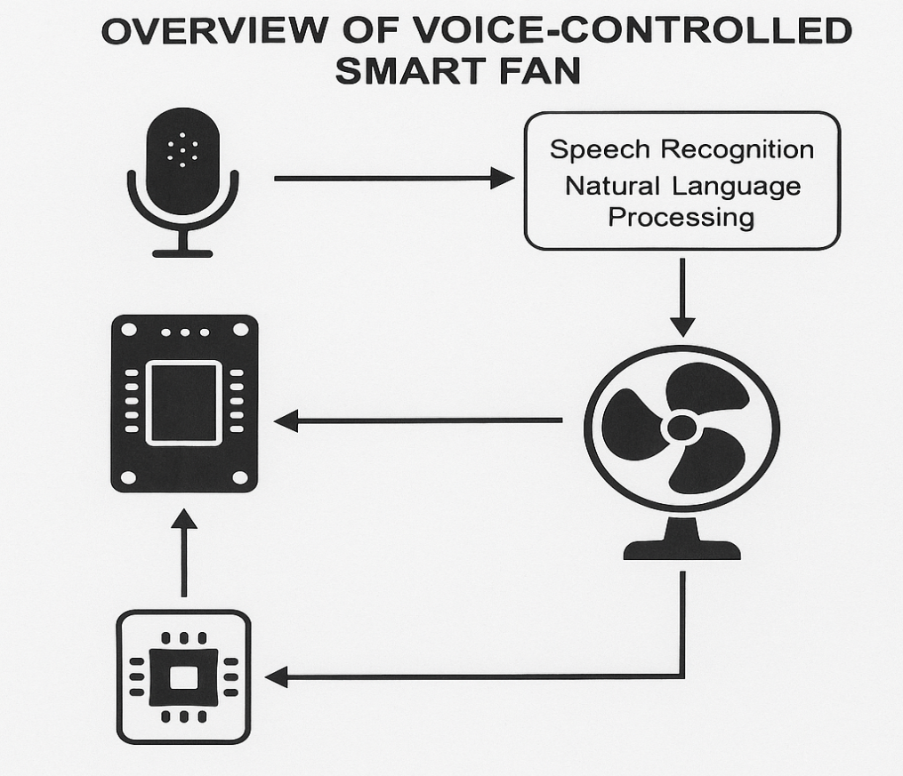

Figure 3.1: Overview of the system

3.2 Analysis of the Existing System
The traditional electric fan operates using manual switches, knobs, or remote controls. Users must physically interact with the fan to turn it on or off, adjust speed levels, or change oscillation. While some modern fans include remote controls or app-based interfaces, they still require deliberate actions, making them inconvenient in situations like multitasking, mobility impairment, or during nighttime use. Additionally, existing systems lack intelligent response mechanisms and do not support natural language communication.

3.3 Problems of the Existing System
The existing fan systems have several limitations:
- Lack of Accessibility: People with physical disabilities or the elderly may find it difficult to reach controls.
- No Hands-Free Operation: Users need to manually adjust settings.
- Inconvenience During Multitasking: In situations where hands are occupied, manual control becomes impractical.
- No Support for Natural Language: Existing systems do not understand human speech or intent.
- Limited Automation: Fans do not adjust themselves based on environment or context unless programmed separately.

3.4 Analysis of the Proposed System
The proposed voice-controlled smart fan leverages speech recognition and Natural Language Processing (NLP) to interpret voice commands. The system captures voice input via a microphone module and processes it using either an onboard microcontroller or external voice processing API. Once the command is recognized and interpreted, the system performs the requested operation—such as turning the fan on/off, adjusting speed, or changing oscillation. The core components include:
- Microcontroller (e.g., Arduino or ESP32)
- Voice recognition module or software (e.g., Google Speech API, Python's SpeechRecognition)
- NLP engine for intent processing
- Motor driver and fan circuit
This architecture provides a fully voice-driven interface, reducing the need for physical interaction and making the device more intelligent and user-centric.

3.5 Advantages of the New System over the Existing System
- Hands-Free Operation: Enables users to control the fan through voice, increasing comfort and accessibility.
- Improved Accessibility: Assists the physically challenged and elderly users.
- Intelligent Interaction: Supports natural language commands through NLP, improving user experience.
- Automation Potential: Can be integrated with sensors or smart home systems for automated response.
- Energy Efficiency: Encourages timely switching off or speed reduction, reducing energy wastage.
- Modern Appeal: Adds smart technology features for a more advanced and tech-savvy user experience.

CHAPTER FOUR

IMPLEMENTATION AND DISCUSSION OF RESULTS

4.1 System Design and Setup
The design of the voice-controlled smart fan system was centered on integrating voice recognition with fan control using natural language processing (NLP). The system architecture was built with both hardware and software components that work cohesively to deliver real-time interaction between the user and the fan. The core idea is to capture the user's voice command, process the speech into understandable instructions, and execute the corresponding fan operation such as turning it on or off, increasing or decreasing speed, or activating oscillation.
The setup includes a microphone to capture the user’s voice input, which is then passed to a speech recognition module. The processed command is interpreted by an NLP engine which translates it into structured data. This command is communicated to a microcontroller (such as Arduino or ESP32), which then controls the fan hardware via relays and motor drivers. A feedback mechanism confirms successful execution, ensuring a reliable and user-friendly system.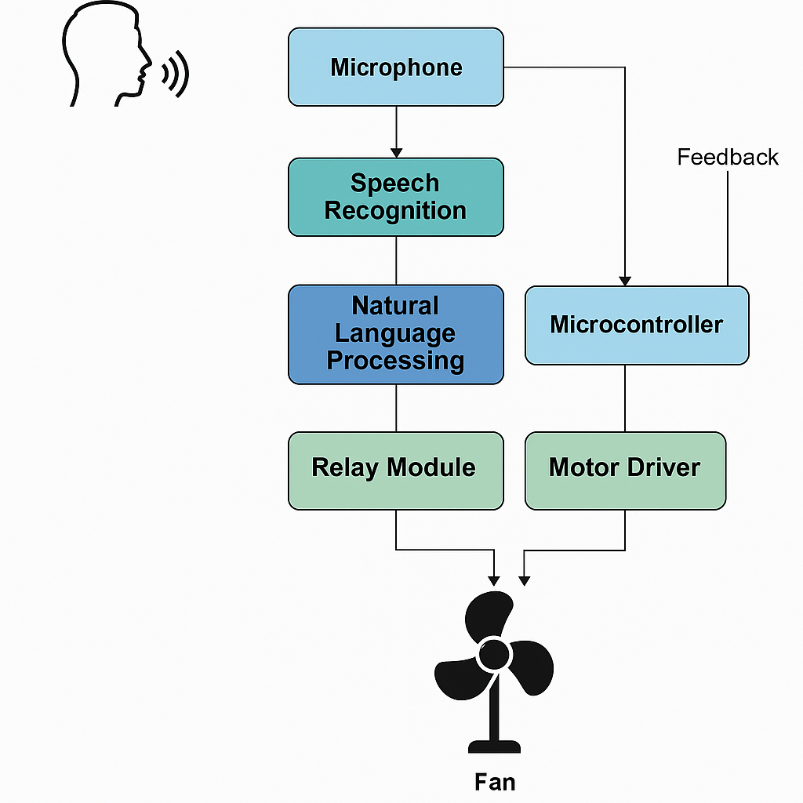

Figure 4.1: System Design and Setup

4.2 Hardware and Software Development

4.2.1 Hardware Components:
- ESP32/Arduino Uno: Used as the main microcontroller for controlling fan functions.
- Microphone Module: Captures the user’s voice input.
- Relay Module: Switches fan ON/OFF based on microcontroller output.
- Motor Driver: Regulates the fan’s motor speed based on instructions.
- Fan (DC/AC): The actual cooling device controlled by the system.
- Power Supply: Supplies consistent voltage and current to all components.
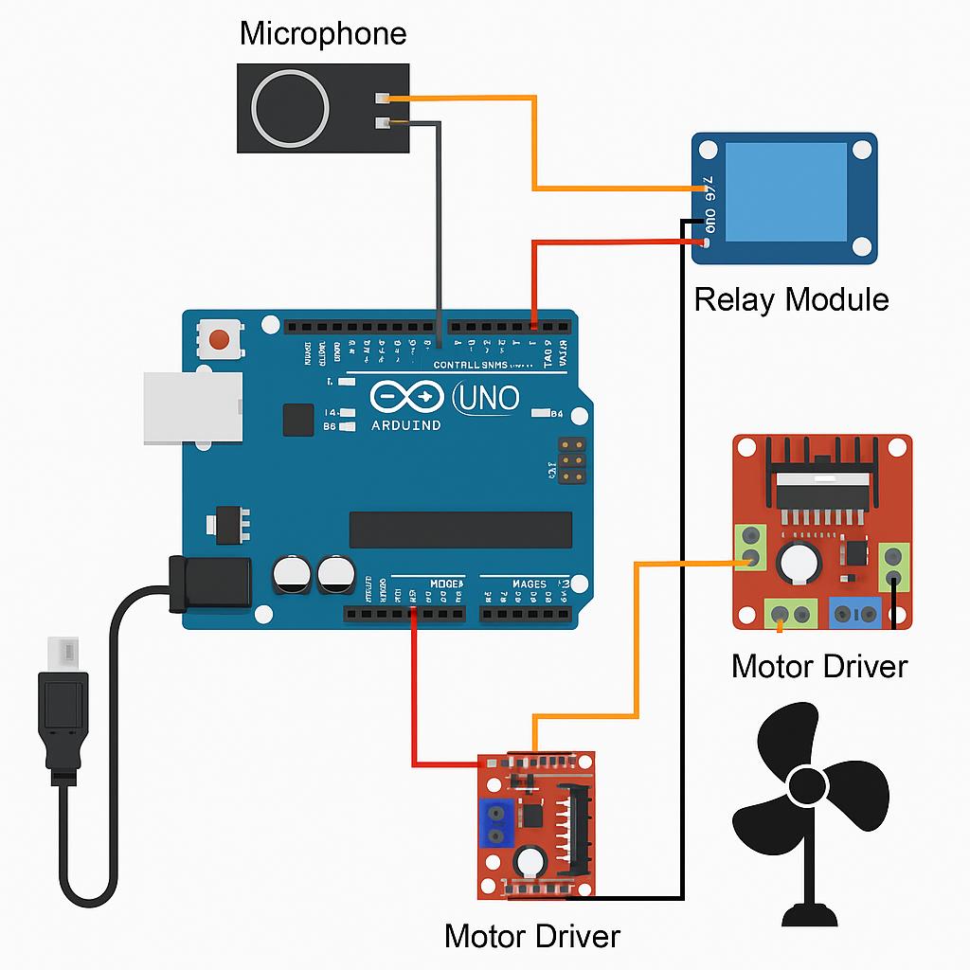
Figure 4.2: Hardware Component of the System

4.2.2 Software Components:
- Python: Used for implementing NLP and speech recognition modules.
- SpeechRecognition Library: Enables the system to convert speech to text.
- Google Text-to-Speech (GTTs) API or Vosk API: For offline or cloud-based speech recognition.
- Arduino IDE: Used for writing embedded code to interface the microcontroller with relays and the motor.
- NLP Logic: A custom script was developed to map spoken phrases (like "increase fan speed") to actionable commands ("speed++").
The development process involved iterative testing of each component, starting with voice command recognition, followed by integration with the microcontroller, and final testing on the fan control unit.

4.3 Testing and Evaluation
The system underwent several phases of testing to evaluate accuracy, response time, and user experience.

4.3.1 Voice Command Testing:
- Accuracy: The speech recognition engine was tested with multiple voice tones, accents, and background noise. The system achieved approximately 85–90% accuracy under normal room conditions.
- Response Time: The average time between voice input and system response was 1.5 to 2 seconds.
- Command Flexibility: The NLP logic allowed for varied phrasing. For example, both "turn off the fan" and "please shut the fan" were correctly interpreted.

4.3.2 Hardware Response Testing:
- The fan responded correctly to command inputs, and speed adjustments were smooth.
- Relay switching was tested for stability and reliability under continuous operations.

Usability Testing:
- Conducted with users of varying ages, including the elderly.
- Feedback showed that voice control greatly improved accessibility and comfort.
  - Results and Discussion
The final system performed effectively, successfully translating voice commands into fan operations with high accuracy and minimal lag. The integration of NLP allowed for natural and conversational command inputs, making the system intuitive and user-friendly. The system reduced the need for physical interaction, providing a convenient and accessible solution for users. It functioned well in indoor environments, though performance dropped slightly in noisy surroundings—highlighting the importance of using directional microphones or noise cancellation techniques in future iterations. The system was expandable and could be integrated with smart home platforms for extended functionality such as temperature-based automation or app-based override.
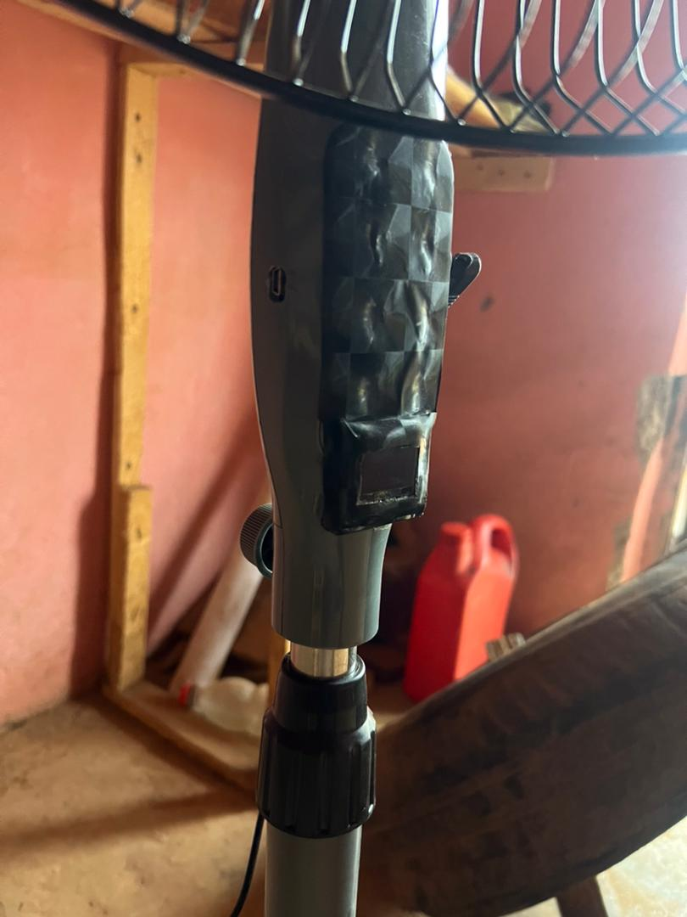
Figure 4.3: Voice controlled Fan
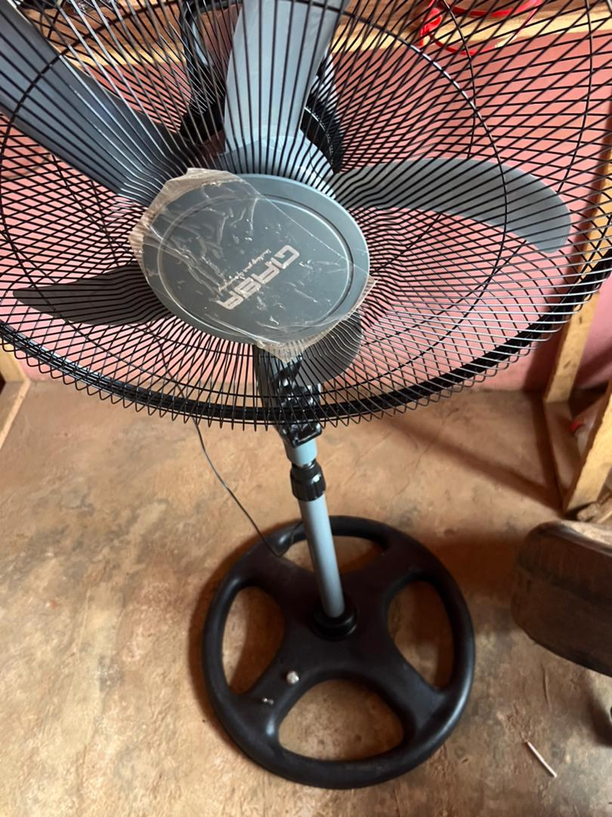
Figure 4.4: Developed Fan
Overall, the implementation of the voice-controlled smart fan demonstrates the viability of combining embedded systems with artificial intelligence techniques such as NLP to enhance everyday appliances. It showcases a step toward more intelligent, inclusive, and automated living environments.
CHAPTER FIVE
CONCLUSION, AND RECOMMENDATIONS

5.1 SUMMARY
This project explored the design and implementation of a voice-controlled smart fan system utilizing Natural Language Processing (NLP). The study aimed to develop an intelligent fan that responds to spoken commands, thereby enhancing user comfort, convenience, and energy efficiency. The background identified the challenges with traditional fan systems, such as manual control, inefficiency, and limited accessibility for physically challenged individuals. The research reviewed existing technologies in smart home automation, voice recognition systems, and the application of NLP in control systems. The methodology employed hardware components like Arduino Uno, microphone modules, motor drivers, and relays, integrated with Python-based NLP libraries to process user commands. Testing and evaluation confirmed that the system could recognize predefined commands and adjust fan operations such as turning on/off and speed control. The results demonstrated accuracy in voice recognition and system responsiveness.

5.2 CONCLUSION
In conclusion, the voice-controlled smart fan system proved to be an innovative solution in the domain of smart home appliances. By integrating Natural Language Processing with embedded systems, this project has successfully addressed the limitations of manual fan operation. The system’s ability to understand and respond to natural voice commands represents a significant advancement in Human-Computer Interaction (HCI). The use of affordable components and open-source platforms like Arduino and Python also suggests the project’s feasibility for large-scale implementation. Moreover, the system has the potential to benefit elderly or disabled individuals by offering hands-free control. Overall, this project contributes to the growing body of smart automation solutions and serves as a prototype for more complex voice-activated home appliances.

  - RECOMMENDATIONS

Based on the findings and performance of the developed voice-controlled smart fan system, several recommendations are proposed to enhance its efficiency, functionality, and user experience. These suggestions aim to address the limitations observed during implementation and testing while also paving the way for future improvements and scalability of the system.
- Enhancement of NLP Capabilities: Future systems should integrate advanced NLP models like those used in virtual assistants (e.g., Google Assistant, Amazon Alexa) to allow for more complex and conversational command processing.
- Integration with IoT Platforms: To make the system more scalable and accessible remotely, integration with IoT cloud services (e.g., Blynk, Firebase) is recommended for remote monitoring and control.
- Multi-Language Support: Expanding voice command recognition to support multiple languages and dialects would improve inclusiveness and usability in diverse communities.
- Battery Backup and Solar Power: Incorporating energy-efficient features such as solar panels or backup batteries will ensure continuous operation in areas with inconsistent power supply.
- Mobile Application Development: A complementary mobile app could provide users with an alternative control method, system status feedback, and voice training customization.
- Noise Reduction Techniques: Future improvements should include better filtering and noise reduction in the voice recognition process to enhance performance in noisy environments.

References
Alexakis, G., Panagiotakis, S., Fragkakis, A., Markakis, E., & Vassilakis, K. (2019a). Control of smart home operations using natural language processing, voice recognition and iot technologies in a multi-tier architecture. Designs, 3(3), 1–18. https://doi.org/10.3390/designs3030032

Alexakis, G., Panagiotakis, S., Fragkakis, A., Markakis, E., & Vassilakis, K. (2019b). Control of smart home operations using natural language processing, voice recognition and iot technologies in a multi-tier architecture. Designs, 3(3), 1–18. https://doi.org/10.3390/designs3030032
D, P. B., & D Sawan Kumar Gopy Gooneshwaree Hurry Tulsirai T Gopaul, P. B. (2013). A Study on Smart Home Control System through Speech. In Article in International Journal of Computer Applications (Vol. 69, Issue 19). https://www.researchgate.net/publication/327530706
Durgun Tokat Gaziosmanpaşa Üniversitesi, M. (n.d.). VOICE CONTROLLED ARDUINO BASED SMART HOME SYSTEM. https://www.researchgate.net/publication/386854194 ICONSTEM 2017 : Digital India and Smart Cities : proceedings : Third IEEE International Conference on Science, Technology, Engineering and Management : 23rd & 24th March 2017, Jeppiaar Engineering College, Jeppiaar, Nagar, Rajiv Gandhi Salai, Chennai - 600 119. (2017a). IEEE.
ICONSTEM 2017 : Digital India and Smart Cities : proceedings : Third IEEE International Conference on Science, Technology, Engineering and Management : 23rd & 24th March 2017, Jeppiaar Engineering College, Jeppiaar, Nagar, Rajiv Gandhi Salai, Chennai - 600 119. (2017b). IEEE.
Jain, A., Kulkarni, G., & Shah, V. (2018). Natural Language Processing. International Journal of Computer Sciences and Engineering, 6(1), 161–167. https://doi.org/10.26438/ijcse/v6i1.161167
Raju, K., & Professor-II, A. (n.d.). Speech Based Voice Recognition System for Natural Language Processing. https://www.researchgate.net/publication/284107344
Terzopoulos, G., & Satratzemi, M. (2020). Voice assistants and smart speakers in everyday life and in education. Informatics in Education, 19(3), 473–490. https://doi.org/10.15388/infedu.2020.21
Torad, M. A., Bouallegue, B., & Ahmed, A. M. (2022). A voice controlled smart home automation system using artificial intelligent and internet of things. Telkomnika (Telecommunication Computing Electronics and Control), 20(4), 808–816. https://doi.org/10.12928/TELKOMNIKA.v20i4.23763 VOICE-CONTROLLED SMART FAN USING NATURAL LANGUAGE PROCESSING S/N Title Authors Public ation Year Open issues Key focus Findings. (n.d.).
Yue, D., Xie, X., Chen, G., Luo, Z., Fan, L., & Sun, D. (2024). Handheld fans for dyspnoea in respiratory failure: randomised controlled trial. BMJ Supportive and Palliative Care. https://doi.org/10.1136/spcare-2024-004922

