DIGIGITAL SURVEY MODELLING
By
OGUNLADE MATTHEW KAYODE
HND/23/SGI/FT/0065

SUBMITIED TO
THE DEPARTMENT OF SURVEYING AND GEOINFORMATICS.
KWARA STATE POLYTECHNIC, ILORIN KWARA STATE.

IN PARTIAL FULFILLMENT OF THE REQUIREMENT
FOR AWARD OF HIGHER NATIONAL DIPLOMA (HND) IN
SURVEYING AND GEOINFORMATICS.

JULY, 2025

CERTIFICATE
I hereby certify that all field work and information contained in this project were obtained as a result of the observation and measurement carried out in the field by me and that the survey was executed in accordance with the survey laws, regulations and department instruction.
Name of student…………………………………
Matric No………………………………………..
Signature of student……………………………..
Date ………………………………………………

CERTIFICATION
This is to certify that Mr. OGUNLADE MATTHEW KAYODE With the Matric Number HND/23/SGI/FT/0065 has satisfactorily carried out survey duties contained therein in this project under my instruction and direct supervision.
………………………………… ……………………
MR. ABIMBOLA I. ISAU DATE
(Project Supervisor)

………………………………… ……………………...
SUV. R.S AWOLEYE DATE
(Project Coordinator)

………………………………… ……………………...
MR. ISAU ABIMBOLA DATE
(Head of Department)

………………………………… ……………………...
(External Coordinator) DATE

DEDICATION
The project is dedicated to Almighty God the giver of knowledge and understanding and to my parent MR. & MRS. OGUNLADE.

ACKNOWLEDGEMENTS
I acknowledge the love guidance and favour of God almighty for the successful completion of the programme
I also appreciate the professional of my supervisor MR. ISAU ABIMBOLA , during the course of writing this project, l shall forever be grateful to you
This acknowledge will not be complete if I did not appreciate the great work and effort of some personnel in great and noble institution; SURV. ISAU ABIMBOLA (H.O.D) Surveying and Geo-informatics
I am also grateful to all my lecture that made my stay in school inevitable and without forgetting those that contributed in several way towards the successful completion of my academic career in this institution and towards the complete of my project work most especially SURV. R.O ASONIBARE and SURV A.G AREMU, SURV BELLO FELIX DIRAN, SURV BANJI, SURV WILLIAMS KAZEEM, SURV BABATUNDE KABIR, SURV ABDULSALAM AYUBA
MY unreserved gratitude goes to my lovely mummy and daddy and my brother, sister, and my lovely Brother Ogunlade Issac for their immeasurable support financially, spiritually, love and advice towards the success of this programme may God in his infinite mercy be with you and strengthen you the more in Jesus name (Amen). I love you so much; you are such a wonderful family.

TABLE OF CONTENTS
Title page i
Certificate ii
Certification iii
Dedication iv
Acknowledgements v
Table of contents vi-viii
List of Tables ix
Abstract x
CHAPTER ONE: INTRODUCTION 1-2
1.1 Background To The Project 1-2
1.2 Aim And Objective Of The Project 2
1.2.1 Aim Of The Project 2
1.2.2 Objectives Of The Project 2
1.3 Scope Of The Project 3
1.4 Personnel 3
1.5 Study Area 4
CHAPTER TWO: LITERATURE REVIEW 5-19
2.0 Basic Concept And Definition 5
CHAPTER THREE: METHODOLOGY 20-32
3.1 Office Planning 20
3.1.1 Field Reconnaissance 20
3.2 Instrument Used 20
3.3 Monumentation 21
3.4 Tests Of Differential Gps 22

3.5 Control Check 22
3.6 Data Source 23
3.7 Geometric Data Acquisition 24
3.7.1 Attribute/ Social Survey 29
3.8 Database Creation/Implement 30
3.8.1. Database Management System (Dbms) 31
3.8.2. Data Quality 31
3.8.3 Data Integrity 31
3.8.4 Data Security 32
CHAPTER FOUR 33-48
4.0 Data Processing And Presentation 33
4.1 Spatial Analysis 33
4.2 Spatial Query 33
4.3 Query Design 34
4.4 Testing Of Database 34
4.5 Existing Parcels And Blocks 35
4.6 Spatial Query 36
4.7 Discussion Of Result 40
4.8 Multiple Criteria Query 40
CHAPTER FIVE: SUMMARY, CONCLUSION AND RECOMMENDATIONS 49-51
5.1 Summary 49
5.2 Problems Encountered 49
5.3 Conclusion 50
5.4 Recommendations 51
References 52-56
Appendix 67

LIST OF TABLES
Table 1.1: Personnel………………………………………………………………………………57
Table 3.4: Control Check…………………………………………………………………………57
Table 5.1: Costing for Recci………………………………………………………………………57
Table 5.3: Costing for Traversing………………………………………………………………57
Table 5.4: Costing for Data Downloading………………………………………………………58
Table 5.5: Costing for Data Processing…………………………………………………………58
Table 5.6: Costing for Information presentation…………………………………………………59

ABSTRACT
The project utilizes digital survey modeling to create accurate 3D models of existing conditions, infrastructure, or sites. This involves collecting data through various surveying techniques and creating detailed digital models for analysis, planning, and design.
Key Components
1. Data Collection: Gathering data through methods like detailing, topography surveying and making use of Handheld GPS and Total station
2. Data Processing: Processing and analyzing collected data to create accurate 3D models.
3. Modeling: Creating detailed digital models of the surveyed area or object.
4. Analysis and Visualization: Using the digital model for analysis, visualization, and decision-making.
Applications
1. Infrastructure Planning: Designing and planning infrastructure projects like roads, bridges, and buildings.
2. Urban Planning: Creating 3D models of cities and towns for urban planning and development.
3. Environmental Monitoring: Monitoring environmental changes and tracking progress over time.
4. Construction and Engineering: Using digital models for construction planning, monitoring, and quality control.
Benefits
1. Improved Accuracy: Digital survey modeling provides accurate and detailed data for decision-making.
2. Enhanced Visualization: 3D models enable better visualization and understanding of complex data.
3. Increased Efficiency: Streamlined data collection and processing workflows.
4. Better Decision-Making: Accurate data and analysis support informed decision-making.

CHAPTER ONE
1.0 INTRODUCTION
1.1 BACKGROUND TO THE PROJECT
Terrain models have always been a topic of interest to military personnel, planners, landscape architects, civil engineers, as well as other experts in various earth sciences. Originally terrain models were physical models, made of clay, sand, and plastic. Since the 1950s, the computer has been introduced into this area and the modeling of the terrain surface has since then been carried out numerically or digitally leading to the current discipline – digital terrain modeling (Ezeomedo, 2019). There are many ways to model elevation but we're going to focus on three digital elevation datasets in particular:
DTM - Digital Terrain Model.
DEM - Digital Elevation Model.
DSM - Digital Surface Model.
The shape of the terrain is important in earth sciences. This makes it necessary for any scientific endeavor to have a thorough understanding of the terrain characteristics. Field-based techniques including triangulation, interpolation, extrapolation, and others have been used in a variety of ways historically. Advancements in technology, such as remote sensing techniques, Light Detection and Ranging (LiDAR) technology, and Geographic Information Systems (GIS), have made it possible to collect, analyze, and visualize data about the Earth's surface with high accuracy and detail. These technological developments have significantly contributed to the study of Digital Surface Modelling (Florinsky, 2016).
Digital Terrain Models, or DTMs, represent the bare earth surface without any features such as buildings or vegetation. DTMs are created using methods similar to DSMs, such as LiDAR or photogrammetry, but require additional processing to remove objects above the ground. This process is known as “bare-earth extraction” (Hirt, 2016).
A digital terrain model has three main components:
* The surface itself.
* The elevation at each point on the surface.
* The slope at each point on the surface.

This model is similar to DSM, but it represents only the highest points on the surface of the terrain instead of every point on its surface as DSM does. DTMs can be used to create contour lines. This is useful for building roads or railroad tracks because it allows you to see if there are any obstacles such as trees or rocks in your way before you start building them. DTMs are particularly useful for terrain analysis, such as slope and aspect calculations, hydrological modeling, and geological applications (Maxwell & Shobe, 2022).
Digital terrain modeling is a process to obtain desirable models of the land surface. Such models have found wide applications in various disciplines such as mapping, remote sensing, engineering, geology etc. Therefore, digital terrain modeling has become a discipline receiving increasing attention. DTM can be considered a synonym of bare-earth DEM. DTMs are often confused with DEMs. The main difference between the two models lies in the fact that the DEM generally takes into account all persistent objects on the ground (vegetation, buildings, and other artifacts)—while the DTM shows the development of the geodesic surface (Hengl & Evans, 2009).
A Digital Elevation Model, also known as a DEM, is a type of raster GIS layer. They are raster grids of the Earth’s surface referenced to the vertical datum—the surface of zero elevation to which heights are referred to by scientists, insurers, and geodesists. At most scales and environments, a generic term like DEM can be used because the differentiation between the bare earth and a surface object is not significant, with DEMs commonly having spatial resolutions of 20m or more. Digital elevation models (DEMs) play an important role in terrain-related applications (Liu et al., 2008).
Digital Elevation Models, or DEMs, represent the elevation of the earth’s surface. DEMs can be either a DSM or DTM. The resulting model shows the elevation of the earth’s surface. The DEM is essentially a superset of the DSM and DTM. DEMs are a 3D grid of terrain elevations collected from an area with satellite imagery or LiDAR technology. DEMs are useful for visualizing landscape changes over time, creating simulations of natural phenomena like landslides and floods, and measuring land use changes over time — as well as many other applications. They can also be combined with other models to create more detailed representations of the Earth's surface (Zhou, 2017).

A Digital Surface Model or DSM captures a surface—including natural and human-made structures such as vegetation and buildings. They illustrate reflective surfaces of all features elevated above the ‘bare earth’. In short, DSMs represent the Earth’s surface and all objects on it. DSM can also be provided from stereo digital aerial photography at various resolutions, depending on the quality and scale of the aerial photography. A digital surface model represents the elevation associated with the surface of the earth including topography and all natural or human-made features located on the surface of the earth. There is a variety of DSM source data available for developed areas and the suitability of these available data depends on the project specifications. In remote regions around the World, where little or no source data are available, the DSM can be produced automatically from stereo satellite scenes, from satellite sensors such as IKONOS, SPOT-5, and Terra-ASTER (El Garouani et al., 2014).
Digital Surface Models, or DSMs, represent the topography of the earth’s surface, including all objects on it, such as trees, buildings, and other features. DSMs are created using aerial data capture methods, like LiDAR (Light Detection and Ranging) or photogrammetry. LiDAR uses laser beams to measure the distance between the sensor and the ground, while photogrammetry uses aerial photographs to create 3D models. There are many benefits of DSMs. For one, they accurately represent the earth's surface, allowing users to measure features and make decisions based on that information. 3D visualization of the Earth's surface allows users to see the surface and features in a more realistic and immersive way. This is particularly useful in applications such as urban planning and design where visualizing the impact of planned developments on the existing landscape is critical. Digital surface models offer several advantages over traditional topographic mapping. Because DSMs are typically created using LiDAR or photogrammetry, they provide high-resolution data. This means that DSMs can capture much more detail than traditional topographic maps, often based on field surveys, and may not accurately capture all features. The high-res data also provides highly accurate elevation measurements. This allows for more precise calculations of slope, aspect, and other terrain characteristics, essential for industries that model water flow and drainage (Priestnall et al., 2000).
Digital Surface Models (DSMs) find wide-ranging applications, particularly in urban planning where they provide a comprehensive depiction of both the Earth's surface and its above-ground structures. These models play a crucial role in understanding and visualizing complex urban landscapes, aiding in decision-making processes as cities evolve over time. DSMs are especially valuable in scenarios such as runway approach zone management in aviation and assessing potential impacts on views from proposed constructions in urban settings. Additionally, DSMs serve diverse purposes including visualization, disaster management, navigation, vegetation monitoring, and facilitating informed decision-making across various domains.
1.2 STATEMENT OF PROBLEM
Part of Kwara State polytechnic lacks an up-to-date topographical information system (TIS). Without accurate data about the study area, and height of features above mean sea level, planning and design processes for this project may be based on incomplete or outdated information. Without Digital Surface Modelling, decision-making related to land development or resource exploration may be less informed and could result in negative consequences for the environment or existing structures.
1.3 AIM AND OBJECTIVES OF THE PROJECT
1.3.1 AIM OF THE PROJECT
The aim of the project is to produce DIGITAL SURFACE MODELING PROJECT, generate and analyze a high resolution digital surface model of the part of kwara state polytechnic, Ilorin , moro local government, Kwara State, Nigeria using GIS approach as well as demonstrating my capability in executing projects of such calibre.
1.3.2 OBJECTIVES OF THE PROJECT
In pursuit of the overarching aim mentioned earlier, the study involved a series of specific operations designed to achieve comprehensive insights into the study area. The specific objectives were as follows:
1. Reconnaissance
2. Data Acquisition.
a) Geometric (Locational) Data Acquisition (X, Y, and Z).
b) Attribute Data Acquisition (Features description).
3. Creation of Database for Spatial entities in the study area.
4. Information Representation and Management.
5. Spatial Analysis.1.5
1.4 SCOPE OF THE PROJECT
The scope of the project covers the following:
i. Project Planning.
ii. Data Acquisition with automated Survey equipment for perimeter traversing, detailing and spot heightens.
iii. Database Design and model.
iv. Data processing
v. Visualization, information presentation, and spatial analyses.
1.6 PERSONNEL
The following individuals are the personnel that will take part in executing this project:
NAMES | MATRIC NUMBER | REMARK
OGUNLADE MATHEW KAYODE | Hnd/23/sgi/ft/0065 | AUTHOR
SHUAIB OLUWATOYIN SHUAIB | Hnd/23/sgi/ft/0063 | MEMBER
ILESANMI EASTHER OLUWASEUN | Hnd/23/sgi/ft/0056 | MEMBER
BABALOLA OLUWATOSIN O. | Hnd/23/sgi/ft/0039 | MEMBER
ADEOYE AYOBAMI LAWRENCE | Hnd/23/sgi/ft/0064 | MEMBER
ABDGANIYU MISTURA DAMILOLA | Hnd/23/sgi/ft/0111 | MEMBER
AYINLA ABDWAHAB BOLAKALE | Hnd/22/Sgi/ft/0094 | MEMBER

1.7 STUDY AREA
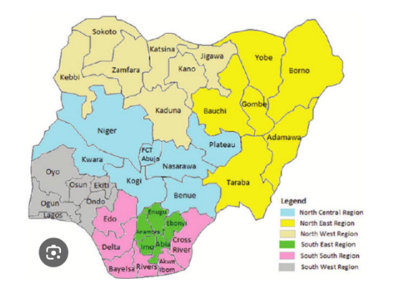
The site is part of Kwara State polythenic Kwara State, Nigeria. It is situated along Old Jebba Road and is approximate area of 4 hectares.
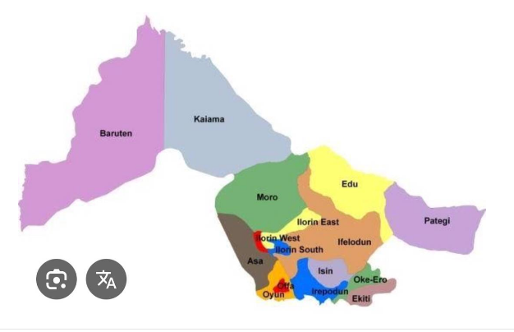

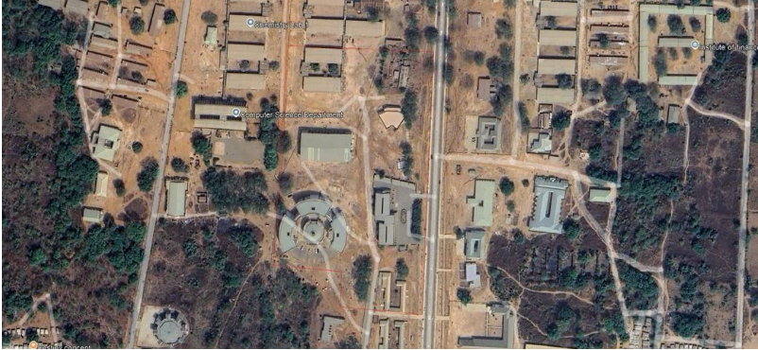

Figure 1.1:- MAP OF THE STUDY AREA

CHAPTER TWO
2.0 LITERATURE REVIEW
Digital surface modeling (DSM) using land surveying methods has become an essential tool in various fields such as civil engineering, environmental management, and urban planning. Land surveying techniques combined with modern digital technologies have enabled the accurate and efficient generation of DSMs for various applications. In this literature review, we will discuss the recent advancements and applications of DSM using land surveying methods.
Digital surface modeling (DSM) is a crucial aspect of modern land surveying methods as it provides detailed and accurate representations of the Earth's surface. This literature review aims to explore the techniques and methods used in digital surface modeling, particularly focusing on land surveying methodologies.
One of the key techniques in digital surface modeling is the use of LiDAR (Light Detection and Ranging) technology. LiDAR is a remote sensing technology that uses laser beams to measure distances to the Earth's surface. LiDAR data can be used to create high-resolution DSMs with detailed elevation information (Polewko et al., 2017).
Another commonly used technique in digital surface modeling is photogrammetry. Photogrammetry involves the use of aerial photographs to create accurate 3D models of the Earth's surface. By analyzing the overlapping images, photogrammetry software can generate detailed DSMs with precise elevation data (Fernandes et al., 2019).
Land surveying methods play a crucial role in the accurate collection of data for digital surface modeling. Traditional surveying techniques such as total station surveying and GPS (Global Positioning System) surveying are often used to collect ground control points for LiDAR and photogrammetry surveys (GSIS, 2020). These ground control points help to ensure the accuracy of the resulting DSMs.
In recent years, the integration of unmanned aerial vehicles (UAVs) into land surveying practices has revolutionized digital surface modeling. UAVs equipped with LiDAR or photogrammetry sensors can capture high-resolution data quickly and efficiently, making them ideal for creating detailed DSMs (Fann et al., 2018).
Overall, digital surface modeling using land surveying methods is a rapidly advancing field that continues to benefit from advancements in technology and methodologies. By combining traditional land surveying techniques with modern remote sensing technologies, researchers and practitioners can create highly accurate and detailed DSMs for a wide range of applications.
These elevation models are essential for creating accurate maps, topographic surveys, and aiding in infrastructure planning and design for projects like roads, bridges, and buildings). Elevation data is critical for a wide range of applications, and it’s collected through techniques like aerial data capture and LiDAR sensors, providing valuable information for urban planning, forestry, and natural resource management. Elevation data is critical for a wide range of applications in various fields. It also plays a key role in helping us better understand and manage the Earth’s resources and environment. The data is collected through various techniques, typically aerial data capture and LiDAR sensors (Lakshmi & Yarrakula, 2019).
Elevation data plays a crucial role across various domains, starting with mapping and surveying, where it enables the creation of precise maps and topographic surveys essential for urban planning, forestry, and natural resource management. In infrastructure planning and design, elevation data informs projects such as roads, bridges, and buildings by determining optimal routes, slopes, and elevations, ensuring their safety and structural integrity. Hydrology benefits from elevation data for modeling water flow and drainage, aiding in flood risk prediction, water resource management, and habitat protection. Additionally, elevation data supports environmental monitoring efforts by tracking changes in the Earth's surface over time, including erosion, land use alterations, and deforestation, thereby informing strategies to mitigate human-induced environmental impacts. Furthermore, in disaster response, elevation data assists in assessing damage caused by natural disasters, enabling emergency responders to plan relief efforts and allocate resources efficiently (Lakshmi & Yarrakula, 2019).
A digital terrain model is a topographic model of the bare earth –terrain relief - that can be manipulated by computer programs. The data files contain the spatial elevation data of the terrain in a digital format which is usually presented as a rectangular grid. Vegetation, buildings, and other man-made (artificial) features are removed digitally - leaving just the underlying terrain (on the other hand, Digital Surface Model (DSM) is usually the main product produced from photogrammetry, which contains all the features mentioned above, while a filtered DSM result in a DTM). Digital terrain models (DTMs) are of significant interest for applications such as environment planning, flood risk assessment, or building detection. DTM is considered as a continuous usually smooth surface which, in addition to height values (as DEMs) also contains other element that describes a topographic surface; slope, aspect, curvature, gradient, and others. A DTM can be derived from a DSM if the distinction between ground and non-ground pixels can be automated (Ouédraogo et al., 2014).
A digital terrain model (DTM) is a representation of surface relief encoded in a format that can be analyzed by computer. DTMs can be created using any data set which consists of several geographical coordinates with an elevation or quantity attached to each position. Data that have been represented in this way are topography, meteorological statistics (e.g. rainfall, evaporation, and temperature), and soil analysis. Other areas where the use of DTMs in data analysis could be useful are suggested. The process involved in creating the DTM is discussed. The DTM can then be analyzed by interpolation of contours at the desired scale, by interrogation at a specific point using the computer's cursor, or by producing a perspective view three-dimensional (3-D) drawing. Digital Terrain Model may be used with appropriate software to perform terrain analysis and to generate a variety of products (Forkuo, 2008).
DSMs measure the height values of the first surface on the ground. This includes terrain features, buildings, vegetation power lines, etc. DSM's therefore provide a topographic model of the earth's surface (Envirocheck.htm). This digital surface model represents the terrain elevations and surface elevation of the tree canopy and the top of the buildings. Over time, the methodologies used for DSM generation have experienced a dramatic improvement: from coarse to high-resolution elevation model generation with detailed building shapes if high-resolution data is used. Like Digital Terrain Models, Digital Surface Models contain the spatial elevation data of the terrain in digital format which is usually presented as a grid with natural and artificial features such as vegetation, buildings, etc (Zhou, 2017).
Digital surface models, or DSMs, are used for many different reasons in many different industries. One area in which they are especially useful is urban planning, where they provide a detailed depiction of the Earth's surface and its above-ground buildings, which helps with decision-making as cities develop. These models, which are frequently produced utilizing stereo photogrammetry or LiDAR (Light Detection and Ranging) technology, offer important insights into intricate urban environments, particularly as built-up areas change over time due to urban expansion. DSMs are essential for evaluating the encroachment of the runway approach zone in aviation as well as for examining the possible effects of proposed constructions on views in urban planning. DSMs are also used in decision-making processes, navigation, vegetation monitoring, disaster management, and visualization. Using LiDAR technology, for example, light pulses are emitted from a LiDAR unit, bounce off nearby objects, and then return to the sensor allowing distance measurements as well as surface geometry and material composition estimations. The generated DSMs provide detailed elevation data that can be used for a variety of applications. They capture changes in manmade buildings as well as natural features like tree canopies.
Digital Surface Model (DSM) data can be sourced from various methods, including topographic maps storing coordinate and elevation information of terrain features, remote sensing materials captured in stereo mode for generating DSMs and orthophotos, as well as laser scanning data producing point clouds. Additionally, ground-based photographs from multiple perspectives are necessary to construct photorealistic 3D models of buildings, complementing information derived from orthophotos and topographic maps, particularly for delineating building contours. DSMs find diverse applications, including urban and architectural planning, tourism, navigation systems, intelligent transport systems, urban risk forecasting, positioning of mobile phone transmitters for telecommunications, and flood risk mapping. A DSM comprehensively captures both natural and human-made environmental features, whereas a Digital Terrain Model (DTM) solely retains characteristics of bare-earth terrain, such as rivers and ridges. Importantly, a DTM can be derived from a DSM, but not vice versa (Zhou, 2017).
Digital Terrain Models represent the bare ground. DSMs include objects on the Earth’s surface, whereas DTMs do not. For most LiDAR applications, the focus is placed on the DEM and DSM as defined above, with DTMs more applicable for GIS and cartographic representations (El Garouani et al., 2014).
DTMs have been used to assist in chemical and physical analysis of soils. In this instance the x, y coordinate would be the geographic position of the soil sample and the z value would usually be some chemical concentration, physical property or pH at that point. Isolines for these properties can then be generated and displayed at the required contour interval (Al-Soghir et al., 2022).
The concept of Digital Elevation Models (DEMs) plays a crucial role in various applications, necessitating increased detail in horizontal sample spacing and vertical accuracy for precise measurements. DEMs are integral to Geographic Information Systems (GIS) and aid in visualizing landscapes and facilitating calculations for water volumes, soil erosion, and earth-moving quantities in construction projects. A wide range of applications is now drilling the requirement for increased details in Digital Elevation Models (DEMs). Details in this instance are defined by the horizontal sample spacing and vertical accuracy of the measurement. DEM is also an important utility of Geographic Information Systems (GIS). Using DEM/3D modeling, the landscape can be better visualized leading to a better understanding of certain relations in the landscape. Many relevant calculations, such as lakes and water volumes, Soil Erosion Volumes, quantities of earth to be moved for channels, dams, roads, embankments, etc (Isioye, 2011).
The generation of digital elevation models (DEMs) is a crucial aspect of topographic attribute derivation, relying on various data acquisition methods such as satellite imagery, digitizing contour lines, or ground surveys. The derivation of topographic attributes relies on digital elevation data sets that may be acquired from satellite imagery, digitizing the contour lines on topographic maps, or conducting ground surveys. Digital elevation data are typically compiled and stored in one of three data structures: (1) point elevation data on a regular grid, (2) point elevation data in triangulated irregular networks, and (3) digitized contour line data. A filtered DSM result to DTM and a DEM is considered the most important component of DTM (Menze et al., 2006).
DEMs are commonly built using data collected using remote sensing techniques, but they may also be built from land surveying. A DEM can be represented as a raster (a grid of squares, also known as a heightmap when representing elevation) or as a vector-based triangular irregular network (TIN). The TIN DEM dataset is also referred to as a primary (measured) DEM, whereas the Raster DEM is referred to as a secondary (computed) DEM. The DEM could be acquired through techniques such as photogrammetry, lidar, IfSAR or InSAR, land surveying, etc. Digital elevation models (DEMs) are very useful in solving various environmental problems such as planning and construction, hydrological and meteorological services, mining and oil industry, risk assessment, and hazard predictions, which makes their accurate production essential (Balasubramanian, 2017).
Airborne LiDAR technology offers advantages for DEM generation, particularly in urban areas, due to its shadow-free nature. However, challenges exist in filtering raw LiDAR data to extract bare earth points accurately. LiDAR technology continues to evolve rapidly, with manufacturers focusing on increasing laser pulse repetition rates to collect more data points efficiently. The competition among LiDAR sensor manufacturers drives advancements in sensor technology and data processing, leading to increased data density and improved data collection capabilities. High-density LiDAR data provide detailed terrain representations but pose challenges in data storage, processing, and manipulation due to the significant increase in data volume. Despite the challenges, LiDAR data have become more affordable, making them accessible for users in various applications (Lohani & Ghosh, 2017).
Mappers employ remote sensing techniques to prepare DEMs, with older methods involving interpolating digital contour maps or direct land surface surveys. While contour line data or sampled elevation datasets are not DEMs but rather digital terrain models, DEMs provide continuous elevation information across the study area. Mappers may prepare digital elevation models in a number of ways, but they frequently use remote sensing rather than direct survey data. Older methods of generating DEMs often involve interpolating digital contour maps that may have been produced by direct survey of the land surface. This method is still used in mountain areas, where interferometry is not always satisfactory. Contour line data or any other sampled elevation datasets (by GPS or ground survey) are not DEMs but may be considered digital terrain models. A DEM implies that elevation is available continuously at each location in the study area (Balasubramanian, 2017).
From the previously reviewed project, a lot of surveying method has been used to generate high resolution digital surface modeling, so we aim at achieving the same thing by employing the use of Dgps (Galasy G1), using land surveying method, using software like (Arc Scene 10.5, Arc Gis 10.5) to produce and visualize then after that we produce a short animation video that show the fly over of the displayed area.

CHAPTER THREE

3.0 METHODOLOGY

3.1 PROJECT PLANNING

Before beginning any survey assignment, project planning is a crucial requirement. It entails a careful investigation of the topic matter about a certain land region that is being evaluated. This crucial step in the surveying process allows the surveyor to become acquainted with the chosen location before starting work. During the reconnaissance phase, the survey's goals, requirements, and required precision levels are examined because these elements have a big impact on the choice of survey tools and techniques. In the end, this project resulted in the development of a first working diagram. Reconnaissance is divided into two phases: (i) Office Planning and (ii) Field reconnaissance.

3.1.1 FIELD RECONNAISSANCE

As part of this process, a surveyor or student must physically visit the site to gain a thorough understanding of its topography, including any vegetation, accessibility, existing frame work, as well as the social and economic 19 activities that take place there. The optimal approach and tools for improved decision-making must also be chosen. This on-site visit gives the surveyor or student a comprehensive grasp of the entire region and allows them to look at the entire area of the land. To guarantee correct orientation, the locations of all accessible horizontal and vertical controls in the region of the research area will be visited, and their outlooks will be viewed. This exercise makes it easier to create a Recce diagram, which is shown below but is not drawn to scale:

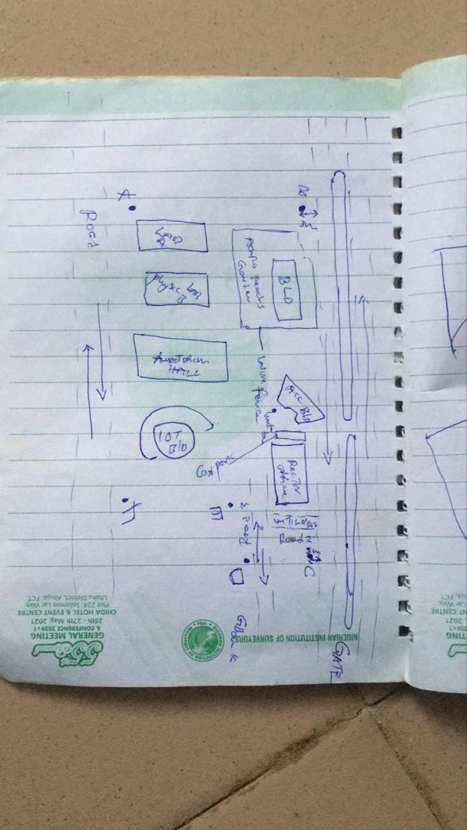

Figure 3.4: RECCI DIAGRAM

3.1.2 OFFICE PLANNING

Gathering crucial project information is the focus of this phase, which is usually done in an office setting. It is the initial phase of planning that comes before the fieldwork itself and entails gathering and analyzing a variety of project-related data. This covers a range of requirements for the project, scheduling, budgeting, and generating the coordinates for the control points under the project control prefix. It includes figuring out the best process, picking the right tools, as well as subscription for the CORS station.

3.2 EQUIPMENT USED/ SYSTEM SELECTION SOFTWARE
The following equipment was used:
- Total station and accessories
- One Tripod
- Two Prism
- One 7.5 meters short tape
- One Plumb bob
- One Cutlass
- Bottle corks and nails
- Writing materials.

3.2.1 HARDWARE USED
Model: HP 15 Note book PC
System Manufacturer: Hewlett-Packard
Rating: 1.0 Windows Experience Index.
Processor: Intel(R) Core(TM) i5-3230M CPU @ 2.60GHz, 2601 Mhz, 2 Core(s), 4 Logical Processor(s)
Installed Memory RAM: 8.00 GB
System Type: x64-based PC.
Product ID: F9F84EA#ABV

3.2.2 SOFTWARE USED
Some of the software used includes:
- AutoCAD 2007
- Notepad
- Microsoft Word 2007
- Microsoft Excel 2007
- Arc GIS 10.5

3.3 DATA ACQUISITION

This involves using different surveying methods and tools to gather data and make observations in the field. To acquire data for this project, handheld GPS and Total station were both used.

3.3.1 PRIMARY DATA SOURCE: This is a type of data source in which data is direct acquired from the field such as data acquired from field survey operations.

3.3.2 SECONDARY DATA SOURCE: This data source are already made data or gotten from research work, which has been acquired for future use. This involves downloading satellite imagery used for the project area and Google map as guide.

3.4 TEST OF INSTRUMENT
Testing of instruments is very crucial when carrying out any survey operation. Having collected the required instruments from the department, the check was carried out on the accuracy and precision of both the handheldl GPS and TOTAL STATION to ensure they were in proper working condition before the actual field observation of the project.

3.4.1 TEST FOR TOTAL STATION
The horizontal collimation and vertical index inaccuracies of the instrument were confirmed. Once the device was positioned on a rather flat surface, the required temporary modifications, including focusing, centering, and setting, were made. Configuration information, such as extra parameters and fast settings, was examined and adjusted as necessary. The configuration parameters selected collimation, namely horizontal collimation. Next, to focus on a distant object, the means' option located on the left side of the device was chosen. The instrument was transited, and the right side went through the same procedure. Then, when the 'accept' button was pushed, the table that was displayed showed the old and new values for the vertical index errors and horizontal collimation. Re-press "ok" signified acceptance of the updated values, which were minimal.
Figure 3.5: INSTRUMENT TEST

The diagrammatic representation of the procedure and the readings obtained are shown below

Table 3.4.1 COLLIMATION TEST OF TOTAL STATION
STN | SIGHT | FACE | HCR | REDUCTION | VCR | REDUCTION
A | B | L | 126º 07’ 11.33” |  | 67º 22’40”
 | B | R | 306º 07’ 31.3” | 180º 00’ 20” | 292º 37’ 1” | 359 º 59’ 41”

HORIZONTAL COLLIMATION ERROR = 180°00’20’’ - 180°
=00°00’20’’
=00°00’20’’/2 =00°00’10’’
VERTICAL INDEX ERROR=360° - 359°59’41.6’’
=00°00’18.4’’
=00°00’18’’/2 =00°00’9.2’’
The instrument's satisfactory operation was validated by the acceptance of the updated readings. It appears from this result that any possible issues can be resolved or at least greatly reduced.

3.4.2 REFERENCING AND ORIENTATION OF TOTAL STATION
Tripod Setup:
- Place the tripod over the station point (known or assumed).
- Level the tripod head as much as possible by adjusting the legs.
Mount the Total Station:
- Fix the total station onto the tripod head.
- Ensure it’s securely locked in place.
Centering and Leveling:
- Use the optical plummet or laser plummet to center the instrument exactly over the survey station mark (station point).
- Level the instrument using the foot screws and circular bubble.
- Fine-tune leveling using the electronic level display.
Power On and Instrument Configuration
- Switch on the Total Station.
- Set the correct project, coordinate system, and units.
- Select the appropriate survey mode (e.g., topographic survey or station setup).
Orientation (Station Setup)
Orientation means establishing the direction of the horizontal angle reference (back sight direction).
Orientation by Known Coordinates (Resection or Free Station)
Used when both the instrument station and a back sight point have known coordinates.
- Input the coordinates of the instrument station (or let the instrument compute it later).
- Sight and measure to one or more known reference points (minimum of 2 for better accuracy).
- The Total Station calculates the instrument position and orientation using these known points.

3.3.7 PERIMETER TRAVERSING
The perimeter of the project area was traversed for the purpose of the coordinating the boundary points. DGPS (GALAXY G1) was connected to kwara state CORS station for referencing and orientation after which all the boundary points were traversed using DGPS from the initial until each successive boundary is occupied.

3.3.8 DETAILING
All features such as roads, buildings, electric poles, street light, trees, etc. were captured by coordinating their edges simultaneously as the perimeter is being measured within the project area. Buildings were measured and identifiers (BD) were used to differentiate them from other features. Roads were also measured and labelled (RD) accordingly. Data captured here were basically in 3Dimension i.e. Easting, Nothings and Elevations (X, Y, and Z) coordinates.

3.3.9 REMOTE ELEVATION MEASUREMENT
All the features such as buildings, electric poles, street light, etc. captured by coordinating their edges from a subsidiary traverse stations created within the project area. Buildings heights were measured and recorded. Electric poles height were also measured and recorded accordingly. So also the same was repeated for the trees. Data captured here were basically in 3Dimension i.e. Easting, Nothings and Elevations + Heights (X, Y and Z + H) coordinates. The following procedures were followed:
- Escape key was pressed then F1 for MENU
- The REM programme was selected.
- Observation was made again and the height of reflector was displayed.
- The telescope was tilted to the top of the object and the height keeps changing until F4 is been pressed to stop.
- The value was recorded.
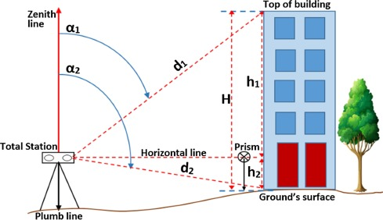
Figure 3.3.9: REM OBSERVATION STRATEGY

3.3.9A SPOT HEIGHTINGS
This was carried out by occupying randomly the subsidiary points within the project area and taking measurements (Easting, Nothings and Heights) along the terrain at approximate intervals to determine the difference in height between points and some areas within the project location. Spot heighten is very important in producing topographical information of the area with the aid of ArcGIS 10.5.

3.4 PHYSICAL DESIGN
At this stage, all geospatial (attribute) data were structured and organized to form a database in a format acceptable by the implementing software and hardware. This was done in a way that, stored information can be accessed and retrieved at any time. Also, for regular updates when the need arise and to allow for analytical functions to be carried out answering generic questions. Also, it provided integrity and security that must be obeyed before such data could be accepted into the records. These virtues are as show in the tables below. ArcGIS 10.5 was used for database creation of the project area.
Table 3.4A TREE TABLE
ATTRIBUTE | DATA TYPE | WIDTH | DECIMAL
T_ ID | String | 5 | -
T_NAME | Float | 20 | -
EASTING | Number | 10 | 3
NORTHING | Number | 10 | 3
T_USE | Float | 10 | -
T_HEGHT | Number | 7 | 3

Table 3.4B ROAD TABLE
ATTRIBUTE | DATA TYPE | WIDTH | DECIMAL
POINT_ID | String | 10 | -
NORTHING | Number | 10 | 3
EASTING | Number | 10 | 3
RD_HEIGHT | Number | 7 | 3

Table 3.4C ELECTRIC POLE TABLE
ATTRIBUTE NAME | DESCRIPTION OF ATTRIBUTE | DATA TYPE | WIDTH | DECIMAL
POINT_ID | Electric pole identifier | Number | 6 | -
NORTHING | Coordinate | Number | 15 | 3
EASTING | Coordinate | Number | 15 | 3
EP_TYPE | Type of Electric pole | Text | 15 | -
EP_HEIGHT | Height of the Electric pole | Number | 5 | 2
Table 3.4D BUILDING TABLE
ATTRIBUTE | DATA TYPE | WIDTH | DECIMAL
P_ID | String | 15 | -
NAME | Text | 15 | -
CONDITION | Text | 15 | -
USE | Text | 15 | -
HEIGHT | Number | 15 | 2
AREA_METERS | Number | 15 | 2

Table 3.4E STREETLIGHT TABLE
ATTRIBUTE NAME | DESCRIPTION OF ATTRIBUTE | DATA TYPE | WIDTH | DECIMAL
POINT_ID | Street light identifier | Number | 6 | -
NORTHING | Coordinate | Number | 15 | 3
EASTING | Coordinate | Number | 15 | 3
SL_HEIGHT | Height of the street light | Number | 5 | 2

3.5 DATABASE CREATION
Database is an organized integrated collection of data stored so as to be capable of use by relevant application with data being accessed by different logical part. This was the construction phase where database was created. After the table has being populated via the keyboard, some attributes such as area, perimeters of parcel were automatically displayed by special command in the ArcGIS 10.5 version.
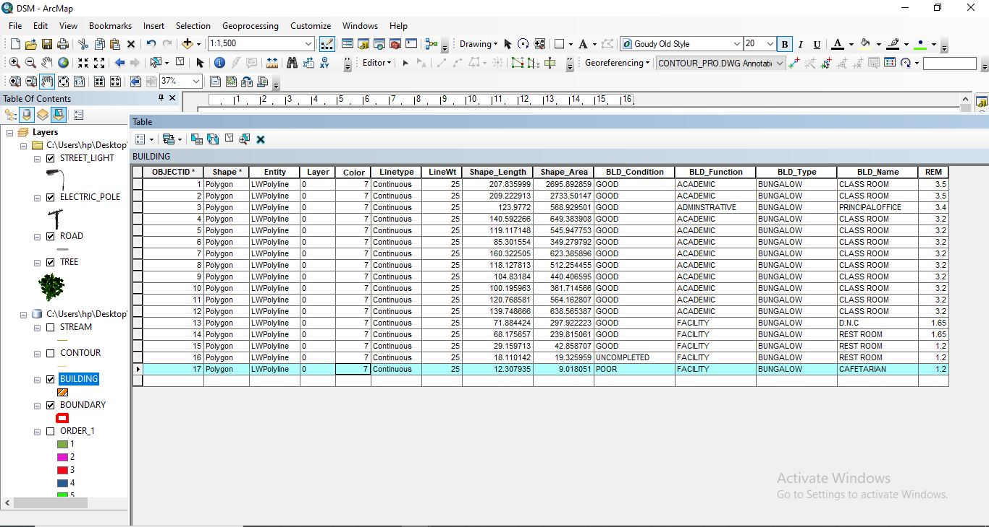
Figure 3.5: ABSTRACTED OF TABLE CREATED

3.5.1 ATTRIBUTE DATA ACQUISITION
The data about the characteristics of features especially man-made features were acquired through oral interview method and online source (Google Earth). Social survey was carried out during which information such as; building name, building use and related data about features were obtained from the students and staffs within the school. All these data formed the attribute aspect of the feature necessary for the database creation.

3.6 DATA PROCESSING

3.6.1 TOTAL STATION DATA DOWNLOADING PROCEDURE
Data downloading is the process of transferring data from the instrument into the computer system connected through the connection cable or wireless such as Bluetooth with the help of software in the computer, the process is as follows as performed on Total station.
- Connection of the two devices (computer and the instrument).
- Go to project working folder created on the instrument.
- Click on export.
- Input the name of file
- Indicate the file extension for the output
- Permit the other device to receive the file.

3.6.2 DRAFTING AND PLOTTING
The script file created containing the refined coordinates was then opened in the AutoCAD environment and the boundary of the project area was plotted using AutoCAD 2007. This was followed by the details, which included buildings, roads, trees, sport facilities and electric poles.
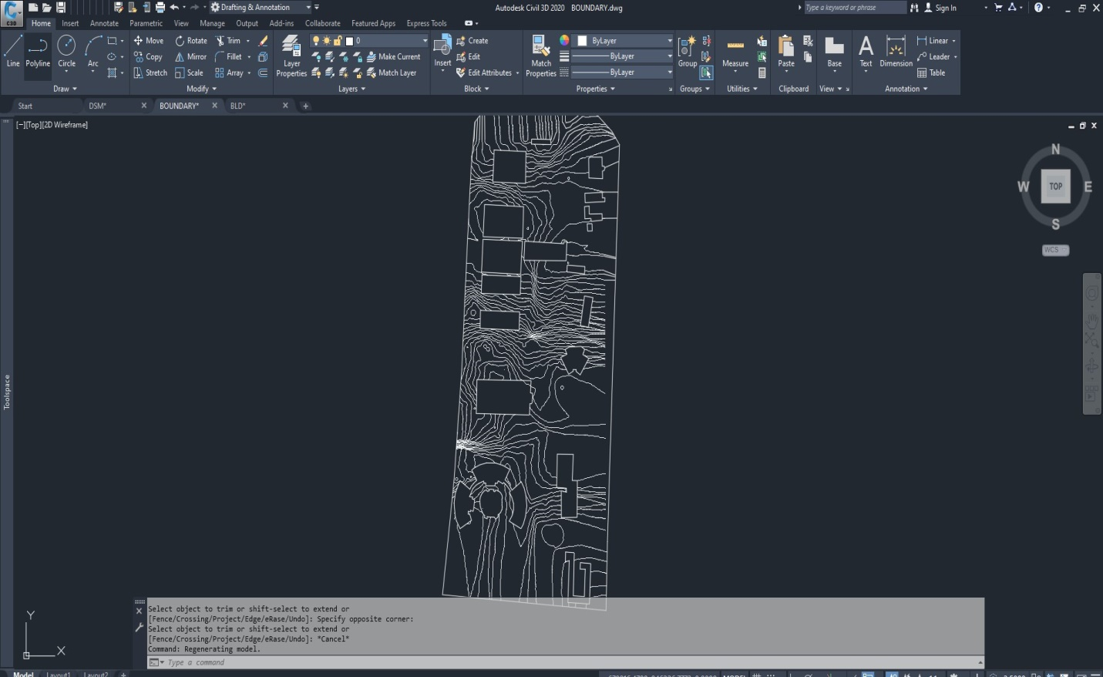
Figure 3.6.2: AUTOCAD PLOTTING.

3.7 DATABASE MANAGEMENT

3.7.1 DATA SECURITY
This is the security measure used the protection of the database security is very important since it is vital for data integrity. The strategic measure used included controlling access to database by use of password.

3.7.2 DATA INTEGRITY
This ensures that data in the database is accurate and that cases of violation of integrity can be detected automatically by the system. Here, care was taken while entering data into the system, such that, accurate data were entered and updating could be done accurately without tampering with existing data. Backups are provided to cater for any loss of data through system failure. Also a member of the project group was appointed for quality assurance and checks therefor do checks the consistency, accuracy and integrity of the input data.

3.8.3 DATABASE MAINTANANCE
Having created the database, proper maintenance practice was made to meet its stated objectives. The ability to include more data and remove irrelevant data can be possible. There is every need for the data to be updated regularly because of the physical changes that tends to occur on the landscape with time, even as a result of development.
Both security and integrity were also exercised to ensure maintenance and to meet its stated objectives.

CHAPTER FOUR

4.0 SPATIAL ANALYSIS AND INFORMATION PRESENTATION

4.1 TESTING OF DATABASE
This is the test carried out to determine whether the relationship between the spatial data of a feature and their attributes is capable of being retrieved. This is necessary to ascertain the quality of data in the database, its reliability to satisfy the demand of the user. The spatial data were arranged logically in an organized manner with respect to their attributes. This was carried out by designing a sample query and running the query to see if the desired result would be achieved. In this project, the database was queried to show different categories of information levels in the project area. Hence the database was confirmed fit for analysis. A sample of the attribute table in the database design can be found on the next page.
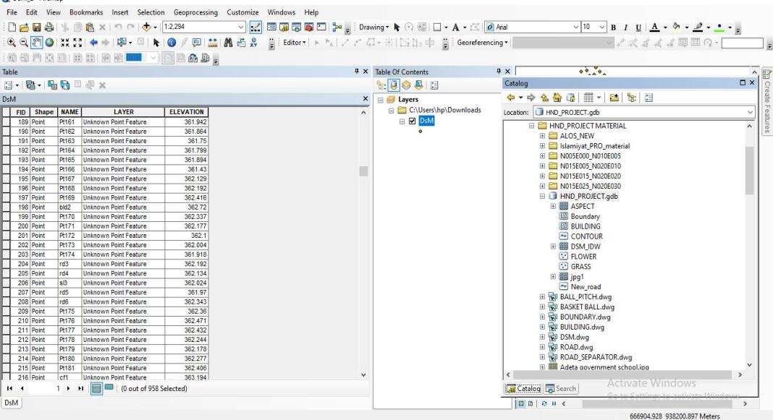
Figure 4.1: SAMPLE OF ATTRIBUTE TABLE

4.2 SPATIAL QUERY
Queries were designed for the purpose of retrieving information from the database. The queries performed in this project gave answers to certain generic questions asked from the database. This was made possible as a result of the implicit link of both the spatial and attributes data. The queries were based on the products from the analysis carried out on the database.

4.2.1 SINGLE CRITERIA QUERY
A single criterion is carried out where one condition is used to design query. This condition is used to retrieve the information from the database.
QUERY ANALYSIS 1 (selection by attribute)
ANALYSIS ONE
Analysis Name: Database extraction
Analysis Type: Single criteria analysis
Syntax: Query analyses showing buildings that are used for Administrative.

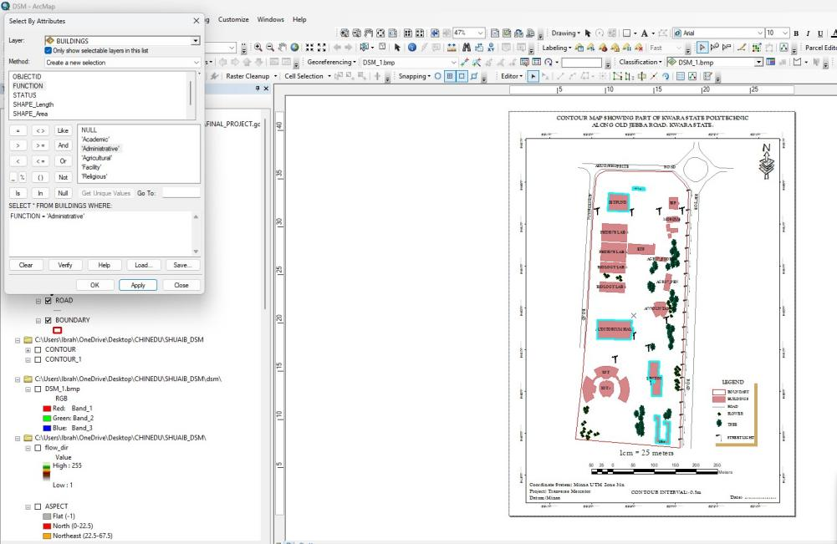
Figure 4.2.1.1 RESULT OF QUERY: (BLD_FUNCTION = “ADMINISTRATIVE”).

Analysis Name: Database extraction
Analysis Type: Single criteria analysis
Syntax: “BLD_ Function” =”Agricultural”
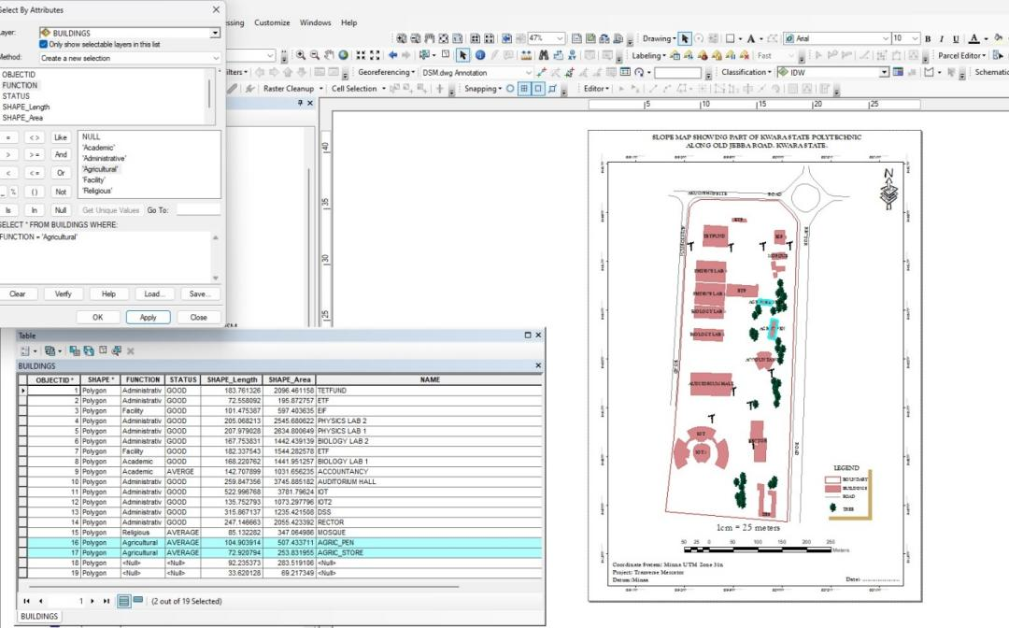
Figure 4.2.1.2: RESULT OF QUERY: (BLD_FUNCTION = “AGRICULTURAL”).
ANALYSIS THREE
Analysis Name: Database extraction
Analysis Type: Single criteria analysis
Syntax: “BLD_ CODITION” =”ACADEMIC”
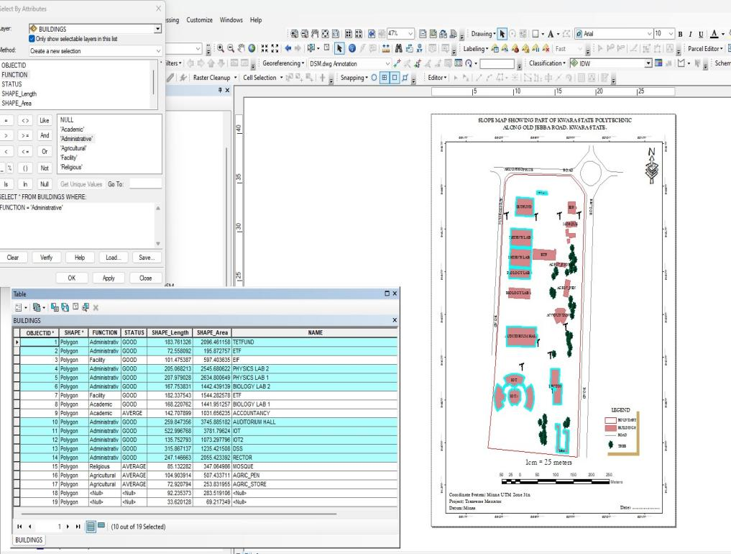
Figure 4.2.1.3: QUERY BLD_FUNCTION"ACADEMIC"

ANALYSIS FOUR
Analysis Name: Database extraction
Analysis Type: Single criteria analysis
Syntax: “TREE_FUNCTION= ORNAMENT”
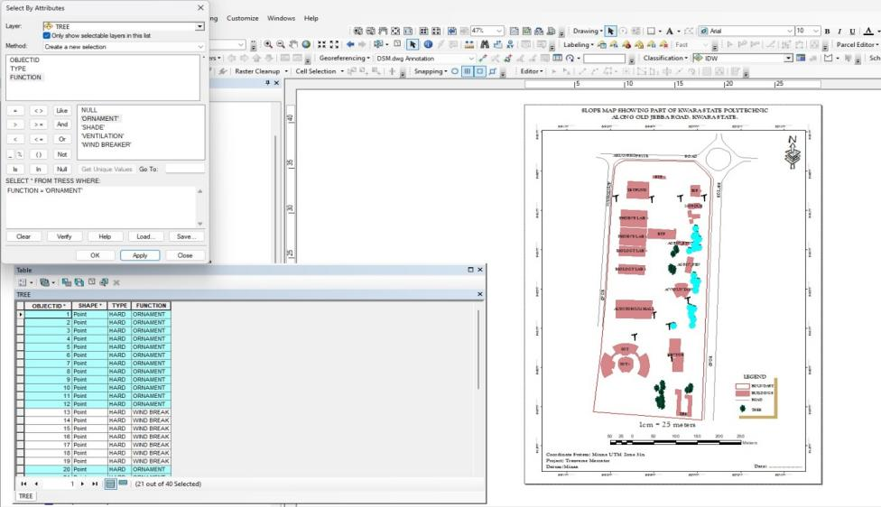
Figure 4.2.1.4: RESULT OF QUERY: (TREE_FUNCTION “ORNAMENT”).

4.2.2 MULTIPLE CRITERIA
This is a situation where two or more conditions are used to design a query. The conditions determine the information that may be requested by the user from the database.

Query for QUERY: TREE_FUNCTION “ORNAMENT” AND TREE_TYPE “HARD”
ANALYSIS FOUR
Analysis Name: Database extraction
Analysis Type: Multiple criteria analysis
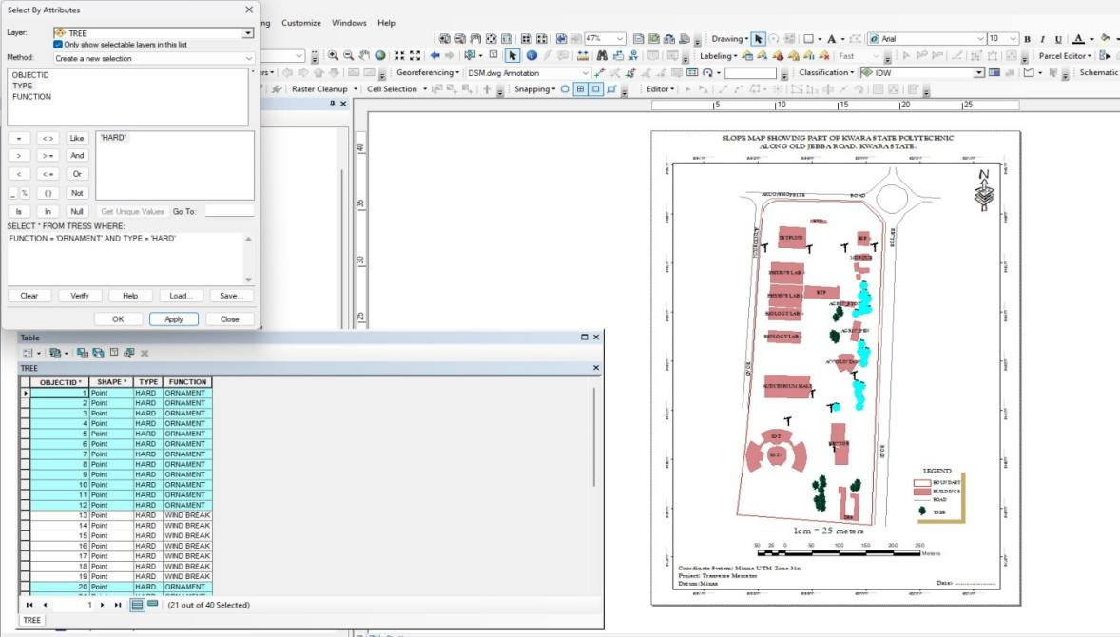
Figure 4.2.2.1 RESULT OF QUERY: TREE_FUNCTION “ORNAMENT” AND TREE_TYPE “HARD”
Query for BLD_FUNCTION =“RELIGIOUS” AND BLD_STATUS= “AVERAGE”
ANALYSIS FOUR
Analysis Name: Database extraction
Analysis Type: Multiple criteria analysis
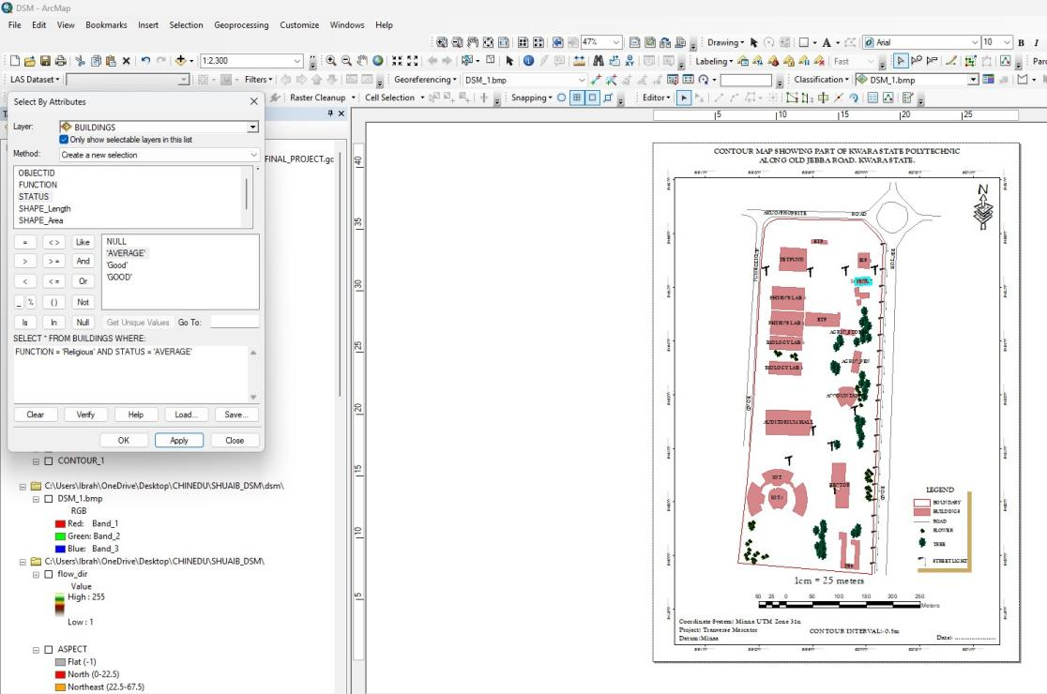
Figure 4.2.2.2 RESULT OF QUERY: BLD_FUNCTION =“RELIGIOUS” AND BLD_STATUS= “AVERAGE”

4.2 SPATIAL ANALIYSIS
This makes Geographic Information System (GIS) a unique analytical tool or technique because of its ability to combine spatial attribute data to produce information relevant for decision making. The basic GIS analysis performed in this project includes overlay and topographic operations. Maps on various themes were overlaid since they were from the same geometric origin.

4.2.1 OVERLAY OPERATION
This overlay operation is the presentation that shows different features within the project area. The outcome of overlay operation could be composite plan if it shows all the existing features, and boundary.

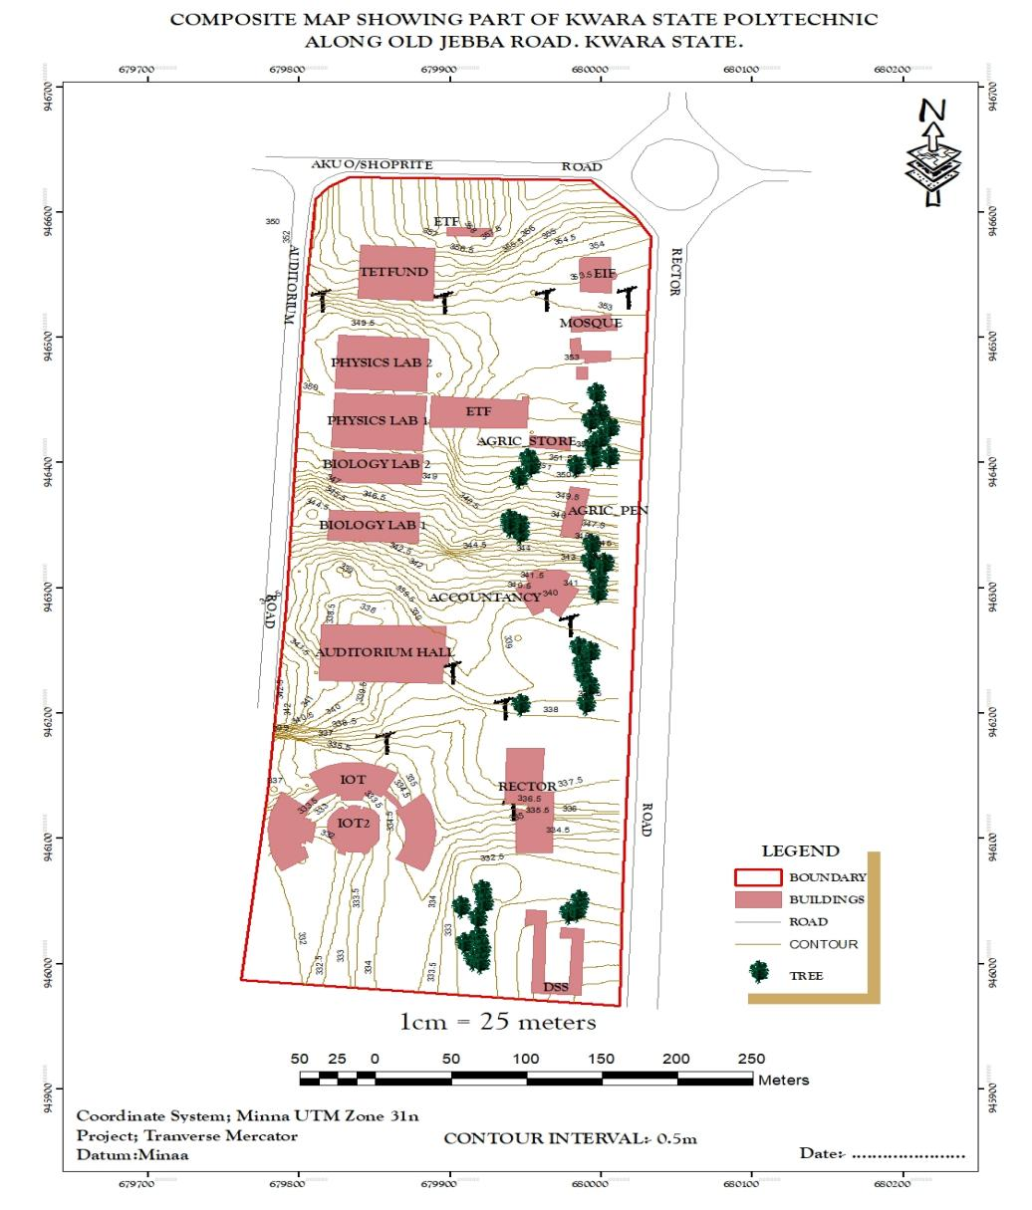
Figure 4.2.1: COMPOSITE MAP OF THE PROJECT AREA.

4.2.2 TOPOGRAPHICAL OPERATIONS
Topographic operations were carried out to determine the surface characteristic of the area which showed the relief of the project. These operations were performed on the Digital Elevation Model (DEM) generated from the use of relevant software, in this case, ArcGIS 10.5 and ArcScene 10.5 was used. The following maps were produced from the topographic operations and analysis:
- TRIANGULATION IRREGULAR NETWORK (TIN): this shows series of triangulated surface automatically generated from ArcGIS 10.5 using 3D analysis tools. This is applicable in finding suitable place for building or any engineering construction
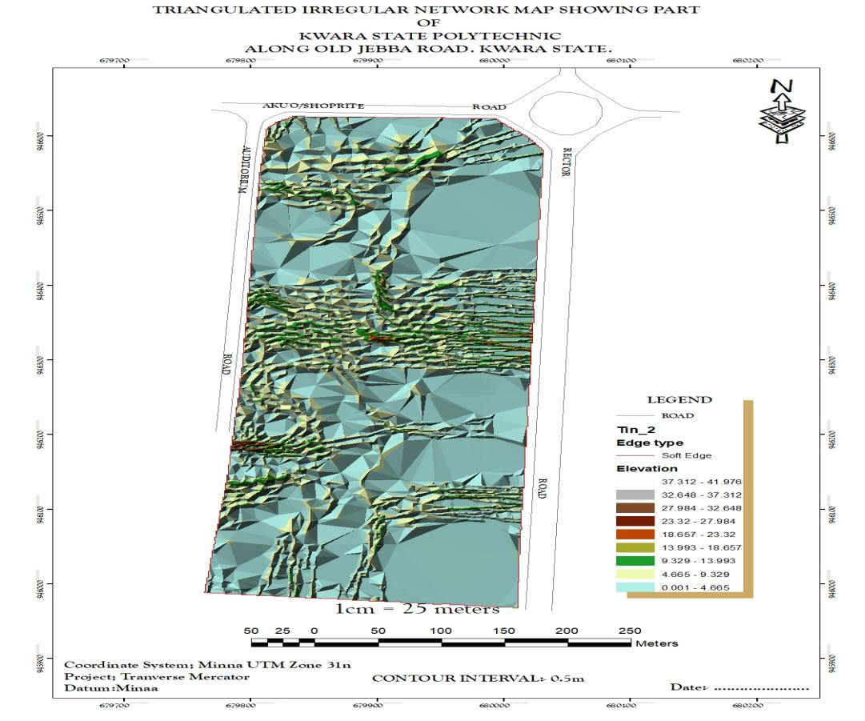
Figure 4.2.2.1: TIN AND DETAILS OVERLAY MAP OF THE PROJECT AREA
- SLOPE MAP: A slope map represents the gradient or steepness of the terrain's surface. It calculates the rate of change in elevation between neighboring pixels or points on a digital elevation model (DEM). Typically, slope is measured in degrees or percentage. Steeper slopes are represented by higher values, while flatter areas have lower values.
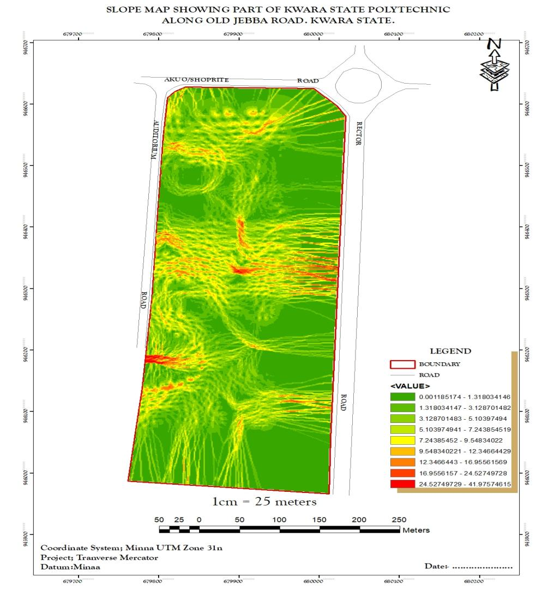
Figure 4.2.2.2: SLOPE MAP OF THE PROJECT AREA
- THE ASPECT MAP:
This shows the direction of the surface faces. It is used to determine how much sun a hill received and the information can be used to put building where they will get enough sun. Also the aspect map shows the suitable place for plane landing i.e. the flat terrain area and also solar illumination which can affect the diversity of life i.e. Vegetation and soil studies; glaciology.

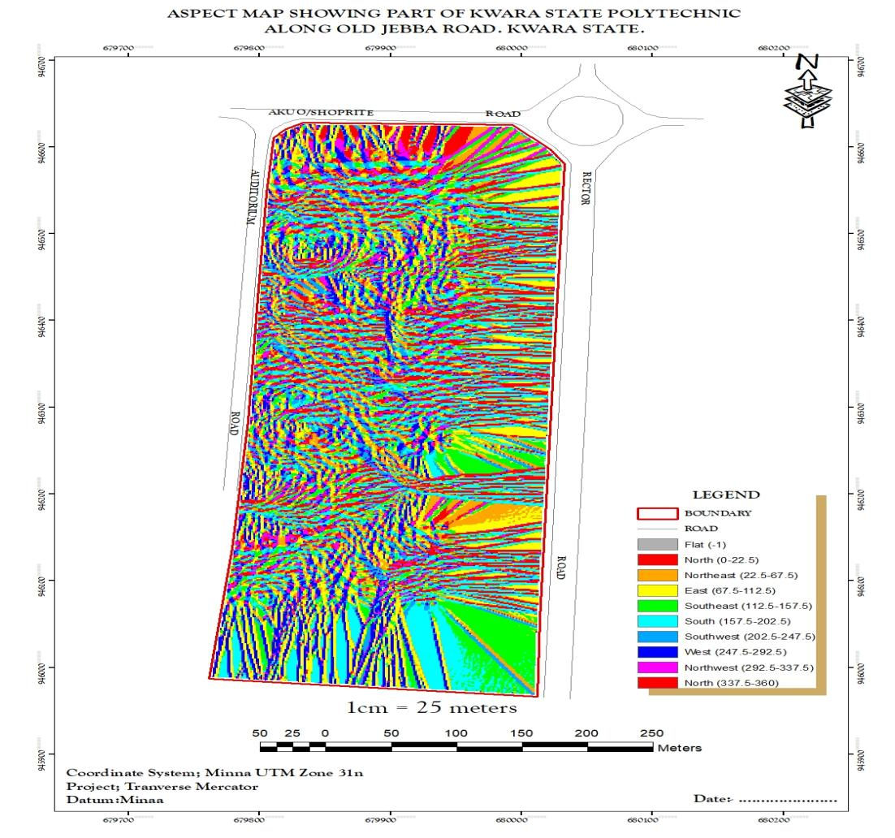
Figure 4.2.2.3: ASPECT MAP OF THE PROJECT AREA.
- THE CONTOUR MAP:
Contour maps display lines connecting points of equal elevation on the terrain surface. These lines, called contour lines, depict the shape and elevation of the land. Contour maps are widely used in topographic mapping and land surveying for visualizing elevation changes and terrain features. This provides a very intuitive view of the landscape. Contour map of the project area can aid in giving information on the highest and the lowest point on the terrain. This is important in road construction and location of other facilities like storage tanks for water distribution.
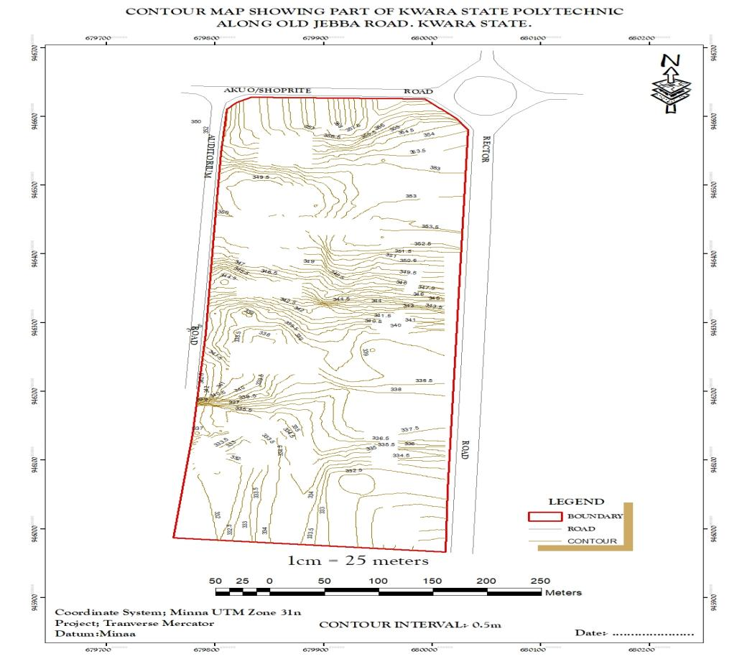
Figure 4.2.2.4: CONTOUR MAP OF THE PROJECT AREA.

- FLOW DIRECTION MAP:
This is used to determine the direction of flow of water within the project area. It also indicates the magnitude and erosive force water passing through an area.
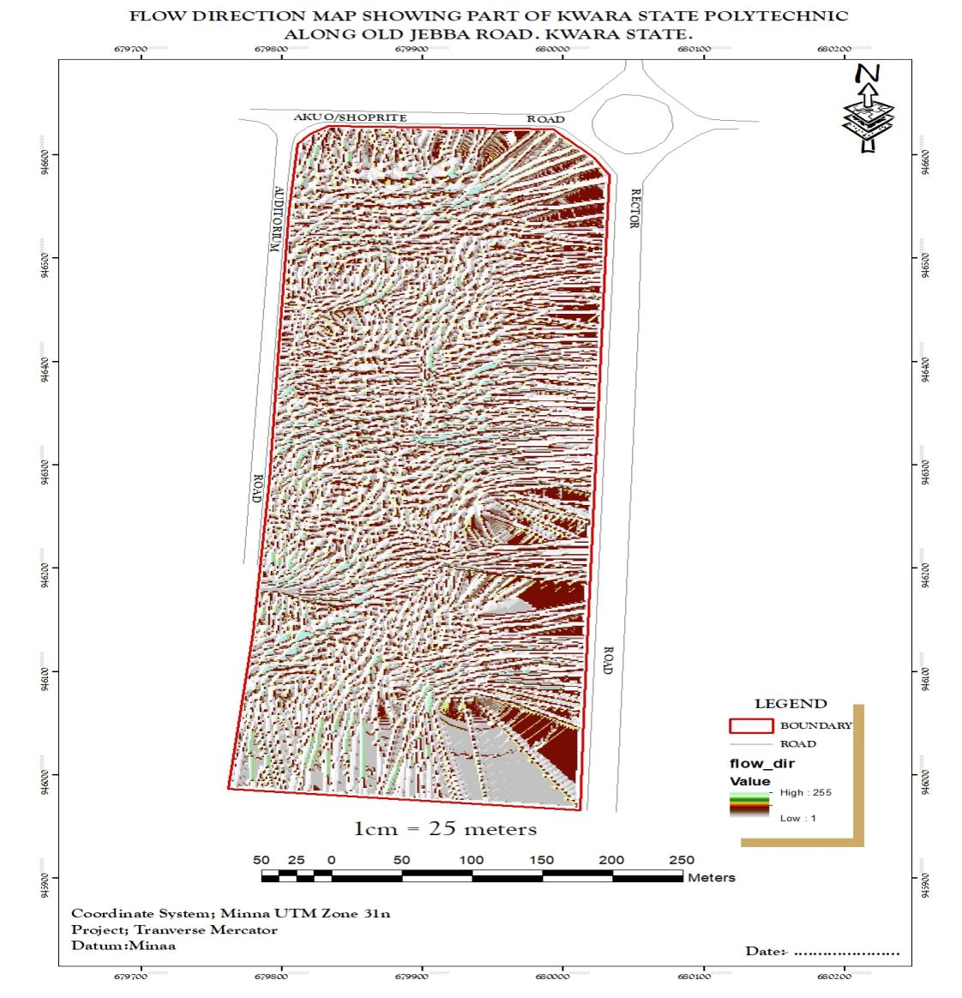
Figure 4.2.2.5 FLOW_DIRECTION MAP OF THE PROJECT AREA
- DIGITAL SURFACE MODEL MAP:
A DSM (Digital Surface Model) map, or Digital Surface Model, represents the elevation of the Earth's surface including all objects on it, such as buildings, vegetation, and other structures. Unlike a DTM (Digital Terrain Model), which only includes the bare-earth surface, a DSM incorporates both natural and man-made features. DSMs are useful for various applications, including urban planning, infrastructure design, and 3D visualization. They are often derived from aerial or satellite imagery, LiDAR data, or photogrammetry techniques. This shows the reality of the terrain of the project area.
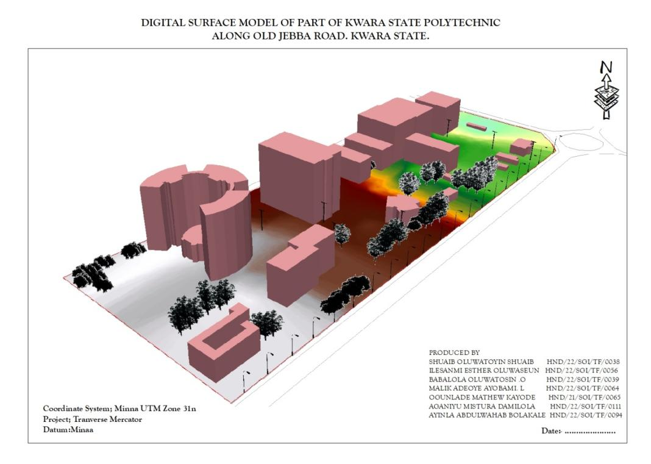
Figure 4.2.2.6: DIGITAL SURFACE MAP OF THE PROJECT AREA

4.3 RESULT ANALYSIS
From the below pie chart, it is inferred that large percentage is serving academic function. The DSM project commenced with the utilization of a Total station referenced to control station within kwara state polytechnic to capture 3D data of the project area. The captured data were then processed using software, employing photogrammetry techniques to generate a high-precision DSM and create a detailed 3D model. Subsequently, ArcGIS and ArcScene software was employed to visualize and analyze the DSM data, facilitating spatial analysis and information presentation both in 2D and 3D respectively.
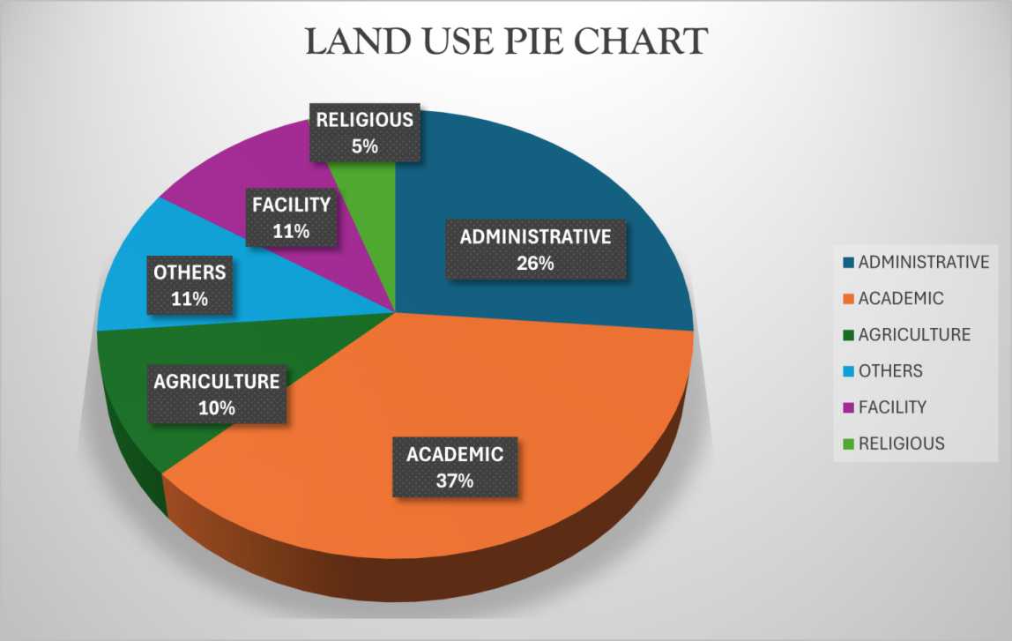
Figure 4.2.2.7: LAND USE PIE CHART

4.4 APPLICATION OF PROJECT
- Generally DSM is applicable in urban development modeling.
- It enhanced visualization and communication of such data not only in maps modeling but also in mobile digital devices for quick navigation and assessment.
- To create a sustainable and favourable living environment.
- Positioning and monitoring of physical features, structures and engineering works on, above or below the surface of the earth to protect properties or investment.
- The feasibility studies through the use of line of sight analysis provide visibility between two points. This is good for network distribution in telecommunication.
- The profile graph is good road construction which will provide the cross section of the topography from which rivers, streams and depression can be shown. Points require bridges, culverts and filling can be known from the profile graph.
- The vector map shows the direction of rivers, streams and depression which helps in road construction.
- The aspect map shows the direction of the surface faces. It is used to determine how much sun a hill received and the information can be used to put building where they will get enough sun also used to find where different crop will do best and also the Converging/diverging flow; soil water properties.
- The aspect map shows the suitable place for plane landing i.e. the flat terrain area and also solar illumination which can affect the diversity of life i.e. Vegetation and soil studies; glaciology.
- The result from the analysis can be help in managing the land resources of the project area. With the DSM, adequate information has been provided for proper decision making on the school land. Proper allocation various land use can now be done without difficulty in the decision making process.
- The slope map which is used to find low- slope for potential construction site and high slope that may be vulnerable to erosion or landslide.
- Also, the slope map shows slope length which is important topographical parameters for soil erosion analysis and traditional soil erosion studied
- Contour map of the project area can aid in giving information on the highest point on the terrain as well as the lowest. This is important in Road construction and location of other facilities like storage tank for water distribution.

CHAPTER FIVE
5.0 SUMMARY, CONCLUSION AND RECOMMENDATION.
5.1 SUMMARY
Conclusively, the primary goal of this project involves generating a Digital Surface Model, part of kwara state polytechnic, within the Ilorin West L.G Area. Initial phases included a review of pertinent literature and the highlighting of previous research. Subsequently, data acquisition employed digital land survey techniques, followed by processing utilizing relevant ArcGIS software tools.
Post-processing involved the creation and implementation of a database conforming to established rules and conventions. This phase succeeded through the utilization of software tailored to the project's processing, analysis, and presentation needs, such as ArcGIS. Information dissemination occurred digitally, through both hard and soft copy map formats. A comprehensive report detailing all project procedures was compiled, encompassing every aspect of the endeavor.
5.2 PROBLEMS ENCOUNTERED
The problem encountered in the course of carrying out this project was:
i. Refusal of the management of the Institution to approve the letter of permission given to us initially, which delays the execution of the project in time.
ii. Harsh weather condition as there is burning sun on the of data acquisition
iii. Financial challenges
5.3 CONCLUSION
As result of dynamism in technology and the need for spatial information in digital format, the acquisition and management of topographic information is a basic necessity for every development. The use of digital equipment and GIS application have become a veritable tool that must be used by all and sundry if the needed high accuracy spatial information system must be provided for spatial decision making. This will in turn aid physical and economic development, hence sustainability of the landscape in question and the environment at large.
Aim of developing a DSM for the project was achieved through the application of GIS to the topographical surveying of the project area by the use of ArcGIS 10.5 and ArcScene 10.5 software for the product generation and Topographic analysis.
5.4 RECOMMENDATIONS
Having considered various stages undergone in this project, I hereby recommend as follows;
i. The school authority should acquire survey site vehicle for easy mobility of the student and equipment to and fro from their various project site so as to protect the life of both students and equipment instead of using motor cycle and public cabs.
ii. The school should at least establish a central spatial database within the school environs by making use of the supervised students final project and practical as an input into database.
iii. There should be mass sensitization on the need to have topographic information in digital format since this is easier to review and update.
iv. There should be detailed topographic mapping of any portion of the land before any physical development on the said parcel can be embarked on.

REFERENCE
Adriana, A. and Nicholas, Y. (2002).“Sustainable Urbanization: Bridging the Brown and GreenAgenda”. University College London pp 31-35.
(Charles D. Ghilani& Paul R. Wolf 2008): Elementary surveying An introduction to Geomatics_12th edition
Harrison, JD, Birrell, SJ, Sudduth, KA and Borgelt, SC (1992).Global positioning
system applications for site-specific farming research. Proc ofASAE, Nashville, Tennessee, Paper no. 92-3615.
Keeble, Lewis (1969). Principles and Practice of Town and Country Planning,).In Shrapnel Urban Planning http://www.shrapnel.com.au/planning.htm.
Kufoniyi, O. (1998):Database Design and Creation in C.U. Ezeigbo, Principles and Application of Geographic Information System. Pp. 46.
Li, (1994); Maume et al., (2001); Li et al., (2005) Jobin, (2010): Digital terrain modellingprinciples and methodology. Pp. 7 - 9. CRC Press. Boca Raton.
Maune, D.F., Huff, L.C., and Guenther, G.C. 2001.DEM user applications. In: Maune,
D.F. (Ed.), Digital Elevation Model Techniques and Applications: The DEM User
Manual, American Society for Photogrammetry and Remote Sensing, Bethesda, MD,
pp. 367–394.
Moore and Foster, (1990): Terrain Modelling in Surveying and Civil Engineering, Computer Aided Design, Vol. 19/4, Pp. 173.
Ndukwe, N.(2001): Digital Technology in Surveying and Mapping, principle, Application and Legislative Issues RhyceKerex Publishers, Enugu pg. 18-21.
Nkeki, F. N. (2013a). Living near high-voltage power lines: GIS-based modeling of the risk in Nigeria’s Beninregion.Applied GIS, 9(1), 1-20.
Office of University Planning (1997).Planning Principles and Premises for Physical Developmenthttp://www.gov.ms/ministries/ppunit.htm.Accessed on the 19th November,2006.
Remondino, F., Gruen, Armin & Zhang, L. (2006) – High resolution satellite imagery for 3D modeling and visualization of cultural heritage sites. The journal of survey. V.56, 30-33.
Toutin T. & Gray, L. (2000) - State-of-the-art of elevation extraction from satellite SAR Data. ISPRS Journal of Photogrammetry and Remote Sensing, Vol. 55, No 1, pp. 13-33.
Wilson, J.P. and Gallant, J. (Eds.) 2000.Terrain Analysis: Principle and Applications.
John Wiley & Sons, Singapore.
COSTING OF THE DIGITAL SURVEY MODEL OF PART OF KWARA STATE POLYTECHNIC
RECONNAISANCE

S/NO | PERSONEL OFFICER | DAYS | UNIT RATE | AMOUNT
1 | Senior Surveyor | 1 | 10, 000 | 10,000
2 | Technical Officer | 1 | 40, 000 | 40,000
3 | Skill Labour | 1 | 5,000 | 5,000
4 | Transportation | 1 | 20,000 | 20,000
5 | Basic Equipment | 1 | 5,000 | 5,000
 | Total |  |  | 83,000

DETAILING AND SPOT HEIGHT
S/NO | PERSONNEL OFFICER | DAY(S) | UNIT RATE | AMOUNT
1 | Senior suveyor | 4 | 40,000 | 40,000
2 | Technical Officer | 4 | 20,000× 8 | 160, 000
3 | Basic Equipment (Total Station) | 4 | 80,000 | 80,000
4 | Transportation | 4 | 5,000 | 20,000
 | Total |  |  | 300,000

DATA PROCESSING

S/NO | PERSONNEL OFFICER | DAY(S) | UNIT RATE | AMOUNT
1 | Principal Surveyor | 5 | 10,000 | 10,000
2 | Senior Surveyor | 5 | 8,000 | 8,000
3 | Assistant Technical Surveyor | 5 | 5,000 | 5,000
4 | Computer Accessories | 5 | 15,000 | 15,000
 | Total |  |  | 190, 000

INFORMATION PRESENTATION
S/NO | PERSONNEL OFFICER | DAY(S) | UNIT RATE | AMOUNT
1 | Senior Surveyor | 1 | 10,000 | 10,000
2 | Technical Officer | 1 | 8,000 | 8,000
3 | Standard Set (Computer Plotter) | 1 | 15,000 | 15,000
 | Total |  |  | 33, 000

TECHNICAL REPORT
S/NO | PERSONNEL OFFICER | DAY(S) | UNIT RATE | AMOUNT
1 | Chief Surveyor | 1 | 30, 000 | 30, 000
 | Principal Surveyor | 1 | 20, 000 ×2 | 40, 000
 | Total |  |  | 70, 000

SET OF PROJECT | 676, 000
Mobilization (10% of the project) | 67, 600
Contingency (5% of the project) | 33, 800
Total cost on the project | 777, 400
CAT (5% of the project) | 38, 870
Grand total | 816, 270

APPENDIX PAGE
I. PROCESSING WITH ARCGIS
II. ARCGIS PROCEDURE
III. LIST OF COORDINATE

PROCESSING WITH ARCGIS
i. Launch ArcMap.
ii. Cancel the dialog box displayed which contained an existing file.
iii. Click on file menu, select extension, click the available extensions and click OK.
iv. Click on file, select new project and in a small dialog displayed, click on add data.
v. Select the directory containing the AutoCAD drawing and import the drawing into the ArcGIS environment.
vi. Select the directory containing the AutoCAD drawing and import the drawing the ArcMap environment.
vii. A new window is displayed containing the imported drawing.
viii. Convert it to shape by clicking on ArcCatalog theme menu. In the ArcCatalog, Tool box displayed, click feature and select output directory and give the name of the new shape file by clicking on it.
i. Give a name for each polygon

CREATING A PERSONAL GEO-DATABASE
Creating a new personal geo-database involves creating .mdb file on the disk. To create a new personal geodatabase using ArcCatalog, the steps are as follows:
To create a new geo-database using ArcCatalog, the following are the steps:
i. Right click the file folder in the ArcCatalog tree where you want to create the new personal geo-database.
ii. Click on new.
iii. Click on file geo-database. ArcCatalog will create a new file geo-database in the location you selected.
iv. Rename the new file geo-database by right clicking on it and choose Rename.
v. Click finish.
TABLE CREATION
Make the theme active and right click to select open attribute table.
i. Right click and select add field and give the field name, its width, select data
Type and click OK.
ii. Go to editor table, select start editing.
iii. Repeat the above steps to create other fields.
iv. Populate the table and save.
QUERY
Click tools and click select by attribute and the query dialog box will display.
Double click the value to develop the query.
The resulting graphic is displayed. Edit and save the result.
SELECT BY ATTRIBUTE
The select attribute dialog box allows you to select features on a given layer, using SQL expression.
i. Click selection on the main menu and click select by attributes
ii. Click the layer drop-down arrow and click the layer containing the feature you
Want to select.
iii. Click the method drop-down arrow and click a selection method.
iv. Double click the field to add the field name to the expression box.
If you want to sort the list of fields or see the fields by their aliases, click the small button on the top right of the field list.
v. Click an operator to add it to the expression.
vi. Click on get unique values to see the values for the selected field.
Double click a value to add it to the expression.
vii. Click the verify button to see if you are using proper syntax or if the criteria you have entered will select any feature.
viii. Click on apply. The status bar at the bottom of the ArcMap window tells you the number of features selected.
ix. Use the clear button to empty the expression box.
x. Use the save and load buttons respectively to save your current query as a file
Or load an existing one. The files used to save the queries have .exp extension but can be edited with any text editor. Only the content of the expression box is saved in the file, not the complete expression.
xi. Click close when you have finished selecting the features.
CREATION OF TIN, SLOPE AND ASPECT MAPS
i. Click view and click Toolbars to make 3D Analyst Extension active.
ii. Clicks create /modify TIN and select create TIN from features. Do the same for slope and aspect maps using the TIN created by clicking surface analysis.

COORDINATE LIST
Detail E N ELEVATION
679549.147 940622.115 349.661
679571.054 940634.161 349.647
679592.961 940646.207 349.647
679614.867 940658.253 357.133
679636.911 940670.039 4330
679659.764 940680.158 349.661
679683.38 940688.339 349.661
679707.585 940674.572 349.647
679731.947 940700.18 349.661
679,756 940705.789 349.661
679780.673 940711.397 349.647
679805.036 947717.006 349.647
679829.399 940722.614 357.133
679853.761 940728.223 349.635
679878.124 940733.831 350.567
679902.468 940739.52 349.731
679926.406 940746.703 350.484
679949.664 940755.852 350.233
679972.079 940766.906 350.012
679993.497 940779.788 349.347
680013.768 940794.407 349.402
680032.752 940810.663 349.661
680050.318 940808.441 349.661
680067.208 940846.873 349.647
680084.097 940865.305 349.647
680100.986 940883.738 357.133
680177.876 940902.17 349.635
680134.765 940920.602 350.567
680151.654 940939.034 349.731
680168.544 940957.467 350.484
680185.433 940975.899 350.233
680202.323 940994.331 350.012
680219.212 941012.764 349.347
680236.101 941031.196 349.402
680252.991 941049.628 349.661
680269.88 941068.06 349.661
680286.77 941086.493 349.647
680303.996 941104.607 349.647
680322.097 941121.847 357.133
680341.038 941138.161 349.635
680360.77 941153.507 350.567
680381.244 941167.848 349.731
680402.41 941181.148 350.484
680424.213 941193.373 350.233
680446.601 941204.494 350.012
680469.485 941214.558 349.347
680492.472 941224.39 349.402
680595.455 941234.233 349.661
680538.44 941244.055 349.661
680561.426 941253.888 349.647
680584.411 941263.72 349.647
680677.396 941273.552 357.133
680630.382 941283.385 349.635
680653.367 941293.271 350.567
680676.352 941303.05 349.731
680699.337 941312.882 350.484
680722.323 941322.547 350.233
680745.308 941342.379 350.012
680768.296 941352.212 349.347
680791.279 941362.044 349.402
680814.264 941371.877 349.661
680837.249 941381.779 349.661
680869.234 941391.542 349.647
680883.22 941401.374 349.647
680906.205 941411.206 357.133
680929.19 941421.039 349.635
680952.175 941430.871 350.567
680975.161 941440.774 349.731
680998.146 941450.334 350.484
681021.216 941459.483 350.233
681044.482 941468.576 350.012
681067.77 941477.669 349.347
681091.057 941486.761 349.402
681114.345 941495.854 356.33
681160.921 941504.947 333.336
681184.209 941514.039 350.561
681207.496 941523.132 350.528
681230.784 941532.225 349.57
681254.072 941541.318 349.314
681277.36 941550.411 336.852
681300.248 941559.503 336.426
681323.935 941568.596 336.839
681347.223 941577.689 336.841
681370.511 941586.782 346.601
681393.799 941595.874 335.186
681417.087 941604.967 346.322
681440.374 941614.06 346.327
681463.662 941623.153 346.33
681486.95 961632.245 335.276
681510.238 941641.338 335.358
681533.526 941650.431 335.304
676356.26 938198.37 335.258
676368.289 938195.409 356.33
636364.319 938192.449 333.336
676368.348 938189.448 350.561
676372.377 938186.528 350.528
676376.407 938183.568 349.57
676380.436 938180.607 349.314
676384.465 938177.647 336.852
676388.495 938174.686 336.426
676392.524 938171.726 336.839
676396.553 938168.765 336.841
676400.583 938165.805 346.601
676404.612 938160.847 335.186
676408.648 938159.892 346.322
676412.698 938156.961 346.327
676416.763 938154.049 346.33
676420.842 938151.158 335.276
676424.936 938148.287 335.358
676429.044 938145.437 335.304
676433.158 938142.596 335.258
676437.272 938139.754 356.33
676441.386 938136.913 333.336
676445.5 938134.071 350.561
676449.615 938131.229 350.528
676453.729 938128.388 349.57
676457.843 938125.546 349.314
676461.957 938122.705 336.852
676466.071 938119.863 336.426
676470.185 938117.022 336.839
676474.299 938114.18 336.841
676478.415 938111.341 346.601
676482.538 938108.541 335.186
676486.49 938105.7 346.322
676490.808 938102.89 346.327
679494.943 938100.08 346.33
676499.079 938097.271 335.276
676503.215 938094.461 335.358
676507.351 938091.651 335.304
676511.487 938088.841 335.258
675515.622 938086.031 356.33
676519.758 938083.222 333.336
676523.894 938080.412 350.561
676528.03 938077.602 350.528
676532.166 938074.792 349.57
676536.302 938071.982 349.314
676540.437 938069.173 336.852
676544.573 938066.363 336.426
676548.709 938063.553 336.839
676552.845 938060.743 336.841
676556.981 938057.934 346.601
676561.117 938055.124 335.186
676565.252 938052.314 346.322
676569.388 938049.504 346.327
676573.524 938046.694 346.33
676577.66 938042.885 335.276
676581.796 938041.075 335.358
676585.932 938038.265 335.304
676590.067 938035.455 335.258
676594.205 938032.647 335.354
676598.354 938029.857 335.526
676602.517 938027.088 346.038
676606.694 938024.34 346.075
676610.884 938021.612 346.127
676615.086 938019.902 335.887
676619.289 938016.194 335.276
676623.492 938013.486 335.358
676627.695 938010.778 335.304
676631.898 938008.069 335.258
676636.101 938005.361 335.354
676640.302 938002.649 335.526
676644.48 937999.903 346.038
676648.63 937997.114 346.075
676652.759 937994.294 346.127
676656.887 937991.472 335.887
676661.014 937988.65 348.773
676665.142 937985.829 349.333
676669.269 937983.006 349.333
676673.397 937980.185 348.33
676677.525 937977.363 335.354
676681.652 937974.541 335.354
676685.78 937971.719 335.526
676689.907 937968.897 346.038
676694.035 937966.075 346.075
676698.162 937963.253 346.127
676702.29 937960.431 335.887
676706.417 937957.609 335.276
676710.545 937951.965 335.358
676714.672 937949.143 335.304
676718.8 937946.321 335.258
676722.927 937943.521 335.354
676727.069 937940.818 335.526
676731.276 937938.221 346.038
676735.548 937935.732 346.075
676739.885 937933.345 346.127
676744.278 937930.981 335.887
676748.684 937928.616 348.773
676753.089 937926.252 349.333
676757.495 937923.888 349.333
676761.901 937921.524 348.33
676766.307 937919.16 335.354
676770.713 937919.16 349.661
676775.118 937916.196 349.661
676779.524 937914.432 349.647
676783.93 937912.068 349.647
676788.336 937909.103 357.133
679950.479 946498.189 349.661
679950.491 946498.191 349.661
679950.504 946498.018 349.647
679950.518 946498.081 349.647
679934.511 946685.294 357.133
679950.555 946498.085 349.635
679767.154 946487.096 350.567
679889.863 946495.087 349.731
679908.552 946495.934 350.484
679922.324 946485.237 350.233
679938.369 946482.334 350.012
YB 679942.726 946447.667 349.347
YB 679951.616 946494.93 349.402
muu 679954.166 946493.685 356.33
zsu 680052.252 946663.441 333.336
Pl 679877.555 946362.24 350.561
kp704cp 679790.101 946612.117 350.528
Rd1 679797.106 946608.52 349.57
Rd1 679798.963 946607.102 349.314
PL1 679951.493 946504.835 336.852
PL2 679778.794 946218.243 336.426
PL3 679773.011 946212.525 336.839
Rd2 679776.97 946218.623 336.841
Rd2 679776.992 946218.657 346.601
Rd2 679874.136 946428.193 335.186
679884.297 946419.018 346.322
679874.159 946428.114 346.327
679935.313 946390.241 346.33
679761.812 946401.236 335.276
IOT 679767.23 946400.507 335.358
IOT 679766.877 946397.766 335.304
IOT 679767.39 946393.899 335.258
IOT 679768.185 946392.132 335.354
IOT 679780.852 946390.63 335.526
Ep 679787.141 946389.368 346.038
Ep 679796.626 946383.742 346.075
IOT 679795.987 946382.484 346.127
IOT 679802.37 946376.284 335.887
IOT 679797.038 946362.095 335.276
IOT 679798.791 946356.995 335.358
IOT 679799.368 946350.984 335.304
IOT 679811.452 946351.109 335.258
IOT 679809.795 946338.021 335.354
IOT 679808.56 946332.144 335.526
IOT 679856.7 946402.607 346.038
IOT 679865.099 946413.267 346.075
AUD 679868.065 946417.833 346.127
AUD 679874.472 946430.042 335.887
AUD 679821.234 946466.003 348.773
AUD 679796.705 946483.775 349.333
RD1 679802.487 946480.038 349.333
RD1 679824.499 946474.962 348.33
STL 679992.15 946412.203 335.354
ACC 679928.325 946404.352 335.526
ACC 679947.108 946413.144 346.038
ACC 679966.022 946430.1 346.075
TREE 679954.869 946416.095 346.127
TREE 679951.942 946418.633 335.887
TREE 679946.089 946403.635 348.773
679955.07 946420.288 349.333
679970.027 946416.214 349.333
679949.719 946391.003 348.33
EP 679953.97 946390.006 335.354
679940.811 946369.187 335.526
679926.79 946376.368 346.038
679917.705 946382.196 346.075
679921.791 946399.618 346.127
679902.133 946412.212 335.887
679886.129 946422.819 348.773
679880.055 946408.541 349.333
679894.626 946399.673 349.333
679908.308 946390.299 348.33
67896.923 946375.722 335.887
679981.384 946376.767 348.773
STL 679878.204 946367.443 349.333
WT 679875.94 946369.131 349.333
WT 679876.93 946371.023 348.33
WT 679879.252 946369.096 335.276
WT 679881.127 946385.816 335.358
679869.276 946393.585 335.304
679903.999 946366.986 335.258
MSQ 679916.947 946363.527 335.354
MSQ 679910.932 946354.601 335.526
MSQ 679900.085 946357.584 346.038
MSQ 679912.022 943330.948 346.075
CARP 679908.229 946326.306 346.127
CARP 679872.245 946368.601 335.887
CARP 679868.541 946364.229 335.276
CARP 679863.66 946350.6 335.358
RECTOR 679879.993 946341.304 335.304
RECTOR 679868.976 946925.282 335.258
RECTOR 679873.052 946312.293 335.354
RECTOR 679866.974 946302.191 335.526
RECTOR 679842.011 946372.685 346.038
RECTOR 679842.007 946372.683 346.075
679844.923 946386.445 346.127
679830.916 946371.166 335.887
679818.994 946358.6 348.773
679805.906 946377.496 349.333
679809.597 946383.496 349.333
679816.535 946393.23 348.33
EP 6798626.452 946405.202 347.586
679808.254 946421.525 335.276
679799.138 946408.163 335.358
679791.397 946395.303 335.304
679773.316 946398.098 335.258
679767.303 946409.27 335.354
679770.338 946414.894 335.526
TREE 679782.687 946419.253 346.038
679795.94 946435.294 346.075
679802.913 946438.451 346.127
679790.889 946448.778 350.752
STL 679790.165 946418.168 349.338
EP 679809.615 946383.514 348.733
EP 679822.886 946353.509 349.029
679828.814 946348.826 349.377
679840.564 946345.286 349.179
EP 679850.537 946338.807 348.3302
679916.014 946412.481 353.37
676917.035 946433.207 353.3308
ACC 679936.018 946460.231 355.228
ACC 679969.032 946503.296 356.711
WIREFENCE 679959.048 946497.993 356.208
679944.204 946506.013 355.33
679930.437 946512.695 350.752
679919.293 946494.447 349.338
679928.906 946485.964 348.733
679939.243 946476.365 349.029
679929.081 946460.821 349.377
679914.112 946468.615 349.179
679904.141 946472.315 348.3302
679887.739 946444.47 353.37
679899.748 946438.196 353.3308
679913.373 946434.103 355.228
679844.744 946322.441 356.711
679835.358 946308.958 356.208
679820.262 946317.617 355.33
679811.268 946322.831 350.752
679792.405 946308.835 349.338
679810.85 946298.029 348.733
679823.981 946295.136 349.029
679808.038 946293.822 349.377
EP 679804.218 943278.115 349.179
679800.779 946273.668 348.3302
TREE 679791.67 946264.05 344.233
TREE 679803.187 946266.737 335.15
RD3 679812.433 946259.653 335.231
RD3 679813.059 946259.106 335.011
AUD 679822.607 946253.774 335.272
AUD 679791.984 946234.386 333.705
RD3 679786.581 946232.487 333.033
RD3 689758.276 946229.73 342.651
EP 679757.229 946231.852 342.609
679776.672 946852.809 344.233
679776.674 946282.812 335.15
PL5 679776.684 946282.8 335.231
PL5 679729.76 946217.895 335.011
IOT 679724.982 946202.784 335.272
IOT 679720.122 946191.069 333.705
IOT 679727.667 946189.137 333.033
IOT 679731.729 946185.142 342.651
IOT 679732.753 946173.222 342.609
IOT 679731.566 946156.504 344.233
IOT 679736.458 946160.546 335.15
IOT 679748.502 946150.008 335.231
IOT 679763.547 946135.015 335.011
IOT 679765.932 946123.941 335.272
IOT 679755.728 946154.631 333.705
IOTCAR 679761.208 946165.795 333.033
IOTCAR 673761.328 946181.224 342.651
IOTCAR 679759.198 946190.102 342.609
IOTCAR 679756.778 946198.261 344.233
IOTCAR 679748.325 946209.728 335.15
IOTCAR 679738.387 946216.575 335.231
IOTCAR 679729.133 946193.58 335.011
IOTCAR 679791.431 946273.704 335.272
PL5 679780.157 946220.381 333.705
PL4 679842.028 946222.811 333.033
AUD 6798280275 946219.97 347.857
RD 6798270872 946217.076 347.829
RD 679701.552 946284.126 350.326
PL6 679711.47 946286.216 350.3303
679726.233 946282.318 350.207
679749.786 946279.757 350.309
679766.964 946277.688 350.763
679778.44 946275.937 350.732
679916.412 946440.847 353.3304
679967.317 946502.488 351.3305
LAB 679953.447 946495.441 352.013
LAB 679932.711 946484.612 347.857
LAB 679918.429 946477.254 347.829
LAB 679896.597 946519.121 350.326
LAB 679894.309 946524.58 350.3303
679887.459 946513.309 350.207
679877.034 946506.23 350.309
679866.745 946499.249 350.763
679877.531 946479.312 350.732
679890.763 946484.201 353.3304
679903.82 946489.798 351.3305
679914.965 946471.205 352.013
679899.523 946464.72 347.857
STREETLIGHT 679888.742 946459.561 347.829
679893.393 946446.288 350.326
679893.348 946446.299 350.3303
679905.506 9464510413 350.207
679920.122 946454.749 350.309
679889.219 946537.761 350.763
679878.716 946559.804 350.732
LAB 697842.259 946566.147 353.3304
LAB 679841.218 946557.973 351.3305
LAB 679841.226 956557.965 352.013
679841.179 946547.3 351.641
679859.662 946543.615 350.33
679863.356 946555.265 350.265
679880.926 946552.61 349.3308
679881.131 946539.771 350.088
679894.893 946550.513 349.313
679929.131 946546.304 348.562
679910.9 946533.748 348.833
679922.266 946531.412 348.533
679923.969 946538.261 347.3301
679925.312 946544.538 348.529
679920.956 946549.028 347.3301
679937.632 946530.579 347.28
679942.359 946540.665 350.33
679961.886 946536.949 350.265
679954.955 946533.448 349.3308
676899.008 946540.596 350.088
679595.563 926077.774 349.313
679584.498 926096.94 348.562
679610.828 926041.662 348.833
679530.083 926071.317 348.533
680136.869 946468.048 347.3301
PL1 680118.501 946563.078 348.529
PL2 680162.982 946533.033 347.3301
680143.539 946535.543 347.28
680135.188 946537.814 350.33
680129.161 946540.4 350.265
680122.031 946540.418 349.3308
680124128 946534.5 350.088
680135.503 946524.907 349.313
680126.966 946526.341 348.562
BLD 680117.808 946509.489 348.833
BLD 680099.807 946519.512 348.533
BLD 680087221 946500.313 347.3301
BLD 680112.801 946482.968 348.529
BLD 680108.689 946476.814 330.611
BLD 680121.514 946477.457 330.533
6801127.184 946485.028 330.153
680130.068 946491.122 330.333
680139.799 946482.89 330.115
680138.212 946490.96 330.633
680144.614 946499.432 331.325
680137.673 946509.715 331.3308
680148.336 946516.23 332.375
680119.823 946500.707 330.782
680107.316 946507.273 330.3308
680090.498 946515.917 330.611
680087.674 946510.725 330.533
680102.204 946503.742 330.153
680118.045 946493.463 330.333
680117.252 946475.535 330.115
680111.624 946463.279 330.633
680103.628 946455.397 331.325
680090.966 946444.463 331.3308
680083.202 946449.399 332.375
680073.893 946456.352 330.782
680079.016 946462.359 330.3308
680083.982 946469.515 330.611
680090.234 946464.677 330.533
680072.27 946470.994 330.153
680065.653 946471.062 330.333
680089.305 946429.839 330.115
680080.898 946436.514 330.633
680074.493 946442.448 331.325
680067.942 946444.048 331.3308
680060.661 946444.139 332.375
680057.18 946437.511 330.782
680053.972 946430.704 330.3308
680060.373 946426.062 330.783
680066.994 946421.446 330.88
680074.955 946416.657 330.03
680080.257 946413.373 330.26
680075.453 946407.571 330.3308
680067.385 496404.576 330.575
680060.997 946409.008 330.313
980055.631 946412.843 330.276
680049.554 946408.475 330.3308
680043.739 956401.831 330.577
680051.182 946398.539 330.72
680057.742 946394.685 330.855
680052.102 946389.309 330.57

680034.027 946378.19 330.378
BLD 680039.434 946385.919 330.379
BLD 680029.451 946392.61 330.33
BLD 680064.95 946449.304 330.116
BLD 680072.991 946462.481 330.178
BLD 680060.274 946470.863 330.3306
BLD 680026.388 946279.188 330.553
CP1 680026388 946279.188 330.553
CP1 687969.31 946303.241 330.035
CP1 679967.787 946291.188 330.722
CP2 679915.507 945264.285 330.035
PT4 679938.317 946279.995 330.722
BLD 679960.805 946294.594 330.429
BLD 679944.446 946328.264 330.3306
BLD 679957.896 946322.486 330.859
679965.619 946311.485 330.622
679970.16 946304.965 330.05
679940.921 946298.082 330.256
679970.341 946298.082 330.731

