
DEPARTMENT OF QUANTITY SURVEYING,
ESTIMATING AND BUDGETING FOR THE PROPOSED MEDIUM SCALE BULDING.
(A CASE STUDY OF A ESTIMATE AND BUDGET FOR A PROPOSED WARE FOR MT. OLIVE NIGERIANLIMITED LOCATED AT AKOGUN FAMILY LAND AT OKE BOLA IRONA QUARTERS ADO EKITI LGEA AREA, EKITI STATE)

BY
ALIYU ABDULLAHI
ND/23/QTS/FT/0002

SUBMITTED TO
THE DEPARTMENT OF QUATITY SURVEYING,
INSTITUTE OF ENVIRONMENTAL STUDIES (IES),
KWARA STATE POLYTECHNIC, ILORIN, KWARA STATE.

IN
PARTIAL FULFILMENT OF THE REQUIREMENTS FOR THE AWARD OF NATIONAL
DIPLOMA (ND) IN QUATITY SURVEYING, DEPARTMENT OF QUATITY SURVEYING
JULY, 2025.

CERTIFCATION
This is to certify that ALIYU ABDULLAHI ND/23/QTS/FT/0002 have successfully completed their practical project work in partial fulfillment and requirements for the award of National Diploma in Quantity Surveying department, institute of Environment studies, Kwara State Polytechnic, Ilorin.

__________________ ___________________
Q.S SIDIQ LATEEF DATE
(Project Supervisor)

__________________ ___________________
Q.S YUSUF A,O DATE
(Head of Department)

__________________ ___________________
Q.S AISHAT UMAR DATE
(Project Coordinator)

__________________ ___________________
DATE
(External Examiner)

DEDICATION
I dedicated this research work to Almighty God, for his unwavering support, encouragement and guidance throughout my academic journey.
I also dedicate this project work to my parents, my for their financial support and advice. Thank you. God bless you

ACKNOWLEDGEMENT
I would like to express my heartfelt gratitude to the following individuals who have supported me throughout this research journey.
First and foremost, I would like to thank my project supervisor QS. , for his guidance, expertise and unwavering support. His constructive feedback and encouragement were instrumental in shaping this study.
I would also like to extend my deepest gratitude to my loving family, who have been my rock throughout this journey. To my parent MR and MRS ALIYU, thank you for your unconditional love, prayers and support. Your selflessness and dedication to our family are qualities that I admire and aspire too.

ABSTARCT
The main reason for this study is for estimating and budgeting Unpriced Bill of Quamity for a proposed Ware house for Mt. Olive Nigeria Limited on Akogan Family Land, at Oke Bolu irona Quarters, Ado Ekiti. Ado Ekiti local government area. Ekiti state ilorin The following has been discussed under the mentioned chapter in this project work with a view of finding solution to it Chapter one contain the background Information and the aim and objectives of the project work Chapter two contains Site Report, the essence of preliminary items required. Chapter three deals with the Project Methodology that is taking off process and abstracting process Chapter four contains the project Substructure and Super structure work, Abstracting and Bill of Quantities of the project, Chapter five is all about Summary, Recommendation and Conclusion of the whole project work and for further studies.

TABLE OF CONTENT
Title page I
Certification II
Dedication III
Acknowledgement IV
Abstract V
Table of content VI-VII
CHAPTER ONE
1.0 Background information 1
1.1 Description of works 1-2
1.2 Aim 2
1.2.0 Title 2
1.2.1 Objectives 2
1.3 Scope and limitation 2
1.3.0 Limitation 2
1.3.1 Scope 2
1.4 Definition of terms 2-3
CHAPTER TWO
2.0 Title 4
2.1 Site Description 4
2.2 Location 4
2.2.1 Accessibility 4
2.2.2 Nature of Land 4
2.2.3 Availability and proximity of resources 4-6
CAHPTER THREE
3.0 Taking off 7-11
3.1 Method of taking off 11
3.1.0 Selection of taking off 11-13
3.1.1 Abstracting 13
3.2 Bill of quantities 13-14
3.3 Purpose of a bill of quatity 14-17
CHAPTER FOUR
4.0 Sub-structure 18-26
4.1 Super-structure 27- 37
4.2 Bill of quantity 38-53
CHAPTER FIVE
5.1 Summary 54
5.2 Conclusion 54
5.3 Recommendation 54
Abstract 55-66

1.0 INTRODUCTION
BACKGROUND INFORMATION
This project is based on a proposed warehouse for Mt. Olive Nigeria Limited located at Akogun Family land, at oke bola iron a quarters, Ado Ekiti, ado local government area, Ekiti State.
In construction industry, cost is considered as one of the important element for constructing a project. Cost in construction includes the initial capital cost, and also the subsequent operation cost and maintenance cost. Generally, running a construction project will involve a lot of budget. Furthermore, the increasing rate of inflation by years, will affect the price of raw material, transportation, fuel, machinery, manpower and others will be a bothers for the clients such as developer to invest money for a project. Hence, to overcome this problems and alternative material or a new system will be the best option.
Construction Industry Development Board Malaysia (CIDBM) proposes cost saving method which are the Industrialized Building System (IBS) where the building component or the building system are pre-fabricated and then install on site. Moreover, it is proven not only reducing the cost but also reducing the construction time.
Furtherance to the information by Construction Industry Development Board (CIDB). There are five types of Industrialized Building System (IBS) that were introduced for the construction industry to practice which are pre-cast concrete framing; Panel and board system, steel formwork system, steel framing system, pre-fabricated timber framing system system and finally the block work system. This report will focus on all sections of building works i.e Block work, roof ete block made from cement lateraled.
The usage of interlocking blocks as the construction materials has been proven to provide a lot of benefits. By implementing the element laterized interlocking block for buildings will greatly reduce the wastage, volume of building materials, reducing unskilled workers, provide better quality control, promote a safer and more organized site; and last but not least will greatly reduce the construction cost and time.
1.1 DESCRIPTION OF WORK
The building project comprises of the construction of a proposed Warehouse for Mt. Olive Nigeria Limited on Akogun family land, at oke Bola irona quarters, Ado Ekiti, ado local government area, Ekiti state.
The building has a rectangular shape with the land area of about 38.1m in length and 14.30m width.
The construction is found on the plain in-situ concrete foundation with over site concrete floor which is a reinforced concrete slab (150mm thick). The walls are 225mm thick hollow sand Crete block.
The roofing used is long span aluminum roofing sheet, windows are aluminum frame sliding and of different sizes, doors are: iron steel and hard wood panels with different sizes fixed to manufacturer's details.
The wall are rendered and painted with emulsion internally and textured and paint externally. Floor finishing is vitrified sand and cement screeded bed.
Service conducted are mechanical and electrical installation as well as fire fighting and alarm system.
1.2 AΙΜ
The aim of this project is to estimate and budget for a proposed Ware house for Mt. Olive Nigeria limited on Akogun family land, at oke bola irona quarters, ado ekiti, ado local government area, Ekiti state.
1.2.0 Title:
A proposed Ware house for Mt. Olive Nigeria Limited on Akogun Family Land, at Oke Bola irona Quarters, Ado Ekiti, Ado Ekiti local government area, Ekiti state.
1.2.1 ORJECTIVES:
1 To determine the effect of site location and construction on the cost of building project
2. To understand the process involved in preparation of Will of quantities (BOQ)
3. To understand the process of site investigation and project report
1.3 Scope and Limitations:
1.3.0 Scope
The scope of this project is to prepare a bill of Quantity (BOQ) for the proposed Examination Hall building for kwara state polytechnic, Ilorin kwara state
1.3.1 Limitations
1. Inability to conduct proper site investigation
2. Insufficient design information
3. Pricing (market survey) was not carried out to determine actual price of measured items
1.4 Definition of Terms
1. Prime cost sum: This is a sum provided for work or service to be executed by nominated sub-contractor or for materials or goods to be obtained from a nominated supplier. The term includes specialists work carried out by a person apart from the main contractor (Invory Seelay).
2. Contingency Sum: it is the sum allocated to unforeseen expenses. It is expended only with the consent of the Architect or Supervisory engineer.
3. Provisional cost sum: This is the sum allocated to work that is subjected to change or that cannot be accurately measured. The sun will later be adjusted according to the extent and true value of work.
4. Estimating: This can be defined as the technical process of predicting cost of construction It can also be further explained as a process by which cost of item is carried out.
5. Preliminaries Item: These are items meant for the smooth execution of project but are not related to a particular trade section in BOQ.
6. Tender: It is an offer to execute a given project at a certain amount of money and specified period off-time.
7. Plant: This are tools. Machines and equipment needed for the smooth execution of the project.
8. Project: This is a process of work organized carefully and designed e.g building or Civ engineering work.

CHAPTER TWO
SITE REPORT
2.0 Title
A proposed ware house for Mt. Olive Nigeria Limited on Akogun Family Land, at Oke Bola Iron a Quarters, Ado Ekiti, Ado local Government area, Ekiti State
2.1 Site Description
The proposed ware house for Mt. Olive Nigeria Limited has a total length of 29,000mm and 6000mm width which appear to be in rectangular shape
< The site is located at Akogun Family Land, at oke Bola Irona Quarters, Ado Ekiti, Ado local Government area, Ekiti State. The site has small and big trees and bushes which needs to be cleared away from site.
2.2 Location
The site is located within Oke Bola Irona Quarters, Ado Ekiti, Ado local Government area, Ekiti State.
2.2.1 Accessibility
There are untarred roads leading to the site from the main road in the area. So there is no problem delivery of materials to site and the labour are expected to resume work as early as possible.
2.2.2 Nature of land
The proposed site of the building is a virgin land with a flat surface. This will minimize the construction cost of the foundation because of the balanced surface when compare to that of the study area which increases the constructional cost.
2.2.3 Availability and proximity of Resources
Availability of construction resources simply means the extent of convenictice at which the resources can be found in the market and the selling price. While proximity means the closeness of the materials resources of the proposed site.
The construction resources include the following:
Plant
All necessary plant needed for the proposed projects are readily available in Ilorin Such plant include: concrete mixer, Bulldozer, Electric generator, Compacting machine e.t.c all mentioned plant can behired in area's not far to the site.

Materials
The whole material necessary for smooth execution of this project are all available at Ilorin, but costly to some materials price in some arca of the country this project all are available at Ilorin, but costly tosome materials price in some area of the country
However, all the material needed for smooth execution of this proposed project is remote to the site.
Labour
The human effort is necessary and needed on the proposed project, all can be found at near by village and area's and need to be transported on a daily basis from their homes to the site within a short distance.
Tender of preliminaries required
To an extent preliminaries items have a great effect on construction project. Such preliminaries items are explained below.
Scaffolding
There should be a provision for scaffolding because the project requires roofing works, there will be the need for rendering and painting at the higher level of the building
Setting out
This is the transfer of information on the building drawing to the ground with high degree of accuracy. In setting out, site clearance is necessary by cutting down of trees and edges of top soil excavationbefore making the provisions of setting out instruments, such as profile pegs, measuring tapes, builder square c.te before the commencement of site operation.
Temporary Road
This is done temporarily to provide easy access to the site during work.
Temporary Fence
Temporary fence should be done to cover and protect the materials on site from vandalism.
First aid box
This is very important in any construction site due to some injuries that may occur on site which might be minor or major injuries before being taken to the hospital.
Site Supervision
This is the contractor's agent on the site who supervises the whole of the project. He/She also co-ordinates the works of sub-contractors and receives instructions from architect on

Setting out of the works
This contractor will set out the position of the building on the site before commencement of any actual work to the satisfaction of the Architect.
Temporary Latrine
Welfare facility of this type must be provided on the site by the contractor to satisfaction of the architect.
Temporary store
The contractor will construct a lockable store for storage of material on site, such as storage facilities must be protected from damage by weather.
Site Meeting
The contractor is expected make all necessary arrangement for meeting to be held on the site and those attending must be made reasonably comfortable.

CHAPTER THREE
PROJECT METHODOLOGY
3.0 TAKING OFF PROCESS
This implies reading of dimension from drawings setting them down in a specific order on specific paper know as dimension paper and inserting an appropriate description. It also refers to the process of identifying elements of construction works that can be measured and priced.
This is necessary to produce bill of quantities and requires that the design is complete and specification has been prepared.
Analysis of drawing and specification allow the cost consultant (usually a Quantity Surveyor) to prepare a taking off list, which lists all of the individual elements that comprises the works. These elements can be measured in number, length, area, volume, item then collected and structured to produce an un-price bill of quantity (BOQ). This process is sometimes referred to as "working up"
The traditional dimension sheet is divided vertically in to two identical haves cach comprising a set of four columns in effort, the ruling on the right half of the sheet may be considered to be a continuation of these on the left side of the sheets.
A | B | C | D |  | A | B | C | D
COLUMN A: are the missing columns. These column are used to enter multiplier where there is more than one of the particular item being measured.
3 | 1.20  1.20

COLUMN B: They are dimension columns, these columns are used to record the dimensions in meters. Each linear-dimension is underlined.
 |  | 3.45  7.59 |  | Length  Width
AREA

 |  | 3.45  7.59  0.75 |  | Length  Width  Depth
Volume

2

Number
NOTE: The order of entering dimension is strictly
- Length
- Width
- Height/Depth

 | Item |  | Allow for bringing to site and removing from site all plants required for this work section.

Column c: Are the squaring column: the resulting area and volumes inserted in the timesing and dimension columns are subsequently calculated and entered into the squaring column opposite their respective dimension.

2 | 7.55  0.09  0.10 | 1.36

Column D: The description column. There are many ways of inserting description on the dimension sheet but most acceptable however, is description which commence in the same level with its first dimension.
The example below show the dimension and description should be arranged in dimension sheet
4 | 3.45  0.68  0.45 | 7.90 | Hardcore filling ton make up level under floor average thickness not exceeding 250mm.

Waste calculation
This is an imaginary column occupying the right hand side of the description columns in which the taker-off inserts any preliminary calculation (waste) which may be necessary In order to arrive at the dimensions.
All preliminary calculation must be shown in waste, they need to be set down accurately and carefully sothat they can be checked.
They should be written either above or below the description to avoid confusion.
Waste: calculate is necessary for each dimension except in the following situations:
a. When a scaled or figured dimensions, can be transferred direct from the drawing to the dimension column.
b. When the dimension has been derived from a previous waste calculations.
c. When a dimension has been inserted from a previous dimension.
d. In all other instance the preliminary calculation, should be shown on waste.
Waste calculation should be done in millimeters (mm) or in three places of decimal. Final figures are then rounded off to the nearest 10mm before being transferred to the dimension column.
3.1 METHOD OF TAKING-OFF
1. Nill: is a method of cancelling wrong entries during taking-off process
Nill may be done in three (3) ways ie on waste calculation, on framed description and on figured dimensions.
2. Bracketing: it is used to determine one item of measurement from another
3. Adding on: This is the method of connecting two or more description related to a common dimension.
3.1.0 SELECTION OF TAKING OFF
The taking off dimension is usually divided into section under the main sub division of
1) Sub-Structure
2) Super Structure
3) Finishes
4) Service
5) External works
The section found in a normal building would generally comprises the following:
1) Sub-Structure
1. Site Clearance
2. Top Soil Excavation
3. Disposal of top soil
4. Trench Excavation
5. Pit Excavation
6. Leveling and Compacting
7. Anti-termite treatment
8. Earth work support
9. Hardcore filling
10. Back filling
11. Over site concrete
12. Block work
13. Finishes to sub structure
2) Super Structure
2. Frame
3. Upper Noors
4. Roof
5. Stairs
6. External walls
7. Windows and Doors
8. Internal walls and partitions
9. Internal doors

c) Finishes 10. Walls finishes
11. Ceiling finishes
12. Sanitary appliance

D) Services
13. Disposal installation
14. Waste installation
15. Icating installation
16. Electrical installation
17. Gas installation
18. Lift installation
19. Communication installation
20. Builder's work in condition With service

E) External work 21. Site work
22. Drainage
3.1.1 ABSTRACTING PROCESS
After the squaring process, the next process is abstracting. This is in a special rule sheet. The sheet are ruled with series of vertical line that are spaced about 250mm apart and usually on A4 in width each abstract sheet is headed with the job reference, sheet number and work section and possibly the sub-structure of the work to which the abstract dimension refer. the sheet may be divided into work section or element
Abstracting id process where various items are stored out into their respective trades as they are entered on the abstract paper
Description are usually spaced over two columns. The dimension are entered in the left column while any deductions are entered on the right hand column
The order of abstracting is to commence with cubic items, followed by superficial (square), linear and finally enumerated items. Also labour items should proceed labour and materials. Smaller items proceeding larger ones and cheaper items proceeding more expensive items.

3.2 BILL OF QUANTITIES (BOQ)
Bill of quantities is a documents which set out the quantities and description of the items of labour, materials and plant require to erect and complete a building or other works in a systematic manner.
The measured items are grouped in appropriate sections and cach section starts with a number of preamble clauses.
CONTENTS OF THE BILL OF QUANTITIES (BOQ)
The principal use of the bill of quantities is to obtain competitive tenders and for this purpose B.O.Q should be prepared to recognized method of measurement to standardize the bills. Bill of quantities prepared in accordance with a standard method of measurement, fully described and accurate respect the work to be executed and this provides a uniform basis for competitive tendering.
During the construction of the project, the client and the contractor use the pill as the basis for financial management
Bill of Quantity may consist some all of the following
Bill Nr. 1. Preliminary
Bill Nr. 2. Preamble
Bill Nr. 3. Measured work
D. CARCASS
1. Foundation (substructure)
2. Frame (column & beam)
3. External & internal walls
4. Partitions
5. Floors
6. Roofs
B. FINISHING
1. External & internal finishing (walls, floor and ceiling)
2. Windows
3. Doors including opening without joinery
4. Fixtures & sundries
5. stairs & lifts
6. Plumbing & engineering service
C. EXTERNAL WORKS
1. Drainage
2. Roads, paths, site layout, out buildings etc.
D. Sport items: These are items that are alteration and repair items of a building:
Bill Nr. 4. Provisional quantities
Bill Nr. 5. Prime cost & provisional sum
Bill Nr. 6. General summary
3.3 PURPOSE OF A BILL OF QUANTITIES
1 It serves as a schedule on which all variation in the work may be valued
2 To provide detailed list of every service to be performed.
3 To supply each tenders with information which will estimate them to tender on a uniform basis.
4 To describe in addition to any description in the specification of the quantity of the work and the method of carrying it out.
5. It can be use for further cost investigation and cost planning information.
6. Prevent disputes as to what is and what is not included in the contract prices and the value of any work or Labour which has been omitted
PRODUCTION OF BILL OF QUANTITIES
These are several techniques of preparing bill of quantities (BOQ)
TRADITIONAL BILL METHOD: It is set down in the sequence following the out of the building and engineering standard method of measurement [BESMM). This system provides "the taking off' with a logical system of measurement designed to prevent accurate and efficient taking off.
The work is measured in series of groups, cach representing a particular section of building without regard to the order in which items will finally appearing the bill. As the sequence of measurement is not related to the order of the bill the "working up" process must involved the preparation of an abstract to collectand arrange the items in the order necessary for writing the defect bill. This system is mostly used in the examination
It comprises of the following:
1 Taking-off usually group system
2. Working up: Squaring, abstracting, totaling, rounding off & billing
OPERATIONAL, BILL METHOD: It is tendering document for estimating costs prepared by architects that describes a construction project in terms of the operations (which include labour and plant) needed to build it. This form of document contracts with that bills of quantities in which such tendering and estimation is limited to the materials in the completed work operation bills have the advantages of enhancing communication between design and production, enabling realistic tender pricing and making the preparation of critical path analysis easy for the contractor.
ACTIVITIES BILL METHOD: The activity bill was a development of operational form but without the separation of labour and materials. It was sub- divided into section based on activities or operation derived from a network analysis. The work was measured in accordance with the standard method of measurement although on site and off site activities were usually separated and specialist equipment and component of and the work of nominated specialist could be grouped in spate bills (Seelay and winifield 2005).

ELEMENT BILL METHOD: Here the work is billed in trade order not in sequence of the building and engineering standard method of measurement [BESMM] but under heading that from a break down of the building into the main element of the structural wall, floor and roof, Although these provide a more useful control document during the construction operation, it makes the tendering procedure more complicated (T.C onouah)
ANNOTATED BILL: It is possible for the bill of quantities to give the contract fill details of the quantities, types and quantity of materials and labour and for an accurate and complete set drawing to show him precisely where and how the work is to be executed. (Seelay and winifield 2005).
CUT AND SHUFFLE BILL METHOD: This is a faster method than the traditional method. The civil engineer or surveyor take off quantities into specially designed sheet in duplicate where the original sheet is perforated into strips which can be separated from the book and collected together to form group of items
DIVISION OF BILL PREPARATION: The traditional method of preparation of bill of quantities can be broken down into two main processes
TAKING OFF: Seelay 1988 defined "taking off as the process in which dimension are scaled read from drawings and entered in a recognized form in a special ruled paper called dimension paper
WORKING UP: This process can be divided into two stages as follow:
SQAURING: This comprises squaring the dimension and transferring the resultant lengths, area and volumes to the abstract.
ABSTRACTING: The squared dimension are arranged in convenient order for billing and reduced to the recognized units of measure.
Other process include:
EDITING: The editor must check and make adjustment in the abstract, prior to printing as the draft bill is written direct from the abstract.
WRITING THE BILL: This process involve the listing in full the various items of work, making up the complete project with the quantities involved in a suitable order, under work section or elemental heading.
REQUIREMENT FOR ACCURACY:
1. Whatever the method adopted for bill preparation, the requirement for accuracy is the same for example.
2. Work shall be measured not as fixed in position overlaps. (General Rule 4.1)
1. Dimension used in calculating quantities shall be taken to the nearest 10mm (ic Smmand Jess than 5mm shall be disregarded) (General Rule 4.21 All dimension shall be record to two decimal places and waste calculation are to three decimal places.
4. Quantities measured in tones shall be given to two decimal places. (General Rule 4.3)
5. Other quantities shall be given in the nearest whole except that any quantity less than ten shall be given as to the nearest first decimal. (General Rule 4.4).
6. Void or openings, which are wholly within the boundaries of measured area and voids or openings wholly at the boundaries of measured piers, column and similar member, shall always be the subject of deduction, irrespective of size (General Rule 4.5) 7. Items can be measured within a range of stated limits. Average or an interpolation of level may be required for the measurement of execution. Due to problem with reprographics and the inherent inaccuracy of the process, scaling drawing should be avoided whenever possible. However, where dimension are stated on drawing there is no excuse for measurement bring anything other than correct.

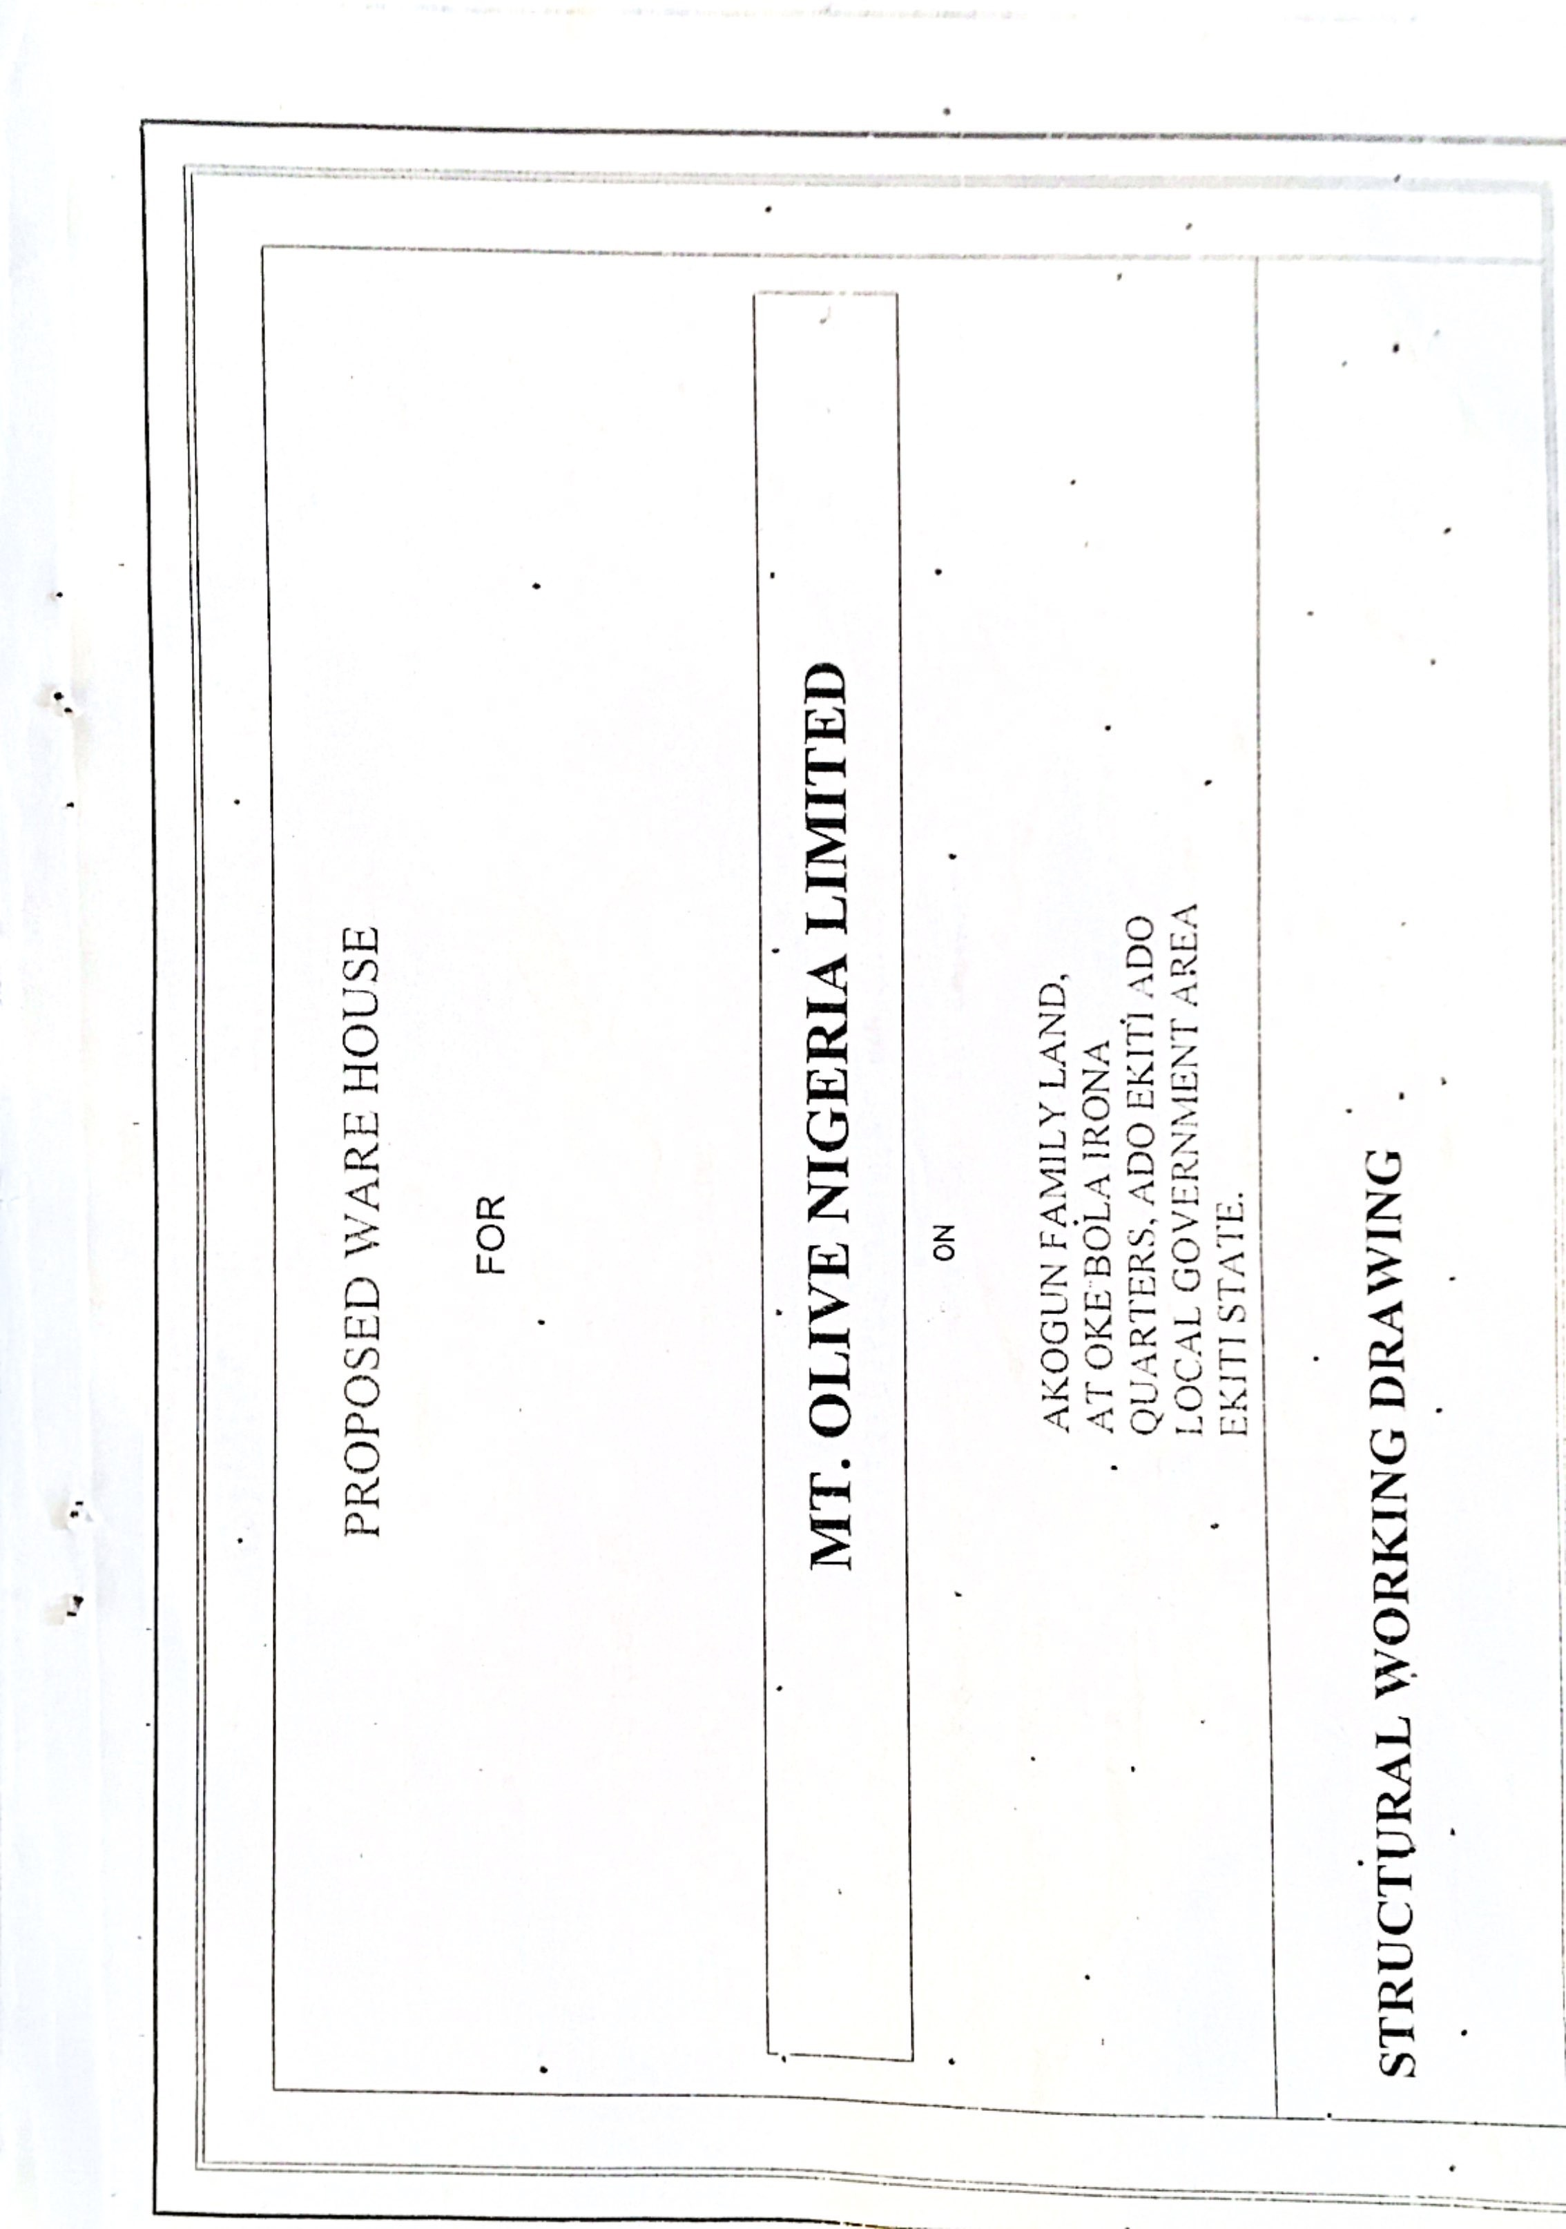

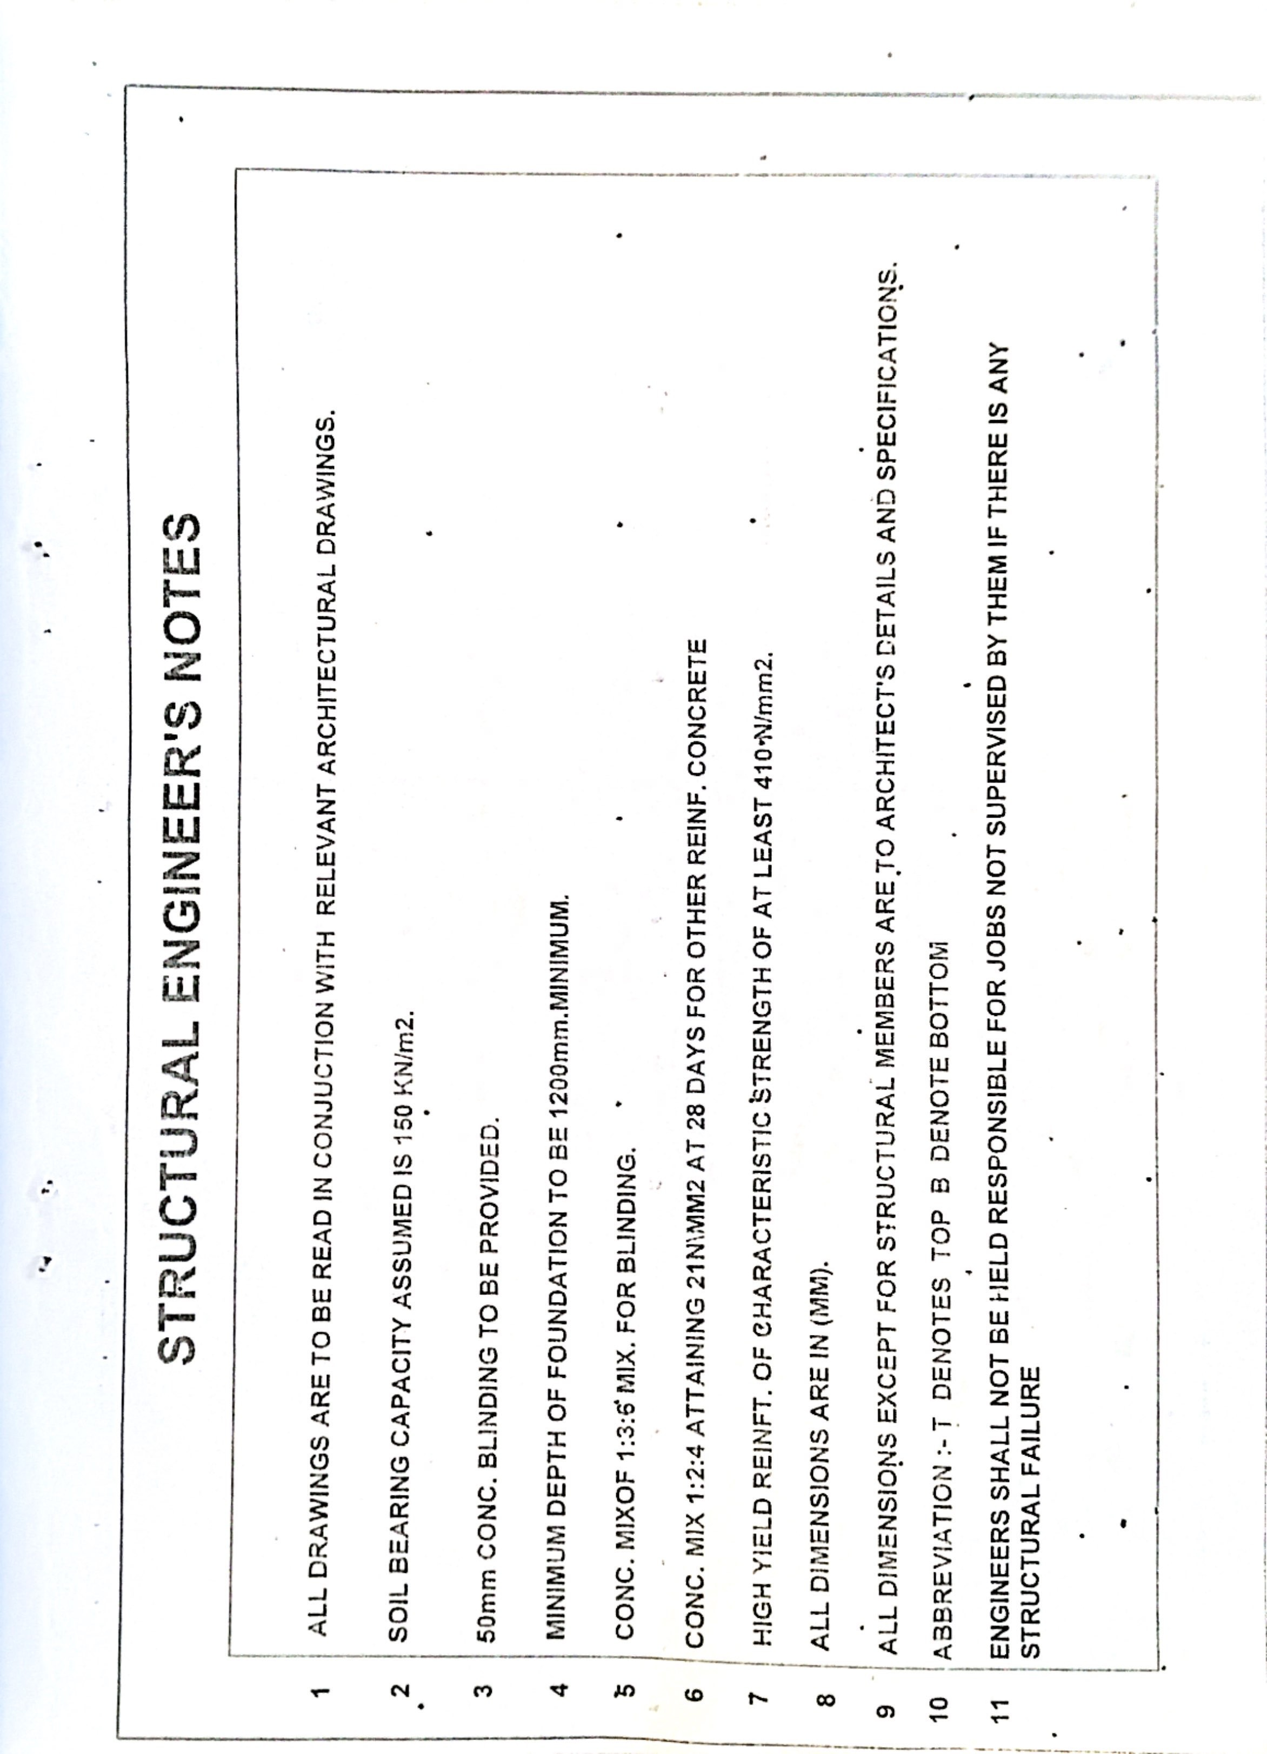

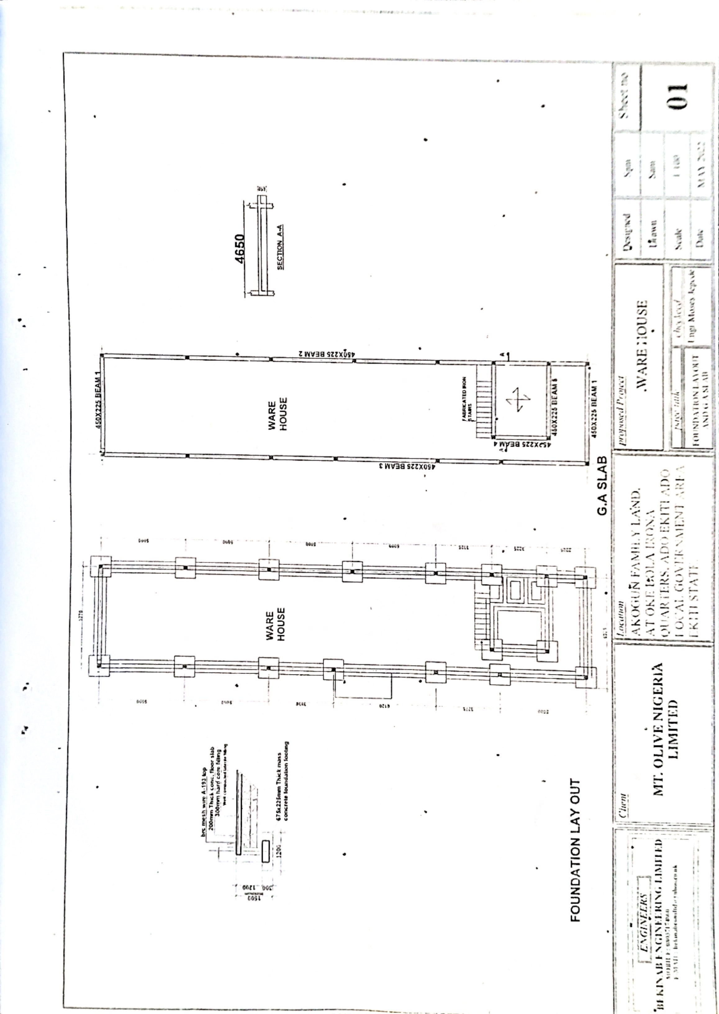

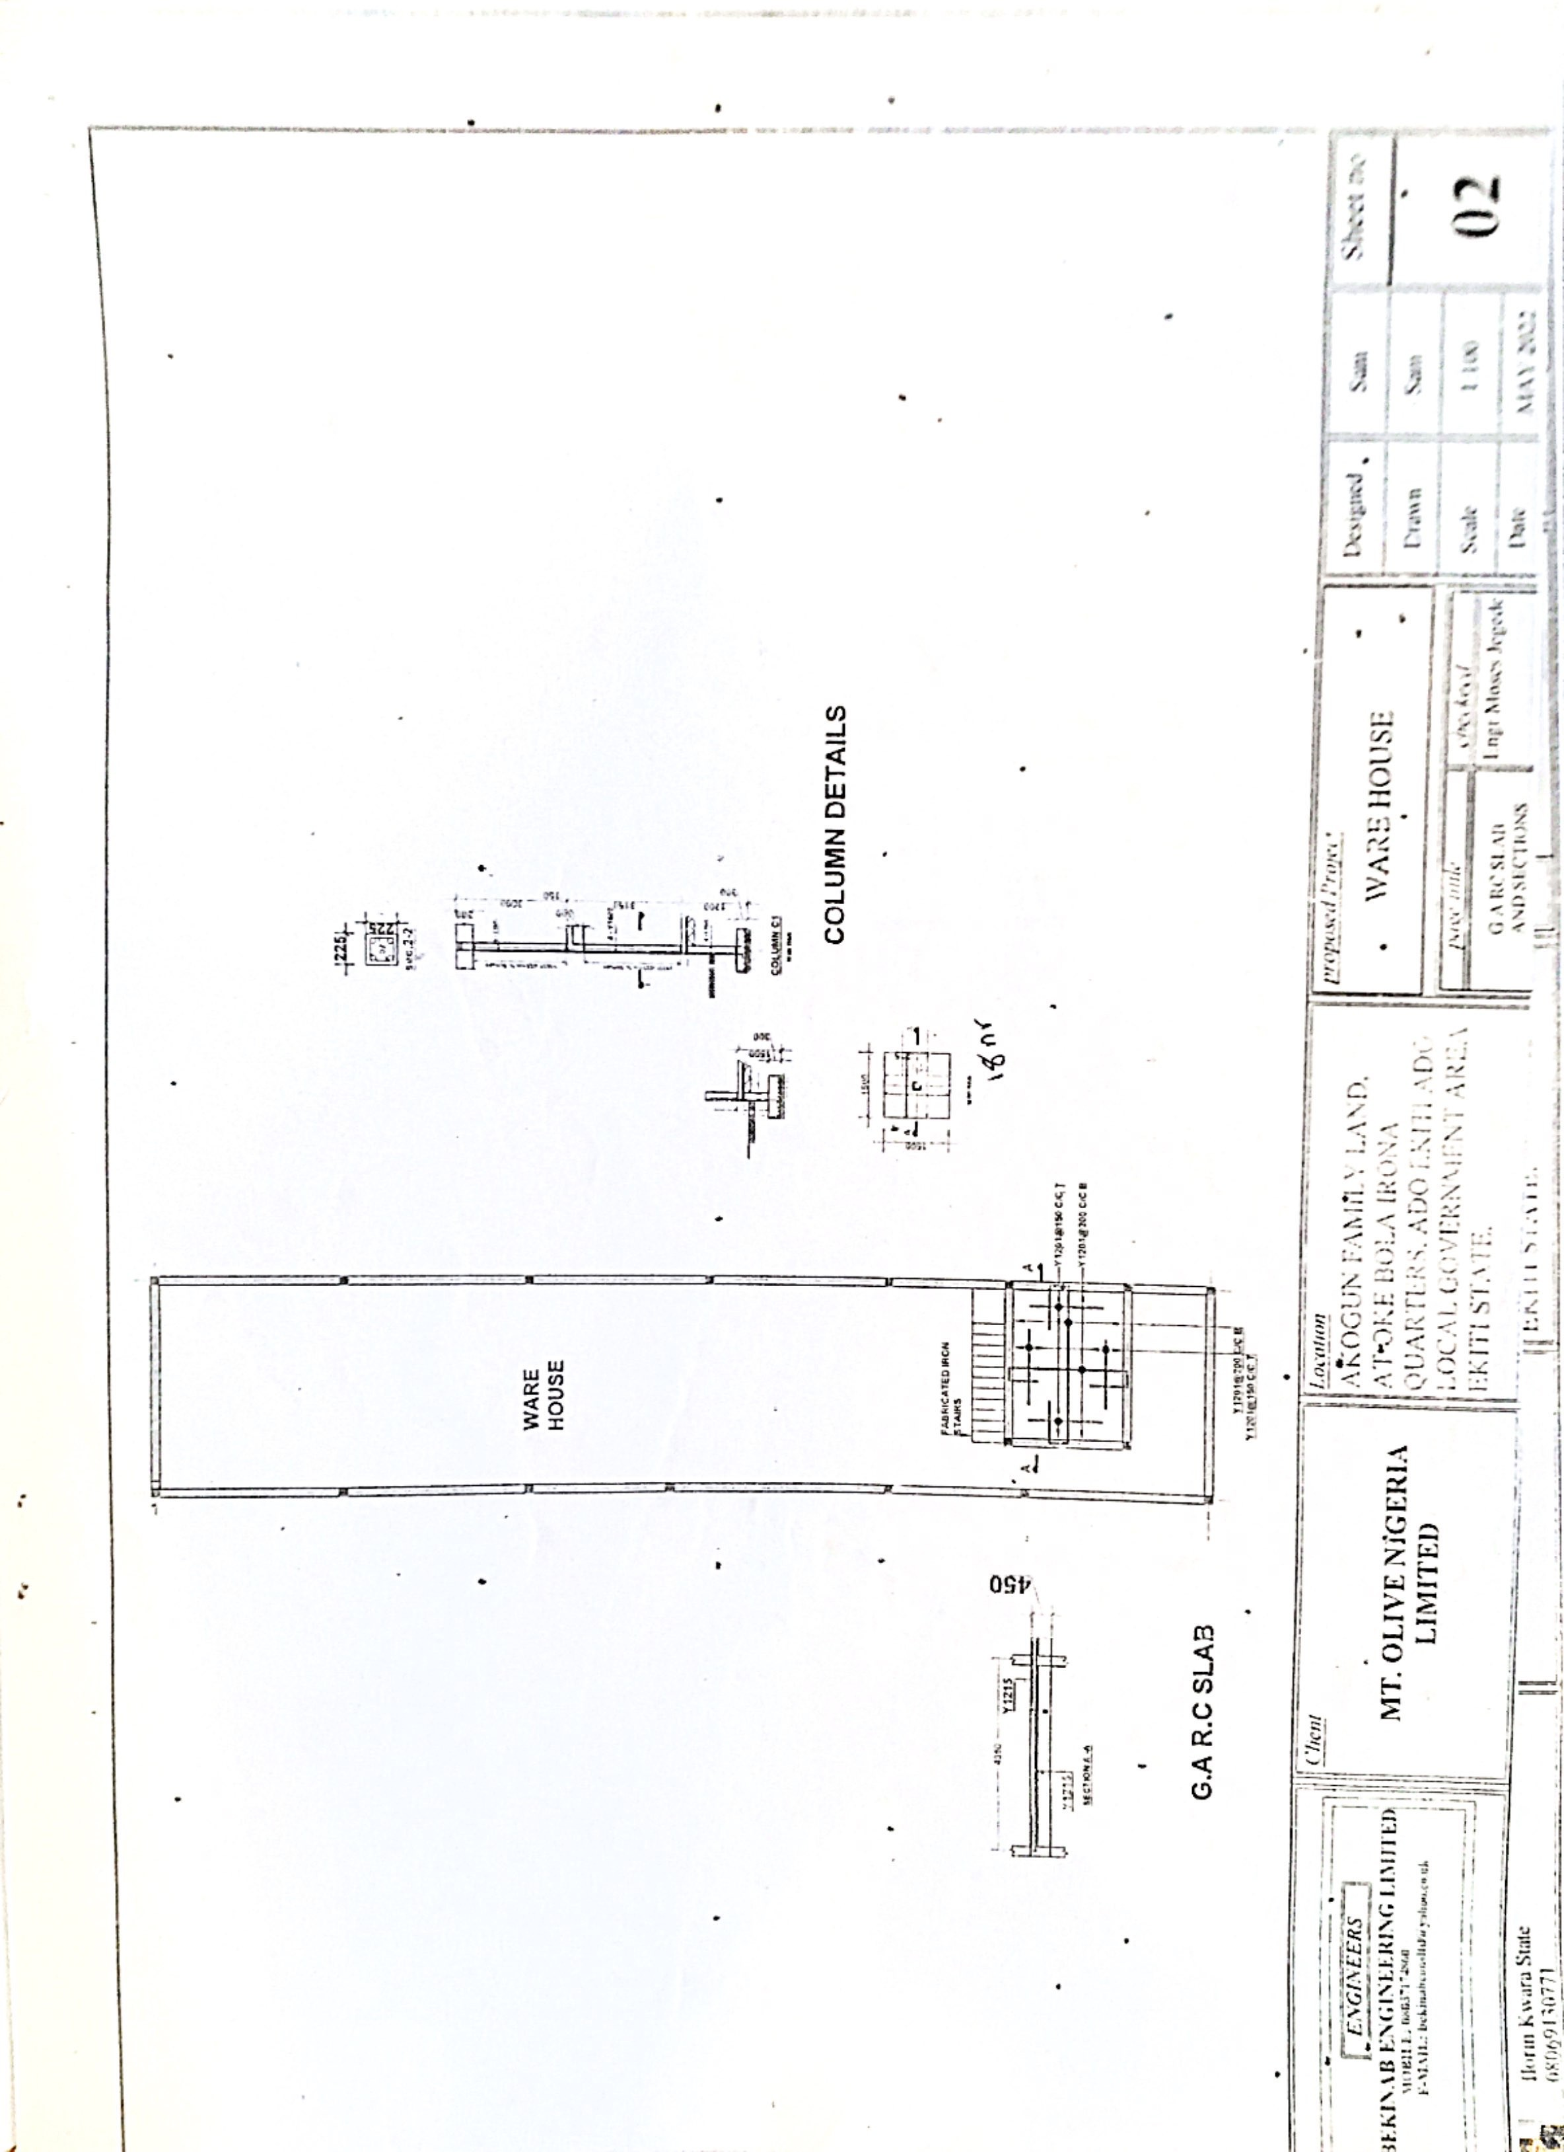

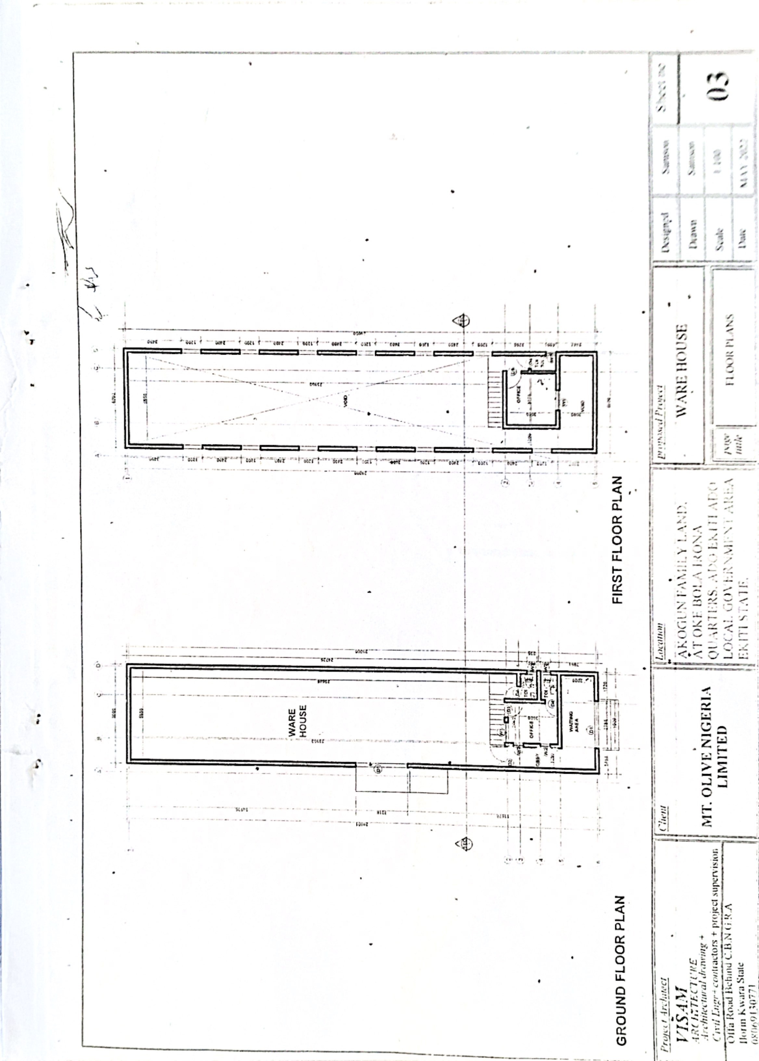

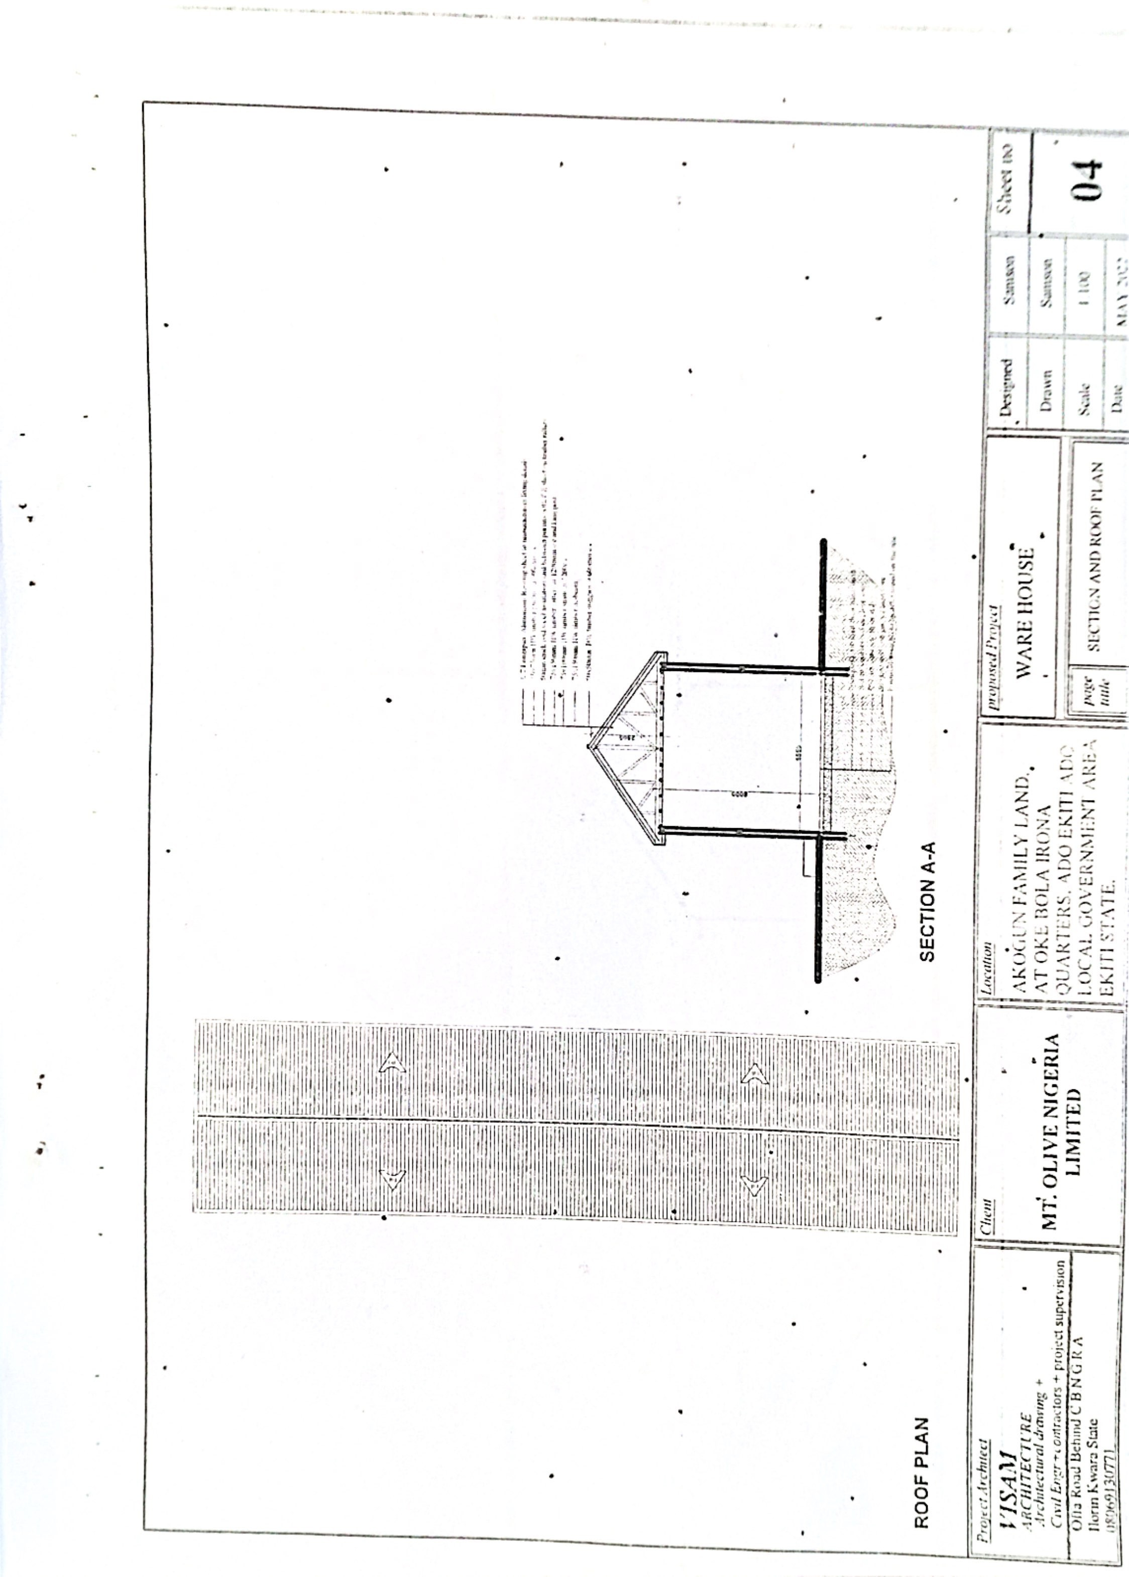

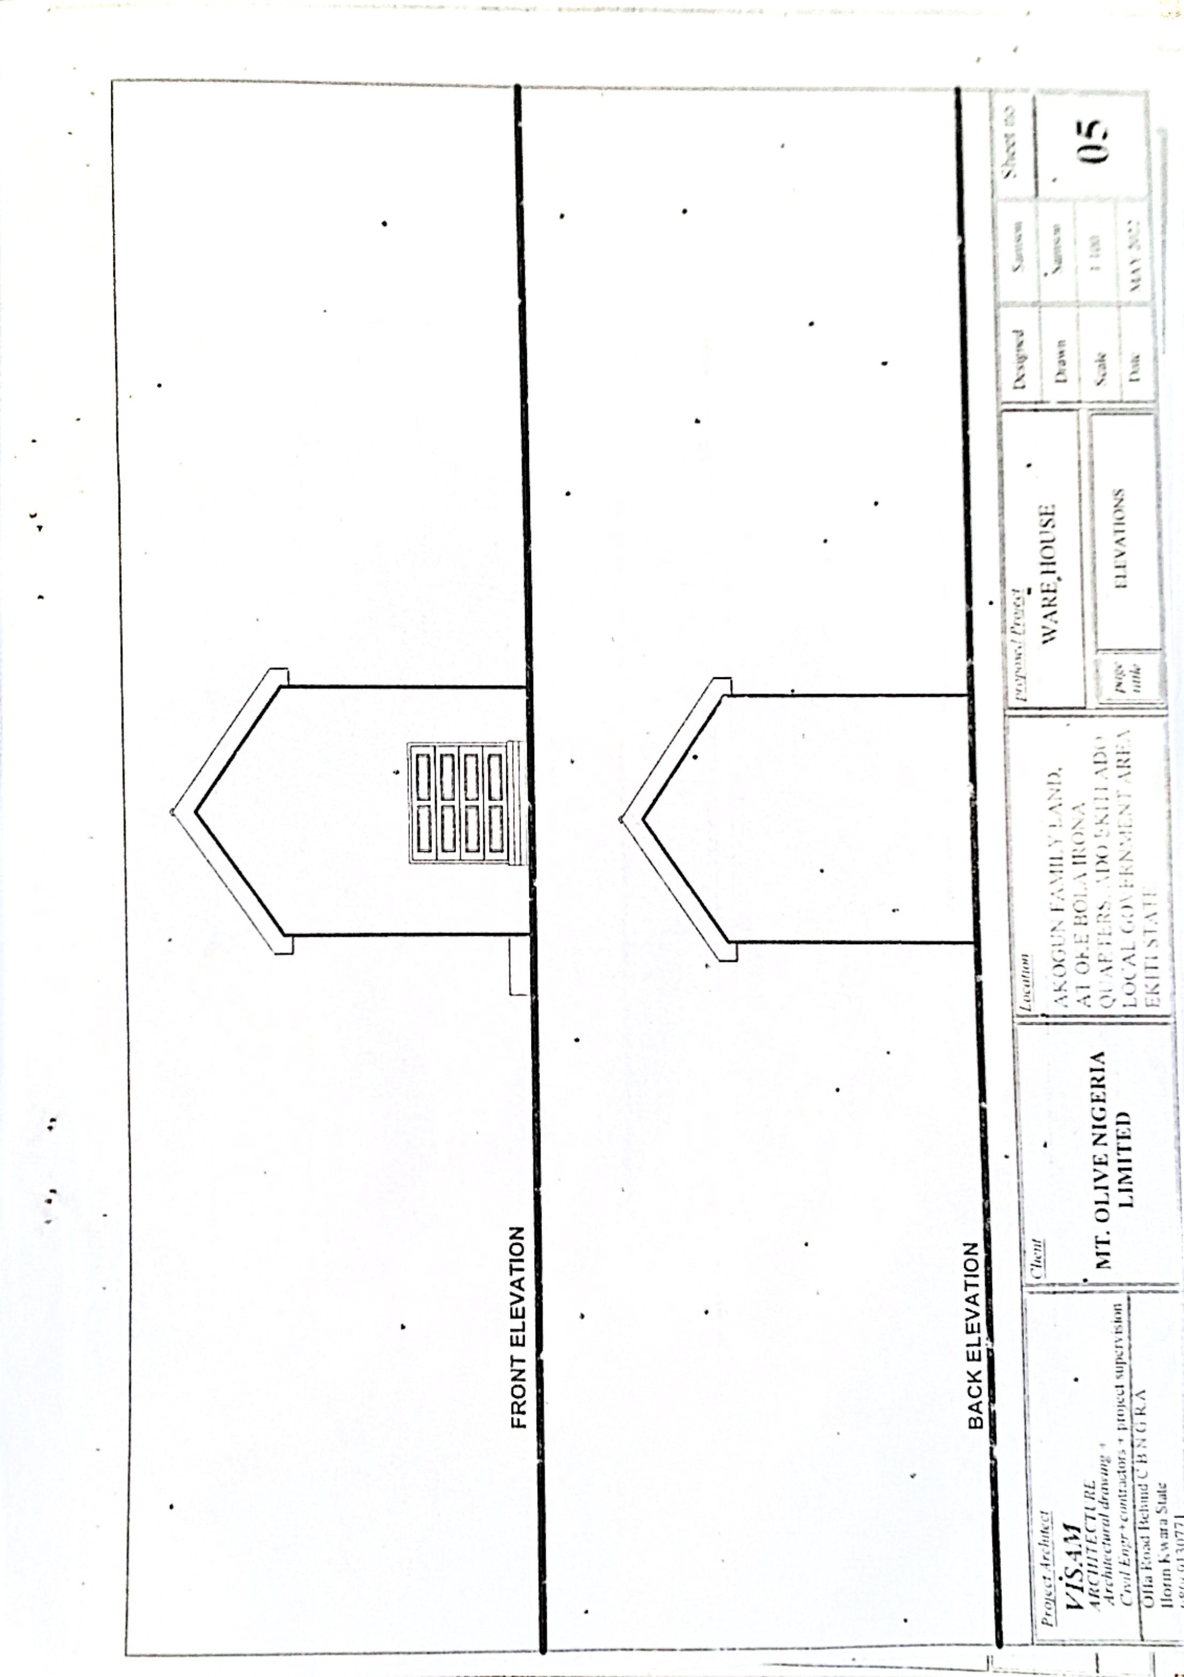

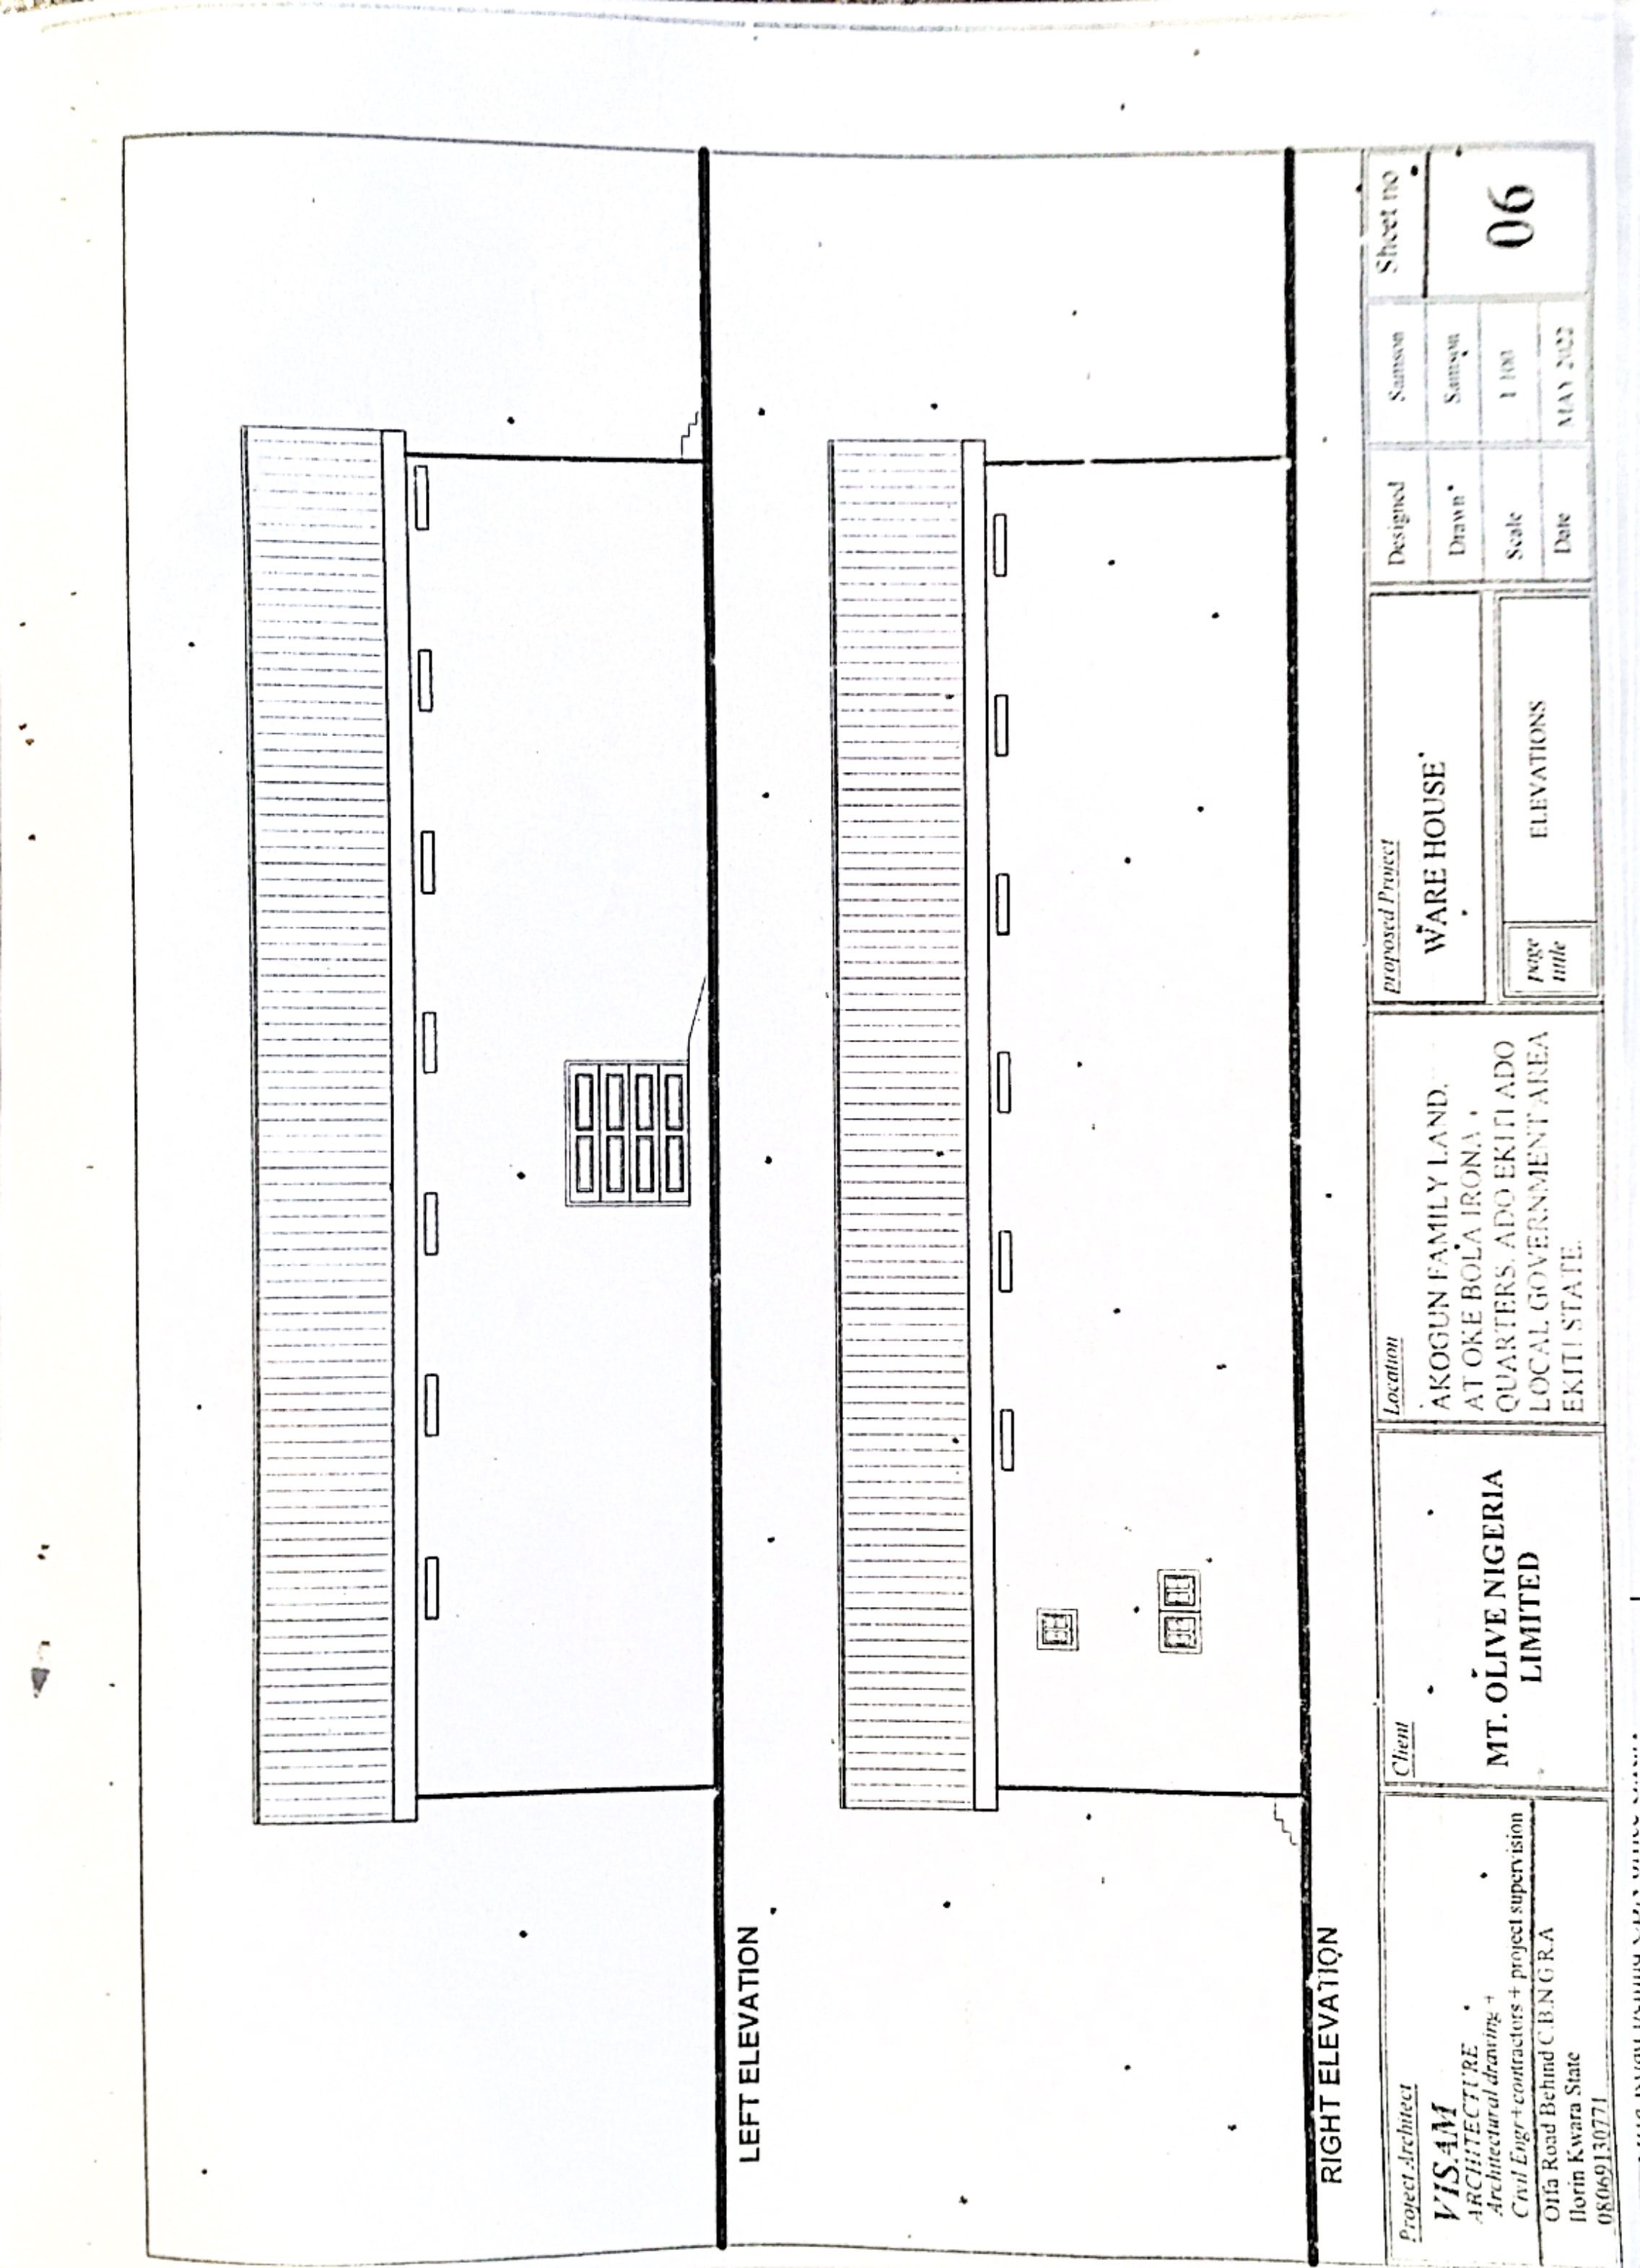

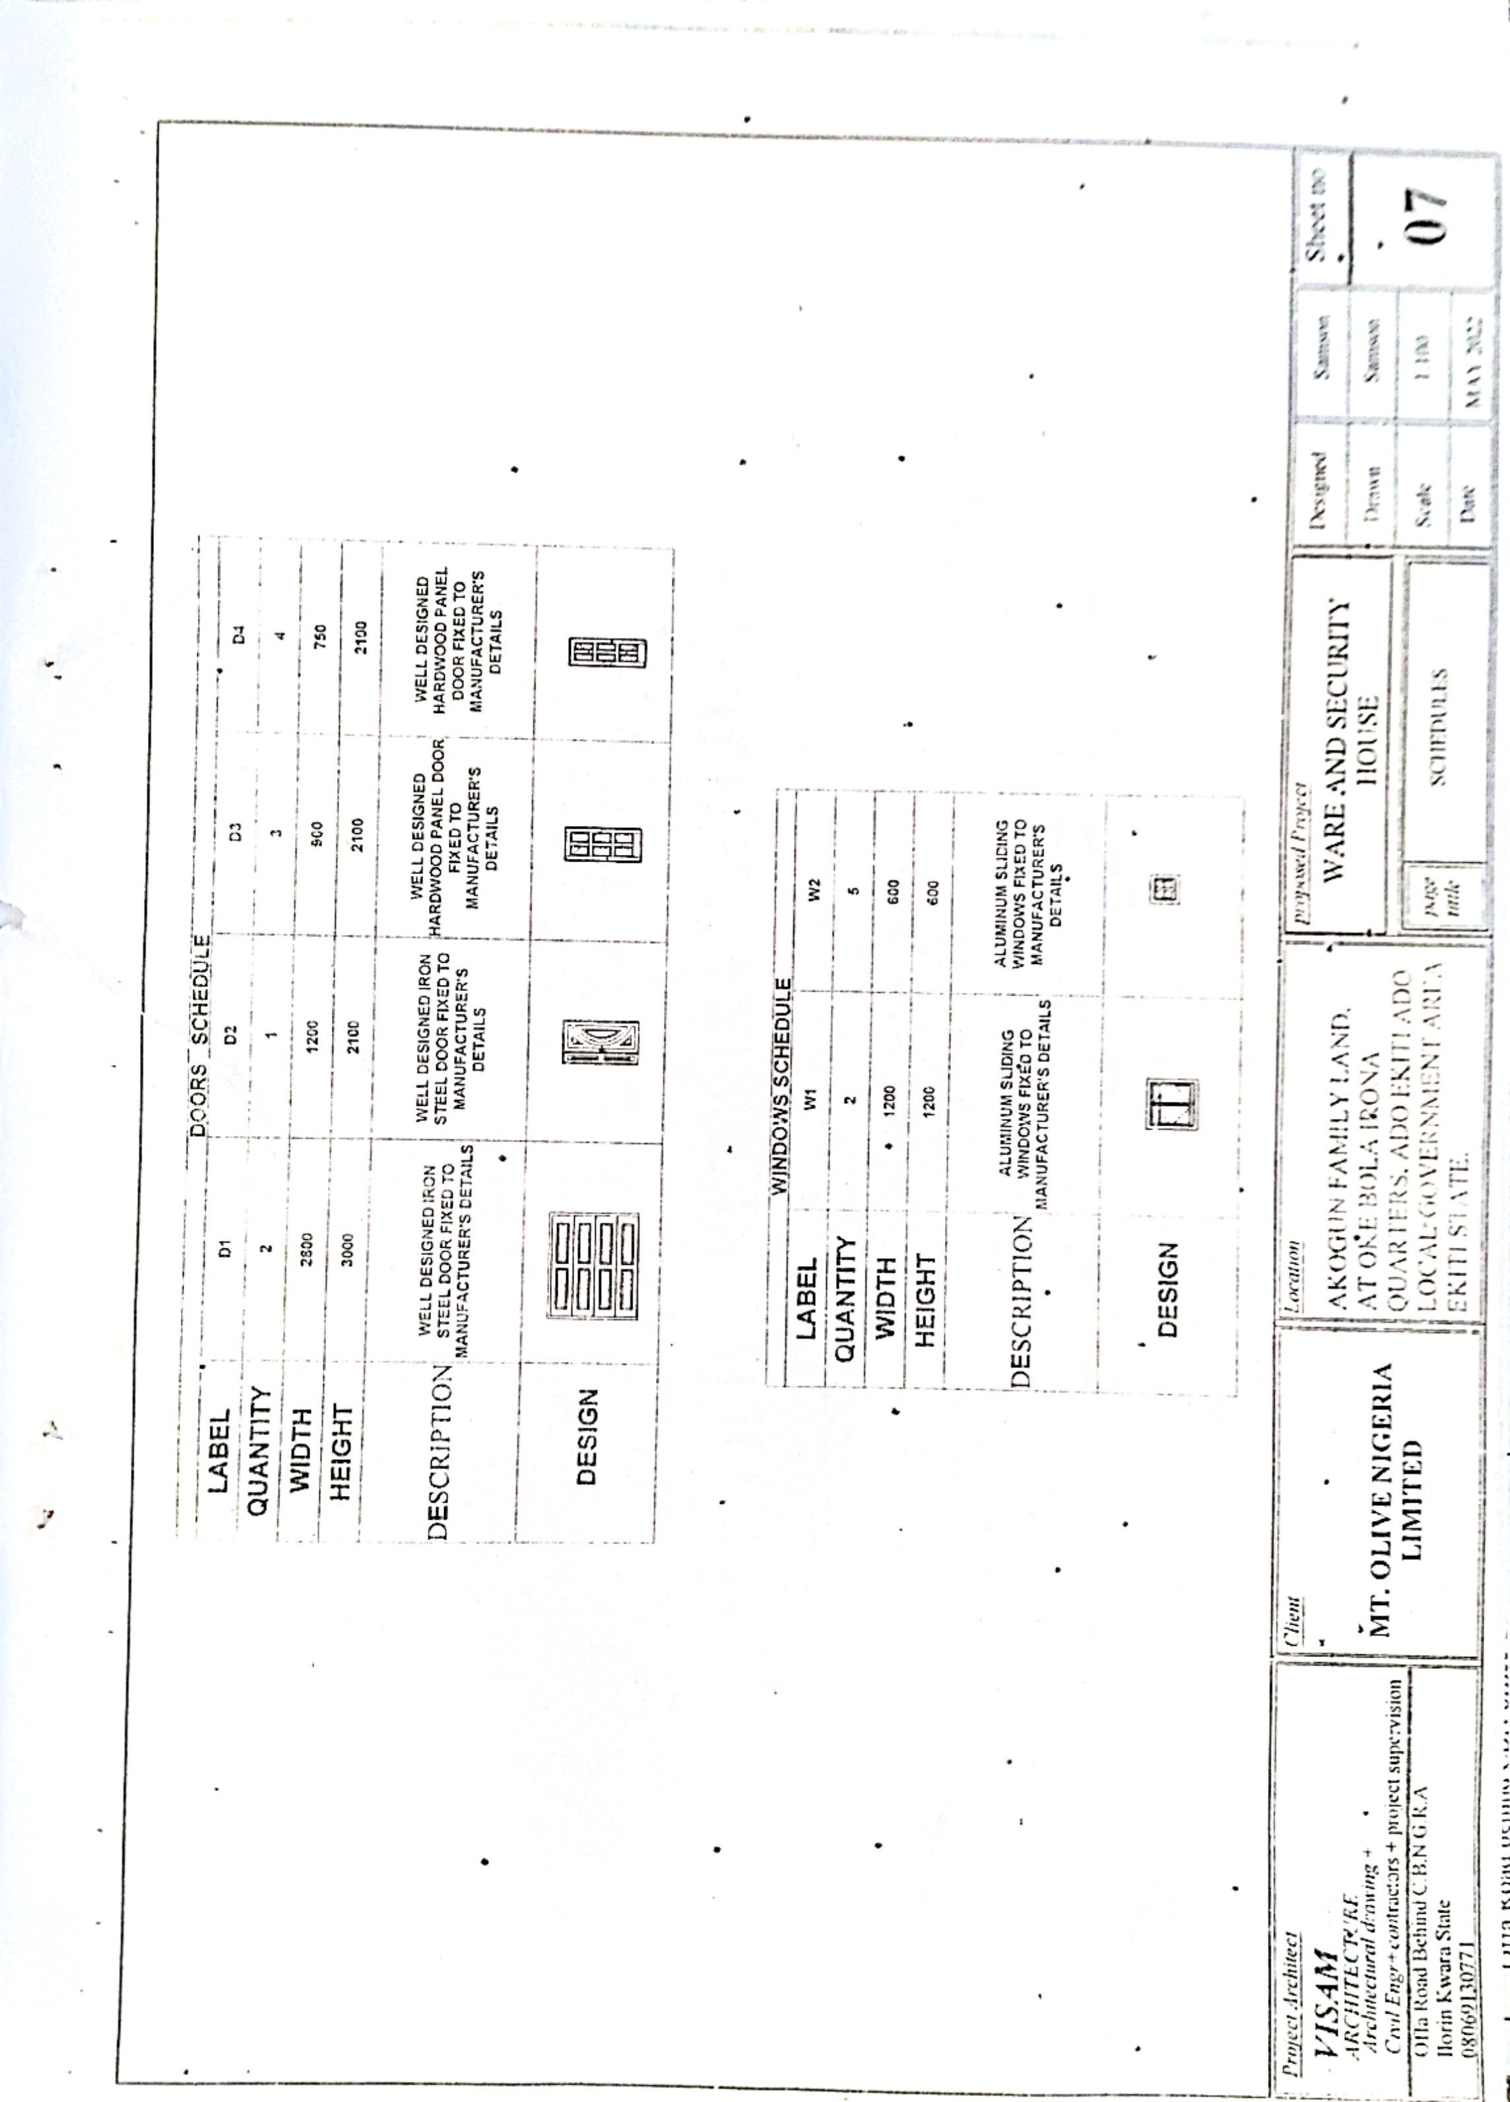

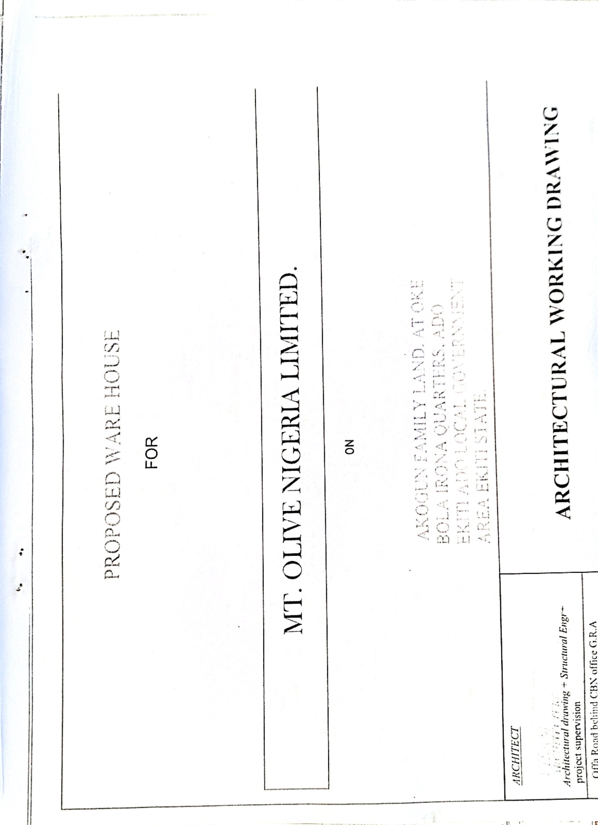

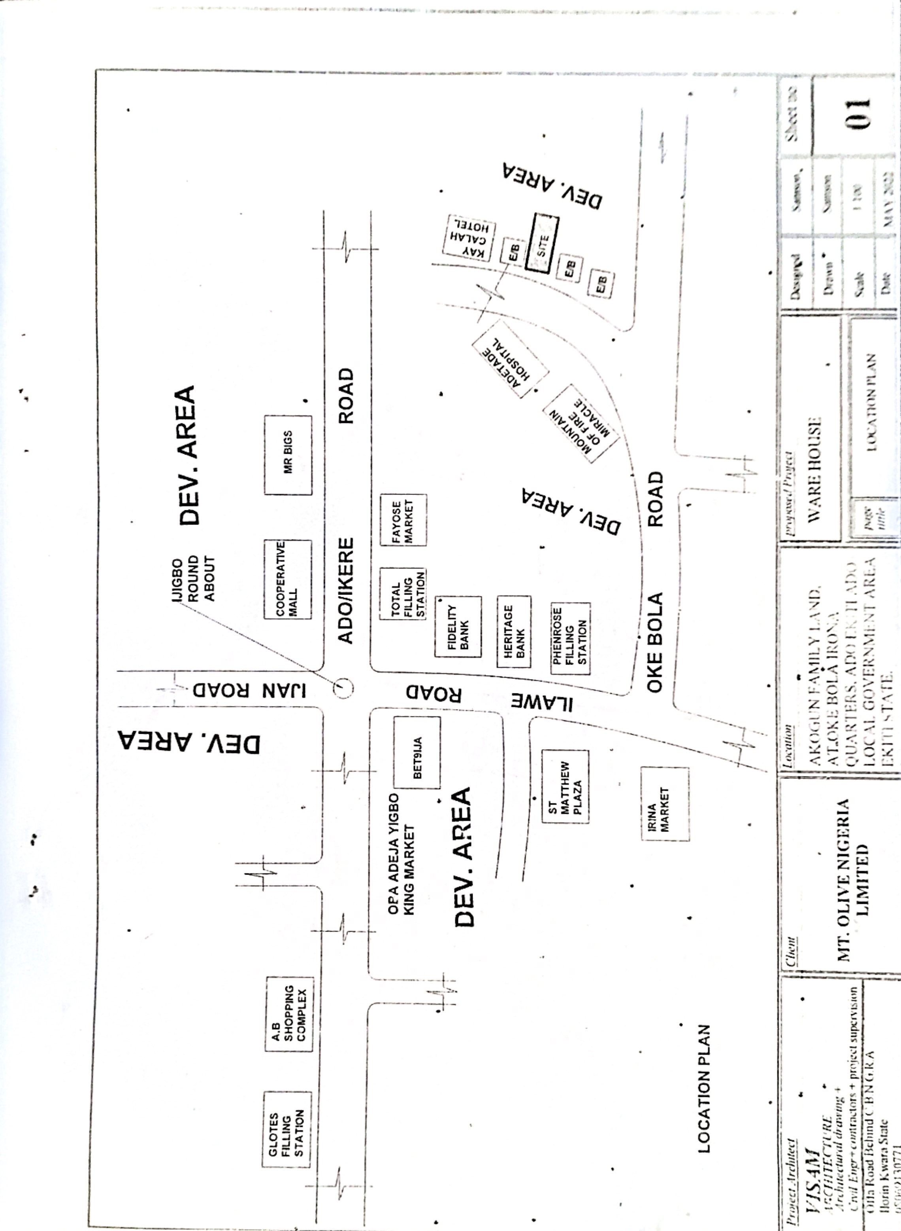

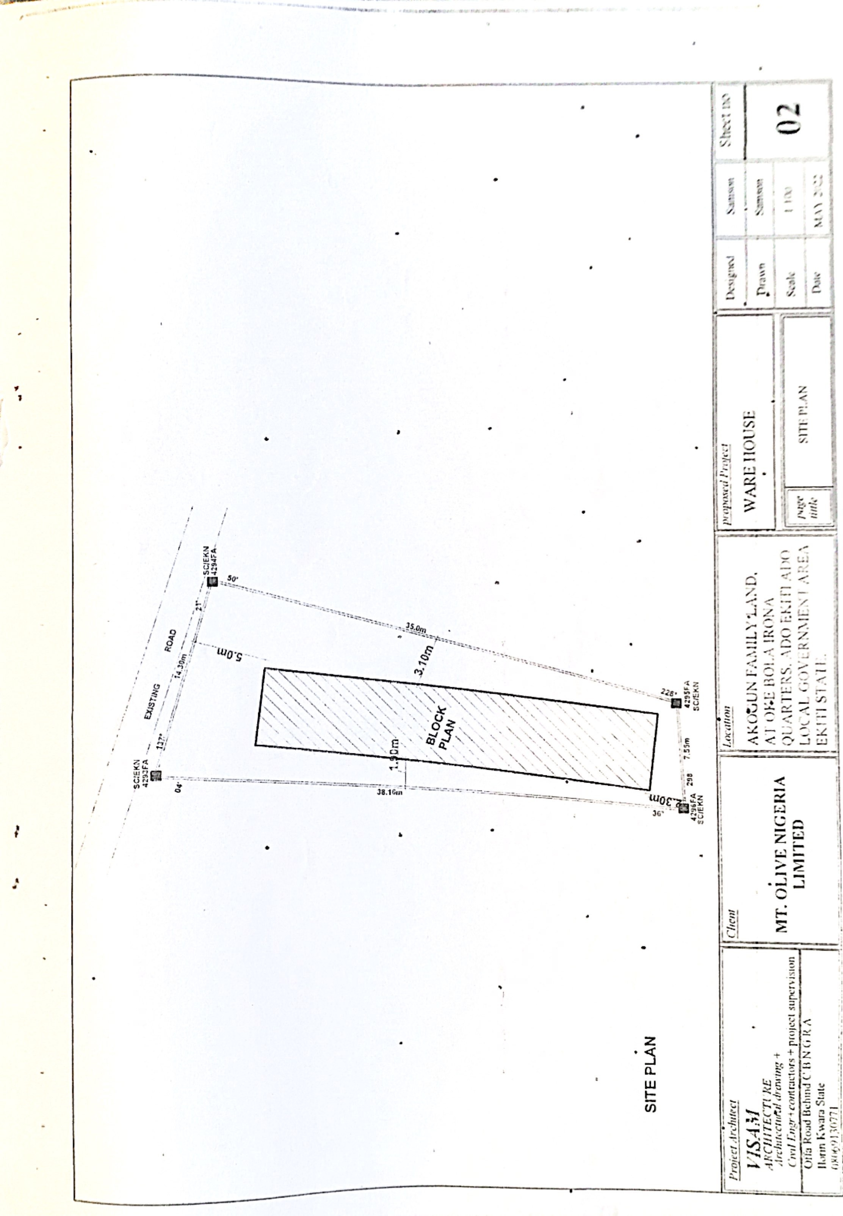

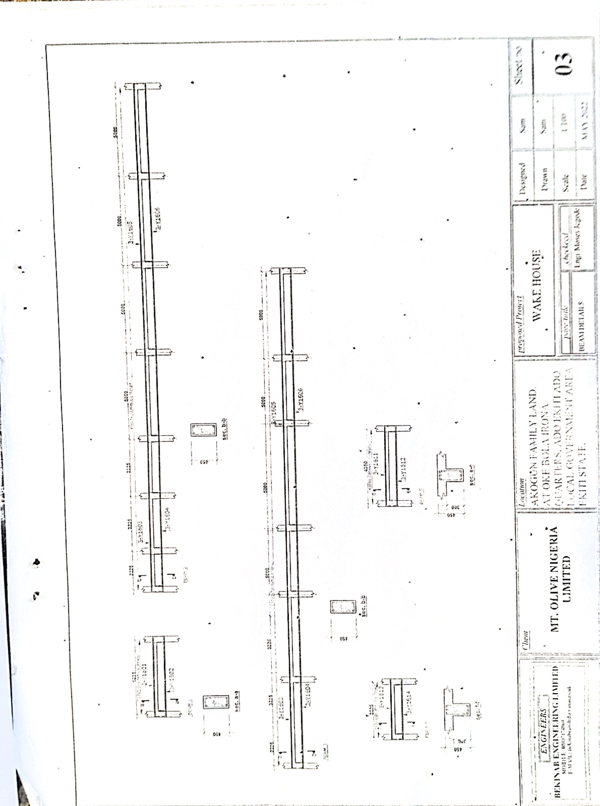

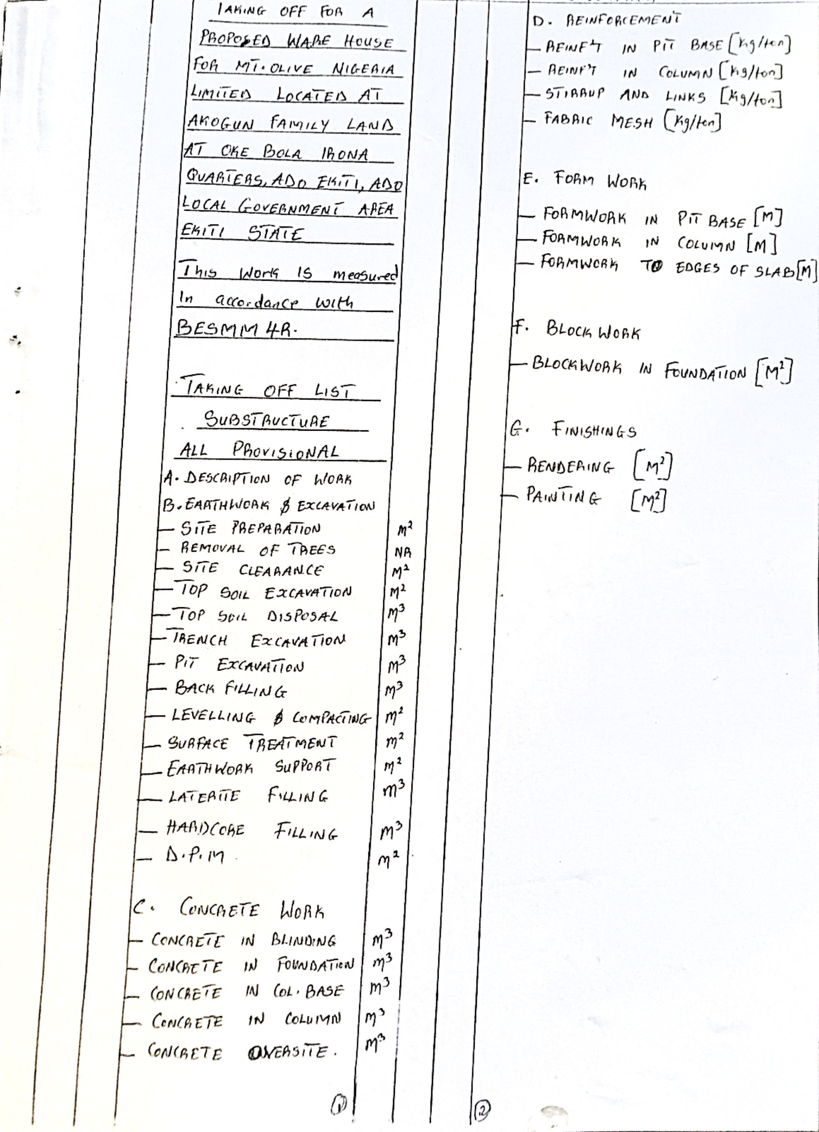

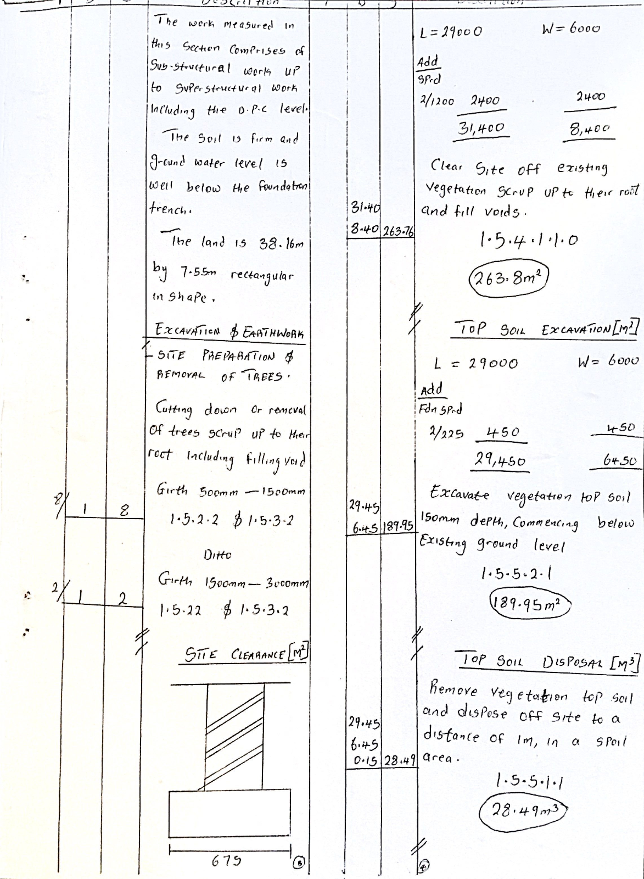

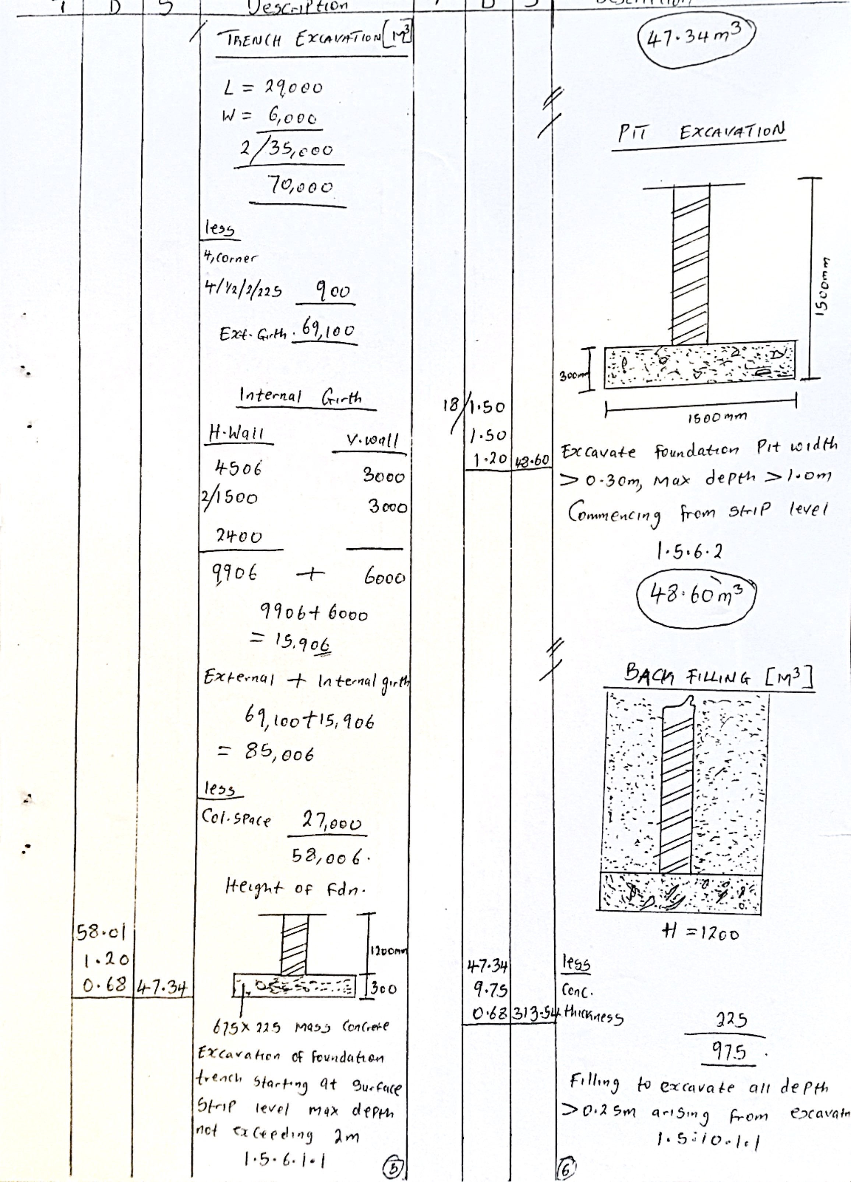

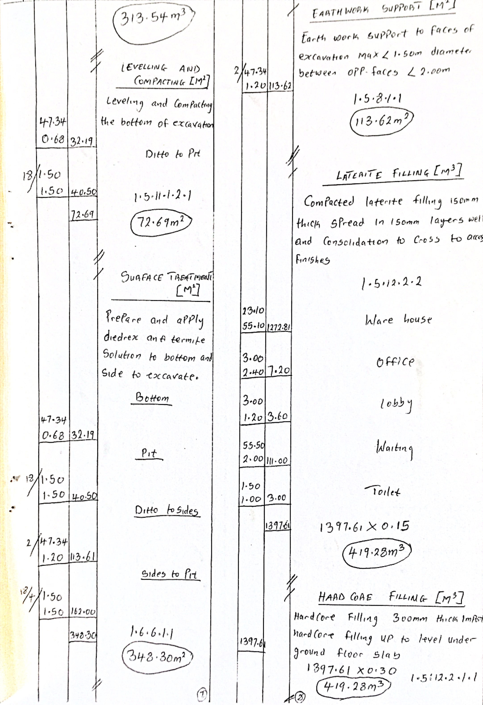

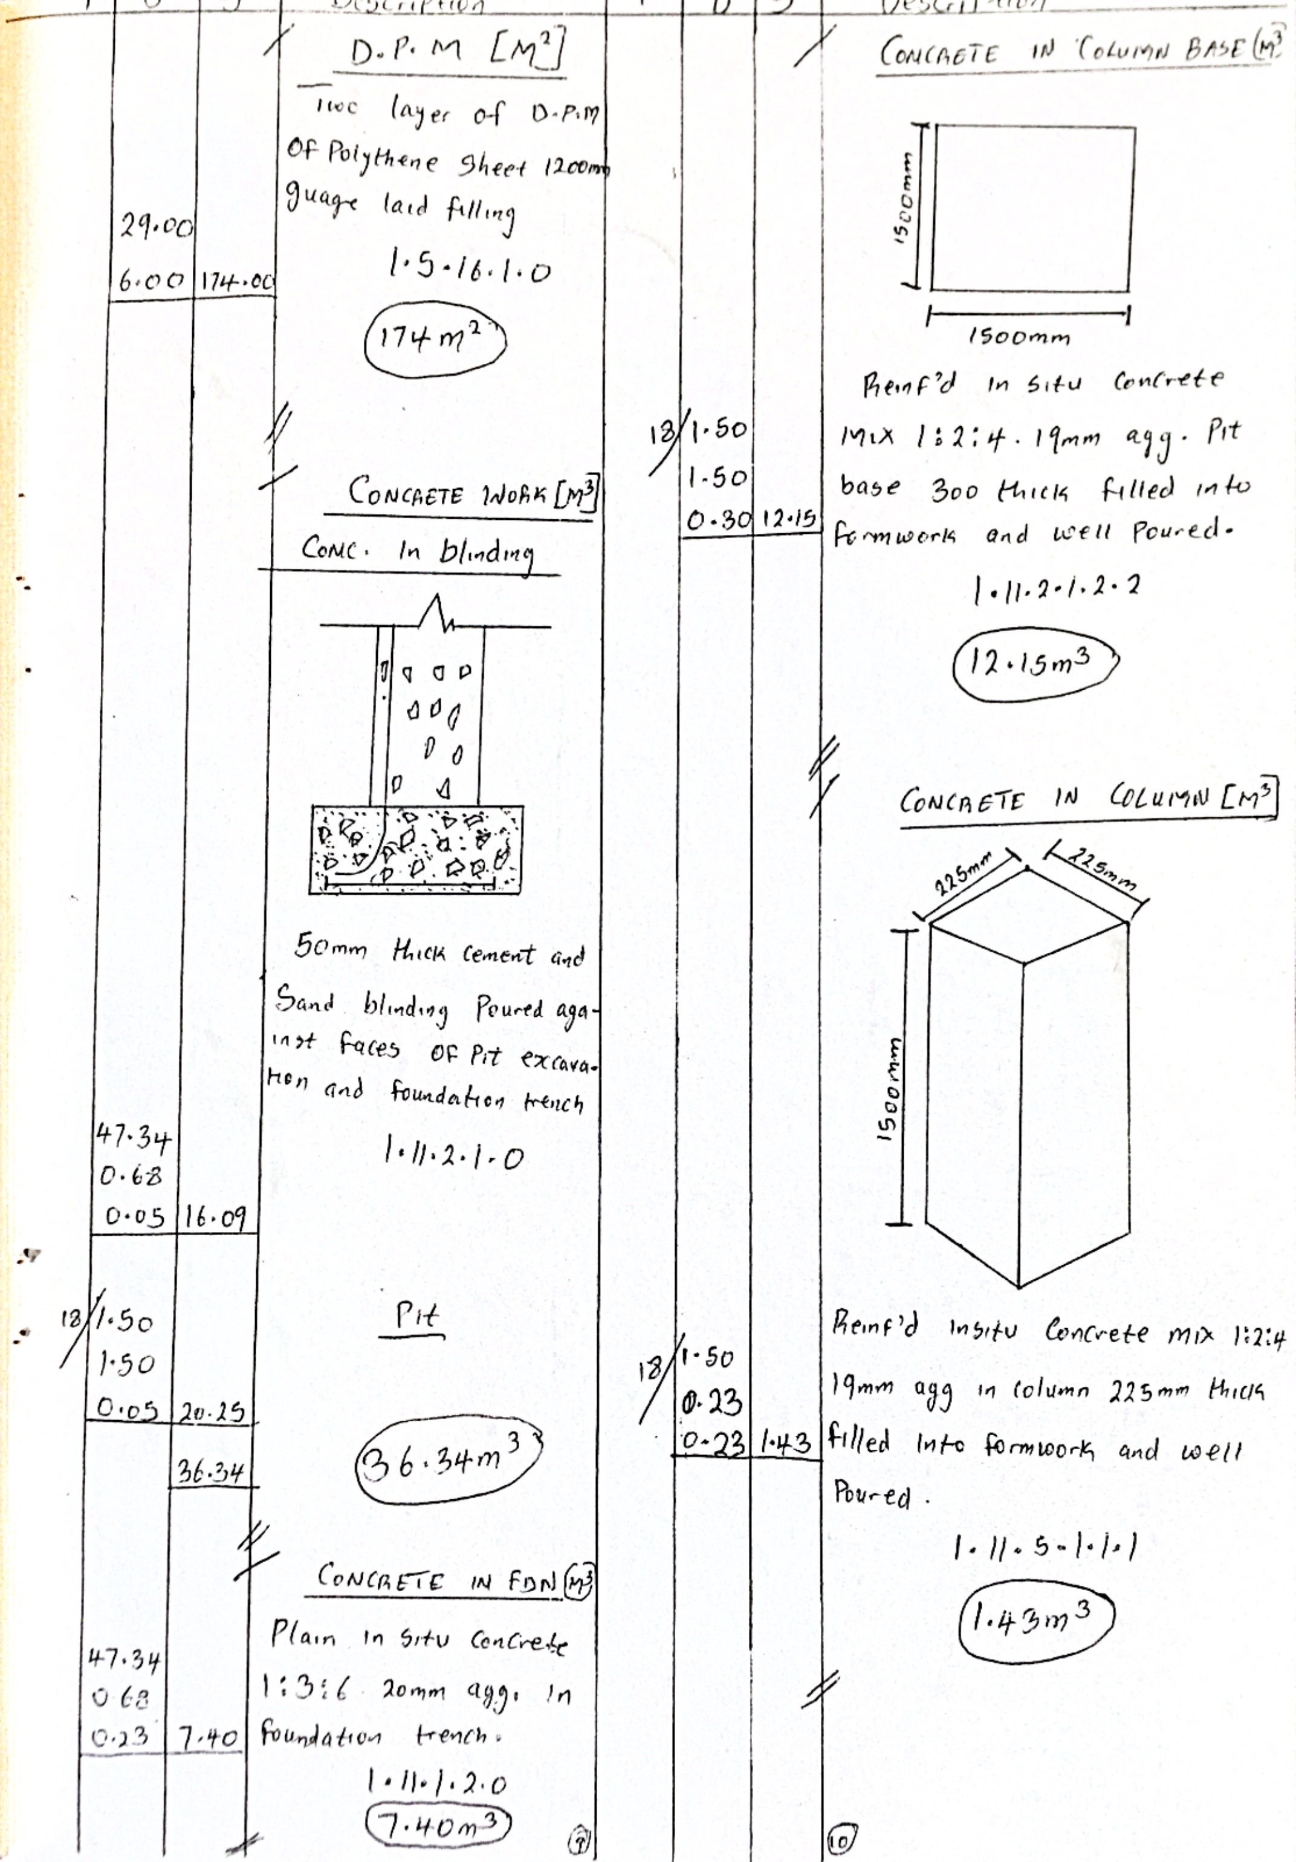

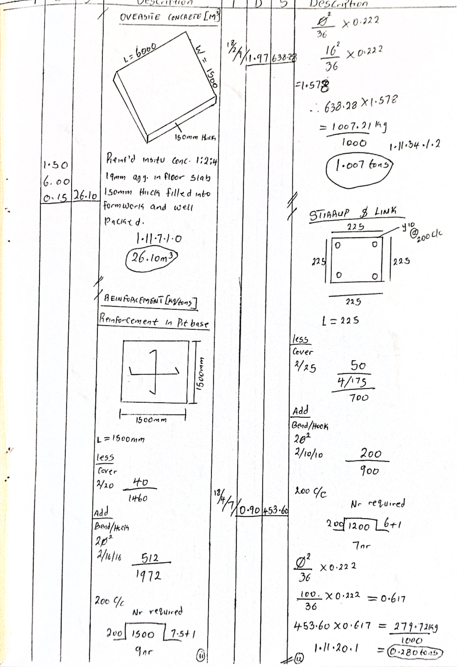

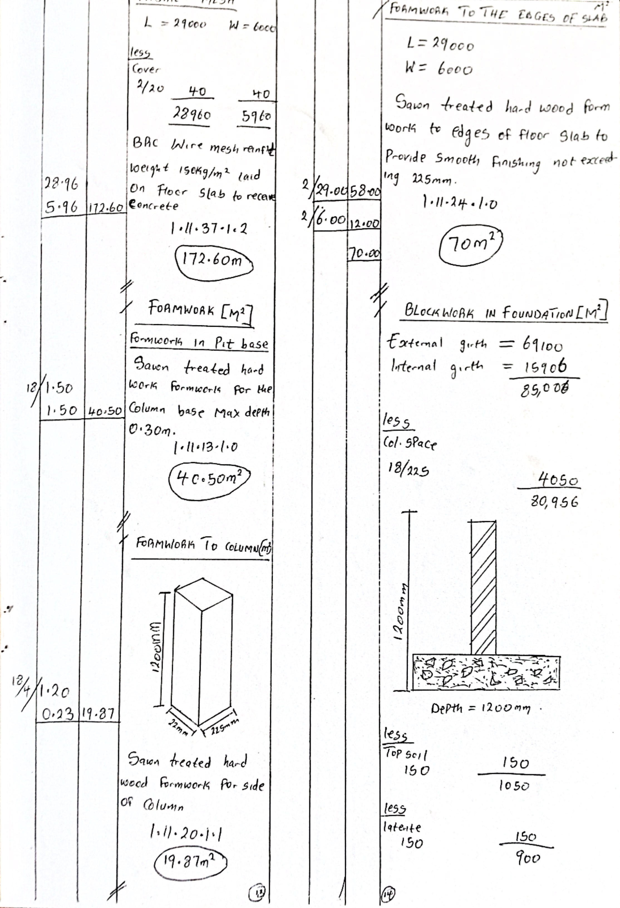

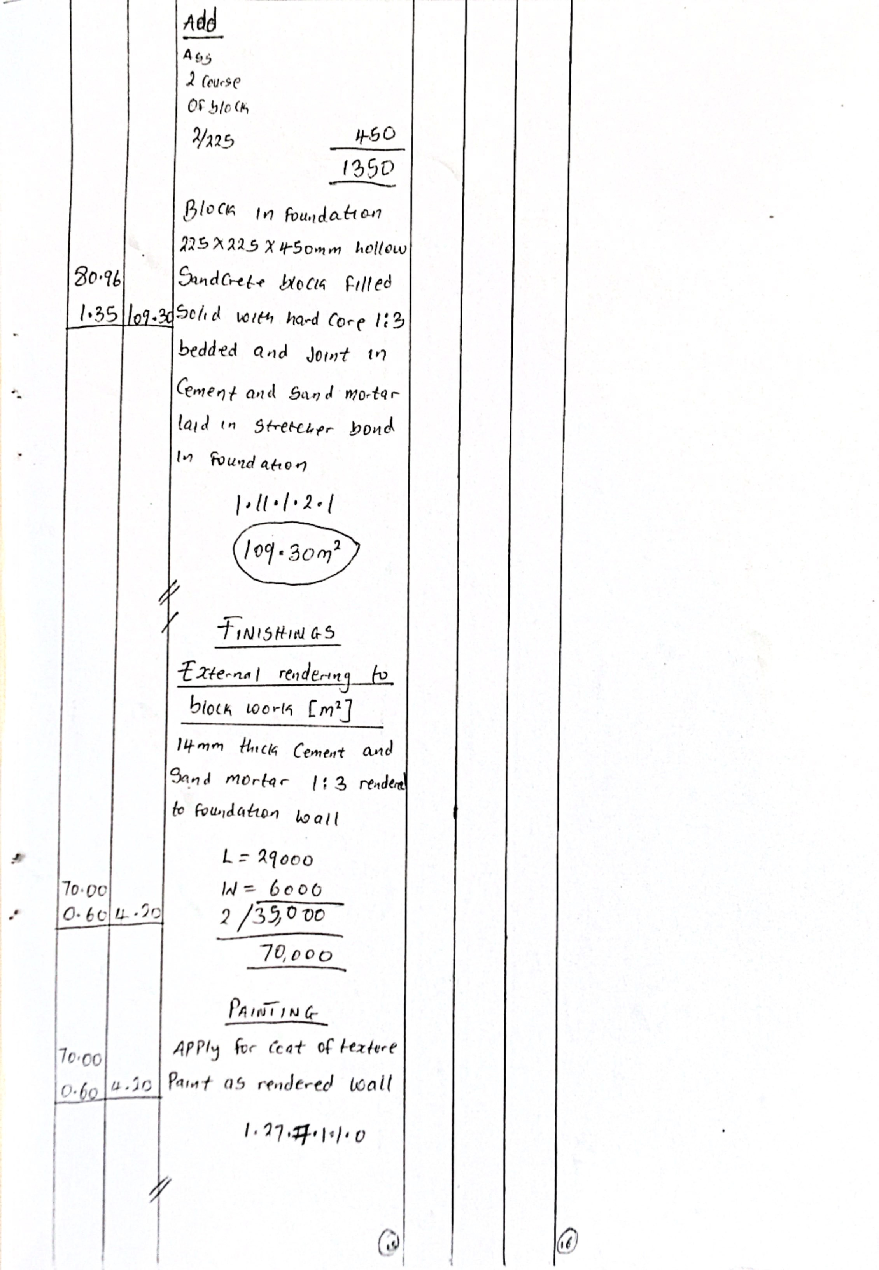

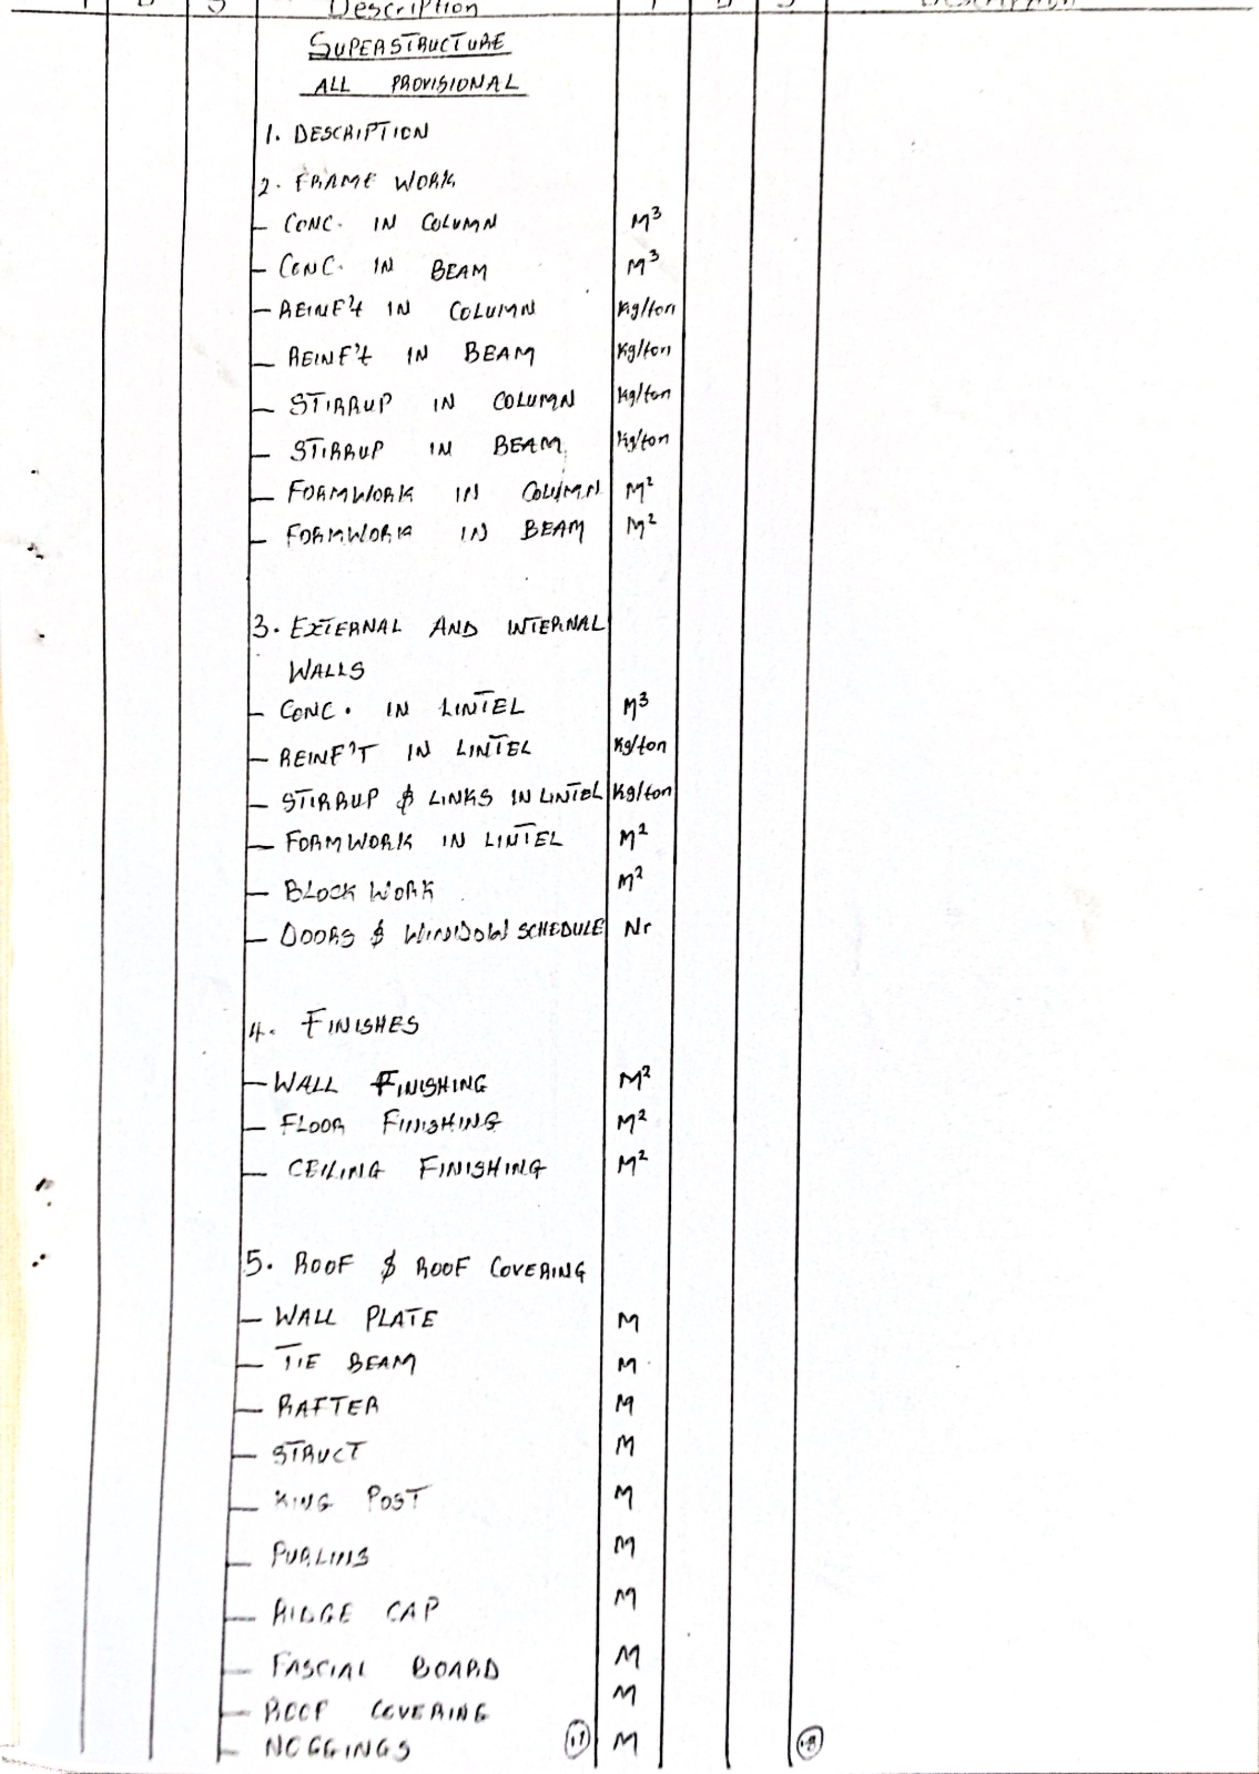

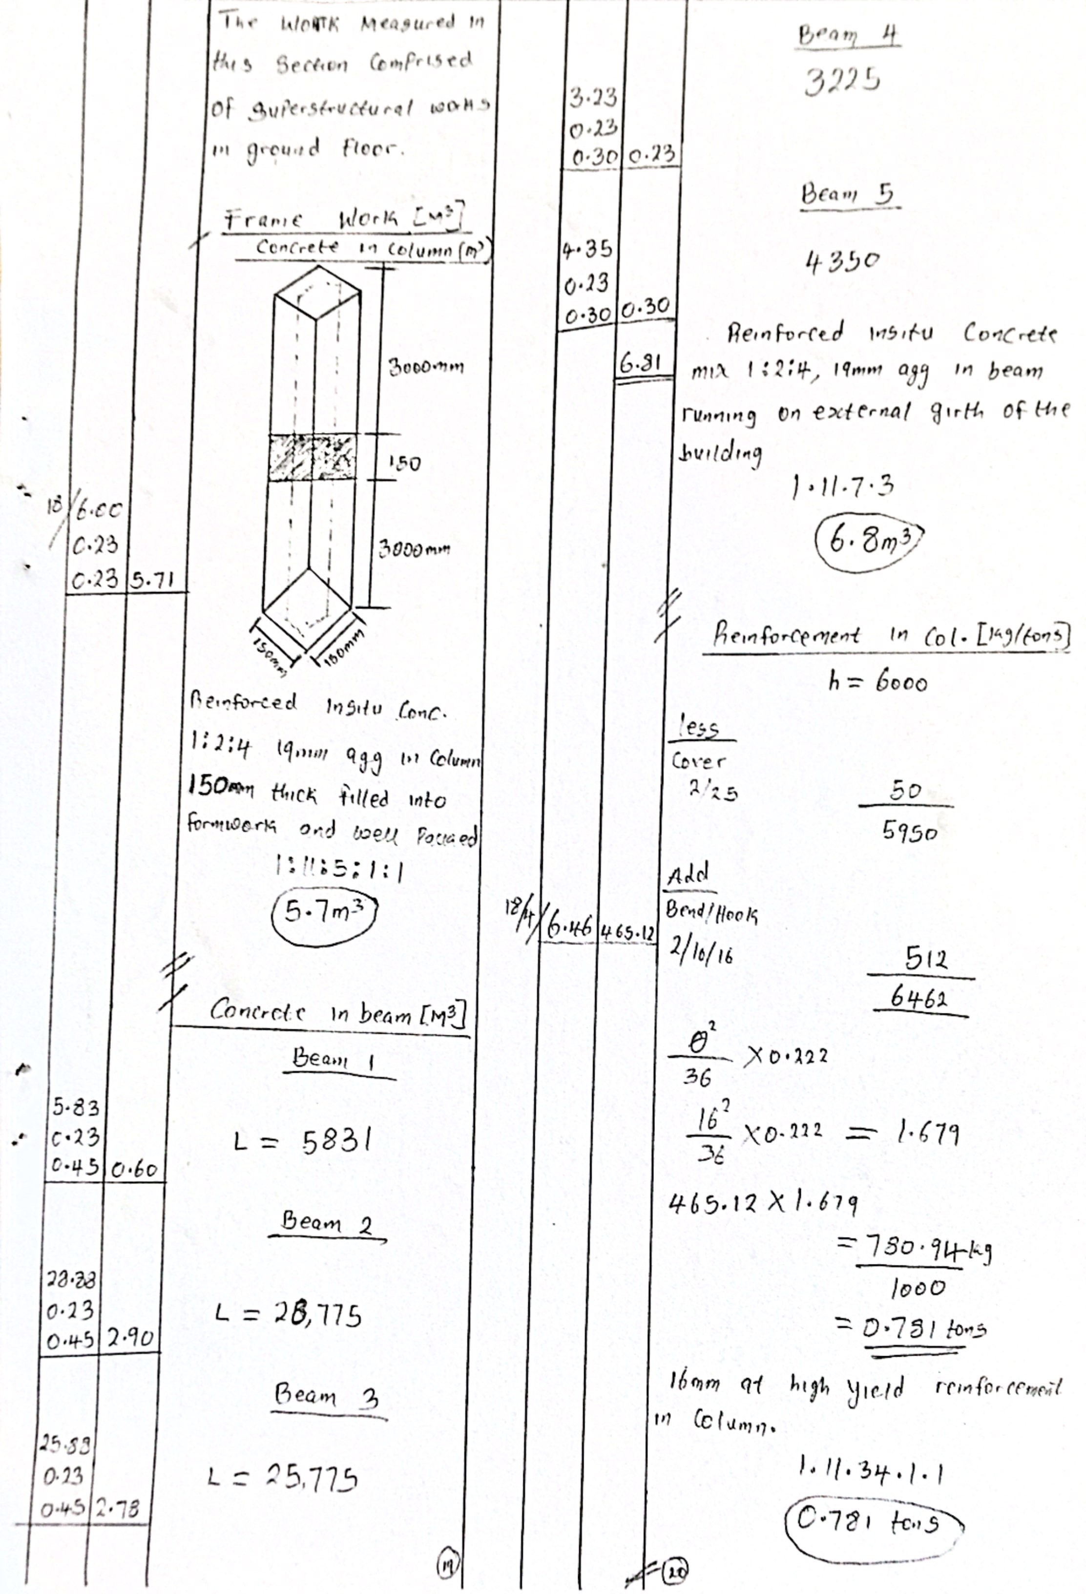

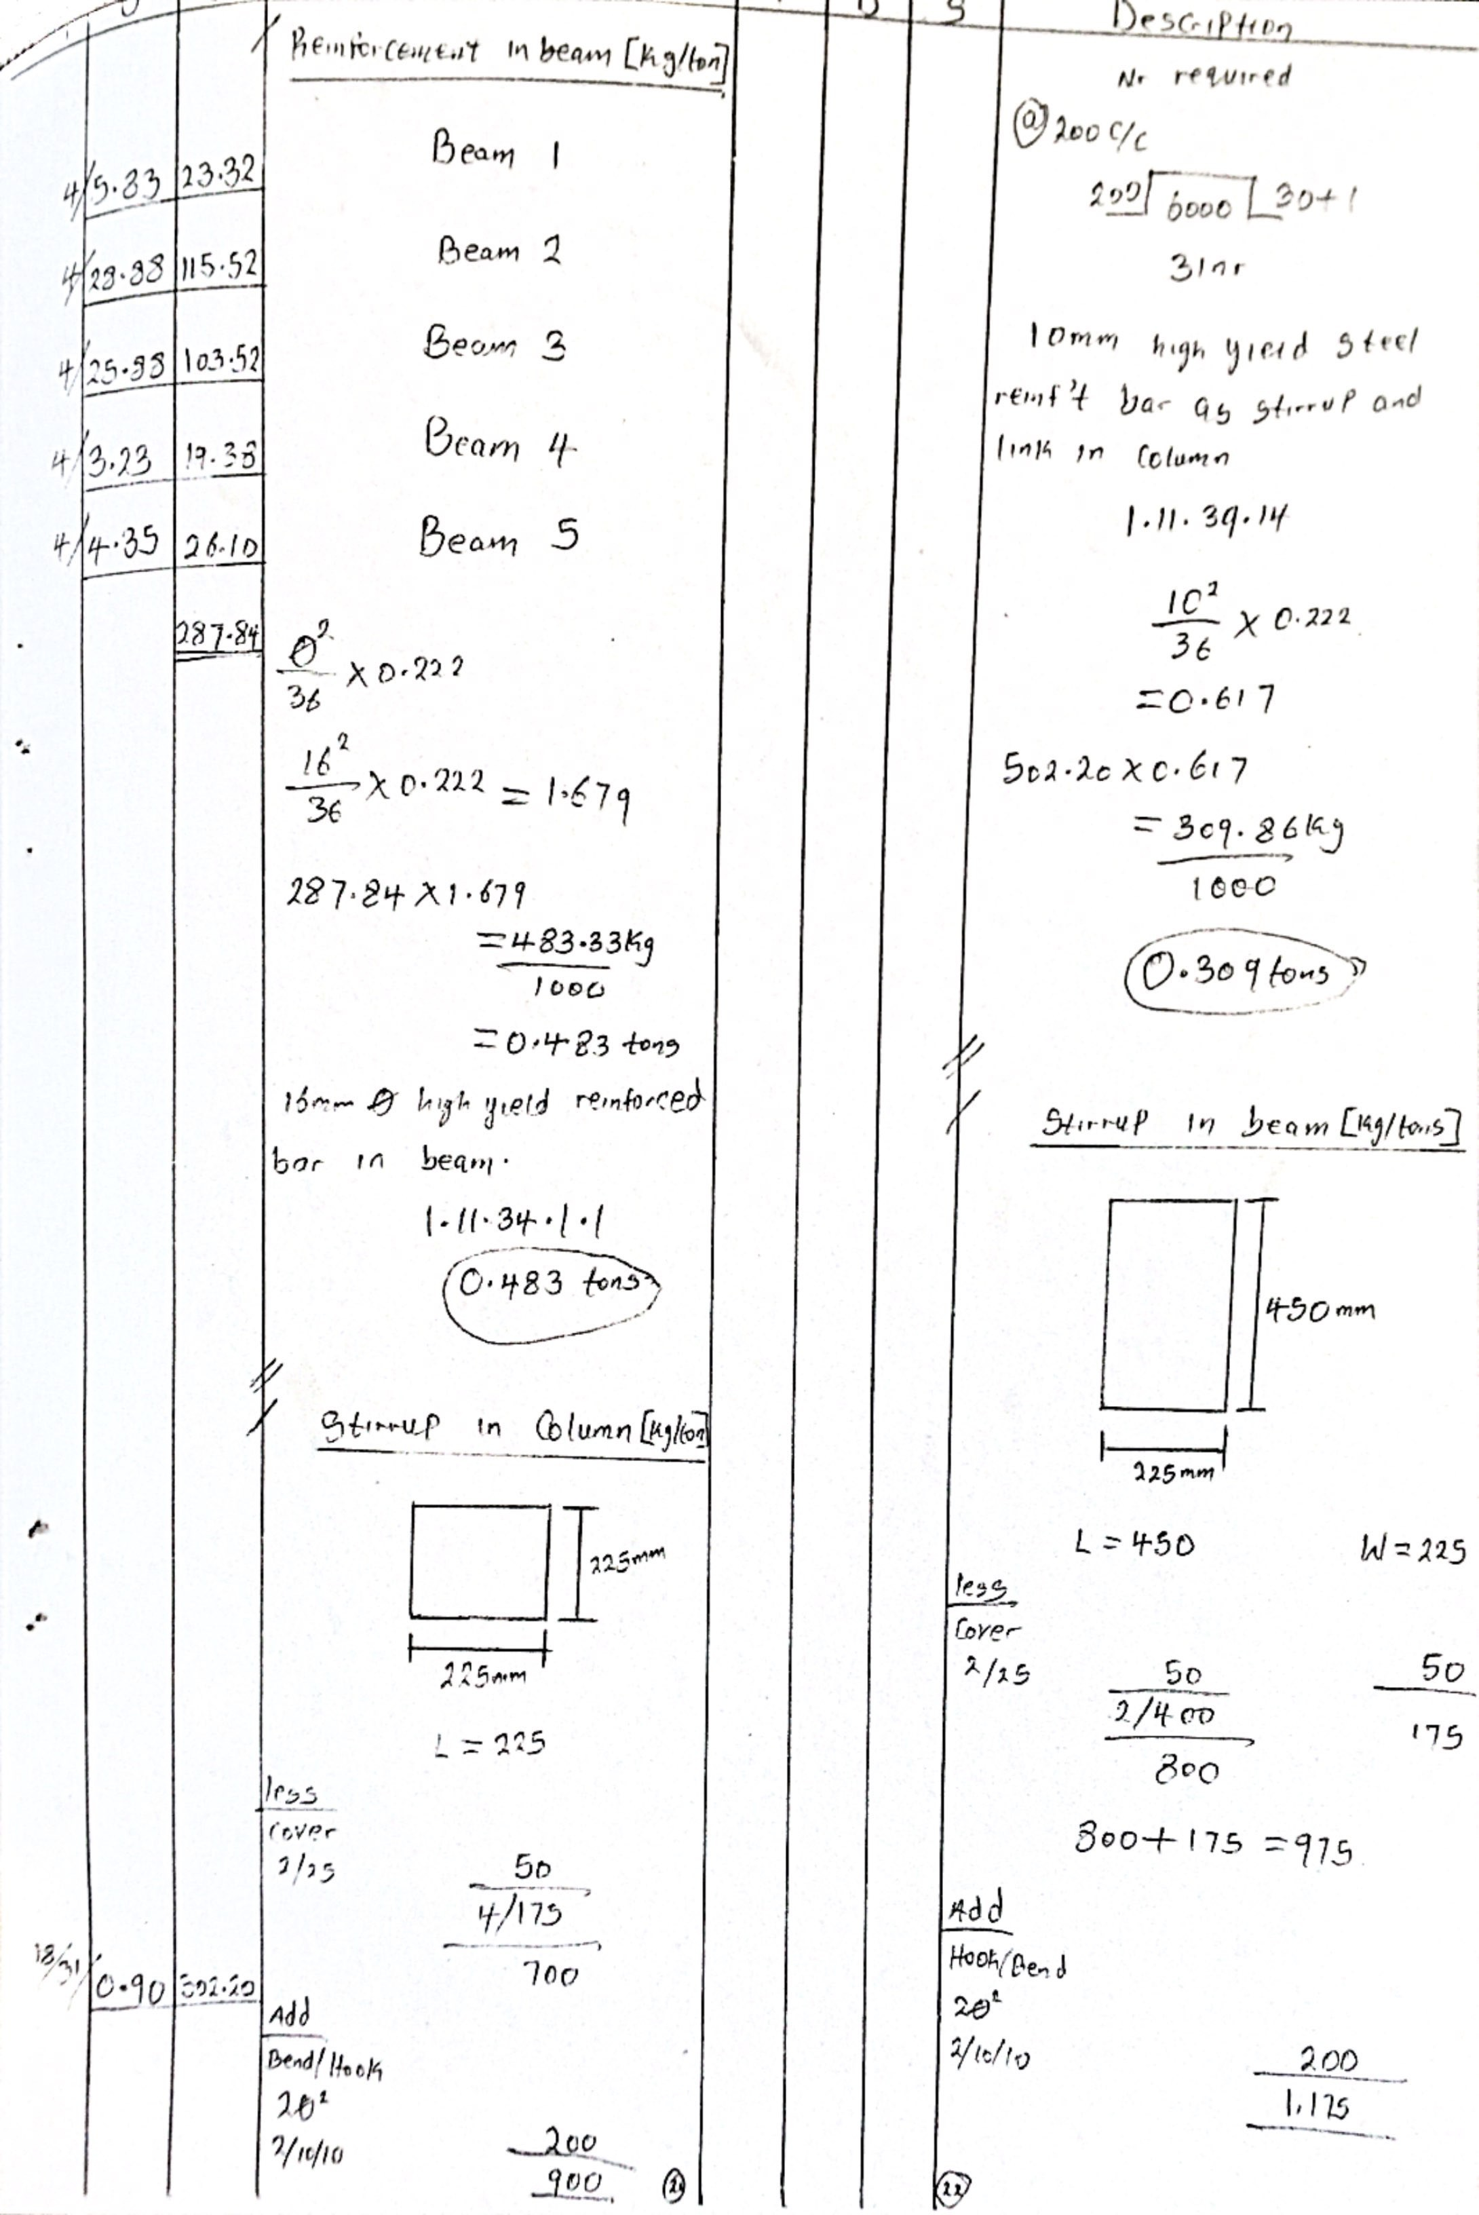

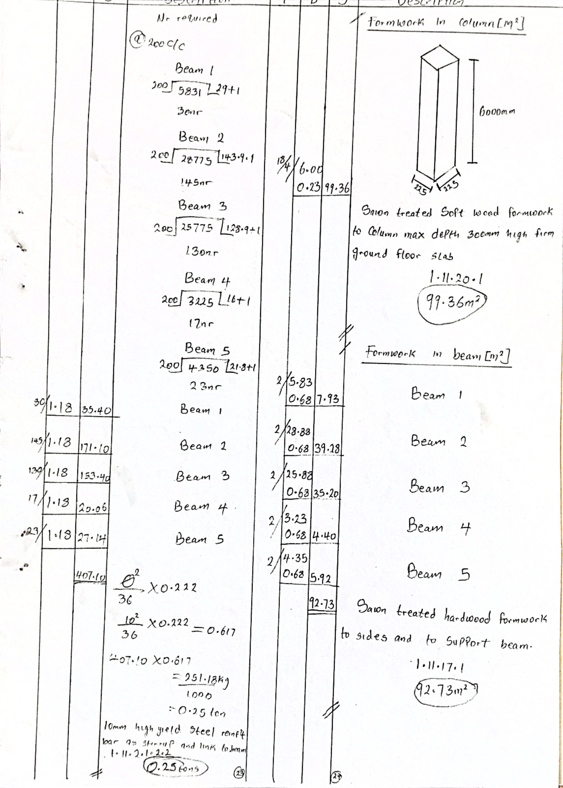

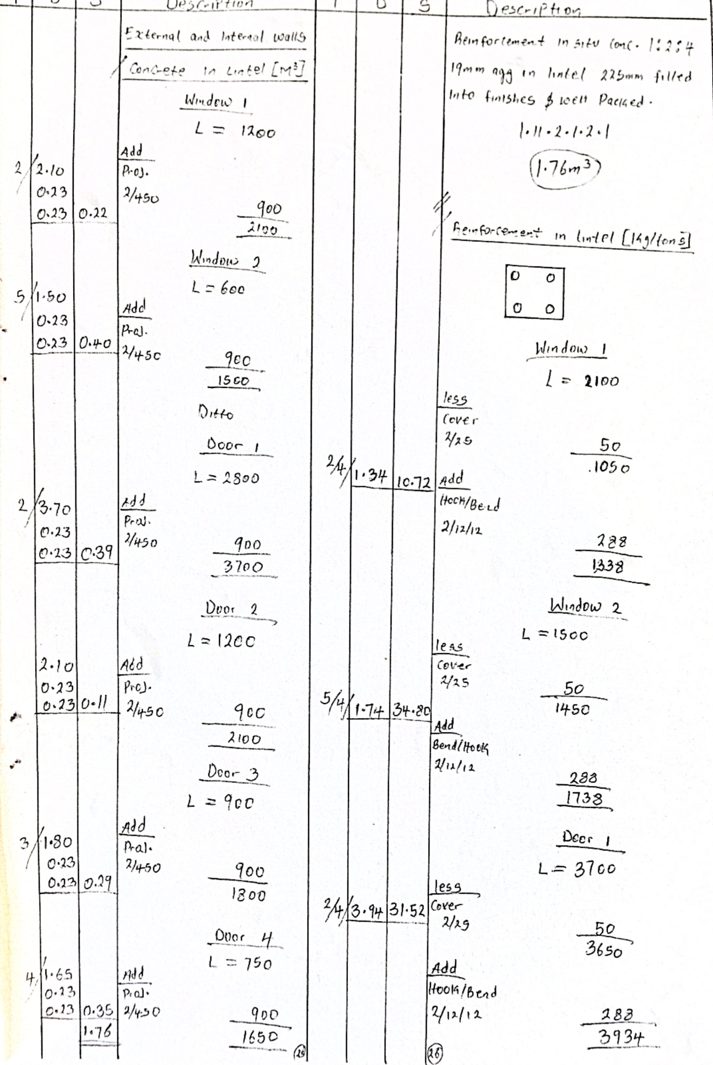

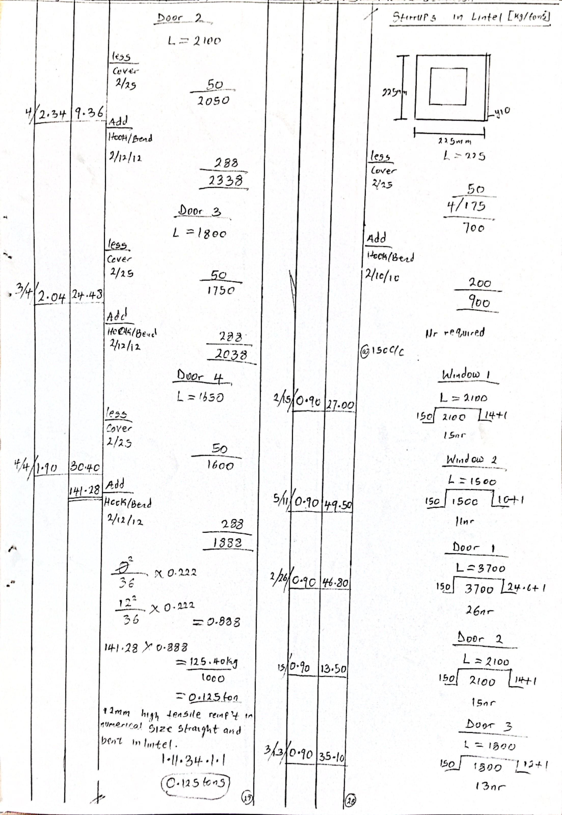

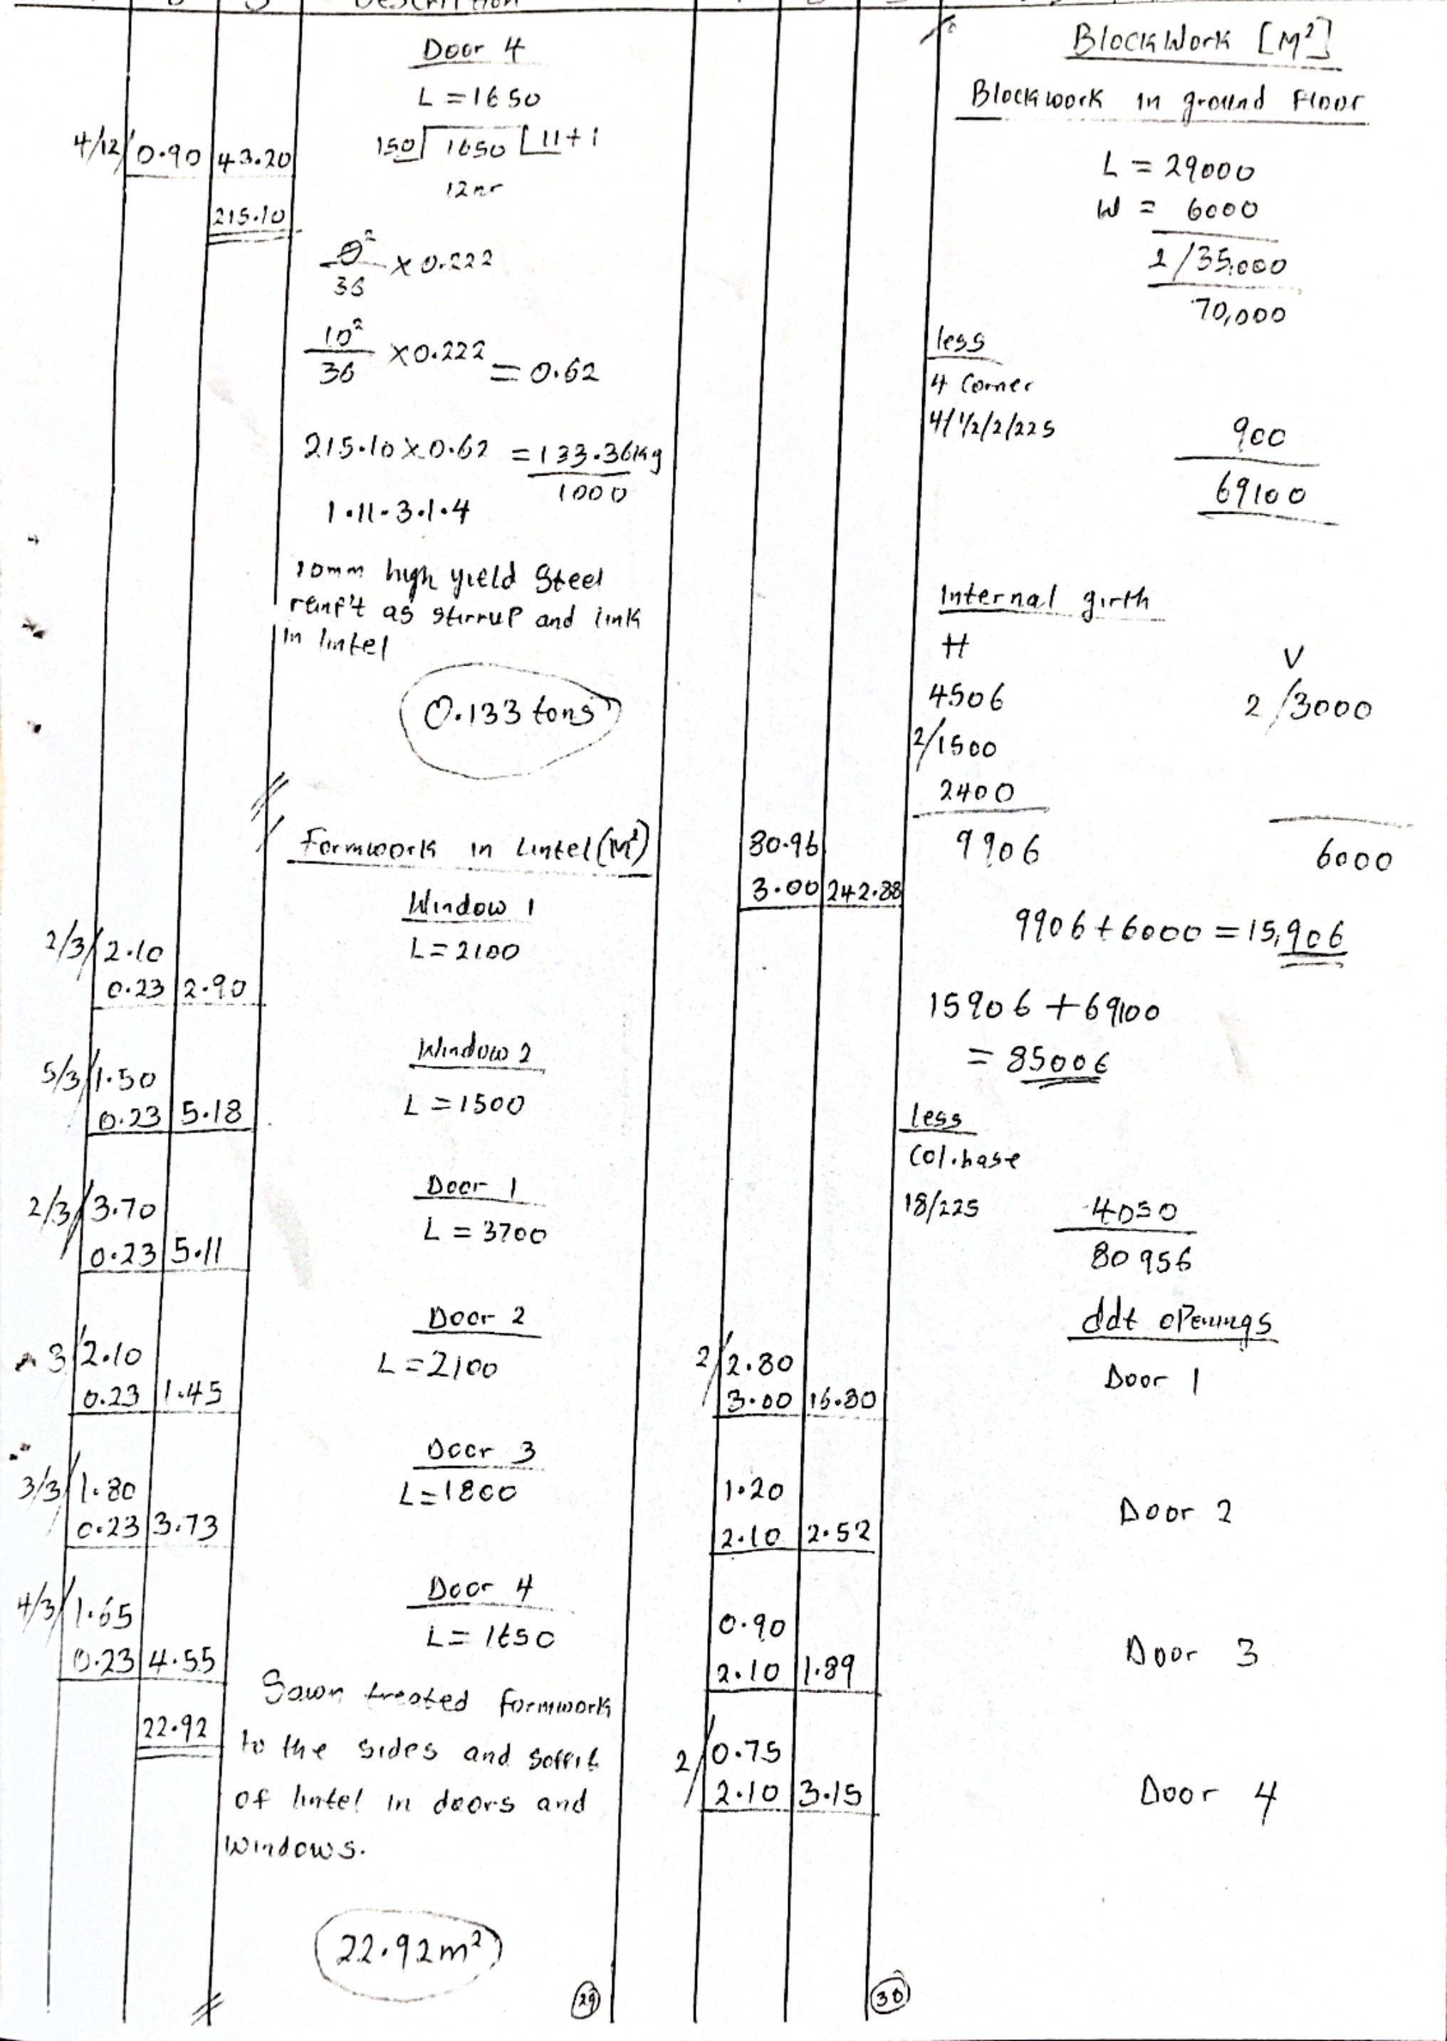

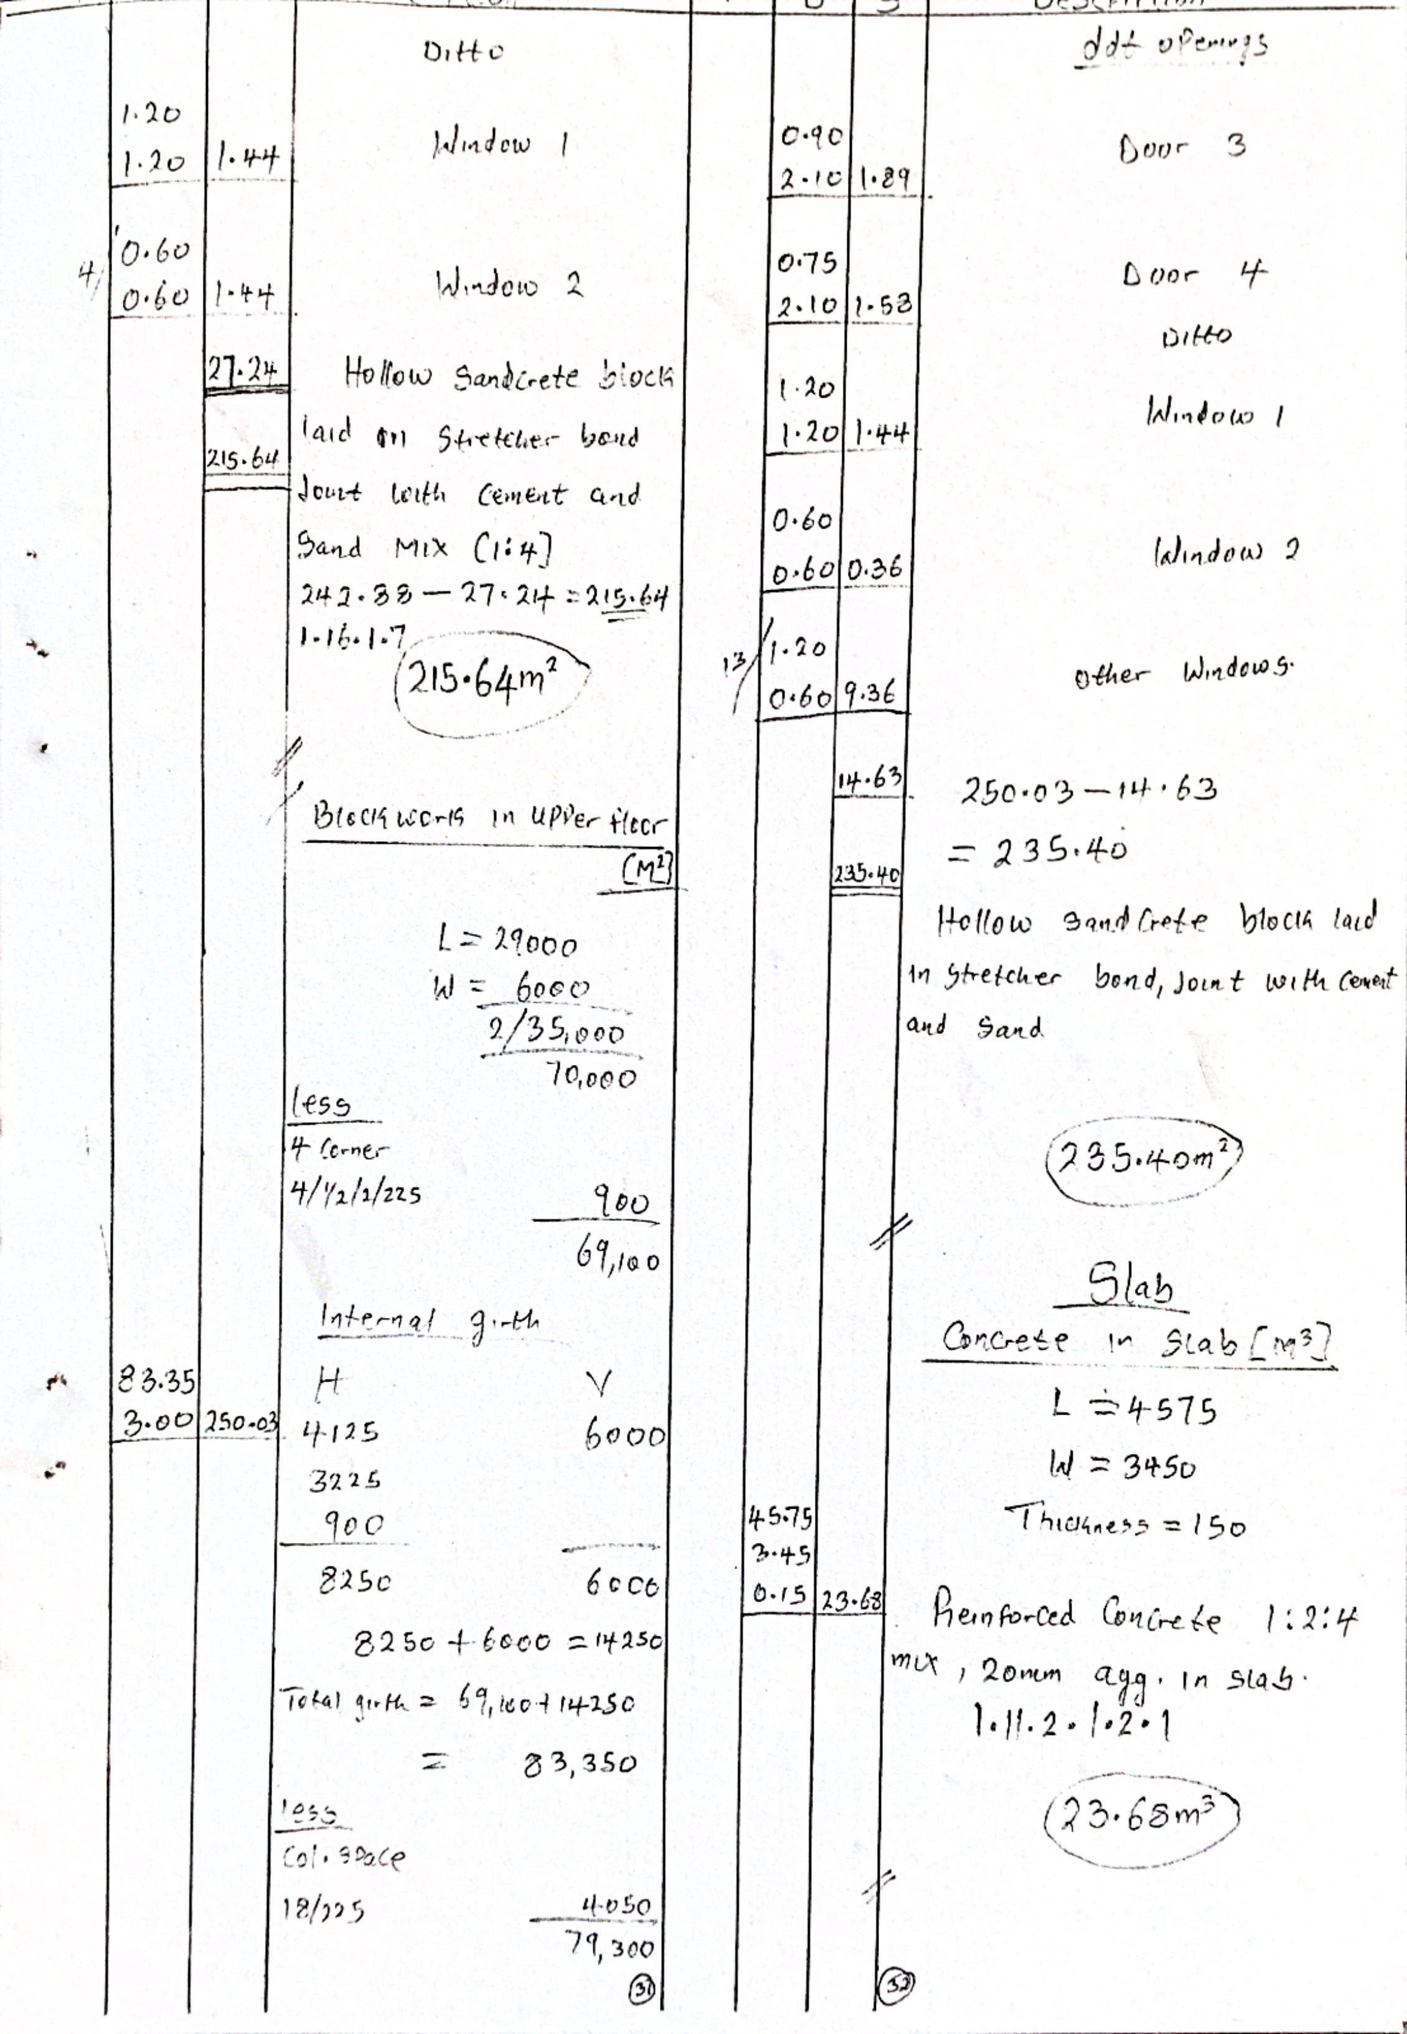

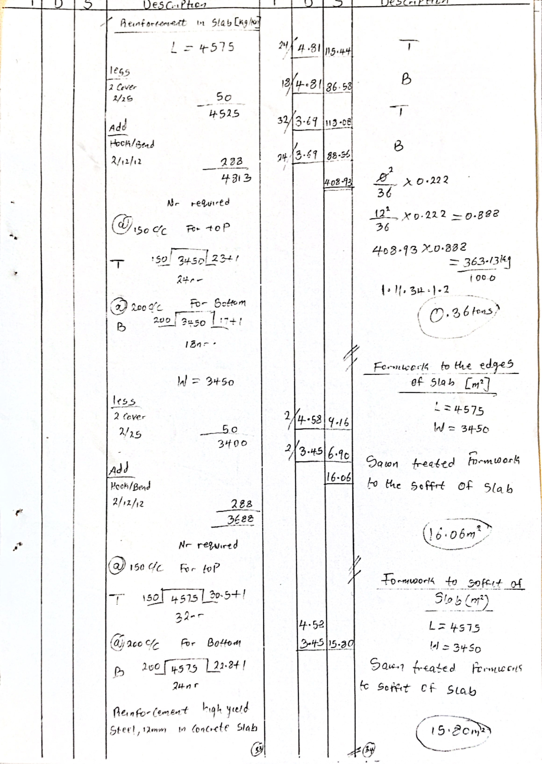

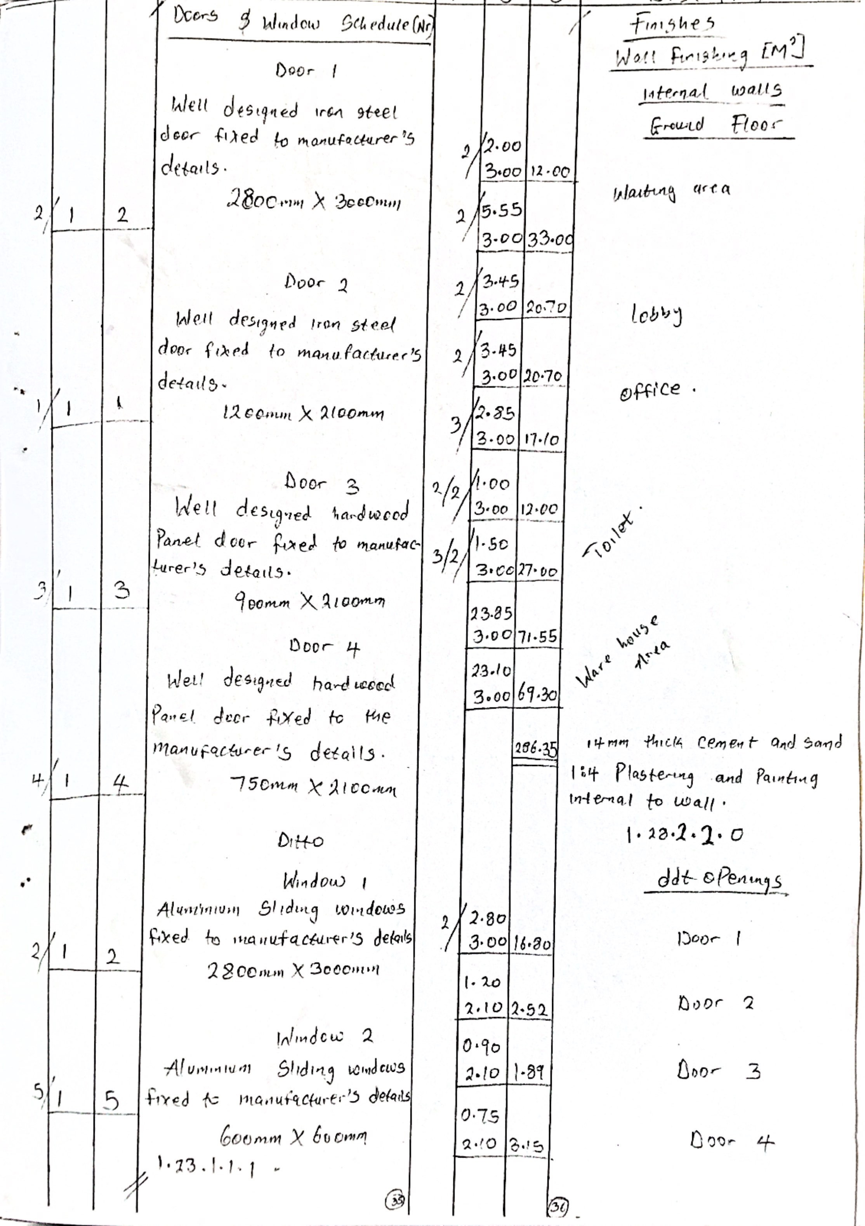

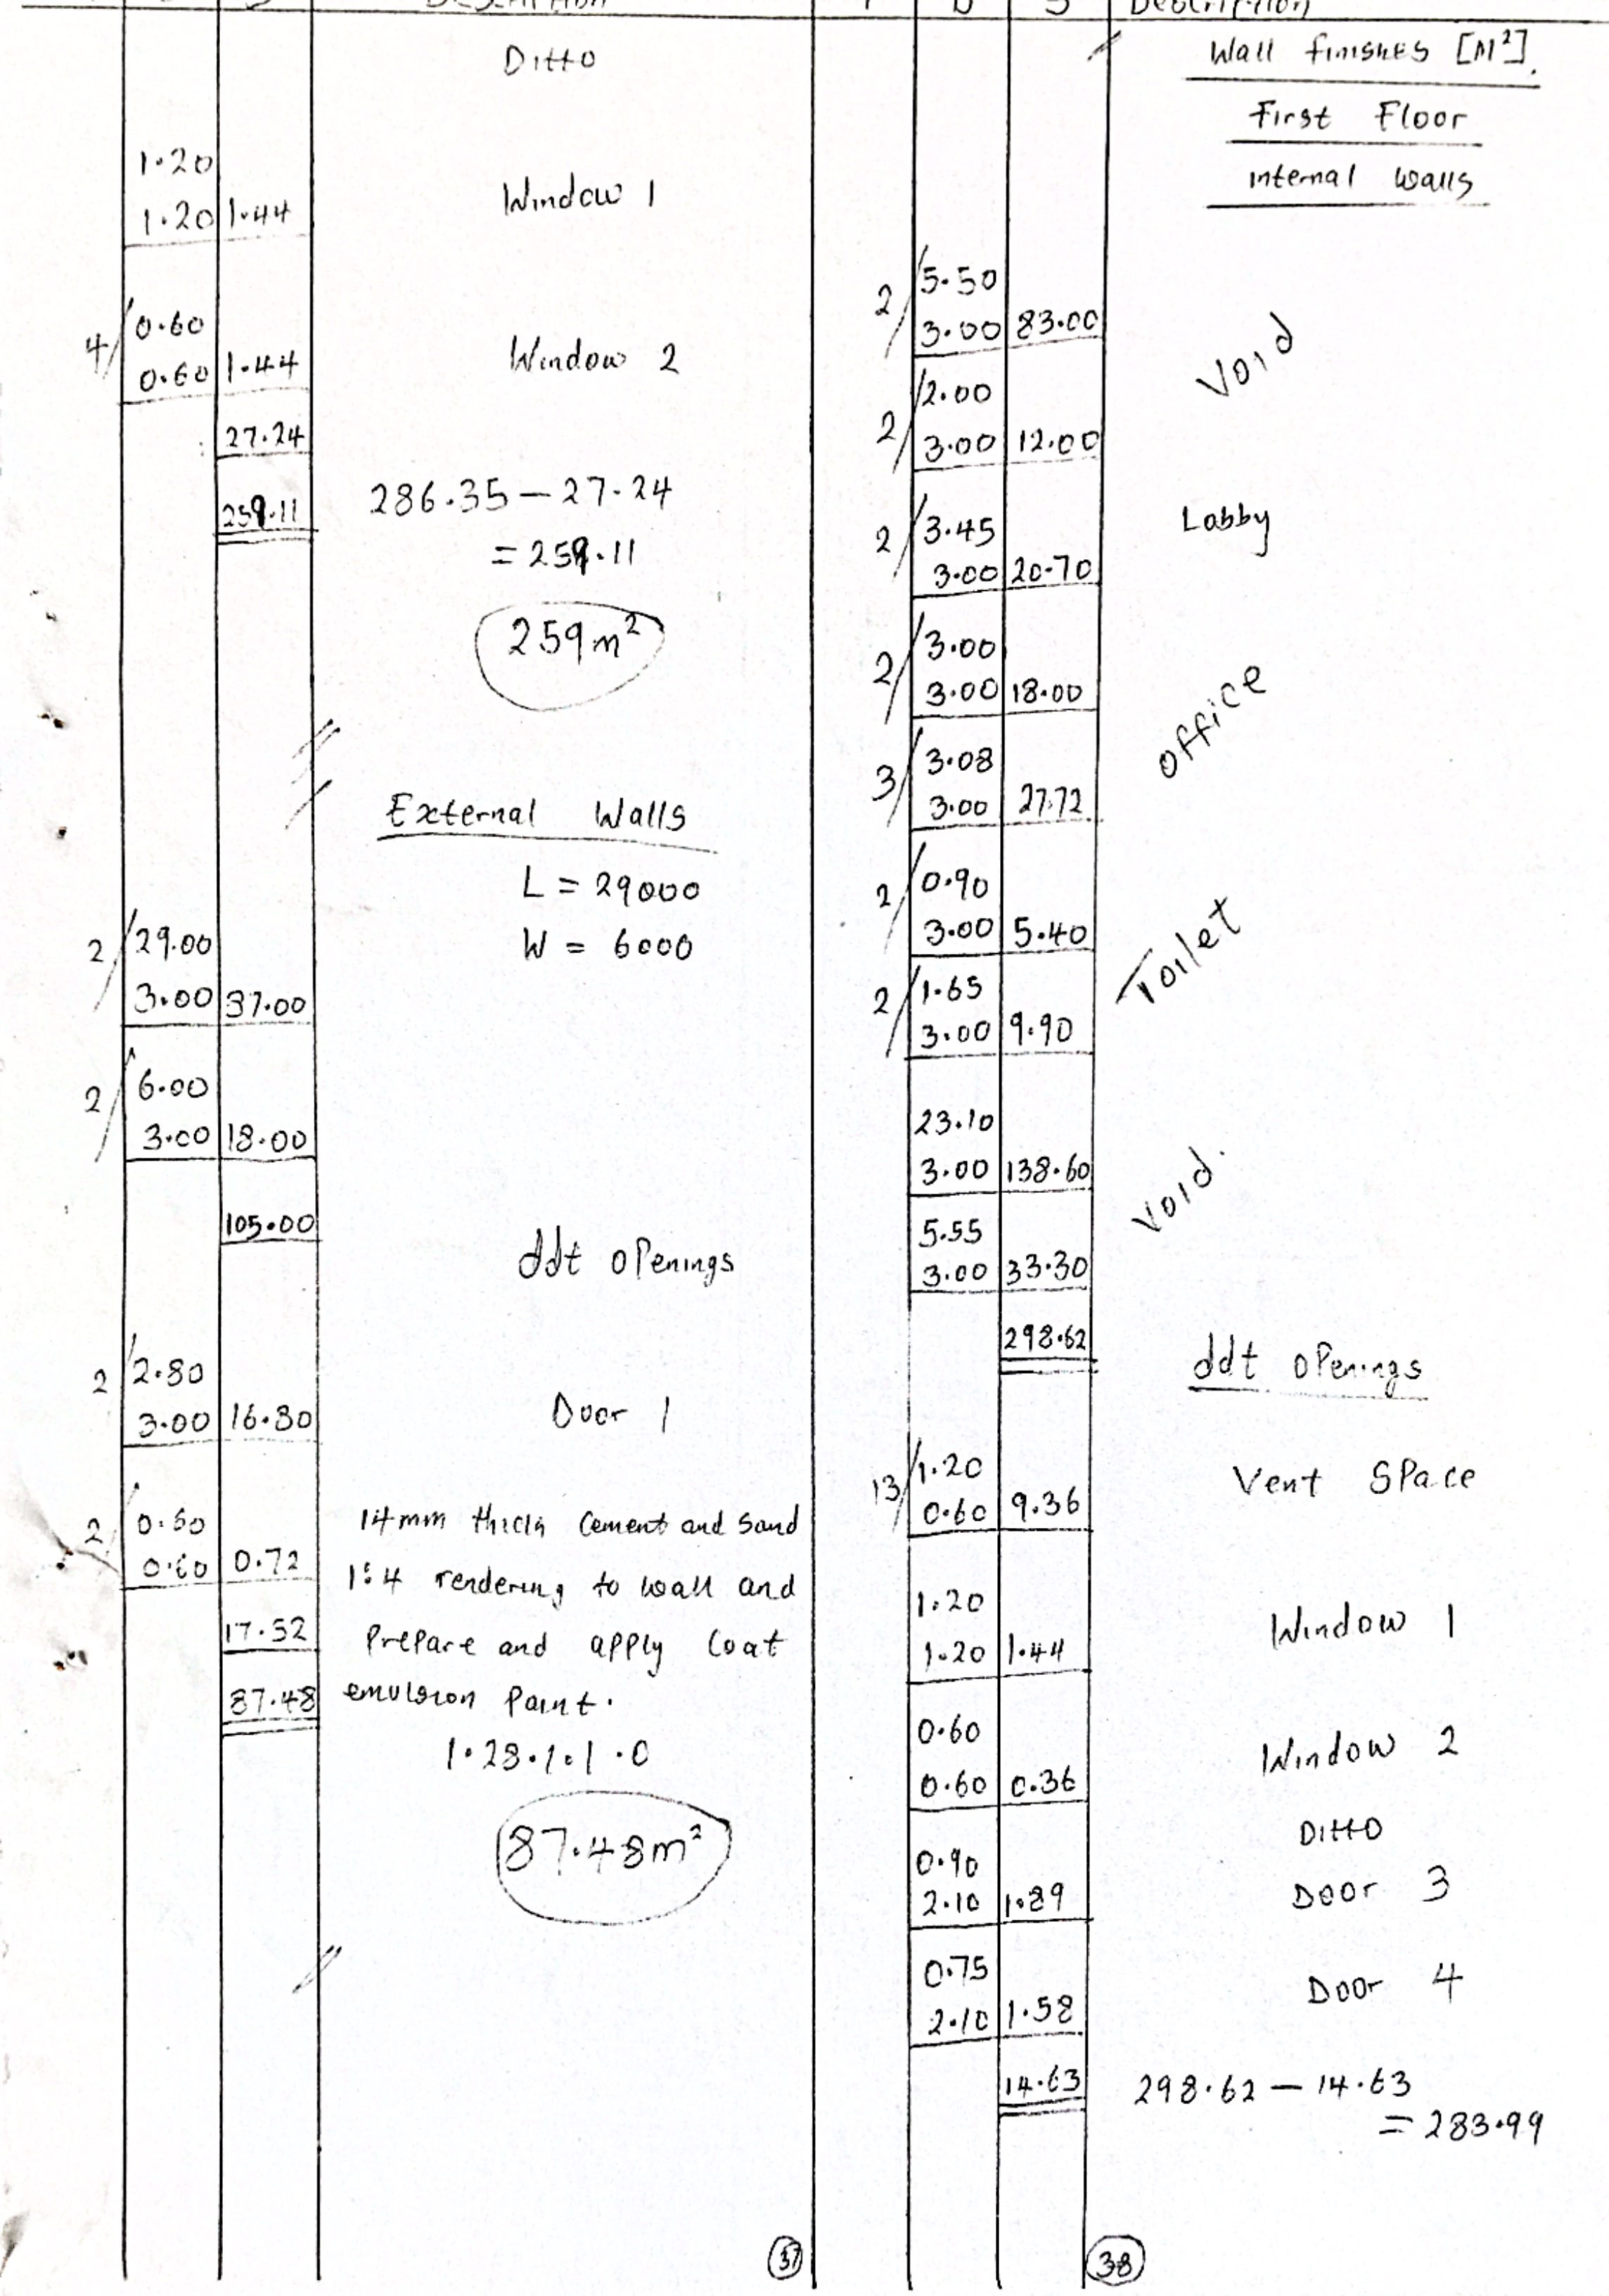

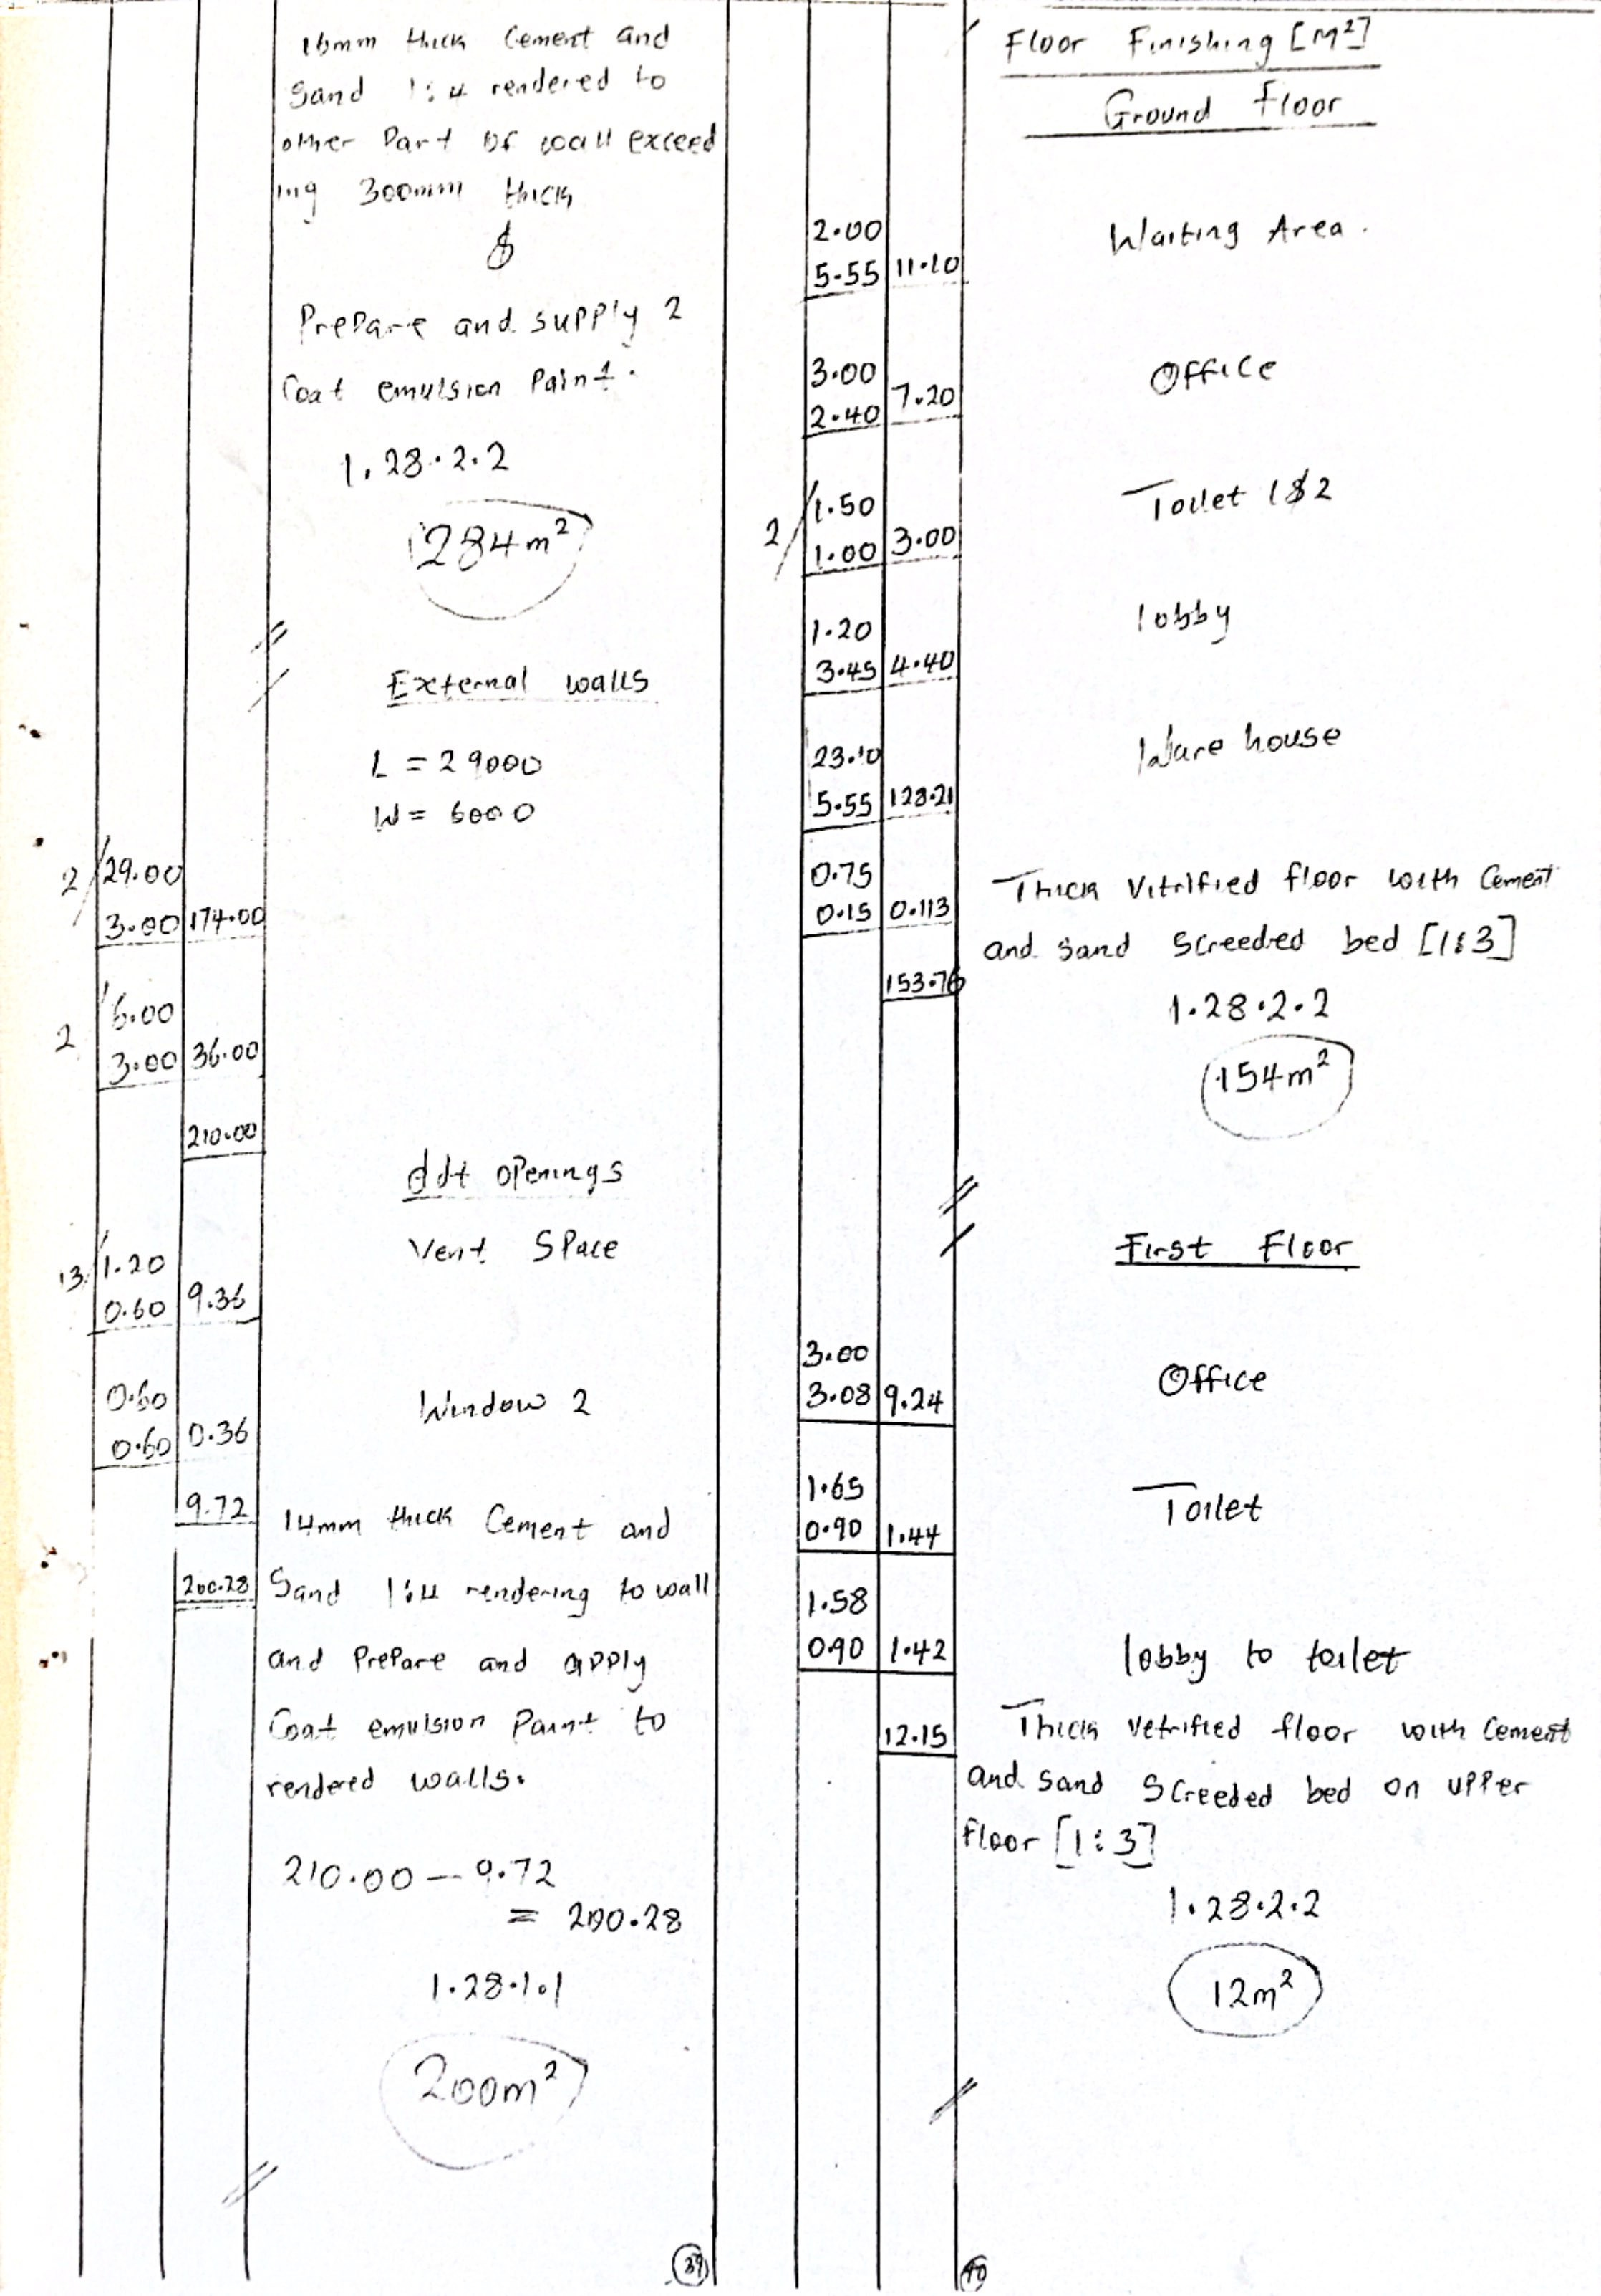

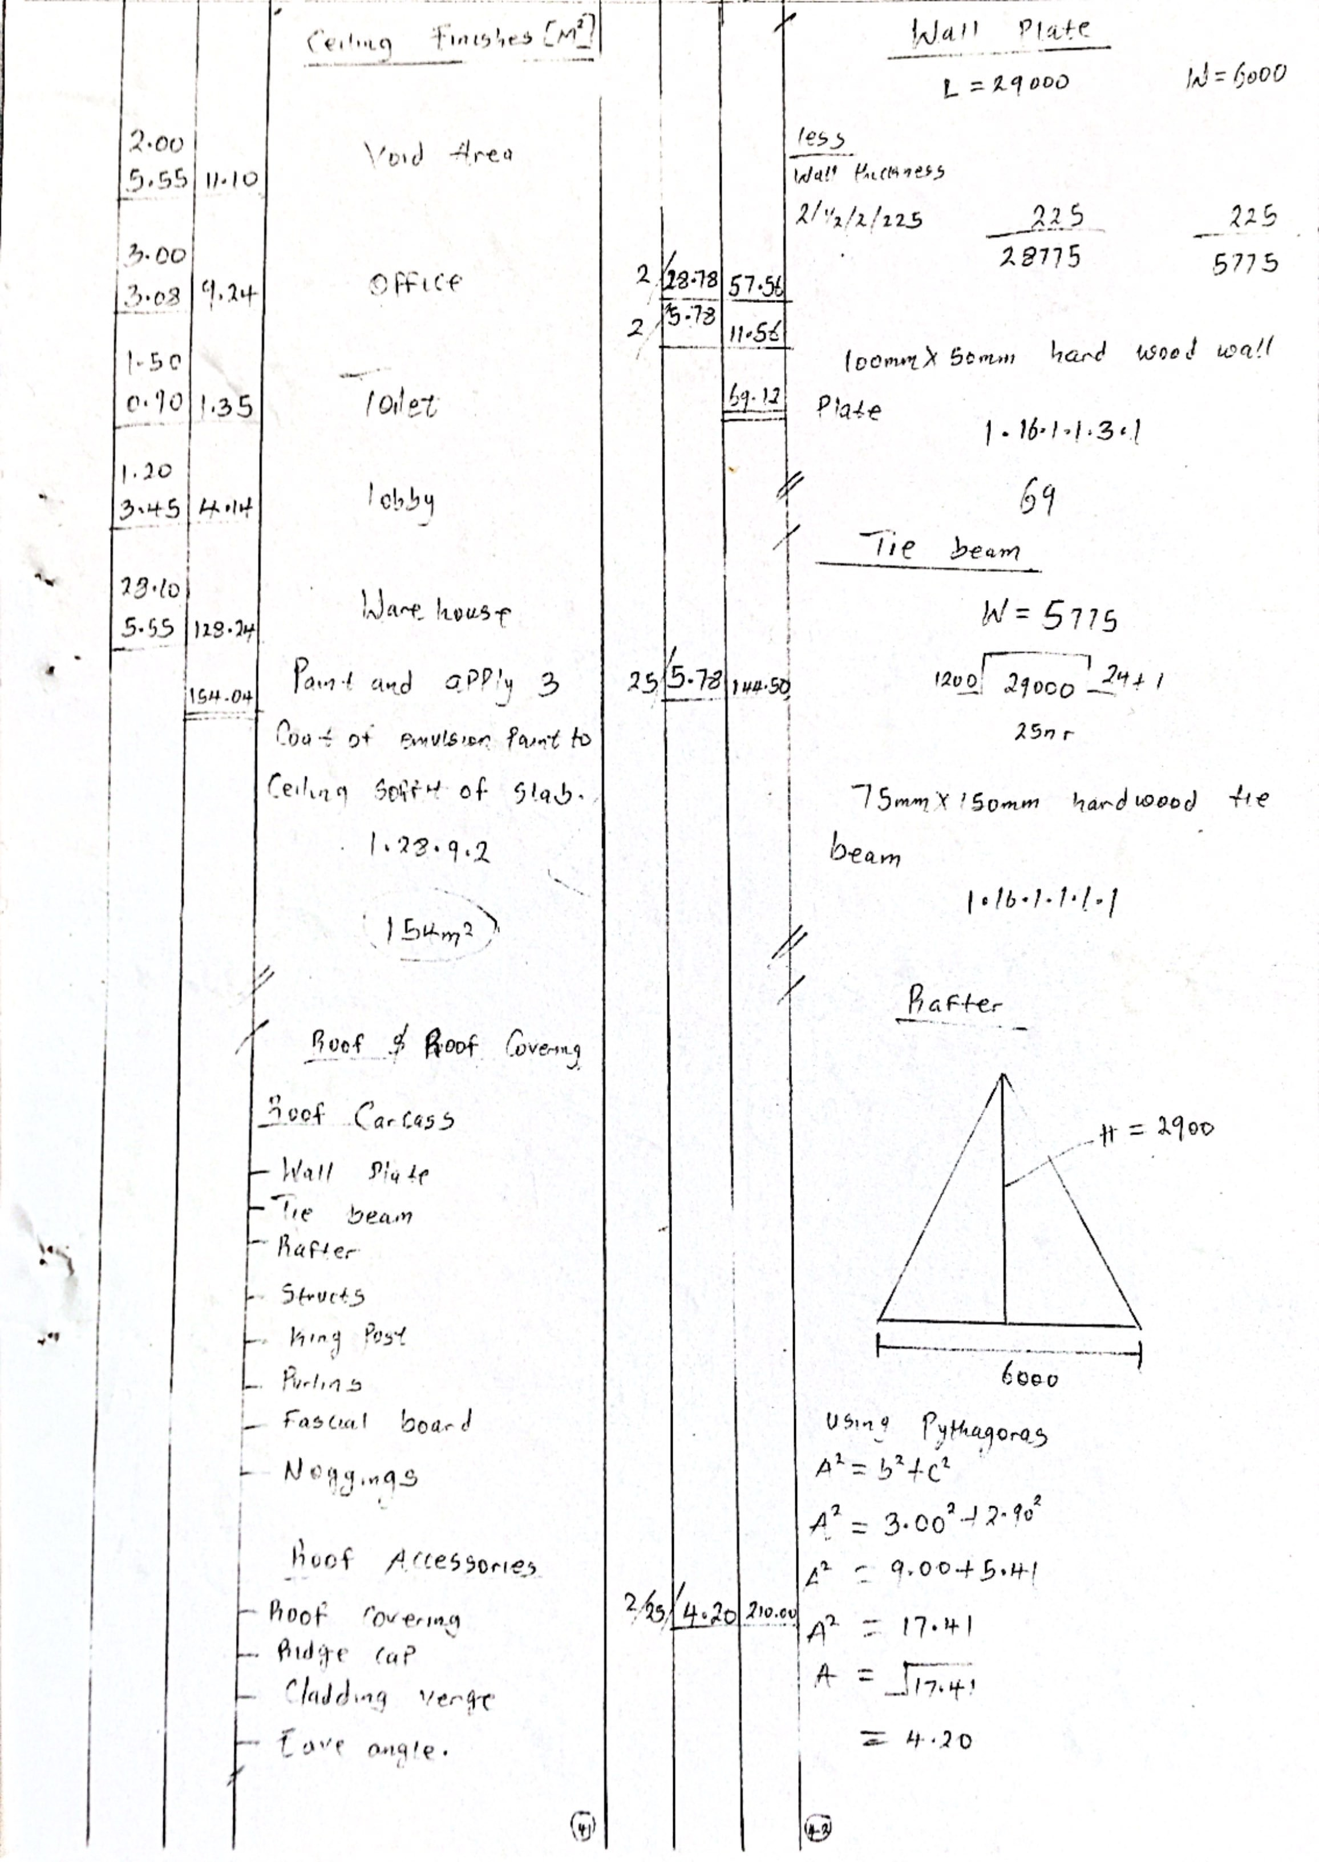

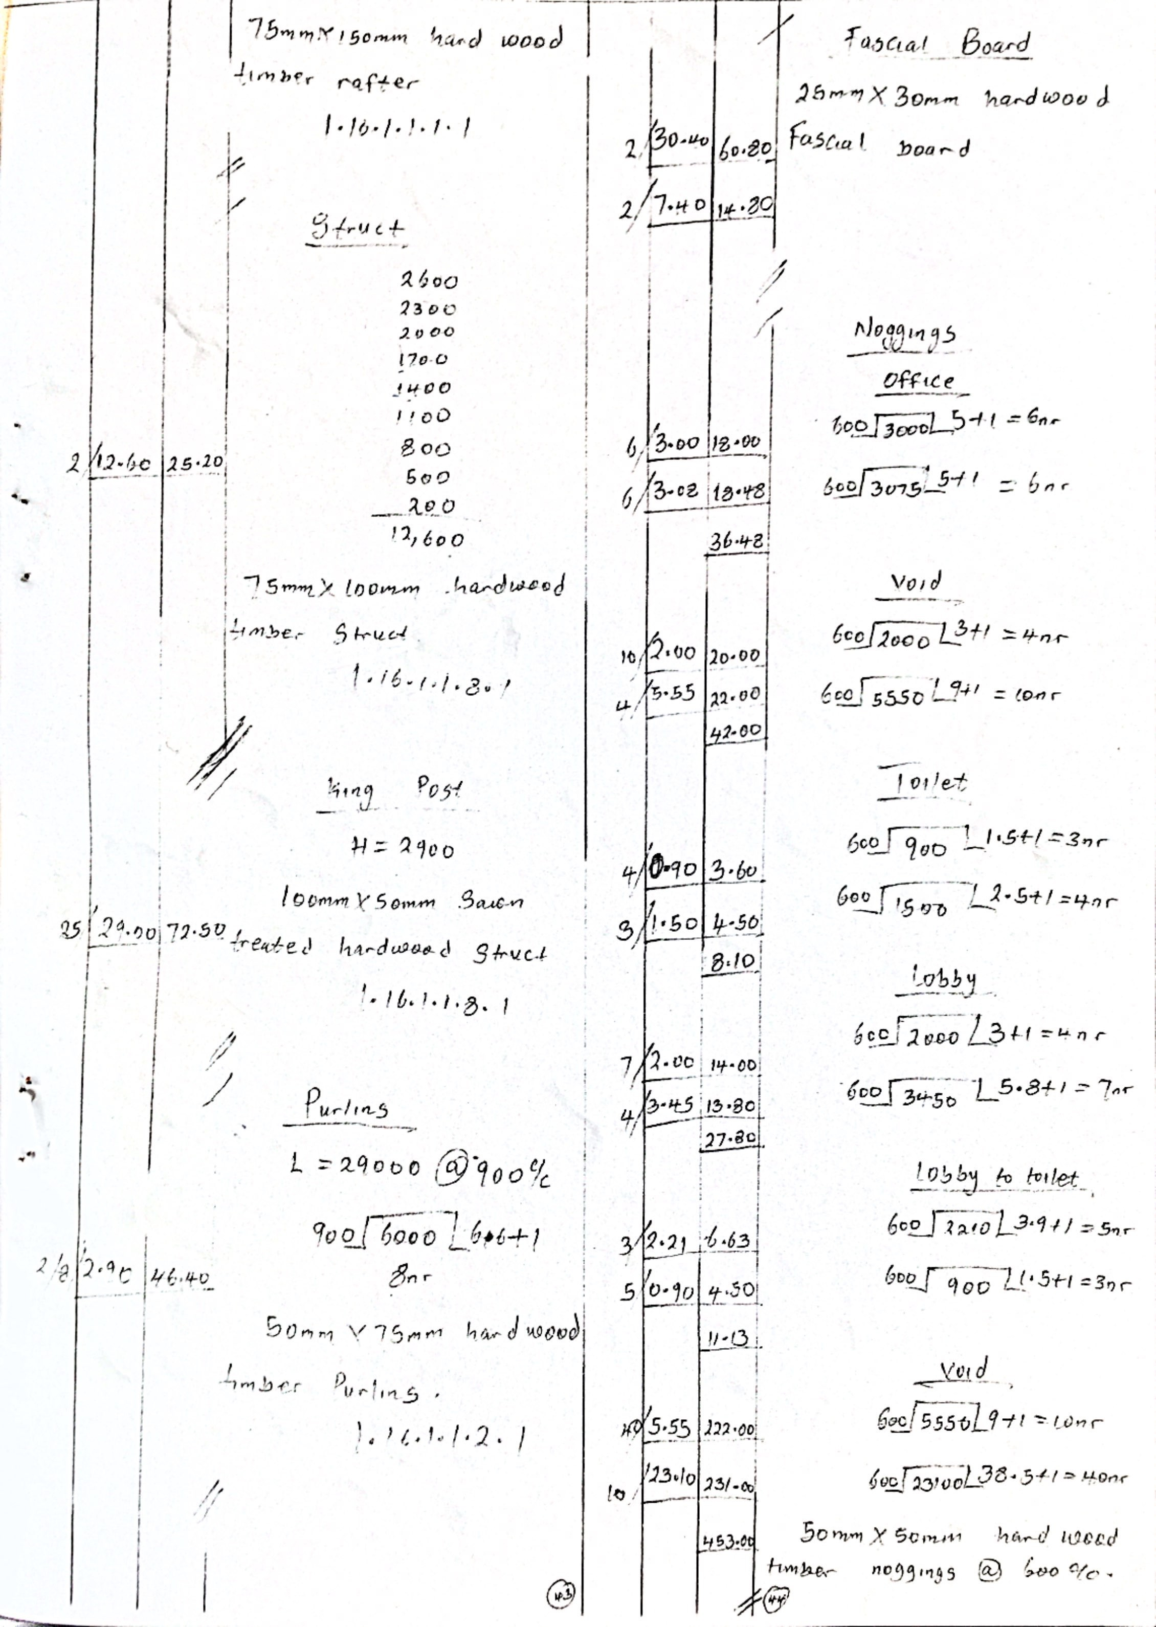

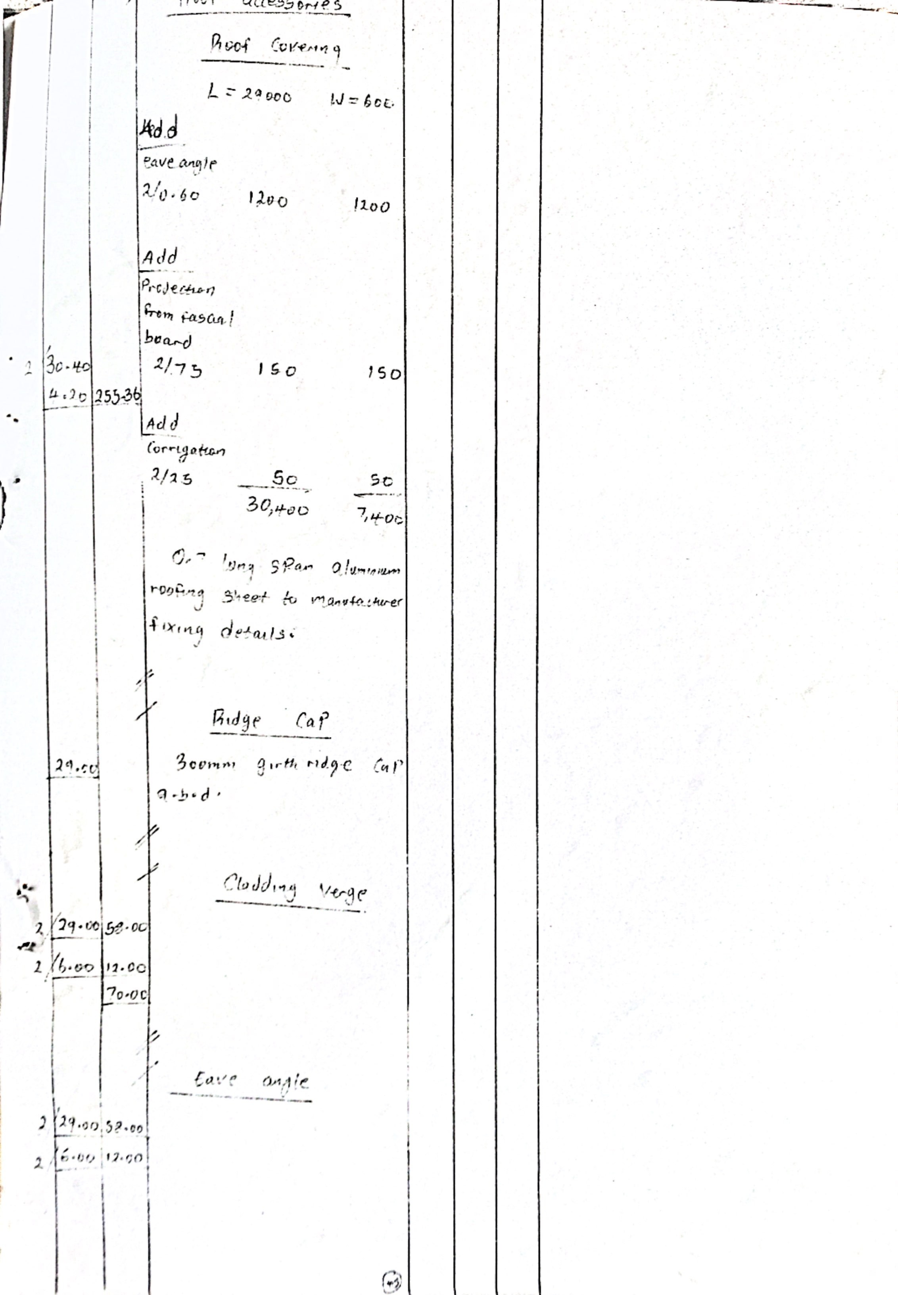

CHAPTER FIVE
5.1 SUMMARY
This research was carried out to estimate and budget for a medium scale building for a proposed Examination Hall at Kwara State Polytechnic, Ilorin Kwara State.
It is also designed to sow the process of taking off, abstracting and method of preparing Bill of Quantities.
5.2 CONCLUSION
In conclusion, we observed that estimating for medium scale building project is very important.
- It gives an itemized list of the component parts of building with a full description and quantity of each part.
- It serves as a guidance for the contractor.
- It provides a basis for a valuation of variable which often occur during the progress of the work.
- It enables all contractors tendering for a contract to price on exactly the same information with a minimum of effort.
5.3 RECOMMENDATION
From the analysis of the data in chapter four of this project, the following recommendations were be made:
- The Quantity Surveyor should provide an estimate during the preliminary stage of the project in order to forecasts its likely cost.
- It is important not to under estimate, proper estimating procedures should be clear and logical.

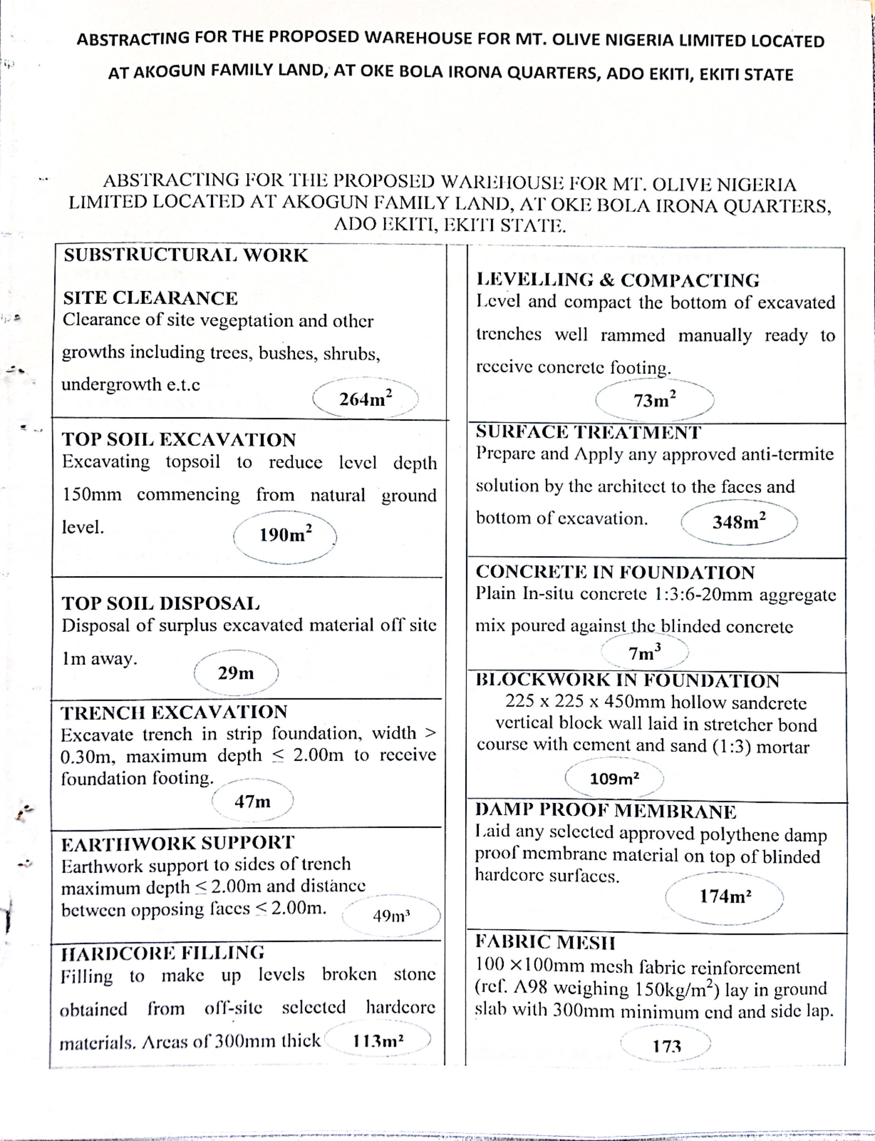
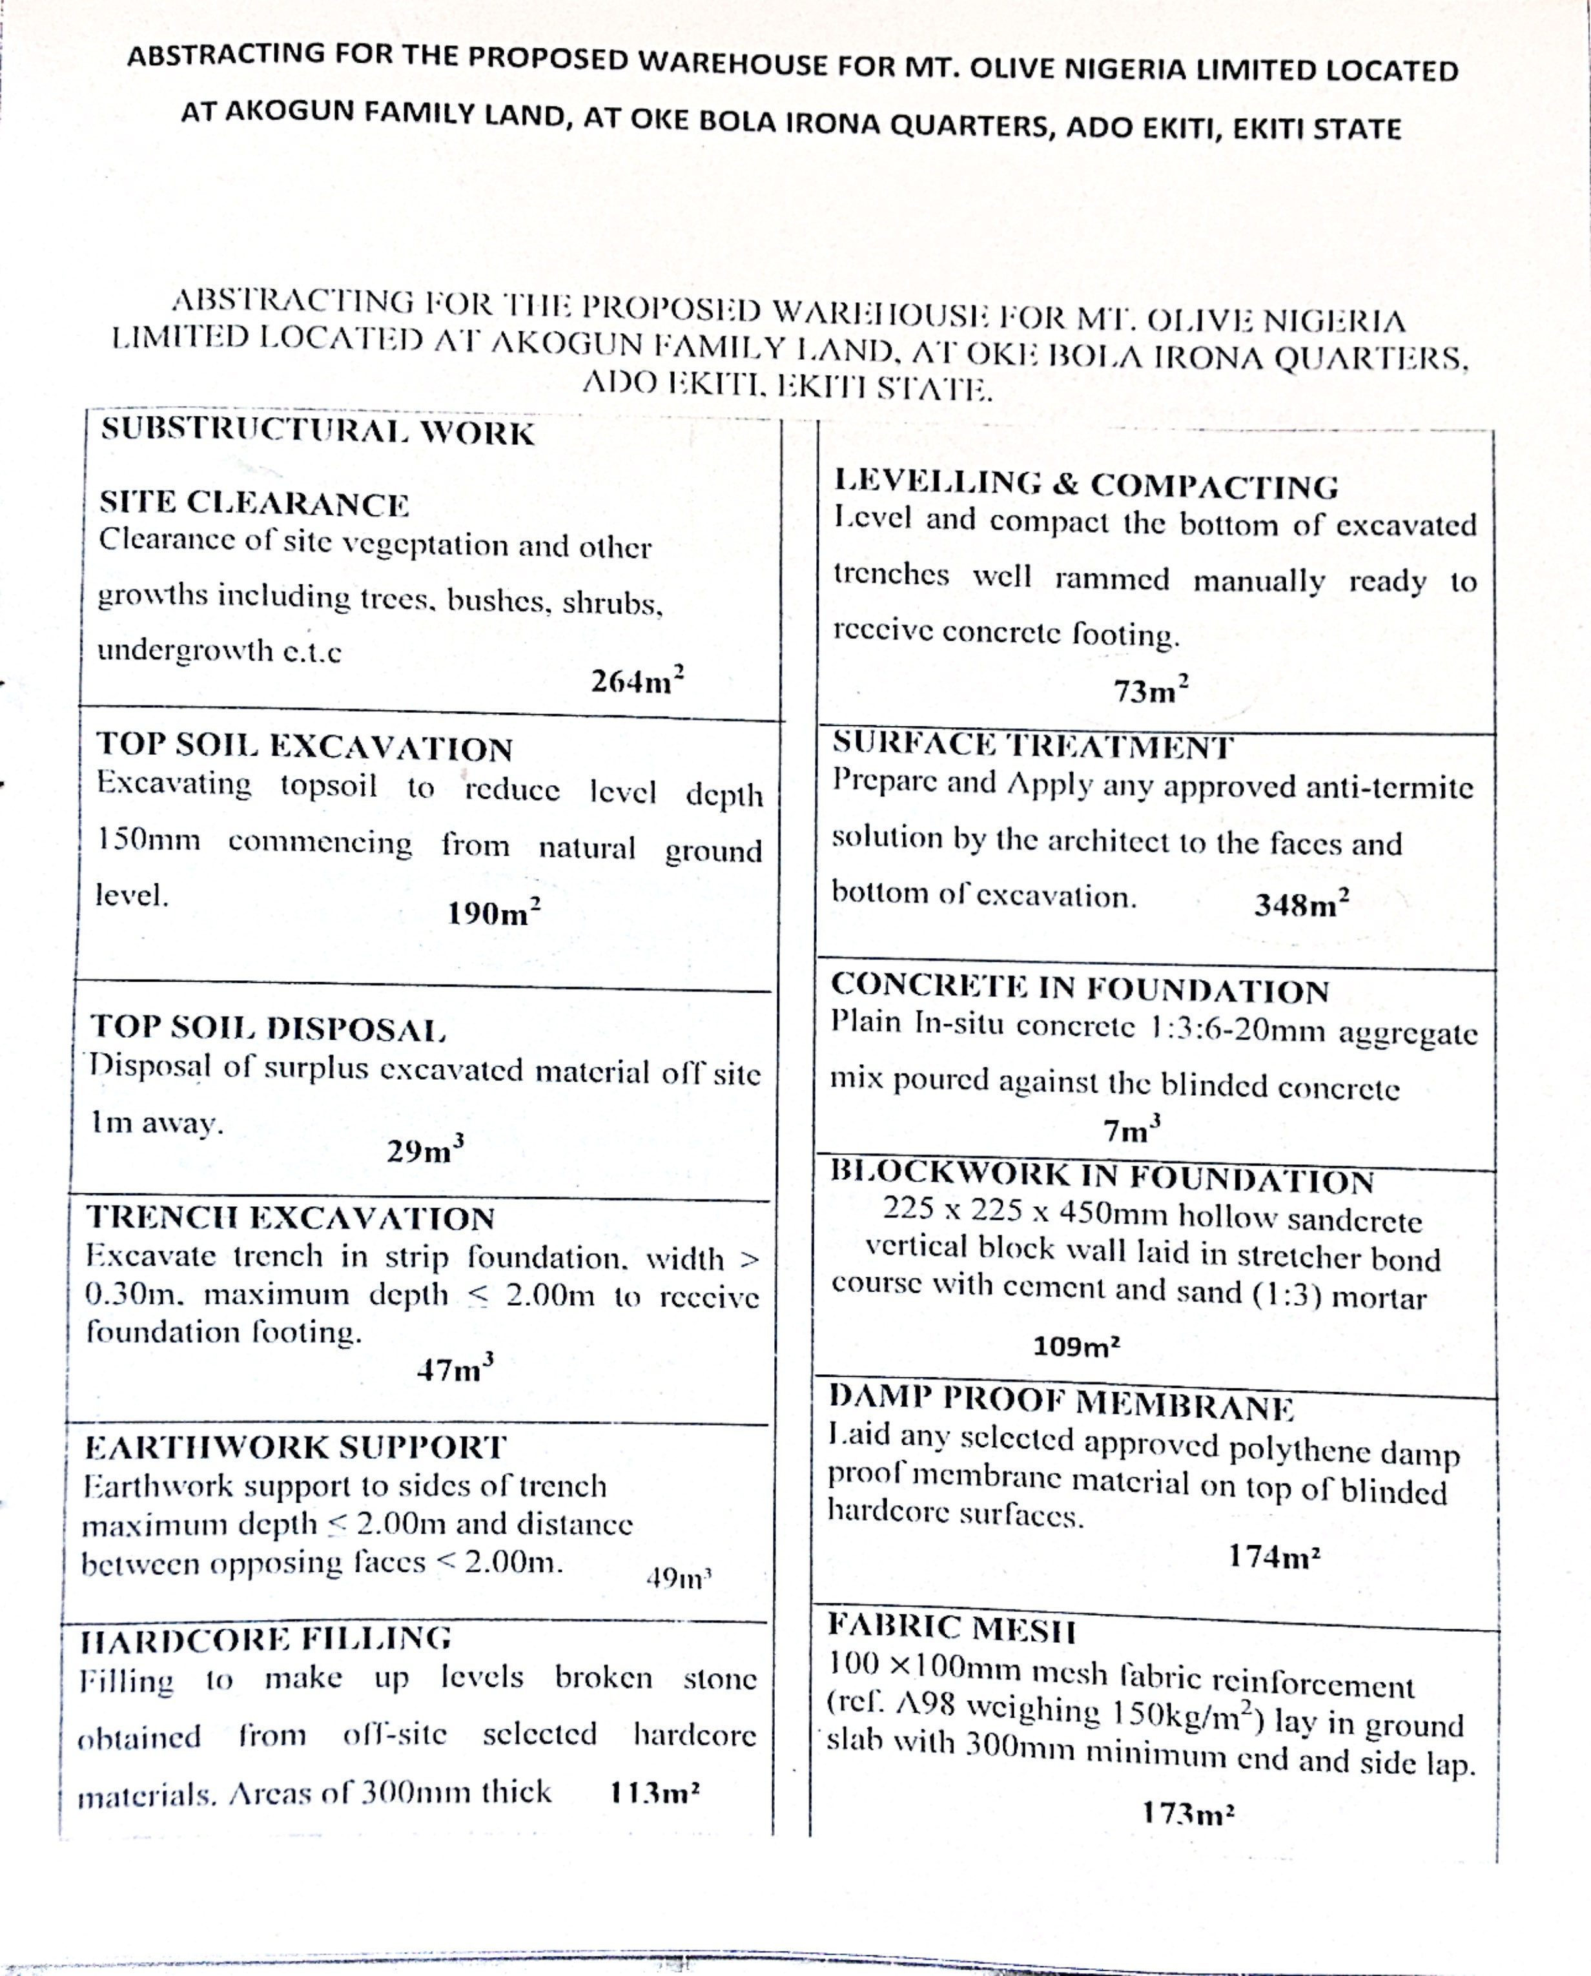
GFHGFHD

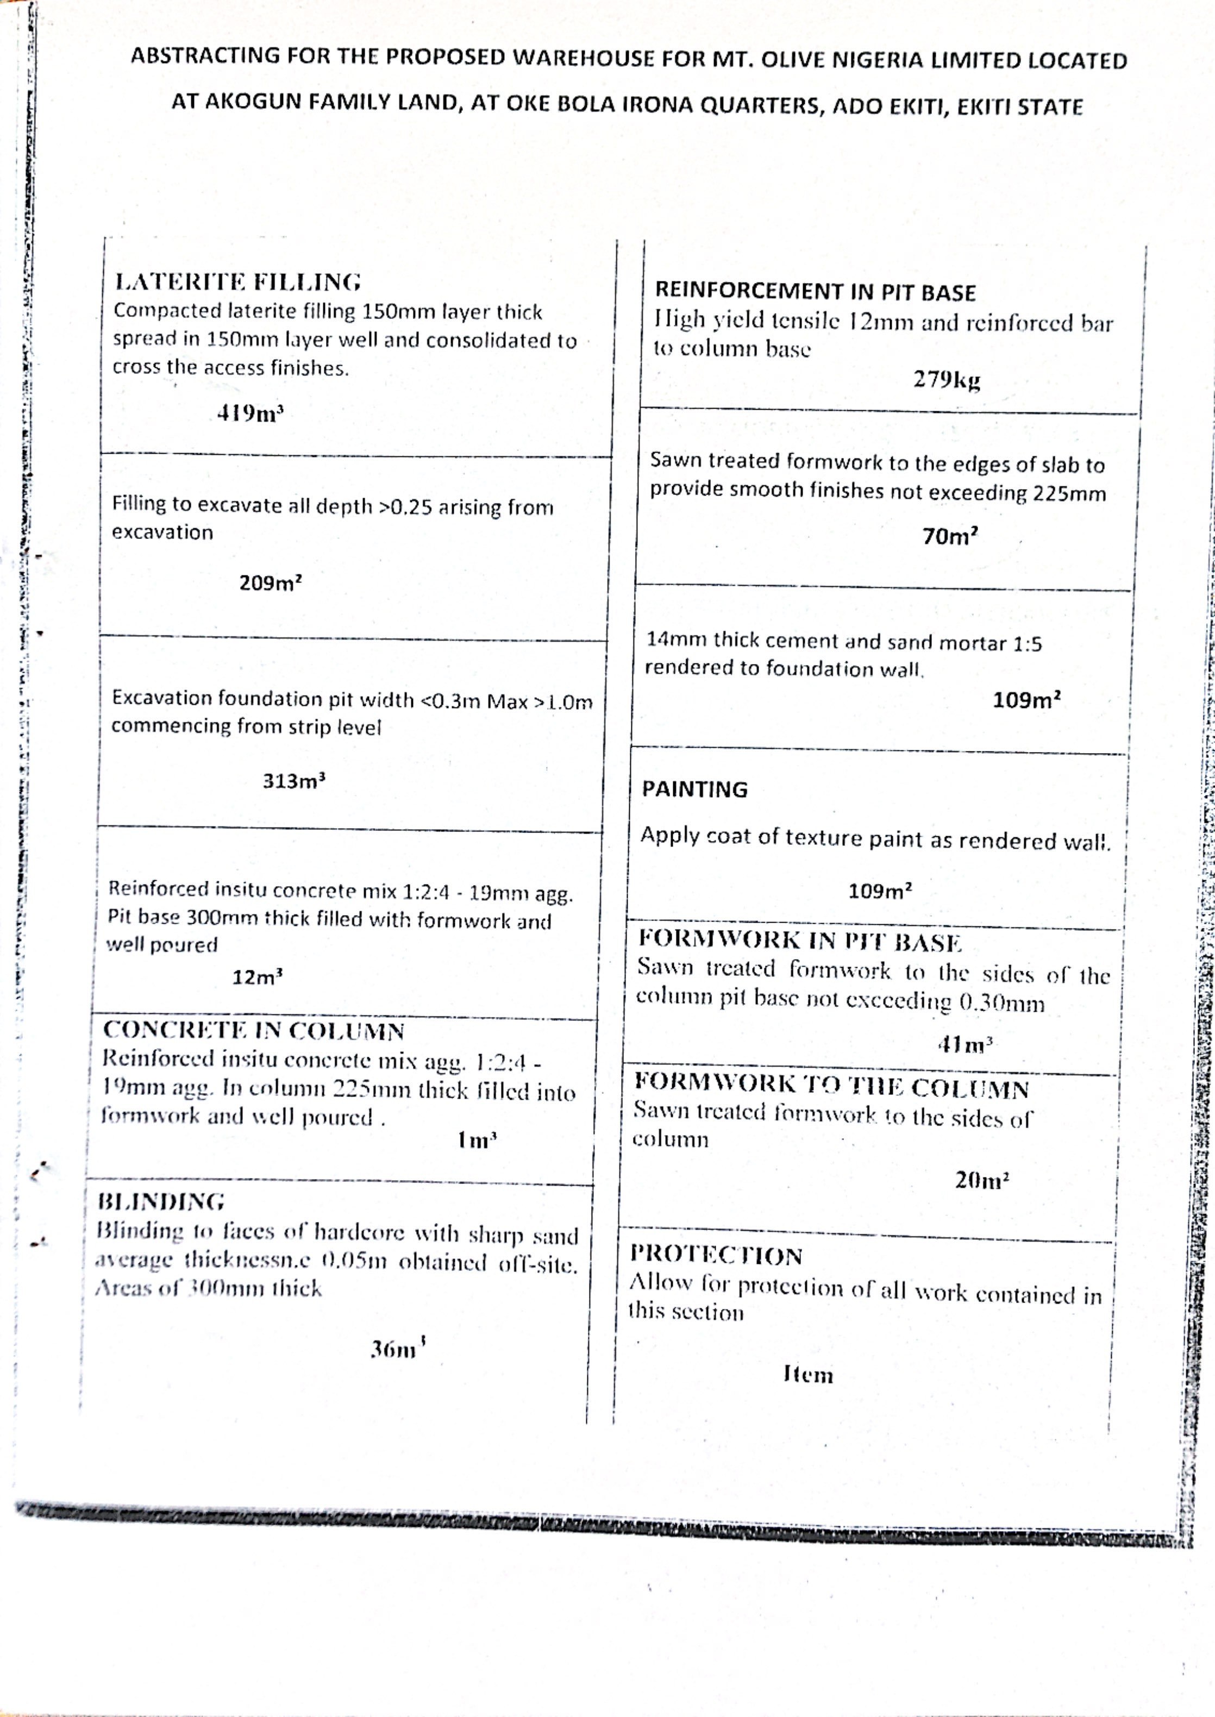

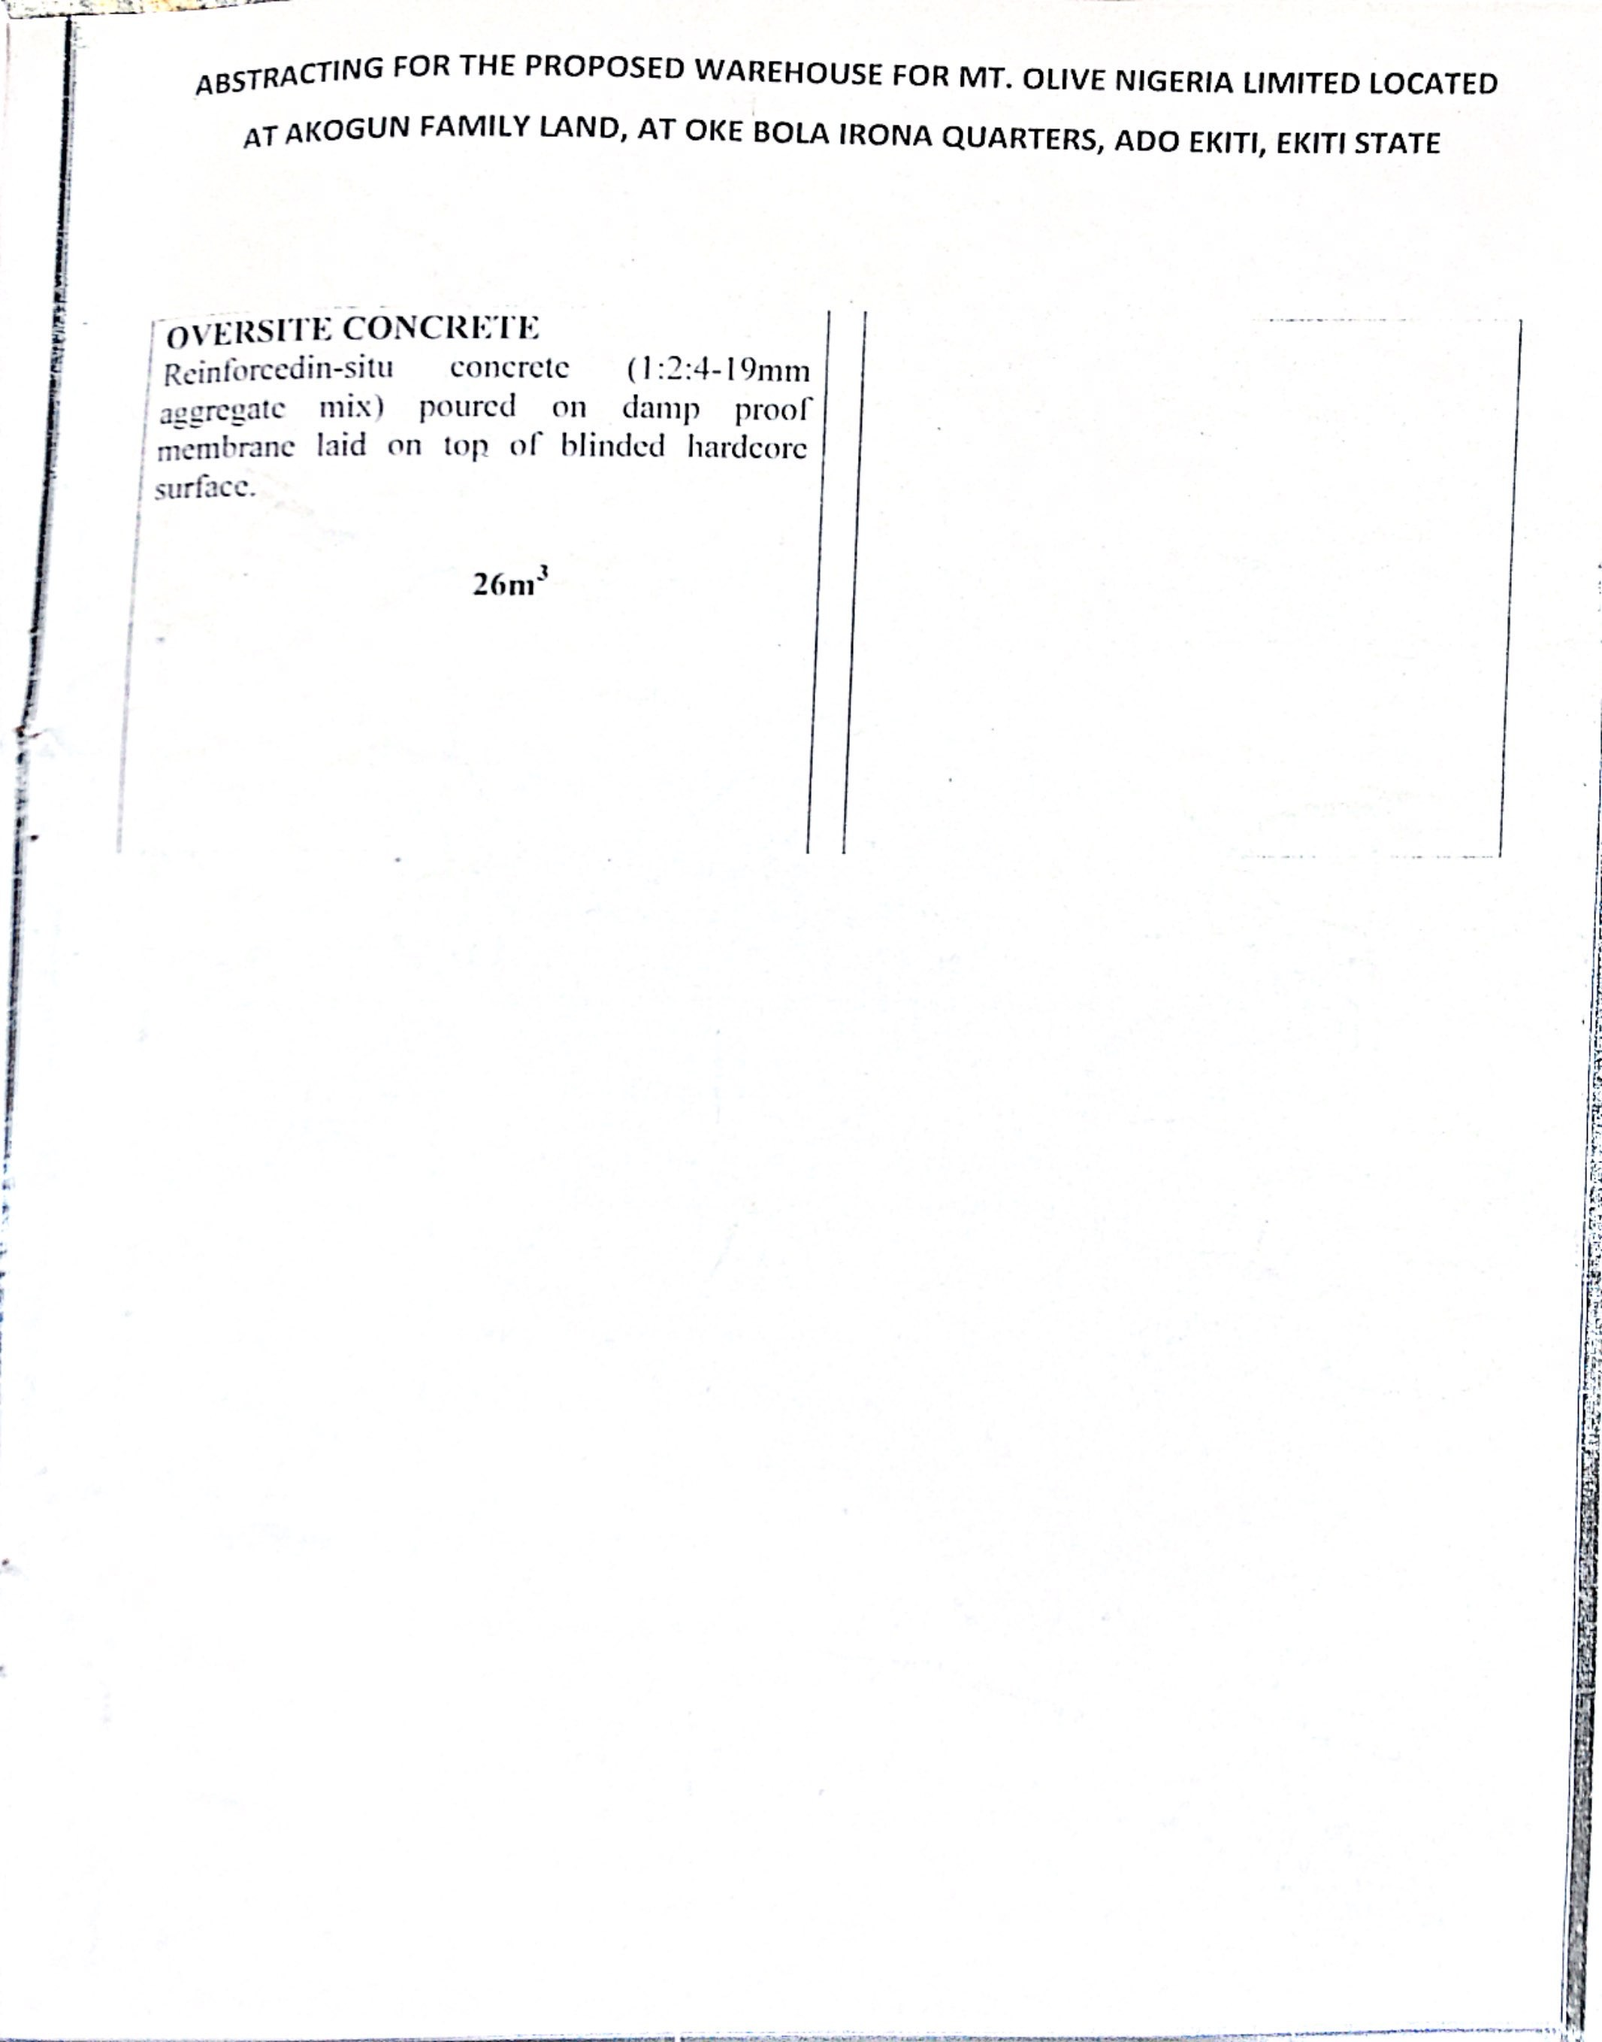

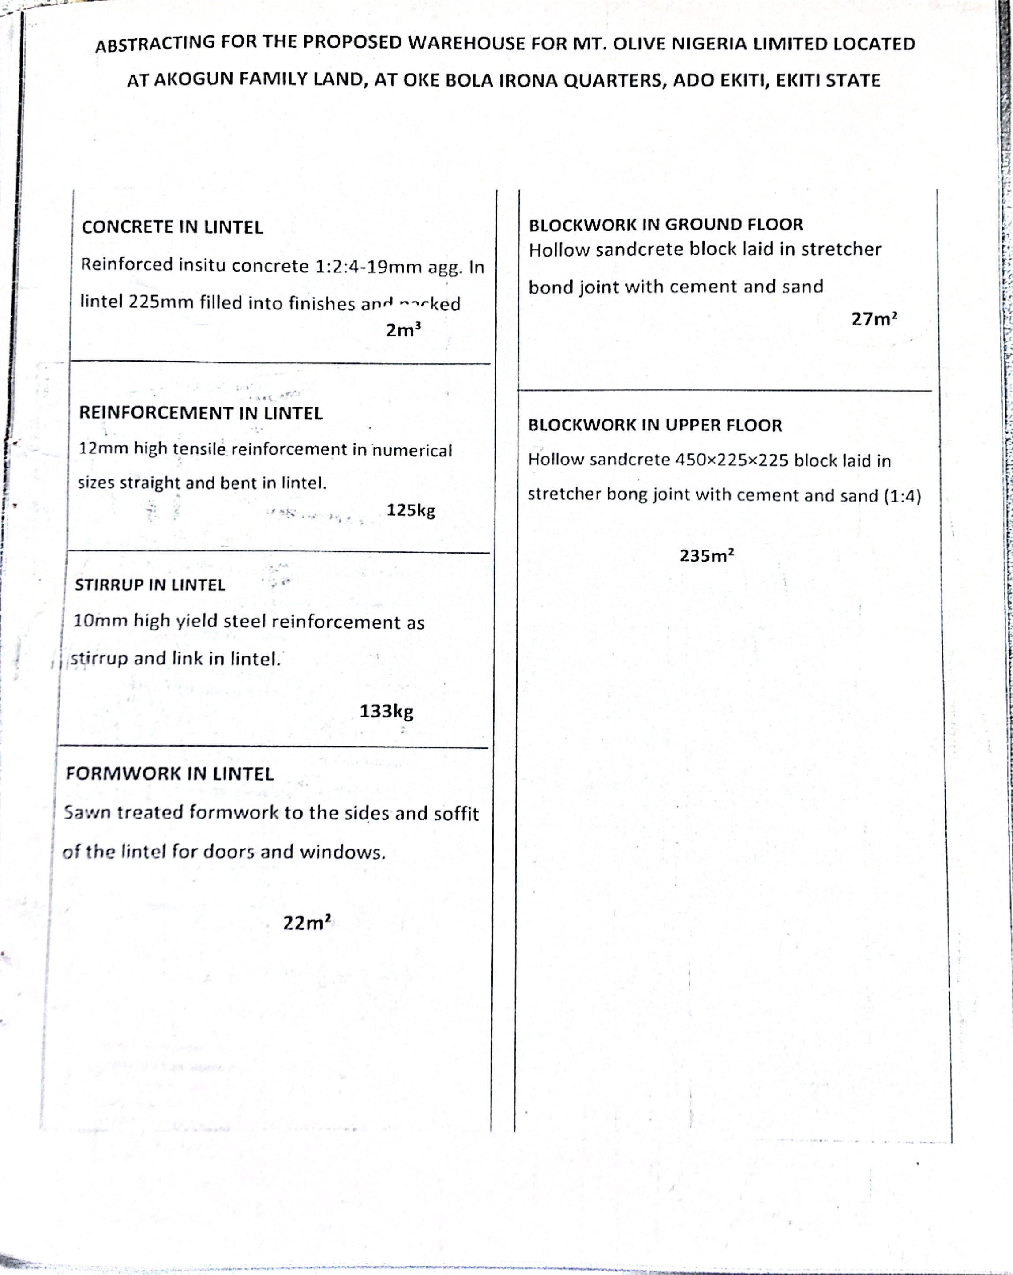

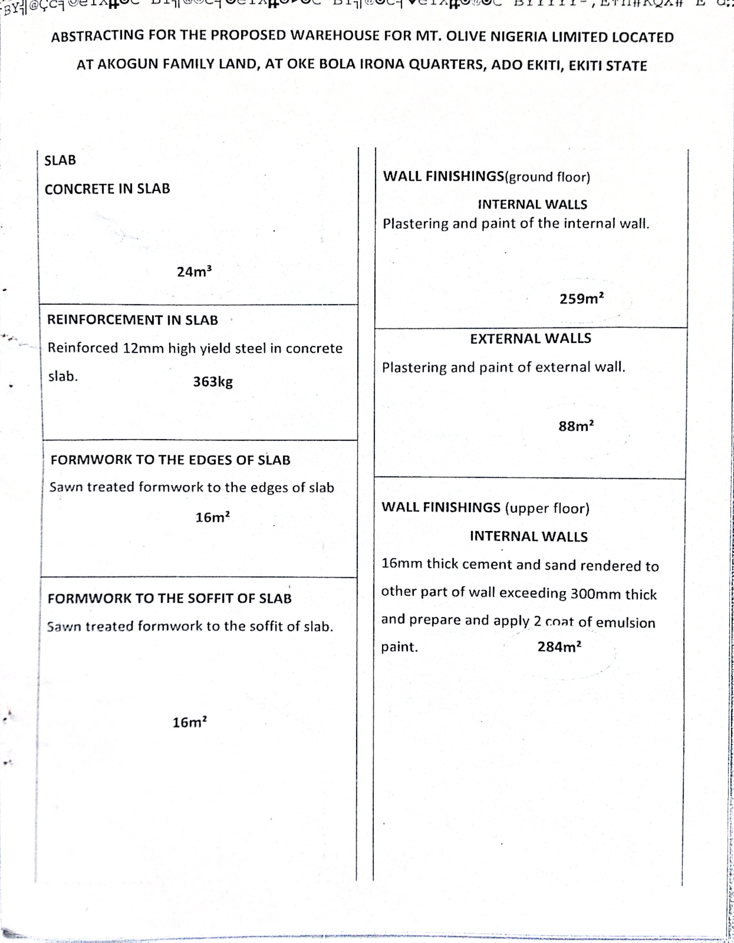

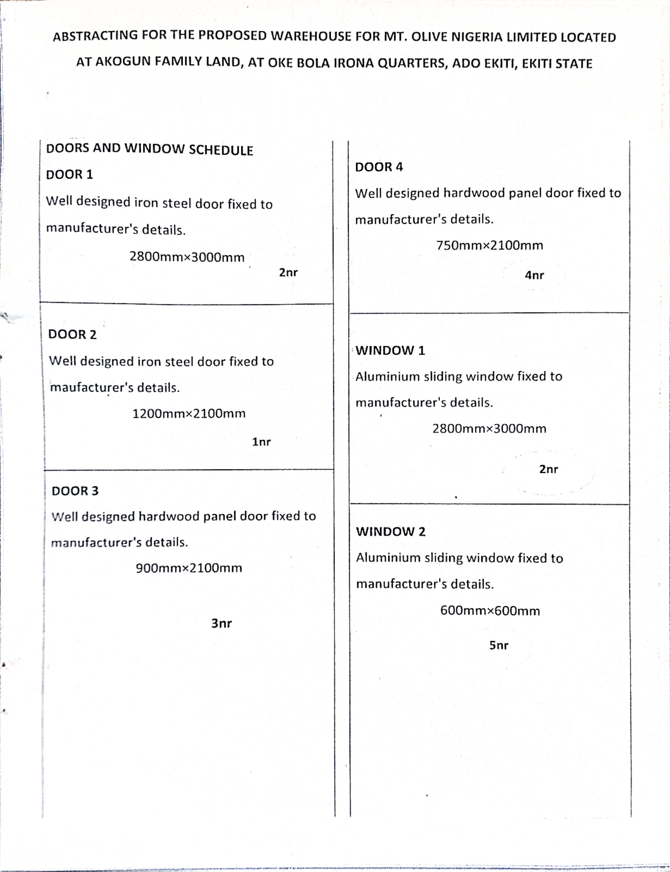

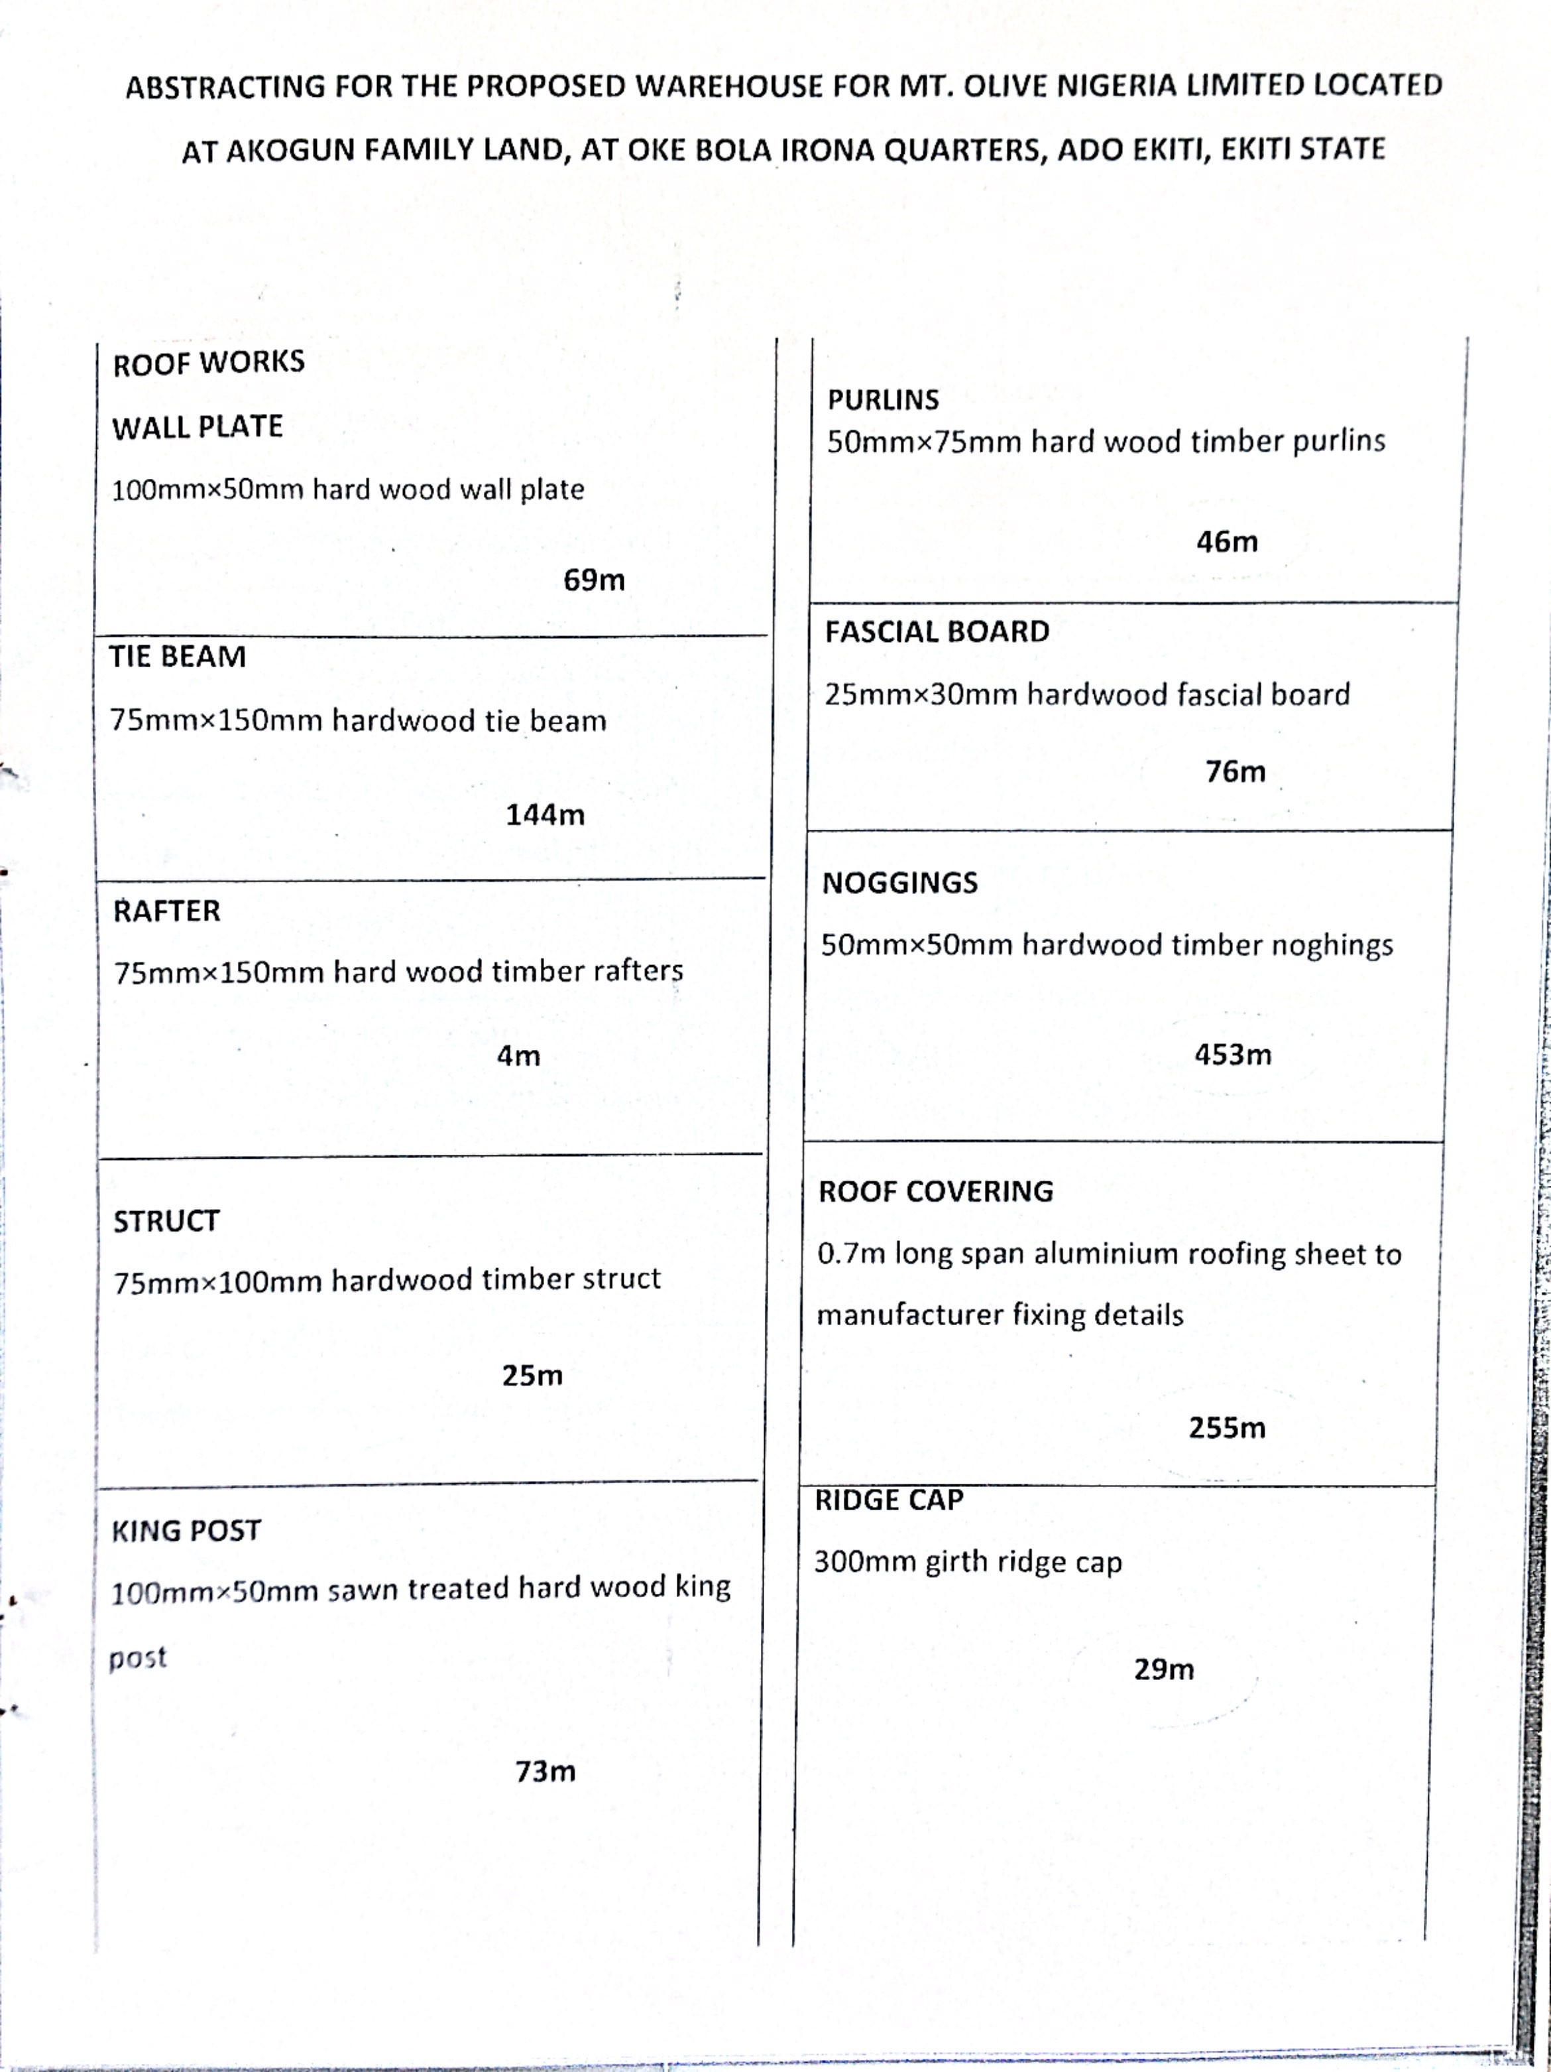

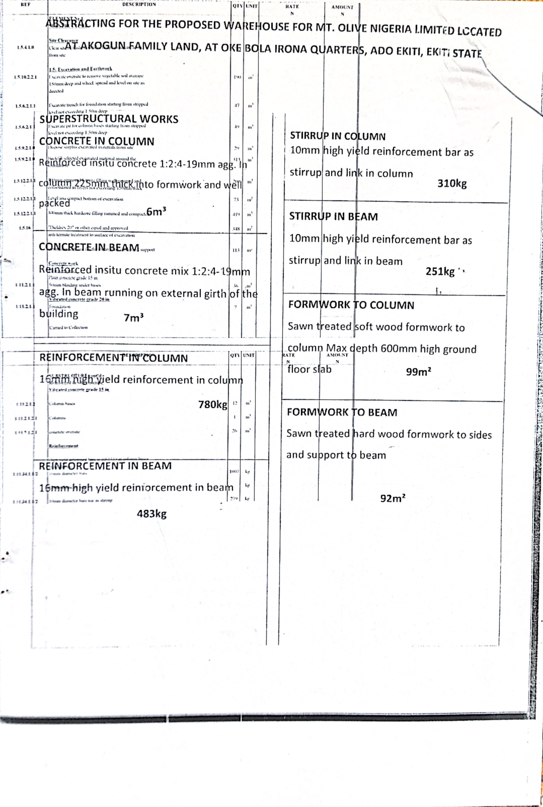
S

