PHONICS MASTERY APPLICATION

BY:
OLANREWAJU IBRAHIM BABATUNDE
ND/23/COM/PT/0389

A PROJECT SUBMITTED TO THE DEPARTMENT OF COMPUTER SCIENCE, INSTITUTE OF INFORMATION AND COMMUNICATION TECHNOLOGY, KWARA STATE POLYTECHNIC, ILORIN, NIGERIA

IN PARTIAL FULFILLMENT OF THE REQUIREMENTS FOR
THE AWARD OF NATIONAL DIPLOMA {ND} IN
COMPUTER SCIENCE

JULY 2025

CERTIFICATION
This is to certify that this project is carried out by OLANREWAJU IBRAHIM BABATUNDE with matric number ND/23/COM/PT/0389, has been read and approved as meeting part of the requirement for the award of National Diploma, in the Department of Computer Science, Institute of Information Communication Technology, Kwara State Polytechnic, Ilorin.

____________________ ________________
Mr. Oyedepo F.S Date
Project Supervisor

____________________ __________________
Mr. Oyedepo F.S Date
Head of Department

____________________ __________________
External Examiner Date

DEDICATION
This project is dedicated to Almighty God the beginning and the end of all creation.

ACKNOWLEDGEMENT
My Appreciation goes to the Almighty God for his Grace, Mercy and Favour over my life, may his name be praise
I thank my amiable supervisor the person of Mr. Oyedepo F.S for his advice and guidance throughout the project process
To my wonderful and supportive parent Mr. and Mrs. Olanrewaju for their financial support and words of encouragement.
I want to use this medium to appreciate my lovely siblings, thanks for all you do, I will never take it for granted
Lastly my appreciation also goes to my colleagues, friends in Computer Science Department thanks for your support, I wish us all success in life.

ABSTRACT
Phonics Mastery Application is a multimedia application for spelling out words onto the pupils to help nursery school pupils learn the basics of English alphabets with the use of computer system. This vocal alphabet manual is a method of spelling out the English alphabets A-Z by reading it aloud to the pupils and by identifying either capital or small letters. This stimulates quick identification and memorization of the letters and alphabets in the pupils and also serves as an instructional material for the teacher. The basic purpose of the framework is to develop independent voice enabled application. This application was developed using Visual C#.

TABLE OF CONTENTS
Title Page i
Certification ii
Dedication iii
Acknowledgement iv
Abstract v
Table of Contents vi

CHAPTER ONE: GENERAL INTRODUCTION
  - Introduction
  - Statement of the Problem
  - Aim and Objectives of the Study
  - Significance of Study
  - Scope of the Study
  - Definition Of Terms
  - Organization Of The Report

CHAPTER TWO: LITERATURE REVIEW
  - Review Of Related Literature
  - Review Of General Text

CHAPTER THREE: RESEARCH METHODOLOGY AND ANALYSIS
  - Research Methodology
  - Analysis Of The Existing System
  - Problems Of The Existing System
  - Description Of The Proposed System
  - Advantages Of The Proposed System

CHAPTER FOUR: DESIGN, IMPLEMENTATION & DOCUMENTATION OF THE NEW SYSTEM
  - Design Of The System
    - Output Design
    - Input Design
    - Database Design
    - Procedure Design
  - Implementation Of the System
  - Implementation Techniques
    - Hardware Support
    - Software Support
  - System Documentation
    - Program Documentation
    - Maintaining The System

CHAPTER FIVE: SUMMARY, CONCLUSION & RECOMMENDATION
  - Summary Of Findings
  - Conclusion
  - Recommendation For Further Investigation
References
Flowchart
Program Listing
Program Source Code
CHAPTER ONE
GENERAL INTRODUCTION
1.1 INTRODUCTION
Having a look at the educational practices, many people will perceive that there are some obstacles bedeviling the teaching in nursery and primary schools nowadays. Computer assisted instruction (also known as Computer Aided Instrument, CAI)today presents new options and opportunities: powerful machines, advanced computer science techniques and input from cognitive psychology. Using these tools well is a challenge for which there is a few guidance or examples. The purpose of this write up is to describe how to use some simple artificial intelligence techniques in a powerful educational programming environment to capture some of the expertise experienced teachers used for their instructional programs.
Phonics Aid is a multimedia application for spelling out words onto the pupils to help nursery pupils primarily to learn the basics of the English alphabets with the use of computer system.
The basic purpose of the framework is to develop independent voice enabled application. This vocal alphabet manual is a method of spelling out the English alphabets A-Z by reading it aloud to the pupils and by identifying either capital or small letters. This stimulates quick identification and memorization of the letters and alphabets in the pupils and also serves as an instructional material for the teacher.
This enables the pupils to use the application easily to perform certain tasks in computer using voice commands and to know and be able to identify the English alphabets easily. The contents of the application are organized into different modules that comprises of interactive learning programs to develop skills for reading and identifying the alphabets. The pronunciation and sounds of the alphabets produced by the computers imparted knowledge of alphabets into the pupils and the fun of what they see on the screen and what they hear from the system enable them to be able to identify, remember and master that which they are been taught.
The above discussion suggests that we need a “Tool” that will engage students with vocal alphabetical manual problems covering more than the current week’s topic. Ideally, this tool would encourage students to use variety of skills and to apply these skills in the context of real-world data sets. We propose that cognitive tutor offer one way to do just that; the name “cognitive tutor” refers to a computerized learning environment whose design is based on cognitive principles and whose interaction with pupils is based on that of a (human) tutor–i.e., making comments when the student are, answering questions about what to do next, and maintaining a low profile while the student is performing well. Vocal Alphabetical manual teaches English alphabets to nursery pupils with the use of text to speech application as well as ability to analyze data presented.
1.2 STATEMENT OF THE PROBLEM
In most cases pupils find the classroom teaching or singing to be very interesting at the expenses of leaving out useful classroom teachings. This can hamper their academic performance. Also, some feelings the pupils have towards their teacher do affect them academically. But the advent of computerized vocal alphabetical manual helps the pupils to improve their Intelligent Quotient (IQ), potentials, speed of thinking, sense and remembrance and also serves as a means of relaxation during leisure. This concept is basically a concept that implements the use of alphabetical manual to make the pupils undergo some kind of brain tasking activities.
1.3 AIM AND OBJECTIVES
The aim of this research is to develop Audio visual aid for child development. The objectives of this project are as follows:
- To improve the pupils learning ability
- To increase the pupils Intelligent Quotient (IQ) and speed of identification of alphabets
- To serve as a readily available means of learning.
1.4 SIGNIFICANCE OF THE STUDY
The main significance of this research reflects on the fact that computer applications are not just designed to take up users’ time on the system but to develop a learning avenue and engage the pupils in some brain tasking activities that improves their learning ability. This application will increase the speed of memorization, identification, meditation and remembrance in pupils’ academic performance.
1.5 SCOPE OF THE STUDY
There is no gain saying that the computer age is a blessing to the world as the versatility of the computer has made it possible for our pupils to learn on the computer system or electronic device like smart phones, tablets etc. This study mainly covers developing a computerized child vocal alphabetical manual that allows pupils to use the computer to learn English alphabet thereby encouraging the need for computer education and as well develops software for conventional academic application.
1.6 DEFINITION OF TERMS
Tutor: A private teacher, especially the one who teaches an individual or a small group.
Computerize: To make computers do work being previously done manually.
Teacher: A professional that is the foundation of quality education. Hence, teacher’s production is a retention effective education as an instrument per excellence for national development.
Pupil: A person who is studying in a school. A boy or a girl attending a school for the purpose of knowledge acquisition.
Cognitive: Connected with mental process of understanding
Implementation: To make something that has been officially decided start to happen or be used.
Design: The general arrangement of the different parts of something that is made, such as building, books, machines etc.
1.7 ORGANIZATION OF THE REPORT
This is the overall organizational structure of the work as presented in this project. Chapter one of this project deals with the general introduction to the work in the project. It also entails the aims and objectives of this project, the significance of the study, the methods used for data collection, the scope and limitation of the study.
Chapter two deals with the literature review, computerization of current state of the art and discussion of related aspects of the project topic.
Chapter three covers the analysis of the existing system, description of the current procedure, problems of existing system, description of the proposed system and the basic advantages of the proposed web based application for library management.
Chapter four entails design, implementation and documentation of the system. The design involves the system design, output design form, input design form, database structure and the procedure of the system. The implementation involves the implementation techniques used in details, choice of programming language used and the hardware and software support. The documentation of the system involves the operation of the system and the maintenance of the system.
Chapter five deals with summary, conclusion and recommendation.

CHAPTER TWO
REVIEW OF RELATED LITERATURE
2.1 LITERATURE REVIEW
With the advancement of the Internet and Web technologies from static information delivery to dynamic, interactive, data-driven applications, U.S. companies have been integrating such technologies into their corporate computer information systems to maintain a competitive edge (Zhao and Alexander 2024).
The Partnership for 21st Century Skills (2023) suggests that education is the key to preparing students for learning in today’s complex, digital society. Learning will be more meaningful and more effective if public education can focus on closing the gap between how students live and how they learn. They also suggest that a critical component in adapting education will be a deeper understanding of how people learn.
The Partnership for 21st Century Skills (2023) reported research findings of a 2000 report of the National Research Council entitled, How People Learn: Brain, Mind, Experience, and School.
Today, given the realities of globalization, knowledge work, and accelerating social change, it’s obvious that what students learn, as well as how and when they learn it, are changing” (p. 7). Lemke (2018) suggests that to be genuinely equipped for success in today’s digital age, “all students need evolving skill sets that reflect this reality Lemke (2018).There seems to be a general consensus among the public and educators that students need to be “computer literate.” However, these authors raise some interesting questions on the meaning of computer literacy: “Can a student who operates a computer well enough to play a game, send email or surf the Web be considered computer literate? Will a student who uses computers in school only for running tutorials or an integrated learning system have the skills necessary to survive in our society? Will the ability to do basic word processing be sufficient for students entering the workplace or post-secondary education?” Their answer was, “clearly not Eisenberg et al, (2017).
Rose and Dugger (2018), define technology literacy as “one’s ability to use, manage, assess, and understand technology.” According to Lemke (2016), “The No Child Left Behind legislation establishes technology literacy as a core foundation for learning, calling for academic excellence in the context of modern technologies”.
The U.S. Department of Education (Hall, 2016) defines technological literacy as “computer skills and the ability to use computers and other technology to improve learning, productivity, and performance” (p. 100). Hall suggests that a definition of technological literacy should have a broader focus in order to provide a solid technological foundation.
Hall (2015), implies that “…society is advancing faster than its understanding of technologies that have allowed it to achieve these new heights.” Because of continuous changes in technology, it is our responsibility to provide all students with a basic knowledge of what technology is, how it can be used, and how it will affect their future lives (Hall, 2015).
Russell (2016), suggests that “…learning about technology includes cognitive knowledge acquisition, skill development, and affective/analytical capacity-building.
This chapter deals with the review of the works of several scholars that are related to the present study.
Investigations and research (Fletcher Flynn and Gravatt, 2020) has shown that heavy investments have been made in the development of computerized learning in the UK. The purpose of investment have not been clear or made explicit, part of the drive towards greater use of technology in education is aimed at modernizing schools and equipping the pupil of today with skills that will make them able to use such technology in work place when they leave school, other stated goals is to reduce teachers work load and also reducing bureaucracy by providing and exchanging information in electronic form.
Perhaps the ultimate goal in promoting the use of computerized tutor in schools has been to increase the effectiveness of teaching and improve pupils learning. It’s this goal that is focus for the questions underpinning this review;
1. What is the evidence that computerized tutor can make positive impact on students learning in schools.
2. How can computerized tutor be used effectively in schools to improve pupils learning.
There are evidences that computerized tutor can help students learn more effectively. However there is not a simple message in such evidence that computerized tutor will make a difference simply by being used. Findings suggest that computerized tutors can improve learning but some issues have to be put to consideration.
Computer-Based Tutor, diverse and rapidly expanding spectrum of computer technologies assist the teaching and learning processes. CBT is also known as computer-assisted instruction. Examples of CBT applications include guided drill and practice exercises, computer visualization of complex objects, and computer-facilitated communication between students and teachers. The number of computers in American schools has risen from one for every 125 students in 1981 to one for every nine students in 1996. While the United States leads the world in the number of computers per school student, Western European and Japanese schools are also highly computerized.
First is the modest effect of computerized tutor, second is the almost negligible effect of the provision and use at general level.
Also a study by the British educational technology association (BECTA, 2016) found no link between level of resources for computerized learning and either reading or mathematics grades at stage 1 in 1999, at stage 2 there was a significant but weak association between computerized tutor and students attainment. This indicates that at general level it makes a little impact.
2.2 REVIEW OF GENERAL TEXT
In the mid-1950s and early 1960s collaboration between educators at Stanford University in California and International Business Machine Corporation (IBM) introduced CAI into select elementary schools. Initially, CAI programs were in a linear presentation of information with drill and practice sessions. These early CAI system were limited by the expense and the difficulty of obtaining, maintaining and using the computers that were available at that time.
Programmed Logic for Automatic Teaching Operation (PLATO) system another early CAI system initiated at the University of Illinois in the early 1960s and developed by Control Data Corporation, was used for higher learning. It consisted of a mainframe computer that supported up to 1000 terminal for use by individual student. By 1985 over 100 PLATO systems were operating in the United States. With the advent of cheaper and more powerful personal computers in the 1980s, use of CAI increased dramatically. In 1980 only 5 percent of elementary schools and 20 percent of secondary schools in the United States had computers for assisting instruction. Three years later, both numbers had roughly quadrupled, and by the end of the decade nearly all schools in the United States and in most industrialized countries were equipped with teaching computers.
A recent development with far ranging implications for CAI is the vast expansion of the internet, a consortium of interlinked computers. By connecting millions of computers worldwide, these networks enables students to access huge stores of information, which greatly enhances their research capabilities computer aided instruction (CAI), diverse and rapidly expanding spectrum of computer technologies that assist the teaching and learning process. CAI is also known as Computer Assisted Instruction. Examples of CAI application include guided drill and practice exercise, computer visualization of complex objects and computer facilitates communication between student and teachers.

CHAPTER THREE
METHODOLOGY AND ANALYSIS OF THE EXISTING SYSTEM
3.1 RESEARCH METHODOLOGY
Methodology and analysis of the existing system, problem of the existing system are discussed, description of proposed system and advantage of the proposed system also discussed.
In the design of this project work, a high level programming language C# was used in order to achieve a good end. Before design the front and backend of a design must be known, therefore C# is the programming language used for the scripting of the design and MYSQL database was use for the database in the implementation.
METHOD OF DATA COLLECTION
Data collection method employed in gathering information for this project involves Internet survey and literature review. Browsing the internet helps in gathering related online journals and texts. Relevant information are extracted from these materials and used in aiding the effective analysis and design of this project.
The method used for data collection is:
- BOOK REVIEW:
The method used in book review is a secondary method of review, which relate to reading of textbooks, internet search, past project work and other daily business magazine etc. The lists of books reviewed are analyzed in the reference section.
- INTERNET SEARCH
During the process of this research work, some websites were visited and some data were inferred. Website like the search engine e.g. Wikipedia, Google and yahoo etc. for data collection.

3.2 ANALYSIS OF DATA AND THE EXISTING SYSTEM
The system used in teaching in our nursery and primary school is what we will like to refer to as the manual method of teaching, which is the use of chalk board and textbook in classes. We discovered that children find it hard to understand the teacher some of the time, some students don’t even listen in class which makes it very hard for them to gain anything in the class during classes which leads to failure teaching, with an audio visual aid development that will be reading lessons out aloud to the children for them to be repeating after the system teaching is made easier because apart from the fact that children like computer games, operating a computer system will captivate them and at the same time they will be learning what they are supposed to at the right time.
3.3 PROBLEMS OF THE EXISTING SYSTEM
The problems of the existing system before the introduction of computer into teaching to widen the communication barrier between the teacher and students to enhance child development includes:
i. The teaching techniques of the teacher is not always understandable by every students and these keep some students behind in class performance
ii. Substituting teacher always affects some student academic performance
iii. The system is limited to classroom lectures alone the student doesn’t have the privilege to learn on the system
iv. Most teachers are not widened with teaching ability but rather find themselves teaching. They will frustrate the students with learning instead of encouraging them.
3.4 DESCRIPTION OF THE PROPOSED SYSTEM
The purpose of the framework is to develop independent voice enabled application, this vocal alphabet manual is a method of spelling out the English alphabets i.e A-Z by reading it aloud to the pupils and by identifying either capital or small letters. This enables quick memorization and identification of the letters and alphabets by the people and also serves as an instructional material for the teacher.
3.5 ADVANTAGES OF PROPOSED SYSTEM
i. It enhances effective performance and knowledge outcomes
ii. Teaching will not be bound by time constraints
iii. It makes learning faster, easier and wider for pupils
iv. Improved learner can be known easily because the computer saves each pupils performance data
v. It aid child development by improving their learning skills

CHAPTER FOUR
DESIGN, IMPLEMENTATION AND DOCUMENTATION OF THE SYSTEM
4.1 DESIGN OF THE SYSTEM
This is the computation of the particulars of a new system and the determination of what the proposed system would be and the function it is to perform. This may involve changing from one system to another or modifying the existing system operation.
The most challenging phase of the system life cycle is the change from manual operation to a faster and more accurate one; system design stage covers the technical specifications that will be employed in the implementation of the new system in order to modify the previous system. Some factors are put in consideration. These factors include input design, output design, definitions file and procedure designs and other documentation.
4.1.1 OUTPUT DESIGN
This incorporates the objectives of solving the existing system problems and challenges. This involves the structuring of the desired information and also to enhance efficient and effective Audio Visual Aid System. Things taken into consideration in determining the output are represented below:


Figure 4.1: Main menu interface
This diagram is a main menu diagram that contain others menus
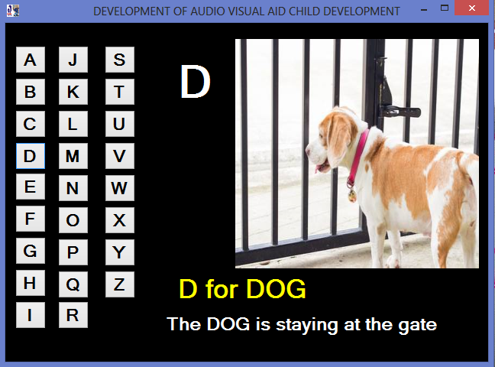

Figure 4.2: Lesson interface
This interface displays the outputs; Audio & Image
4.1.2 INPUT DESIGN
The input to run this software is obtained from Audio Visual Aid System administrator. He can achieve this by clicking the button that contains alphabets.
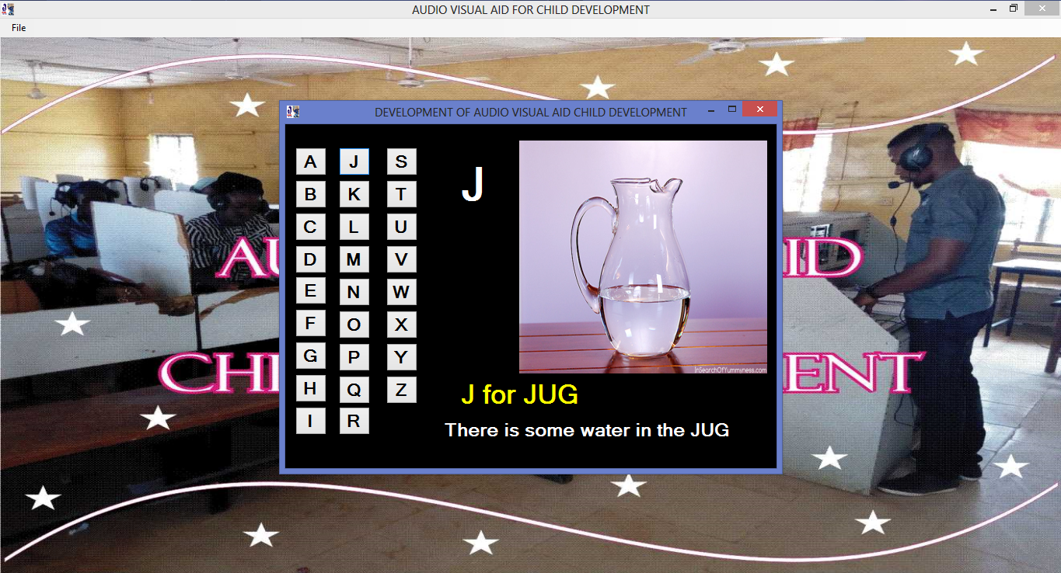

Figure 4.3: Lesson interface
This interface is where the user click on the button to display the images that represent each button clicked.

4.1.3 DATABASE
Table 4.1
S/NO | FIELD NAMES | FIELD TYPE | FIELD SIZE
1. | User name | String | 50
2 | date | Date Time | 10

4.1.4 PROCEDURE DESIGN
These are the steps involved in unifying the whole process to produce the desired output. It involves computer procedures which start from the original input lessons to the output result file. This allows the processing of user information and result to be possible. Menu is provided to aid user in the processing of the output file.
4.2 IMPLEMENTATION OF THE SYSTEM
This entails the choice of the programming language employed to implement the software which should-be suitable for Audio Visual Aid System. The software is designed for the use of Audio Visual Aid System which should serve as an assistant. It is also expected to be used in conjunction with the user.
4.2.1 CHOICE OF PROGRAMMING LANGUAGE
The Application was developed in a .net (dot net) integrated development environment (.net IDE). The Application IDE is chosen following the fact that extracted information needs to be presented in an enhanced pictorial/graphical format and easy communication with the database for program flexibility in windows platform.
4.2.2 HARDWARE REQUIREMENT
i. 500 Hz minimum with CD ROM drive etc.
ii. Hard disk of capacity 10GB Minimum
iii. 126-512 megabyte of RAM
iv. An Uninterrupted power supply (UPS)
v. A voltage stabilizer
vi. A power generating set etc.
4.2.3 SOFTWARE REQUIREMENT
I. Window Operated system such Windows7
ii. Visual studio 2010
iii. Server Query Language (SQL).
4.3 DOCUMENTATION OF THE SYSTEM
4.3.1 PROGRAM DOCUMENTATION
The program is packaged for use in any system irrespective of either it runs visual studio application or not. After developing a program in Visual studio, there is a facility provided in Microsoft Visual Studio suite called “Package and Deployment Wizard” that is used in Visual studio application packaging and deployment.
The Audio Visual Aid System is packaged into an installable setup that can be run from any system.
4.3.2 MAINTAINING THE SYSTEM
The system maintenance refers to making modification to an already existing application/program without necessarily re-writing everything from start. Program maintenance of a program includes modification of the program to meet-up with certain requirements of the users. In this course, additional features can be added, errors corrected, ambiguous interfaces redesigned to eliminate confusions and unnecessary features removed.
Maintaining this program can be done in a Visual studio environment. Any future modification can be by re-running the program source code in a Visual Studio Environment making necessary changes and updates and recompile the application into an upgrade version of the existing version of the mini word processing application. Further versions of this program can be named following their year of release or it can be given a different version number.

CHAPTER FIVE
SUMMARY, CONCLUSION AND RECOMMENDATION
5.1 SUMMARY
Audio visual enables the pupils to use the computerized application easily to perform certain tasks in computer using voice commands and to know and be able to identify the English alphabets easily. The contents of the application are organized into different modules that comprises of interactive learning programs to develop skills for reading and identifying the alphabets. The pronunciation and sounds of the alphabets produced by the computers imparted knowledge of alphabets into the pupils and the fun of what they see on the screen and what they hear from the system enable them to be able to master, remember and identify what they are been taught.
5.2 CONCLUSION
This research discusses the design and implementation of electronic phonics audio visual aid for child development. The tutor puts an emphasis on helping students learn how to think and requires them to draw conclusions in context. By adding this tool, we find that primary school teachers can be released from attending to the details of students’ solutions and can focus then on the deeper issues. Moreover, a controlled experiment showed that, even over short period of use, this tool led to significant improvements in students. In particular, results suggested that after the research, when participants encountered a new problem, they were thinking about it in terms of the appropriate analysis instead of in terms of the subject matter.
5.3 RECOMMENDATIONS
Based on the researchers’ findings, it is strongly recommended that
i. Our future plans should include extending the use of audio visual aid in classroom (to more schools all over the country).
ii. User Training, the teacher should be trained on the maintenance of the system for its effectiveness
iii. More research should be conducted on more audio visual applications that aid child development

REFERENCES

Bruce, S. (2000) Secrets& lies: Digital security in a Networked World, ISBN 0-471-253111
Olagunju, M. (2013) Programming with Java, ISBN: 986 3288-2-14, Rajim Modern printers, Ilorin.
Olatunji, E.K (2000), Assembly Language Programming ISBN: 978-34364-6-5, Kazfam System Technology Ilorin.
Olatunji, E.K (2001), Introductory to cobol programming; ISBN: 973-36062-04, Adlex Printing Enterprises.
Olatunji, E.K. (2004), Computer Programming Principle, ISBN: 978-978-903-952-4, Rafmik Int’l Print, Ilorin
Olatunji, E.K. (2008), Basic Programming, ISBN: 978-36062-9-8, Rafmik Int’l Print, Ilorin
Oyedepo, F.S. and Dada, O.M. (2009), Introductory to Visual Basic Programming, ISBN: 978-187-281-0, Rafmik Int’l Ltd, Ilorin.
Renu, R. (2010), Door Entry Systems – Important Security Accessories. Ezine Articles. Source: http://ezinearticles.com/?expert=Renu_Rohila
Ross, J. and Eerson U. (2000), Security engineering: a guide to building dependable distributed systems. ISBN 0-471-38922-6 Robert C.
Seacord, H. (2005), Secure coding in C and C+ +. Addison Wesley, September, 2005. ISBN 0321-33572-4
Steven, R. and Keller, D. (2009), Motion detector.Microsoft Encarta 2009. Microsoft Corporation.

