AN EQUITY-CENTERED ANALYSIS OF EDUCATIONAL OUTCOME: INSIGHTS FROM 2024 JAMB PERFORMANCE DATA.

BY:

IDRIS AISHA HAJA
HND/23/STA/FT/0040

BEING A RESEARCH PROJECT SUBMITTED TO THE DEPARTMENT OF STATISTICS, INSTITUTE OFAPPLIED SCIENCES (IAS).
KWARA STATE POLYTECHNIC, ILORIN
IN PARTIAL FULFILLMENT OF THE REQUIREMENT FOR THE AWARD OF HIGHER NATIONAL DIPLOMA (HND) IN STATISTICS.

JULY, 2025

KWARA STATE POLYTECHNIC, ILORIN,
INSTITUTE OF APPLIED SCIENCES
DEPARTMENT OF STATISTICS
PROJECT CLEARNCE FORM
This project has been read and approved as meeting the requirement for the award of Higher National Diploma (HND) in the Statistics, Institute of Applied Science, Kwara state polytechnic, Ilorin.
NAME: IDRIS AISHAT HAJA
MATRIC NUMBER: HND/23/STA/FT/0040

……………………………….. ……………………………
BEKI D.O. DATE
(Project supervisor)

……………………………….. ……………………………
AJIBOYE R.A. DATE
(Project Coordinator)

……………………………….. ……………………………
ELEPO T.A. DATE
(Head of Department)

……………………………….. ……………………………
(External Examiner) DATE
ABSTRACT
This study analyzed disparities in student performance across school types, locations, and socioeconomic backgrounds. Using secondary data from 5,000 JAMB candidates, the study employed descriptive statistics, correlation analysis, multiple regression, two-way ANOVA, and independent samples t-tests to address the research objectives. The results revealed that students from private schools and urban areas performed better than their counterparts in public and rural schools. Study hours, attendance rates, and teacher quality were found to be significant positive predictors of JAMB performance, with study hours having the strongest effect. Access to extra tutorials had a statistically significant, but small, impact on student scores. Overall, the study concluded that variations in educational outcomes are strongly linked to school characteristics, student behaviors, teacher quality, and resource availability. The findings highlight the urgent need for interventions focused on improving public school resources, promoting equitable access to learning materials, and strengthening study habits among students from disadvantaged backgrounds.
Keywords: Educational Equity, JAMB Performance, School Type, Study Hours, Attendance Rate, Teacher Quality, Socioeconomic Factors, Access to Tutorials

CHAPTER ONE
INTRODUCTION
- BACKGROUND OF THE STUDY
Education is universally recognized as a fundamental tool for individual development and societal advancement. In contemporary societies, academic performance at key educational stages, such as university entrance examinations, plays a critical role in shaping future opportunities for young people. In Nigeria, the Joint Admissions and Matriculation Board (JAMB) examination serves as the primary gateway to tertiary education, making it a crucial benchmark for assessing the effectiveness of the education system. However, persistent disparities in student performance across different socioeconomic and geographic groups have raised concerns about the fairness and equity of educational outcomes.
Several studies have identified that factors such as school type (public versus private), geographical location (urban versus rural), availability of qualified teachers, study habits, and access to additional educational resources significantly influence students' academic achievements (Abbasi & Mir, 2012; Ali et al., 2013; Ahlan et al., 2014). Students from more privileged backgrounds often have greater access to quality education, private tutoring, and supportive learning environments, leading to better performance compared to their less advantaged counterparts. These disparities are further exacerbated by differences in school facilities, teacher quality, and students' individual study patterns (Bugge & Wikan, 2013; Chigozie, 2019).
In Nigeria, the uneven distribution of educational resources between urban and rural areas, as well as between public and private schools, continues to challenge efforts aimed at achieving equitable education for all. Students in rural areas or from low-income families often face barriers such as inadequate school infrastructure, limited access to experienced teachers, and fewer opportunities for academic support outside regular school hours (Adeyemi, 2014; Egunsola & Isani, 2014). Understanding how these factors interact to influence academic performance is essential for designing interventions that can bridge the achievement gap and promote inclusive educational development.
This study seeks to analyze the 2024 JAMB performance data with a focus on examining the distribution of scores across different school types and locations, assessing how study habits and school-related factors impact student outcomes, and identifying the extent of performance disparities linked to socioeconomic status. By uncovering the key determinants of variations in academic achievement, the study aims to provide evidence-based recommendations to policymakers, educators, and stakeholders working towards fostering greater equity in educational outcomes.
  - SCOPE OF THE STUDY
This study focuses on analyzing the 2024 JAMB performance data with an emphasis on equity-related disparities in educational outcomes across different socioeconomic and geographic groups in Nigeria. The study aims to provide insights into the factors contributing to variations in student performance, particularly with regard to school type (public versus private) and geographical location (urban versus rural). The geographic scope encompasses all regions of Nigeria, with particular attention paid to the differences between urban and rural areas, as these distinctions are crucial in understanding access to resources and the potential impact on student outcomes. The study will consider key demographic factors such as gender, age, family income, and access to extra tutorials, recognizing that socioeconomic status can significantly influence academic performance.
Additionally, the study will examine how school type - public or private affects students' JAMB performance, considering variables such as teaching quality, study hours, and attendance rates. The data used in this study will be drawn exclusively from the 2024 JAMB results, which will serve as the basis for exploring the factors influencing educational disparities. This research is framed within the context of the 2024 academic year, ensuring that the findings are relevant to the current educational landscape in Nigeria.
  - SIGNIFICANCE OF THE STUDY
This study holds significant value for several stakeholders in the Nigerian educational system. By analyzing the 2024 JAMB performance data with a focus on equity-related disparities, it provides crucial insights into how various factors, such as school type, geographic location, and socioeconomic background, contribute to the variations in student performance. Understanding these factors can help policymakers and educational authorities in Nigeria identify and address systemic inequalities within the educational system. The findings of this study can be used to inform decisions about resource allocation, especially in rural areas or underfunded public schools, where disparities in educational outcomes are often more pronounced.
For educational institutions, the study offers evidence-based recommendations to improve teaching practices, study environments, and support mechanisms for students, especially those from disadvantaged backgrounds. It can also guide efforts to bridge the gap between urban and rural educational outcomes, ensuring that all students, regardless of their location or socioeconomic status, have equal opportunities to succeed academically. Additionally, by highlighting the impact of factors such as study hours, teacher quality, and attendance rates on student performance, the study can provide useful guidelines for educators to improve instructional strategies and student engagement.
The study's results are also beneficial for parents, students, and advocacy groups who seek to understand the broader systemic challenges affecting educational outcomes in Nigeria. For students, this research can provide a clearer understanding of how their academic environment and personal circumstances influence their performance, enabling them to take proactive steps toward improvement. Ultimately, this study contributes to the ongoing discourse on educational equity in Nigeria, offering practical solutions to reduce performance disparities and promote a more inclusive educational system.
  - AIM AND OBJECTIVES
The main aim of this study is to analyze education outcome from the 2024 JAMB performance data, focusing on equity-related disparities and identify key factors contribution to variations in student performance across different socioeconomic and geographic groups, to achieve this the following objectives will be achieved;
- To examine the distribution of JAMB scores across school types (public vs private) and location (urban vs rural).
- To assess the relationship between study hours, attendance rates, teacher quality, and student performance.
- To identify the extent of disparities in performance linked to socioeconomic factors, such as access to extra tutorials and resources.
  - LIMITATIONS OF THE STUDY
Despite its contributions, this study is subject to certain limitations. The reliance on secondary data from the 2024 JAMB performance dataset means that the analysis may not fully capture the complex factors influencing student performance, such as individual student circumstances, psychological factors, or family support. Additionally, focusing solely on JAMB scores limits the scope to a standardized entrance exam, which may not reflect a student's overall academic abilities. The study also concentrates on socioeconomic and geographic disparities, potentially overlooking other influential factors such as peer influences or cultural expectations. Moreover, while the study is specific to Nigeria, the findings may not be directly applicable to other educational systems with different structures.
  - DEFINITION OF BASIC TERMS
Some basic terms used in this study includes;
- Educational Outcome: Refers to the academic performance of students, typically measured through examination results, grades, or assessments that reflect the knowledge, skills, and competencies acquired during the course of their education.
- JAMB (Joint Admissions and Matriculation Board): A Nigerian organization responsible for conducting entrance examinations for students seeking admission into tertiary institutions in Nigeria. The JAMB examination results are used as a key criterion for determining students' eligibility for university, polytechnic, or college admission.
- Socioeconomic Factors: Refers to the social and economic conditions that influence individuals' opportunities and outcomes. These factors include income level, parental education, occupation, and access to resources such as books, private tutoring, or technology that may affect a student’s educational performance.
- Geographic Location: Refers to the physical area where a student’s school is situated, typically categorized into urban or rural settings. This can affect access to educational resources, infrastructure, and the general learning environment.
- School Type: Refers to the classification of educational institutions into public and private schools. Public schools are government-funded and generally have more limited resources compared to private schools, which are privately funded and may offer better facilities and individualized attention.
- Teacher Quality: Refers to the qualifications, experience, and teaching effectiveness of educators. It can also include factors like teacher-student interaction, teaching methods, and the ability to engage and motivate students in the learning process.
- Study Hours: The amount of time a student dedicates to studying outside of school hours. It is believed that increased study hours correlate with improved academic performance, though the effectiveness also depends on the quality of the study time.
- Attendance Rate: The percentage of school days that a student attends. Regular school attendance is considered crucial for academic success, as missing school can result in gaps in learning and reduced performance.
- Extra Tutorials: Refers to additional academic support provided outside of regular school hours. This may include private tutoring, remedial classes, or after-school programs aimed at improving students' academic performance.
- Equity in Education: Refers to fairness in educational opportunities and outcomes. It aims to ensure that all students, regardless of their background or circumstances, have access to the resources and support they need to achieve their academic potential.

CHAPTER TWO
LITERATURE REVIEW
2.0 Introduction
Academic performance remains a critical indicator of educational success, influencing not only the personal and professional lives of students but also the socio-economic development of nations. Researchers have extensively examined various factors that determine academic outcomes, ranging from personal characteristics to institutional and environmental conditions. Given the increasing emphasis on education as a means of achieving equity and social mobility, it is crucial to investigate the factors influencing students' performance through an equity-centered lens. This chapter presents a detailed review of existing studies related to examination malpractice, institutional challenges, socio-demographic factors, learning environments, and student attitudes. An appraisal of the reviewed literature will conclude the chapter.
2.1 Examination Malpractice and Academic Integrity
Several studies have addressed the causes and implications of examination malpractice in Nigeria. Ajayi, Opadare, and Ariwola (1997) conducted a study involving 480 students from ten secondary schools in Ibadan Municipality. Their findings revealed that factors such as laziness, poor teaching, inadequate supervision, insufficient funding, negative parental attitudes, desperation for certificates, and the desire for good grades without corresponding hard work contributed to students' involvement in examination malpractice. Using the chi-square distribution test and Hotelling’s T² distribution, they statistically validated these findings. In a similar vein, Olayinka (1996) noted that many individuals perceive the main goal of education as passing examinations to obtain certificates rather than acquiring knowledge and skills. Oluyeba (1996) further emphasized that financial/material benefits, lack of integrity, poor teaching and learning conditions, intense competition for limited opportunities in education and employment, and unhealthy societal values that prioritize wealth and affluence over merit and integrity are significant causes of examination malpractice. These studies collectively highlight that academic dishonesty is deeply rooted in both systemic deficiencies and societal pressures.
2.2 Multivariate Analysis of Academic Performance
The application of multivariate statistical techniques has offered nuanced insights into student performance outcomes. Ubong (2009) conducted a Master's level seminar project focused on optimizing extrusion conditions for plastic film production, where he utilized two-way multivariate analysis of variance (MANOVA) to analyze the effect of extrusion rate and additive amounts on tear resistance, gloss, and opacity. Although the study was industrial in nature, it demonstrated the power of MANOVA in handling multiple response variables simultaneously, a method relevant for educational data analysis.
Onwuatu (2009) applied MANOVA to assess the performance of students from Biochemistry and Microbiology departments at Imo State University across two academic sessions (2005/2006 and 2006/2007). The findings indicated that neither the session, department, nor gender had a significant effect on students’ JAMB scores. Contrastingly, Anaike (2008), in a similar study within the physical sciences departments at Imo State University, found that while the session and department effects were statistically significant, the interaction effect was not. These findings suggest that while departmental and sessional variations can influence academic performance, their effects may not always interact significantly.
2.3 Factors Influencing Academic Performance
Numerous studies have explored the diverse range of factors influencing academic achievement. Mlambo (2011), Abbasi and Mir (2012), Bugge and Wikan (2013), Mekonnen (2014), and Wambugu and Emeka (2016) all contributed to a growing body of knowledge indicating that variables such as students' motivation, entry qualifications, age, and work ethics play pivotal roles in academic success. According to Bamiro and Adedeji (2010), the persistent underfunding of Nigerian tertiary institutions has weakened the ability of these institutions to maintain physical facilities essential for effective teaching and research, leading to declining student performance.
Beyond financial inadequacies, factors influencing academic outcomes vary across contexts, with Abbasi and Mir (2012) arguing that students' personal initiative and engagement are critical to their academic achievements. Personality traits, gender, parental influence, housing costs, socio-economic background, and time management practices have also been identified as major determinants of academic performance (Bugge & Wikan, 2013). Mekonnen (2014) further noted that students' attitudes toward their courses significantly affect their success rates. These studies collectively underscore that academic success is multifactorial and context-dependent.
2.4 Institutional and Environmental Factors
The environment in which students learn has been widely recognized as a major determinant of academic performance. Haolader and Nickolaus (2012) and Haolader et al. (2015) identified several institutional factors that influence students’ academic success, including physical facilities, class attendance policies, library resources, academic staff quality, teaching methods, and assessment systems. A conducive learning environment, they argue, fosters better performance, while inadequacies in these areas have detrimental effects.
However, Osaikhiuwu (2014) presented a slightly different perspective, suggesting that factors such as poor learning conditions, water scarcity, and inadequate library resources do not significantly impact student performance in some cases. Furthermore, Ahlan et al. (2014) demonstrated that students’ access to technology, particularly personal computers, is positively associated with academic achievement. This evidence points to the increasing relevance of technological access as part of a conducive learning environment, especially in the digital age.
2.5 Socioeconomic and Demographic Factors
Socioeconomic and demographic variables also substantially affect academic outcomes. Wambugu and Emeka (2016) examined the relationship between university entry requirements and academic performance at the University of Nairobi. Their findings indicated that entry qualifications moderately predict performance at the tertiary level, although the strength of the association varied across disciplines. Hansen (2000) emphasized that learning abilities, gender, and race influence academic achievement, while Gardy and Akbay (2015) found that the mother’s education level, family size, student age, and employment status significantly correlate with students’ academic success. Simmons et al. (2005) similarly reported that family income, grant aid receipt, and completion of advanced coursework significantly impact college persistence among first-generation students.
Ali et al. (2013) further identified social networks and participation in extracurricular activities as significant factors affecting academic outcomes. Islam (2014) also highlighted the importance of parental education levels and involvement in children’s education, reinforcing the broader role of family background in shaping academic trajectories. These studies underline that academic success is intricately linked to a range of social, economic, and demographic factors.
2.6 Appraisal of Literature
The reviewed literature presents a comprehensive understanding of the multiple factors influencing educational outcomes. Examination malpractice remains a pervasive issue, fueled by systemic weaknesses and societal pressures. At the same time, both personal and institutional characteristics significantly shape student success. Socioeconomic status, parental involvement, and access to technology further contribute to variations in academic achievement. However, a gap persists in the integration of equity-centered frameworks that explicitly address how differential access to resources impacts educational outcomes. While existing studies have largely focused on isolated factors, an equity-focused analysis, proposed in this study using 2024 JAMB performance data, will provide a more holistic understanding of disparities in academic achievement. By focusing on equity, this study aims to contribute to the development of more inclusive and effective educational policies and practices.

CHAPTER THREE
RESEARCH METHODOLOGY
3.0 Introduction
This chapter discusses the research methodology adopted for the study. It describes the research design, population, data sources, methods of data collection and analysis, variable measurement, and model specification. The focus is to ensure that the approach used aligns with the study's aim of conducting an equity-centered analysis of educational outcomes based on the 2024 JAMB performance data.
3.1 Research Design.
A research design is the overall strategy that is chosen to integrate the different components of the study in a coherent and logical way, thereby ensuring the research problem is addressed effectively (Sacredheart, 2020). In essence, a research design outlines the structure and approach through which a study is conducted.
This study adopted a quantitative research design. Statistical analyses, including correlation analysis, multiple regression, t-tests, and two-way ANOVA, were conducted to investigate the factors influencing students’ JAMB scores. The design was chosen to identify and quantify relationships between study behaviors, school characteristics, and student performance.
3.2 Population of the Study
The population of this study comprises all candidates who sat for the 2024 Joint Admissions and Matriculation Board (JAMB) examination across Nigeria. This includes candidates from diverse socio-economic backgrounds, gender identities, geographical regions (North, South, East, and West), types of schools attended (public vs private), and urban versus rural settings. Since the study focuses on equity, capturing this diversity is critical to a comprehensive analysis.
3.3 Source of Data
The data used for this research was obtained from Kaggle, a well-known open-source data platform. The dataset contains records of 5,000 students, covering variables such as JAMB scores, study hours per week, attendance rates, teacher quality ratings, access to learning materials, school type, and school location.
3.4 Methods of Data Analysis
The study will employ a quantitative research design to analyze the 2024 JAMB performance data. Statistical analyses will be conducted to investigate the factors influencing students’ JAMB scores. These analyses will include:
- Correlation analysis: To identify relationships between variables such as study hours, attendance rates, teacher quality, and student performance.
- Multiple regression: To quantify the impact of various factors (e.g., school type, school location, socioeconomic status) on JAMB scores.
- T-tests: To compare the mean JAMB scores between different groups, such as public vs. private schools and urban vs. rural locations.
- Two-way ANOVA: To examine the interaction effects of school type and school location on student performance.
The chosen methods are designed to identify and quantify relationships between study behaviors, school characteristics, and student performance, ultimately addressing the research problem effectively.
    - CORRELATION ANALYSIS
Correlation analysis will be employed to examine the nature and strength of the relationships between key quantitative variables. This involves calculating correlation coefficients, which are statistical measures that describe the extent to which two variables change together. Specifically, this study will use Pearson's correlation coefficient (r) to assess the linear relationships between Study hours, Attendance rates, Teacher quality ratings, Access to learning materials and JAMB scores
    - REGRESSION ANALYSIS
Multiple regression analysis is a statistical technique used to model the relationship between a dependent variable and two or more independent variables. In this study, multiple regression will be used to predict JAMB scores (the dependent variable) based on several independent variables, including:
- School type (public or private)
- School location (urban or rural)
- Socioeconomic status (e.g., family income, parental education level)
- Study hours
- Attendance rates
- Teacher quality
The multiple regression model will take the following form:
Y = β₀ + β₁X₁ + β₂X₂ + β₃X₃ + ... + βₙXₙ + ε
Where:
- Y is the dependent variable (JAMB score)
- β₀ is the y-intercept (the predicted value of Y when all X variables are 0)
- β₁, β₂, β₃, ..., βₙ are the regression coefficients, representing the change in Y for a one-unit change in the corresponding X variable, holding all other X variables constant.
- X₁, X₂, X₃, ..., Xₙ are the independent variables.
- ε is the error term, representing the unexplained variation in Y.
This analysis will allow us to:
- Determine the relative importance of each independent variable in predicting JAMB scores.
- Assess the combined effect of multiple factors on student performance.
- Identify potential predictors of success or challenges in JAMB performance.
    - INDEPENDENT SAMPLE T-TESTS
Independent samples t-tests will be used to compare the mean JAMB scores between two independent groups. Specifically, t-tests will be conducted to determine if there are statistically significant differences in average JAMB scores between:
- Students attending public schools versus those attending private schools.
- Students from urban areas versus students from rural areas.
The t-test calculates a t-statistic, which is used to determine if the difference between the group means is statistically significant. The significance is assessed by comparing the t-statistic to a critical value from the t-distribution or by examining the p-value associated with the t-statistic.
    - TWO WAY ANALYSIS OF VARIANCE (ANOVA)
Two-way ANOVA will be employed to examine the simultaneous effects of two categorical independent variables on JAMB scores and to assess if there is any interaction between these variables. In this study, the two-way ANOVA will be used to analyze the effects of School type (public or private), School location (urban or rural) and their relationship on student's JAMB scores.
    - SOFTWARE FOR DATA ANALYSIS
The statistical analyses will be conducted using PYTHON. These tools provide the necessary functions for performing correlation analysis, multiple regression, t-tests, and ANOVA, as well as for data management and visualization.

CHAPTER FOUR
DATA PRESENTATION AND ANALYSIS
- INTRODUCTION
This chapter presents the analysis and interpretation of the data collected for the study. The analysis is guided by the research objectives, which aim to examine the distribution of JAMB scores across different school types and locations, assess the relationship between academic factors such as study hours, attendance rates, teacher quality and student performance, and identify disparities linked to socioeconomic factors like access to extra tutorials and learning resources. Descriptive statistics, and correlation analyses are employed to explore patterns in the data, while inferential statistical tests are used to determine the significance of observed differences. The results are systematically organized in line with the study objectives to provide clear insights into educational outcomes and equity-related disparities among students.
4.1 DESCRIPTIVE STATISTIC
This section presents the descriptive statistics of the key variables used in this study. Table 1 below summarizes the distribution of JAMB scores, study habits, school type, socioeconomic indicators, and student demographics. These descriptive results provide a foundational understanding of the data before further inferential analysis is conducted.
Table 1: Descriptive Statistics of Key Variables
Variable | Mean | Std. Dev. | Median (50th Pctl) | 75th Percentile | Max
JAMB Score | 174.07 | 47.62 | 170 | 209 | 367
Study Hours per Week | 19.52 | 9.63 | 19 | 26 | 40
Attendance Rate (%) | 84.24 | 9.49 | 84 | 91 | 100
Teacher Quality (1–5) | 2.52 | 0.99 | 2 | 3 | 5
Age | 18.45 | 2.30 | 18 | 20 | 22
Gender (0=Female, 1=Male) | 0.49 | 0.50 | 0 | 1 | 1

Interpretation: From the table above, the average JAMB score among students was approximately 174, with a median score of 170 and a standard deviation of about 47.6, suggesting a moderate spread in performance levels. This indicates that while many students scored around the average, there were notable variations, with some students performing significantly above or below the mean.
Students reported an average of approximately 19.5 study hours per week, with the median also close at 19 hours, implying that study time was relatively consistent among the group, although the standard deviation of 9.6 hours highlights individual differences in study habits.
Attendance rates were generally high, with a mean of 84% and a relatively low standard deviation, indicating that most students maintained regular school attendance. Teacher quality was rated at an average of 2.5 out of 5, suggesting that students generally perceived their teachers as moderately effective. Demographically, the average student age was about 18 years.
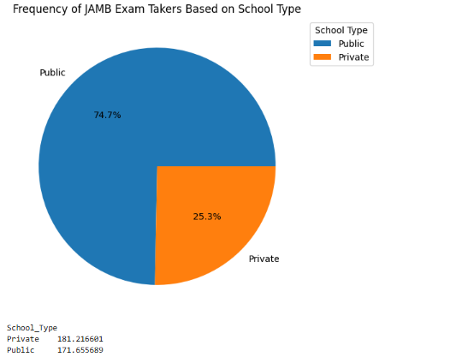
Figure 1: Distribution of Students by School Type
The distribution of students by school type indicates that a significantly larger proportion of JAMB candidates in 2024 attended public schools, accounting for 74.7% of the total, compared to 25.3% from private schools. This reflects the dominance of public education in Nigeria, where public schools cater to a majority of the student population. However, despite having fewer candidates, students from private schools achieved a notably higher average JAMB score of 181.22 compared to 171.66 for their public school counterparts. This suggests that while public schools serve more students, the quality of education, resources, and individualized attention typically available in private schools may contribute to superior academic performance.
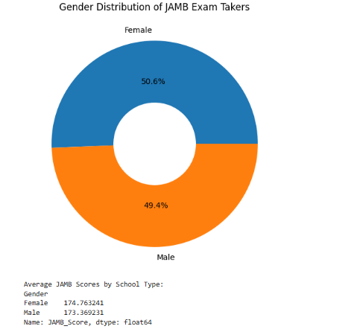
Figure 2: Distribution of Students by Gender
The gender distribution of JAMB candidates, as depicted in the figure, reveals an almost equal representation between male and female students, with females making up 50.6% and males accounting for 49.4% of the total candidates. This near parity suggests significant progress towards gender balance in access to tertiary education opportunities in Nigeria. Furthermore, a slight performance difference was observed, with female candidates achieving an average JAMB score of 174.76 compared to 173.37 for male candidates, indicating that females not only participated in similar numbers but also slightly outperformed their male counterparts in academic achievement.

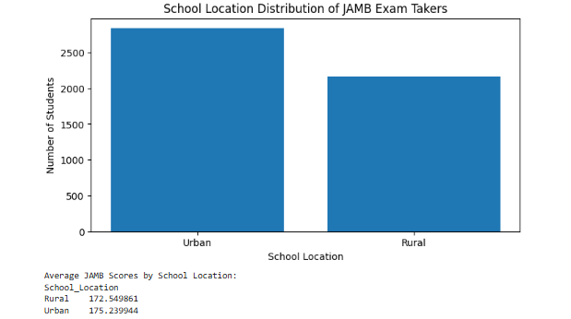
Figure 3: Distribution of Students by School Location
The school location distribution demonstrates that urban schools produced more JAMB candidates than rural schools, with approximately 2,800 students coming from urban areas and about 2,200 from rural areas, underscoring the disparity in educational access and participation between urban and rural regions. Additionally, students from urban schools achieved a higher average JAMB score of 175.24 compared to 172.55 among rural students, indicating that better educational facilities, access to experienced teachers, and supportive learning environments prevalent in urban areas contribute significantly to improved academic performance.
4.3 INFERENTIAL STATISTICAL ANALYSIS
This section presents the inferential statistical analyses conducted to explore the relationships between academic factors and JAMB performance. The analyses include correlation analysis, multiple regression analysis, independent sample t-tests, and two-way ANOVA. The results are presented in tables followed by detailed interpretations to provide insights into the key factors affecting students’ JAMB scores.
Figure 4: Correlation Matrix showing relationships between:
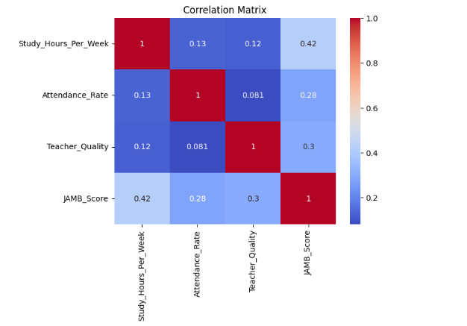
Interpretation: The correlation matrix above shows the relationships between key academic factors and JAMB scores. Study hours per week have a moderate positive correlation with JAMB scores (r = 0.42), indicating that students who dedicate more time to studying tend to perform better. Attendance rate also shows a positive, though weaker, correlation with JAMB scores (r = 0.28), suggesting that regular school attendance is associated with higher performance. Teacher quality has a slightly stronger correlation with JAMB scores (r = 0.30) compared to attendance, implying that better-rated teachers may contribute to improved student outcomes. Overall, while all factors are positively related to student performance, study hours exhibit the strongest association, highlighting the critical role of independent learning time in academic success.

Table 2: Regression Output Table
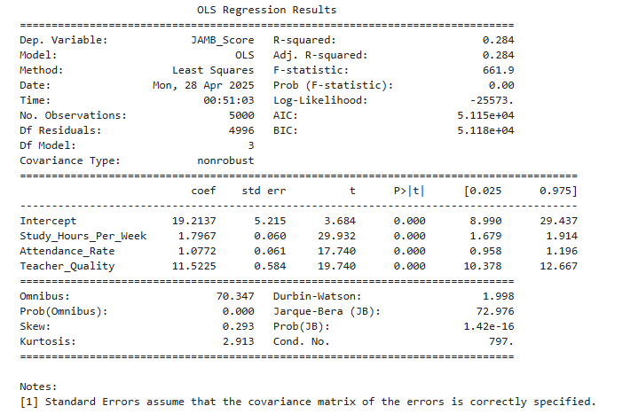
Interpretation: The regression results show that Study Hours per Week, Attendance Rate, and Teacher Quality are all significant positive predictors of JAMB scores. The model explains about 28.4% of the variance in JAMB scores (R-squared = 0.284), suggesting that while these factors are important, other unmeasured variables also influence student performance. Specifically, for each additional hour spent studying per week, a student's JAMB score increases by approximately 1.80 points (p < 0.001). Similarly, a one-percentage-point increase in attendance rate is associated with about a 1.08-point increase in JAMB score (p < 0.001), and each one-unit improvement in teacher quality leads to an increase of about 11.52 points in JAMB score (p < 0.001). The F-statistic is significant (p < 0.001), confirming that the overall model is statistically meaningful. Thus, consistent study habits, regular attendance, and access to high-quality teachers are all critical contributors to better academic outcomes among the students analyzed.
Table 3: Two-Way ANOVA Results for the Effects of School Type and School Location on JAMB Scores
 | Sum of squares | Degree of freedom | F | PR(>F)
C(School_Type) | 85923.072238 | 1.000000 | 38.192897 | 0.000000
C(School_Location) | 8427.986872 | 1.000000 | 3.746249 | 0.052983
C(School_Type):C(School_Location) | 1.596518 | 1.000000 | 0.000710 | 0.978748
Residual | 11239568.284593 | 4996.000000 | nan | nan
Interpretation: The two-way ANOVA analysis reveals that School Type (public vs private) has a statistically significant effect on students' JAMB scores (F = 38.19, p < 0.001), indicating that the type of school attended plays an important role in explaining differences in performance. School Location (urban vs rural) shows a weaker but marginally significant effect (F = 3.75, p = 0.053), suggesting that location may influence scores, although the effect is less strong and borders on the conventional significance threshold of 0.05. The interaction between School Type and School Location is not statistically significant (F ≈ 0, p = 0.979), implying that the effect of school type on JAMB scores does not differ meaningfully between urban and rural areas. Overall, these results suggest that school type matters more than location in influencing academic outcomes in this study.
Table 4: Independent Samples T-Test Comparing JAMB Scores Based on Access to Tutorials
T-test result: t=3.34, p=0.0008
Cohen's d: 0.10
Interpretation: The independent samples t-test conducted to compare JAMB scores between students who had access to extra tutorials and those who did not showed a statistically significant difference in mean JAMB scores between the two groups, t(4998) = 3.34, p = 0.0008, indicating that access to tutorials was associated with higher performance. However, the effect size, measured by Cohen’s d (0.10), was small, suggesting that while the difference is statistically meaningful, the practical impact of tutorial access on overall student performance is relatively modest.

CHAPTER FIVE
SUMMARY CONCLUSION AND RECOMMENDATION
5.0 INTRODUCTION
This chapter presents the summary of key findings, conclusions drawn from the study, and recommendations based on the results of the analysis. The aim is to consolidate the insights gained from the study and propose actionable steps toward addressing equity-related disparities in educational outcomes based on the 2024 JAMB performance data.
5.1 SUMMARY OF FINDINGS
This study analyzed the 2024 JAMB performance data to investigate disparities in educational outcomes with a focus on school type, school location, and socioeconomic factors. Descriptive statistics showed moderate variations in JAMB scores, study hours, attendance rates, and teacher quality among students. It was found that students from private schools and urban areas performed better on average compared to their counterparts from public schools and rural areas.
Correlation analysis revealed that study hours, attendance rate, and teacher quality were all positively associated with student performance, with study hours having the strongest correlation. Regression analysis confirmed that study hours per week, attendance rates, and teacher quality significantly predicted JAMB scores, collectively explaining about 28.4% of the variance in student performance.
The two-way ANOVA results indicated that school type had a statistically significant effect on JAMB scores, while the effect of school location was marginally significant. The interaction between school type and location was not significant, suggesting independent effects. Additionally, the independent samples t-test showed that access to extra tutorials had a statistically significant, though small, impact on student performance.
5.2 CONCLUSION
Based on the results of the analysis, the following conclusions are drawn:
  - Students from private schools performed significantly better than those from public schools, indicating that school type plays a crucial role in academic outcomes.
  - Urban students generally achieved higher JAMB scores compared to rural students, although the impact of location was marginally significant.
  - Study hours per week had the strongest positive relationship with JAMB scores, emphasizing the importance of consistent personal study time.
  - Attendance rates were positively associated with student performance, showing that regular school attendance contributes meaningfully to academic achievement.
  - Teacher quality had a significant positive impact on JAMB scores, suggesting that access to better-rated teachers enhances student outcomes.
  - Access to extra tutorials was associated with higher performance, although the practical impact (effect size) was small.
  - Disparities in educational outcomes were linked to school characteristics, student study behaviors, teacher quality, and socioeconomic factors, confirming the presence of equity-related gaps among the 2024 JAMB candidates.
5.3 RECOMMENDATION
Based on the findings of this study, the following recommendations are proposed:
- The government and stakeholders should invest more in improving facilities, teacher quality, and learning environments in public schools, particularly in rural areas, to bridge the performance gap.
- Schools and communities should promote access to affordable or free extra tutorials, especially for students from disadvantaged backgrounds, as additional academic support can enhance performance.
- Recruitment, training, and continuous professional development programs should be prioritized to ensure that teachers possess the necessary skills and motivation to effectively support student learning.
- Schools should monitor attendance closely and create initiatives that encourage students to maintain consistent study hours outside school, such as study clubs or mentorship programs.
- Ensuring that students in both urban and rural areas have access to textbooks, technology, and other essential educational resources is critical for supporting equitable academic achievement.
REFERENCES
Abbasi, A.R. & Mir, G.M. (2012). Impact of teacher’s ability, students’ work ethics and institutional environment on student performance at University of Gujrat. Middle-East Journal of Scientific Research, 12(4), 572–579. http://dx.doi.org/10.5829/idosi.mejsr.2012.12.4.1716
Ajayi, J.B., Opadare, G.B., & Ariwola, S.A.T. (1997). Examination malpractice in secondary schools in Ibadan, Oyo State: Incidence, causes and control measures. Unpublished B.Ed. project report, Nsukka: University of Nigeria.
Anaike, O.E. (2008). A project work on Two-way MANOVA with interaction in Physical Sciences of Imo State University, Owerri, Department of Statistics. Unpublished B.Sc project.
Ahlan, A.R., Atanda, B.N., Yahaya, I., & Shehu, Y.I. (2014). Information technology enhances students’ academic performance: A case of University of Ilorin. The Online Journal of Distance Education and E-Learning, 2(2), 15–20.
Ali, S., Haider, Z., Munir, F., Khan, H., & Ahmed, A. (2013). Factors contributing to student’s academic performance: A case study of Islamia University Sub-campus. American Journal of Educational Research, 1(8), 283–289. http://dx.doi.org/10.12691/education-1-8-3
Bamiro, O.A. & Adedeji, O.S. (2010). Sustainable financing of higher education in Nigeria. Ibadan: Ibadan University Press.
Bugge, L.S. & Wikan, G. (2013). Student level factors influencing performance and study progress. TOJNED: The Online Journal of New Horizons in Education, 3(2), 30–38.
Haolader, F.A., & Nickolaus, R. (2012). Addressing the Quality and Relevance of Technical and Vocational Education and Training (TVET) in Bangladesh. International Journal of Engineering and Technology, 2(2), 1-12.
Haolader, F.A., Ali, M., & Foysol, K.M. (2015). The taxonomy for learning, teaching, and assessing: Current practices at polytechnic institutions in Bangladesh and its effects in developing students’ competence. International Journal for Research in Vocational Education and Training, 2(2), 99–118.
Mekonnen, H. (2014). Factors affecting academic performance of regular university students: The case of Jimma University. Journal of Education and Practice, 5(22), 55–63.
Olayinka, M.S. (1996). An appraisal of the status of education in Nigeria. Educational Horizons, 74(2), 70–75.
Oluyeba, S.O. (1996). Examination malpractice in educational systems: Management challenges and solutions. Educational Horizons, 74(2), 80–87.
Onwuatu, L.I. (2009). Comparative analysis of Biochemistry and Microbiology students' performances using multivariate approach at Imo State University, Owerri. Unpublished Master's seminar project.
Ubong, E.A. (2009). Optimization of extrusion conditions for plastic film production: A multivariate analysis. Unpublished M.Sc project report.
Wambugu, L.N. & Emeka, V.A. (2016). Factors influencing students' academic performance in Kenya Certificate of Secondary Education in public secondary schools in Kayole division, Nairobi county, Kenya. Journal of Education and Practice, 7(34), 62–67.
Data source: https://www.kaggle.com/datasets/idowuadamo/students-performance-in-2024-jamb

