

PRJECT REPORT
ON
DIGITAL MAPPING OF INFRASTRUCTURAL FACILITIES OF PART OF ROYAL VALLEY ESTATE
AT KULENDE / AKEREBIATA ROAD, SANGO, ILORIN
ILORIN EAST LOCAL GOVERNMENT AREA
KWARA STATE

BY
POPOOLA BLESSING
HND/23/SGI/FT/0094

SUBMITTED IN PARTIAL FULFILMENT OF THE REQUIREMENTS FOR THE AWARD OF HIGHER NATIONAL DIPLOMA IN SURVEYING AND GEO-INFORMATICS TO THE DEPARTMENT OF SURVEYING AND GEO-INFORMATICS, KWARA STATE POLYTECHNIC ILORIN, KWARA STATE
JUNE, 2025

CERTIFICATION
This is to certify that the research work carried out by Popoola blessing with matriculation number HND/23/SGI/FT/0094 in accordance with survey law’s and departmental instructions.

…………………………….. ……………………………
Surv. R. S. Awoleye Signature &Date
Supervisor

…………………………….. ……………………….
Surv. R. S. Awoleye Signature &Date
Project coordinator

…………………………….. …………………………….
MR. I. I. Abimbola Signature &Date
Head of Department

DECLARATION
I hereby conclude that I Popoola blessing with matriculation number HND/23/SGI/FT/ 0094 fully participated on this project and acquired more experience about Digital surfacing modelling.

Name of student: Popoola blessing
Student signature: ……………………………………………………………………….
Date: …………………………………………………………………………………………….

DEDICATION
This project is dedicated to Almighty God for His goodness endures forever, forHis wisdom, knowledge and understanding for the completion of the project.

ACKNOWLEDGEMENT
My great appreciation goes to God almighty my Maker, The Alpha and Omega who has given me the rare opportunity to be among the living souls.
I am also grateful and thankful to my supervisor surv. R. S Awoleye for his wonderful assistance and contributions despite his tight schedules, he still finds time to attend to me.
To my lecturers people of selfless interest thank you so much Surv. R . O Asonibare, Surv A. G Aremu, Surv. Abdulsalam, Surv. kabir ,Mr Abimbola Isaau, Surv. Baniji and Surv. R. S Awoleye l pray God almighty will be and abide with you and your families forever.
I will be ungrateful If fail to appreciate the efforts and labour of my irreplaceable, amazing, and supportive parents Dn and Mrs POPOOLA, for your parental care and support since the inception of my educational carrier, you stood by me when things were tough and rough for me, you gave me hope when others mock me, I will forever love and cherish you. You shall reap the fruit of your labourijn. AMEN
To my amazing and lovely siblings Popoola Theophilus olamilekan, Popoola Precious David and Popoola mayokunNoami I love you so much. Thanks for being amazing and supportive blood.
To my wonderful sister MrsOyunwola Emily Christiana Thanks for all you do ma
I really appreciate your support and advice.
To my BSF family Bro Reuben, Sis opeyemi and Bro Samson Ayomide and everyone who has make an impact in the journey of my academics I really appreciate you all thank you so much.
To my coursemates and project mates thank you so much. I really appreciate your your support and advice.
MAY GOD ALMIGHTY BLESS YOU AND REWARD YOU ALL IJN (AMEN)

ABSTRACT
This paper shows a detailed methodology for creating 2D and 3D visual facility map of the campus. The purpose of this study work is to develop an interactive interface containing the 2 and 3-Dimensional features of all the facilities within the Royal Valley Estate. The spatial attributes of the facilities were collected with the aid of total stations. The most recent Google earth software was used as source of data to produce 2-dimensional facilities of the study area through digitization process. SRTM Digital elevation model image was downloaded from United State Geological Survey website to give the elevation data required for the 3-dimensional representation. All these data were processed with ArcGIS 10.2.1.

TABLE OF CONTENTS
CHAPTERONE 1
1.0 INTRODUCTION 1
1.1 BACKGROUND TO THE STUDY 2
1.2 STATEMENT OF PROBLEM 8
1.3 AIM AND OBJECTIVES 8
1.3.AIM: 8
1.3.2 OBJECTIVES: 8
1.4 SCOPE OF THE PROJECT 9
1.5 PERSONEL 9
1.6 STUDY AREA 10
1.7 SPECIFICATIONS 11
CHAPTER TWO 12
2.0 LITERATURE REVIEW 12
2.1 Conceptual Framework of Digital Mapping………………………………..12
2.2 Geospatial Technologies in Infrastructure Mapping…………………..12
2.3 Applications in Urban and Regional Planning…………………………….13
2.4Infrastructure and the Sustainable DevelopmentGoals (SDGs)…..13
2.5Challenges in the Adoption of Digital Mapping……………..……………13
2.6Case Studies and Best Practices………..………………………………………..14
2.7 Identified Research Gaps…………………………………………….……………..14
2.8 NUnderstanding Digital Mapping and Spatial Data Infrastructure………………………………………………………………………..…..15
2.9 Sector-Specific Applications of Digital Mapping……………………..15
2.10 Participatory and Community-Based Mapping…...………...………….16
2.11 Data Integration, Interoperability, and Governance…………….17
2.12 Real-Time Monitoring and Smart Infrastructure…………..………17
2.13 Policy Integration and Institutional Adoption……………………..17
2.14 Digital Twins and Smart Infrastructure Management………..…18
2.15 Disaster Risk Reduction and Resilience Planning………………..…18
2.16 AI and Machine Learning in Digital Mapping…..……….…………...…19
2.17 Ethical Considerations in Digital Mapping………………………..…..19
2.18 Digital Mapping in the Context of the Global South……….……..20
2.19 Gender and Social Inclusion in Infrastructure Mapping….…….20
2.20 Mapping Informal Settlements and Urban Marginality…………21
2.21 Open-Source GIS and Mapping Platforms……………………………..…22
2.22 Climate Change and Environmental Infrastructure Mapping…22
2.23 Human Capacity and Institutional Development…………….………..23
2.24 Geospatial Data in Infrastructure Financing and Investment………………………………………………………………………………….24
2.25 Equity in Infrastructure Distribution………….…….……….………..24
2.26 Digital Mapping and Land Information Systems (LIS)………………25
2.27 Remote Sensing for Infrastructure Monitoring……………..……..26
2.28 Infrastructure Mapping and the Sustainable Development Goals (SDGs)…………………………………………………..…………………………….26
2.29 Spatial Decision Support Systems (SDSS) in Infrastructure Planning………………………………………………………………….………………….27
2.30 Governance and Institutional Integration of Digital Mapping……………………………………………………………………….………………27
2.31 Spatial Data Governance ……………………………………………………..29
2.32 Urban Mobility and Infrastructure Mapping…………………………30
2.33 Smart Infrastructure and Digital Mapping……………………………3O
2.34 Data Visualization in Infrastructure Mapping……………………….31
2.35 Case Studies of Digital Mapping in Infrastructure Development………………………………………………………………………………32
Conclusion…………………………………………………………………………………32

CHAPTERTHREE 33
3.0 METHODOLOGY 33
3.1 DATABASEDESIGN 33
3.1.1 VIEWOF REALITY 34
Fig.3.1Design andConstructionPhasesinSpatialDatabase 35
3.1.2 CONCEPTUALDESIGN 36
Fig.3.2.:E-RDiagram(Entityrelationship diagram) 36
3.1.3 LOGICALDESIGN 37
3.1.4 PHYSICALDESIGN 37
Table3.1: Buildingand itsattribute………………………………………………………..…37

Table3.3:Treesanditsattributes …………………………………………………………….38

3.2 RECONNAISSANCE 38
3.2.1 OFFICEPLANNING 39
Table 3.4CoordinatesofControls 39
3.2.2 FIELDRECONNAISSANCE 39
Fig.3.3: Reccediagramofthestudy area (notdrawn to scale). 40
3.3 EQUIPMENTUSED/SYSTEMSELECTIONANDSOFTWARE 41
3.3.1 HARDWAREUSED 41
3.3.2 SOFTWARECOMPONENT 41
3.4 INSTRUMENTTEST 42
3.4.1 HORIZONTALCOLLIMATIONTEST 42
Fig3.4:HorizontalCollimation andVerticalIndexerrortest. 42
3.4.2 VERTICALINDEXERRORTEST 43
Table3.6:VerticalIndexData 43
3.4.3 ANALYSISOFCOLLIMATIONANDVERTICALINDEXDATA 43
3.5 CONTROLCHECK 44
Table3.7:showing thebackcomputationof thecontrolcoordinates 44
Table 3.9 showing theobservation resultof thecontrol check 45
3.6 MONUMENTATION 45
3.7 DATAACQUISITION 46
PRIMARYDATASOURCE 46
3.7.1 GEOMETRICDATAACQUISITION 46
3.7.2 ATTRIBUTES DATA ACQUISITION 47
3.8 DATADOWNLOADINGANDPROCESSING 47
3.8.1 DATADOWNLOADINGANDEDITING 47
3.8.2 DATAPROCESSINGANDDATAEDITING 48
3.8.3 DATAPROCESSINGUSINGARCGIS10.3 48
3.8.4 Topographical Map (DEM) 49
EDITING,CONVERTINGANDMERGING GEODATABASE 52
ADDINGSPOTHEIGHTSDATA 52
TIN,ASPECTANDSLOPECREATIONUSINGARCMAP 53
TOCHANGETHEFACEOF THETINACCODINGTOITSELEVATION 53
TOCREATE ASPECT 53
3.8.5 Facility Map Production 53
3.8.6 3D Map Production 53
3.8.7 Findings 53
3.8.8 Attribute data creation 57
Table3.10: Building 58
Table3.12:Trees 58
3.8.9 DATABASEIMPLEMENTATION 59
3.8.10 DATABASEMANAGEMENTSYSTEMS 59
3.8.11 DATABASEMAINTENANCE 60
3.8.12 AREA COMPUTATIONTable 61
CHAPTERFOUR 62
4.0 SPATIAL ANALYSES AND PRESENTATION 62
4.1 TESTINGOF DATABASE 62
4.11 ANALYSIS OF RESULT 62
SINGLESELECTIONCRITERION 63
Fig4.1:shows the completed building 63
Fig4.2:shows the 2D completed building 63
Figure 4.3 shows the 3D of completed building ………………………………………………63

Fig4.4Queryshows the 2D of uncompleted building 64
Figure 4.5 shows the 3D of uncomplted building 65
CHAPTER FIVE 66
5.0 Costing Estimation, Summary, Conclusion, Recommendation and Problem Encountered ……………………………………………………………………………………………66
5.1 Costing Estimation 66
5.2 Summary 71
5.3 Conclusion 72
5.4 Recommendations 72
5.5 Problems Encountered 73
APPENDIX I 75

CHAPTER ONE
1.0 INTRODUCTION
Infrastructural development is a cornerstone of economic growth and societal well-being. From transportation systems and energy supply to healthcare, education, and communication networks, the availability and quality of infrastructure significantly influence national development indicators. In recent years, the need for efficient planning, management, and monitoring of infrastructural facilities has become increasingly urgent, especially in the face of rapid urbanization, climate change, and growing population demands.
Traditional methods of infrastructure inventory and planning, which often rely on manual mapping, paper-based records, and sporadic field surveys, are increasingly proving inadequate. These methods are time-consuming, prone to errors, and difficult to update or integrate with other data sources. Consequently, they limit the ability of decision-makers to respond effectively to infrastructural needs, plan future expansions, or manage existing assets efficiently.
The integration of digital technologies into spatial data management has given rise to a powerful tool: digital mapping. Digital mapping involves the use of Geographic Information Systems (GIS), Remote Sensing (RS), and Global Positioning Systems (GPS) to capture, store, analyze, and visualize geospatial data in a dynamic, interactive format. Through these tools, infrastructural facilities can be accurately mapped, monitored, and analyzed across time and space, enabling more precise and data-driven decision-making processes.
Digital mapping not only enhances planning and monitoring, but also supports transparency, citizen participation, disaster response, and sustainable development. For instance, governments can use digital maps to identify areas lacking basic amenities, monitor maintenance needs, or track infrastructure expansion projects. NGOs and researchers can leverage digital maps for advocacy and policy analysis. In disaster-prone areas, emergency response teams can use real-time infrastructure maps to prioritize rescue operations and resource allocation.
Despite the potential benefits, the adoption of digital mapping in many regions, especially in developing countries, remains limited. Challenges such as lack of technical capacity, high implementation costs, weak institutional support, and poor data sharing frameworks continue to hinder widespread use. Addressing these barriers requires a deeper understanding of the technology, its applications, and its relevance to local and national development agendas.
This study, therefore, explores the concept, tools, and practical applications of digital mapping in the context of infrastructural facilities. It aims to assess the current practices, evaluate the benefits and limitations of digital mapping, and propose strategies to improve its implementation for sustainable infrastructure management. The study ultimately seeks to demonstrate how digital mapping can serve as a catalyst for more inclusive, efficient, and informed infrastructural development planning.
1.1 Background to the study
Infrastructural facilities such as roads, water supply networks, electricity grids, health centers, schools, and communication systems form the backbone of socioeconomic development in any society. Accurate, up-to-date, and accessible information about these facilities is crucial for effective planning, resource allocation, maintenance, and emergency response. Traditionally, data on infrastructure has been collected and managed manually, often resulting in outdated, fragmented, and inefficient records that hinder decision-making and development efforts.
The advent of digital mapping technologies—powered by Geographic Information Systems (GIS), Remote Sensing, and Global Positioning Systems (GPS)—has revolutionized how spatial data is collected, analyzed, and visualized. Digital mapping allows for the creation of detailed, accurate, and interactive maps that can be easily updated and shared across various platforms. This technological shift has opened new possibilities for urban planning, rural development, disaster management, and infrastructure monitoring.

Digital mapping of infrastructural facilities not only enhances transparency and accountability in public infrastructure projects but also supports evidence-based policy formulation. By integrating various data layers, planners and decision-makers can identify gaps in infrastructure, assess the quality and accessibility of services, and prioritize investment areas more effectively. Furthermore, digital maps provide valuable tools for communities, researchers, and NGOs working towards sustainable development goals.
Despite its benefits, the implementation of digital mapping in many regions, particularly in developing countries, remains limited due to challenges such as lack of technical expertise, inadequate funding, and weak institutional frameworks. This study seeks to explore the role, process, and impact of digital mapping in infrastructural development, highlighting its potential to transform planning and governance practices.
Infrastructure is widely recognized as a fundamental pillar of national development, directly influencing the quality of life, economic productivity, and social well-being of a population. The efficient functioning of roads, water distribution systems, electrical grids, telecommunication networks, healthcare facilities, educational institutions, and waste management systems is essential for sustainable development and poverty alleviation. Accurate and up-to-date data about these infrastructural facilities is critical for effective planning, monitoring, and management.
Traditionally, infrastructure data collection has been a labor-intensive process involving physical surveys, paper maps, and fragmented records. These conventional methods are often plagued by inaccuracies, redundancy, and limited accessibility, particularly in rapidly urbanizing or remote rural areas. As a result, planners and policymakers frequently operate with incomplete or outdated information, leading to inefficient resource allocation, delays in project execution, and missed development opportunities.

The emergence of digital mapping technologies—especially Geographic Information Systems (GIS), Remote Sensing (RS), and Global Positioning Systems (GPS)—has significantly changed how spatial data is collected, analyzed, stored, and presented. Digital mapping provides dynamic, scalable, and highly interactive tools for visualizing infrastructure and spatial patterns. These technologies allow for the real-time updating of maps, the integration of diverse data sources, and multi-layer analysis of environmental, social, and economic variables. With these capabilities, digital mapping has become an indispensable tool in infrastructure planning, disaster risk reduction, environmental management, and smart city initiatives.

Moreover, digital maps are not only useful to government institutions but also to private sector actors, researchers, non-governmental organizations (NGOs), and the general public. For instance, utility companies can use digital maps to monitor and manage service delivery infrastructure; researchers can analyze spatial inequalities in infrastructure distribution; while emergency services can plan more efficient responses during disasters.
In the context of sustainable development goals (SDGs), particularly those related to infrastructure (Goal 9), sustainable cities (Goal 11), and partnerships (Goal 17), digital mapping plays a crucial role in tracking progress and identifying gaps. The ability to visualize infrastructure data spatially enhances transparency, accountability, and stakeholder engagement in development processes.
However, the adoption of digital mapping is not without challenges. In many developing countries, constraints such as limited financial resources, inadequate institutional capacity, poor data sharing practices, and lack of trained personnel hinder its effective implementation. In addition, issues related to data privacy, standardization, and interoperability need to be addressed to fully realize the benefits of digital infrastructure mapping.

Given these realities, this study investigates the concept, tools, applications, and challenges associated with the digital mapping of infrastructural facilities. It seeks to understand how digital mapping can improve infrastructure planning and management, and what strategies can be adopted to overcome the existing barriers to its adoption and sustainability.
Infrastructural facilities form the bedrock of any nation's socioeconomic development. They encompass physical systems such as transportation networks, water supply and sanitation systems, energy grids, communication infrastructure, healthcare facilities, and educational institutions. The availability, accessibility, and functionality of these facilities have a direct influence on the quality of life, public health, economic productivity, and social equity. For policymakers, planners, and development agencies, accurate information on the location, condition, and distribution of these assets is essential for informed decision-making, efficient service delivery, and sustainable development planning.
However, in many parts of the world—particularly in developing countries—there are significant challenges associated with the documentation, tracking, and management of infrastructural assets. Traditional methods for recording infrastructure data often involve manual surveys, paper records, and static maps, which are prone to errors, inconsistencies, and rapid obsolescence. In fast-growing urban centers or remote rural regions, the lack of reliable data hampers effective infrastructure planning and investment, exacerbating service delivery gaps and spatial inequality.
With the advancement of digital technologies, digital mapping has emerged as a powerful tool for addressing these challenges. At the heart of digital mapping are technologies such as Geographic Information Systems (GIS), Remote Sensing (RS), and Global Positioning Systems (GPS). These tools enable the collection, integration, analysis, and visualization of geospatial data in a dynamic and interactive manner. By converting physical infrastructure information into digital spatial formats, users can produce accurate maps that depict the location, status, and interrelationships of infrastructural elements in real-time.

Digital mapping brings a multitude of benefits. It facilitates evidence-based planning, where decisions regarding infrastructure development and maintenance are grounded in spatial data analysis. It supports asset management, helping government agencies and utility providers monitor the condition and usage of infrastructure over time. Furthermore, digital mapping enhances disaster preparedness and response, allowing emergency teams to quickly identify critical infrastructure and develop effective contingency plans.
The relevance of digital mapping extends to several critical sectors:
Urban and Regional Planning: Enables planners to visualize growth patterns and plan for future infrastructure expansion.
Public Health: Assists in mapping health service delivery points and identifying underserved areas.
Education: Supports mapping of school locations and helps optimize student access and resource allocation.
Utilities and Services: Facilitates monitoring and maintenance of water, electricity, and waste management systems.
Transportation: Allows real-time mapping of road networks, traffic flows, and public transit systems.
Globally, the integration of digital mapping into national and local planning frameworks has become an important strategy for achieving the United Nations Sustainable Development Goals (SDGs). Particularly, Goal 9 (Industry, Innovation, and Infrastructure), Goal 11 (Sustainable Cities and Communities), and Goal 17 (Partnerships for the Goals) highlight the importance of robust infrastructure and data-driven planning tools for sustainable development.

Nevertheless, several obstacles continue to impede the full adoption of digital mapping technologies. These include:

High initial costs of hardware, software, and data acquisition.
Lack of technical expertise and training among government personnel and local planners.
Institutional resistance to change and limited collaboration among data custodians.
Inadequate policies and frameworks for geospatial data governance and standardization.
Limited internet connectivity and electricity, particularly in rural areas.
This study is therefore conceived to bridge the knowledge gap in understanding how digital mapping technologies can be effectively utilized for infrastructure development. It aims to investigate the current state of digital mapping practices, evaluate their impact on infrastructure planning and management, and identify the key challenges and opportunities for broader implementation. The insights from this study will contribute to a deeper understanding of the role of spatial data in modern governance and provide practical recommendations for enhancing infrastructural development through geospatial technologies.

1.2 STATEMENT OF PROBLEM
Governments, urban planners, and utility providers face significant challenges with traditional infrastructure mapping and monitoring methods, which rely on manual inspections, paper-based records, and static maps. These outdated approaches are inefficient, time-consuming, and prone to inaccuracies, leading to poor decision-making, maintenance delays, and increased operational costs. This ultimately affects service delivery and public safety. This study investigates the potential of digital mapping to improve infrastructure management, examining its benefits, challenges, and providing recommendations for effective implementation.
1.3 aim and objectives
1.3.1 Aim:
The study aims to determine how digital mapping can enhance decision-making, optimize resource allocation, and improve the long-term sustainability of infrastructural facilitie of ROYAL VALLEY ESTATE.

1.3.2 OBJECTIVES:
The following objectives were considered in order to accomplish the above aim:
1Project planning which include office planning and field reconnaissance
2 Monumentation
3 Data acquisition (geometric data with TOTAL STATION, Social survey through oral interview and pillar description inclusive).
4 Data processing: This include downloading and processing of data using appropriate software
5 Information presentation: It involved plotting of survey data on both soft copy and hard copy showing correct location of points.
1.4 SCOPE OF THE PROJECT
Based on the purpose and significance of this project, the scope includes;
1 Project planning
2 Station selection and monumentation
3 Data Acquisition
4 Data downloading and Data processing
5 Data Analysis and information presentation
1.5 PERSONEL
The underlisted students of HND II 2024/2025 set are the personnel that participated in the execution of this project. They are: -
S/N | NAMES | MATRIC NO | REMARKS
1 | POPOOLA BLESSING | HND/23/SGI/FT/0094 | AUTHOR
2 | ALAI ABDULLAH AKANNI | HND/23/SGI/FT/0105 | MEMBER
3 | ADEYEMO MARIAM O. | HND/23/SGI/FT/0095 | MEMBER
4 | OGUNDEPO QUADRI O. | HND/23/SGI/FT/0102 | MEMBER
5 | ADEKANBI ABIGAEL BIMBO | HND/23/SGI/FT/096 | MEMBER
6 | OKE TEMITOPE JOHN | HND/23/SGI/FT/103 | MEMBER
7 | ALADA TOLUWANI O. | HND/23/SGI/FT/126 | MEMBER
8 | OLAREWAJU OLUWATOSIN D. | HND/23/SGI/FT/131 | MEMBER
Table 1.5.1: Shows the group personnel
1.6 STUDY AREA
Royal valley estate Sango Ilorin, kwara state, Ilorin south local government area

N
NIGERIA
NIGERIA
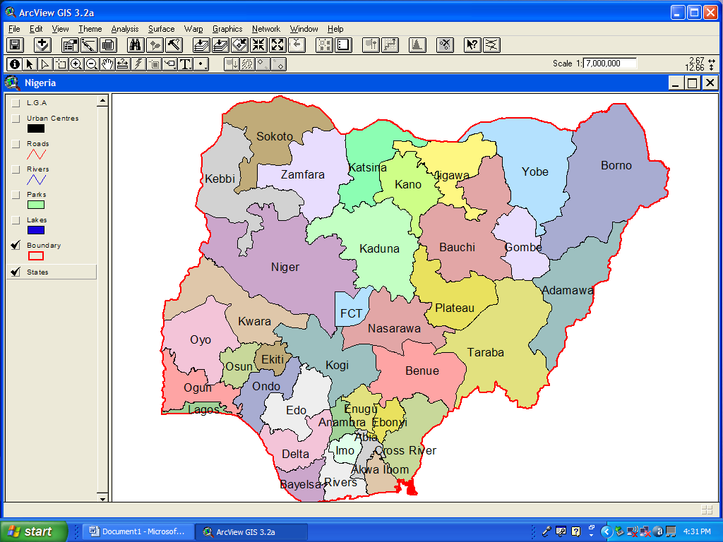
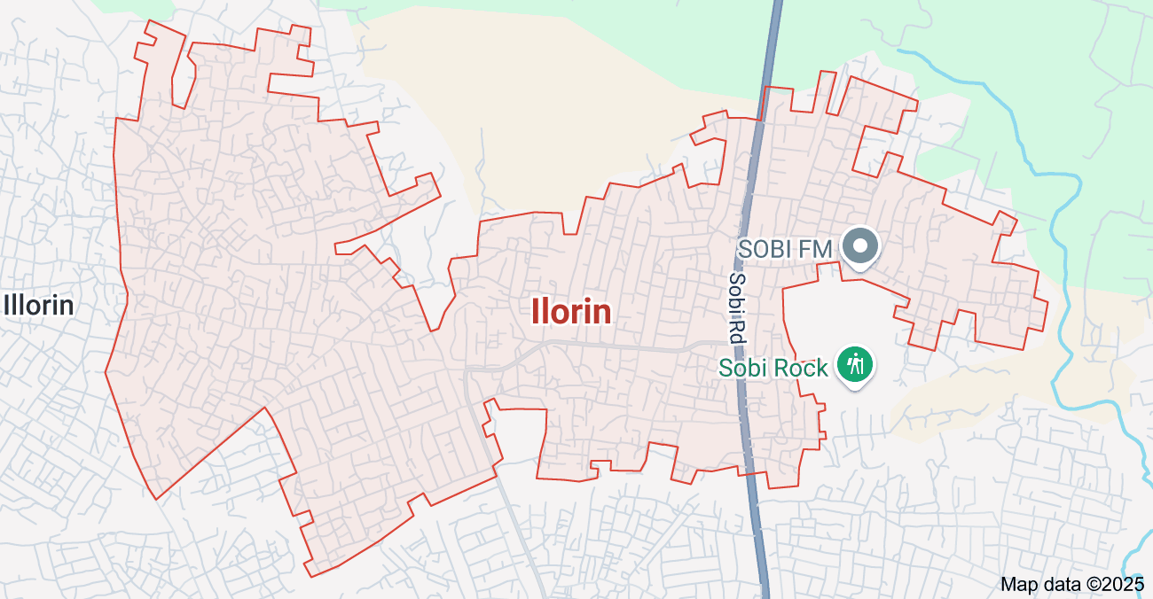

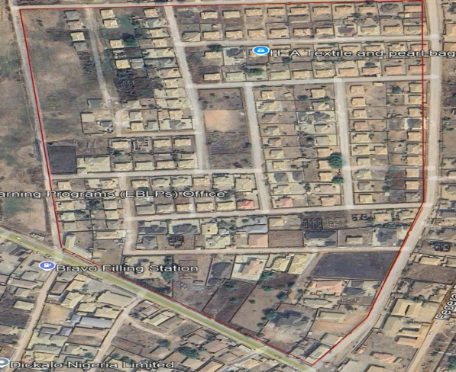
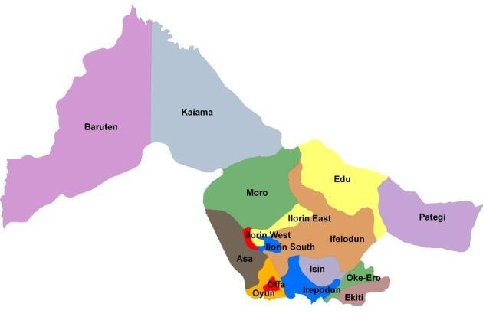

ROYAL VALLEY ESTATE
ILORIN

Table 1.5.1: Show the group personnel involved
1.7 SPECIFICATIONS
The project speciation’s were referenced to the speciation for land information system using total station which was sources from the Higher National Diploma. The specification includes the following:
- Total station (YE00240)
- Minimum number of datum control required- three (3)
- Traverse should run between secondary or higher order control point.

CHAPTER TWO
2.0 LITERATURE REVIEW
2.1 Conceptual Framework of Digital Mapping
Digital mapping refers to the process of collecting, compiling, and visualizing spatial data in a digital format using geospatial technologies. It encompasses the use of tools such as Geographic Information Systems (GIS), Global Positioning Systems (GPS), and Remote Sensing (RS) for mapping physical features, analyzing spatial relationships, and facilitating informed decision-making. According to Longley et al. (2015), digital mapping provides an integrative platform for spatial analysis, modeling, and visualization, especially in fields that rely heavily on locational data such as urban planning, environmental management, and infrastructure development.
2.2 Geospatial Technologies in Infrastructure Mapping
The application of geospatial technologies in infrastructure management has grown significantly in recent decades. GIS, in particular, is widely used to map and analyze infrastructure such as roads, water supply systems, sewage networks, electrical grids, and public buildings. It enables the layering of different datasets, allowing for complex spatial analysis. GPS technology aids in accurate ground data collection and real-time tracking of infrastructural assets, while remote sensing provides large-scale, high-resolution imagery for monitoring land use and infrastructure changes over time (Campbell & Wynne, 2011).
Several studies, such as those by Bolstad (2016) and Foody (2002), have emphasized the role of remote sensing in infrastructure monitoring and change detection. These technologies provide the necessary data for decision-makers to assess infrastructure conditions, plan maintenance, and prioritize investments.

2.3 Applications in Urban and Regional Planning
In urban planning, digital mapping is utilized to design, assess, and monitor the development of physical infrastructure. It enables the identification of underserved areas, analysis of spatial accessibility, and simulation of future development scenarios. Scholars such as Batty (2013) and Goodchild (2007) argue that digital mapping supports "smart city" planning by integrating infrastructure data with demographic, environmental, and economic datasets.
In rural contexts, digital mapping has been instrumental in locating and planning essential services such as health centers, schools, and water facilities. A study by UNICEF (2018) showed how digital mapping of water points in Sub-Saharan Africa helped identify functional and non-functional systems, thereby improving water service delivery and planning.
2.4 Infrastructure and the Sustainable Development Goals (SDGs)
The relevance of digital mapping in achieving the Sustainable Development Goals (SDGs), particularly SDG 9 (Industry, Innovation, and Infrastructure) and SDG 11 (Sustainable Cities and Communities), is well-documented. According to the United Nations (2019), geospatial technologies play a crucial role in tracking progress, identifying gaps, and enabling evidence-based decision-making in infrastructure development. By offering spatial insights into infrastructure accessibility and inequality, digital mapping contributes to more inclusive and equitable development.
2.5 Challenges in the Adoption of Digital Mapping
Despite its potential, digital mapping faces several barriers, especially in low- and middle-income countries. A major challenge is the lack of skilled personnel and technical capacity to develop and manage digital mapping systems. Additionally, the cost of acquiring high-resolution satellite imagery, software licenses, and data collection equipment remains a significant constraint (Kuffer et al., 2016).
Data availability and quality are also recurring concerns. In many countries, infrastructure data is often fragmented, outdated, or not publicly available. Institutional challenges, including poor inter-agency collaboration and weak geospatial data governance, further hinder the effective adoption of digital mapping (Williamson et al., 2010).
2.6 Case Studies and Best Practices
Several countries have successfully integrated digital mapping into infrastructure planning and management. For example:
In India, the Smart Cities Mission has incorporated GIS-based platforms for infrastructure and urban service monitoring (Government of India, 2020).
In Kenya, digital mapping of health facilities has improved the allocation of health resources and outreach programs (World Bank, 2018).
In Estonia, one of the most digitally advanced nations, geospatial data integration across government departments has enhanced infrastructure maintenance and planning transparency.
These case studies highlight the importance of political will, investment in capacity-building, and the establishment of national spatial data infrastructures (NSDIs) in promoting successful implementation.
2.7 Identified Research Gaps
While considerable literature exists on the technical and practical aspects of digital mapping, several gaps remain. Few studies offer localized evaluations of the effectiveness of digital mapping in improving infrastructure delivery in rural or peri-urban areas. There is also limited research on community participation in infrastructure mapping, as most initiatives are government- or donor-driven. Moreover, the socio-political dynamics influencing the adoption of geospatial technologies in different institutional settings remain underexplored.
2.8 Understanding Digital Mapping and Spatial Data Infrastructure
Digital mapping is a transformative process that involves the digitization of geographic data to produce visual representations of spatial phenomena. It goes beyond traditional cartography by enabling real-time updates, user interaction, and the integration of attribute data with spatial features. At the core of digital mapping is the Spatial Data Infrastructure (SDI)—a framework of policies, technologies, standards, and people necessary for effective collection, sharing, and utilization of geospatial data (Rajabifard et al., 2006).
National and regional SDIs are instrumental in supporting infrastructure mapping initiatives. For instance, the European Union’s INSPIRE Directive mandates standardized spatial data sharing across member states for environmental and infrastructure-related decision-making (European Commission, 2007). In contrast, many developing nations still lack coordinated SDI strategies, impeding seamless data sharing and multi-agency collaboration.
2.9 Sector-Specific Applications of Digital Mapping
- Transportation and Roads
GIS-based road infrastructure mapping has been widely used for traffic analysis, road condition monitoring, and transport route optimization. According to Elrahman& Abraham (2016), GIS applications have enhanced the ability of governments to prioritize road rehabilitation based on wear patterns, accident data, and connectivity
- Water and Sanitation
In water infrastructure, GIS and remote sensing tools are applied for mapping water pipelines, boreholes, and distribution points. Digital mapping facilitates leak detection, coverage analysis, and service equity assessments. A study by the World Health Organization (2017) demonstrated how GIS-based planning significantly improved water access in underserved rural communities in Uganda and Malawi.
- Electricity and Energy
Utility companies globally have adopted Geospatial Asset Management Systems to monitor electrical grids and optimize service delivery. GIS enables tracking of load centers, identification of outage-prone areas, and strategic expansion of the grid to new locations. In countries like Nigeria and India, such tools have been used in planning rural electrification (IRENA, 2019).
- Healthcare and Education
Digital mapping is vital for locating health and education infrastructure and assessing accessibility. For example, studies have used spatial accessibility models to identify disparities in school access in rural South Asia (Ahmed et al., 2020) and hospital locations in remote Latin American regions (Paez et al., 2018). These applications inform decisions about where to invest in new facilities.
2.10 Participatory and Community-Based Mapping
Emerging literature emphasizes the value of participatory GIS (PGIS) and volunteered geographic information (VGI) in infrastructure planning. Community members, through tools such as OpenStreetMap (OSM) and mobile apps, can contribute infrastructure data, especially in informal settlements or disaster-hit regions where official data may be lacking (Goodchild, 2007; McCall & Dunn, 2012).
For instance, the “Map Kibera” project in Nairobi, Kenya, empowered local youth to map their informal community, revealing the location of roads, schools, toilets, and water points that had previously been invisible on official maps. Such grassroots mapping fosters inclusiveness and empowers marginalized populations to participate in local development planning.
2.11 Data Integration, Interoperability, and Governance
An essential theme in digital mapping literature is the interoperability of data across agencies and platforms. Many researchers highlight the need for open data standards (e.g., OGC, ISO 19115) and metadata frameworks to facilitate integration and reuse of spatial data (Williamson et al., 2010).
Poor data governance, including the hoarding of geospatial data, lack of licensing clarity, and absence of national repositories, has been a persistent barrier in several developing countries. Strengthening institutional frameworks and enforcing open data policies is critical to unlocking the full potential of digital mapping.

2.12 Real-Time Monitoring and Smart Infrastructure
The integration of Internet of Things (IoT) technologies with digital mapping platforms is creating smart infrastructure systems that can self-report their condition or usage. For example, sensor-based monitoring of road traffic or water flow is increasingly being visualized through GIS dashboards in real-time (Kitchin, 2014).
Cities like Singapore and Barcelona have adopted such smart technologies to enable predictive maintenance, optimize service delivery, and support sustainability goals. The combination of real-time data with spatial analysis represents the frontier of digital infrastructure mapping.
2.13 Policy Integration and Institutional Adoption
Policy documents from international organizations such as the World Bank, UN-Habitat, and African Development Bank emphasize the strategic integration of digital mapping into national development plans. The World Bank’s Geo-Enabling Initiative for Monitoring and Supervision (GEMS) is one such example that promotes GIS use in fragile and conflict-affected countries to monitor infrastructure investments and service delivery projects (World Bank, 2020).
However, institutional inertia, political interference, and a lack of long-term planning often limit the sustainability of such initiatives. Literature points to the need for capacity building, political will, and legal frameworks to institutionalize digital mapping within government structures.
2.14 Digital Twins and Smart Infrastructure Management
An emerging advancement in the digital mapping space is the use of digital twins—virtual models that replicate real-world infrastructure systems using real-time spatial and sensor data. Digital twins allow for predictive analysis, performance monitoring, and scenario simulation, particularly in urban infrastructure. As described by Batty (2018), digital twins are revolutionizing how cities manage roads, buildings, transit systems, and utilities by creating continuously updated spatial models that inform smart governance.
For example, the city of Singapore has implemented a nation-wide digital twin (Virtual Singapore) that integrates 3D spatial data with real-time environmental and infrastructure sensors, enabling advanced urban simulations and scenario testing (Singapore Government, 2021).
2.15 Disaster Risk Reduction and Resilience Planning
Digital mapping plays a crucial role in disaster preparedness, risk assessment, and post-disaster recovery. Through the integration of hazard maps, vulnerability data, and critical infrastructure locations, decision-makers can identify at-risk populations and prioritize interventions. GIS has been applied in mapping flood-prone zones, earthquake impacts, and pandemic spread in relation to infrastructure capacity (Cutter et al., 2003).
After the 2010 Haiti earthquake, for example, crowdsourced mapping platforms like Ushahidi and OpenStreetMap provided up-to-date maps of affected areas, helping responders locate hospitals, blocked roads, and shelters. These examples show the importance of spatial data for crisis coordination and infrastructure recovery planning.
2.16 AI and Machine Learning in Digital Mapping
Recent literature highlights the integration of Artificial Intelligence (AI) and Machine Learning (ML) in analyzing geospatial data for infrastructure management. AI-powered image classification and object recognition techniques can automatically detect roads, buildings, or damaged infrastructure from satellite imagery (Zhu et al., 2017).
Google’s Project Sunroof, for instance, uses machine learning on satellite imagery to map rooftop solar potential across cities. In other applications, AI models predict road deterioration, assess building quality, and even analyze traffic congestion patterns when integrated with real-time spatial data.
Despite these innovations, the literature also points to challenges in model accuracy, data bias, and interpretability, especially in areas with limited high-resolution data or cloud-free imagery.
2.17 Ethical Considerations in Digital Mapping
While digital mapping offers numerous benefits, ethical concerns arise, particularly around privacy, data ownership, representation, and informed consent. In some contexts, the mapping of informal settlements or religious facilities has led to tension, surveillance, or exclusion from services (Craglia et al., 2018).
There is also a risk of data colonialism, where external organizations collect and control local spatial data without involving local communities or institutions. Scholars advocate for open geospatial ethics, inclusive participatory mapping approaches, and data sovereignty principles to ensure that digital mapping respects local rights and contexts (Tuckwood, 2014; Taylor & Broeders, 2015).

2.18 Digital Mapping in the Context of the Global South
Studies across the Global South reveal varying levels of adoption and adaptation of digital mapping technologies. In Nigeria, for example, the National Space Research and Development Agency (NASRDA) has made efforts to map public facilities using satellite imagery and GIS tools. However, limited access to high-resolution imagery, irregular updates, and poor institutional coordination remain persistent obstacles (Aderogba, 2013).
In Ethiopia, participatory mapping has been integrated into rural health planning with notable success, but sustainability has been challenged by turnover in trained personnel and dependence on donor funding (Tulu et al., 2017). These regional studies underscore the need for context-specific strategies that address governance, financing, and capacity building.

2.19 Gender and Social Inclusion in Infrastructure Mapping
The gendered dimensions of infrastructure access have prompted scholars to explore how digital mapping can highlight inequalities in service provision. For example, mapping the distance women travel to access water or health services in rural areas reveals spatial and social barriers not captured by aggregate statistics (O’Neill et al., 2020).
Gender-sensitive mapping also informs infrastructure design—for instance, by ensuring that street lighting or public toilets are positioned to improve women’s safety. Despite these insights, gender-inclusive mapping remains limited, and more research is needed on how spatial tools can support inclusive planning.
Synthesis of the Literature
From the literature reviewed, several key themes emerge:
Technological advancement has made infrastructure mapping more precise, dynamic, and scalable.
Institutional frameworks are crucial for integrating digital mapping into national infrastructure planning systems.
Participatory approaches improve data richness and ensure local relevance.
Ethical and social concerns must be addressed to ensure responsible and inclusive use of spatial data.
Cross-sector collaboration between government, academia, private tech firms, and communities is essential for sustainable digital mapping efforts.
However, the application and impact of digital mapping remain uneven across regions and sectors. While urban centers and well-funded programs have adopted advanced tools, rural and marginalized communities are often left behind due to infrastructural, financial, and institutional constraints.
2.20 Mapping Informal Settlements and Urban Marginality
A growing body of research focuses on the digital mapping of informal settlements, where official infrastructure data is often lacking or outdated. These areas, often excluded from formal urban planning processes, present complex challenges due to their dense, unregulated, and rapidly changing nature.
Digital mapping has emerged as a critical tool for:
Visualizing infrastructure gaps (e.g., lack of sanitation, roads, or drainage systems),
Supporting community-led upgrading projects, and
Documenting tenure claims or hazards (e.g., landslide or flood-prone zones).
Tools like Drone-based photogrammetry and mobile data collection apps (e.g., KoboToolbox, Survey123) have empowered NGOs and residents to produce high-resolution maps. Projects such as Slum Dwellers International (SDI)’s Know Your City campaign exemplify how participatory digital mapping is used to advocate for infrastructure investment in informal urban areas (Patel et al., 2012).
2.21 Open-Source GIS and Mapping Platforms
Open-source software has dramatically expanded access to digital mapping, particularly in resource-constrained settings. Tools such as:
- QGIS (a free, community-developed GIS platform),
- OpenStreetMap (OSM) (a global editable map),
- Leaflet and Mapbox (for web-based visualization),
allow governments, NGOs, and communities to bypass expensive proprietary platforms.
Studies by Sieber (2006) and Budhathoki et al. (2008) highlight the democratizing effect of open-source mapping, enabling broader stakeholder engagement and reducing dependency on external consultants. However, challenges persist in terms of technical support, data accuracy, and integration with formal government systems.
2.22 Climate Change and Environmental Infrastructure Mapping
Digital mapping also plays a central role in climate resilience and environmental infrastructure planning. For instance:
Green infrastructure (e.g., parks, wetlands, tree cover) is mapped to analyze heat islands or stormwater retention capacity.
Climate vulnerability indices combine infrastructure data with socio-environmental indicators to guide adaptive planning.
Remote sensing has been used to track deforestation, coastal erosion, and floodplain expansion—critical for planning protective infrastructure such as levees, sea walls, or storm drains (Adger et al., 2005). GIS has also been instrumental in mapping carbon emissions and renewable energy infrastructure (e.g., wind farms, solar plants).
In Africa, the Africa Risk Capacity (ARC) initiative uses satellite mapping to trigger parametric insurance payouts for droughts—highlighting a practical, finance-linked application of digital mapping in infrastructure-related resilience.
16. Mobile and Crowdsourced Mapping Innovations
The rise of mobile GIS and crowdsourcing tools has led to a wave of decentralized data collection. Innovations such as:
GPS-enabled mobile apps (e.g., Locus, Epicollect5),
Field-based asset mapping tools (e.g., Fulcrum, ODK),
Participatory platforms (e.g., Mapillary for street-level imagery),
allow infrastructure data to be collected quickly and accurately, even by non-experts.
For example, during the Ebola outbreak in West Africa, mobile mapping helped track the locations of health centers, road access, and quarantine zones, facilitating quicker intervention. Studies such as those by Meier (2015) emphasize the efficiency of mobile mapping in both humanitarian and development contexts.
2.23 Human Capacity and Institutional Development
Effective implementation of digital mapping requires not only technology but also institutional commitment and human resource development. Research shows that lack of trained GIS professionals, unclear data mandates, and fragmented institutions hinder the full integration of mapping tools into infrastructure governance (Enemark et al., 2005).
Capacity-building initiatives—such as short courses, professional certifications, and university programs in geospatial technologies—are vital. International organizations (e.g., UN-GGIM, Esri, GSDI) emphasize the need to embed spatial literacy within government departments, especially those managing roads, health, education, and utilities.
Additionally, institutional partnerships—between local governments, universities, and NGOs—are increasingly seen as a model for sustainable mapping programs. These collaborations ensure that infrastructure data remains relevant, updated, and actionable.
2.24 Geospatial Data in Infrastructure Financing and Investment
One of the newer frontiers of digital mapping is its integration into infrastructure financing, particularly in public-private partnerships (PPPs) and international development programs. Multilateral development banks, such as the World Bank and African Development Bank, increasingly require geospatial evidence to guide, monitor, and evaluate infrastructure investments.
Digital maps are used to:
- Demonstrate project feasibility and coverage,
- Identify beneficiary populations and environmental impacts, and
- Enhance transparency and accountability.
Tools such as Geo-Enabling Initiative for Monitoring and Supervision (GEMS) provide spatial dashboards to monitor infrastructure project progress. This not only supports better governance but also helps investors and donors assess risk and optimize returns based on spatial demand and connectivity.
2.25 Equity in Infrastructure Distribution
Digital mapping has become a powerful instrument for evaluating the equity of infrastructure access across social, economic, and geographic lines. Spatial inequality studies use GIS to assess disparities in access to:
- Clean water and sanitation,
- Roads and public transport,
- Health and education services,
- Internet connectivity and electrification.
These studies often integrate socio-demographic data (e.g., income levels, gender, disability) with infrastructure maps to uncover hidden forms of exclusion. The concept of “spatial justice” has gained traction, highlighting the need for infrastructure planning that prioritizes underserved and marginalized communities (Soja, 2010).
2.26 Digital Mapping and Land Information Systems (LIS)
Digital mapping is at the core of modern Land Information Systems, which integrate cadastral, tenure, and land use data to support planning and property management. Infrastructural development often intersects with land ownership issues—necessitating accurate spatial records for:
- Land acquisition,
- Compensation,
- Resettlement,
- Rights-of-way determination.
In countries like Rwanda and Ghana, digital land mapping reforms have significantly improved tenure security, enabling infrastructure projects to proceed with less conflict. The Fit-for-Purpose Land Administration model (Enemark et al., 2014) promotes low-cost, scalable mapping solutions to support both land and infrastructure planning in developing countries.
2.27 Remote Sensing for Infrastructure Monitoring
Advancements in satellite remote sensing and aerial technologies (e.g., drones, LiDAR) have dramatically improved the monitoring of infrastructure assets. Applications include:
- Monitoring construction progress,
- Detecting unauthorized land use changes,
- Assessing the structural condition of roads and bridges.
Open-access programs like NASA’s Landsat, ESA’s Sentinel, and Google Earth Engine provide long-term satellite data that can be harnessed for infrastructure change detection. High-resolution commercial imagery (e.g., from Maxar or Planet Labs) allows for micro-level analysis, albeit at a cost.
Remote sensing is especially useful in conflict zones, disaster-hit areas, or regions with limited field access, where on-the-ground surveys may be impossible or dangerous.
2.28 Infrastructure Mapping and the Sustainable Development Goals (SDGs)
There is growing scholarly attention on how digital mapping contributes to monitoring and achieving the UN Sustainable Development Goals (SDGs), particularly:
- SDG 6 – Clean water and sanitation,
- SDG 7 – Affordable and clean energy,
- SDG 9 – Industry, innovation, and infrastructure,
- SDG 11 – Sustainable cities and communities.
- Spatial data enables precise measurement of indicators such as:
- Proportion of population with access to paved roads, Geographic disparities in healthcare infrastructure,
Percentage of population connected to the electric grid or the internet.
The UN GGIM (Global Geospatial Information Management) framework emphasizes the integration of digital mapping into national SDG reporting systems, advocating for interoperable and policy-aligned spatial data infrastructures.
2.29 Spatial Decision Support Systems (SDSS) in Infrastructure Planning
The literature increasingly highlights the use of Spatial Decision Support Systems (SDSS) to aid infrastructure planning and prioritization. These systems combine GIS with multicriteria decision analysis (MCDA), simulation modeling, and stakeholder inputs to:
- Evaluate multiple infrastructure scenarios,
- Optimize locations based on environmental and social constraints,
Support participatory planning processes.
For instance, an SDSS could help a local government decide where to place new health centers based on population density, road access, land availability, and disease incidence. Such tools make digital mapping actionable and evidence-based, rather than just descriptive.
2.30 Governance and Institutional Integration of Digital Mapping
Finally, institutional and governance literature stresses the importance of embedding digital mapping within national infrastructure systems. This includes:
- Designating spatial data custodians (e.g., Ministries of Works or Land),
- Establishing national geospatial agencies or registries,
- Developing legal frameworks for data sharing and privacy.
Countries like Estonia and South Korea have fully digitized public infrastructure inventories that feed into national digital governance platforms. In contrast, many low-income nations face fragmented, donor-driven systems with limited sustainability. Institutional coordination and leadership are key to long-term mapping success.
Key Takeaways from the Expanded Literature Review
Theme | Contribution to Infrastructure Mapping
Finance & Investment | Enhances project viability and monitoring transparency
Equity & Access | Exposes spatial inequalities and improves planning fairness
Land & Tenure | Supports legal certainty and reduces conflicts in infrastructure deployment
Remote Sensing | Enables large-scale and inaccessible-area mapping
SDGs Alignment | Facilitates progress tracking on global development goals
SDGs Alignment | Facilitates progress tracking on global development goals
Decision Support | Enables evidence-based, optimized infrastructure decisions
Governance | Institutionalizes and sustains mapping systems through policy and capacity

2.31 Spatial Data Governance
As digital mapping becomes more integral to infrastructure management, governance and policy frameworks for spatial data have become a crucial area of study. Spatial data governance involves the management of how geospatial data is collected, stored, shared, and used across sectors. A robust governance framework ensures:
Data quality control and standardization (e.g., accuracy, timeliness),
Clear ownership and access rights,
Data privacy and security concerns, especially regarding sensitive infrastructure data,
Interoperability between different data systems and organizations.
Countries like Australia and Canada have pioneered the development of national spatial data infrastructures (SDIs), which coordinate the collection and sharing of geospatial data across federal, state, and local governments. These frameworks enable diverse stakeholders, from private developers to public health agencies, to access and utilize spatial data in a harmonized way (Rajabifard et al., 2006).
However, in many developing regions, weak institutional frameworks, fragmented data systems, and lack of trust in data-sharing agreements pose significant challenges. The introduction of open data policies and geospatial data commons could improve data access and integration, but these need careful regulatory oversight to avoid misuse (De Lange, 2015).

2.32 Urban Mobility and Infrastructure Mapping
The integration of digital mapping technologies with urban mobility is one of the fastest-growing applications in infrastructure planning. The rise of smart cities and mobility-as-a-service (MaaS) platforms has led to an increased demand for real-time infrastructure data related to transportation networks, pedestrian pathways, public transport hubs, and bicycle lanes.
Smart cities leverage sensors, IoT devices, and digital maps to monitor and manage traffic flow, parking availability, and transit operations. Data from platforms like Google Maps, Waze, and Citymapper are integrated into urban management systems to optimize mobility and reduce congestion. These platforms generate vast amounts of data that help urban planners make informed decisions about infrastructure improvements, road repairs, and public transport scheduling.
The European Union’s Urban Mobility Framework is an example of how regional governance can support the mapping and management of urban mobility through coordinated policies, funding, and data-sharing agreements (EU Commission, 2020). This trend is expanding rapidly as more cities explore autonomous vehicles, electrification of public transport, and multi-modal transport networks.
2.33 Smart Infrastructure and Digital Mapping
The concept of smart infrastructure revolves around integrating digital technologies into the physical built environment to enhance the functionality and efficiency of infrastructure systems. Digital mapping is central to the management and operation of these smart systems, particularly in areas like:
- Energy grids (smart grids for electricity distribution),
- Water networks (smart water meters and leak detection),
- Transportation systems (smart traffic signals, autonomous vehicle lanes),
- Waste management (smart bins and waste sorting).
Technologies like 5G networks, edge computing, and AI-powered analytics are revolutionizing infrastructure management by allowing for real-time monitoring and decision-making. Building Information Modeling (BIM) and Geographic Information Systems (GIS) are increasingly being integrated to form Integrated Infrastructure Management Systems (IIMS), which help in the design, construction, and operation of infrastructure assets (Kamara et al., 2017).
An example of this in action is Smart Dubai, which uses digital mapping in combination with IoT sensors to manage everything from water usage to traffic congestion. This combination of technologies allows for predictive maintenance, energy optimization, and urban health improvements.
2.34 Data Visualization in Infrastructure Mapping
Effective data visualization is essential for translating complex spatial data into actionable insights for policymakers, urban planners, and the general public. Visualization tools such as interactive maps, 3D city models, and spatial dashboards enable stakeholders to engage with infrastructure data and make better-informed decisions.
Heatmaps, density maps, and animated overlays are commonly used in urban infrastructure planning to identify areas in need of improvement. For instance, transportation planners use heatmaps to visualize traffic patterns and congestion, which guides the construction of new roads or public transit routes. Similarly, climate adaptation planners use dynamic maps to visualize flood risk areas and implement flood protection infrastructure.
Tools like Tableau, Power BI, and ArcGIS Online allow infrastructure data to be visualized and interpreted at various levels, from regional to micro-level. The ability to interact with these visualizations fosters more transparent, inclusive, and participatory decision-making processes.
2.35 Case Studies of Digital Mapping in Infrastructure Development
Several international case studies highlight how digital mapping has been applied to enhance infrastructure development and management in diverse geographical and socio-economic contexts:
- The Netherlands’ Flood Protection Infrastructure: The Netherlands employs advanced digital mapping techniques to maintain its extensive flood protection systems, which include dikes, sea walls, and dams. Using a combination of remote sensing, LiDAR, and GIS, the country monitors the condition of its flood infrastructure and predicts the impacts of sea-level rise (Veraart et al., 2019).
- India’s Smart Cities Mission: As part of its Smart Cities Mission, India has integrated digital mapping to enhance urban planning and governance. Cities like Bhubaneswar and Surat have used GIS to map infrastructure assets, improve waste management, and enhance public service delivery (Sharma et al., 2021).
- Brazil’s Infrastructure and Environmental Monitoring: In Brazil, satellite-based mapping is used to track deforestation and land degradation, which directly impacts the infrastructure needed for sustainable development. This is essential for planning transportation networks that avoid environmentally sensitive areas and mitigate climate-related risks (Alves et al., 2018).
- Rwanda’s Land Registration Program: Rwanda’s national land registration program employs digital mapping technologies, including GPS-based surveying and satellite imagery, to formalize land ownership and improve infrastructure development. This program has led to more secure tenure and more equitable access to resources (Davis et al., 2017).
Conclusion
The literature establishes a strong theoretical and practical foundation for the use of digital mapping in infrastructural development. Geospatial technologies have proven benefits in enhancing planning, monitoring, and equitable service delivery. However, barriers related to cost, capacity, governance, and data quality persist, particularly in developing contexts. These gaps provide justification for further research aimed at exploring localized applications, evaluating the effectiveness of digital mapping, and developing strategies for broader adoption.

CHAPTERTHREE

3.0 METHODOLOGY
Thisstageinvolvesthemethodsandprocedureusedinplanning,dataacquisition,dataprocessing, and creation of database, creation of database management system and informationpresentation.These operations were logically structured and carried out in stages involvingdatabase design. It is normally considered to involve a spatially referenced and structureddigital database and appropriate application software for geospatial analysis. This basicallydescribesthe techniquesandprinciples adopted incarrying out theproject.
Geographicinformationsystemmethodswereadoptedinaccomplishingthedesiredresults.

3.1 DATABASEDESIGN
Thedesignof anydatabaseinvolves threestages namely;
i Conceptualdesign
ii Logical designiii Physicaldesign

3.1.1 VIEWOF REALITY
In database design, there is need for reality which is referred to as the phenomenon thatactually exists, including all aspects which may or may not be perceived by individuals. Theview of reality however, is the mental abstraction of the reality for a particular application orgroupofapplications.
For thisapplication, the view of reality ismadeof the topography of the project.Since itisnot possible to represent the real world, the only option is to conceptualize and model it in aspecifiedmanner torepresentthe realworld.Thearea of interesttousinthisproject

Includes;GreenReserve,Roads,Electricpoles,Trees,WaterFacilities,Buildings,Footballpitch,Streams.
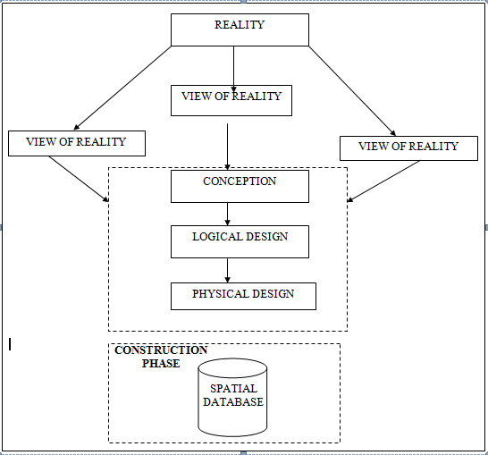

Fig.3.1Design andConstructionPhasesinSpatialDatabase

3.1.2 CONCEPTUALDESIGN

Vectordatamodelisthedatatypeadoptedforthisproject,whichisrepresented,bypoints,linesandpolygon. Theidentifiedentities are:-
      - Vegetation area (polygon)

      - Roads(line)

      - Trees(point)

      - Boundary line (polygon)

      - Buildings(polygon)
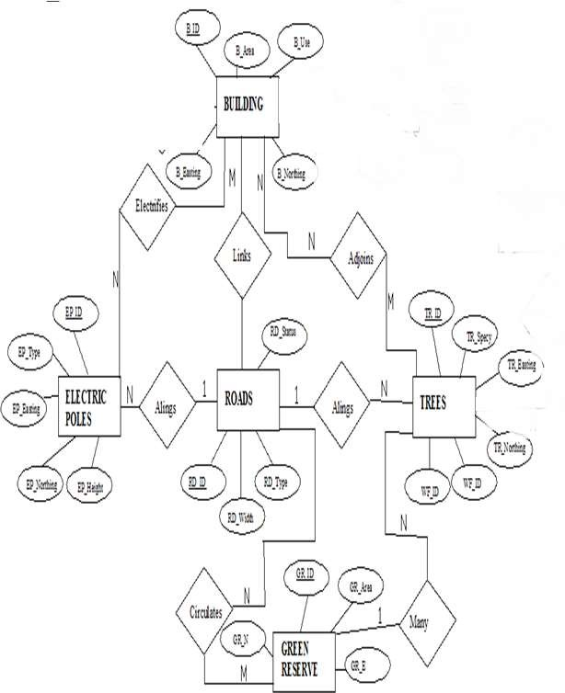

Fig.3.2.:E-RDiagram(Entityrelationship diagram)

3.1.3 LOGICALDESIGN

This is the design aspect of the database refers to the process of creating a conceptualframework or model that represents the structure and organization of spatial data within thesystem.Itinvolvesdefiningthedataelement,theirrelationship,andtherulesfordatamanipulation and analysis.In this phase, theentities, their attributes and their relationshipsare represented in a single uniform manner in form of relation in such a way that would be noinformation loss and at the same time no unnecessary duplication of data. In this study, thelogical database design is employed to generate a geo-relation database structure. Each entityhas unique identifier in bold type. An attribute type or combination of attribute types thatservesto identifyanentitytypeis termed an identifier.
- Building(B_ID,B_Area, B_Name,B_Easting,B_Northing)

- Roads(R_ID,R_Width,R_Type,R-Condition,R_Easting,R_Northing)

- Vegetation(V_ID,GR_Area,)

- Tree(TR_ID,TR_spp,TR_Importance,TR_Easting,TR_Northing)

- ElectricPole(EP_No,EP_Type,EP_Height,EP_Easting,EP_Northing)

- WaterFacility(WF_ID,WF_Depth,WF_Type,WF_Easting,WF_Northing)

- FootballPitch(FP_ID,FP_Area,FP_Status)

- Stream(S_ID,Length,Width)

3.1.4 PHYSICALDESIGN

Table3.1: Buildingand itsattribute

ENTITY | DESCRIPTION
B_ID | BuildingIdentification
B_name | BuildingName
B_Area | BuildingArea
B_Easting | BuildingEasting
B_Northing | BuildingNorthings

Table3.2:Roadanditsattributes

ENTITY | DESCRIPTION
R_ID | RoadIdentifier
R_Length | RoadLength
R_Width | Road Width
R_Type | RoadType
R_Condition | RoadCondition

Table3.3:Treesanditsattributes

ENTITY | DESCRIPTION
TR_ID | TreeIdentifier
TR_Spp | Treespecy
TR_E | Tree_Easting
TR_N | TreeNorthing

3.2 RECONNAISSANCE

Thisisthepreparatorystagebeforetheexecutionofthisproject;itinvolvescollectionofavailableinformation about theproject area.
Thenecessarysteptakenforthesuccessfulexecutionoftheprojectinvolvestwostages,whichare:-
- OfficePlanning
- Fieldreconnaissance

3.2.1 OFFICEPLANNING

This involves the collection of information about the study area, testing the instrument to beused in execution of the project and itemizing the numbers of equipment needed, number ofdays to be use, how each activity is to be carried out, delegation of works to each teammembersbased onsupervisor’sguide/instructions.

Table 3.4CoordinatesofControls

Station | Northing(m) | Easting(m) | Height(m)
KWCS 625T | 941451.040 | 674200.278 | 255.212
KWCS 623T | 941753.095 | 673845.702 | 250.532
KWCP 690 | 94I802.041 | 673810.314 | 249.087

Source:Surveyor general office Kwara

3.2.2 FIELDRECONNAISSANCE

Thefieldreconnaissanceisthefirstvisitationtotheprojectsitetogetintimatedwiththeenvironment.
- Boundarypoints was selected

- Thedistributionoffeatureswasstudied

- Controlstobeusedwerelocated

- Methodandtypeof instrumenttobe useswasdetermined

- SubsidiarypointforGroundcontrolPointswerepickedanddefineusingnailandbottlecock
- Adiagram of the studyareawas drawn.
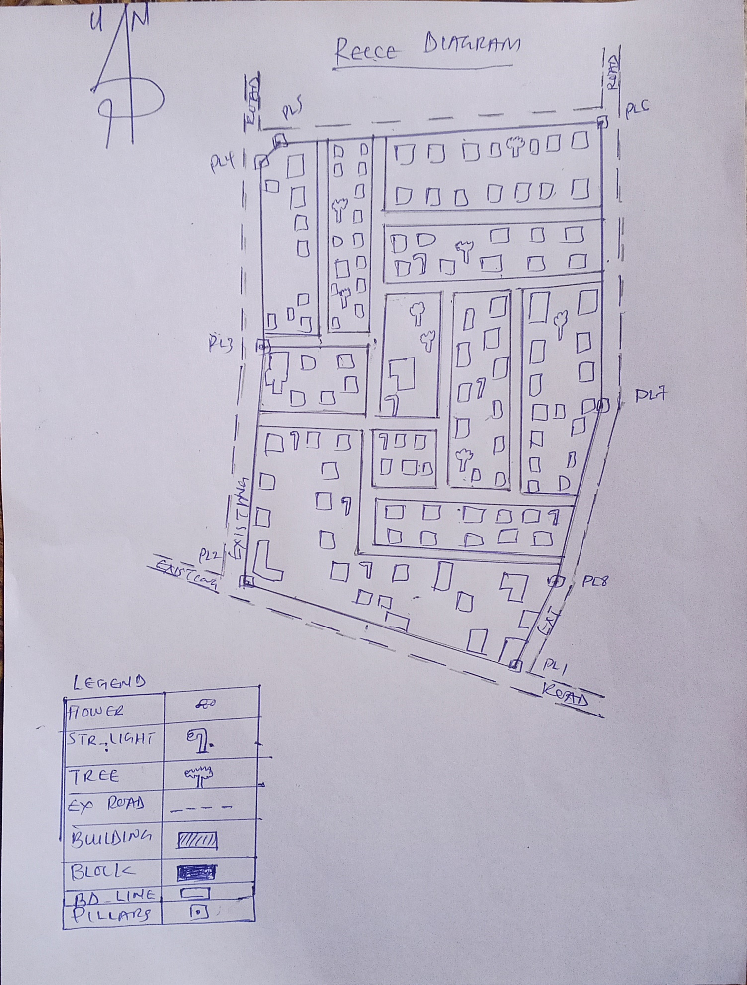

Fig.3.3: Reccediagramofthestudy area (notdrawn to scale).

3.3 EQUIPMENTUSED/SYSTEMSELECTIONANDSOFTWARE

3.3.1 HARDWAREUSED

- Totalstation

- 1reflectorwith atrackingrod.

- 1Tripod

- One(1)50m tape

- One(1)umbrella

- 1cutlass

- HandheldGPS

- Hammer

- Nailsandbottlecover

- Fieldbookandwriting materials

- 1-NoofPersonalComputerHP655 andits accessories

- 1-NoofHP Desk JetK7100 A3 printer

- 1-NoofHPDesk Jet 1110 A4printer

3.3.2 SOFTWARECOMPONENT

- Notepad.

- MicrosoftExcel.

- AutoCAD2007

- ArcGIS10.3

- MicrosoftWord.

3.4 INSTRUMENTTEST

To ensure data quality,the TotalStationused for thisprojectwastested for bothverticalindex and horizontal collimation errors.It was also to ascertain the efficiency and reliabilityofthe instrument. Theprocedureused isdescribed below.

3.4.1 HORIZONTALCOLLIMATIONTEST
This test was conducted to ensure that the line of sight was perpendicular to the trunnion axis.The Total Station was positioned over a specific point, and initial adjustments were made toensureproperalignment,leveling,andfocus(toeliminateparallaxinthetelescope). Avertical target was placed at a distance of 100 meters from the Total Station. To access theconfigurationmenuoftheTotalStation,themenukeywaspressedandheldforapproximately 2 seconds. From the main menu, the calibration sub-menu was selected, andwithin that, the horizontal collimation test option was chosen. The target was then observedand divided into two halves, with horizontal readings recorded for Face left and Face right.Thereadings areshown in Table 3.4.1 below.

TotalStation
100m
REFLECTOR(TARGET)

STATIONA
FairlyLevelGround
STATIONB

Fig3.4:HorizontalCollimation andVerticalIndexerrortest.

Table3.5:HorizontalCollimation Data

Station | Target | Face | HzReading | Difference | Error
A | B | L | 38˚42‟32”
 |  | R | 218˚42‟35” | 180˚00‟03” | 03”

3.4.2 VERTICALINDEXERRORTEST

This test was conducted to verify the accuracy of the vertical reading when the line of sight ishorizontal.Thedesiredmeasurementforthistestisexactlyninetydegrees(90˚),anydeviationfrom this valueis referred to asthevertical index error.
The Total Station was positioned over a specific point, and necessary temporary adjustmentswere made to ensure proper alignment and functionality. A target was placed approximately100 meters away fromthe TotalStation,and the instrumentwasaimedatthe target.Thetarget was bisected by aligning the instrument on the face left, and the corresponding readingwas recorded. Similarly, the target was then bisected on the face right, and the respectivereadingwasalso recorded.Therecordedreadingsareprovided below:

Table3.6:VerticalIndexData
InstrumentStation | TargetStation | Face | Vertical | Sum | Error
A | B | L | 90˚00‟00”
 |  | R | 270˚00‟02” | 360˚00‟02” | 02”

3.4.3 ANALYSISOFCOLLIMATIONANDVERTICALINDEXDATA

Thereadingobtainduringcalibrationwerereducedtoobtainnewcollimationandverticalerrors.
Horizontalcollimation={(FR–FL)–180}/2={(00˚00‟03”}/2=1.5”

Verticalcollimation={(FL+FR)–360}=(90˚00‟00”+270˚00‟02”)-360}=02”Theresult shows thattheinstrument is stillin good working condition.

3.5 CONTROLCHECK
Three control beacons (KWCS 625T, KWCS 623T and KWCP 690) were used.In order toascertain the in-situ of the control beacons, a check was carried out on them by observing theangle between them and comparing the result obtained with the computed angles from thegivingcoordinates.
The total station instrument was set on the control beacon KWCS 623T. After performing allthenecessarytemporaryadjustment,thereflectorwasplacedonthecontrolbeaconKWCS 625T which served as the back station. The horizontal angular reading was taken andrecorded while the instrument was on face left. The reflector was then taken to the controlbeacon KWCP 690 which serves as the forward station, the horizontal angle reading wasthen taken and recorded on both face left and face right. The reflector was taken back to thebackstation, the horizontal angle wasthenrecorded on face right.

Table3.7:showing thebackcomputationof thecontrolcoordinates

From STN | Bearing | Dist(m) | ∆N | ∆E | Northing(m) | Easting  (m) | ToSTN
 |  |  |  |  | 941451.040 | 674200.278 | KWCS 625T
KWCS 625T | 130°25'37'' | 465.791 | 302.055 | -354.576 | 941753.095 | 673845.702 | KWCS 623T
KWCS 623T | 149°38'02'' | 60.399 | 48.946 | -35.388 | 941802.041 | 673810.314 | KWCP 690

Table3.8: showingthedistanceobservationresultofthecontrolcheck

FROM | OBSERVED DISTANCE  (m) | COMPUTED DISTANCE  (m) | TO
KWCS 625T | 465.902 | 465.791 | KWCS 623T
KWCS 623T | 60.521 | 60.399 | KWCP 690

Table 3.9 showing theobservation resultof thecontrol check

STN | SIGHT | FACE | OBSERVEDHZANGLE | REDUCED  HZANGLE | MEAN
 | KWCS 625T | L1 | 195° 14'07''
KWCS 623T | KWCP 690 | L2 | 64° 47'29'' | 130°26'38''
 | KWCP 690 | R2 | 15° 14'13'' | 130°26'22''
 | KWCS 625T | R1 | 145° 40'35'' |  | 130°26'30''

Differenceinangle (observed -computed)=188°31'40''-188°31'36''

=00° 00'04''

Since the allowable accuracy (angular) of third order traverse of one station is 00° 00' 30'' andtheresultobtainedfromthecontrolcheck(00°00'04'')islessthanallowableerror.Therefore,thecontrols wereangularlyintact.

3.6 MONUMENTATION
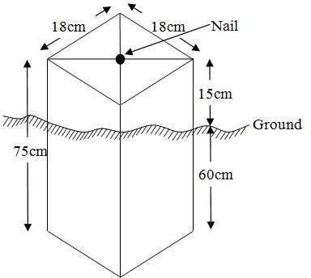
Theboundaryoftheareacarvedoutwasdemarcatedwiththeprecastconcretebeacons,afterclearingtherequiredlineofsights.Theidentifiedpointsofchangesindirections were dug and beacons were buried on it, leaving about 15cm part of the beaconabove the ground level. The beacons were buried at convenient distances as dictated by thenatureof theboundary

Fig.3.5:PillarDescription

3.7 DATAACQUISITION

PRIMARYDATASOURCE
Field observation was the primary source of data for this project. Ground based method wasused in acquiring data with the use of Total Station Instrument, which involved the collectionofX, Y, Z data through coordinated Ground control Points (GCP) established at conspicuouspoints within thestudyarea.
SECONDARYDATASOURCE
AnimageryoftheareawasacquiredthroughUpdatedGoogleearth;thiswasusedtoascertaintheextent ofcoverageof theproject area.

3.7.1 GEOMETRICDATAACQUISITION
The total station instrument was set carefully on control point KWCS 623T back sight takento KWCS 625T after necessary station adjustments has been carried out on it. Theadjustmentsincludes;centering,levelingandfocusing.Thefollowingprocedureswere then followed to determine the position of the next point KWCS 623T and the sameprocedure were repeated until all we come close to the site. The method used inacquiring data on site was radiation method where two or more points are coordinatedfromone point.
- Havingsetuptheinstrumentandtemporaryadjustmentcarriedout,theinstrument was powered „on‟ and a job wascreated under job menu in theinternalmemoryof theinstrument. Thejob createdwasnamed GRP6B
- On the job, the coordinates of the three (3) control points were keyed in to thememoryoftheinstrumentandsomecodeswerealsosaved.Thecodesinclude
- „RD‟forroad,„SP‟forspotheight,„BDforbuildings,etc.
- The height of the instrument was measured and saved on the memory of theinstrumentas wellas thereflector height.
- On coordinate menu,orientation was set by inputtingthe coordinatesof theinstrument station and back sight. The reflector at the back station was perfectlybisectedbeforetheorientationwasconfirmedbyclicking„yes‟.
- Having done the orientation, the reflector at the next nail; was bisected and „obs‟(observe)optionwasclicked.Thethreedimensionalcoordinateofthepoint(E,N, H) were displayed on the display unit of the instrument and „rec‟ (record) wasclickedtosavethedataintothememory oftheinstrument.Forsubsequentobservationafterthis,„all‟optionwasusedinsteadofpressing„obs‟andpressing
- „Record‟later.
- It was ensured that the center of the prism of the reflector was bisected and that itwassetperfectlyonthetripodinordertominimizetheerroronheightdetermination.
- The instrument is been shifted to another nail after all details, spot height andboundary point visible from the instrument station have been picked, set over itandtemporaryadjustments carried out.
- Nonetheless, the above operations were repeated until all the boundary points withheightswere coordinated.
- In this project all spot height are not in grid intervals but randomly acquired. Threeedges (3) of building were picked. At the end of data acquisition process all detailswere acquired and properly recorded to be shown in their respective positions on theplan.

3.7.2 ATTRIBUTES DATA ACQUISITION
Attributedataisinformationaboutspatialfeatures.Theyprovidethecharacteristics,description and nomenclature about spatial objects. Thus the attributes data acquired includesnames of buildings and their uses such as classrooms, roads, water facilities and prominentnatural features likes river and trees found and vegetation were properly identified within andaroundthe studyarea.

3.8 DATADOWNLOADINGANDPROCESSING

3.8.1 DATADOWNLOADINGANDEDITING
This is stage whereby all data acquired which were automatically stored in the Total Stationwere downloaded into personal computer. This was done with the aid of downloading cableconnected to the computer and some associated complementing software installed on theSystem.

3.8.2 DATAPROCESSINGANDDATAEDITING
The geometric data downloaded were further processed in order to convert it to auseful format and to enhance its accuracy. The output coordinates, were edited and exportedin *.txt, *.xls and *.pdf format. Thereafter, they were imported into Arc GIS 10.3 for furtheroperationsand to carryout spatial analysis.

3.8.3 DATAPROCESSINGUSINGARCGIS10.3

Before launching of ArcGIS AutoCAD was used in plotting of feature data saving themseparatelyin different filenamed road, boundaryline,buildings, trees andelectric poles.
- LaunchtheArc MapinArcGIS10.3
- ClickonANEWEMPTYMAPonthedialogboxdisplayedafterloading
- Clickon Toolsonthemenubar, thenselect extensions,mark alland close.
- Atthe LHS,rightclickonlayers,andthenselectproperties.
- ClickoncoordinatesystemtosettheprojectionsystemtoMINNADATUMZONE31Nand general to set theunit, then applyand okay.
- AdddatawasselectedatthetoolbarallsavedAutoCADfiewasselectedandloadontothetableof contentlayer section
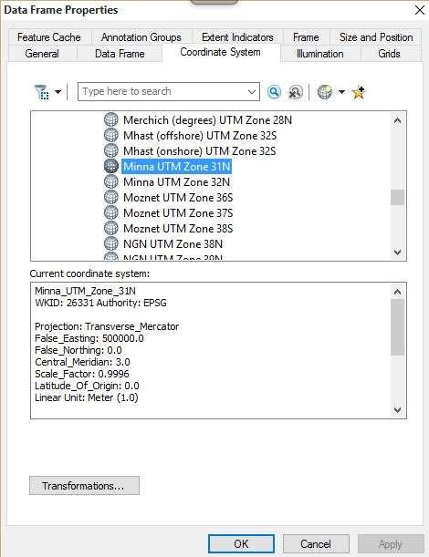

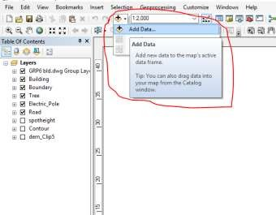
Alldrawingwasexportedtoshapefile.Afterthefeatureclasshasbeencreates,clickonEditorto start Editing, and then click on the load object.

3.8.4 Topographical Map (DEM)
CRATING CONTOUR: Firstly DEM was created by searching in the search icon INTERPOLATION> NATURAL NIGHBOR and selecting THE XYZ data for creation of DEM in respect to the boundary line as extent. In order to create contours, you will need to enable the Spatial Analyst toolbar, which can be found by going to Customize > Toolbars > Spatial Analyst or open the search bar. You can do this by clicking Windows > Search, or by clicking on the search icon.
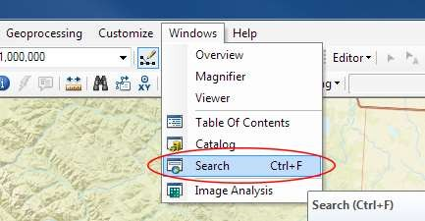

Inthesearchbartype Contour,andselect Contour(SpatialAnalyst) fromthesearchresults list

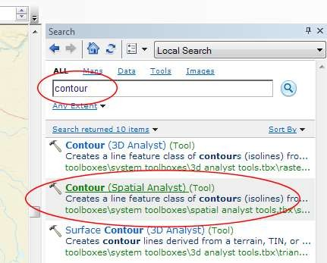

After choosing Contour, a dialogue window will appear, prompting you for five settings:Input raster: select the DEM file from which you want to generate contours by locating it onyour hard drive or in the dropdown menu, showing layers present in the Table of ContentsOutput polyline features: indicate where you want to save your output contours Contourinterval: set the distance between contour lines in meters – the smaller the number, thegreater the number of lines Base contour (optional): the starting point from which the linesare generated – for example, the default is 0 so with an interval of 25 meters, the contours aregenerated at 25, 50, 75, 100…, but ifthe base contour is set at 40, then the contours aregenerated at 65, 90, 115, 140 and so on Z factor (optional): can be used to adjust the unitsof data; for example, if you have data in meters andyou want to produce your contours infeet,useaz-factor of 3.28 because 3.28feet equals onemeter.

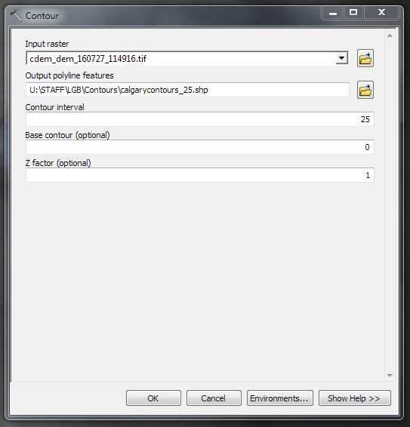

Thegeneratedcontourswill automaticallybe added tothemap.
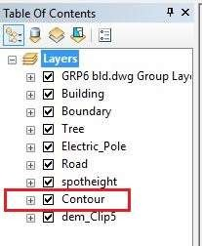

Inputthedatawhich istheAutoCADdrawingandselectthefeaturetypeyou wanttoload,

- ClickAddandNext,thenselecttheTargetlayer youwantit tobe

- LoaditintofromthefeatureclasscreatedontheARCGLS.

- ClickonNext,thenselect “onlythe featuresthat satisfythe

- Query”andclickonQueryBuildertoqueryforthefeaturetobeloude.g.“layer”=Boundary”.
- ClickonNext. Then finish

RightclickontheBoundaryInthetableofcontentandclickonzoomtolayertodisplaythefeature.

EDITING,CONVERTINGANDMERGING GEODATABASE

- Removeallnecessaryfeaturesbyrightclickingon itandpress "REMOVE"

- Convertsomefeatures that arenotin theircorrect„features-type‟likepoint, line, andpolygonfeaturesetc.
- ToconvertaGOEDATABASEFEATURECLASStoanotherthefollowingstepsweretaken:
- FORLINEFEATURECLASSTOPOLYGONFEATURECLASS
- GotoWINDOW onthe menu barandselect ARCToolbox.
- SelectDATAMANAGEMENTTOOLS,clickonFEATURES,andthenSelectFEATURETOPOLYGON.
- ONINPUTFEATURES,selectfeaturetobeconverted,onOUTPUTFEATURECLASS,then saveon theGRP6CFOLDER, pressOKand CLOSE.
- ThenremovetheconvertedfeatureclassintheLAYERMenuandARCCATALOGfiles.
- OnINPUTDATASETS,selectfeaturestobemerged,onOUTPUTDATASETS,thensaveon the GRP6C folder, pressOKand CLOSE.
- ThenremovetheconvertedfeatureclassintheLAYERMenuandARCCATALOGfiles.

ADDINGSPOTHEIGHTSDATA
- NOTE:STOPEDITINGontheEDITORMENU before addingdatafield,
- GotoFIELD ONTHE MENUBAR,scrolltoaddDataandthenADDXYZDATA
- BrowsetheEXCELFILEforSPOTHEIGHTS,selectEASTINGVALUEonX-FIELD andNORTHINGVALUEon Y-IELD andELEVATION
- « Select DATA the EXPORT DATA, locate the folder created and give it name thenYESANDOK,removethepreviouslayerbyrightclickingonitandselectREMOVE.

TIN,ASPECTANDSLOPECREATIONUSINGARCMAP
NOTE:Makingsurethe3DAnalystExtensionisactive,selectVIEWonMENUbar,thenclickTOOLBARS andMARK the3DAnalyst EXTENTION Then X,YData
TOCREATE TIN
- Clickon3DAnalystarrow,selectcreateTINandthencreateTIN fromFEATURE.
- OnlayersmarktheSPOTHEIGHT LAYER,selectheightdataonHEIGHT,thenok.

TOCHANGETHEFACEOF THETINACCODINGTOITSELEVATION
- RIGHTCLICKontheTIN,selectPROPERTIES,andclickonSYMBOLOGY.
- Then ADD, select FACE ELEVATION WITH COLOR RAMP, click ADD, and thenselectAPPLYand OK.

TOCREATE ASPECT
- Click on 3D analyst arrow, select SPATIAL ANALYST TOOLS, SURFACE andTHENDOUBLE CLICKon ASPECT.
- Browse to where the raster format of all the acquired data created from the surfer wassavedto.
- BrowsetowhereyouwanttheOUTPUTRASTERtobesaved
- Youcanchangethe OUTPUTMEASUREMENTtoDegree ORpercent
- ClickOK[then itdisplays onthedata viewscreen], thenClose.

3.8.5 Facility Map Production
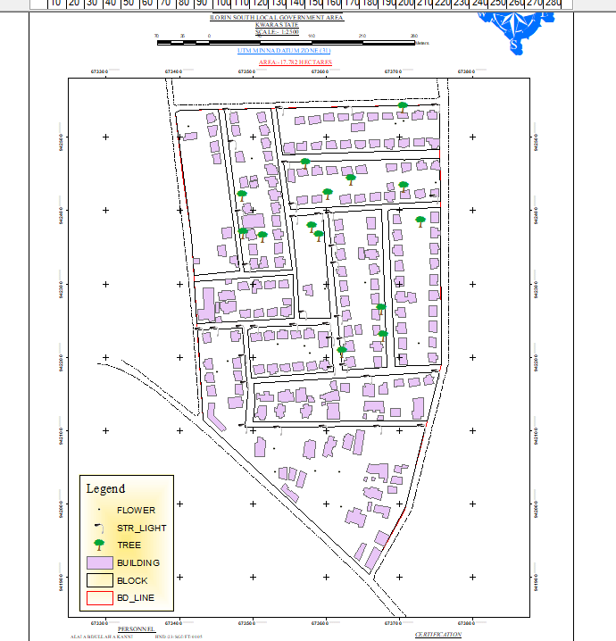
The buildings were digitized from the downloaded Google earth image using ArcGIS 10.2.1. Shape files for the facilities were created in Arc Catalogue. The created shape files were added to Arc Map and editor was started to digitize out to facilities. The road network, buildings are extracted using polyline and polygon respectively while street lights and trees are represented by point data for 3D map production the generated 2D map is shown in Figure 3.6, Figure 3.7 shows the old 2D CAD map of the campus.

Figure 3.6 showing the 2D facility map of the study area.

3.8.6 3D Map Production
The 3D image was done Arc Scene using the created DEM; the created DEM was added to Arc Scene and extruded with the heights gotten on the field. Extrusion incorporates the height of these features in their representation to give them 3D look and was made to float on DEM to have a true land representation.
The created DEM was also added to Arc Scene, The height of the buildings gotten from the field was added to the already created height field in the attribute table of each of the facility shape file in Arc Map. Arc Scene was launched and all the shape files were added, from the table of content each shape file was right clicked on to access the property dialog box, from the property dialog box the shape files were extruded to give them 3D look and were made to float on the DEM to have a full 3D visualization.

3.8.7 Findings
This study has demonstrated a capability of GIS in facility mapping with different visualizations techniques i.e. 2D and 3D visualization, Figure 3.6 shows the generated 2D map while Figure 4(a) and Figure 4(b) show cross-sections of the generated 3D map of the campus. All the facilities were geo-located with the aid of total station and imported into ArcGIS 10.2, the facilities were also digitized from the Google earth image downloaded for the study area. 3D topographic maps of the study areas were created from the point data gotten from field-work and also from the downloaded SRTM DEM image downloaded from USGS, Figure 5 shows the 2D Topographic map generated from the point data gotten from the field using Total station while Figure 6 shows the 3D topographic map generated using the same data source. Figure 7 shows the 2D topographic map generated from SRTM 30 m while Figure 8 shows the 3D topographic map generated using the same data source. The 2D facility map was produced by digitizing all the facilities out as features from the Google earth image downloaded using Google downloader. The 3D model of the campus was produced by exporting all the features created in Arc Map to Arc Scene for extrusion; the extruded features were made to float on the 3D topography map created through interpolation using Kriging method. The 3D visualization gives the study area a near real life view.
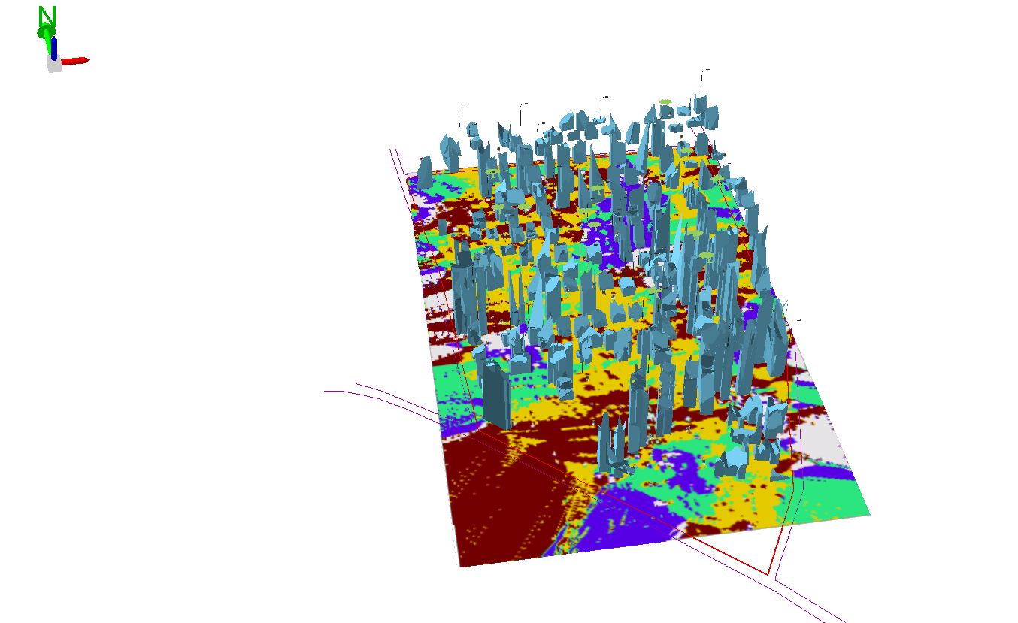

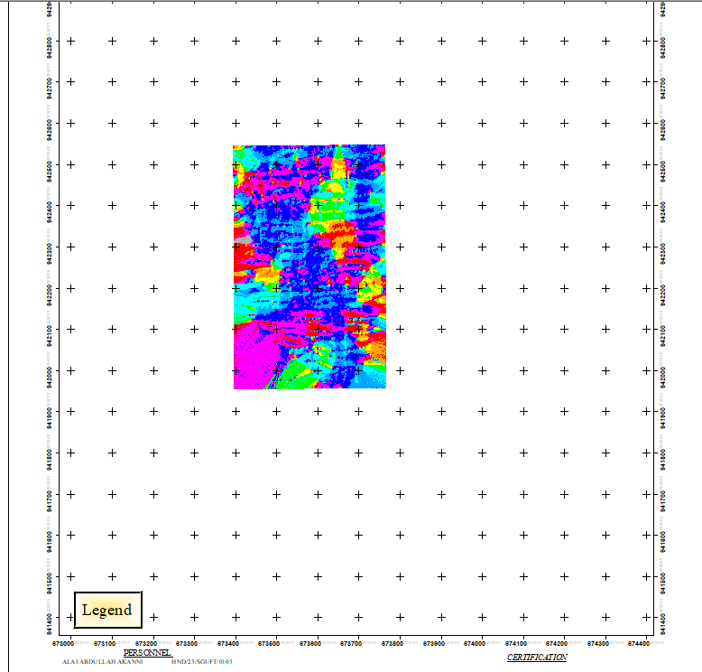
Figure 3.7 (a) Showing 3D model of the study area area

Figure 3.8 showing the 2D DEM (Digital elevation model) of the study area (derived from the field data).

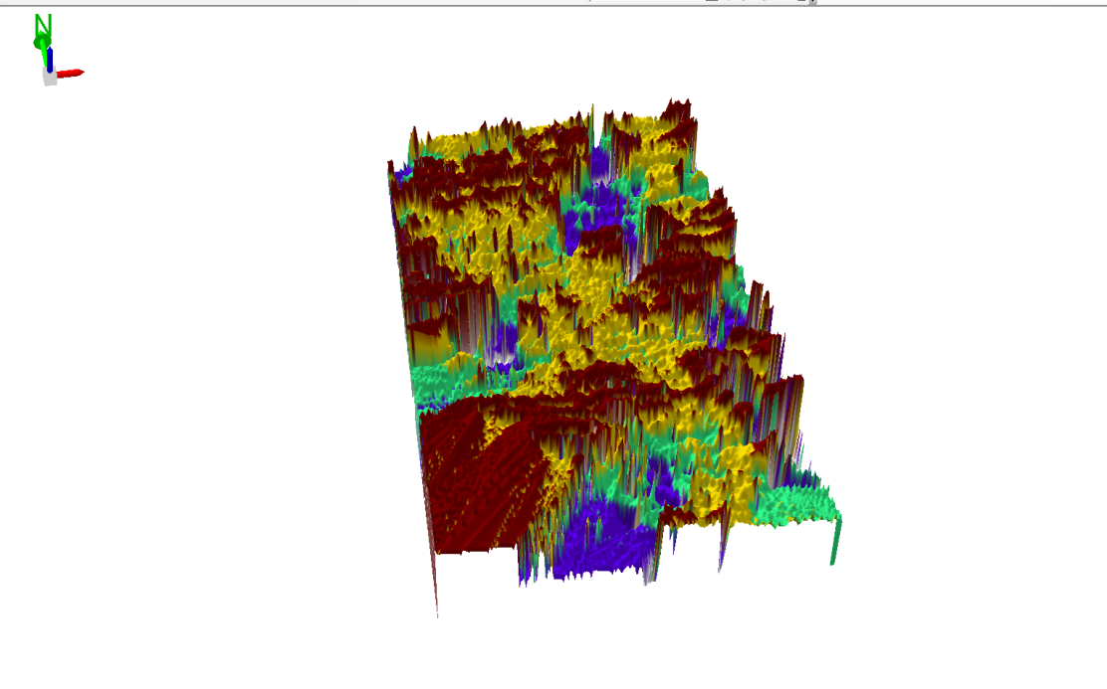

Figure 3.9 Showing 3D DEM (Digital Elevation Model) of the study area (derived from the field data).

3.8.8 Attribute data creation
There is need to create attribute tables for the features so as to be used for queries.NOTE: The editor on the menu bar must be stopped before adding field to its table.THEFOLLOWING PROCEDURES WERE FOLLOWED:
- Rightclickonthefeatureclass,thenselectOPENATTRIBUTESTABLEclickonOPTIONSand select ADD FIELD.
- GiveitFIELDNAME,clickonTYPEandselect[SHORTINTEGERorLONGINTEGERforSHORTorLONGWHOLEVARIABLESorDOUBLEFORDECIMALVARIABLESORTEXTvariableorDATEforDATE],thenenterprecision or LENGTH for text width and scale for DECIMAL PLACES, and thenclickOK
- To input variables on the ATTRIBUTE TABLE, go to the EDITOR on Menu bar,selectSTART EDITING,
- Click on ATTRIBUTE on menu bar [behind the TARGET], click on the features onthe DATA VIEW display,and then input the variables of data acquired throughSOCIALSURVEYor DATAACQUIRED ON THEFIELD.
- Save it after the input by selecting SAVE EDITS on the editor menu. To switch toother layers, select STOP EDITING on the EDITOR menu. Then repeatthe abovestepto createotherfields. Populatethe table and save.

Table3.10: Building

ENTITY | FIELDALIAS | DATATYPE | FIELDSIZE
B_ID | BuildingIdentification | Numeric | -
B_name | BuildingName | Text | 10
B_Area | BuildingArea | Numeric | -
B_E | BuildingEasting | Numeric | -
B_Northing | BuildingNorthings | Numeric | -

Table3.11:Road

ENTITY | FIELDALIAS | DATATYPE | FIELDSIZE
R_ID | RoadIdentifier | Numeric | -
R_Length | RoadLength | Numeric | -
R_Width | Road Width | Numeric | -
R_Type | RoadType | Text | 10
R_Condition | RoadCondition | Text | 10

Table3.12:Trees

ENTITY | FIELDALIAS | DATATYPE | FIELDSIZE
TR_ID | TreeIdentifier | Numeric | -
TR_Spp | Treespecy | Text | 10
TR_E | Tree_Easting | Numeric | -
TR_N | TreeNorthing | Numeric | -

Table3.13:ElectricPoles

ENTITY | FIELDALIAS | DATATYPE | FIELDSIZE
EP_ID | ElectricpoleIdentifier | Numeric | -
EP_Type | ElectricpoleType | Text | 10
EP_Height | ElectricpoleHeight | Numeric | -
EP_E | ElectricpoleEasting | Numeric | -
EP_N | ElectricpoleNorthing | Numeric | -

3.8.9 DATABASEIMPLEMENTATION
This is the database creation phase. Having completed the three stages of design phase (i.e.Reality,ConceptualandLogicaldesign),thedatabasewascreatedusingArcGIS10.3software. It involves the combination and storage of acquired graphic data and attributes dataincreating the database forthe purposeofspatial analysisand query.
Database is an organized integrated collection of data stored so as to be capable of use byrevenant application with data being accessed by different logical part. After the Attributetable was populated via the keyboard, some attributes such as areas of settlements wereautomaticallydisplayedbyspecialcommandintheArcGIS10.3version.TheArcGISsoftwarewas used to linkthe graphic dataandtableforquerygeneration.

3.8.10 DATABASEMANAGEMENTSYSTEMS

Databasemanagementisacollectionofsoftwareforcreating,storing,manipulating,updating, organizing and querying of information in a database (Kufoniyi, 1998). It is asoftwarepackagewhose function is tomanipulate adatabaseon behalfoftheuser.
Agood DBMS must provide the following functions:

      - Storageandretrievalofdata.

      - Accessto byseveral users at atime.

      - Astandardizedinterfacebetweendatabaseandapplicationprogrammed.
      - Standardized access to data and separation of data storage and retrieval functions fromtheprogram using the data.
      - Maintenanceof datasecurityandintegrity.

3.8.11 DATABASEMAINTENANCE

Havingcreatedthedatabase,propermaintenancepracticewasmadetomeetitsstatedobjectives.Theabilitytoincludemoredataandremoveirrelevantdatawaspossiblebywayof maintenance. There is every need for the data to be updated regularly because of thephysical changes that may occur on the landscape with time. Both security and integrity werealsoexercised to ensure maintenanceand to meetits stated objectives.
Proper observance, updating and management of database ensure its currency and quality tostand a profound chance in Spatial Decision Support System (SDSS). The quality of anydatabase depends on the currency and fitness for use as a decision support system (SDSS).The quality of database depends on its ability to generally fit and use as a decision system(DSS). The storage media should be from time to time justified if otherwise could necessitatedata inaccessibility or physical deterioration of the storage media.Also care must be takenduring populating any database system, as a database is only good as the data supplied. Inarchivingstable media should be used. Examplesoftheseare:-
- Computercompatibletapereader
- Magnetictape
- Opticaldiscandcompactdisc

3.8.12 AREA COMPUTATIONTable
Table3.14: shows area computation
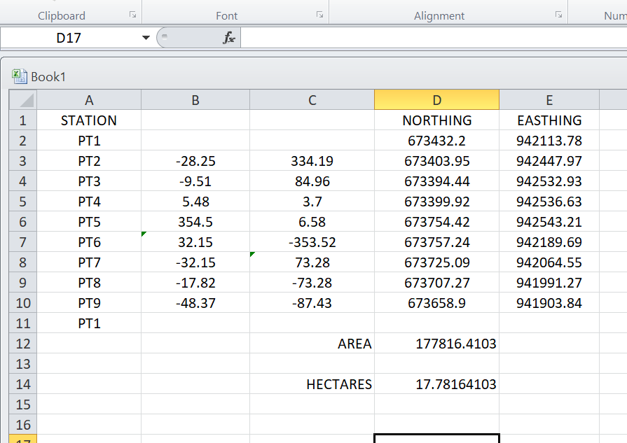

CHAPTERFOUR

4.0 SPATIAL ANALYSES AND PRESENTATION

GIS is distinct among other information system because of its spatial analytical capability;especiallyoverlayoperation,buffering,spatialsearch,topographicoperation,andneighborhoodandconnectivityoperations.GISusesthisspatialanalyticalcapabilitytoanswerfundamentalgenericquestionoflocation,condition,trend,routing,patternandmodeling by the manipulation and analysis of input data. The major analyses performed inthisproject wereoverlayoperations, topographic operations andspatial search.

4.1 TESTINGOF DATABASE

This is the test carried out to determine whether there exists a relationship between datamodeledaboutentitiesinaspatialdatabaseaswellasputtingintotestitsretrievalcapabilities. This was done by designinga sample query with certain conditions attached andthequerywill beran to seeif desired result is achieved.

4.11 ANALYSIS OF RESULT

The contour whose value is greater or equal to350 meters depicts the likelihood that sucharea may not be prone to flood in the project area as shown in Fig. 4.5(Query 1). Thisrepresents the elevation of points that are greater than to 350m. The displayed attribute tableconfirmedthatNorth-Eastpartoftheinstitutehadthehighestelevation.Heightisanimportant factor when considering the surface or slope of the terrain. The South-west part oftheschoolhadthelowestelevationwhichisverypronetoerosion.Buildingsthatwillbesited in that region must have a very high foundation above the ground level. The result of thequerywillaffordtheschoolmanagementtodecideconciselytheterraincharacteristicsandthe kind of building that should build in every region of the project area looking critically attheterrain of thearea.

SINGLESELECTIONCRITERION

Query1:shows the completed building

SELECT* FROM Building WHERE "BLD_STATUS" LIKE COMPLETED
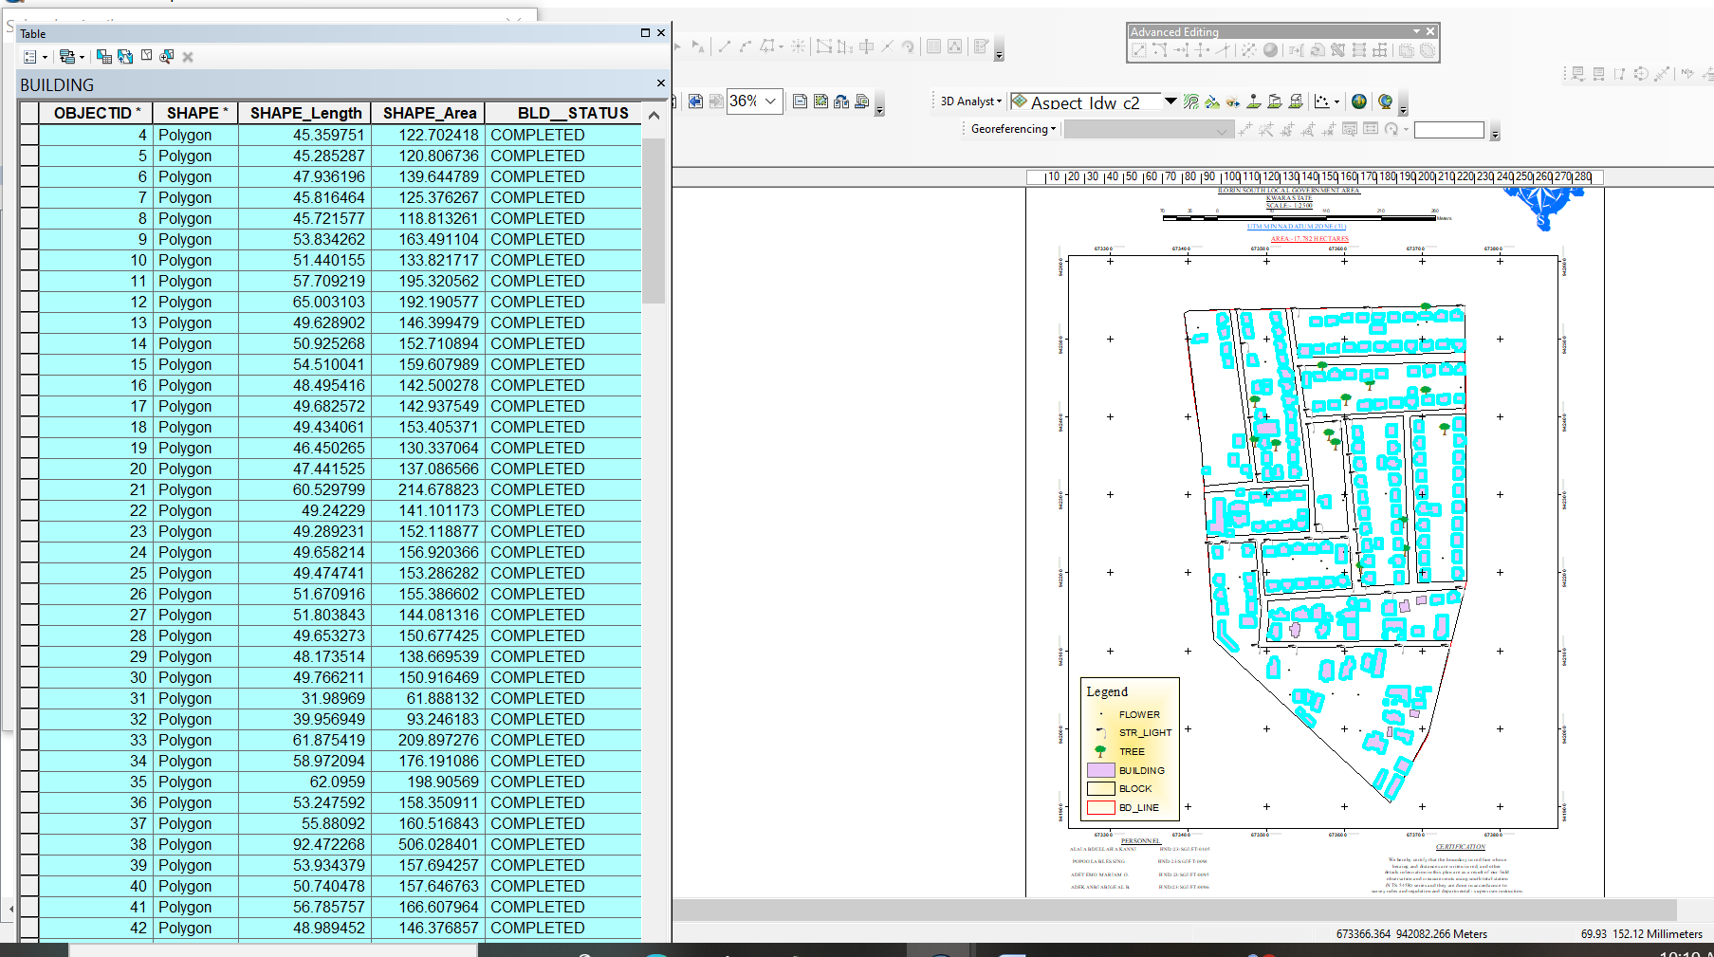

Fig4.1:shows the completed building
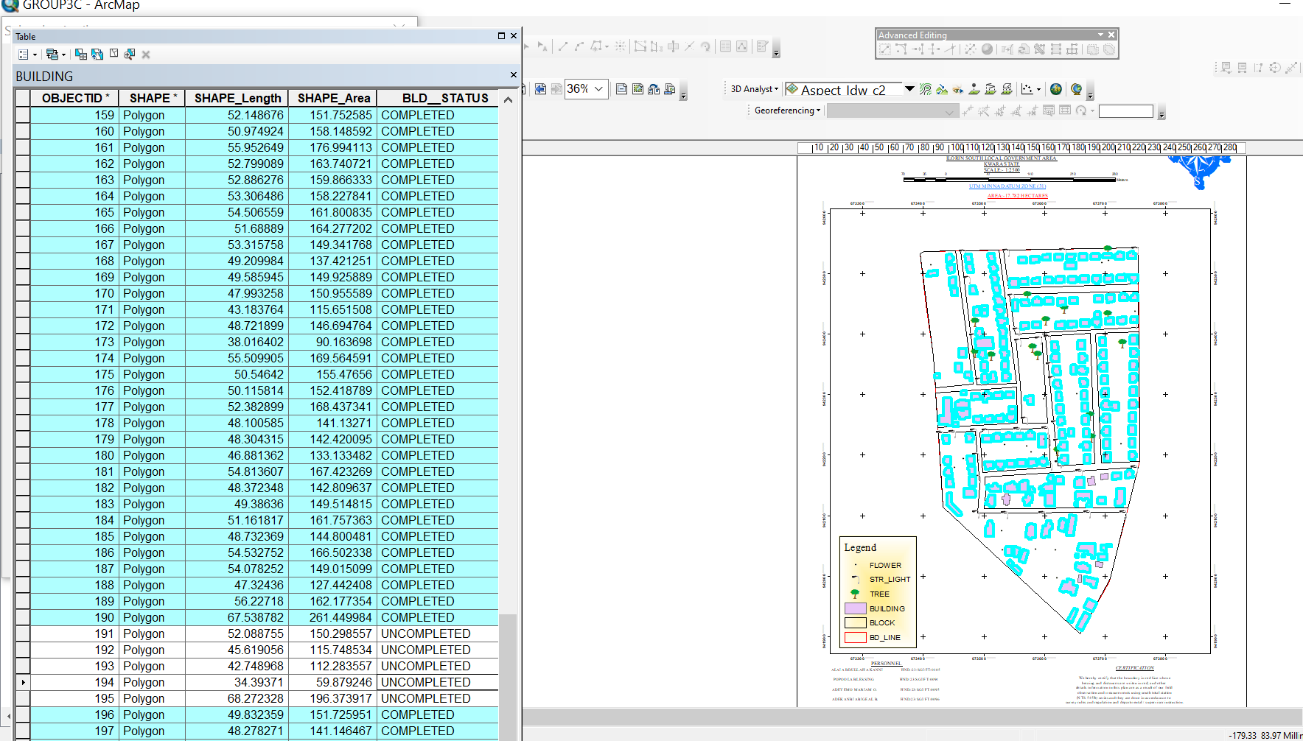

Fig4.2:shows the 2D completed building
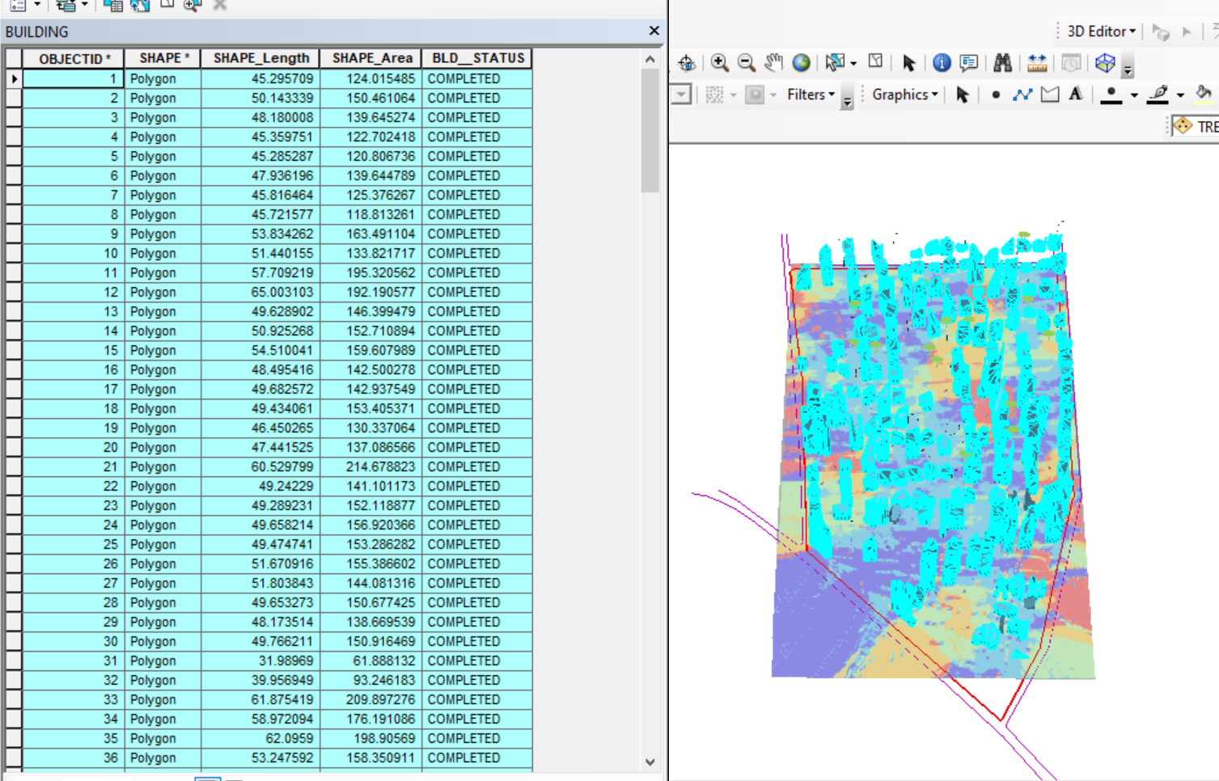

Figure 4.3 shows the 3D of completed building
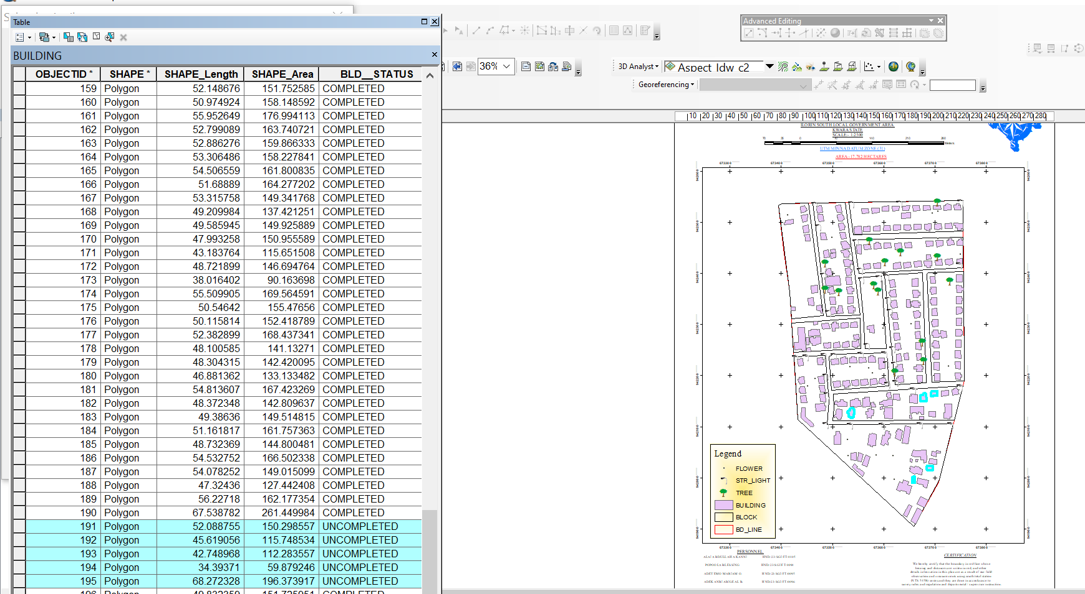

Fig4.4Queryshows the 2D of uncompleted building

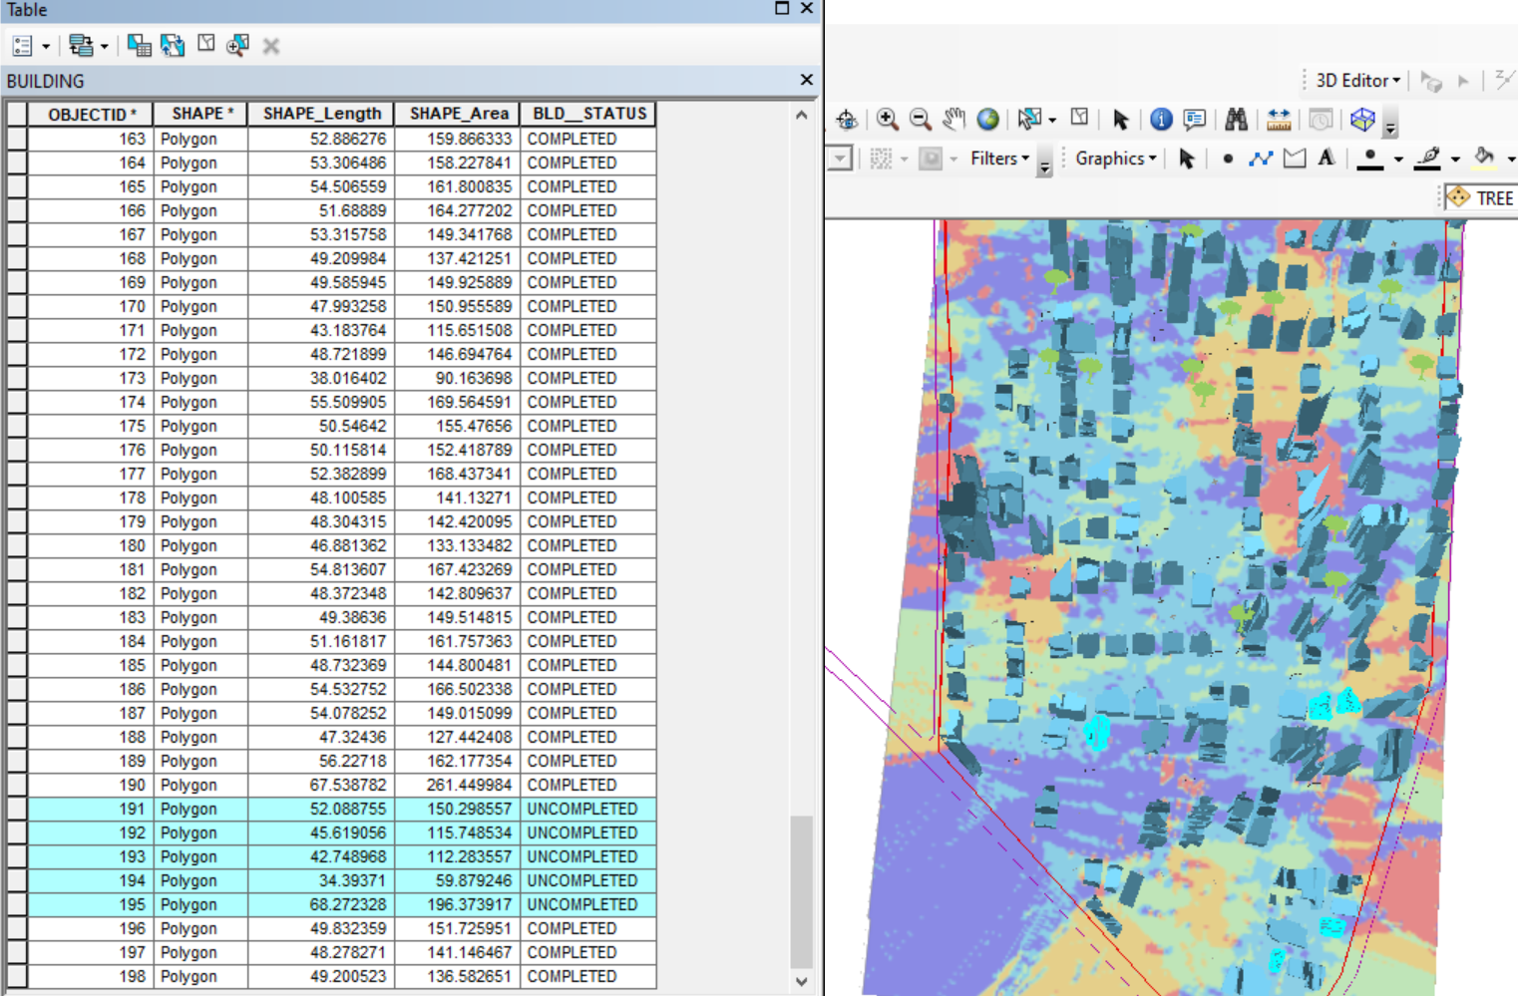

Figure 4.5 shows the 3D of uncomplted building

CHAPTER FIVE
5.0 Costing Estimation, Summary, Conclusion, Recommendation and Problem Encountered
5.1 Costing Estimation
RECCONNAISSANCE
S/N | PERSONNEL | QTY | DAILY RATE | NO OF DAYS | REMARK
1 | Group leader | 1 | 5000 | 1 | 5000
2 | Ass group leader | 1 | 2500 | 1 | 2500
3 | Basic equipment | 1 | 25000 | 1 | 25000
4 | Transportation | 1 | 3000 | 1 | 3000
Subtotal = #35,500

Monumentation
S/N | PERSONNEL | QTY | DAILY RATE | NO OF DAYS | REMARK
1 | Group leader | 1 | 5000 | 1 | 5000
2 | Ass group leader | 1 | 2500 | 1 | 2500
3 | Skilled labor | 3 | 1500 | 1 | 4500
4 | Basic equipment | 1 | 25000 | 1 | 25000
5 | Transportation | 1 | 7500 | 1 | 3000
Subtotal = #40,000
Beaconing
S/N | PERSONNEL | QTY | DAILY RATE | NO OF DAYS | REMARK
1 | Group leader | 1 | 5000 | 1 | 5000
2 | Ass group leader | 1 | 2500 | 1 | 2500
3 | Basic equipment | 1 | 5000 | 1 | 5000
4 | Transportation | 1 | 3000 | 1 | 3000
Subtotal = #5,500

Beacon
S/N | PERSONNEL | QTY | DAILY RATE | NO OF DAYS | REMARK
1 | Group leader | 1 | 5000 | 1 | 5000
2 | Ass group leader | 1 | 2500 | 1 | 2500
3 | Beacon | 10 | 1000 | 1 | 10,000
4 | Transportation | 1 | 3000 | 1 | 3000
Subtotal = #19,500

Traversing
S/N | PERSONNEL | QTY | DAILY RATE | NO OF DAYS | REMARK
1 | Supervisor | 1 | 6000 | 1 | 6000
2 | Group leader | 1 | 5000 | 1 | 5000
3 | Ass group leader | 1 | 2500 | 1 | 2500
4 | Skilled labour | 6 | 1500 | 1 | 10,000
5 | Basic equipment | 1 | 25000 | 1 | 5000
6 | Transportation | 1 | 10,500 | 1 | 10,500
Subtotal = #43,500

Spot Height
S/N | PERSONNEL | QTY | DAILY RATE | NO OF DAYS | REMARK
1 | Supervisor | 1 | 6000 | 2 | 12,000
2 | Group leader | 1 | 5000 | 2 | 10,000
3 | Ass group leader | 1 | 2500 | 2 | 5000
4 | Skilled labor | 6 | 1500 | 2 | 20,000
5 | Basic equipment | 1 | 25000 | 1 | 5000
6 | Transportation | 1 | 10,500 | 2 | 21,000
Subtotal = #73,000
Data processing
S/N | PERSONNEL | QTY | DAILY RATE | NO OF DAYS | REMARK
1 | Group leader | 1 | 5000 | 1 | 5000
2 | Ass group leader | 1 | 2500 | 1 | 2500
3 | Basic equipment | 1 | 10,000 | 1 | 10,000
4 | Generator and fuel | 1 | 10,000 | 1 | 10,000
Subtotal = #27,500

Technical report
S/N | PERSONNEL | QTY | DAILY RATE | NO OF DAYS | REMARK
1 | Group leader | 1 | 5000 | 1 | 5000
2 | Ass group leader | 1 | 2500 | 1 | 2500
3 | Basic equipment | 1 | 10,000 | 1 | 10,000
4 | Generator and fuel | 1 | 10,000 | 1 | 10,000
Subtotal = #27,500
Sum total = 271,500.00

Contingency allowance = 271,500.00 X 5 = 13,575
100

VAT = 271,500.00 X 7.5 = 20,362.5
100

ACCOMODATION = 271,500.00 X 1.5 = 4,072.5
100
MOB/DEMB = 271,500.00 X 10 = 27,150
GLEARANCE TAX =65,159.5
5.2 Summary
This project focused on the digital mapping of the Federal Royal Valley Estate located in the Sango Kulende area of Ilorin, Kwara State. The survey was executed in compliance with third-order specifications. A thorough reconnaissance both office and field-based was conducted to facilitate effective planning and execution. This included identifying suitable control points for orientation, selecting appropriate instruments, and preparing a preliminary sketch of the survey area.
The scope of the project encompassed traversing, perimeter survey, leveling, detailing, and the acquisition of spot heights, with the Total Station serving as the primary surveying instrument. Traversing was employed to determine the coordinates (Northings and Eastings) of survey stations, while the elevation data for these stations were derived from perimeter leveling. Tachometric methods were applied to determine the positions of new points.
Subsequent data processing was carried out, and the final plan was produced in both manual and digital formats. The resulting title plan clearly delineated the perimeter and detailed features of the entire project area. A comprehensive technical report was also prepared, documenting the methodology, execution, and outcomes of the project.
5.3 Conclusion
The literature establishes a strong theoretical and practical foundation for the use of digital mapping in infrastructural development. Geospatial technologies have proven benefits in enhancing planning, monitoring, and equitable service delivery. However, barriers related to cost, capacity, governance, and data quality persist, particularly in developing contexts. These gaps provide justification for further research aimed at exploring localized applications, evaluating the effectiveness of digital mapping, and developing strategies for broader adoption.
5.4 Recommendations
Having actively participated in this practical project and gained valuable hands-on experience, I hereby offer the following recommendations based on the outcomes and products generated:

1. Utilization of the Survey Plan:
The government is encouraged to utilize the produced plan for effective decision-making concerning the premises. It is also recommended that the school premises be properly fenced, as it is bordered by multiple roads, which may pose safety and security concerns.
2. Improved Resource Management:
Adequate supervision and maintenance should be provided for existing facilities such as the borehole, furniture (chairs and tables), and staff welfare, to ensure their continued functionality and longevity.
3. Integration of Computer Programming:
The application of computer programming tools in data processing should be fully adopted. This will enhance the efficiency and speed with which students handle survey data and improve the overall learning experience.

4. Accessibility of Project Outputs:
The outputs of this project, including the final plans and report, should be made available for future reference and review, particularly for academic and administrative purposes.
5.5 Problems Encountered
Several challenges were encountered during the course of the fieldwork, many of which were unavoidable. One major issue was the constant movement of vehicles and the presence of students within the project area, which caused interruptions and made it difficult to maintain consistent measurements during surveying operations.
Additionally, the Total Station experienced intermittent battery issues, with the battery frequently running low. This led to delays and increased stress, as it required sourcing and replacing batteries more often than anticipated, thereby affecting the workflow and overall efficiency of the project..

References
H Xia, Z Liu, M Efremochkina, X Liu, C Lin - Sustainable Cities and Society, 2022 - Elsevier
W Li, M Batty, MF Goodchild - International Journal of …, 2020 - Taylor & Francis
B Veenendaal, MA Brovelli, S Li - ISPRS International Journal of Geo …, 2017 - mdpi.com
A Chakraborty, B Wilson, S Sarraf, A Jana - Journal of Urban Management, 2015 - Elsevier
Eruteya E. O. (2009): basic principles in surveying handout
A Degbelo, C Granell, S Trilles, D Bhattacharya… - … International Journal of …, 2016 - mdpi.com

ID | EASTINGS | NORTHINGS
B1 | 666472 | 937402.5
B2 | 666484.9 | 937400.9
B3 | 666483.2 | 937390.2
B4 | 666470 | 937391.8
B5 | 666488.5 | 937412
B6 | 666516 | 937406.7
B7 | 666514.7 | 937395
B8 | 666486.5 | 937399.9
B9 | 666493.4 | 937431.3
B10 | 666505.4 | 937428.8
B11 | 666501.4 | 937411.7
B12 | 666489 | 937414.4
B13 | 666502.4 | 937464.7
B14 | 666512.1 | 937462.9
B15 | 666505.4 | 937428.8
B16 | 666495.4 | 937431.5
B17 | 666496.1 | 937473.4
B18 | 666501.2 | 937472.2
B19 | 666499.9 | 937465.1
B20 | 666494.2 | 937467
B21 | 666502.1 | 937480.3
B22 | 666555 | 937468.8
B23 | 666553.3 | 937459.1
B24 | 666501 | 937470.5
B25 | 666556 | 937468.2
B26 | 666563.7 | 937466.8
B27 | 666560.9 | 937455.8
B28 | 666553.1 | 937457.4
B29 | 666536.1 | 937394
B30 | 666550.7 | 937457.5
B31 | 666563.2 | 937454.9
B32 | 666548.6 | 937390.6
B33 | 666520.1 | 937405.8
B34 | 666536.3 | 937403.6
B35 | 666534.7 | 937393.3
B36 | 666516.3 | 937395.6
B37 | 666516.6 | 937401.6
B38 | 666519.4 | 937401.4
B39 | 666512.5 | 937495.1
B40 | 666559 | 937484.2
B41 | 666556.4 | 937472
B42 | 666509.4 | 937484.4
B43 | 666508.3 | 937512.3
B44 | 666546 | 937503.8
B45 | 666541.7 | 937489.7
B46 | 666505.1 | 937499.1
B47 | 666512.5 | 937530.7
B48 | 666550.1 | 937522.3
B49 | 666546 | 937506.4
B50 | 666508.8 | 937514.8
B51 | 666552.2 | 937521.6
B52 | 666564 | 937518.3
B53 | 666556.3 | 937489.5
B54 | 666545.2 | 937493.2
B55 | 666566.8 | 937517.6
B56 | 666577.2 | 937515
B57 | 666569.7 | 937485.5
B58 | 666559.1 | 937489.6
B59 | 666574.3 | 937526
B60 | 666604 | 937520
B61 | 666601.9 | 937508.7
B62 | 666572.4 | 937516.2
B63 | 666612.9 | 937520.2
B64 | 666617.9 | 937519.7
B65 | 666617.2 | 937510.3
B66 | 666611.8 | 937511.1
B67 | 666612.3 | 937503
B68 | 666617 | 937502.6
B69 | 666615.9 | 937491.5
B70 | 666611.5 | 937492
B71 | 666470.8 | 937486.2
B72 | 666474.4 | 937486.1
B73 | 666474.1 | 937481.5
B74 | 666470.7 | 937481.7
B75 | 666473.3 | 937500.4
B76 | 666476.9 | 937500.3
B77 | 666476.9 | 937497.6
B78 | 666473 | 937497.8
B79 | 666472.1 | 937517.6
B80 | 666476.4 | 937517.2
B81 | 666475.8 | 937510.8
B82 | 666471.9 | 937511.4
B83 | 666472.7 | 937535
B84 | 666478.9 | 937534.7
B85 | 666478.1 | 937526.2
B86 | 666472.2 | 937526.3
B87 | 666479.4 | 937539.6
B88 | 666485.9 | 937539.1
B89 | 666485.9 | 937535.6
B90 | 666479.2 | 937536.3
B91 | 666495 | 937536.2
B92 | 666508 | 937534
B93 | 666505.6 | 937519.6
B94 | 666492.6 | 937522.1
PL1 | 666472.2 | 937540.7
PL2 | 666618.3 | 937521.3
PL3 | 666607.4 | 937371.4
PL4 | 666468.4 | 937392
RD 1 | 666651 | 937536.1
RD2 | 666470.5 | 937557.3
RD3 | 666469.8 | 937584.6
RD 4 | 666651.8 | 937521.6
RD 5 | 666469.2 | 937545.7
RD 6 | 666463.1 | 937332.5
RD 7 | 666445.1 | 937341.2
RD 8 | 666452.1 | 937584.6
RD 9 | 666464.5 | 937381.6
RD 10 | 666609.9 | 937359.6
RD 11 | 666464.5 | 937381.6
RD 12 | 666609.9 | 937359.6
RD 13 | 666624.2 | 937525.6
RD 14 | 666608.8 | 937346.4
RD 15 | 666637.5 | 937523.5
RD 16 | 666619.4 | 937345.5

