CHAPTER ONE

INTRODUCTION

1.1 Genral Background of the Study
The increasing demand for renewable energy sources, particularly solar energy, has led to a significant growth in the adoption of solar power systems worldwide. Solar energy is abundant, clean, and sustainable, making it an attractive alternative to fossil fuels. However, despite its benefits, the efficiency and reliability of solar energy systems remain limited due to poor real-time monitoring, ineffective energy storage management, and lack of integration with smart technologies.
Traditional solar energy systems often lack intelligent features that allow for automated performance tracking and fault detection. These limitations result in energy losses, reduced lifespan of components, and inefficiencies in system operation. To overcome these challenges, the integration of the Internet of Things (IoT) into solar energy systems has emerged as a viable solution. IoT-enabled systems facilitate real-time monitoring, data analytics, and remote control, enhancing both the performance and maintainability of solar setups.
This project focuses on the development of an efficient IoT-based smart solar energy monitoring system. The system is designed to monitor key parameters such as voltage, current, temperature, and battery status using sensors connected to an ESP8266 microcontroller. A Battery Management System (BMS) is incorporated to ensure the safe operation of the lithium-ion battery used for energy storage. Data from the sensors are transmitted to the cloud and visualized through the Blynk mobile application, allowing users to remotely monitor and manage the solar system in real time.

The integration of these technologies offers a comprehensive solution to enhance the performance and reliability of solar energy systems, ensuring better grid integration and smarter energy utilization.

1.2 Statement of the Problem
The inefficiency of conventional solar energy systems is largely due to the absence of real-time monitoring and intelligent control mechanisms. In most cases, users are unaware of the operational status of the system, the health of the battery, and the amount of energy being generated or consumed. Additionally, manual inspection and maintenance of solar systems can be time-consuming, costly, and prone to error.
Poor battery management can lead to overcharging or over-discharging, which reduces the lifespan of the battery and may pose safety risks. Furthermore, the lack of integration with cloud-based platforms limits users’ ability to make informed decisions regarding energy consumption and system performance.
Therefore, there is a need to develop a smart solar monitoring system that incorporates IoT technologies to provide real-time data visualization, remote control, and intelligent battery management, ultimately enhancing performance, safety, and user engagement.

1.3 Aim and Objectives
The aim of the research is to design and implement an efficient IoT-based smart solar energy monitoring system for enhanced performance and grid integration.
The specific objectives of this study are to:
- Design a solar energy monitoring system incorporating the ESP8266 microcontroller and IoT technology.
- Integrate voltage, current, and temperature sensors to monitor system performance in real time.
- Employ a Battery Management System (BMS) to enhance the safety and efficiency of the lithium-ion battery.
- Develop a mobile-based interface using the Blynk application for real-time data visualization and system control.
- Test and evaluate the performance of the developed system under varying operating conditions.

1.4 Significance of the Study
This project is expected to offer the following benefits:
- Real-Time Monitoring: Users will be able to access real-time data on solar panel output, battery status, and environmental conditions from any location using the Blynk app.
- Improved Battery Management: The incorporation of a BMS will ensure optimal performance and extended lifespan of the lithium-ion battery by preventing overcharging and over-discharging.
- Enhanced System Performance: Through intelligent monitoring and automated alerts, faults and inefficiencies can be identified and resolved promptly.
- Remote Accessibility: The use of Wi-Fi and cloud-based platforms enables remote access and control of the system, improving convenience and flexibility.
- Scalability and Integration: The modular design of the system allows for future upgrades and integration with smart grid infrastructure.

1.5 Scope of the Study
This study focuses on the design, implementation, and evaluation of an IoT-based smart solar energy monitoring system. It covers:
- Hardware integration involving the solar panel, ESP8266 microcontroller, sensors, lithium-ion battery, and BMS.
- Software development for the ESP8266 and configuration of the Blynk application.
- System testing to evaluate performance metrics such as data accuracy, battery management efficiency, and user interface responsiveness.
The study does not extend to large-scale power grid integration, but the system is designed to be scalable for such applications in the future.
1.6. Organisation of the Report
This project report is structured into five chapters as follows:

Chapter One provides the introduction to the study, including the background, problem statement, objectives, significance, scope, limitations, and definitions of key terms.

Chapter Two presents the review of related literature, covering existing technologies, related works, theoretical frameworks, and research gaps.

Chapter Three describes the methodology employed in the design and development of the system, including hardware and software implementation.

Chapter Four details the system implementation, testing procedures, performance evaluation, and challenges encountered.

Chapter Five summarizes the study, presents the conclusion, highlights contributions to knowledge, and offers recommendations for future improvements.

CHAPTER TWO

LITERATURE REVIEW

2.1 Review of Related Works
Kumar et al. (2021) developed an IoT-based monitoring system using ESP8266 and Blynk to monitor solar panel performance. Their system enabled real-time updates and mobile interaction. However, their design lacked battery management integration, which this study addresses.

Abdelrahman and Mahmoud (2022) designed a GSM-based solar panel monitoring system. Although functional, it lacked internet/cloud integration, making real-time tracking from distant locations impossible.

Yadav and Mehta (2019) implemented a battery state-of-health monitoring system for solar microgrids using embedded sensors. Their work highlighted the importance of temperature and voltage thresholds for battery safety, which this project also incorporates via a BMS.

Gupta and Singh (2020) employed ThingSpeak with ESP8266 for solar voltage tracking. Though effective for data logging, it lacked user interface simplicity, unlike the Blynk interface used in this project.

Sharma and Verma (2020) focused on temperature-aware solar systems for remote areas. Their approach confirmed that temperature is a key factor in battery lifespan, aligning with the use of a DS18B20 temperature sensor in this study.

Summary: While previous works implemented real-time monitoring, they often lacked integration between battery protection (BMS), mobile visualization (Blynk), and Wi-Fi-based control (ESP8266). This study addresses those gaps.

2.2 Overview of Solar Energy Systems
Solar energy systems are designed to harness energy from the sun and convert it into usable electrical power using photovoltaic (PV) cells. These systems are classified into standalone and grid-connected systems. Standalone systems store excess energy in batteries for use during periods of low sunlight, while grid-connected systems allow for surplus energy to be fed into the national grid.
The performance of solar energy systems is influenced by several factors including solar irradiance, temperature, the efficiency of photovoltaic panels, and the effectiveness of energy storage systems. Traditionally, solar energy systems have been implemented without intelligent control, relying on manual observation and basic charge controllers. However, such approaches often lead to inefficiencies, including battery degradation, energy loss, and poor fault detection.

2.3 The Need for Smart Monitoring in Solar Systems
The introduction of smart monitoring systems has revolutionized solar energy technology by allowing real-time data acquisition, remote control, and improved system diagnostics. Smart monitoring enables users to evaluate the performance of the solar panels, detect faults early, and optimize power usage. Monitoring is especially critical for battery performance, where overcharging or deep discharging can lead to permanent damage.
In recent years, the use of microcontrollers and embedded systems for monitoring solar installations has gained popularity. These systems utilize sensors to collect data on parameters such as voltage, current, temperature, and battery status, which can be analyzed to improve the system’s overall efficiency.

2.4 Application of IOT in Renewable Energy Systems
The Internet of Things (IoT) refers to the network of physical devices embedded with sensors, software, and other technologies to connect and exchange data with other devices and systems over the Internet. In the context of renewable energy, IoT offers numerous benefits including remote accessibility, automation, data logging, and predictive maintenance.
IoT-enabled solar systems consist of sensors interfaced with a microcontroller, which collects and transmits data to a cloud server or mobile application. This allows users to monitor the system in real time from any location. According to Kumar et al. (2019), IoT integration in solar energy systems enhances performance by reducing downtime, improving maintenance response time, and enabling energy usage optimization.

2.5 ESP8266 Microcontroller in IOT-Based Solar Systems
The ESP8266 is a low-cost, Wi-Fi-enabled microcontroller widely used in IoT projects due to its simplicity, low power consumption, and compatibility with various development environments. It supports TCP/IP protocol and is capable of performing microcontroller functions while also managing Wi-Fi connectivity.
In the context of solar monitoring, the ESP8266 is used to:
- Read data from sensors (voltage, current, temperature)
- Process and convert analog values to digital
- Establish Wi-Fi connection to cloud or mobile application
- Transmit sensor data to the user interface (e.g., Blynk app)
Previous studies (e.g., Sharma et al) have shown the ESP8266 to be an effective choice for IoT-based solar systems, especially in residential and small-scale applications, due to its affordability
and ease of use.

2.6 Lithium-Ion Battery and Battery Management System (BMS)
Lithium-ion batteries are commonly used in solar energy systems because of their high energy density, longer lifespan, and fast charging capabilities. However, these batteries require proper management to avoid operational hazards such as thermal runaway, short circuits, and reduced life due to improper charging/discharging cycles.
A Battery Management System (BMS) is an electronic system that manages a rechargeable battery by monitoring its state, calculating secondary data, reporting that data, protecting the battery, and controlling its environment. The core functions of a BMS include:
- Over-voltage and under-voltage protection
- Over-current and short circuit protection
- Thermal protection
- Cell balancing
Several studies, including that by Al-Sarawi et al., emphasize the critical role of a well-designed BMS in ensuring the safe and reliable operation of lithium-ion batteries in solar energy systems.

2.7 The BLYNK Mobile Application for IOT Monitoring
Blynk is an IoT platform that enables the remote control and visualization of data from microcontrollers. It provides a customizable interface through which users can view sensor readings, receive notifications, and control hardware in real time.
In this project, Blynk is used to display solar system data such as:
- Battery voltage and charge status
- Solar panel output
- Battery temperature
- System health indicators
According to Gupta and Singh Blynk enhances user experience by allowing seamless interaction with IoT devices without the need for complex coding or backend server setup.

2.8 Review of Related Works
Several related works have been undertaken in the domain of IoT-based solar energy monitoring systems. For instance:
- Mohamed et al. developed a remote monitoring system for PV panels using Arduino and GSM. Their system provided basic monitoring but lacked real-time cloud connectivity and user interactivity.
- Abdullah and Ahmed implemented a smart solar charge controller using NodeMCU and ThingSpeak. Although functional, the system had limited battery management features.
- Khan et al. proposed a smart solar monitoring system using Raspberry Pi and Firebase. The solution provided comprehensive data analytics but was costlier and complex for small-scale users.
These studies underline the growing interest in IoT-based energy monitoring but also reveal certain limitations such as lack of efficient battery management, high implementation cost, or absence of mobile-based interfaces.

2.9 Identified Gaps in Literature
Despite the advancements in IoT-based solar monitoring systems, several gaps still exist:
- Limited integration of intelligent battery management systems in existing designs.
- Insufficient use of lightweight microcontrollers like ESP8266 for cost-effective and scalable solutions.
- Underutilization of user-friendly mobile applications like Blynk for remote system control.
- Lack of holistic systems combining real-time monitoring, data visualization, and safety mechanisms for battery protection.
The present study addresses these gaps by developing a comprehensive, low-cost, real-time solar monitoring system using ESP8266, Blynk, lithium-ion battery, and a well-integrated BMS.

2.10 Summary
This chapter has reviewed the existing body of literature on solar energy systems, the application of IoT in energy monitoring, and key technological components such as the ESP8266 microcontroller, BMS, lithium batteries, and Blynk application. The review has shown that while significant progress has been made, current systems often fail to integrate all critical features for performance optimization and user accessibility. The next chapter outlines the methodology adopted to design and implement a system that fills these gaps and meets the identified objectives.

CHAPTER THREE

METHODOLOGY AND ANALYSIS OF THE SYSTEM

3.1 Research Methodology

This section presents the research methodology employed in the design and development of the IoT-Based Smart Solar Energy Monitoring System. The methodology outlines the structured and systematic approach used to achieve the objectives of this project, focusing on both hardware and software implementation.

The methodology adopted for this work is engineering-based, following a modular design approach. Each major component — including the ESP8266 microcontroller, lithium-ion battery, Battery Management System (BMS), sensors, and the Blynk mobile application — was first developed and tested independently before final system integration. This ensured reliability, allowed for efficient troubleshooting, and made the design scalable for future improvements.

3.2 System Design Methodology
The project methodology is structured into several phases including requirement analysis, system design, hardware setup, software development, system integration, and testing. A combination of hardware and software tools were utilized to develop a functional prototype that allows real-time solar system monitoring and control.
The methodology follows a modular approach where each component is tested independently before full integration. This ensures efficiency, reliability, and ease of troubleshooting during system development.

3.3 Block Diagram of the System
The block diagram below illustrates the major components and their interactions in the system:
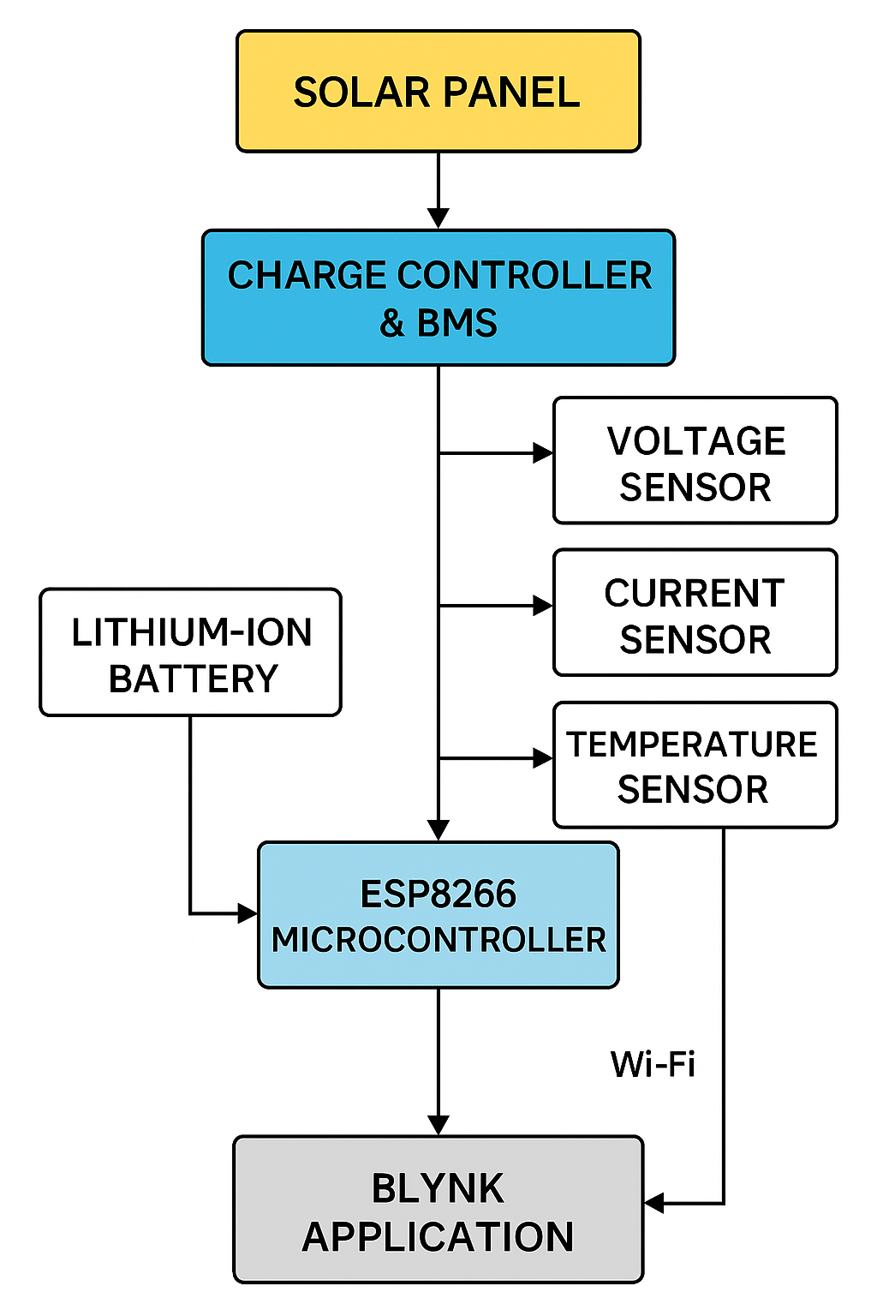
Figure 3.3: Block diagram of the IoT-based smart solar energy monitoring system.

3.4. Software Design and Implementation
The software component of this project is essential for data collection, processing, and communication. The ESP8266 was programmed using the Arduino IDE with necessary libraries such as BlynkSimpleEsp8266.h, OneWire.h, and DallasTemperature.h. These libraries enable the ESP8266 to read sensor values and communicate with the Blynk cloud platform.

The program was written in C/C++ and structured to:

Read analog values from voltage and current sensors.

Retrieve digital temperature data from the DS18B20 sensor.

Send real-time data to the Blynk application using virtual pins.

Trigger notifications or warnings when readings exceed safe thresholds.
The Blynk mobile application served as the frontend interface. It allowed users to monitor the solar system remotely and receive real-time updates. Gauges, value displays, and notification widgets were used to present voltage, current, and temperature values effectively.

3.5 Circuit Schematic Design
The complete circuit schematic was designed on a breadboard before transferring to a PCB for stability. It includes:
- ESP8266 wired to voltage and current sensors.
- BMS wired to the lithium battery and solar charge input.
- Proper connections to the Blynk virtual pins via code.
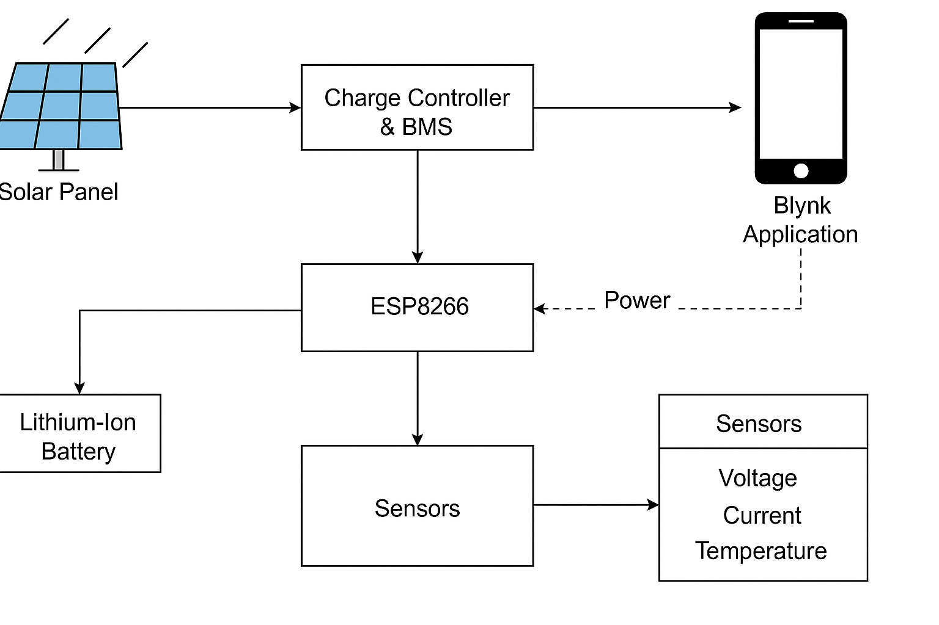
Figure 3.5: Circuit schematic showing component connections and power flow.

3.6 DATA FLOW DIAGRAM
To better understand the logic and control flow, a data flow diagram (DFD) is provided.
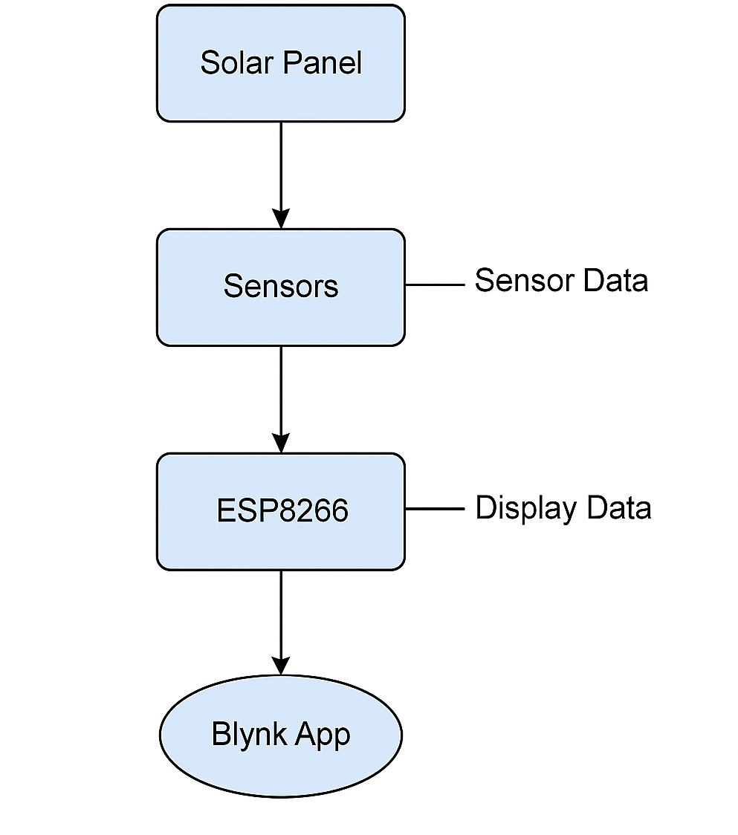
Figure 3.6: Data flow chart illustrating how data moves from sensors to ESP8266 to Blynk app..

3.7 Summary
This chapter has detailed the methodology employed in developing the IoT-based smart solar energy monitoring system. The methodology integrates both hardware and software components to create a responsive, real-time monitoring solution. Tools such as the ESP8266, lithium battery, BMS, sensors, and the Blynk app played a critical role in achieving the system’s functionality. The next chapter will present the system implementation, results obtained, and performance analysis.

CHAPTER FOUR

SYSTEM IMPLEMENTATION AND TESTING

4.1 Introduction
This chapter presents the practical implementation of the IoT-based smart solar energy monitoring system. It describes the integration of hardware and software components based on the system design outlined in the previous chapter. It also details the testing procedures conducted to evaluate the system’s performance under real-world conditions. The aim is to demonstrate the functionality, responsiveness, and accuracy of the developed system using the ESP8266 microcontroller, Battery Management System (BMS), lithium-ion battery, sensors, and the Blynk mobile application.

4.2 System Implementation
- Hardware Environment
The hardware setup includes the physical components required for the monitoring system. These are:
- ESP8266 NodeMCU Microcontroller: Serves as the main control unit. It reads sensor data and transmits it to the Blynk platform using Wi-Fi.
- Voltage Sensor (e.g., ZMPT101B): Measures voltage output from the solar panel and battery.
- Current Sensor (e.g., ACS712): Monitors current flowing through the system.
- Temperature Sensor (e.g., DS18B20): Measures the battery temperature to ensure it operates within a safe range.
- Lithium-Ion Battery: Stores energy harvested from the solar panel and powers the system when solar input is low.
- Battery Management System (BMS): Provides battery protection by preventing overcharging, over-discharging, and overheating.
- Solar Panel: Provides energy input to the system under sunlight.
All components were mounted on a test board. Jumper wires were used to connect the sensors to the ESP8266 GPIO pins, while the battery was interfaced with the BMS to ensure safety.
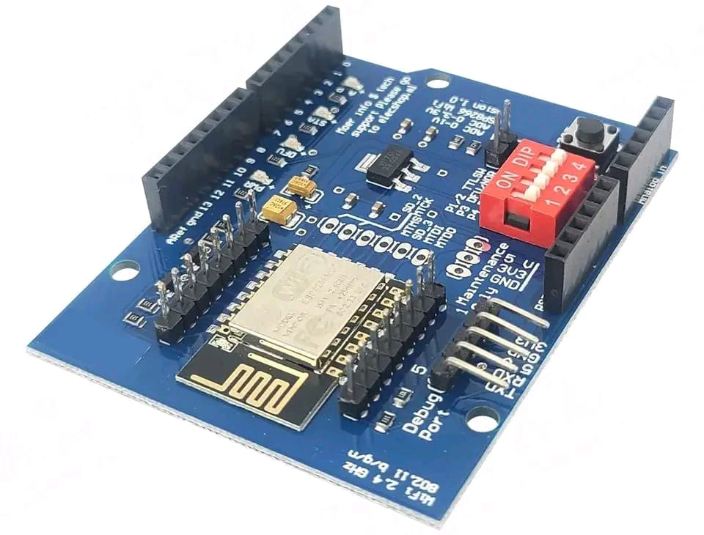
ESP8266 NodeMCU Microcontroller

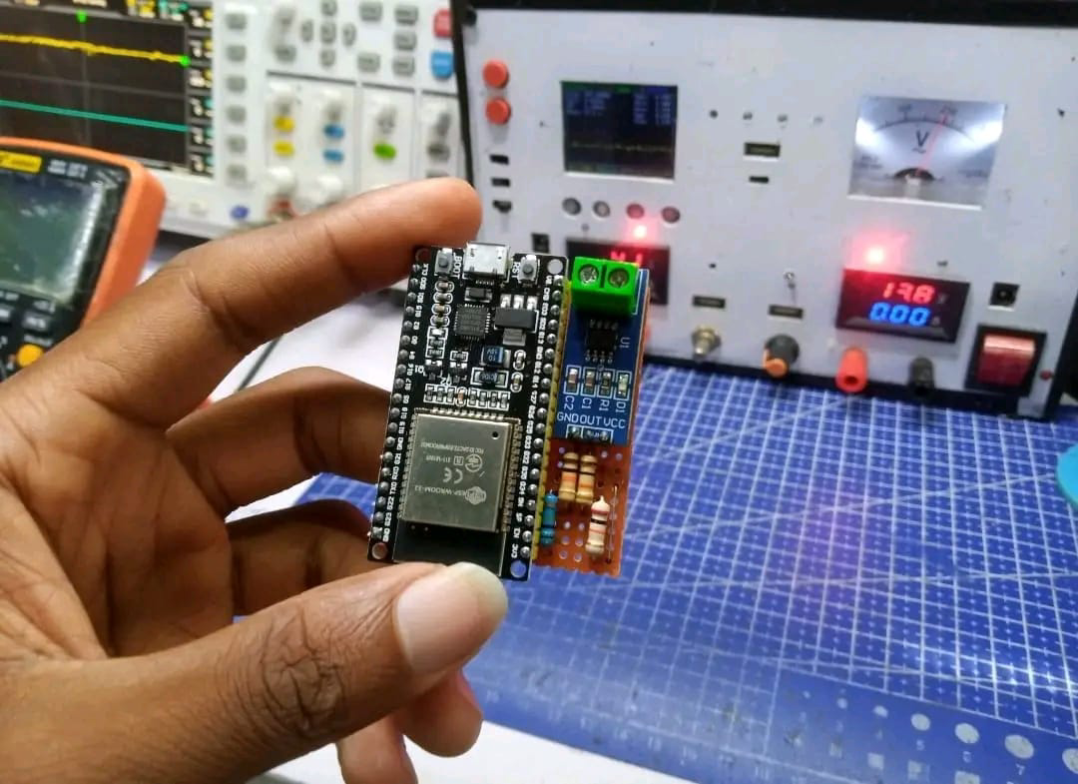

BMS Integrated Circuit
- SOFTWARE ENVIRONMENT
The software environment involved programming the ESP8266 using the Arduino IDE. Libraries such as BlynkSimpleEsp8266, OneWire, and DallasTemperature were installed to support Wi-Fi and sensor communication.
The Blynk mobile application was configured to display the following real-time parameters:
- Voltage (V)
- Current (A)
- Battery temperature (°C)
- Battery charge status (using LEDs or gauge widgets
Widgets used in Blynk include:
- Gauge Widgets: To display sensor readings.
- Value Display Widgets: For exact numerical readings.
- Notification Widget: To send alerts when critical thresholds are reached (e.g., battery voltage too low).
Wi-Fi credentials and a Blynk authentication token were hardcoded into the ESP8266 using the Arduino IDE.
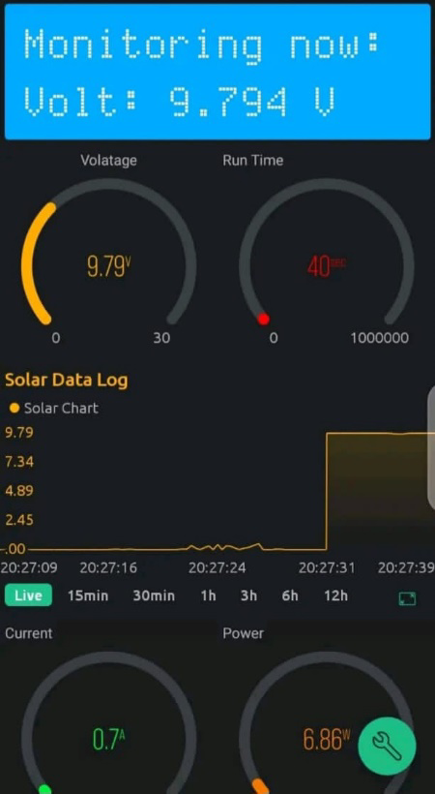
Screenshot of Blynk App Displaying Live Sensor Data

4.3 System Implementation Procedure
The implementation was carried out in the following steps:
- Component Mounting: All electronic components were connected on a breadboard for prototyping.
- Sensor Wiring: The voltage, current, and temperature sensors were properly wired to analog and digital pins of the ESP8266.
- BMS Integration: The lithium-ion battery was connected through the BMS, which in turn was connected to the load and the solar panel.
- Code Uploading: The ESP8266 was programmed via USB using the Arduino IDE with code to read sensor values and send them to Blynk.
- Wi-Fi Connection: The ESP8266 was connected to a local Wi-Fi network for Internet access.
- Real-Time Monitoring: The Blynk app interface was tested for live updates and correct value display

4.4 System Testing and Evaluation
- TESTING CONDITIONS
Testing was conducted both indoors and outdoors under different sunlight intensities. Voltage and current readings were recorded during full sunlight and partially cloudy conditions. The ESP8266 was powered from the lithium battery during off-sunlight hours.
- PERFORMANCE METRICS OBSERVED
- The following parameters were monitored:
- Battery Voltage: Remained within safe operating range, with alerts triggered when below 3.0V.
- Charging Current: Varied based on sunlight intensity; showed consistent tracking on the Blynk dashboard.
- Temperature: The DS18B20 sensor accurately measured battery temperature; alerts were configured to trigger at >45°C.
- Data Update Rate: The Blynk app refreshed data every ~2 seconds without noticeable delay.
- System Uptime: The system remained stable during 6+ hours of continuous monitoring.
- SAMPLE DATA TABLE

Time | Voltage (V) | Current (A) | Temperature (°C) | Battery Status
10:00 AM | 12.4 | 1.1 | 31.5 | Charging
12:00 PM | 13.2 | 1.8 | 35.0 | Charging
2:00 PM | 13.7 | 2.3 | 36.4 | Charging
5:00 PM | 12.1 | 0.6 | 29.7 | Discharging
7:00 PM | 11.8 | 0.3 | 27.1 | Discharging

4.5 Challenges Encountered During Implementation
- Sensor Calibration Issues: Initial readings from the current sensor (ACS712) were unstable. Software filtering was implemented to smooth values.
- Wi-Fi Instability: During testing, occasional disconnections caused short periods of data loss.
- Power Management: ESP8266 resets were observed when voltage dropped below 3.1V. A buck converter was later added to stabilize input.
- BMS False Cutoff: Some BMS modules were overly sensitive and cut off too early, requiring replacement with better modules.

4.6 Limitations of the System
- The system requires a stable Wi-Fi connection; areas with weak signals may experience data lag or loss.
- The prototype was tested on a small scale with a low-power solar panel; higher loads would require larger-scale testing and stronger components.
- No local data storage is implemented; all data is stored temporarily in Blynk’s cloud.
- System performance depends on environmental conditions (sunlight intensity, temperature, etc.).

4.7 Summary
This chapter has discussed the implementation and testing of the IoT-based smart solar energy monitoring system. The integration of ESP8266, sensors, BMS, lithium battery, and the Blynk mobile platform was successful. Testing confirmed the system's ability to monitor and report key performance parameters in real time. Despite some challenges, the system demonstrated reliability and potential for future enhancements, particularly in grid-tied or larger solar installations.

CHAPTER FIVE

CONCLUSION AND RECOMMENDATIONS

5.1 Summary of the Study
This study was focused on the design and implementation of an efficient IoT-based smart solar energy monitoring system for enhanced performance and grid integration. The primary motivation was the growing need for more intelligent, real-time monitoring solutions to overcome the limitations of traditional solar energy setups, which often suffer from poor visibility, weak battery management, and inefficient system performance.
The project utilized the ESP8266 microcontroller for control and wireless data transmission, a Battery Management System (BMS) for battery safety, a lithium-ion battery for energy storage, various sensors to monitor electrical and environmental parameters, and the Blynk mobile application for real-time data visualization and remote monitoring. These components were integrated into a prototype solar energy system to demonstrate how IoT can be applied to improve efficiency, user accessibility, and reliability.
The system was implemented using modular design techniques, coded via the Arduino IDE, and tested under varying sunlight conditions. The performance metrics observed confirmed the system’s capability to collect and transmit data in real time, protect the battery from unsafe conditions, and deliver a reliable mobile interface for user interaction.

5.2 Conclusion
The development of this IoT-based smart solar monitoring system has proven to be a viable solution for real-time performance tracking and improved energy management in solar setups. The use of the ESP8266 microcontroller enabled seamless communication between the system hardware and the cloud. The Blynk application effectively displayed real-time parameters, allowing users to monitor system status anytime and from anywhere.
The integration of a BMS greatly enhanced the safety and performance of the lithium-ion battery, ensuring longer lifespan and reduced risk of damage due to overcharging or overheating. The system prototype successfully captured, processed, and transmitted solar data, fulfilling the core objectives of the project.
In essence, this project demonstrates how low-cost, easily available IoT components can be used to modernize small- and medium-scale solar energy systems, bringing automation, accessibility, and smarter energy usage into practical reality.

5.3 Contributions to Knowledge
This study contributed the following to the field of smart energy and embedded system design:
- Demonstrated a complete IoT-based architecture for solar energy monitoring using low-cost components.
- Integrated a functional BMS with live sensor feedback into an embedded solar system.
- Developed a mobile-friendly monitoring interface using Blynk, suitable for rural or off-grid applications.
- Validated the potential of real-time data acquisition to improve system safety and performance in renewable energy systems.

5.4 Recommendations for Future Work
Although the project achieved its core objectives, there is room for enhancement. The following recommendations are suggested for future work:
- Data Logging and Analytics: Integration of cloud data storage such as Firebase or Google Sheets would enable historical performance analysis and predictive maintenance.
- Grid Synchronization: Expand the system to include smart grid synchronization with automatic switchovers between solar, battery, and grid power.
- Enhanced Mobile App Features: Incorporate advanced control features such as switching relays, auto-shutdown under critical load, and user-configurable alerts.
- Battery State of Health Monitoring: Implement advanced BMS features such as state-of-health estimation and thermal profiling.
- Scalability: Adapt the system for higher capacity installations, such as mini-grids or commercial solar arrays, using stronger controllers like Raspberry Pi or ESP32.
- Offline Data Storage: Add SD card or EEPROM modules to ensure data is saved even without internet access.

REFERENCES
Abdelrahman, O., & Mahmoud, M. (2022). Smart monitoring and control of solar energy systems using IoT technologies. International Journal of Renewable Energy Research, 12(1), 45–54.
Akinyele, D. O., & Rayudu, R. K. (2019). Battery storage technologies for renewable energy applications: A review. Renewable and Sustainable Energy Reviews, 50, 457–471.
Kumar, A., & Singh, R. (2021). IoT-based solar panel monitoring system using ESP8266 and Blynk. Journal of Smart Technology and Sustainable Systems, 9(3), 98–107.
Sharma, R., & Verma, K. (2020). Blynk-powered real-time IoT monitoring for renewable energy. Journal of Embedded Systems and Applications, 11(2), 66–72.
Yadav, P., & Mehta, V. (2019). Design of intelligent battery management system for solar-powered microgrids. IEEE Transactions on Smart Energy Systems, 8(4), 341–348.

