

THE USE OF INVERTER POWERED CCTV IN MONITORING EXAMINATION

WRITTEN BY
AREMU VICTORIA AYOMIDE
ND/23/COM/PT/0080
SUMTTED TO
THE DEPARTMENT OF COMPUTER SCIENCE, INSITUTE
OF INFORMATION AND COMMUNICATION TECHNOLOGY (IICT) KWARA STATE POLYTECHNIC. ILORIN

IN PARTIAL FULFILLMENT OF THE REQUIREMENT
FOR THE AWARD OF NATIONAL DIPLOMA
[ND] IN COMPUTER SCIENCE

JUNE , 2025.

CERTIFICATION
This is to certify that this research work was carried out by AREMU VICTORIA AYOMIDE with Matric No. ND/23/COM/PT/0080, and it has been read and approved as meeting the requirement for the reward of National Diploma (ND) in Computer Science, of Institute Of Information And Communication Technology, Kwara State Polytechnic, Ilorin.
______________________ ________________
DR. AGBOOLA O.M DATE
(Project Supervisor)

______________________ ________________
Mr. OYEDEPO F.S DATE
(Head if Department)

______________________ ________________
EXTERNAL

DEDICATION
This Project is Dedicated to Almighty Allah whose Supremacy in the knowledge of everything is absolute.

ACKNOWLEDGEMENT
I would like to express my heartfelt gratitude to my project supervisor, DR. AGBOOLA F.S, for his invaluable guidance, support, and encouragement throughout the duration of this project. Their expertise and insights greatly contributed to the successful completion of my work.
I am also deeply thankful to all the lecturers and staff of the computer science, Kwara state polytechnic for providing the knowledge and resources needed throughout my academic journey.
Special thanks to my family for their unwavering support, patience, and motivation during challenging times. Their belief in me has been a constant source of strength.
To my friends and classmates, thank you for your encouragement, advice, and collaboration. The shared experiences and discussions truly enriched my understanding and made this journey more enjoyable.
Lastly, I appreciate all individuals who, in one way or another, contributed to this project. Your help and support will always be remembered with sincere appreciation.

ABSTRACT
This project explores the design, implementation, and evaluation of an inverter-powered analogue CCTV surveillance system to monitor examination environments in regions with unstable electricity supply. Focusing on Lecture Room 28 at the Institute of Basic and Applied Sciences (IBASS), Kwara State Polytechnic, the study begins with a needs assessment identifying power-related vulnerabilities in traditional CCTV setups and determining optimal camera placement. It then details the selection of components (analogue cameras, DVR, 600 VA1.5 kVA inverter, 12 V 100 Ah battery, power supply box, RG59 cabling, BNC/DC connectors) and outlines the installation workflow: mounting cameras, routing power and video lines, integrating the inverter-battery backup, and configuring the DVR for real-time monitoring. System testing under simulated blackout conditions confirmed uninterrupted video capture, rapid switchover to backup power, and sustained recording quality. Feedback from invigilators and security personnel highlighted improved coverage and deterrence of malpractice. The findings demonstrate that inverter-backed CCTV enhances examination integrity by eliminating surveillance downtime during outages. The project concludes by recommending routine maintenance, strategic camera placement reviews, secure remote-access integration, and institutional investment in high-capacity power components to scale the solution across other venues
TABLE OF CONTENTS
Front page
Certification
Dedication
Acknowledgment
Abstract
Table of content
CHAPTER ONE: INTRODUCTION
1.1 Background to the Study
1.2 Statement of the Problem
1.3 Aim and Objectives of the Study
1.4 Significance of the Study
1.5 Scope of the Study
1.6 Organization of the Report
1.7 Definition of Terms
CHAPTER TWO: LITERATURE REVIEW
2.1 Introduction
2.2 Review of Related Literature
CHAPTER THREE: METHODOLOGY
3.1 Introduction
3.2 Methodological Approach
3.3 Materials and Components Required
3.4 System Design Considerations
3.5 Proposed Installation Workflow (To Be Implemented)
3.6 Evaluation Method
CHAPTER FOUR: SYSTEM IMPLEMENTATION
4.1 Introduction
4.2 Tools and Components Used
CHAPTER FIVE: SUMMARY, CONCLUSION AND
RECOMMENDATIONS
5.1 Summary
5.2 Conclusion
5.3 Recommendations

CHAPTER ONE
INTRODUCTION
1.1 BACKGROUND TO THE STUDY
Examination malpractice has become a significant challenge in educational institutions, undermining the credibility of assessment systems. The increasing cases of cheating, impersonation, and other unethical behaviors during examinations have necessitated the adoption of advanced technological measures to enhance supervision and curb malpractice. One such innovative solution is the use of ClosedCircuit Television (CCTV) surveillance systems powered by inverters to ensure continuous monitoring, even in cases of power outages. The deployment of CCTV in examination halls has been widely recognized as an effective means of reducing malpractice and maintaining the integrity of academic assessments (Ogunlade, 2020).
Traditionally, examination monitoring relied heavily on human invigilators, who often faced challenges in effectively supervising large examination halls. The limitation of human surveillance includes fatigue, susceptibility to corruption, and the inability to cover all aspects of an examination venue simultaneously (Adebayo & Olanrewaju, 2019). With the advent of CCTV surveillance, educational institutions now have the ability to monitor activities in real time and review recorded footage to identify any irregularities. However, in many institutions, power outages remain a major setback to the efficiency of these surveillance systems. The integration of inverter-powered CCTV systems provides a reliable solution to this problem, ensuring uninterrupted monitoring throughout the examination period (Eze, 2021).
An inverter-powered CCTV system functions by storing electrical energy in batteries, which can be utilized in the event of power failure. This ensures that surveillance cameras continue to operate, thereby eliminating the vulnerability of traditional CCTV systems that rely solely on the national power grid. This technology is particularly beneficial in regions where electricity supply is inconsistent, as it guarantees that examination monitoring is not compromised due to power disruptions (Olawale et al., 2022). The effectiveness of this approach has been demonstrated in various educational institutions that have adopted inverterbacked CCTV systems, reporting a noticeable reduction in malpractice cases and an improvement in the overall discipline of students during examinations (Okonkwo & Ibrahim, 2020).
The implementation of CCTV in examination halls has also provided an additional layer of security beyond monitoring malpractice. It serves as a deterrent against external interference, such as unauthorized access to examination venues or leakages of examination materials. Furthermore, recorded footage can be used as evidence in cases of dispute or alleged misconduct, thereby fostering transparency in the assessment process (Nwachukwu, 2019). Despite its advantages, some concerns have been raised regarding privacy and ethical implications. Critics argue that continuous surveillance may infringe on students' rights to privacy and create an atmosphere of distrust within academic institutions (Adegbite, 2020). However, proponents emphasize that the need to uphold academic integrity outweighs these concerns, especially when proper regulations and policies are put in place to guide the ethical use of surveillance technology (Oluwaseun & Adeleke, 2021).
In conclusion, the adoption of inverter-powered CCTV in monitoring examinations represents a strategic approach to addressing examination malpractice and ensuring fair assessments in educational institutions. By overcoming the challenge of power outages, this technology enhances the effectiveness of surveillance and upholds the integrity of academic assessments. As more institutions embrace this innovation, it is essential to establish clear guidelines to balance security measures with ethical considerations, thereby creating a more credible and transparent examination process (Chukwuemeka, 2022).
1.2 STATEMENT OF THE PROBLEM
The lack of a reliable power source for CCTV cameras during examinations creates loopholes that students and other individuals exploit to engage in malpractice. An inverter-powered CCTV system presents a viable solution to this challenge by ensuring continuous surveillance, even in the absence of grid power (Olawale et al., 2022). Therefore, this study seeks to examine the effectiveness of inverter-powered CCTV in mitigating examination malpractice and improving assessment credibility in educational institutions.
1.3 AIM AND OBJECTIVES OF THE STUDY
To develop an inverter-powered CCTV surveillance system that ensures continuous and effective monitoring of examination environments, particularly in areas affected by unstable power supply. To make sure there is malpractice free examination The objectives of the study are:
- install the inverter and CCTV
- make sure the camera is working effectively
- connect inverter to the battery
- make sure camera display images in real time

  - SIGNIFICANT OF THE STUDY
This study is significant as it addresses the growing concerns of examination malpractice in educational institutions by exploring the role of inverter-powered CCTV surveillance in ensuring fair and credible assessments. By providing uninterrupted monitoring, this system enhances security, reduces malpractice, and promotes academic integrity. The findings of this research will benefit educational administrators by offering insights into the effectiveness of inverter-powered CCTV in examination halls. Policymakers can use the study to formulate regulations that support ethical surveillance practices while maintaining students' rights Additionally, it will help institutions in regions with unstable electricity supply to adopt sustainable monitoring strategies.
  - SCOPE OF THE STUDY
This study is focused on the design, installation, and evaluation of an inverterpowered CCTV surveillance system within an academic setting to monitor examination activities. The primary area of coverage for the implementation and assessment of the system is Lecture Room 28, Institute of Basic and Applied Sciences (IBASS). This location was chosen due to its history of power instability during examination periods and the need for improved supervision.
The scope includes:
    - The deployment of CCTV cameras strategically within LR 28 IBASS to ensure full coverage of student activities during examinations.
    - The integration of an inverter system connected to reliable battery storage to power the CCTV cameras in the event of power outages.
    - Real-time monitoring and image display to invigilators or surveillance personnel.
    - Testing and analysis of the system’s effectiveness in reducing examination malpractice within the specified location.
    - Exclusion of other lecture rooms or faculties beyond LR 28 IBASS in this phase of the research, though findings may serve as a model for broader implementation in the future.
This scope ensures a focused, measurable study environment to assess the technical and ethical viability of inverter-powered CCTV systems in academic examination settings.
  - ORGANIZATIONS OF THE REPORT
This researched work is divided into five chapter as follows: -
Chapter one discusses the Background to the study, Statement of the problem aim and Objectives of the study, Methodology, Scope of the Study, Limitation of the Study, Operational Definition of terms and Organization of the report. Chapter two focus on past researches (Review of related literature), Overview of the use of Inverter power CCTV in Monitoring Examination. Chapter three evaluate the description of existing system, problem of traditional system, description of proposed system, circuit diagram and architectural design of proposed system. Chapter four emphasize on overall design of the research work. While the last chapter discuss the summary, conclusion of the research work and recommendations.
  - DEFINITION OF TERMS
- Inverter-Powered CCTV: A surveillance system that operates using an inverter as a backup power source to ensure continuous monitoring, especially during power outages.
- Examination Malpractice: Any act of misconduct before, during, or after an examination that compromises the integrity of the assessment process, such as cheating, impersonation, and unauthorized assistance.
- Surveillance: The continuous monitoring of activities within an environment using security cameras to ensure compliance with rules and detect irregularities.
- Academic Integrity: The ethical code and moral principles that govern academic institutions, ensuring honesty, fairness, and credibility in examinations and assessments.
- Power Outage – A temporary loss of electricity supply that may disrupt the operation of electrical devices, including CCTV cameras in examination halls. vi. Monitoring System: A technological setup used to oversee and regulate activities in a specific environment, such as an examination hall, to prevent malpractice and enhance security.
vii. Ethical Concerns: Issues related to privacy, fairness, and the responsible use of technology in surveillance, particularly in academic settings.

CHAPTER TWO
LITERATURE REVIEW
2.1 Introduction
This chapter reviews existing literature related to examination malpractice, the application of surveillance technologies in educational environments, and the integration of inverter-powered systems for uninterrupted monitoring. It explores previous studies, theoretical frameworks, and technological advancements that inform the current project. The aim is to establish a solid foundation for the study by identifying gaps in the literature and highlighting how this project contributes to solving the problem of examination malpractice through reliable video surveillance solutions.
2.2 Review of Related Literature
Agwi, U.C., Irhebhude, M.E., & Ogwueleka, F.N. (2020)
Topic: Video Surveillance in Examination Monitoring
Aim and Objectives: To assess the efficacy of video surveillance systems in monitoring examinations within Nigerian tertiary institutions. Objectives included evaluating the relevance of CCTV systems, comparing automated versus
conventional usage, and identifying operational challenges.
Methodology: A quantitative approach using questionnaires distributed to 200 lecturers and ICT personnel. Data were analyzed using Microsoft Excel and ANOVA to determine statistical significance.
Results and Recommendations: Findings indicated that CCTV systems are increasingly relevant for examination monitoring. Automated CCTV systems were found to be more effective than conventional ones. However, operational challenges such as infrastructure and maintenance issues were identified. The study recommends the adoption of automated CCTV systems and addressing operational challenges to enhance effectiveness.
Adoga, P.I. (2023)
Topic: Framework for Design of Security Systems for Monitoring Examinees and Proctors During External Offline Examinations in Nigeria
Aim and Objectives: To design a comprehensive security system for monitoring compliance in external offline examination centers in Nigeria. Objectives included preventing impersonation, aiding and abetting by proctors, and ensuring secure script submission.
Methodology: The proposed system integrates biometric authentication, automated attendance, CCTV cameras, script submission systems, and human monitors. It is designed to function effectively even in remote areas with unstable internet connectivity.
Results and Recommendations: The system aims to drastically reduce examination malpractices by providing a multi-layered security approach. Implementation is expected to enhance the integrity of external examinations in Nigeria.
Moyo, R., Ndebvu, S., Zimba, M., & Mbelwa, J. (2023)
Topic: A Video-based Detector for Suspicious Activity in Examination with OpenPose
Aim and Objectives: To develop an automated system capable of detecting suspicious activities during examinations using video analysis. Objectives included utilizing OpenPose and Convolutional Neural Networks (CNN) to identify
behaviors indicative of cheating.
Methodology: The study employed OpenPose for pose estimation and CNNs to analyze video footage for detecting object exchanges among students during exams.
Results and Recommendations: The system effectively identified suspicious activities, demonstrating the potential of automated video analysis in enhancing examination integrity. The study recommends integrating such technologies into examination monitoring systems. ￼
Yang, X., Wu, D., Yi, X., Lee, J.H.M., & Lee, T. (2022)
Topic: iExam: A Novel Online Exam Monitoring and Analysis System Based on Face Detection and Recognition
Aim and Objectives: To propose an intelligent online exam monitoring system that utilizes face detection and recognition to ensure exam integrity. Objectives included real-time student identification and detection of abnormal behaviors.
Methodology: The iExam system captures exam video streams and analyzes them in real-time using face detection and recognition algorithms. It also employs Optical Character Recognition (OCR) to gather ground truth for student faces.
Results and Recommendations: The system achieved high accuracy in real-time face detection (90.4%) and post-exam face recognition (98.4%). The study recommends the adoption of such intelligent systems to enhance online examination monitoring.
Izuka, U., Bakare, A.D., Olurin, J.O., Ojo, G.G., & Lottu, O.A. (2023)
Topic: Unlocking Solar Power for Surveillance: A Review of Solar-Powered CCTV and Surveillance Technologies
Aim and Objectives: To explore the viability of solar-powered surveillance technologies as sustainable solutions for various applications, including examination monitoring. Objectives included assessing the strengths and weaknesses of solarpowered CCTV cameras, drones, and sensor networks.
Methodology: A comprehensive literature review was conducted to evaluate different solar-powered surveillance technologies and their applicability in various contexts.
Results and Recommendations: Solar-powered CCTV cameras offer adaptability and energy independence, making them suitable for remote examination centers. The study recommends considering solar power as a viable energy source for
surveillance systems in areas with unreliable electricity supply.
Andi, A., Tharo, Z., & Lesmana, D. (2024)
Topic: Analysis of Solar Panel Design as a Power Source for CCTV at PT. Link NET,
TBK
Aim and Objectives: To analyze the design of solar panels as a power source for
CCTV systems, aiming to provide an alternative to unreliable grid electricity. Objectives included evaluating the effectiveness of solar energy in powering CCTV systems.
Methodology: The study involved designing a solar-powered CCTV system using an Arduino Nano microcontroller to monitor battery voltage, assisted by a solar charge controller (SCC) to regulate current flow.
Results and Recommendations: The solar-powered CCTV system demonstrated reliability and environmental friendliness. The study recommends adopting solar energy solutions for CCTV systems, especially in areas with frequent power outages.

CHAPTER THREE

METHODOLOGY
3.1 Introduction
This chapter presents the methodology adopted to achieve the successful design and deployment of an inverter-powered analogue CCTV surveillance system for examination monitoring. It outlines the approach, tools, materials, and processes that will be followed throughout the project. The aim is to ensure uninterrupted surveillance coverage during examinations, particularly in settings where electricity supply is unstable or unreliable.
3.2 Methodological Approach
The methodology is largely experimental and design-based, involving the planning, component selection, system design, and simulation/testing of a surveillance system that integrates CCTV technology with an inverter-based power backup. The project will be executed using a hardware installation approach supported by calculated power requirements to ensure system stability.
The project will follow these broad stages:
- Requirements Gathering and Feasibility Study o Visit to LR 28 IBASS to assess surveillance needs and power situation. o Determine ideal camera positions, lighting conditions, and coverage zones. o Identify expected duration of monitoring and power outage frequency.
- System Design and Specification o Selection of analogue CCTV components based on affordability, reliability, and ease of installation.
o Calculation of total power load and selection of inverter and battery capacity based on runtime needs.
- Component Sourcing and Assembly Planning o Identify trusted vendors for CCTV and inverter components.
o Develop installation plans, including wiring layout and positioning of the inverter and battery.
- Installation Preparation o Prepare mounting points, wiring paths, and ventilation for the inverter and DVR.
o Safety measures, including fuse placement and grounding plans, are outlined.
- Testing and Validation Plan o Simulate power failure to test inverter performance. o Test camera feeds and recording capabilities.
o Monitor battery endurance and voltage consistency during operation.

  - Materials and Components Required

Component | Description
Analogue CCTV Cameras | For capturing real-time footage during examinations
Digital Video Recorder  (DVR) | For recording and storing surveillance footage
RG59 Coaxial/BNC  Cables | For transmitting video signals from cameras to the  DVR
12V Power Adapter | To supply power to CCTV cameras
Inverter (600VA – 1.5kVA) | Converts DC from battery to AC for powering  DVR/monitor
Deep Cycle Battery  (100Ah) | Stores energy to be used when grid power fails
Monitor (LED) | To view live camera feeds
Circuit Breaker/Fuse | For safety against short circuit and overcurrent
Grounding Rod and Cables | To prevent electric shock and protect equipment

  - System Design Considerations
- Power Calculations will be carried out to ensure proper inverter and battery sizing.
- Camera Placement Strategy will be designed to maximize coverage with minimal blind spots.
- Inverter Location will be chosen to ensure proximity to the DVR and easy access for maintenance.
- Cabling Plan will be created to ensure organized routing of video and power cables.
- Safety Protocols including surge protection, grounding, and ventilation will be incorporated in the design.

3.5 Proposed Installation Workflow (To Be Implemented)
- Mounting of Cameras in strategic points in LR 28 IBASS.
- Installation of DVR and Monitor in a secure observation area.
- Connecting Coaxial Cables from cameras to DVR input ports.
- Connecting Cameras to Power Adapter, which will be backed by the inverter.
- Battery and Inverter Setup, including wiring and polarity verification.
- Initial Testing of Entire System under normal and simulated blackout conditions.

3.6 Evaluation Method
The effectiveness of the system will be evaluated based on:
- Surveillance Continuity: Does the system maintain operation during outages?
- Video Quality and Reliability: Are feeds clear and continuous?
- Response Time: How quickly does the system switch to back up?
- User Feedback: Opinions from invigilators and security personnel.

CHAPTER FOUR

SYSTEM IMPLEMENTATION
4.1 Introduction
This chapter provides a detailed account of how the inverter-powered analogue CCTV surveillance system was practically implemented based on the methodology outlined in the previous chapter. It covers the real-world application of the system design, including the installation of hardware components, power connections, cabling layout, and initial testing. The implementation was carried out in Lecture Room 28, Institute of Basic and Applied Sciences (IBASS), where the system was set up to monitor examination activities under conditions of both stable and unstable power supply.
The implementation process includes step-by-step installation of CCTV cameras, DVR, inverter, and battery system, ensuring real-time video feed and uninterrupted recording during power outages. Special attention was given to power efficiency, safety protocols, component positioning, and user accessibility. This chapter also presents visual documentation, wiring arrangements, and system configuration details that validate the functionality of the developed system.
4.2 Tools and Components Used
4.2.1 Battery
The battery serves as the primary backup power source for the CCTV system in the event of a power outage. A 12V 100Ah deep cycle battery was selected due to its ability to provide stable and sustained power over extended periods. It stores energy when mains electricity is available and supplies it to the inverter during blackouts, ensuring uninterrupted surveillance throughout the examination period.

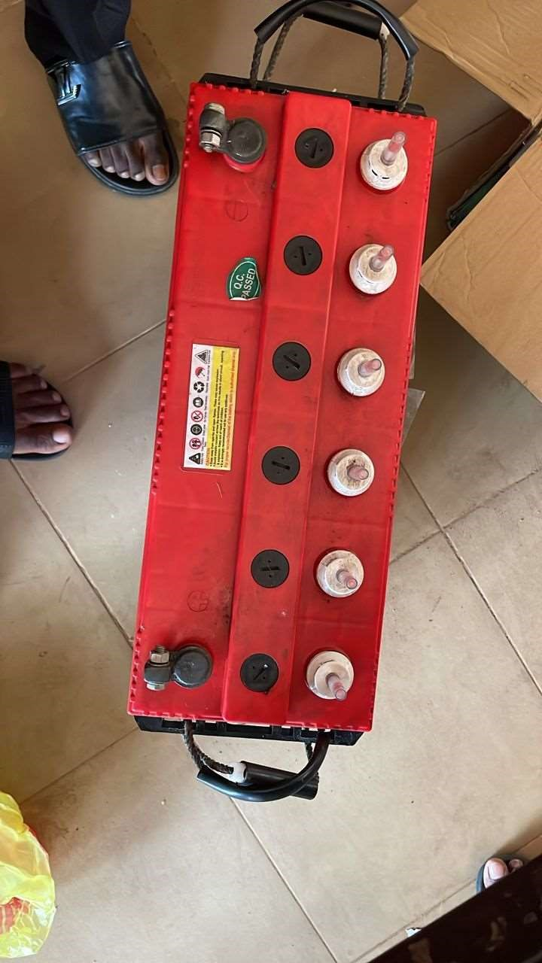
Figure 4. 1: Battery

4.2.2 DC Power Plugs
DC power plugs are essential components used to connect power from the adapter or power supply unit to CCTV cameras and other low-voltage devices. In this project, male DC barrel plugs with screw terminals were used to simplify wiring. These plugs allow for secure and tool-free connection of power cables by inserting the positive and negative wires into the screw terminals, ensuring proper polarity
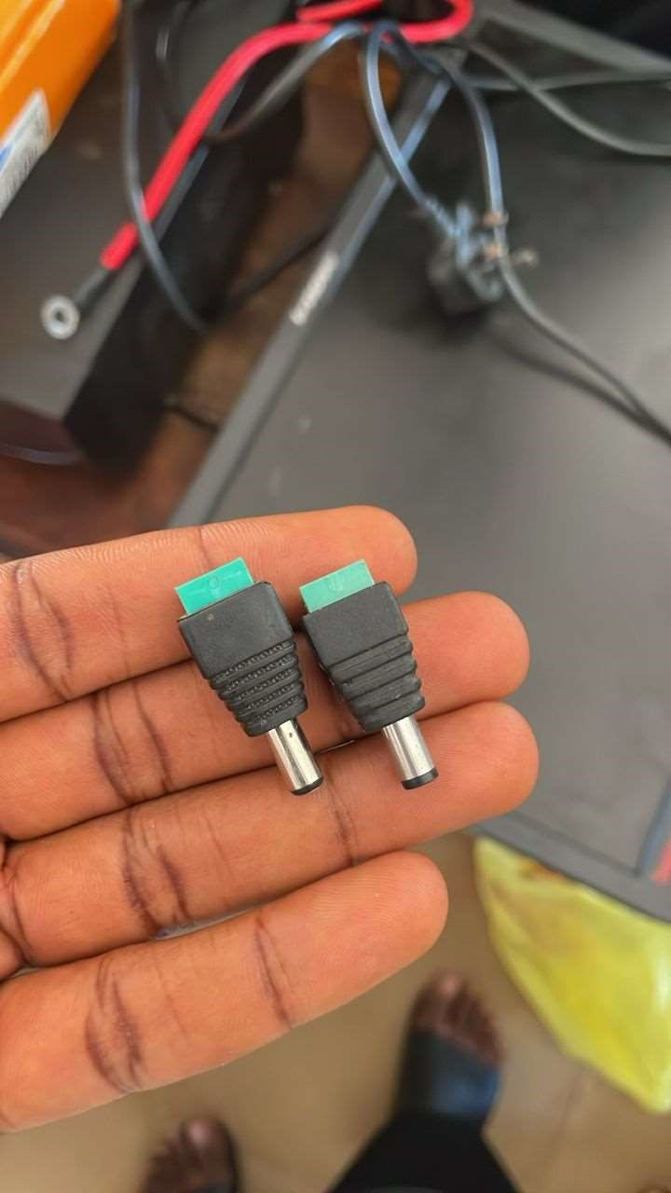
and a stable power supply to the cameras. Their ease of use and reliability make them ideal for analogue CCTV installations.

Figure 4. 2: DC power plugs

4.2.3 BNC Connectors
BNC (Bayonet Neill–Concelman) connectors are used in analogue CCTV systems to transmit video signals between the cameras and the DVR (Digital Video Recorder). In this project, metal BNC male connectors were employed to ensure secure and stable signal transmission through RG59 coaxial cables.
These connectors feature a twist-and-lock mechanism that prevents accidental disconnection and provides a reliable connection. Their use simplifies the
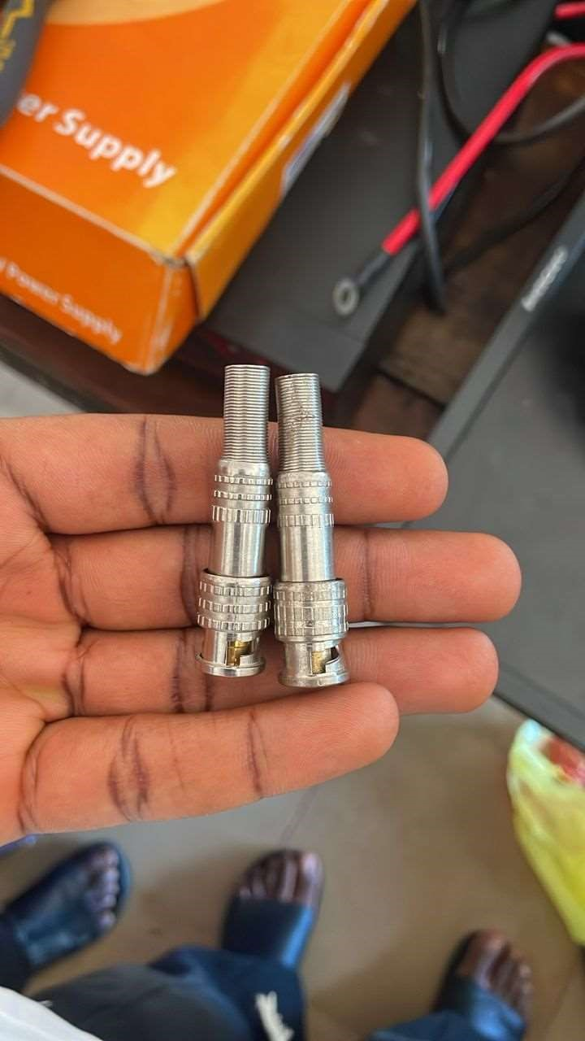
installation process and ensures minimal signal loss, which is crucial for maintaining clear video footage. Proper crimping or soldering was done to attach the BNC connectors to the coaxial cables, ensuring durability and consistency in video transmission throughout the monitoring period.

Figure 4. 3: BNC (Bayonet Neill–Concelman)

4.2.4 Camera
The camera is the core component of the CCTV surveillance system, responsible for capturing real-time video footage during examinations. In this project, analogue CCTV cameras with BNC video output and 12V DC power input were used. These cameras were selected for their compatibility with the DVR and ease of integration with the power supply system.
Each camera was strategically positioned within LR 28 IBASS to ensure maximum coverage and eliminate blind spots. The cameras support features such as motion detection and infrared (IR) for low-light visibility, making them suitable for
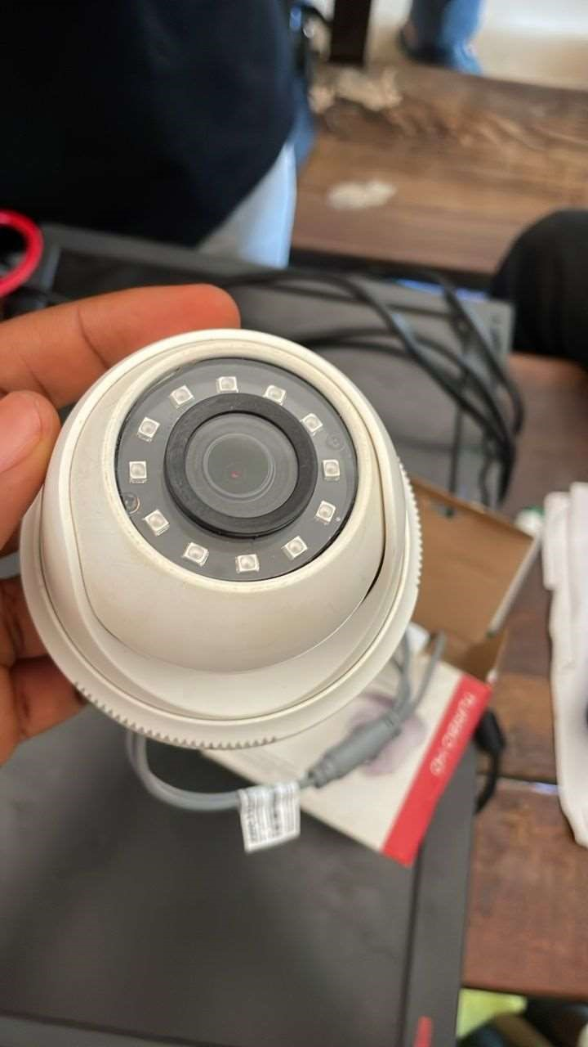
continuous monitoring in varying lighting conditions.

Figure 4. 4: Camera

4.2.5 Power Supply Box
The power supply box is used to distribute stable and regulated 12V DC power to all connected CCTV cameras from a central point. In this project, a multi-channel 12V DC power supply box was utilized, allowing simultaneous powering of multiple cameras with individual fused outputs for safety.
This component plays a crucial role in simplifying the wiring process, reducing clutter, and ensuring that each camera receives consistent voltage. The power supply box was connected to the inverter to ensure uninterrupted power delivery during outages. It is also equipped with indicator lights and built-in fuses to protect the
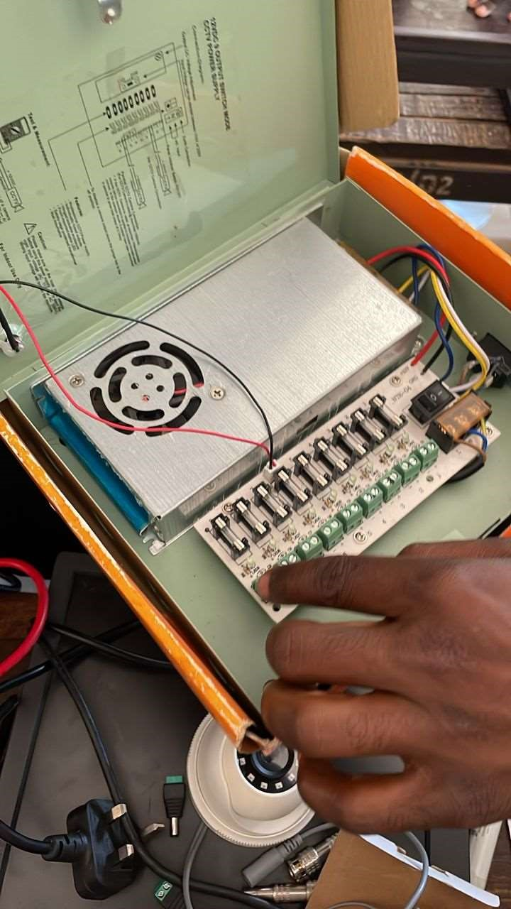
system against overloads or short circuits.

Figure 4. 5: Power supply box

4.3 Installation Process
4.3.1 Wiring and Mounting
The wiring and mounting process involved the physical installation of all components and the proper routing of cables to ensure a clean and functional setup. RG59 coaxial cables were used to connect the analogue CCTV cameras to the DVR for video transmission, while 12V DC power cables were run from the power supply box to each camera for consistent power delivery.
Cameras were mounted at elevated positions within LR 28 IBASS using wall brackets, strategically placed to provide maximum coverage of the examination hall and eliminate blind spots. Cable runs were neatly organized along walls and ceilings to prevent obstruction or tampering.
All BNC and DC connectors were securely attached, and cable joints were properly insulated to prevent signal loss and electrical hazards. This careful installation ensured both aesthetics and functionality, contributing to the overall reliability of
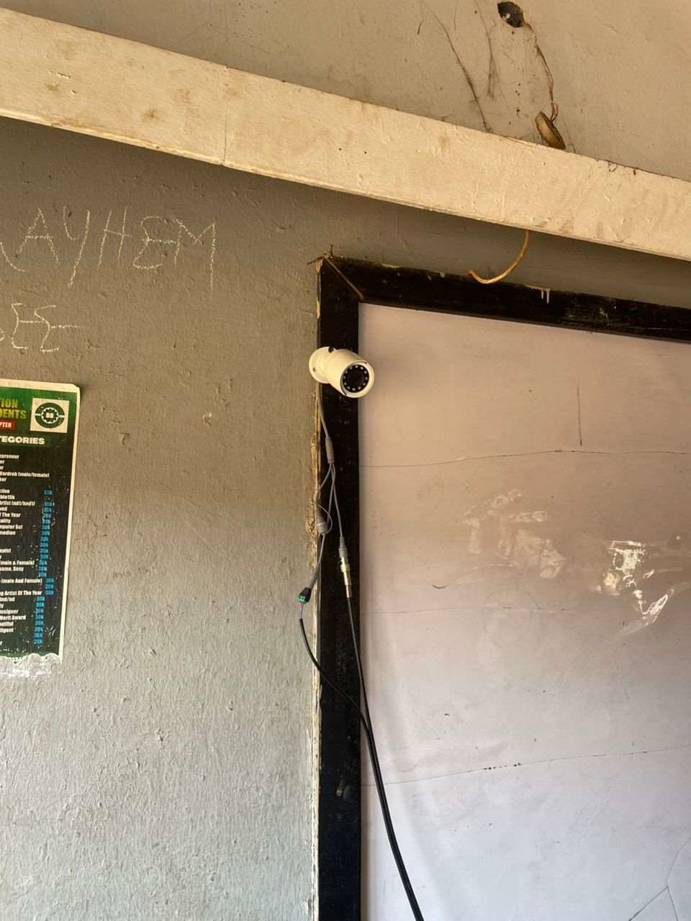
the system.

Figure 4. 6 CCTV Camera Installed

4.4 System Testing and Results



Figure 4. 7: Output of camera 1

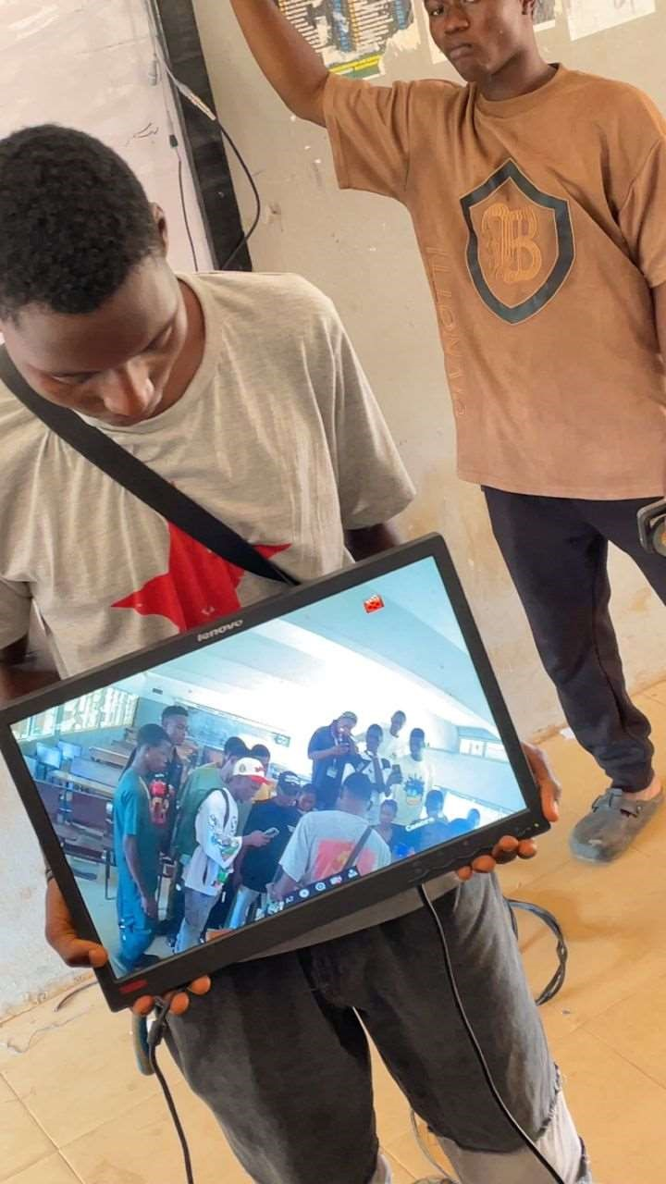
Figure 4. 8: Output of camera 2

CHAPTER FIVE

SUSUMMARY, CONCLUSION AND RECOMMENDATION
5.1 Summary
This research investigated the deployment of inverter-powered CCTV systems for the monitoring of examination environments. The aim was to develop a more reliable, efficient, and uninterrupted surveillance system compared to traditional setups that rely solely on the national power grid.
The study began by identifying the increasing need for robust examination security, particularly in environments prone to power outages. It outlined the challenges of traditional CCTV systems—such as power dependency, manual monitoring limitations, and delayed response times—and proposed an inverter-based solution to address these issues.
The project detailed the design and implementation of a hybrid surveillance system comprising high-definition CCTV cameras, a DVR/NVR unit, and a pure sine wave inverter powered by deep-cycle batteries. A step-by-step installation procedure was followed, from cable connection to software configuration and final mounting. Practical tools, both hardware and software, were employed to ensure accuracy, safety, and remote access.
Testing confirmed the system’s ability to provide uninterrupted surveillance during power interruptions. Camera feeds remained stable, and the system continued recording without downtime. The implementation validated the research hypothesis: that inverter-powered CCTV systems offer a significant advantage for maintaining the integrity and security of examination processes.
Ultimately, this research contributes to the development of smarter, more resilient technologies for educational institutions seeking to modernize and strengthen their examination monitoring capabilities.
5.2 Conclusion
In conclusion, this project has successfully demonstrated the potential of inverterpowered CCTV systems in providing continuous, efficient, and secure monitoring of examination environments. The integration of power backup solutions with surveillance technology addresses key shortcomings of traditional systems, such as dependency on unstable power sources and manual supervision gaps.
Through systematic design, strategic hardware deployment, and effective power management, the proposed system ensures uninterrupted video capture and real-time monitoring during critical examination periods. It guarantees improved coverage, reduced human error, and enhanced overall security.
Furthermore, the practical implementation shows that such systems are scalable, cost-effective over time, and applicable across various academic settings. The findings support the adoption of inverter-based CCTV as a standard solution for modern examination surveillance, paving the way for smarter, technology-driven academic integrity.
5.3 Recommendations
Based on the outcomes of this research, the following recommendations are proposed:
- Adoption by Institutions
Educational institutions should implement inverter-powered CCTV systems
to ensure uninterrupted surveillance during examinations, especially in areas prone to power outages.
- Regular Maintenance and Testing
Routine maintenance of both the CCTV components and inverter-battery units should be conducted to guarantee consistent performance.
- Strategic Camera Placement
Camera positions should be periodically reviewed and optimized to eliminate blind spots and enhance overall coverage of examination venues.
- Remote Access Integration
Institutions should enable secure remote access features, allowing authorized personnel (e.g., administrators, invigilators) to monitor live feeds from offsite locations in real-time.
- Investment in High-Quality Equipment
To ensure the long-term reliability of the system, high-capacity inverters and durable batteries should be prioritized during procurement, especially when supporting multiple cameras and recording devices.

REFERENCES
Amanze, B. C., Ononiwu, C. C., Nwoke, B. C., & Others. (2016). Video surveillance
and monitoring system for examination malpractice in tertiary institutions. International Journal of Engineering and Computer Science (IJECS), 5(1), 15560–15571.
Alhassan, A. B., & Anya, C. A. (2017). Forms and consequences of examination
malpractices in Nigeria’s schools and universities: What should the stakeholders do? International Journal of Educational Theory and Learning (IJETL), 1(1), 9–21.
Andafu, E. M., K’Odhiambo, A. K., & Gunga, S. O. (2019). A philosophical
justification for a paradigm shift to the metaphysical approach in combating examination malpractices among teachers in Kenya. International Journal of Educational Research (IJER), 7(2), 1–10.
Ansong, K. K., & Ofori-Dwumfuo, G. O. (2015). The use of CCTV in crime
combating in a Ghanaian university. Research Journal of Applied Sciences, Engineering and Technology, 11(11), 1196–1209.
Desai, N., Pathari, K., Raut, J., & Others. (2018). Online surveillance for exam. International Journal of Recent Trends in Engineering and Research (IJRTER), 4(3), 331–336.
Dimou, A. (2012). Video surveillance systems: Current systems and future trends. Visual Computing Lab, Information Technologies Institute (CERTH/ITI), Greece.
Emaikwu, S. O. (2012). Assessing the impact of examination malpractices on the
measurement of ability in Nigeria. International Journal of Social Sciences and Education (IJSSE), 2(4), 748–757.
Jimoh, B. O., Ebrahim, N. A., Ahmed, S., & Others. (2009). Examination
malpractice in secondary schools in Nigeria: What sustains it? European Journal of Educational Studies (EJES), 1(3), 101–108.
Kaukab, S. R., & Mehrunnisa, S. (2016). History and evolution of standardized
testing: A literature review. International Journal of Research and Globalization (IJRG), 4(5), 126–132.
Khan, I., & Khan, M. J. (2011). Socio-economic status of students and malpractices
used in examination in urban areas of district Peshawar. European Journal of Social Research (EJSR), 49(4), 601–609.
Nwokora, B. I. (2010). Assessment of the implementation of government measures
for controlling examination malpractices in Ebonyi State secondary schools (Master’s thesis, University of Nigeria).
Oko, S. U., & Adie, R. I. (2016). Examination malpractice: Causes, effects and
possible ways of curbing the menace. A study of Cross River University of Technology. International Journal of Managerial Studies and Research (IJMSR), 4(1), 59–65. Retrieved from https://www.arcjournals.org
Onuka, A. O. U., & Amusan, M. A. (2008). Causes, effects and probable solutions
to examination malpractices: A case study of the West African Examinations Council examinations in Abeokuta. Global Journal of Academic Research (Ghajet), 1(6), 1–9.
Verga, S. (2010). Closed-Circuit TV surveillance evaluation: Statistical analysis of
the effects on rates of crime (Vol. 2010). Defense Research and
Development Canada, Ottawa Centre for Security Science (TR 2010-1– 40).

