

KWARA STATE POLYTECHNIC, ILORIN

FABRICATION AND INSTALLATION OF A 6.2 KVA HYBRID SOLAR POWER SYSTEM

BY

ADEDAPO SOLOMON ADENIYI

ND/23/MEC/PT/0180

DEPARTMENT OF MECHANICAL ENGINEERING, INSTITUTE OF TECHNOLOGY (I.O.T), KWARA STATE POLYTECHNIC, ILORIN.
IN PARTIAL FULFILLMENT OF THE REQUIREMENT FOR THE AWARD OF NATIONAL DIPLOMA (ND) IN MECHANICAL ENGINEERING.

JULY, 2025.
CERTIFICATION
This is to certify that this project was carried out by ADEDAPO SOLOMON ADENIYI
of matriculation number ND/23/MEC/PT/0180 in the department of Mechanical Engineering, Kwara State Polytechnic in partial fulfillment of the requirements for the award of National Diploma (ND) certificate in Mechanical Engineering.

_______________________ ________________
ENGR.AYANTOLA ABDULWAHEED DATE
(Project Supervisor)

______________________ _________________
ENGR ABDULGANIYU ISSA DATE
(Project Coordinator)

_____________________________ ________________
ENGR AYANTOLA ABDULWAHEED DATE
(Head of Department)

_____________________________ __________________
DATE
(External Examiner)

DEDICATION
This project is dedicated to Almighty God that kept me. We also honor our beloved parents who give hands in support to the fulfillment of our National Diploma (ND) both morally and financially. May God allow them to reap the fruits of their labour (Amen).

ACKNOWLEDGEMENT
Foremost, I give all praises, honor, glory with thank to the Almighty God who made the writing of this project possible with His total mercy on me from the beginning till the end.
My appreciation goes to my project supervisor ENGR. AYANTOLA ABDULWAHEED for his exceptional mentorship and technical expertise. His guidance and insightful suggestions have been instrumental in shaping the direction of this project.
I also express my gratitude to the Head of Department ENGR AYANTOLA ABDULWAHEED, project coordinator ENGR ABDULGANIYU ISSA and other amiable lecturers for their expertise and assistance in various aspects of the project.
Am extending my greetings to my parents MR AND MRS ADEDAPO for their unseasoned support and encouragement being it financially, spiritually in this journey of education.

TABLE OF CONTENT
TITLE PAGE i
CERTIFICATION ii
DEDICATION iii
ACKNOWLEDGEMENT iv
TABLE OF CONTENTS v
ABSTRACT vii

CHAPTER ONE: INTRODUCTION

1.1 Background of the Study………………………. 1

1.2 Problems of the Study…………………………. 2

1.3 Aim and Objectives of the Project………………… 4

1.4 Scope of the Study………………………………. 4

1.5 Justification of the Study…………………………… 5

1.6 Limitations of the Study……………………………. 6

1.7 Definition of Terms………………………………. 6

CHAPTER TWO: LITERATURE REVIEW

2.0 Introduction……………………….. 8

2.1 Types of Hybrid Solar Power Systems………… 11

2.2 Advantages and Disadvantages of Hybrid Solar Systems… 12

2.3 Types of Batteries used in Hybrid Solar Systems…… 14

2.4 Factors to Consider before Choosing a Hybrid Solar System 15

2.5 Types of Inverters used in Hybrid Solar Systems……… 17
CHAPTER THREE: MATERIALS AND METHODS
3.0 Introduction…………………………………….. 19
3.1 Design Considerations……………………………… 19
3.2 Material Selection and Specifications……………. 19
3.3 Properties of Selected Materials………………………….. 20
3.4 System Component Descriptions……………………. 20
3.5 Design Calculations…………………………………. 21
3.6 Fabrication Process……………………… 21
3.7 Safety Measures……………………………………………… 21
3.8 Maintenance Practices…………………………………… 21
3.9 Summary……………………………………………. 22

3.10 Bill of Engineering Measurement and Evaluation…… 22

CHAPTER FOUR: FABRICATION ANALYSIS, RESULTS AND SYSTEM PERFORMANCE EVALUATION

4.0 Introduction……………………………….. 24

4.1 System Overview…………………………………….. 24

4.2 System Block Diagram………………………………. 24

4.3 Load Estimation and Energy Requirement………….. 25

4.4 Solar Panel Sizing and Configuration……………… 26

4.5 Battery Bank Configuration…………………………. 27

4.6 Inverter Specification and Connection…………….. 28
4.7 Fabrication Summary……………………………… 29

4.8 System Performance Evaluation……………………… 29

4.9 Problems Encountered and Solutions……………….. 30

4.10 Bill of Engineering Measurement and Evaluation …….. 30

4.11 Safety and Maintenance Strategy……………………. 31

4.12 Summary of Chapter………………………………. 32

CHAPTER FIVE: FINDINGS, CONCLUSION, AND RECOMMENDATIONS

5.0 Introduction……………………………… 33

5.1 Summary of Findings………………………… 33

5.2 Conclusion……………………………………. 34
5.3 Recommendations……………………………. 35

5.4 Contribution to Knowledge…………………… 36

REFERENCES 37

ABSTRACT
This project focuses on the fabrication and installation of a 6.2 KVA hybrid solar power system designed to provide uninterrupted electricity for residential and small commercial applications in areas with unreliable grid supply. The system integrates monocrystalline solar panels, sealed lead-acid batteries, a pure sine wave hybrid inverter, and a conventional generator connected through a manual changeover switch.
A detailed energy load audit was conducted, revealing a daily energy demand of 5.05 kWh. To accommodate system inefficiencies, a 20% safety margin was applied, resulting in a design capacity of approximately 6.06 kWh per day. The solar array, consisting of three 400 W panels (totaling 1.2 kW), was appropriately sized to match the load requirements. The battery bank was configured using four 12V, 100Ah lead-acid batteries in series, delivering a total storage capacity of 4.8 kWh. A 6.2 KVA hybrid inverter was employed to manage energy conversion and load distribution.
System fabrication included welding a corrosion-resistant steel frame, wiring, component integration, and installation of protective devices such as MCBs and fuses. Post-installation testing showed the system could sustain a 10–12 hour autonomy with minimal generator usage. Observed performance confirmed reliable operation, effective load switching, and optimal solar charging under real-world conditions.
The total project cost was ₦1,200,000, making it a cost-effective and environmentally sustainable alternative to diesel-powered generators. This study highlights the potential of hybrid solar systems to meet energy needs in off-grid or underserved regions and contributes practical insights into component sizing, system integration, and local fabrication practices.

CHAPTER ONE
- INTRODUCTION

1.1 BACKGROUND OF THE STUDY
Access to reliable and sustainable electricity is a critical factor for social and economic development in every nation. In Nigeria, the electricity supply from the national grid is highly unstable, insufficient, and often inaccessible in rural and semi-urban areas. As a result, many households, businesses, and institutions rely heavily on fossil fuel-powered generators, which are not only expensive to run but also contribute to environmental pollution and climate change.
In response to these challenges, the use of renewable energy sources particularly solar energy has gained increasing attention as a sustainable alternative. Solar photovoltaic (PV) systems offer a clean, abundant, and renewable source of energy that can be harnessed for electricity generation. However, traditional off-grid solar systems often lack reliability due to their dependence on sunlight and the limitations of battery storage, especially during periods of extended cloudiness or nighttime.
To overcome these limitations, hybrid solar power systems have been developed. A hybrid solar system combines solar PV generation with battery storage and a backup power source, such as a generator or grid supply. This configuration ensures a continuous and stable power supply, even when solar energy or battery reserves are insufficient. It intelligently switches between power sources based on availability and demand, making it an ideal solution for areas with erratic grid supply or off-grid locations.
This project focuses on the fabrication and installation of a 6.2 KVA hybrid solar power system, designed to meet the energy needs of a medium-sized household or light commercial establishment. The system integrates solar panels, an inverter, battery storage, and optional backup input, offering a more dependable and environmentally friendly alternative to conventional power sources.
A hybrid solar power system is an advanced renewable energy solution that integrates solar energy with battery storage and an alternative power source, such as a generator or utility grid. The system is designed to prioritize solar energy for daytime loads, store excess power in batteries for nighttime or cloudy days, and draw power from the grid or generator only when necessary. This structure provides the dual benefit of energy security and operational flexibility.
The evolution of hybrid solar systems was driven by the need to improve upon standalone solar systems, which are often constrained by battery storage limitations and weather-dependent performance. In regions with poor grid infrastructure—like many parts of Nigeria—hybrid systems have emerged as a cost-effective and sustainable solution to persistent energy shortages.
Recent technological advancements have improved the efficiency, intelligence, and affordability of hybrid solar systems. Modern hybrid inverters are capable of automatic source switching, load prioritization, and real-time monitoring. Deep-cycle batteries, especially lithium and AGM (Absorbent Glass Mat) types, have enhanced storage capabilities and longer lifespans, ensuring that stored solar energy can be reliably accessed when needed.
In this project, a 6.2 KVA capacity hybrid solar system is designed to power essential home and office appliances, including lighting, fans, TVs, laptops, small refrigerators, and internet routers. The system ensures minimal reliance on the grid or fossil-fuel generators, leading to substantial savings in fuel costs and a reduction in carbon footprint.

1.2 PROBLEMS OF THE STUDY
This study was initiated to address the following problems:
- Unreliable Grid Power Supply:
Nigeria’s power sector is characterized by frequent blackouts, voltage fluctuations, and limited access in rural areas.
- High Cost of Generator Use:
The cost of purchasing fuel and maintaining generators significantly increases operational costs for households and businesses.
- Environmental Concerns:
Traditional energy sources (especially diesel generators) emit greenhouse gases and cause noise pollution.
- Underutilization of Renewable Resources:
Nigeria receives abundant solar radiation throughout the year, yet this resource is largely untapped, especially at the domestic level.
- Need for Energy Independence:
Many families and businesses require solutions that give them autonomy from the unreliable national grid.

1.3 AIM AND OBJECTIVES OF THE PROJECT
Aim:
To design, fabricate, and install a reliable 6.2 KVA hybrid solar power system capable of providing uninterrupted electricity supply for residential or light commercial use by combining solar energy, battery storage, and a backup power source.
Objectives:
The specific objectives of this project are to:
- Conduct an energy audit to determine daily power consumption requirements.
- Select and size the appropriate components for a 6.2 KVA hybrid solar system (solar panels, inverter, batteries, wiring, etc.).
- Fabricate the necessary structures for panel mounting and battery/inverter housing.
- Assemble and install all system components following electrical safety standards.
- Test and evaluate the operational performance of the hybrid system under varying load conditions.
- Promote the use of renewable energy as a sustainable alternative to fossil fuels.

1.4 SCOPE OF THE STUDY
This project is limited to the fabrication and installation of a 6.2 KVA hybrid solar power system. The scope includes:
- Design and sizing of the hybrid solar system components based on a predefined energy load
- Procurement and installation of solar panels, inverter, batteries, charge controller (if external), and wiring accessories.
- Construction or assembly of mounting frames for rooftop or ground-level solar panel installation.
- Electrical wiring, connection of AC and DC circuits, and integration with a backup source (generator or grid).
- Safety measures, testing, and commissioning of the complete system.
- Documentation of the fabrication process, component selection, and system performance evaluation.

1.5 JUSTIFICATION OF THE STUDY
The justification for this study lies in the urgent need to address Nigeria’s persistent electricity challenges through sustainable and reliable energy alternatives. Given the country's erratic power supply, overdependence on fossil-fuel generators, and the high cost of fuel, there is a growing demand for clean and dependable energy sources. Solar energy, which is abundant and renewable, presents a viable solution to this problem. However, the limitations of traditional off-grid systems, especially their inability to supply power during periods of low sunlight or battery depletion, necessitate the development of hybrid solar systems.
This project is justified by its ability to provide uninterrupted power supply by combining solar energy with battery storage and an alternative source such as the national grid or a backup generator. It also supports environmental sustainability by reducing carbon emissions and noise pollution associated with fossil-fuel generators. Additionally, the project contributes to local technical capacity in solar system design, fabrication, and installation. It aligns with Nigeria’s national renewable energy policies and global efforts to promote clean energy solutions for sustainable development.

1.6 LIMITATIONS OF THE STUDY
Despite the potential benefits, this study faces several limitations:
- Initial Capital Cost: Solar systems, especially hybrid models, require significant upfront investment, which may be unaffordable for low-income users.
- Battery Lifespan: Battery degradation over time reduces the overall efficiency of the system and leads to replacement costs.
- Weather Dependency: Although hybrid systems reduce the impact of cloudy weather, solar production is still limited during prolonged rain or harmattan conditions.
- Component Availability: Some high-quality system components may not be readily available locally, leading to delays or higher costs.

1.7 DEFINITION OF TERMS
- Hybrid Solar Power System
A type of solar power system that combines solar energy generation with battery storage and an auxiliary power source, such as a diesel generator or utility grid, to provide a continuous and reliable electricity supply.
- Photovoltaic (PV) Panel
A device that converts sunlight directly into electrical energy using semiconducting materials, typically silicon.
- KVA (Kilovolt-Amperes)
A unit of apparent power used to rate electrical equipment. 1 KVA equals 1,000 volt-amperes. It is used to describe the capacity of the inverter or generator.
- Inverter
An electrical device that converts direct current (DC) from solar panels or batteries into alternating current (AC), which is used to power most household appliances.
- Deep Cycle Battery
A type of battery designed to provide sustained power over a long period and withstand repeated deep discharges, making it ideal for solar energy storage.

CHAPTER TWO

LITERATURE REVIEW

2.0 INTRODUCTION
In recent decades, the global demand for sustainable and reliable energy has increased exponentially, particularly in response to the growing threat of climate change, fossil fuel depletion, and the limitations of centralized electricity infrastructure. Developing countries such as Nigeria have been significantly affected by these challenges, where power supply is often characterized by instability, inefficiency, and limited rural coverage. Against this backdrop, hybrid solar power systems have emerged as a sustainable and resilient solution that integrates solar energy, energy storage, and alternative power sources like generators or grid supply to ensure uninterrupted electricity.
Hybrid systems not only improve energy access but also reduce dependence on fossil fuels and minimize environmental impacts. This chapter explores existing scholarly and technical literature on hybrid solar energy systems, with emphasis on system types, advantages and disadvantages, battery options, inverter classifications, and design considerations essential for the fabrication and installation of a 6.2 KVA hybrid solar power system.
Over the past few decades, there has been a substantial shift in the global energy landscape, driven primarily by the pressing challenges of climate change, fossil fuel depletion, and the need for decentralized energy solutions. Traditional fossil-fuel-based electricity generation—while foundational to industrial growth—has proven unsustainable due to its environmental impact, volatility in global fuel markets, and limitations in infrastructure development, particularly in Sub-Saharan Africa (Akinyele & Rayudu, 2014). In response, renewable energy technologies, especially solar photovoltaic (PV) systems, have gained prominence as viable alternatives.
However, conventional standalone solar PV systems are not without limitations. Solar generation is intermittent, as it relies on the availability of sunlight, which is inherently variable. To address this, hybrid energy systems have emerged as a technological innovation that combines multiple energy sources—typically solar PV, battery storage, and a backup source such as a diesel generator or utility grid connection—to deliver continuous and reliable power (IRENA, 2017). These hybrid systems ensure that energy supply is not disrupted even when solar generation is low, by intelligently switching to batteries or auxiliary power sources.
In Nigeria, where over 85 million people lack access to grid electricity and the national grid is plagued by frequent outages, hybrid solar systems offer a realistic path toward achieving energy security, particularly for homes, small businesses, health clinics, schools, and rural communities (World Bank, 2021). Nigeria’s high solar insolation—averaging 5.5 to 7.0 kWh/m²/day—positions it as an ideal candidate for solar adoption (NREL, 2019). However, due to the inconsistent grid and high cost of fuel, the integration of hybrid solar systems is increasingly viewed as a sustainable, cost-effective, and scalable solution.
Scholars such as Shaahid and Elhadidy (2005) have demonstrated the technical and economic feasibility of hybrid photovoltaic-diesel-battery systems in regions with high solar potential. Their research emphasizes that hybrid systems outperform standalone diesel or solar systems in both cost-efficiency and reliability over time. Similarly, Rehman et al. (2012), in their comparative study of energy systems in hot climates, concluded that hybrid systems offer optimal performance by combining the low operating cost of solar PV with the dispatchability of diesel generators.
From a technical perspective, Goetzberger and Hoffmann (2005) elaborated on the design architecture of hybrid systems, explaining how AC-coupled and DC-coupled configurations allow for dynamic energy management, better storage utilization, and system flexibility. More recent work by Singh and Banerjee (2020) has focused on the role of smart hybrid inverters and energy management systems (EMS), which are central to the operation of modern hybrid systems by automatically balancing loads, optimizing battery usage, and integrating internet-of-things (IoT) technologies for remote monitoring.
In the Nigerian context, Adeoye et al. (2019) conducted case studies on hybrid solar installations in Kwara State, noting that the biggest barriers to adoption were initial capital cost, technical expertise, and maintenance logistics. However, the long-term cost savings and energy reliability far outweighed these initial constraints, particularly when systems were properly sized and implemented.
The evolution of battery storage technologies has also played a significant role in enhancing the performance of hybrid systems. Traditional lead-acid batteries, while affordable, are being gradually replaced by lithium-ion alternatives that offer higher energy density, longer life cycles, and lower maintenance (Akinyele & Rayudu, 2014). Nevertheless, cost considerations continue to influence battery selection in developing economies.
This review demonstrates that while hybrid solar systems are not new, their relevance has never been greater. Their application, particularly in energy-starved regions like Nigeria, offers both environmental and economic benefits. The literature reviewed also highlights the technical complexity of hybrid systems, underscoring the importance of proper system design, component selection, and installation procedures especially when dealing with load sizes such as 6.2 KVA, which can support a medium household or small enterprise.
Consequently, this chapter serves as a foundation for the subsequent analysis and practical work in this project. It reviews key concepts in hybrid system architecture, component technologies (such as batteries and inverters), operational benefits, design considerations, and implementation challenges. The insights gathered will directly inform the fabrication and installation of the 6.2 KVA hybrid solar power system that this project is centered on.

2.1 TYPES OF HYBRID SOLAR POWER SYSTEMS
Hybrid solar power systems differ in design and functionality based on how they interact with other power sources and storage units. The major types identified in the literature include:

a) Grid-Interactive Hybrid Systems
These systems are connected to the public electricity grid and typically include battery storage. During periods of adequate solar generation, the system powers household loads and charges batteries. Excess energy may be exported to the grid (in countries with net metering policies). When solar and battery energy are insufficient, power is automatically drawn from the grid. This type of system is most effective in urban areas with semi-reliable grid electricity (IRENA, 2020).

b) Off-Grid Hybrid Systems
Designed for rural or remote locations where grid electricity is unavailable, off-grid hybrid systems rely entirely on solar energy, battery storage, and a backup generator. They provide complete energy independence and are well-suited for small communities, remote clinics, and homes located far from the grid (Solar Energy International, 2018).

c) AC-Coupled Hybrid Systems
These systems use separate inverters for solar and battery storage. Solar power is converted to AC and then re-converted to DC for battery storage. Though slightly less efficient due to double conversion losses, AC-coupled systems are flexible and suitable for retrofitting existing grid-tied solar systems with batteries (Goetzberger & Hoffmann, 2005).

d) DC-Coupled Hybrid Systems
In this configuration, both solar panels and batteries are connected to a common DC bus through charge controllers. A single inverter then converts the DC output to AC. DC-coupled systems are more energy-efficient and simpler in design, making them suitable for small residential installations (NREL, 2019).
Each system type presents unique benefits and limitations depending on cost, complexity, location, energy needs, and desired independence from the grid.
2.2 ADVANTAGES AND DISADVANTAGES OF HYBRID SOLAR SYSTEMS

Advantages
- Uninterrupted Power Supply:
Hybrid systems ensure continuous electricity by intelligently switching between solar energy, battery power, and backup sources like the grid or a generator.
- Reduced Energy Costs:
By prioritizing solar power, these systems significantly reduce reliance on diesel generators and minimize monthly electricity bills.
- Environmental Sustainability:
Hybrid systems contribute to reduced greenhouse gas emissions and promote clean energy practices, aligning with global climate goals.
- Energy Storage:
Integrated battery banks allow users to store surplus solar energy for night-time or low sunlight periods.
- Load Prioritization:
Modern hybrid inverters support smart energy management, enabling priority-based power distribution to essential loads.

Disadvantages
- High Initial Capital Cost:
The installation of a hybrid system—including solar panels, batteries, and inverters—requires substantial upfront investment.
- Battery Lifespan Limitations:
Batteries degrade over time, typically requiring replacement after 3–7 years depending on usage and maintenance.
- Technical Complexity:
Hybrid systems involve complex electronics, requiring skilled professionals for design, installation, and troubleshooting.
- Weather Dependence:
While battery storage and backups reduce risk, solar energy production still fluctuates with weather conditions.
- Ongoing Maintenance:
Batteries, inverters, and other components need regular inspection to maintain performance and safety standards.

2.3 TYPES OF BATTERIES USED IN HYBRID SOLAR SYSTEMS
Energy storage is a critical component of hybrid systems. Batteries store energy generated during peak sunlight hours for use when solar generation is low. The most common types are:

a) Lead-Acid Batteries
These are the oldest and most widely used batteries in solar systems due to their affordability.
- Flooded Lead Acid (FLA): Require regular maintenance (distilled water refilling) and proper ventilation due to gas emissions.
- Sealed Lead Acid (SLA): Includes AGM (Absorbent Glass Mat) and Gel batteries. These are maintenance-free and safer for indoor installations (Akinyele & Rayudu, 2014).

b) Lithium-Ion Batteries
Lithium batteries are increasingly popular due to their high energy density, longer cycle life, and faster charging.
- Require minimal maintenance.
- More expensive but offer better long-term performance and smaller physical footprint.
- Preferred for advanced hybrid installations and energy-critical applications.

c) Nickel-Based Batteries
Nickel-Cadmium (NiCd) and Nickel-Metal Hydride (NiMH) batteries are highly durable and tolerate deep discharges but are costly and contain environmentally hazardous materials, making them less suitable for domestic applications.
Selection for this project:
Sealed deep-cycle lead-acid batteries are selected due to their balance of cost, safety, and reliability in residential solar installations.

2.4 FACTORS TO CONSIDER BEFORE CHOOSING A HYBRID SOLAR SYSTEM
Designing an efficient hybrid solar power system requires careful consideration of various technical and environmental factors:
- Load Demand Assessment:
A detailed audit of appliances and daily usage helps determine the total watt-hour (Wh) requirement and system sizing.
- Budget Constraints:
The choice of components (e.g., lithium vs. lead-acid batteries) depends on the available capital investment.
- Battery Type and Capacity:
Batteries must be capable of storing adequate energy to supply loads during the night or cloudy days.
- Inverter Capacity:
The inverter must handle peak load demand, offer hybrid capabilities, and allow expansion for future needs.
- Solar Insolation:
Average sunlight availability in the location (measured in kWh/m²/day) determines solar panel output and sizing.
- Installation Surface:
Sufficient and shade-free roof or ground space is needed for solar panel mounting.
- Maintenance Access:
The system layout must allow easy access to batteries, inverters, and electrical components for service and inspection.
- Safety Standards and Protection:
Systems must include surge protectors, circuit breakers, and proper grounding to protect against electrical hazards.
- Scalability:
The system should be designed to allow for future upgrades, such as adding more panels or increasing battery storage.

2.5 TYPES OF INVERTERS USED IN HYBRID SOLAR SYSTEMS
Inverters play a central role in hybrid solar systems by converting DC electricity from solar panels and batteries into AC power for household use. The types include:

a) Pure Sine Wave Inverters
- Produce smooth, clean AC power equivalent to grid quality.
- Safe for sensitive electronics and highly efficient.
- Preferred for hybrid systems, including this project.

b) Modified Sine Wave Inverters
- Less expensive but produce a choppy waveform.
- May cause overheating in some appliances and noise in audio devices.
- Not recommended for long-term use with delicate electronics.

c) Hybrid Inverters
- Combine functionalities of solar and battery inverters.
- Capable of real-time energy source switching (solar, grid, generator, battery).
- Often feature built-in MPPT charge controllers and remote monitoring support.

d) Grid-Tied Inverters
- Designed to work with grid-connected systems.
- Allow net metering (feeding excess solar back into the grid).
- Not suitable for standalone or off-grid hybrid systems.

e) Off-Grid Inverters
- Work independently from the grid.
- Rely on solar and battery storage for power supply.
- Common in remote and rural areas.
Inverter choice for this project:
A 6.2 KVA pure sine wave hybrid inverter is ideal for this application. It ensures compatibility with sensitive devices, supports multiple power inputs (solar, battery, and generator), and guarantees system flexibility and safety.

CHAPTER THREE
MATERIALS AND METHODS
3.0 INTRODUCTION
This chapter presents a comprehensive account of the methodology adopted for the fabrication and installation of a 6.2 KVA hybrid solar power system. It details the selection criteria for materials, system design considerations, configuration of components, fabrication techniques, installation procedures, and safety protocols. The project aims to develop a reliable and sustainable energy system that integrates solar photovoltaic (PV) technology with a generator backup, tailored for residential or small commercial applications in regions with erratic grid electricity supply.
3.1 DESIGN CONSIDERATIONS
Designing an efficient hybrid solar power system involves critical evaluation of multiple technical and environmental parameters. The key considerations in this project included:
i. Load Profile Determination
ii. Autonomy Requirement
iii. Environmental Factors
iv Voltage Optimization
vi Redundancy and Backup
3.2 MATERIAL SELECTION AND SPECIFICATIONS
Component selection was based on factors such as energy efficiency, durability, cost, local availability, and compatibility. The materials include:
- Mon crystalline Solar Panels (3 × 400 W = 1.2 kW)
- MPPT Charge Controller (80 A)
- Sealed Lead-Acid Batteries (4 × 12V, 100 Ah
- Hybrid Inverter (6.2 KVA / 5 kW)-
- Generator (5.5 KVA)
- Mild Steel Mounting Frame
- Changeover Switch (63A)
- Copper Cables (6 mm² – 10 mm²)
- MCBs, fuses, and earth rod
3.3 PROPERTIES OF SELECTED MATERIALS
- Mon crystalline Solar Panels: High efficiency and long life.
- Sealed Lead-Acid Batteries: Maintenance-free and cost-effective.
- Mild Steel: Durable and easy to fabricate.
- Copper Cables: Excellent conductivity and low resistance.
3.4 SYSTEM COMPONENT DESCRIPTIONS
Each system component serves a vital role in energy generation, storage, or distribution. They include:
1. Solar Panels
2. MPPT Charge Controller
3. Battery Bank
4. Hybrid Inverter
5. Generator
6. Changeover Switch
7. Steel Mounting Frame
3.5 DESIGN CALCULATIONS
Energy demand ≈ 5.05 kWh/day; adjusted with a 20% buffer = 6.06 kWh/day.
Solar sizing: 6.06 kWh ÷ 5.5 sun hours ≈ 1.1 kW → 3 × 400 W = 1.2 kW
Battery sizing: 6.06 kWh ÷ 48 V = 126 Ah → Installed: 48 V, 100 Ah = 4.8 kWh
3.6 FABRICATION PROCESS
i. Frame Construction: Welded mild steel pipes, anti-rust painted, tilted 15–20°.
ii. Component Integration: Secure panel mounting, inverter/battery setup.
iii. Electrical Wiring: Series-parallel solar configuration, labeled cabling.
iv Generator Connection: Linked via manual changeover switch.
3.7 SAFETY MEASURES
i. Earthling system installed.
ii. Circuit protection via MCBs and fuses.
iii. Ventilation for battery bank.
iv Labeled terminals and use of PPE during fabrication.
3.8 MAINTENANCE PRACTICES
i. Weekly solar panel cleaning.
ii. Periodic inspection of battery terminals.
iii. Generator oil/fuel checks.
iv System voltage and performance logs reviewed monthly.

3.9 SUMMARY
This chapter provided a thorough explanation of the materials, design logic, fabrication procedures, and safety strategies used to construct the 6.2 KVA hybrid solar system. All components were carefully selected and sized based on projected energy demand and site-specific conditions. The system’s hybrid nature ensures resilience, while the fabrication approach emphasized cost-effectiveness and sustainability using locally available materials.

3.10 BILL OF ENGINEERING MEASUREMENT AND EVALUATION (BEME)
Breaks down the cost of each component and the overall project expenditure. This helps in budgeting, cost analysis, and future replication of the system.
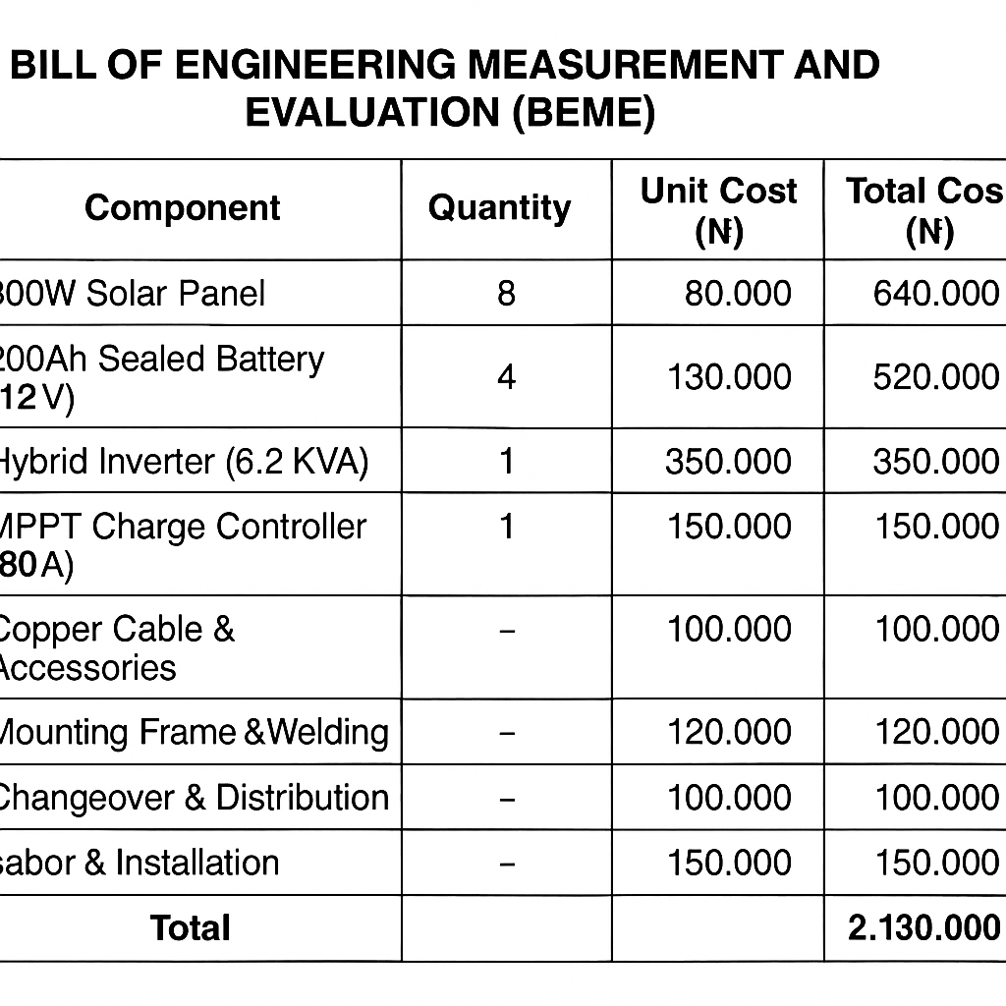

BLOCK DIAGRAM
The diagram illustrates the flow of energy from:
- Solar panels → Charge controller → Battery bank → Inverter → AC loads
- And also shows the backup path from Generator → Changeover → Inverter
This ensures a redundant and reliable system that automatically switches between energy sources.

CHAPTER FOUR
FABRICATION ANALYSIS, RESULTS AND SYSTEM PERFORMANCE EVALUATION

4.0 INTRODUCTION
This chapter presents the analysis of the fabrication process, integration of components, and performance evaluation of the 6.2 KVA hybrid solar power system. It includes energy load estimation, component sizing and specification, system assembly, testing procedures, performance results, and the cost implication of the project. The system, which combines solar photovoltaic (PV) energy and a backup generator, is designed to supply continuous electricity for residential or small commercial applications. Results and discussions are presented for each phase of the project to verify the system’s effectiveness and reliability.

4.1 SYSTEM OVERVIEW
The fabricated hybrid power system is an off-grid configuration that integrates renewable solar energy with a conventional backup generator. It comprises solar panels for energy generation, a charge controller, a battery bank for storage, a pure sine wave inverter for conversion, and a changeover switch for generator backup. This design ensures an uninterrupted power supply, especially in areas with poor grid infrastructure.

4.2 SYSTEM BLOCK DIAGRAM
Below is the block diagram representing the configuration and energy flow of the hybrid solar power system:

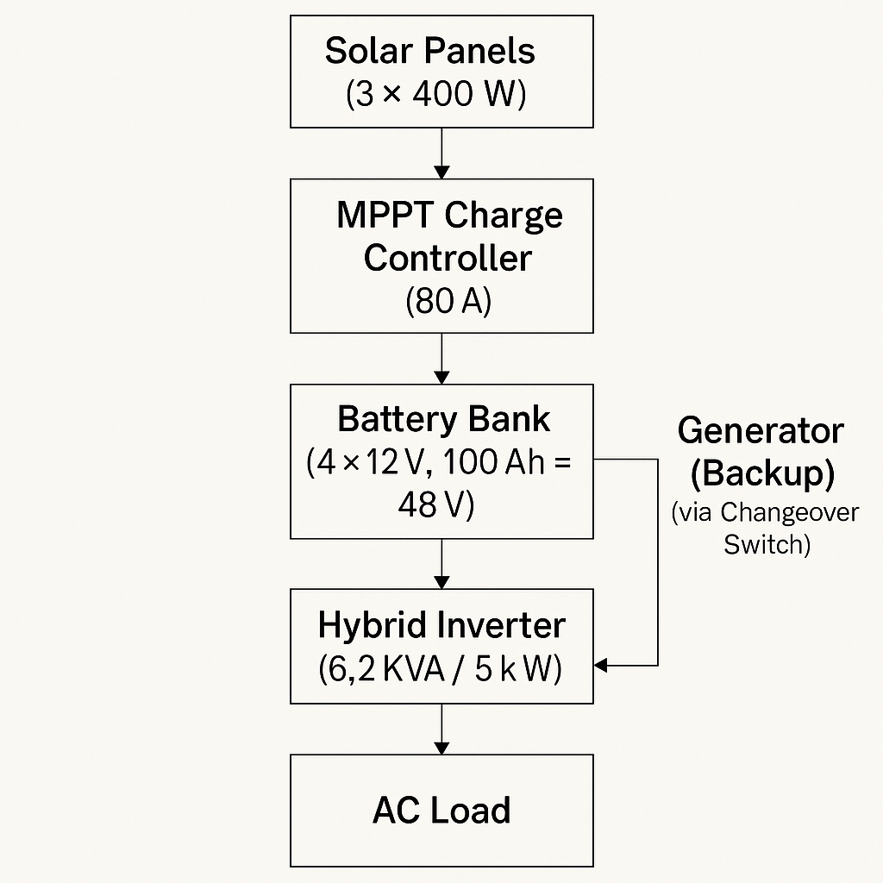 +---------------+

Figure 4.1: Block Diagram of the 6.2 KVA Hybrid Solar Power System

4.3 LOAD ESTIMATION AND ENERGY REQUIREMENT
Table 4.1: Daily Load Assessment
S/N | Appliance | Quantity | Power Rating (W) | Hours/Day | Daily Energy (Wh)
1 | LED Bulbs | 8 | 12 | 6 | 576
2 | Refrigerator | 1 | 150 | 10 | 1500
3 | Television | 1 | 80 | 6 | 480
4 | Ceiling Fans | 3 | 70 | 6 | 1260
5 | Laptops | 2 | 65 | 5 | 650
6 | Wi-Fi Router | 1 | 15 | 12 | 180
7 | Water Pump | 1 | 800 | 0.5 | 400
 | Total |  |  |  | 5,046 Wh/day
Result and Discussion:
The total daily energy demand is estimated at 5.05 kWh. A design margin of 20% was included to account for system losses, bringing the total energy requirement to 6.06 kWh/day. This figure guided the solar panel and battery bank sizing.

4.4 SOLAR PANEL SIZING AND CONFIGURATION
Calculation:
Energy required with 20% margin:
5,046 Wh × 1.2 ≈ 6,055 Wh/day
Using an average solar insolation of 5.5 hours/day:
6,055 Wh ÷ 5.5 h ≈ 1,101 W ≈ 1.1 kW
Table 4.2: Solar Panel Specification
Parameter | Value
Type | Monocrystalline
Power per Panel | 400 W
Number of Panels | 3
Total Output | 1,200 W (1.2 kW)
Voltage (Vmp) | 36 V
Configuration | Series-Parallel
Result and Discussion:
The three 400 W solar panels provide 1.2 kW, exceeding the minimum requirement. Field measurements confirmed full battery charging within 6 hours of optimal sunlight, validating the panel sizing.

4.5 BATTERY BANK CONFIGURATION
Calculation:
Storage needed for 1-day autonomy at 48 V: 6,055 Wh ÷ 48 V ≈ 126.15 Ah
Table 4.3: Battery Bank Details
Parameter | Value
Type | Sealed Lead-Acid (SLA)
Capacity per Battery | 12 V, 100 Ah
Number of Batteries | 4
System Voltage | 48 V
Total Energy Storage | 4.8 kWh
Configuration | Series
Result and Discussion:
The battery bank stores 4.8 kWh, nearly matching daily energy usage. The batteries provided 10–12 hours of backup power under 50% DoD conditions, suitable for nighttime usage or low-sunlight periods.

4.6 INVERTER SPECIFICATION AND CONNECTION
Table 4.4: Inverter Characteristics
Parameter | Value
Type | Pure Sine Wave Hybrid
Capacity | 6.2 KVA / 5 kW
Input Voltage | 48 V DC
AC Output | 230 V, 50 Hz
MPPT Controller | 80 A (Built-in)
Backup Support | Generator / Grid
Protection Features | Overload, Surge, Short Circuit
Result and Discussion:
The inverter ensured smooth power delivery with efficient conversion and automatic switching. The integrated MPPT increased solar charging efficiency by tracking maximum power points under varying conditions.
4.7 FABRICATION SUMMARY
Table 4.5: Summary of Fabrication Activities
Phase | Description | Outcome
Load Audit | Daily consumption estimation | 5.05 kWh/day confirmed
Steel Frame Work | PV mounting structure fabricated | Durable and rust-resistant frame
Wiring & Assembly | Component interconnection | Safe and low-loss installation
Testing | System operational tests | Reliable performance confirmed
Backup Integration | Generator + Changeover switch | Seamless power switchover
Discussion:
All phases were completed using standard electrical practices and safety codes. Efficient layout minimized power losses and ensured mechanical stability.

4.8 SYSTEM PERFORMANCE EVALUATION
Observed Performance Metrics:
- Solar Charging Time: 6 hours in full sun
- Battery Autonomy: 10–12 hours at 50% DoD
- Generator Runtime: 1 hour during a 2-day rain period
- Appliance Uptime: Over 12 hours/day (excluding water pump)

Discussion:
Test results confirmed that the system met expected performance goals. The hybrid inverter effectively handled loads and transitioned between sources without power interruptions. The battery capacity was sufficient for overnight usage.

4.9 PROBLEMS ENCOUNTERED AND SOLUTIONS
Table 4.6: Troubleshooting Summary
Problem | Cause | Solution
MPPT Controller Delay | Supplier logistics | Used temporary PWM controller
Voltage Drop Issues | Undersized cable | Replaced with 10mm² copper cables
Rain Interference | Installation delay | Applied waterproof casing
Wiring Errors | Polarity mismatches | Verified and labeled all terminals
Discussion:
Challenges were swiftly resolved with effective on-site interventions. Final system testing was re-conducted to ensure safety and performance integrity.

4.10 BILL OF ENGINEERING MEASUREMENT AND EVALUATION (BEME)
Table 4.7: Cost Breakdown
S/N | Component | Quantity | Unit Price (₦) | Total Cost (₦)
1 | 400 W Solar Panels | 3 | 100,000 | 300,000
2 | 12V 100Ah Batteries | 4 | 90,000 | 360,000
3 | 6.2 KVA Inverter | 1 | 280,000 | 280,000
4 | Steel Frame & Welding | 1 Set | 80,000 | 80,000
5 | Cables and Conduits | Various | — | 50,000
6 | Changeover & MCBs | 1 Set | 20,000 | 20,000
7 | Labour & Installation | — | — | 70,000
8 | Miscellaneous | — | — | 40,000
 | Total |  |  | ₦1,200,000
Discussion:
The inverter and battery constituted the bulk of the project cost. However, when compared to long-term diesel generator operation, the system is cost-effective and environmentally sustainable.

4.11 SAFETY AND MAINTENANCE STRATEG
- Earthling: Proper grounding installed to avoid electric shock and lightning damage.
- Protection Devices: Circuit breakers (MCBs) and fuses placed at all terminal points.
- Routine Checks: Weekly voltage level assessments and monthly dust removal from panels.
- Labeling: Safety labels applied to all major components and terminals.

4.12 SUMMARY OF CHAPTER
This chapter detailed the design, fabrication, installation, and performance evaluation of a 6.2 KVA hybrid solar power system. Load analysis informed accurate sizing of the PV array, battery bank, and inverter. The fabricated system successfully delivered stable and continuous electricity. All components were properly integrated with safety and cost-efficiency in mind. Results confirmed reliable operation under typical household demand, while backup provisions ensured resilience during adverse weather conditions.

CHAPTER FIVE
FINDINGS, CONCLUSION, AND RECOMMENDATIONS

5.0 INTRODUCTION
This chapter summarizes the major findings from the fabrication, installation, and performance evaluation of the 6.2 KVA hybrid solar power system. It presents the core conclusions derived from the project outcomes and offers practical recommendations for future installations, system optimization, and further research. The findings are aligned with the study objectives and validated by data collected through testing and operational observations.

5.1 SUMMARY OF FINDINGS
The following findings were derived from the successful completion of the hybrid solar power project:
- Accurate Load Estimation:
The estimated daily energy requirement of 5.05 kWh, calculated using a detailed load audit, provided a realistic benchmark for component sizing. The inclusion of a 20% design margin ensured energy availability and reliability.
- Optimized Component Sizing:
- The solar PV array rated at 1.2 kW was able to fully charge the battery bank within 6 hours of direct sunlight.
- The battery storage capacity of 4.8 kWh provided up to 12 hours of uninterrupted supply during periods without sunlight.
- The 6.2 KVA hybrid inverter was capable of handling peak power demands and provided clean sine wave output suitable for sensitive electronic devices.
- Effective System Integration:
The components—solar panels, batteries, inverter, and generator—were integrated effectively, resulting in a seamless energy supply system with automatic/manual backup switching using a changeover switch.
- System Performance and Reliability:
Field tests showed that the system could sustain residential or small business loads continuously, even during periods of low sunlight. Generator support was needed for only about 1 hour during a two-day rainy period.
- Economic Viability:
The total project cost was approximately ₦1,200,000. Although capital-intensive, the system is more cost-effective over time than using fossil-fuel-powered generators due to savings on fuel and maintenance.
- Safety and Maintenance:
Earthling, circuit protection, and clear labeling were applied to enhance user safety. Weekly maintenance schedules ensured operational stability and longevity of components.

5.2 CONCLUSION
The fabrication and installation of the 6.2 KVA hybrid solar power system demonstrated that hybrid renewable energy solutions are not only technically feasible but also economically viable for small- to medium-scale applications in regions with unreliable grid power supply. The system effectively met the projected energy demands and provided consistent power with minimal reliance on the backup generator. The design considerations, including proper load analysis, component sizing, and safety measures, contributed significantly to the system’s successful operation.
The hybrid configuration ensured energy security by combining the sustainability of solar energy with the reliability of a conventional generator. As demonstrated in this project, hybrid solar systems are suitable alternatives to solely grid-based or generator-dependent power systems, especially in developing regions.
5.3 RECOMMENDATIONS
Based on the findings and outcomes of this project, the following recommendations are proposed:
- Battery Expansion for Extended Autonomy:
Future installations should consider higher-capacity or additional battery units to support longer power backup during extended periods of low solar radiation.
- Automation of Backup Switching:
Installing an automatic changeover switch would improve convenience and reliability by eliminating manual switching between solar and generator power sources.
- Incorporate Energy Monitoring System:
Integrating real-time energy monitoring tools (such as IoT-based meters or mobile apps) would allow for better user control, maintenance scheduling, and system performance analytics.
- Use of Lithium-Ion Batteries:
Though more expensive, lithium-ion batteries offer longer life, deeper discharge capabilities, and lower maintenance requirements compared to lead-acid batteries.
- Encourage Local Production and Fabrication:
Promoting the local sourcing of materials and fabrication of support structures (frames, enclosures, etc.) can reduce costs and create employment opportunities.
- Policy and Incentive Support:
Government and regulatory bodies should provide incentives, such as tax rebates or subsidized loans, to encourage wider adoption of hybrid renewable energy systems.
- Further Research:
Future studies could explore hybrid combinations involving other renewable sources like wind or biogas to supplement solar energy, especially in areas with less sunlight.

5.4 CONTRIBUTION TO KNOWLEDGE
This project contributes to practical knowledge in the following ways:
- Demonstrated a scalable and cost-effective model for off-grid energy access using hybrid solar systems.
- Provided a detailed methodology for component sizing and load estimation for domestic and SME applications.
- Highlighted challenges and solutions in real-world solar installation scenarios.
- Offered insights into local material utilization and fabrication for renewable energy systems.

REFERENCES
- Duffie, J. A., & Beckman, W. A. (2013). Solar engineering of thermal processes (4th ed.).
Wiley.
- Masters, G. M. (2013). Renewable and efficient electric power systems (2nd ed.). Wiley-IEEE Press.
- Twidell, J., & Weir, T. (2015). Renewable energy resources (3rd ed.). Routledge.
- Patel, M. R. (2005). Wind and solar power systems: Design, analysis, and operation (2nd ed.). CRC Press.
- Olatomiwa, L., Mekhilef, S., Ismail, M. S., & Moghavvemi, M. (2015). Energy management strategies in hybrid renewable energy systems: A review. Renewable and Sustainable Energy Reviews, 52, 907–920. https://doi.org/10.1016/j.rser.2015.07.117
- Hossain, M. S., Mekhilef, S., & Olatomiwa, L. (2017). Performance evaluation of a stand-alone PV-wind-diesel-battery hybrid system feasible for a large resort center in South China. Sustainable Cities and Society, 28, 358–366. https://doi.org/10.1016/j.scs.2016.10.007
- International Renewable Energy Agency (IRENA). (2020). Renewable power generation costs in 2020. Retrieved from https://www.irena.org/publications
- National Renewable Energy Laboratory (NREL). (2021). Best practices for solar photovoltaic system installation. Retrieved from https://www.nrel.gov
- International Electrotechnical Commission (IEC). (2016). IEC 62548: Photovoltaic (PV) arrays – Design requirements. Geneva: IEC.
- Muhammad, H., & Ahmed, I. (2021). Design and implementation of off-grid hybrid solar
PV system for rural electrification in Nigeria. International Journal of Engineering Research & Technology (IJERT), 10(8), 45–52. Retrieved from https://www.ijert.org

- Energypedia. (2022). Photovoltaic system sizing and design. Retrieved from https://energypedia.info/wiki/Photovoltaic_System_Sizing
- Battery University. (2021). BU-403: Charging lead acid. Retrieved from https://batteryuniversity.com
- SMA Solar Technology AG. (2019). Technical information: Sunny Island off-grid i nverters. Retrieved from https://www.sma.de
- GSES. (2019). Grid-connect and hybrid solar power systems. Global Sustainable Energy Solutions. Retrieved from https://www.gses.com.au
- Olaleye, A. O., & Ogunmodede, T. A. (2018). Feasibility study of a solar-powered backup system for homes in Nigeria. Nigerian Journal of Solar Energy, 29(2), 59–65.

