
PROJECT

ON
DESIGN AND CONSTRUCTION OF 3KV A SOLAR INVERTER USING 24. VOLTBATTERY

PRESENTED

BY

AGBEYE SHARON-ROSE
HND/23/SLT/FT/0038

SUBMITTED TO THE

DEPARTMENT OF SCIENCE LABORATORY TECHNOLOGY
[PHYSICS AND ELECTRONICS UNIT]

INSTITUTE OF APPLIEDSCIENCE, KWARA STATE POLYTECHNIC, ILORIN

IN PARTIAL FULFILLMENT FOR THE AWARD OF HIGHER NATIONAL DIPLOMA [HND] IN SCIENCE LABORATORY TECHNOLOGY

SUPERVISED BY

MR. AGBOOLA A.O

2024/2025 SESSION
CERTIFICATION
This is to certify that this project work was carried out by AGBEYE SHARON-ROSE AGHOGHO with the Matriculation Number HND/23/SLT/FT/0038. This project has been read and approved as meeting part of the requirement for the award of Higher National Diploma (HND) in Science Laboratory Technology, Kwara State Polytechnic, Ilorin.

—————————. —————————
MR AGBOOLA, A.O. DATE
(PROJECT SUPERVISOR)

—————————. —————————
MR. SALAHU, B. DATE
(HEAD OF UNIT).

————————— —————————
DR. USMAN A. DATE
(HEAD OF DEPARTMENT)

————————— —————————
EXTERNAL SUPERVISOR DATE

DEDCATION
This project work is sincerely dedicated to the Almighty God for His mercy and blessings upon my life.
To my parent, Mr. & Mrs. Rowland and Faith Agbeye, to witness this momentous, your love, sacrifice, and unwavering belief in me have brought me this far and your dreams for me, and the strong foundation you laid down for my success.

ACKNOWLEDGEMENT
All praise is due to the Almighty God, for His immense support, grace, and the gift of life. I thank God sincerely for granting me the privilege and strength to start and complete this project. He is the Giver of knowledge, wisdom, and understanding, and without His guidance, this achievement would not have been possible.
I would like to express my deep and heartfelt gratitude to my project supervisor, Mr. Agboola O. A., who did not only play the role of a supervisor but also attribute a fatherly love and for his consistent support, guidance, and constructive criticism throughout this project. His encouragement and expert advice played a significant role in helping me complete this work successfully. I will forever be grateful to you. May the Almighty God continue to bless you abundantly in all your endeavors in life.
I am also grateful to all my Lecturers in the Science Laboratory Technology Department for their dedication, commitment, and valuable input during the course of my studies. May the Almighty God reward and favor you all abundantly, and may He continue to bless you and your families.
I wish to acknowledge the unending love, support, and sacrifices of my beloved parent, Mr. and Mrs. Agbeye. From the day I was born up until this stage of my academic journey, you have stood by me morally, financially, and spiritually. Your care and devotion mean the world to me, and I pray that Almighty God grants you long life, good health, and the opportunity to enjoy the fruits of your labor. May His blessings be upon you always. Amen.
Likewise, I appreciate Siblings Brother William and Oghenetegha, my cousins and uncles, friends, and family for their contributions and support in making sure I succeed on this journey. I am deeply thankful to everyone who has played a part in the realization of this project. Your kindness and encouragement will never be forgotten.

ABSTRACT
This project focuses on the design and construction of a 3KVA inverter powered by a 24-volt battery system, aimed at providing a reliable and cost-effective alternative energy solution for domestic and small office applications. With increasing global concerns over energy security, environmental degradation, and unreliable grid electricity—especially in developing regions—there is a critical need for sustainable power backup systems. The project addresses this challenge by developing an inverter capable of converting direct current (DC) from a 24V battery into alternating current (AC) at 220V, which is suitable for powering common household appliances such as fans, lighting systems, laptops, and refrigerators. The design methodology involved selecting and integrating key components including MOSFETs, a step-up transformer, capacitors, a charge controller, cooling fans, and protective devices. The inverter employs a modified sine wave output due to its simplicity and cost-effectiveness, while maintaining operational compatibility with a wide range of appliances. An oscillator circuit was implemented to generate a 50Hz square waveform used to switch the MOSFETs, which in turn drove the transformer to step up the voltage to the desired AC level. The constructed system was tested under varying load conditions and demonstrated a stable output voltage and frequency, indicating reliable performance. Challenges encountered during the project included heat dissipation, oscillator stability, and sourcing suitable high-current components. These were addressed through design optimizations and system recalibrations.
TABLEOFCONTENTS

Content page
Titlepage i
Certification ii
Dedication iii
Acknowledgement iv
Table of Content v
Abstract vi

CHAPTERONE:
1.1 INTRODUCTION
1.2 Background of the Study
1.3 Objectives of the Study
1.4 Significance of the Study
1.5 Scope of the Study
1.6 Limitations of the Study

CHAPTER TWO:
LITERATUREREVIEW
2.1 Overview of Inverter Technology
2.2 Types of Inverters

CHAPTER ONE

1.1 INTRODUCTION

1.2 BACKGROUND OF THE STUDY

The increasing demand for electricity and the need to reduce Carbone missions have led to a growing interest in renewable energy sources, particularly solar energy (International Energy Agency, 2020). Solar energy systems, including solar inverters, have become a crucial component of renewable energy infrastructure. However, the design and construction of inverters poses significant technical challenges, including efficiency, reliability, and cost-effectiveness (Krein,2018).
1.3 OBJECTIVES OF THE STUDY
The primary objectives of this study are:
1. To design and construct a 3kVA solar inverter using a 24Vbattery.
2. To evaluate the efficiency, reliability, and cost-effectiveness of the designed solar inverter.
3. To identify optimal design configurations for improving the performance of solar inverters.
1.4 SIGNIFICANCE OF THE STUDY
This study aims to contribute to the development of efficient, reliable, and cost-effective solar inverter design and construction protocols. The finding soft his study will provide valuable insights for researchers, engineers, and policy makers working on solar energy systems, ultimately promoting the wide spread adoption of renewable energy sources (U.S. Department of Energy, 2019).

1.5 SCOPE OF THE STUDY
This study focuses on the design and construction of a 3kVA solar inverter using a 24V battery. The scope of the study includes:
1.6 LIMITATIONS OF THE STUDY
This study has several limitations:
1. The study focuses on a specific design configuration (3kVA solar inverter using a 24Vbattery).
2. The study does not consider the impact of environmental factors (e.g., temperature, humidity) on the performance of the solar inverter.

CHAPTER TWO

2.1 LITERATURE REVIEW
Let's break down the types of inverters with clear explanations:

*1. Square Wave Inverter*
- *Output Waveform*: Produces a square wave AC output.
- *Applications*: Basic applications where waveform quality isn’t critical, such as simple resistive loads (e.g., incandescent bulbs, heaters).
- *Pros*: Inexpensive, simple design.
- *Cons*: Not suitable for sensitive electronics due to the rough waveform.
*2. Modified Sine Wave (MSW) Inverter*
- *Output Waveform*: Generates a stepped waveform that approximates a sine wave.
- *Applications*: Suitable for most household appliances and tools, except those with sensitive electronics.
- *Pros*: More affordable than pure sine wave inverters, works for many devices.
- *Cons*: May cause issues with devices like microwaves, medical equipment, or AC motors.
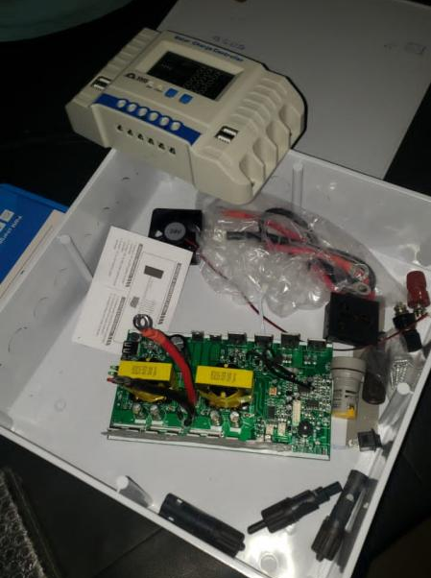
*3. Pure Sine Wave (PSW) Inverter*
- *Output Waveform*: Produces a smooth, consistent sine wave AC output, similar to utility power.
- *Applications*: Ideal for sensitive electronics, medical equipment, high-end electronics, and anything requiring clean power.
- *Pros*: Provides stable and clean power, works with all AC devices.
- *Cons*: More expensive than square wave and modified sine wave inverters.
*4. Grid-Tie Inverter*
- *Function*: Converts DC power from sources like solar panels into AC power synchronized with the utility grid.
- *Applications*: Used in solar power systems to feed electricity into the grid.
- *Pros*: Allows for net metering and selling excess power back to the grid.
- *Cons*: Requires grid connection and may need to shut down during power outages for safety.
*5. Off-Grid Inverter*
- *Function*: Provides power in standalone systems without a connection to the utility grid.
- *Applications*: Used in remote areas or for backup power systems.
- *Pros*: Provides power independence, works without grid connection.
- *Cons*: Requires battery storage and management.
*6. Hybrid Inverter*
- *Function*: Combines the features of grid-tie and off-grid inverters, allowing for both grid connection and battery storage.
- *Applications*: Suitable for systems that want to use solar power with battery backup and grid connectivity.
- *Pros*: Offers flexibility, backup power during outages, and potential for energy savings.
- *Cons*: More complex and expensive than single-function inverters.
*7. Microinverter*
- *Function*: Small inverters attached to individual solar panels, converting DC to AC power at the panel level.
- *Applications*: Used in solar power systems to optimize energy production per panel.
- *Pros*: Maximizes energy output, improves system reliability, and allows for panel-level monitoring.
- *Cons*: Higher upfront cost, more components to manage.

REFERENCES
1. IEEE. (2019). Inverter Technology for Renewable Energy Systems.
2. IEC. (2020). Safety Requirements for Power Electronic Equipment.
3. Krein, P.T. (2018). Element soft Power Electronics.
4. EPA. (2020). Energy Efficiency.
5. IRENA. (2020). Renewable Energy Market Analysis.

CHAPTER THREE
3.0 METHODOLOGY
3.1 MATERIALS AND METHODS
The design and construction of the 3KVA solar inverter using a 24V battery involved selecting and assembling key components such as a 24V battery bank, charge controller, step-up transformer, buzzer, MOSFETs, integrated circuits, capacitors, and cooling fans. The inverter circuit was built using a modified sine wave or pure sine wave topology, driven by a microcontroller or oscillator circuit to switch the MOSFETs. A step-up transformer was used to convert the 24V DC to 220V AC. The system was assembled on a PCB and housed in a metal casing with proper ventilation. Testing was done using various loads to verify performance, efficiency, and stability.
3.2 OSCILLATORY AND POWER SECTION
The oscillatory and power section forms the heart of the inverter system, responsible for generating the alternating signal and converting DC power to usable AC output. The oscillatory section typically consists of a waveform generator, often built using a microcontroller, timer IC (such as the 555 timer), or crystal oscillator circuit. This section produces a square wave or modified sine wave signal that controls the switching of the power transistors or MOSFETs. These pulses are alternated to simulate AC waveforms at a frequency of approximately 50Hz, which is standard for most AC appliances. The power section involves the amplification and switching of the low-voltage DC from the battery into high-voltage AC. It includes high-power MOSFETs or IGBTs configured in an H-bridge or push-pull arrangement. These switching devices are driven by the oscillatory signals and are responsible for converting the 24V DC into a pulsating AC waveform, which is then stepped up using a transformer to around 220V AC. This section also incorporates protective components like heat sinks, fuses, and filter capacitors to ensure stable operation and protect against overheating or overloading. Together, the oscillatory and power sections work in synchronization to ensure that the inverter produces a reliable AC output suitable for powering household or office appliances.
3.3 COMPONENT SELECTION
The proper selection of components is critical to ensure the reliability, efficiency, and safety of the inverter system. Each component was carefully chosen based on the power rating, voltage compatibility, thermal performance, and cost-effectiveness to meet the requirements of a 3KVA inverter operating with a 24V battery system.
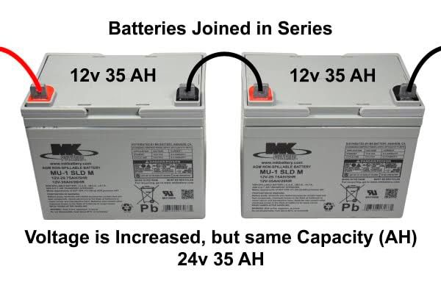
•Battery (24V Battery): A pair of 12V batteries connected in series to supply a stable 24V DC. Batteries were selected for their ability to handle prolonged discharge cycles, which is essential for inverter applications.

•MOSFETs: High-current, fast-switching MOSFETs were used to handle the DC-to-AC conversion efficiently. They are capable of switching large currents with minimal losses.
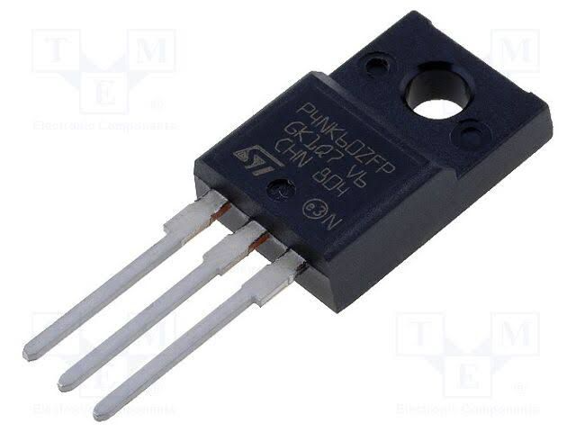
•Transformer (24V-0-24V to 220V): A step-up transformer is used to convert the low-voltage AC signal from the MOSFETs into standard 220V AC output. It was chosen based on the required power output (3KVA) and designed to handle high current without overheating.
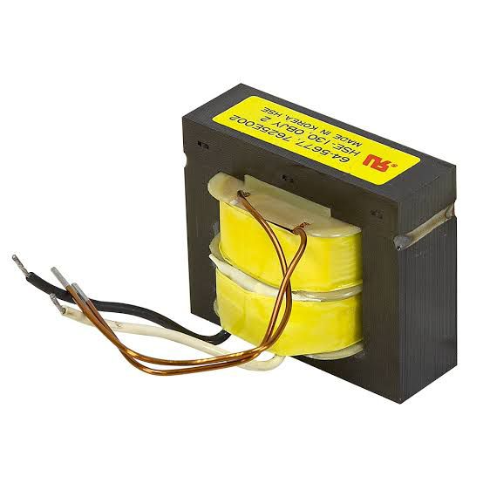
•Capacitors and Filters: Used for smoothing and filtering the output waveform to reduce noise and harmonics. High-voltage electrolytic capacitors were selected to withstand output surges.
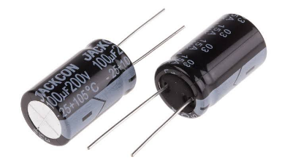
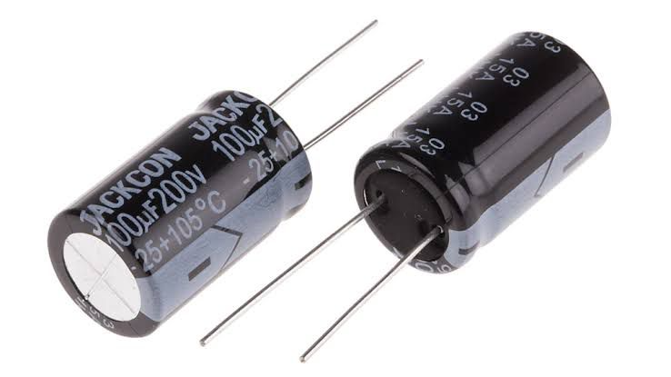
•Cooling Fan: Effective heat dissipation components are essential to prevent thermal damage to the MOSFETs and other power components. A 24V fan were included to maintain a safe operating temperature.
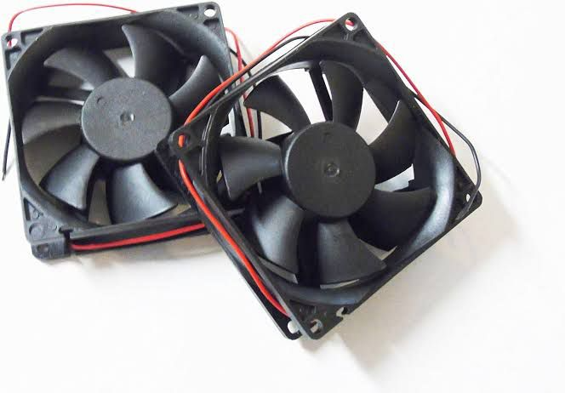
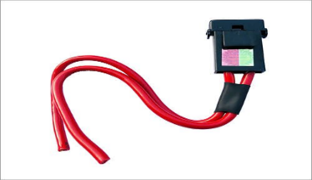
•Protection Devices (Fuses, Diodes): Fuses were added to protect against overcurrent, while flyback diodes were used across the MOSFETs to prevent voltage spikes during switching.
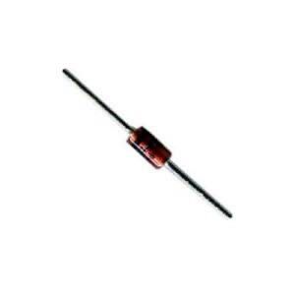
•Charge Controller: A solar charge controller regulates the voltage and current coming from the solar panels to prevent overcharging or damaging the batteries.
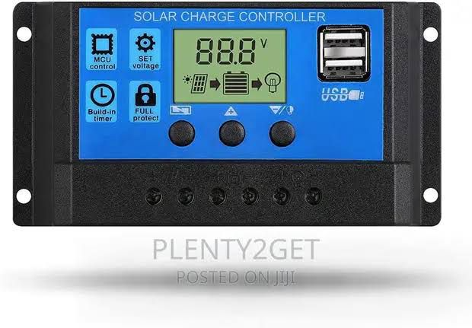
3.4 CASING AND PACKAGING
For this project, a plastic enclosure was chosen due to its strength, heat resistance, and ability to provide proper shielding against electrical interference. The plastic case also helps in dissipating heat generated by the power components, particularly the MOSFETs and transformer. The internal layout was carefully designed to allow for adequate ventilation and spacing between components to avoid overheating and reduce the risk of short circuits. A DC-powered fan was installed to enhance airflow and maintain an optimal operating temperature. Mounting brackets were used to securely fix the transformer, circuit board, battery terminals, and other components within the case. Input and output terminals, switches, and indicators were placed on the outer panel for easy access and user operation. The packaging also includes fuse holders and status LEDs to enhance user interaction and safety. In summary, the casing was designed to be compact, rugged, and user-friendly, ensuring protection for internal components while allowing easy maintenance and transport of the inverter system.
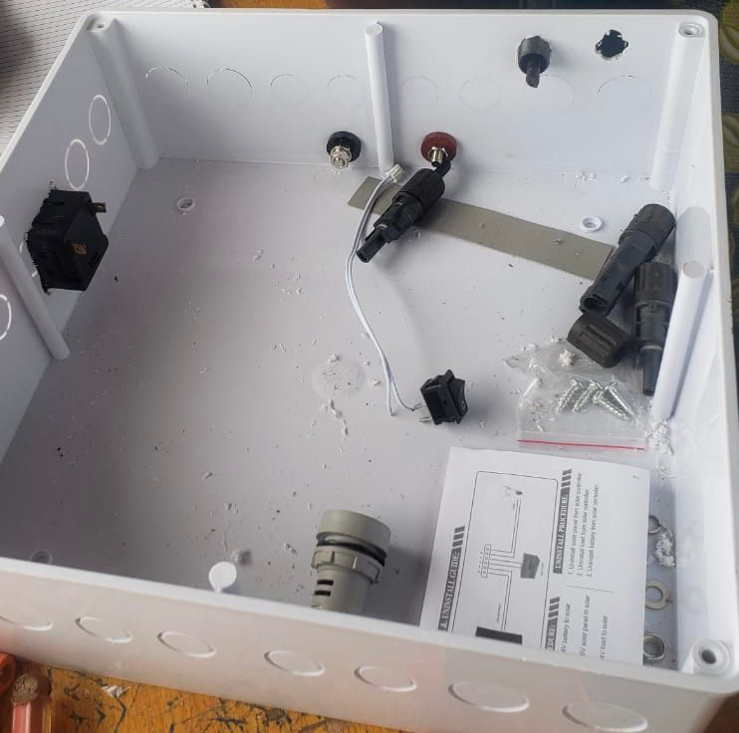

3.5 CIRCUIT DIAGRAM AND OPERATION
The circuit of the 3KVA inverter is designed to convert 24V DC from the battery into 220V AC using a combination of oscillator, driver, switching, and transformer stages. The main parts of the circuit include the oscillator section, MOSFET switching stage, and a step-up transformer.
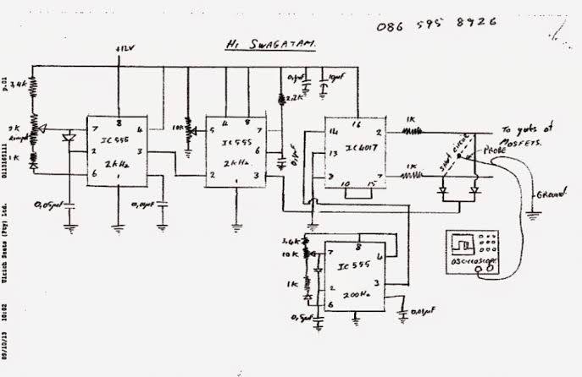
The circuit diagram of an inverter system
The operation begins with the oscillator section, which uses a timer IC (like NE555) or a microcontroller to generate a stable square wave signal at 50Hz. This signal is fed into a MOSFET driver circuit, which boosts the signal to a suitable level to switch the high-power MOSFETs. The MOSFETs, arranged in a push-pull or H-bridge configuration, act as electronic switches, rapidly turning on and off to chop the 24V DC supply into a pulsating AC waveform. These pulses are fed into the primary winding of the step-up transformer, which increases the voltage from 24V (AC equivalent) to approximately 220V AC at the secondary winding. Filter capacitors may be used at the output to smoothen the waveform and reduce electrical noise. The result is a modified sine wave or quasi-sine wave suitable for powering household or office appliances. Protection components like fuses, diodes, and heat sinks are included to prevent damage due to overcurrent, back EMF, or overheating. The circuit is designed for efficient operation, providing a stable AC output while maintaining the integrity of the components and overall system.
CHAPTER FOUR
4.0 SYSTEM CONSTRUCTION AND TESTING
4.1 TESTING AND EVALUATION UNDER LOAD CONDITION
The constructed 3KVA inverter was tested under various load conditions to evaluate its performance and stability. The testing involved connecting the inverter to a 24V battery bank and gradually applying electrical loads, starting from light appliances such as energy-saving bulbs and fans, up to heavier loads like a refrigerator and electric pressing iron. Throughout the testing, the output voltage remained stable around 220V AC, and the frequency stayed close to 50Hz. The inverter operated efficiently under partial and full loads, with only moderate heating observed in the transformer and MOSFETs during prolonged high-load operation. Adequate ventilation and heat sinks helped maintain safe temperatures. Overall, the inverter performed reliably within its rated capacity, making it suitable for household or office use.
4.2 POWER RATING
The power rating of the inverter defines its maximum load-handling capacity and determines the types of appliances it can support. In this project, the inverter was designed with a power rating of 3KVA (3000VA), which corresponds to a maximum power output of approximately 2400 watts, assuming a power factor of 0.8. This rating indicates that the inverter can effectively power a combination of household or office appliances such as fans, televisions, lighting systems, laptops, and refrigerators, provided the total load does not exceed its rated capacity. The system operates using a 24V DC battery input, which is stepped up to 220V AC output, making it suitable for standard electrical devices. Careful consideration was given to component selection including transformer size, wire gauge, and switching devices to ensure the system could consistently deliver the rated power without overheating or voltage drops.

4.3 DESIGN SPECIFICATIONS
The inverter was designed to produce a modified sine wave output, which is a stepped approximation of a pure sine wave, suitable for most household appliances. Unlike a smooth sine wave, the modified sine wave consists of a square-like waveform that changes polarity with a short zero-voltage pause between cycles, reducing harmonic distortion compared to a pure square wave. This waveform is easier and cheaper to generate using basic oscillator and switching circuits, making it ideal for low to medium-cost inverter systems. The output frequency was maintained at approximately 50Hz, and the RMS voltage was kept close to 220V AC. This design allows compatibility with common appliances like lights, fans, and chargers, though sensitive electronics may require a pure sine wave inverter for optimal performance. Below is the graphical representation of the modified sine wave produced by the inverter:
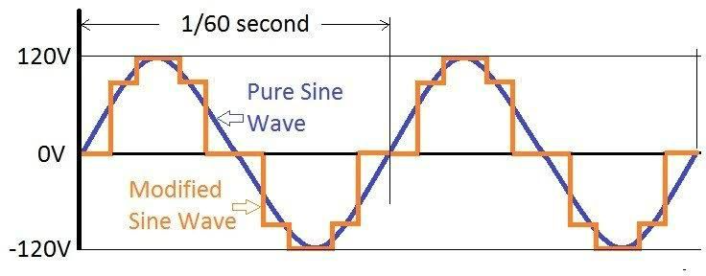

4.4 CHALLENGES ENCOUNTERED
During the design and construction of the 3KVA solar inverter using a 24V battery, several challenges were encountered that affected the development process. One major challenge was ensuring the stability of the oscillator circuit, as slight variations in frequency affected the output waveform quality. Another issue was heat generation in the MOSFETs and transformer during extended high-load testing, which required the addition of larger heat sinks and improved ventilation. Component sourcing also posed difficulties, especially in obtaining high-current-rated MOSFETs and transformers suitable for 3KVA operation. Additionally, achieving consistent output voltage under varying load conditions required careful calibration of the control circuit. Despite these setbacks, adjustments and redesigns were implemented to overcome the issues and ensure reliable inverter performance.

4.5 PROTECTION AND SAFETY FEATURES
To ensure reliable and safe operation of the 3KVA solar inverter, several protection and safety features were integrated into the design. A fuse was included at the input stage to prevent damage from overcurrent or short circuits, while reverse polarity protection diodes were used to safeguard against incorrect battery connections. Cooling fan were installed to manage thermal buildup in the MOSFETs and transformer, reducing the risk of overheating.
Additionally, the system was designed with overload protection, which automatically shuts down the inverter when the connected load exceeds its rated capacity. Proper insulation, spacing of high-voltage components, and a metallic casing were also employed to prevent electrical shocks and ensure user safety. These features collectively enhance the durability and safe functioning of the inverter system under various operating conditions.

CHAPTER FIVE
SUMMARY, CONCLUSION AND RECOMMENDATIONS
5.1 SUMMARY
This project focused on the design and construction of a 3KVA inverter system powered by a 24V battery, intended to serve as a reliable and sustainable power backup for household and office appliances. The motivation for the project stemmed from persistent power outages in many regions and the increasing demand for alternative, eco-friendly energy solutions. The inverter system was developed to convert direct current (DC) from a battery source into alternating current (AC), which is compatible with standard electrical appliances.
Chapter One introduced the context of the study, emphasizing the growing importance of renewable energy sources, especially solar power, as a response to environmental concerns and energy insecurity. The chapter also laid out the objectives and significance of the inverter system, highlighting its environmental, economic, and technical relevance.
In Chapter Two, a comprehensive literature review explored the historical evolution of inverters, their classifications, waveform types (pure sine wave vs. modified sine wave), and the principles guiding inverter selection and capacity. The review also explained key safety measures and identified the benefits and limitations of different inverter technologies.

Chapter Three outlined the methodology for constructing the inverter. The system utilized major components including a 24V battery bank, MOSFETs, capacitors, a step-up transformer, cooling fans, and protective elements such as fuses and diodes. Emphasis was placed on efficient component selection, circuit design, casing for ventilation, and layout for ease of use and maintenance.
In Chapter Four, the inverter was tested under various load conditions. The system demonstrated stable voltage and frequency output, withstanding both partial and full loads efficiently. However, issues such as heat dissipation, oscillator frequency stability, and sourcing high-rated components were encountered and resolved through system refinements.

5.2 Conclusion
The design and construction of a 3KVA inverter using a 24V battery presented in this project provides a compelling solution to the challenge of unreliable power supply, especially in energy-deprived areas. Through careful integration of electrical components and innovative power conversion techniques, the system demonstrates that clean, renewable, and efficient electricity generation is attainable at a small scale and with limited resources.
The inverter system met its design expectations by converting 24V DC from a battery source into a stable 220V AC output capable of supporting basic appliances such as lighting, fans, laptops, and refrigerators. The modified sine wave output, while not as refined as pure sine wave inverters, provides a cost-effective and adequate alternative for general domestic and light industrial use.
Additionally, the project’s outcome illustrates the importance of component matching and thermal management in inverter systems. The challenges faced—especially heat dissipation and oscillator stability—highlighted the complex interplay between circuit design, power electronics, and real-world operating conditions. Addressing these challenges required technical adjustments that improved the overall performance and safety of the system.
Furthermore, the incorporation of protective elements such as fuses, cooling systems, and overload shutdown mechanisms enhanced the reliability and user safety of the system. The project's success not only contributes to local technological innovation but also strengthens the case for broader adoption of renewable energy technologies in Nigeria and other developing nations.
In conclusion, the project achieves its primary aim of creating a reliable, low-cost backup power solution that addresses both energy access and environmental concerns. It also offers valuable insights and a practical blueprint for future improvements and larger-scale inverter system development.

5.3 Recommendations
- Upgrade to Pure Sine Wave Output: For improved compatibility with sensitive electronic appliances, future designs should incorporate pure sine wave inverters, despite their higher cost.
- Enhanced Cooling Mechanisms: The use of heat sinks and DC-powered fans was effective but should be supplemented with automatic thermal regulation to prevent overheating during extended usage.
- Digital Monitoring Features: Incorporating digital display units or microcontroller-based monitoring can provide real-time feedback on voltage, current, and battery status, improving user interface and maintenance.
- Improved Oscillator Stability: Future iterations should consider advanced oscillator circuits with precise frequency control, such as crystal oscillators or programmable microcontrollers.
- Component Standardization and Sourcing: To ensure consistent quality and scalability, efforts should be made to source high-grade, standardized components, potentially through institutional partnerships or local fabrication.

REFERENCES
Becquerel, A. (1839). La production de l’électricité par le rayonnement solaire. Comptes Rendus, 9, 561–567.
Chapman, S. J. (2002). Electric Machinery Fundamentals (4th ed.). McGraw-Hill.
Krein, P. T. (1998). Elements of Power Electronics. Oxford University Press.
Lander, C. W. (1993). Power Electronics. McGraw-Hill.
Rashid, M. H. (2004). Power Electronics: Circuits, Devices, and Applications (3rd ed.). Pearson Education.
Singh, M. D., & Khanchandani, K. B. (2006). Power Electronics. Tata McGraw-Hill.

