DESIGN AND IMPLEMENTATION OF AUTOMATED CAR PARKING SYSTEM

BY
ATOYEBI MUTIYAT OLAITAN
HND/23/COM/FT/328

A Project Submitted to the Department of Computer Science,
Institute of Information and Communication Technology,
Kwara State Polytechnic, Ilorin

In Partial Fulfilment of the Requirements for the Award of Higher National Diploma (HND) in Computer Science

July, 2025
CERTIFICATION
This is to certify that this project research was carried out by ATOYEBI Mutiyat Olaitan with Matric number HND/23/COM/FT/328, has been read and approved as meeting part of the requirements for the award of Higher National Diploma (HND) in Computer Science.

___________________ ________________
MR. SAKA T.O Date
Project Supervisor

___________________ ________________
MR. OYEDEPO, F. S. Date
Head of Department

___________________ ________________
External Examiner Date

ii
DEDICATION
This project is dedicated to the creator of the earth and universe, the Almighty God. It is also dedicated to my parents for their moral and financial support.

iii
ACKNOWLEDGEMENT
All praise is due to the Almighty God the Lord of the universe. I praise Him and thank Him for giving me the strength and knowledge to complete my HND programme and also for my continue existence on the earth.
I appreciate the utmost effort of my supervisor, Mr. Saka T. O., whose patience support and encouragement have been the driving force behind the success of this research work. She gave useful corrections, constructive criticisms, comments, recommendations, advice and always ensures that an excellent research is done. My sincere gratitude goes to the Head of the Department and other members of staff of the Department of Computer Science, Kwara State Polytechnic, Ilorin, for their constant cooperation, constructive criticisms and encouragements throughout the programme.
Special gratitude to my parents who exhibited immeasurable financial support, prayers and understanding during the periods in which I was undergoing my studies. Special thanks go to all my lovely siblings.
My sincere appreciation goes to my friends and classmates.

iv

TABLE OF CONTENTS
Title Page i
Certification ii
Dedication iii
Acknowledgements iv
Table of Contents v - vi
CHAPTER ONE: GENERAL INTRODUCTION
  - Background to the Study 1 - 2
  - Statement of the Problem 2
  - Aim and Objectives of the Study 2
  - Significance of the Study 2 - 3
  - Scope of the Study 5
  - Organization of the Report 4
CHAPTER TWO: LITERATURE REVIEW
2.1 Review of Related Works 5 - 8
CHAPTER THREE:
RESEARCH METHODOLOGY AND ANALYSIS OF THE EXISTING SYSTEM
  - Research Methodology 9
  - Analysis of the Existing System 9
  - Problems of the Existing System 9 - 10
  - Description of the Proposed System 10
  - Advantages of the proposed system 10
  - Analysis of the proposed System 10
v
CHAPTER FOUR: DESIGN, IMPLEMENTATION AND DOCUMENTATION OF THE SYSTEM
  - Design of the System 11
    - Output Design 11 - 12
    - Input Design 13- 14
    - Database Design 14 - 15
    - Procedure Design 15
  - Implementation of the System 15
    - Choice of Programming Language 15
    - Hardware Requirement 16
    - Software Requirement 16
    - Implementation Technique 16
  - Documentation of the System 16
  - Operating the System 17
  - Maintaining the System 17
CHAPTER FIVE: SUMMARY, CONCLUSION AND RECOMMENDATION
  - Summary 18
  - Conclusion 18 - 19
  - Recommendation 19
References 20- 21

vi
CHAPTER ONE
1.0 INTRODUCTION
1.1 BACKGROUND OF THE STUDY
Due to the increasing number of vehicles caused by rapid population growth in urban areas, the demand on parking infrastructure for the general public has increased significantly (Polycarpou et al., 2021). As Polycarpou et al. (2019) further points out, finding a free parking space in urban cities especially during peak hours is more or less impossible, in many cases. Looking for a vacant parking lot in a busy city like Helsinki, at a peak hour is a nightmare to drivers. They have to drive around looking for a free parking spot, something that is believed to increase traffic congestion (Chinrungrueng et al., 2021; Srikanth et al., 2020; Geng et al., 2022). The cycling around not only frustrates drivers but also increases the average consumption of gas and hence the air pollution (Chinrungrueng et al., 2019) oking for a free spot in a busy city, the likelihood of causing an accident is higher. Another challenge is associated with paying for the parking, most of the time, the machines from which to get the payment ticket are located some distance from the car. The ticket machines too, present some complications since they are not the same; some machines take only coins or coins plus credit/debit cards or only credit/debit cards. The situation looks like drivers have to prepare for the possibility of any of the above type of ticket machines. Smart parking is a vehicle parking system that aid drivers to identify empty parking lots (Pcmag, 2019). The smart parking system also includes the means of calculating and paying for the time spent in the parking lot. The idea behind such arrangement is that, the system allocates a parking space and automates the payment for the parked time (Revathi et al. 2022). In addition to establishing the location of vacant parking space and payment for the parking, the system could also include the management of parking permits. Currently, the parking permits are hard copies and digitizing them would be a value addition and a further utilization of the system.
Now, days in many multiplex systems there is a severe problem for car parking space. There are many lanes for car parking, so to park a car one has to look for the all lanes. Moreover there is a lot of men labour involved for this process for which there is lot of investment. So the need is to develop a system which indicates directly which parking slot is vacant in any lane. The project involves a system including infrared transmitter and receiver in every lane and a LED and LCD display outside the car parking gate. So the person entering parking area can view the LED display and can decide which lane to enter so as to park the car.
Conventionally, car parking systems does not have any intelligent monitoring system. Parking lots are monitored by human beings. All vehicles enter into the parking and waste time for searching for parking slot. Sometimes it creates blockage. Condition become worse when there are multiple parking lanes and each lane have multiple parking slots. Use of automated system for car parking monitoring will reduce the human efforts. Display unit is installed on entrance of parking lot which will show LEDs for all Parking slot and for all parking lanes. Empty slot is indicated by the respective glowing LED.
1.2 STATEMENT OF THE PROBLEM
There is always a problem of parking of cars in public places such as worship places, markets place, government houses, etc. so to park a car one has to look for all the lanes which wastes time and energy to do such. In some places lot of men are hired to carry out the assignment which costs huge amount of money to pay them. So the need is to develop a system which indicates directly which parking slot is vacant in any lane, this device was invented to solve or perform this function.
1.3 AIM / OBJECTIVES OF THE PROJECT
The aim of this project is to solve these problems of car parking using automatic car parking slot indicator using microcontroller. The microcontroller serves as a programming tool to run the whole operation, to reduce the cost in terms of requirement such as job opportunity and to increase security. Moreover, this system is faster, flexible and can meet market needs. The system also has software which fulfils the following objectives:
1.4 THE SIGNIFICANCE OF THE PROJECT
It will enable the drivers at the exit gate to enter if there is any empty space in the parking and disable them to enter when there is no empty space. It will manage the main parking spaces by alerting the drivers if there are spaces to park in or not. It will provide an automated system that whenever there is no space no one can access the parking and when there is space drivers can access the parking.
In terms of money, this project has two things in general; namely: It will reduce the number of people needed at the gate to guide drivers.
It will provide a way of getting money for any institution that has this system because it can be put on the market and people use it for their interest like in a commercial sector where an institution has movement of clients that have vehicles and the institution cannot support them at the same time; hence this automated system can be a solution.
1.5 SCOPE OF THE PROJECT
In the project Car Parking System we have shown the concept of an automatic car parking system. As in the modern world everything is going automatic, we have built a system which will automatically sense the entry and exit of cars through the gate and then display the number of cars in the parking lot. Even we can set a maximum capacity of cars by the help of user interface given in the hardware in the form of switches so that there is no congestion. We have deployed a microcontroller used to sense the movement of cars and check whether there is a capacity for cars to park, then decide the gate either opens or not. It is also possible to open a gate when any car enters in the parking lot or close the door when a car exits from it.
There are two sets of sensors: one is installed on the first gate (entry gate) and the other is installed on another gate (exit gate). When a car arrives at the door, the microcontroller receives the signal from the entry sensors and then checks whether there is a space for the car to be accommodated. Simultaneously, it will display the number of cars present in the parking lot on a LCD screen and opens the gate if there is a space for the car to park. When a car moves out of the parking area, the microcontroller reduces the count displayed on the LCD accordingly and then closes the gate. The sensing of entry and exit of cars is done through infrared transmitters and receivers. Before the door the infrared transmitter is mounted on one side and the receiver is placed directly against the transmitter across the door. When a car arrives, the infrared beam is blocked by the car and the receiver is devoid of infrared rays and its output changes. This change message is sent to the microcontroller and accordingly it increases the count and opens the door if there is some empty position. The procedure for the exit of cars is much similar to that of entry.

1.6 ORGANIZATION OF THE REPORT
The work is organized as follows:
CHAPTER ONE: discuss the introductory part of the work, chapter two presents the literature review of the study, chapter three describes the methods applied, chapter four discusses the results of the work, chapter five summarizes the research outcomes and the recommendations.
CHAPTER TWO: The chapter one of this work has been displayed above. The complete chapter two of design and construction of an intelligent car parking system is also available. Orders full work to download. Chapter two of design and construction of an intelligent car parking system consists of the literature review. In this chapter all the related work on design and construction of an intelligent car parking system was reviewed.
CHAPTER THREE: The complete chapter three of design and construction of an intelligent car parking system is available. Orders full work to download. Chapter three of design and construction of an intelligent car parking system consists of the methodology. In this chapter all the method used in carrying out this work was discussed.
CHAPTER FOUR: The complete chapter four of design and construction of an intelligent car parking system is available. Orders full work to download. Chapter four of design and construction of an intelligent car parking system consists of all the test conducted during the work and the result gotten after the whole work
CHAPTER FIVE: The complete chapter five of design and construction of a design and construction of an intelligent car parking system is available. Orders full work to download. Chapter five of design and construction of an intelligent car parking system consist of conclusion, recommendation and references.

CHAPTER TWO
2.0 LITERATURE REVIEW
2.1 REVIEW OF ALL LITERATURE WORKS
Hsiao-Kuang, et al. (2022) proposed WSN-based traveling facts range along with communication process. These people engineered in addition to prototype hardware in addition to applications WSN themes. Additionally, they establish you are the different parts of ITS for the reason that security sub- system, approach sub- system, execution subsystem in addition to communication sub-system. That they produced some nodes choices: vehicle machine (mobile nodes), roadside equipment (static nodes) along with intersection item (sink). One’s own success targets solving that successful supervision and additionally road safety practices struggle by giving the composition to collect traffic knowledge Wu,EriC, et al,(2014).

Qing, et al, (2021) studied a good VANET that includes roadside entrance nodes. Their particular inter-vehicle conversation (IVC) process offers a couple of categories of connection; routine together with aware primarily based. Their specific purpose should be to improve safe practices. They were proven their specific criteria working with Matlab simulators and lastly accomplished concerning appliance applying smallish rural autos. Additionally, they highlight several other VANET implementations. You succeed targets curing the successful potential customers operations together with highway safe practices challenge by giving a good structural part to recover traffic data.

Zips, Patrik, Martin Böck, and Andreas Kugi (2021) additional analyze the number of choices associated with exploitation the technological know-how from WSN within A. In-depth detailed description from sensor node developed for sensing the intensity of magnetic discipline in addition to velocity is commonly given. By way of example, an offered sensor is needed to help sense the acceleration involving moving vehicles so to classify the vehicles’ corresponding their predicted proportions. You succeed targets in clearing up that efficient traffic direction test just by keeping track of vehicles in addition to classifying these in line with one's own span shape.
Venkateswaran et. al, (2020) provide some traffic monitoring process implemented as a result of WSN using the essence some bendable, efficient, low-cost in addition to low-maintenance Wi-Fi solution concerning choosing traffic related info to get generating safety warnings for black color sites down the road mobile phone network. Ones own WSN is made of a particular Entrance Node (GN) together with n Sensor Nodes (SNs) implemented on the roadside as per some close to linear topology.

As per study by Chen, Na, et al. (2021) the necessities for a successful WSN construction designed for ITSs. These people surveyed WSN architectures and additionally stated a principal amount of HER projects. They've already labeled all of them straight into monitoring parking lots, traffic supervision in addition to influence, and traffic evaluation. They will talk about the main element aspects that will generate the model of WSN because of its. They are particular succeed targets solving this effective traffic organization obstacle together with improving upon buyer working experience by providing a competent WSN engineering.

Srinu, M. Venkata, and B. Shiva Shankar (2021) concentrate on detailed analysis of the mobile phone network topology, energy conserving and additionally stability in addition to integrity. These people seal the deal electronic style and design associated with multilevel sensor node and additionally mobile phone network methods suited to urban open take strategy via the internet travel and leisure buses, could be administered with real- time, to achieve the purpose of intelligent operations. It offers higher cost performance look when placed against today's Navigation Systems applied to general public transit strategy. People present their particular answer, however, certainly no comparison created from by using prevailing treatments. Their work objectives curing this powerful traffic organization concern by providing an assembly to accumulate traffic facts.

Merriman et. al, (2022) studies show a powerful construction to enhance the safe practices from road travel around applying WSN and Wireless Bluetooth Most people additionally discuss an ad-hoc mobile phone network creation relating to vehicles in addition to facts trading sensed as a result of detectors. Their simulation effects demonstrate which Wireless Bluetooth along with sensor systems can be used collaboratively to increase wellbeing with streets travel around. Additionally, they highlight a lot of pattern factors for its. You will get the job done targets at curing the street welfare challenge by giving some knowledge selection structural part determined by WSN in addition to Bluetooth.

Chen, Xiaohong, et al. (2021) speak about heterogeneous wireless sensor network to get traveling system functions. Inside their daily news, WSN uses inside The Country's, that transportation techniques along with the employ middleware to help you combine heterogeneous Wi-Fi cooperative subjects usually are talked over . They describe various hardware tools which might be utilized since mobile cooperating toys within the prototype functions. Some functions from each hierarchical stage along with an inter-hierarchical stage practical application have with results from those tests around researching the feasibility of using middleware inside actual take program applications.

Inside their proxy newspaper, Xiaohong, et al, provide a fantastic comparison associated with mobile technologies and some more ITS jobs on their extension daily news. Both of their functions aim at helping you out with the useful traffic direction struggle by providing a good assembly to accumulate traffic data files choosing heterogeneous WSN.

Jannati et. al, (2020) can be some other loaded and additionally accommodate stage by way of QMIC that will work with real-time monitoring of quality of air as well natural world circumstances. The idea will allow users to get into these kinds of information and facts by way of innovative functions which can be reached because of various programs including portable shipping, world-wide-web, TXT, and approach partnership. The following base can provide other improvements to be able to end user knowledge.

This info is usually useful to establish the intelligent assistance and additional uses which tackle the needs of numerous user segments. This device provides a framework to accumulate facts for useful traffic operations. San Francisco’s Municipal Travelling Service proven SFpark to use cutting edge solutions along with plans to boost parking around San Francisco Bay area by lessening traffic by facilitating drivers look for parking rewards most people. SFpark functions applying intelligent costs to make sure that owners can quickly see offered spaces. This approach mission provides a system to improve customer practical experience further.

Chatzigiannakis (2021) studied Valeo will be an assisted parking method that will application a few devices and various factors that can help people fit their vehicles straight into perhaps even a smallest parking attraction. The car theme parks again but without the driver’s involvement. This product discusses making improvements to visitor working experience by way of concept to help on the autopilot woodland car. BMW’s Recreation area Tool is usually the section of its Attached Generate initiative.

CHAPTER THREE
3.0 RESEARCH METHODOLOGY AND ANALYSIS
3.1 RESEARCH METHODOLOGY
The system will require a Node MCU with various IR sensors attached to it. The IR sensors will determine the parking status. The microcontroller of the Node MCU is at Mega and to see the status of the parking in the parking lot we use the display unit for monitoring and an Android App. The parking lot setup (Node MCU and IR sensor) will be accessible to the server over Internet of things. The Android App will be used by users to check the parking status on their cell phones, and hence it will be the User interface of our project. The Node MCU is interfaced with the IR sensors to determine the parking status will be the hardware setup of the project.
3.2 ANALYSIS OF THE EXISTING SYSTEM
The issue has been additionally exacerbated by the fact that nowadays even individuals from the low-salary group are able to own cars. Especially in the cities and the big towns, there is a problem where the supply and demand ratio make parking a problem for parking space providers, the drivers or both. Here comes the importance of a smart car parking system (SPS) framework. The idea of Internet of Things (IoT) began with things with identity communication devices. The devices could be tracked, controlled or monitored utilizing remote computers connected through Internet. IoT broadens the utilization of Internet providing the communication, and thus inter- network of the devices and physical items, or ‘Things’. The two prominent words in IoT are “internet” and “things”.
3.3 PROBLEM OF THE EXISTING SYSTEM
In recent years parking has become costly resource in the any significant urban areas on the planet, and its limited availability is the simultaneous cause of urban traffic blockage and air pollution. The common strategy for finding a parking space is manual where the driver usually finds a space in the city or on the streets through his / her experience or luck. This process requires time and effort and may prompt to the worst scenario of failing to discover any parking space if the driver is driving in a city with high vehicle density.
3.4 DESCRIPTION OF THE PROPOSED SYSTEM
Proposed system not only targeted on the aforementioned issues, but also security measure is taken into consideration. In this case, the security measure is referring to how good the system can prevent the user from cheating on the car park charges. This is also one of the aspects that determine whether the car park management will choose to adopt the system. Furthermore, the system also attempts to minimize the amount of data communication required.
3.5 ADVANTAGES OF THE PROPOSED SYSTEM
Before the user exits the car park, he/she is just required to run the Android app, then the new QR- Code will be generated for user to exit the car park. Also, it helps to remove the hassle of queuing up to pay for the parking, users are no longer required to search for small notes or coins when paying as well. In addition to the software development, a car park management system has been developed to govern the entering and exiting of cars in the car park.
3.6 ANALYSIS OF THE PROPOSED SYSTEM
Here, an endeavor has been done to computerize the vehicle as well as the vehicle parking framework with a Smart Parking System (SPS) which is based on the integration of an Android app and QR Code reader. The presentation of a novel calculation that expands the proficiency of the current smart- parking framework and builds an android application to gather information about the occupancy state of parking spaces, and to advice the drivers to the closest vacant parking spot. The going into or leaving the parking slot is constrained by an Android-based app. The algorithm improves the likelihood of successful parking and minimizes the user waiting time.

CHAPTER FOUR
4.0 DESIGN, IMPLEMENTATION AND DOCUMENTATION OF THE SYSTEM
4.1 DESIGN OF THE SYSTEM
This is the computation of the particulars of a new system and the determination of what the new system would be and the function it is to perform. This may involve changing from one system to another or modifying the existing system operation.
The most challenging phase of the system life cycle is the change from manual operation to a faster and more accurate one; system design stage covers the technical specifications that will be employed in the implementation of the new system in order to modify the previous system. Some factors are put in consideration. These factors include input design, output design, definitions file and procedure designs and other documentation.
4.1.1 OUTPUT DESIGN
This incorporates the objectives of solving the existing system problems and challenges. This involves the structuring of the desired information and also to enhance efficient and effective Design and implementation of SMS based taxi ordering system. Things taken into consideration in determining the output are represented below:

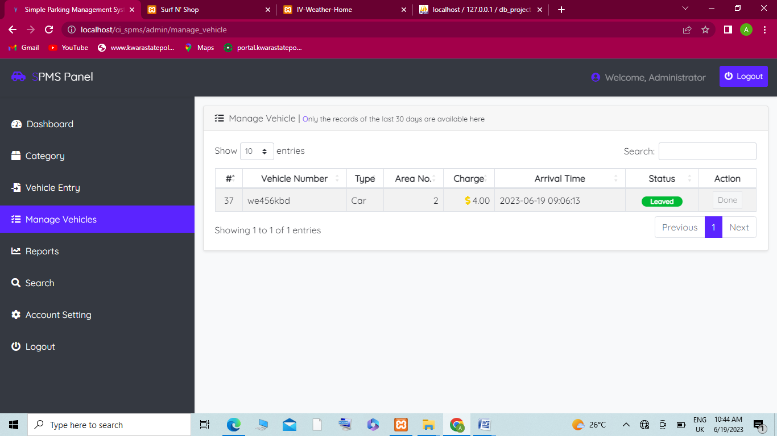
Figure 4.1: Main Menu Interface
The figure 4.1 above is the main menu interface which contains some other menu which can be click to navigate to other pages.

Figure 4.2: Taxi Ordering Inter face
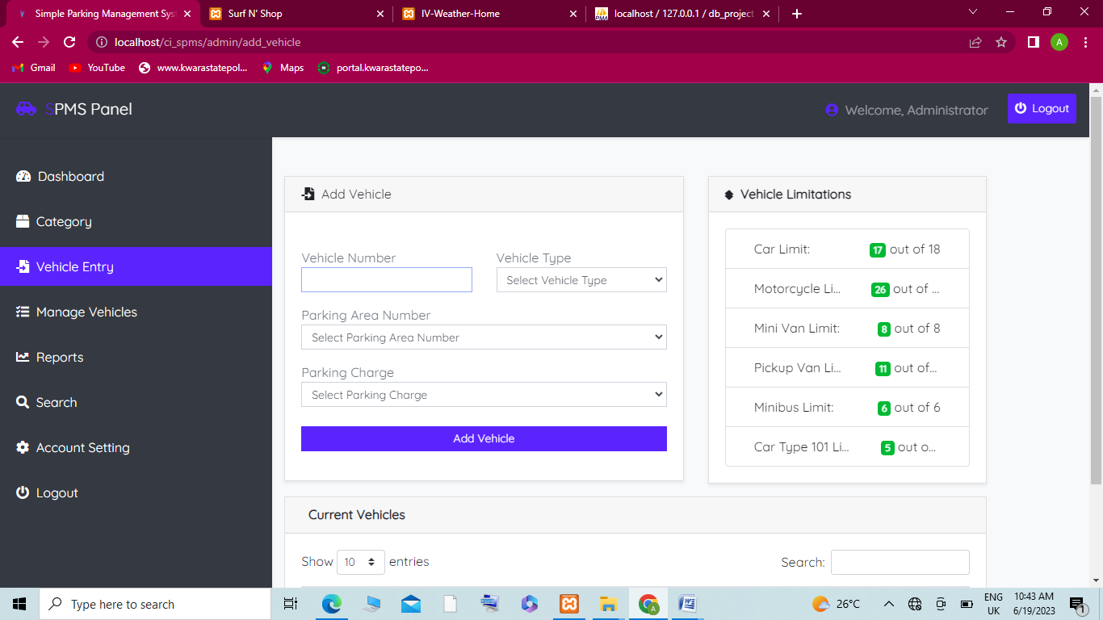
Figure 4.3: vehicle verification page

4.1.2 INPUT DESIGN
The input to run this software is obtained from Design and implementation of SMS taxi ordering system administrator. The administrator is expected to register any User information. He can achieve this by typing via the keyboard. The input required from the Users is their personal data and answer?
To the questions set by the administrator, it can serve as the various input layouts from the various modules first from the collection of data and module then from the assessment module and input from User respectively
Figure 4.6: Modification Interface
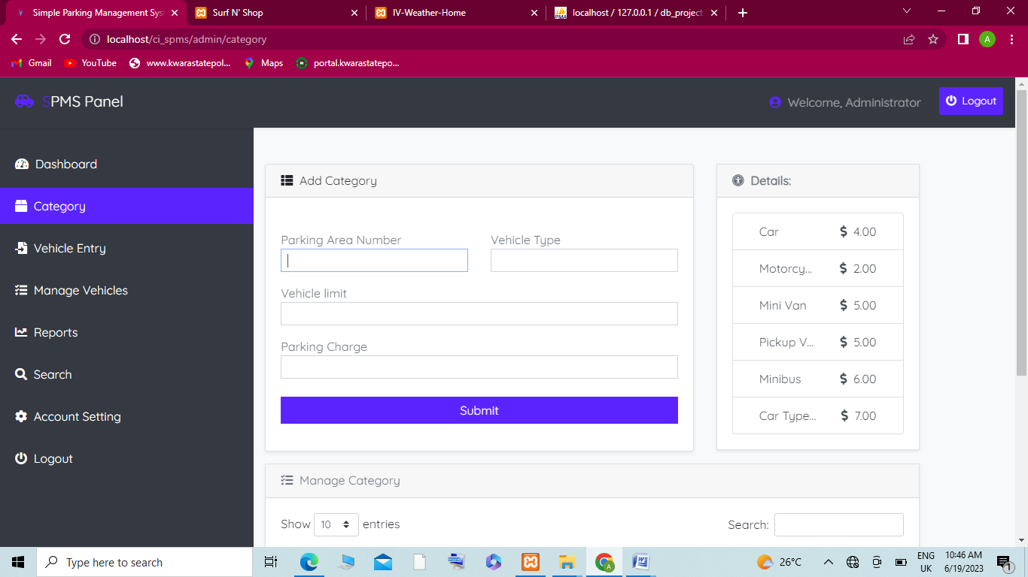
Figure 4.7: Vehicle registration interface

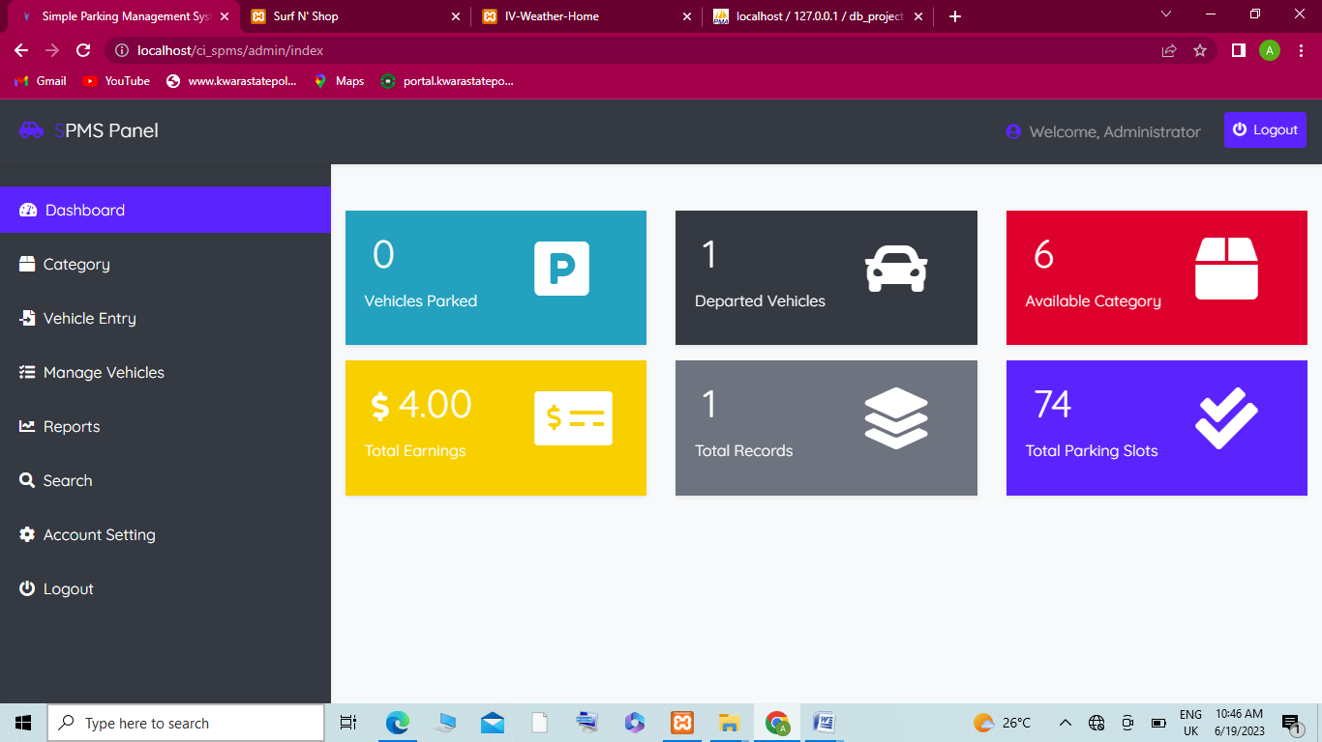
Figure 4.8: Login Interface
4.1.3 DATABASE DESIGN
The input file is processed against the output file to produce the required output and the" various file layout (designs) has already been given in the various pages, under the input design and the output design for the various modules respectively.
Table 4.1: Customer Account Table
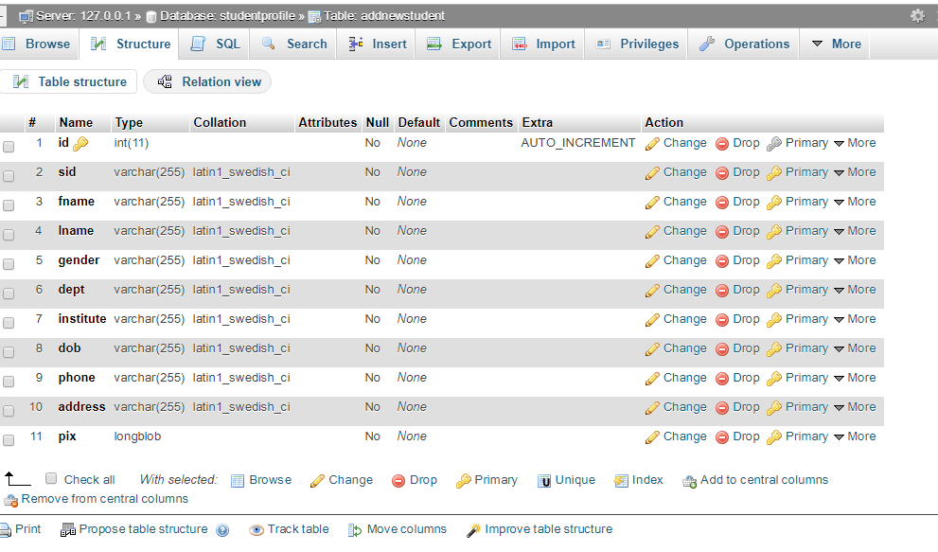
Table 4.2: Cab database table
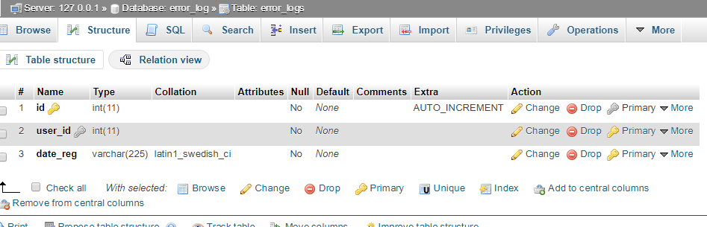

4.1.4 PROCEDURE DESIGN
These are the steps involved in unifying the whole process to produce the desired output. It involves computer procedures which start from the original input lessons to the output result file. This allows the processing of User information and result to be possible. Menu is provided to aid User in the processing of the output file.
4.2 IMPLEMENTATION OF THE SYSTEM
This entails the choice of the programming language employed to implement the software which should-be suitable for Design and implementation of SMS based taxi ordering system. The software is designed for the use of taxi ordering which should serve as an assistant. It is also expected to be used in conjunction with the User. The Design and implementation of SMS based taxi ordering system admin will prepare data base while the admin will provide personal data about the User.
4.2.1 CHOICE OF PROGRAMMING LANGUAGE
The Application was developed in a .net (dot net) integrated development environment (.net IDE). The Application IDE is chosen following the fact that extracted information needs to be presented in an enhanced pictorial/graphical format and easy communication with the database for program flexibility in windows platform.

4.2.2 HARDWARE REQUIREMENT
i. 500 Hz minimum with CD ROM drive etc.
ii. Hard disk of capacity 10GB Minimum
iii. 126-512 megabyte of RAM
iv. An Uninterrupted power supply (UPS)
v. A voltage stabilizer
vi. A power generating set etc.
4.2.3 SOFTWARE REQUIREMENT
i. Windows Operating system such as Windows 7 etc
ii. Visual C#
- Server Query Language (SQL).
- SMS Services
4.2.4 IMPLEMENTATION TECHNIQUE
Implementation phase of fingerprint involves implementation on the interface and on the backend coding. The system interface was implemented using Microsoft Visual Studio while the backend components, which are database and coding, were implemented fully using visual C# and MySQL.
4.3 DOCUMENTATION OF THE SYSTEM
The program is packaged for use in any system irrespective of either it runs visual studio application or not. After developing a program in Visual studio, there is a facility provided in Microsoft Visual Studio suite called “Package and Deployment Wizard” that is used in Visual studio application packaging and deployment. The Design and implementation of crime investigation system using fingerprint is packaged into an installable setup that can be run from any system.
    - OPERATING THE SYSTEM
The installed program can be use using the stated points below.
- Click on start button on the desktop
- Point to all programs
- Select the program name, that is, fingerprint crime investigation

4.3.3 MAINTAINING THE SYSTEM
The system maintenance refers to making modification to an already existing application/program without necessarily re-writing everything from start. Program maintenance of a program includes modification of the program to meet-up with certain requirements of the Users. In this course, additional features can be added, errors corrected, ambiguous interfaces redesigned to eliminate confusions and unnecessary features removed.
Maintaining this program can be done in a Visual studio environment. Any future modification can be by re-running the program source code in a visual studio environment making necessary changes and updates and recompile the application into an upgrade version of the existing version of the mini word processing application. Further versions of this program can be named following their year of release or it can be given a different version number.

CHAPTER FIVE
5.0 SUMMARY, CONCLUSION AND RECOMMENDATIONS
5.1 SUMMARY
In this project, we have discussed about various parking and vehicle reservation system, for the management of the off-street parking spots in consolidated cities. Various systems put the management of parking spots into a different perspective that goes over the simple automation of parking system through the use of advanced technological solutions, such as wireless networks and sensor communication. In fact, it is concerned with:
- The quality of life in modern cities, in terms of the amount of pollution and effects of the urban traffic congestion on the abilities of the drivers.
- The quality of mobility in urban areas. On further modification, we are looking forward to implementing an intelligent parking assistant (IPA) architecture aims at overcoming current public parking management solutions. Future modifications the SPS system will include the following points:
• Considerations would be made about the evaluation of the revenue of the parking site.
• A module for the Smartphone App to navigate the users to the assigned parking spots using a vocal guide.
• A module to use Bluetooth technology to complete the check-in process.

5.2 CONCLUSION
The systems proposed by various authors help us effectively in reserving as well as eliminates the need for searching of a parking space in private parking lot. Many researchers have implemented systems which have dynamic arrangement scheme for satisfying the different needs of drivers and service providers, which is based on real-time parking information. Hence, we conclude that this paper is very useful for new researcher for innovation of new techniques to manage the problem faced by drivers on day to day basis. The table contains advantages and disadvantages of various systems implemented by researchers. In future work, we innovate this system which is not only used in a particular parking area available, but can be extended and also be implemented on various other platforms such as railway stations, airports, mall parking spaces. This will make the management of the parking spaces efficiently, by eliminating need of manual labor work.

5.3 RECOMMENDATIONS
The systems proposed by various authors help us effectively in reserving as well as eliminates the need for searching of a parking space in private parking lot. Many researchers have implemented systems which have dynamic arrangement scheme for satisfying the different needs of drivers and service providers, which is based on real-time parking information. Hence, we conclude that this paper is very useful for new researcher for innovation of new techniques to manage the problem faced by drivers on day to day basis. The table contains advantages and disadvantages of various systems implemented by researchers. In future work, we innovate this system which is not only used in a particular parking area available, but can be extended and also be implemented on various other platforms such as railway stations, airports, mall parking spaces. This will make the management of the parking spaces efficiently, by eliminating need of manual labor work.

REFERENCES
- R. Yusnita, Fariza Norbaya, and Norazwinawati Basharuddin "Intelligent Systems for Car Parking with Image Processing".
- L. Mainetti, L. Palano, L. Patrono, M. L. Stefanizzi, and R. Vergallo, Integration of RFID and WSN technologies in a smart parking system," in Proc. 22nd Int. Conf. Softw., Telecommun. Comput. Netw. (SoftCOM), 2021, pp. 104110.
- Hamada R. H.Al-Absi, Justin Dinesh Daniel Devaraj, Patrick Sebastian, Yap Vooi Voon "A vision based car parking system"
- A Cloud-Based Smart-Parking System Based on Internet-of-Things Technologies. Novomax (2020) http://www.parkbysms.net/files/activities
- Hanif NHHM, Badiozaman MH, Daud H (2020) Smart parking reservation system using Short Message Services (SMS). In: International Conference on Intelligent and Advanced Systems (ICIAS), pp 1–5
- Khang SC, Hong TJ, Chin TS, Wang S (2021) Wireless Mobile-Based Shopping Mall Car Parking System (WMCPS). In: IEEE Asia- Pacific Services Computing Conferences (APSCC), pp 573–577
- Hamada R.H. Al-Absi Patrick Sebastian Justin Dinesh Daniel Devaraj Yap Vooi Voon. “Vision- based automated parking system.” 10th International Conference on Information Science, Signal Processing and their Applications (ISSPA 2010) 2020.
- M.M. Rashid A.Musa M.Ataur Rehman N.Farhana A.Farhana. “Automatic parking management system and parking fee collection based on number plate recognition.” International Journal of Machine Learning and Computing, 2:93- 98, 2021.
- M.O. Reze M.F. Ismail A.A. Rokoni M.A.R. Sarkar. “Smart parking system with image processing facility”. I.J. Intelligent Systems and Applications, 3:41-47, 2020.
- Amba James Garba Adamu Murtala Zungeru, Adamu Murtala Zungeru. “Design and implementation of a short message service based remote controller”. Computer Engineering and Intelligent Systems, 3:106- 119, 2021.
- Zhang, Zusheng, et al. "A street parking system using wireless sensor networks." International Journal of Distributed Sensor Networks 2019 (2019).
- Wu,Eric Hsiao-Kuang, et al. "Agile urban parking recommendation service for intelligent vehicular guiding system." Intelligent Transportation Systems Magazine, IEEE 6.1 (2020): 35-49.
- Tian, Qing, et al. "Design of intelligent parking management system based on license plate recognition." Journal of Multimedia 9.6 (2021): 774- 780.

