DESIGN AND IMPLEMENTATION OF HOSPITAL MANAGEMENT SYSTEM
(A CASE STUDY OF UITH)

By:
AKANJI FUAD OLAMILEKAN
ND/23/COM/FT/0093

A Project Submitted to the Department of Computer Science, Institute of Information and Communication Technology, Kwara State Polytechnic, Ilorin

In Partial Fulfillment of the Requirements for the Award of National Diploma [ND] In Computer Science

July, 2025
CERTIFICATION
This is to certify that this project work was carried out by AKANJI, Fuad Olamilekan with matriculation number ND/23/COM/FT/093. has been read and approved as meeting part of the requirements for the award of National Diploma (ND) in Computer Science.

_______________________ __________________
Mr. Olajide A.T. Date
(Project Supervisor)

_______________________ __________________
Mr. Oyedepo, F. S. Date
(Head of Department)

_________________________ __________________
External Examiner Date
DEDICATION
This project is dedicated to the creator of the earth and universe, the almighty God. It is also dedicated to my parents for their moral and financial support.

ACKNOWLEDGEMENT
All praise due to Almighty God the Lord of the Universe. I praise Him and thank Him for giving me the strength and knowledge to complete my ND programme and also for me continue existence on the earth.
I appreciate the utmost effort of my supervisor, Mr. Olajide, A.T., whose patience support and encourages have been the driving force behind the success of this research work. He gave useful corrections, constructive criticisms, comments, recommendations, advice and always ensures that an excellent research is done. My sincere gratitude goes to Head of the Department and other members of staff of the Department of Computer Science, Kwara State Polytechnic, Ilorin, for their constant cooperation, constructive criticisms and encouragements throughout the programme.
Special gratitude to my parents who exhibited immeasurable financial, patience, support, prayers and understanding during the periods in which I was busy tirelessly in my studies. Special thanks go to all my lovely siblings.
My sincere appreciation goes to my friends and classmates.

TABLE OF CONTENTS
Title Page i
Certification ii
Dedication iii
Acknowledgements iv
Abstract v
Table of Contents vi
CHAPTER ONE: GENERAL INTRODUCTION
  - Background to the Study 1
  - Statement of the Problem 3
  - Aim and Objectives of the Study 4
  - Significance of the Study 4
  - Scope of the Study 5
  - Organization of the Report 5
CHAPTER TWO: LITERATURES REVIEW
  - Review of Related Works 7
  - Review of Related Concepts 9
2.2.1 Overview of Hospital 9
2.2.2 Hospital Management System 9
2.2. 3 Health Care Overview 10
2.2.4 Health Care System 10
2.2.5 Hospital System 11
2.2.6 Electronic Health record System 12
CHAPTER THREE: RESEARCH METHODOLOGY AND ANALYSIS
  - Research Methodology 13
  - Analysis of the Existing System 14
  - Problems of the Existing System 14
  - Description of the Proposed System 15
  - Advantages of the Proposed System 15
CHAPTER FOUR: DESIGN, IMPLEMENTATION AND DOCUMENTATION OF THE SYSTEM
  - Design of the System 16
    - Output Design 16
    - Input Design 18
    - Database Design 20
    - Procedure Design 21
  - Implementation of the System 22
    - Choice of Programming Language 22
    - Hardware Support 23
    - Software Support 23
  - Documentation of the System 23
    - Program Documentation 24
    - Maintaining the System 25
CHAPTER FIVE: SUMMARY, CONCLUSION AND RECOMMENDATION
  - Summary 26
  - Conclusion 26
  - Recommendation 27
References 28

ABSTRABCT
The project developed an automated system that is used to manage patient information and its administration. This was with a view to eliminate the problem of inappropriate data Keeping, inaccurate reports, time wastage in storing, processing and retrieving information encountered by the traditional hospital system in order to improve the overall efficiency of the organization. The tools used to implement the system are Visual C Sharp, Microsoft Visual Studio, and My Structured Query Language (MySQL).The Proposed system was tested using the information collected from University of Ilorin Teaching Hospital (UITH), Ilorin, Kwara State , Nigeria and compared with the existing traditional hospital system. The design provides excellent patient services and improved information infrastructure.

CHAPTER ONE
GENERAL INTRODUCTION
  - BACKGROUND TO THE STUDY
Before computerized Hospital Management System came into practice, it was difficult to keep proper records of the daily activities of hospitals, patient information, maintenance schedule of equipment in the hospital, and how funds are being allocated and used. This resulted in waste of money, time and manpower. Hospital Management System is an information management system designed to help manage the various aspects of a hospital (administrative, clinical and financial). It helps in monitoring and controlling the hospital’s daily transactions, as well as the hospital’s performance. It also helps to address the critical requirements of the hospital. Hospital Management System enables access to the right information and automation of complex task, thereby allowing staff to spend more time caring for patients (Olamide, Adedayo, & Abiodun, 2020).
According to Ajibola (2019), a hospital is a health care institution providing patient treatment with specialized health science and auxiliary healthcare staff and medical equipment. The best-known type of hospital is the general hospital, which typically has an emergency department to treat urgent health problems ranging from fire and accident victims to a sudden illness. A district hospital typically is the major health care facility in its region, with many beds for intensive care and additional beds for patients who need long-term care. Specialized hospitals include trauma centers, rehabilitation hospitals, children's hospitals, seniors' (geriatric) hospitals, and hospitals for dealing with specific medical needs such as psychiatric treatment (see psychiatric hospital) and certain disease categories. Specialized hospitals can help reduce health care costs compared to general hospitals. Hospitals are classified as general, specialty, or government depending on the sources of income received.
Management has been defined as the process, comprised of social and technical functions and activities, occurring within organizations for the purpose of accomplishing predetermined objectives through humans and other resources (Longest, Rakich & Darr, 2020). Healthcare quality and patient safety are the common mantra of all primary and secondary health care providers. In hospitals, over the years, a variety of models and schemes for hospital interventions and development have been deployed. Hospital Management System provides the benefits of streamlined operations, enhanced administration & control, superior patient care, strict cost control and improved profitability (Adebisi et al., 2019).
World Health Organization (WHO) has defined hospital as an integral part of social and medical organization that provides the complete curative and preventive health care and treatment to people. Hospitals are the focal points of education for the health professionals and clinical research necessary for advancement of medicine. Thus, the hospital is one of the most complexes of all administrative organizations. The main purpose of the hospital is to provide adequate care and treatment to the people. Various operational works that are done in a hospital include: recording information about the Patients, generating bill, recording information related to diagnosis given to Patients, Keeping record of the Immunization provided to patient, Keeping information about various diseases and medicines available to cure them and so on (Adebisi et al, 2015).
All these works are done in most hospitals on papers. The need for proper management of the health sector leads to the creation of an electronic means of keeping records, administering discharge, querying of data, prescription helper and also good accountability. Information technology in general enables intra organizational networking that facilitates effective information flow within the various units of a firm. The application of information technology in health care is unceasingly evolving as the quality of patient care in contemporary times seems to depend on the timely acquisition and processing of clinical information related to the patient. The hospital management system (HMS) comprises a computerized application for record keeping, tracking and prescriptions with monitoring (Dey et al., 2018).
An important request of health care professionals is the centralization of medical data in such a way that its accessibility on a wider scale is ensured. This purpose is not always served by various installed applications, as each one of them addresses a specific need and organizes data in a single health center or hospital. The need for optimal data organization becomes more compulsory in the course of time, as citizens’ mobility is growing bigger and expert health care services are required in all areas. The related need of a centralized Patient Heath Record (PHR) requires medical data to be concentrated in a manner that it is accessible through a web interface from physicians and citizens as well. It would be also desirable to provide to citizens the ability of authorizing any physician to view their medical data (Makris et al., 2018).
In this project, a computerized hospital management system is presented, addressing most of these needs.

  - STATEMENT OF THE PROBLEM
The problem of record management has become very crucial in areas of privacy and quick access to data. Many problems are encountered with the manual method of handling files. It is quite unfortunate that UITH Hospital, in spite of her large medical service and recognition still keep her records manually. The problems associated with this manual system include time wastage, ineffective use of statistical data, and duplication of efforts in records keeping. Delay in decision making, it requires a lot of clerical efforts inability to cope up with daily work load. Slow in responding the queries / enquires, Rodents records, lot of human mistakes, lack of confidentiality of files and high cost of stationary. Some hospitals that use the computerized method are also faced with the challenge of adjusting to it. Such problems include: high cost of software development, deployment and improvement, difficulty in migrating from manual processes, because both staff and patients are used to the manual processes. This project is aimed at devising a system that will eradicate these above problems and improve medical services to the citizens. This computerization process is believed to be capable of not only solving these problems but many more to be encountered.
  - AIM AND OBJECTIVES OF THE STUDY
The main aim of this project is to design a computer based hospital management system. To achieve the stated aim, the following specific objectives were laid out:
i. design a system that will computerize all the details of the patient and hospital;
ii. develop a software to manage all the entire records of UITH; and
iii. implement a system that will boost the effectiveness and calibre of medical care center.
  - SIGNIFICANCE OF THE STU/DY
Presently UITH Hospital, Ilorin doesn’t have a management system. The significance of the need for an automated Hospital Management System is that, it will increase the level of accuracy in the hospital. All operations would be done correctly and accurately. In practice, errors will be completely eliminated. It will also makes hospital system more reliable, it will eliminate data redundancy, the system would assure economic use of storage space and consistency in the data stored. The proposed system will allow immediate retrieval of information and immediate storage of information.
1.5 SCOPE OF THE STUDY
It can be used in any hospital, clinic, dispensary, or pathology labs for maintaining patient details and their test results. The hospital management system is capable of supporting any number of staff of the hospital and each module of the package runs independently without affecting other modules. This means that all the departments of the hospital work independently, but this system is specifically designed for UITH hospital.
1.6 DEFINITION OF TERMS
- Hospital: A large medical facility, usually in a building with multiple floors where seriously ill or injured patients are given extensive medical and surgical treatment.
- Automation: the act or process of converting the controlling of a machine or device to a more automatic system, such as computer or electronic controls.
- Computerized: the act of computerizing something, or something computerized.
- Psychiatry: the branch of medicine that subjectively diagnosis, treats, and studies mental disorders and behavioural conditions.
- Health: the state of being fre from physical or psychological disease, illness, or malfunction; wellness.
  - ORGANIZATION OF THE REPORT
This is the overall organizational structure of the work as presented in this project. Chapter one of this project deals with the general introduction to the work in the project. It also entails the aim and objectives of the project, significance of the study, the scope and limitation of the study. Chapter two deals with the literature review, and discussion of related aspect of the project topic. Chapter three covers the methodology adopted, the methods used for data collection, analysis of the existing system, description of the current procedure, problems of existing system (procedure) itemized, and description of the proposed system and the basic advantages of the proposed hospital management. Chapter four entails design, implementation and documentation of the system. The design involves the system design, output design form, input design form, database structure and the procedure of the system. The implementation involves the implementation techniques used in details, choice of programming language used and the hardware and software support. The documentation of the system involves the operation of the system and the maintenance of the system. Chapter five deals with the summary, conclusion and recommendations.

CHAPTER TWO
LITERATURE REVIEW
2.1 REVIEW OF RELATED WORKS
Adebisi, et al, (2019) design and implementation of hospital management system. The paper developed an automated system that is used to manage patient information and its administration. This was with a view to eliminate the problem of inappropriate data Keeping, inaccurate reports, time wastage in storing, processing and retrieving information encountered by the traditional hospital system in order to improve the overall efficiency of the organization. The tools used to implement the system are Hypertext Markup Language (HTML), Cascading Style Sheets (CSS), Hypertext Preprocessor (PHP), and My Structured Query Language(MySQ).The Proposed system was tested using the information collected from Murab Hospital, Ilorin, kwara State , Nigeria and compared with the existing traditional hospital system. The design provides excellent patient services and improved information infrastructure.
Olamide, et al., (2019) designed and implemented a hospital management system using Java. The research work is on design and construction of Hospital Management System (HMS). The system provides the benefits of streamlined operations, enhanced administration and control, superior patient care, strict cost control and improved profitability. The system uses JAVA as the front-end software which is an Object Oriented Programming language and has connectivity with the back-end software.
Portela and Schmidt (2017) proposed an evaluation and diagnosis method proposed for hospital management. The purpose of the study was to propose a method for the evaluation and diagnosis of hospital management based on the Gaucho productivity and quality program and the Brazilian program of Hospital accreditation. This descriptive and bibliographic research enabled to elaborate a criteria arrangement between the two programs in order to verify convergent and divergent aspects. The analysis revealed that both programs present compatible and complementary criteria.
Dey, et al., (2016) developed an effectiveness of care pathways in ideal hospital management system. In the review, attempts have been made to highlight on the strategic points like the implementations and utilities of clinical care pathways and its role in the control of emergency medical cases like strokes, importance of timelines and key performance indicators of health administrators, effectiveness of clinical decision making of medical professionals and their overall contribution in the quality improvement of health care and thus hospital management.
Udoh, (2016) developed a patient management system. The study investigated online hospital management system as a tool to revolutionize medical profession. With many writers decrying how patients queue up for hours in order to receive medical treatment, and some end-up being attended to as „spillover‟, the analyst investigated the manual system in detail with a view to finding out the need to automate the system. Subsequently, a computer-aided program was designed to bring about improvement in the care of individual patients, taking the advantage of computer speed, storage and retrieved facilities. The software designed will take care of patient’s registration, billing, treatment and payments. The programming language employed in this work was Microsoft C#.
Arthi and Priya, (2016) proposed an exclusive E-health care using centralized health management system. The project attempted to construct a nationwide health database system that provided access to the detailed patient’s records and doctor’s assistant performed technical task involved in the project efficiently. Convincing and persistent participation of the users of the system make the system more interactive and more useful.
Bellazzi, Riva and Stefanelli, (2017) developed web-based telemedicine systems for home-care. In the paper they discussed the general architectural and technical issues related to the development of web-based systems for telecare applications, relying on the experience we gained within the telecare project T-IDDM (Telematic Management of Insulin Dependent Diabetes Mellitus), devoted to assist the management and home-monitoring of Type 1 Diabetes Mellitus patients.
2.2 REVIEW OF RELATED CONCEPTS
2.2.1 Overview of Hospital
A hospital is a health care institution providing patient treatment with specialized health science and auxiliary healthcare staff and medical equipment. The best-known type of hospital is the general hospital, which typically has an emergency department to treat urgent health problems ranging from fire and accident victims to a sudden illness. A district hospital typically is the major health care facility in its region, with many beds for intensive care and additional beds for patients who need long-term care. Specialized hospitals include trauma centers, rehabilitation hospitals, children's hospitals, seniors' (geriatric) hospitals, and hospitals for dealing with specific medical needs such as psychiatric treatment (see psychiatric hospital) and certain disease categories. Specialized hospitals can help reduce health care costs compared to general hospitals. Hospitals are classified as general, specialty, or government depending on the sources of income received.
A teaching hospital combines assistance to people with teaching to health science students and auxiliary healthcare students. A health science facility smaller than a hospital is generally called a clinic. Hospitals have a range of departments (e.g. surgery and urgent care) and specialist units such as cardiology. Some hospitals have outpatient departments and some have chronic treatment units. Common support units include a pharmacy, pathology, and radiology (Arthi & Priya, 2016).
2.2.2 Hospital Management System
Management has been defined as the process, comprised of social and technical functions and activities, occurring within organizations for the purpose of accomplishing predetermined objectives through humans and other resources. Healthcare quality and patient safety are the common mantra of all primary and secondary health care providers. In hospitals, over the years, a variety of models and schemes for hospital interventions and development have been deployed. Hospital Management System provides the benefits of streamlined operations, enhanced administration & control, superior patient care, strict cost control and improved profitability. There are different modules in the process of Hospital Management System. These include: Patient management, Services management, Appointment scheduling, Store management, Pharmacy management, Admission management, Ambulatory, Laboratory, Account management, Payroll and Human Resource Management (Arthi & Priya, 2016).

2.2.3 Health Care Overview
Health care is the maintenance or improvement of health via the prevention, diagnosis, treatment, amelioration, or cure of disease, illness, injury, and other physical and mental impairments in people. Health care is delivered by health professionals and allied health fields. Medicine, dentistry, pharmacy, midwifery, nursing, optometry, audiology, psychology, occupational therapy, physical therapy, athletic training, and other health professions are all part of health care. It includes work done in providing primary care, secondary care, and tertiary care, as well as in public health.
Access to health care may vary across countries, communities, and individuals, influenced by social and economic conditions as well as health policies. Providing health care services means "the timely use of personal health services to achieve the best possible health outcomes". Factors to consider in terms of health care access include financial limitations (such as insurance coverage), geographic barriers (such as additional transportation costs, the possibility to take paid time off of work to use such services), and personal limitations (lack of ability to communicate with health care providers, poor health literacy, low income). Limitations to health care services affect negatively the use of medical services, the efficacy of treatments, and overall outcome (well-being, mortality rates) (Adeola, 2019).
2.2.4 Health Care System
Health care systems are organizations established to meet the health needs of targeted populations. According to the World Health Organization (WHO), a well-functioning health care system requires a financing mechanism, a well-trained and adequately paid workforce, reliable information on which to base decisions and policies, and well-maintained health facilities to deliver quality medicines and technologies. An efficient health care system can contribute to a significant part of a country's economy, development, and industrialization. Health care is conventionally regarded as an important determinant in promoting the general physical and mental health and well-being of people around the world. An example of this was the worldwide eradication of smallpox in 1980, declared by the WHO as the first disease in human history to be eliminated by deliberate health care interventions.
Health care system is a formal structure for a defined population, whose finance, management, scope, and content is defined by law and regulations. It provides for services to be delivered to people to contribute to their health delivered in defined settings, such as homes, educational institutions, workplaces, public places, communities, hospitals and clinics.
A health system consists of all organizations, people, and actions whose primary intent is to promote, restore, or maintain health. This includes efforts to influence determinants of health as well as more direct health-improving activities. It is therefore more than the pyramid of publicly owned facilities that deliver personal health services. It includes, for example, a mother caring for a sick child at home; private providers; behavior change programs; vector-control campaigns; health insurance organizations; and occupational health and safety legislation. It includes inter-sectoral action by health staff, for example, encouraging the ministry of education to promote female education, a well known determinant of better health (Adeola, 2019).

    - Hospital Systems
A hospital system is a group of hospitals or facilities that work together to deliver services to their communities. Different types of hospital systems have different types of ownership and financial goals. Types of hospital systems include:
    - Public Hospitals: Public hospitals are funded and owned by local, state or federal governments and receives money from the government. Some public hospitals are associated with medical schools.
    - Non-profit Hospitals: Non-profit hospitals are often community hospitals and may be linked with a religious denomination. The main goal of a non-profit hospital is to provide service to the community.
    - Private Hospitals: Private hospitals are owned by investors. Their goal is to earn a profit. Private hospitals tend to offer more profitable services such as rehabilitation, elective or plastic surgery or cardiology. They try to avoid unprofitable services such as emergency medicine, which can lose money due to uninsured patients (Ajibola, 2019).
2.2.6 Electronic Health Record System (EHRs)
EHRs are defined as “a longitudinal electronic record of patient health information generated by one or more encounters in any care delivery setting. Included in this information are patient demographics, progress notes, problems, medications, vital signs, past medical history, immunizations, laboratory data, and radiology reports”. Some of the basic benefits associated with EHRs include being able to easily access computerized records and the elimination of poor penmanship, which has historically plagued the medical chart. EHR systems can include many potential capabilities, but three particular functionalities hold great promise in improving the quality of care and reducing costs at the health care system level: clinical decision support (CDS) tools, computerized physician order entry (CPOE) systems, and health information exchange (HIE). These and other EHR capabilities are requirements of the “meaningful use” criteria set forth in the HITECH Act of 2009.
    - A CDS system is one that assists the provider in making decisions with regard to patient care. Some functionalities of a CDS system include providing the latest information about a drug, cross-referencing a patient allergy to a medication, and alerts for drug interactions and other potential patient issues that are flagged by the computer. With the continuous growth of medical knowledge, each of these functionalities provides a means for care to be delivered in a much safer and more efficient manner. As more and more CDS systems are used, one can expect certain medical errors to be averted and that, overall, the patient will receive more efficient and safe care (Ajibola, 2019).

CHAPTER THREE
RESEARCH METHODOLOGY AND ANALYSIS OF THE EXISTING SYSTEM
3.1 RESEARCH METHODOLOGY
Methodology is a structured approach used to accomplish a task, solve a problem, or conduct research. It serves as a guiding framework, detailing the processes and principles that will be followed to achieve the desired outcomes. The purpose of a methodology is to ensure clarity, efficiency, and consistency in the work being undertaken.
In the context of a Hospital Management System (HMS), methodology refers to the systematic framework and processes used to design, develop, implement, and evaluate the system to meet the needs of a hospital environment. It ensures that the project is carried out efficiently and achieves its goal of streamlining hospital operations.
The methodology begins with requirement analysis, where stakeholders like doctors, nurses, administrative staff, and patients provide input on what they need from the system. For example, a doctor might prioritize quick access to patient history, while the administration might focus on billing and inventory management. This stage ensures the system is tailored to meet diverse requirements. Following this, the system design phase involves creating a blueprint of the HMS, outlining how various modules such as patient registration, appointment scheduling, and pharmacy management will interact. This includes designing a database to store critical data securely and ensuring interoperability between different hospital departments.
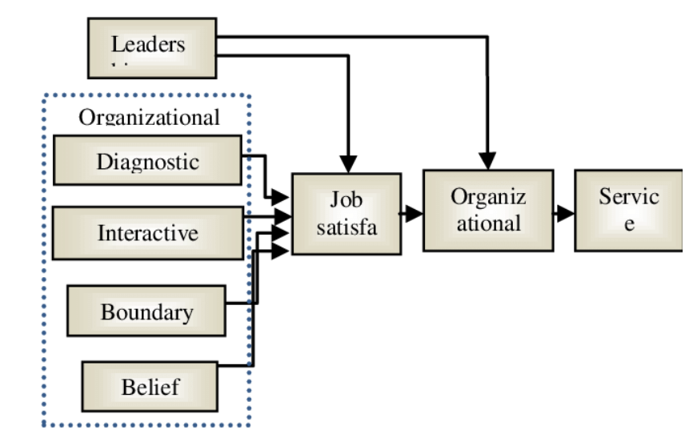
Figure 3.1: A Conceptual framework for hospital management system.

3.2 ANALYSIS OF THE EXISTING SYSTEM
The information flow used is a one directional system where the receptionist refers patient to doctors, doctors referring patients to the pharmacist either in or out patients and the same way out. The system that is currently being used in the hospital is entirely manual. When a patient requests drugs from the staff, all the information is recorded manually from the drug dispenser (Pharmacist). Similarly when the supplier delivers drugs all the information from the dispenser to the account on drugs is recorded manually. The following are the weaknesses of the current system at the hospital:
1. The hospital staff find it tiresome and time consuming when computing patient data, drug supplier and staff Payment receipts and voucher cards this leads to delay in medical reports.
2. The hospital Administration currently uses health record files for storing patients and drug supplier’s information. This system of information storage is susceptible to security problems such as illegal modification and update of records.
3. The Staff usually waste a lot of time in retrieving data. 4. The paper work reduces the efficiency of the System.
3.3 PROBLEMS OF THE EXISTING SYSTEM
The problems associated with the existing system that this project is set to solve in the manual method of keeping and retrieving patient information system are: difficulties in retrieving files, to retrieve a particular file among all the files manually is always a difficult problem as its usually takes a lot of time. In extreme case, it may lead to an emergency. Long queuing during registration, patients remain in a queue for a long period before they could be registered. Another problem is documentation; there is a lot of problem in keeping all the patient files, since a large number of patients files are to be documented. These problems can be solved by a web based healthcare system for health institution.
3.4 DESCRIPTION OF THE PROPOSED SYSTEM
The system will make accessing of health records in the said hospital more easy, management of records will be easy. The system concentrates most of the medical data to a central data store in order to provide solutions for all affiliated individuals of this area. One of the main purposes of this system is to ensure access to the hospital records.
The new system among other things will have the following characteristics which will improvement the current system in use
1. The new system designed will help the management to use computer system to find patients information with regards to billing, treatments, and so on.
2. Accuracy is maintained, as the computer information will yield an accurate result.
3. There will not be much congestion in hospitals, as the medical system developed will assist patients to be treated and the information stored. 4. The speed of operation of the medical system is high when compared to manual method.
3.5 ADVANTAGES OF THE PROPOSED SYSTEM
The hospital management system has various advantages, they are as follows;
- It retains a high level of data integrity in the centralized database system.
- It eradicates the manual method of documentation.
- It protect against lost of health records.

CHAPTER FOUR
DESIGN AND IMPLEMENTATION OF THE SYSTEM
4.1 DESIGN OF THE SYSTEM
This is the computation of the particulars of a new system and the determination of what the new system would be and the function it is to perform. This may involve changing from one system to another or modifying the existing system operation.
The most challenging phase of the system life cycle is the change from manual operation to a faster and more accurate one; system design stage covers the technical specifications that will be employed in the implementation of the new system in order to modify the previous system. Some factors are put in consideration. These factors include input design, output design, definitions file and procedure designs and other documentation.
4.1.1 OUTPUT DESIGN
This incorporates the objectives of solving the existing system problems and challenges. This involves the structuring of the desired information and also to enhance efficient and effective Payroll mobility. Things taken into consideration in determining the output are represented below:

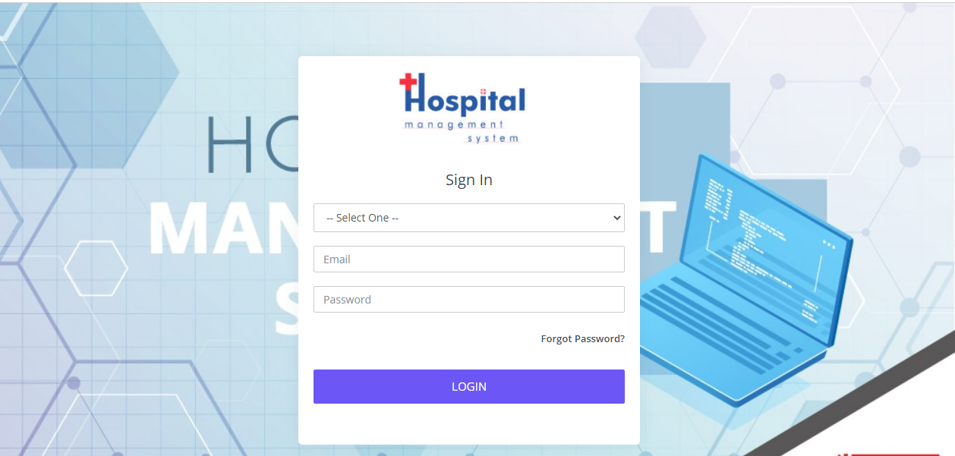
Figure 4.1: Sign in Page
This is the page where the user or admin will sign up to the system.
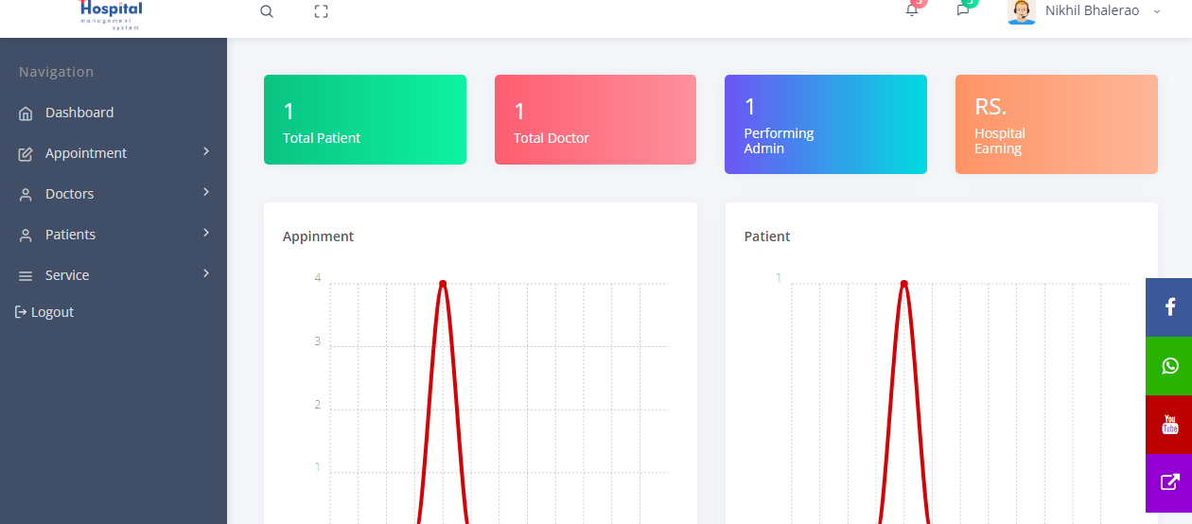
Figure 4.2: Admin Menu Interface
This interface shows the main menus where the admin can navigate to other pages on the system. The menus are Dashboard, Appointment, Doctors, Patients, Services and Logout.
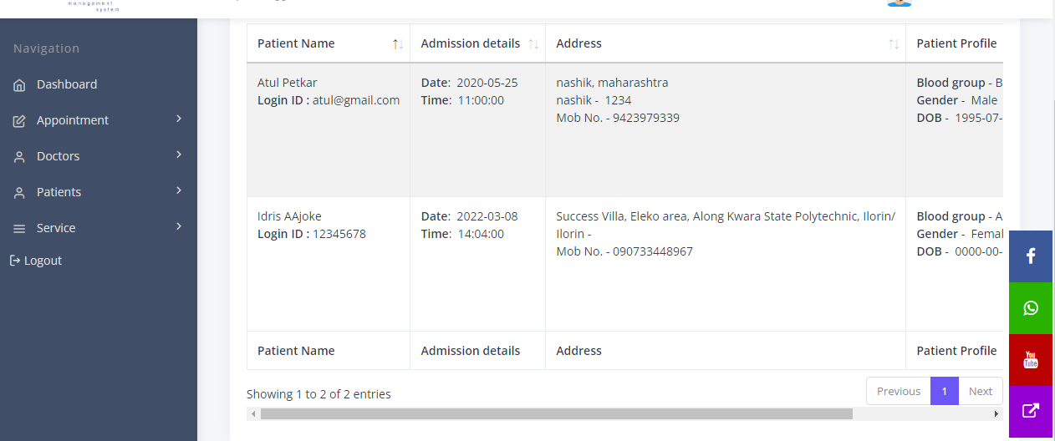
Figure 4.3: Patient Dashboard
This interface shows the main menus where the patient can navigate to other pages on the system. The menus are Dashboard, Book appointment, Doctors, Patients, Services and Logout.
4.1.2 INPUT DESIGN
The input to run this software is obtained from hospital management system administrator. The administrator is expected to register any emergency patient on the system. He can achieve this by typing via the keyboard or loading from the diskette. The input required from the staff is their personal data and answer?
To the questions set by the administrator, it can serve as the various input layouts from the various modules first from the collection of data and module then from the assessment module and input from staff respectively.
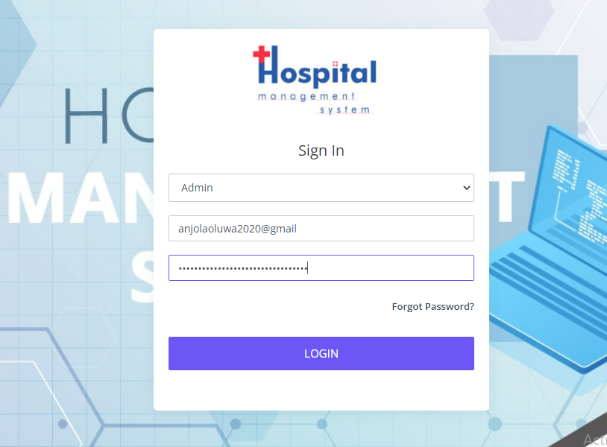

Figure 4.4: Login Interface
This indicate the page where the admin and the patient can login to the system
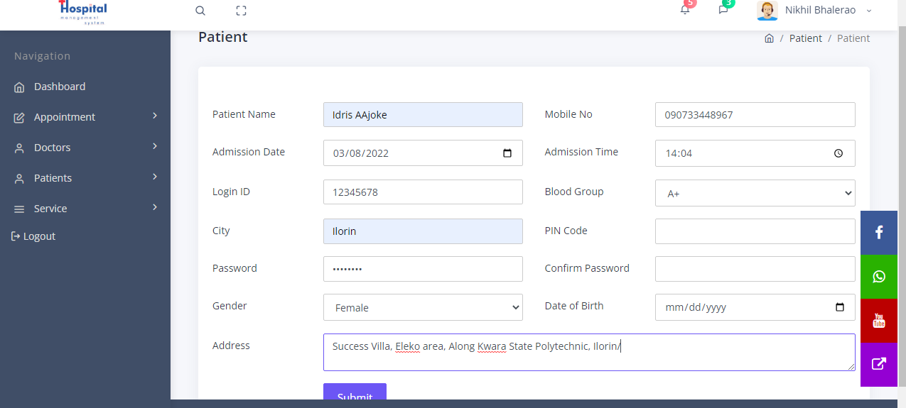
Figure 4.5 Add Patient Interface
This is the page where the admin can add patient to the system by entering some details like name, gender, address, number and so on.
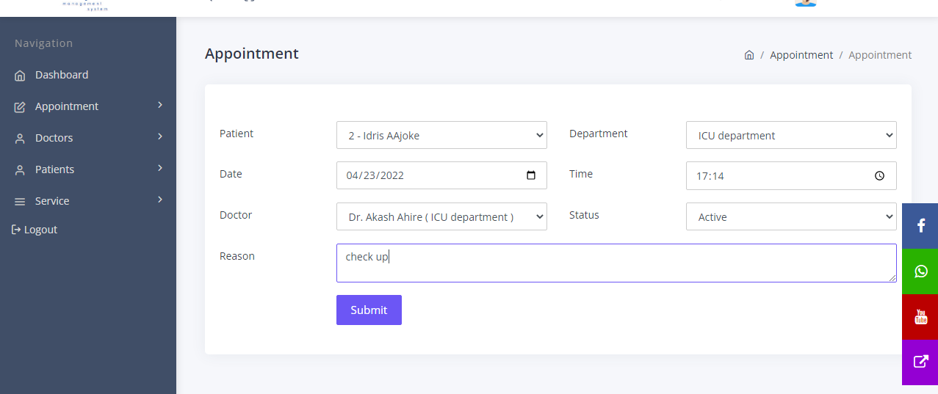
Figure 4.6 Patient Appointment Interface
This is the page where any patient can book an appointment to see a doctor.
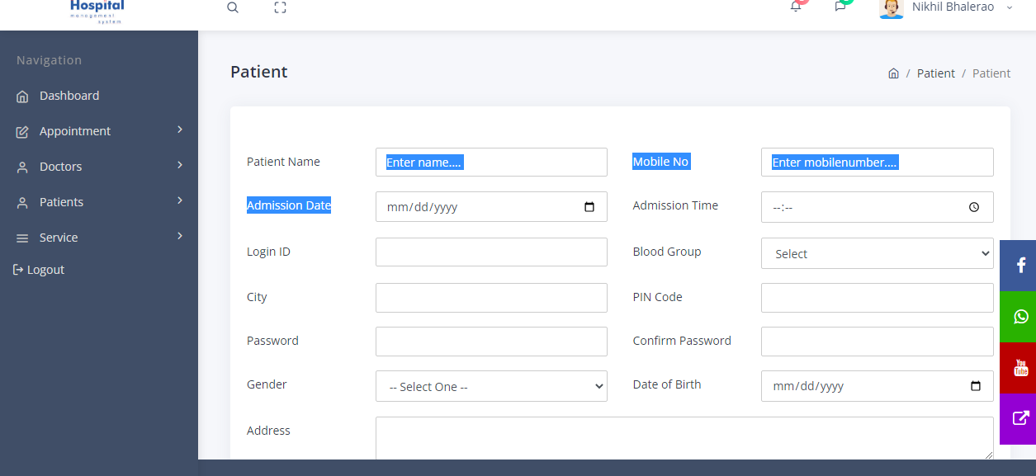
Figure 4.7 Patient Registration Interface
4.1.3 DATABASE DESIGN
The input file is processed against the output file to produce the required output and the" various file layout (designs) has already been given in the various pages, under the input design and the output design for the various modules respectively.
Table 4.1: Admin registration table
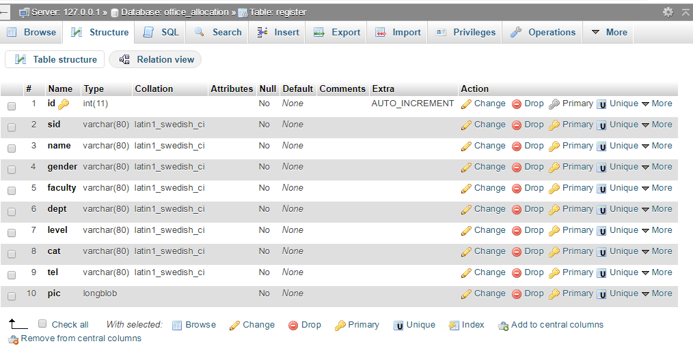

Figure 4.2: Patient Registration table
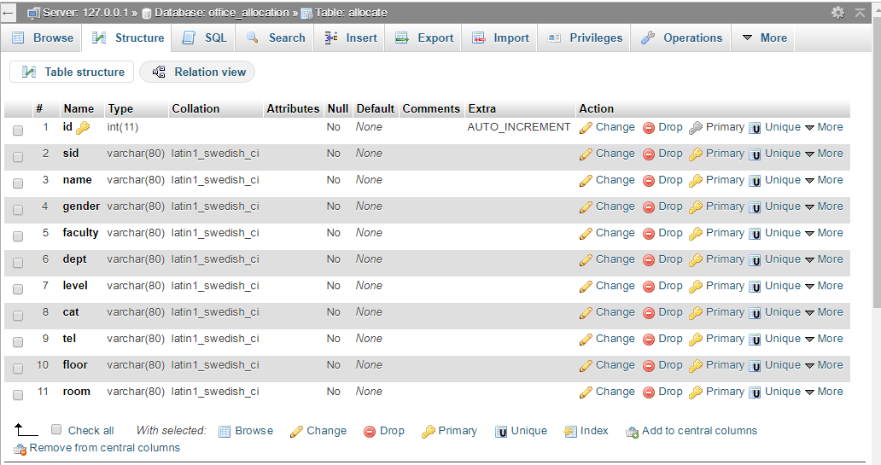
Figure 4.3: Doctor Registration table
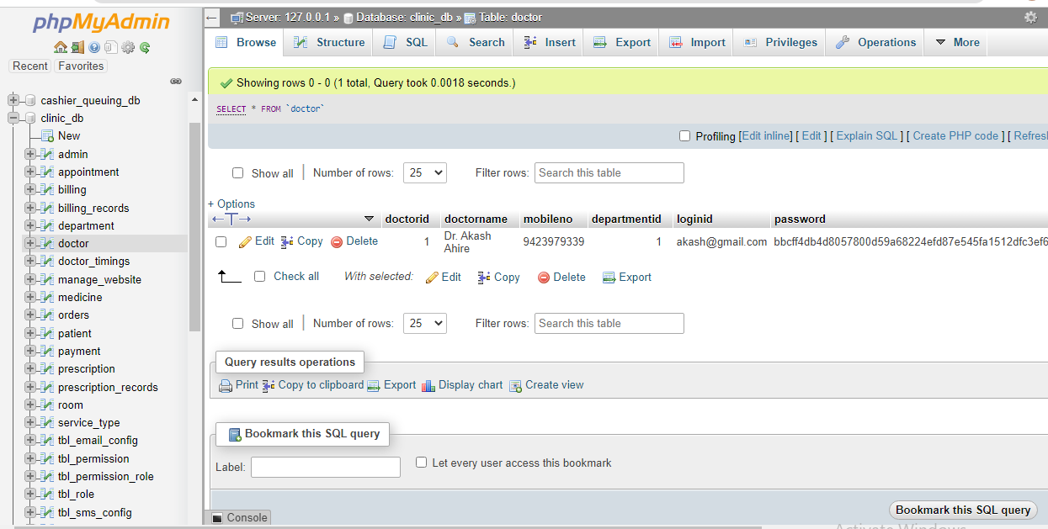

Figure 4.4: Treatment Record table
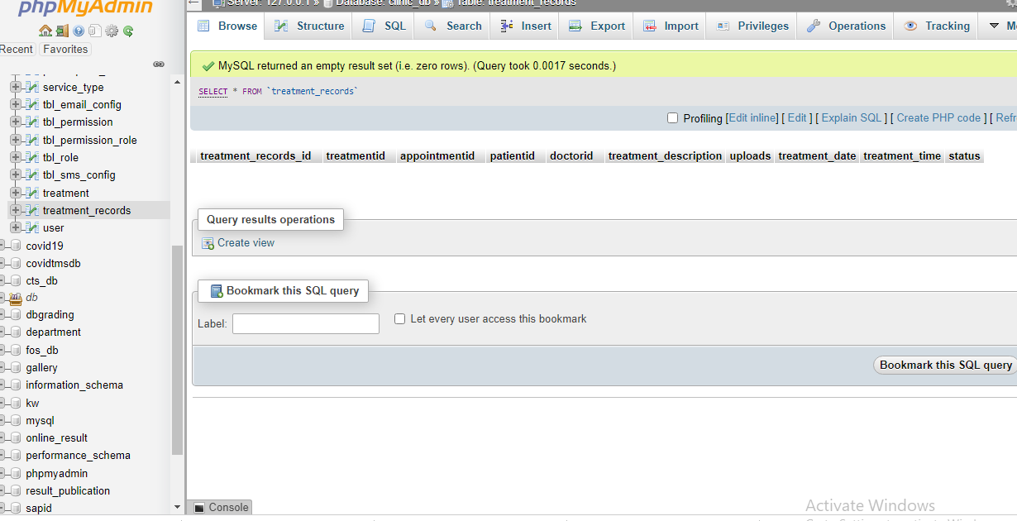
Figure 4.5: Appointment Record table
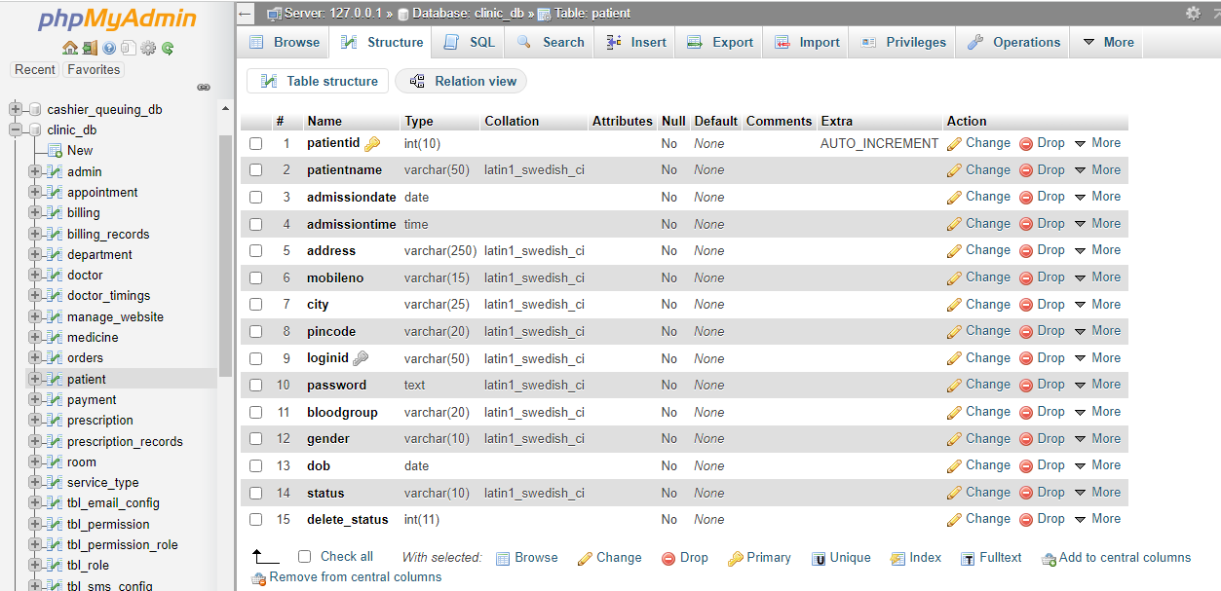
4.1.4 PROCEDURE DESIGN
These are the steps involved in unifying the whole process to produce the desired output. It involves computer procedures which start from the original input lessons to the output result file. This allows the processing of the information and result to be possible. Menu is provided to aid user in the processing of the output file.
4.2 IMPLEMENTATION OF THE SYSTEM
This entails the choice of the programming language employed to implement the software which should-be suitable for hospital management system. The software was designed to manage hospital records.
4.2.1 HARDWARE REQUIREMENT
Minimum of Microcomputer Pentium IV- Intel 1.5 GHZ processor, 1.0 GB RAM, 40GB Hard disk, 14” VGA Monitor Windows XP or higher, Enhanced keyboard, mouse and pad.
4.2.2 SOFTWARE REQUIREMENT
i. Windows Operating system such Windows 7, Windows 8, Windows 10 etc.
ii. Visual Studio (Enterprise Edition which allows the Programmer to run all the necessary Data, which has been supplied.
4.3 DOCUMENTATION OF THE SYSTEM
After the program has been well tested with input that the output has already been known, the next is to install the software in to the computer system for use.
The process of installing are been stated below
- Insert the CD into the system through the CD-ROM after the computer is switch on
- Locate the CD drive directory in my computer and click it to open
- After open, locate setup.exe, and then click to install the program by following the necessary step in installing the program.
- Ensure full installing of the software for effective operation of the system.
After the program has been fully install. The next thing is to locate the package install to put it into operation, to locate the package for expiration purpose the following step are to be taking .
- Click on start menu from task bar. Then select all program
- From the display sub option, select by locating the software installed named Information to load the software.
4.3.1 PROGRAM DOCUMENTATION
The program is packaged for use in any system irrespective of either it runs Visual Studio Application or not. After developing a program in Visual Studio, there is a facility provided in Microsoft Visual Studio suite called “Package and Deployment Wizard” that is used in Visual studio application packaging and deployment.
The hospital management system is packaged into an installable setup that can be run from any system.
4.3.2 OPERATING THE SYSTEM
To operate the system, the following algorithm must be followed:-
- Switch the system on
- Allow it to boot
- Click on start menu
- Select the package name “Hospital Management System” and wait for the application to load.
- From the list of menu that appears on the application main page, user can
- Select any one to navigate and carry the operation of the menu item.
4.3.2 MAINTAINING THE SYSTEM
The system maintenance refers to making modification to an already existing application/program without necessarily re-writing everything from start. Program maintenance of a program includes modification of the program to meet-up with certain requirements of the users. In this course, additional features can be added, errors corrected, ambiguous interfaces redesigned to eliminate confusions and unnecessary features removed.
Maintaining this program can be done in a Visual Studio environment. Any future modification can be by re-running the program source code in a Visual Studio environment making necessary changes and updates and recompile the application into an upgrade version of the existing version of the mini word processing application. Further versions of this program can be named following their year of release or it can be given a different version number.
4.3.3 PROCEDURE DESIGN
The procedure design refers to the construct of the whole program i.e. how each section functions individually and collectively as a whole to make up the whole execution of the program work/operate according to specification.
The system contains menus, each menu having different forms and they are control by modules.

CHAPTER FIVE
SUMMARY, CONCLUSION AND RECOMMENDATIONS
5.1 SUMMARY
In this project, the researchers have successfully implemented a hospital management system. As presented in this project, a computerized system has been developed, answering some concurrent requirements of the health care industry and professionals. Without the use of computerized system for medical system, I wonder what will be the stand of our economy today. Since, the implementation of this system does more good than harm in UITHhospital. Hence not only does it provide good health with the help of the following factors, accuracy, flexibility, and speedy treatment. But, also it will be a big relief for medical doctors and nurses when attending to patients. This project is well designed with reliability and efficiency as our mainstay, have come just in time to correct those weaknesses and anomalies, which exist in the existing manual method. The achievements made up this design can be summarized as follows: a. Result of high processing speed of the computerize system b. Patient’s records can now be retrieved easily. c. Billing system in the hospital will be more effective. d. Similarly there is also an easy access to clinical reports for research purpose and decision making.
5.2 CONCLUSION
Hospital Management System not only provides an opportunity to the hospital to enhance their patients care, but also increases the profitability of the organization. Hospital administrators would be able to significantly improve the operational control and thus streamline operations. This would improve the response time to the demands of patient care because it automates the process of collecting, collating and retrieving patient information.
5.3 RECOMMENDATIONS
Generally, it is recommended that hospitals currently practicing the manual system Hospital Management should switch to the electronic system because it is more efficient and easier to use. Also, since the use of computers is growing fast globally, introducing the electronic system will enable hospitals fit into the current global trend.
Based on the findings of this project, it is specifically recommended that:
- UITH hospital should adopt the system as this will make all their records save.
- More research should be conducted on this topic so as to solve the limitation of this project work.

REFERENCES
Adebisi, O., A., Oladosu, D., A., Busari, O., A. & Oyewola, Y., V. (2019). Design and Implementation of Hospital Management System. International Journal of Engineering and Innovative Technology (IJEIT). Vol. 5, Issue: 1. Pp. 31-33.
Ajibola, G. (2019). Hospital Management System, Journal of Medical Internet Research, Vol. 1, Issue: 1, Pp. 2-4.
Arthi, C. & Priya, R. L. (2016). Exclusive E Health Care using Centralized Health Management System, International Journal of Computer & Organization Trends (IJCOT). Vol. 6, Issue: 2. Pp. 67-68. ISSN: 2249-2593 http://www.ijcotjournal.org.
Bellazzi, M., Riva, R. & Stefanelli, B. (2017). Healthcare information portal: a web technology for the healthcare community, Technology in Society, Elsevier Science, Vol. 24. Pp. 234-235.
Dey, B., Mitra, A., Prakash, K., Basu, K., Ray, S. & Mitra1, A. (2016). Effectiveness of Care Pathways in Ideal Hospital Management System: A Review, Indo Global Journal of Pharmaceutical Sciences. Vol. 3, Issue: 3. Pp. 185-191.
Hong, G. (2008). A New Value-Added Telematics Service for Telemedicine Applications, IEEE Transactions on Information Technology in Biomedicine, Vol.5, Issue: 3. Pp. 210-224.
Koytelakis, G., Boukouvalas, C., Mandellos, G., Koukias, M., Lymperopoulos, D. & Triantafylloul, G. (2020). Web Based Telemedicine Portal for Centralized Access to Patient Health Records, Proceedings of The 5th WSEAS International Conference on Multimedia, Internet and Video Technologies, Corfu, Greece. Pp. 186-191.
Makris, L., Kamilatos, I., Kopsascheilis, E., V. & Strintzis, M. G. (2018). Teleworks: A CSCW Application for Remote Medical Diagnosis Support and Teleconsultation’, IEEE Transactions on Information Technology in Biomedicine, vol.2, Issue: 2, Pp. 62-72.
Masseroli, B., Sisconti, A, Bano, M. & Pineiroli, P. (2016). CoMed: a real time collaborative medicine system, International Journal of Medical Informatics, Elsevier Science, Vol. 57. Pp. 117-126
Lu, S., Hong, Y.,Wang, L. & Dssouli, R. (2018). Securing telehealth applications in a web-based e-health portal, 3rd International Conference on Availability, Reliability and Security (ARES), IEEE, Pp. 2-4.
Olamide, O., Adedayo E, & Abiodun, O. (2015). Design and Implementation of Hospital Management System Using Java, IOSR Journal of Mobile Computing & Application (IOSR-JMCA). Vol. 2, Issue: 1. Pp. 32-36. www.iosrjournals.org DOI: 10.9790/0050-0213236.
Portela, O., T. & Schmidt, A., S. (2017). An evaluation and diagnosis method proposed for hospital management, Nursing Meeting, Production Engineering of the Universidade Federal de Santa Maria - UFSM - Santa Maria (RS), Brazil. Pp. 199-200.
Ruben, A., Rachel, E., P., Marco, H., Nam, Q., N., & Bin, X. (2020). Implementing Electronic Health Care Predictive Analytics: Considerations and Challenges, International Conference on Multimedia, Pp. 8-10.
Triantafyllou, G., Koytelakis, J., Boukouvalas, K., Mandellos, N., Koukias, H. & Lymperopoulos, B. (2015). Information technology and Telemedicine, CMAJ. Vol. 6 Issue: 6. Pp. 277-279.

Appendices: System Flowchart
Appendix 1: Main Menu flowchart
Patient Registration
Start
Main Menu
Patient Bio-Data
Admin Login
Stop
Patient Record Modification

Report

Appendix 2: Patient Registration Flowchart
Start
Is Record OK?
CLOSE DB
Another Record?
RETURN
Yes
Open Database

Accept Patient Record

No
Save Record to DB

No
Yes

Appendix 3: Patient Bio-Data Flowchart
Start
Open Database
Display Main Menu

Search Patient Data
RECORD

No
Is Record Found?
Yes
Display
RECORD

Close Database
Stop

Appendix 4: Update Patient Record
Start
Display Record
Return
Open Database
Accept Patient ID
Is Record Found?
Modify Another Record?
Close Database
Display Record Not Found
No
Yes
No
Search Patient record
Edit/Delete Record

Yes
Update Database
RECORD

Appendix 5: Report Flowchart

START

Open Database

Display Main Menu

View Patient Report
RECORD

Close Database

STOP

Appendix 7: Source Code
using System;
using System.Collections.Generic;
using System.ComponentModel;
using System.Data;
using System.Drawing;
using System.Linq;
using System.Text;
using System.Windows.Forms;
using System.IO;
using MySql.Data.MySqlClient;
namespace Fault_detection_in_Cloud
{
public partial class CreateData : Form
{
public void randomareg()
{
String rid = "Rec-001";
MySqlConnection mycon = new MySqlConnection(Class1.connectstring);
mycon.Open();
MySqlCommand cmd = new MySqlCommand("select Count(rid) from recor", mycon);
int i = Convert.ToInt32(cmd.ExecuteScalar());
mycon.Close();
i++;
textBox1.Text = rid + i.ToString();
}

